CHAPTER 10

Applications for Business

**Introduction**

In the rapidly evolving landscape of cloud computing, businesses continually seek innovative solutions to enhance agility, reduce costs, and elevate the customer experience. Chapter 9 delves into a spectrum of AWS business applications, cloud financial management tools, media services, and cutting-edge blockchain solutions, demonstrating how these services empower organizations to centralize governance, drive innovation, and align with compliance requirements.

Business Applications

Alexa for Business

Amazon's voice-activated intelligent personal assistant, Alexa, extends its capabilities into the business realm. Alexa for Business enables organizations to leverage voice commands for various tasks, from scheduling meetings to retrieving information, fostering a more intuitive and efficient workplace.

Amazon Chime

Amazon Chime is a communication service that simplifies online meetings, video conferencing, and collaboration. With features like screen sharing and integrations, Chime streamlines communication, promoting seamless collaboration across teams.

Amazon Chime SDK

The Amazon Chime SDK provides developers with the tools to integrate real-time communication features, such as audio and video calling, into their applications. This empowers businesses to create custom communication solutions tailored to their needs.

Amazon Connect

Revolutionizing customer service, Amazon Connect is a cloud-based contact center service. It enables businesses to build scalable and cost-effective customer engagement solutions, integrating seamlessly with other AWS services.

Amazon Honeycode

Amazon Honeycode facilitates the effortless creation of custom business applications without the need for programming skills. This no-code platform allows users to build applications for task management, project tracking, and more.

Amazon Pinpoint

A versatile and scalable marketing and analytics service, Amazon Pinpoint helps businesses understand user behavior, engage customers through personalized messaging, and enhance overall user experiences.

Amazon Simple Email Service (SES)

Amazon SES provides a reliable and scalable email-sending and receiving service. It is designed to simplify the complexities of email infrastructure, ensuring secure and efficient email communication.

Amazon WorkDocs

Amazon WorkDocs is a secure content collaboration platform that enables teams to create, edit, and share documents. Features like version control and user permissions enhance collaboration within organizations.

Amazon WorkMail

Amazon WorkMail is a secure and managed email and calendaring service. It provides businesses with a reliable and scalable solution for email communication while maintaining data security.

AWS Supply Chain (Preview)

AWS Supply Chain offers innovative solutions for managing and optimizing the supply chain. Although currently in preview, this service is poised to transform how businesses handle logistics, inventory, and overall supply chain operations.

AWS Wickr

AWS Wickr is a secure collaboration platform designed to protect sensitive communications. With end-to-end encryption and advanced security features, it ensures confidentiality in business messaging.

Cloud Financial Management

Amazon EC2 Spot Instances

Amazon EC2 Spot Instances allow users to bid for unused EC2 capacity, providing cost-effective computing resources. This is particularly beneficial for applications with flexible start and end times.

AWS Budgets

AWS Budgets is a tool for setting custom cost and usage budgets that alert users when they exceed predefined thresholds. This proactive approach to financial management helps businesses control their AWS spending.

AWS Cost and Usage Report

The AWS Cost and Usage Report provides detailed information about the costs and usage of AWS services. This empowers organizations with insights to optimize their spending and make informed financial decisions.

AWS Cost Explorer

AWS Cost Explorer offers a user-friendly interface for visualizing, understanding, and managing AWS costs. It provides actionable insights into cost drivers and helps optimize resource allocation.

Reserved Instance (RI) Reporting

Reserved Instances offer significant cost savings, and RI Reporting provides detailed analysis and recommendations for optimizing reserved instance usage, ensuring maximum cost efficiency.

Savings Plans

Savings Plans offer flexible pricing options to reduce costs, providing businesses with financial flexibility. This pay-as-you-go model allows users to adapt to changing needs while optimizing expenses.

Media Services

Amazon Elastic Transcoder

Amazon Elastic Transcoder simplifies media file transcoding, making it easy to convert media files into different formats. It is a scalable solution for delivering high-quality video content to various devices.

Amazon Interactive Video Service

Enabling the creation of interactive live video experiences, Amazon Interactive Video Service facilitates low-latency streaming, audience engagement, and real-time interaction in live video applications.

Amazon Kinesis Video Streams

Amazon Kinesis Video Streams allows for the secure ingestion and processing of video data at any scale. It is a powerful tool for building real-time applications that involve video streaming.

Amazon Nimble Studio

Amazon Nimble Studio is a cloud-based studio service that enables the creation of visual effects, animations, and interactive content. It simplifies content production workflows, making collaboration more efficient.

AWS Elemental Appliances & Software

AWS Elemental Appliances & Software provides a range of solutions for video processing and delivery. From live streaming to on-demand video, these services ensure high-quality viewing experiences.

AWS Elemental MediaConnect

Facilitating secure and reliable transport of live video, AWS Elemental MediaConnect supports the contribution and distribution of video content across different locations.

AWS Elemental MediaConvert

AWS Elemental MediaConvert is a file-based video transcoding service that supports a wide range of input and output formats. It ensures efficient and high-quality video conversion for various applications.

AWS Elemental MediaLive

For creating live video streams with reliability and scalability, AWS Elemental MediaLive offers encoding and streaming solutions. It is suitable for broadcasting live events or continuous channels.

AWS Elemental MediaPackage

AWS Elemental MediaPackage simplifies the preparation and protection of video content for delivery over the Internet. It supports various devices and ensures secure content delivery.

AWS Elemental MediaStore

AWS Elemental MediaStore provides a high-performance and low-latency storage solution for media assets. It is designed for applications requiring fast and consistent access to video content.

AWS Elemental MediaTailor

Enhancing the monetization of video content, AWS Elemental MediaTailor enables personalized ad insertion in live or on-demand video streams. It tailors advertising to individual viewer preferences.

Blockchain

Amazon Managed Blockchain

Amazon Managed Blockchain (AMB) is a fully managed service designed to simplify blockchain network management. It allows businesses to build scalable and decentralized applications using popular blockchain frameworks.

Amazon Quantum Ledger Database (QLDB)

Amazon QLDB is a fully managed ledger database service that provides transparent, immutable, and cryptographically verifiable transaction logs. It is designed for applications requiring a central, authoritative source of truth.

The abstract/summary for Chapter 9 captures the essence of AWS's diverse offerings in business applications, cloud financial management, media services, and blockchain solutions. This chapter aims to provide readers with a comprehensive understanding of how these AWS services can revolutionize their approach to application development, financial management, media content creation, and decentralized applications. From enhancing collaboration in the workplace to redefining customer engagement and ensuring transparent financial practices, the AWS ecosystem continues to push the boundaries of what is possible in the cloud computing domain.

Part 1: Business Applications

**Alexa for Business**

Alexa for Business is a groundbreaking solution by Amazon Web Services (AWS) that brings the power of voice-enabled technology to the workplace. Launched in 2017, Alexa for Business leverages the capabilities of Amazon's virtual assistant, Alexa, to enhance productivity and streamline various tasks within organizational settings[1].

Introduction

In the modern workplace, where efficiency and seamless collaboration are paramount, Alexa for Business emerges as a transformative tool. By integrating voice commands and natural language processing, Alexa for Business enables users to interact with a myriad of devices, automating routine tasks and fostering a more intuitive work environment.

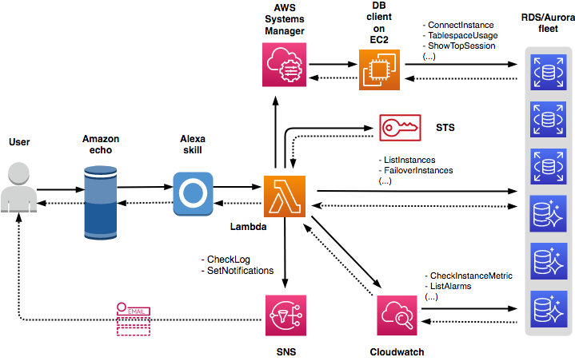

Figure 1 RDS Database fleet management through voice commands infrastructure (AWS Blogs).

Key Features

1. **Voice-Activated Meetings and Conferencing**

* Alexa for Business simplifies meeting scheduling and management through voice commands. Users can instruct Alexa to schedule, reschedule, or cancel meetings, check room availability, and even start or join virtual meetings through supported conferencing platforms1
* This feature enhances collaboration by reducing the friction associated with traditional meeting management processes, allowing teams to focus on their agenda rather than administrative details.

2. **Voice-Controlled Devices**

* The integration of Alexa into various devices such as Echo speakers and third-party hardware allows users to control smart office devices, adjust room settings, and access information hands-free.
* This capability extends beyond traditional office spaces, offering a range of applications in industries such as healthcare, where touchless controls can contribute to hygiene and efficiency1.

3. **Customizable Skills**

* Alexa for Business allows organizations to develop custom skills tailored to their specific needs. These skills can range from providing company-specific information to automating industry-specific workflows.
* Customizable skills empower businesses to leverage Alexa not just as a virtual assistant but as a personalized, enterprise-grade solution addressing unique challenges1.

Implementation and Integration

1. **Device Provisioning and Management**

* Organizations can easily provision and manage Alexa-enabled devices at scale through the Alexa for Business console. This centralized management ensures seamless deployment and updates across all connected devices (Amazon, 2017).

2. **Security and Compliance**

* Security is a top priority in enterprise environments. Alexa for Business provides administrative controls to manage data privacy settings and integrates with AWS Identity and Access Management (IAM) for robust security measures1.
* Compliance with industry standards and regulations is addressed through features such as encryption, audit logs, and the ability to disable voice recording to meet specific organizational requirements1.

Use Cases

1. **Enhanced Meeting Experiences**

* Alexa for Business transforms meeting experiences by allowing users to start meetings with a simple voice command, control conference room settings, and access information without manual intervention.
* This feature not only saves time but also contributes to a more natural and collaborative meeting environment, fostering innovation and idea exchange1.

2. **Increased Productivity**

* The hands-free nature of Alexa for Business enhances productivity by enabling users to perform tasks such as checking email, managing calendars, and accessing relevant information using voice commands.
* This voice-driven approach to tasks minimizes interruptions, allowing employees to maintain focus on critical work1.

Conclusion

In conclusion, Alexa for Business represents a significant leap in workplace technology, leveraging the capabilities of voice-enabled AI to redefine how organizations operate. From revolutionizing meeting dynamics to enhancing productivity and customization through skills, Alexa for Business stands as a testament to AWS's commitment to innovation in business applications.

By seamlessly integrating into the existing AWS ecosystem and offering robust security features, Alexa for Business not only addresses current organizational needs but also lays the foundation for a future where voice-enabled technology becomes an integral part of daily operations. As businesses increasingly recognize the value of intuitive and efficient tools, Alexa for Business emerges as a game-changer, shaping the landscape of smart workplaces.

**Amazon Chime**

Amazon Chime, an enterprise communication and collaboration service by Amazon Web Services (AWS), redefines the way businesses conduct online meetings, video conferencing, and team collaboration. Launched in 2017, Amazon Chime provides a secure and feature-rich platform for organizations to connect, communicate, and collaborate seamlessly [2].

Introduction

In the fast-paced and interconnected business landscape, effective communication is a cornerstone of success. Amazon Chime addresses this need by offering a comprehensive set of tools that streamline virtual meetings, enhance collaboration, and ensure a secure communication environment.

Key Features

1. **Online Meetings and Video Conferencing**

* Amazon Chime facilitates high-quality online meetings with HD video and audio, fostering a virtual meeting experience that closely resembles face-to-face interactions2.
* With features like real-time chat and content sharing, users can collaborate seamlessly during meetings, enhancing productivity and engagement.

2. **Unified Communications**

* The platform unifies communication channels, allowing users to switch between chat, voice, and video seamlessly. This integration creates a cohesive communication experience across various devices 2.
* Whether users are in the office or working remotely, Amazon Chime ensures they have access to a consistent set of communication tools.

3. **Security and Compliance**

* Security is a top priority for Amazon Chime. The service employs encryption to protect communications, and access controls ensure that only authorized individuals participate in meetings 2.
* Compliance with industry standards and regulations is addressed, making Amazon Chime suitable for businesses with stringent security and compliance requirements.

Implementation and Integration

1. **Easy Deployment**

* Amazon Chime offers easy deployment, allowing organizations to quickly onboard users and configure settings through the AWS Management Console 2.
* This simplicity in deployment reduces the burden on IT teams and accelerates the adoption of the communication platform.

2. **Integration with AWS Services**

* Amazon Chime integrates seamlessly with other AWS services, providing additional functionality and extending its capabilities.
* Integration with services like Amazon S3 for file storage and AWS Key Management Service (KMS) for encryption key management enhances the overall utility of Amazon Chime within the AWS ecosystem 2.

Use Cases

1. **Remote Collaboration**

* Amazon Chime is particularly valuable for remote teams, enabling them to collaborate effectively irrespective of geographical location.
* The platform's features, such as virtual meetings, chat, and content sharing, contribute to a cohesive virtual work environment.

2. **Scalable Communication**

* Amazon Chime scales effortlessly to accommodate the communication needs of growing businesses. Whether an organization is small or large, the platform adapts to varying user counts and usage patterns 2.
* This scalability ensures that businesses can rely on Amazon Chime as they expand and evolve.

Conclusion

In conclusion, Amazon Chime emerges as a robust solution for businesses seeking to enhance their communication and collaboration capabilities. By providing a unified platform for meetings, chat, and video conferencing, Amazon Chime simplifies communication workflows and contributes to increased productivity.

The emphasis on security and compliance makes Amazon Chime a trustworthy choice for organizations operating in regulated industries or those with specific data protection requirements. As a part of the AWS suite, Amazon Chime aligns with the broader AWS ecosystem, offering seamless integration with other cloud services.

Amazon Chime's versatility in catering to remote collaboration needs and its ability to scale make it an asset for businesses of all sizes. As the business landscape continues to evolve, Amazon Chime stands as a testament to AWS's commitment to providing innovative solutions that empower organizations to communicate and collaborate effectively in the digital age.

**Amazon Chime SDK**

Amazon Chime SDK (Software Development Kit) empowers developers to integrate Amazon Chime's powerful communication and collaboration features directly into their applications. Launched as part of the broader Amazon Chime family, the SDK provides a set of tools and resources to build custom communication solutions tailored to specific business needs [3].

Features and Capabilities

1. **Real-Time Communication**

* The Amazon Chime SDK enables real-time audio and video communication within applications, fostering a dynamic and engaging user experience.
* Developers can leverage the SDK to implement features like one-to-one or multiparty video calls, audio conferencing, and content sharing seamlessly 3.

2. **Customizable User Interface**

* Developers have the flexibility to design a customized user interface that aligns with the look and feel of their applications.
* This level of customization ensures a cohesive user experience, promoting brand consistency and user adoption 3.

3. **Scalable Infrastructure**

* Amazon Chime SDK is built on a scalable infrastructure that adapts to varying usage patterns and user counts.
* Whether an application has a small user base or experiences rapid growth, the underlying infrastructure ensures reliable and responsive communication capabilities 3.

Implementation and Integration

1. **Developer-Friendly APIs**

* The SDK provides developer-friendly APIs, simplifying the integration process and reducing the time and effort required to implement communication features.
* These APIs cover a range of functions, including initiating and managing calls, handling audio and video streams, and controlling meeting room settings 3.

2. **Cross-Platform Compatibility**

* Amazon Chime SDK supports cross-platform development, allowing applications to deliver consistent communication experiences across various devices and operating systems.
* This compatibility enhances the accessibility of communication features for users on different platforms 3.

Use Cases

1. **In-App Communication**

* Applications across industries can benefit from in-app communication features powered by Amazon Chime SDK.
* For example, healthcare applications can integrate video consultation capabilities, while educational apps can offer virtual classrooms with interactive audio and video3.

2. **Collaborative Tools**

* Business applications requiring collaborative tools, such as project management or team collaboration platforms, can enhance user interaction with Amazon Chime SDK.
* Features like multiparty video calls and content sharing contribute to a more interactive and collaborative digital workspace 3.

Conclusion

In conclusion, Amazon Chime SDK stands as a valuable resource for developers seeking to enrich their applications with robust communication and collaboration capabilities. By offering real-time audio and video communication, customizable user interfaces, and scalable infrastructure, the SDK provides the building blocks for creating immersive user experiences.

The ease of implementation, supported by developer-friendly APIs and cross-platform compatibility, positions Amazon Chime SDK as a versatile solution for applications across diverse industries. Whether integrated into healthcare, education, or collaborative tools, the SDK empowers developers to elevate the communication experience within their applications.

As the digital landscape continues to evolve, Amazon Chime SDK exemplifies AWS's commitment to providing tools that enable innovation and enhance the functionality of applications, ultimately contributing to the success of businesses in the digital era.

**Amazon Connect**

Amazon Connect is a cloud-based contact center service designed to deliver seamless and efficient customer interactions. With a focus on simplicity and flexibility, Amazon Connect empowers businesses to build scalable and personalized customer service solutions [4].

Key Features and Capabilities

1. **Omnichannel Communication**

* Amazon Connect supports omnichannel communication, allowing businesses to engage with customers across various channels such as voice, chat, and email.
* This omnichannel approach ensures a consistent and integrated customer experience, regardless of the communication channel chosen 4.

2. **Natural Language Processing (NLP)**

* Leveraging NLP capabilities, Amazon Connect enables natural and intuitive interactions between customers and contact center agents.
* NLP enhances automated interactions, providing customers with quick and relevant information without the need for manual intervention 4.

3. **Scalability and Flexibility**

* Amazon Connect is built on a scalable infrastructure, allowing businesses to adjust their contact center operations based on demand.
* This scalability ensures that businesses can efficiently manage varying call volumes and adapt to changing customer service needs 4.

Integration and Automation

1. **AWS Lambda Integration**

* Integration with AWS Lambda allows businesses to extend the functionality of Amazon Connect by integrating with other AWS services and third-party applications.
* This level of integration enables businesses to create customized solutions that align with their specific requirements 4.

2. **Contact Flow Design**

* Amazon Connect's contact flow design interface enables businesses to create dynamic and personalized customer journeys.
* Contact flows can be easily designed and modified to accommodate changes in business processes or to enhance the customer experience 4.

Use Cases

1. **Customer Support**

* Amazon Connect serves as a powerful platform for customer support, allowing businesses to efficiently handle customer inquiries, issues, and requests.
* The omnichannel capabilities ensure that customers can choose their preferred communication channel, enhancing overall satisfaction 4.

2. **Virtual Contact Centers**

* For businesses with remote or distributed teams, Amazon Connect facilitates the creation of virtual contact centers.
* This capability allows organizations to tap into a global talent pool and adapt their contact center operations to a changing work landscape 4.

Conclusion

In conclusion, Amazon Connect stands as a versatile solution for businesses seeking to elevate their customer service and contact center operations. The platform's emphasis on omnichannel communication, NLP-driven interactions, and scalability positions it as a valuable tool for delivering exceptional customer experiences.

The integration capabilities, including AWS Lambda integration and contact flow design, provide businesses with the flexibility to tailor Amazon Connect to their unique needs. Whether used for customer support, virtual contact centers, or other applications, Amazon Connect empowers businesses to build efficient and responsive customer service solutions.

As customer expectations continue to evolve, Amazon Connect exemplifies AWS's commitment to providing innovative solutions that enable businesses to stay ahead in the digital landscape.

**Amazon Honeycode**

Amazon Honeycode is a fully managed service that allows users to quickly build powerful mobile and web applications without the need for programming or software development skills. Launched by Amazon Web Services (AWS), Honeycode simplifies the application development process, enabling teams to create custom applications tailored to their specific business needs [5].

Key Features and Capabilities

1. **No-Code Application Development**

* Amazon Honeycode adopts a no-code approach, allowing users to create applications using a visual interface without writing any code.
* This feature empowers business users and teams to participate directly in the application development process, reducing reliance on dedicated development resources (Amazon, n.d.a).

2. **Database and Logic Building Blocks**

* Users can leverage Honeycode's built-in database and logic building blocks to design and customize the data model and functionality of their applications.
* This feature ensures that applications are not only visually appealing but also functionally robust, supporting a wide range of business processes 5.

3. **Real-Time Collaboration**

* Honeycode emphasizes real-time collaboration, allowing multiple team members to work on an application simultaneously.
* This collaborative approach enhances productivity by enabling teams to collectively contribute to the development and improvement of applications 5.

Integration and Automation

1. **AWS Integration**

* Amazon Honeycode seamlessly integrates with other AWS services, enabling users to connect their applications with various AWS resources.
* This integration extends the capabilities of Honeycode by allowing users to incorporate additional features and functionalities into their applications 5.

2. **RESTful APIs**

* Honeycode supports RESTful APIs, providing users with the ability to integrate external data sources and services into their applications.
* This flexibility ensures that Honeycode applications can interact with a wide array of data and services, enhancing their utility and relevance 5.

Use Cases

1. **Task and Project Management**

* Amazon Honeycode is well-suited for creating applications related to task and project management. Teams can build custom solutions to track tasks, manage projects, and streamline workflows.
* The no-code development approach enables teams to quickly adapt applications to changing project requirements 5.

2. **Collaborative Data Tracking**

* Businesses can utilize Honeycode to develop collaborative data-tracking applications. Whether it's managing inventory, tracking customer interactions, or monitoring sales metrics, Honeycode offers a versatile solution.
* Real-time collaboration ensures that teams are always working with the most up-to-date information 5.

Conclusion

In summary, Amazon Honeycode provides businesses with a powerful tool for rapidly creating custom applications that cater to specific business requirements. The no-code approach, coupled with built-in database and logic building blocks, makes application development accessible to a broader audience within an organization.

The seamless integration with AWS services and support for RESTful APIs further enhances Honeycode's capabilities, allowing users to leverage a comprehensive ecosystem of tools and resources. Whether used for task and project management or collaborative data tracking, Honeycode stands as an asset for teams aiming to enhance their operational efficiency through customized applications.

**Amazon Pinpoint**

Amazon Pinpoint, an AWS service, is a versatile and scalable solution designed to help businesses engage and retain their customers effectively. With features tailored for targeted communication, analytics, and user engagement, Pinpoint empowers businesses to create personalized and impactful interactions with their audience [6].

Key Features and Capabilities

1. **Multi-Channel Messaging**

* Amazon Pinpoint supports multi-channel messaging, allowing businesses to engage with their customers through various channels such as email, SMS, push notifications, and voice messages.
* This multi-channel approach ensures that businesses can reach their customers through their preferred communication channels, enhancing the overall user experience 6.

2. **Personalization and Targeting**

* Pinpoint enables businesses to personalize their messages based on user behavior, preferences, and demographics.
* By leveraging this capability, businesses can create targeted and relevant content, increasing the likelihood of customer engagement and satisfaction 6.

3. **Analytics and User Insights**

* The service provides robust analytics and user insights, allowing businesses to track user interactions, measure campaign effectiveness, and gain a deeper understanding of customer behavior.
* These analytics empower businesses to make data-driven decisions and optimize their engagement strategies for better outcomes 6.

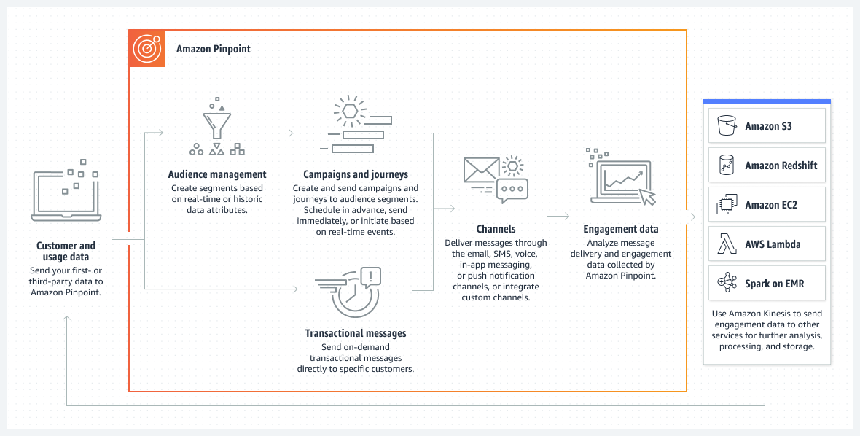

Figure 2 "Amazon Pinpoint offers marketers and developers one customizable tool to deliver customer communications across channels, segments, and campaigns at scale."(AWS Pinpoint documentation)

Integration and Automation

1. **AWS Ecosystem Integration**

* Amazon Pinpoint seamlessly integrates with other AWS services, facilitating the incorporation of messaging and engagement capabilities into existing applications.
* This integration enhances the overall capabilities of applications by adding targeted messaging functionality 6.

2. **Marketing Automation**

* Pinpoint supports marketing automation, enabling businesses to automate the delivery of personalized messages based on user behavior and predefined triggers.
* This automation streamlines marketing workflows, ensuring timely and relevant communication with users 6.

Use Cases

1. **Customer Engagement Campaigns**

* Amazon Pinpoint is ideal for running customer engagement campaigns, whether it's sending personalized product recommendations, announcing promotions, or seeking feedback.
* The multi-channel messaging capability ensures that businesses can reach customers through their preferred communication channels 6.

2. **User Onboarding and Retention**

* Businesses can use Pinpoint to create onboarding campaigns for new users, guiding them through key features and encouraging continued usage.
* Additionally, Pinpoint supports retention campaigns to re-engage users who may have lapsed in their interactions with the application or service 6.

Conclusion

In conclusion, Amazon Pinpoint stands as a powerful tool for businesses seeking to enhance their customer engagement and communication strategies. With its multi-channel messaging, personalization, and analytics features, Pinpoint provides a comprehensive solution for creating targeted and effective communication campaigns.

The seamless integration with the AWS ecosystem and support for marketing automation further solidifies Pinpoint's position as an asset for businesses looking to optimize their customer interactions and drive overall user satisfaction.

**Amazon Simple Email Service (SES)**

Amazon Simple Email Service (SES) is a cloud-based email-sending service designed to simplify the process of sending transactional and marketing emails 7. With a scalable infrastructure, reliable delivery, and cost-effectiveness, SES is a valuable tool for businesses aiming to establish and maintain effective email communication with their customers.

Key Features and Capabilities

1. **Scalability and Deliverability**

* Amazon SES provides a scalable and reliable platform for sending emails. Its architecture ensures high deliverability rates, making it suitable for businesses of all sizes.
* The service dynamically adjusts to the sending volume, accommodating the needs of both startups and large enterprises [7].

2. **Email Sending Options**

* SES offers various options for sending emails, including the Simple Mail Transfer Protocol (SMTP) interface and a robust set of APIs.
* This flexibility allows businesses to integrate SES seamlessly into their applications, websites, or marketing platforms 7.

3. **Content Personalization and Customization**

* Businesses can personalize and customize the content of their emails using SES. This includes adding dynamic content, images, and attachments based on user attributes.
* The ability to tailor emails to specific recipients enhances engagement and communication effectiveness 7.

Security and Compliance

1. **Authentication Mechanisms**

* SES supports various authentication mechanisms such as DomainKeys Identified Mail (DKIM) and Sender Policy Framework (SPF).
* These mechanisms help businesses establish the authenticity of their emails and prevent phishing attempts 7.

2. **Encryption and Secure Transfer**

* SES ensures secure email communication using Transport Layer Security (TLS) encryption.
* This encryption safeguards sensitive information during email transit, contributing to overall data security 7.

Integration with AWS Ecosystem

1. **AWS Management Console and SDKs**

* SES seamlessly integrates with the AWS Management Console, providing a user-friendly interface for email management.
* Additionally, SES offers Software Development Kits (SDKs) for various programming languages, simplifying the integration process 7.

2. **Integration with AWS Services**

* SES can be integrated with other AWS services, allowing businesses to enhance their email communication with additional functionalities.
* Integration possibilities include utilizing Amazon S3 for storing email content or AWS Lambda for executing custom code in response to email events 7.

Use Cases

1. **Transactional Emails**

* Amazon SES is well-suited for sending transactional emails such as order confirmations, shipping notifications, and account updates.
* Its reliability and scalability make it an ideal choice for businesses with varying transactional email volumes 7.

2. **Marketing Campaigns**

* SES supports marketing campaigns by enabling businesses to send bulk emails to a large audience.
* The service's deliverability features ensure that marketing messages reach the intended recipients effectively 7.

Conclusion

In conclusion, Amazon Simple Email Service (SES) offers businesses a robust and scalable solution for managing their email communication needs. Whether sending transactional emails or running marketing campaigns, SES provides the necessary features to ensure reliable delivery, content personalization, and security.

By integrating seamlessly with the AWS ecosystem and offering various sending options, SES stands as a valuable tool for businesses seeking to streamline their email communication processes and enhance their overall customer engagement.

**Amazon WorkDocs**

Amazon WorkDocs is a fully managed, secure content creation, storage, and collaboration service that enables organizations to collaborate on content with the utmost security and compliance [8]. This section provides an in-depth exploration of the key features, capabilities, security aspects, and use cases of Amazon WorkDocs.

Key Features and Capabilities

1. **Secure Document Storage and Sharing**

* WorkDocs offers secure cloud-based document storage, allowing teams to store, share, and collaborate on various types of content.
* Granular access controls ensure that users have the right level of access to documents, promoting secure collaboration 8.

2. **Real-time Collaboration**

* The service supports real-time collaboration on documents, enabling multiple users to edit and comment simultaneously.
* Features like version history and change tracking enhance collaboration and document management 8.

3. **Integration with Productivity Tools**

* WorkDocs seamlessly integrates with popular productivity tools such as Microsoft Office, enabling users to edit and co-author documents using familiar applications.
* This integration enhances the overall workflow and user experience 8.

Security and Compliance

1. **Data Encryption and Compliance**

* WorkDocs ensures data security through encryption in transit and at rest, providing a secure environment for sensitive documents.
* The service adheres to various compliance standards, including HIPAA, GDPR, and ISO, meeting the regulatory needs of diverse industries 8.

2. **Access Controls and Audit Trails**

* Granular access controls enable administrators to manage user permissions effectively.
* Audit trails and activity logs provide transparency into document access and changes, supporting compliance and security requirements 8.

Integration with AWS Ecosystem

1. **AWS Identity and Access Management (IAM) Integration**

* WorkDocs seamlessly integrates with AWS IAM, allowing organizations to manage user access centrally.
* This integration simplifies user onboarding, offboarding, and overall identity management 8.

2. **Integration with AWS Key Management Service (KMS)**

* Organizations can leverage AWS KMS to manage encryption keys for WorkDocs, enhancing control over data encryption.
* This integration strengthens data protection and aligns with organizational security policies 8.

Use Cases

1. **Document Collaboration and Editing**

* WorkDocs facilitates collaborative document creation and editing, particularly beneficial for teams working on projects that require shared documentation.
* Real-time collaboration features to streamline the editing process and improve team productivity 8.

2. **Secure Document Storage for Compliance**

* Organizations in regulated industries, such as healthcare and finance, can use WorkDocs to securely store and manage documents in compliance with industry standards.
* The service's security features contribute to maintaining the integrity of sensitive information 8.

Conclusion

Amazon WorkDocs serves as a comprehensive solution for organizations seeking a secure and collaborative environment for document creation and management. With its robust security features, seamless integration with productivity tools, and compliance capabilities, WorkDocs addresses the evolving needs of modern businesses for efficient and secure document collaboration.

**Amazon WorkMail**

Amazon WorkMail is a secure and fully managed email and calendaring service designed for businesses looking for a reliable communication platform in the cloud [9]. This section delves into the key features, security aspects, and integration capabilities of Amazon WorkMail.

Key Features and Capabilities

1. **Email and Calendar Management**

* WorkMail provides a feature-rich email experience, allowing users to send, receive, and organize emails efficiently.
* Integrated calendar functionality streamlines scheduling and enhances overall productivity 9.

2. **Security and Compliance**

* The service prioritizes security with features such as encryption, secure access controls, and anti-malware protection.
* WorkMail is designed to meet various compliance standards, offering a secure environment for handling sensitive business communications (Amazon, n.d.a).

3. **Integration with Productivity Tools**

* Seamless integration with other AWS services and productivity tools such as Microsoft Outlook simplifies user workflows.
* Users can access their emails and calendars through familiar applications, fostering a user-friendly experience 9.

Security and Compliance

1. **Encryption and Data Protection**

* WorkMail encrypts data in transit and at rest, ensuring the confidentiality and integrity of emails and attachments.
* The service supports Transport Layer Security (TLS) for secure communication over the internet 9.

2. **Access Controls and Auditing**

* Granular access controls enable administrators to manage user permissions effectively, limiting access to sensitive information.
* Auditing capabilities provide visibility into user activities, supporting compliance and security auditing requirements 9.

Integration with AWS Ecosystem

1. **AWS Directory Service Integration**

* WorkMail seamlessly integrates with AWS Directory Service, allowing organizations to manage user identities centrally.
* This integration simplifies user provisioning, directory synchronization, and overall identity management 9.

2. **AWS Key Management Service (KMS) Integration**

* Organizations can use AWS KMS to manage encryption keys for WorkMail, enhancing control over data encryption.
* This integration aligns with organizational security policies and provides additional layers of data protection 9.

Use Cases

1. **Corporate Email Communication**

* WorkMail serves as a robust platform for corporate email communication, offering a secure and reliable channel for internal and external correspondence.
* Features such as shared calendars and distribution lists enhance collaboration within organizations 9.

2. **Compliance-Driven Email Management**

* Organizations subject to regulatory requirements, such as those in healthcare or finance, can leverage WorkMail's security and compliance features for managing email communications.
* The service supports the creation of retention policies to meet specific regulatory standards 9.

Conclusion

Amazon WorkMail provides a secure and scalable solution for organizations seeking a cloud-based email and calendaring service. With its focus on security, seamless integration with productivity tools, and compliance capabilities, WorkMail empowers businesses to establish and maintain effective communication channels in today's dynamic and digital business landscape.

**AWS Supply Chain (Preview)**

AWS Supply Chain is a comprehensive set of services designed to optimize and enhance various aspects of the supply chain process within an organization. This section explores the key components, features, and benefits of AWS Supply Chain.

Key Components of AWS Supply Chain

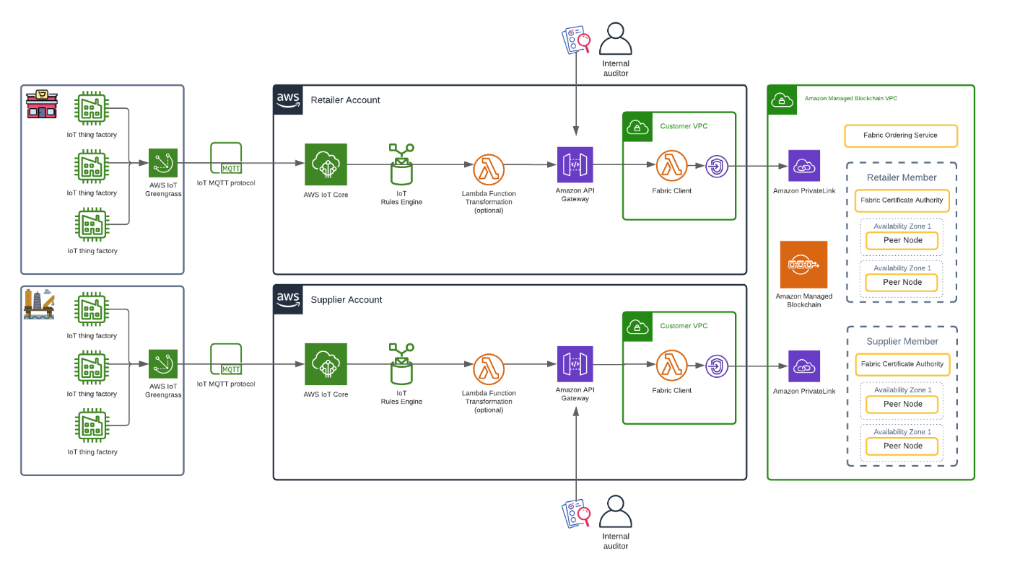

Figure 3 "Reference architecture for an IoT-enabled supply chain consisting of a retailer and a manufacturer."(AWS Blogs)

1. Amazon Forecast

* *Description*: Amazon Forecast is a machine learning service that utilizes advanced algorithms to generate accurate demand forecasts. It helps organizations make informed decisions about inventory management and supply chain optimization [10].
* *Integration*: Forecast seamlessly integrates with other AWS services, allowing organizations to incorporate machine learning capabilities into their existing supply chain workflows 10.

2. **Amazon Connect**

* *Description*: Amazon Connect is a cloud-based contact center service that plays a vital role in improving customer interactions. In the context of the supply chain, it enables efficient communication between various stakeholders, including customers, suppliers, and internal teams [11].
* *Benefits*: Enhanced communication leads to better coordination and responsiveness throughout the supply chain, ultimately improving customer satisfaction and operational efficiency 11.

3. **AWS IoT Core**

* *Description*: AWS IoT Core facilitates the connection of devices to the cloud, enabling real-time monitoring and control of physical assets within the supply chain. This can include tracking the location and condition of goods during transportation [12].
* *Use Case*: Organizations can leverage IoT Core to implement end-to-end visibility, ensuring that goods are handled and transported under the specified conditions to maintain product quality 12.

4. **Amazon Simple Storage Service (S3)**

* *Description*: Amazon S3 serves as a scalable and secure storage solution for managing and archiving critical data related to the supply chain. It provides the necessary infrastructure for storing and retrieving large volumes of information [13].
* *Integration*: S3 integrates with other AWS services, allowing organizations to build data lakes and analytics solutions to gain insights into supply chain trends and performance 12.

Benefits of AWS Supply Chain

1. **Optimized Inventory Management**

* By leveraging forecasting models provided by Amazon Forecast, organizations can optimize inventory levels, reducing carrying costs while ensuring product availability.

2. **Enhanced Visibility and Tracking**

* AWS IoT Core enables real-time tracking and monitoring of goods throughout the supply chain, providing stakeholders with visibility into the status and location of assets.

3. **Improved Communication and Customer Service**

* Amazon Connect facilitates better communication with customers, suppliers, and internal teams, leading to improved customer service and responsiveness.

4. **Data-Driven Decision-Making**

* The integration of Amazon S3 and other analytics services allows organizations to make data-driven decisions by analyzing historical and real-time data from the supply chain.

Considerations and Best Practices

1. **Security and Compliance**

* When implementing AWS Supply Chain services, organizations should adhere to AWS's security best practices and ensure compliance with relevant industry regulations 10.

2. **Scalability**

* As the organization's supply chain grows, AWS Supply Chain services can scale to accommodate increased data volumes and complexity.

Conclusion

AWS Supply Chain, with its array of services, empowers organizations to build a resilient, data-driven, and optimized supply chain. By leveraging machine learning, IoT, and cloud storage, businesses can enhance various facets of their supply chain processes, leading to improved efficiency, reduced costs, and ultimately, a competitive advantage in the market.

**AWS Wickr**

AWS Wickr is a secure communication platform that ensures end-to-end encryption for messages, files, and voice and video calls. This section delves into the features, benefits, and use cases of AWS Wickr in the context of business applications.

Key Features of AWS Wickr

1. **End-to-End Encryption**

* *Description*: AWS Wickr employs end-to-end encryption, ensuring that only authorized parties can access the content of messages and files. This is crucial for maintaining the confidentiality and integrity of sensitive business communications [14].
* *Security Assurance*: The end-to-end encryption protocol used by AWS Wickr provides a high level of security, preventing unauthorized interception of communication content 14.

2. **Secure File Sharing**

* *Description*: Wickr allows secure sharing of files, enabling teams to collaborate without compromising the confidentiality of the shared documents. This feature is particularly valuable for businesses handling sensitive information [15].
* *Control and Permissions*: AWS Wickr provides granular control over file-sharing permissions, allowing administrators to manage who can access, download, or modify shared files 15.

3. **Voice and Video Calls**

* *Description*: In addition to text messaging, AWS Wickr supports encrypted voice and video calls. This feature facilitates real-time communication between team members or external partners, fostering collaboration [16].
* *Secure Meetings*: The encryption applied to voice and video calls ensures that business meetings conducted through AWS Wickr remain private and secure 16.

Benefits of AWS Wickr for Business Applications

1. **Confidential Communication**

* AWS Wickr ensures that all forms of communication, including messages, files, and multimedia, are kept confidential through robust encryption mechanisms.

2. **Compliance and Data Protection**

* The end-to-end encryption and secure file-sharing features of AWS Wickr contribute to regulatory compliance and data protection efforts within the business environment.

3. **Remote Collaboration**

* With encrypted voice and video calls, AWS Wickr supports remote collaboration, allowing team members to connect securely regardless of their physical location.

Use Cases and Scenarios

1. **Secure Team Communication**

* AWS Wickr is ideal for businesses that require a secure and private platform for internal team communication, especially when dealing with sensitive projects or information.

2. **Confidential Document Sharing**

* Organizations handling confidential documents, such as legal firms or financial institutions, can use AWS Wickr for secure file sharing, ensuring that only authorized individuals have access.

3. **Executive and Board Communications**

* Executives and board members can utilize AWS Wickr for confidential discussions, strategic planning, and decision-making, knowing that their communications are protected.

Considerations and Best Practices

1. **User Training and Awareness**

* Organizations should invest in user training to ensure that employees are aware of best practices for secure communication and file sharing on the AWS Wickr platform.

2. **Regular Security Audits**

* Conducting regular security audits and assessments helps ensure that AWS Wickr is configured correctly and that any potential vulnerabilities are addressed promptly.

Conclusion

AWS Wickr provides a robust solution for businesses seeking secure and confidential communication channels. With its focus on end-to-end encryption, secure file sharing, and encrypted voice and video calls, AWS Wickr addresses the growing need for privacy and data protection in today's business landscape.

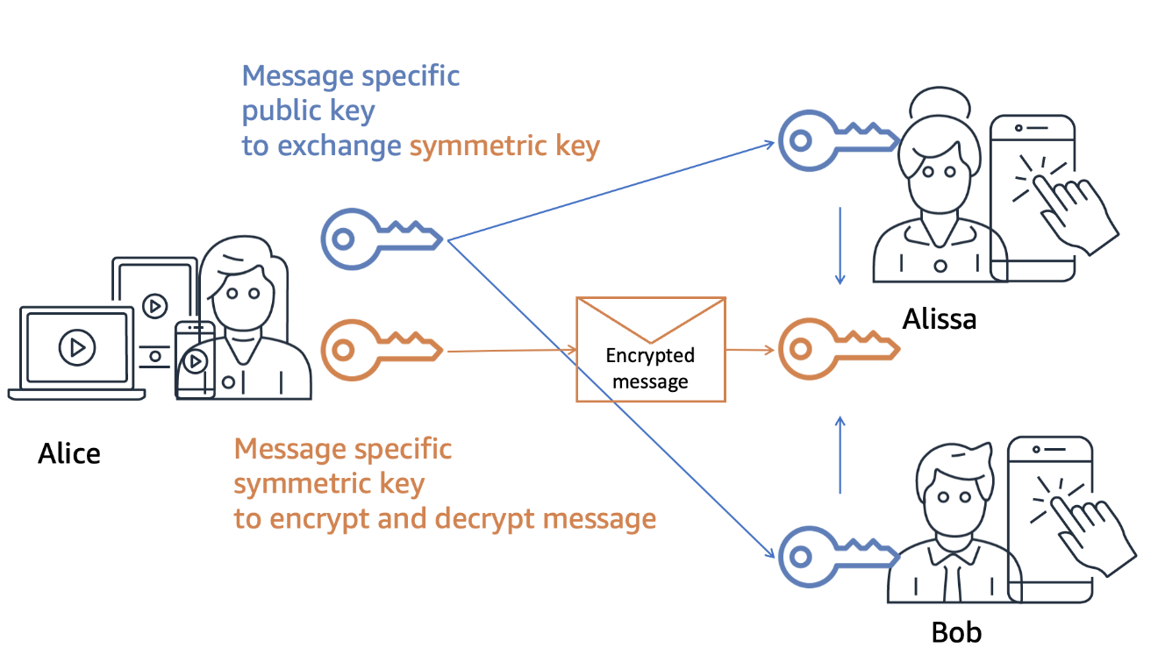

Figure 4 "The Wickr secure messaging protocol is open and documented, allowing the community to inspect it. The source code we use in Wickr clients to implement the secure messaging protocol is available to audit and review." (AWS Blogs)

Part 2: Cloud Financial Management

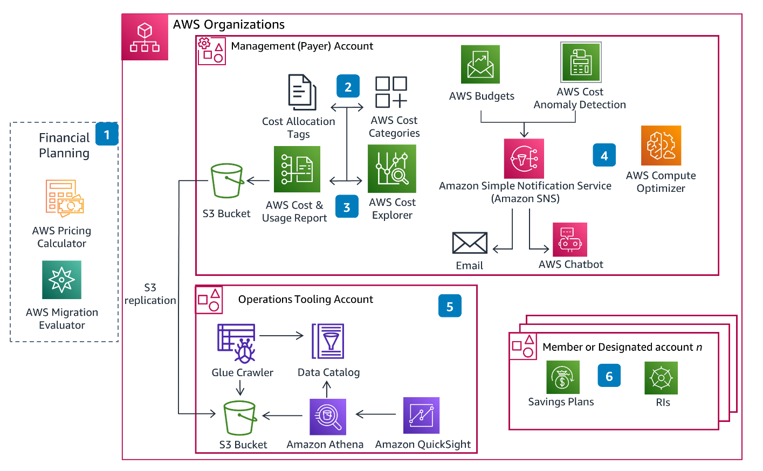

Figure 5 Cloud Financial Management on AWS Architecture (AWS Solutions Guidance documentation).

**Amazon EC2 Spot Instances**

Amazon EC2 Spot Instances offer a cost-effective alternative for businesses to run applications flexibly and efficiently, optimizing computing costs. In this section, we explore the features, benefits, and use cases of Amazon EC2 Spot Instances in the context of cloud financial management.

Overview of Amazon EC2 Spot Instances

1. **Cost Savings**

* *Description*: Amazon EC2 Spot Instances enable users to access spare Amazon EC2 computing capacity at a lower price. Spot Instances can significantly reduce costs compared to On-Demand Instances, making them suitable for various use cases, including fault-tolerant applications and workloads with flexible start and end times[17].
* *Cost Fluctuation*: Spot Instance prices vary based on supply and demand dynamics in the AWS Cloud. Users bid for available capacity, and when the bid exceeds the current Spot price, the instances are terminated. Therefore, users benefit from cost savings while being aware of the variable nature of Spot Instance pricing 17.

2. **Flexible Workloads**

* *Description*: Amazon EC2 Spot Instances are well-suited for workloads that can handle interruptions and are fault tolerant. Applications such as data analysis, rendering, and simulations can leverage Spot Instances to optimize costs without sacrificing performance 17.
* *Integration with Auto Scaling*: Spot Instances seamlessly integrate with Auto Scaling groups, allowing users to automatically adjust capacity based on changing workloads. This ensures that applications maintain performance even during Spot Instance interruptions 17.

Benefits of Amazon EC2 Spot Instances in Cloud Financial Management

1. **Optimized Cost-Performance Ratio**

* Amazon EC2 Spot Instances provide a high cost-performance ratio, allowing businesses to achieve more computational power for their budget compared to On-Demand Instances.

2. **Scalability and Flexibility**

* The flexible nature of Spot Instances makes them ideal for workloads that can scale up or down based on demand, optimizing resource usage and costs.

3. **Diverse Use Cases**

* Spot Instances cater to a range of use cases, including batch processing, testing environments, and high-performance computing, allowing businesses to choose the most cost-effective solution for their specific requirements.

Use Cases and Scenarios

1. **Batch Processing**

* Businesses can use Amazon EC2 Spot Instances for batch processing tasks, such as data transformation and analysis, taking advantage of cost savings during periods of excess capacity.

2. **Testing and Development**

* Development and testing environments that require scalable resources can benefit from the cost-efficient nature of Spot Instances, allowing teams to experiment without incurring high expenses.

3. **High-Performance Computing (HPC)**

* Applications with high-performance computing requirements, such as scientific simulations and rendering, can leverage the computational power of Spot Instances at a lower cost.

Considerations and Best Practices

1. **Fault Tolerance**

* Design applications running on Spot Instances to be fault-tolerant, as interruptions may occur based on changes in Spot pricing and capacity availability.

2. **Monitoring and Automation**

* Implement robust monitoring and automation practices to manage Spot Instances dynamically, adjusting capacity based on changing demands and gracefully handling interruptions.

Conclusion

Amazon EC2 Spot Instances offer businesses an opportunity to optimize their cloud costs by leveraging spare capacity at a lower price. With careful consideration of use cases, fault tolerance, and automation, organizations can benefit from the flexibility and cost-effectiveness that Spot Instances brings to cloud financial management.

**AWS Budgets**

In the realm of cloud financial management, AWS Budgets stands out as a pivotal tool, empowering businesses to gain granular control over their expenditures. This section delves into the features, benefits, and applications of AWS Budgets, providing a comprehensive understanding of how it contributes to effective cost management within the AWS cloud infrastructure.

Overview of AWS Budgets

1. **Definition and Purpose**

* *Description*: AWS Budgets is a service designed to set custom cost and usage budgets that alert stakeholders when thresholds are exceeded. It plays a crucial role in preventing unexpected expenditures and aids in aligning financial goals with the dynamic nature of cloud usage [18].
* *Customization*: Users can tailor AWS Budgets based on various parameters, including cost, usage, RI utilization, and even specific AWS account dimensions. This level of customization ensures that budgets align with the unique needs and structure of each business unit 18.

2. **Alerts and Notifications**

* *Real-Time Alerts*: AWS Budgets provides real-time alerts when actual or forecasted costs breach the set thresholds. These alerts can be configured to notify stakeholders via multiple channels, such as email or Amazon Simple Notification Service (SNS), facilitating prompt action to control costs 18.
* *Forecasting*: The service offers forecasting capabilities, allowing businesses to anticipate future costs based on historical data. This proactive approach enables organizations to make informed decisions and adapt their cloud spending strategies accordingly 18.

Benefits of AWS Budgets in Cloud Financial Management

1. **Cost Predictability**

* AWS Budgets contribute to cost predictability by providing insights into current and future expenditures. This transparency enables businesses to make informed decisions, preventing financial surprises.

2. **Resource Optimization**

* With the ability to set specific budgets for different dimensions, AWS Budgets aids in optimizing resource allocation. Businesses can allocate resources efficiently based on budgetary constraints and organizational priorities.

3. **Financial Accountability**

* AWS Budgets foster financial accountability by keeping stakeholders informed about their resource consumption. This transparency encourages responsible cloud usage and aligns individual actions with overall financial objectives.

Use Cases and Scenarios

1. **Departmental Budgeting**

* AWS Budgets is instrumental in departmental budgeting, allowing organizations to allocate specific budgets to different departments. This ensures that each department operates within its financial constraints.

2. **Project-Based Budgets**

* Businesses undertaking specific projects can create project-based budgets, enabling project managers to monitor and manage costs effectively. This use case is particularly valuable for maintaining financial control over diverse initiatives.

3. **Cost Control for Development Environments**

* AWS Budgets are valuable for managing costs in development environments. By setting usage thresholds, businesses can prevent unexpected spikes in costs during the development phase.

Considerations and Best Practices

1. **Regular Monitoring**

* Regularly monitor budget reports and alerts to stay abreast of cost trends and potential deviations from the set budget. This proactive approach enhances cost management effectiveness.

2. **Collaboration and Communication**

* Foster collaboration and communication among stakeholders to ensure that budgetary constraints are well-understood. This collaborative effort is vital for aligning financial goals across the organization.

Conclusion

AWS Budgets emerge as a fundamental tool for businesses aiming to exert precise control over their AWS spending. By combining customization, real-time alerts, and forecasting capabilities, AWS Budgets empowers organizations to navigate the dynamic landscape of cloud financial management with confidence.

**AWS Cost and Usage Report**

**Introduction**

In the realm of cloud financial management, the AWS Cost and Usage Report (CUR) stands as a cornerstone for businesses seeking comprehensive insights into their AWS spending patterns. This section delves into the intricacies of AWS CUR, exploring its features, functionalities, and its role in facilitating informed financial decision-making within the AWS cloud infrastructure.

AWS Cost and Usage Report: An Overview

1. **Definition and Purpose**

* *Description*: The AWS Cost and Usage Report is a robust tool designed to provide customers with granular details about their AWS usage and associated costs. It goes beyond the high-level cost breakdowns available in the AWS Management Console, offering detailed information at the level of individual resources and usage patterns[19].
* *Granularity*: The report encompasses a wealth of information, including hourly or daily granularity, making it a valuable resource for organizations aiming to gain a profound understanding of their cloud resource consumption 19.

2. **Customization and Flexibility**

* *Custom Reporting*: AWS CUR empowers users to create customized reports based on their specific requirements. This includes selecting the desired data fields, filtering options, and even defining the period covered by the report. Such flexibility ensures that the report aligns precisely with the informational needs of the organization 19.
* *Multiple Dimensions*: Users can leverage the multiple dimensions provided by CUR to drill down into specific aspects of their usage, such as geographical region, instance type, or even the identity of the end-user. This level of detail facilitates targeted analysis and decision-making 19.

Benefits of AWS Cost and Usage Report in Cloud Financial Management

1. **Granular Cost Insights**

* AWS CUR offers granular insights into costs, allowing businesses to understand the financial implications of each resource and activity. This depth of information is crucial for optimizing spending and enhancing cost predictability.

2. **Resource Optimization**

* By providing details at the resource level, AWS CUR assists organizations in optimizing their resource allocation. Businesses can identify underutilized resources, make informed decisions about scaling, and ensure that resources align with actual usage patterns.

3. **Showback and Chargeback**

* The detailed information provided by AWS CUR facilitates showback and chargeback mechanisms within organizations. This is particularly valuable for businesses with multiple departments or projects, enabling them to transparently communicate costs and foster financial accountability (Amazon Web Services, 2022a).

Use Cases and Scenarios

1. **Budgetary Planning**

* AWS CUR is instrumental in budgetary planning, providing organizations with the data needed to create accurate and realistic budgets. This ensures that financial planning aligns with the actual resource consumption patterns.

2. **Cost Allocation**

* Businesses with complex structures can use AWS CUR for detailed cost allocation. This is especially relevant for enterprises with multiple departments, projects, or teams, allowing them to attribute costs accurately.

3. **Resource-Specific Analysis**

* For organizations seeking to optimize specific resources, AWS CUR enables resource-specific analysis. This includes understanding the costs associated with different types of instances, storage, or data transfer, aiding in targeted optimization efforts.

Considerations and Best Practices

1. **Regular Review and Analysis**

* Regularly review and analyze AWS CUR reports to stay informed about cost trends and identify potential areas for optimization. This proactive approach ensures that organizations can adapt to changing usage patterns.

2. **Collaboration Across Teams**

* Foster collaboration across different teams within the organization by leveraging the insights provided by AWS CUR. This collaboration is key for aligning resource usage with overall business objectives.

Conclusion

The AWS Cost and Usage Report emerges as a linchpin in the cloud financial management arsenal, providing businesses with the depth of information needed to navigate the complexities of AWS spending. By offering granularity, customization, and detailed insights, AWS CUR empowers organizations to make informed decisions and optimize their cloud resources effectively.

**AWS Cost Explorer**

In the realm of AWS Cloud Financial Management, one of the key tools that empower businesses to gain insights into their cloud spending is AWS Cost Explorer. This section provides an in-depth exploration of AWS Cost Explorer, shedding light on its features, functionalities, and pivotal role in helping organizations visualize, understand, and manage their AWS costs effectively.

AWS Cost Explorer: Unveiling Cloud Costs

1. **Overview and Purpose**

* **Definition**: AWS Cost Explorer is a comprehensive cost management tool provided by Amazon Web Services, designed to assist users in visualizing, understanding, and managing their AWS costs and usage [20].
* **Purpose**: The primary purpose of AWS Cost Explorer is to empower businesses with intuitive and interactive interfaces, enabling them to explore historical and forecasted costs, identify cost drivers, and make data-driven decisions to optimize their cloud spending 20.

2. **Visualization Capabilities**

* **Cost Trends**: AWS Cost Explorer provides users with the ability to visualize their cost trends over customizable periods. This includes daily, monthly, or custom date ranges, allowing for a granular understanding of how costs evolve 20.
* **Forecasting**: Businesses can leverage Cost Explorer's forecasting capabilities to estimate future costs based on historical data. This forward-looking view aids in proactive budgeting and planning 20.

Utilizing AWS Cost Explorer for Effective Cost Management

1. **Cost Allocation and Filtering**

* **Resource-Level Breakdown**: AWS Cost Explorer offers a resource-level breakdown of costs, enabling users to identify the specific AWS services or resources contributing to overall expenditure. This granularity facilitates targeted optimization efforts 20.

**Filtering Options**: Users can apply various filters, such as by region, instance type, or tags, to isolate and analyze specific cost components. This feature is invaluable for businesses with diverse and complex AWS infrastructures 20.

2. **Reserved Instance (RI) Recommendations**

* **RI Utilization Analysis**: AWS Cost Explorer provides insights into Reserved Instance (RI) utilization, helping businesses understand the effectiveness of their RI purchases. This is critical for optimizing costs through strategic RI planning 20.
* **RI Purchase Recommendations**: The tool offers recommendations for additional RI purchases based on historical usage patterns, ensuring that organizations can maximize savings through well-informed RI decisions 20.

3. **Custom Reports and Views**

* **Saved Reports**: Users can create and save custom reports tailored to their specific reporting needs. This feature streamlines recurring cost analysis tasks by allowing the quick retrieval of preferred report configurations 20.
* **Cost Anomaly Detection**: AWS Cost Explorer includes anomaly detection capabilities, alerting users to unexpected cost changes. This proactive feature aids in identifying irregularities and potential cost optimization opportunities 20.

Best Practices for Effectively Leveraging AWS Cost Explorer

1. **Regular Monitoring and Analysis**

* Regularly monitor and analyze cost trends using AWS Cost Explorer. This proactive approach ensures that organizations stay abreast of their AWS spending patterns and can promptly address any deviations from budgetary expectations.

2. **Collaborative Decision-Making**

* Foster collaboration among different teams within the organization by utilizing the visualizations and insights provided by AWS Cost Explorer. This collaborative approach ensures that cost-related decisions align with overall business objectives.

Conclusion

AWS Cost Explorer emerges as a pivotal tool in the AWS Cloud Financial Management toolkit, providing businesses with the means to visualize, understand, and manage their AWS costs effectively. By offering intuitive visualizations, granular breakdowns, and forecasting capabilities, AWS Cost Explorer empowers organizations to optimize their cloud spending and drive cost-efficient cloud operations.

**Reserved Instance (RI) Reporting**

Cloud Financial Management is a critical aspect of optimizing costs in cloud computing, and Reserved Instances (RIs) play a significant role in achieving cost efficiency. This section delves into the intricacies of RI Reporting, exploring how businesses can leverage AWS tools to manage and maximize the benefits of Reserved Instances.

Reserved Instances (RIs): A Strategic Investment

1. **Understanding Reserved Instances**

* **Definition**: Reserved Instances (RIs) are a pricing model offered by AWS that provides customers with significant discounts (up to 75%) compared to On-Demand pricing, in exchange for a commitment to a one- or three-year term [21].

**Strategic Investment**: RIs represent a strategic investment for businesses with predictable and steady-state workloads. By committing to a term, organizations can achieve substantial savings over pay-as-you-go pricing 21.

2. **Importance of Reporting in RI Management**

* **Optimizing RI Utilization**: Effective RI reporting is essential for optimizing RI utilization. Businesses need insights into how well their existing RIs align with actual instance usage to avoid underutilization or mismatched reservations 21.
* **Cost Planning and Budgeting**: RI reporting aids in cost planning and budgeting by providing visibility into the realized savings from RIs. This information is crucial for financial stakeholders to assess the impact of RI investments on the overall budget 21,

Leveraging AWS Tools for RI Reporting

1. **AWS Cost Explorer for RI Utilization Analysis**

* **Resource-Level Breakdown**: AWS Cost Explorer offers detailed resource-level breakdowns, allowing businesses to analyze how well their RIs match with actual resource usage. This granularity is essential for identifying areas of improvement 22.
* **Filtering Options**: By applying filters such as instance types, regions, and tags, organizations can drill down into specific details related to RI usage. This level of detail is valuable for targeted optimizations and informed decision-making [22].

2. **AWS Budgets for Cost Planning**

* **RI-Related Budgets**: AWS Budgets enable the creation of custom budgets specifically focused on RI-related costs. This feature allows businesses to set thresholds and receive alerts when actual spending deviates from the budgeted amounts [23].
* **Forecasting with Budgets**: AWS Budgets include forecasting capabilities, providing insights into future spending trends based on historical data. This forward-looking view assists organizations in aligning their RI investments with anticipated future workloads 23.

3. **Custom Reporting with AWS Cost and Usage Report (CUR)**

* **Granular Data Export**: The AWS Cost and Usage Report (CUR) allows organizations to export detailed, granular data related to their AWS usage and costs. This includes specific information on RI usage and facilitating customized reporting and analysis [24].
* **Integration with BI Tools**: The exported CUR data can be integrated with Business Intelligence (BI) tools, providing advanced reporting capabilities. This integration enables businesses to create bespoke RI reports tailored to their unique reporting requirements 24.

Best Practices for RI Reporting and Management

1. **Regular Review and Adjustment**

* Regularly review RI reports and adjust reservations based on changing workloads. This practice ensures that RIs remain aligned with actual usage patterns, maximizing cost savings.

2. **Collaboration between Finance and Technical Teams**

* Foster collaboration between finance and technical teams by sharing RI reports. This collaboration ensures that financial stakeholders understand the impact of RI investments and can provide insights into budgeting and forecasting.

Conclusion

Reserved Instance Reporting is a linchpin in the effective management of cloud costs, allowing businesses to capitalize on the cost-saving benefits of RIs. By leveraging tools like AWS Cost Explorer, AWS Budgets, and the AWS Cost and Usage Report, organizations can gain valuable insights, optimize RI utilization, and make informed decisions to align their cloud spending with business objectives.

**Cloud Financial Management - Savings Plans**

Cloud Financial Management is a critical component of an effective cloud computing strategy, and Savings Plans within the AWS ecosystem offer a flexible and cost-effective pricing model. This section explores the concept of Savings Plans, their advantages, and how businesses can leverage them for optimized cost savings.

Understanding Savings Plans

1. **Definition of Savings Plans**

* **Flexible Pricing Model**: Savings Plans are a pricing model introduced by AWS that provides significant savings (up to 72%) over On-Demand pricing. They offer flexibility by allowing customers to commit to a consistent amount of usage (measured in $/hr) for a 1 or 3-year period [25].
* **Versatility Across Instance Types**: Unlike Reserved Instances, Savings Plans provide flexibility across instance families, sizes, and regions. This adaptability makes Savings Plans suitable for a broader range of dynamic workloads 25.

2. **Advantages of Savings Plans**

* **Cost Savings**: Savings Plans deliver cost savings compared to On-Demand pricing, making them a strategic choice for businesses with steady-state or variable usage patterns. The pricing model ensures a consistent discount irrespective of changes in usage 25.
* **Usage Flexibility**: With Savings Plans, customers benefit from usage flexibility. They can switch between instance types and operating systems while still enjoying the cost benefits. This feature aligns well with the dynamic nature of modern cloud workloads 25.

Leveraging AWS Tools for Savings Plans Management

1. **AWS Cost Explorer for Savings Plans Analysis**

* **Usage and Coverage Analysis**: AWS Cost Explorer provides detailed insights into Savings Plans usage and coverage. Businesses can analyze how well their Savings Plans align with actual usage patterns, ensuring optimal coverage and identifying areas for improvement [26].
* **Forecasting with Cost Explorer**: Cost Explorer includes forecasting capabilities, enabling organizations to predict future spending trends based on historical data. This feature assists in aligning Savings Plans with anticipated future workloads and optimizing cost planning 26.

2. **AWS Budgets for Savings Plans Monitoring**

* **Custom Budgets for Savings Plans**: AWS Budgets allows the creation of custom budgets focused on Savings Plans-related costs. This feature enables organizations to set budget thresholds and receive alerts when actual spending deviates from the budgeted amounts [27].
* **Monitoring Cost and Usage Trends**: AWS Budgets facilitates monitoring cost and usage trends related to Savings Plans. This helps organizations stay proactive in managing their financial commitments and ensures alignment with budgetary goals27.

3. **Custom Reporting with AWS Cost and Usage Report (CUR)**

* **Detailed Usage Reports**: The AWS Cost and Usage Report (CUR) provides detailed usage reports, including information on Savings Plans. This granular data export option enables businesses to create customized reports tailored to their specific reporting requirements [28].

**Integration with BI Tools**: The CUR data, including Savings plan details, can be integrated with Business Intelligence (BI) tools. This integration enhances reporting capabilities, allowing organizations to create sophisticated reports for in-depth analysis 28.

Best Practices for Savings Plans Management

1. **Regular Analysis and Adjustment**

* Regularly analyze Savings Plans usage patterns and adjust commitments based on changing workloads. This practice ensures that Savings Plans remain aligned with actual usage, maximizing cost-effectiveness.

2. **Collaboration between Finance and Technical Teams**

* Foster collaboration between finance and technical teams by sharing Savings Plan reports. This collaboration ensures that financial stakeholders understand the impact of Savings Plans on the overall budget and can contribute insights into budgeting and forecasting.

Conclusion

Savings Plans represent a powerful tool for businesses seeking cost savings and flexibility in their cloud financial management. By leveraging AWS tools such as Cost Explorer, Budgets, and the Cost and Usage Report, organizations can gain valuable insights, optimize Savings Plans utilization, and make informed decisions to align their cloud spending with business objectives.

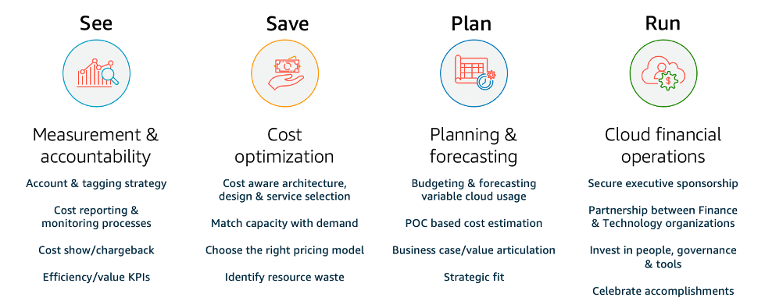

Figure 6 The four pillars of Cloud Financial Management. (AWS Well-Architected Framework documentation).

Part 3: Media Services

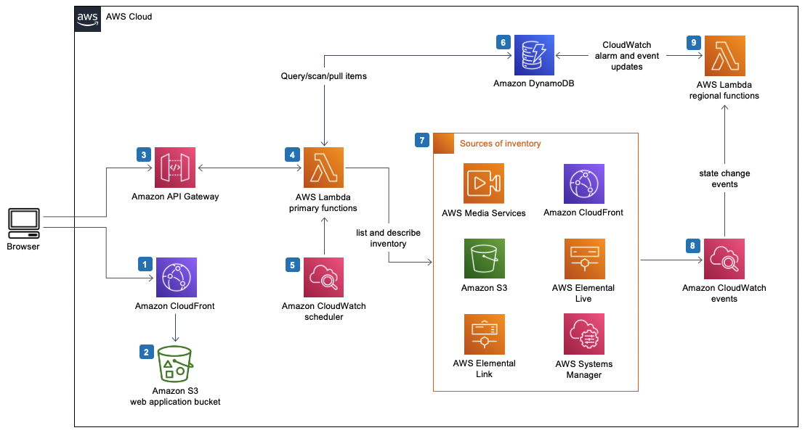

Figure 7 "Media Services Application Mapper on AWS" (AWS Solutions Library).

**Amazon Elastic Transcoder**

In the ever-evolving landscape of digital content, efficient and scalable media transcoding is paramount for delivering high-quality multimedia experiences. Amazon Elastic Transcoder, a part of AWS Media Services, addresses this need by providing a comprehensive solution for transcoding media files into various formats. This section delves into the intricacies of Amazon Elastic Transcoder, exploring its features, use cases, and the advantages it offers in the realm of media processing.

Understanding Amazon Elastic Transcoder

1. **Overview of Amazon Elastic Transcoder**

* **Scalable Media Transcoding**: Amazon Elastic Transcoder is a fully managed media transcoding service that enables the conversion of media files from their source format into versions optimized for various devices and playback scenarios [29].
* **Wide Format Support**: The service supports a broad range of input and output formats, allowing users to transcode media files into formats suitable for web browsers, mobile devices, smart TVs, and other platforms 29.

2. **Key Features and Capabilities**

* **Elastic Scalability**: Amazon Elastic Transcoder automatically scales based on the volume of transcoding jobs, ensuring optimal performance and responsiveness to varying workloads 29.
* **Customizable Presets**: Users can choose from a selection of predefined transcoding presets or create custom presets to tailor the output to specific requirements, such as resolution, bitrate, and codec settings (Amazon Web Services, 2022a).
* **Thumbnail Generation**: The service can generate thumbnails from the input video at specified intervals, enhancing the ability to create engaging and visually appealing content 29.

Use Cases of Amazon Elastic Transcoder

1. **Multi-Device Content Delivery**

* Amazon Elastic Transcoder is instrumental in preparing media content for delivery to a diverse array of devices, ensuring a seamless and optimized viewing experience across platforms.

2. **Dynamic Adaptive Streaming over HTTP (DASH) and HTTP Live Streaming (HLS)**

* The service supports popular streaming protocols like DASH and HLS, enabling the delivery of adaptive bitrate streaming for an enhanced streaming experience 29.

3. **User-Generated Content Processing**

* Content platforms that involve user-generated media can leverage Amazon Elastic Transcoder to efficiently process and format content uploaded by users.

Integration with AWS Services

1. **Amazon S3 Integration**

* Seamless integration with Amazon S3 allows users to store input and output files, simplifying the management of media assets throughout the transcoding process 29.

2. **Amazon CloudFront for Content Delivery**

* Amazon Elastic Transcoder can be coupled with Amazon CloudFront to ensure low-latency and high-performance delivery of transcoded media files to end-users globally 29.

Best Practices for Effective Usage

1. **Optimal Preset Selection**

* Careful consideration of transcoding presets is crucial for achieving the right balance between file size, quality, and compatibility with target devices 29.

2. **Cost Optimization**

Understanding the cost structure and optimizing transcoding configurations based on the specific needs of the project is essential for the cost-effective usage of Amazon Elastic Transcoder 29.

Conclusion

Amazon Elastic Transcoder stands as a powerful tool in the AWS Media Services suite, empowering businesses to deliver high-quality multimedia content efficiently and at scale. By understanding its features, use cases and integration possibilities, organizations can unlock the full potential of this service, enhancing their capabilities in the ever-expanding digital content landscape.

**Amazon Interactive Video Service**

The modern digital landscape places significant emphasis on interactive and engaging video content. Amazon Interactive Video Service (IVS) emerges as a pivotal player in this domain, offering a fully managed live streaming service that facilitates the delivery of interactive and personalized video experiences. This section delves into the intricacies of Amazon IVS, exploring its features, applications, and the advantages it brings to businesses venturing into live video streaming.

Understanding Amazon Interactive Video Service

1. **Overview of Amazon IVS**

* **Fully Managed Live Streaming**: Amazon IVS is designed to simplify the complexities associated with live video streaming by offering a fully managed service. It enables businesses to focus on content creation and audience engagement without the burden of managing the underlying infrastructure [30].
* **Real-time Interaction**: A distinguishing feature of Amazon IVS is its capability to support real-time interaction. This includes live chat integration, polling, and other interactive elements that enhance viewer engagement during live streams 30.

2. **Key Features and Capabilities**

* **Low Latency Streaming**: Amazon IVS is optimized for low-latency streaming, ensuring that the gap between the live event and its delivery to viewers is minimized. This is crucial for scenarios where real-time interaction is a priority 30.
* **Scalability and Flexibility**: The service automatically scales to accommodate varying audience sizes, providing flexibility for businesses hosting events of different scales30.

Use Cases of Amazon Interactive Video Service

1. **Live Events and Webinars**

* Amazon IVS is well-suited for hosting live events and webinars where real-time interaction with the audience is essential. This includes Q&A sessions, polls, and other engagement features 30.

2. **Gaming and Esports**

* The low latency streaming capabilities of Amazon IVS make it an ideal choice for gaming and esports scenarios, where minimal delay is critical for an immersive viewer experience 30.

3. **Online Education and Training**

* Educational institutions and training organizations can leverage Amazon IVS for conducting live classes, workshops, and training sessions with interactive elements for participant engagement 30.

Integration with AWS Services

1. **Amazon IVS Player SDK**

* The Amazon IVS Player SDK enables seamless integration of live video streams into web and mobile applications, providing a consistent and high-quality viewing experience across different devices 30.

2. **AWS Elemental Media Services Integration**

Integration with AWS Elemental Media Services allows users to further enhance their live video streams with advanced features such as server-side ad insertion, transcoding, and content protection 30.

Best Practices for Effective Usage

1. **Optimizing for Viewer Interaction**

* Businesses should strategically leverage the interactive features offered by Amazon IVS, tailoring them to the nature of the content and the preferences of the target audience 30.

2. **Monitoring and Analytics**

* Regular monitoring of stream performance and leveraging analytics tools provided by Amazon IVS can offer insights into viewer behavior, helping businesses refine their content and engagement strategies 30.

Conclusion

Amazon Interactive Video Service stands as a testament to AWS's commitment to providing innovative solutions for the evolving needs of digital content creators. By offering a reliable and scalable platform for live video streaming with interactive elements, Amazon IVS empowers businesses to deliver captivating and immersive experiences to their audiences.

**Amazon Kinesis Video Streams**

In the realm of cloud-based media services, Amazon Kinesis Video Streams (KVS) emerges as a robust solution for efficiently processing and analyzing video streams at scale. This section provides a comprehensive exploration of Amazon Kinesis Video Streams, delving into its core functionalities, use cases, and the transformative impact it brings to businesses engaged in video data processing.

Understanding Amazon Kinesis Video Streams

1. **Overview of Amazon Kinesis Video Streams**

* **Real-time Video Ingestion**: Amazon Kinesis Video Streams facilitates the ingestion of real-time video data from various sources, including cameras, connected devices, and mobile applications [31].
* **Secure and Durable Storage**: The service offers secure and durable storage for video streams, ensuring that the data is reliably stored and can be accessed for various applications such as analytics, machine learning, and playback (Amazon Web Services, 2022c).

2. **Key Features and Capabilities**

* **Scalable and Flexible**: Amazon Kinesis Video Streams is designed to scale with the requirements of the application, allowing businesses to handle many concurrent video streams and adapt to changing workloads (Amazon Web Services, 2022c).
* **Integration with AWS Services**: The seamless integration with other AWS services enables users to build end-to-end video processing pipelines, incorporating capabilities such as real-time analytics with Amazon Kinesis Data Analytics and storage with Amazon S3 31.

Use Cases of Amazon Kinesis Video Streams

1. **Video Analytics and Machine Learning**

* Amazon Kinesis Video Streams serve as a foundational element for implementing video analytics and machine learning applications. It allows businesses to extract valuable insights from video data, enabling applications such as object detection, facial recognition, and sentiment analysis 31.

2. **Security and Surveillance**

* Businesses can leverage Amazon Kinesis Video Streams for building scalable and cost-effective security and surveillance systems. The service enables real-time monitoring, recording, and analysis of video streams from multiple cameras 31.

3. **Live Streaming and Content Delivery**

* The service supports the implementation of live-streaming applications, allowing businesses to deliver high-quality video content to a global audience. This is particularly valuable for scenarios such as live events, online gaming, and interactive broadcasting 31.

Integration with AWS Services

1. **Amazon Kinesis Data Analytics**

* Integration with Amazon Kinesis Data Analytics allows users to perform real-time analytics on streaming data. This can include running SQL queries, detecting patterns, and making data-driven decisions based on the insights derived from video streams 31.

2. **Amazon Rekognition**

* Integration with Amazon Rekognition, a deep learning-based image and video analysis service, enhances the capabilities of Amazon Kinesis Video Streams by enabling advanced image and video analysis, including object and activity detection31.

Best Practices for Effective Usage

1. **Optimizing for Cost and Performance**

* Businesses are advised to optimize their usage of Amazon Kinesis Video Streams by choosing appropriate settings based on their specific requirements. This includes considerations for storage duration, stream resolution, and throughput 31.

2. **Implementing Security Best Practices**

* Given the sensitive nature of video data, businesses should implement security best practices, including encryption of data in transit and at rest, to ensure the confidentiality and integrity of video streams 31.

Conclusion

Amazon Kinesis Video Streams empowers businesses to harness the power of video data for a wide array of applications, ranging from enhancing security and surveillance to enabling real-time analytics and machine learning. As an integral part of the AWS ecosystem, Amazon Kinesis Video Streams exemplifies AWS's commitment to providing scalable and innovative solutions for handling video data in the cloud.

**Media Services - Amazon Nimble Studio**

Amazon Nimble Studio stands out as a groundbreaking service within AWS's media services portfolio, redefining how creative studios and content creators approach animation, visual effects (VFX), and interactive media production workflows. This section delves into the intricacies of Amazon Nimble Studio, exploring its key features, applications, and the transformative impact it brings to the media and entertainment industry.

Understanding Amazon Nimble Studio

1. **Overview of Amazon Nimble Studio**

* **Virtual Studio in the Cloud**: Amazon Nimble Studio introduces a virtual studio environment in the cloud, allowing creative professionals to collaborate on content creation from anywhere in the world [32].
* **End-to-end Content Production**: The service provides end-to-end capabilities for content production, including virtual workstations, scalable storage, and integration with popular creative applications 33.

2. **Key Features and Capabilities**

* **Collaborative Workflows**: Amazon Nimble Studio facilitates collaborative workflows, enabling multiple artists and contributors to work concurrently on projects while seamlessly accessing shared resources 33.
* **Elastic Rendering**: The service offers elastic rendering, allowing users to scale rendering resources based on project requirements, thereby optimizing performance, and reducing rendering times 32.

Use Cases of Amazon Nimble Studio

1. **Animation and VFX Production**

* Amazon Nimble Studio is tailor-made for animation and visual effects production, providing the necessary tools and infrastructure for creating high-quality, immersive content. Its virtual studio environment enhances collaboration among artists working on complex animation and VFX projects 32.

2. **Remote Collaboration in Media Production**

* In an era where remote work is increasingly prevalent, Amazon Nimble Studio addresses the challenges of remote collaboration in media production. It allows geographically dispersed teams to collaborate seamlessly, fostering creativity and productivity 32.

3. **Interactive Media and Gaming**

* The service extends its utility to interactive media and gaming, providing a scalable and flexible platform for developing visually stunning and interactive gaming experiences. It integrates with popular gaming engines and tools, streamlining the game development process 32.

Integration with AWS Services

1. **Amazon S3 and Amazon FSx for Lustre Integration**

* Amazon Nimble Studio seamlessly integrates with Amazon S3 for scalable object storage and Amazon FSx for Lustre for high-performance file systems, ensuring that media assets are stored, accessed, and processed efficiently 33.

2. **AWS Identity and Access Management (IAM) Integration**

* Integration with AWS IAM enhances security and access control. It allows administrators to define fine-grained permissions, ensuring that only authorized individuals have access to specific resources and functionalities within Amazon Nimble Studio [33].

Best Practices for Effective Usage

1. **Optimizing Workstation Configurations**

* Users are encouraged to optimize virtual workstation configurations based on the specific requirements of their creative applications. This involves selecting the right instance types, storage options, and GPU configurations to achieve optimal performance 33.

2. **Implementing Secure Collaboration**

* Given the collaborative nature of Amazon Nimble Studio, implementing secure collaboration practices is paramount. This includes configuring access controls, encrypting data in transit and at rest, and regularly auditing user permissions 33.

Conclusion

Amazon Nimble Studio emerges as a game-changer in the media and entertainment industry, reimagining traditional content creation workflows by bringing them into the cloud. With its emphasis on collaboration, scalability, and flexibility, the service aligns seamlessly with the evolving needs of creative professionals and studios, ushering in a new era of cloud-enabled media production.

**AWS Elemental Appliances & Software**

AWS Elemental Appliances & Software is a comprehensive suite of solutions designed to revolutionize video processing and delivery workflows. This section provides an in-depth exploration of the key components, features, and applications of AWS Elemental Appliances & Software, illustrating its pivotal role in delivering high-quality, scalable, and efficient video content across various platforms.

Understanding AWS Elemental Appliances & Software

1. **Overview of AWS Elemental Appliances & Software**

* **Complete Video Processing Solution**: AWS Elemental Appliances & Software offers a complete solution for video processing, including encoding, transcoding, packaging, and delivery. It addresses the complexities of video workflows, ensuring seamless content delivery to a global audience [34].
* **Scalability and Flexibility**: The suite is built on a foundation of scalability and flexibility, allowing users to adapt their video processing infrastructure to match the demands of different projects and varying audience sizes (AWS Elemental, n.d.).

2. **Key Components and Features**

* **Elemental Live**: This real-time video and audio processing software ensures high-quality live streaming by encoding and packaging content for various devices (AWS Elemental, n.d.).
* **Elemental Server**: An on-premises video processing solution, Elemental Server enables file-based video transcoding, allowing users to create on-demand video assets optimized for different screens 34.
* **Elemental Conductor**: Serving as the management and control plane for Elemental solutions, Elemental Conductor provides centralized management of multiple Elemental Live and Elemental Server instances 34.

Use Cases of AWS Elemental Appliances & Software

1. **Live Event Streaming**

* AWS Elemental Appliances & Software is instrumental in live event streaming, supporting the real-time encoding and packaging of video content for delivery to a global audience. Its ability to handle dynamic workloads ensures a seamless viewing experience during high-profile events 34.

2. **On-Demand Video Processing**

* For on-demand video services, the suite's Elemental Server is a crucial component. It empowers content providers to transcode and package video files, optimizing them for delivery to various devices and platforms 34.

3. **Multi-Screen Video Delivery**

* Addressing the multi-screen landscape, AWS Elemental Appliances & Software allows for the creation of adaptive bitrate streams, ensuring that viewers receive the best possible video quality based on their device and network conditions 34.

Integration with AWS Services

1. **AWS Elemental MediaPackage Integration**

* AWS Elemental Appliances & Software seamlessly integrates with AWS Elemental MediaPackage, enhancing the packaging and origination of live or on-demand video content for delivery to a broad range of devices 34.

2. **AWS Elemental MediaLive Integration**

* Integration with AWS Elemental MediaLive facilitates real-time video encoding for live streaming, enabling broadcasters to deliver high-quality video to viewers around the world 34.

Best Practices for Effective Usage

1. **Optimizing Video Workflows**

* Users are advised to optimize their video workflows by leveraging the scalable and flexible nature of AWS Elemental Appliances & Software. This involves aligning resources with specific project requirements and adjusting configurations based on dynamic workloads 34.

2. **Implementing Security Measures**

* Given the sensitive nature of video content, implementing robust security measures is crucial. Users should employ encryption protocols and access controls to safeguard video assets throughout the processing and delivery pipeline 34.

Conclusion

AWS Elemental Appliances & Software emerges as a cornerstone in the video processing landscape, offering a comprehensive suite of solutions to meet the diverse needs of content creators and distributors. With its focus on scalability, flexibility, and seamless integration with other AWS services, it plays a pivotal role in shaping the future of video content delivery.

**AWS Elemental MediaConnect**

AWS Elemental MediaConnect is a sophisticated and reliable service designed to facilitate secure and high-quality live video transport between different sources and destinations. In this section, we delve into the intricacies of AWS Elemental MediaConnect, exploring its features, use cases, and integration capabilities within the broader AWS ecosystem.

Understanding AWS Elemental MediaConnect

1. **Overview of AWS Elemental MediaConnect**

* **Live Video Transport**: AWS Elemental MediaConnect enables the transport of live video content securely and efficiently. It acts as a conduit for transmitting video streams between various points, making it an integral part of media workflows [35].
* **Reliability and Low Latency**: The service prioritizes reliability and low latency, ensuring that live video is delivered with minimal delay and high quality. This makes it suitable for applications where real-time video is critical 35.

2. **Key Features and Components**

* **Secure and Reliable Transport**: AWS Elemental MediaConnect employs encryption and secure network protocols to provide a secure environment for transporting live video. This is particularly important for protecting sensitive content during transmission (AWS Elemental, n.d.).
* **Hub-and-Spoke Model**: The hub-and-spoke model allows for flexible and scalable connectivity between different sources (hubs) and destinations (spokes). This architecture simplifies the management of complex video transport workflows 35.

Use Cases of AWS Elemental MediaConnect

1. **Live Event Broadcasting**

* AWS Elemental MediaConnect is instrumental in live event broadcasting, facilitating the transmission of live video feeds from event locations to production studios or content distribution networks. Its reliability ensures uninterrupted coverage of events 35.

2. **Contribution and Distribution**

* MediaConnect plays a crucial role in contribution and distribution scenarios, where broadcasters need to transport live video feeds from remote locations to central studios or distribute content to various affiliates and platforms 35.

3. **Cloud-Based Workflows**

* The service seamlessly integrates with cloud-based workflows, allowing users to connect on-premises sources to cloud resources or establish connections between different cloud environments. This flexibility is particularly advantageous for organizations transitioning to cloud-based media processing 35.

Integration with AWS Services

1. **AWS Elemental MediaLive Integration**

* AWS Elemental MediaConnect integrates seamlessly with AWS Elemental MediaLive, providing a comprehensive solution for live video processing and delivery. This integration enhances the capabilities of both services, enabling end-to-end live video workflows 35.

2. **AWS Elemental MediaPackage Integration**

* Integration with AWS Elemental MediaPackage allows users to further enhance the packaging and origination of live video content. This integration ensures that live video streams are efficiently prepared for delivery to a wide range of devices and platforms 35.

Best Practices for Effective Usage

1. **Optimizing Video Transport Workflows**

* Users are advised to optimize their video transport workflows by leveraging the hub-and-spoke model. This involves strategically placing hubs to efficiently connect multiple spokes, reducing complexity, and enhancing manageability 35.

2. **Ensuring Security and Compliance**

* Given the importance of secure video transport, implementing robust security measures is paramount. This includes configuring encryption settings and access controls to meet compliance requirements and protect against unauthorized access 35.

Conclusion

AWS Elemental MediaConnect emerges as a cornerstone in the live video transport landscape, offering a reliable and secure solution for organizations with diverse media workflow needs. Its integration capabilities with other AWS services make it a versatile choice for building end-to-end live video solutions.

**AWS Elemental MediaConvert**

AWS Elemental MediaConvert is a comprehensive and scalable file-based video transcoding service offered by Amazon Web Services (AWS). In this section, we explore the intricacies of AWS Elemental MediaConvert, delving into its features, use cases, and integration capabilities within the broader AWS ecosystem.

Understanding AWS Elemental MediaConvert

1. **Overview of AWS Elemental MediaConvert**

* **File-Based Video Transcoding**: AWS Elemental MediaConvert facilitates the conversion of video files from one format to another, supporting a wide range of codecs and resolutions. This transcoding process is essential for ensuring compatibility with various devices and delivery platforms [36].
* **Scalability and Elasticity**: The service operates in a scalable and elastic manner, allowing users to process a single file or millions of files with ease. This scalability is particularly beneficial for media workflows with varying workloads (AWS Elemental, n.d.).

2. **Key Features and Components**

* **Wide Format Support**: AWS Elemental MediaConvert supports a broad spectrum of input and output formats, enabling users to transcode videos into formats suitable for streaming, broadcasting, or on-demand delivery. This flexibility caters to diverse media delivery requirements 36.
* **Automated Resource Scaling**: Leveraging AWS infrastructure, MediaConvert automatically scales resources based on the volume and complexity of transcoding jobs. This automated scaling ensures optimal performance and cost-effectiveness 36.

Use Cases of AWS Elemental MediaConvert

1. **Multi-Screen Video Delivery**

* AWS Elemental MediaConvert is integral to multi-screen video delivery strategies, allowing content providers to deliver video content across a variety of devices, from smartphones to smart TVs. The service ensures that content is optimized for each screen's specifications 36.

2. **OTT (Over-The-Top) Streaming**

* Over-the-top streaming services leverage MediaConvert for transcoding content into various streaming formats. This is crucial for delivering high-quality streaming experiences to viewers accessing content over the internet without traditional cable or satellite subscriptions 36.

3. **Broadcast Workflows**

* In traditional broadcast workflows, AWS Elemental MediaConvert plays a pivotal role in preparing content for distribution. Whether for live events or scheduled broadcasts, the service ensures that content is efficiently transcoded and meets broadcast standards 36.

Integration with AWS Services

1. **AWS Elemental MediaPackage Integration**

* Seamless integration with AWS Elemental MediaPackage allows users to package and protect their MediaConvert outputs for delivery to a wide range of devices. This integration ensures a streamlined workflow for preparing and delivering video content 36.

2. **AWS Elemental MediaLive Integration**

* Integration with AWS Elemental MediaLive enables users to create end-to-end workflows for live video processing and delivery. This integration enhances the capabilities of both services, providing a comprehensive solution for live video transcoding and broadcasting 36.

Best Practices for Effective Usage

1. **Optimizing Transcoding Settings**

* Users are encouraged to optimize transcoding settings based on their specific use case. This includes selecting appropriate codecs, resolutions, and bitrates to achieve the desired balance between video quality and file size 36.

2. **Utilizing Automated Workflows**

* Leveraging AWS Elemental MediaConvert's automation features, such as job templates and pre-defined settings, can significantly streamline transcoding workflows. Automated processes enhance efficiency and reduce the likelihood of errors 36.

Conclusion

AWS Elemental MediaConvert emerges as a pivotal tool in the realm of file-based video transcoding, offering a flexible and scalable solution for organizations with diverse media processing needs. Its integration capabilities with other AWS services make it an integral component of end-to-end media workflows.

**AWS Elemental MediaLive**

AWS Elemental MediaLive is a powerful and scalable service offered by Amazon Web Services (AWS) for encoding live video streams for broadcast and multiscreen delivery. In this section, we will explore the key features, use cases, and integration aspects of AWS Elemental MediaLive.

Understanding AWS Elemental MediaLive

1. **Overview of AWS Elemental MediaLive**

* **Live Video Encoding**: AWS Elemental MediaLive is designed to encode live video streams in real-time, making it a fundamental component for broadcasting live events, 24/7 channels, and over-the-top (OTT) content delivery [37].
* **Scalability and Resilience**: The service is built on a scalable and resilient infrastructure, allowing users to encode video for delivery to a wide range of devices while automatically adjusting resources based on demand. This ensures both efficiency and cost-effectiveness (AWS Elemental, n.d.).

2. **Key Features and Components**

* **Wide Format Support**: AWS Elemental MediaLive supports a variety of input and output formats, codecs, and resolutions, enabling users to deliver high-quality video streams across different platforms and devices 37.
* **Channel Configuration**: Users can create and manage channels, defining encoding settings, input sources, and output destinations. This level of configuration flexibility allows for the customization of live video encoding workflows 37.

Use Cases of AWS Elemental MediaLive

1. **Live Events Streaming**

* AWS Elemental MediaLive is extensively used for encoding live events, including sports, concerts, news, and other real-time broadcasts. Its ability to handle dynamic workloads ensures a smooth streaming experience for viewers 37.

2. **24/7 Channel Broadcasting**

* MediaLive facilitates the creation of continuous 24/7 channels, providing a reliable solution for broadcasters and content providers aiming for non-stop content delivery. This is particularly valuable for linear broadcasting scenarios 37.

3. **OTT Content Delivery**

* Over-the-top (OTT) streaming services leverage AWS Elemental MediaLive for encoding live content that is delivered directly over the internet. This is a key use case in the modern media landscape, catering to the growing demand for on-demand and live streaming 37.

Integration with AWS Services

1. **Integration with AWS Elemental MediaPackage**

* AWS Elemental MediaLive seamlessly integrates with AWS Elemental MediaPackage, a service that prepares and protects video streams for delivery to various devices. This integration ensures a comprehensive solution for live video processing and packaging 37.

2. **AWS CloudTrail Integration**

* Integration with AWS CloudTrail allows users to monitor, audit, and receive alerts on MediaLive API activity. This ensures enhanced security and compliance by providing a detailed history of API calls made on the account 37.

Best Practices for Effective Usage

1. **Optimizing Video Quality**

* Users are advised to optimize video quality by selecting appropriate codecs, bitrates, and resolutions based on the target devices and network conditions. This ensures a balance between video quality and efficient bandwidth usage 37.

2. **Implementing Redundancy**

* To enhance the reliability of live video streams, implementing redundancy is crucial. This involves configuring backup input sources and redundant outputs to mitigate the impact of potential failures 37.

Conclusion

AWS Elemental MediaLive stands as a foundational service for live video encoding, offering the flexibility and scalability needed to meet the demands of diverse broadcasting scenarios. Its integration with other AWS services and adherence to best practices make it a valuable tool for content providers and broadcasters.

**AWS Elemental MediaLive**

AWS Elemental MediaLive is a powerful and scalable cloud-based service offered by Amazon Web Services (AWS) for encoding live video streams for broadcast and multiscreen delivery. This section provides an in-depth exploration of the key features, use cases, and integration aspects of AWS Elemental MediaLive.

Understanding AWS Elemental MediaLive

**Overview of AWS Elemental MediaLive**

AWS Elemental MediaLive is a fully managed service designed to encode live video streams in real-time, providing the essential infrastructure for broadcasting live events, continuous 24/7 channels, and over-the-top (OTT) content delivery [38]

The service is built on a scalable and resilient architecture, allowing for the efficient and cost-effective encoding of video streams. It automatically adjusts resources based on demand, ensuring both scalability and reliability in video processing workflows (AWS Elemental, n.d.).

**Key Features and Components**

AWS Elemental MediaLive supports a wide array of input and output formats, codecs, and resolutions, enabling users to deliver high-quality video streams across various platforms and devices (AWS Elemental, n.d.). The service allows users to create and manage channels, defining encoding settings, input sources, and output destinations. This level of configuration flexibility ensures the customization of live video encoding workflows to meet specific requirements 38.

Use Cases of AWS Elemental MediaLive

**Live Events Streaming**

One primary use case of AWS Elemental MediaLive is the encoding of live events, including sports, concerts, news, and other real-time broadcasts. Its ability to handle dynamic workloads ensures a seamless streaming experience for viewers, making it a preferred choice for event-based streaming 38.

**24/7 Channel Broadcasting**

AWS Elemental MediaLive facilitates the creation of continuous 24/7 channels, providing a reliable solution for broadcasters and content providers aiming for non-stop content delivery. This capability is particularly valuable for linear broadcasting scenarios 38.

**OTT Content Delivery**

Over-the-top (OTT) streaming services leverage AWS Elemental MediaLive for encoding live content delivered directly over the internet. This is a crucial use case in the modern media landscape, catering to the growing demand for on-demand and live-streaming services 38.

Integration with AWS Services

**Integration with AWS Elemental MediaPackage**

AWS Elemental MediaLive seamlessly integrates with AWS Elemental MediaPackage, a service that prepares and protects video streams for delivery to various devices. This integration ensures a comprehensive solution for live video processing and packaging within the AWS ecosystem 38.

**AWS CloudTrail Integration**

For enhanced security and compliance, AWS Elemental MediaLive integrates with AWS CloudTrail. This integration allows users to monitor, audit, and receive alerts on MediaLive API activity, providing a detailed history of API calls made on the AWS account 38.

Best Practices for Effective Usage

**Optimizing Video Quality**

To optimize video quality, users are advised to carefully select codecs, bitrates, and resolutions based on the target devices and network conditions. This ensures a balance between video quality and efficient bandwidth usage, providing an optimal viewing experience 38.

**Implementing Redundancy**

Enhancing the reliability of live video streams is achieved by implementing redundancy. This involves configuring backup input sources and redundant outputs to mitigate the impact of potential failures, ensuring continuous content delivery 38.

Conclusion

AWS Elemental MediaLive stands as a fundamental service for live video encoding, offering the flexibility and scalability needed to meet the demands of diverse broadcasting scenarios. Its seamless integration with other AWS services and adherence to best practices make it an invaluable tool for content providers and broadcasters seeking a robust solution for live video processing.

**AWS Elemental MediaPackage**

In the realm of media content delivery, AWS Elemental MediaPackage stands out as a key component of the AWS Media Services suite. This section delves into the intricacies of AWS Elemental MediaPackage, exploring its functionalities, use cases, and integration capabilities within the broader AWS ecosystem.

Understanding AWS Elemental MediaPackage

**Overview of AWS Elemental MediaPackage**

AWS Elemental MediaPackage is a fully managed video origination and just-in-time packaging service designed to securely prepare and protect live and on-demand video streams for delivery to various devices [39]. By dynamically packaging video content into formats suitable for different devices, MediaPackage ensures a seamless streaming experience for end-users.

Built on a scalable and resilient architecture, AWS Elemental MediaPackage automatically scales resources based on demand, providing both flexibility and reliability in delivering high-quality video streams 39.

**Key Features and Components**

AWS Elemental MediaPackage supports a range of features crucial for efficient video delivery. These include support for multiple streaming formats, Digital Rights Management (DRM) integration, and the ability to scale resources horizontally to handle varying workloads 39. The service allows users to create and configure channels, define packaging configurations, and integrate with other AWS services seamlessly.

Use Cases of AWS Elemental MediaPackage

**Multiscreen Video Delivery**

One of the primary use cases of AWS Elemental MediaPackage is multiscreen video delivery. By dynamically packaging content for various devices, including smartphones, tablets, and smart TVs, MediaPackage enables broadcasters and content providers to reach a broad audience with diverse viewing preferences 39.

**Live Event Streaming**

MediaPackage excels in delivering live events over the internet. Whether it's sports, news, or entertainment, the service ensures low-latency, high-quality streaming for live broadcasts, meeting the expectations of viewers tuned in to real-time events 39.

**Video-on-demand (VOD) Streaming**

For on-demand content, AWS Elemental MediaPackage provides just-in-time packaging, ensuring that video content is dynamically packaged in the desired format for efficient delivery. This use case is particularly relevant for streaming platforms offering a library of content for users to access at their convenience 39.

Integration with AWS Services

**Integration with AWS Elemental MediaLive**

AWS Elemental MediaPackage seamlessly integrates with AWS Elemental MediaLive, the live video encoding service. This integration allows users to create end-to-end workflows for live streaming, from content origination and encoding to packaging and delivery, all within the AWS environment [40].

**AWS CloudTrail Integration**

To enhance security and compliance, AWS Elemental MediaPackage integrates with AWS CloudTrail. This integration enables users to monitor, audit, and receive alerts on API activity, providing a comprehensive log of actions taken on the AWS account (AWS Elemental, n.d.b).

Best Practices for Effective Usage

**Fine-Tuning Packaging Configurations**

Optimizing packaging configurations based on the characteristics of the content and the target audience is crucial. Users are advised to fine-tune parameters such as video quality, bitrate, and packaging formats to ensure an optimal streaming experience 40.

**Leveraging CDN Integration**

Integrating AWS Elemental MediaPackage with Content Delivery Networks (CDNs) can significantly enhance content delivery performance. By distributing content across a network of edge locations, users can reduce latency and improve the scalability of their streaming infrastructure 40.

Conclusion

AWS Elemental MediaPackage plays a pivotal role in the efficient and secure delivery of video content over the Internet. Its robust features, diverse use cases, and seamless integration with other AWS services make it a valuable tool for media companies, broadcasters, and streaming platforms looking to provide high-quality, scalable, and secure video streaming experiences.

**AWS Elemental MediaStore**

Within the AWS Media Services suite, AWS Elemental MediaStore serves as a reliable and scalable storage solution tailored for media content. This section delves into the intricacies of AWS Elemental MediaStore, exploring its features, use cases, and how it facilitates the storage and retrieval of media assets in the cloud.

Understanding AWS Elemental MediaStore

**Overview of AWS Elemental MediaStore**

AWS Elemental MediaStore is a storage service optimized for media, providing the performance, low latency, and consistency required for media workflows [41]. Designed to work seamlessly with other AWS Media Services, MediaStore offers durable and scalable storage for media assets, ensuring quick and reliable access to content.

**Key Features and Components**

One of the primary features of AWS Elemental MediaStore is its durability and low-latency access to media assets. The service replicates objects across multiple Availability Zones to enhance durability and provides an HTTP-based API for easy integration into media workflows 41. MediaStore also supports byte-range requests, enabling efficient streaming of media content.

Use Cases of AWS Elemental MediaStore

**Content Delivery**

AWS Elemental MediaStore is well-suited for content delivery scenarios where low-latency access to media assets is critical. By leveraging the service's capabilities, organizations can ensure a seamless and responsive delivery of media content to end-users, enhancing the overall viewing experience 41.

**Live Streaming**

In live streaming workflows, where real-time access to media files is essential, AWS Elemental MediaStore excels. The service's low-latency characteristics make it a reliable choice for storing and retrieving live-streaming content, meeting the stringent requirements of live broadcasts 41.

**Video-on-demand (VOD) Applications**

For platforms offering on-demand video content, AWS Elemental MediaStore provides the necessary infrastructure for storing and serving media assets efficiently. Its scalable and durable storage ensures that VOD platforms can deliver content reliably to users, even in high-demand situations 41.

Integration with AWS Services

**Integration with Amazon CloudFront**

AWS Elemental MediaStore seamlessly integrates with Amazon CloudFront, AWS's content delivery network (CDN) service. This integration allows users to leverage CloudFront's global edge locations for caching and delivering content, optimizing the distribution of media assets to end-users worldwide [42].

**Compatibility with Other AWS Media Services**

As part of the AWS Media Services ecosystem, AWS Elemental MediaStore integrates effortlessly with other services like AWS Elemental MediaLive and AWS Elemental MediaPackage. This compatibility enables users to build end-to-end media workflows, from live video encoding to storage and delivery (AWS Elemental, n.d.b).

Best Practices for Effective Usage

**Multi-AZ Configuration**

To enhance durability and availability, users are encouraged to configure AWS Elemental MediaStore with multi-Availability Zone (AZ) settings. This ensures that media assets are replicated across multiple physical locations, reducing the risk of data loss, and increasing overall system resilience 42.

**CDN Integration for Global Delivery**

Integrating AWS Elemental MediaStore with a content delivery network, such as Amazon CloudFront, can significantly improve the global delivery performance of media assets. By leveraging CloudFront's edge locations, users can reduce latency and improve the responsiveness of media content delivery 42.

Conclusion

AWS Elemental MediaStore stands as a foundational component within the AWS Media Services suite, providing a robust and scalable storage solution tailored for media workflows. Whether used in conjunction with live streaming, VOD applications, or content delivery, MediaStore offers the performance and reliability required to meet the demands of modern media consumption.

**AWS Elemental MediaTailor**

In the ever-evolving landscape of media consumption, delivering personalized and targeted content has become paramount. AWS Elemental MediaTailor is a service designed to address this need, providing server-side ad insertion and tailored content delivery. This section explores the capabilities, features, and integration possibilities of AWS Elemental MediaTailor within the broader context of media services on AWS.

Understanding AWS Elemental MediaTailor

**Overview of AWS Elemental MediaTailor**

AWS Elemental MediaTailor is a personalized ad-insertion service that allows content providers to serve targeted ads to viewers. By employing server-side ad insertion, MediaTailor ensures a seamless and personalized viewing experience across a variety of devices, including smart TVs, tablets, and smartphones [43]. This section delves into the key features and functionalities that make AWS Elemental MediaTailor an essential component for content providers.

**Key Features and Components**

**Server-Side Ad Insertion:** One of the distinctive features of AWS Elemental MediaTailor is its server-side ad insertion capability. This means that ads are stitched into the content stream on the server side, allowing for a more consistent and personalized ad experience for viewers 43.

**Targeted Ad Delivery:** MediaTailor facilitates targeted ad delivery by integrating with AWS Elemental MediaPackage. This integration enables content providers to deliver personalized ads based on viewer profiles and preferences, enhancing engagement, and increasing the effectiveness of advertising campaigns 43.

Use Cases of AWS Elemental MediaTailor

**Enhanced Monetization**

AWS Elemental MediaTailor enables content providers to maximize revenue through targeted ad delivery. By serving ads that align with viewer interests, providers can enhance the effectiveness of advertising campaigns and, consequently, increase monetization opportunities 43.

**Consistent Viewer Experience**

Server-side ad insertion ensures a consistent viewer experience across different devices and platforms. AWS Elemental MediaTailor helps eliminate inconsistencies in ad delivery, providing a seamless transition between content and ads for a more enjoyable viewing experience 43.

Integration with AWS Services

**Integration with AWS Elemental MediaPackage**

AWS Elemental MediaTailor integrates seamlessly with AWS Elemental MediaPackage, a video origination and packaging service. This integration allows content providers to deliver personalized ads with low latency and high-quality video streaming, enhancing the overall streaming experience 43.

**Compatibility with Ad Decision Servers (ADS)**

AWS Elemental MediaTailor is compatible with various Ad Decision Servers (ADS), allowing content providers to leverage existing ad decisioning workflows. By integrating with ADS, MediaTailor ensures that the right ads are delivered to the right viewers at the right time, optimizing the ad insertion process 43.

Best Practices for Effective Usage

**Viewer Profile Management**

To fully capitalize on the capabilities of AWS Elemental MediaTailor, content providers should invest in robust viewer profile management. Understanding viewer preferences and behaviors allows for more accurate ad targeting, leading to improved engagement and ad campaign performance 43.

**Collaborative Ad Campaign Planning**

Collaboration between content providers and advertisers is crucial for successful ad campaigns. By working together to define target audiences and ad content, stakeholders can create more effective and personalized ad experiences for viewers using AWS Elemental MediaTailor 43.

Conclusion

AWS Elemental MediaTailor plays a pivotal role in transforming the way advertisements are delivered in the digital media landscape. By offering server-side ad insertion and targeted ad delivery, MediaTailor empowers content providers to enhance monetization, deliver a consistent viewer experience, and optimize ad campaigns for greater impact.

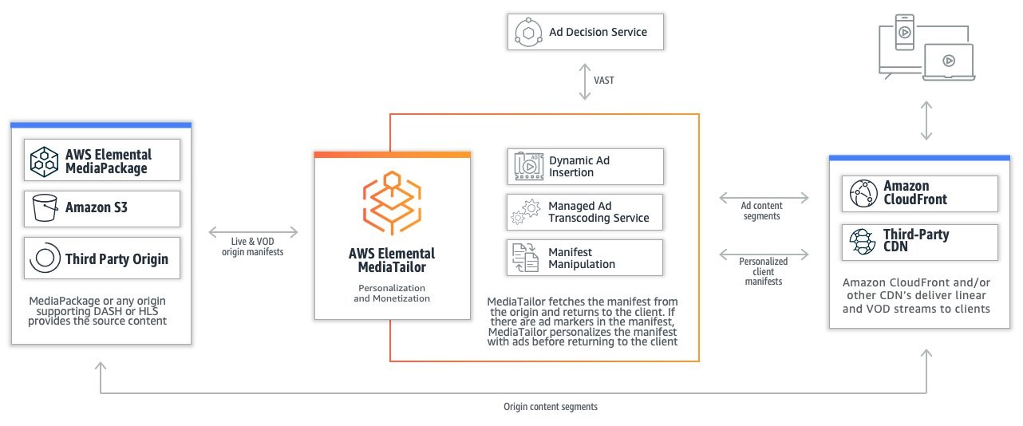

Figure 8 "How to configure advanced features in AWS Elemental MediaTailor: Holistic view of OTT streaming solution with MediaTailor, various origin types, an ADS connection, and media types served through a CDN"[44]

Part 4: Amazon Managed Blockchain

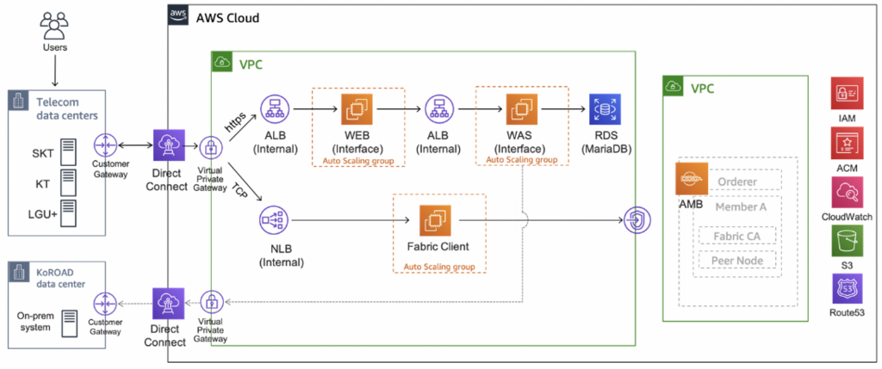Figure 9 "Building a secure digital ID using Amazon Managed Blockchain" (AWS Database Blog).

**Amazon Managed Blockchain**

In the ever-evolving landscape of business applications, blockchain technology has emerged as a transformative force, offering decentralized and secure solutions. Amazon Managed Blockchain, a fully managed service by AWS, empowers businesses to harness the potential of blockchain without the complexity of manual setup and maintenance. This section delves into the fundamentals, features, and use cases of Amazon Managed Blockchain.

Understanding Amazon Managed Blockchain

**Overview of Amazon Managed Blockchain**

Amazon Managed Blockchain simplifies the process of creating and managing scalable blockchain networks using popular open-source frameworks such as Hyperledger Fabric and Ethereum. It allows businesses to focus on developing applications rather than dealing with the challenges of setting up and maintaining a blockchain infrastructure [45].

**Key Features and Components**

**Decentralized Networks:** Amazon Managed Blockchain enables the creation of decentralized networks, where multiple parties can securely transact and share data without the need for central authority. This decentralized approach enhances transparency, security, and trust among participants (Amazon Web Services, Inc., 2022a).

**Fully Managed Service:** The service is fully managed, meaning AWS handles the operational aspects of the blockchain network, including setup, configuration, monitoring, and maintenance. This allows businesses to focus on building applications and exploring the possibilities of blockchain technology 44.

Use Cases of Amazon Managed Blockchain

**Supply Chain Management**

Amazon Managed Blockchain finds extensive use in supply chain management, providing a decentralized and transparent ledger for tracking the production, shipment, and delivery of goods. This enhances traceability and reduces the risk of fraud within the supply chain 44.

**Financial Transactions**

For financial institutions, Amazon Managed Blockchain offers a secure and efficient way to handle transactions. It ensures the integrity and immutability of financial records, reducing the risk of errors and fraudulent activities 44.

Integration with AWS Services

**Integration with Amazon Aurora and Amazon RDS**

Amazon Managed Blockchain seamlessly integrates with other AWS services like Amazon Aurora and Amazon Relational Database Service (RDS). This integration enables businesses to build comprehensive applications that leverage both traditional databases and blockchain technology 44.

**Scalability and Flexibility**

The service is designed for scalability, allowing businesses to scale their blockchain networks as the number of participants or the volume of transactions grows. This ensures that the blockchain infrastructure can adapt to the evolving needs of the business 44.

Best Practices for Effective Usage

**Network Design and Setup**

A well-thought-out network design is essential for the effective use of Amazon Managed Blockchain. Businesses should carefully plan the network's structure, defining the members, peer nodes, and policies to ensure optimal performance and security 44.

Security and Compliance

Ensuring the security and compliance of blockchain networks is paramount. Amazon Managed Blockchain provides tools and features for encryption, access control, and compliance monitoring. Businesses should leverage these to maintain the integrity and confidentiality of their blockchain data 44.

Conclusion

Amazon Managed Blockchain stands as a testament to AWS's commitment to providing accessible and scalable blockchain solutions. By simplifying the complexities associated with blockchain infrastructure, businesses can leverage this service to explore innovative applications across various industries, promoting transparency, security, and efficiency.

**Amazon Quantum Ledger Database (QLDB)**

In the realm of blockchain technology, Amazon Quantum Ledger Database (QLDB) emerges as a robust and scalable solution for businesses seeking a secure and transparent ledger system. This section explores the intricacies of Amazon QLDB, its underlying principles, and its applications across various industries.

Understanding Amazon Quantum Ledger Database (QLDB)

**Overview of Amazon QLDB**

Amazon QLDB is a fully managed ledger database service that provides a transparent, immutable, and cryptographically verifiable transaction log. Unlike traditional blockchain frameworks, Amazon QLDB operates on a centralized ledger model, ensuring consistency and offering a comprehensive and efficient solution for businesses [46].

**Immutability and Verifiability**

One of the key features of Amazon QLDB is its commitment to data immutability. Once a transaction is committed, it cannot be altered or deleted, fostering a reliable and auditable record of all transactions. The cryptographic verifiability of the data ensures that the integrity of the ledger remains intact 45.

Use Cases of Amazon Quantum Ledger Database (QLDB)

**Supply Chain Traceability**

Amazon QLDB finds practical applications in supply chain management, providing an immutable and transparent record of the movement of goods and transactions. This ensures traceability and reduces the risk of fraud in the supply chain 45.

**Regulatory Compliance**

Industries with stringent regulatory requirements, such as finance and healthcare, benefit from Amazon QLDB's ability to maintain an immutable and auditable record of transactions. This assists organizations in meeting compliance standards and facilitates regulatory audits 45.

Integration with AWS Services

**Seamless Integration with AWS**

Amazon QLDB seamlessly integrates with various AWS services, including AWS Identity and Access Management (IAM), AWS Key Management Service (KMS), and AWS CloudTrail. This integration enhances security, access control, and monitoring capabilities for businesses utilizing the service 45.

**Flexibility and Scalability**

Designed for flexibility, Amazon QLDB supports the development of a range of applications, from simple transactional databases to complex systems requiring stringent data integrity. Its scalability ensures that businesses can adapt to growing transaction volumes and evolving application needs 45.

Best Practices for Effective Usage

**Data Modeling and Query Optimization**

Efficient data modeling and query optimization are crucial for maximizing the benefits of Amazon QLDB. Businesses should carefully design their data structures and optimize queries to ensure optimal performance and responsiveness 45.

**Security Controls and Monitoring**

To enhance security, businesses should leverage the security controls provided by Amazon QLDB, including fine-grained access control and encryption. Regular monitoring of the ledger and access logs ensures early detection of any potential security issues 45.

Conclusion

Amazon QLDB stands as a testament to AWS's commitment to providing innovative solutions for businesses seeking a secure, transparent, and scalable ledger system. By combining the benefits of immutability, verifiability, and seamless integration with AWS services, Amazon QLDB offers a compelling option for a diverse range of applications.

**Chapter 9 Conclusion**

The exploration of AWS services in Chapter 9, "Applications for Business," has been a fascinating journey through the multifaceted landscape of cloud solutions. As we conclude this chapter, let us delve into a comprehensive reflection on the transformative impact of Business Applications, Cloud Financial Management, Media Services, and Blockchain offerings.

Business Applications: Revolutionizing the Workplace

The suite of Business Applications presented in this chapter, including **Alexa for Business [47]**, **Amazon Chime** [48], and **Amazon Honeycode** [49], signals a paradigm shift in how organizations approach workplace efficiency and collaboration. Alexa for Business, with its voice-enabled capabilities, has the potential to redefine the way employees interact with technology, fostering a more natural and streamlined work environment.

Moreover, **Amazon WorkDocs** [50] and **Amazon WorkMail** [51] contribute to a secure and collaborative ecosystem for document management and communication. The integration of these tools aligns with the evolving needs of modern, distributed workforces, emphasizing the importance of seamless digital collaboration.

The transformative potential of these Business Applications extends beyond mere convenience. They represent a strategic investment in cultivating workplace innovation and efficiency, aligning with the broader trends in digital transformation and the evolving nature of work.

Cloud Financial Management: Navigating the Cost Landscape

In the realm of Cloud Financial Management, AWS provides a rich set of tools such as **Amazon EC2 Spot Instances**[52], **AWS Budgets**[53], and **Savings Plans**[54]. These tools empower businesses to optimize costs, forecast expenditures, and gain granular insights into their cloud spending.

The **Cost and Usage Report[55]** and **Cost Explorer[56]** offer businesses detailed analyses of their usage patterns, enabling strategic decision-making for cost efficiency and resource optimization. The emphasis on financial transparency and control is a testament to AWS's commitment to providing organizations with the tools they need to navigate the complex landscape of cloud costs.

Media Services: Fueling Creative Innovation

Media Services presented in this chapter, such as **Amazon Elastic Transcoder** [57], **Amazon Kinesis Video Streams[58]**, and **AWS Elemental MediaConvert[59]**, underscore AWS's role in fostering creative innovation in the digital content space.

These services not only provide flexible and scalable solutions for content creation and distribution but also pave the way for innovative viewing experiences. The advent of technologies like **Amazon Nimble Studio[60]** and **AWS Elemental Appliances & Software[61]** further solidifies AWS's position as a key enabler for content creators and media professionals.

As organizations continue to explore digital content creation and distribution, the AWS Media Services portfolio stands as a testament to the cloud's pivotal role in shaping the future of media and entertainment.

Blockchain: Building Trust in Digital Transactions

The exploration of **Amazon Managed Blockchain**[62] and **Amazon Quantum Ledger Database (QLDB)**[63] highlights the significance of blockchain in building trust in digital transactions. These services cater to industries requiring resilient Web3 applications and reliable transactional databases, contributing to the ongoing evolution of decentralized and secure digital ecosystems.

The decentralized nature of blockchain, coupled with the capabilities of services like Amazon Managed Blockchain, holds the promise of revolutionizing industries that rely on secure and transparent digital transactions. As organizations explore the potential of blockchain, AWS stands ready to support its journey toward building robust and trustworthy systems.

Navigating the AWS Landscape

In conclusion, Chapter 9 has taken us through a rich tapestry of AWS services, each playing a unique role in the digital transformation journey of businesses. The integration of voice-enabled technologies, robust financial management tools, cutting-edge media services, and secure blockchain solutions positions AWS as a pivotal player in shaping the future of digital business applications.

The strategic investment in Business Applications signals a shift toward more intuitive and collaborative work environments. The emphasis on Cloud Financial Management tools reflects AWS's commitment to providing businesses with the transparency and control needed to navigate the intricacies of cloud costs effectively.

Media Services showcase the potential of AWS in fueling creative innovation, offering scalable solutions for digital content creation and distribution. As organizations leverage these services, they open new possibilities for engaging and immersive digital experiences.

The exploration of blockchain services underscores the importance of trust in the digital landscape. As businesses seek secure and decentralized solutions, AWS's offerings in this space provide a foundation for building resilient and transparent digital ecosystems.

In navigating the AWS landscape, organizations are not merely adopting cloud services but embracing a transformative journey. The synergy of Business Applications, Cloud Financial Management, Media Services, and Blockchain offerings represents the diversity.

1. Amazon. (2017). *Introducing Alexa for Business.* Retrieved from <https://aws.amazon.com/alexaforbusiness/>.
2. Amazon. (2017). *Amazon Chime.* Retrieved from <https://aws.amazon.com/chime/>.
3. Amazon. (n.d.a). *Amazon Chime SDK.* Retrieved from <https://aws.amazon.com/chime/chime-sdk/>.
4. Amazon. (n.d.a). *Amazon Connect.* Retrieved from <https://aws.amazon.com/connect/>.
5. Amazon. (n.d.a). *Amazon Honeycode.* Retrieved from <https://www.honeycode.aws/>.
6. Amazon. (n.d.a). *Amazon Pinpoint.* Retrieved from <https://aws.amazon.com/pinpoint/>
7. Amazon. (n.d.a). *Amazon Simple Email Service (SES).* Retrieved from https://aws.amazon.com/ses/
8. Amazon. (n.d.a). *Amazon WorkDocs.* Retrieved from https://aws.amazon.com/workdocs/
9. Amazon. (n.d.a). *Amazon WorkMail.* Retrieved from https://aws.amazon.com/workmail/
10. Amazon. (n.d.b). *Amazon Forecast.* Retrieved from https://aws.amazon.com/forecast/
11. Amazon. (n.d.c). *Amazon Connect.* Retrieved from https://aws.amazon.com/connect/
12. Amazon. (n.d.d). *AWS IoT Core.* Retrieved from https://aws.amazon.com/iot-core/
13. Amazon. (n.d.e). *Amazon Simple Storage Service (S3).* Retrieved from https://aws.amazon.com/s3/
14. Wickr. (n.d.a). *End-to-End Encryption.* Retrieved from https://www.wickr.com/security/
15. Wickr. (n.d.b). *File Sharing.* Retrieved from https://www.wickr.com/file-sharing/
16. Wickr. (n.d.c). *Voice & Video Calls.* Retrieved from https://www.wickr.com/voice-video-calls/
17. Amazon Web Services. (2022a). *Amazon EC2 Spot Instances.* Retrieved from https://aws.amazon.com/ec2/spot/
18. Amazon Web Services. (2022b). *AWS Budgets.* Retrieved from https://aws.amazon.com/aws-cost-management/aws-budgets/
19. Amazon Web Services. (2022a). *AWS Cost and Usage Report.* Retrieved from https://aws.amazon.com/aws-cost-management/aws-cost-and-usage-report/
20. Amazon Web Services. (2022b). *AWS Cost Explorer.* Retrieved from https://aws.amazon.com/aws-cost-management/aws-cost-explorer/
21. Amazon Web Services. (2022a). *Reserved Instances.* Retrieved from https://aws.amazon.com/ec2/pricing/reserved-instances/
22. Amazon Web Services. (2022b). *AWS Cost Explorer.* Retrieved from https://aws.amazon.com/aws-cost-management/aws-cost-explorer/
23. Amazon Web Services. (2022c). *AWS Budgets.* Retrieved from [https://aws.amazon.com/aws-cost-management/aws-budgets/](https://aws.amazon.com/aws-cost-management/aws-budget
24. Amazon Web Services. (2022d). *AWS Cost and Usage Report.* Retrieved from https://aws.amazon.com/aws-cost-management/aws-cost-and-usage-report/
25. Amazon Web Services. (2022a). *Savings Plans.* Retrieved from https://aws.amazon.com/savingsplans/
26. Amazon Web Services. (2022b). *AWS Cost Explorer.* Retrieved from https://aws.amazon.com/aws-cost-management/aws-cost-explorer/
27. Amazon Web Services. (2022c). *AWS Budgets.* Retrieved from https://aws.amazon.com/aws-cost- /aws-budgets/
28. Amazon Web Services. (2022d). *AWS Cost and Usage Report.* Retrieved from <https://aws.amazon.com/aws-cost-management/aws-cost-and-usage-report/>
29. Amazon Web Services. (2022a). *Amazon Elastic Transcoder.* Retrieved from https://aws.amazon.com/elastictranscoder/
30. Amazon Web Services. (2022b). *Amazon Interactive Video Service (IVS).* Retrieved from https://aws.amazon.com/ivs/
31. Amazon Web Services. (2022c). *Amazon Kinesis Video Streams.* Retrieved from https://aws.amazon.com/kinesis/video-streams/
32. Amazon Web Services. (2022c). *Amazon Kinesis Video Streams.* Retrieved from https://aws.amazon.com/kinesis/video-streams/
33. Amazon Web Services. (2022d). *Amazon Nimble Studio.* Retrieved from https://aws.amazon.com/nimble-studio/
34. AWS Elemental. (n.d.). *AWS Elemental Appliances & Software.* Retrieved from https://www.elemental.com/products/appliances-software/
35. AWS Elemental. (n.d.). *AWS Elemental MediaConnect.* Retrieved from https://www.elemental.com/products/mediaconnect/
36. AWS Elemental. (n.d.). *AWS Elemental MediaConvert.* Retrieved from https://www.elemental.com/products/mediaconvert/
37. AWS Elemental. (n.d.). *AWS Elemental MediaLive.* Retrieved from https://www.elemental.com/products/medialive/
38. AWS Elemental. (n.d.). *AWS Elemental MediaLive.* Retrieved from https://www.elemental.com/products/medialive/
39. AWS Elemental. (n.d.a). *AWS Elemental MediaPackage.* Retrieved from https://www.elemental.com/products/mediapackage/
40. AWS Elemental. (n.d.b). *Integrating AWS Elemental MediaPackage with AWS Elemental MediaLive.* Retrieved from https://docs.aws.amazon.com/mediapackage/latest/ug/medialive-channel.html/
41. AWS Elemental. (n.d.a). *AWS Elemental MediaStore.* Retrieved from https://www.elemental.com/products/mediastore/
42. AWS Elemental. (n.d.b). *Integrating AWS Elemental MediaStore with AWS Elemental MediaLive and AWS Elemental MediaPackage.* Retrieved from https://docs.aws.amazon.com/mediastore/latest/ug/mediastore-live-package.html/
43. AWS Elemental. (n.d.a). *AWS Elemental MediaTailor.* Retrieved from https://www.elemental.com/products/media-tailor/
44. Cunningham, S. & Khosla, D. (2022) [AWS Elemental MediaTailor](https://aws.amazon.com/blogs/media/category/media-services/aws-elemental-mediatailor/), [Direct-To-Consumer & Streaming](https://aws.amazon.com/blogs/media/category/industries/entertainment/direct-to-consumer-ott/), [Media & Entertainment](https://aws.amazon.com/blogs/media/category/industries/entertainment/), [Media & Entertainment](https://aws.amazon.com/blogs/media/category/media-entertainment/), [Media Services](https://aws.amazon.com/blogs/media/category/media-services/). AWS for M&E Blog.
45. Amazon Web Services, Inc. (2022a). *Amazon Managed Blockchain.* Retrieved from https://aws.amazon.com/managed-blockchain/
46. Amazon Web Services, Inc. (2022b). *Amazon Quantum Ledger Database (QLDB).* Retrieved from https://aws.amazon.com/qldb/
47. Amazon Web Services, Inc. (2022a). Alexa for Business. https://aws.amazon.com/alexaforbusiness/
48. Amazon Web Services, Inc. (2022c). Amazon Chime. https://aws.amazon.com/chime/
49. Amazon Web Services, Inc. (2022d). Amazon Honeycode. https://aws.amazon.com/honeycode/
50. Amazon Web Services, Inc. (2022e). Amazon WorkDocs. https://aws.amazon.com/workdocs/
51. Amazon Web Services, Inc. (2022f). Amazon WorkMail. https://aws.amazon.com/workmail/
52. Amazon Web Services, Inc. (2022g). Amazon EC2 Spot Instances. https://aws.amazon.com/ec2/spot/
53. Amazon Web Services, Inc. (2022h). AWS Budgets. https://aws.amazon.com/aws-cost-management/budgets/
54. Amazon Web Services, Inc. (2022i). Savings Plans. https://aws.amazon.com/savingsplans/
55. Amazon Web Services, Inc. (2022j). Cost and Usage Report. https://aws.amazon.com/aws-cost-management/reporting-tools/
56. Amazon Web Services, Inc. (2022k). AWS Cost Explorer. https://aws.amazon.com/aws-cost-management/aws-cost-explorer/
57. Amazon Web Services, Inc. (2022l). Amazon Elastic Transcoder. https://aws.amazon.com/elastictranscoder/
58. Amazon Web Services, Inc. (2022n). Amazon Kinesis Video Streams. https://aws.amazon.com/kinesis/video-streams/
59. Amazon Web Services, Inc. (2022o). AWS Elemental MediaConvert. https://aws.amazon.com/media/convert/
60. Amazon Web Services, Inc. (2022m). Amazon Nimble Studio. https://aws.amazon.com/nimble-studio/
61. Amazon Web Services, Inc. (2022p). AWS Elemental Appliances & Software. https://aws.amazon.com/media/elemental-appliances-software/
62. Amazon Web Services, Inc. (2022q). Amazon Managed Blockchain. https://aws.amazon.com/managed-blockchain/
63. Amazon Web Services, Inc. (2022r). Amazon Quantum Ledger Database (QLDB). https://aws.amazon.com/qldb/