CHAPTER 11

Analytics and Machine Learning

Introduction

In the ever-evolving landscape of cloud computing, the integration of analytics and machine learning has appeared as a transformative force, empowering businesses to extract meaningful insights from vast datasets and deploy intelligent solutions. This chapter explores a range of AWS services that cater to both analytics and machine learning needs, offering a comprehensive suite for data-driven decision-making and innovative artificial intelligence applications.

This chapter will guide you through the intricacies of each of these services, offering insights into their functionalities, use cases, and practical applications. From analytics to machine learning, AWS provides a comprehensive suite of tools that cater to the diverse needs of businesses, enabling them to explore the realm of data-driven decision-making and artificial intelligence.

Learning Objectives

By the end of this chapter, you will have a solid understanding of the foundational and advanced concepts underlying AWS analytics and machine learning services, as well as their contributions to modern cloud-native architectures. You will explore key analytics tools, including Amazon Athena, QuickSight, Redshift, and AWS Glue, gaining insight into their roles in data querying, visualization, warehousing, and **ETL (Extract, Transform, Load)** processes. You will also learn how AWS supports real-time data processing through services like Amazon Kinesis and MSK, as well as collaborative analytics with AWS Clean Rooms and Data Exchange. At the forefront of Rekognition and learning, you will examine the AWS ML lifecycle using tools such as Amazon SageMaker, Bedrock, and Rekognition, and discover how pre-built and customizable models can be used to automate tasks, drive intelligence, and enhance application functionality. The chapter also provides real-world use cases and architectural patterns, enabling you to design, deploy, and scale analytics and AI-driven applications across diverse industries.

Structure

This chapter will cover the following topics:

* Analytics
  + Amazon Athena
  + Amazon CloudSearch
  + Amazon DataZone (Preview)
  + Amazon EMR
  + Hosted Hadoop framework
  + Amazon FinSpace
  + Amazon Kinesis
  + Amazon Managed Streaming for Apache Kafka (MSK)
  + Amazon OpenSearch Service
  + Amazon QuickSight
  + Amazon Redshift
  + AWS Clean Rooms (Preview)
  + AWS Data Exchange
  + AWS Data Pipeline
  + AWS Glue
  + AWS Lake Formation
* Machine Learning
  + Amazon Augmented AI
  + Amazon Bedrock
  + Amazon CodeGuru
  + Amazon Comprehend
  + Amazon DevOps Guru
  + Amazon Elastic Inference
  + Deep learning inference acceleration
  + Amazon Forecast
  + Amazon Fraud Detector
  + Amazon HealthLake
  + Amazon Kendra
  + Amazon Lex
  + Amazon Lookout for Equipment
  + Amazon Lookout for Metrics
  + Amazon Monitron
  + Amazon Omics
  + Amazon Personalize
  + Amazon Polly
  + Amazon Rekognition
  + Amazon SageMaker
  + Amazon SageMaker Ground Truth
  + Amazon Textract
  + Amazon Transcribe
  + Amazon Translate
  + Apache MXNet on AWS
  + AWS Deep Learning AMIs
  + AWS Deep Learning Containers
  + AWS DeepComposer
  + AWS DeepLens
  + AWS DeepRacer
  + AWS Inferentia
  + AWS Panorama
  + PyTorch on AWS
  + TensorFlow on AWS
  + Amazon CodeWhisperer

Analytics

In the dynamic landscape of cloud computing, analytics plays a pivotal role in extracting meaningful insights from vast datasets. This section examines various AWS services designed for analytics, offering users powerful tools to process, analyze, and visualize data efficiently.

The architecture in *Figure 11.1* illustrates how various AWS services integrate to support a modern analytics workflow. It highlights how raw data from diverse sources is ingested, transformed, stored, and queried—showing the end-to-end journey from data collection to insight generation in a scalable and cloud-native environment.

**Figure 11.1:** Example Analytics Architecture (AWS Documentation)

Amazon Athena

Amazon Athena stands out as a serverless query service, allowing users to analyze data stored in Amazon S3 using SQL queries. This enables on-the-fly analysis without the need for complex data transformations or managing infrastructure. [1].

Amazon CloudSearch

Amazon CloudSearch is a fully managed search service designed to simplify the implementation of search functionality within applications. It offers fast, scalable, and full-text search capabilities, making it an asset for applications that require robust search functionality. [2].

Amazon DataZone

For the life sciences domain, Amazon DataZone offers a secure environment for data sharing and collaboration. It aims to help advancements in genomics and biomedical research by providing a safe space for researchers to collaborate on sensitive data. [3].

Amazon EMR

**Amazon Elastic MapReduce** (**EMR**) is a cloud-based data processing platform designed to manage large datasets using popular frameworks, including Apache Spark and Apache Hadoop. EMR enables scalable and cost-effective data processing, making it a fundamental tool for big data analytics [4].

Hosted Hadoop framework

AWS offers a hosted Hadoop framework as part of its analytics services. This framework enables users to deploy and manage Hadoop clusters seamlessly, providing a scalable and reliable environment for distributed data processing. [5]

Amazon FinSpace

Tailored for the financial industry, Amazon FinSpace streamlines data management, analytics, and collaboration. It addresses the unique challenges of financial data workflows, offering a comprehensive solution for financial analytics. [6].

Amazon Kinesis

Amazon Kinesis is a suite of services that helps real-time processing of streaming data at scale. Kinesis enables applications to ingest, buffer, and process streaming data with ease, making it a vital part of real-time analytics scenarios. [7].

Amazon managed to stream for Apache Kafka.

Amazon **Managed Streaming for Apache Kafka** (**MSK**) is a fully managed Kafka service that simplifies the deployment, scaling, and management of Apache Kafka clusters. It provides a reliable and scalable platform for streaming data, supporting various analytics and data processing applications. [8].

Amazon OpenSearch Service

Amazon OpenSearch Service is a managed service for Elasticsearch, offering powerful search and analytics capabilities. It simplifies the deployment and operation of Elasticsearch clusters, making it easier for users to build scalable search applications. [9].

Amazon QuickSight

Amazon QuickSight is a fast, cloud-powered business analytics service that enables users to create interactive dashboards and visualizations. QuickSight makes it easy to derive insights from data, enhancing the decision-making process. [10].

Amazon Redshift

Amazon Redshift is a fully managed data warehouse service improved for high-performance analysis. It allows users to run complex queries on large datasets, making it a cornerstone for data warehousing and analytics. [11].

AWS clean rooms

In the realm of compliance and data privacy, AWS Clean Rooms (Preview) offers a secure and isolated environment for analyzing sensitive data. It addresses the need for secure data processing in compliance with regulatory requirements. [12].

AWS data exchange

AWS Data Exchange serves as a marketplace for discovering and subscribing to third-party data sets. It promotes data collaboration and accessibility, providing a platform for users to find and use valuable external data. [13].

AWS data pipeline

AWS Data Pipeline is a web service that orchestrates and automates the movement and transformation of data between various AWS services. It simplifies the creation, scheduling, and management of data pipelines. [14].

AWS Glue

AWS Glue is a fully managed **extract, transform, and load** (**ETL**) service that automates data preparation for analysis. It provides a serverless environment for running ETL jobs, making data integration more efficient. [15].

*Figure 11.2* illustrates the ingestion layer within a data architecture built on AWS Glue. It describes how source systems provide raw data to the analytics pipeline, highlighting Glue’s role in orchestrating data extraction and transformation before it reaches storage or query layers. This foundational step is crucial for enabling precise, prompt, and scalable analytics.

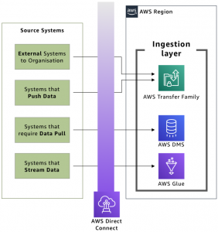

**Figure 11.2:** Ingestion layer against source systems (AWS Blog)

AWS lake formation

AWS Lake Formation plays a significant role in modern data lake architecture by simplifying the creation of secure, well-governed, and highly scalable data lakes. As enterprises generate increasingly large and diverse datasets, the need for unified data storage, access control, and governance becomes critical. Lake Formation addresses this challenge by automating the complex manual steps involved in setting up data lakes, such as ingesting data from multiple sources, cleaning and classifying data, defining access policies, and enabling secure analytics. It empowers organizations to move faster from raw data to actionable insights while ensuring compliance with internal and external data regulations.

*Figure 11.3* illustrates the governance and transformation layer within AWS Lake Formation architecture. It shows how raw data is cleansed, cataloged, secured, and made query-ready within the data lake, enabling controlled access and compliance across analytical workloads. This step ensures that the data lake stays both scalable and trustworthy for enterprise use.

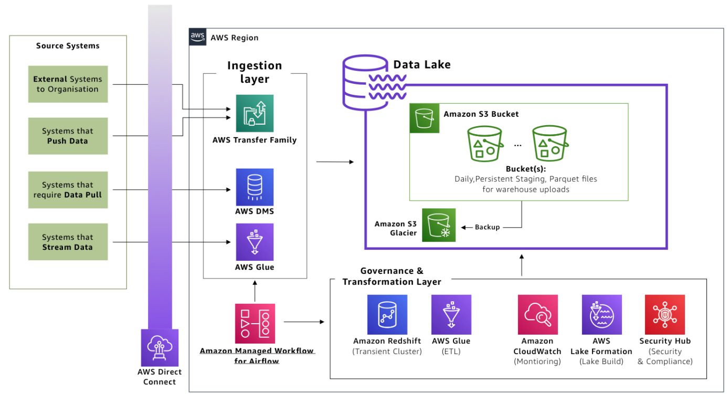

Figure 11.3 The governance and transformation layer prepares data in the lake (AWS Blog).

Designed for building, securing, and managing data lakes, AWS Lake Formation streamlines the process of organizing and analyzing diverse datasets. It offers tools for data ingestion, security, and access control in a data lake environment. [16].

This section has provided an overview of AWS analytics services, highlighting the breadth and depth of tools available for processing, analyzing, and visualizing data. As we delve into the specifics of each service, you will gain a deeper understanding of how to use these tools for various analytics use cases.

In the expansive domain of machine learning, AWS offers a comprehensive suite of services that cater to diverse needs, ranging from building custom models to seamlessly integrating pre-trained solutions.

**Machine learning**

Machine learning (ML) in the AWS ecosystem provides an end-to-end platform for designing, training, deploying, and managing intelligent applications. Whether users are building custom models or using pre-trained APIs, AWS offers scalable tools that support a wide range of use cases—from fraud detection and recommendation systems to natural language processing and image recognition. The platform is designed to accommodate a range of skill levels, enabling data scientists, developers, and non-technical users to build and run machine learning workflows. With integrated support for frameworks such as TensorFlow, PyTorch, and Apache MXNet and robust services like Amazon SageMaker, AWS accelerates the entire ML lifecycle, transforming raw data into actionable, real-world predictive insights.

*Figure 11.4* below illustrates the core infrastructure and components of AWS’s machine learning stack, highlighting the diverse services and tools that support scalable, secure, and production-ready machine learning workflows across various industries.

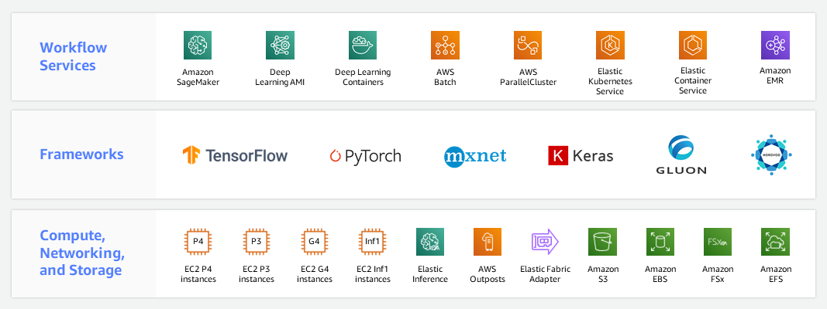

Figure 11.4 AWS Machine Learning Infrastructure (AWS Documentation)

Amazon augmented AI

**Amazon Augmented AI** (**A2I**) empowers developers to create custom machine learning workflows with human review. By integrating human intelligence into the model's decision-making process, A2I ensures the reliability and accuracy of machine learning predictions. [17].

Amazon Bedrock

Amazon Bedrock is a foundational service that simplifies the end-to-end machine learning process. From data preparation and model training to deployment, Bedrock streamlines the development lifecycle, enabling the efficient and scalable development of machine-learning applications. [18].

Amazon CodeGuru

Amazon CodeGuru enhances code quality by providing automated code reviews. This machine learning-powered service finds and recommends improvements in code, optimizing performance and reliability. [19].

Amazon Comprehend

Amazon Comprehend facilitates natural language processing tasks by extracting insights and relationships from text. With support for multiple languages, Understand enables developers to build applications with advanced language understanding capabilities. [20].

Amazon DevOps guru

Amazon DevOps Guru leverages machine learning to find operational issues and anomalies. By analyzing operational data, it automates the detection of problems, offering actionable insights to enhance application reliability. [21].

Amazon elastic inference

Amazon Elastic Inference complements machine learning instances with cost-effective inference acceleration. By attaching low-cost GPU-powered inference acceleration to Amazon EC2 instances, Elastic Inference improves deep learning inference. [22].

Deep learning inference acceleration

AWS offers deep learning inference acceleration to enhance the performance of machine learning models. This service includes purpose-built hardware solutions, such as AWS Inferentia, designed to deliver high throughput and low-latency inference. [23].

Amazon forecast

Amazon Forecast is a fully managed forecasting service that uses machine learning to generate correct predictions. Whether for demand forecasting or financial planning, Forecast automates the forecasting process with minimal effort. [24].

Amazon fraud detector

Amazon fraud detectors use machine learning to detect and prevent online fraud. By analyzing historical data and building custom models, Fraud Detector enhances security measures to protect against fraudulent activities. [25].

Amazon HealthLake

Amazon HealthLake is a HIPAA-eligible service designed for healthcare providers to securely store, transform, and analyze health data. It uses machine learning for natural language processing, enabling the extraction of structured data from unstructured medical information. [26].

Amazon Kendra

Amazon Kendra is an intelligent search service powered by machine learning. It enables organizations to build powerful search capabilities into their applications, making it easy for users to discover relevant information. [27].

Amazon Lex

Amazon Lex streamlines the process of building conversational interfaces by using natural language understanding. This service powers chatbots and interactive voice response (IVR) systems, enhancing user interactions through the application of machine learning. [28].

Amazon lookout for equipment

Amazon Lookout for Equipment uses machine learning to detect abnormal equipment behavior. By analyzing sensor data, it finds early signs of equipment failure, enabling preventive maintenance and minimizing downtime. [29].

Amazon lookout for metrics

Amazon Lookout for Metrics is a service that uses machine learning to detect anomalies in metrics. It automates the monitoring of key performance indicators, providing prompt alerts for unusual patterns or deviations. [30].

Amazon Monitron

Amazon Monitron offers an end-to-end solution for equipment monitoring. By combining sensors, a gateway, and machine learning algorithms, Monitron enables the prediction of equipment failures before they occur. [31].

Amazon Omics

Amazon Omics is a comprehensive service for analyzing genomic data on a scale. Leveraging machine learning enables researchers to derive meaningful insights from genomic information, advancing scientific discoveries in life sciences. [32].

Amazon Personalize

Amazon Personalize is a machine learning service that helps create personalized recommendations for users. By analyzing user behavior, Personalize tailors’ recommendations for products, content, and more [33].

Amazon Polly

Amazon Polly transforms text into lifelike speech using machine learning. With support for multiple languages and a variety of voices, Polly enables developers to add natural-sounding speech to applications. [34].

Amazon Rekognition

Amazon Rekognition is a powerful image and video analysis service that uses machine learning. It can find objects, people, text, scenes, and activities, making it a valuable tool for content analysis and security applications. [35].

Amazon SageMaker

Amazon SageMaker is a fully managed machine learning service that covers the end-to-end ML workflow. It simplifies model building, training, and deployment, allowing developers to focus on creating robust machine-learning applications. [36].

Amazon SageMaker ground truth

Amazon SageMaker Ground Truth is a data labeling service that uses machine learning to reduce labeling costs and improve annotation accuracy. It streamlines the process of creating high-quality training datasets for machine learning. [36].

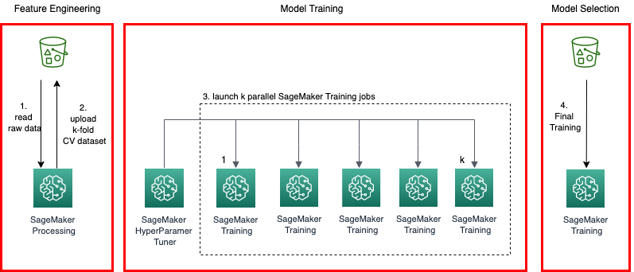

Figure 11.5 Cross-validation with Amazon SageMaker (AWS Documentation)

Amazon Textract

Amazon Textract is a fully managed **Optical Character Recognition** (**OCR**) service powered by machine learning. It extracts text, forms, and tables from scanned documents, automating the data extraction process. [37].

Amazon Transcribe

Amazon Transcribe provides automatic speech recognition (ASR) services using machine learning. It converts spoken language into written text, enabling applications to transcribe audio content accurately and reliably. [38].

Amazon Translate

Amazon Translate is a neural machine translation service that supports translating text between languages. Leveraging machine learning, Translate provides correct and natural-sounding translations for a wide range of applications. [39].

Apache MXNet on AWS

AWS supports Apache MXNet, an open-source deep learning framework. With AWS infrastructure, developers can use the scalability and flexibility of MXNet to build and deploy machine learning models. [40].

AWS deep learning AMIs

AWS offers Deep Learning **Amazon Machine Images** (**AMIs**), providing a collection of deep learning frameworks. These AMIs simplify the process of setting up a deep learning environment on EC2 instances.

AWS deep learning containers

AWS Deep Learning Containers provide pre-configured Docker images for deep learning applications. These containers offer a consistent and reproducible environment for running machine learning workloads. [23].

AWS DeepComposer

AWS DeepComposer is a machine learning-enabled keyboard that allows developers to create music using generative AI models. It shows the creative possibilities of combining machine learning with music composition. [41].

AWS DeepLens

AWS DeepLens is a deep learning-enabled video camera that helps the development of computer vision applications. It offers a direct approach to learning and implementing deep learning models in real-world scenarios. [42].

AWS DeepRacer

AWS DeepRacer is an autonomous 1/18th scale race car designed for reinforcement learning. Developers can use DeepRacer to enhance their understanding of machine learning concepts through an interactive and competitive racing environment. [43].

AWS Inferentia

AWS Inferentia is a custom-built chip designed to accelerate deep learning inference workloads. With high throughput and low latency, Inferentia enhances the performance of machine-learning models. [44].

AWS Panorama

AWS Panorama is a machine learning appliance that brings computer vision capabilities to on-premises cameras. It enables the local analysis of video feeds, opening possibilities for applications in industrial automation and beyond. [45].

PyTorch on AWS

AWS supports PyTorch, an open-source deep learning framework. With AWS infrastructure, developers can use the flexibility and efficiency of PyTorch to build and deploy machine learning models. [46].

TensorFlow on AWS

AWS provides robust support for TensorFlow, an open-source machine learning framework. Developers can harness the scalability and power of AWS to build and train machine learning models using TensorFlow. [47].

TensorFlow on AWS

Amazon CodeWhisperer is a service that uses machine learning to assist developers in writing code more efficiently. By providing context-aware suggestions, it enhances the coding experience and accelerates development workflows. [48].

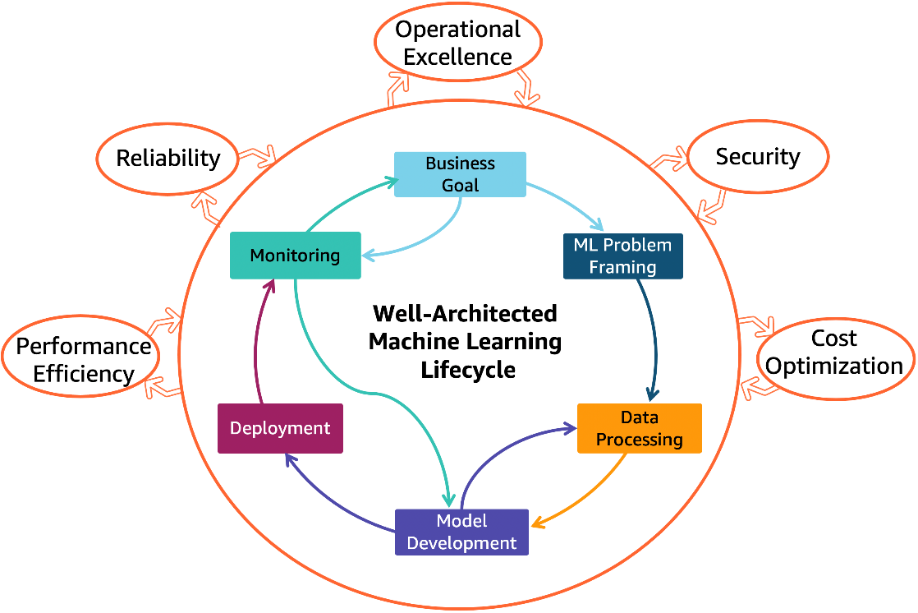

Figure 11.6 AWS Well-Architected Machine Learning Lens (AWS Architecture)

Conclusion

This chapter has delved into the multifaceted realms of Analytics and Machine Learning, unraveling a tapestry of AWS services designed to empower businesses with data-driven insights and intelligent automation. From the seamless query capabilities of Amazon Athena to the advanced machine learning models helped by Amazon SageMaker, this chapter explores the expansive landscape of AWS offerings in analytics and machine learning.

In the analytics domain, AWS offers a comprehensive suite of services tailored to the diverse needs of organizations managing vast datasets. Amazon Athena, a standout in this category, offers a serverless query service that enables on-the-fly analysis of data stored in Amazon S3. [1]. Complementing this, Amazon QuickSight helps intuitive and interactive data visualization, empowering users to derive actionable insights from their analytics. [10].

In the evolving landscape of big data, Amazon EMR (Elastic MapReduce) stands as a stalwart, offering a cloud-based platform for processing large datasets using popular frameworks such as Apache Spark and Apache Hadoop. [8]. Simultaneously, Amazon Redshift appears as a powerful data warehousing solution, allowing organizations to analyze vast datasets with remarkable speed and efficiency. [11].

As organizations grapple with the challenges of data management, AWS offers solutions such as AWS Glue and AWS Lake Formation, which streamline the processes of data integration, transformation, and data lake formation. [15]. These services contribute to setting up a robust analytics foundation within AWS, fostering an environment where data becomes a strategic asset. [16].

The second part - ML, delved into the dynamic landscape of machine learning, where AWS offers an extensive array of services to cater to the evolving needs of developers and data scientists. At the forefront, Amazon SageMaker appears as a cornerstone, offering end-to-end machine learning workflow capabilities that simplify the model building, training, and deployment processes. [36].

Within the machine learning spectrum, specialized services such as Amazon Comprehend [20] Amazon Rekognition brings natural language processing and computer vision capabilities to the forefront. [35]. These services empower developers to integrate machine learning into applications without requiring extensive technical ability.

In the realm of recommendation engines and personalization, Amazon Personalize takes center stage, providing developers with tools to create individualized experiences for users based on their behavior. [33]. Simultaneously, services like Amazon Forecast utilize machine learning to generate accurate predictions, providing a valuable asset for businesses engaged in demand forecasting and financial planning. [24].

As the chapter unfolds, it becomes clear that AWS is not merely providing tools but fostering an ecosystem where machine learning becomes an accessible and integral part of the development process. The array of services, including deep learning inference acceleration, supports developers in improving the performance of their machine-learning models. [49].

The holistic vision

In conclusion, this chapter encapsulates the holistic vision of AWS in democratizing analytics and machine learning. The seamless integration of services, spanning from the granular analytics of Amazon Athena to the intricate machine learning models of Amazon SageMaker, reflects a commitment to simplifying complex processes and empowering users across the spectrum of technical ability.

The journey through analytics and machine learning within AWS shines innovation, efficiency, and scalability. AWS's commitment to customer-centric solutions is apparent in the diverse range of services that cater to the unique needs of businesses, regardless of their size or industry. As organizations navigate the data-intensive landscape, the tools and services explored in this chapter become beacons, guiding them toward a future where data is not just a resource but a strategic advantage.

References

|  |  |
| --- | --- |
| [1] | AWS, "Amazon Athena.," n.d.a. [Online]. Available: https://aws.amazon.com/athena/. [Accessed 26 January 2025]. |
| [2] | AWS, "Amazon CloudSearch," n.d. |
| [3] | AWS, "Amazon DataZone," n.d.. |
| [4] | AWS, "Amazon EMR," n.d. |
| [5] | AWS, "AWS Analytics," n.d. |
| [6] | AWS, "Amazon FinSpace," n.d. |
| [7] | AWS, "Amazon Kinesis," n.d. |
| [8] | AWS, "Amazon Managed Streaming for Apache Kafka (MSK)," n.d.. |
| [9] | AWS, "Amazon OpenSearch Service," n.d. |
| [10] | AWS, "Amazon QuickSight," n.d. |
| [11] | AWS, "Amazon Redshift," n.d. |
| [12] | AWS, "AWS Clean Rooms (Preview," n.d. |
| [13] | AWS. "AWS Data Exchange." AWS Data Exchange, n.d. |
| [14] | AWS, "AWS Data Pipeline," n.d. |
| [15] | AWS, "AWS Glue," n.d. |
| [16] | AWS, "AWS Lake Formation," n.d. |
| [17] | AWS, "Amazon Augmented AI," n.d. |
| [18] | AWS, "Amazon Bedrock," n.d. |
| [19] | AWS, "Amazon CodeGuru," n.d.. |
| [20] | AWS, "Amazon Comprehend," n.d. |
| [21] | AWS, "Amazon DevOps Guru," n.d. |
| [22] | AWS, "Amazon Elastic Inference," n.d. |
| [23] | AWS, "AWS Deep Learning Containers," n.d. |
| [24] | AWS, "Amazon Forecast," n.d. |
| [25] | AWS, "Amazon Fraud Detector," n.d. |
| [26] | AWS, "Amazon HealthLake," n.d. |
| [27] | AWS, "Amazon Kendra," n.d. |
| [28] | AWS, "Amazon Lex," n.d. |
| [29] | AWS, "Amazon Lookout for Equipment," n.d. |
| [30] | AWS, "Amazon Lookout for Metrics," n.d. |
| [31] | AWS, "Amazon Monitron," n.d. |
| [32] | AWS, "Amazon Omics," n.d. |
| [33] | AWS, "Amazon Personalize," n.d. |
| [34] | AWS, "Amazon Polly," n.d. |
| [35] | AWS, "Amazon Rekognition," n.d.. |
| [36] | AWS, "Amazon SageMaker," n.d.. |
| [37] | AWS, "Amazon Textract," n.d. |
| [38] | AWS, "Amazon Transcribe," n.d. |
| [39] | AWS, "Amazon Translate," n.d. |
| [40] | AWS, "Apache MXNet on AWS," n.d.. |
| [41] | AWS, "AWS DeepComposer," n.d. |
| [42] | AWS, "AWS DeepLens," n.d. |
| [43] | AWS, "AWS DeepRacer," n.d.. |
| [44] | AWS, "AWS Inferentia," n.d. |
| [45] | AWS, "AWS Panorama," n.d.. |
| [46] | AWS, "PyTorch on AWS," n.d.. |
| [47] | AWS, "TensorFlow on AWS," n.d. |
| [48] | AWS, "Amazon CodeWhisperer," n.d. |
| [49] | AWS, "Deep Learning Inference Acceleration," n.d. |