CHAPTER 11

Analytics and Machine Learning

**Introduction**

In the rapidly changing field of cloud computing, integrating analytics and machine learning is transforming how businesses gain insights from large datasets and develop intelligent solutions. This chapter examines various AWS services that support analytics and machine learning, providing essential tools for data-driven decision-making and innovative artificial intelligence applications.

In this chapter we will cover:

* Analytics
  + Amazon Athena
  + Amazon CloudSearch
  + Amazon DataZone (Preview)
  + Amazon EMR
  + Hosted Hadoop framework
  + Amazon FinSpace
  + Amazon Kinesis
  + Amazon Managed Streaming for Apache Kafka (MSK)
  + Amazon OpenSearch Service
  + Amazon QuickSight
  + Amazon Redshift
  + AWS Clean Rooms (Preview)
  + AWS Data Exchange
  + AWS Data Pipeline
  + AWS Glue
  + AWS Lake Formation
* Machine Learning
  + Amazon Augmented AI
  + Amazon Bedrock
  + Amazon CodeGuru
  + Amazon Comprehend
  + Amazon DevOps Guru
  + Amazon Elastic Inference
  + Deep learning inference acceleration
  + Amazon Forecast
  + Amazon Fraud Detector
  + Amazon HealthLake
  + Amazon Kendra
  + Amazon Lex
  + Amazon Lookout for Equipment
  + Amazon Lookout for Metrics
  + Amazon Monitron
  + Amazon Omics
  + Amazon Personalize
  + Amazon Polly
  + Amazon Rekognition
  + Amazon SageMaker
  + Amazon SageMaker Ground Truth
  + Amazon Textract
  + Amazon Transcribe
  + Amazon Translate
  + Apache MXNet on AWS
  + AWS Deep Learning AMIs
  + AWS Deep Learning Containers
  + AWS DeepComposer
  + AWS DeepLens
  + AWS DeepRacer
  + AWS Inferentia
  + AWS Panorama
  + PyTorch on AWS
  + TensorFlow on AWS
  + Amazon CodeWhisperer

This chapter will explain the key AWS services related to analytics and machine learning, highlighting their functions, use cases, and practical applications. AWS offers a wide range of tools for businesses focused on data-driven decision-making and artificial intelligence.

Part 1: Analytics

Analytics is essential in cloud computing for deriving insights from large datasets. This section reviews various AWS analytics services that empower users to process, analyze, and visualize data effectively.

**Figure 1** below shows AWS data collected from multiple data sources across the enterprise, including software-as-a-service (SaaS) applications, edge devices, logs, streaming media, and social networks (AWS Documentation).

Figure 1 AWS Architecture: Data

**Amazon Athena:** A serverless query service that allows SQL-based analysis of data in Amazon S3 without the need for complex data transformations or infrastructure management [1].

**Amazon CloudSearch:**  A fully managed search service that provides fast, scalable full-text search capabilities for applications requiring robust search functionality [2].

**Amazon DataZone:** In preview for the life sciences domain, Amazon DataZone offers a secure environment for data sharing and collaboration to support genomics and biomedical research [3].

**Amazon EMR (Elastic MapReduce):** A cloud-based platform for processing large datasets using frameworks like Apache Spark and Apache Hadoop, enabling scalable and cost-effective big data analytics [4].

**Hosted Hadoop Framework:** AWS's hosted framework for easily deploying and managing Hadoop clusters, providing a reliable environment for distributed data processing [5].

**Amazon FinSpace:** A solution designed for the financial industry that streamlines data management, analytics, and collaboration to address unique challenges in financial data workflows [6].

**Amazon Kinesis:** A service for real-time [7]data processing, allowing the ingestion and processing of streaming data at scale [7].

**Amazon Managed Streaming for Apache Kafka (MSK):** Simplifies the deployment and management of Apache Kafka clusters for reliable streaming data applications [8].

**Amazon OpenSearch Service:** A managed service that simplifies the deployment and operation of Elasticsearch, making it easier to create scalable search applications [9].

**Amazon QuickSight:** An analytics service that enables users to create interactive dashboards and visualizations for quick data insights [10].

**Amazon Redshift:** A fully managed data warehouse service designed for high-performance analysis of large datasets, essential for data warehousing and analytics [11].

**AWS Clean Rooms (Preview):** Provides a secure environment for analyzing sensitive data, ensuring compliance with regulatory requirements [12].

**AWS Data Exchange:** A marketplace for discovering and subscribing to third-party data sets, enhancing data collaboration and accessibility [13].

**AWS Data Pipeline:** A web service that automates data movement and transformation between AWS services, simplifying pipeline creation and management [14].

**AWS Glue:** A fully managed ETL service that automates data preparation for analysis in a serverless environment, streamlining data integration [15].

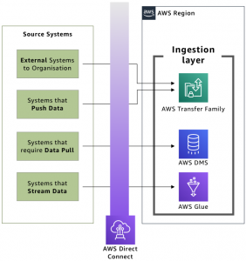.

Figure 2 Ingestion layer against source systems (AWS Blog).

**AWS Lake Formation:**

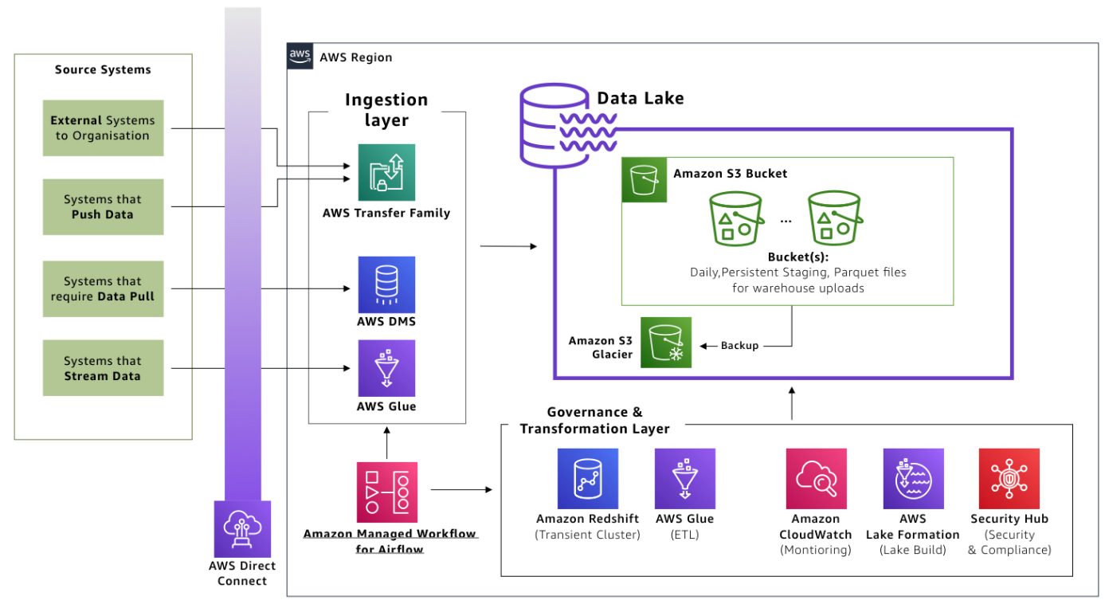

Figure 3 Governance and transformation layer prepares data in the lake (AWS Blog).

AWS Lake Formation simplifies the building, securing, and managing of data lakes by providing tools for data ingestion, security, and access control [16].

This overview highlights the wide range of AWS analytics services available for processing, analyzing, and visualizing data. As we explore each service, you'll learn how to apply these tools to various analytics

tasks. In machine learning, AWS offers a robust suite of services for building custom models and integrating pre-trained solutions.

Part 2: Machine Learning

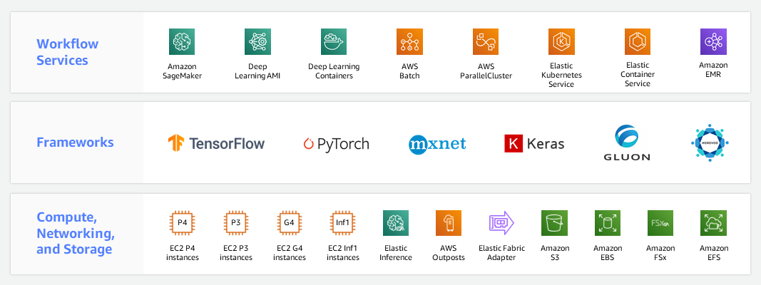

Figure 4 AWS Machine Learning Infrastructure (AWS Documentation).

**Amazon Augmented AI (A2I):** A2I allows developers to create custom machine learning workflows that include human review, ensuring reliable and accurate predictions [17].

**Amazon Bedrock:** Bedrock simplifies the entire machine learning process, from data preparation to deployment, streamlining development for scalable applications [18].

**Amazon CodeGuru:**  CodeGuru provides automated code reviews using machine learning, identifying improvements to optimize code performance and reliability [19].

**Amazon Comprehend:** Comprehend aids in natural language processing by extracting insights and relationships from text, supporting multiple languages for enhanced language understanding [20].

**Amazon DevOps Guru:** DevOps Guru uses machine learning to identify operational issues and anomalies, automating problem detection and offering insights to improve application reliability [21].

**Amazon Elastic Inference:** Elastic Inference provides cost-effective inference acceleration for machine learning instances by adding low-cost GPU support to Amazon EC2 [22].

**Deep Learning Inference Acceleration:** AWS offers tailored hardware solutions like AWS Inferentia to improve the performance of deep learning models, delivering high throughput and low latency [23].

**Amazon Forecast:** Forecast is a managed service that uses machine learning to automate accurate predictions for demand forecasting and financial planning [24].

**Amazon Fraud Detector:** Fraud Detector employs machine learning to identify and prevent online fraud by analyzing historical data and creating custom models to enhance security [25].

**Amazon HealthLake:** HealthLake is a HIPAA-eligible service for healthcare providers that securely stores, transforms, and analyzes health data, using machine learning for extracting structured information from unstructured medical data [26].

**Amazon Kendra:** Amazon Kendra is an intelligent search service powered by machine learning. It enables organizations to build powerful search capabilities into their applications, making it easy for users to discover relevant information [27].

**Amazon Lex:** Amazon Lex simplifies the process of building conversational interfaces using natural language understanding. This service powers chatbots and interactive voice response (IVR) systems, enhancing user interactions through machine learning [28].

**Amazon Lookout for Equipment:** Amazon Lookout for Equipment uses machine learning to detect abnormal equipment behavior. By analyzing sensor data, it finds early signs of equipment failure, enabling preventive maintenance and minimizing downtime [29].

**Amazon Lookout for Metrics:** Amazon Lookout for Metrics is a service that uses machine learning to detect anomalies in metrics. It automates the monitoring of key performance indicators, providing prompt alerts for unusual patterns or deviations [30].

**Amazon Monitron:** Amazon Monitron offers an end-to-end solution for equipment monitoring. By combining sensors, a gateway, and machine learning algorithms, Monitron helps predict equipment failures before they occur [31].

**Amazon Omics:** Amazon Omics is a comprehensive service for analyzing genomic data on a scale. Leveraging machine learning enables researchers to derive meaningful insights from genomic information, advancing scientific discoveries in the life sciences [32].

**Amazon Personalize:** Amazon Personalize is a machine learning service that helps the creation of personalized recommendations for users. By analyzing user behavior, Personalize tailors’ recommendations for products, content, and more [33].

**Amazon Polly:** Amazon Polly transforms text into lifelike speech using machine learning. With support for multiple languages and a variety of voices, Polly enables developers to add natural-sounding speech to applications [34].

**Amazon Rekognition:** Amazon Rekognition is a powerful image and video analysis service that uses machine learning. It can find objects, people, text, scenes, and activities, making it a valuable tool for content analysis and security applications [35].

**Amazon SageMaker:** Amazon SageMaker is a fully managed machine learning service that covers the end-to-end ML workflow. It simplifies model building, training, and deployment, allowing developers to focus on creating robust machine-learning applications [36].

**Amazon SageMaker Ground Truth:** Amazon SageMaker Ground Truth is a data labeling service that uses machine learning to reduce labeling costs and improve annotation accuracy. It streamlines the process of creating high-quality training datasets for machine learning [36].

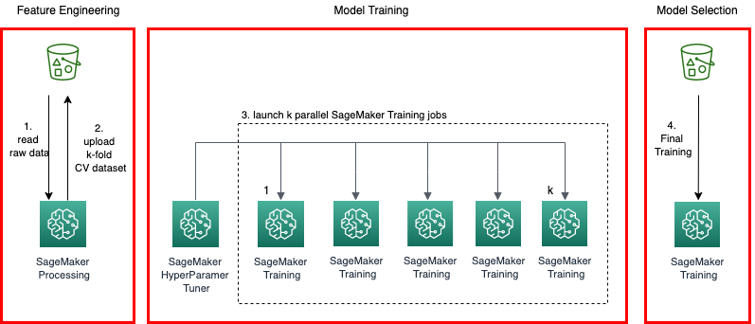

Figure 5 Cross-Validation Machine Learning Model Pipeline at Scale with Amazon SageMaker (AWS Documentation).

**Amazon Textract:** Amazon Textract is a fully managed OCR (Optical Character Recognition) service powered by machine learning. It extracts text, forms, and tables from scanned documents, automating the process of data extraction [37].

**Amazon Transcribe:** Amazon Transcribe provides automatic speech recognition (ASR) services using machine learning. It converts spoken language into written text, enabling applications to transcribe audio content accurately [38].

**Amazon Translate:** Amazon Translate is a neural machine translation service that supports translating text between languages. Leveraging machine learning, Translate provides correct and natural-sounding translations for a wide range of applications [39].

**Apache MXNet on AWS:** AWS supports Apache MXNet, an open-source deep learning framework. With AWS infrastructure, developers can use the scalability and flexibility of MXNet to build and deploy machine learning models [40].

**AWS Deep Learning AMIs:** AWS offers Deep Learning Amazon Machine Images (AMIs), providing a collection of deep learning frameworks. These AMIs simplify the process of setting up a deep learning environment on EC2 instances [41].

**AWS Deep Learning Containers:** AWS Deep Learning Containers provide pre-configured Docker images for deep learning applications. These containers offer a consistent and reproducible environment for running machine learning workloads [23].

**AWS DeepComposer:** AWS DeepComposer is a machine learning-enabled keyboard that allows developers to create music using generative AI models. It shows the creative possibilities of combining machine learning with music composition [42].

**AWS DeepLens:** AWS DeepLens is a deep learning-enabled video camera that helps the development of computer vision applications. It offers a direct approach to learning and implementing deep learning models in real-world scenarios [43].

**AWS DeepRacer:** AWS DeepRacer is an autonomous 1/18th scale race car designed for reinforcement learning. Developers can use DeepRacer to enhance their understanding of machine learning concepts through an interactive and competitive racing environment [44].

**AWS Inferentia:** AWS Inferentia is a custom-built chip designed to accelerate deep learning inference workloads. With high throughput and low latency, Inferentia enhances the performance of machine learning models [45].

**AWS Panorama:** AWS Panorama is a machine learning appliance that brings computer vision capabilities to on-premises cameras. It enables the analysis of video feeds locally, opening possibilities for applications in industrial automation and beyond [46].

**PyTorch on AWS:** AWS supports PyTorch, an open-source deep learning framework. With AWS infrastructure, developers can use the flexibility and efficiency of PyTorch to build and deploy machine learning models [47].

**TensorFlow on AWS:** AWS provides robust support for TensorFlow, an open-source machine learning framework. Developers can harness the scalability and power of AWS to build and train machine learning models using TensorFlow [48].

**TensorFlow on AWS:** Amazon CodeWhisperer is a service that employs machine learning to help developers in writing code more efficiently. By providing context-aware suggestions, it enhances the coding experience and accelerates development workflows [49].

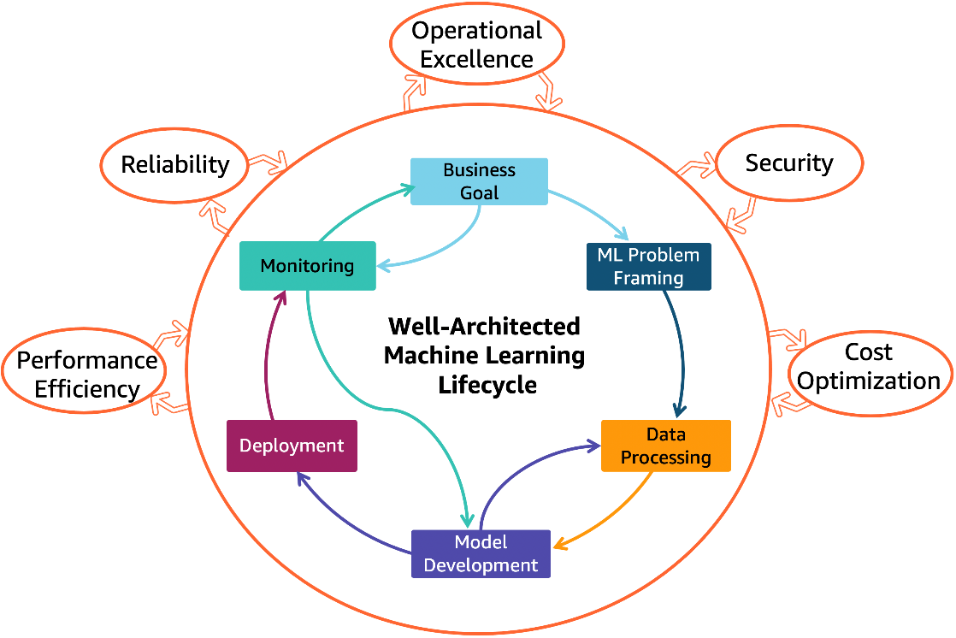

Figure 6 AWS Well-Architected Machine Learning Lens (AWS Architecture).

# Conclusion

Overall, Chapter 11 highlights AWS's commitment to making analytics and machine learning accessible. It provides [33]es a range of services that address the diverse needs of businesses and position data as a strategic asset. Chapter 11 provides an overview of Analytics and Machine Learning within AWS, showcasing various services that enhance data-driven decision-making and automation [24].

Part 1: Analytics

AWS offers several analytics services for managing large datasets. Amazon Athena enables real-time data analysis through a serverless query service [41]

for Amazon S3, while Amazon QuickSight provides data visualization tools. Amazon EMR processes large datasets using frameworks like Apache Spark and Hadoop, and Amazon Redshift is a powerful data warehousing solution. AWS Glue and AWS Lake Formation assist with data integration and transformation, supporting effective analytics frameworks.

Part 2: Machine Learning

In machine learning, AWS provides services for developers and data scientists, with Amazon SageMaker offering end-to-end capabilities for model development. Other services like Amazon Comprehend and Amazon Rekognition deliver natural language processing and computer vision functionalities. Amazon Personalize helps create tailored user experiences, and Amazon Forecast generates accurate predictions for demand forecasting [36].

The Holistic Vision

In conclusion, Chapter 10 encapsulates the holistic vision of AWS in democratizing analytics and machine learning. The seamless integration of services, spanning from the granular analytics of Amazon Athena to the intricate machine learning models of Amazon SageMaker, reflects a commitment to simplifying complex processes and empowering users across the spectrum of technical ability.

The journey through analytics and machine learning within AWS shines innovation, efficiency, and scalability. AWS' commitment to customer-centric solutions is clear in the diversity of services, addressing the unique needs of businesses irrespective of their size or industry. As organizations navigate the data-intensive landscape, the tools and services explored in this chapter become beacons, guiding them toward a future where data is not just a resource but a strategic advantage.

**References**

|  |  |
| --- | --- |
| [1] | AWS, "Amazon Athena.," n.d.a. [Online]. Available: https://aws.amazon.com/athena/. [Accessed 26 Jamuary 2025]. |
| [2] | AWS, "Amazon CloudSearch," n.d.. |
| [3] | AWS, "Amazon DataZone," n.d.. |
| [4] | AWS, "Amazon EMR," n.d.. |
| [5] | AWS, "AWS Analytics," n.d.. |
| [6] | AWS, "Amazon FinSpace," n.d.. |
| [7] | AWS, "Amazon Kinesis," n.d.. |
| [8] | AWS, "Amazon Managed Streaming for Apache Kafka (MSK)," n.d.. |
| [9] | AWS, "Amazon OpenSearch Service," n.d.. |
| [10] | AWS, "Amazon QuickSight," n.d.. |
| [11] | AWS, "Amazon Redshift," n.d.. |
| [12] | AWS, "AWS Clean Rooms (Preview," n.d.. |
| [13] | AWS, "AWS Data Exchange," AWS Data Exchange, n.d.. |
| [14] | AWS, "AWS Data Pipeline," n.d.. |
| [15] | AWS, "AWS Glue," n.d.. |
| [16] | AWS, "AWS Lake Formation," n.d.. |
| [17] | AWS, "Amazon Augmented AI," n.d.. |
| [18] | AWS, "Amazon Bedrock," n.d.. |
| [19] | AWS, "Amazon CodeGuru," n.d.. |
| [20] | AWS, "Amazon Comprehend," n.d.. |
| [21] | AWS, "Amazon DevOps Guru," n.d.. |
| [22] | AWS, "Amazon Elastic Inference," n.d.. |
| [23] | AWS, "AWS Deep Learning Containers," n.d.. |
| [24] | AWS, "Amazon Forecast," n.d.. |
| [25] | AWS, "Amazon Fraud Detector," n.d.. |
| [26] | AWS, "Amazon HealthLake," n.d.. |
| [27] | AWS, "Amazon Kendra," n.d.. |
| [28] | AWS, "Amazon Lex," n.d.. |
| [29] | AWS, "Amazon Lookout for Equipment," n.d.. |
| [30] | AWS, "Amazon Lookout for Metrics," n.d.. |
| [31] | AWS, "Amazon Monitron," n.d.. |
| [32] | AWS, "Amazon Omics," n.d.. |
| [33] | AWS, "Amazon Personalize," n.d.. |
| [34] | AWS, "Amazon Polly," n.d.. |
| [35] | AWS, "Amazon Rekognition," n.d.. |
| [36] | AWS, "Amazon SageMaker," n.d.. |
| [37] | AWS, "Amazon Textract," n.d.. |
| [38] | AWS, "Amazon Transcribe," n.d.. |
| [39] | AWS, "Amazon Translate," n.d.. |
| [40] | AWS, "Apache MXNet on AWS," n.d.. |
| [41] | AWS, "Deep Learning Inference Acceleration," n.d.. |
| [42] | AWS, "AWS DeepComposer," n.d.. |
| [43] | AWS, "AWS DeepLens," n.d.. |
| [44] | AWS, "AWS DeepRacer," n.d.. |
| [45] | AWS, "AWS Inferentia," n.d.. |
| [46] | AWS, "AWS Panorama," n.d.. |
| [47] | AWS, "PyTorch on AWS," n.d.. |
| [48] | AWS, "TensorFlow on AWS," n.d.. |
| [49] | AWS, "Amazon CodeWhisperer," n.d.. |