CHAPTER 11

Analytics and Machine Learning

**Introduction**

In the ever-evolving landscape of cloud computing, the integration of analytics and machine learning has emerged as a transformative force, empowering businesses to extract meaningful insights from vast datasets and deploy intelligent solutions. This chapter delves into a multitude of AWS services that cater to both analytics and machine learning needs, providing a comprehensive suite for data-driven decision-making and cutting-edge artificial intelligence applications.

Analytics:

Amazon Athena: Starting our analytics journey, Amazon Athena offers a serverless query service, allowing users to analyze data stored in Amazon S3 using SQL queries, eliminating the need for complex data transformations.

Amazon CloudSearch: This fully-managed search service simplifies the implementation of search functionality within applications, enabling fast and scalable full-text search capabilities.

Amazon DataZone (Preview): An innovative service designed for life sciences, DataZone facilitates secure data sharing and collaboration among researchers, fostering advancements in genomics and biomedical research.

Amazon EMR (Elastic MapReduce): Amazon EMR provides a cloud-based big data platform, supporting the processing of large datasets using popular frameworks like Apache Spark and Apache Hadoop.

Amazon FinSpace: Tailored for the financial industry, FinSpace streamlines data management, analytics, and collaboration, enhancing the efficiency of financial data workflows.

Amazon Kinesis: As a suite of services, Kinesis enables real-time processing of streaming data, unlocking possibilities for applications ranging from analytics to machine learning.

Amazon Managed Streaming for Apache Kafka (MSK): This fully-managed Kafka service simplifies the deployment, scaling, and management of Apache Kafka clusters, a cornerstone for real-time data streaming.

Amazon OpenSearch Service: A managed service for Elasticsearch, OpenSearch facilitates powerful search and analytics capabilities for a variety of use cases.

Amazon QuickSight: QuickSight offers fast, cloud-powered business analytics, delivering insights through rich visualizations and dashboards.

Amazon Redshift: A fully managed data warehouse service, Redshift is optimized for high-performance analysis using SQL queries on large datasets.

AWS Clean Rooms (Preview): In the domain of compliance and data privacy, Clean Rooms offers a secure and isolated environment for analyzing sensitive data.

AWS Data Exchange: A marketplace for discovering and subscribing to third-party data sets, Data Exchange promotes data collaboration and accessibility.

AWS Data Pipeline: Simplifying the movement and transformation of data between different AWS services, Data Pipeline orchestrates complex data workflows.

AWS Glue: A fully managed extract, transform, and load (ETL) service, Glue automates the preparation of data for analysis.

AWS Lake Formation: For building, securing, and managing data lakes, Lake Formation streamlines the process of organizing and analyzing diverse datasets.

Machine Learning:

**Amazon Augmented AI**: Augmented AI facilitates the creation of high-quality training data for machine learning models by incorporating human judgment.

**Amazon Bedrock**: Bedrock is an integrated environment for machine learning that supports the entire ML lifecycle, from data preparation to model deployment.

**Amazon CodeGuru**: CodeGuru employs machine learning to automate code reviews and identify performance issues, enhancing the efficiency of software development.

**Amazon Comprehend**: A natural language processing (NLP) service, Comprehend extracts insights and relationships from unstructured text.

**Amazon DevOps Guru**: DevOps Guru leverages machine learning to identify operational issues and recommend solutions, ensuring smooth and reliable application performance.

**Amazon Elastic Inference**: To optimize the cost of deep learning inference, Elastic Inference allows users to attach low-cost GPU-powered inference acceleration to Amazon EC2 instances.

**Deep Learning Inference Acceleration**: AWS provides a range of services, including Amazon Elastic Inference, for accelerating deep learning inference workloads.

**Amazon Forecast**: Forecast utilizes machine learning to generate accurate predictions, facilitating demand forecasting and time series analysis.

**Amazon Fraud Detector**: With machine learning-powered fraud detection, Fraud Detector assists in identifying potentially fraudulent activities.

**Amazon HealthLake**: Designed for healthcare and life sciences, HealthLake facilitates the structuring and analysis of healthcare data.

**Amazon Kendra**: Kendra is an intelligent search service that employs machine learning to deliver precise answers to natural language queries.

**Amazon Lex**: For building conversational interfaces, Lex enables the development of chatbots and voice-powered applications.

**Amazon Lookout for Equipment**: Leveraging machine learning, Lookout for Equipment detects anomalies in industrial equipment, preventing unplanned downtime.

**Amazon Lookout for Metrics**: An anomaly detection service, Lookout for Metrics automates the monitoring of metrics and alerts.

**Amazon Monitron**: Monitron is an end-to-end equipment monitoring solution, utilizing machine learning for predictive maintenance.

**Amazon Omics**: Tailored for genomics data analysis, Omics accelerates research in life sciences by offering scalable and cost-effective computational resources.

**Amazon Personalize**: Personalize delivers personalized recommendations for content and products, enhancing user engagement.

**Amazon Polly**: Polly is a text-to-speech service that leverages deep learning for creating natural and lifelike speech from text.

**Amazon Rekognition**: Offering powerful image and video analysis, Rekognition employs deep learning for object and activity recognition.

**Amazon SageMaker**: A fully managed service for building, training, and deploying machine learning models, SageMaker simplifies the ML workflow.

**Amazon SageMaker Ground Truth**: For labeling and preparing training datasets, SageMaker Ground Truth combines human labelers with machine learning.

**Amazon Textract**: Textract employs machine learning to extract text, forms, and tables from scanned documents, streamlining document processing.

**Amazon Transcribe**: Transcribe is a speech-to-text service that uses machine learning to convert spoken language into written text.

**Amazon Translate**: Utilizing deep learning, Translate provides language translation services, breaking down language barriers.

**Apache MXNet on AWS**: As an open-source deep learning framework, MXNet is supported on AWS for building and training machine learning models.

**AWS Deep Learning AMIs**: Deep Learning Amazon Machine Images (AMIs) provide pre-configured environments for deep learning frameworks.

**AWS Deep Learning Containers**: Containers for deep learning frameworks, Deep Learning Containers simplify the deployment of ML models.

**AWS DeepComposer**: DeepComposer is a creative tool that uses generative AI models to assist in composing music.

**AWS DeepLens**: DeepLens is a deep learning-enabled video camera, allowing developers to run machine learning models locally.

**AWS DeepRacer**: DeepRacer is a machine learning-enabled racing car designed for reinforcement learning experimentation.

**AWS Inferentia:** Inferentia is a custom-designed chip for accelerating machine learning inference workloads.

**AWS Panorama**: Panorama is a machine learning appliance that enables the deployment of computer vision applications at the edge.

**PyTorch on AWS**: As a popular deep learning framework, PyTorch is supported on AWS for building and training machine learning models.

**TensorFlow on AWS**: TensorFlow, a widely used deep learning framework, is supported on AWS for building and training machine learning models.

**Amazon CodeWhisperer**: CodeWhisperer is an ML-based service that analyzes code changes and recommends improvements, enhancing code quality.

This chapter will guide you through the intricacies of each of these services, offering insights into their functionalities, use cases, and practical applications. From analytics to machine learning, AWS provides a comprehensive suite of tools that cater to the diverse needs of businesses venturing into the realm of data-driven decision-making and artificial intelligence.

Part 1: Analytics

In the dynamic landscape of cloud computing, analytics plays a pivotal role in extracting meaningful insights from vast datasets. This section explores various AWS services dedicated to analytics, providing users with powerful tools to process, analyze, and visualize data efficiently.

Figure 1 Architecture: Data is collected from multiple data sources across the enterprise, including software-as-a-service (SaaS) applications, edge devices, logs, streaming media, and social networks (AWS Documentation).

Amazon Athena:

Amazon Athena stands out as a serverless query service, allowing users to analyze data stored in Amazon S3 using SQL queries. This enables on-the-fly analysis without the need for complex data transformations or the management of infrastructure [1].

Amazon CloudSearch:

Amazon CloudSearch is a fully managed search service designed to simplify the implementation of search functionality within applications. It offers fast and scalable full-text search capabilities, making it an asset for applications requiring robust search capabilities [2].

Amazon DataZone (Preview):

For the life sciences domain, Amazon DataZone (Preview) provides a secure data-sharing and collaboration environment. It aims to facilitate advancements in genomics and biomedical research by offering a secure space for researchers to collaborate on sensitive data [3].

Amazon EMR (Elastic MapReduce):

Amazon EMR is a cloud-based big data platform designed to process large datasets using popular frameworks such as Apache Spark and Apache Hadoop. EMR enables scalable and cost-effective data processing, making it a fundamental tool for big data analytics [4].

Hosted Hadoop Framework:

AWS offers a hosted Hadoop framework as part of its analytics services. This framework enables users to deploy and manage Hadoop clusters seamlessly, providing a scalable and reliable environment for distributed data processing [5].

Amazon FinSpace:

Tailored for the financial industry, Amazon FinSpace streamlines data management, analytics, and collaboration. It addresses the unique challenges of financial data workflows, offering a comprehensive solution for financial analytics [6].

Amazon Kinesis:

Amazon Kinesis is a suite of services that facilitates real-time processing of streaming data at scale. Kinesis enables applications to ingest, buffer, and process streaming data with ease, making it a vital component for real-time analytics scenarios [7].

Amazon Managed Streaming for Apache Kafka (MSK):

Amazon MSK is a fully managed Kafka service that simplifies the deployment, scaling, and management of Apache Kafka clusters. It provides a reliable and scalable platform for streaming data, supporting various analytics and data processing applications [8].

Amazon OpenSearch Service:

Amazon OpenSearch Service is a managed service for Elasticsearch, offering powerful search and analytics capabilities. It simplifies the deployment and operation of Elasticsearch clusters, making it easier for users to build scalable search applications [9].

Amazon QuickSight:

Amazon QuickSight is a fast, cloud-powered business analytics service that enables users to create interactive dashboards and visualizations. QuickSight makes it easy to derive insights from data, enhancing the decision-making process [10].

Amazon Redshift:

Amazon Redshift is a fully managed data warehouse service optimized for high-performance analysis. It allows users to run complex queries on large datasets, making it a cornerstone for data warehousing and analytics [11].

AWS Clean Rooms (Preview):

In the realm of compliance and data privacy, AWS Clean Rooms (Preview) offers a secure and isolated environment for analyzing sensitive data. It addresses the need for secure data processing in compliance with regulatory requirements [12].

AWS Data Exchange:

AWS Data Exchange serves as a marketplace for discovering and subscribing to third-party data sets. It promotes data collaboration and accessibility, providing a platform for users to find and leverage valuable external data [13].

AWS Data Pipeline:

AWS Data Pipeline is a web service for orchestrating and automating the movement and transformation of data between different AWS services. It simplifies the creation, scheduling, and management of data pipelines [14].

AWS Glue:

AWS Glue is a fully managed extract, transform, and load (ETL) service that automates data preparation for analysis. It provides a serverless environment for running ETL jobs, making data integration more efficient [15].

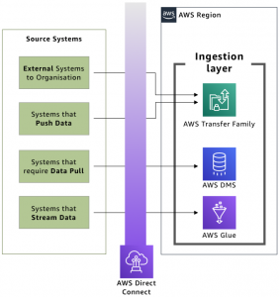

Figure 2 Ingestion layer against source systems (AWS Blog).

AWS Lake Formation:

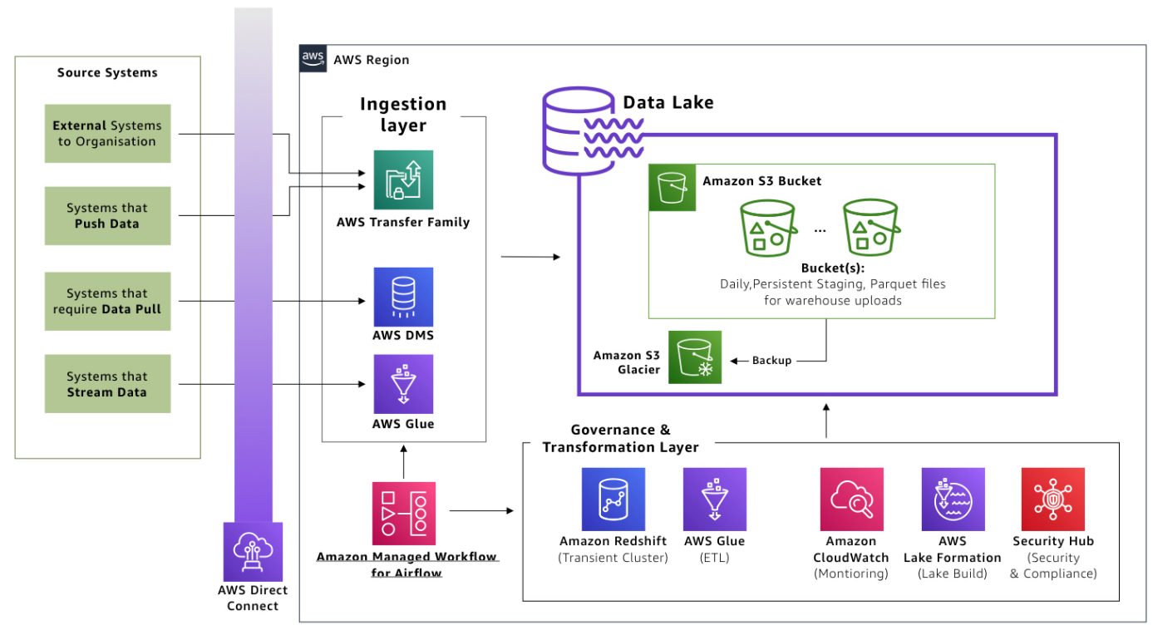

Figure 3 Governance and transformation layer prepares data in the lake (AWS Blog).

Designed for building, securing, and managing data lakes, AWS Lake Formation streamlines the process of organizing and analyzing diverse datasets. It offers tools for data ingestion, security, and access control in a data lake environment [16].

This section has provided an overview of AWS analytics services, showcasing the breadth and depth of tools available for processing, analyzing, and visualizing data. As we delve into the specifics of each service, you will gain a deeper understanding of how these tools can be effectively leveraged for various analytics use cases.

In the expansive domain of machine learning, AWS provides a comprehensive suite of services that cater to diverse needs, from building custom models to integrating pre-trained solutions seamlessly.

Part 2: Machine Learning

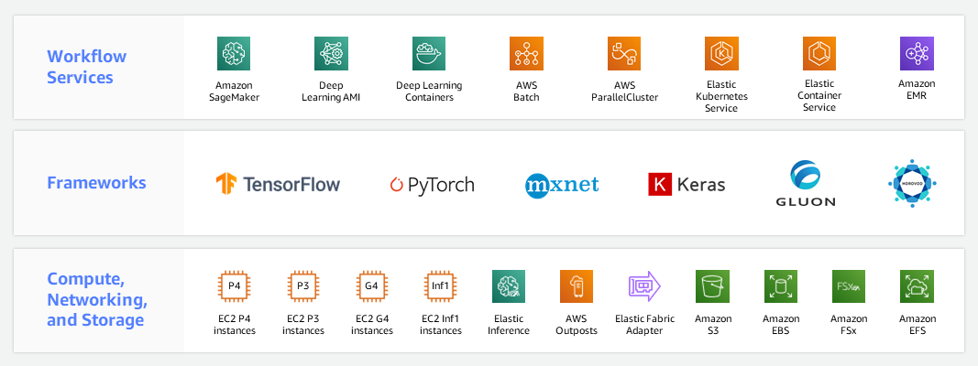

Figure 4 AWS Machine Learning Infrastructure (AWS Documentation).

Amazon Augmented AI (A2I):

Amazon Augmented AI (A2I) empowers developers to create custom machine learning workflows with human review. By integrating human intelligence into the model's decision-making process, A2I ensures the reliability and accuracy of machine learning predictions [17].

Amazon Bedrock:

Amazon Bedrock is a foundational service that simplifies the end-to-end machine learning process. From data preparation and model training to deployment, Bedrock streamlines the development lifecycle, enabling efficient and scalable machine learning applications [18].

Amazon CodeGuru:

Amazon CodeGuru enhances the quality of code by providing automated code reviews. This machine learning-powered service identifies and recommends improvements in code, optimizing performance and reliability [19].

Amazon Comprehend:

Amazon Comprehend facilitates natural language processing tasks by extracting insights and relationships from text. With support for multiple languages, Comprehend enables developers to build applications with advanced language understanding capabilities [20].

Amazon DevOps Guru:

Amazon DevOps Guru leverages machine learning to identify operational issues and anomalies. By analyzing operational data, it automates the detection of problems, providing actionable insights to enhance application reliability [21].

Amazon Elastic Inference:

Amazon Elastic Inference complements machine learning instances with cost-effective inference acceleration. By attaching low-cost GPU-powered inference acceleration to Amazon EC2 instances, Elastic Inference optimizes deep learning inference [22].

Deep learning inference acceleration:

AWS offers deep learning inference acceleration to enhance the performance of machine learning models. This service includes purpose-built hardware solutions like AWS Inferentia, designed to deliver high throughput and low-latency inference [23].

Amazon Forecast:

Amazon Forecast is a fully managed forecasting service that utilizes machine learning to generate accurate predictions. Whether for demand forecasting or financial planning, Forecast automates the forecasting process with minimal effort [24].

Amazon Fraud Detector:

Amazon Fraud Detector leverages machine learning to detect and prevent online fraud. By analyzing historical data and building custom models, Fraud Detector enhances security measures to protect against fraudulent activities [25].

Amazon HealthLake:

Amazon HealthLake is a HIPAA-eligible service designed for healthcare providers to store, transform, and analyze health data securely. It utilizes machine learning for natural language processing, enabling structured data extraction from unstructured medical information [26].

Amazon Kendra:

Amazon Kendra is an intelligent search service powered by machine learning. It enables organizations to build powerful search capabilities into their applications, making it easy for users to discover relevant information [27].

Amazon Lex:

Amazon Lex simplifies the process of building conversational interfaces using natural language understanding. This service powers chatbots and interactive voice response (IVR) systems, enhancing user interactions through machine learning [28].

Amazon Lookout for Equipment:

Amazon Lookout for Equipment utilizes machine learning to detect abnormal equipment behavior. By analyzing sensor data, it identifies early signs of equipment failure, enabling preventive maintenance and minimizing downtime [29].

Amazon Lookout for Metrics:

Amazon Lookout for Metrics is a service that uses machine learning to detect anomalies in metrics. It automates the monitoring of key performance indicators, providing timely alerts for unusual patterns or deviations [30].

Amazon Monitron:

Amazon Monitron offers an end-to-end solution for equipment monitoring. By combining sensors, a gateway, and machine learning algorithms, Monitron helps predict equipment failures before they occur [31].

Amazon Omics:

Amazon Omics is a comprehensive service for analyzing genomic data at scale. Leveraging machine learning enables researchers to derive meaningful insights from genomic information, advancing scientific discoveries in the life sciences [32].

Amazon Personalize:

Amazon Personalize is a machine learning service that facilitates the creation of personalized recommendations for users. By analyzing user behavior, Personalize tailors recommendations for products, content, and more [33].

Amazon Polly:

Amazon Polly transforms text into lifelike speech using machine learning. With support for multiple languages and a variety of voices, Polly enables developers to add natural-sounding speech to applications [34].

Amazon Rekognition:

Amazon Rekognition is a powerful image and video analysis service that utilizes machine learning. It can identify objects, people, text, scenes, and activities, making it a valuable tool for content analysis and security applications [35].

Amazon SageMaker:

Amazon SageMaker is a fully managed machine learning service that covers the end-to-end ML workflow. It simplifies model building, training, and deployment, allowing developers to focus on creating robust machine-learning applications [36].

Amazon SageMaker Ground Truth:

Amazon SageMaker Ground Truth is a data labeling service that uses machine learning to reduce labeling costs and improve annotation accuracy. It streamlines the process of creating high-quality training datasets for machine learning [37].

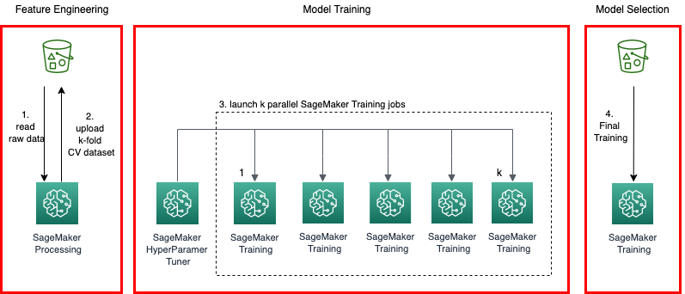

Figure 5 Cross-Validation Machine Learning Model Pipeline at Scale with Amazon SageMaker (AWS Documentation).

Amazon Textract:

Amazon Textract is a fully managed OCR (Optical Character Recognition) service powered by machine learning. It extracts text, forms, and tables from scanned documents, automating the process of data extraction [38].

Amazon Transcribe:

Amazon Transcribe provides automatic speech recognition (ASR) services using machine learning. It converts spoken language into written text, enabling applications to transcribe audio content accurately [39].

Amazon Translate:

Amazon Translate is a neural machine translation service that supports translating text between languages. Leveraging machine learning, Translate provides accurate and natural-sounding translations for a wide range of applications [40].

Apache MXNet on AWS:

AWS supports Apache MXNet, an open-source deep learning framework. With AWS infrastructure, developers can leverage the scalability and flexibility of MXNet to build and deploy machine learning models [41]

AWS Deep Learning AMIs:

AWS offers Deep Learning Amazon Machine Images (AMIs), providing a collection of deep learning frameworks. These AMIs simplify the process of setting up a deep learning environment on EC2 instances.

AWS Deep Learning Containers:

AWS Deep Learning Containers provide pre-configured Docker images for deep learning applications. These containers offer a consistent and reproducible environment for running machine learning workloads [42].

AWS DeepComposer:

AWS DeepComposer is a machine learning-enabled keyboard that allows developers to create music using generative AI models. It demonstrates the creative possibilities of combining machine learning with music composition [43].

AWS DeepLens:

AWS DeepLens is a deep learning-enabled video camera that facilitates the development of computer vision applications. It offers a hands-on approach to learning and implementing deep learning models in real-world scenarios [44].

AWS DeepRacer:

AWS DeepRacer is an autonomous 1/18th scale race car designed for reinforcement learning. Developers can use DeepRacer to enhance their understanding of machine learning concepts through an interactive and competitive racing environment [45].

AWS Inferentia:

AWS Inferentia is a custom-built chip designed to accelerate deep learning inference workloads. With high throughput and low latency, Inferentia enhances the performance of machine learning models [46].

AWS Panorama:

AWS Panorama is a machine learning appliance that brings computer vision capabilities to on-premises cameras. It enables the analysis of video feeds locally, opening up possibilities for applications in industrial automation and beyond [47].

PyTorch on AWS

AWS supports PyTorch, an open-source deep learning framework. With AWS infrastructure, developers can leverage the flexibility and efficiency of PyTorch to build and deploy machine learning models [48].

TensorFlow on AWS:

AWS provides robust support for TensorFlow, an open-source machine learning framework. Developers can harness the scalability and power of AWS to build and train machine learning models using TensorFlow [49].

TensorFlow on AWS

Amazon CodeWhisperer is a service that employs machine learning to assist developers in writing code more efficiently. By providing context-aware suggestions, it enhances the coding experience and accelerates development workflows [50].

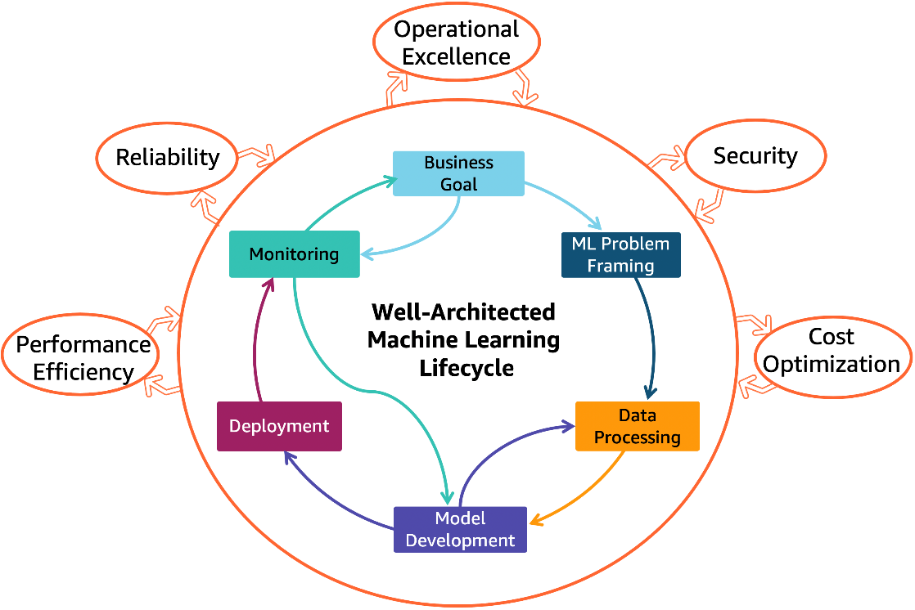

Figure 6 AWS Well-Architected Machine Learning Lens (AWS Architecture).

**Chapter 10 Conclusion**

Chapter 10 delves into the multifaceted realms of Analytics and Machine Learning, unraveling a tapestry of AWS services designed to empower businesses with data-driven insights and intelligent automation. From the seamless query capabilities of Amazon Athena to the advanced machine learning models facilitated by Amazon SageMaker, this chapter explores the expansive landscape of AWS offerings in analytics and machine learning.

Part 1: Analytics

In the analytics domain, AWS provides a comprehensive suite of services that cater to the diverse needs of organizations grappling with vast datasets. Amazon Athena, a standout in this category, offers a serverless query service, enabling on-the-fly analysis of data stored in Amazon S3 [51]. Complementing this, Amazon QuickSight facilitates intuitive and interactive data visualization, empowering users to derive actionable insights from their analytics [52].

In the evolving landscape of big data, Amazon EMR (Elastic MapReduce) stands as a stalwart, providing a cloud-based platform for processing large datasets using popular frameworks like Apache Spark and Apache Hadoop [53]. Simultaneously, Amazon Redshift emerges as a powerful data warehousing solution, allowing organizations to analyze vast datasets with remarkable speed and efficiency [54].

As organizations grapple with the challenges of data management, AWS offers solutions like AWS Glue and AWS Lake Formation, streamlining the process of data integration, transformation, and lake formation [55]. These services collectively contribute to the establishment of a robust analytics foundation within AWS, fostering an environment where data becomes a strategic asset [56].

Part 2: Machine Learning

The second part of Chapter 10 delves into the dynamic landscape of machine learning, where AWS provides an extensive array of services to cater to the evolving needs of developers and data scientists. At the forefront, Amazon SageMaker emerges as a cornerstone, offering end-to-end machine learning workflow capabilities, simplifying the model building, training, and deployment process [57].

Within the machine learning spectrum, specialized services such as Amazon Comprehend [58] and Amazon Rekognition bring natural language processing and computer vision capabilities, respectively, to the forefront [59]. These services empower developers to infuse machine learning into applications without the need for extensive expertise.

In the realm of recommendation engines and personalization, Amazon Personalize takes center stage, providing developers with the tools to create individualized experiences for users based on their behavior [60]. Simultaneously, services like Amazon Forecast leverage machine learning to generate accurate predictions, offering an asset for businesses engaged in demand forecasting and financial planning [61].

As the chapter unfolds, it becomes evident that AWS is not merely providing tools but fostering an ecosystem where machine learning becomes an accessible and integral part of the development process. The array of services, including deep learning inference acceleration, supports developers in optimizing the performance of their machine-learning models [62].

The Holistic Vision

In conclusion, Chapter 10 encapsulates the holistic vision of AWS in democratizing analytics and machine learning. The seamless integration of services, spanning from the granular analytics of Amazon Athena to the intricate machine learning models of Amazon SageMaker, reflects a commitment to simplifying complex processes and empowering users across the spectrum of technical expertise.

The journey through analytics and machine learning within AWS is marked by innovation, efficiency, and scalability. AWS' commitment to customer-centric solutions is evident in the diversity of services, addressing the unique needs of businesses irrespective of their size or industry. As organizations navigate the data-intensive landscape, the tools and services explored in this chapter become beacons, guiding them toward a future where data is not just a resource but a strategic advantage.

1. Amazon Web Services, Inc. (n.d.). Amazon Athena. https://aws.amazon.com/athena/
2. Amazon Web Services, Inc. (n.d.). Amazon CloudSearch. https://aws.amazon.com/cloudsearch/
3. Amazon Web Services, Inc. (n.d.). Amazon DataZone (Preview). https://aws.amazon.com/datazone/
4. Amazon Web Services, Inc. (n.d.). Amazon EMR. https://aws.amazon.com/emr/
5. Amazon Web Services, Inc. (n.d.). Analytics. https://aws.amazon.com/analytics/
6. Amazon Web Services, Inc. (n.d.). Amazon FinSpace. https://aws.amazon.com/finspace/
7. Amazon Web Services, Inc. (n.d.). Amazon Kinesis. https://aws.amazon.com/kinesis/
8. Amazon Web Services, Inc. (n.d.). Amazon Managed Streaming for Apache Kafka (MSK). https://aws.amazon.com/msk/
9. Amazon Web Services, Inc. (n.d.). Amazon OpenSearch Service. https://aws.amazon.com/opensearch-service/
10. Amazon Web Services, Inc. (n.d.). Amazon QuickSight. https://aws.amazon.com/quicksight/
11. Amazon Web Services, Inc. (n.d.). Amazon Redshift. https://aws.amazon.com/redshift/
12. Amazon Web Services, Inc. (n.d.). AWS Clean Rooms (Preview). https://aws.amazon.com/clean-rooms/
13. Amazon Web Services, Inc. (n.d.). AWS Data Exchange. https://aws.amazon.com/data-exchange/
14. Amazon Web Services, Inc. (n.d.). AWS Data Pipeline. https://aws.amazon.com/datapipeline/
15. Amazon Web Services, Inc. (n.d.). AWS Glue. https://aws.amazon.com/glue/
16. Amazon Web Services, Inc. (n.d.). AWS Lake Formation. https://aws.amazon.com/lake-formation/
17. Amazon Web Services, Inc. (n.d.). Amazon Augmented AI. https://aws.amazon.com/augmented-ai/
18. Amazon Web Services, Inc. (n.d.). Amazon Bedrock. https://aws.amazon.com/bedrock/
19. Amazon Web Services, Inc. (n.d.). Amazon CodeGuru. https://aws.amazon.com/codeguru/
20. Amazon Web Services, Inc. (n.d.). Amazon Comprehend. https://aws.amazon.com/comprehend/
21. Amazon Web Services, Inc. (n.d.). Amazon DevOps Guru. https://aws.amazon.com/devops-guru/
22. Amazon Web Services, Inc. (n.d.). Amazon Elastic Inference. https://aws.amazon.com/elastic-inference/
23. Amazon Web Services, Inc. (n.d.). Deep Learning Inference Acceleration. https://aws.amazon.com/deep-learning/
24. Amazon Web Services, Inc. (n.d.). Amazon Forecast. https://aws.amazon.com/forecast/
25. Amazon Web Services, Inc. (n.d.). Amazon Fraud Detector. https://aws.amazon.com/fraud-detector/
26. Amazon Web Services, Inc. (n.d.). Amazon HealthLake. https://aws.amazon.com/healthlake/
27. Amazon Web Services, Inc. (n.d.). Amazon Kendra. https://aws.amazon.com/kendra/
28. Amazon Web Services, Inc. (n.d.). Amazon Lex. https://aws.amazon.com/lex/
29. Amazon Web Services, Inc. (n.d.). Amazon Lookout for Equipment. https://aws.amazon.com/lookout-for-equipment/
30. Amazon Web Services, Inc. (n.d.). Amazon Lookout for Metrics. https://aws.amazon.com/lookout-for-metrics/
31. Amazon Web Services, Inc. (n.d.). Amazon Monitron. https://aws.amazon.com/monitron/
32. Amazon Web Services, Inc. (n.d.). Amazon Omics. https://aws.amazon.com/omics/
33. Amazon Web Services, Inc. (n.d.). Amazon Personalize. https://aws.amazon.com/personalize/
34. Amazon Web Services, Inc. (n.d.). Amazon Polly. https://aws.amazon.com/polly/
35. Amazon Web Services, Inc. (n.d.). Amazon Rekognition. https://aws.amazon.com/rekognition/
36. Amazon Web Services, Inc. (n.d.). Amazon SageMaker. https://aws.amazon.com/sagemaker/
37. Amazon Web Services, Inc. (n.d.). Amazon SageMaker Ground Truth. https://aws.amazon.com/sagemaker/groundtruth/
38. Amazon Web Services, Inc. (n.d.). Amazon Textract. https://aws.amazon.com/textract/
39. Amazon Web Services, Inc. (n.d.). Amazon Transcribe. https://aws.amazon.com/transcribe/
40. Amazon Web Services, Inc. (n.d.). Amazon Translate. https://aws.amazon.com/translate/
41. Amazon Web Services, Inc. (n.d.). Apache MXNet on AWS. https://aws.amazon.com/mxnet/
42. Amazon Web Services, Inc. (n.d.). AWS Deep Learning Containers. https://aws.amazon.com/machine-learning/containers/
43. Amazon Web Services, Inc. (n.d.). AWS DeepComposer. https://aws.amazon.com/deepcomposer/
44. Amazon Web Services, Inc. (n.d.). AWS DeepLens. https://aws.amazon.com/deeplens/
45. Amazon Web Services, Inc. (n.d.). AWS DeepRacer. https://aws.amazon.com/deepracer/
46. Amazon Web Services, Inc. (n.d.). AWS Inferentia. https://aws.amazon.com/inferentia/
47. AWS Panorama: Amazon Web Services, Inc. (n.d.). AWS Panorama. https://aws.amazon.com/panorama/
48. Amazon Web Services, Inc. (n.d.). PyTorch on AWS. https://aws.amazon.com/pytorch/
49. Amazon Web Services, Inc. (n.d.). TensorFlow on AWS. <https://aws.amazon.com/tensorflow/>
50. Amazon Web Services, Inc. (n.d.). Amazon CodeWhisperer. https://aws.amazon.com/codewhisperer/
51. Amazon Web Services, Inc. (n.d.). Amazon Athena. Retrieved from https://aws.amazon.com/athena/
52. Amazon Web Services, Inc. (n.d.). Amazon QuickSight. Retrieved from https://aws.amazon.com/quicksight/
53. Amazon Web Services, Inc. (n.d.). Amazon EMR (Elastic MapReduce). Retrieved from https://aws.amazon.com/emr/
54. Amazon Web Services, Inc. (n.d.). Amazon Redshift. Retrieved from https://aws.amazon.com/redshift/
55. Amazon Web Services, Inc. (n.d.). AWS Glue. Retrieved from https://aws.amazon.com/glue/
56. Amazon Web Services, Inc. (n.d.). AWS Lake Formation. Retrieved from https://aws.amazon.com/lake-formation/
57. Amazon Web Services, Inc. (n.d.). Amazon SageMaker. Retrieved from https://aws.amazon.com/sagemaker/
58. Amazon Web Services, Inc. (n.d.). Amazon Comprehend. Retrieved from https://aws.amazon.com/comprehend/
59. Amazon Web Services, Inc. (n.d.). Amazon Rekognition. Retrieved from https://aws.amazon.com/rekognition/
60. Amazon Web Services, Inc. (n.d.). Amazon Personalize. Retrieved from https://aws.amazon.com/personalize/
61. Amazon Web Services, Inc. (n.d.). Amazon Forecast. Retrieved from https://aws.amazon.com/forecast/
62. Amazon Web Services, Inc. (n.d.). Deep learning inference acceleration. Retrieved from https://aws.amazon.com/deeplearning/inference/.