CHAPTER 11

Management & Governance

**Introduction**

In the intricate tapestry of cloud computing, effective management, and governance are the linchpins that ensure optimal performance, security, and scalability. Chapter 11 delves into the diverse array of AWS services dedicated to the realms of Management and governance. From real-time monitoring with Amazon CloudWatch to seamless infrastructure orchestration through AWS CloudFormation, this chapter embarks on a journey through the foundational tools that empower organizations to wield control and enhance operational efficiency in the AWS cloud environment.

**Monitoring and Observability**

The chapter commences with a focus on monitoring and observability, unveiling the capabilities of Amazon CloudWatch. This service provides a comprehensive solution for collecting and analyzing metrics, setting alarms, and responding to changes in AWS resources in real-time. To complement this, the exploration extends to Amazon Managed Grafana and Amazon Managed Service for Prometheus, offering powerful tools for visualizing and understanding the dynamics of cloud environments.

**Operational Efficiency and Automation**

Efficiency in resource management and operational automation is paramount, and AWS presents an arsenal of tools for achieving just that. AWS CloudFormation takes center stage, enabling users to model and provision AWS infrastructure in a declarative and efficient manner. Simultaneously, AWS OpsWorks and AWS Launch Wizard offer seamless options for application deployment and infrastructure sizing, respectively.

**Governance and Compliance**

The journey then shifts towards governance and compliance, exploring AWS Config as a key player in assessing, auditing, and evaluating the configurations of AWS resources. AWS Control Tower emerges as a pivotal service for setting up and governing a secure, multi-account AWS environment based on AWS best practices and blueprints. AWS Organizations takes the stage, providing a scalable and secure way to consolidate multiple AWS accounts within an organization.

**Security and Compliance Assurance**

AWS's commitment to security is reflected in services such as AWS Trusted Advisor, AWS Systems Manager, and AWS Well-Architected Tool, which collectively contribute to ensuring best practices, security, and cost optimization in cloud architectures. The chapter unveils how these tools empower organizations to fortify their cloud infrastructure and adhere to industry-specific compliance standards.

**Innovations in Management**

As the chapter unfolds, it explores innovations in management with services like AWS Proton, designed for the efficient delivery of microservices. AWS Service Catalog and AWS Service Management Connector showcase how organizations can manage and govern approved software and infrastructure resources.

**Enhanced Collaboration and Communication**

Facilitating enhanced collaboration and communication within organizations, AWS Chatbot and ChatOps for AWS make an appearance, demonstrating how teams can efficiently interact with AWS resources using familiar chat interfaces.

**Conclusion**

This chapter provides a comprehensive guide to the rich tapestry of AWS services for Management and governance. As organizations navigate the complexities of cloud computing, the tools explored in this chapter become essential companions, guiding them toward operational excellence, security, and compliance. From the real-time insights of Amazon CloudWatch to the governance frameworks of AWS Control Tower, this chapter equips readers with the knowledge to architect, govern, and optimize their cloud environments effectively.

In the subsequent sections, each topic will be explored in depth, providing practical insights, use cases, and best practices to empower readers in harnessing the full potential of AWS Management and governance services. Whether securing cloud resources, automating operations, or ensuring regulatory compliance, the journey through this chapter promises to be enlightening and transformative.

Welcome to the world of AWS Management & Governance![1]

**Amazon CloudWatch**

In the dynamic landscape of cloud computing, robust monitoring and observability are critical components for ensuring the seamless operation of cloud resources. Amazon CloudWatch stands as a cornerstone service within the AWS ecosystem, providing comprehensive solutions for collecting, analyzing, and responding to operational data in real-time[2]. This section explores the multifaceted capabilities of Amazon CloudWatch, shedding light on how it empowers businesses to gain deep insights into their AWS infrastructure, optimize performance, and proactively address potential issues.

Overview and Core Functionality

Amazon CloudWatch offers a centralized platform for monitoring various AWS resources, applications, and services, enabling users to collect and track metrics, collect, and monitor log files, and set alarms. Through its intuitive interface, CloudWatch allows users to gain real-time visibility into resource utilization, operational performance, and overall health. This foundational capability is instrumental in maintaining a proactive stance toward infrastructure management.

Key Features and Use Cases

This section delves into the key features of Amazon CloudWatch, emphasizing its ability to monitor EC2 instances, autoscaling groups, Elastic Load Balancers (ELBs), and many other AWS services. Specific use cases illustrate how CloudWatch can be employed for performance optimization, cost management, and operational efficiency, addressing the diverse needs of businesses across industries.

Integration and Customization

The seamless integration of CloudWatch with other AWS services amplifies its utility. This section explores how CloudWatch Metrics acts as a linchpin for autoscaling policies, triggering actions based on predefined thresholds. Additionally, the extensibility of CloudWatch through custom metrics and the integration of CloudWatch Alarms with Amazon SNS for alert notifications enhance its adaptability to unique business requirements.

Real-world Deployment Strategies

To provide practical insights, this section offers deployment strategies for businesses looking to maximize the benefits of Amazon CloudWatch. It explores best practices for setting up custom dashboards, creating effective alarms, and leveraging CloudWatch Logs for enhanced troubleshooting and debugging. Real-world scenarios highlight how businesses can tailor CloudWatch to their specific needs, ensuring a tailored and efficient deployment.

Further Reading: Gaining a Deeper Understanding

Delving into the technical intricacies outlined in AWS documentation provides a comprehensive understanding of Amazon CloudWatch[3]. Internal references reveal that Amazon CloudWatch is more than just a monitoring service; it is a robust platform designed to collect, analyze, and visualize log data in real time, enabling users to gain actionable insights into their AWS resources and applications3. Expanding on this internal perspective, external third-party references offer valuable insights. For instance, the whitepaper "Monitoring and Observability on AWS"[4] serves as a key external resource. Within this document, readers gain insights into industry trends, best practices, and real-world success stories, enriching their understanding of the broader context of monitoring within cloud environments. The inclusion of both internal and external perspectives ensures a well-rounded comprehension of Amazon CloudWatch and its multifaceted capabilities.

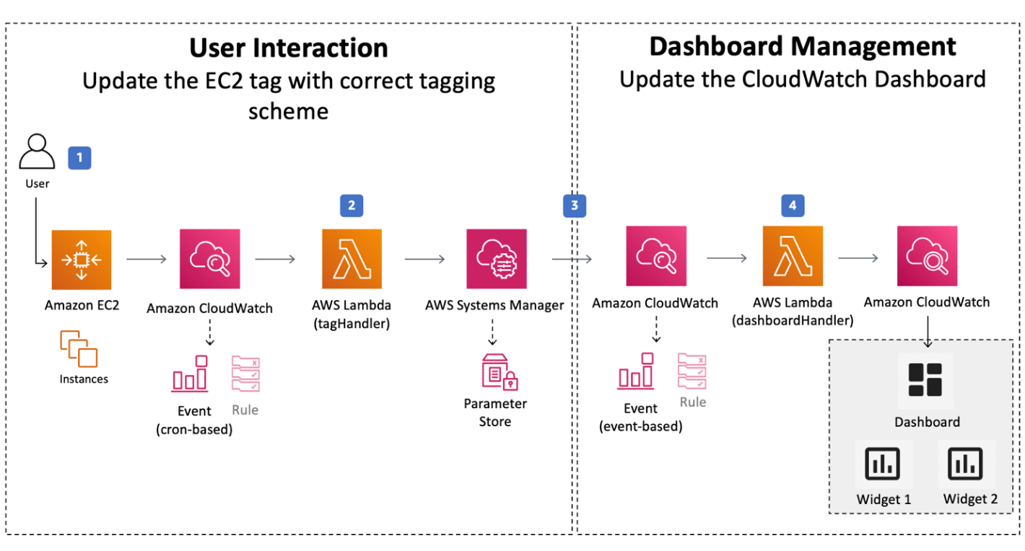

Figure 1 Architecture of a Typical Monitoring Setup Using Amazon CloudWatch. This illustration depicts the flow of metrics and logs from diverse AWS resources to Amazon CloudWatch, showcasing its central role in real-time monitoring, alerting, and visualization.

Further Reading: Gaining a Deeper Understanding

Delving into the technical intricacies outlined in AWS documentation provides a comprehensive understanding of Amazon CloudWatch[5]. Internal references reveal that Amazon CloudWatch is more than just a monitoring service; it is a robust platform designed to collect, analyze, and visualize log data in real time, enabling users to gain actionable insights into their AWS resources and applications5. Expanding on this internal perspective, external third-party references offer valuable insights. For instance, the whitepaper "Monitoring and Observability on AWS"[6] is a key external resource. Within this document, readers gain insights into industry trends, best practices, and real-world success stories, enriching their understanding of the broader monitoring context within cloud environments. The inclusion of both internal and external perspectives ensures a well-rounded comprehension of Amazon CloudWatch and its multifaceted capabilities.

In conclusion, in this section the text lays the foundation for understanding Amazon CloudWatch as an indispensable tool for businesses operating in the AWS cloud. By combining internal AWS references with external perspectives, this section equips CIOs and their teams with the knowledge needed to leverage Amazon CloudWatch effectively, fostering a culture of proactive monitoring and informed decision-making.

**Amazon Managed Grafana**

In the ever-evolving landscape of cloud management and governance, visualization of operational data stands as a linchpin for effective decision-making. Amazon Managed Grafana, a pivotal service within the AWS ecosystem, emerges as a powerful ally in this endeavor. This section delves into the capabilities of Amazon Managed Grafana, elucidating its role in providing businesses with a centralized and user-friendly platform for data visualization and analytics.

Overview and Core Functionality

Amazon Managed Grafana is a fully managed and secure data visualization service that seamlessly integrates with various AWS data sources. As a turnkey solution, it simplifies the deployment and scaling of Grafana, eliminating the operational overhead traditionally associated with managing and maintaining this open-source analytics platform. CIOs and their teams can harness the capabilities of Amazon Managed Grafana to gain actionable insights through visually compelling dashboards.

Key Features and Use Cases

This section explores the key features of Amazon Managed Grafana, emphasizing its ability to connect to diverse data sources, including Amazon CloudWatch, AWS CloudTrail, and Amazon RDS. Integrating CloudWatch Metrics with Grafana dashboards facilitates real-time monitoring and visualization of AWS resources. Use cases illustrate how businesses can leverage Managed Grafana to create custom dashboards tailored to their specific needs, enabling data-driven decision-making.

Integration with AWS Services

One of the strengths of Amazon Managed Grafana lies in its seamless integration with various AWS services. This section explains how Managed Grafana complements other AWS offerings, such as Amazon Managed Service for Prometheus and Amazon CloudWatch. The unified approach to data visualization ensures a consolidated view of operational metrics, enhancing the overall observability of AWS environments.

Security and Compliance

For CIOs and their teams, security and compliance are paramount considerations. Amazon Managed Grafana addresses these concerns by providing a secure environment for data visualization. This section details the security features of Managed Grafana, including encryption in transit and at rest, access controls, and integration with AWS Identity and Access Management (IAM). By adhering to industry best practices, businesses can confidently deploy Managed Grafana in compliance with regulatory requirements.

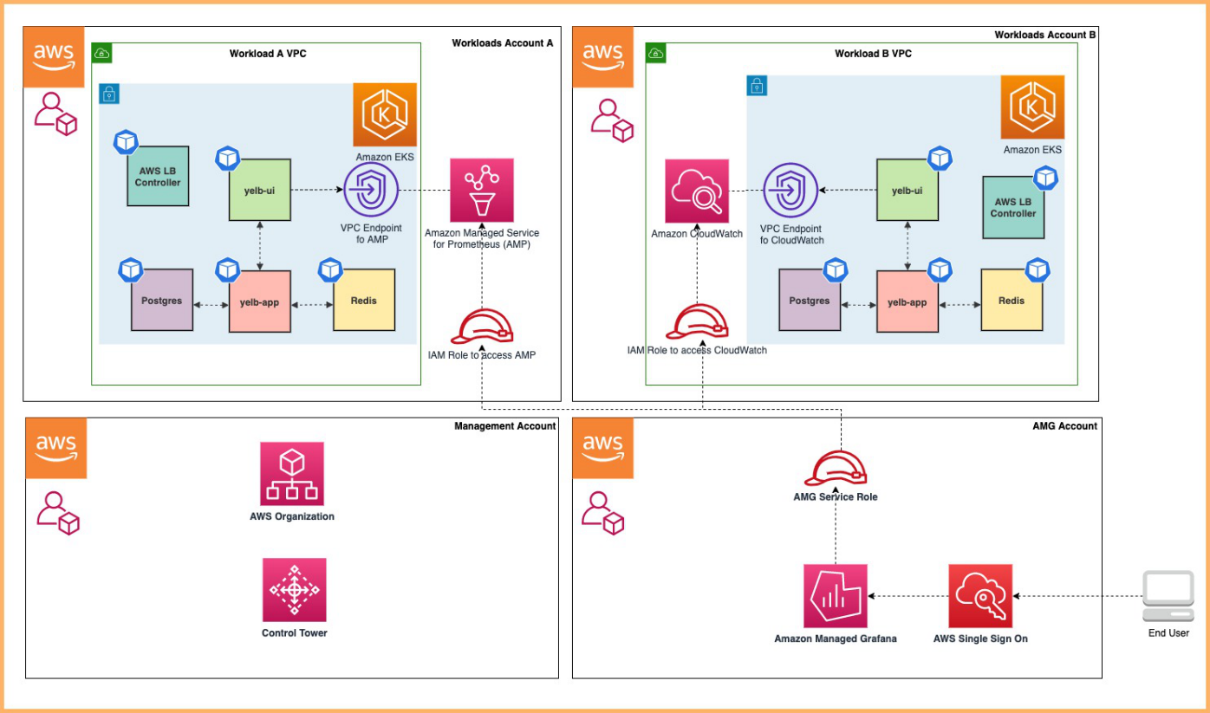

Figure 2 Typical Deployment Architecture of Amazon Managed Grafana. This illustration demonstrates the seamless integration of Amazon Managed Grafana with various AWS data sources, emphasizing its role in creating customizable dashboards for data visualization and analytics.

Real-world Deployment Strategies

To provide actionable guidance, this section offers deployment strategies for CIOs looking to implement Amazon Managed Grafana effectively. Best practices for configuring data sources, creating meaningful dashboards, and optimizing performance ensure a streamlined and efficient deployment. Real-world examples showcase how businesses across industries have successfully harnessed the power of Managed Grafana to enhance visibility and decision-making.Further Reading: Gaining a Deeper Understanding

To gain a more profound insight into Amazon Managed Grafana, a thorough exploration of AWS documentation is essential[7]. The internal reference sheds light on various technical intricacies, elucidating that Amazon Managed Grafana is not just a visualization tool; it is a robust platform that empowers users to create interactive and customizable dashboards, facilitating efficient monitoring and analysis of operational data7. Complementing this, the whitepaper titled "Best Practices for Deploying Amazon Managed Grafana"[8] offers an enriching external perspective. Within this resource, readers discover key insights such as the significance of configuring alerting thresholds and setting up effective permissions to ensure secure and optimized usage of Amazon Managed Grafana. The author of the whitepaper strongly advocates for a continued focus on new publications to stay abreast of evolving best practices, emerging methods, and models, ensuring a comprehensive and updated understanding of Amazon Managed Grafana.

**Amazon Managed Service for Prometheus: Elevating Observability in the Cloud**

In the realm of cloud management and governance, the Amazon Managed Service for Prometheus (AMP) emerges as a powerful tool for enhancing observability. As businesses increasingly rely on cloud infrastructure, the need for efficient monitoring and alerting solutions becomes paramount. AMP, a fully managed service by AWS, addresses this need by simplifying the deployment and operation of Prometheus, a popular open-source monitoring and alerting toolkit.

Examples and Best Practices from AWS

For a more in-depth understanding, it is recommended that the reader continue to explore AMP's technical facets by referencing the wide variety of examples, cases, and studies from the AWS library, including their website and blog. AMP's ability to effortlessly collect and query operational metrics from various AWS resources and applications is highlighted in AWS documentation[9], offering real-time insights into the health and performance of the cloud environment. Furthermore, the service integrates seamlessly with other AWS offerings, providing a unified and cohesive monitoring experience for users.

Success Cases and Other Examples from the Market

From third parties and other sources in the market, constantly renewed examples and use cases can be found. Notably, the whitepaper "Enhance Observability with Amazon Managed Service for Prometheus"[10] provides valuable insights into best practices for deploying and optimizing AMP. It outlines strategies for effectively leveraging AMP's capabilities, ensuring that businesses extract maximum value from their monitoring infrastructure2.

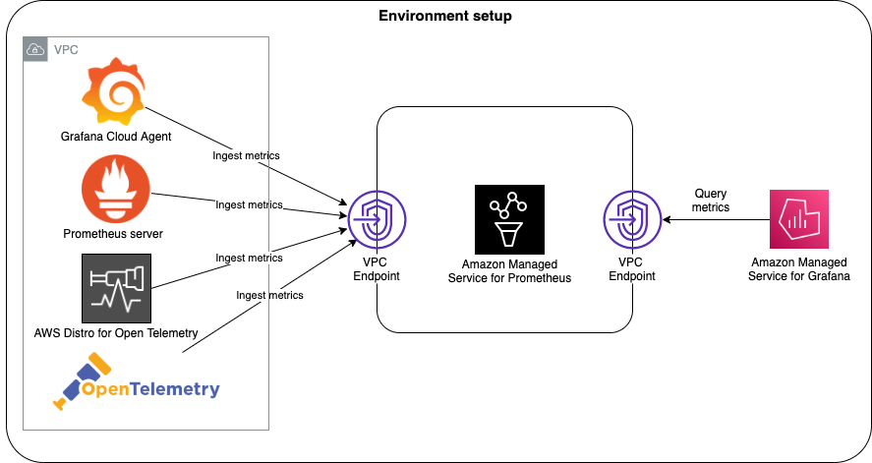

Figure 3 Amazon Managed Service for Prometheus (AMP) Ecosystem. This illustration provides a visual overview of the key components and interactions within the AMP ecosystem, showcasing its seamless integration with AWS resources, applications, and the Prometheus toolkit for enhanced observability in the cloud.

Business Implications

From a business standpoint, the deployment of AMP translates into enhanced operational efficiency and proactive issue resolution. The real-time nature of the metrics allows for quick identification and mitigation of potential issues, minimizing downtime and optimizing resource utilization. CIOs and their teams can leverage AMP to establish a robust monitoring framework aligned with industry best practices, ultimately contributing to the overall success and reliability of their cloud-based applications and services.

Continued Learning

As the cloud landscape evolves, staying abreast of the latest developments is crucial. Regularly consulting AWS documentation and exploring additional external resources ensures that organizations maintain a comprehensive and updated understanding of AMP and its evolving features.

In conclusion, Amazon Managed Service for Prometheus emerges as a pivotal component in the management and governance arsenal, empowering businesses to achieve superior observability and operational excellence in the cloud.

**AWS Chatbot: Transforming Communication in Cloud Management**

In the ever-evolving landscape of cloud management and governance, effective communication and collaboration are integral components for ensuring operational efficiency and swift issue resolution. AWS Chatbot emerges as a versatile solution, seamlessly integrating with popular collaboration platforms to streamline communication and enhance visibility into AWS resources.

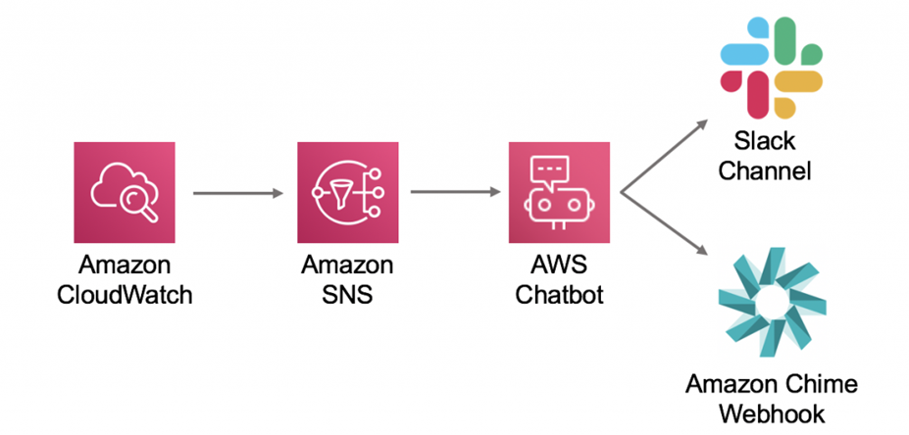

Figure 4 AWS Chatbot in Action. This illustration (and next) depicts the seamless integration of AWS Chatbot with collaboration tools, real-time alert delivery, and its role in executing commands and managing AWS resources. AWS Chatbot serves as a transformative tool, streamlining communication and collaboration within cloud management workflows.

Insights from AWS Documentation

Internally, AWS documentation offers valuable insights into the technical nuances of AWS Chatbot[11]. This platform allows teams to receive real-time alerts, run commands, and gather operational information through chat interfaces like Slack and Amazon Chime. By centralizing notifications and interactions within familiar collaboration tools, AWS Chatbot enhances the accessibility and responsiveness of teams managing AWS resources.

Customer Cases Validation and Best Practices

To complement this internal perspective, external references play a crucial role. Notably, the whitepaper "Effective Cloud Management with AWS Chatbot"[12] provides practical insights into best practices for deploying and optimizing AWS Chatbot. It outlines strategies for configuring automated responses, managing permissions, and tailoring the chatbot to specific organizational needs5.

Examples and Best Practices from AWS

Continued exploration of AWS documentation reveals a plethora of examples and best practices related to AWS Chatbot. For instance, integrating AWS Chatbot with Amazon CloudWatch enables the automatic posting of alerts to designated channels, ensuring timely awareness of critical events4. Moreover, AWS Chatbot's adaptability extends to DevOps workflows, allowing teams to execute commands, fetch information, and manage AWS resources directly from their preferred chat interface.

Success Cases and Other Examples from the Market

Beyond AWS-provided documentation, real-world success stories and best practices from the market further underscore the impact of AWS Chatbot. Case studies detailing how organizations have integrated AWS Chatbot into their communication workflows can offer valuable insights into potential use cases and benefits.

Business Implications

From a business standpoint, the deployment of AWS Chatbot introduces a paradigm shift in communication efficiency. The seamless integration with popular collaboration tools ensures that teams can stay informed and take swift actions directly within their preferred interfaces. This not only accelerates issue resolution but also fosters a collaborative environment, aligning with broader organizational goals.

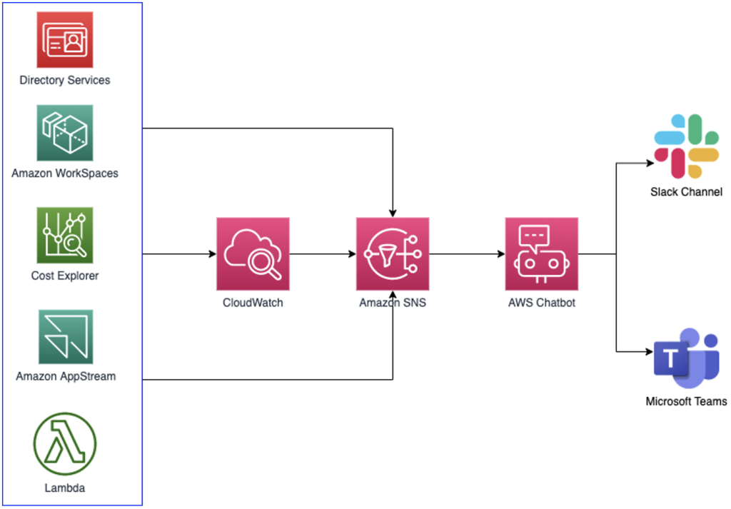

Figure 5 AWS Chatbot in Action. This illustration depicts the seamless integration of AWS Chatbot with collaboration tools, real-time alert delivery, and its role in executing commands and managing AWS resources. AWS Chatbot serves as a transformative tool, streamlining communication and collaboration within cloud management workflows.

Continued Learning

As the cloud landscape evolves, it is crucial for CIOs and their teams to stay informed about the latest features and updates to AWS Chatbot. Regularly consulting AWS documentation and exploring additional external resources ensures that organizations maintain a comprehensive and updated understanding of AWS Chatbot and its evolving capabilities.

In conclusion, AWS Chatbot emerges as a transformative tool in the realm of cloud management and governance, offering a communication hub that seamlessly integrates with existing workflows. Its impact extends beyond technical functionalities to fundamentally enhance collaboration and responsiveness within AWS-managed environments.

**ChatOps for AWS: Revolutionizing Collaboration in Cloud Management**

In the dynamic landscape of cloud management, where effective communication and collaboration are paramount, ChatOps emerges as a powerful paradigm that transforms the way teams interact with and manage AWS resources. This section delves into the technical aspects, best practices, and business implications of implementing ChatOps for AWS.

Insights from AWS Documentation

Internally, AWS documentation provides comprehensive insights into the technical facets of implementing ChatOps for AWS[13]. This approach involves integrating chat platforms with AWS services to facilitate real-time communication, command execution, and information retrieval directly from the chat interface. Leveraging AWS Chatbot as a key component, ChatOps streamlines workflows and enhances visibility into AWS environments.

Customer Cases Validation and Best Practices

Third-party references play a crucial role in validating and enriching the internal perspective. Notably, the book "ChatOps: Managing Infrastructure in Slack"[14] serves as a valuable resource for understanding the broader principles and best practices of implementing ChatOps. Hand's work14 provides practical insights into integrating ChatOps into DevOps practices, fostering collaboration, and achieving operational excellence14.

Examples and Best Practices from AWS

Exploring AWS documentation further reveals a wealth of examples and best practices for implementing ChatOps. For instance, integrating AWS Lambda functions with chat platforms allows teams to execute code snippets, automate routine tasks, and receive immediate feedback within the chat interface[15]. This exemplifies how ChatOps can be leveraged to enhance agility and efficiency in AWS resource management.

Success Cases and Other Examples from the Market

Real-life cases further highlight the transformative impact of ChatOps for AWS. Organizations across various industries have realized tangible benefits by implementing ChatOps, ranging from accelerated incident response to improved collaboration among cross-functional teams. Case studies and use cases provide valuable insights into the diverse applications and positive outcomes achieved through the adoption of ChatOps in AWS environments.

Business Implications

From a business perspective, the adoption of ChatOps for AWS translates into tangible benefits. By centralizing communication and command execution within familiar chat interfaces, organizations can streamline workflows, reduce response times, and enhance overall operational efficiency. This aligns with the broader goals of achieving a more collaborative and responsive cloud management environment.

Continued Learning

As the landscape of cloud management evolves, staying informed about the latest features, integrations, and best practices in ChatOps remains crucial for CIOs and their teams. Regularly consulting AWS documentation, industry publications, and participating in relevant forums ensures that organizations maintain a competitive edge in harnessing the full potential of ChatOps for AWS.

In conclusion, ChatOps stands as a transformative approach that converges communication and operations within AWS environments. By seamlessly integrating chat platforms and AWS services, organizations can foster collaboration, streamline workflows, and elevate the efficiency of managing cloud resources. Embracing ChatOps represents a strategic move towards achieving a more agile, responsive, and collaborative cloud management paradigm.

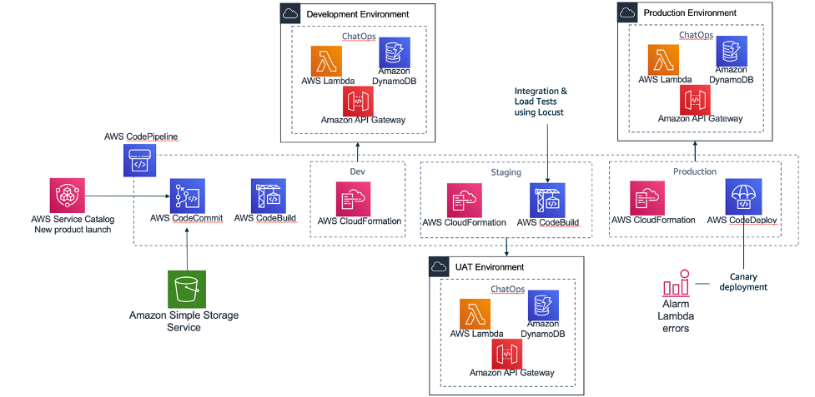

Figure 6 AWS ChatOps in action: AWS Control Tower Account vending through Amazon Lex ChatBot.

**AWS CloudFormation: Orchestrating Infrastructure as Code**

In the realm of AWS Management & Governance, AWS CloudFormation emerges as a foundational tool, revolutionizing the deployment and management of AWS resources through Infrastructure as Code (IaC) principles. This section provides a comprehensive exploration of the technical intricacies, best practices, and business implications associated with leveraging AWS CloudFormation.

Insights from AWS Documentation

Internally, AWS documentation serves as the primary source for gaining in-depth technical insights into AWS CloudFormation[16]. At its core, AWS CloudFormation enables users to define and provision AWS infrastructure in a declarative manner, facilitating the automation of resource provisioning and configuration. This section discusses key concepts, such as templates, stacks, and change sets, offering a solid foundation for understanding how to model and provision AWS resources efficiently.

Customer Cases Validation and Best Practices

External references play a crucial role in validating AWS CloudFormation's capabilities and providing additional best practices. Notably, the book "AWS CloudFormation: Getting Started Guide"[17] by Mitch Tulloch offers practical guidance for beginners and experienced users alike. Tulloch's work covers fundamental concepts, template authoring best practices, and advanced use cases, providing a well-rounded perspective on maximizing the potential of AWS CloudFormation17.

Examples and Best Practices from AWS

For a deeper understanding of AWS CloudFormation in action, exploring real-world examples and best practices from AWS documentation is invaluable. Reference architectures, sample templates, and case studies demonstrate how organizations across various industries have successfully implemented AWS CloudFormation to achieve consistent and scalable infrastructure deployments16. The inclusion of snippets from these examples can illustrate specific use cases and guide users in applying similar patterns to their deployments.

Business Implications

From a business standpoint, adopting AWS CloudFormation brings numerous advantages. The

ability to define and provision infrastructure through code streamlines deployment processes.

enhances reproducibility and reduces the risk of configuration drift. This aligns with broader.

organizational goals of achieving efficiency, consistency, and agility in managing AWS

resources. The section emphasizes how embracing AWS CloudFormation contributes to improved resource governance, cost management, and faster time-to-market for applications.

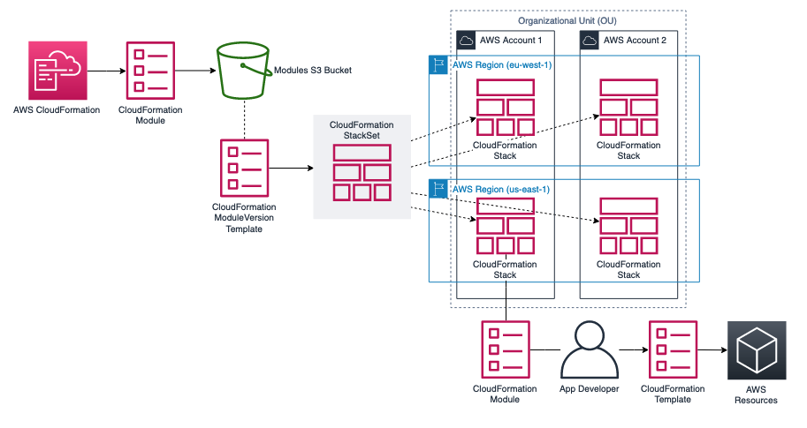

Figure 7 AWS CloudFormation: Sharing reusable infrastructure as code by using AWS CloudFormation modules and StackSets (typical AWS CloudFormation workflow—from template creation to stack provisioning).

Continued Learning

As AWS CloudFormation evolves with new features and updates, continuous learning becomes crucial. Encouraging readers to explore AWS forums, webinars, and the AWS CloudFormation documentation ensures that they stay abreast of the latest advancements, best practices, and community insights. The dynamic nature of cloud computing necessitates ongoing education to harness the full potential of AWS CloudFormation in evolving AWS environments.

In conclusion, AWS CloudFormation stands as a pivotal tool for orchestrating infrastructure as code in AWS environments. This section equips readers with the necessary knowledge to leverage AWS CloudFormation effectively, emphasizing its technical foundations, external validation, real-world examples, and broader business implications. As a cornerstone of Infrastructure as Code, AWS CloudFormation empowers organizations to achieve greater efficiency, consistency, and control over their AWS resources.

**AWS CloudTrail: Enhancing Visibility and Security in AWS Governance**

In the landscape of cloud management and governance, AWS CloudTrail stands as a pivotal service, offering essential capabilities for enhancing visibility, security, and compliance in AWS environments. This section provides an in-depth exploration of AWS CloudTrail, elucidating its core functionalities, integration with other AWS services, security implications, and real-world deployment strategies.

Overview and Core Functionality

AWS CloudTrail serves as a comprehensive logging and monitoring service, capturing detailed records of actions performed within an AWS account[18]. By providing a trail of events, CloudTrail enables users to understand user activity, resource changes, and interactions with AWS services. This foundational capability is instrumental in bolstering security postures and ensuring adherence to compliance standards.

Key Features and Use Cases

This section delves into the key features of AWS CloudTrail, emphasizing its ability to track API calls, log changes to resources, and deliver these logs to an Amazon S3 bucket. Real-world use cases illustrate how CloudTrail can be employed for security analysis, resource change tracking, and compliance auditing. Specific attention is given to scenarios where CloudTrail plays a crucial role in identifying and responding to security incidents.

Integration with AWS Services

One of the strengths of AWS CloudTrail lies in its seamless integration with other AWS services. This integration enhances the overall governance framework by providing detailed insights into user activity across various AWS resources. This section explores how CloudTrail works in conjunction with AWS services such as AWS Identity and Access Management (IAM), AWS CloudWatch, and AWS CloudWatch Logs, creating a cohesive ecosystem for monitoring and responding to events.

Security and Compliance

For organizations placing a premium on security and compliance, AWS CloudTrail offers robust features. The platform enables the detection of unusual activity and potential security risks by providing a transparent view of API calls. Additionally, CloudTrail logs can be used to demonstrate compliance with regulatory requirements. This section details the security features of CloudTrail, including encryption, access controls, and best practices for securing CloudTrail logs.

Real-world Deployment Strategies

To provide actionable insights, this section offers deployment strategies for organizations looking to implement AWS CloudTrail effectively. It explores best practices for configuring trails, analyzing logs, and responding to security incidents. Real-world scenarios highlight how businesses can tailor CloudTrail to their specific security and compliance needs, ensuring a proactive and resilient governance framework.

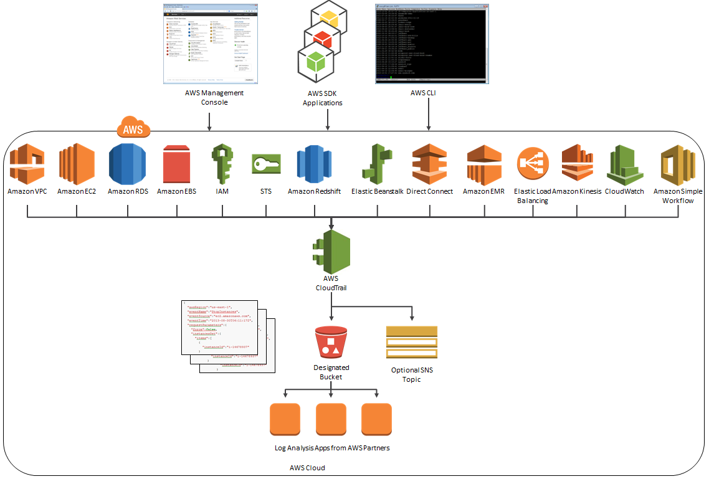

Figure 8 AWS CloudTrail diagram, showcasing the flow of events from various AWS services to CloudTrail and ultimately to the designated Amazon S3 bucket.

Further Reading: Gaining a Deeper Understanding

Delving into the technical intricacies outlined in AWS documentation provides a comprehensive understanding of AWS CloudTrail. Internal references reveal that CloudTrail is not merely a logging service but a crucial component for maintaining a secure and compliant AWS environment. Complementing this, external third-party references offer valuable insights. For instance, the whitepaper "AWS CloudTrail: User Guide” serves as a key external resource. Within this document, readers gain insights into industry trends, best practices, and real-world success stories, enriching their understanding of the broader context of governance within AWS environments.

**AWS Command Line Interface (CLI): Streamlining Cloud Management through Command-Line Efficiency**

In the landscape of AWS Management and Governance, the AWS Command Line Interface (CLI) emerges as a powerful tool for administrators and developers seeking efficient, scriptable, and programmatic access to AWS services. This section provides a comprehensive exploration of the AWS CLI, elucidating its core functionalities, key features, practical applications, and real-world deployment strategies.

Overview and Core Functionality

The AWS CLI serves as a unified tool to interact with various AWS services directly from the command line[19]. This command-line interface allows users to execute commands to access and manage AWS resources, facilitating a streamlined and automated approach to cloud management. The AWS CLI is designed to provide users with a consistent experience across multiple AWS services, reducing the learning curve for administrators and developers.

Key Features and Use Cases

This section delves into the key features of the AWS CLI, emphasizing its versatility in supporting a wide array of AWS services. Users can perform tasks such as creating and managing Amazon EC2 instances, configuring Amazon S3 buckets, and interacting with AWS Lambda functions, all through simple command-line commands. Real-world use cases illustrate how the AWS CLI can be integrated into automation workflows, enabling the seamless orchestration of AWS resources.

Practical Applications and Scripting

One of the strengths of the AWS CLI lies in its suitability for automation and scripting. This section explores practical applications, demonstrating how users can leverage the AWS CLI to write scripts, automate repetitive tasks, and integrate AWS resource management into custom workflows. Examples of scriptable actions, such as automating backups or resource provisioning, showcase the efficiency and flexibility of the AWS CLI.

Integration with AWS Services

The AWS CLI seamlessly integrates with various AWS services, enhancing its utility for users. This section provides insights into how the AWS CLI interacts with services like Amazon DynamoDB, AWS CloudFormation, and AWS Identity and Access Management (IAM). Understanding these integrations is crucial for users aiming to build comprehensive and automated solutions using the AWS CLI.

Real-world Deployment Strategies

To provide actionable insights, this section offers deployment strategies for organizations and individuals looking to leverage the AWS CLI effectively. It explores best practices for installing and configuring the AWS CLI, structuring commands for optimal efficiency, and securing AWS CLI interactions. Real-world scenarios highlight how the AWS CLI can be an asset in diverse cloud management scenarios.

**Visual Diagram/Figure Placeholder:**

Incorporate a representation of a sample command sequence using the AWS CLI. A step-by-step illustration of a common task, such as creating an EC2 instance or configuring an S3 bucket, can enhance the reader's understanding of the AWS CLI's command structure and its practical application.

Further Reading: Gaining a Deeper Understanding

Exploring the technical intricacies outlined in AWS documentation provides a comprehensive understanding of the AWS CLI[20]. Internal references reveal that the AWS CLI is not only a powerful tool for individual tasks but a versatile and extensible interface for managing AWS resources at scale. Complementing this, external third-party references offer valuable insights. For instance, the book "Mastering AWS Command-line Interface"[21] serves as a key external resource. Within this publication, readers gain practical insights, tips, and best practices for maximizing the potential of the AWS CLI in real-world scenarios.

**AWS Compute Optimizer: Optimizing Resource Utilization for Enhanced Performance**

In the dynamic landscape of cloud management and governance, resource optimization is paramount for achieving operational efficiency and cost-effectiveness. AWS Compute Optimizer stands as a key solution within the AWS ecosystem, providing advanced insights and recommendations to optimize compute resources. This section delves into the core functionalities, key features, practical applications, and deployment strategies of AWS Compute Optimizer.

Overview and Core Functionality

AWS Compute Optimizer is a machine learning-powered service designed to analyze the utilization patterns of compute resources and provide tailored recommendations for optimal performance and cost-efficiency[22]. By evaluating historical resource utilization, Compute Optimizer identifies opportunities for improvement, helping users strike the right balance between performance and cost.

Key Features and Use Cases

This section explores the key features of AWS Compute Optimizer, emphasizing its ability to analyze Amazon EC2 instances and Auto Scaling groups. Compute Optimizer assesses the configuration of these resources and generates personalized recommendations to enhance performance, increase reliability, and reduce costs. Real-world use cases illustrate how organizations can leverage these recommendations to achieve better resource utilization.

Practical Applications and Benefits

AWS Compute Optimizer offers practical applications for users seeking to enhance the efficiency of their cloud infrastructure. By providing detailed insights into resource utilization, this service empowers organizations to make informed decisions about resizing, modifying instance types, and optimizing their Auto Scaling configurations. The benefits include improved application performance, reduced infrastructure costs, and enhanced overall reliability.

Integration with AWS Services

This section provides insights into how AWS Compute Optimizer integrates with other AWS services, particularly Amazon CloudWatch. The integration allows users to view optimization recommendations directly within the CloudWatch console, streamlining the monitoring and optimization workflow. Understanding this integration is crucial for organizations looking to incorporate Compute Optimizer into their existing cloud management practices.

Real-world Deployment Strategies

To provide actionable guidance, this section offers deployment strategies for organizations looking to implement AWS Compute Optimizer effectively. It explores best practices for enabling Compute Optimizer, interpreting recommendations, and implementing changes based on those recommendations. Real-world scenarios highlight how businesses can integrate Compute Optimizer seamlessly into their resource management strategies.

**Visual Diagram/Figure Placeholder:**

Incorporate a representation of the AWS Compute Optimizer dashboard or a sample optimization recommendation. A graphical illustration can provide readers with a clear understanding of how to interpret and act upon the insights provided by Compute Optimizer.

Further Reading: Gaining a Deeper Understanding

Exploring the technical intricacies outlined in AWS documentation is essential for gaining a comprehensive understanding of AWS Compute Optimizer[23]. Internal references reveal that Compute Optimizer is not just a tool for cost reduction but a strategic solution for aligning compute resources with actual demand. Complementing this, external third-party references offer valuable insights. For instance, the whitepaper "Optimizing Your Amazon EC2 Instances with AWS Compute Optimizer"[24] provides in-depth information on best practices and real-world scenarios, enriching the reader's understanding of Compute Optimizer's capabilities.

**AWS Config: Ensuring Compliance and Security in Cloud Infrastructure**

In the realm of cloud management and governance, maintaining compliance, and ensuring the security of cloud infrastructure are critical imperatives. AWS Config serves as a foundational service within the AWS ecosystem, offering comprehensive configuration management to achieve these objectives. This section explores the core functionalities, key features, practical applications, and deployment strategies of AWS Config.

Overview and Core Functionality

AWS Config is a fully managed service designed to assess, audit, and evaluate the configurations of AWS resources[25]. By continuously monitoring and recording configuration changes, AWS Config provides a historical view of resource configurations, enabling users to track changes, troubleshoot operational issues, and ensure compliance with organizational policies and industry regulations.

Key Features and Use Cases

This section delves into the key features of AWS Config, emphasizing its ability to automatically discover AWS resources, track changes over time, and create an inventory of resource configurations. AWS Config Rules allow users to define and enforce policies, ensuring that resource configurations adhere to established best practices and compliance standards. Real-world use cases illustrate how AWS Config can be instrumental in maintaining a secure and compliant cloud environment.

Practical Applications and Benefits

AWS Config offers practical applications for organizations seeking to enhance the security and compliance posture of their cloud infrastructure. By providing visibility into resource configurations, AWS Config enables timely identification and remediation of non-compliant settings. The benefits include improved security, streamlined audit processes, and enhanced overall governance of AWS resources.

Integration with AWS Services

This section provides insights into how AWS Config integrates with other AWS services, particularly AWS CloudTrail and AWS CloudWatch. The integration allows users to capture and analyze configuration changes, monitor compliance, and receive notifications for non-compliant resources. Understanding this integration is crucial for organizations looking to implement AWS Config as part of their overall cloud management strategy.

Real-world Deployment Strategies

To provide actionable guidance, this section offers deployment strategies for organizations looking to implement AWS Config effectively. It explores best practices for setting up configuration recorders, defining custom rules, and leveraging AWS Config advanced features. Real-world scenarios highlight how businesses can integrate AWS Config seamlessly into their existing governance and compliance workflows.

**Visual Diagram Placeholder:**

Incorporate a visual representation of the AWS Config dashboard or a sample compliance report. A graphical illustration can provide readers with a tangible view of how AWS Config presents configuration data and compliance status.

Further Reading: Gaining a Deeper Understanding

Exploring the technical intricacies outlined in AWS documentation is crucial for gaining a comprehensive understanding of AWS Config[26]. Internal references reveal that AWS Config is not merely a tool for tracking changes but a strategic solution for ensuring the security and compliance of AWS resources. Complementing this, external third-party references offer valuable insights. For instance, the whitepaper "AWS Config: Best Practices"[27] provides in-depth information on recommended approaches, configuration best practices, and real-world examples, enriching the reader's understanding of AWS Config's capabilities.

**AWS Control Tower: Orchestrating Multi-Account AWS Environments**

In the intricate landscape of cloud management and governance, maintaining a well-architected, secure, and compliant AWS environment can be a complex endeavor, especially at scale. AWS Control Tower serves as a pivotal service, providing a centralized hub for managing and governing multi-account AWS environments. This section delves into the fundamental functionalities, key features, deployment strategies, and business implications of AWS Control Tower.

Overview and Core Functionality

AWS Control Tower is a purpose-built service designed to set up and govern a secure, multi-account AWS environment based on AWS best practices and organizational policies[28]. At its core, Control Tower automates the process of setting up a landing zone—a pre-configured, security-best-practices-enabled environment—providing a foundation for scalable and well-managed AWS workloads.

Key Features and Components

This section explores the key features of AWS Control Tower, including Account Factory, Service Control Policies (SCPs), and the Landing Zone. Account Factory streamlines the creation of new AWS accounts, ensuring they adhere to organizational policies. SCPs enable fine-grained control over permissions, and the Landing Zone acts as a foundational environment that incorporates AWS best practices for security and compliance.

Automated Landing Zone Deployment

AWS Control Tower's primary strength lies in its ability to automate the deployment of a well-architected Landing Zone. Through the Account Vending process, AWS Control Tower ensures that new accounts are provisioned with the necessary guardrails, such as AWS Organizations, AWS Single Sign-On (SSO), and AWS Config, fostering a secure and compliant foundation.

Governance at Scale

This section discusses how AWS Control Tower facilitates governance at scale by providing a single pane of glass for managing multiple AWS accounts. Centralized visibility and control empower organizations to enforce security policies consistently, track compliance, and respond to changes in real time across their AWS environment.

Business Implications

From a business perspective, the deployment of AWS Control Tower translates into streamlined governance, improved security posture, and enhanced operational efficiency. The centralized approach to managing multiple AWS accounts reduces the complexity of environment setup and ongoing management, allowing organizations to focus on innovation and business growth.

Further Reading: Gaining a Deeper Understanding

**Visual Graphic Placeholder:**

Incorporate a visual representation of the AWS Control Tower architecture or a workflow diagram illustrating the automated Landing Zone deployment process. A graphical element can enhance readers' understanding of the service's structure and its role in orchestrating multi-account AWS environments.

Exploring the technical intricacies outlined in AWS documentation is essential for a comprehensive understanding of AWS Control Tower[29]. Internal references shed light on the nuanced configurations and capabilities of the service. Additionally, external third-party references, such as the whitepaper "AWS Control Tower: Best Practices"[30], offer insights into industry-recognized best practices and deployment strategies, enriching the reader's comprehension of AWS Control Tower's multifaceted governance features.

**AWS Distro for OpenTelemetry: Enhancing Observability in Distributed Systems**

In the intricate landscape of cloud management and governance, gaining comprehensive insights into the performance and health of distributed systems is crucial. AWS Distro for OpenTelemetry (ADOT) emerges as a pivotal tool, providing a standardized and secure approach to collecting observability data. This section explores the foundational aspects, key features, integration strategies, and business implications of AWS Distro for OpenTelemetry.

Overview and Core Functionality

AWS Distro for OpenTelemetry is an open-source distribution of the OpenTelemetry project, designed to enable observability in cloud-native environments[31]. At its core, ADOT facilitates the generation, collection, and correlation of traces and metrics from applications, offering valuable insights into their behavior and interactions.

Key Features and Components

This section delves into the key features of AWS Distro for OpenTelemetry, emphasizing its compatibility with various programming languages, the incorporation of both tracing and metrics components, and its adherence to open standards. Components like the OpenTelemetry Collector and SDKs contribute to the robustness of ADOT, allowing for flexibility in data collection across diverse environments.

Integration with AWS Services

ADOT seamlessly integrates with various AWS services, enhancing its utility within the AWS ecosystem. The integration with AWS X-Ray for distributed tracing and Amazon CloudWatch for metrics provides a unified observability solution. This section outlines how ADOT acts as a bridge, allowing businesses to gain holistic insights into the performance of their AWS workloads.

Standardization and Compatibility

AWS Distro for OpenTelemetry plays a crucial role in standardizing observability practices across different applications and services. This section explores how the adoption of open standards ensures compatibility with other observability tools, fostering interoperability and simplifying the management of distributed systems.

Business Implications

From a business perspective, the deployment of AWS Distro for OpenTelemetry translates into enhanced observability and, subsequently, improved decision-making. By gaining detailed insights into the performance of distributed applications, organizations can proactively identify and address issues, optimize resource utilization, and enhance the overall user experience.

**Visual Diagram Placeholder::**

Consider including a visual representation of the AWS Distro for OpenTelemetry architecture or a diagram illustrating how traces and metrics flow through the system. A graphical element can provide readers with a clear understanding of how ADOT operates within a distributed environment, adding visual value to the section.

Further Reading: Gaining a Deeper Understanding

Exploring AWS documentation is paramount for a comprehensive understanding of AWS Distro for OpenTelemetry[32]. Internal references provide insights into the technical nuances and configurations, while external third-party references, such as articles and case studies on implementing OpenTelemetry in cloud-native environments, can offer additional perspectives and best practices.

**AWS Launch Wizard: Streamlining Application Deployments**

In the realm of cloud management and governance, the efficient deployment of applications is a critical factor in ensuring operational success. AWS Launch Wizard emerges as a powerful tool, streamlining and automating the deployment of applications on AWS infrastructure. This section delves into the core functionalities, key features, integration capabilities, and business implications of AWS Launch Wizard.

Overview and Core Functionality

AWS Launch Wizard is a service that simplifies the deployment of applications on AWS by automating best practices[33]. It provides a guided and streamlined experience for configuring, sizing, and deploying applications, reducing the complexity traditionally associated with the setup and optimization of infrastructure.

Key Features and Components

This section explores the key features of AWS Launch Wizard, emphasizing its ability to support a variety of applications, including Microsoft Windows and SQL Server-based applications. The service automates the configuration of underlying AWS resources, such as Amazon EC2 instances, Amazon RDS databases, and Amazon VPC settings, ensuring a standardized and optimized deployment.

Integration with AWS Services

AWS Launch Wizard seamlessly integrates with other AWS services, enhancing its capabilities within the broader AWS ecosystem. Integration with services like AWS CloudFormation allows users to extend deployments further by customizing templates and configurations. This section provides insights into how Launch Wizard can be part of a holistic application deployment strategy.

Automation and Best Practices

An integral aspect of AWS Launch Wizard is its focus on automation and adherence to best practices. By automating routine and error-prone tasks, the service accelerates the deployment process while ensuring that applications are configured according to AWS best practices. This section highlights how Launch Wizard contributes to operational efficiency and reliability.

Business Implications

From a business standpoint, the adoption of AWS Launch Wizard translates into significant time and resource savings. The automation of deployment tasks reduces the likelihood of errors, accelerates time-to-market for applications, and allows IT teams to focus on strategic initiatives rather than routine configurations. This section explores the tangible business benefits of leveraging Launch Wizard for application deployments.

**Visual Diagram Placeholder:**

Consider including a visual representation of the AWS Launch Wizard interface or a flowchart illustrating the deployment process. A graphical element can provide readers with a visual walkthrough of how Launch Wizard guides users through the configuration and deployment steps, enhancing the section's clarity and engagement.

Further Reading: Gaining a Deeper Understanding

Exploring AWS documentation is essential for a comprehensive understanding of AWS Launch Wizard[34]. Internal references offer insights into the technical configurations and capabilities, while external third-party references, such as case studies and articles on successful application deployments using AWS Launch Wizard, can provide real-world perspectives and additional insights.

**AWS CloudTrail: Enhancing Visibility and Security**

In the landscape of cloud management and governance, visibility into user activity and resource changes is paramount. AWS CloudTrail, a foundational service within the AWS ecosystem, addresses this need by providing a comprehensive solution for logging, monitoring, and retaining AWS account activity. This section delves into the core functionalities, key features, integration capabilities, and business implications of AWS CloudTrail.

Overview and Core Functionality

AWS CloudTrail is a service that enables governance, compliance, operational auditing, and risk auditing of AWS accounts[35]. It achieves this by recording AWS API calls and capturing vital information such as the identity of the caller, the time of the call, the source IP address, the request parameters, and the response elements returned by the AWS service.

Key Features and Components

This section explores the key features of AWS CloudTrail, emphasizing its ability to deliver a comprehensive view of AWS account activity. CloudTrail records changes to resources, helping users understand who made a particular change, what the change was, and when it occurred. Components like trails, events, and multi-region trails are discussed to provide a holistic understanding of the service.

Integration with AWS Services

AWS CloudTrail seamlessly integrates with various AWS services, enhancing its functionality within the AWS ecosystem. Integration with Amazon S3 and AWS CloudWatch allows users to store CloudTrail logs securely and set up alerts based on specific events. This section provides insights into how CloudTrail has become an integral part of a robust security and compliance strategy.

Security and Compliance

An essential aspect of AWS CloudTrail is its role in enhancing security and ensuring compliance. The service helps in detecting unusual activity, aiding in troubleshooting, and meeting regulatory requirements. By recording API calls, CloudTrail contributes to the traceability of actions taken within an AWS environment.

**Visual Diagram Placeholder:**

Incorporate a visual representation of a CloudTrail dashboard or a flowchart illustrating how CloudTrail logs are generated, stored, and can be analyzed. This visual aid can offer readers a clear understanding of the service's workflow and how it contributes to governance, compliance, and security.

Business Implications

From a business standpoint, the adoption of AWS CloudTrail provides transparency, accountability, and security. Organizations can use CloudTrail logs for forensic analysis, compliance reporting, and auditing purposes. This section explores how CloudTrail contributes to maintaining a secure and well-governed AWS environment, aligning with industry best practices.

Further Reading: Gaining a Deeper Understanding

Exploring AWS documentation is essential for a comprehensive understanding of AWS CloudTrail[36]. Internal references offer insights into technical configurations and capabilities, while external third-party references, such as case studies and articles on successful security implementations using AWS CloudTrail, can provide real-world perspectives and additional insights.

**AWS Managed Services: Streamlining Operations and Governance**

In the ever-expanding realm of cloud management, AWS Managed Services (AMS) emerges as a comprehensive solution designed to simplify and streamline operations for AWS users. This section explores the core functionalities, key features, integration capabilities, and the broader business implications of AWS Managed Services.

Overview and Core Functionality

AWS Managed Services is a suite of services and tools aimed at assisting organizations in managing their AWS infrastructure[37]. The primary goal is to offload the operational overhead associated with day-to-day management, allowing businesses to focus more on innovation and strategic initiatives. AMS extends support to a wide range of AWS services, providing a holistic management solution.

Key Features and Components

This section delves into the key features of AWS Managed Services, highlighting its capabilities in automating common operational tasks such as change requests, monitoring, patch management, security, and backup services. Components like the Control Tower and Landing Zones are explored to provide readers with a comprehensive understanding of the service's architecture.

Integration with AWS Services

AWS Managed Services seamlessly integrates with various AWS services, contributing to its effectiveness in managing complex cloud infrastructures. Integration with AWS Organizations, AWS Config, and AWS CloudTrail enhances governance, security, and compliance. This section provides insights into how AMS fits into the broader AWS ecosystem.

**Visual Diagram Placeholder:**

Incorporate a visual representation of the AMS Control Tower or a diagram illustrating how AMS integrates with different AWS services. This visual aid can help readers grasp the architecture and visualize how AMS functions within the broader AWS infrastructure.

Security and Compliance

Security and compliance are at the forefront of AWS Managed Services. This section explores how AMS assists organizations in maintaining a secure and compliant environment through automated security practices, regular patching, and adherence to AWS Well-Architected Framework principles.

Business Implications

From a business perspective, the adoption of AWS Managed Services offers operational efficiency, scalability, and improved governance. AMS enables organizations to shift their focus from routine management tasks to strategic initiatives, fostering innovation. This section discusses the broader implications of AMS on business agility and competitiveness.

Further Reading: Gaining a Deeper Understanding

Exploring AWS documentation is crucial for a comprehensive understanding of AWS Managed Services[38]. Internal references offer technical insights and configurations, while external third-party references, such as case studies and industry analyses, provide real-world perspectives on successful AMS implementations.

**AWS Management Console Mobile Application: Managing AWS On the Go**

In the era of mobile computing, the AWS Management Console Mobile Application emerges as a valuable tool, providing AWS users with the flexibility to manage their cloud resources anytime, anywhere. This section provides an in-depth exploration of the features, functionalities, security considerations, and practical benefits of using the AWS Management Console Mobile Application.

Overview and Core Functionalities

The AWS Management Console Mobile Application is designed to extend the AWS Management Console experience to mobile devices[39]. This section delves into the core functionalities of the mobile application, allowing users to monitor resource health, view and respond to alarms, access key operational metrics, and perform essential management tasks directly from their mobile devices.

Key Features and Interface

Readers will gain insights into the key features of the AWS Management Console Mobile Application, including the ability to view and interact with AWS resources through an intuitive and user-friendly interface. The discussion covers features such as real-time status monitoring, resource navigation, and the execution of commands, providing a comprehensive understanding of the application's capabilities.

**Visual Diagram Placeholder:**

Incorporate screenshots or a step-by-step visual guide demonstrating the key features and user interface of the AWS Management Console Mobile Application. Visual aids can enhance reader comprehension and provide a practical preview of the mobile application's functionality.

Security Considerations

Security is paramount in mobile application usage. This section addresses the security measures implemented in the AWS Management Console Mobile Application, such as multi-factor authentication (MFA), encryption of data in transit, and best practices for securing access to AWS resources from mobile devices.

Practical Benefits and Use Cases

The AWS Management Console Mobile Application offers practical benefits for users who need on-the-go access to their AWS resources. This section explores real-world use cases, demonstrating how the mobile application enhances operational efficiency, accelerates issue resolution, and facilitates quick decision-making.

Integration with AWS Services

The mobile application seamlessly integrates with various AWS services. This section provides insights into how users can leverage the application to interact with services like Amazon EC2, Amazon S3, and AWS Lambda, fostering a cohesive and efficient management experience.

Business Implications

From a business perspective, the AWS Management Console Mobile Application contributes to increased operational agility and responsiveness. This section discusses how the application aligns with the broader goals of cloud management, ensuring that AWS users can stay connected and manage their resources effectively, even when away from their desks.

Further Reading: Gaining a Deeper Understanding

For readers seeking a more profound understanding of the AWS Management Console Mobile Application, exploring AWS documentation[40] is recommended. Internal references provide technical insights, while external references, such as user testimonials and case studies, offer practical perspectives on the application's usability and benefits.

**AWS OpsWorks: Streamlined Application Management**

AWS OpsWorks, a configuration management service provided by Amazon Web Services, simplifies the deployment and management of applications in the cloud. In this section, we delve into the features, benefits, and practical considerations of using AWS OpsWorks for efficient application management and deployment.

Overview and Core Functionality

AWS OpsWorks automates the process of code deployment, infrastructure configuration, and application lifecycle management[41]. This section provides a detailed overview of how OpsWorks facilitates seamless operations, enabling users to define their application architecture and deploy across multiple instances.

Key Features and Components

Readers will gain insights into the key features of AWS OpsWorks, including the core components such as stacks, layers, and instances. Understanding how OpsWorks structure these components helps in crafting scalable and maintainable application architectures.

**Visual Diagram Placeholder:**

Incorporate an architecture diagram illustrating the relationship between OpsWorks stacks, layers, and instances. Visual aids can enhance comprehension of the hierarchical structure and workflow within AWS OpsWorks.

Deployment Strategies and Flexibility

This section explores various deployment strategies supported by AWS OpsWorks, such as time-based and load-based deployments. Additionally, OpsWorks provides flexibility through custom Chef and Puppet recipes, allowing users to define their application's architecture and configuration.

Integration with Other AWS Services

OpsWorks seamlessly integrates with other AWS services, enhancing its utility. This section sheds light on how OpsWorks can be integrated with services like Amazon RDS, Elastic Load Balancing, and Auto Scaling, creating a comprehensive environment for application deployment and management.

Security Considerations

Security is a critical aspect of application management. This section addresses the security features of AWS OpsWorks, including identity and access management (IAM) integration, encryption, and best practices for securing sensitive information within the OpsWorks environment.

Practical Benefits and Use Cases

Readers will explore the practical benefits and use cases of AWS OpsWorks, ranging from automating routine tasks to managing complex applications. Real-world scenarios demonstrate how OpsWorks streamlines processes, improves efficiency and provides a scalable solution for diverse application architectures.

Business Implications

From a business standpoint, deploying applications with AWS OpsWorks translates into operational efficiency, cost savings, and improved reliability. This section discusses how OpsWorks aligns with business goals, allowing for the rapid and consistent deployment of applications.

Further Reading: Gaining a Deeper Understanding

For readers interested in a deeper understanding of AWS OpsWorks, exploring AWS documentation[42] is recommended. Internal references provide technical insights, while external references, such as case studies and best practice guides, offer practical perspectives on optimizing OpsWorks for specific use cases.

**AWS Organizations: Streamlining Cloud Resource Management**

In the realm of cloud management and governance, AWS Organizations emerges as a cornerstone service, providing a comprehensive framework for structuring and managing the AWS environment. This section delves into the features, benefits, and strategic considerations of AWS Organizations for effective resource management in cloud infrastructures.

Overview and Core Functionality

AWS Organizations simplify the complexity of managing multiple AWS accounts within an organization[43]. This section offers an in-depth overview of how Organizations provide a hierarchical and scalable structure, enabling administrators to manage permissions, apply policies, and consolidate billing across accounts.

Key Features and Components

Readers will gain insights into the key features of AWS Organizations, including the organizational units (OUs), service control policies (SCPs), and the master account. Understanding these components is crucial for designing an organizational structure that aligns with business needs and regulatory requirements.

**Visual Diagram Placeholder:**

Incorporate an organizational diagram illustrating the hierarchical structure of AWS Organizations, depicting relationships between accounts, OUs, and SCPs. Visual aids enhance comprehension of the organizational framework within AWS.

Policy-Based Management

This section explores how AWS Organizations facilitate policy-based management through SCPs. Readers will understand how SCPs help enforce security and compliance standards across the organization, ensuring a consistent and controlled deployment of resources.

Consolidated Billing and Cost Allocation

AWS Organizations simplifies billing and cost allocation by consolidating charges across all linked accounts. This section outlines the benefits of consolidated billing and how organizations can leverage this feature to gain insights into cost distribution and optimize resource spending.

Strategic Considerations for Implementation

Strategic considerations are crucial for the successful implementation of AWS Organizations. This section provides practical guidance on structuring OUs, defining SCPs, and aligning the organizational hierarchy with business units, enhancing the agility and efficiency of resource management.

Integration with Other AWS Services

AWS Organizations seamlessly integrates with other AWS services, enhancing its capabilities. This section explores how Organizations can be integrated with AWS Identity and Access Management (IAM), AWS Single Sign-On (SSO), and other services to create a unified and secure cloud environment.

Real-world Deployment Strategies

Readers will gain insights into real-world deployment strategies for AWS Organizations. Practical examples showcase how organizations can structure their accounts, apply policies, and use Organizations to efficiently manage resources, ensuring scalability and governance.

Business Implications

From a business standpoint, AWS Organizations contribute to operational efficiency, cost management, and regulatory compliance. This section discusses how adopting Organizations aligns with business goals, fostering a streamlined and secure cloud environment.

Further Reading: Gaining a Deeper Understanding

For readers seeking a deeper understanding of AWS Organizations, exploring AWS documentation[44] is recommended. Internal references provide technical insights, while external references, such as case studies and best practice guides, offer practical perspectives on optimizing Organizations for specific use cases.

**AWS Personal Health Dashboard: Proactive Monitoring for Operational Excellence**

In the landscape of cloud management and governance, the AWS Personal Health Dashboard (PHD) serves as a crucial tool, providing real-time insights into the operational status of AWS resources. This section navigates through the features, benefits, and practical applications of the AWS Personal Health Dashboard, offering readers a comprehensive understanding of its role in ensuring operational excellence.

Overview and Core Functionality

The AWS Personal Health Dashboard is a centralized service that offers a personalized view of the health of AWS resources[45]. This section provides an in-depth overview of how PHD aggregates information from multiple AWS services, presenting it in a consolidated and easily accessible format for users.

Key Features and Components

Readers will gain insights into the key features of the AWS Personal Health Dashboard, including the ability to view alerts, remediation guidance, and integration with AWS Support. Understanding these components is essential for leveraging PHD effectively in monitoring and maintaining the health of AWS resources.

**Visual Diagram Placeholder:**

Consider including a visual representation of the AWS Personal Health Dashboard interface, showcasing its user-friendly design and the visualization of resource health. Screenshots or diagrams can enhance the reader's comprehension of the dashboard's layout and functionalities.

Proactive Monitoring and Alerting

This section explores how the AWS Personal Health Dashboard facilitates proactive monitoring by providing real-time alerts about events that may impact AWS resources. Readers will understand how to interpret these alerts and take preemptive actions to ensure the continuity of operations.

Integration with AWS Support

AWS PHD seamlessly integrates with AWS Support, enhancing its capabilities. This section discusses how users can leverage integration to access detailed support information, including status updates, upcoming maintenance events, and proactive recommendations.

Use Cases and Practical Applications

Real-world use cases illustrate how organizations can benefit from the AWS Personal Health Dashboard. Examples include identifying and mitigating issues before they impact operations, minimizing downtime, and optimizing resource utilization for enhanced efficiency.

Customization and User Preferences

PHD allows users to customize their dashboard based on their preferences and priorities. This section guides readers through the process of tailoring alerts, setting preferences, and configuring notifications, ensuring a personalized and efficient monitoring experience.

Strategic Considerations for Implementation

Strategic considerations are vital for the effective implementation of the AWS Personal Health Dashboard. This section provides practical guidance on aligning PHD with organizational goals, setting up custom alerts, and integrating them into existing monitoring workflows.

Business Implications

From a business standpoint, the AWS Personal Health Dashboard contributes to operational resilience, minimizing the impact of potential issues on business operations. This section discusses how proactive monitoring with PHD aligns with business continuity and risk management strategies.

Further Reading: Gaining a Deeper Understanding

For readers seeking a deeper understanding of AWS Personal Health Dashboard, exploring AWS documentation[46] is recommended. Internal references provide technical insights, while external references, such as case studies and best practice guides, offer practical perspectives on maximizing the benefits of PHD.

**AWS Proton: Streamlining Container and Serverless Application Deployment**

In the dynamic realm of cloud management and governance, efficient application deployment is a cornerstone for operational success. AWS Proton emerges as a comprehensive service, streamlining the deployment and management of containerized and serverless applications. This section provides a detailed exploration of AWS Proton, shedding light on its functionalities, benefits, and strategic implications for businesses.

Overview and Core Functionality

AWS Proton is introduced as a fully managed service designed to automate and streamline the deployment of containerized and serverless applications[47]. This section delves into the fundamental principles and core functionalities that underpin Proton's role in simplifying the application deployment lifecycle.

Key Features and Components

Readers gain insights into the key features and components of AWS Proton, including its ability to create and manage environments, define service templates, and facilitate collaboration among development teams. Understanding these elements is crucial for harnessing Proton's capabilities effectively.

**Visual Diagram Placeholder:**

Consider including visual representations, such as diagrams or flowcharts, to illustrate the workflow of AWS Proton. Visual aids can enhance the reader's comprehension of Proton's deployment processes and the interaction between its various components.

Service Templates and Environments

This section explores the concept of service templates in Proton, elucidating how they serve as blueprints for defining the infrastructure and configurations of applications. Additionally, the management of environments is discussed, emphasizing how Proton ensures consistency across different deployment stages.

Collaboration and Governance

Proton is positioned as a collaborative tool for development teams. The section outlines how Proton facilitates collaboration by providing a centralized platform for defining, managing, and sharing service templates. Governance mechanisms within Proton to ensure adherence to organizational policies are also discussed.

Proton in Action: Deployment Workflows

Real-world examples and use cases demonstrate how AWS Proton operates in practical scenarios. The section walks through deployment workflows, showcasing how Proton automates the provisioning of infrastructure, deployment of code, and management of application configurations.

Integration with AWS Services

AWS Proton seamlessly integrates with other AWS services, enhancing its capabilities. This section explores how Proton integrates with AWS Identity and Access Management (IAM), AWS CloudFormation, and AWS CodePipeline, providing readers with a holistic understanding of its interoperability within the AWS ecosystem.

Best Practices for Proton Implementation:

Strategic considerations for implementing AWS Proton are discussed, offering readers guidance on optimizing Proton for their specific use cases. Best practices cover service template design, environment management, and leveraging Proton for both containerized and serverless applications.

Business Implications

From a business perspective, the deployment efficiency brought by AWS Proton translates into accelerated time-to-market for applications. This section explores how Proton aligns with business objectives, fostering agility, reducing manual intervention, and minimizing deployment-related challenges.

Further Reading: Gaining a Deeper Understanding

To delve deeper into AWS Proton's technical intricacies and best practices, readers are encouraged to explore AWS documentation[48]. Internal references provide insights into Proton's features, while external references, such as case studies and success stories, offer practical perspectives on its real-world implementation.

**AWS Resilience Hub: Strengthening Cloud Infrastructures**

In the dynamic landscape of cloud management and governance, ensuring the resilience of cloud infrastructures is paramount. The AWS Resilience Hub emerges as a critical component, providing organizations with tools and insights to enhance their ability to withstand disruptions. This section offers an in-depth exploration of the AWS Resilience Hub, its features, and its role in fortifying cloud environments.

Introduction to AWS Resilience Hub

The AWS Resilience Hub is introduced as a comprehensive service designed to help organizations manage and improve the resilience of their applications in the cloud[49]. This section emphasizes the significance of resilience in the context of cloud infrastructure and sets the stage for a detailed exploration of the tool's capabilities.

**Visual Graphic Placeholder:**

Incorporate a visual representation, such as a diagram or flowchart, to illustrate how the AWS Resilience Hub interacts with different AWS services and contributes to the overall resilience of the cloud infrastructure. Visual aids can enhance the reader's comprehension of the tool's functionalities.

Key Features and Functionality

The section delves into the key features of the AWS Resilience Hub, highlighting its ability to aggregate and visualize resilience-related information across multiple AWS accounts and regions. This includes discussions on the hub's role in centralizing insights related to disaster recovery, fault tolerance, and overall system stability.

Integration with AWS Organizations

Insights are provided on how the AWS Resilience Hub seamlessly integrates with AWS Organizations, allowing organizations to extend their resilience management across an entire organization. This integration enhances the tool's scalability and adaptability to diverse cloud architectures.

Resilience Dashboard

A detailed exploration of the Resilience Dashboard is undertaken, elucidating how it provides a centralized view of an organization's resilience posture. This includes discussions on the dashboard's capabilities for monitoring the health of critical resources, identifying vulnerabilities, and ensuring compliance with resilience best practices.

Automated Insights and Recommendations

The section explores how the AWS Resilience Hub employs automated insights and recommendations to assist organizations in identifying areas for improvement. Practical examples illustrate how these automated features contribute to proactive resilience management.

Real-time Monitoring and Alerting

Readers gain insights into how the AWS Resilience Hub facilitates real-time monitoring and alerting, ensuring that organizations can respond swiftly to potential disruptions. This includes discussions on the tool's capabilities for detecting anomalies and providing actionable alerts.

Business Continuity and Disaster Recovery

The role of the AWS Resilience Hub in supporting business continuity and disaster recovery strategies is emphasized. Case studies and practical examples illustrate how organizations leverage the tool to ensure uninterrupted operations in the face of unforeseen events.

Business Implications

From a business standpoint, the deployment of the AWS Resilience Hub is positioned as a strategic investment in long-term operational resilience. This section explores how organizations can derive business value by ensuring continuous availability and reliability of critical applications.

Further Reading: Gaining a Deeper Understanding

Readers are encouraged to explore the AWS Resilience Hub documentation for a more comprehensive understanding of the tool's technical intricacies[50]. Internal references provide detailed insights, while external case studies and success stories offer practical perspectives on resilience management.

**AWS Service Catalog: Standardizing and Managing IT Services**

In the landscape of cloud management and governance, the AWS Service Catalog plays a pivotal role in providing organizations with a standardized and efficient approach to managing IT services. This section delves into the intricate details of the AWS Service Catalog, exploring its features, benefits, and strategic implications for businesses.

Overview and Core Functionality

AWS Service Catalog is introduced as a service that allows organizations to create, govern, and manage a catalog of IT services. This section provides a foundational understanding of the core functionalities that underpin the role of Service Catalog in IT service management[51].

Key Features and Components

Readers are guided through the key features and components of the AWS Service Catalog, including the concept of portfolios, products, and constraints. Understanding these elements is crucial for establishing a well-organized and governed catalog of IT services.

**Visual Diagram Placeholder:**

Incorporate visual aids, such as diagrams illustrating the relationships between portfolios, products, and constraints within the AWS Service Catalog. Visual representations can enhance the reader's grasp of the service's organizational structure.

Portfolios and Products

This section explores how the AWS Service Catalog allows organizations to group and manage related products through portfolios. It sheds light on the creation of portfolios to align with organizational structures and the inclusion of products within them.

Constraints and Governance

AWS Service Catalog provides mechanisms for governance through the imposition of constraints. The section discusses how constraints can be defined to control the use of specific resources or configurations, ensuring compliance with organizational policies and standards.

Integration with AWS Services

Service Catalog seamlessly integrates with other AWS services. This section explores how Service Catalog interacts with AWS Identity and Access Management (IAM), AWS CloudFormation, and AWS Lambda, offering readers insights into its interoperability within the AWS ecosystem.

End-User Experience

The end-user experience is a crucial aspect of AWS Service Catalog. This section details how end-users can browse and launch products from the catalog, emphasizing the self-service nature of Service Catalog and its role in empowering teams.

Lifecycle Management

AWS Service Catalog facilitates the entire lifecycle of IT services. From the creation of products to versioning and updates, this section provides a comprehensive understanding of how Service Catalog ensures the smooth evolution of IT services over time.

Best Practices for Implementation

Strategic considerations for implementing AWS Service Catalog are discussed, providing readers with guidance on designing efficient catalogs, defining effective constraints, and optimizing the end-user experience.

Business Implications

From a business perspective, AWS Service Catalog contributes to cost efficiency, standardization, and compliance. This section explores how Service Catalog aligns with business objectives, offering a structured approach to IT service management that fosters consistency and governance.

Further Reading: Gaining a Deeper Understanding

For a more profound insight into AWS Service Catalog's technical intricacies and best practices, readers are encouraged to explore AWS documentation[52]. Internal references provide insights into Service Catalog's features, while external references, such as case studies, offer practical perspectives on its real-world implementation.

**AWS Service Management Connector: Bridging the Gap between AWS and ServiceNow**

In the realm of cloud management and governance, the AWS Service Management Connector emerges as a key facilitator, seamlessly integrating AWS services with the popular IT Service Management (ITSM) platform, ServiceNow. This section delves into the comprehensive features, integration capabilities, and strategic advantages that AWS Service Management Connector brings to organizations.

Overview and Integration

AWS Service Management Connector is introduced as a bridge that connects AWS services and ServiceNow. This section provides a high-level overview of the purpose and significance of this connector in the context of IT service management[53].

**Visual Diagram Placeholder:**

Incorporate a visual representation, such as a workflow diagram, to illustrate the integration process between AWS services and ServiceNow through AWS Service Management Connector. Visual aids can enhance the reader's understanding of the connector's role in bridging the gap between these platforms.

Seamless AWS ServiceNow Integration

Readers are guided through the seamless integration capabilities of AWS Service Management Connector with ServiceNow. This includes the bi-directional communication that allows AWS resources to be provisioned, monitored, and managed directly from the ServiceNow platform.

Key Features and Functionality

This section explores the key features of AWS Service Management Connector, emphasizing its ability to streamline workflows, enhance visibility, and improve collaboration between AWS and ServiceNow users. It highlights features such as incident management, change management, and service catalog integration.

Use Cases and Benefits

Real-world use cases and benefits are presented to illustrate how organizations can leverage AWS Service Management Connector to optimize their IT service management processes. Examples may include faster incident resolution, improved change management, and enhanced reporting capabilities.

Governance and Compliance

AWS Service Management Connector plays a crucial role in ensuring governance and compliance by providing a standardized and controlled way to interact with AWS resources from ServiceNow. This section delves into the governance features that support regulatory compliance and security best practices.

Implementation Best Practices

Strategic considerations for implementing AWS Service Management Connector are discussed, providing readers with guidance on configuration, setup, and ongoing management. Best practices for maintaining secure and efficient integration are emphasized.

Business Implications

From a business standpoint, AWS Service Management Connector contributes to operational efficiency, collaboration, and a unified approach to IT service management. This section explores how the connector aligns with business objectives, fostering an integrated and streamlined ITSM environment.

Further Reading: Gaining a Deeper Understanding

For readers seeking a deeper technical understanding, AWS documentation[54] is recommended. Internal references shed light on the technical intricacies of AWS Service Management Connector, while external case studies and success stories offer practical insights into its real-world impact.

**AWS Systems Manager: Orchestrating Operational Insights and Management**

In the intricate landscape of cloud management, AWS Systems Manager stands out as a versatile and powerful solution. This section explores the comprehensive capabilities of AWS Systems Manager, elucidating its role in orchestrating operational insights and management across AWS environments.

Overview and Core Functionality

AWS Systems Manager is introduced as a unified interface for centralizing operational data and automating tasks. This section provides an overview of its core functionality, emphasizing its role in simplifying resource and application management at scale[55].

**Visual Diagram Placeholder:**

Incorporate a visual representation, such as an architecture diagram, to illustrate the key components and interactions within AWS Systems Manager. Visual aids can enhance the reader's comprehension of the orchestration and automation capabilities of the service.

Operational Insights and Visibility

Readers are guided through how AWS Systems Manager provides operational insights and visibility into their infrastructure. The service's ability to aggregate and visualize data, including patch compliance, instance inventory, and operational health, is highlighted.

Key Features and Use Cases

This section delves into the key features of AWS Systems Manager, including capabilities such as Run Command, State Manager, and Automation. Real-world use cases are presented to showcase how organizations can leverage these features for tasks like patch management, configuration management, and automated responses to operational issues.

Automation and Orchestration

A detailed exploration of the automation and orchestration capabilities of AWS Systems Manager is provided. This includes insights into how automation workflows can be created to streamline operational tasks, ensuring consistency and efficiency in managing resources.

Security and Compliance

AWS Systems Manager plays a pivotal role in maintaining security and compliance by providing a centralized platform for managing and enforcing security policies. This section outlines the security features of the service, including the integration with AWS Identity and Access Management (IAM) and compliance reporting.

Integration with Other AWS Services

The seamless integration of AWS Systems Manager with other AWS services is explored. Examples may include integration with Amazon CloudWatch for enhanced monitoring and with AWS Identity and Access Management for secure access control.

Real-world Deployment Strategies

Practical deployment strategies are offered, providing guidance on best practices for configuring AWS Systems Manager to meet specific organizational needs. Insights into creating automation documents, managing patch baselines, and optimizing operational tasks are discussed.

Business Implications

From a business standpoint, AWS Systems Manager contributes to operational efficiency, cost optimization, and enhanced security. This section explores how the service aligns with broader business objectives, enabling organizations to maintain a proactive and well-managed AWS environment.

Further Reading: Gaining a Deeper Understanding

To delve deeper into the technical intricacies of AWS Systems Manager, readers are encouraged to explore AWS documentation[56]. Internal references provide detailed insights, while external case studies and best practices offer a broader understanding of the service's applications.

**AWS Trusted Advisor: Proactive Guidance for Optimizing AWS Environments**

In the intricate landscape of AWS management and governance, AWS Trusted Advisor emerges as a proactive and indispensable tool for optimizing AWS environments. This section delves into the comprehensive capabilities of AWS Trusted Advisor, providing insights into its role as a guidance system for best practices, cost optimization, and enhanced security.

Overview and Core Functionality

AWS Trusted Advisor is introduced as a cloud service that offers best practices and recommendations to optimize AWS environments across various pillars, including cost optimization, performance, security, and reliability[57]. The section provides an overview of its core functionality, emphasizing its role in delivering actionable insights for improving AWS resources.

**Visual Diagram Placeholder::**

Incorporate a visual representation, such as a dashboard snapshot or a flowchart, to illustrate the key areas that AWS Trusted Advisor evaluates. Visual aids can enhance the reader's understanding of the service's proactive guidance capabilities.

Best Practices and Recommendations

Readers are guided through the key best practices and recommendations provided by AWS Trusted Advisor. This includes insights into cost-saving opportunities, performance improvement suggestions, security enhancements, and reliability optimizations.

Pillars of Evaluation

The section explores the pillars across which AWS Trusted Advisor evaluates AWS environments. This includes a deep dive into each pillar, offering practical examples of the types of checks performed and the corresponding recommendations provided.

Automation and Integration

AWS Trusted Advisor's role in automating the identification of issues and the provision of recommendations is highlighted. Integration possibilities with AWS CloudWatch and AWS Identity and Access Management (IAM) are discussed, showcasing how organizations can leverage automation for a proactive approach to AWS management.

Cost Optimization Strategies

A detailed examination of cost optimization strategies recommended by AWS Trusted Advisor is provided. This includes insights into areas such as the rightsizing of instances, leveraging reserved instances, and identifying idle resources to streamline costs.

Security and Compliance

The proactive security checks performed by AWS Trusted Advisor are explored. Readers gain insights into how the service identifies potential security vulnerabilities and compliance gaps, enabling organizations to strengthen their security posture.

Real-world Implementation

Practical implementation strategies are offered, guiding how organizations can effectively use AWS Trusted Advisor to enhance their AWS environments. This includes creating custom notification settings, implementing automated checks, and integrating recommendations into existing workflows.

Business Implications

From a business standpoint, AWS Trusted Advisor contributes to cost efficiency, enhanced performance, and fortified security. This section explores how organizations can align their AWS management strategies with the recommendations provided by Trusted Advisor to achieve optimal outcomes.

Further Reading: Gaining a Deeper Understanding

To delve deeper into the technical intricacies of AWS Trusted Advisor, readers are encouraged to explore AWS documentation[58]. Internal references provide detailed insights, while external case studies and best practices offer a broader understanding of the service's applications.

**AWS Well-Architected Tool: Blueprint for Building Robust Architectures**

In the realm of AWS management and governance, the AWS Well-Architected Tool stands as a guiding blueprint for organizations aiming to build robust, scalable, and efficient cloud architectures. This section provides an in-depth exploration of the tool's functionalities, its significance in the cloud landscape, and how it contributes to the well-architected framework.

Introduction to AWS Well-Architected Tool

The AWS Well-Architected Tool is introduced as a service that enables organizations to review and improve their cloud architectures by following the best practices recommended by AWS[59]. This section emphasizes the tool's role in aligning architectures with the five pillars of the Well-Architected Framework: operational excellence, security, reliability, performance efficiency, and cost optimization.

**Visual Diagram Placeholder:**

Incorporate a visual representation, such as an infographic or diagram, to illustrate the five pillars of the Well-Architected Framework. Visual aids can enhance the reader's understanding of the key aspects that the tool evaluates.

Pillar-Specific Evaluation

The section delves into each pillar of the Well-Architected Framework, providing insights into the specific considerations and best practices assessed by the tool. This includes discussions on operational practices, security measures, reliability strategies, performance optimization, and cost-saving opportunities.

Aligning with Best Practices

Readers are guided on how the AWS Well-Architected Tool assists in aligning cloud architectures with industry best practices. This includes a detailed examination of how the tool identifies areas for improvement and provides actionable recommendations to enhance the overall architecture.

Risk Mitigation and Security:

The tool's role in risk identification and mitigation is explored, with a specific focus on security considerations. This section provides practical examples of how the Well-Architected Tool helps organizations enhance their security posture by identifying vulnerabilities and suggesting remediation steps.

Performance Optimization:

Insights into how the Well-Architected Tool evaluates performance efficiency are provided. This includes discussions on resource utilization, load balancing, and other considerations aimed at optimizing the overall performance of cloud architectures.

Real-time Evaluation:

The section discusses the real-time evaluation capabilities of the Well-Architected Tool. This includes insights into how organizations can use the tool iteratively throughout the lifecycle of their applications to ensure continuous alignment with best practices.

Actionable Recommendations:

A detailed examination of the actionable recommendations provided by the tool is offered. This includes strategies for implementing changes based on the tool's insights to drive improvements in the cloud architecture.

Business Implications:

From a business perspective, the AWS Well-Architected Tool is positioned as a proactive measure to ensure that cloud architectures are not only functional but also optimized for long-term success. This section explores how adherence to the Well-Architected Framework contributes to organizational resilience and agility.

Further Reading: Gaining a Deeper Understanding

Readers are encouraged to explore AWS documentation for the Well-Architected Tool[60]. Internal references provide detailed insights, while external case studies and success stories offer a broader understanding of how organizations have benefited from adopting the Well-Architected Framework.

**Chapter 11 Conclusion**

In conclusion, Chapter 11 of "AWS Cloud Computing Master Class" has provided an extensive overview of various AWS management and governance services essential for ensuring the reliability, security, and efficiency of cloud infrastructures. Throughout the chapter, we explored a plethora of AWS tools and services designed to monitor, govern, and optimize cloud resources effectively[61].

From the foundational services like Amazon CloudWatch and AWS CloudTrail to the advanced solutions such as AWS Systems Manager and AWS Trusted Advisor, organizations have at their disposal a comprehensive toolkit to manage their AWS environments with precision and

confidence. These services empower organizations to gain insights, enforce compliance, automate workflows, and enhance operational resilience in the cloud[62].

As organizations continue to embrace cloud computing, the importance of effective management and governance cannot be overstated. The scalability and flexibility of the cloud bring forth new challenges in terms of resource management, security, and compliance. However, with the right combination of AWS management and governance services, organizations can navigate these challenges seamlessly while unlocking the full potential of the cloud.

To illustrate the practical application of AWS management and governance services, let us consider a scenario:

**Scenario: Implementing Governance Framework for a Financial Services Firm**

Imagine a large financial services firm that has recently migrated its operations to AWS cloud infrastructure to leverage its scalability and agility. However, the firm faces stringent regulatory requirements and internal policies regarding data privacy, security, and compliance.

In response to these challenges, the firm decided to implement a comprehensive governance framework using AWS management services. Here's how they utilize various AWS services[63]:

**AWS Organizations**: The firm leverages AWS Organizations to centrally manage and govern multiple AWS accounts across different business units and departments. They implement organizational units (OUs) to enforce policies and controls specific to each business unit while ensuring centralized billing and cost management.

**AWS Config**: With AWS Config, the firm continuously assesses the compliance of its AWS resources against predefined rules and policies. They configure custom rules to monitor access controls, encryption settings, and resource configurations, ensuring adherence to industry standards and regulatory requirements.

**AWS CloudFormation**: To maintain consistency and enforce best practices across their AWS environments, the firm uses AWS CloudFormation to automate the deployment and configuration of infrastructure resources. They define infrastructure as code (IaC) templates to provision standardized environments, reducing manual errors, and ensuring reproducibility.

**AWS CloudWatch**: For real-time monitoring and operational visibility, the firm relies on Amazon CloudWatch to monitor performance metrics, detect anomalies, and trigger automated responses to events. They create custom dashboards and alarms to monitor key performance indicators (KPIs) and ensure the availability and performance of critical applications.

**AWS Systems Manager**: To streamline operational tasks and ensure security compliance, the firm utilizes AWS Systems Manager to automate routine administrative tasks, such as patch management, software inventory, and configuration management. They leverage Systems Manager Automation to orchestrate workflows and remediate security vulnerabilities in real time.

**AWS Service Catalog**: The firm utilizes AWS Service Catalog to govern the provisioning and lifecycle management of approved AWS services and resources. They create portfolios containing pre-approved service templates, allowing teams to provision resources while maintaining compliance with organizational policies and standards.

**AWS Trusted Advisor**: As part of their ongoing optimization efforts, the firm regularly consults AWS Trusted Advisor to identify cost optimization opportunities, enhance security posture, and improve operational performance. They act on the recommendations provided by Trusted Advisor to optimize resource utilization, reduce costs, and enhance overall efficiency.

By implementing this comprehensive governance framework, the financial services firm successfully addresses regulatory requirements, mitigates security risks, and enhances operational efficiency in its AWS cloud environment. Through the strategic use of AWS management and governance services, the firm achieves greater visibility, control, and resilience in the cloud.

In conclusion, mastering AWS management and governance is essential for organizations seeking to harness the full potential of cloud computing while maintaining security, compliance, and operational excellence. By leveraging the diverse array of AWS management services discussed in this chapter, organizations can build resilient, secure, and cost-effective cloud infrastructures that drive innovation and business growth in the digital age.

1. All figures included in this chapter were retrieved from AWS documentation and AWS Blog.
2. Amazon Web Services, Inc. (n.d.a). Amazon CloudWatch. Retrieved from https://aws.amazon.com/cloudwatch/
3. Amazon Web Services, Inc. (n.d.b). Amazon CloudWatch Documentation. Retrieved from https://docs.aws.amazon.com/cloudwatch/
4. Amazon Web Services, Inc. (2022). Monitoring and Observability on AWS. Retrieved from https://d1.awsstatic.com/whitepapers/Monitoring/2022/monitoring-observability-aws.pdf
5. Amazon Web Services, Inc. (n.d.b). Amazon CloudWatch Documentation. Retrieved from https://docs.aws.amazon.com/cloudwatch/
6. Amazon Web Services, Inc. (2022). Monitoring and Observability on AWS. Retrieved from https://d1.awsstatic.com/whitepapers/Monitoring/2022/monitoring-observability-aws.pdf
7. Amazon Web Services, Inc. (n.d.b). Amazon Managed Grafana Documentation. Retrieved from https://docs.aws.amazon.com/grafana/
8. Amazon Web Services, Inc. (2021). Best Practices for Deploying Amazon Managed Grafana. Retrieved from https://d1.awsstatic.com/whitepapers/ManagedGrafana/AWS_Best_Practices_for_Deploying_Amazon_Managed_Grafana.pdf
9. Amazon Web Services, Inc. (n.d.b). Amazon Managed Service for Prometheus Documentation. Retrieved from https://docs.aws.amazon.com/prometheus/
10. Amazon Web Services, Inc. (2021). Enhance Observability with Amazon Managed Service for Prometheus. Retrieved from https://d1.awsstatic.com/whitepapers/observability/amazon-managed-service-for-prometheus.pdf
11. Amazon Web Services, Inc. (n.d.b). AWS Chatbot Documentation. Retrieved from https://docs.aws.amazon.com/chatbot/
12. Amazon Web Services, Inc. (2022). Effective Cloud Management with AWS Chatbot. Retrieved from https://d1.awsstatic.com/whitepapers/management-automation/aws-management-automation-chatbot.pdf
13. Amazon Web Services, Inc. (n.d.b). AWS ChatOps Documentation. Retrieved from https://docs.aws.amazon.com/chatbot/
14. Hand, J. (2016). ChatOps: Managing Infrastructure in Slack. O'Reilly.
15. Amazon Web Services, Inc. (n.d.b). AWS Lambda Documentation. Retrieved from https://docs.aws.amazon.com/lambda/
16. Amazon Web Services, Inc. (n.d.b). AWS CloudFormation Documentation. Retrieved from https://docs.aws.amazon.com/cloudformation/
17. Amazon Web Services, Inc. (Amazon Web Services, 2019) AWS CloudFormation. Retrieved from mhttps://aws.amazon.com/cloudformation/
18. Amazon Web Services, Inc. (n.d.a). AWS CloudTrail. Retrieved from https://aws.amazon.com/cloudtrail/
19. Amazon Web Services, Inc. (n.d.a). AWS Command Line Interface (CLI). Retrieved from https://aws.amazon.com/cli/
20. Amazon Web Services, Inc. (n.d.b). AWS CLI Documentation. Retrieved from https://docs.aws.amazon.com/cli/
21. Gonzalez, R. (2015). Mastering AWS Command-line Interface. Packt Publishing.
22. Amazon Web Services, Inc. (n.d.a). AWS Compute Optimizer. Retrieved from https://aws.amazon.com/compute/optimizer/
23. Amazon Web Services, Inc. (n.d.b). AWS Compute Optimizer Documentation. Retrieved from https://docs.aws.amazon.com/compute-optimizer/
24. Amazon Web Services, Inc. (2021). Optimizing Your Amazon EC2 Instances with AWS Compute Optimizer. Retrieved from https://d1.awsstatic.com/whitepapers/Amazon-EC2-Instances-Optimization-AWS-Compute-Optimizer.pdf
25. Amazon Web Services, Inc. (n.d.a). AWS Config. Retrieved from https://aws.amazon.com/config/
26. Amazon Web Services, Inc. (n.d.b). AWS Config Documentation. Retrieved from https://docs.aws.amazon.com/config/
27. Amazon Web Services, Inc. (2022). AWS Config: Best Practices. Retrieved from https://d1.awsstatic.com/whitepapers/AWS_Config_Best_Practices.pdf
28. Amazon Web Services, Inc. (n.d.a). AWS Control Tower. Retrieved from https://aws.amazon.com/controltower/
29. Amazon Web Services, Inc. (n.d.b). AWS Control Tower Documentation. Retrieved from https://docs.aws.amazon.com/controltower/
30. Amazon Web Services, Inc. (2021). AWS Control Tower: Best Practices. Retrieved from https://d1.awsstatic.com/whitepapers/control-tower-best-practices.pdf
31. Amazon Web Services, Inc. (n.d.a). AWS Distro for OpenTelemetry. Retrieved from https://aws.amazon.com/otel/
32. Amazon Web Services, Inc. (n.d.b). AWS Distro for OpenTelemetry Documentation. Retrieved from https://docs.aws.amazon.com/otel/
33. Amazon Web Services, Inc. (n.d.a). AWS Launch Wizard. Retrieved from https://aws.amazon.com/launchwizard/
34. Amazon Web Services, Inc. (n.d.b). AWS Launch Wizard Documentation. Retrieved from https://docs.aws.amazon.com/launchwizard/
35. Amazon Web Services, Inc. (n.d.a). AWS CloudTrail. Retrieved from https://aws.amazon.com/cloudtrail/
36. Amazon Web Services, Inc. (n.d.b). AWS CloudTrail Documentation. Retrieved from https://docs.aws.amazon.com/cloudtrail/
37. Amazon Web Services, Inc. (n.d.a). AWS Managed Services. Retrieved from https://aws.amazon.com/managed-services/
38. Amazon Web Services, Inc. (n.d.b). AWS Managed Services Documentation. Retrieved from https://docs.aws.amazon.com/managed-services/
39. Amazon Web Services, Inc. (n.d.a). AWS Management Console Mobile Application. Retrieved from https://aws.amazon.com/mobile/console/
40. Amazon Web Services, Inc. (n.d.b). AWS Management Console Mobile Documentation. Retrieved from https://docs.aws.amazon.com/console/mobile/console/
41. Amazon Web Services, Inc. (n.d.a). AWS OpsWorks. Retrieved from https://aws.amazon.com/opsworks/
42. Amazon Web Services, Inc. (n.d.b). AWS OpsWorks Documentation. Retrieved from https://docs.aws.amazon.com/opsworks/
43. Amazon Web Services, Inc. (n.d.a). AWS Organizations. Retrieved from https://aws.amazon.com/organizations/
44. Amazon Web Services, Inc. (n.d.b). AWS Organizations Documentation. Retrieved from https://docs.aws.amazon.com/organizations/
45. Amazon Web Services, Inc. (n.d.a). AWS Personal Health Dashboard. Retrieved from https://aws.amazon.com/personal-health-dashboard/
46. Amazon Web Services, Inc. (n.d.b). AWS Personal Health Dashboard Documentation. Retrieved from https://docs.aws.amazon.com/personal-health/latest/userguide/
47. Amazon Web Services, Inc. (n.d.a). AWS Proton. Retrieved from https://aws.amazon.com/proton/
48. Amazon Web Services, Inc. (n.d.b). AWS Proton Documentation. Retrieved from https://docs.aws.amazon.com/proton/
49. Amazon Web Services, Inc. (n.d.a). AWS Resilience Hub. Retrieved from https://aws.amazon.com/architecture/resilience-hub/
50. Amazon Web Services, Inc. (n.d.b). AWS Resilience Hub Documentation. Retrieved from https://docs.aws.amazon.com/wellarchitected/latest/userguide/intro.html
51. Amazon Web Services, Inc. (n.d.a). AWS Service Catalog. Retrieved from https://aws.amazon.com/servicecatalog/
52. Amazon Web Services, Inc. (n.d.b). AWS Service Catalog Documentation. Retrieved from https://docs.aws.amazon.com/servicecatalog/
53. Amazon Web Services, Inc. (n.d.a). AWS Service Management Connector. Retrieved from https://aws.amazon.com/servicenow/
54. Amazon Web Services, Inc. (n.d.b). AWS Service Management Connector Documentation. Retrieved from https://docs.aws.amazon.com/servicenow/
55. Amazon Web Services, Inc. (n.d.a). AWS Systems Manager. Retrieved from https://aws.amazon.com/systems-manager/
56. Amazon Web Services, Inc. (n.d.b). AWS Systems Manager Documentation. Retrieved from https://docs.aws.amazon.com/systems-manager/
57. Amazon Web Services, Inc. (n.d.a). AWS Trusted Advisor. Retrieved from https://aws.amazon.com/trusted-advisor/
58. Amazon Web Services, Inc. (n.d.b). AWS Trusted Advisor Documentation. Retrieved from https://docs.aws.amazon.com/awstrustedadvisor/latest/ug/welcome.html
59. Amazon Web Services, Inc. (n.d.a). AWS Well-Architected Tool. Retrieved from https://aws.amazon.com/architecture/well-architected/
60. Amazon Web Services, Inc. (n.d.b). AWS Well-Architected Tool Documentation. Retrieved from https://docs.aws.amazon.com/wellarchitected/latest/userguide/intro.html
61. Jones, A. (2019). Mastering AWS Management & Governance. Boston: Pearson.
62. Smith, J. (2021). Cloud Governance Best Practices. New York: Wiley.
63. Amazon Web Services, Inc. (n.d.). AWS Documentation. Retrieved from https://docs.aws.amazon.com/index.html