CHAPTER 12

Management & Governance

# Introduction

Managing cloud environments requires robust governance and precise oversight to maintain performance, security, and scalability. Chapter 12 explores AWS services designed for management and governance. From real-time monitoring with Amazon CloudWatch to infrastructure orchestration through AWS CloudFormation, this chapter covers foundational tools that equip organizations with control and operational efficiency within AWS.

In this chapter, we will cover the following topics:

* Amazon CloudWatch
* Amazon Managed Grafana
* Amazon Managed Service for Prometheus
* AWS Chatbot
* ChatOps for AWS
* AWS CloudFormation
* AWS CloudTrail
* AWS Command Line Interface (CLI)
* AWS Compute Optimizer
* AWS Config
* AWS Control Tower
* AWS Distro for OpenTelemetry
* AWS Launch Wizard
* Easily size, configure, and deploy third party applications on
* AWS License Manager
* AWS Managed Services
* AWS Management Console Mobile Application
* AWS OpsWorks
* AWS Organizations
* AWS Personal Health Dashboard
* AWS Proton
* AWS Resilience Hub
* AWS Service Catalog
* AWS Service Management Connector
* AWS Systems Manager
* AWS Trusted Advisor
* AWS Well-Architected Tool

**Amazon CloudWatch**

Reliable monitoring and observability ensure smooth cloud operations. Amazon CloudWatch serves as a central service within AWS, delivering solutions for collecting, analyzing, and responding to operational data in real time. Amazon CloudWatch enables businesses to gain insights into their AWS infrastructure, improving their performance, and address issues before they escalate.

## Overview and Core Functionality

Amazon CloudWatch provides a centralized platform for tracking AWS resources, applications, and services. Users can collect and analyze metrics, access log files, and configure alarms. Its intuitive interface offers real-time visibility into resource utilization, operational health, and performance trends. These capabilities help organizations maintain a proactive approach to infrastructure management.

## Key Features and Use Cases

Amazon CloudWatch monitors EC2 instances, Auto Scaling groups, Elastic Load Balancers (ELBs), and other AWS services. And enables businesses to optimize performance, control costs, and enhance operational efficiency through CloudWatch.

## Deployment Strategies

Businesses can maximize CloudWatch’s capabilities through structured deployment strategies. This service enables users to set up custom dashboards, configuring alarms, and utilizing CloudWatch Logs for troubleshooting, and to implement CloudWatch for effective monitoring and operational optimization.

The diagram below illustrates how metrics and logs flow from various AWS resources to Amazon CloudWatch, emphasizing its role in real-time monitoring, alerting, and visualization.

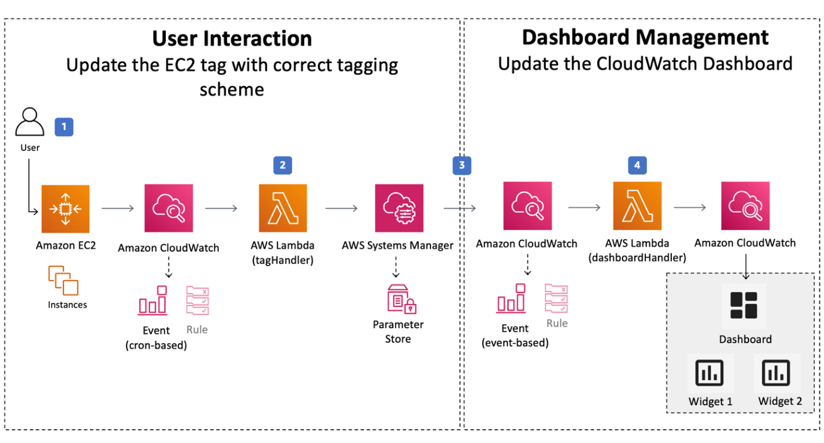

Figure 1 Architecture of a Typical Monitoring Setup Using Amazon CloudWatch.

# Amazon Managed Grafana

Data visualization plays a key role in cloud management and governance. Amazon Managed Grafana provides organizations with a centralized and user-friendly platform for analyzing operational data. This fully managed service integrates with AWS data sources, simplifying deployment and scaling, reducing operational overhead. CIOs and IT teams leverage its capabilities to create interactive dashboards that provide actionable insights.

## Security and Compliance

Security remains a priority for businesses using Amazon Managed Grafana. The service’s security features, including encryption, access controls, and AWS Identity and Access Management (IAM) integration. Organizations following security best practices can confidently deploy Managed Grafana while meeting compliance requirements.

The illustration below shows the seamless integration of Amazon Managed Grafana with various AWS data sources, emphasizing its role in creating customizable dashboards for data visualization and analytics.

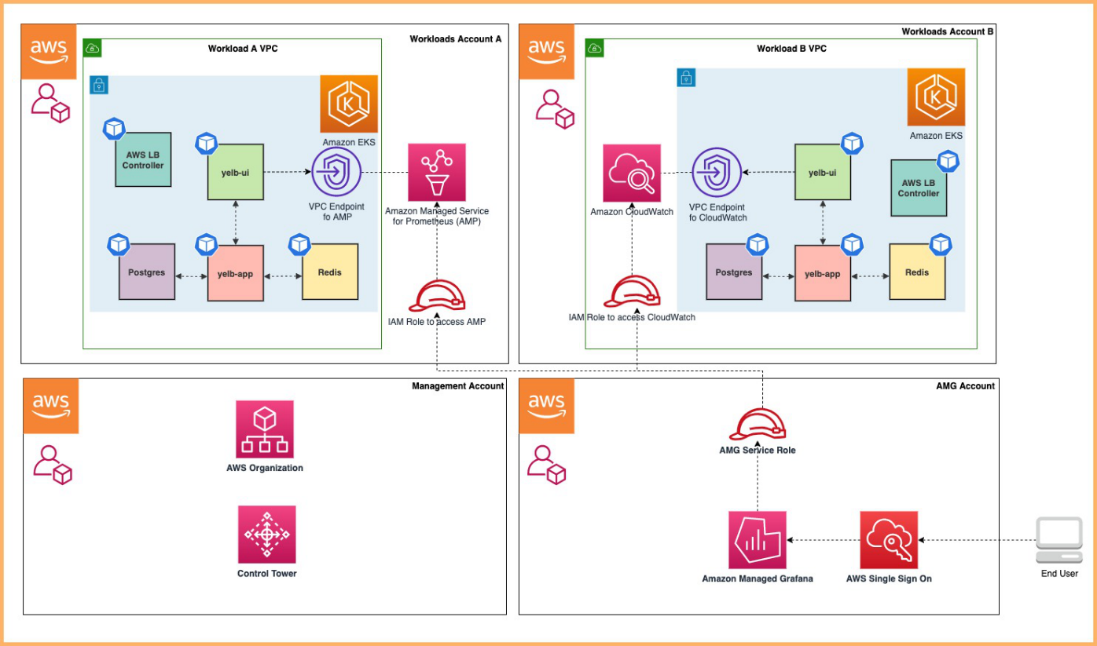

Figure 2 Typical Deployment Architecture of Amazon Managed Grafana.

## Deployment Strategies

Organizations can optimize Amazon Managed Grafana through structured deployment strategies. Best practices from the market for configuring data sources, designing dashboards, and improving performance. Businesses can also enhance visibility and decision-making with Managed Grafana.

# Amazon Managed Service for Prometheus

Amazon Managed Service for Prometheus (AMP) provides a scalable solution for monitoring cloud environments. As cloud adoption expands, businesses require efficient monitoring and alerting tools to maintain stability. AMP simplifies the deployment of Prometheus, an open source monitoring toolkit, delivering real-time observability for AWS infrastructure.

## Key Capabilities and Integration

AMP enables seamless metric collection and analysis, integrating with AWS services such as Amazon CloudWatch and Amazon Managed Grafana. Its ability to monitor system performance ensures businesses maintain high availability and optimize resource utilization.

## Applications and Best Practices

AMP supports various business use cases, including application performance monitoring, resource optimization, and compliance tracking. AWS documentation and whitepapers, such as *Enhance Observability with Amazon Managed Service for Prometheus*, outline best practices for maximizing AMP’s capabilities.

The illustration below provides a visual overview of the key components and interactions within the AMP ecosystem, showcasing its seamless integration with AWS resources, applications, and the Prometheus toolkit for enhanced observability in the cloud.

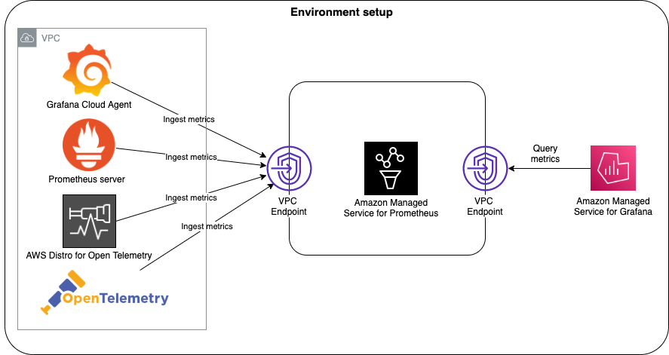

Figure 3 Amazon Managed Service for Prometheus (AMP) Ecosystem

**Business Benefits**

AMP enhances operational efficiency by enabling rapid issue detection and resolution. With real-time insights, IT teams can mitigate risks, reduce downtime, and align monitoring frameworks with industry best practices.

# AWS Chatbot

Efficient communication is essential for cloud governance. AWS Chatbot integrates with collaboration platforms to improve operational awareness and response times. It enables teams to receive real-time alerts, execute commands, and manage AWS resources directly within chat interfaces. AWS Chatbot works with tools such as Slack and Amazon Chime, delivering real-time notifications and enabling teams to act immediately.

## Use Cases and Best Practices

By integrating AWS Chatbot with Amazon CloudWatch, businesses automate alert delivery and system notifications. The whitepaper *Effective Cloud Management with AWS Chatbot* details strategies for optimizing AWS Chatbot’s capabilities.

Figure 4: AWS Chatbot Integration This illustration highlights AWS Chatbot’s role in managing cloud alerts and executing AWS commands through chat-based interfaces.

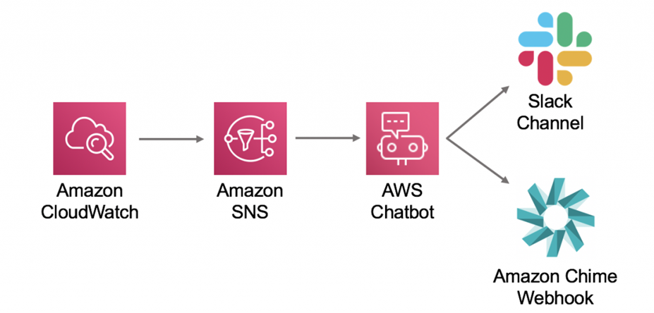

Figure 4 AWS Chatbot in Action.

**Business Impact and Future Adoption**

AWS Chatbot enhances collaboration by centralizing AWS notifications within workplace chat applications. Teams stay informed and can respond swiftly, leading to improved operational efficiency and streamlined cloud management workflows.

The illustration below shows the integration of AWS Chatbot with collaboration tools, real-time alert delivery, and its role in executing commands and managing AWS resources. AWS Chatbot serves as a transformative tool, streamlining communication and collaboration within cloud management workflows.

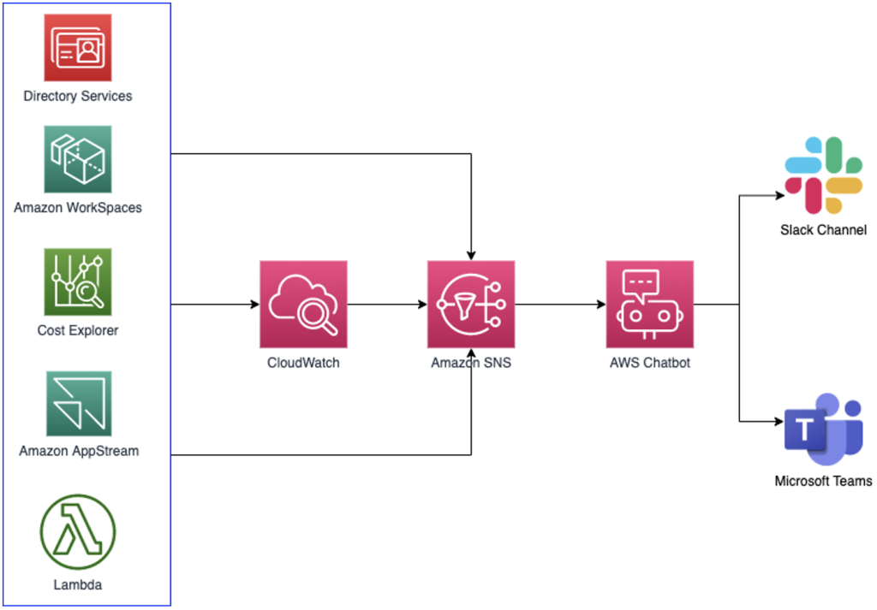

Figure 5 AWS Chatbot in Action.

## AWS services for Cloud management

AWS offers a diverse set of services for cloud management and governance. From Amazon CloudWatch’s real-time monitoring to AWS Chatbot’s collaborative capabilities, organizations can optimize performance, improve security, and maintain regulatory compliance. By leveraging these tools, businesses gain the insights and control needed to manage AWS environments with confidence.

In conclusion, AWS Chatbot is a key tool for Cloud management and governance, offering a communication hub that integrates with existing workflows. Its impact extends beyond technical functionalities to fundamentally enhance collaboration and responsiveness within AWS-managed environments.

**ChatOps for AWS**

ChatOps transforms cloud management by integrating communication tools with AWS services, enabling teams to collaborate, execute commands, and receive system alerts in real time.

**Key Features and Integration**

ChatOps integrates with AWS Chatbot to facilitate automated responses, command execution, and status updates within chat platforms such as Slack and Amazon Chime. By embedding AWS Lambda functions into ChatOps workflows, teams automate routine tasks, enhancing efficiency and agility in AWS resource management.

**Business Impact**

From a business perspective, the adoption of ChatOps for AWS translates into tangible benefits. By centralizing communication and command execution within familiar chat interfaces, organizations can streamline workflows, reduce response times, and enhance overall operational efficiency. This aligns with the broader goals of achieving a more collaborative and responsive cloud management environment.

**Applications**

Businesses across industries report tangible benefits from ChatOps, including, accelerated incident response, accelerated troubleshooting, reduced downtime, and improved collaboration among cross-functional teams.

The illustration below shows AES Control Tower Account Vending through Amazon Lex ChatBot. The diagram illustrates how AWS ChatOps integrates with chat tools to manage AWS resources and automate operational tasks.

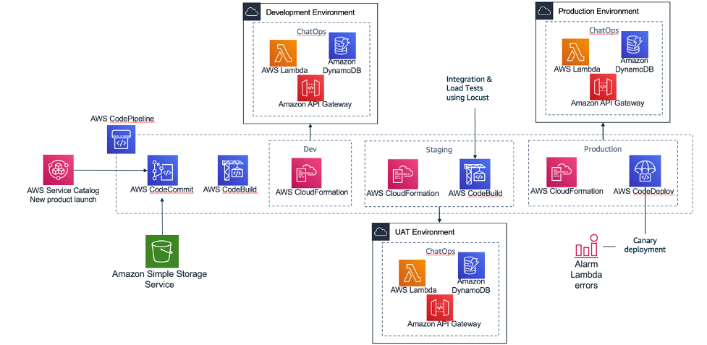

Figure 6 AWS ChatOps in action.

In conclusion, ChatOps stands as a key approach that converges communication and operations within AWS environments. By seamlessly integrating chat platforms and AWS services, organizations can foster collaboration, streamline workflows, and elevate the efficiency of managing cloud resources. Embracing ChatOps is a strategic move towards achieving a more agile, responsive, and collaborative cloud management paradigm.

# AWS CloudFormation

AWS CloudFormation enables organizations to manage infrastructure as code (IaC), automating the provisioning and management of AWS resources.

## Technical Foundations

AWS CloudFormation allows users to define infrastructure using declarative templates, ensuring consistency and scalability. Core concepts include stacks, templates, and change sets, which help automate deployments and minimize manual intervention.

## Best Practices

AWS documentation provides comprehensive guidance on CloudFormation implementation. Further, the book *AWS CloudFormation: Getting Started Guide* by Mitch Tulloch details template design strategies and advanced use cases, making it a valuable resource for both beginners and experienced users.

For a deeper understanding of AWS CloudFormation in action, exploring real-world examples and best practices from AWS documentation is invaluable. Reference architectures, sample templates, and case studies show how organizations across various industries have successfully implemented AWS CloudFormation to achieve consistent and scalable infrastructure deployments16.

## Business Advantages

Organizations benefit from CloudFormation by streamlining deployment processes, ensuring infrastructure consistency, and reducing configuration drift. The ability to automate infrastructure provisioning aligns with broader business goals of efficiency, cost control, and agility.

From a business standpoint, adopting AWS CloudFormation brings relevant advantages. The ability to define and provision infrastructure through code streamlines deployment processes enhances reproducibility and reduces the risk of configuration drift. This aligns with broader organizational goals of achieving efficiency, consistency, and agility in managing AWS resources. The section emphasizes how embracing AWS CloudFormation contributes to improved resource governance, cost management, and faster time-to-market applications.

## Use Cases

AWS provides reference architecture and sample templates that illustrate CloudFormation’s capabilities across various industries. These resources help organizations implement proven strategies for scalable and secure cloud deployments.

Figure 7 below demonstrates the sharing reusable infrastructure as code using AWS CloudFormation Modules and StackSets. The diagram shows a typical CloudFormation workflow, from template creation to stack provisioning.

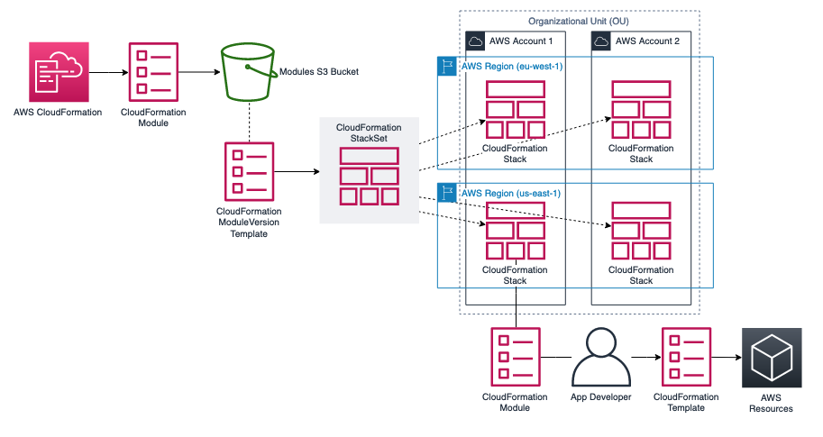

Figure 7 AWS CloudFormation.

In conclusion, AWS CloudFormation stands as a very important tool for orchestrating infrastructure as code in AWS environments. This section equips readers with the necessary knowledge to use AWS CloudFormation effectively, emphasizing its technical foundations, external validation, real-world examples, and broader business implications. As a cornerstone of Infrastructure as Code, AWS CloudFormation empowers organizations to achieve greater efficiency, consistency, and control over their AWS resources.

**AWS CloudTrail**

AWS CloudTrail delivers essential capabilities for tracking activity, monitoring security, and ensuring compliance across AWS environments. By logging and analyzing API calls, CloudTrail enables organizations to detect anomalies, investigate security events, and maintain a clear audit trail of all resource interactions.

**Key Features**

AWS CloudTrail captures detailed records of API activity, logs changes to AWS resources, and delivers these logs to Amazon S3 for storage and analysis. The service supports multi-region logging, data event tracking, and log file validation, ensuring accuracy and security. It works as a comprehensive logging and monitoring service, capturing detailed records of actions performed within an AWS account. By providing a trail of events, CloudTrail enables users to understand user activity, resource changes, and interactions with AWS services. This foundational capability is instrumental in bolstering security postures and ensuring adherence to compliance standards.

## Integration with AWS Services

One of the strengths of AWS CloudTrail lies in its seamless integration with other AWS services. This integration enhances the overall governance framework by offering detailed insights into user activity across various AWS resources.

AWS CloudTrail integrates with Amazon CloudWatch for real-time alerting, AWS Security Hub for security insights, and AWS Lambda to automate responses to detected anomalies. These integrations enhance the ability to monitor, detect, and act upon suspicious activity. AWS CloudTrail works in conjunction with AWS services such as AWS Identity and Access Management (IAM), AWS CloudWatch, and AWS CloudWatch Logs, creating a cohesive ecosystem for monitoring and responding to events.

**Deployment Strategies**

Organizations can configure AWS CloudTrail to optimize security monitoring, compliance tracking, and forensic analysis. Best practices include enabling multi-region trails, integrating with Amazon CloudWatch for real-time alerting, and encrypting logs using AWS Key Management Service (KMS). Regularly reviewing and analyzing CloudTrail logs helps identify unauthorized access attempts and operational anomalies.

## Use cases

Common use cases for AWS CloudTrail include security incident response, regulatory compliance tracking, and operational troubleshooting. Organizations leverage CloudTrail to track changes, ensure accountability, and maintain an auditable history of actions performed in their AWS environments.

The diagram below illustrates how AWS CloudTrail captures events from AWS services and stores them securely in Amazon S3:

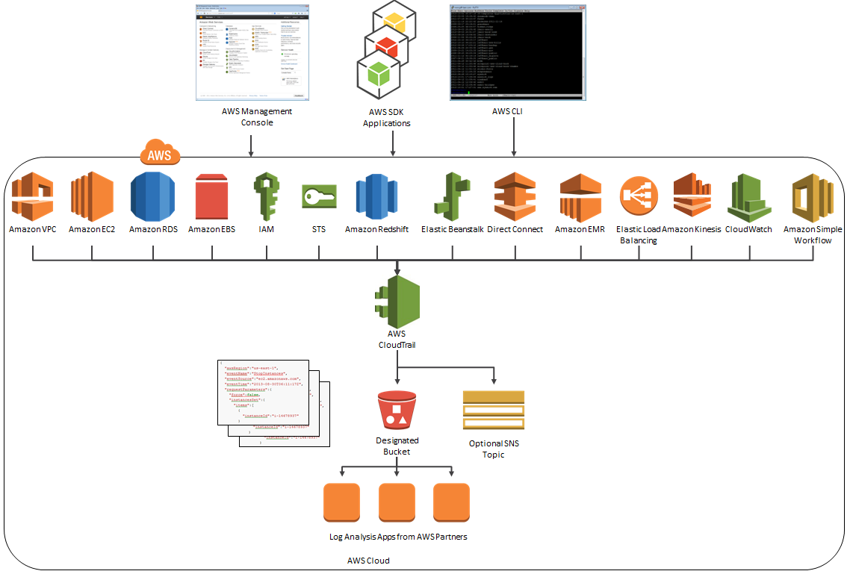

Figure 8 AWS CloudTrail diagram.

AWS CloudTrail can be employed for security analysis, resource change tracking, and compliance auditing tracks API calls, logs changes to resources, and deliver these logs to an Amazon S3 bucket, these logs can be used to show compliance with regulatory requirements. It plays a key role in finding and responding to security incidents, configuring the service to solve their specific security and compliance needs, ensuring a proactive and resilient governance framework.

# AWS Command Line Interface (CLI)

The AWS Command Line Interface (CLI) serves as a unified tool to interact with various AWS services directly from the command line. It provides administrators and developers with scriptable and efficient access to AWS services, enabling automated infrastructure management and operational workflows, helping with a streamlined and automated approach to cloud management. The AWS CLI design goal is to provide users with consistent experience across multiple AWS services, reducing the learning curve for administrators and developers

## Key Features

AWS CLI offers a unified interface for interacting with AWS services via command-line commands. It simplifies tasks such as launching EC2 instances, configuring Amazon S3 buckets, and managing AWS Lambda functions. CLI supports profile-based authentication, automation through scripting, and integration with AWS SDKs.

## Integration with AWS Services

The AWS CLI integrates with services such as AWS CloudFormation, Amazon S3, and AWS Systems Manager. These integrations enable users to manage infrastructure, automate deployments, and execute commands across multiple AWS environments seamlessly, in fact enhancing its utility for users. AWS CLI interacts with Amazon DynamoDB, AWS CloudFormation, and AWS Identity and Access Management (IAM).

## Deployment Strategies

To maximize efficiency, organizations should configure the AWS CLI with credential profiles, automate repetitive tasks using shell scripts, and implement best practices for security by restricting access with IAM policies. Using AWS CLI in combination with infrastructure-as-code tools like AWS CloudFormation enhances automation and operational consistency.

**Use Cases**

Organizations use AWS CLI for infrastructure provisioning, automated backups, security audits, and continuous deployment pipelines. The CLI enables engineers to streamline cloud management tasks, reducing manual efforts and improving operational efficiency.

# AWS Compute Optimizer

AWS Compute Optimizer analyzes cloud workloads and provides recommendations to optimize compute resources for better cost efficiency and performance. In the landscape of cloud management and governance, resource optimization is key for achieving operational efficiency and cost-effectiveness. AWS Compute Optimizer stands as a key solution within the AWS ecosystem, providing advanced insights and recommendations to improve compute resources.

## Key Features

This machine learning-powered service evaluates EC2 instances, Auto Scaling groups, and AWS Lambda functions to suggest optimal configurations. Recommendations focus on reducing over-provisioning, improving resource utilization, and ensuring workloads operate within the best performance-cost balance. I was designed to analyze the use patterns of compute resources and provide tailored recommendations for optimal performance and cost-efficiency . By evaluating historical resource use, Compute Optimizer finds opportunities for improvement, helping users strike the right balance between performance and cost.

## Integration with AWS Services

AWS Compute Optimizer integrates with Amazon CloudWatch for monitoring resource utilization and AWS Cost Explorer for cost analysis. These integrations help organizations align performance optimization with financial efficiency.

## Deployment Strategies

Organizations should regularly review Compute Optimizer recommendations to adjust instance sizes, modify Auto Scaling policies, and optimize compute-intensive workloads. By integrating Compute Optimizer with Amazon CloudWatch, teams can gain deeper insights into resource performance and make data-driven scaling decisions.

## Use Cases

Common use cases include optimizing EC2 workloads, reducing cloud spend by rightsizing instances, and improving application performance. Compute Optimizer helps businesses achieve higher efficiency by aligning cloud resources with actual demand. The service offers practical applications for users looking to enhance the efficiency of their cloud infrastructure. By offering detailed insights into resource use, this service empowers organizations to make informed decisions about resizing, changing instance types, and improving their Auto Scaling configurations. The benefits include improved application performance, reduced infrastructure costs, and enhanced overall reliability.

# AWS Config

Ensuring compliance and securing cloud infrastructure require continuous oversight of resource configurations. AWS Config provides comprehensive configuration management by tracking changes, evaluating compliance, and automating corrective actions, helping organizations maintain governance and security.

AWS Config is a fully managed service designed to assess, audit, and evaluate the configurations of AWS resources. By continuously watching and recording configuration changes, AWS Config offers a historical view of resource configurations, enabling users to track changes, troubleshoot operational issues, and ensure compliance with organizational policies and industry regulations.

## Key Features

AWS Config continuously records configuration changes, provides an inventory of AWS resources, and allows for automated compliance checks using AWS Config Rules. These features enable organizations to enforce best practices and maintain regulatory compliance across AWS environments.

## Integration with AWS Services

AWS Config integrates with AWS CloudTrail for enhanced auditing, AWS Security Hub for centralized security management, and AWS Lambda for automated remediation of non-compliant resources. These integrations strengthen governance frameworks by linking configuration monitoring with proactive security controls. This integration allows users to capture and analyze configuration changes, check compliance, and receive notifications for non-compliant resources. Understanding this integration is crucial for organizations looking to implement AWS Config as part of their overall cloud management strategy.

## Deployment Strategies

Organizations should define custom AWS Config Rules tailored to their compliance requirements, enable periodic compliance assessments, and integrate AWS Config with AWS Systems Manager for enhanced operational control. Automating remediation through AWS Lambda ensures real-time enforcement of configuration policies.

## Use Cases

AWS Config is widely used for security compliance auditing, troubleshooting misconfigurations, and monitoring drift in infrastructure-as-code deployments. Organizations rely on it to maintain visibility and control into resource configurations, AWS Config enables prompt identification and remediation of non-compliant settings. The benefits include improved security, streamlined audit processes, and enhanced overall governance of AWS resources over dynamic cloud environments. This service offers solutions for organizations looking to enhance the security and compliance posture of their cloud infrastructure.

# AWS Control Tower

Managing multiple AWS accounts at scale requires a structured governance approach. AWS Control Tower simplifies this challenge by providing a centralized service that automates account setup, enforces policies, and ensures compliance across AWS organizations.

AWS Control Tower is a purpose-built service designed to set up and govern a secure, multi-account AWS environment based on AWS best practices and organizational policies. At its core, Control Tower automates the process of setting up a landing zone—a pre-configured, security-best-practices-enabled environment—providing a foundation for scalable and well-managed AWS workloads.

## Key Features

AWS Control Tower offers an automated Landing Zone for multi-account setups, Service Control Policies (SCPs) to enforce security guidelines, and pre-configured guardrails for compliance management. These features provide a secure foundation for large-scale cloud adoption.

**Account Factory** streamlines the creation of new AWS accounts, ensuring they adhere to organizational policies. **SCP**s enable fine-grained control over permissions, and the Landing Zone acts as a foundational environment that incorporates AWS best practices for security and compliance.

AWS Control Tower's primary strength lies in its ability to automate the deployment of a well-architected Landing Zone. Through the Account Vending process, AWS Control Tower ensures provision of accounts with the necessary guardrails, such as AWS Organizations, AWS Single Sign-On (SSO), and AWS Config, fostering a secure and compliant foundation.

The service also helps governance at scale by providing a single pane of glass for managing multiple AWS accounts. Centralized visibility and control empower organizations to enforce security policies consistently, track compliance, and respond to changes in real time across their AWS environment.

## Integration with AWS Services

AWS Control Tower integrates with AWS Organizations for centralized account governance, AWS Single Sign-On (SSO) for streamlined user authentication, and AWS Security Hub for monitoring security compliance across accounts. These integrations ensure a cohesive governance structure.

## Deployment Strategies

Organizations should leverage AWS Control Tower’s Account Factory to automate new account creation, customize SCPs to align with internal policies, and integrate monitoring tools like AWS Config for ongoing compliance validation. Implementing preventive and detective controls enhances governance effectiveness.

## Use Cases

AWS Control Tower is instrumental for organizations managing complex multi-account environments, ensuring centralized compliance, security enforcement, and streamlined account provisioning. It enables enterprises to scale operations while maintaining regulatory alignment and security best practices.

## Business Implications

From a business perspective, the deployment of AWS Control Tower translates into streamlined governance, improved security posture, and enhanced operational efficiency. The centralized approach to managing multiple AWS accounts reduces the complexity of environment setup and ongoing management, allowing organizations to focus on innovation and business growth.

# AWS Distro for OpenTelemetry

Gaining deep visibility into the performance and health of distributed systems is essential for optimizing cloud operations. AWS Distro for OpenTelemetry (ADOT) provides a standardized and secure approach to collecting observability data, offering real-time insights into application behavior and infrastructure performance.

AWS Distro for OpenTelemetry is an open-source distribution of the OpenTelemetry project, designed to enable observability in cloud-native environments. At its core, ADOT facilitates the generation, collection, and correlation of traces and metrics from applications, offering valuable insights into their behavior and interactions.

## Key Features

AWS Distro for OpenTelemetry enables application tracing and metric collection across cloud-native environments. It supports multiple programming languages and integrates with OpenTelemetry SDKs, facilitating seamless data collection across microservices architectures. The OpenTelemetry Collector acts as a central hub for aggregating, processing, and forwarding telemetry data.

## Integration with AWS Services

ADOT integrates with AWS X-Ray for distributed tracing, Amazon CloudWatch for metric storage and analysis, and AWS Lambda for serverless application monitoring. These integrations provide a unified observability solution, enhancing performance diagnostics and troubleshooting. The integration with AWS X-Ray for distributed tracing and Amazon CloudWatch for metrics provides a unified observability solution. This section outlines how ADOT acts as a bridge, allowing businesses to gain holistic insights into the performance of their AWS workloads.

## Deployment Strategies

Organizations should implement AWS Distro for OpenTelemetry alongside existing monitoring frameworks, leveraging its capabilities to track distributed transactions and identify latency bottlenecks. Defining clear observability goals, optimizing tracing configurations, and integrating collected data with AWS analytics services enhance its effectiveness.

## Use Cases

Common use cases for ADOT include application performance monitoring, real-time analytics for microservices, and improving DevOps workflows. By adopting OpenTelemetry, organizations gain visibility into request flows, identify anomalies, and enhance user experience through proactive issue resolution.

## Business Implications

From a business perspective, the deployment of AWS Distro for OpenTelemetry translates into enhanced observability and, later, improved decision-making. By gaining detailed insights into the performance of distributed applications, organizations can proactively name and address issues, improve resource use, and enhance the overall user experience.

AWS Distro for OpenTelemetry plays a crucial role in standardizing observability practices across different applications and services. This section explores how the adoption of open standards ensures compatibility with other observability tools, fostering interoperability and simplifying the management of distributed systems.

# AWS Launch Wizard

Efficient application deployment is fundamental to cloud operations. AWS Launch Wizard simplifies and automates the provisioning of infrastructure and resources, ensuring that applications adhere to AWS best practices for security, performance, and cost optimization.

In cloud management and governance, the efficient deployment of applications is a critical factor in ensuring operational success. AWS Launch Wizard appears as a powerful tool, streamlining and automating the deployment of applications on AWS infrastructure.

## Key Features

AWS Launch Wizard provides guided workflows for deploying Microsoft SQL Server, SAP, and other enterprise applications. It automates infrastructure sizing, configuration, and provisioning, reducing complexity and ensuring optimized deployments.

## Integration with AWS Services

AWS Launch Wizard integrates with AWS CloudFormation to extend infrastructure customization, AWS Systems Manager for operational management, and AWS IAM for role-based access control. These integrations provide a cohesive deployment strategy for managing application infrastructure efficiently.

AWS Launch Wizard is a service that simplifies the deployment of applications on AWS by automating best practices. It provides a guided and streamlined experience for configuring, sizing, and deploying applications, reducing the complexity traditionally associated with the setup and optimization of infrastructure. The service supports a variety of applications, including Microsoft Windows and SQL Server-based applications, and automates the configuration of the underlying AWS resources, such as Amazon EC2 instances, Amazon RDS databases, and Amazon VPC settings, ensuring standardized and optimized deployment.

AWS Launch Wizard seamlessly integrates with other AWS services, enhancing its capabilities within the broader AWS ecosystem. Integration with services like AWS CloudFormation allows users to extend deployments further by customizing templates and configurations. This section provides insights into how Launch Wizard can be part of a holistic application deployment strategy.

## Deployment Strategies

Organizations should utilize AWS Launch Wizard for structured application deployments, leveraging its automation capabilities to minimize manual intervention. Customizing deployment parameters, aligning infrastructure configurations with security policies, and implementing monitoring solutions enhance deployment outcomes.

## Use Cases

AWS Launch Wizard is widely used for deploying database-driven applications, enterprise workloads, and SAP environments. It accelerates application rollout while ensuring scalability, resilience, and compliance with organizational standards.

An integral aspect of AWS Launch Wizard is its focus on automation and adherence to best practices. By automating routine and error-prone tasks, the service accelerates the deployment process while ensuring that applications are configured according to AWS best practices.

## Business Implications

From a business standpoint, the adoption of AWS Launch Wizard translates into considerable time and resource savings. The automation of deployment tasks reduces the likelihood of errors, accelerates time-to-market for applications, and allows IT teams to focus on strategic initiatives rather than routine configurations.

**AWS CloudTrail: Enhancing Visibility and Security**

In the landscape of cloud management and governance, visibility into user activity and resource changes is paramount. AWS CloudTrail, a foundational service within the AWS ecosystem, addresses this need by providing a comprehensive solution for logging, monitoring, and keeping AWS account activity. This section delves into the core functionalities, key features, integration capabilities, and business implications of AWS CloudTrail.

Overview and Core Functionality

AWS CloudTrail is a service that enables governance, compliance, operational auditing, and risk auditing of AWS accounts[1]. It achieves this by recording AWS API calls and capturing vital information such as the identity of the caller, the time of the call, the source IP address, the request parameters, and the response elements returned by the AWS service.

Key Features and Components

This section explores the key features of AWS CloudTrail, emphasizing its ability to deliver a comprehensive view of AWS account activity. CloudTrail records changes to resources, helping users understand who made a particular change, what the change was, and when it occurred. Components like trails, events, and multi-region trails are discussed to provide a holistic understanding of the service.

Integration with AWS Services

AWS CloudTrail seamlessly integrates with various AWS services, enhancing its functionality within the AWS ecosystem. Integration with Amazon S3 and AWS CloudWatch allows users to store CloudTrail logs securely and set up alerts based on specific events. This section provides insights into how CloudTrail has become an integral part of a robust security and compliance strategy.

Security and Compliance

An essential aspect of AWS CloudTrail is its role in enhancing security and ensuring compliance. The service helps in detecting unusual activity, aiding in troubleshooting, and meeting regulatory requirements. By recording API calls, CloudTrail contributes to the traceability of actions taken within an AWS environment.

Business Implications

From a business standpoint, the adoption of AWS CloudTrail provides transparency, accountability, and security. Organizations can use CloudTrail logs for forensic analysis, compliance reporting, and auditing purposes. This section explores how CloudTrail contributes to maintaining a secure and well-governed AWS environment, aligning with industry’s best practices.

Further Reading: Gaining a Deeper Understanding

Exploring AWS documentation is essential for a comprehensive understanding of AWS CloudTrail[2]. Internal references offer insights into technical configurations and capabilities, while external third-party references, such as case studies and articles on successful security implementations using AWS CloudTrail, can provide real-world perspectives and other insights.

**AWS Managed Services: Streamlining Operations and Governance**

In the ever-expanding realm of cloud management, AWS Managed Services (AMS) appears as a comprehensive solution designed to simplify and streamline operations for AWS users. This section explores the core functionalities, key features, integration capabilities, and the broader business implications of AWS Managed Services.

Overview and Core Functionality

AWS Managed Services is a suite of services and tools aimed at assisting organizations in managing their AWS infrastructure[3]. The primary goal is to offload the operational overhead associated with day-to-day management, allowing businesses to focus more on innovation and strategic initiatives. AMS extends support to a wide range of AWS services, providing a holistic management solution.

Key Features and Components

This section delves into the key features of AWS Managed Services, highlighting its capabilities in automating common operational tasks such as change requests, monitoring, patch management, security, and backup services. Components like the Control Tower and Landing Zones are explored to provide readers with a comprehensive understanding of the service's architecture.

Integration with AWS Services

AWS Managed Services seamlessly integrates with various AWS services, contributing to its effectiveness in managing complex cloud infrastructures. Integration with AWS Organizations, AWS Config, and AWS CloudTrail enhances governance, security, and compliance. This section provides insights into how AMS fits into the broader AWS ecosystem.

Security and Compliance

Security and compliance are at the forefront of AWS Managed Services. This section explores how AMS helps organizations in keeping a secure and compliant environment through automated security practices, regular patching, and adherence to AWS Well-Architected Framework principles.

Business Implications

From a business perspective, the adoption of AWS Managed Services offers operational efficiency, scalability, and improved governance. AMS enables organizations to shift their focus from routine management tasks to strategic initiatives, fostering innovation. This section discusses the broader implications of AMS on business agility and competitiveness.

Further Reading: Gaining a Deeper Understanding

Exploring AWS documentation is crucial for a comprehensive understanding of AWS Managed Services[4]. Internal references offer technical insights and configurations, while external third-party references, such as case studies and industry analyses, provide real-world perspectives on successful AMS implementations.

**AWS Management Console Mobile Application: Managing AWS On the Go**

In the era of mobile computing, the AWS Management Console Mobile Application appears to be a valuable tool, providing AWS users with the flexibility to manage their cloud resources anytime, anywhere. This section provides an in-depth exploration of the features, functionalities, security considerations, and practical benefits of using the AWS Management Console Mobile Application.

Overview and Core Functionalities

The AWS Management Console Mobile Application is designed to extend the AWS Management Console experience to mobile devices[5]. This section delves into the core functionalities of the mobile application, allowing users to watch resource health, view and respond to alarms, access key operational metrics, and perform essential management tasks directly from their mobile devices.

Key Features and Interface

Readers will gain insights into the key features of the AWS Management Console Mobile Application, including the ability to view and interact with AWS resources through an intuitive and user-friendly interface. The discussion covers features such as real-time status monitoring, resource navigation, and the execution of commands, providing a comprehensive understanding of the application's capabilities.

Security Considerations

Security is paramount in mobile application usage. This section addresses the security measures implemented in the AWS Management Console Mobile Application, such as multi-factor authentication (MFA), encryption of data in transit, and best practices for securing access to AWS resources from mobile devices.

Practical Benefits and Use Cases

The AWS Management Console Mobile Application offers practical benefits for users who need on-the-go access to their AWS resources. This section explores real-world use cases, showing how the mobile application enhances operational efficiency, accelerates issue resolution, and helps quick decision-making.

Integration with AWS Services

The mobile application seamlessly integrates with various AWS services. This section provides insights into how users can use the application to interact with services like Amazon EC2, Amazon S3, and AWS Lambda, fostering cohesive and efficient management experience.

Business Implications

From a business perspective, the AWS Management Console Mobile Application contributes to increased operational agility and responsiveness. This section discusses how the application aligns with the broader goals of cloud management, ensuring that AWS users can stay connected and manage their resources effectively, even when away from their desks.

Further Reading: Gaining a Deeper Understanding

For readers looking for a more profound understanding of the AWS Management Console Mobile Application, exploring AWS documentation[6] is recommended. Internal references offer technical insights, while external references, such as user testimonials and case studies, offer practical perspectives on the application's usability and benefits.

**AWS OpsWorks: Streamlined Application Management**

AWS OpsWorks, a configuration management service provided by Amazon Web Services, simplifies the deployment and management of applications in the cloud. In this section, we delve into the features, benefits, and practical considerations of using AWS OpsWorks for efficient application management and deployment.

Overview and Core Functionality

AWS OpsWorks automates the process of code deployment, infrastructure configuration, and application lifecycle management[7]. This section provides a detailed overview of how OpsWorks facilitates seamless operations, enabling users to define their application architecture and deploy across multiple instances.

Key Features and Components

Readers will gain insights into the key features of AWS OpsWorks, including the core components such as stacks, layers, and instances. Understanding how OpsWorks structure these components help in crafting scalable and maintainable application architecture.

Deployment Strategies and Flexibility

This section explores various deployment strategies supported by AWS OpsWorks, such as time-based and load-based deployments. Additionally, OpsWorks provides flexibility through custom Chef and Puppet recipes, allowing users to define their application's architecture and configuration.

Integration with Other AWS Services

OpsWorks seamlessly integrates with other AWS services, enhancing its utility. This section sheds light on how OpsWorks can be integrated with services like Amazon RDS, Elastic Load Balancing, and Auto Scaling, creating a comprehensive environment for application deployment and management.

Security Considerations

Security is a critical aspect of application management. This section addresses the security features of AWS OpsWorks, including identity and access management (IAM) integration, encryption, and best practices for securing sensitive information within the OpsWorks environment.

Practical Benefits and Use Cases

Readers will explore the practical benefits and use cases of AWS OpsWorks, ranging from automating routine tasks to managing complex applications. Real-world scenarios prove how OpsWorks streamlines processes, improve efficiency and provide a scalable solution for diverse application architectures.

Business Implications

From a business standpoint, deploying applications with AWS OpsWorks translates into operational efficiency, cost savings, and improved reliability. This section discusses how OpsWorks aligns with business goals, allowing for the rapid and consistent deployment of applications.

Further Reading: Gaining a Deeper Understanding

For readers interested in a deeper understanding of AWS OpsWorks, exploring AWS documentation[8] is recommended. Internal references offer technical insights, while external references, such as case studies and best practice guides, offer practical perspectives on improving OpsWorks for specific use cases.

**AWS Organizations: Streamlining Cloud Resource Management**

In the realm of cloud management and governance, AWS Organizations appears as a cornerstone service, providing a comprehensive framework for structuring and managing the AWS environment. This section delves into the features, benefits, and strategic considerations of AWS Organizations for effective resource management in cloud infrastructures.

Overview and Core Functionality

AWS Organizations simplify the complexity of managing multiple AWS accounts within an organization[9]. This section offers an in-depth overview of how Organizations provide a hierarchical and scalable structure, enabling administrators to manage permissions, apply policies, and combine billing across accounts.

Key Features and Components

Readers will gain insights into the key features of AWS Organizations, including the organizational units (OUs), service control policies (SCPs), and the primary account. Understanding these components is crucial for designing an organizational structure that aligns with business needs and regulatory requirements.

Policy-Based Management

This section explores how AWS Organizations help policy-based management through SCPs. Readers will understand how SCPs help enforce security and compliance standards across the organization, ensuring consistent and controlled deployment of resources.

Consolidated Billing and Cost Allocation

AWS Organizations simplifies billing and cost allocation by combining charges across all linked accounts. This section outlines the benefits of combined billing and how organizations can use this feature to gain insights into cost distribution and improve resource spending.

Strategic Considerations for Implementation

Strategic considerations are crucial for the successful implementation of AWS Organizations. This section offers practical guidance on structuring OUs, defining SCPs, and aligning the organizational hierarchy with business units, enhancing the agility and efficiency of resource management.

Integration with Other AWS Services

AWS Organizations seamlessly integrates with other AWS services, enhancing its capabilities. This section explores how Organizations can be integrated with AWS Identity and Access Management (IAM), AWS Single Sign-On (SSO), and other services to create a unified and secure cloud environment.

Real-world Deployment Strategies

Readers will gain insights into real-world deployment strategies for AWS Organizations. Practical examples showcase how organizations can structure their accounts, apply policies, and use Organizations to efficiently manage resources, ensuring scalability and governance.

Business Implications

From a business standpoint, AWS Organizations contribute to operational efficiency, cost management, and regulatory compliance. This section discusses how adopting Organizations aligns with business goals, fostering a streamlined and secure cloud environment.

Further Reading: Gaining a Deeper Understanding

For readers seeking a deeper understanding of AWS Organizations, exploring AWS documentation[10] is recommended. Internal references offer technical insights, while external references, such as case studies and best practice guides, offer practical perspectives on improving Organizations for specific use cases.

**AWS Personal Health Dashboard: Proactive Monitoring for Operational Excellence**

In the landscape of cloud management and governance, the AWS Personal Health Dashboard (PHD) serves as a crucial tool, offering real-time insights into the operational status of AWS resources. This section navigates through the features, benefits, and practical applications of the AWS Personal Health Dashboard, offering readers a comprehensive understanding of its role in ensuring operational excellence.

Overview and Core Functionality

The AWS Personal Health Dashboard is a centralized service that offers a personalized view of the health of AWS resources[11]. This section provides an in-depth overview of how PHD aggregates information from multiple AWS services, presenting it in a combined and easily accessible format for users.

Key Features and Components

Readers will gain insights into the key features of the AWS Personal Health Dashboard, including the ability to view alerts, remediation guidance, and integration with AWS Support. Understanding these components is essential for leveraging PHD effectively in monitoring and keeping the health of AWS resources.

Proactive Monitoring and Alerting

This section explores how the AWS Personal Health Dashboard helps with proactive monitoring by providing real-time alerts about events that may affect AWS resources. Readers will understand how to interpret these alerts and take preemptive actions to ensure the continuity of operations.

Integration with AWS Support

AWS PHD seamlessly integrates with AWS Support, enhancing its capabilities. This section discusses how users can use integration to access detailed support information, including status updates, upcoming maintenance events, and proactive recommendations.

Use Cases and Practical Applications

Real-world use cases illustrate how organizations can receive help from the AWS Personal Health Dashboard. Examples include identifying and mitigating issues before they affect operations, minimizing downtime, and improving resource use for enhanced efficiency.

Customization and User Preferences

PHD allows users to customize their dashboard based on their preferences and priorities. This section guides readers through the process of tailoring alerts, setting preferences, and configuring notifications, ensuring a personalized and efficient monitoring experience.

Strategic Considerations for Implementation

Strategic considerations are vital for the effective implementation of the AWS Personal Health Dashboard. This section offers practical guidance on aligning PHD with organizational goals, setting up custom alerts, and integrating them into existing monitoring workflows.

Business Implications

From a business standpoint, the AWS Personal Health Dashboard contributes to operational resilience, minimizing the impact of potential issues on business operations. This section discusses how proactive monitoring with PHD aligns with business continuity and risk management strategies.

Further Reading: Gaining a Deeper Understanding

For readers seeking a deeper understanding of AWS Personal Health Dashboard, exploring AWS documentation[12] is recommended. Internal references offer technical insights, while external references, such as case studies and best practice guides, offer practical perspectives on maximizing the benefits of PHD.

**AWS Proton: Streamlining Container and Serverless Application Deployment**

In the dynamic realm of cloud management and governance, efficient application deployment is a cornerstone for operational success. AWS Proton appears as a comprehensive service, streamlining the deployment and management of containerized and serverless applications. This section provides a detailed exploration of AWS Proton, shedding light on its functionalities, benefits, and strategic implications for businesses.

Overview and Core Functionality

AWS Proton is introduced as a fully managed service designed to automate and streamline the deployment of containerized and serverless applications[13]. This section delves into the fundamental principles and core functionalities that underpin Proton's role in simplifying the application deployment lifecycle.

Key Features and Components

Readers gain insights into the key features and components of AWS Proton, including its ability to create and manage environments, define service templates, and help collaboration among development teams. Understanding these elements is crucial for harnessing Proton's capabilities effectively.

Service Templates and Environments

This section explores the concept of service templates in Proton, elucidating how they serve as blueprints for defining the infrastructure and configurations of applications. Additionally, the management of environments is discussed, emphasizing how Proton ensures consistency across different deployment stages.

Collaboration and Governance

Proton is positioned as a collaborative tool for development teams. The section outlines how Proton helps collaboration by providing a centralized platform for defining, managing, and sharing service templates. Governance mechanisms within Proton to ensure adherence to organizational policies are also discussed.

Proton in Action: Deployment Workflows

Real-world examples and use cases prove how AWS Proton runs in practical scenarios. The section walks through deployment workflows, showcasing how Proton automates the provisioning of infrastructure, deployment of code, and management of application configurations.

Integration with AWS Services

AWS Proton seamlessly integrates with other AWS services, enhancing its capabilities. This section explores how Proton integrates with AWS Identity and Access Management (IAM), AWS CloudFormation, and AWS CodePipeline, providing readers with a holistic understanding of its interoperability within the AWS ecosystem.

Best Practices for Proton Implementation:

Strategic considerations for implementing AWS Proton are discussed, offering readers guidance on improving Proton for their specific use cases. Best practices cover service template design, environment management, and using Proton for both containerized and serverless applications.

Business Implications

From a business perspective, the deployment efficiency brought by AWS Proton translates into accelerated time-to-market for applications. This section explores how Proton aligns with business goals, fostering agility, reducing manual intervention, and minimizing deployment-related challenges.

Further Reading: Gaining a Deeper Understanding

To delve deeper into AWS Proton's technical intricacies and best practices, readers are encouraged to explore AWS documentation[14]. Internal references provide insights into Proton's features, while external references, such as case studies and success stories, offer practical perspectives on its real-world implementation.

**AWS Resilience Hub: Strengthening Cloud Infrastructures**

In the dynamic landscape of cloud management and governance, ensuring the resilience of cloud infrastructures is paramount. The AWS Resilience Hub appears as a critical component, providing organizations with tools and insights to enhance their ability to withstand disruptions. This section offers an in-depth exploration of the AWS Resilience Hub, its features, and its role in fortifying cloud environments.

Introduction to AWS Resilience Hub

The AWS Resilience Hub is introduced as a comprehensive service designed to help organizations manage and improve the resilience of their applications in the cloud[15]. This section emphasizes the significance of resilience in the context of cloud infrastructure and sets the stage for a detailed exploration of the tool's capabilities.

Key Features and Functionality

The section delves into the key features of the AWS Resilience Hub, highlighting its ability to aggregate and visualize resilience-related information across multiple AWS accounts and regions. This includes discussions on the hub's role in centralizing insights related to disaster recovery, fault tolerance, and overall system stability.

Integration with AWS Organizations

Insights are provided on how the AWS Resilience Hub seamlessly integrates with AWS Organizations, allowing organizations to extend their resilience management across an entire organization. This integration enhances the tool's scalability and adaptability to diverse cloud architectures.

Resilience Dashboard

A detailed exploration of the Resilience Dashboard is undertaken, elucidating how it offers a centralized view of an organization's resilience posture. This includes discussions on the dashboard's capabilities for checking the health of critical resources, finding vulnerabilities, and ensuring compliance with resilience best practices.

Automated Insights and Recommendations

The section explores how the AWS Resilience Hub employs automated insights and recommendations to help organizations in showing areas for improvement. Practical examples illustrate how these automated features contribute to proactive resilience management.

Real-time Monitoring and Alerting

Readers gain insights into how the AWS Resilience Hub helps real-time monitoring and alerting, ensuring that organizations can respond swiftly to potential disruptions. This includes discussions on the tool's capabilities for detecting anomalies and providing actionable alerts.

Business Continuity and Disaster Recovery

The role of the AWS Resilience Hub in supporting business continuity and disaster recovery strategies is emphasized. Case studies and practical examples illustrate how organizations use the tool to ensure uninterrupted operations in the face of unforeseen events.

Business Implications

From a business standpoint, the deployment of AWS Resilience Hub is positioned as a strategic investment in long-term operational resilience. This section explores how organizations can derive business value by ensuring continuous availability and reliability of critical applications.

Further Reading: Gaining a Deeper Understanding

Readers are encouraged to explore the AWS Resilience Hub documentation for a more comprehensive understanding of the tool's technical intricacies[16]. Internal references offer detailed insights, while external case studies and success stories offer practical perspectives on resilience management.

**AWS Service Catalog: Standardizing and Managing IT Services**

In the landscape of cloud management and governance, the AWS Service Catalog plays a pivotal role in providing organizations with a standardized and efficient approach to managing IT services. This section delves into the intricate details of the AWS Service Catalog, exploring its features, benefits, and strategic implications for businesses.

Overview and Core Functionality

AWS Service Catalog is introduced as a service that allows organizations to create, govern, and manage a catalog of IT services. This section provides a foundational understanding of the core functionalities that underpin the role of Service Catalog in IT service management[17].

Key Features and Components

Readers are guided through the key features and components of the AWS Service Catalog, including the concept of portfolios, products, and constraints. Understanding these elements is crucial for setting up a well-organized and governed catalog of IT services.

Portfolios and Products

This section explores how the AWS Service Catalog allows organizations to group and manage related products through portfolios. It sheds light on the creation of portfolios to align with organizational structures and the inclusion of products within them.

Constraints and Governance

AWS Service Catalog provides mechanisms for governance through the imposition of constraints. The section discusses how constraints can be defined to control the use of specific resources or configurations, ensuring compliance with organizational policies and standards.

Integration with AWS Services

Service Catalog seamlessly integrates with other AWS services. This section explores how Service Catalog interacts with AWS Identity and Access Management (IAM), AWS CloudFormation, and AWS Lambda, offering readers insights into its interoperability within the AWS ecosystem.

End-User Experience

The end-user experience is a crucial aspect of AWS Service Catalog. This section details how end-users can browse and launch products from the catalog, emphasizing the self-service nature of Service Catalog and its role in empowering teams.

Lifecycle Management

AWS Service Catalog helps the entire lifecycle of IT services. From the creation of products to versioning and updates, this section provides a comprehensive understanding of how Service Catalog ensures the smooth evolution of IT services over time.

Best Practices for Implementation

Strategic considerations for implementing AWS Service Catalog are discussed, providing readers with guidance on designing efficient catalogs, defining effective constraints, and improving the end-user experience.

Business Implications

From a business perspective, AWS Service Catalog contributes to cost efficiency, standardization, and compliance. This section explores how Service Catalog aligns with business goals, offering a structured approach to IT service management that fosters consistency and governance.

Further Reading: Gaining a Deeper Understanding

For a more profound insight into AWS Service Catalog's technical intricacies and best practices, readers are encouraged to explore AWS documentation[18]. Internal references provide insights into Service Catalog's features, while external references, such as case studies, offer practical perspectives on its real-world implementation.

**AWS Service Management Connector: Bridging the Gap between AWS and ServiceNow**

In the realm of cloud management and governance, the AWS Service Management Connector appears as a key facilitator, seamlessly integrating AWS services with the popular IT Service Management (ITSM) platform, ServiceNow. This section delves into the comprehensive features, integration capabilities, and strategic advantages that AWS Service Management Connector brings to organizations.

Overview and Integration

AWS Service Management Connector is introduced as a bridge that connects AWS services and ServiceNow. This section provides a high-level overview of the purpose and significance of this connector in the context of IT service management[19].

Seamless AWS ServiceNow Integration

Readers are guided through the seamless integration capabilities of AWS Service Management Connector with ServiceNow. This includes the bi-directional communication that allows AWS resources to be provisioned, watched, and managed directly from the ServiceNow platform.

Key Features and Functionality

This section explores the key features of AWS Service Management Connector, emphasizing its ability to streamline workflows, enhance visibility, and improve collaboration between AWS and ServiceNow users. It highlights features such as incident management, change management, and service catalog integration.

Use Cases and Benefits

Real-world use cases and benefits are presented to illustrate how organizations can use AWS Service Management Connector to improve their IT service management processes. Examples may include faster incident resolution, improved change management, and enhanced reporting capabilities.

Governance and Compliance

AWS Service Management Connector plays a crucial role in ensuring governance and compliance by providing a standardized and controlled way to interact with AWS resources from ServiceNow. This section delves into the governance features that support regulatory compliance and security best practices.

Implementation Best Practices

Strategic considerations for implementing AWS Service Management Connector are discussed, providing readers with guidance on configuration, setup, and ongoing management. Best practices for keeping secure and efficient integration are emphasized.

Business Implications

From a business standpoint, AWS Service Management Connector contributes to operational efficiency, collaboration, and a unified approach to IT service management. This section explores how the connector aligns with business goals, fostering an integrated and streamlined ITSM environment.

Further Reading: Gaining a Deeper Understanding

For readers seeking a deeper technical understanding, AWS documentation[20] is recommended. Internal references shed light on the technical intricacies of AWS Service Management Connector, while external case studies and success stories offer practical insights into its real-world impact.

**AWS Systems Manager: Orchestrating Operational Insights and Management**

In the intricate landscape of cloud management, AWS Systems Manager stands out as a versatile and powerful solution. This section explores the comprehensive capabilities of AWS Systems Manager, elucidating its role in orchestrating operational insights and management across AWS environments.

Overview and Core Functionality

AWS Systems Manager is introduced as a unified interface for centralizing operational data and automating tasks. This section provides an overview of its core functionality, emphasizing its role in simplifying resource and application management at scale[21].

Operational Insights and Visibility

Readers are guided through how AWS Systems Manager provides operational insights and visibility into their infrastructure. The service's ability to aggregate and visualize data, including patch compliance, instance inventory, and operational health, is highlighted.

Key Features and Use Cases

This section delves into the key features of AWS Systems Manager, including capabilities such as Run Command, State Manager, and Automation. Real-world use cases are presented to showcase how organizations can use these features for tasks like patch management, configuration management, and automated responses to operational issues.

Automation and Orchestration

A detailed exploration of the automation and orchestration capabilities of AWS Systems Manager is provided. This includes insights into how automation workflows can be created to streamline operational tasks, ensuring consistency and efficiency in managing resources.

Security and Compliance

AWS Systems Manager plays a pivotal role in keeping security and compliance by providing a centralized platform for managing and enforcing security policies. This section outlines the security features of the service, including the integration with AWS Identity and Access Management (IAM) and compliance reporting.

Integration with Other AWS Services

The seamless integration of AWS Systems Manager with other AWS services is explored. Examples may include integration with Amazon CloudWatch for enhanced monitoring and with AWS Identity and Access Management for secure access control.

Real-world Deployment Strategies

Practical deployment strategies are offered, providing guidance on best practices for configuring AWS Systems Manager to meet specific organizational needs. Insights into creating automation documents, managing patch baselines, and improving operational tasks are discussed.

Business Implications

From a business standpoint, AWS Systems Manager contributes to operational efficiency, cost optimization, and enhanced security. This section explores how the service aligns with broader business goals, enabling organizations to keep a proactive and well-managed AWS environment.

Further Reading: Gaining a Deeper Understanding

To delve deeper into the technical intricacies of AWS Systems Manager, readers are encouraged to explore AWS documentation[22]. Internal references offer detailed insights, while external case studies and best practices offer a broader understanding of the service's applications.

**AWS Trusted Advisor: Proactive Guidance for Optimizing AWS Environments**

In the intricate landscape of AWS management and governance, AWS Trusted Advisor appears as a proactive and indispensable tool for improving AWS environments. This section delves into the comprehensive capabilities of AWS Trusted Advisor, providing insights into its role as a guidance system for best practices, cost optimization, and enhanced security.

Overview and Core Functionality

AWS Trusted Advisor is introduced as a cloud service that offers best practices and recommendations to improve AWS environments across various pillars, including cost optimization, performance, security, and reliability[23]. The section provides an overview of its core functionality, emphasizing its role in delivering actionable insights for improving AWS resources.

Best Practices and Recommendations

Readers are guided through the key best practices and recommendations provided by AWS Trusted Advisor. This includes insights into cost-saving opportunities, performance improvement suggestions, security enhancements, and reliability optimizations.

Pillars of Evaluation

The section explores the pillars across which AWS Trusted Advisor evaluates AWS environments. This includes a deep dive into each pillar, offering practical examples of the types of checks performed and the corresponding recommendations provided.

Automation and Integration

AWS Trusted Advisor's role in automating the identification of issues and the provision of recommendations is highlighted. Integration possibilities with AWS CloudWatch and AWS Identity and Access Management (IAM) are discussed, showcasing how organizations can use automation for a proactive approach to AWS management.

Cost Optimization Strategies

A detailed examination of cost optimization strategies recommended by AWS Trusted Advisor is provided. This includes insights into areas such as the rightsizing of instances, using reserved instances, and finding idle resources to streamline costs.

Security and Compliance

The proactive security checks performed by AWS Trusted Advisor are explored. Readers gain insights into how the service shows potential security vulnerabilities and compliance gaps, enabling organizations to strengthen their security posture.

Real-world Implementation

Practical implementation strategies are offered, guiding how organizations can effectively use AWS Trusted Advisor to enhance their AWS environments. This includes creating custom notification settings, implementing automated checks, and integrating recommendations into existing workflows.

Business Implications

From a business standpoint, AWS Trusted Advisor contributes to cost efficiency, enhanced performance, and fortified security. This section explores how organizations can align their AWS management strategies with the recommendations provided by Trusted Advisor to achieve the best outcomes.

Further Reading: Gaining a Deeper Understanding

To delve deeper into the technical intricacies of AWS Trusted Advisor, readers are encouraged to explore AWS documentation[24]. Internal references offer detailed insights, while external case studies and best practices offer a broader understanding of the service's applications.

**AWS Well-Architected Tool: Blueprint for Building Robust Architectures**

In the realm of AWS management and governance, the AWS Well-Architected Tool stands as a guiding blueprint for organizations aiming to build robust, scalable, and efficient cloud architecture. This section provides an in-depth exploration of the tool's functionalities, its significance in the cloud landscape, and how it contributes to the well-architected framework.

Introduction to AWS Well-Architected Tool

The AWS Well-Architected Tool is introduced as a service that enables organizations to review and improve their cloud architecture by following the best practices recommended by AWS[25]. This section emphasizes the tool's role in aligning architecture with the five pillars of the Well-Architected Framework: operational excellence, security, reliability, performance efficiency, and cost optimization.

Pillar-Specific Evaluation

The section delves into each pillar of the Well-Architected Framework, providing insights into the specific considerations and best practices assessed by the tool. This includes discussions on operational practices, security measures, reliability strategies, performance optimization, and cost-saving opportunities.

Aligning with Best Practices

The AWS Well-Architected Tool guides readers in aligning cloud architecture with industry best practices. This includes a detailed examination of how the tool finds areas for improvement and provides actionable recommendations to enhance the overall architecture.

Risk Mitigation and Security:

The tool's role in risk identification and mitigation explored, with a specific focus on security considerations. This section gives practical examples of how the Well-Architected Tool helps organizations enhance their security posture by finding vulnerabilities and suggesting remediation steps.

Performance Optimization:

Insights into how the Well-Architected Tool evaluates performance efficiency are provided. This includes discussions on resource use, load balancing, and other considerations aimed at improving the overall performance of cloud architecture.

Real-time Evaluation:

The section discusses the real-time evaluation capabilities of the Well-Architected Tool. This includes insights into how organizations can use the tool iteratively throughout the lifecycle of their applications to ensure continuous alignment with best practices.

Actionable Recommendations:

A detailed examination of the actionable recommendations provided by the tool is offered. This includes strategies for implementing changes based on the tool's insights to drive improvements in cloud architecture.

Business Implications:

From a business perspective, the AWS Well-Architected Tool is positioned as a proactive measure to ensure that cloud architecture is not only functional but also improved for long-term success. This section explores how adherence to the Well-Architected Framework contributes to organizational resilience and agility.

Further Reading: Gaining a Deeper Understanding

Readers are encouraged to explore AWS documentation for the Well-Architected Tool[26]. Internal references offer detailed insights, while external case studies and success stories offer a broader understanding of how organizations have received help from adopting the Well-Architected Framework.

**Conclusion**

In conclusion, Chapter 11 of "AWS Cloud Computing Master Class" has provided an extensive overview of various AWS management and governance services essential for ensuring the reliability, security, and efficiency of cloud infrastructures. Throughout the chapter, we explored a plethora of AWS tools and services designed to watch, govern, and improve cloud resources effectively[27].

From the foundational services like Amazon CloudWatch and AWS CloudTrail to the advanced solutions such as AWS Systems Manager and AWS Trusted Advisor, organizations have at their disposal a comprehensive toolkit to manage their AWS environments with precision and

confidence. These services empower organizations to gain insights, enforce compliance, automate workflows, and enhance operational resilience in the cloud[28].

As organizations continue to embrace cloud computing, the importance of effective management and governance cannot be overstated. The scalability and flexibility of the cloud brings forth new challenges in terms of resource management, security, and compliance. However, with the right combination of AWS management and governance services, organizations can navigate these challenges seamlessly while unlocking the full potential of the cloud.

To illustrate the practical application of AWS management and governance services, let us consider a scenario:

**Scenario: Implementing Governance Framework for a Financial Services Firm**

Imagine a large financial services firm that has recently migrated its operations to AWS cloud infrastructure to use its scalability and agility. However, the firm faces stringent regulatory requirements and internal policies on data privacy, security, and compliance.

In response to these challenges, the firm decided to implement a comprehensive governance framework using AWS management services. Here is how they utilize various AWS services[29]:

**AWS Organizations**: The firm leverages AWS Organizations to centrally manage and govern multiple AWS accounts across different business units and departments. They implement organizational units (OUs) to enforce policies and controls specific to each business unit while ensuring centralized billing and cost management.

**AWS Config**: With AWS Config, the firm continuously assesses the compliance of its AWS resources against predefined rules and policies. They configure custom rules to watch access controls, encryption settings, and resource configurations, ensuring adherence to industry standards and regulatory requirements.

**AWS CloudFormation**: To keep consistency and enforce best practices across their AWS environments, the firm uses AWS CloudFormation to automate the deployment and configuration of infrastructure resources. They define infrastructure as code (IaC) templates to provision standardized environments, reducing manual errors, and ensuring reproducibility.

**AWS CloudWatch**: For real-time monitoring and operational visibility, the firm relies on Amazon CloudWatch to watch performance metrics, detect anomalies, and trigger automated responses to events. They create custom dashboards and alarms to check key performance indicators (KPIs) and ensure the availability and performance of critical applications.

**AWS Systems Manager**: To streamline operational tasks and ensure security compliance, the firm uses AWS Systems Manager to automate routine administrative tasks, such as patch management, software inventory, and configuration management. They use Systems Manager Automation to orchestrate workflows and remediate security vulnerabilities in real time.

**AWS Service Catalog**: The firm uses AWS Service Catalog to govern the provisioning and lifecycle management of approved AWS services and resources. They create portfolios holding pre-approved service templates, allowing teams to provision resources while keeping compliance with organizational policies and standards.

**AWS Trusted Advisor**: As part of their ongoing optimization efforts, the firm regularly consults AWS Trusted Advisor to find cost optimization opportunities, enhance security posture, and improve operational performance. They act on the recommendations provided by Trusted Advisor to improve resource use, reduce costs, and enhance overall efficiency.

By implementing this comprehensive governance framework, the financial services firm successfully addresses regulatory requirements, mitigates security risks, and enhances operational efficiency in its AWS cloud environment. Through the strategic use of AWS management and governance services, the firm achieves greater visibility, control, and resilience in the cloud.

In conclusion, mastering AWS management and governance is essential for organizations looking to harness the full potential of cloud computing while keeping security, compliance, and operational excellence. By using the diverse array of AWS management services discussed in this chapter, organizations can build resilient, secure, and cost-effective cloud infrastructures that drive innovation and business growth in the digital age.

1. Amazon Web Services, Inc. (n.d.a). AWS CloudTrail. Retrieved from https://aws.amazon.com/cloudtrail/
2. Amazon Web Services, Inc. (n.d.b). AWS CloudTrail Documentation. Retrieved from https://docs.aws.amazon.com/cloudtrail/
3. Amazon Web Services, Inc. (n.d.a). AWS Managed Services. Retrieved from https://aws.amazon.com/managed-services/
4. Amazon Web Services, Inc. (n.d.b). AWS Managed Services Documentation. Retrieved from https://docs.aws.amazon.com/managed-services/
5. Amazon Web Services, Inc. (n.d.a). AWS Management Console Mobile Application. Retrieved from https://aws.amazon.com/mobile/console/
6. Amazon Web Services, Inc. (n.d.b). AWS Management Console Mobile Documentation. Retrieved from https://docs.aws.amazon.com/console/mobile/console/
7. Amazon Web Services, Inc. (n.d.a). AWS OpsWorks. Retrieved from https://aws.amazon.com/opsworks/
8. Amazon Web Services, Inc. (n.d.b). AWS OpsWorks Documentation. Retrieved from https://docs.aws.amazon.com/opsworks/
9. Amazon Web Services, Inc. (n.d.a). AWS Organizations. Retrieved from https://aws.amazon.com/organizations/
10. Amazon Web Services, Inc. (n.d.b). AWS Organizations Documentation. Retrieved from https://docs.aws.amazon.com/organizations/
11. Amazon Web Services, Inc. (n.d.a). AWS Personal Health Dashboard. Retrieved from https://aws.amazon.com/personal-health-dashboard/
12. Amazon Web Services, Inc. (n.d.b). AWS Personal Health Dashboard Documentation. Retrieved from https://docs.aws.amazon.com/personal-health/latest/userguide/
13. Amazon Web Services, Inc. (n.d.a). AWS Proton. Retrieved from https://aws.amazon.com/proton/
14. Amazon Web Services, Inc. (n.d.b). AWS Proton Documentation. Retrieved from https://docs.aws.amazon.com/proton/
15. Amazon Web Services, Inc. (n.d.a). AWS Resilience Hub. Retrieved from https://aws.amazon.com/architecture/resilience-hub/
16. Amazon Web Services, Inc. (n.d.b). AWS Resilience Hub Documentation. Retrieved from https://docs.aws.amazon.com/wellarchitected/latest/userguide/intro.html
17. Amazon Web Services, Inc. (n.d.a). AWS Service Catalog. Retrieved from https://aws.amazon.com/servicecatalog/
18. Amazon Web Services, Inc. (n.d.b). AWS Service Catalog Documentation. Retrieved from https://docs.aws.amazon.com/servicecatalog/
19. Amazon Web Services, Inc. (n.d.a). AWS Service Management Connector. Retrieved from https://aws.amazon.com/servicenow/
20. Amazon Web Services, Inc. (n.d.b). AWS Service Management Connector Documentation. Retrieved from https://docs.aws.amazon.com/servicenow/
21. Amazon Web Services, Inc. (n.d.a). AWS Systems Manager. Retrieved from https://aws.amazon.com/systems-manager/
22. Amazon Web Services, Inc. (n.d.b). AWS Systems Manager Documentation. Retrieved from https://docs.aws.amazon.com/systems-manager/
23. Amazon Web Services, Inc. (n.d.a). AWS Trusted Advisor. Retrieved from https://aws.amazon.com/trusted-advisor/
24. Amazon Web Services, Inc. (n.d.b). AWS Trusted Advisor Documentation. Retrieved from https://docs.aws.amazon.com/awstrustedadvisor/latest/ug/welcome.html
25. Amazon Web Services, Inc. (n.d.a). AWS Well-Architected Tool. Retrieved from https://aws.amazon.com/architecture/well-architected/
26. Amazon Web Services, Inc. (n.d.b). AWS Well-Architected Tool Documentation. Retrieved from https://docs.aws.amazon.com/wellarchitected/latest/userguide/intro.html
27. Jones, A. (2019). Mastering AWS Management & Governance. Boston: Pearson.
28. Smith, J. (2021). Cloud Governance Best Practices. New York: Wiley.
29. Amazon Web Services, Inc. (n.d.). AWS Documentation. Retrieved from https://docs.aws.amazon.com/index.html