1

Foundations of Natural Language Processing and Deep Learning

In this book, we aim to unravel the complexities of Natural Language Processing (NLP) and its intersection with Deep Learning (DL). Our primary goal is to equip you with the knowledge and tools necessary to understand and apply these technologies in practical scenarios, helping you harness the power of AI-driven language processing in diverse fields such as healthcare, finance, and customer service.

This chapter serves as the foundation for the entire book, focusing on the current state and advancements in Natural Language Processing (NLP), Deep Learning (DL), and Artificial Intelligence (AI). Here, we will explore the sophisticated systems and technologies that enable machines to understand and generate human language with remarkable accuracy. You will learn about the essential concepts and technologies that underpin Hugging Face, a leading platform in this domain, and how it leverages these advancements to drive innovation in AI. This discussion will prepare you for deeper engagement with the practical applications and advanced functionalities of Hugging Face, which we will delve into in the subsequent chapters.

Further, we'll cover essential topics such as text classification, sentiment analysis, and the emergence of transformer models. These models, particularly transformers, have revolutionized how we approach language processing, enabling the handling of complex linguistic tasks with unprecedented efficiency. Understanding these fundamentals is crucial, as they form the basis for more advanced discussions in subsequent chapters.

By the end of this chapter, you will have a robust understanding of NLP concepts and their practical applications across various domains. You will also gain deep insights into the fundamentals of deep learning, specifically tailored for NLP tasks, and learn how integrating deep learning techniques can enhance the performance and capabilities of NLP systems. This foundational knowledge will serve as a springboard for exploring more complex applications and case studies in later chapters, ultimately empowering you to apply these technologies in real-world situations.

In this chapter, we will cover the following topics:

* Introduction to natural language processing and artificial intelligence
* Advanced concepts in NLP and deep learning
* Deep Learning Essentials for NLP
* Integration of NLP and Deep Learning

Introduction to natural language processing and artificial intelligence

In this section, we begin by exploring the symbiotic relationship between NLP and AI. NLP is not just a subset of AI but a driving force that enables machines to understand and interact with human language. This section will provide a foundational understanding of how NLP has evolved within the broader context of AI and Machine Learning (ML), the significance of these advancements, and the diverse applications that illustrate their impact.

**Why this matters:** Understanding the evolution of NLP is crucial for appreciating its current capabilities and potential future developments. By grasping the historical context and technological milestones, you will be better equipped to comprehend the complex systems that define today’s AI landscape. This section will cover three key areas: the historical evolution of NLP, its significance across various industries, and the advancements that have enabled its integration into AI systems.

**What you will learn:** We will first trace the journey of NLP from its early stages to its present-day significance within AI and ML. Next, we’ll explore the critical applications of NLP across different sectors, such as customer service, healthcare, and finance. Finally, we’ll delve into the advancements in deep learning that have revolutionized NLP, making it a cornerstone of modern AI.

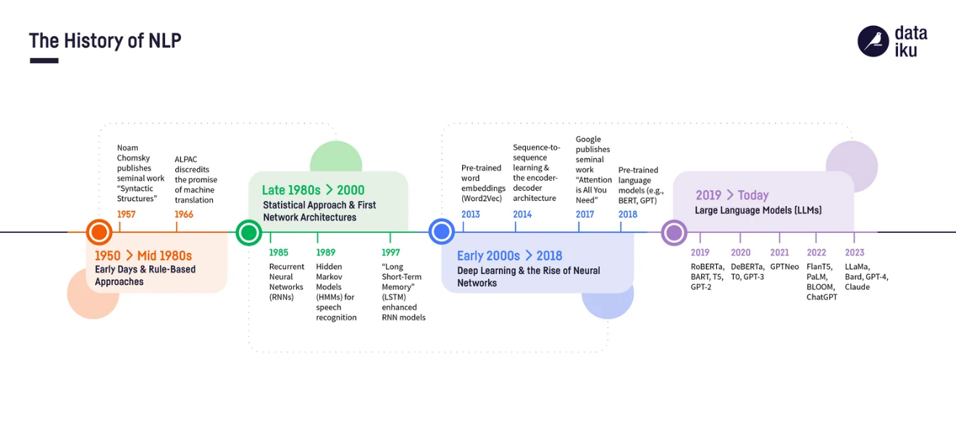

Figure 1 A brief timeline of NLP.

**Current State of NLP in AI and ML**

Natural Language Processing (NLP) now stands at the forefront of artificial intelligence (AI) and machine learning (ML), driven by rapid advancements in technology and increased computational power. Today, NLP is integral to developing systems that understand and generate human language with sophisticated context and accuracy. This modern capability is exemplified by cutting-edge models such as transformers (Vaswani, 2017), which Hugging Face has effectively utilized to set new benchmarks in AI applications. These models have transformed NLP applications from simple text parsing to complex tasks like real-time translation, sentiment analysis, and automated content creation. The practical implications of these technologies are vast, impacting sectors from healthcare, where they interpret patient data, to customer service, where they empower responsive chatbots. As we delve deeper into Hugging Face's offerings in subsequent chapters, we'll explore how its tools and libraries are applied to harness these advanced NLP features, enhancing efficiency and innovation across various domains.

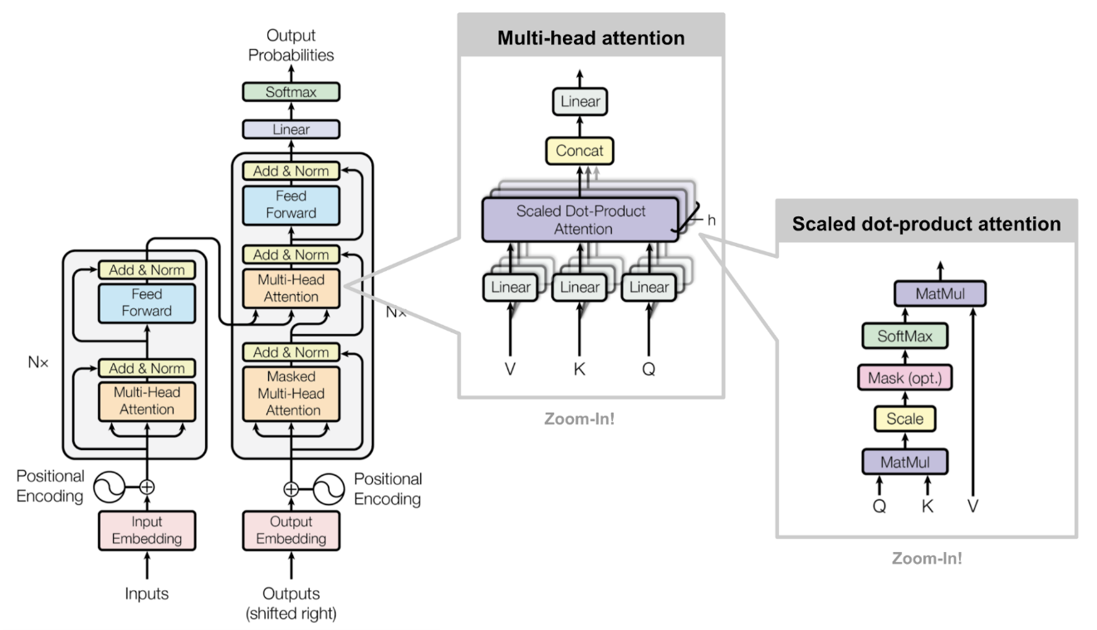

Figure 2 Transformer Architecture Components

Significance of NLP in diverse applications

Natural Language Processing (NLP) has transformative applications across multiple sectors, each demonstrating the profound impact of this technology. In **customer service**, NLP-driven chatbots and virtual assistants, such as those deployed by major tech firms like Amazon and Google, use sophisticated models to handle customer queries with nuances that traditional systems can't match (Brown, 2020). For example, Google's Meena chatbot utilizes advanced NLP to maintain context over extended interactions, providing responses that are not only contextually relevant but also engaging, mimicking human-like exchanges.

In **healthcare**, NLP is revolutionizing the way medical data is interpreted (Esteva, 2019). Systems equipped with NLP are being used by institutions like the Mayo Clinic to extract critical information from unstructured clinical notes. These systems can identify medical terminologies, extract patient histories, and support diagnostic processes, thus significantly enhancing patient care by providing insights that are both timely and personalized.

In the **finance sector**, companies like Bloomberg and Thomson Reuters use NLP to sift through vast amounts of financial documents, earnings reports, and real-time news to extract actionable insights. These NLP systems analyze market sentiments, detect trends, and track economic indicators to inform better decision-making, offering a competitive edge by providing deeper analytical capabilities and quicker response times (Bao & Datta, 2018).

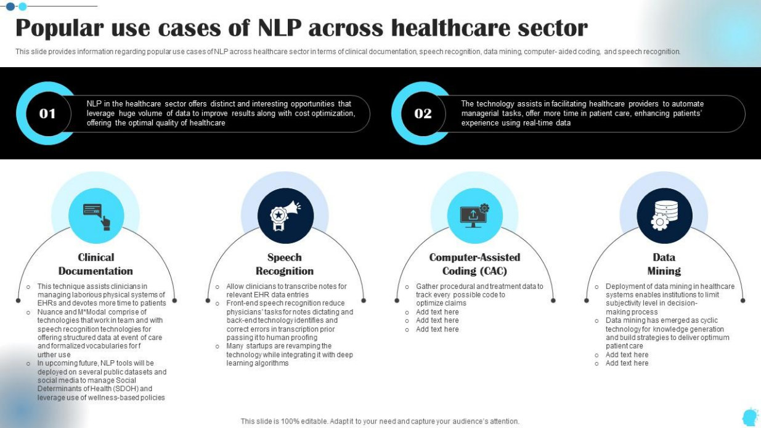

Figure 3 Use cases of NLP in the healthcaresector.

Understanding Sentiment Analysis with BERT

As we explore the current capabilities of NLP technologies, it's important to demonstrate their application in real-world scenarios. Sentiment analysis is a pivotal NLP task used to interpret the emotional tone behind texts, which is crucial for understanding opinions in user feedback and social media. To showcase how NLP models can be practically implemented, we'll focus on BERT (Bidirectional Encoder Representations from Transformers), a state-of-the-art model known for its effectiveness across various NLP tasks.

BERT's architecture, developed by researchers at Google, leverages deep learning to understand the nuances of language, making it ideal for tasks like sentiment analysis. In this example, we'll use a pre-trained BERT model from the Hugging Face's Transformers library, a robust suite of tools that provides access to numerous pre-trained models designed to facilitate a wide range of NLP applications. This example not only highlights the utility of BERT in sentiment analysis but also introduces you to the practical use of Hugging Face's library, which is central to deploying these advanced models efficiently.

Here is a simple Python example that demonstrates sentiment analysis using the Hugging Face's Transformers library:

`` python

from transformers import BertTokenizer, BertForSequenceClassification  
 from transformers import pipeline

tokenizer = BertTokenizer.from_pretrained('bert-base-uncased')  
 model = BertForSequenceClassification.from_pretrained('bert-base-uncased')

nlp = pipeline("sentiment-analysis", model=model, tokenizer=tokenizer)

example_text = "Hugging Face Transformers is incredibly simple to use. What an amazing library!"

result = nlp(example_text)

print(f"Sentiment: {result[0]['label']}, with a confidence of {result[0]['score']:.4f}")

``

**Detailed Analysis of the Sentiment Analysis Code Snippet**

Let’s take a closer look at how the code snippet operates to provide a deeper understanding of its function:

* Library Imports: The script begins by importing necessary components from the Hugging Face's transformers library. This library offers access to pre-trained models like BERT, which are equipped with functionalities such as tokenization, essential for processing text.
* Initializing Tokenizer and Model: We initialize the BertTokenizer and BertForSequenceClassification with the bert-base-uncased model. This particular model is chosen because it has been trained on a vast corpus of English text in lowercase and is fine-tuned for sequence classification tasks, making it suitable for sentiment analysis.
* Setting up the Pipeline: A pipeline is established to streamline the process of tokenization, prediction, and output generation. We specify 'sentiment-analysis' as the task, which configures the pipeline to classify the sentiment of the input text.
* Running the Model: An example sentence is input into the model. The pipeline efficiently processes the text, applies the model, and outputs the sentiment classification and a confidence score. For instance, if the input sentence is "I love this product!", the model might classify this as Positive with a confidence score of 0.98, indicating high certainty in its analysis.
* Interpreting Results: The result of this process provides insights into the emotional tone of the input text. The confidence score, a value between 0 and 1, quantifies the model's certainty about its sentiment classification, with values closer to 1 indicating higher confidence.

In upcoming chapters, specifically in Chapters 7 and 8, we will explore more about how these models are fine-tuned and further optimized for specific tasks beyond basic sentiment analysis. These discussions will delve into the inner workings of model training and fine-tuning processes, providing you with a comprehensive skill set for enhancing model accuracy and adapting them to various NLP tasks.

Advanced Concepts in NLP and Deep Learning for Hugging Face Diffusers

Natural Language Processing (NLP) and deep learning form the backbone of the Hugging Face Diffusers technology, powering a new generation of language understanding and generation models. This section focuses on essential NLP tasks and how they are enhanced through deep learning techniques, specifically within the Hugging Face ecosystem.

Key NLP Tasks Enhanced by Hugging Face Diffusers

Hugging Face Diffusers utilize state-of-the-art deep learning models to tackle core NLP tasks with unprecedented efficiency and accuracy:

* Text Classification: Leveraging transformer models, Hugging Face Diffusers efficiently categorize text into predefined labels. This capability is crucial in applications like spam detection and content moderation.
* Named Entity Recognition (NER): Hugging Face models excel in identifying and classifying named entities in text, such as person names, locations, and organizations, enhancing data extraction and analysis processes.
* Sentiment Analysis: By applying deep learning, Hugging Face Diffusers provide nuanced analysis of emotions and sentiments in text, a key component in customer feedback analysis and market research.

Transformative Role of Transformer Models

The introduction of transformer models marks a significant evolution in NLP, primarily driven by the architectures available through Hugging Face. Unlike traditional models, transformers handle vast datasets and complex linguistic patterns more effectively, making them ideal for:

* Real-time Language Translation: Achieving near-human accuracy in translating multiple languages, transforming global communication.
* Advanced Content Generation: Creating high-quality, context-aware text that can mimic human writing styles.

Each of these tasks demonstrates the practical application of advanced NLP concepts within the Hugging Face platform, highlighting the critical role of deep learning in enhancing the functionality and scope of modern NLP applications. This knowledge not only prepares you to use Hugging Face Diffusers more effectively but also underscores the importance of these foundational technologies in pushing the boundaries of what AI can achieve in language processing.

Advanced NLP Techniques and Their Real-World Applications

Text Classification Enhanced by Deep Learning

Text classification stands as a cornerstone of NLP, serving critical functions across numerous industries. For instance, in the legal domain, text classification algorithms are employed to automatically sort legal documents into categories such as contracts, briefs, and judgments, streamlining workflows and reducing manual labor. A notable advancement in this area has been achieved through the integration of **Convolutional Neural Networks (CNNs)**, which excel in recognizing patterns in text structure (Kim, 2014); (Zhou, et al., 2016). This capability allows for the extraction and classification of legal terms and clauses with high precision, significantly enhancing the efficiency of legal document analysis.

Additionally**, Recurrent Neural Networks (RNNs)** have transformed email management systems by improving spam detection algorithms. These models excel at understanding sequence and context in text, enabling them to distinguish between genuine communications and spam with greater accuracy. This not only optimizes the user experience by reducing false positives but also adapts to evolving spam tactics more effectively than traditional methods (Lample, Ballesteros, Subramanian, Kawakami, & Dyer, 2016).

Named Entity Recognition (NER) in Dynamic Environments

NER technology is pivotal in managing vast amounts of unstructured data across sectors. In **media and journalism**, NER systems automatically tag content with relevant metadata about people, places, and organizations. This tagging supports sophisticated content recommendation engines that enhance user engagement by suggesting articles based on the entities mentioned. For instance, during major events such as elections or sports tournaments, NER systems categorize and recommend articles in real-time, helping news platforms increase readership and maintain relevance.

In **finance**, NER helps in risk assessment processes by identifying critical entities in investment reports and news articles that could signify market movements. By recognizing company names and associating them with market trends and events, these systems provide traders and analysts with timely insights, supporting better-informed investment decisions.

Sentiment Analysis for Market Insights

Sentiment analysis has become a vital tool in market analysis and consumer behavior studies. **Deep learning**, particularly using **Long Short-Term Memory (LSTM)** networks, has empowered sentiment analysis tools to grasp the nuances of human emotion in customer feedback (Hochreiter & Schmidhuber, 1997). This technology is crucial for brands to gauge public sentiment on social media platforms, where customer opinions are voluminous and varied.

For example, **automotive companies** utilize sentiment analysis to monitor customer reactions to new vehicle launches across different regions. By analyzing comments and reviews, these companies can quickly address concerns and improve product features. Moreover, LSTMs enable these models to understand context over long stretches of text, such as customer emails or discussion threads, providing more accurate sentiment assessments that directly influence product development and marketing strategies.

These advanced NLP techniques, powered by sophisticated deep learning models, not only automate routine tasks but also unlock new insights and efficiencies across various industries. Their ability to adapt to specific needs and continuously learn from new data makes them indispensable in today's fast-paced digital economy.

Text classification involves categorizing text into predefined groups. It is fundamental in applications such as spam detection, where emails are classified into 'spam' or 'non-spam' categories, and sentiment analysis, where opinions in text are classified as positive, negative, or neutral. For instance, companies use sentiment analysis to monitor brand sentiment from customer reviews on social media and other online platforms. Advanced deep learning models, such as Convolutional Neural Networks (CNNs) and Recurrent Neural Networks (RNNs), have significantly improved the accuracy and efficiency of these tasks by capturing contextual nuances in text data (Kim, 2014; Zhou et al., 2016)./

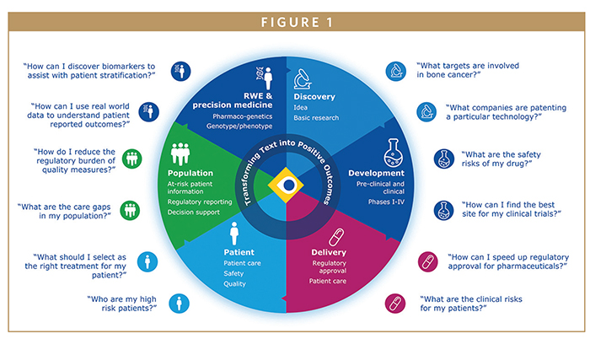

Figure 4 Real world applications of advanced NLP techniques.

Exploring the Transformative Impact of Transformers in NLP

Having delved into how advanced NLP techniques like text classification, NER, and sentiment analysis are revolutionizing industries by leveraging deep learning models, we now transition to understanding the next leap in NLP technology: transformers. These models have significantly advanced the state of the art, offering even more nuanced understanding and generation of human language.

Transformative Role of Transformer Models in NLP

The introduction of transformer models by Vaswani et al. (2017) marked a revolutionary advancement in NLP. Unlike previous models reliant on sequential data processing, transformers use a mechanism known as 'attention' to weigh the influence of different words in a sentence, regardless of their positional distance. This allows the model to capture complex word dependencies and significantly improves the efficiency of language understanding tasks.

Transformers have been foundational in developing state-of-the-art models such as BERT (Bidirectional Encoder Representations from Transformers) and GPT (Generative Pretrained Transformer). BERT, for example, has set new standards for NER and question answering tasks by effectively understanding the context in which words appear (Devlin et al., 2019). GPT, on the other hand, has been utilized to generate coherent and contextually relevant text based on a given prompt, demonstrating remarkable capabilities in text generation tasks (Radford et al., 2019).

In this section, we delved into advanced NLP tasks and explored the impact of transformative deep learning models, particularly transformers. These insights are crucial for understanding the complexities and capabilities of modern NLP systems. Moving forward, we will now examine the practical applications of these models, focusing on how they are integrated into real-world systems to solve complex language processing challenges.

Text Classification: Principles to Practice

Text classification is a foundational task in natural language processing (NLP), where text is categorized into predefined groups. It is essential for applications such as spam detection—where emails are classified as 'spam' or 'non-spam'—and sentiment analysis, which involves categorizing opinions in text as positive, negative, or neutral. Advanced deep learning models, like Convolutional Neural Networks (CNNs) and Recurrent Neural Networks (RNNs), have significantly improved the accuracy and efficiency of these tasks by capturing contextual nuances in text data.

To provide a clearer understanding of how these theoretical applications are put into practice, we will explore a practical example using the Hugging Face Transformers library. This example demonstrates how a state-of-the-art transformer model can be utilized for sentiment analysis, a common text classification task. By leveraging pretrained models such as BERT (Bidirectional Encoder Representations from Transformers), this example will illustrate how text classification can be effectively performed to identify sentiment in customer reviews, showcasing the model's ability to discern emotional tone from text.

Example: Utilizing Hugging Face Diffusion for Text Classification

In this practical demonstration, we'll use the Hugging Face Transformers library to perform sentiment analysis. The library provides access to powerful transformer models that excel in classifying text into predefined categories. Here's how you can apply it to determine the sentiment expressed in various texts, such as reviews, which is crucial for businesses monitoring brand sentiment on social media platforms and other online forums.

By embedding this example directly within the discussion on text classification, it connects theoretical concepts with their practical applications, enhancing comprehension and providing a cohesive reading experience.

``python

from transformers import pipeline  
  
classifier = pipeline('sentiment-analysis', model="distilbert-base-uncased-finetuned-sst-2-english")  
  
texts = ["I love using Hugging Face Transformers, they make NLP easy!",   
 "The movie was terrible and I was disappointed by the plot."]  
  
results = classifier(texts)  
  
for i, text in enumerate(texts):  
 print(f"Text: {text}\nSentiment: {results[i]['label']} with a confidence of {results[i]['score']:.4f}\n")

Let's dive into the details of the code snippet to understand it better:

* Library Import**:** We import the pipeline function from Hugging Face's transformers library, which provides high-level utilities for accomplishing various NLP tasks.
* Initializing the Pipeline**:** The pipeline is set up for sentiment analysis using "distilbert-base-uncased-finetuned-sst-2-english," a lighter version of BERT that is pre-trained and fine-tuned on a sentiment analysis task (Stanford Sentiment Treebank).
* Processing Texts**:** We input a list of texts to the model. The pipeline handles tokenization, model inference and returns the sentiment classification and confidence score for each text.

Deep Learning Essentials for NLP

Deep learning, a subset of machine learning that mimics the human brain's ability to process data and recognize patterns, plays a crucial role in the evolution of **Natural Language Processing (NLP)**. This section explores how deep learning technologies empower NLP applications, impacting various sectors, particularly marketing.

Deep learning models, including **Neural Networks**, **Convolutional Neural Networks (CNNs)**, and **Recurrent Neural Networks (RNNs)**, are fundamental in processing and interpreting complex data structures. These models excel in tasks ranging from sentiment analysis to customer behavior prediction, which are essential for crafting effective AI-driven marketing strategies.

**Practical Application in Marketing**: NLP techniques are integral to marketing campaigns where understanding and engaging with customers through language is crucial. For instance, machine learning algorithms analyze customer feedback to segment audiences and personalize marketing efforts, significantly improving engagement rates. This real-world application demonstrates the direct impact of NLP and deep learning in transforming marketing strategies.

**Integration of AI in Marketing Campaigns**: AI tools, including those powered by NLP, enable marketers to leverage large datasets to forecast trends, personalize content, and optimize campaign performance. For example, NLP tools are used to optimize content for SEO, ensuring it resonates with both target audiences and search engine algorithms, which is crucial for enhancing online visibility and engagement (Korzhov, 2024).

**Towards Hugging Face Diffusion**: The insights gained from understanding these deep learning principles are pivotal when employing advanced technologies like the Hugging Face Diffusion library. This library integrates state-of-the-art machine learning models to enhance NLP tasks, offering tools that are especially beneficial in sectors like marketing where real-time data analysis and customer interaction are paramount.

By exploring these deep learning fundamentals, we prepare to utilize the Hugging Face Diffusion library effectively, ensuring that readers can apply these advanced models to real-world scenarios. This approach not only enriches the reader's knowledge but also showcases the practical applications of these technologies in modern industries, including marketing.

**Why These Topics are Essential**: Understanding the fundamentals of deep learning and NLP is essential for any professional looking to leverage AI in practical applications. These technologies are not just academic concepts but are the driving force behind many modern business strategies, especially in data-driven sectors such as marketing. By mastering these topics, readers can anticipate industry needs, innovate solutions, and apply AI technologies more effectively and ethically in their respective fields. /

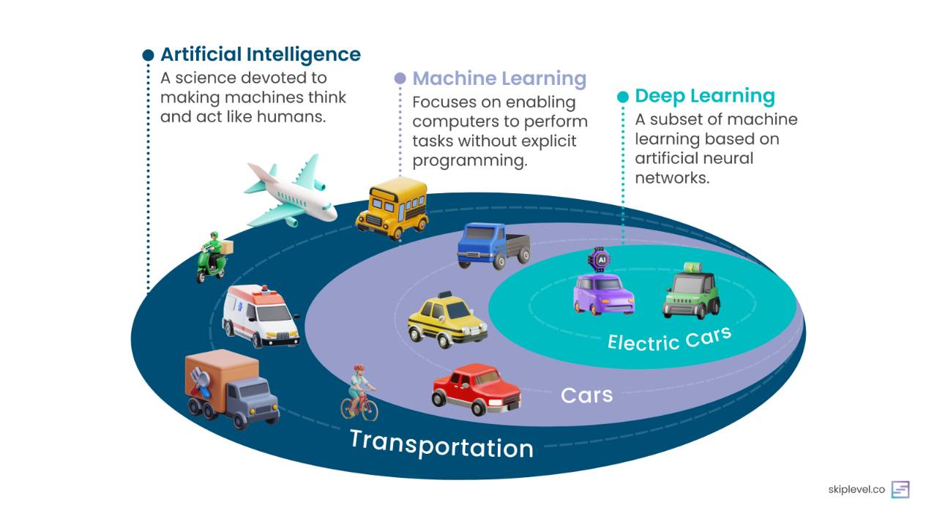

Figure 5 Deep learning essentials for NLP compared.

Fundamentals of Neural Networks Applied to NLP Tasks

Neural networks have dramatically transformed the field of **Natural Language Processing (NLP)** by enabling the development of models that understand and generate human language with unprecedented complexity and subtlety. These models learn to recognize patterns and infer meanings from data without explicit programming, which is crucial for handling the intricacies of human communication.

**Feedforward Neural Networks:** Feedforward neural networks are the most straightforward type of artificial neural networks, where information moves in only one direction—from input nodes, through hidden layers, to output layers. This architecture is fundamental for learning from static inputs where temporal dynamics are not required (Goodfellow, Bengio, & Courville, 2016). For example, they are used in text classification tasks where the context does not depend on the sequence of words, such as identifying whether an email is spam.

**Recurrent Neural Networks (RNNs):** RNNs are designed to recognize sequences in data by maintaining a 'memory' of previous inputs using their internal state (Hochreiter & Schmidhuber, 1997). This feature makes them ideal for NLP tasks where the sequence and context of words matter. RNNs and their more advanced variants like **LSTM (Long Short-Term Memory)** networks are commonly used for language translation and generating text where continuity from one word to the next is crucial.

**Deep Learning Enhancements in NLP:** Recent breakthroughs in deep learning have led to the development of models that can handle even more complex language tasks. Transformer models, such as those available through **Hugging Face**’s library, are built on the foundations laid by RNNs and LSTMs but use attention mechanisms to significantly improve the processing of sequences. Unlike RNNs that process data linearly, transformers process all words or tokens in parallel, making them more efficient at understanding context across long texts. This architectural enhancement is particularly evident in models like BERT and GPT, which have set new benchmarks in tasks ranging from sentence classification to generating human-like text.

By integrating these advanced neural network architectures, **Hugging Face**’s platform enables the creation and deployment of powerful NLP applications that can understand and interact with human language in a way that mimics human thought processes. Understanding these fundamentals not only provides a clearer picture of how modern NLP works but also sets the stage for practical application in real-world scenarios.

Feedforward Neural Networks

At the core, **feedforward neural networks**, including perceptrons and multi-layer networks, set the stage for learning textual data. These networks typically involve layers of neurons that process input features (words or characters) and transmit signals to subsequent layers, ultimately leading to output layers that make predictions or classifications (Goodfellow et al., 2016).

Recurrent Neural Networks (RNNs)

RNNs are a pivotal advancement in NLP due to their ability to handle sequences, such as sentences or longer texts. Unlike feedforward networks, RNNs have loops allowing information to persist, mimicking memory. This architecture is beneficial for tasks where context from earlier in the sequence is necessary to understand or predict later elements, such as language translation or sentiment analysis (Hochreiter & Schmidhuber, 1997).

Having explored the foundational role of RNNs in understanding sequences, we now turn our attention to how these principles are integrated into more complex and contemporary models like Transformers, which have expanded the horizons of NLP by addressing some of the limitations inherent in traditional RNN architectures./

Common Architectures Used in NLP

To harness the vast potential of natural language processing, it is imperative to understand the two pivotal neural network architectures that underpin current NLP technologies—Recurrent Neural Networks (RNNs) and Transformers. Each offers unique advantages for processing language data, addressing different challenges and requirements in the field of NLP.

Recurrent Neural Networks (RNNs)

RNNs are essential for sequence modeling tasks because they can handle data where the order and context matter, such as sentences or longer texts. Their ability to maintain a memory of previous inputs in their internal state allows for the dynamic processing of sequences. This architecture is especially beneficial in tasks like language translation or sentiment analysis, where understanding the flow of language is crucial. RNNs, including variants like LSTM (Long Short-Term Memory) and GRU (Gated Recurrent Units), address the vanishing gradient problem that hinders many standard neural networks, thereby improving the learning of dependencies in lengthy text sequences. These advancements have enhanced their capability to model complex language patterns over time, making them a staple in modern NLP pipelines (Hochreiter & Schmidhuber, 1997); (Chung, 2014).

Transformers

Transformers have rapidly become the backbone of modern NLP systems, often replacing RNNs in many applications. Their reliance on attention mechanisms allows them to process input data in parallel and capture complex relationships between words, irrespective of their position in the text. This ability significantly enhances the performance and efficiency of language understanding tasks. Transformers are crucial in driving the success of models like BERT and GPT, which have set new standards for accuracy in a variety of NLP tasks, from machine translation to text summarization (Vaswani, 2017).

Transformative Role of Transformer Models in NLP

Transformer models, particularly those enabled by the Hugging Face Transformers library, have revolutionized natural language processing. These models, which rely on advanced architectures like BERT, excel in tasks requiring deep contextual understanding, such as named entity recognition (NER) and sentiment analysis. The ability of transformers to process input data in parallel, without the need for sequential data processing, significantly speeds up the learning and application phases, making them ideal for real-time NLP applications.

Following this exploration of transformers' capabilities, let's delve into a practical application that highlights their versatility and power in a common NLP task.

Example: Building and Customizing NLP Pipelines with Hugging Face Transformers

This example demonstrates the practical implementation of transformer models by focusing on a Named Entity Recognition (NER) task. We will use a pretrained BERT model, widely recognized for its effectiveness in identifying and classifying entities such as names, locations, and organizations, to illustrate how the theoretical advantages of transformers translate into real-world applications.

``python

from transformers import pipeline, AutoModelForTokenClassification, AutoTokenizer

tokenizer = AutoTokenizer.from_pretrained("dbmdz/bert-large-cased-finetuned-conll03-english")  
model = AutoModelForTokenClassification.from_pretrained("dbmdz/bert-large-cased-finetuned-conll03-english")  
  
ner_pipeline = pipeline("ner", model=model, tokenizer=tokenizer)  
  
text = "Hugging Face is a technology company based in New York and Paris."  
  
ner_results = ner_pipeline(text)  
  
print("Detected Entities and their Labels:")  
for entity in ner_results:  
 print(f"Text: {entity['word']}, Entity: {entity['entity']}")

``

Understanding the Code:

* Library Import: We import the pipeline, AutoModelForTokenClassification, and AutoTokenizer from the Hugging Face Transformers library, streamlining tokenization and model inference.
* Loading Pretrained Components: The tokenizer and model are sourced from a BERT model fine-tuned on the CoNLL-2003 dataset—a benchmark for NER tasks, ensuring the model's adeptness at recognizing various entity types in English text.
* Setting up the NER Pipeline: The named entity recognition pipeline is established with the loaded tokenizer and model, automating the process of tokenization, model inference, and entity classification.
* Processing Text: The example text is analyzed by the pipeline, which efficiently identifies and classifies entities, showcasing the direct application of transformers in enhancing NLP tasks.

This practical illustration not only demonstrates the straightforward integration of complex NLP tasks into usable applications but also underscores how the theoretical advancements discussed previously are directly applicable in enhancing real-world NLP solutions.

Introduction to Tokenization, Word Embeddings, and Attention Mechanisms

Understanding the building blocks of natural language processing is essential for harnessing the full potential of NLP technologies. In this section, we explore three foundational concepts that are crucial for developing effective NLP models: Tokenization, Word Embeddings, and Attention Mechanisms. Each of these elements plays a vital role in the way machines process and interpret human language, making them indispensable for any advanced NLP system.

Tokenization

Tokenization is the process of breaking down text into smaller units, called tokens. This could involve splitting text into words, syllables, or subwords. Effective tokenization is crucial for preparing input data for neural networks in NLP tasks.

Word Embeddings

Word embeddings are dense vector representations of words that capture contextual and semantic meanings. Models like **Word2Vec** (Mikolov, 2013) or **GloVe** (Pennington, Socher, & Manning, 2014) provide a way for neural networks to understand text data by converting words into vectors that reflect their semantic relationships in a high-dimensional space.

Attention mechanisms

Attention mechanisms have transformed the capabilities of neural networks by allowing models to focus on different parts of the input sequence when performing a task. This is particularly useful in tasks like machine translation, where the relevance of input words can vary depending on the context. The introduction of attention in models such as the Transformer (Vaswani et al., 2017) allows for a more nuanced understanding and generation of language.

With the introduction of attention mechanisms enhancing our understanding and capabilities in complex NLP tasks, we are poised to delve into how these innovations are being integrated into larger systems. Next, we will explore the applications of these advanced techniques in real-world scenarios, demonstrating the practical impact and the ongoing evolution of NLP technologies./

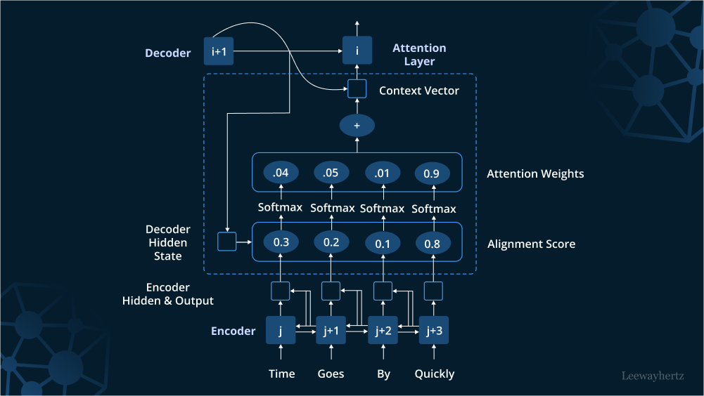

Figure 6 Attention mechanism in deep Learning

In this section, we experienced the versatility and power of hugging face transformers in building customized NLP pipelines for real-world applications. The purpose of including this example here was to give you hands-on experience and insights into developing effective NLP systems using state-of-the-art technologies.

This section provides a comprehensive exploration of deep learning essentials for NLP, equipping you with the necessary knowledge to apply these advanced techniques in various NLP tasks.

Integration of NLP and Deep Learning

The integration of deep learning and NLP has led to significant breakthroughs across various domains, demonstrating the power of these technologies when combined. Here we explore several practical applications and real-world case studies where deep learning has enhanced NLP capabilities.

Machine Translation

One of the most impactful applications is in machine translation, where deep learning models, particularly those based on the Transformer architecture, have significantly improved translation quality. For example, Google Translate has adopted Neural Machine Translation (NMT) systems that utilize deep learning to provide more accurate and contextually relevant translations than ever before (Wu et al., 2016).

Sentiment Analysis in Social Media

Deep learning has also transformed sentiment analysis, enabling more nuanced and accurate interpretations of emotions from text data. For instance, companies use LSTM networks to analyze customer feedback on social media, helping them to quickly identify and respond to customer sentiments, ranging from satisfaction to frustration (Zhang et al., 2018).

Automated Content Generation

Deep learning models like GPT-3 have revolutionized content generation, allowing for the creation of coherent and contextually relevant text based on minimal input. This technology is used by media outlets to generate news reports and by companies to create dynamic content for websites (Brown et al., 2020).

Healthcare Documentation

In healthcare, deep learning is applied in extracting and summarizing medical information from patient records, significantly reducing the time healthcare professionals need to spend on paperwork. Models trained on specific datasets can identify key medical terms and patient information, facilitating quicker and more accurate record-keeping (Rajkomar et al., 2018).

Strategies for Optimizing NLP Models through Deep Learning Methodologies

To optimize natural language processing (NLP) models effectively, especially when leveraging deep learning methodologies, several strategic approaches are employed. These strategies enhance the model's performance and adaptability to various NLP tasks, ensuring they can handle the complexities of language effectively. Here we explore key methodologies designed to refine the efficiency and accuracy of NLP models in practical applications.

* **Fine-Tuning Pretrained Models:** One effective strategy for optimizing NLP models is fine-tuning pretrained models on specific tasks. For example, BERT and its variants can be fine-tuned with additional layers or trained on task-specific corpora to improve performance on tasks like question answering and named entity recognition (Devlin et al., 2019).
* **Data Augmentation:** Another strategy is data augmentation, which involves artificially expanding the training dataset by modifying existing data points. Techniques such as synonym replacement, back-translation, and text surface transformation help in creating robust models that generalize better on unseen data (Wei & Zou, 2019).
* **Hyperparameter Optimization:** Hyperparameter optimization plays a critical role in maximizing the performance of deep learning models. Techniques like grid search, random search, and Bayesian optimization are used to find the most effective learning rates, dropout rates, and other parameters that influence training dynamics (Bergstra et al., 2012).

Building on our understanding of neural network architectures and their applications, it's crucial to recognize the role of hyperparameter optimization in refining model performance. This process involves fine-tuning the settings under which models operate, which is essential for achieving the best results in practical scenarios./

Example: Build Your Own AlphaZero AI

In this example, we demonstrate setting up a basic version of the AlphaZero algorithm using Python and TensorFlow. Developed by DeepMind, AlphaZero integrates deep learning with Monte Carlo Tree Search (MCTS) to master complex games through self-play. By continually competing against itself, it learns optimal strategies, showcasing significant advancements in artificial intelligence capabilities applied to game theory. Below, we outline a simplified implementation tailored for a generic game environment, highlighting the essential steps and components involved in replicating AlphaZero's methodology.

``python

import numpy as np  
import tensorflow as tf  
from tensorflow.keras.models import Sequential  
from tensorflow.keras.layers import Dense, Conv2D, Flatten  
  
board_size = 3 # For simplicity, a 3x3 board like Tic-Tac-Toe  
num_actions = board_size ** 2  
  
def create_az_model():  
 model = Sequential([  
 Conv2D(32, kernel_size=(3, 3), activation='relu', input_shape=(board_size, board_size, 1)),  
 Flatten(),  
 Dense(64, activation='relu'),  
 Dense(num_actions, activation='softmax')  
 ])  
 model.compile(optimizer='adam', loss='categorical_crossentropy')  
 return model  
  
az_model = create_az_model()  
  
much more complex)  
def generate_self_play_data():  
 # Randomly create game states (board positions) and their outcomes  
 data_size = 100  
 states = np.random.rand(data_size, board_size, board_size, 1)  
 actions = np.random.randint(num_actions, size=data_size)  
 action_probs = np.eye(num_actions)[actions] # Convert actions to one-hot encoded probabilities  
 values = np.random.randint(2, size=data_size) * 2 - 1 # Game outcomes as -1 or 1  
 return states, action_probs, values  
  
states, action_probs, values = generate_self_play_data()  
  
az_model.fit(states, {'action_probs': action_probs, 'values': values}, epochs=10)  
  
az_model.summary()

Let's dive into the details of the code snippet to understand it better:

1. **Environment and Model Setup:** We define a simple game environment like Tic-Tac-Toe with a 3x3 board. The neural network model is structured to predict both move probabilities and game outcome, key components in AlphaZero's architecture.
2. **Neural Network Architecture:** The model uses convolutional layers to process the board state, flattening the output, and dense layers to predict action probabilities and game outcomes. This mimics AlphaZero's approach but on a much simpler scale.
3. **Self-Play Data Simulation:** Typically, AlphaZero generates data through self-play. Here, we mock this process by randomly generating game states and outcomes. This is a placeholder for more complex self-play logic.
4. **Model Training:** The model is trained on the generated data, learning to associate board states with action probabilities and outcomes, foundational for strategy development in games.

This example gives you a hands-on look at how to integrate deep reinforcement learning techniques to build intelligent systems that can learn and adapt through self-play, reflecting the methodologies behind advanced algorithms like AlphaZero.

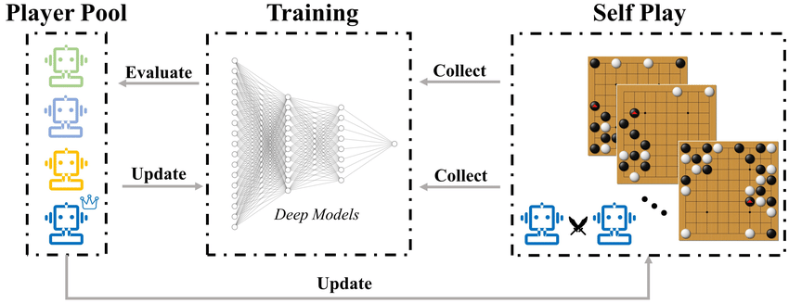

Figure 7 AlphaZero's pipeline. Self-play games' data are continuous generation.

Summary

In this chapter, we laid a robust foundation for understanding the synergy between NLP and deep learning. We embarked on a journey exploring the evolution of NLP within the realms of artificial intelligence and machine learning, demonstrating how advancements in deep learning technologies have revolutionized our approach to processing and understanding human language. Our exploration covered key NLP tasks such as text classification, named entity recognition, and sentiment analysis, detailing how these are implemented with cutting-edge deep learning models to improve accuracy and efficiency.

We delved into the transformative role of transformer models in NLP, showcasing their unique ability to handle complex word dependencies, which enhances language understanding tasks significantly. Practical applications were discussed to illustrate how the integration of NLP with deep learning techniques is being applied across various domains, from machine translation to automated content generation, each demonstrating significant breakthroughs in capability and efficiency.

Having explored these foundational aspects, we are now poised to delve deeper into the practical application of these technologies using the Hugging Face Diffusers library. In the next chapter, we will focus on leveraging this library to implement advanced models and techniques for generating human-like text and beyond, opening up exciting new possibilities in the field of AI/

References

Bao, Y., & Datta, A. (2018). Simultaneously Discovering and Learning New Features for Action Recognition. *Proc. of IEEE Conference on Computer Vision and Pattern Recognition*, (pp. 779–788).

Bergstra, J., Bengio, Y., & Hutter, F. (2012). Random Search for Hyper-Parameter Optimization. *Journal of Machine Learning Research, 13*, 281–305.

Brown, T. B. (2020). *Language Models are Few-Shot Learners.*

Chung, J. (2014). *Empirical Evaluation of Gated Recurrent Neural Networks on Sequence Modeling.*

Devlin, J., Chang, M. W., Lee, K., & Toutanova, K. (2019). *BERT: Pre-training of Deep Bidirectional Transformers for Language Understanding.*

Esteva, A. (2019). A Guide to Deep Learning in Healthcare. *Nature Medicine, 25*, 24–29.

Goodfellow, I., Bengio, Y., & Courville, A. (2016). *Deep Learning.* Cambridge, MA: MIT Press.

Hochreiter, S., & Schmidhuber, J. (1997). Long Short-Term Memory. *Neural Computation, 9*, 1735–1780.

Jurafsky, D., & Martin, J. H. (2019). *Speech and Language Processing* (3rd ed.). Pearson.

Kim, Y. (2014). *Convolutional Neural Networks for Sentence Classification.*

Lample, G., Ballesteros, M., Subramanian, S., Kawakami, K., & Dyer, C. (2016). *Neural Architectures for Named Entity Recognition.*

Manning, C. D., Raghavan, P., & Schütze, H. (2008). *Introduction to Information Retrieval.* Cambridge University Press.

Mikolov, T. (2013). *Distributed Representations of Words and Phrases and their Compositionality.* NIPS.

Pennington, J., Socher, R., & Manning, C. (2014). *GloVe: Global Vectors for Word Representation.* EMNLP.

Radford, A. (2019). Language Models are Unsupervised Multitask Learners. *OpenAI Blog*.

Rajkomar, A. (2018). Scalable and accurate deep learning with electronic health records. *NPJ Digital Medicine, 1*, 18.

Vaswani, A. (2017). Attention is All You Need. *Proc. of NIPS 2017*, (pp. 5998–6008).

Wei, J., & Zou, K. (2019). *EDA: Easy Data Augmentation Techniques for Boosting Performance on Text Classification Tasks.*

Wu, Y. (2016). *Google's Neural Machine Translation System: Bridging the Gap between Human and Machine Translation.*

Zhang, X., Zhao, J., & LeCun, Y. (2018). *Character-level Convolutional Networks for Text Classification.* NIPS.

Zhou, P., Shi, W., Tian, J., Qi, Z., Li, B., Hao, H., & Xu, B. (2016). *Attention-Based Bidirectional Long Short-Term Memory Networks for Relation Classification.*