Gauging the Carbon Footprint Impact of Mining Cryptocurrencies
Paulo H. Leocadio
Zinnia Holdings LLC

Author Note
Research article exclusive for Brainz Magazine Publication, January of 2023

Abstract
With the continuously increasing concern with the environment, the adoption of sustainability measures by governments and corporations alike, it would not take long for the carbon footprint and energy use of blockchain technologies, with special attention to the growing number of cryptocurrencies and tokens released to marked frequently.
Tracing a parallel pathway with similar discussions when the adoption of Cloud technologies boomed after 2010 (Hari, Sai, & Venkata, 2015), the attention to the enormous datacenters, their localization, and their energy consumption was a common counter argument to sales pitches to businesses and their significant savings by adopting those technologies.
A common term when talking or reading about cryptocurrencies is “decentralization”, and also distributed and open environment, free from central governments control e centralized policies. Extrapolating to our topic, do we have the answers whether these aspects are eco-friendly, sustainable, or leave low carbon footprint?
Behind the Cloud that we see, as briefly mentioned above, we have regional datacenters, fault recovery datacenters These very large computing environments consume a considerable amount of power, but also generate, or generate power in the form of heat, certainly with potential to interfere with the environment.
Government sponsored cryptocurrency (specifically Bitcoin or BTC) we found in China and Argentina for example, leveraging their cold regions, to offset the effects of the mining process (Houy, 2019). It is not different from private investors, with large mining operation in the cold regions of Norway. Soon enough, we might witness large mining operations built underwater like one of the top global Cloud providers did.
This paper explores the meaning of sustainability, carbon footprint, and energy use related to cryptocurrencies. It will have a glimpse of the apparent differences between a home miner, a larger home mining operation, businesses with crypto mining at their core, the decentralized processes, and the Web3.
It is outside the scope of this article to discuss any policy implication, political views, FIAT currency, not even exercise previsions of monetary rebooting or financial collapse.
The objective of this paper is to connect different aspects of blockchain technologies, cryptocurrencies and Web3 when environmental sustainability could be impacted.
Keywords: Sustainability; Carbon Footprint; Cryptocurrency; Blockchain; Cryptocurrency Mining; Crypto Mining; Web3; DeFi; Smart Contracts

Gauging the Carbon Footprint Impact of Mining Cryptocurrencies
Cryptocurrencies and other tools provided by the adoption of blockchain technologies and the advent of Web3 are experiencing exponential public, enterprise, and government interest. There are countless crypto coins and derived tokens, different implementation of blockchain technologies by the original groups responsible for the release of their respective solutions. It is not possible to navigate our social media profiles without scrolling through advertisements, discussions, and offers related to “cryptos”. A quick search through the video uploading services and we find hundreds of channels with tutorials, opinions, lessons, market analysis, prevision about the future. Likewise, there are critics. From one side, the more conservative audience and their passion for silver and gold, from the other, those who consider it a threat to modern day power usage. (Mir, 2020)

Current Aspects of Cryptocurrency Energy Consumption
The aim of this paper is to talk about cryptocurrencies as a set – or group – of systems, behaving similarly and, thus, exercising similar effects in energy consumption, carbon footprint, and, overall, sustainability (Qin, Klaaßen, Gallersdörfer, Stoll, & Zhang, 2021). It is important to reinforce the importance of Bitcoin (BTC) in most aspects that can be compared between any random two cryptocurrencies. The fundamental difference is that, while BTC was designed and implemented to function as (digital) currency, decentralized and independent from any government or regulatory agency, there are other cryptocurrency blockchain implementations, and their respective coins and tokes, we implemented to function as decentralized finance (DeFi) platforms, enablers developers to deploy different applications, and even offer digital contracts (smart contracts) for a countless number of processes.

Cryptocurrency Related Energy Consumption
It is a common understanding among experts, analysts, and critics that the energy consumed by the processes behind the cryptocurrency processes is enormous (Mir, 2020), and has been growing exponentially over the last few years. According to (Mir, 2020), “Some critics believe that BTC transactions consume more energy than a country’s total usage.”
Today, we can find websites, blogs, and publications dedicated to track, analyze, assess. And compare BTC energy consumption against, for example, cities, states, and central governments (Stoll, Klaaßen, & Gallersdörfer, The Carbon Footprint of Bitcoin, 2019).
Digiconomist maintained blog states the energy usage by BTC as being, approximately, 0.3% of the total energy consumed by the entire world (de Vries, Bitcoin Energy Consumption Index, 2023). The specialized periodic Joule published an article assessing aspects of BTC energy consumption. One single BTC transaction is equivalent to the electricity required by 5 average houses in the USA (Holthaus, 2017). Comparing to entire countries, BTC is ranked 61st in the world when comparing energy consumption (PowerCompare UK, 2022).
There is also the network power consumption by the hardware, cooling devices, and other electricity related costs, is estimated to measure approximately 2.555 gigawatts (GW). When extrapolating to cryptocurrency miners and their expected revenues, the existing alternative green energy sources are not prepared for the future. This study used the quantile regression (QR) technique to determine mathematically the impact of cryptocurrency mining energy consumption costs. The study results demonstrate a negative impact on miners’ revenues. The remaining question: “are there cheaper sources of energy? (Das & Dutta, 2020)
Finally, there are estimate methodologies for cryptocurrency’s energy consumption, presenting the calculations in terms of carbon footprint, using as baseline the data provided by hardware manufacturers (such as Bitmain), the mining facilities (from small to large scale), and the mining pools themselves. The estimates are converted to carbon footprints emission factors for a specific region. These results also estimates high carbon for BTC, far apart from residing on the green quadrant (Kononova & Dek, 2020).

The impact of cryptocurrencies beyond the consumption of energy
In an article for the One World periodical, de Vries et al. (2021) developed a framework based on Global Reporting Initiative Standards. Introduced below, it shows environmental, social, and
governance aspects to consider for cryptocurrency investments:
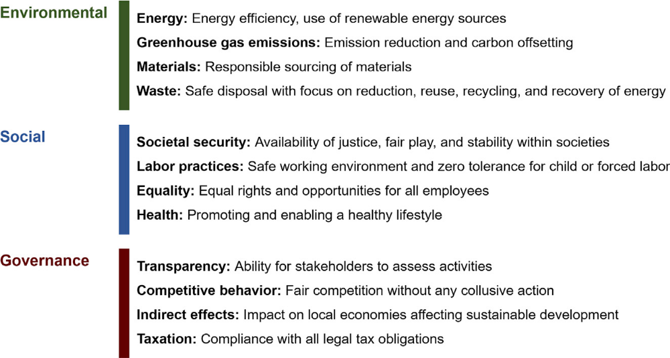
Figure 1 by Alex de Vries, Ulrich Gallersdorfer, Lena Klaaßen, and Christian Stoll
As this is not part of the scope of this paper, this citation permits the introduction of other factors to be use to estimate the true cost behind the on-going cryptocurrency and blockchains trends. The authors compiled a comprehensive list of topics and issues to be considered when evaluating existing and current state, or future scenarios for the adoption and growth of BTC and its sisters coins, tokens, blockchains and related applications.

The case for cryptocurrency trade, transactions, and exchanges
Cryptocurrency and sustainability as a topic, is making its presence noticed in literature, researches, studies, and experiments across the board. There are other aspects to consider to evaluate the true carbon footprint impact in the environment. One major factor is related to the trade volume of cryptocurrencies.
On their article published by Finance Rsearch Letters periodical, Sarkodie, Ahmed, & Leirvik (2022) state that “Blockchain technology is widely believed to be the most attractive and promising technological breakthrough for various industries, namely logistic management, supply chain system, operational management, and internet of things (IoT)”, and also that “the increase in the adoption of bitcoin in finance, retail, and politics is gradually bridging the gap between bitcoin and traditional assets that have existed in the past. Institutional adoption of cryptocurrencies, particularly bitcoin, is growing, thus altering the factors that affect current bitcoin trading compared to historical trends. The stock market crash of 2020 triggered a
massive bitcoin bull run that lasted over a year—as investors used it as a conduit for the store of value during high uncertainty, low confidence in the economy, and expectations of higher future inflation”. (Sarkodie, Ahmed, & Leirvik, 2022)
From the home and consumer scale, to global corporations and entire countries, the demand for cryptocurrencies, or, better yet, the use of cryptocurrency for a multitude of transactions is also growing in the front end.
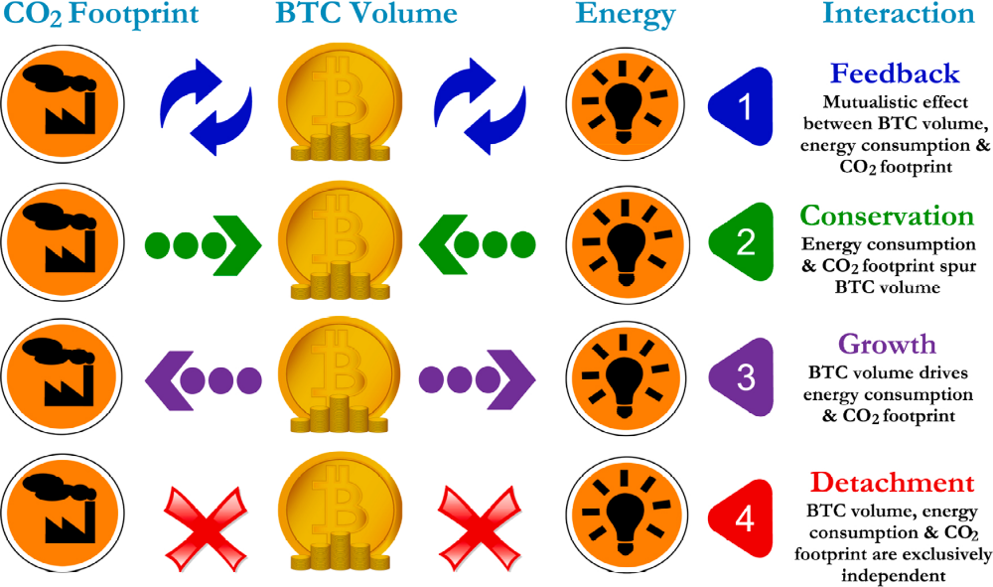
Figure 2 Theoretical framework showing the relationship between bitcoin, carbon footprint, and energy consumption. Here, we use BTC volume in the scheme as a case study, yet, it can be replaced with either market price or market capitalization without losing the theoretical interpretations. By (Sarkodie, Ahmed, & Leirvik, 2022)
There are publications frequently providing insights relating the trade volume of BTC and the BTC consumption of energy and its carbpm footprint. There is a gap when we look for insights the finanvial indicators and the footprint and energy consumption of BTC, since the main pipeline of articles and posts investigate the complex connection, cause and effect between bitcoin price, trade volume, market capitalization, bitcoin energy consumption, and carbon footprint using inadequate estimation methods (Sarkodie, Ahmed, & Leirvik, 2022).

Revisiting Bitcoin and cryptocurrencies mining
As mentioned above, the lack of robust prescriptive frameworks and of data quality related to BTC’s impact is the main roadblock to precisely assess the effects on the environment. Köhler & Pizzol (2019) applied the Life Cycle Assessment methodology to perform detailed assessments of the what the whast and future environment impacts driver are for the BTC mining distributed environment. The study yealds a detailed analisys using solid proven methods to increase the accuracy in the modeling of regional electricity mixes (Köhler & Pizzol, 2019).
“Bitcoin mining is not only the fundamental process to maintain Bitcoin network, but also the key linkage between the virtual cryptocurrency and the physical world” (Sun, et al., 2022).
The mining energy consumption and the environmental impact is not geographically uniform, including not only the many aspects introduced so far but also regional differences in network security, asset management, and the local meaning of sustainability impacts. The study of BTC mining under a spatial perspective will introduce new interpretations and further empirical evidence beyond what is available today. By exploring the spatial distribution of BTC mining using geospacial statistics and bottom-up tracking will show how the bitcoin network is distributed, spatial concentration, differences between geographical nodes, will enable the linkage between existing local policies and the concentration of mining operations, and the dynamic of the changes in the network (Sun, et al., 2022).

Artificial Intelligence, Machine Learning, and Beyond
This paper visited the topic of cryptocurrencies and environmental sustainabiliy. It discussed enery consumption and carbon footprint, and how this is measured or determined. During the final sections, the paper introduced the case for the relevance of mining to any cryptocurrency operation, how mining footprint is assessed today and the lack or more robust methods and data quality for these investigations, similar to the trading scenarios where the assessments are still in early stages when it comes to the use of methodological frameworks applied in the different scenarios.
The overarching topic of this paper raises many questions like “does BTC contribute to climate change?” The many constraints in estimating power consumption and other elements were introduced above, but what about newer solutions to help to offset the uncertainities and precarius data collection?
Artificial Inteligence (AI) and Machine Learning (ML) are realities today. Feed-forward neural networks, a sub-set of ML methods, are gaining popularity because of their unmatched performance in prediction tasks. For our case, the ability to approximate inknown data generating processes, while handling large and complex datasets seems like a perfect fit (Calvo-Pardo, Mancini, & Olmo, 2022). The methods, also known as multilayer perceptrons (MLPs) “approximate and learn unknown functions of the inputs or the data that generate an output”, like the CO₂ emissions related to the BTC network energy consumption, and assumes that information “feeds forward” from the input, through the unknown function, to the output.
The impact of everything Bitcoin and cryptocurrencies is a reality. The nuances and variables of this reality are uncertain. To predict how to dapat the grid to the fast growth in the adoption of cryptocurrencies does not provides trustworthy responses.
There are methods rarely used that can drastically improve the measurement and the predictions of the footprint, however the gap between the influencers and their novelty methods of analisys is still wide open.
The relevance of machine learning and artificial intelligence is phenomenal given the above scenario. ML methods can be applied today and mature with the cryptocurrencies technologies providing a deeper understanding of the cryptocurrency sustainability as a whole.

References
Calvo-Pardo, H. F., Mancini, T., & Olmo, J. (2022). Machine Learning the Carbon Footprint of Bitcoin Mining. . (M. AG, Ed.) Journal of Risk and Financial Management, 15(2), 71. doi:10.3390/jrfm15020071
Das, D., & Dutta, A. (2020, January). Bitcoin’s energy consumption: Is it the Achilles heel to miner’s revenue? Economics Letters, 186. doi:10.1016/j.econlet.2019.108530
de Vries, A. (2018, May 05). Bitcoin’s growing energy problem. Joule, 2(5), pp. 801-805.
de Vries, A. (2023). Bitcoin Energy Consumption Index. Retrieved from DIGICONOMIST: https://digiconomist.net/bitcoin-energy-consumption
de Vries, A., Gallersdorfer, U., Klaaßen, L., & Stoll, C. (2021, June 4). The true costs of digital currencies: Exploring impact beyond energy use. One Earth, pp. 786-789. doi:10.1016/j.oneear.2021.05.009
de Vries, A., Gallersdörfer, U., Klaaßen, L., & Stoll, C. (2021). The true costs of digital currencies: Exploring impact beyond energy use. One Earth, 4(6), 786-789. doi:10.1016/j.oneear.2021.05.009
Hari, K. R., Sai, S. Y., & Venkata, T. V. (2015). Cryptocurrency Mining – Transition to Cloud. International Journal of Advanced Computer Science and Applications, 6(9), 115-124. doi:10.14569/IJACSA.2015.060915
Holthaus, E. (2017, December 05). Bitcoin could cost us our clean-energy future . Retrieved from Grist: https://grist.org/article/bitcoin-could-cost-us-our-clean-energy-future/
Houy, N. (2019, August 28). Rational mining limits Bitcoin emissions. Nature Climate Change, 9(655). doi:10.1038/s41558-019-0533-6
Köhler, S., & Pizzol, M. (2019). Life Cycle Assessment of Bitcoin Mining. Environmental Science & Technology, 53(23), 13598–13606. doi:10.1021/acs.est.9b05687
Kononova, K., & Dek, A. (2020, September). Bitcoin Carbon Footprint: Mining Pools Based Estimate Methodology. HA/CTA, 265-273. Retrieved from http://ceur-ws.org/Vol-2761/HAICTA_2020_paper39.pdf
Kumar, S. (2021). Review of geothermal energy as an alternate energy source for Bitcoin mining. Journal of Economics and Economic Education Research, 23(1), 1-12.
Mir, U. (2020, August 31). Bitcoin and Its Energy Usage: Existing Approaches, Important Opinions, Current Trends, and Future Challenges. KSII Transactions on Internet and Information Systems (TIIS), 14(8), 3243-3256. doi:10.3837/tiis.2020.08.005
PowerCompare UK. (2022). Bitcoin Mining Now Consuming More Electricity. Retrieved from PowerCompare: https://powercompare.co.uk/blog/bitcoin-mining-now-consuming-more-electricity/
Qin, S., Klaaßen, L., Gallersdörfer, U., Stoll, C., & Zhang, D. (2021, November 5). Bitcoin's future carbon footprint. Cornell University. doi:10.48550/arXiv.2011.02612
Sarkodie, S. A., Ahmed, M. Y., & Leirvik, T. (2022). Trade volume affects bitcoin energy consumption and carbon footprint. Finance Research Letters, 48. doi:10.1016/j.frl.2022.102977
Stoll, C., Klaaßen, L., & Gallersdörfer, U. (2019). The Carbon Footprint of Bitcoin. Joule, 3(7), 1647-1661. doi:10.1016/j.joule.2019.05.012
Stoll, C., Klaaßen, L., & Gallersdörfer, U. (2019, July 12). The Carbon Footprint of Bitcoin. Joule, 3(7), pp. 1647-1661. doi:10.1016/j.joule.2019.05.012
Stoll, C., L., K., & Gallersdörfer, U. (2019). The carbon footprint of bitcoin. Joule, 3(7), pp. 1647–1661.
Sun, W., Jin, H., Jin, F., Jin, F., Kong, L., Peng, Y., & Dai, Z. (2022, June 23). Spatial analysis of global Bitcoin mining. Scientific Reports, 12(1), 10694. doi:10.1038/s41598-022-14987-0

