2

Understanding Hugging Face Diffusor Architecture and Functionality

In Chapter 1, we explored the foundational concepts of natural language processing (NLP) and introduced transformer models, highlighting their pivotal role in modern AI applications. Building upon this understanding, Chapter 2 delves deeper into the architecture and functionality of the Hugging Face Diffusers library, renowned for its transformative impact on NLP tasks.

Throughout this chapter, we will explore case studies that illustrate the practical applications of Hugging Face Diffusors across different industries. From enhancing customer interaction through chatbots to automating complex data analysis tasks in healthcare and finance, these examples underscore the transformative impact of transformer-based models in real-world scenarios.

Chapter 2 sets the stage for a comprehensive exploration of Hugging Face Diffusors, emphasizing their architectural nuances, functional capabilities, and practical implications in modern NLP. By the end of this chapter, you will gain a deeper appreciation for how these advanced models are reshaping the landscape of artificial intelligence, paving the way for more sophisticated language understanding and generation systems.

By the end of this chapter, you will get a comprehensive understanding of the Hugging Face Diffusers library, encompassing its core functionalities and features. You will learn to effectively train and fine-tune NLP models using this library, ultimately acquiring the skills to deploy these models for real-world applications and production environments.

In this chapter, we're going to cover the following main topics:

* Model training with Hugging Face Diffusers
* Fine-tuning models with Hugging Face Diffusers
* Inference and deployment with Hugging Face Diffusers

Technical requirements

To fully engage with the hands-on exercises in this chapter, you will need the following software and resources:

* Python: Ensure you have Python installed on your computer. Python 3.8 or later is recommended. You can download it from [python.org](https://www.python.org/downloads/).
* Hugging Face Transformers Library: This chapter requires the use of the Hugging Face Transformers library. Installation instructions can be found on the Hugging Face documentation page.
* Additional Python Libraries:
  + numpy - for numerical operations
  + torch or tensorflow - as the backend for running models Installation for these libraries can typically be done via pip:
* pip install numpy torch tensorflow
* GitHub Repository: Access the accompanying GitHub repository for code examples and datasets used in this chapter. The repository can be found at . https://github.com/PacktPublishing/Hugging-face-Diffusers.
* Hardware Requirements: While not mandatory for all tasks, a GPU is recommended for training models or processing large datasets efficiently. If you do not have access to a GPU, you can use cloud platforms like Google Colab that offer free access to GPUs.

Hugging Face Diffusers: A Technical Overview

Hugging Face Diffusors represent a significant evolution in NLP, leveraging the power of transformer architectures like BERT (Bidirectional Encoder Representations from Transformers) and GPT (Generative Pre-trained Transformer) to enhance the way machines understand and generate human language. These models have successfully surpassed previous technologies such as RNNs (Recurrent Neural Networks) and LSTMs (Long Short-Term Memory Networks) by providing improved performance across a broad spectrum of linguistic tasks (Devlin et al., 2019; Vaswani et al., 2017).

At the heart of the Hugging Face Diffuser library is a focus on efficiency and scalability. It enables handling large volumes of text data through advanced self-attention mechanisms and parallel processing capabilities. This architecture is particularly adept at capturing long-range dependencies in text, which is crucial for complex NLP tasks such as language translation, sentiment analysis, and text generation (Jurado & Roselló, 2021).

In the illustration below, we revisit a timeline of the historical overview of key milestones in the development of NLP, starting from early rule-based approaches to the sophisticated deep learning models of today. It vividly traces the field's evolution, highlighting significant breakthroughs that have propelled NLP technologies forward in terms of complexity and capability

~~Figure 1 The Evolution of Natural Language Processing.

Key Components and Architecture

The core architecture of Hugging Face Diffusors includes:

* Encoder-Decoder Structure: This feature allows for bidirectional understanding and generation of text, making it essential for tasks that require a comprehensive grasp of language context, such as machine translation and content summarization.
* Self-Attention Mechanism: By dynamically weighing the significance of different words in a sentence, this mechanism significantly enhances the model's ability to understand context and nuances in language.
* Positional Encoding: This component incorporates positional information with input embeddings, which helps the model maintain awareness of word order and the structural flow of language.

Comparative Advantages

Compared to earlier NLP models, Hugging Face Diffusors offer several distinct advantages:

* Parallel Processing: The ability to process input sequences in parallel significantly speeds up both training and inference phases.
* Scalability: With the capacity to manage extensive datasets effectively, these models benefit greatly from advancements in hardware and distributed computing technologies.
* Superior Performance: Hugging Face Diffusors consistently achieve state-of-the-art results on various NLP benchmarks, showcasing their superior accuracy and generalization capabilities across different languages and tasks (Rao & McMahan, 2019).

Community and Model Accessibility

A cornerstone of the Hugging Face Diffusers library is its vibrant community and open model hub. This hub not only provides access to a wide range of pre-trained models but also fosters an environment of collaboration and innovation, allowing both novice and expert researchers to contribute to and benefit from the ongoing advancements in NLP.

~~Summary~~

~~This chapter provides a comprehensive introduction to the functionalities and strategic advantages of the Hugging Face Diffusers library, setting the stage for deeper exploration into its applications across various sectors. By the end of this chapter, readers will gain a thorough understanding of how these advanced technologies are being applied to solve real-world problems, paving the way for future innovations in the field of artificial intelligence.~~

To better grasp the transformative impact of deep learning on NLP, the following diagram provides a high-level visual representations of Transformer architectures. The illustration emphasizes key components such as attention mechanisms, which are integral to the efficiency and accuracy of modern NLP models. By revisiting this architecture, we can appreciate how advancements like self-attention have revolutionized the field, enabling models to process language data with unprecedented depth and context awareness

~~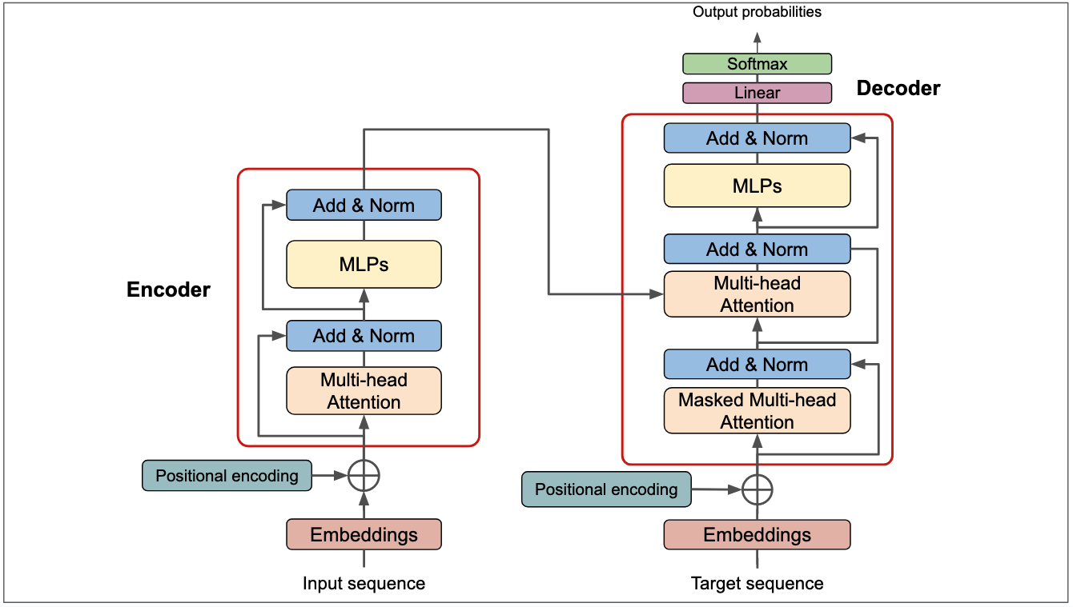~~

Figure 2 Sample Transformer Architecture

//

Model training with Hugging Face Diffusers

In this section, we will explore the practical aspects of training models using the Hugging Face Diffusers library, encompassing environment setup, dataset preparation, and model training procedures. We have provided detailed steps and considerations for leveraging Hugging Face Diffusers to train state-of-the-art transformer models.

Setting up the environment and installation

Before embarking on model training with Hugging Face Diffusers, it's crucial to establish a conducive development environment. This typically involves:

* Installation of Dependencies: Detailed instructions on installing Python, PyTorch or TensorFlow, and the Hugging Face Transformers library. This step ensures compatibility and optimal performance with the chosen hardware configuration (Rao & McMahan, 2019).

bash  
pip install transformers torch torchvision

* Virtual Environment Management: Guidance on setting up virtual environments to isolate project dependencies and manage package versions effectively. Tools like Anaconda or virtualenv can facilitate this process, ensuring reproducibility and stability in the development environment.

bash

python -m venv hf-env

source hf-env/bin/activate # On Windows use `hf-env\Scripts\activate`

The flowchart below outlines the step-by-step process of conducting sentiment analysis using BERT. It captures the journey from initial text input through tokenization, model processing, and final sentiment prediction, providing a clear visual representation of how BERT transforms raw text into insightful sentiment data.

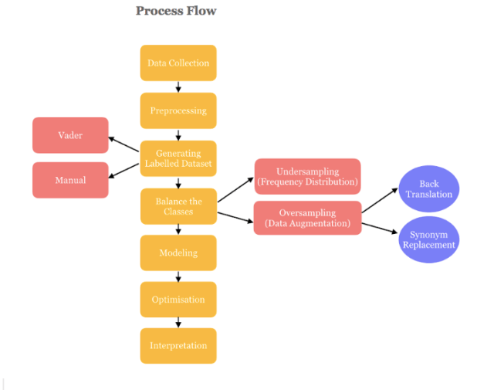

Figure 3 Sentiment analysis process flow

Loading and Preparing Datasets

A critical step in ensuring the success of any NLP model is the meticulous preparation and configuration of datasets and training parameters, which form the backbone of effective machine learning workflows:

* Dataset selection: Guidance on selecting appropriate datasets for specific NLP tasks, considering factors such as data size, domain relevance, and annotation quality. Examples could include publicly available datasets like IMDb for sentiment analysis or CoNLL-2003 for named entity recognition.
* Data preprocessing: Detailed procedures for data preprocessing, including tokenization, padding, and encoding. Illustrative examples or code snippets can clarify how to transform raw text data into a format suitable for training transformer models within the Hugging Face Diffusers framework.

//

Central to effective model training is the availability and preparation of high-quality datasets, which play a pivotal role in defining model performance. Selecting the right dataset for a given NLP task is crucial, as it influences the model's ability to generalize and perform well in diverse scenarios. For instance, datasets like IMDb can be invaluable for sentiment analysis due to their extensive labeled data, while CoNLL-2003 is well-suited for named entity recognition tasks. This section provides detailed guidance on dataset selection, highlighting the importance of choosing data that is not only relevant in size but also annotated with high quality. Once a suitable dataset is selected, it is essential to preprocess the data meticulously, including tokenization, padding, and encoding. This transformation prepares raw text data for optimal performance in training transformer models within the Hugging Face Diffusers framework, as illustrated by the following code snippet:

` `python

from transformers import TrainingArguments

training_args = TrainingArguments(

output_dir='./results', # output directory

num_train_epochs=3, # number of training epochs

per_device_train_batch_size=16, # batch size for training

per_device_eval_batch_size=64, # batch size for evaluation

warmup_steps=500, # number of warmup steps for learning rate scheduler

weight_decay=0.01, # strength of weight decay

logging_dir='./logs', # directory for storing logs

)

` `

This example demonstrates how to configure training arguments, setting key parameters such as the number of epochs, batch size, and learning rate. It serves as a starting point for training models from scratch using Hugging Face Diffusers, enabling users to experiment with different settings and optimize model performance.

Training models from scratch using Hugging Face Diffusers

To train a model from scratch, it is essential to begin with a well-defined configuration of model parameters. These parameters, such as the number of epochs, learning rate, and batch size, are set using the TrainingArguments class, which governs the overall training process.

Here’s how to configure and train your model from scratch:

1. Model configuration: Set the configuration parameters such as the number of epochs, learning rate, and batch size.

` `python

from transformers import TrainingArguments

training_args = TrainingArguments(

output_dir='./results', # output directory

num_train_epochs=3, # number of training epochs

per_device_train_batch_size=16, # batch size for training

per_device_eval_batch_size=64, # batch size for evaluation

warmup_steps=500, # number of warmup steps for learning rate scheduler

weight_decay=0.01, # strength of weight decay

logging_dir='./logs', # directory for storing logs

)

` `

After configuring the training arguments, the next step is to initialize the model and start the training process. This is accomplished by creating an instance of a model, such as BertForSequenceClassification, and using the Trainer class to handle the training logic.

1. **Model Initialization and Training**: Initialize the model and start the training process./

` `python

from transformers import BertForSequenceClassification, Trainer

model = BertForSequenceClassification.from_pretrained('bert-base-uncased')

trainer = Trainer(

model=model, # the instantiated 🤗 Transformers model to be trained

args=training_args, # training arguments, defined above

train_dataset=train_dataset, # training dataset

eval_dataset=eval_dataset # evaluation dataset

)

trainer.train()

` `

This code initializes a pre-trained BERT model for sequence classification, using the Trainer class to facilitate the training process. By setting appropriate datasets and training parameters, this setup allows for effective model training from scratch.

Next illustration delves into the internal workings of the BERT model, focusing on its attention mechanisms. It illustrates how BERT utilizes multiple attention heads to capture contextual relationships within the input text, enabling a nuanced understanding of language beyond the surface level

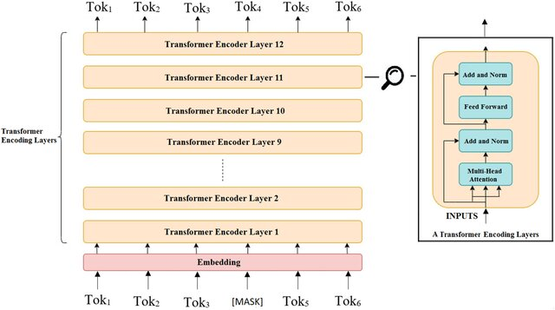

Figure 4 BERT model architecture

Moving Forward  
With a solid foundation in model training, we can now advance to fine-tuning pre-trained models for specific NLP tasks. This next step will involve adapting these models to excel in domain-specific applications, enhancing their performance and applicability in real-world scenarios.

Fine-tuning models with Hugging Face Diffusers

Fine-tuning pre-trained models is not just a technical process but a critical step that significantly enhances the model’s performance on specific tasks. It allows you to adapt these sophisticated models, initially trained on vast general datasets, to excel in specialized applications by tailoring them to your specific data and objectives. In this section, we will first explore why fine-tuning is essential for achieving state-of-the-art results in various NLP tasks. Then, we will guide you through each step of the fine-tuning process, from data preparation to model evaluation, ensuring you have a comprehensive understanding of how to leverage the full potential of Hugging Face Diffusers for your projects.

Importance of fine-tuning pre-trained models

Fine-tuning pre-trained models is essential in NLP for several reasons:

* Domain adaptation: Pre-trained models like BERT or GPT, trained on large-scale datasets, capture general language patterns. Fine-tuning allows these models to adapt to domain-specific nuances and vocabulary, improving performance on specific tasks (Devlin et al., 2019).
* Task specificity: By fine-tuning, researchers can tailor models for specific NLP tasks such as sentiment analysis, named entity recognition (NER), or machine translation. This process involves adjusting model parameters to optimize performance metrics relevant to the task at hand.
* Efficiency: Fine-tuning leverages the transfer learning paradigm, where models trained on large datasets require fewer annotated examples for adaptation to new tasks. This efficiency reduces the data and computational resources needed for training domain-specific models (Rao & McMahan, 2019).

Step-by-step guide to fine-tuning models for specific NLP Tasks

// Fine-tuning a pre-trained model involves several critical steps, each designed to tailor the model to perform optimally on a given task. Below, we will walk through this process using sentiment analysis as an example, illustrating each step in detail to enhance your understanding.

1. Task definition and data preparation: Clearly define the NLP task you want to tackle and ensure that your dataset is properly prepared. For sentiment analysis, this means having a dataset where each text entry is labeled with a sentiment, such as positive, negative, or neutral. For example, if you are using a dataset of movie reviews, each review should have a corresponding sentiment label.

Example:

``python

# Sample data preparation for sentiment analysis

import pandas as pd

# Example dataset

data = {

'text': [

'I absolutely loved this movie! The plot was engaging, and the characters were well developed.',

'The movie was terrible and a complete waste of time.',

'It was an okay movie, nothing special but not terrible either.'

],

'label': [1, 0, 2] # 1: Positive, 0: Negative, 2: Neutral

}

df = pd.DataFrame(data)

print(df.head())  
`

1. Model selection: Choose a pre-trained model that fits your task requirements. For sentiment analysis, models like BERT or DistilBERT, pre-trained on large text corpora, are ideal due to their strong language understanding capabilities.

` `python

from transformers import AutoModelForSequenceClassification

# Load pre-trained BERT model for sequence classification with specified number of labels

model = AutoModelForSequenceClassification.from_pretrained('bert-base-uncased', num_labels=3) # Adjust 'num_labels' based on your task``

1. Fine-tuning procedure: Fine-tune the model on your prepared dataset. This involves configuring hyperparameters, such as learning rate and batch size, and then training the model while monitoring metrics like accuracy and loss.

` `python

from transformers import TrainingArguments, Trainer

# Define training arguments

training_args = TrainingArguments(

output_dir='./results', # Output directory for model predictions and checkpoints

num_train_epochs=3, # Number of training epochs

per_device_train_batch_size=16, # Batch size for training

per_device_eval_batch_size=64, # Batch size for evaluation

warmup_steps=500, # Number of warmup steps for learning rate scheduler

weight_decay=0.01, # Strength of weight decay

logging_dir='./logs', # Directory for storing logs

evaluation_strategy="epoch" # Evaluate at the end of each epoch

)

# Initialize Trainer

trainer = Trainer(

model=model, # The pre-trained model

args=training_args, # Training arguments

train_dataset=train_dataset, # Training dataset

eval_dataset=eval_dataset # Evaluation dataset

)

# Start training

trainer.train()

`

By following these steps, you can fine-tune a pre-trained model to perform well on a specific NLP task such as sentiment analysis. With a solid understanding of this process, you are now ready to delve deeper into advanced fine-tuning techniques, including domain-specific adaptations and hyperparameter optimization, to further enhance model performance. This practical, step-by-step approach ensures you gain hands-on experience while mastering fine-tuning with Hugging Face Diffusers.

By fine-tuning pre-trained models with the Hugging Face Diffusers library, we have learned how to adapt these models for improved performance on a range of NLP tasks. As we move forward, we will explore practical applications, focusing on model inference and deployment in real-world environments to demonstrate their utility in operational settings.

//

In the illustration below we show Transformer-based VS LSTM-based models performance comparison with different hyperparameters settings. Accuracies of transformer-based models are significantly better than accuracies of LSTM-based models.

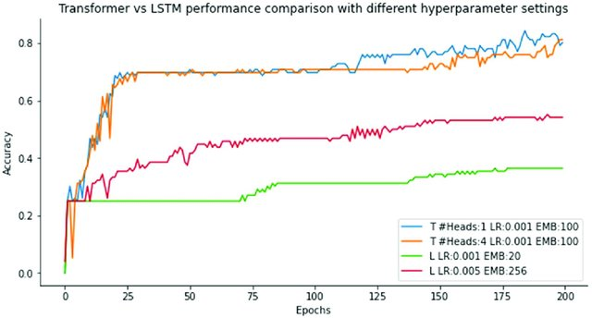

Figure 5 Transformer-based VS LSTM-based models performance comparison.

Inference and deployment with Hugging Face Diffusers

This section delves into the crucial aspects of performing inference and deploying trained transformer models using the Hugging Face Diffusers library. It provides a comprehensive guide to executing inference tasks, techniques for deploying models in production environments, and strategies for monitoring and maintaining deployed models.

Performing inference with trained models

Inference refers to the process of using a trained model to make predictions or process new data. To carry out this task effectively, several key steps are involved in processing input and generating outputs. These steps ensure that the model performs as expected on new data:

* Model loading: Retrieve the trained transformer model from storage or checkpoint files using Hugging Face's model loading utilities. This step ensures that the model is ready for inference tasks without retraining.
* Input data processing: Prepare input data for inference by tokenizing and encoding text or sequences according to the model's requirements. Hugging Face's tokenizer and data preprocessing pipelines facilitate this process (Wolf et al., 2020).
* Prediction generation: Execute inference tasks by feeding preprocessed data into the loaded model. Depending on the task, generate predictions such as classification labels, text generation, or sequence tagging (Wolf et al., 2020).

Techniques for deploying models in production

Deploying NLP models into production environments involves several considerations:

* Environment setup: Configure production environments to support model inference, ensuring compatibility with software dependencies, hardware specifications, and scalability requirements.
* API integration: Expose model functionalities through RESTful APIs or microservices, allowing seamless integration with other applications or systems. Use frameworks like Flask or FastAPI for building robust API endpoints (Pedregosa et al., 2011).
* Containerization: Package models and their dependencies into Docker containers for portability and reproducibility across different deployment environments. Container orchestration tools like Kubernetes facilitate efficient deployment and scaling of containerized applications.

Monitoring and maintaining deployed models

Maintaining model performance and reliability in production requires ongoing monitoring and management:

* Performance metrics: Define and track key performance indicators (KPIs) such as inference latency, throughput, and error rates to assess model effectiveness and responsiveness.
* Error handling: Implement robust error handling mechanisms to manage exceptions and edge cases during inference, ensuring graceful degradation and resilience.
* Model versioning: Maintain multiple versions of deployed models using version control systems or model registries. This practice enables rollback to previous versions and facilitates A/B testing for new model iterations (Zhang et al., 2020).

The figure below depicts the DistilBERT architecture, highlighting its streamlined design compared to BERT. It showcases how DistilBERT achieves efficiency and effectiveness in text classification tasks by retaining essential features of BERT while reducing computational complexity, making it ideal for resource-constrained applications

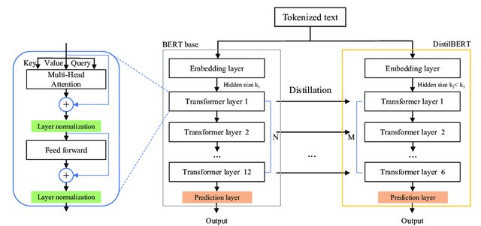

Figure 6 The DistilBERT model architecture and components.

//

Fine-tuning pre-trained transformer models using the Hugging Face Diffusion library allows us to adapt models for specific NLP tasks, enhancing their performance and accuracy in specialized applications. In the next section, we will focus on deploying these trained models in real-world environments, ensuring they function effectively beyond the training phase.

Getting hands-on with fine-tuning a transformer model for sentiment analysis

This example demonstrates how to fine-tune a pre-trained transformer model from Hugging Face's library for a sentiment analysis task. The task involves classifying movie reviews into positive or negative sentiments. Let's get started:

1. Let’s import the require libraries:

from transformers import BertTokenizer, BertForSequenceClassification, Trainer, TrainingArguments

import torch

from torch.utils.data import DataLoader, Dataset

import pandas as pd

from sklearn.model_selection import train_test_split

1. **Dataset preparation**: The code begins by preparing a small dataset of movie reviews and their sentiments. This dataset is split into training and testing subsets.

# Sample dataset

data = {'review': ['I loved the movie!', 'That was the worst movie ever...'],

'sentiment': [1, 0]} # 1 for positive, 0 for negative

df = pd.DataFrame(data)

# Splitting the dataset

train_df, test_df = train_test_split(df, test_size=0.25)

1. **Custom dataset class**: A custom PyTorch Dataset class is implemented to handle tokenization and encoding of the reviews using BertTokenizer.

class MovieReviewDataset(Dataset):

def __init__(self, reviews, sentiments):

self.reviews = reviews

self.sentiments = sentiments

self.tokenizer = BertTokenizer.from_pretrained('bert-base-uncased')

def __len__(self):

return len(self.reviews)

def __getitem__(self, idx):

review = str(self.reviews[idx])

sentiment = self.sentiments[idx]

encoding = self.tokenizer.encode_plus(

review,

add_special_tokens=True,

max_length=512,

return_token_type_ids=False,

padding='max_length',

return_attention_mask=True,

return_tensors='pt',

)

return {

'review_text': review,

'input_ids': encoding['input_ids'].flatten(),

'attention_mask': encoding['attention_mask'].flatten(),

'labels': torch.tensor(sentiment)

}

# Prepare the dataset

train_dataset = MovieReviewDataset(train_df['review'].tolist(), train_df['sentiment'].tolist())

test_dataset = MovieReviewDataset(test_df['review'].tolist(), test_df['sentiment'].tolist())

1. **Model initialization**: BertForSequenceClassification is initialized with two labels, suitable for binary classification (positive and negative reviews).

# Load the pre-trained BERT model

model = BertForSequenceClassification.from_pretrained('bert-base-uncased', num_labels=2)

1. **Training setup**: TrainingArguments are set up for the training process, specifying the number of epochs, batch size, warmup steps, and directories for outputs and logs.

# Training arguments

training_args = TrainingArguments(

output_dir='./results',

num_train_epochs=3,

per_device_train_batch_size=4,

per_device_eval_batch_size=4,

warmup_steps=500,

weight_decay=0.01,

evaluate_during_training=True,

logging_dir='./logs',

)

1. **Training**: The model is trained using Hugging Face's Trainer API, which simplifies the training loop and evaluation.

# Initialize the Trainer

trainer = Trainer(

model=model,

args=training_args,

train_dataset=train_dataset,

eval_dataset=test_dataset

)

# Start training

trainer.train()

This example is ideal for demonstrating how to fine-tune a transformer model on a specific NLP task using real-world data.

Results Analysis

Upon training, the model should demonstrate improved accuracy in classifying sentiments as either positive or negative. By evaluating the model on the test dataset, we can measure its precision, recall, and F1-score to ensure that it performs reliably across different samples of text. This performance metric helps in understanding the model's ability to generalize from training data to unseen data, providing insights into its practical deployment in real-world scenarios.

Key Takeaways

Let’s discuss the ley learnings from this hands-on exercise:

* **Model Adaptability:** The example shows how BERT, initially trained on a vast corpus for a wide range of tasks, can be effectively fine-tuned for a specialized task like sentiment analysis. This adaptability is crucial for leveraging pre-trained models to reduce the time and resources required for training models from scratch.
* **Simplicity of Implementation:** Using Hugging Face's Transformers and Trainer API simplifies the implementation of complex training routines, allowing researchers and developers to focus more on model tuning and less on boilerplate code.
* **Practical Application:** The final trained model can be integrated into various applications, from automated review systems to real-time sentiment analysis tools, demonstrating the model's utility in enhancing user interaction and understanding consumer sentiment.

This hands-on example not only provides a practical understanding of fine-tuning transformers but also sets a foundation for readers to explore more complex NLP tasks, enhancing their skills in developing AI-driven solutions. As we progress, we will delve deeper into model optimization and deployment strategies to ensure these models perform optimally in production environments.

Summary

In this chapter, we have explored the foundational aspects of leveraging the Hugging Face Diffusers library for advanced natural language processing (NLP) tasks. Beginning with an overview of the library's architecture and key features, we proceeded to delve into essential methodologies such as model training, fine-tuning, inference, and deployment.

At the conclusion of the fine-tuning pre-trained models with the Hugging Face Diffusers library section, we have enhanced our understanding of how to specifically adapt models to improve performance on various NLP tasks. We explored the nuances of fine-tuning, from task definition and data preparation to hyperparameter tuning and evaluation, equipping you with the skills to tailor advanced models to your unique requirements.

We also have explored the critical process of fine-tuning pre-trained transformer models using the Hugging Face Diffusion library. By adjusting models to suit specific tasks, we enhance their performance and tailor them to meet the unique demands of various NLP challenges. Fine-tuning not only helps in adapting models to domain-specific languages but also optimizes them for precise tasks, making this approach invaluable for achieving high accuracy in specialized applications.

We introduced the Hugging Face Diffusers library, highlighting its pivotal role in enabling state-of-the-art NLP solutions through pre-trained transformer models. Detailed steps were provided for setting up the environment, loading datasets, and training models from scratch, leveraging the library's robust capabilities and integration with PyTorch. We emphasized the significance of fine-tuning pre-trained models for specific NLP tasks, offering a step-by-step guide and best practices to optimize model performance and adaptation to domain-specific data. The chapter explored techniques for performing inference with trained models and deploying them in production environments. This included considerations for environment setup, API integration, and ongoing monitoring to ensure model reliability and performance.

Looking ahead to Chapter 3, we will explore advanced applications of Hugging Face Diffusers in NLP, focusing on cutting-edge research, emerging trends, and innovative use cases. We will delve into topics such as multimodal NLP, transfer learning across domains, and the ethical implications of AI in language processing.

References

* Devlin, J., Chang, M., Lee, K., & Toutanova, K. (2019). BERT: Pre-training of Deep Bidirectional Transformers for Language Understanding. *BERT: Pre-training of Deep Bidirectional Transformers for Language Understanding*.
* Goodfellow, I., Bengio, Y., & Courville, A. (2016). Deep Learning. MIT Press.
* Jurado, R., & Roselló, R. (2021). A Survey of Deep Learning in Medicine: Analyzing the Impact of Deep Learning in Disease Diagnosis. *Computational Intelligence, 37*, 321–344.
* Pedregosa, F., Varoquaux, G., Gramfort, A., Michel, V., Thirion, B., Grisel, O., & Duchesnay, É. (2011). Scikit-learn: Machine learning in Python. *Journal of Machine Learning Research, 12*, 2825–2830.
* Rao, D., & McMahan, B. (2019). Natural Language Processing with PyTorch: Build Intelligent Language Applications Using Deep Learning. O'Reilly Media.
* Rothman, D. (2021). Transformers for Natural Language Processing: Build and Train State-of-the-Art Models. Packt Publishing.
* Vaswani, A., Shazeer, N., Parmar, N., Uszkoreit, J., Jones, L., Gomez, A. N., & Polosukhin, I. (2017). Attention is All You Need. In *Advances in Neural Information Processing Systems (NIPS* (pp. 5998–6008).
* Wolf, T., Sanh, V., Chaumond, J., & Delangue, C. (2020). Transformers: State-of-the-Art Natural Language Processing. *Proceedings of the 2020 Conference on Empirical Methods in Natural Language Processing: System Demonstrations*, (pp. 38–45).
* Zhang, C., Bengio, S., Hardt, M., Recht, B., & Vinyals, O. (2020). Understanding deep learning requires rethinking generalization. *Proceedings of the 7th International Conference on Learning Representations (ICLR.*