Chapter 5 Sequence labeling with Hugging Face Diffusion

Sequence labeling is a core task in natural language processing (NLP) that involves assigning labels to individual tokens in a sequence, such as words in a sentence. Two major applications of sequence labeling include **Named Entity Recognition (NER)** and **Part-of-Speech (POS) tagging**. These tasks are crucial for extracting structured information, understanding sentence structure, and enhancing semantic understanding. This chapter focuses on how to implement sequence labeling tasks using the Hugging Face Diffusion library.

Learning Goals

By the end of this chapter, you will:

* Understand the fundamentals of sequence labeling and its significance in NLP applications.
* Implement Named Entity Recognition (NER) using pre-trained models and fine-tune them for domain-specific tasks.
* Perform Part-of-Speech (POS) tagging, labeling each token with its grammatical role in a sentence.
* Train and evaluate sequence labeling models using relevant datasets and performance metrics.
* Apply sequence labeling to specialized domains like biomedical text analysis and social media text processing.

Overview of Sequence Labeling in NLP

Sequence labeling is the process of assigning categorical labels to elements in a sequence of tokens, typically words. This task plays a foundational role in NLP applications such as information extraction, syntactic analysis, and semantic understanding. Popular sequence labeling tasks include:

* **Named Entity Recognition (NER):** Identifying entities like persons, organizations, and locations in a text.
* **Part-of-Speech (POS) Tagging:** Assigning grammatical labels (e.g., noun, verb, adjective) to each word in a sentence.

Both tasks are widely used in industries such as healthcare, where NER can be applied to extract key medical information from unstructured clinical notes, and in social media analytics, where POS tagging helps parse and understand informal text.

Fundamentals of sequence labeling

Sequence labeling models are designed to predict an output sequence that corresponds to the input sequence of words or characters. These models consider the contextual relationships between elements in a sequence, which is vital for understanding language patterns and structures. The most common approaches to sequence labeling include Conditional Random Fields (CRFs), Hidden Markov Models (HMMs), and more recently, neural network-based models like Recurrent Neural Networks (RNNs) and Transformers.

* **Conditional Random Fields (CRFs)**: CRFs are statistical modeling methods often used in sequence labeling that model the conditional probability of a label sequence given a corresponding sequence of input tokens. They are particularly effective in cases where the decision at one position depends on the decisions at earlier positions (Lafferty et al., 2001).
* **Hidden Markov Models (HMMs)**: HMMs are used for sequence labeling by modeling the sequence as a Markov process with hidden states. They are well-suited for tasks where the label of a token depends only on its immediate predecessor, making them effective for simpler tagging tasks (Rabiner, 1989).

Significance of sequence labeling in NLP

Sequence labeling is crucial in NLP for its role in structuring raw text data into formats that are more easily analyzed and understood. This capability is essential for applications such as:

* **Information Extraction**: Naming and classifying key pieces of information from text, such as dates, names, and locations, which is fundamental for data retrieval and organization tasks.
* **Sentiment Analysis**: Tagging parts of texts to name sentiment-bearing phrases or to figure out the sentiment expressed toward specific entities.
* **Speech Recognition**: Converting speech into text that can be further processed and labeled to enhance comprehensibility and interaction quality in human-computer interaction.

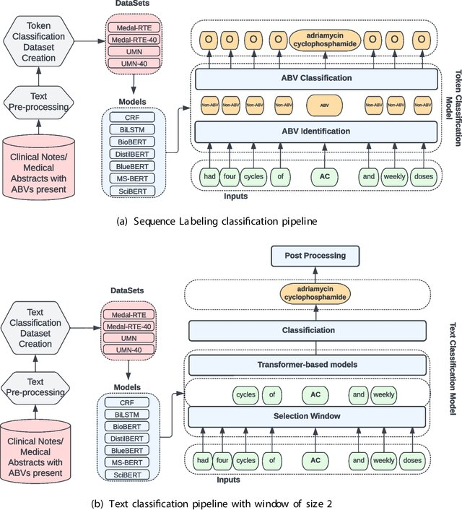Sequence labeling serves as a cornerstone in natural language processing (NLP) applications such as information extraction, sentiment analysis, and speech recognition. By structuring raw text into labeled formats, it allows systems to extract and classify meaningful data from unstructured inputs. To provide a clearer understanding of this process, the diagram below illustrates the step-by-step flow of sequence labeling—from the initial text input through to the generation of labeled output.

Figure 1 Sequence Labeling classification pipeline

Applications of sequence labeling

Sequence labeling plays a pivotal role in various applications across multiple industries, enhancing the way we interact with and process textual data. Here are key applications where sequence labeling techniques are particularly effective:

Information retrieval

Sequence labeling is crucial in information retrieval systems where the goal is to extract structured information from unstructured text. For example, in legal and financial documents, entities such as case law references, statutes, monetary amounts, or party names can be named and used to index documents, making them easier to search and retrieve (McCallum, 2005).

Healthcare analytics

In the healthcare sector, sequence labeling is used to extract medical entities from clinical notes. This includes naming symptoms, diagnoses, medications, and dosages, which can then be used for patient management systems, billing, and research purposes. By automating the extraction of these entities, healthcare providers can improve patient care efficiency and accuracy (Jagannatha & Yu, 2016).

Sentiment analysis

In customer service and marketing, sequence labeling helps analyze customer feedback by naming and categorizing sentiments expressed in reviews and social media posts. This application is crucial for businesses to gauge public sentiment, understand customer needs, and tailor their services or products accordingly (Pang & Lee, 2008).

Application example: Sentiment analysis

Before we dive into the technical setup of a sequence labeling model, let us consider a practical example of sentiment analysis applied to social media monitoring. Companies often use sentiment analysis to track how customers feel about their brand in real time by analyzing tweets, Facebook posts, and other social media content. By labeling sequences of words in these posts as positive, negative, or neutral, companies can quickly respond to customer complaints, gauge overall sentiment about product launches, and tailor marketing strategies to better align with public opinion.

This practical example sets the stage for the following Python code demonstration, where we will implement a basic Conditional Random Field (CRF) model for part-of-speech tagging, which is a foundational technique that can be adapted for more complex sequence labeling tasks like sentiment analysis.

By linking these applications with the upcoming code example, readers can see the direct relevance and impact of their learning, enhancing both understanding and engagement.

Part-of-Speech (POS) Tagging

Part-of-Speech tagging assigns grammatical labels to words in a sentence, identifying their role as nouns, verbs, adjectives, etc. This task plays a critical role in syntactic and semantic analysis, making it fundamental for various NLP tasks, including machine translation, sentiment analysis, and information retrieval. With the Hugging Face Diffusion library, POS tagging becomes streamlined and accessible, leveraging pre-trained models to assign grammatical labels to tokens in text.

To implement POS tagging, you begin by loading a pre-trained model and applying it to a sample text. Below is an example demonstrating how to tokenize the text and use the Hugging Face Diffusion library to assign POS tags:

Application Example: Implementing a Conditional Random Field (CRF) for Part-of-Speech (POS) Tagging

In the context of sequence labeling tasks, Part-of-Speech (POS) tagging is a crucial step for syntactic analysis in NLP applications. POS tagging assigns grammatical labels, such as nouns, verbs, and adjectives, to each word in a sentence. One effective approach for this task is the use of a Conditional Random Field (CRF), which is a probabilistic model commonly used for structured prediction tasks like sequence labeling. CRFs model the relationships between labels in a sequence, making them well-suited for tasks where the context of neighboring labels matters, such as POS tagging.

In this example, we will implement a CRF model using Python's sklearn-crfsuite library to perform POS tagging on a simplified dataset. Below is the code demonstrating the process, from feature extraction to model training and evaluation.

 ``python

import sklearn_crfsuite

from sklearn_crfsuite import metrics

from sklearn.model_selection import train_test_split

# Example dataset (simplified)

sentences = [

[("I", "PRON"), ("saw", "VERB"), ("the", "DET"), ("cat", "NOUN")],

[("The", "DET"), ("cat", "NOUN"), ("sat", "VERB"), ("on", "ADP"), ("the", "DET"), ("mat", "NOUN")]

]

# Feature extraction for CRF

def word2features(sent, i):

word = sent[i][0]

features = {

'bias': 1.0,

'word.lower()': word.lower(),

'word[-3:]': word[-3:],

'word[-2:]': word[-2:],

'word.isupper()': word.isupper(),

'word.istitle()': word.istitle(),

'word.isdigit()': word.isdigit(),

}

if i > 0:

word1 = sent[i-1][0]

features.update({

'-1:word.lower()': word1.lower(),

'-1:word.istitle()': word1.istitle(),

})

else:

features['BOS'] = True

  if i < len(sent)-1:

word1 = sent[i+1][0]

features.update({

'+1:word.lower()': word1.lower(),

'+1:word.istitle()': word1.istitle(),

})

else:

features['EOS'] = True

return features

# Generate features

X = [[word2features(s, i) for i in range(len(s))] for s in sentences]

y = [[label for token, label in s] for s in sentences]

# Split the data

X_train, X_test, y_train, y_test = train_test_split(X, y, test_size=0.25, random_state=0)

# Train CRF model

crf = sklearn_crfsuite.CRF(

algorithm='lbfgs',

c1=0.1,

c2=0.1,

max_iterations=100,

all_possible_transitions=True

)

crf.fit(X_train, y_train)

# Predictions

y_pred = crf.predict(X_test)

print("Accuracy:", metrics.flat_accuracy_score(y_test, y_pred))

``

The code begins by preparing a simplified dataset of sentences, where each word is paired with its corresponding Part-of-Speech (POS) tag, such as "PRON" for pronoun or "VERB" for verb. In order to feed the data into the CRF model, the word2features function extracts relevant features for each word in a sentence. These features include various characteristics like the lowercase form of the word, the last few characters (which are helpful for identifying suffixes), and whether the word is capitalized or in title case. This contextual information aids the CRF in learning the relationships between the words and their respective tags. The function also captures neighboring words, allowing the model to consider the influence of surrounding tokens when making predictions.

Next, the CRF model is trained using the sklearn-crfsuite library. The training process involves splitting the dataset into training and testing sets and applying the CRF algorithm. The model is optimized using the lbfgs algorithm, with both L1 (c1) and L2 (c2) regularization to prevent overfitting. After the model is trained, it makes predictions on the test set, which are compared to the actual labels to compute the accuracy of the model. The accuracy score, calculated using metrics.flat_accuracy_score, evaluates how well the model performs on unseen data.

This example highlights the practical application of a CRF model for sequence labeling tasks like POS tagging. By considering the features of words and their neighboring tokens, CRF models can effectively label each word in a sentence with its appropriate grammatical role, showcasing the utility of advanced NLP techniques in structured prediction tasks.

Named Entity Recognition (NER)

Named Entity Recognition involves identifying and classifying named entities such as persons, organizations, and locations in a text. It plays a crucial role in tasks like information extraction, knowledge graph creation, and question answering. With the Hugging Face Diffusion library, implementing NER becomes highly accessible using pre-trained models like BERT.

To demonstrate, we can load a pre-trained model fine-tuned on NER tasks and then fine-tune it further for domain-specific use cases, such as identifying biomedical entities. In this example, we will use a pre-trained BERT model fine-tuned on NER for general purposes.

`python

from transformers import AutoModelForTokenClassification, AutoTokenizer, pipeline # Load a pre-trained model

tokenizer = AutoTokenizer.from_pretrained("bert-base-cased")

model = AutoModelForTokenClassification.from_pretrained("dbmdz/bert-large-cased-finetuned-conll03-english") # Use Hugging Face pipeline for Named Entity Recognition

ner_pipeline = pipeline("ner", model=model, tokenizer=tokenizer)

# Test the NER pipeline text = "Hugging Face is a company based in New York." print(ner_pipeline(text))

`

This code snippet demonstrates how to load a pre-trained BERT model and utilize it to perform NER. The pipeline function from the Hugging Face library simplifies the process by encapsulating the model and tokenizer, allowing easy text input for entity recognition. In the example, the text "Hugging Face is a company based in New York" is processed, and the model identifies the relevant named entities such as "Hugging Face" (organization) and "New York" (location). The pre-trained model can be further fine-tuned for domain-specific tasks, offering flexibility and accuracy for more specialized applications.

This streamlined implementation highlights the ease with which NER can be customized using the Hugging Face Diffusion library, showcasing its potential for both general and domain-specific applications.

Mechanisms of NER

NER systems typically work by combining grammatical rules with statistical techniques, including machine learning algorithms that have been trained on large, annotated corpora. Advanced NER systems use deep learning models, particularly those based on the transformer architecture, to enhance the accuracy and efficiency of entity recognition.

* **Rule-Based systems**: Early NER systems relied heavily on handcrafted rules. These systems perform well when the language structure is consistent, but they lack flexibility and scalability.
* **Statistical models**: With the advent of statistical NLP, models like Conditional Random Fields (CRF) and Hidden Markov Models (HMM) have been used. These models learn from data and can generalize across different contexts (Lafferty et al., 2001).
* **Deep learning approaches**: Recent advancements involve using deep learning models such as Bidirectional Encoder Representations from Transformers (BERT) and other transformer-based models, which consider the context of each word in a sentence to improve the accuracy of entity recognition (Devlin et al., 2019).

The mechanisms behind Named Entity Recognition (NER) range from early rule-based systems to advanced deep learning approaches using transformer models like BERT. These methods enable the extraction of valuable information, such as people, organizations, and locations, from raw text, making NER a versatile tool across industries like healthcare, journalism, and finance. To better illustrate the concept, the following diagram provides an example of how NER transforms a sample text input into labeled entities, clearly showing how each part of the input is categorized based on the entities it identifies.

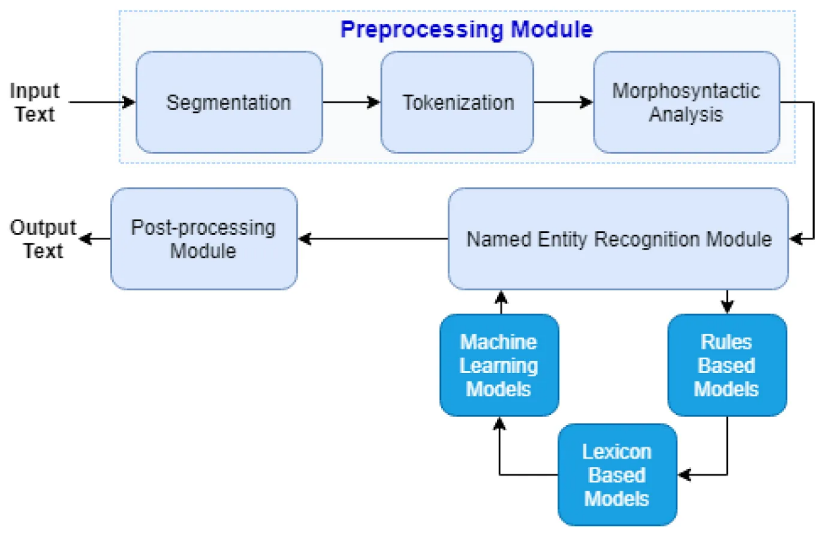

Figure 2 Example of Named Entity Recognition (NER) a sample text input and its transformation into labeled entities.

Applications of NER

NER has proven invaluable across various industries, streamlining processes and improving the extraction of critical information from unstructured text. Below are key examples of how NER is applied in real-world scenarios:

* **Healthcare**: In healthcare, NER systems extract medical information from patient records, such as disease names, medication types, and dosages, which are crucial for patient care management and clinical decision-making (Jagannatha & Yu, 2016).
* **Media and Journalism**: In the media industry, NER helps in automatically categorizing news articles and extracting relevant entities such as people, organizations, and locations, thus aiding in content management and recommendation systems.
* **Finance**: In the financial sector, NER is used to check and analyze financial documents, extracting critical data points like company names, stock symbols, and financial indicators, which are essential for automated trading systems and financial analysis.

Application example: Implementing NER with Hugging Face Transformers

This example demonstrates how to implement Named Entity Recognition (NER) using the Hugging Face transformers library, which leverages a pre-trained BERT model fine-tuned for NER tasks. BERT models are particularly effective for tasks like NER due to their ability to capture context and dependencies between words in a sentence.

The code begins by loading a pre-trained BERT model that has been fine-tuned on the CoNLL-2003 dataset, specifically designed for NER tasks. Alongside the model, a tokenizer is also loaded, which is responsible for converting the raw text into a format suitable for the model to process. Once the model and tokenizer are in place, the next step is to set up the NER pipeline. The pipeline abstracts the complex operations required for named entity recognition, allowing for a streamlined approach to processing text and detecting entities.

The provided example sentence, “Microsoft was founded by Bill Gates and Paul Allen on April 4, 1975,” is passed through the NER pipeline. The model processes this text and outputs the recognized entities along with their respective categories, such as persons or organizations. The results are then printed, showing how the model correctly identifies and classifies "Microsoft," "Bill Gates," and "Paul Allen" as entities, providing insights into the model's ability to parse and analyze structured information within unstructured text.

``python

from transformers import AutoModelForTokenClassification, AutoTokenizer, pipeline

# Load pre-trained model and tokenizer

model = AutoModelForTokenClassification.from_pretrained("dbmdz/bert-large-cased-finetuned-conll03-english")

tokenizer = AutoTokenizer.from_pretrained("dbmdz/bert-large-cased-finetuned-conll03-english")

# Setup NER pipeline

ner_pipeline = pipeline("ner", model=model, tokenizer=tokenizer)

# Example text

text = "Microsoft was founded by Bill Gates and Paul Allen on April 4, 1975."

# Perform NER

results = ner_pipeline(text)

# Display results

print("Detected Entities:")

for entity in results:

print(f"Entity: {entity['word']}, Type: {entity['entity']}")

``

The implementation of this NER task with Hugging Face begins by loading the pre-trained BERT model and tokenizer. This model, fine-tuned on the CoNLL-2003 dataset, has already been trained to identify entities such as people, organizations, locations, and dates. The tokenizer prepares the text by converting it into a tokenized format, which the model can process to perform the NER task.

Next, the NER pipeline is set up. This pipeline simplifies the overall process by encapsulating the tokenization, model prediction, and result generation in a single step. By passing the input text into this pipeline, the model automatically identifies named entities and categorizes them. In the example, "Microsoft" is identified as an organization, while "Bill Gates" and "Paul Allen" are classified as persons. The detected entities and their categories are printed for review, demonstrating the model's ability to interpret the text effectively.

This implementation highlights how pre-trained models, like BERT, can be used to perform NER tasks efficiently, making it a valuable tool for tasks such as information extraction, question answering, and document analysis. By leveraging the Hugging Face Diffusion library, even complex NLP tasks like NER become more accessible, allowing practitioners to apply cutting-edge AI techniques in real-world scenarios.

Part-of-Speech (POS) tagging

Part-of-Speech (POS) tagging is a fundamental task in natural language processing (NLP) that involves assigning a part-of-speech tag (such as noun, verb, adjective, among others) to each word in each text. This process is critical for understanding the syntactic structure and semantics of language, which supports different NLP tasks such as parsing, sentiment analysis, and machine translation.

Importance in syntax and semantics

POS tagging is essential for parsing sentences correctly, as it helps disambiguate word meanings and grammatical functions, improving the accuracy of syntactic analysis. For example, distinguishing between "record" (a noun) and "record" (a verb) based on context is crucial for correct sentence structure interpretation and next processing.

Techniques and Models for Effective POS Tagging

To implement Part-of-Speech (POS) tagging effectively, several techniques and models have evolved over time, each offering unique advantages based on the complexity of the text and the goals of the tagging process. From early rule-based methods to sophisticated deep learning approaches, the advancements in POS tagging have greatly enhanced the accuracy of syntactic and semantic analysis. The following are some of the most commonly used techniques and models for POS tagging, reflecting the progression from traditional methodologies to cutting-edge neural networks:

* **Rule-Based Techniques**: Early POS taggers used handwritten rules to decide tags based on word suffixes and the context within a sentence.
* **Statistical Models**: These include Hidden Markov Models (HMMs) and Maximum Entropy Markov Models (MEMMs), which calculate the probability of a tag sequence given a sequence of words (Manning, 2011).
* **Deep Learning Approaches**: Recent approaches use neural networks, especially Recurrent Neural Networks (RNNs) and Long Short-Term Memory networks (LSTMs), to consider the context more effectively. These models often outperform traditional methods, especially when combined with techniques like Conditional Random Fields (CRFs) for sequence prediction (Huang et al., 2015).

Applications of POS Tagging

Part-of-Speech (POS) tagging plays a crucial role in various applications, improving the functionality and accuracy of language-based tools. For example, in text editing and grammar checking tools like Grammarly, POS tagging identifies different parts of speech in a sentence, enabling the system to suggest grammatical corrections. Similarly, content filtering systems rely on POS tagging to categorize content based on specific nouns, verbs, or adjectives, making it essential in recommendation systems. In voice recognition systems, POS tagging enhances the accuracy of speech-to-text conversion, helping the model better understand and process speech nuances.

As we've discussed, POS tagging is an essential process for understanding the syntactic and semantic structure of language, supporting a range of NLP applications. The different techniques—rule-based methods, statistical models, and deep learning approaches—contribute to the accuracy and effectiveness of this task. To further clarify the steps involved in POS tagging, the following diagram illustrates the entire process, from input text to the assignment of part-of-speech tags, providing a visual representation of how these tags are applied in real-world scenarios.

Figure 3 POS Tagging Process Diagram:

Application Example: Implementing POS Tagging with Hugging Face Transformers

This example demonstrates how to implement POS tagging using the Hugging Face transformers library with a pre-trained BERT model fine-tuned for the POS tagging task. The process begins by loading both the tokenizer and model that have been specifically trained to perform token classification. The pipeline for POS tagging is set up, which simplifies the entire task of token classification by integrating tokenization, model inference, and result generation into a single step.

Once the pipeline is established, we provide an example sentence, "The quick brown fox jumps over the lazy dog." The pipeline processes this input and outputs the POS tags for each word, identifying them as nouns, verbs, adjectives, and other parts of speech. This approach highlights the utility of transformer-based models in simplifying and improving the efficiency of common NLP tasks, such as POS tagging, which are foundational for tasks like grammar checking, machine translation, and syntactic analysis.

The code snippet below illustrates how this process works in practice:

``python

from transformers import AutoModelForTokenClassification, AutoTokenizer, pipeline

# Load tokenizer and model

model = AutoModelForTokenClassification.from_pretrained("bert-base-cased-finetuned-pos")

tokenizer = AutoTokenizer.from_pretrained("bert-base-cased-finetuned-pos")

# Setup POS tagging pipeline

pos_pipeline = pipeline("token-classification", model=model, tokenizer=tokenizer)

# Example sentence

sentence = "The quick brown fox jumps over the lazy dog."

# Perform POS tagging

pos_results = pos_pipeline(sentence)

# Display POS tags

print("POS Tags:")

for token in pos_results:

print(f"Word: {token['word']}, POS Tag: {token['entity']}")

``

In this example, the model setup involves loading a pre-trained BERT model specifically fine-tuned for POS tagging. The POS tagging pipeline simplifies the token classification task, where each word in the sentence is analyzed and tagged with its corresponding part of speech. As the model processes the input sentence, it outputs the POS tags, showing the model's ability to correctly identify and label different parts of speech for each word.

This section offers a comprehensive understanding of POS tagging, detailing its technical mechanisms and practical applications while providing a hands-on coding example that demonstrates how to implement this task using advanced models like BERT. By leveraging the Hugging Face transformers library, we can streamline complex NLP tasks, making them more accessible and efficient in real-world applications.

Model training and evaluation

Training and evaluating sequence labeling models effectively are crucial for achieving high performance in tasks such as Named Entity Recognition (NER) and Part-of-Speech (POS) tagging. This section outlines the best practices for training these models and the methodologies used to evaluate their performance.

Best practices for training sequence labeling models

Training sequence labeling models requires a careful approach to ensure that the model not only learns to predict the correct labels but also generalizes well to new, unseen data.

* **Data preparation**: Quality and quantity of training data significantly affect model performance. It is crucial to use a well-annotated, diverse dataset that stands for the variability of language in real-world scenarios.
* **Feature selection**: Choosing the right set of features is vital. For traditional models like CRFs, manually crafted features such as word suffixes, prefixes, and POS tags are useful. For neural models, embeddings that capture semantic meanings, like word2vec or GloVe, enhance the model's understanding.
* **Regularization and dropout**: To prevent overfitting, especially in deep learning models, techniques like L2 regularization and dropout are employed during training.
* **Transfer learning**: Using pre-trained models and fine-tuning them on specific tasks can drastically improve performance due to the pre-learned contextual representations in the model (Devlin et al., 2019).

Methods for evaluating the performance of NER and POS Tagging systems

When training sequence labeling models, it is essential to follow best practices that ensure robust performance and adaptability across various real-world datasets. These practices not only help the model learn accurate label predictions but also improve its ability to generalize effectively to unseen data. The following key strategies are fundamental for achieving optimal results when training sequence labeling models:

* **Accuracy**: The most straightforward metric, accuracy measures the proportion of correctly predicted labels over all predictions.
* **Precision, recall, and F1-Score**: Precision measures the accuracy of positive predictions, recall measures the coverage of actual positive cases, and the F1-score provides a balance between precision and recall.
* **Confusion matrix**: Provides a detailed breakdown of predictions versus actual labels, helping name specific areas where the model is underperforming.

Examples of application

Application: NER on biomedical text

In the biomedical field, NER systems are used to extract medical entities such as drug names, symptoms, and diseases from clinical texts, which are crucial for patient care and medical research.

Application: POS Tagging on social media text

Social media text often includes slang, abbreviations, and emoticons. POS tagging in this domain helps in sentiment analysis, content filtering, and linguistic research by providing a structural understanding of informal language used online.

Application example: Training and evaluating an NER Model

This example demonstrates how to train and evaluate a Named Entity Recognition (NER) model using the Hugging Face transformers library. The process involves loading a dataset, preprocessing the data by tokenizing it with the BERT tokenizer, and aligning the labels with the tokenized inputs. Once the data is prepared, a pre-trained BERT model is adapted for token classification, and training is carried out with a specified number of epochs and batch size. The model is then evaluated using metrics such as precision, recall, and F1-score to assess its performance.

The following code snippet illustrates how to train and evaluate the NER model:

``python

from transformers import BertForTokenClassification, BertTokenizer, Trainer, TrainingArguments

from datasets import load_dataset

# Load dataset

dataset = load_dataset("conll2003")

# Preprocess and tokenize data

tokenizer = BertTokenizer.from_pretrained('bert-base-cased')

def tokenize_and_align_labels(examples):

tokenized_inputs = tokenizer(examples['tokens'], truncation=True, padding=True, is_split_into_words=True)

labels = []

for i, label in enumerate(examples['ner_tags']):

word_ids = tokenized_inputs.word_ids(batch_index=i)

previous_word_idx = None

label_ids = []

for word_idx in word_ids:

if word_idx is None:

label_ids.append(-100)

elif word_idx != previous_word_idx:

label_ids.append(label[word_idx])

else:

label_ids.append(-100)

previous_word_idx = word_idx

labels.append(label_ids)

tokenized_inputs["labels"] = labels

return tokenized_inputs

# Apply tokenization and alignment

tokenized_dataset = dataset.map(tokenize_and_align_labels, batched=True)

# Load pre-trained BERT model for token classification

model = BertForTokenClassification.from_pretrained('bert-base-cased', num_labels=dataset['train'].features['ner_tags'].feature.num_classes)

# Define training arguments

training_args = TrainingArguments(

output_dir='./results',

num_train_epochs=3,

per_device_train_batch_size=16,

evaluation_strategy="epoch"

)

# Initialize Trainer

trainer = Trainer(

model=model,

args=training_args,

train_dataset=tokenized_dataset['train'],

eval_dataset=tokenized_dataset['test']

)

# Train and evaluate the model

trainer.train()

``

In this code, we first prepare and tokenize the dataset using a BERT tokenizer, ensuring the labels are properly aligned with the tokenized inputs through the function tokenize_and_align_labels. This preprocessing step is essential for training the model with the correct label mappings. Next, we set up a pre-trained BERT model that has been fine-tuned for token classification tasks, which includes configuring the model to handle the specific number of labels present in the dataset. The training process is initiated by specifying key parameters such as the number of epochs and the batch size, after which the model undergoes evaluation using metrics like precision, recall, and F1-score to assess its performance in recognizing and classifying named entities. This streamlined workflow highlights the process of building and optimizing an NER model using Hugging Face transformers, offering both a theoretical and practical understanding of how these systems function in real-world applications.

not only provides an in-depth understanding of training and evaluating sequence labeling models but also illustrates their practical applications in real-world scenarios, supported by a coding example.

Wrapping up chapter 5

In Chapter 5, we thoroughly explored the fundamentals of sequence labeling in natural language processing (NLP), focusing on key tasks such as Named Entity Recognition (NER) and Part-of-Speech (POS) tagging. We began by introducing the importance of sequence labeling in structuring and analyzing raw text data, followed by a deep dive into the practical applications of NER and POS tagging across fields like healthcare, media, and finance. Throughout the chapter, we demonstrated how advanced models, especially those based on transformers, have significantly improved the accuracy and adaptability of these tasks. Practical coding examples using Hugging Face Diffusion illustrated the real-world implementation of these techniques, solidifying our understanding of how sequence labeling models can be trained and optimized.

Our goal was to equip readers with the knowledge and tools necessary to effectively implement, train, and evaluate sequence labeling models. With the detailed discussions, examples, and case studies presented, we have successfully laid a strong foundation for tackling real-world NLP challenges.

**Looking Ahead to Chapter 6**As we transition to Chapter 6, we will shift from the task of labeling and structuring data to the exciting domain of generative AI. In "Advanced Generative Tasks with Hugging Face Diffusion," we will explore how to leverage transformer-based models for creating content, including text-to-image and image-to-video synthesis. Building on the principles of deep learning and model training covered in Chapter 5, this next chapter will demonstrate the innovative potential of generative AI to not only interpret but also create complex multimedia content.

By the end of Chapter 6, you will gain insight into cutting-edge generative models and their applications, further expanding the horizons of what can be achieved with AI in creative fields. Let's dive into this new frontier of AI-driven creativity.

References

Devlin, J., Chang, M. W., Lee, K., & Toutanova, K. (2018). BERT: Pre-training of deep bidirectional transformers for language understanding. *NAACL-HLT*.

Honnibal, M., & Montani, I. (2017). spaCy 2: Natural language understanding with Bloom embeddings, convolutional neural networks and incremental parsing. *preprint*.

Huang, Z., Xu, W., & Yu, K. (2015). Bidirectional LSTM-CRF Models for Sequence Tagging. *preprint*.

Jagannatha, A., & Yu, H. (2016). Structured prediction models for RNN based sequence labeling in clinical text. *Proceedings of the Conference on Empirical Methods in Natural Language Processing*, (pp. 856–865).

Lafferty, M. A., & Pereira, F. C. (2001). Conditional random fields: Probabilistic models for segmenting and labeling sequence data. *Proceedings of the Eighteenth International Conference on Machine Learning.*

Lample, G., Ballesteros, M., Subramanian, S., Kawakami, K., & Dyer, C. (2016). Neural architectures for named entity recognition. *preprint*.

Manning, C. D. (2011). Part-of-Speech Tagging from 97% to 100%: Is It Time for Some Linguistics? *Computational Linguistics and Intelligent Text Processing.*

Manning, C. D. (2014). The Stanford CoreNLP Natural Language Processing Toolkit. *Association for Computational Linguistics (ACL) System Demonstrations*, 55–60.

McCallum, A. (2005). Information extraction: Distilling structured data from unstructured text. *Queue, 3*, 48–57.

Mikolov, C. K., & Dean, J. (2013). Efficient estimation of word representations in vector space.

Pang, B., & Lee, L. (2008). Opinion mining and sentiment analysis. *Foundations and Trends® in Information Retrieval, 2*, 1–135.

Pennington, J., Socher, R., & Manning, C. D. (2014). Glove: Global vectors for word representation. *Proceedings of the 2014 conference on empirical methods in natural language processing (EMNLP)*, (pp. 1532-1543).