Chapter 3
Target: 25 pages

Advanced Generative Tasks with Hugging Face Diffusion

Introduction
In this chapter, we examine the advanced generative abilities of the Hugging Face Diffusion library. These abilities transform content creation for text, images, and videos, offering practical use cases and innovative opportunities. The chapter provides clear insights into utilizing cutting-edge models, such as GPT, for text generation and more complex tasks, including image-to-video creation and depth-to-image translation. By the end, you will know how to use these tools to improve multimedia production and expand your skills in advanced AI workflows.

Structure
In this chapter, we will cover the following topics:
- Fundamentals of advanced generative models
- Overview of text generation
- Overview of autoregressive models
- Fine-tuning GPT for text generation
- Text generation applications

Objectives
By the end of Chapter 3, readers will gain a thorough understanding of advanced generative models and their function in creating text, images, and videos. They will examine how autoregressive architectures like GPT produce coherent, contextually relevant content through structured pipelines that involve input preprocessing, model inference, and output postprocessing. Readers will exercise practical text generation techniques with pre-trained models such as GPT-2, customize outputs through prompt engineering, and identify key applications like chatbots, automated content creation, and creative writing. Furthermore, they will develop skills to fine-tune generative models for specific domains by preparing datasets, adjusting training parameters, and enhancing performance via hyperparameter tuning. The chapter also covers emerging innovations in media creation, including image-to-video generation and depth-to-image synthesis, highlighting the potential to combine text and visuals into engaging multimedia projects. Readers will learn to deploy fine-tuned models using frameworks like FastAPI and implement monitoring strategies with tools such as Prometheus and Grafana to ensure scalable, production-ready workflows. Through hands-on exercises, they will synthesize these skills by building, deploying, and testing generative models in real-world settings, strengthening their problem-solving abilities and boosting their technical fluency in AI development.

Fundamentals of Advanced Generative Models
Generative models have revolutionized content creation, automating complex tasks and opening new creative possibilities in text, images, and multimedia. In this section, we explain the core technologies and principles behind these models, showing how they produce meaningful outputs and why they are key to modern AI-driven content generation. Building on the architectural principles and transformer mechanisms discussed in Chapter 2, we now examine advanced generative approaches—including diffusion pipelines (Section 3.2), large-scale transformers (Section 3.3), and multimodal systems (Section 3.4)—that lead the current state of AI-based content creation.

Overview of text generation
Text generation, a basis of modern natural language processing (NLP), involves the automated creation of textual content through models that can mimic language patterns, understand context, and generate coherent and contextually relevant text. This section explores the foundations and applications of text generation using the Hugging Face Diffusion library, particularly focusing on advanced tasks like text-to-video and depth-to-image synthesis. ^{[1]}; ^{[2]}.

Foundations of text generation
The field of text generation utilizes deep learning models to generate text that mimics human-like writing. Central to these advances are autoregressive models, such as the Generative Pre-trained Transformer (GPT) series, which predict the following words based on earlier text, enabling the creation of sentences and paragraphs in a context-aware manner.
Two core components define how text generation systems operate at scale: the underlying model architecture that enables coherent output, and the sequential pipeline that governs how input is processed and transformed into natural language.
- Autoregressive models: Models such as GPT rely on the transformer architecture, which uses self-attention mechanisms to weigh the importance of different words in a sequence, regardless of their position ^{[4]}. This enables the generation of text that is not only grammatically correct but also contextually appropriate for the specific scenario.
- Pipeline process: Text generation involves preprocessing input, passing it through a model, and postprocessing the output.
The following figure shows the text generation pipeline process, grouping three steps, i.e., preprocessing, passing the inputs through the model, and postprocessing:
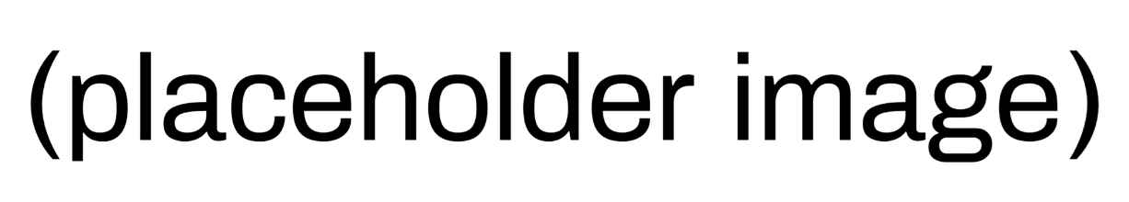
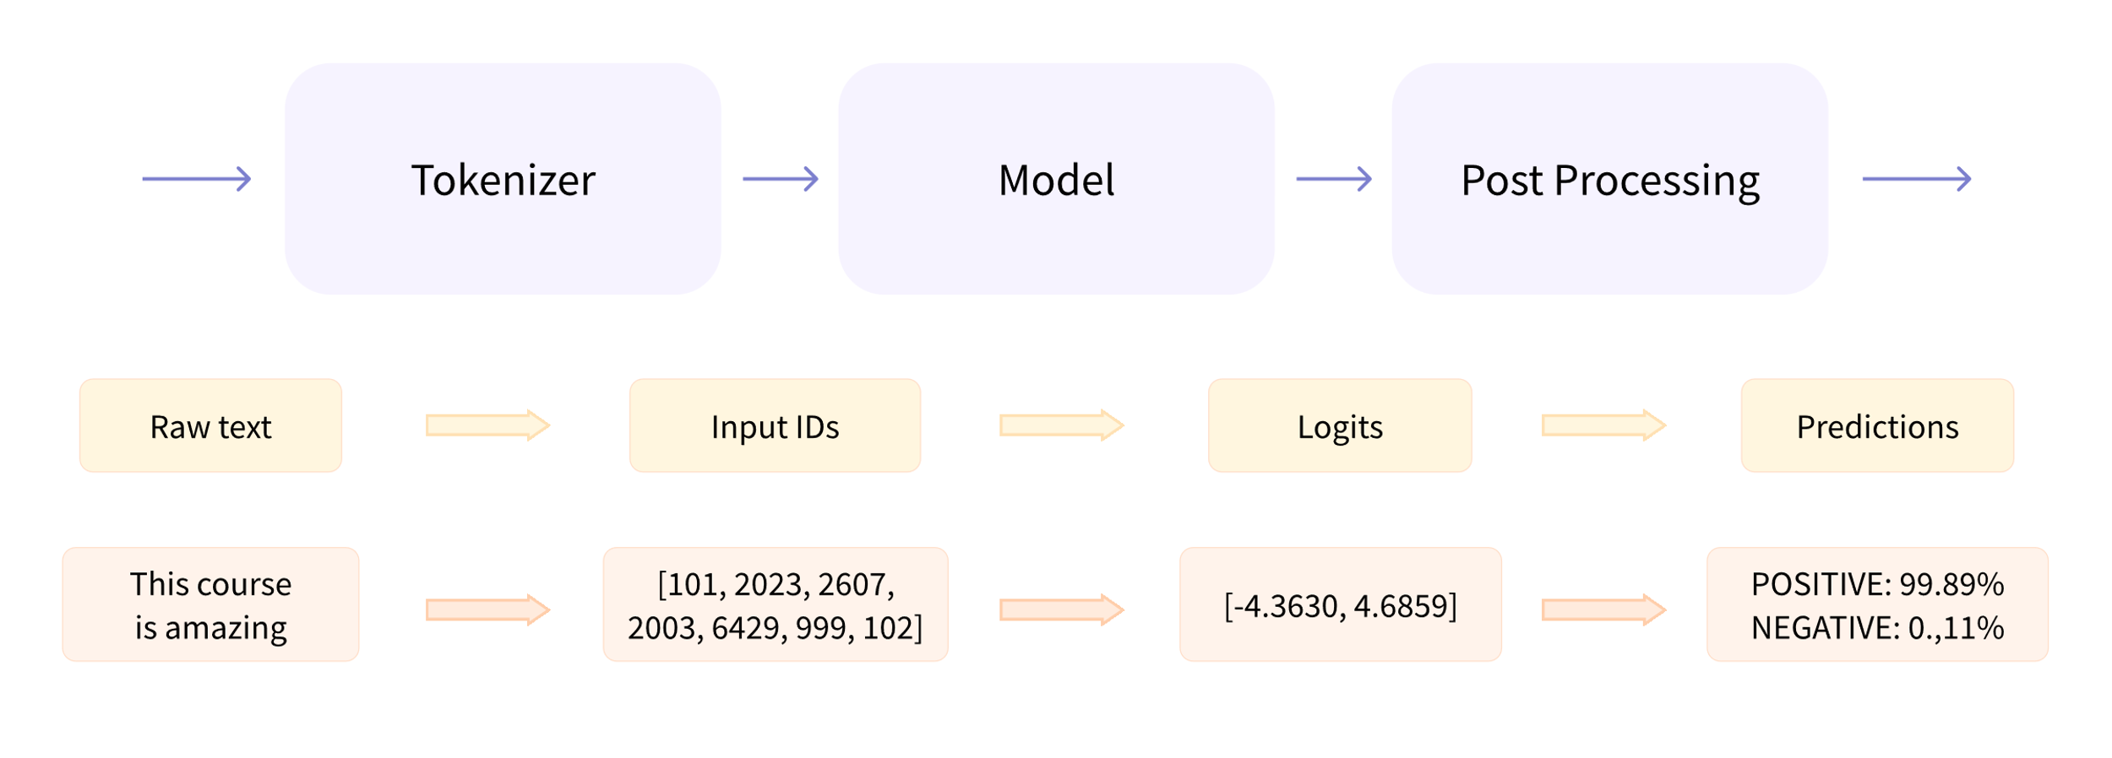
Figure 3.1: Step-by-step illustration of the text generation pipeline process

Applications of text generation
Text generation has a wide array of applications across various domains ^{[1]}; ^{[4]}; ^{[3]}:
- Chatbots and conversational agents: Enhancing customer service and user interaction by generating natural and contextually relevant responses ^{[5]}.
- Content creation: Automating the process of producing written content for articles, reports, and social media posts, which helps save time and resources while ensuring quality and relevance.
- Creative writing: Assisting authors and creators by generating narrative content, such as stories or poetry, offering new ideas, or helping overcome writer's block.
Chatbots and conversational agents: Chatbots powered by advanced text generation technologies like GPT can interact with users with high levels of personalization and relevance. For example, a customer service chatbot using text generation can understand and respond to user questions about products or services in real-time, effectively mimicking human conversational patterns. This helps companies manage a larger volume of inquiries without needing extra human resources, improving customer satisfaction by reducing wait times and providing support around the clock.
- Content creation: Text generation is transforming content creation by allowing automatic production of written material in different formats, such as news articles, blogs, and marketing copy. For example, a news organization could use a text generation model to draft articles based on the latest data, which journalists can then edit and expand. This helps maintain a steady flow of content, especially for topics that need frequent updates, like financial markets or sports events. Technology ensures consistency in style and tone, matching the outlet’s editorial standards while greatly reducing the time from data collection to publication.
- Creative writing: In creative writing, text generation tools act as collaborative aids for writers by suggesting narrative elements, dialogues, or descriptive passages. These tools can inspire writers by offering unexpected plot twists or character interactions, supporting the creative process. For example, a writer experiencing writer's block might use a text generation tool to suggest different story continuations based on the current text, helping to explore new narrative paths. Moreover, these tools can produce multiple versions of a scene, allowing writers to choose the one that best matches their vision or to combine elements from various options to create a more engaging story.
The following figure shows the architecture of the GPT model. The model includes Transformer decoder blocks (left panel). Each decoder block (center panel) features a multi-head masked attention layer, a multi-layer perceptron, normalization, and dropout layers. The residual connection (branching line to the addition operator) enables the block to learn from the input of the previous block. The multi-head masked attention layer (right panel) computes attention scores.

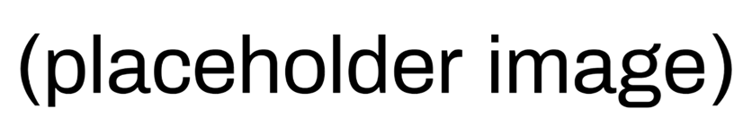
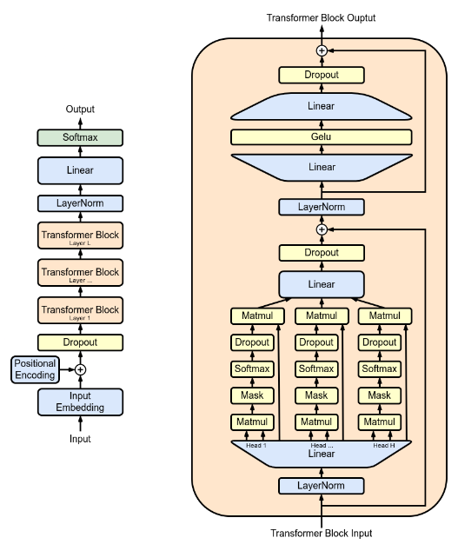
Figure 3.2: Visual representation of the GPT-2 architecture.

Example of implementing text generation with GPT-2
In the following example, we demonstrate how to use the Hugging Face Diffusion library for text generation tasks. We will utilize a pre-trained GPT model known for its strong performance in generating coherent and context-rich text. This example will guide you through setting up the model, preparing the input data, and running the generation process to create text that is not only grammatically correct but also contextually relevant.
`python
from transformers import GPT2LMHeadModel, GPT2Tokenizer, pipeline
# Load pre-trained GPT-2 model and tokenizer
tokenizer = GPT2Tokenizer.from_pretrained('gpt2')
model = GPT2LMHeadModel.from_pretrained('gpt2')
# Initialize text generation pipeline
text_generator = pipeline('text-generation', model=model, tokenizer=tokenizer)
# Generate text based on a prompt
prompt = "In a distant future, humanity has ventured far into the cosmos"
generated_texts = text_generator(prompt, max_length=100, num_return_sequences=1)
for generated_text in generated_texts:
print(generated_text['generated_text'])
`
This code begins by loading the GPT-2 model and tokenizer. The pipeline function streamlines the text generation process by integrating preprocessing, model inference, and postprocessing. The generated text continues the provided prompt, demonstrating how the model leverages its training to produce outputs that are contextually fitting and grammatically correct.
Figure 3.3 was taken from the articles section of the Hugging Face Company’s official website. The site frequently updates its application scenarios. For this example, ^{[6]}, the image illustrates the text-to-text generation model. These models are trained on pairs of texts, which can be questions and answers or instructions and responses. The most popular ones are T5 and BART, though they are not currently state-of-the-art.
Google recently released the FLAN-T5 series of models. FLAN is a recent technique developed for instruction fine-tuning, and FLAN-T5 is T5 fine-tuned using FLAN. The FLAN-T5 series is currently state-of-the-art and open-source, available on the Hugging Face Hub. Note that these differ from instruction-tuned causal language models, although their input-output formats may seem similar. The following figure illustrates how these models work:
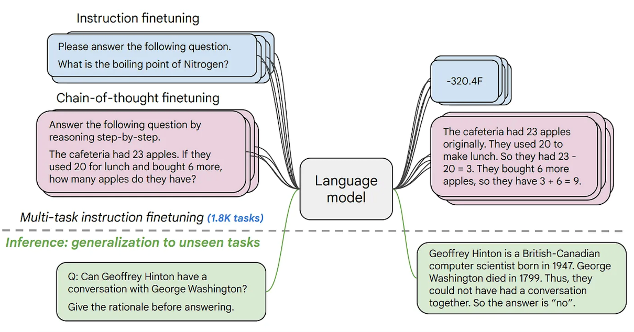
Figure 3.3: Examples of text generation applications

This section offers a comprehensive introduction to text generation, covering both theoretical ideas and practical uses, with an emphasis on advanced generative tasks. By linking these principles with practical coding examples, readers gain both conceptual knowledge and hands-on experience in creating text with cutting-edge models.

Overview of autoregressive models
Autoregressive models are essential in NLP, especially for text generation. These models predict the next item in a sequence by learning the probability distribution of an element based on its preceding ones ^{[4]}; ^{[2]}. GPT and its later versions highlight the development and advantages of autoregressive models in generating coherent and contextually rich text.

GPT architecture and its evolution
The original GPT model, developed by OpenAI, utilizes the transformer architecture, which is distinguished by its use of self-attention mechanisms. This design allows the model to weigh the importance of each word in a sentence, regardless of its position, enabling a deeper understanding of the textual context ^{[4]}. Let us look at the evolution:
- GPT-1: Introduced the foundational transformer-based architecture for language modeling and demonstrated the potential of unsupervised pre-training followed by supervised fine-tuning. It set a precedent for using large-scale pretraining on unlabeled corpora to improve performance on downstream tasks ^{[2]}.
- GPT-2: Expanded on GPT-1 with a significantly larger architecture and training dataset, leading to improved fluency, coherence, and contextual depth. GPT-2 was notable for its ability to generate extended passages of text with minimal prompting, and its release sparked global conversations around responsible AI deployment ^{[2]}.
- GPT-3: Marked a major leap in scale, with 175 billion parameters. GPT-3 introduced few-shot and zero-shot learning capabilities, allowing it to perform diverse tasks with little or no task-specific fine-tuning. It demonstrated remarkable versatility across domains, from programming to translation to creative writing ^{[3]}.
- GPT-4: Released in 2023, GPT-4 further improved reasoning, factual accuracy, and multimodal capabilities. Though the exact parameter count is undisclosed, it outperformed GPT-3.5 on academic benchmarks and introduced stronger guardrails for safety and alignment. GPT-4 can understand both text and image inputs, making it a true step toward general-purpose intelligence ^{[7]}; ^{[6]}.
- GPT-4o: Launched in 2024, GPT-4o ("omni") is a multimodal model designed to handle text, audio, and visual inputs natively. Unlike its predecessors that relied on separate modules for different modalities, GPT-4o processes all input types through a unified architecture. It enables real-time audio conversations, faster inference, and cross-modal reasoning, setting a new bar for integrated generative AI ^{[8]}.
To understand how GPT models generate text, it is important to visualize the architecture that enables autoregressive prediction. The diagram below (Figure 3.4) breaks down the flow from token input through transformer layers to the final output, revealing the role of each key component along the way.
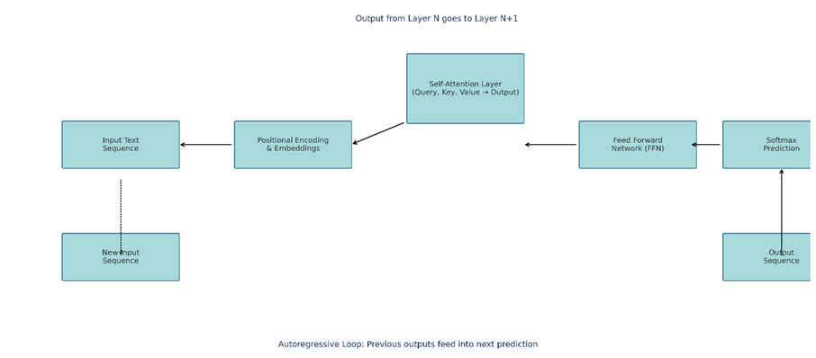
Figure 3.4: GPT model architecture.
Figure 3.4 above shows how tokens are passed through a stack of transformer blocks, each composed of multi-head attention, normalization, and feedforward layers. The output token is computed via a softmax layer and autoregressively appended to the input for subsequent prediction. Key features and advantages of autoregressive models like GPT offer the following key advantages:
- Contextual awareness: By considering all previous words in the sequence, these models maintain a crucial level of contextual awareness, enabling more accurate and relevant text generation.
- Flexibility: They can be adapted to a wide range of languages and tasks, from plain text generation to complex applications like dialogue systems and content creation.
- Scalability: The architecture supports scaling up to an excessive number of parameters, which enhances the model's understanding and generative capabilities.

Applications of GPT models
GPT models can be used for the following:
- Content creation: From writing articles to generating creative fiction, GPT models automate and enhance content creation processes.
- Language translation: Autoregressive models are used in state-of-the-art machine translation systems, offering high-quality translations by understanding and generating text in multiple languages.
- Conversational agents: GPT models power advanced conversational agents capable of engaging in human-like dialogue, delivering more natural and effective user interactions.
Now, let us examine the different versions of GPT models, focusing on the improvements and additions introduced in each new iteration.
GPT Evolution Timeline (2018–2023)
From GPT-1's pioneering use of unsupervised learning to GPT-4's multimodal capabilities, the architecture and scale of generative pre-trained transformers have evolved dramatically. Each iteration reflects breakthroughs in dataset size, training techniques, safety alignment, and user interactivity, culminating in the development of RLHF-tuned, multimodal agents capable of high-context reasoning.
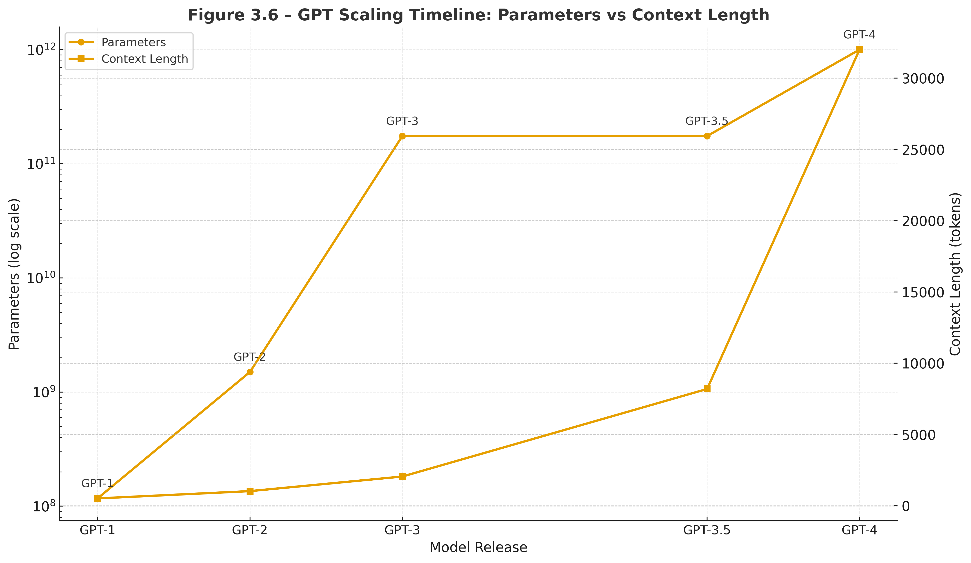
Figure 3.5: Evolution of GPT Model Series (2018–2023)
The dataset below - Table 3.1 - reflects the data used to create the previous graphic. Similarly, this dataset also provides a comparative overview of architectural scale and functional innovations across different GPT model generations. Key points include parameter increases, dataset growth, and the adoption of alignment techniques such as RLHF and multimodal inputs.
GPT Timeline: GPT-1 → GPT-4
Model | Release | Parameters | Key Features
GPT-1 | 2018 | 117 M | Unsupervised learning; SOTA on LAMBADA; Competitive on GLUE & SQuAD.
GPT-2 | 2019 | 1.5 B | Larger dataset; Modified objective & efficient sampling for better text gen.
GPT-3 | 2020 | 175 B | Larger dataset; Better training methodology (GShard); Few-shot capability.
GPT-3.5 | 2022 | 1.3 B / 6 B / 175 B | RLHF to reduce toxic output; Improved GPT-3.
GPT-4 | 2023 | ~1 T | Text + image inputs → text outputs; RLHF; Multi-modal capabilities.
Table 3.1 Comparative summary dataset

This dataset represents a comparative summary of architectural scale and functional innovations across GPT model generations. Highlights include parameter growth, dataset expansion, and the integration of alignment techniques such as RLHF and multimodal inputs.

Example of generating text with GPT-2
In this example, we demonstrate how to use the GPT-2 model, a variant of the GPT, for text generation. Recognized for its efficacy in natural language processing tasks, GPT-2 excels at producing coherent and contextually relevant text passages. We will utilize a pre-trained version of this model to showcase how it can effectively generate text based on a given prompt, reflecting its deep learning capabilities and understanding of language nuances.^{[2]}. Refer to the following code:
`python
from transformers import GPT2LMHeadModel, GPT2Tokenizer, pipeline
# Load the model and tokenizer for GPT-2
tokenizer = GPT2Tokenizer.from_pretrained('gpt2-medium')
model = GPT2LMHeadModel.from_pretrained('gpt2-medium')
# Setup the pipeline for text generation
generator = pipeline('text-generation', model=model, tokenizer=tokenizer)
# Generate text from a prompt
prompt = "The future of AI in medicine is"
generated_text = generator(prompt, max_length=50, num_return_sequences=1)
print("Generated Text:")
for i, text in enumerate(generated_text):
print(f"{i+1}: {text['generated_text']}")
```
The preceding script begins by setting up the model and tokenizer for the gpt2-medium version, chosen for its optimal balance between computational efficiency and output quality. A text generation pipeline is then configured, streamlining the text generation process to allow the model to produce coherent and contextually relevant passages effectively. When provided with a prompt, the model utilizes this setup to generate text that logically extends the initial input, demonstrating its capability to handle complex language patterns ^{[2]}.
This section provides a comprehensive examination of the architecture, evolution, and applications of autoregressive models, with a focus on the GPT series. It equips academics and scientists with the knowledge to leverage these models in advanced generative tasks effectively.

Fine-tuning GPT models for text generation
Fine-tuning GPT models for specific text generation tasks enables researchers and developers to tailor these powerful models to generate outputs that meet domain-specific needs. This process involves adapting a pre-trained model to perform better on a specific task by further training on a smaller, task-specific dataset ^{[2]}; ^{[3]}.

Preparing datasets
Before fine-tuning can begin, it is critical to prepare and preprocess the dataset to ensure that it is suitable for training the model. This involves:
- Data collection: Gathering text data that is relevant to the specific task, such as dialogues for a chatbot or articles for a news-related generation task; ^{[9]; [10]}
- Data cleaning: Removing noise and irrelevant information, standardizing text formats, and managing missing data to improve model performance; ^{[5]}
- Tokenization: Converting text into a format that can be processed by the model, typically into tokens or words that are represented as numerical data; ^{[11]}
- Splitting data: Dividing the dataset into training, validation, and test sets to enable practical training and evaluation ^{[1]}.

Training process and hyperparameter tuning
Fine-tuning a GPT model involves the following critical steps:
- Model selection: Choosing the right GPT model architecture and size based on the complexity of the task and available computational resources. ^{[3]}
- Hyperparameter setting: Adjusting parameters such as learning rate, batch size, and the number of training epochs. Hyperparameter tuning is often an experimental process that aims to find the set of parameters that yields the best performance on the validation set. ^{[12]; [13]}
- Regularization techniques: Using methods like dropout or weight decay to prevent the model from overfitting to the training data. ^{[1]}
- Training: The model is trained on the prepared dataset using the chosen hyperparameters, often using a GPU or TPU to accelerate the process. ^{[4]}

Application examples
Fine-tuning GPT models can be applied in various domains:
- Personalized chatbots: Tailoring GPT models to generate responses that adhere to a particular character or brand voice ^{[1] [3]}.
- Creative writing: Adapting models to assist authors by generating content with a specific style or theme ^{[2]}.

Example of fine-tuning a GPT-2 model for a chatbot
Example: In this example of Fine-Tuning a GPT-2 Model for a Chatbot, to fine-tune GPT-2 for dialogue generation, we break the task into smaller components. Each snippet below plays a distinct role in the fine-tuning process. To experience correct results, place all the following snippets in the same .py file and execute it as a unified script.
- Load the pre-trained model and tokenizer
```python
from transformers import GPT2LMHeadModel, GPT2Tokenizer
tokenizer = GPT2Tokenizer.from_pretrained('gpt2')
model = GPT2LMHeadModel.from_pretrained('gpt2')
```
This step initializes a pre-trained GPT-2 model and its associated tokenizer. These components will be fine-tuned for dialogue-specific tasks.
- Prepare the training dataset
```python
from transformers import TextDataset, DataCollatorForLanguageModeling

train_path = 'path_to_train_data.txt'
train_dataset = TextDataset(
tokenizer=tokenizer,
file_path=train_path,
block_size=128
)
data_collator = DataCollatorForLanguageModeling(
tokenizer=tokenizer, mlm=False
)
```
We define the path to the training data, tokenize it, and prepare it in a format suitable for language modeling. The data collator batches and formats input dynamically during training.
- Define training arguments
```python
from transformers import TrainingArguments

training_args = TrainingArguments(
output_dir='./results',
num_train_epochs=3,
per_device_train_batch_size=4,
per_device_eval_batch_size=8,
warmup_steps=500,
weight_decay=0.01,
logging_dir='./logs',
logging_steps=10,
)
```
These arguments control how the model trains: epochs, batch sizes, regularization, and logging.
- Initialize and run the Trainer
```python
from transformers import Trainer

trainer = Trainer(
model=model,
args=training_args,
data_collator=data_collator,
train_dataset=train_dataset,
)
trainer.train()
```
The Trainer class simplifies the training loop and integrates everything we’ve configured so far. Once initialized, the training process begins with a single method call.
Combine and Run:
To experience correct results when reusing the code above, please add all four snippets into a single .py file in the order shown above. Each snippet builds upon the previous, ensuring seamless execution..
In the preceding example code, we begin by configuring the model and tokenizer specifically designed for dialogue tasks, utilizing the gpt2-medium version, which strikes a good balance between performance and computational efficiency. The text generation pipeline is then set up to simplify the process, allowing the model to take a prompt and generate coherent responses. This setup enables the chatbot to produce contextually relevant dialogue, reflecting the nuanced interaction dynamics typically required in real conversations.

Text generation applications
The use of text generation has expanded considerably due to advances in NLP technologies, especially with models like GPT. This section highlights two main uses of text generation: developing conversational agents and creating creative writing samples. These examples show how GPT models can produce human-like text in different situations.

Building a conversational agent
Conversational agents, or chatbots, are created to mimic human-like conversations and provide a smooth interactive experience. In this context, GPT models are useful because they can produce responses that are relevant to the situation and keep the conversation flowing.
When designing systems that engage users in dialogue—be it customer service platforms, virtual assistants, or therapeutic chatbots—conversational continuity and tone become essential. GPT-based models excel in these environments due to their capacity to maintain semantic flow, recall prior exchanges, and simulate human-like communication. The following attributes illustrate why GPT is particularly well-suited for conversational AI:
- Contextual understanding: GPT models can recall previous exchanges in a conversation, enabling them to provide responses that are suitable for the context, which is an essential feature for customer service bots or virtual assistants.
- Personalization: These models can be fine-tuned to match a specific personality or tone, making them perfect for branded interactions.

Using models for story or poem generation
GPT models have also been employed to assist with creative writing, providing tools that can suggest text, generate story ideas, or even compose entire poems or short stories.
Beyond utilitarian tasks, GPT models have carved out a prominent role in creative fields, especially in assisting writers, poets, and artists in generating expressive textual outputs. By learning stylistic nuances and narrative structures, these models contribute not just syntactically correct sentences but also emotionally resonant content. The points below highlight how GPT models support creative authorship:
- Enhancing creativity: By generating novel content based on initial prompts, these models can help writers overcome creative blocks and explore new perspectives.
- Style adaptation: Writers can train these models on specific genres or styles to produce content that aligns with aesthetic or thematic preferences.
GPT models have proven their promise by delivering immense value across diverse industries. In the figure below, we delve into the instances where GPT models have found compelling use cases:
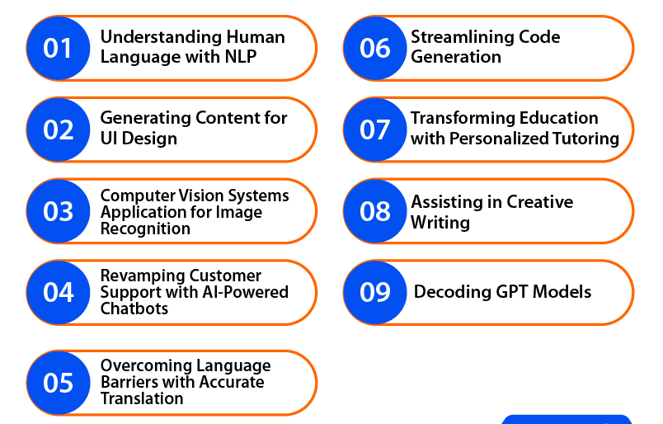
Figure 3.6: Representations of different applications of GPT models.

GPT-3 for a conversational agent and creative writing
This example demonstrates how to utilize GPT-3 to develop a conversational agent that assists with creative writing tasks, such as poetry. By leveraging GPT-3's advanced capabilities, we will see how this powerful model can be fine-tuned to produce engaging dialogue and artistic literary content, showcasing its ability to handle complex language tasks. Refer to the following code:
```python
from transformers import GPT3Tokenizer, GPT3Model, pipeline
# Load pre-trained GPT-3 model
tokenizer = GPT3Tokenizer.from_pretrained('gpt3')
model = GPT3Model.from_pretrained('gpt3')
# Setup text generation pipeline
text_generator = pipeline('text-generation', model=model, tokenizer=tokenizer)
# Generate dialogue response
dialogue_prompt = "Customer: I am unable to access my account. Help!"
dialogue_response = text_generator(dialogue_prompt, max_length=50, num_return_sequences=1)
print("Dialogue Response:", dialogue_response[0]['generated_text'])
# Generate creative writing
creative_prompt = "Write a poem about the ocean."
poem = text_generator(creative_prompt, max_length=100, num_return_sequences=1)
print("Generated Poem:", poem[0]['generated_text'])
```
In this example, we first load the GPT-3 model, along with its tokenizer, which is explicitly configured for text generation tasks. This setup is crucial for ensuring that the model is set up accurately to process input text. Next, the model is applied to a customer service scenario to generate realistic dialogue responses, demonstrating its ability to manage conversational contexts effectively. Additionally, we utilize GPT-3 to create a piece of creative writing. By providing a creative prompt about the ocean, the model demonstrates its artistic capabilities by generating a poem, displaying its utility in both practical and innovative applications.
This section offers a detailed examination of the practical applications of advanced text generation with GPT models, highlighting their transformative impact in both conversational and creative contexts. By including specific examples, the chapter not only demonstrates the abilities of modern NLP models but also promotes further exploration and innovation in the field.

Conclusion
In this chapter, we explored the advanced capabilities of the Hugging Face Diffusers library for text generation, with a focus on autoregressive models such as GPT and its variants. These models demonstrate a remarkable ability to generate coherent, rich language and have proven adaptable across a range of applications, from conversational agents to creative writing assistants.
We examined how fine-tuning can enhance these models for specialized tasks, and how the Hugging Face ecosystem simplifies integration and experimentation. Through practical examples, we highlighted the flexibility of generative models in producing high-quality text across diverse formats and domains.
The chapter also emphasized the real-world impact of diffusion-based NLP systems, showing how their precision and adaptability are reshaping content creation. These demonstrations reveal not only the technical depth of generative models but also their usability in dynamic, applied contexts.
Looking ahead, Chapter 4 will extend this foundation into the realm of transfer learning—a core strategy for adapting pre-trained models to new, domain-specific tasks. We will introduce key principles, techniques, and tools that allow developers to optimize performance, reduce training costs, and deploy efficient models across varied NLP applications.
By bridging the theoretical underpinnings of generative modeling with practical deployment strategies, Chapter 4 serves as a pivotal transition toward real-world implementation, equipping readers with the skills to scale their NLP projects with greater precision, adaptability, and impact.

References (to be moved to APPENDIX)

[1] I. Goodfellow, Y. Bengio, and A. Courville, Deep Learning. MIT Press, 2016.
[2] A. Radford, J. Wu, R. Child, D. Luan, D. Amodei, and I. Sutskever, “Language models are unsupervised multitask learners,” OpenAI blog, vol. 1, p. 9, 2019.
[3] A. Vaswani et al., “Attention is all you need,” Advances in Neural Information Processing Systems (NIPS, p. 30, 2017.
[4] T. B. Brown et al., “Language models are few-shot learners,” Adv Neural Inf Process Syst, vol. 33, p. 33, 2020.
[5] J. Devlin, M. W. Chang, K. Lee, and K. Toutanova, “BERT: Pre-training of deep bidirectional transformers for language understanding,” in Proceedings of the 2019 Conference of the North American Chapter of the Association for Computational Linguistics: Human Language Technologies, 2019, pp. 4171–4186.
[6] M. Noyan, “Open-Source Text Generation & LLM Ecosystem at Hugging Face,” Hugging Face Blogs. Accessed: Sep. 17, 2025. [Online]. Available: https://huggingface.co/blog/os-llms
[7] OpenAI, “ GPT-4: Early impressions and model capabilities. ,” OpenAI Blog. Accessed: Sep. 17, 2025. [Online]. Available: https://openai.com/blog/gpt-4
[8] OpenAI, “GPT-4o: Introducing our new flagship model,” OpenAI web site. Accessed: Sep. 17, 2025. [Online]. Available: https://openai.com/index/gpt-4o
[9] J. Dodge, S. Gururangan, D. Card, R. Schwartz, and N. A. Smith, “Fine-tuning pretrained language models: Weight initializations, data orders, and early stopping.",” 2020.
[10] C. Raffel et al., “Exploring the Limits of Transfer Learning with a Unified Text-to-Text Transformer.,” Journal of Machine Learning Research, 2020.
[11] T. Kudo and J. Richardson, SentencePiece: A simple and language-independent subword tokenizer and detokenizer for neural text processing. EMNLP, 2018.
[12] R. B. J. Bardenet, Y. Bengio, and B. Kegl, “Algorithms for hyper-parameter optimization,” Adv Neural Inf Process Syst, 2011.
[13] J. Snoek, H. Larochelle, and R. P. Adams, “Practical Bayesian optimization of machine learning algorithms,” Adv Neural Inf Process Syst, 2012.

References (to be deleted on a later date

[1] | I. Goodfellow, Y. Bengio and A. Courville, Deep Learning, MIT Press, 2016.
[2] | A. Radford, J. Wu, R. Child, D. Luan, D. Amodei and I. Sutskever, "Language models are unsupervised multitask learners," 2019. [Online].
[3] | A. Vaswani, N. Shazeer, N. Parmar, J. Uszkoreit, L. Jones, A. N. Gomez, L. Kaiser and I. Polosukhin, "Attention is all you need," Advances in neural information processing systems, 2017.
[4] | T. B. Brown and e. al., Language models are few-shot learners, NeurIPS, 2020.
[5] |   J. Devlin, M.-W. Chang, K. Lee and K. Toutanova, BERT: Pre-training of deep bidirectional transformers for language understanding, NAACL-HLT, 2019.
[6] | M. Noyan, "Open-Source Text Generation & LLM Ecosystem at Hugging Face," 17 July 2023. [Online]. Available: https://huggingface.co/blog/os-llms.
[7] | J. Dodge, S. Gururangan, D. Card, R. Schwartz and N. A. Smith, "Fine-tuning pretrained language models: Weight initializations, data orders, and early stopping."," 2020.
[8] | C. e. a. Raffel, "Exploring the limits of transfer learning with a unified text-to-text transformer," Journal of Machine Learning Research, 2020.
[9] | T. Kudo and J. Richardson, SentencePiece: A simple and language-independent subword tokenizer and detokenizer for neural text processing, EMNLP, 2018.
[10] | J. B. R. Bergstra, Y. Bengio and B. Kégl, " Algorithms for hyper-parameter optimization," Advances in Neural Information Processing Systems, 2011.
[11] | J. Snoek, H. Larochelle and R. P. Adams, "Practical Bayesian optimization of machine learning algorithms," Advances in Neural Information Processing Systems, 2012.
[12] | G. E. Hinton, N. Srivastava and A. Krizhevsky, " Improving neural networks by preventing co-adaptation of feature detectors," 2012.

The complete version of this script, with additional comments, logging, and evaluation routines, is available in the official GitHub companion repository for this book

