Chapter 3 - Advanced Generative Tasks with Hugging Face Diffusion
Target: 25 pages

In this chapter, we examine the advanced generative abilities of the Hugging Face Diffusion library. These abilities transform content creation for text, images, and videos, offering practical use cases and innovative opportunities. The chapter provides clear insights into utilizing cutting-edge models, such as GPT, for text generation and more complex tasks, including image-to-video creation and depth-to-image translation. By the end, you will know how to use these tools to improve multimedia production and expand your skills in advanced AI workflows.
In this chapter, we will cover the following topics:
- Overview of Text Generation
- Autoregressive Models: GPT and Its Variants
- Fine-tuning GPT for Text Generation
- Application: Generating Dialogue Responses
- Application: Generating Creative Writing Samples

Learning Objectives
By the end of Chapter 3, readers will be able to:
Understand Advanced Generative Models
- Understand the fundamental technologies and concepts behind advanced generative models for text, images, and videos.
- Understand how autoregressive models, such as GPT, generate coherent and contextually appropriate content.
- Explore the pipeline steps involved in generative tasks, including input preprocessing, model inference, and output postprocessing.
Apply Text Generation Techniques
- Utilize pre-trained models, such as GPT-2, to implement text generation workflows.
- Tailor generative outputs to meet specific creative or task-oriented needs through prompt engineering.
- Identify main uses of text generation, such as chatbots, content creation, and creative writing.
Fine-Tune Generative Models for Specific Tasks
- Prepare datasets for fine-tuning by collecting, cleaning, tokenizing, and dividing into training, validation, and testing sets.
- Fine-tune pre-trained GPT models to handle domain-specific tasks, such as creating customer service conversations or personalized stories.
- Experiment with hyperparameter tuning to optimize model performance.
Explore Innovations in Media Creation
- Utilize generative models for advanced media tasks, like image-to-video generation and depth-to-image synthesis.
- Grasp how to combine text and visuals to craft engaging multimedia experiences.
- Explore the potential for collaboration between AI-generated content and human creativity.
Deploy and Monitor Generative Models
- Deploy fine-tuned models with frameworks like FastAPI to build RESTful APIs for real-world applications.
- Integrate monitoring tools, such as Prometheus and Grafana, to track the performance and health of deployed AI models.
- Create a systematic method to manage generative workflows and ensure they can scale.
Synthesize Knowledge Through Direct Exercises
- Practice real-world applications of generative tasks using Hugging Face Diffusion.
- Build and deploy APIs, fine-tune models, and monitor their performance in a production-like environment.
- Improve problem-solving and technical skills by working through guided exercises that link theory to practice.
- These objectives match the chapter's focus on practical, advanced uses of generative AI, helping readers utilize Hugging Face Diffusion's features for research and real-world innovation.

The Fundamentals of Advanced Generative Models
Generative models have revolutionized content creation by enabling the automation and creativity required to produce text, images, and multimedia. This section explains the key technologies and concepts behind these models, highlighting their impactful role in AI-driven content generation.

Overview of Text Generation
Text generation, a basis of modern natural language processing (NLP), involves the automated creation of textual content through models that can mimic language patterns, understand context, and generate coherent and contextually relevant text. This section explores the foundations and applications of text generation using the Hugging Face Diffusion library, particularly focusing on advanced tasks like text-to-video and depth-to-image synthesis [1]; [2].

Foundations of Text Generation
The field of text generation utilizes deep learning models to generate text that mimics human-like writing. Central to these advances are autoregressive models, such as the Generative Pre-trained Transformer (GPT) series, which predict the following words based on earlier text, enabling the creation of sentences and paragraphs in a context-aware manner.
- Autoregressive Models: Models such as GPT rely on the transformer architecture, which uses self-attention mechanisms to weigh the importance of different words in a sequence regardless of their position [3]. This enables the generation of text that is not only grammatically correct but also contextually appropriate for the specific scenario.
- Pipeline Process: Text generation involves preprocessing input, passing it through a model, and postprocessing the output.
The illustration below shows the text generation pipeline process, grouping together three steps: preprocessing, passing the inputs through the model, and postprocessing.
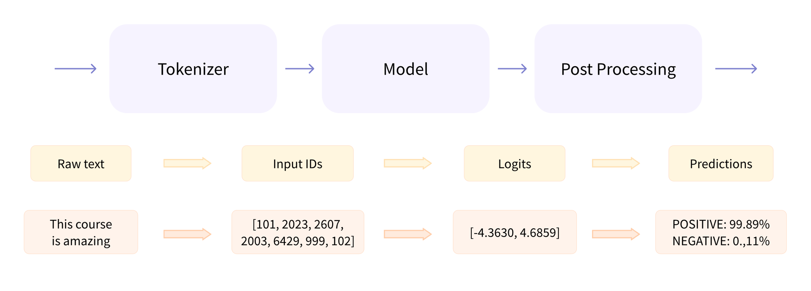
Figure 1 Step-by-step illustration of the text generation pipeline process.

Applications of Text Generation
Text generation has a wide array of applications across various domains [1] [3] [4]:
- Chatbots and Conversational Agents: Enhancing customer service and user interaction by generating natural and contextually relevant responses [5].
- Content Creation: Automating the process of producing written content for articles, reports, and social media posts, which helps save time and resources while ensuring quality and relevance.
- Creative Writing: Assisting authors and creators by generating narrative content, such as stories or poetry, offering new ideas, or helping overcome writer's block.
- Chatbots and Conversational Agents: Chatbots powered by advanced text generation technologies, such as GPT (Generative Pre-trained Transformer), can engage users with high levels of personalization and relevance. For example, a customer service chatbot using text generation can understand and respond to user queries about products or services in real-time, effectively mimicking human conversational patterns. This allows companies to handle a higher volume of inquiries without needing additional human resources, thereby improving customer satisfaction by reducing wait times and increasing support availability 24/7.
- Content Creation: Text generation is revolutionizing content creation by enabling automatic production of written material in various formats, including news articles, blogs, and marketing copy. For example, a news organization could use a text generation model to draft articles based on the latest data, which journalists can then refine and expand. This helps ensure a steady flow of content, especially for topics that require frequent updates, such as financial markets or sports events. Technology ensures consistency in style and tone, aligning with the outlet’s editorial standards while significantly reducing the time from data collection to publication.
- Creative Writing: In creative writing, text generation tools act as collaborative aids for writers by suggesting narrative elements, dialogues, or descriptive passages. These tools can inspire writers by offering unexpected plot twists or character interactions, supporting the creative process. For example, a writer experiencing writer's block might use a text generation tool to suggest different story continuations based on the current text, helping to explore new narrative paths. Moreover, these tools can produce multiple versions of a scene, allowing writers to choose the one that best matches their vision or to combine elements from various options to create a more engaging story.
The following illustration shows the architecture of the GPT model. The model includes Transformer decoder blocks (left panel). Each decoder block (center panel) features a multi-head masked attention layer, a multi-layer perceptron, normalization, and dropout layers. The residual connection (branching line to the addition operator) enables the block to learn from the input of the previous block. The multi-head masked attention layer (right panel) computes attention scores.
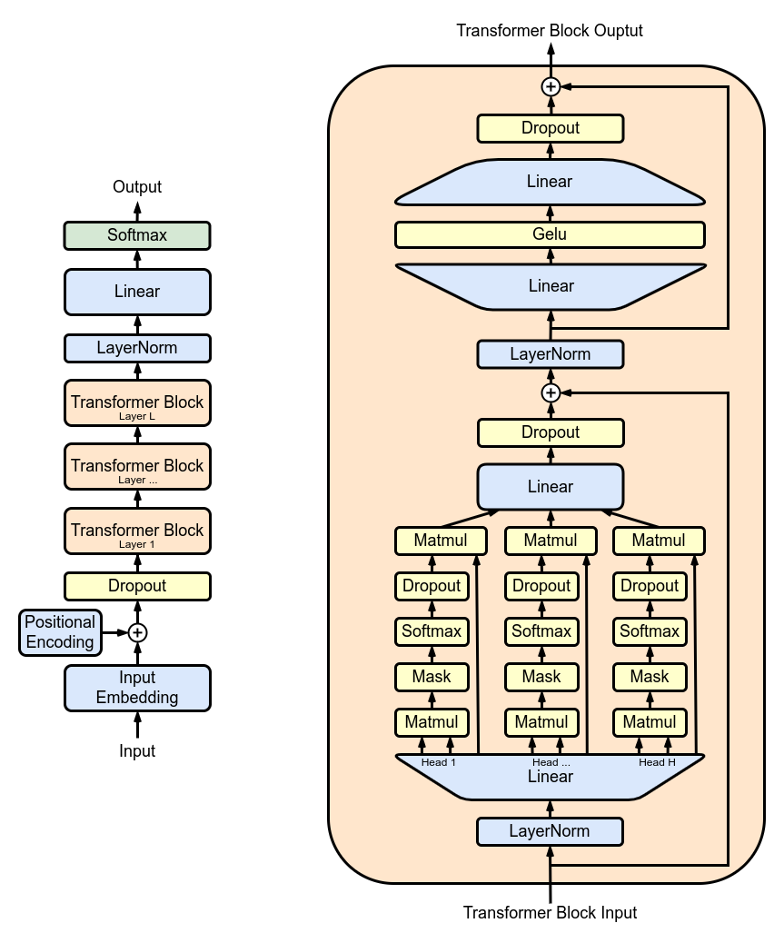
Figure 2 Visual representation of the GPT-2 architecture.

Example: Implementing Text Generation with GPT-2
In the example below, we demonstrate how to use the Hugging Face Diffusion library for text generation tasks. We will utilize a pre-trained GPT model known for its strong performance in generating coherent and context-rich text. This example will guide you through setting up the model, preparing the input data, and running the generation process to create text that is not only grammatically correct but also contextually relevant.
`python
from transformers import GPT2LMHeadModel, GPT2Tokenizer, pipeline
# Load pre-trained GPT-2 model and tokenizer
tokenizer = GPT2Tokenizer.from_pretrained('gpt2')
model = GPT2LMHeadModel.from_pretrained('gpt2')
# Initialize text generation pipeline
text_generator = pipeline('text-generation', model=model, tokenizer=tokenizer)
# Generate text based on a prompt
prompt = "In a distant future, humanity has ventured far into the cosmos"
generated_texts = text_generator(prompt, max_length=100, num_return_sequences=1)
for generated_text in generated_texts:
print(generated_text['generated_text'])
`
This code begins by loading the GPT-2 model and tokenizer. The pipeline function streamlines the text generation process by integrating preprocessing, model inference, and postprocessing. The generated text continues the provided prompt, demonstrating how the model leverages its training to produce outputs that are contextually fitting and grammatically correct.
The image below was taken from the “articles” section of the Hugging Face Company’s official website. The site frequently updates its application scenarios. In this example [6], the image illustrates “the text-to-text generation model.” These models are trained on pairs of texts, which can be questions and answers or instructions and responses. The most popular ones are T5 and BART, though they are not currently state-of-the-art. Google recently released the FLAN-T5 series of models. FLAN is a recent technique developed for instruction fine-tuning, and FLAN-T5 is T5 fine-tuned using FLAN. The FLAN-T5 series is currently state-of-the-art and open-source, available on the Hugging Face Hub. Note that these differ from instruction-tuned causal language models, although their input-output formats may seem similar. Below, you can see an illustration of how these models work.
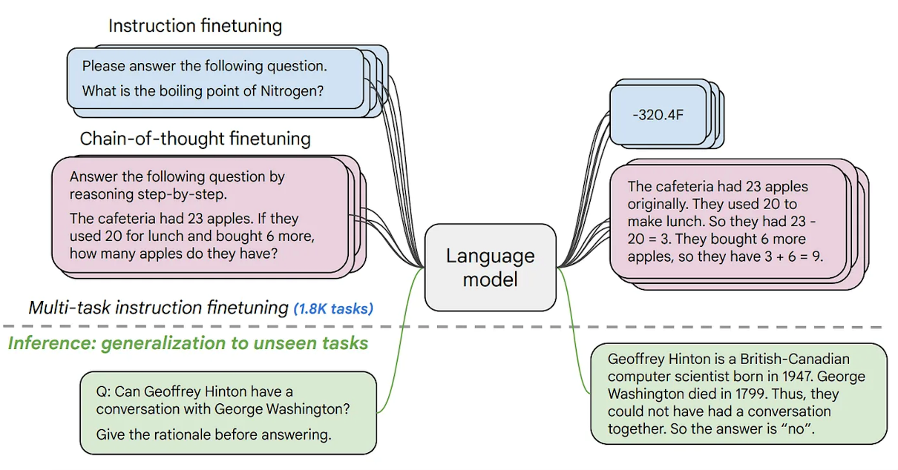
Figure 3 Examples of text generation applications.
This section provides a comprehensive introduction to text generation, encompassing both theoretical concepts and practical applications, with a focus on advanced generative tasks. By connecting these principles with practical coding examples, readers acquire both conceptual understanding and hands-on experience in creating text with cutting-edge models.

Overview of Autoregressive Models: GPT and Its Variants
Autoregressive models are a key approach in natural language processing (NLP), especially for text generation. These models predict the following item in a sequence by learning the probability distribution of an element based on its previous ones [3]; [2]. The Generative Pre-Trained Transformer (GPT) and its later versions demonstrate the development and strengths of autoregressive models in producing coherent and contextually rich text.

GPT Architecture and Its Evolution
The original GPT model, developed by OpenAI, utilizes the transformer architecture, which is distinguished by its use of self-attention mechanisms. This design allows the model to weigh the importance of each word in a sentence, regardless of its position, enabling a deeper understanding of the textual context [3].
- GPT-1: Introduced the basic framework of using transformers for language modeling and text generation. It was pre-trained on a large corpus of text and fine-tuned for specific tasks, setting a new standard for transfer learning in NLP [2].
- GPT-2: Expanded on GPT-1 with a much larger model size and training dataset, significantly improving the quality and reliability of the generated text. GPT-2 demonstrated the ability of autoregressive models to generate long passages of text that are coherent and contextually relevant over paragraphs [2].
- GPT-3: The latest in the series, GPT-3, further scales up the model size to 175 billion parameters, introducing even more sophisticated capabilities, including few-shot learning, where the model performs tasks with a minimal amount of task-specific data [4].
In the following figure, we use an architecture diagram to demonstrate how a GPT model using self-attention responds to a user input (text sequence) on a significant level, starting at the arrow on the top left corner (over-simplified):
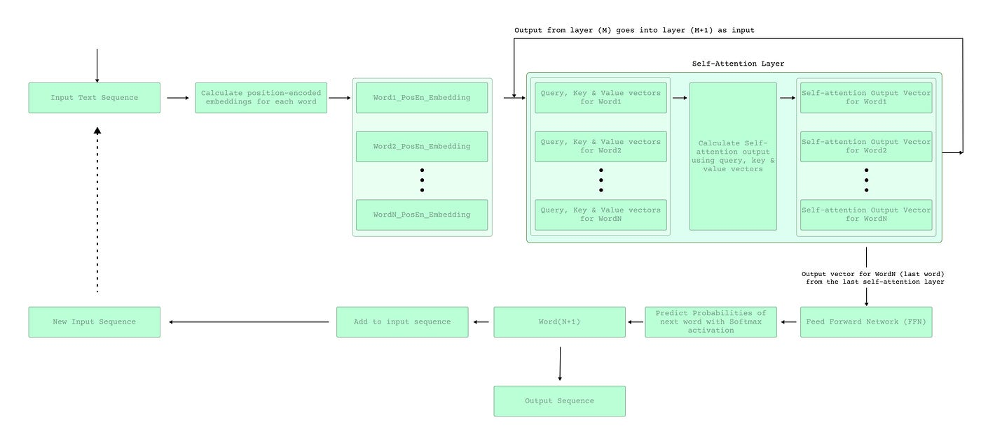
Figure 4 GPT Model Architecture Diagram.

Key Features and Advantages of Autoregressive Models
Autoregressive models like GPT offer the following key advantages:
- Contextual Awareness: By considering all previous words in the sequence, these models maintain a crucial level of contextual awareness, enabling more accurate and relevant text generation.
- Flexibility: They can be adapted to a wide range of languages and tasks, from plain text generation to complex applications like dialogue systems and content creation.
- Scalability: The architecture supports scaling up to an excessive number of parameters, which enhances the model's understanding and generative capabilities.

Applications of GPT Models
- Content Creation: From writing articles to generating creative fiction, GPT models automate and enhance content creation processes.
- Language Translation: Autoregressive models are used in state-of-the-art machine translation systems, offering high-quality translations by understanding and generating text in multiple languages.
Conversational Agents: GPT models power advanced conversational agents capable of engaging in human-like dialogue, delivering more natural and effective user interactions. Now, let's examine the different versions of GPT models, focusing on the improvements and additions introduced in each new iteration.
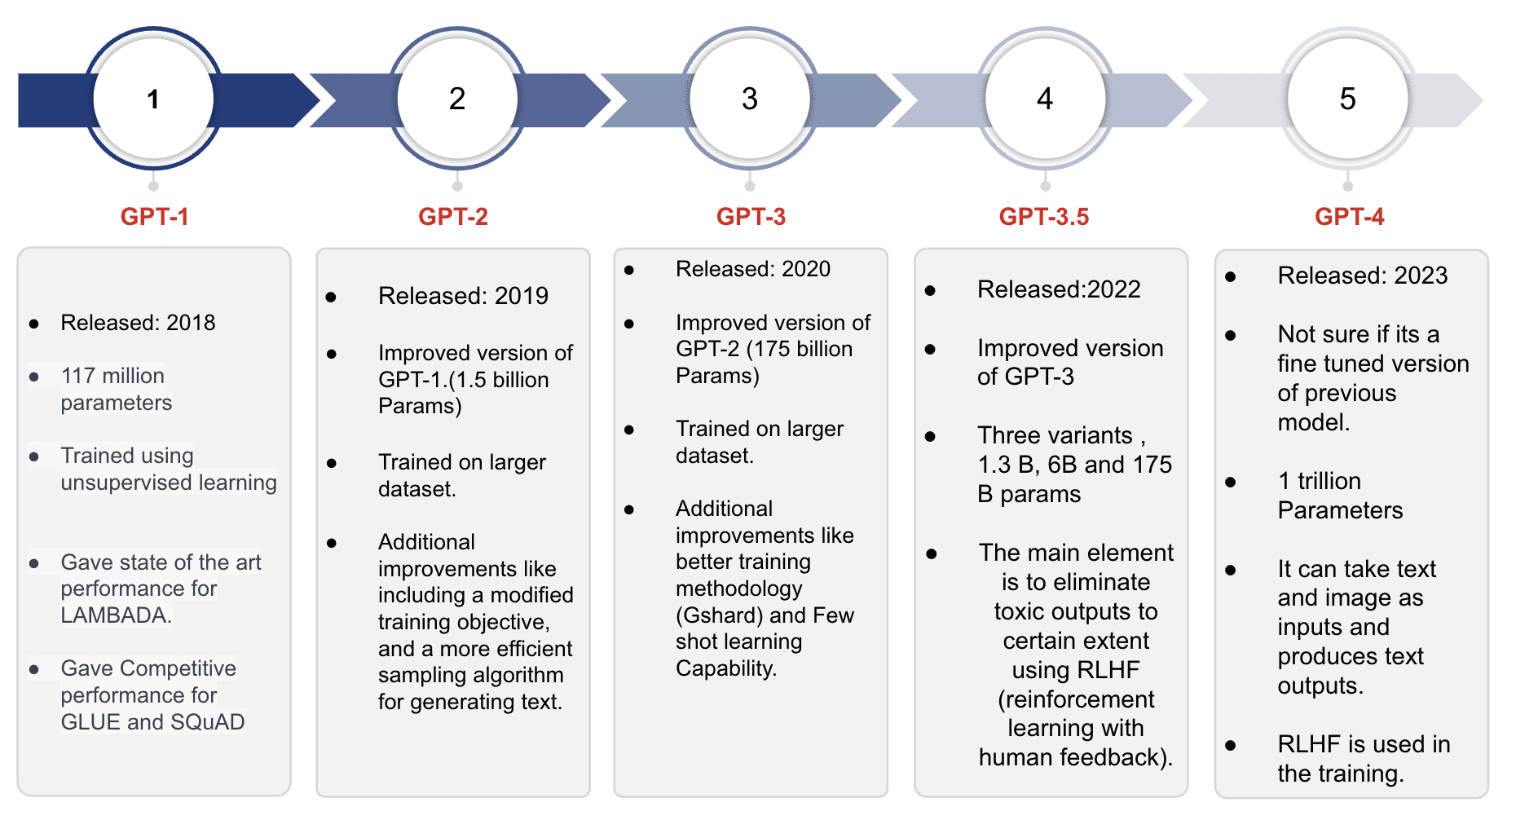
Figure 5 Evolution Timeline of GPT Models

Example: Generating Text with GPT-2
In this example, we demonstrate how to use the GPT-2 model, a variant of the Generative Pre-trained Transformer, for text generation. Recognized for its efficacy in natural language processing tasks, GPT-2 excels at producing coherent and contextually relevant text passages. We'll utilize a pre-trained version of this model to showcase how it can effectively generate text based on a given prompt, reflecting its deep learning capabilities and understanding of language nuances [2].
`python
from transformers import GPT2LMHeadModel, GPT2Tokenizer, pipeline
# Load the model and tokenizer for GPT-2
tokenizer = GPT2Tokenizer.from_pretrained('gpt2-medium')
model = GPT2LMHeadModel.from_pretrained('gpt2-medium')
# Setup the pipeline for text generation
generator = pipeline('text-generation', model=model, tokenizer=tokenizer)
# Generate text from a prompt
prompt = "The future of AI in medicine is"
generated_text = generator(prompt, max_length=50, num_return_sequences=1)
print("Generated Text:")
for i, text in enumerate(generated_text):
print(f"{i+1}: {text['generated_text']}")
`
The script above begins by setting up the model and tokenizer for the 'gpt2-medium' version, chosen for its optimal balance between computational efficiency and output quality. A text generation pipeline is then configured, streamlining the text generation process to allow the model to produce coherent and contextually relevant passages effectively. When provided with a prompt, the model utilizes this setup to generate text that logically extends the initial input, demonstrating its capability to handle complex language patterns [2].
This section provides a comprehensive examination of the architecture, evolution, and applications of autoregressive models, with a focus on the GPT series. It equips academics and scientists with the knowledge to leverage these models in advanced generative tasks effectively.

Fine-tuning GPT Models for Text Generation
Fine-tuning Generative Pre-trained Transformer (GPT) models for specific text generation tasks enables researchers and developers to tailor these powerful models to generate outputs that meet domain-specific needs. This process involves adapting a pre-trained model to perform better on a specific task by further training on a smaller, task-specific dataset [5]; [4].

Preparing Datasets
Before fine-tuning can begin, it is critical to prepare and preprocess the dataset to ensure that it is suitable for training the model. This involves:
- Data Collection: Gathering text data that is relevant to the specific task, such as dialogues for a chatbot or articles for a news-related generation task [7] [8].
- Data Cleaning: Removing noise and irrelevant information, standardizing text formats, and managing missing data to improve model performance [5].
- Tokenization: Converting text into a format that can be processed by the model, typically into tokens or words that are represented as numerical data [9].
- Splitting Data: Dividing the dataset into training, validation, and test sets to enable practical training and evaluation [1].

Training Process and Hyperparameter Tuning
Fine-tuning a GPT model involves the following critical steps:
- Model Selection: Choosing the right GPT model architecture and size based on the complexity of the task and available computational resources [4].
- Hyperparameter Setting: Adjusting parameters such as learning rate, batch size, and the number of training epochs. Hyperparameter tuning is often an experimental process that aims to find the set of parameters that yields the best performance on the validation set [10]; [11].
- Regularization Techniques: Using methods like dropout or weight decay to prevent the model from overfitting to the training data [1].
- Training: The model is trained on the prepared dataset using the chosen hyperparameters, often using a GPU or TPU to accelerate the process [3].

Application Examples
Fine-tuning GPT models can be applied in various domains:
- Personalized Chatbots: Tailoring GPT models to generate responses that adhere to a particular character or brand voice [1] [4].
- Creative Writing: Adapting models to assist authors by generating content with a specific style or theme [2].

Example: Fine-tuning a GPT-2 Model for a Chatbot
This example shows the process of fine-tuning a GPT-2 model to generate dialogue responses, illustrating how it can be used to create a chatbot capable of engaging in realistic conversations.

``python
from transformers import GPT2LMHeadModel, GPT2Tokenizer, Trainer, TrainingArguments, TextDataset, DataCollatorForLanguageModeling

# Load tokenizer and model
tokenizer = GPT2Tokenizer.from_pretrained('gpt2')
model = GPT2LMHeadModel.from_pretrained('gpt2')

# Prepare dataset
train_path = 'path_to_train_data.txt'
train_dataset = TextDataset(
tokenizer=tokenizer,
file_path=train_path,
block_size=128
)

data_collator = DataCollatorForLanguageModeling(
tokenizer=tokenizer, mlm=False,
)

# Define training arguments
training_args = TrainingArguments(
output_dir='./results', # output directory
num_train_epochs=3, # number of training epochs
per_device_train_batch_size=4, # batch size for training
per_device_eval_batch_size=8, # batch size for evaluation
warmup_steps=500, # number of warmup steps for learning rate scheduler
weight_decay=0.01, # strength of weight decay
logging_dir='./logs', # directory for storing logs
logging_steps=10,
)

# Initialize Trainer
trainer = Trainer(
model=model,
args=training_args,
data_collator=data_collator,
train_dataset=train_dataset,
)

# Train the model
trainer.train()
``
In the example code above, we begin by configuring the model and tokenizer specifically designed for dialogue tasks, utilizing the gpt2-medium version, which strikes a good balance between performance and computational efficiency. The text generation pipeline is then set up to simplify the process, allowing the model to take a prompt and generate coherent responses. This setup enables the chatbot to produce contextually relevant dialogue, reflecting the nuanced interaction dynamics typically required in real conversations.

Text Generation Applications
The use of text generation has expanded considerably due to advances in NLP technologies, especially with models like GPT. This section highlights two main uses of text generation: developing conversational agents and creating creative writing samples. These examples show how GPT models can produce human-like text in different situations.

Generating Dialogue Responses: Building a Conversational Agent
Conversational agents, or chatbots, are created to mimic human-like conversations and provide a smooth interactive experience. In this context, GPT models are useful because they can produce responses that are relevant to the situation and keep the conversation flowing.
- Contextual Understanding: GPT models can recall previous exchanges in a conversation, enabling them to provide responses that are suitable for the context — an essential feature for customer service bots or virtual assistants.
- Personalization: These models can be fine-tuned to match a specific personality or tone, making them perfect for branded interactions.

Creative Writing Samples: Using Models for Story or Poem Generation
GPT models have also been employed to assist with creative writing, providing tools that can suggest text, generate story ideas, or even compose entire poems or short stories.
- Enhancing Creativity: By generating novel content based on initial prompts, these models can help writers overcome creative blocks and explore new perspectives.
- Style Adaptation: Writers can train these models on specific genres or styles to produce content that aligns with aesthetic or thematic preferences.
GPT models have proven their promise by delivering immense value across diverse industries. In the figure below, we delve into the instances where GPT models have found compelling use cases:

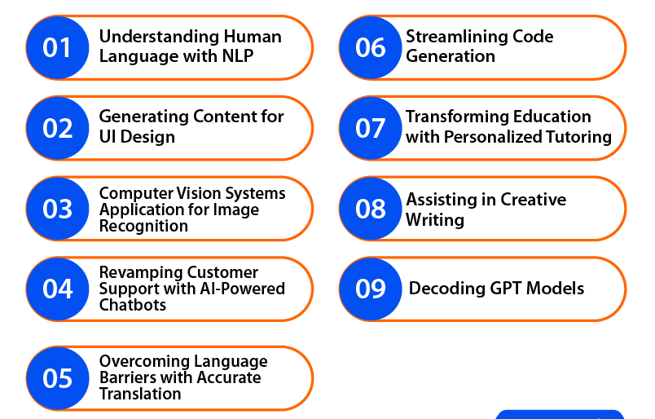
Figure 6 Representations of different applications of GPT models.

Example: Using GPT-3 for a Conversational Agent and Creative Writing
This example demonstrates how to utilize GPT-3 to develop a conversational agent that assists with creative writing tasks, such as poetry. By leveraging GPT-3's advanced capabilities, we will see how this powerful model can be fine-tuned to produce engaging dialogue and artistic literary content, showcasing its ability to handle complex language tasks.
`python
from transformers import GPT3Tokenizer, GPT3Model, pipeline
# Load pre-trained GPT-3 model
tokenizer = GPT3Tokenizer.from_pretrained('gpt3')
model = GPT3Model.from_pretrained('gpt3')
# Setup text generation pipeline
text_generator = pipeline('text-generation', model=model, tokenizer=tokenizer)
# Generate dialogue response
dialogue_prompt = "Customer: I am unable to access my account. Help!"
dialogue_response = text_generator(dialogue_prompt, max_length=50, num_return_sequences=1)
print("Dialogue Response:", dialogue_response[0]['generated_text'])
# Generate creative writing
creative_prompt = "Write a poem about the ocean."
poem = text_generator(creative_prompt, max_length=100, num_return_sequences=1)
print("Generated Poem:", poem[0]['generated_text'])
``
In this example, we first load the GPT-3 model, along with its tokenizer, which is explicitly configured for text generation tasks. This setup is crucial for ensuring that the model is set up accurately to process input text. Next, the model is applied to a customer service scenario to generate realistic dialogue responses, demonstrating its ability to manage conversational contexts effectively. Additionally, we utilize GPT-3 to create a piece of creative writing. By providing a creative prompt about the ocean, the model demonstrates its artistic capabilities by generating a poem, displaying its utility in both practical and innovative applications.
This section offers a detailed examination of the practical applications of advanced text generation with GPT models, highlighting their transformative impact in both conversational and creative contexts. By including specific examples, the chapter not only demonstrates the abilities of modern NLP models but also promotes further exploration and innovation in the field.

Conclusion
In Chapter 3, we examined the advanced features of the Hugging Face Diffusion library for text generation. This chapter offered insights into complex generative tasks that are changing natural language processing. By examining autoregressive models, such as GPT and their variants, we demonstrate how they significantly influence the creation of coherent and contextually relevant stories.
We have seen how these models can be fine-tuned to improve their utility across various applications, from building complex conversational agents to supporting creative writing projects. The practical examples demonstrated the flexibility and strength of the Hugging Face Diffusion library, showcasing its ability to adapt to and respond to the nuanced needs of various content creation tasks.
The versatility of generative models was highlighted through detailed demonstrations of their ability to produce dynamic content across various formats and media. These examples not only demonstrate the technical skill of advanced generative models but also their real-world practical uses.
As we move forward, Chapter 4 will build on these concepts by introducing more advanced generative techniques, focusing on how they can be integrated into larger AI-driven applications. This growth will deepen our understanding of the transformative power of NLP technologies in various creative and technical fields.
We now focus on transfer learning for NLP tasks. As we move forward, we will explore how the foundational models discussed earlier can be adapted through transfer learning to excel across a broader range of NLP applications. This chapter introduces the key principles of transfer learning, providing a detailed framework for utilizing pre-trained models to enhance performance and efficiency in specialized NLP tasks.
Chapter 4 serves as a crucial link between the theoretical basis of model training and the practical applications these models can have in real-world situations. It provides insights into optimizing these advanced tools, ensuring readers are prepared to apply these strategies in their fields, and thereby boost the impact and effectiveness of their NLP projects.

References

[1] | I. Goodfellow, Y. Bengio and A. Courville, Deep Learning, MIT Press, 2016.
[2] | A. Radford, J. Wu, R. Child, D. Luan, D. Amodei and I. Sutskever, "Language models are unsupervised multitask learners," 2019. [Online].
[3] | A. Vaswani, N. Shazeer, N. Parmar, J. Uszkoreit, L. Jones, A. N. Gomez, L. Kaiser and I. Polosukhin, "Attention is all you need," Advances in neural information processing systems, 2017.
[4] | T. B. Brown and e. al., Language models are few-shot learners, NeurIPS, 2020.
[5] | J. Devlin, M.-W. Chang, K. Lee and K. Toutanova, BERT: Pre-training of deep bidirectional transformers for language understanding, NAACL-HLT, 2019.
[6] | M. Noyan, "Open-Source Text Generation & LLM Ecosystem at Hugging Face," 17 July 2023. [Online]. Available: https://huggingface.co/blog/os-llms.
[7] | J. Dodge, S. Gururangan, D. Card, R. Schwartz and N. A. Smith, "Fine-tuning pretrained language models: Weight initializations, data orders, and early stopping."," 2020.
[8] | C. e. a. Raffel, "Exploring the limits of transfer learning with a unified text-to-text transformer," Journal of Machine Learning Research, 2020.
[9] | T. Kudo and J. Richardson, SentencePiece: A simple and language-independent subword tokenizer and detokenizer for neural text processing, EMNLP, 2018.
[10] | J. B. R. Bergstra, Y. Bengio and B. Kégl, " Algorithms for hyper-parameter optimization," Advances in Neural Information Processing Systems, 2011.
[11] | J. Snoek, H. Larochelle and R. P. Adams, "Practical Bayesian optimization of machine learning algorithms," Advances in Neural Information Processing Systems, 2012.
[12] | G. E. Hinton, N. Srivastava and A. Krizhevsky, " Improving neural networks by preventing co-adaptation of feature detectors," 2012.

