Part 2

Practical applications of the Hugging Face Diffusers library
Part 2 of this book marks a transition from understanding the foundational elements of the Hugging Face Diffusers library to applying its powerful tools in practical scenarios. With rapid advancements in natural language processing (NLP), machine learning practitioners are increasingly focusing on the real-world applications of transformer-based models. The Hugging Face Diffusers library is at the forefront of these innovations, enabling the efficient execution of a wide range of tasks, from text classification to complex generative models.
In this section of the book, we will explore practical use cases and examples, helping you understand how to utilize Hugging Face Diffusers to address everyday NLP challenges. The versatility of the Diffusers library allows researchers and practitioners to apply innovative technology to tasks such as sentiment analysis, topic classification, and text generation. We will also examine more advanced techniques, including training models for sequence labeling, deploying autoregressive models like Generative Pre-trained Transformer (GPT), and generating creative text.
By the end of this section, you will acquire a comprehensive understanding of using Hugging Face Diffusers in both supervised and unsupervised learning tasks. You will develop the essential skills to fine-tune pre-trained models for specific functions, assess their performance, and apply these models across various industries, including healthcare, finance, media, and more. We will provide practical examples and case studies that demonstrate how these techniques can be integrated into real-world projects, offering you a direct guide to NLP innovation.

Chapter 2

Utilizing Hugging Face Diffusers for Text Classification

Introduction
Text classification is one of the cornerstone applications of NLP, enabling the organization, analysis, and understanding of vast amounts of unstructured text. Whether you are working on sentiment analysis, topic classification, or spam detection, text classification plays a crucial role in extracting actionable insights from data. In this chapter, we will focus on how Hugging Face Diffusers can be used to implement text classification tasks at scale, with particular emphasis on preprocessing, fine-tuning, and evaluation techniques.
We will begin by exploring the fundamental concepts of text classification and its significance across various industries, from e-commerce to healthcare. By utilizing pre-trained models, readers will discover how to fine-tune cutting-edge models like BERT and GPT to achieve superior classification outcomes.
This chapter also goes beyond text classification by introducing the concept of text generation. Through practical examples, you will learn how to apply autoregressive models, such as GPT, for generating creative text, facilitating applications in chatbot design, story generation, and more. The ability to fine-tune these models for specific generation tasks will further enhance your capabilities in deploying robust NLP solutions.

Structure
In this chapter, we will cover the following topics:
- Introduction to text classification
- Preprocessing text data
- Fine-tuning pre-trained models with Hugging Face Diffusers
- Evaluating model performance
- Application: Sentiment analysis
- Application: Topic classification
- Overview of text generation
- Autoregressive models: GPT and its variants
- Fine-tuning GPT for text generation
- Application: Generating dialogue responses
- Application: Generating creative writing samples

Objectives
This chapter will help you understand the fundamentals of text classification and generation using Hugging Face Diffusers, and it will guide you in applying advanced preprocessing techniques to text data to ensure optimal performance. You will learn how to fine-tune pre-trained models to adapt them to specific NLP tasks and evaluate model performance using relevant metrics to ensure generalizability. The chapter also explores practical applications such as sentiment analysis, topic classification, and text generation, while showing how to utilize autoregressive models like GPT to create intelligent text-generation solutions. Finally, you will gain the ability to build and deploy text classification and generation systems that meet real-world needs. With this thorough understanding of fundamental techniques, you will be prepared to tackle a wide range of NLP challenges across various industries.

Introduction to text classification
Text classification is a key task in natural language processing (NLP) that involves assigning textual data to specific classes or categories. It is essential in many applications such as sentiment analysis, topic classification, spam detection, and content categorization. This section offers a detailed overview of text classification, emphasizing its significance, methods, and uses with the Hugging Face diffusers library.
Text classification allows machines to automatically organize and categorize vast amounts of textual data, thereby facilitating efficient information retrieval and decision-making processes. For instance, in sentiment analysis, classifiers can determine the sentiment expressed in a text (positive, negative, neutral), assisting businesses in gauging customer feedback or sentiment towards products and services [1].

Methods and techniques
Historically, text classification relied on handcrafted features and rule-based systems. However, the advent of deep learning has revolutionized this field by enabling models to learn relevant features from raw text data automatically. Deep learning models, particularly those based on transformer architectures like BERT ^{[2]} and GPT ^{[3]}, have shown remarkable performance improvements across various text classification tasks.
Before classification, text data undergoes preprocessing steps such as tokenization, where text is broken into tokens (words, sub-words, or characters). Using a flowchart or diagram to visualize this process can help clarify how raw text is converted into a format suitable for modeling.
Feature extraction techniques convert text into numerical representations (vectors) that machine learning models can process. Techniques like word embeddings ^{[4]} map words to dense vectors capturing semantic meanings, which enhances classification accuracy by preserving contextual information.
The applications and use cases are as follows:
- Sentiment analysis: Classifying text to find the sentiment expressed (positive, negative, neutral) is widely used in social media monitoring, customer feedback analysis, and brand reputation management ^{[5]}.
- Topic classification: Finding the main topics or themes within a document or text corpus is indispensable for organizing information and helping content recommendation systems ^{[6]}.

Illustrative example
Think about a situation where a company wants to analyze customer reviews to understand how consumers feel about their latest product release. Using text classification techniques, they can automatically sort each review as positive, negative, or neutral, helping them find areas for improvement or use positive feedback effectively.
To further illustrate the scenario above, here is a Python code example utilizing the Hugging Face Transformers library to analyze customer reviews for sentiment analysis. This example employs a pre-trained BERT model fine-tuned for sentiment classification. The code loads the model, preprocesses the text data, and classifies each review as positive, negative, or neutral:
``python
from transformers import pipeline
# Load the sentiment analysis pipeline
sentiment_pipeline = pipeline("sentiment-analysis")
# Example customer reviews
reviews = [
"I absolutely love this product! It works wonders for me.",
"This is the worst product I have ever purchased.",
"It's okay, not great but not terrible either."
]
# Analyze sentiment of each review
results = sentiment_pipeline(reviews)
# Print the results
for review, result in zip(reviews, results):
print(f"Review: '{review}'")
print(f"Sentiment: {result['label']}, Confidence: {result['score']:.2f}\n")
``
The following list details what is in the code:
- Pipeline initialization: The code starts by initializing a sentiment analysis pipeline with Hugging Face's pipeline function. This function automatically loads a pre-trained model and tokenizer designed for sentiment analysis.
- Customer reviews: A list of sample reviews has been defined. These are the texts we want to analyze for sentiment.
- Sentiment analysis: The sentiment pipeline is applied to the list of reviews. It processes the text, conducts the necessary tokenization, and feeds the data through the model to classify the sentiment of each review.
- Results display: The sentiment (positive, negative, or neutral) and the model's confidence score for each review are shown. The confidence score indicates the model's certainty regarding the sentiment classification.
This practical example directly relates to the described scenario, demonstrating how a company can utilize NLP techniques to analyze customer sentiment towards a product automatically. This not only accelerates the review analysis process but also provides quantitative insights that can be expanded across large datasets of customer feedback.

Preprocessing text data
Text preprocessing is vital for text classification tasks, as it converts raw text data into a format suitable for machine learning models. This section describes various preprocessing techniques necessary for preparing text data using the Hugging Face Diffusers library.
Text preprocessing involves several steps that clean and convert raw text data into a structured format. These steps generally include:
- Tokenization: Tokenization breaks down text into individual tokens, typically words or sub-word units. This step is fundamental as it forms the basis for the following preprocessing tasks ^{[7]}.
- Lowercasing and normalization: Converting all text to lowercase helps standardize it and reduces vocabulary size by treating words regardless of their casing. Normalization techniques like stemming or lemmatization further reduce words to their base or root forms, which aids in capturing semantic meaning efficiently ^{[8]}.
- Removing stop-words and punctuation: Stop-words are familiar words (e.g., the, and, is) that do not contribute much to the meaning of the text and are often removed. Punctuation marks are also typically removed, as they do not add semantic value but may interfere with tokenization ^{[9]}.

Techniques in text preprocessing
Tokenization can vary based on the granularity of tokens needed:
- Word tokenization: Splits text into words based on space or punctuation.
- Sub-word tokenization: Splits text into smaller units, functional for languages with complex word formations or for handling out-of-vocabulary words ^{[10]}.
- Character-level tokenization: Treats each character as a token, which can be beneficial for tasks like named entity recognition (NER) or morphological analysis.
The Hugging Face diffusers library offers strong support for text preprocessing via its tokenization tools and pipeline features. Researchers and practitioners can use these to make preparing text data for classification tasks easier.
Best practices and considerations are outlined as follows:
- Data cleaning: Addressing noise in text data through techniques like spell checking or removing rare tokens can enhance model performance ^{[11]}.
- Handling outliers: Showing and handling outliers in text, such as extremely long or short sequences, ensures that the model is robust to varying input lengths.

Practical example of cleaning text data and handling outliers
We will utilize basic Python libraries to clean text data and handle outliers, focusing on core steps such as text preprocessing and filtering based on text length. The following Python code shows these tasks using the NLTK Library for tokenization and stop-word removal:
``python
import re
from nltk.tokenize import word_tokenize
from nltk. corpus import stopwords
# Sample data
text_data = [
"This is an example!!!",
"Data cleaning is essential... #NLP",
"Short",
"An extraordinarily long sentence that seems to go on forever, which could potentially skew the results of an analysis."
]
# Function to clean text data
def clean_text(text):
# Remove special characters and numbers
text = re.sub(r'[^a-zA-Z\s]', '', text, re.I|re.A)
# Convert to lowercase
text = text.lower()
# Tokenize text
tokens = word_tokenize(text)
# Remove stopwords
stop_words = set(stopwords.words('english'))
tokens = [token for token in tokens if token not in stop_words]
# Join tokens to recreate the sentence
return ' '.join(tokens)
# Clean each text in the dataset
cleaned_texts = [clean_text(text) for text in text_data]
# Handling outliers by text length
def handle_outliers(texts, lower_quantile=0.1, upper_quantile=0.9):
lengths = [len(text.split()) for text in texts]
lower_bound = sorted(lengths)[int(len(lengths) * lower_quantile)]
upper_bound = sorted(lengths)[int(len(lengths) * upper_quantile)]
filtered_texts = [text for text in texts if lower_bound <= len(text.split()) <= upper_bound]
return filtered_texts
# Apply outlier handling
filtered_texts = handle_outliers(cleaned_texts)
print("Cleaned and Filtered Texts:")
for text in filtered_texts:
print(text)
``
Now, let us examine the details of this code:
We start by importing essential libraries, like re for regular expressions, NLTK for tokenization, and stopwords to eliminate common, non-meaningful words. The clean_text function initially removes special characters and numbers using a regular expression, converts the text to lowercase for consistency, and tokenizes the sentence into individual words. After tokenization, stop-words are eliminated to focus on relevant words, and the tokens are reassembled into a cleaned sentence.
Next, the handle_outliers function identifies and removes excessively long or short texts based on quantile thresholds. By calculating text lengths and establishing lower and upper bounds, this function filters out texts that are too lengthy or too brief, ensuring the dataset remains well-balanced.
Finally, the cleaned and filtered texts are displayed. This approach ensures the dataset is ready for model training, minimizing biases introduced by outlier texts.

Fine-tuning pre-trained models with Hugging Face Diffusers
Fine-tuning pre-trained models are a fundamental technique in NLP that leverages existing knowledge from large-scale models to tailor specific tasks or functions. This section examines the fine-tuning process using the Hugging Face diffusers library, with an emphasis on its methodology, applications, and best practices.
Fine-tuning involves taking a pre-trained model that has been trained on a large corpus of text (e.g., BERT, GPT) and adapting it to a specific task or dataset by further training it in function-specific data. This approach is particularly beneficial in NLP as it allows models to learn from a vast amount of general language knowledge and adapt it to specialized tasks with comparatively fewer annotated examples.

Methodology of fine-tuning
Fine-tuning involves the following:
- Selection of pre-trained model: Choosing the more precise pre-trained model depends on the nature of the task. For instance, BERT is often used for tasks that require bidirectional understanding of text, while GPT is favored for generative functions due to its autoregressive nature.
- Dataset preparation: Curating and preprocessing the dataset is essential for fine-tuning. This includes tokenization, data cleaning, and splitting into training, validation, and test sets to ensure robust model evaluation.
- Fine-tuning process: The fine-tuning process typically involves initializing the pre-trained model with its weights, attaching task-specific layers (e.g., classification head), and then training on the function-specific dataset using supervised learning techniques.

Applications and cases
Fine-tuning pre-trained models have been successfully applied across various NLP tasks:
Sentiment analysis: Adapting BERT for sentiment classification tasks to predict sentiment labels ^{[12]}.
- Named Entity Recognition (NER): Fine-tuning models like RoBERTa ^{[13]} for showing entities such as names, dates, and organizations in text.
- Question answering: Using models like ALBERT ^{[14]} for answering natural language questions based on given contexts.
Best practices and considerations involve the following:
- Learning rate scheduling: Improving learning rate schedules during fine-tuning can improve model convergence and performance ^{[15]}.
- Early stopping: Implementing early stopping techniques based on validation performance helps prevent overfitting and ensures generalization to unseen data.
Evaluating fine-tuned models involves using metrics such as accuracy, F1-score, or perplexity, depending on the task's requirements ^{[2]}.

Practical example of fine-tuning BERT with learning rate scheduling and early stopping
In this example, we will fine-tune a pre-trained BERT model using the Hugging Face transformers library for a sentiment analysis task. We will implement best practices such as learning rate scheduling, early stopping, and custom performance metrics to evaluate the model effectively. The dataset used in this example is a subset of the IMDb dataset, which contains labeled movie reviews for binary sentiment classification. Refer to the following code:
``python
from transformers import BertTokenizer, BertForSequenceClassification, Trainer, TrainingArguments
from transformers import get_scheduler
import torch
from torch.utils.data import DataLoader
from sklearn.metrics import accuracy_score, f1_score
from datasets import load_dataset
# Load dataset
dataset = load_dataset("imdb", split='train[:2000]')
tokenizer = BertTokenizer.from_pretrained('bert-base-uncased')
# Preprocessing the data
def preprocess_data(example):
return tokenizer(example['text'], padding="max_length", truncation=True, max_length=512)
# Map preprocessing function to the dataset
dataset = dataset.map(preprocess_data, batched=True)
# Define a PyTorch DataLoader
data_loader = DataLoader(dataset, batch_size=16, shuffle=True)
# Load pre-trained BERT model
model = BertForSequenceClassification.from_pretrained('bert-base-uncased', num_labels=2)
# Define Trainer Arguments with learning rate scheduler and early stopping
training_args = TrainingArguments(
output_dir='./results',
evaluation_strategy="steps",
eval_steps=500,
logging_steps=500,
num_train_epochs=3,
per_device_train_batch_size=16,
save_steps=1000,
save_total_limit=2,
load_best_model_at_end=True,
metric_for_best_model='accuracy',
greater_is_better=True,
)
# Custom compute_metrics function to calculate accuracy and F1-score
def compute_metrics(eval_pred):
logits, labels = eval_pred
predictions = np.argmax(logits, axis=-1)
acc = accuracy_score(labels, predictions)
f1 = f1_score(labels, predictions, average='binary')
return {"accuracy": acc, "f1": f1}
# Initialize Trainer
trainer = Trainer(
model=model,
args=training_args,
train_dataset=dataset,
compute_metrics=compute_metrics
)
# Training the model with early stopping based on the accuracy
trainer.train()
# Save the model
model.save_pretrained('./fine_tuned_bert')
```
In this code snippet, we start by importing the necessary libraries and loading a subset of the IMDb dataset using the datasets library from Hugging Face. The BertTokenizer is initialized to preprocess the text by tokenizing it and truncating or padding it to a uniform length, preparing the text for input into the BERT model.
Next, we establish a PyTorch DataLoader to manage the preprocessed data in batches for training. We load the pre-trained BERT model, specifying that it should be fine-tuned for binary classification (positive or negative sentiment).
The TrainingArguments are defined as key features, including learning rate scheduling, logging, and early stopping. Early stopping is controlled by monitoring the accuracy metric and halting the training process if no improvement is detected. Additionally, we set up a custom compute_metrics function to evaluate the model's performance using accuracy and F1-score, providing a more balanced metric for binary classification tasks. Once the model is trained using Hugging Face’s Trainer class, it is saved for later use or deployment.
This example demonstrates the use of best practices in fine-tuning NLP models. By adjusting the learning rate and implementing early stopping, we improve the training process, avoid overfitting, and ensure the model reaches optimal performance.

Evaluating model performance
Assessing model performance is essential for understanding how well fine-tuned models work on specific NLP tasks. This section reviews the methods and metrics used for evaluating models, with practical examples in sentiment analysis and topic classification, using the Hugging Face Diffusers library.
Model evaluation ensures that fine-tuned models generalize well to unseen data and perform effectively on the intended task. It involves choosing the right metrics, understanding their implications, and interpreting results accurately. [16].
Methodologies and metrics involved are as follows:
- Performance metrics: Various metrics gauge model performance depending on the task:
  - Accuracy: Measures the proportion of correctly classified instances.
  - Precision and recall: Important for tasks like sentiment analysis, where showing true positives (correctly predicted sentiments) and minimizing false positives (incorrectly predicted sentiments) are critical ^{[17]}.
  - F1-score: Harmonic means of precision and recall, providing a balance between the two metrics.
  - Perplexity: Used in language modeling tasks to assess how well the model predicts the probability of the next word in a sequence ^{[18]}.
Cross-validation: Techniques like k-fold cross-validation ensure robustness of model evaluation by partitioning the dataset into multiple subsets for training and testing iteratively^{[19]}.

Sentiment analysis application
Sentiment analysis continues to be one of the most influential applications of text classification, used across many fields. Besides the well-known IMDb movie-review tasks, entire industries depend on sentiment modeling to inform decisions and enhance user experience. In finance, sentiment scores from news articles, analyst reports, and social media posts can be linked to short-term stock fluctuations or long-term investor confidence ^{[15]}. In healthcare, patient experience surveys and clinician notes show satisfaction trends, helping administrators address quality-of-care concerns ^{[2]}. Political science and public policy experts increasingly monitor discourse on social platforms to gauge voter attitudes and identify shifts in electoral sentiment ^{[20]}.
Despite its usefulness, sentiment analysis faces significant challenges. Sarcasm and irony often confuse even advanced transformers. Multilingual sentiment analysis is complex: direct translation can weaken nuance, while creating separate models for each language is resource-heavy. Domain adaptation—transferring a model trained on movie reviews to financial texts—can result in reduced accuracy without careful fine-tuning or domain-specific pre-training ^{[21]}.
Traditional lexicon-based approaches, like VADER or SentiWordNet, provide interpretability and require minimal computation but fail to capture context or subtle emotions. Transformer-based methods such as BERT, RoBERTa, or XLM-RoBERTa outperform them by modeling the contextual relationships between words ^{[13]}. For advanced applications, multimodal sentiment analysis combines textual cues with visual signals. for example, product reviews that include images or videos, resulting in more comprehensive sentiment predictions ^{[2]}.
Practice methods: Classical lexicon-based approaches (e.g., VADER, SentiWordNet) remain useful for lightweight, explainable baselines and low-resource deployments. They struggle, however, with context, intensifiers, and idioms. Transformer-based approaches (BERT/RoBERTa family; multilingual XLM-R) explicitly model context and generally provide superior accuracy and robustness, especially for nuanced polarity, target-dependent sentiment, and aspect-based sentiment.

Persistent challenges
Some challenges are as follows:
- Sarcasm and irony: Syntactic cues and world knowledge often trump bag-of-words polarity. Sarcasm-focused fine-tuning and contrastive data augmentation help, but coverage remains imperfect.
- Multilingual or low-resource: Direct translation pipelines can bleed nuance; cross-lingual models (XLM-R) and adapter-based fine-tuning reduce per-language overhead.
- Domain adaptation: A model tuned on entertainment reviews may underperform on earnings calls. Effective strategies include continued pretraining on in-domain unlabeled text, adapters/LoRA, and balanced sampling.
- Multimodality: In e-commerce and social media, text + image/video sentiment outperforms text-only. Lightweight CLIP-style image embeddings concatenated with text embeddings are a practical, deployment-friendly start.
Multilingual sentiment pipeline example using XLM-RoBERTa:
```python
from transformers import pipeline
# Load multilingual sentiment-analysis pipeline
sentiment_pipeline = pipeline("sentiment-analysis",
model="cardiffnlp/twitter-xlm-roberta-base-sentiment")
reviews = [
"Este producto es fantástico, funciona perfectamente.", # Spanish
"Ce service est terrible, je ne le recommande pas.", # French
"Dieses Gerät ist in Ordnung, aber unauffällig." # German
]
results = sentiment_pipeline(reviews)
for r, res in zip(reviews, results):
print(f"Review: {r}\nSentiment: {res['label']}, Confidence: {res['score']:.2f}\n")
```
Evaluation and deployment notes. Favor macro-F1 (or class-weighted F1) when classes are imbalanced; add per-aspect metrics for aspect-based sentiment. For production, watch drift (seasonality, campaigns), enforce PII scrubbing, and log model confidence to route low-confidence items to human review.
Figure 2.1 shows a graphic plot of sentiment pipelines across domains, comparing lexicon baseline vs transformer vs multimodal fusion, with latency/accuracy trade-offs:
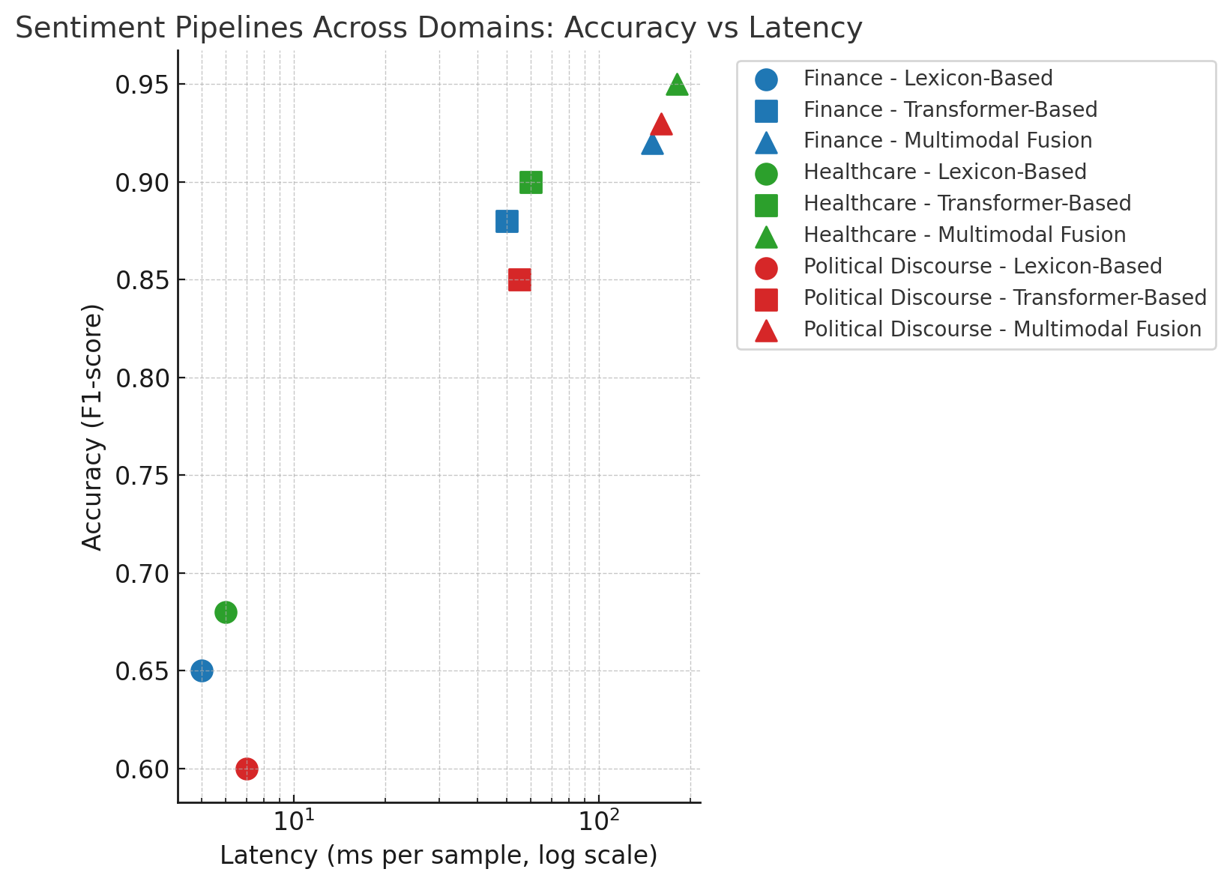
Figure 2.1: Sentiment pipelines across domains

Topic classification application
Topic classification drives retrieval, discovery, and governance across organizations. News platforms triage articles to desks in real time; scientific discovery relies on field- and subfield-labeling to route peer reviewers; legal e-discovery clusters documents by issue and privilege; enterprise KM tags documents for retention, security, and search.
Model selection beyond a single baseline:
- RoBERTa-base/large: strong general baselines.
- DistilBERT: ~40% fewer params with competitive accuracy—useful for low-latency endpoints and edge.
- SciBERT / BioBERT / LegalBERT: domain-specialized pretraining routinely lifts F1 on corresponding corpora.
- Long-context variants (Longformer/BigBird) matter for briefs, scientific papers, and RFC-style docs.
Zero-shot topic classification avoids labeled data by reframing topics as hypotheses in an NLI model:
```
python
from transformers import pipeline
clf = pipeline("zero-shot-classification", model="facebook/bart-large-mnli")

text = "Researchers introduce a new transformer architecture for protein folding."
labels = ["Sports", "Finance", "Scientific Research", "Politics", "Biology"]
print(clf(text, labels)) # scores per candidate label
```
This is powerful for fast-changing taxonomies or early prototypes. For production, combine zero-shot with few-shot calibration or self-training to stabilize labels.
Challenges and trends:
- Class imbalance: Use class-balanced loss (e.g., focal loss), calibrated thresholds, or augmentation for minority classes.
- Hierarchical labeling: Multi-level taxonomies (e.g., CS | ML | NLP) benefit from hierarchical SoftMax or two-stage classifiers (coarse → fine).
- Explainability: Attention-rollup or attribution methods (e.g., Integrated Gradients) increase trust for compliance workflows.

Autoregressive transformers vs recurrent nets
Modern text generation is primarily driven by decoder-only transformers (GPT family). Understanding why they replaced recurrent networks helps clarify decisions for long-context modeling, scaling, and deployment.
Computational framing, recurrence vs attention:
- RNN: ht=f(xt,ht−1)h_t = f(x_t, h_{t-1})ht​=f(xt​,ht−1​). Information flows sequentially; parallelism is limited; gradients traverse long chains (vanishing/exploding).
- LSTM/GRU: gating improves credit assignment and medium-range memory but remains sequential.
- GPT (self-attention): computes pairwise token interactions in parallel within a block; complexity O(n2)O(n^2)O(n2) per layer (various sparsity/linear-attention tricks mitigate this). Parallelism, richer long-range dependencies, and stable optimization drove its dominance.
Refer to the following table”
Property | Vanilla RNN | LSTM / GRU | Transformers (GPT, decoder-only)
Parallelism (sequence) | Low | Low | High (per layer)
Long-range deps | Weak | Medium | Strong
Training stability | Fragile | Improved | Strong
Inference latency (per token) | Low | Low–Med | Med (can cache KV)
Context length scaling | N/A | N/A | Extendable (ALiBi/RoPE/long-attention)
Data/compute scaling | Limited | Limited | Excellent
Table 2.1: Sequence models
Next, Figure 2.2 compares the token-by-token processing of recurrent networks (RNNs and LSTMs) with the fully parallel self-attention mechanism used by GPT. While RNNs pass a single hidden state sequentially—causing bottlenecks for long-range dependencies—GPT considers all tokens simultaneously, allowing for faster training and better modeling of distant contextual relationships. This visual explains why transformer-based architecture has mostly replaced recurrent models in modern NLP workflows.
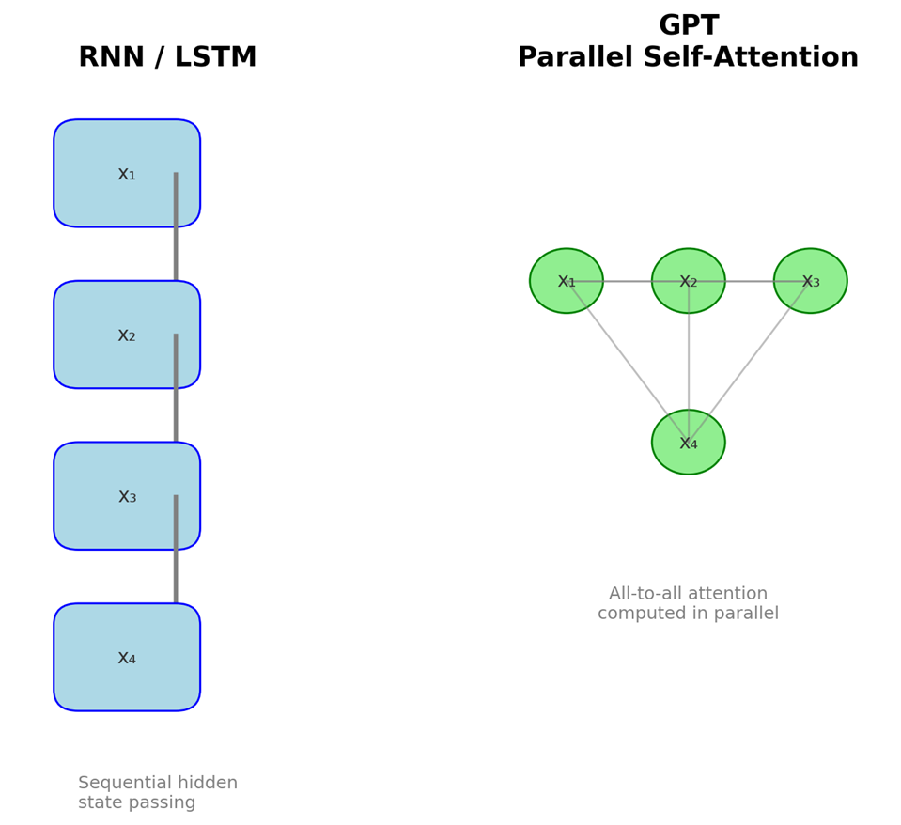
Figure 2.2: RNN/LSTM sequential flow vs GPT parallel self-attention
Bridging note on RNN vs LSTM: LSTMs add input/forget/output gates and a persistent cell state to resist vanishing gradients—hugely influential pre-Transformer. They remain relevant for ultra-low-latency or streaming edge scenarios, but transformers dominate when data and compute permit.
Figure 2.3 traces the development of GPT models from their initial feasibility demonstration to today’s efficient multimodal systems. Instead of focusing on raw parameter counts, the timeline emphasizes increasing context lengths and major functional milestones—GPT-1’s proof of concept, GPT-2’s improvement in coherence, GPT-3’s few-shot learning, GPT-4’s multimodal reasoning, and GPT-4o’s efficiency enhancements. This view shows how expanding context and feature sophistication, not just size, have driven significant advances in generative language capabilities.
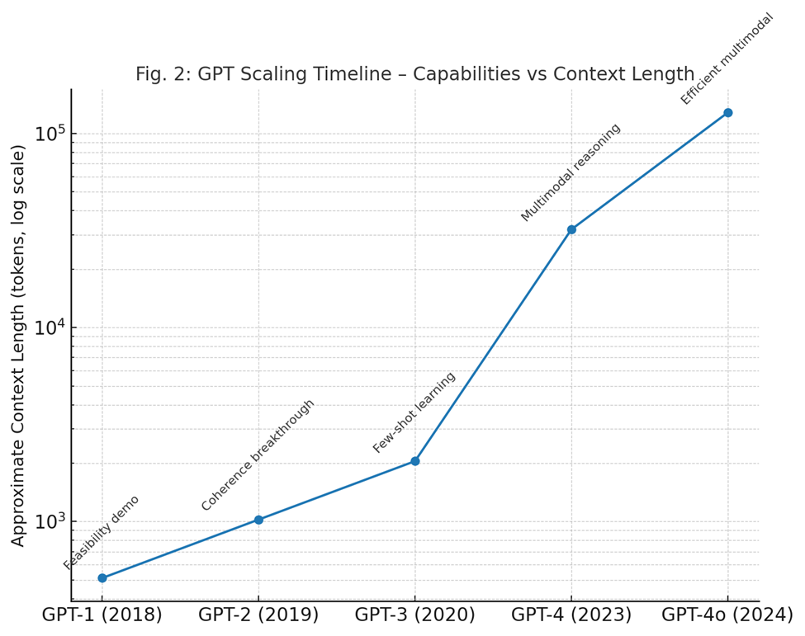
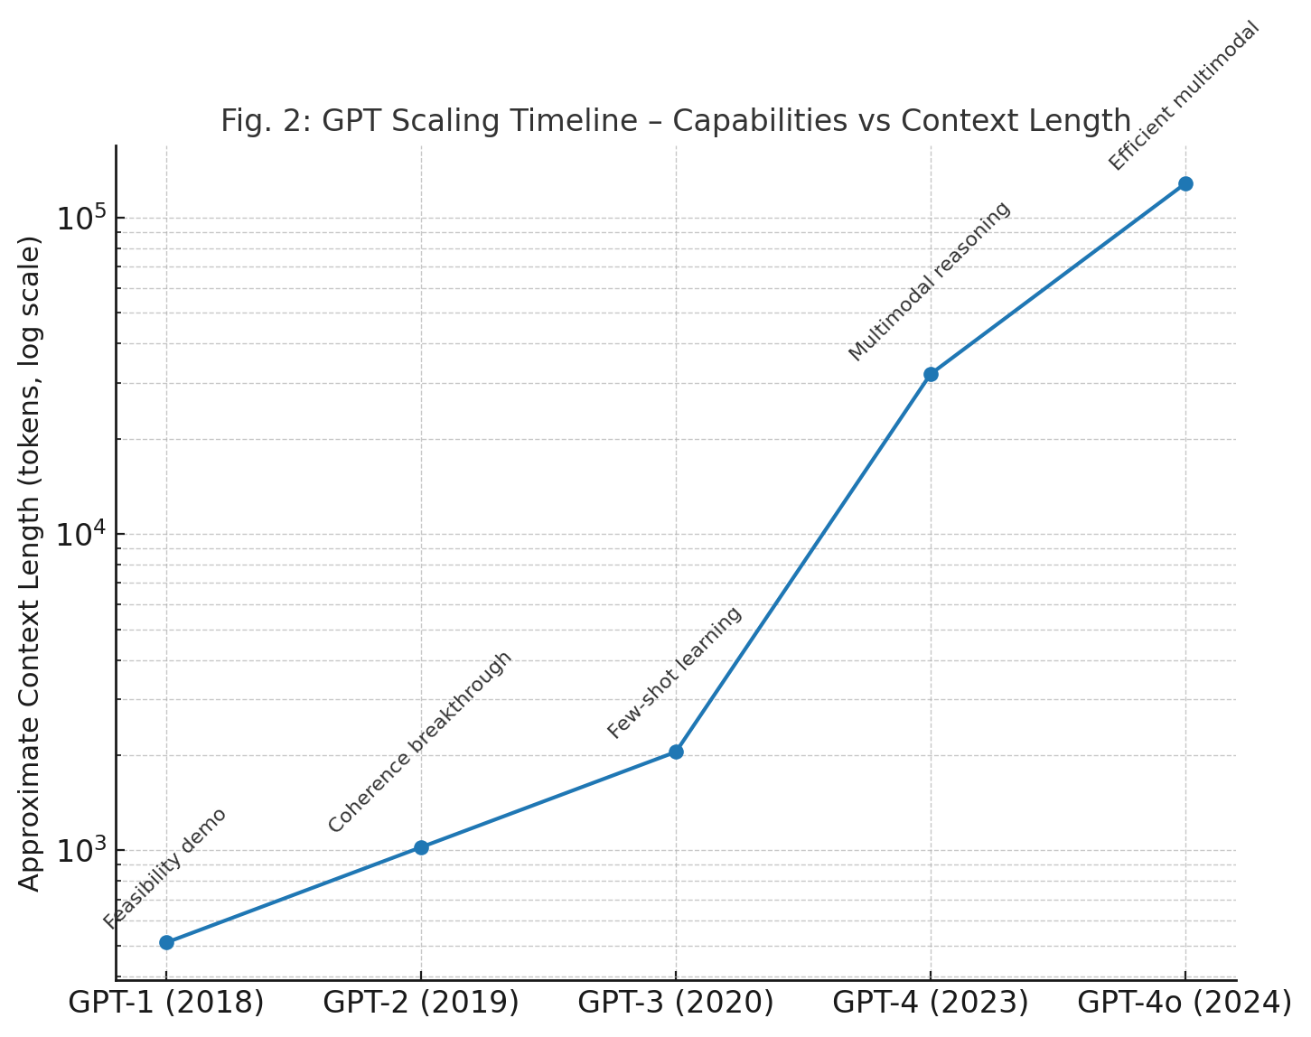
Figure 2.3: GPT scaling timeline (capabilities vs context length)

GPT family and capabilities
The GPT line demonstrates the scaling hypothesis and instruction-following evolution:
Model | Year | Params | Core Features | Notable Capabilities
GPT-1 | 2018 | 117M | Decoder-only LM; BookCorpus pretrain | First clear pretrain→finetune gains
GPT-2 | 2019 | 1.5B | Larger data/scale; better sampling | Coherent long-form generation
GPT-3 | 2020 | 175B | Massive scale; API-first | Few-/zero-shot prompting
GPT-4 | 2023 | Unpublished | Strong reasoning; safety improvements | Robust instruction following
GPT-4o | 2024 | Unpublished | Multimodal I/O; latency/efficiency focus | Near-real-time audio/image+text
Table 2.2: GPT variants (high-level)

Refer to the following list:
- Position encodings and long context: Practical GPT systems rely on improved position representations—RoPE (rotary embeddings) or ALiBi—and attention variants (Longformer, BigBird, Transformer-XL) to extend context windows while controlling cost. KV-cache optimizations keep per-token latency manageable at inference.
- Autoregressive GPT vs diffusion-based text: Diffusion approaches for text remain an active research area (discrete diffusion, continuous relaxation). They can better control global structure in some settings, but training/inference pipelines are more complex and less mature than autoregressive decoders for most production NLP tasks. A pragmatic view: autoregressive GPT for mainstream text generation; diffusion or hybrids for research and niche constraints (controllability, style constraints).
Figure 2.4 compares two main paradigms in generative modeling: GPT’s autoregressive next-token prediction and diffusion models’ iterative denoising. Autoregressive transformers produce sequences one token at a time based on earlier context, providing fine control and strong language coherence. Diffusion methods, on the other hand, start from noise and gradually improve output through multiple denoising steps, allowing high-fidelity generation but with different efficiency and convergence trade-offs. This schematic highlights the methodological divergence that shapes current research in text and image generation.

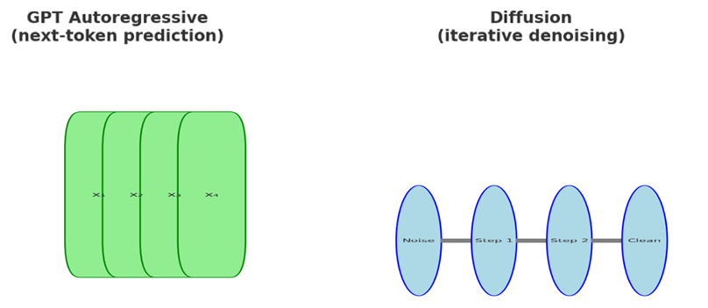
Figure 2.4: GPT (autoregressive) vs diffusion (iterative denoising)

- Safety, governance, and efficiency: GPT-class models can encode social and sampling biases; governance requires dataset curation, refusal policies, and red-teaming. On efficiency, distillation, LoRA/adapters, quantization, and prompt-caching meaningfully reduce cost while preserving quality for domain deployments.

Fine-tuning GPT for text generation
Fine-tuning GPT for text generation is an essential step in customizing pre-trained models for specific uses. This section offers a thorough examination of fine-tuning GPT models, focusing on practical applications like generating dialogue responses and creative writing samples. By fine-tuning GPT models, researchers and practitioners can harness the model’s generative abilities to meet unique task requirements, resulting in more relevant and coherent outputs.
Fine-tuning involves training a pre-trained model on a specific dataset to tailor its performance to a particular task. The pre-trained model, having already learned general language patterns from vast amounts of text, requires fewer resources and less data to adapt to new tasks with increased efficiency. This process is central to enhancing the model’s performance for specific applications, such as dialogue generation and creative writing.
Fine-tuning process involves the following steps:
- Data preparation: The first step in fine-tuning is preparing a relevant dataset. This dataset should be representative of the target task. For dialogue generation, for example, a dataset of conversational exchanges is needed. For creative writing, a corpus of literary texts or user-generated content can be used.
- Model configuration: Configuring the model involves setting parameters such as learning rate, batch size, and the number of epochs. These parameters are relevant in ensuring efficient and effective fine-tuning.
- Training: The actual fine-tuning process involves training the model on the prepared dataset. During this phase, the model adjusts its weight based on the new data, improving its performance on the specific task.
- Evaluation: After fine-tuning, the model’s performance is evaluated using metrics relevant to the task. For dialogue generation, metrics such as coherence, relevance, and response diversity are assessed. For creative writing, metrics may include fluency, originality, and adherence to stylistic conventions.

Generating dialogue responses
Generating dialogue responses is a typical application of fine-tuned GPT models. These models can be utilized in chatbots, virtual assistants, and interactive fiction applications.
Example use case: Chatbots Fine-tuned GPT models can be incorporated into chatbots to deliver more natural and more accurate responses based on context. For example, a customer service chatbot fine-tuned on a dataset of customer interactions can handle queries more efficiently, providing correct and helpful answers.
Example implementation steps are as follows:
- Dataset collection: Gather a dataset of dialogue exchanges, such as transcripts of customer service interactions.
- Fine-tuning: Fine-tuning the GPT model on this dataset, allowing it to learn the patterns of conversation and typical responses.
- Evaluation: Assess the chatbot's responses in various scenarios to ensure coherence and relevance.

Generating creative writing samples
Fine-tuning GPT models for creative writing involves training the model on a wide variety of literary texts. This allows the model to produce original and stylistically consistent works, useful for content creation, brainstorming, and artistic exploration.
Example use case of creative content generation: Writers and content creators can use fine-tuned GPT models to come up with ideas, plot outlines, or even full passages of text. For instance, a fine-tuned model on a collection of fantasy literature can assist in creating new fantasy storylines.
Example implementation steps are given as follows:
- Dataset collection: Compile a corpus of creative writing samples, such as short stories or novels in a specific genre.
- Fine-tuning: Train the GPT model on this dataset to capture the stylistic and thematic elements of the genre.
- Evaluation: Assess the generated texts for originality, coherence, and adherence to the desired style.
Practical considerations and best practices for fine-tuning are as follows:
- Quality of dataset: The quality of the dataset has a fundamental impact on the performance of the fine-tuned model. Ensure the dataset is clean, well-annotated, and representative of the target application.
- Hyperparameter tuning: Experiment with different hyperparameters to improve the fine-tuning process. This includes adjusting the learning rate, batch size, and number of epochs.
- Regular evaluation: Continuously evaluate the model during fine-tuning to watch its performance and make necessary adjustments.
- Ethical considerations: Be mindful of ethical concerns, such as avoiding biased or harmful outputs. Implement safeguards to mitigate potential risks.

Summary examples
This chapter covers the use of Hugging Face diffusers for text classification and generation. By exploring autoregressive models like GPT in depth, we provide a detailed example using the Hugging Face transformers library. The example will include text classification and generating text with a fine-tuned GPT model.

Fine-tuning DistilBERT for sentiment analysis
This example shows how to fine-tune a pre-trained DistilBERT model for sentiment analysis, a common text classification task. We will use a portion of the IMDb dataset and the Hugging Face Transformers library to do this. The fine-tuned model will classify text data as either positive or negative sentiment.
‘’python
from transformers import DistilBertTokenizer, DistilBertForSequenceClassification, Trainer, TrainingArguments
import numpy as np.
from datasets import load_dataset
# Load dataset
dataset = load_dataset ("imdb", split='train[:5000]')
# Preprocess data
tokenizer = DistilBertTokenizer.from_pretrained('distilbert-base-uncased')
def tokenize(batch):
return tokenizer(batch['text'], padding=True, truncation=True, max_length=512)
dataset = dataset.map (tokenize, batched=True, batch_size=len(dataset))
dataset.set_format ('torch', columns=['input_ids', 'attention_mask', 'label'])
# Load DistilBERT for sequence classification
model = DistilBertForSequenceClassification.from_pretrained ('distilbert-base-uncased', num_labels=2)
# Define training arguments
training_args = TrainingArguments (
output_dir=‘. /results',
num_train_epochs=3,
per_device_train_batch_size=16,
warmup_steps=500,
weight_decay=0.01,
logging_dir=‘. /logs',
load_best_model_at_end=True)
# Initialize Trainer
trainer = Trainer (
model=model,
args=training_args,
train_dataset=dataset)
# Train the model
trainer. train()
# Save the model
model_path = “. /distilbert-finetuned-imdb"
model. save_pretrained(model_path)
tokenizer. save_pretrained(model_path)
``
Let us break down the steps of the code:
We begin by importing the necessary libraries from Hugging Face’s Transformers library, which includes the DistilBertTokenizer and DistilBertForSequenceClassification for tokenization and model loading, respectively. Additionally, the Trainer and TrainingArguments classes are imported to manage the training process with minimal boilerplate code.
The dataset is loaded using the datasets library, specifically a subset of 5,000 samples from the IMDb dataset, which is a popular dataset for sentiment classification tasks. The tokenizer is initialized to convert text into tokenized sequences that the model can understand. We apply padding and truncation to ensure that all input sequences have a consistent length, then map the tokenization function across the entire dataset. The data is further formatted into PyTorch tensors, preparing it for use in the DistilBERT model.
We loaded a pre-trained DistilBERT model with a classification head designed for binary sentiment classification (positive or negative). The TrainingArguments specify parameters for the training process, such as the number of epochs, batch size, and early stopping mechanisms, which help ensure the model trains efficiently without overfitting.
Using the Trainer class from Hugging Face makes the training loop easier by handling everything from model updates to validation. After training, both the model and tokenizer are saved to a directory, ready for future use in downstream applications.
This example shows how DistilBERT can be fine-tuned more efficiently for sentiment analysis using the Hugging Face library’s simple API and pre-trained models.

Fine-tuning GPT-2 for creative writing generation
In this example, we fine-tune a pre-trained GPT-2 model to produce creative writing samples. GPT-2, created by OpenAI, is a state-of-the-art autoregressive language model capable of generating coherent and contextually appropriate text. We will use a text dataset containing creative writing samples and fine-tune GPT-2 to adapt it for this specific task. Refer to the following code:
``python
from transformers import GPT2LMHeadModel, GPT2Tokenizer, TextDataset, DataCollatorForLanguageModeling, Trainer, TrainingArguments
# Load tokenizer and model
tokenizer = GPT2Tokenizer.from_pretrained('gpt2')
model = GPT2LMHeadModel.from_pretrained('gpt2')
# Prepare dataset
train_path = 'path_to_training_data.txt'
train_dataset = TextDataset (
tokenizer=tokenizer,
file_path=train_path,
block_size=128)
data_collator = DataCollatorForLanguageModeling (
tokenizer=tokenizer, mlm=False)
# Define training arguments
training_args = TrainingArguments (
output_dir=‘. /gpt2-finetuned',
overwrite_output_dir=True,
num_train_epochs=3,
per_device_train_batch_size=4,
save_steps=10_000,
save_total_limit=2)
# Initialize Trainer
trainer = Trainer (
model=model,
args=training_args,
data_collator=data_collator,
train_dataset=train_dataset)
# Train the model
trainer. train()
# Save the model
model. save_pretrained('./gpt2-finetuned')
tokenizer. save_pretrained('./gpt2-finetuned')
``
Let us break down the steps in the code.
We begin by loading the pre-trained GPT-2 model and its tokenizer from Hugging Face’s Transformers library. The GPT-2 tokenizer converts text into tokens that the model can process, while the GPT-2 language model (GPT2LMHeadModel) is used for generating creative text.
Next, the dataset with creative writing samples is prepared from a text file and tokenized using the GPT-2 tokenizer. We set the block size to break the text into manageable parts for training. DataCollatorForLanguageModeling is used to manage dynamic masking during the language modeling process, ensuring the model accurately learns to predict the next token in the sequence.
The training arguments specify key parameters for training, such as the number of epochs, batch size, and how often to save the model. We set up the Trainer class, which handles the training loop and evaluation, making the fine-tuning process more efficient.
Once training finishes, we save both the fine-tuned GPT-2 model and tokenizer to a designated directory, so they can be reused for future text generation tasks.
This example demonstrates how to customize GPT-2 for specific creative writing tasks by fine-tuning it with a tailored dataset. Fine-tuning allows the model to generate more contextually rich and imaginative content.

Conclusion
In this chapter, we examined the practical uses of the Hugging Face diffusers library for text classification and generation tasks. Our review covered a wide range of topics essential for mastering the use of this powerful library in real-world NLP scenarios.
We started with an introduction to text classification, highlighting its importance in various fields like sentiment analysis and topic identification. By understanding the basics and the role of preprocessing text data, we established a foundation for effectively using pre-trained models.
Next, we examined how to fine-tune pre-trained models using the Hugging Face diffusers library. This process is essential for customizing generic models for specific tasks, improving their performance, and making them more applicable. We looked at the step-by-step process, from setting up the environment and preparing datasets to actually fine-tuning the models.
We then evaluated the model's performance using applications like sentiment analysis and topic classification as case studies. This section emphasized the importance of thorough evaluation metrics and methods to ensure that the models not only perform well on training data but also generalize more effectively to unseen data.
Following this, we offered an overview of text generation, highlighting the fundamental concepts and the importance of generative models in NLP. This was supported by a detailed look at autoregressive models, especially GPT and its variants. We covered architecture, innovations, and the progress these models have made, providing a clear understanding of how they transform text generation tasks.
Finally, we focused on the practical aspects of fine-tuning GPT models for specific text generation tasks. Through applications such as generating dialogue responses and creative writing samples, we demonstrated the versatility and power of GPT models in producing contextually relevant and imaginative text.
In the next chapter, you will gain direct experience and insights into fine-tuning models for specific tasks, ensuring they perform optimally in real-world scenarios. Prepare to deepen your understanding of model deployment, evaluation, and the intricacies of text classification and generation with Hugging Face Diffusers.

Key takeaways
Text classification and generation are essential to modern NLP and play a key role in creating scalable, intelligent applications. In this chapter, you learned how preprocessing converts raw text into structured, tokenized input and why careful cleaning, normalization, and outlier handling are vital for building robust models. You saw how Hugging Face Diffusers simplify the fine-tuning of transformer architectures such as BERT, RoBERTa, and GPT, allowing for top-tier performance on sentiment analysis, topic classification, and related tasks with relatively small, task-specific datasets. Evaluation metrics (accuracy, precision, recall, F1-score, and perplexity) were outlined as crucial tools to measure model performance and promote generalization. Beyond classification, the chapter introduced text generation and autoregressive modeling, emphasizing GPT variants and their applications in dialogue systems, creative writing, and content synthesis, while addressing ethical considerations and model interpretability. Together, these concepts offer a practical framework for developing and deploying high-quality NLP solutions across industries, laying the groundwork for more advanced pipelines and deployment strategies covered in later chapters.

[1] B. Pang and L. Lee, “Opinion mining and sentiment analysis,” Foundations and Trends® in Information Retrieval, vol. 2, pp. 1–135, 2008.
[2] J. Devlin, M. W. Chang, K. Lee, and K. Toutanova, “BERT: Pre-training of deep bidirectional transformers for language understanding,” in Proceedings of the 2019 Conference of the North American Chapter of the Association for Computational Linguistics: Human Language Technologies, 2019, pp. 4171–4186.
[3] A. Radford, K. Narasimhan, T. Salimans, and I. Sutskever, “Improving language understanding by generative pre-training,” 2018. [Online]. Available: https://s3-us-west-2.amazonaws.com/openai-assets/research-covers/language-unsupervised/language_understanding_paper.pdf
[4] T. Mikolov, I. Sutskever, K. Chen, G. S. Corrado, and J. Dean, “Distributed representations of words and phrases and their compositionality,” Adv Neural Inf Process Syst, pp. 3111–3119, 2013.
[5] A. Go, R. Bhayani, and L. Huang, “Twitter sentiment classification using distant supervision,” 2009.
[6] D. M. Blei, A. Y. Ng, and M. I. Jordan, “Latent Dirichlet allocation,” Journal of Machine Learning Research, vol. 3, pp. 993–1022, 2003.
[7] D. Jurafsky and J. H. Martin, Speech and language processing, 3rd ed. Pearson, 2020.
[8] C. D. Manning, P. Raghavan, and H. Schütze, Introduction to information retrieval. Cambridge University Press, 2008.
[9] E. B. S. ; Klein and E. Loper, Natural language processing with Python. O’Reilly Media, 2009.
[10] R. Sennrich, B. Haddow, and A. Birch, “Neural machine translation of rare words with subword units,” Proceedings of the 54th Annual Meeting of the Association for Computational Linguistics (Volume 1: Long Papers, pp. 1715–1725, 2016.
[11] D. Chen and C. D. Manning, “A fast and accurate dependency parser using neural networks,” Proceedings of the 2014 Conference on Empirical Methods in Natural Language Processing (EMNLP, pp. 740–750, 2014.
[12] R. Socher et al., “Recursive deep models for semantic compositionality over a sentiment treebank,” in Proceedings of the 2013 Conference on Empirical Methods in Natural Language Processing (EMNLP, 2013, pp. 1631–1642.
[13] Liu Y. et al., “RoBERTa: A Robustly Optimized BERT Pretraining Approach.,” preprint, 2020.
[14] Z. Lan, M. Chen, S. Goodman, K. Gimpel, P. Sharma, and R. Soricut, “ALBERT: A lite BERT for self-supervised learning of language representations,” Proceedings of the 58th Annual Meeting of the Association for Computational Linguistics (ACL, pp. 185–197, 2019.
[15] A. Vaswani et al., “Attention is all you need,” Advances in Neural Information Processing Systems (NIPS, p. 30, 2017.
[16] A. Halevy, P. Norvig, and F. Pereira, “The unreasonable effectiveness of data,” IEEE Intell Syst, vol. 24, pp. 8–12, 2009.
[17] M. Sokolova and G. Lapalme, “A systematic analysis of performance measures for classification tasks,” Inf Process Manag, vol. 45, pp. 427–437, 2009.
[18] Y. Bengio, R. Ducharme, P. Vincent, and C. Jauvin, “A neural probabilistic language model,” Journal of Machine Learning Research, vol. 3, pp. 1137–1155, 2003.
[19] R. Kohavi, “A study of cross-validation and bootstrap for accuracy estimation and model selection,” International Joint Conference on Artificial Intelligence (IJCAI, vol. 14, pp. 1137–1145, 1995.
[20] M. Lewis et al., “BART: Denoising Sequence-to-Sequence Pre-training for Natural Language Generation, Translation, and Comprehension,” arXiv pre-print, Oct. 2019, [Online]. Available: http://arxiv.org/abs/1910.13461
[21] R. Esfandiarpoor, C. Menghini, and S. H. Bach, “If CLIP Could Talk: Understanding Vision-Language Model Representations Through Their Preferred Concept Descriptions,” in 2024 Conference on Empirical Methods in Natural Language Processing, Beown University, Nov. 2024, pp. 9797–9819. [Online]. Available: https://github.com/BatsResearch/ex2

References

[1] | B. Pang and L. Lee, "Opinion mining and sentiment analysis," Foundations and Trends® in Information Retrieval, vol. 2, p. 1–135, 2008.
[2] | J. Devlin, M. W. Chang, K. Lee and K. Toutanova, "BERT: Pre-training of deep bidirectional transformers for language understanding," in Proceedings of the 2019 Conference of the North American Chapter of the Association for Computational Linguistics: Human Language Technologies, 2019.
[3] | A. Radford, K. Narasimhan, T. Salimans and I. Sutskever, Improving language understanding by generative pre-training, 2018.
[4] | T. Mikolov, I. Sutskever, K. Chen, G. S. Corrado and J. Dean, "Distributed representations of words and phrases and their compositionality," p. 3111–3119, 2013.
[5] | A. Go, R. Bhayani and L. Huang, "Twitter sentiment classification using distant supervision," 2009.
[6] | D. M. Blei, A. Y. Ng and M. I. Jordan, "Latent Dirichlet allocation," Journal of Machine Learning Research, vol. 3, p. 993–1022, 2003.
[7] | D. Jurafsky and J. H. Martin, Speech and language processing, 3rd ed., Pearson, 2020.
[8] | C. D. Manning, P. Raghavan and H. Schütze, Introduction to information retrieval, Cambridge University Press, 2008.
[9] | S. Bird, E. Klein and E. Loper, Natural language processing with Python, O'Reilly Media, 2009.
[10] | R. Sennrich, B. Haddow and A. Birch, "Neural machine translation of rare words with sub-word units," p. 1715–1725, 2016.
[11] | D. Chen and C. D. Manning, "A fast and accurate dependency parser using neural networks," p. 740–750, 2014.
[12] | R. Socher, A. Perelygin, J. Wu, J. Chuang, C. D. Manning, A. Y. Ng and C. Potts, "Recursive deep models for semantic compositionality over a sentiment treebank," in Proceedings of the 2013 Conference on Empirical Methods in Natural Language Processing (EMNLP, 2013.
[13] | Y. Liu, M. Ott, N. Goyal, J. Du, M. Joshi, D. Chen and V. Stoyanov, "RoBERTa: A robustly optimized BERT pretraining approach," arXiv preprint, 2019.
[14] | Z. Lan, M. Chen, S. Goodman, K. Gimpel, P. Sharma and R. Soricut, "ALBERT: A lite BERT for self-supervised learning of language representations," p. 185–197, 2019.
[15] | A. Vaswani, N. Shazeer, N. Parmar, J. Uszkoreit, L. Jones, A. N. Gomez and I. Polosukhin, "Attention is all you need," p. 30, 2017.
[16] | A. Halevy, P. Norvig and F. Pereira, "The unreasonable effectiveness of data," IEEE Intelligent Systems, vol. 24, p. 8–12, 2009.
[17] | M. Sokolova and G. Lapalme, "A systematic analysis of performance measures for classification tasks," Information Processing & Management, vol. 45, p. 427–437, 2009.
[18] | Y. Bengio, R. Ducharme, P. Vincent and C. Jauvin, "A neural probabilistic language model," Journal of Machine Learning Research, vol. 3, p. 1137–1155, 2003.
[19] | R. Kohavi, "A study of cross-validation and bootstrap for accuracy estimation and model selection," International Joint Conference on Artificial Intelligence (IJCAI, vol. 14, p. 1137–1145, 1995.
[20] | T. Bolukbasi, K. W. Chang, J. Y. Zou, V. Saligrama and A. T. Kalai, "Man is to computer programmer as woman is to homemaker? Debiasing word embeddings," p. 29, 2016.
[21] | P. Langley, H. A. Simon, G. L. Bradshaw and J. M. Zytkow, Scientific discovery: Computational explorations of the creative processes, MIT Press, 1987.
[22] | C. D. Manning, P. Raghavan and H. Schütze, Foundations of statistical natural language processing, MIT Press, 1999.
[23] | T. B. Brown, B. Mann, N. Ryder, M. Subbiah, J. Kaplan, P. Dhariwal and D. Amodei, "Language models are few-shot learners," Advances in Neural Information Processing Systems, vol. 33, p. 33, 2020.
[24] | L. Zhang, H. Bao, J. Yang, F. Dong, H. Su and T. Tan, "Dialogpt: Large-scale generative pre-training for conversational response generation," 2020.
[25] | E. M. Bender and T. Gebru, "On the dangers of stochastic parrots: Can language models be too big?," 2021.
[26] | A. Radford, J. Wu, R. Child, D. Luan, D. Amodei and I. Sutskever, "Language models are unsupervised multitask learners," OpenAI blog, vol. 1, p. 9, 2019.
[27] | Y. Liu, M. Ott, N. Goyal, J. Du, M. Joshi, D. Chen and V. Stoyanov, "Iterative refinement in the pretraining of contextualized transformers," 2021.
[28] | Y. Wang, X. Chen, T. Liu, H. Zhang and H. Wang, "Multilingual Neural Machine Translation with GPT-3," arXiv preprint, 2021.
[29] | P. Kumar, A. Gupta and A. Chauhan, "Artificial Intelligence in Creative Writing: Case Study of GPT-3 in Generating Fictional Works," Journal of Creative Writing Studies, vol. 1, 2021.
[30] | J. Ruan, L. Zhang and X. Chen, "Application of GPT-3 in Education: A Preliminary Study," International Journal of Artificial Intelligence in Education, vol. 1, pp. 84-98, 2021.
[31] | S. Zhang, E. Dinan, J. Urbanek, A. Szlam, D. Kiela and J. Weston, "Personalizing dialogue agents: I have a dog, do you have pets too?," 2018.
[32] | Y. Liu, M. Ott, N. Goyal, J. Du, M. Joshi, D. Chen and V. Stoyanov, "RoBERTa: A robustly optimized BERT pretraining approach.," preprint, 2021.

Public parameter counts are known for GPT-1/-2/-3; GPT-4/-4o details are not publicly disclosed. Focus on capabilities and interface (context length, multimodality, tool-use) rather than exact size.

