Chapter 4 - Sequence labeling with Hugging Face Diffusion
Target: 30 pages
Sequence labeling is a core task in natural language processing (NLP) that involves assigning labels to individual tokens in a sequence, such as words in a sentence. Two significant sequence applications labeling include Named Entity Recognition (NER) and Part-of-Speech (POS) tagging. These tasks are crucial for extracting structured information, understanding sentence structure, and enhancing semantic understanding. This chapter focuses on implementing sequence labeling tasks using the Hugging Face Diffusion library.

Learning Goals
By the end of this chapter, you will:
- Learn the fundamentals of sequence labeling and why it matters in NLP applications.
- Implement Named Entity Recognition (NER) using pre-trained models and fine-tune them for domain-specific tasks.
- Perform Part-of-Speech (POS) tagging by labeling each token with its grammatical role in a sentence.
- Train and evaluate sequence labeling models with appropriate datasets and performance metrics.
- Use sequence labeling in specialized fields such as biomedical text analysis and social media text processing.

Overview of Sequence Labeling in NLP
Sequence labeling involves assigning categorical labels to elements within a sequence of tokens, usually words. This task is fundamental for NLP applications, such as information extraction, syntactic analysis, and semantic understanding. These are everyday sequence labeling tasks:
- Named Entity Recognition (NER): Displaying entities such as people, organizations, and places in a text..
- Part-of-Speech (POS) Tagging: Label each word in a sentence with its grammatical role (e.g., noun, verb, adjective). Label each word in a sentence with its grammatical role (e.g., noun, verb, adjective).
Both tasks are commonly used in industries like healthcare, where NER helps extract key medical information from unstructured clinical notes, and in social media analytics, where POS tagging aids in parsing and understanding informal text.

Fundamentals of sequence labeling
Sequence labeling models are designed to predict an output sequence that corresponds to the input sequence of words or characters. These models consider the contextual relationships between elements in a sequence, which is vital for understanding language patterns and structures. The most common approaches to sequence labeling include Conditional Random Fields (CRFs), Hidden Markov Models (HMMs), and more recently, neural network-based models like Recurrent Neural Networks (RNNs) and Transformers.
- Conditional Random Fields (CRFs): CRFs are statistical modeling methods frequently used in sequence labeling that model the conditional probability of a label sequence given a corresponding input token sequence. They are especially effective when the decision at one position depends on the decisions at earlier positions. [1].
- Hidden Markov Models (HMMs): HMMs are used for sequence labeling by modeling the sequence as a Markov process with hidden states. They are well-suited for tasks where the label of a token depends only on its immediate predecessor, making them effective for simpler tagging tasks [2].

Significance of sequence labeling in NLP
Sequence labeling is essential in NLP for organizing raw text data into formats that are easier to analyze and understand. This ability is vital for applications such as:
- Information Extraction: Identifying and classifying key data points from text, such as dates, names, and locations, which are essential for data retrieval and organization tasks.
- Sentiment Analysis: Tagging parts of texts to identify sentiment-bearing phrases or to determine the sentiment expressed toward specific entities.
- Speech Recognition: Converting speech into text that can be further processed and labeled to enhance comprehensibility and interaction quality in human-computer interaction.
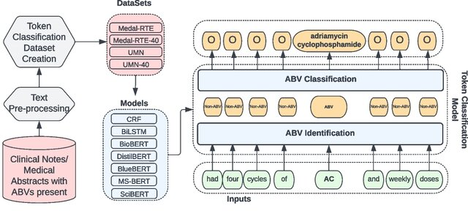
Sequence labeling serves as a cornerstone in natural language processing (NLP) applications such as information extraction, sentiment analysis, and speech recognition. By structuring raw text into labeled formats, systems can extract and classify meaningful data from unstructured inputs. To provide a clearer understanding of this process, the diagram below illustrates the step-by-step flow of sequence labeling—from the first text input through to the generation of labeled output.
Figure 1 Sequence Labeling classification pipeline.

Applications for sequence labeling
Sequence labeling plays a vital role in many applications across various industries, enhancing how we interact with and analyze text data. Here are key areas where sequence labeling techniques are particularly useful.

Information retrieval
Sequence labeling is crucial in information retrieval systems where the aim is to extract structured data from unstructured text. For example, in legal and financial documents, entities such as case law references, statutes, monetary amounts, or party names can be identified and used to index documents, making them easier to search and retrieve [3].

Healthcare analytics
In the healthcare sector, sequence labeling is used to extract medical entities from clinical notes. This includes naming symptoms, diagnoses, medications, and dosages, which can then be used for patient management systems, billing, and research purposes. By automating the extraction of these entities, healthcare providers can improve patient care efficiency and accuracy [4].

Sentiment analysis
In customer service and marketing, sequence labeling enables the analysis of customer feedback by identifying and categorizing sentiments expressed in reviews and social media posts. This application is crucial for businesses to gauge public sentiment, understand customer needs, and tailor their services or products accordingly [5].

Application example: Sentiment analysis
Before we get into the technical details of a sequence labeling model, let's look at a real-world example of sentiment analysis used in social media monitoring. Companies often use sentiment analysis to see how customers feel about their brand in real time by examining tweets, Facebook posts, and other social media content. By labeling sequences of words in these posts as positive, negative, or neutral, companies can quickly respond to customer complaints, assess overall sentiment about product launches, and adjust marketing strategies to better match public opinion.
This practical example sets the stage for the following Python code demonstration, where we will implement a basic Conditional Random Field (CRF) model for part-of-speech tagging, which is a foundational technique that can be adapted for more complex sequence labeling tasks like sentiment analysis.
By linking these applications with the upcoming code example, readers can see the direct relevance and impact of their learning, enhancing both understanding and engagement.

Part-of-Speech (POS) Tagging
Part-of-speech tagging assigns grammatical labels to words in a sentence, identifying their roles as nouns, verbs, adjectives, and other parts of speech. This task is vital for syntactic and semantic analysis, providing a foundation for various NLP applications, including machine translation, sentiment analysis, and information retrieval. With the Hugging Face Diffusion library, POS tagging becomes simpler and more accessible, using pre-trained models to label tokens in text.
To perform POS tagging, start by loading a pre-trained model and applying it to a sample text. Below is an example showing how to tokenize the text and use the Hugging Face Diffusion library to assign POS tags.

Application Example: Implementing a Conditional Random Field (CRF) for Part-of-Speech (POS) Tagging
In sequence labeling tasks, Part-of-Speech (POS) tagging is a crucial step for syntactic analysis in NLP applications. POS tagging assigns grammatical labels, such as nouns, verbs, and adjectives, to each word in a sentence. A common approach for this task is using a Conditional Random Field (CRF), a probabilistic model frequently used for structured prediction tasks like sequence labeling. CRFs effectively capture the relationships between labels in a sequence, making them suitable for tasks where the context of neighboring labels is important, such as POS tagging.
In this example, we will implement a CRF model using Python's sklearn-crfsuite library to perform POS tagging on a simplified dataset. Below is the code showing the process, from feature extraction to model training and evaluation.
``python
import sklearn_crfsuite
from sklearn_crfsuite import metrics
from sklearn.model_selection import train_test_split
# Example dataset (simplified)
sentences = [
[("I", "PRON"), ("saw", "VERB"), ("the", "DET"), ("cat", "NOUN")],
[("The", "DET"), ("cat", "NOUN"), ("sat", "VERB"), ("on", "ADP"), ("the", "DET"), ("mat", "NOUN")]
-]
# Feature extraction for CRF
def word2features(sent, i):
word = sent[i][0]
features = {
'bias': 1.0,
'word.lower()': word.lower(),
'word[-3:]': word[-3:],
'word[-2:]': word[-2:],
'word.isupper()': word.isupper(),
'word.istitle()': word.istitle(),
'word.isdigit()': word.isdigit(),
}
if i > 0:
word1 = sent[i-1][0]
features.update({
'-1:word.lower()': word1.lower(),
'-1:word.istitle()': word1.istitle(),
})
else:
features['BOS'] = True
if i < len(sent)-1:
word1 = sent[i+1][0]
features.update({
'+1:word.lower()': word1.lower(),
'+1:word.istitle()': word1.istitle(),
})
else:
features['EOS'] = True
return features
# Generate features
X = [[word2features(s, i) for i in range(len(s))] for s in sentences]
y = [[label for token, label in s] for s in sentences]
# Split the data
X_train, X_test, y_train, y_test = train_test_split(X, y, test_size=0.25, random_state=0)
# Train CRF model
crf = sklearn_crfsuite.CRF(
algorithm='lbfgs',
c1=0.1,
c2=0.1,
max_iterations=100,
all_possible_transitions=True
)
crf.fit(X_train, y_train)
# Predictions
y_pred = crf.predict(X_test)
print("Accuracy:", metrics.flat_accuracy_score(y_test, y_pred))
``
The code begins by creating a simplified dataset of sentences, where each word is matched with its Part-of-Speech (POS) tag, such as "PRON" for pronouns or "VERB" for verbs. To input the data into the CRF model, the word2features function extracts relevant features for each word in a sentence. These features include various characteristics, such as the lowercase version of the word, the last few characters (which help identify suffixes), and whether the word is capitalized or in title case. This contextual information helps the CRF learn the relationships between words and their tags. The function also considers neighboring words, enabling the model to account for the influence of surrounding tokens when making predictions.
Next, the CRF model is trained using the sklearn-crfsuite library. The training process involves splitting the dataset into training and testing sets and applying the CRF algorithm. The model is optimized using the LBFGS algorithm, with both L1 (c1) and L2 (c2) regularization to prevent overfitting. After the model is trained, it makes predictions on the test set, which are compared to the actual labels to calculate the model's accuracy. The accuracy score is calculated using metrics.flat_accuracy_score, evaluates how well the model performs on unseen data.
This example demonstrates how a CRF model can be used for sequence labeling tasks like POS tagging. By analyzing the features of words and their neighboring tokens, CRF models can accurately label each word with its correct grammatical role, showing the usefulness of advanced NLP techniques in structured prediction tasks.

Named Entity Recognition (NER)
Named Entity Recognition involves detecting and classifying named entities, such as people, organizations, and locations, within a text. It plays a crucial role in tasks such as information extraction, knowledge graph development, and question answering. Using the Hugging Face Diffusion library, implementing NER becomes easier with pre-trained models like BERT.
To demonstrate, we can load a pre-trained model fine-tuned on NER tasks and then further fine-tune it for domain-specific use cases, such as identifying biomedical entities. In this example, we will use a pre-trained BERT model that has been fine-tuned for NER purposes.
`python
from transformers import AutoModelForTokenClassification, AutoTokenizer, pipeline # Load a pre-trained model
tokenizer = AutoTokenizer.from_pretrained("bert-base-cased")
model = AutoModelForTokenClassification.from_pretrained("dbmdz/bert-large-cased-finetuned-conll03-english") # Use Hugging Face pipeline for Named Entity Recognition
ner_pipeline = pipeline("ner", model=model, tokenizer=tokenizer)
# Test the NER pipeline text = "Hugging Face is a company based in New York." print(ner_pipeline(text))
`
This code snippet shows how to load a pre-trained BERT model and use it for NER. The pipeline function from the Hugging Face library makes it easy by wrapping the model and tokenizer, allowing simple input of text for entity recognition. In the example, the text "Hugging Face is a company based in New York" is processed, and the model detects relevant named entities like "Hugging Face" (organization) and "New York" (location). The pre-trained model can also be fine-tuned for domain-specific tasks, offering flexibility and accuracy for more specialized applications.
This streamlined implementation demonstrates how easily NER can be customized using the Hugging Face Diffusion library, showing its potential for both general and domain-specific applications.

Mechanisms of NER
NER systems usually operate by combining grammatical rules with statistical methods, including machine learning algorithms trained on large, annotated corpora. Advanced NER systems employ deep learning models, especially those based on the transformer architecture, to improve the accuracy and efficiency of entity recognition.
- Rule-Based systems: Early NER systems relied heavily on handcrafted rules. These systems perform well when the language structure is consistent, but they lack flexibility and scalability.
- Statistical models: With the advent of statistical NLP, models such as Conditional Random Fields (CRF) and Hidden Markov Models (HMM) have been employed. These models learn from data and can generalize across different contexts [1].
- Deep learning approaches: Recent advancements include using deep learning models like Bidirectional Encoder Representations from Transformers (BERT) and other transformer-based models, which analyze the context of each word in a sentence to enhance entity recognition accuracy [6].
The mechanisms behind Named Entity Recognition (NER) range from early rule-based systems to advanced deep learning methods that utilize transformer models like BERT. These techniques enable the extraction of valuable information such as people, organizations, and locations from raw text, making NER a versatile tool across industries such as healthcare, journalism, and finance. To better illustrate the concept, the following diagram provides an example of how NER converts a sample text into labeled entities, clearly demonstrating how each part of the input is categorized based on the identified entities.
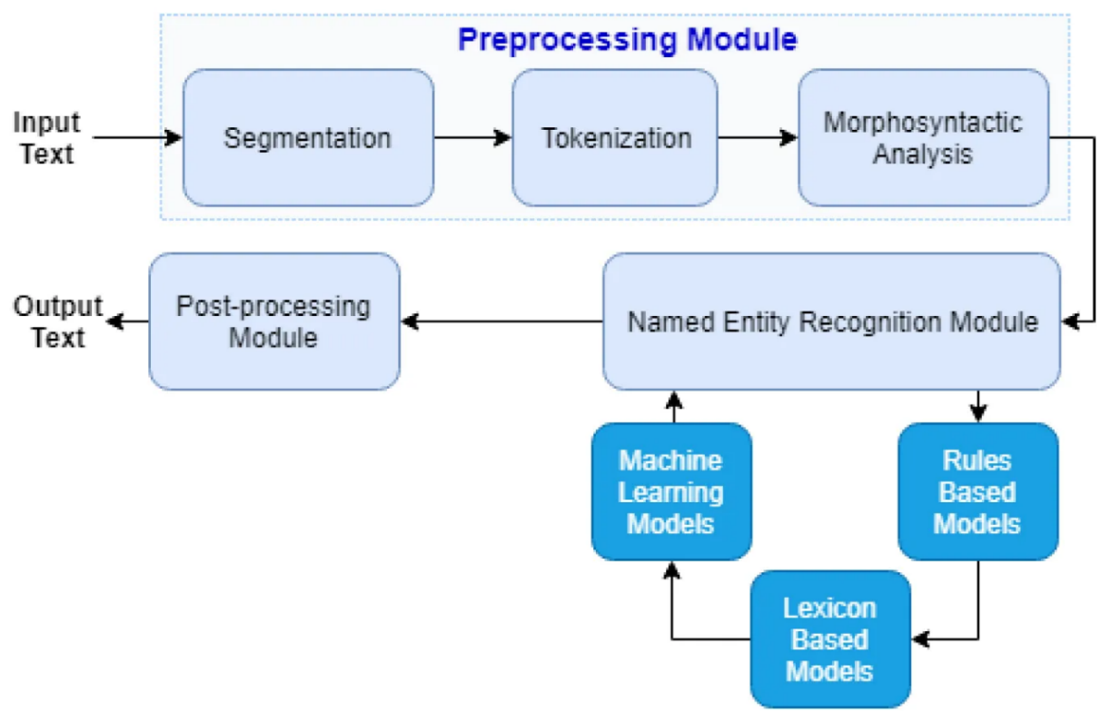
Figure 2 Example of Named Entity Recognition (NER) a sample text input and its transformation into labeled entities.

Applications for NER
NER has proven invaluable across various industries, streamlining processes and enhancing the extraction of critical information from unstructured text. Below are key examples of how NER is used in real-world scenarios.
- Healthcare: In healthcare, NER systems extract medical information from patient records, such as disease names, medication types, and dosages, which are essential for patient care management and clinical decision-making. [4].
- Media and Journalism: In the media industry, NER helps automatically categorize news articles and extract relevant entities such as people, organizations, and locations, thereby supporting content management and recommendations systems.
- Finance: In the financial sector, NER is used to examine and analyze financial documents, extracting key data points like company names, stock symbols, and economic indicators, which are vital for automated trading systems and financial analysis.

Application example: Implementing NER with Hugging Face Transformers
This example demonstrates how to implement Named Entity Recognition (NER) using the Hugging Face Transformers library, which utilizes a pre-trained BERT model fine-tuned for NER tasks. BERT models are particularly effective for tasks like NER because of their ability to understand the context and relationships between words within a sentence.
The code begins by loading a pre-trained BERT model that has been fine-tuned on the CoNLL-2003 dataset, specifically for NER tasks. Along with the model, a tokenizer is loaded, which converts raw text into a format suitable for processing by the model. After setting up the model and tokenizer, the next step is to establish the NER pipeline. This pipeline simplifies the complex operations needed for named entity recognition, making the process of analyzing text and identifying entities more efficient.
The example sentence, “Microsoft was founded by Bill Gates and Paul Allen on April 4, 1975,” is processed through the NER pipeline. The model analyzes this text and outputs the detected entities along with their categories, such as persons or organizations. The results are then displayed, demonstrating how the model correctly identifies and classifies "Microsoft," "Bill Gates," and "Paul Allen" as entities, offering insights into its ability to parse and interpret structured information within unstructured text.
``python
from transformers import AutoModelForTokenClassification, AutoTokenizer, pipeline
# Load pre-trained model and tokenizer
model = AutoModelForTokenClassification.from_pretrained("dbmdz/bert-large-cased-finetuned-conll03-english")
tokenizer = AutoTokenizer.from_pretrained("dbmdz/bert-large-cased-finetuned-conll03-english")
# Setup NER pipeline
ner_pipeline = pipeline("ner", model=model, tokenizer=tokenizer)
# Example text
text = "Microsoft was founded by Bill Gates and Paul Allen on April 4, 1975."
# Perform NER
results = ner_pipeline(text)
# Display results
print("Detected Entities:")
for entity in results:
print(f"Entity: {entity['word']}, Type: {entity['entity']}")
``
The implementation of this NER task with Hugging Face begins by loading the pre-trained BERT model and tokenizer. This model, fine-tuned on the CoNLL-2003 dataset, is already trained to recognize entities such as people, organizations, locations, and dates. The tokenizer prepares the text by converting it into a tokenized format that the model can process to perform the NER task.
Next, the NER pipeline is set up. This pipeline streamlines the process by combining tokenization, model prediction, and result generation into a single step. When input text is fed into this pipeline, the model automatically detects and classifies named entities. For example, "Microsoft" is recognized as an organization, while "Bill Gates" and "Paul Allen" are identified as persons. The detected entities and their categories are displayed for review, demonstrating the model's ability to accurately interpret the text.
This implementation demonstrates how pre-trained models, such as BERT, can be leveraged to efficiently perform NER tasks, making them valuable tools for information extraction, question answering, and document analysis. Using the Hugging Face Diffusion library, complex NLP tasks like NER become more accessible, enabling practitioners to apply innovative AI techniques in real-world situations.

Part-of-Speech (POS) tagging
Part-of-speech (POS) tagging is a key task in natural language processing (NLP) that involves assigning a part-of-speech tag (such as noun, verb, adjective, etc.) to each word in the text. This process is essential for understanding the syntax and semantics of language, which supports various NLP tasks, such as parsing, sentiment analysis, and machine translation.

Importance of syntax and semantics
POS tagging is vital for correctly parsing sentences, as it helps clarify word meanings and grammatical roles, enhancing the accuracy of syntactic analysis. For example, distinguishing between "record" (a noun) and "record" (a verb) based on context is essential for understanding sentence structure and further processing.

Techniques and Models for Effective POS Tagging
To implement Part-of-Speech (POS) tagging effectively, various techniques and models have developed over time, each offering unique advantages depending on the complexity of the text and the goals of the tagging process. From early rule-based methods to advanced deep learning approaches, progress in POS tagging has improved the accuracy of both syntactic and semantic analysis. The following is a sample of the most commonly used techniques and models for POS tagging, showing the shift from traditional methods to cutting-edge neural networks.:
- Rule-Based Techniques: Early POS taggers used handwritten rules to assign tags based on word suffixes and sentence context.
- Statistical Models: These include Hidden Markov Models (HMMs) and Maximum Entropy Markov Models (MEMMs), which calculate the probability of a tag sequence given a sequence of words [7].
- Deep Learning Approaches: Recent approaches use neural networks, especially Recurrent Neural Networks (RNNs) and Long Short-Term Memory networks (LSTMs), to consider the context more effectively. These models often outperform traditional methods, especially when combined with techniques like Conditional Random Fields (CRFs) for sequence prediction [8].

Applications for POS Tagging
Part-of-Speech (POS) tagging plays a crucial role in many applications, improving the accuracy and effectiveness of language-based tools. For example, in text editing and grammar checking tools like Grammarly, POS tagging identifies specific parts of speech in a sentence, allowing the system to make grammatical suggestions. Likewise, content filtering systems rely on POS tagging to classify content based on particular nouns, verbs, or adjectives, making it essential for recommendation systems. In voice recognition systems, POS tagging enhances the accuracy of speech-to-text conversion, helping the model better understand and interpret speech nuances.
As discussed, POS tagging is a fundamental process for analyzing the syntactic and semantic structure of language, supporting a broad spectrum of NLP applications. The different techniques—rule-based methods, statistical models, and deep learning approaches—all contribute to the precision and reliability of this task. To illustrate the steps involved in POS tagging, the following diagram shows the entire process, from input text to the assignment of part-of-speech tags, offering a clear visualization of how these tags are applied in real-world scenarios.

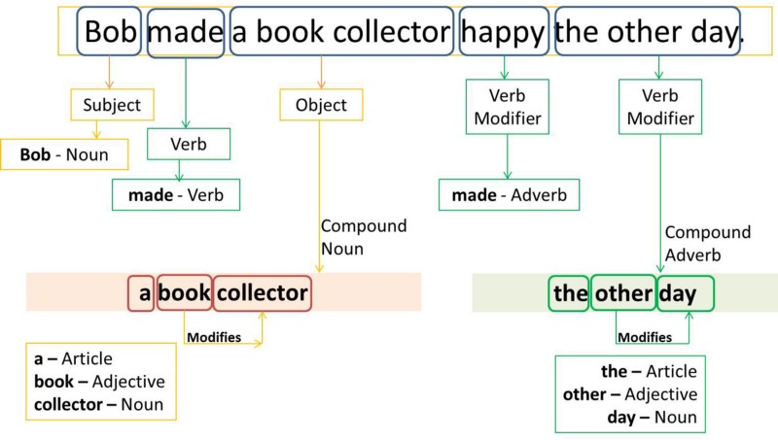
Figure 3 POS Tagging Process Diagram:

Application Example: Implementing POS Tagging with Hugging Face Transformers
This example demonstrates how to perform POS tagging using the Hugging Face transformers library with a pre-trained BERT model fine-tuned for POS tagging. It starts by loading both the tokenizer and model trained specifically for token classification. The POS tagging pipeline is then set up, which simplifies the process by combining tokenization, model inference, and result generation into one step.
Once the pipeline is set up, we provide an example sentence, "The quick brown fox jumps over the lazy dog." The pipeline processes this input and outputs the POS tags for each word, naming them as nouns, verbs, adjectives, and other parts of speech. This approach highlights the utility of transformer-based models in simplifying and improving the efficiency of common NLP tasks, such as POS tagging, which are foundational for tasks like grammar checking, machine translation, and syntactic analysis.
The code snippet below illustrates how this process works in practice:
``python
from transformers import AutoModelForTokenClassification, AutoTokenizer, pipeline
# Load tokenizer and model
model = AutoModelForTokenClassification.from_pretrained("bert-base-cased-finetuned-pos")
tokenizer = AutoTokenizer.from_pretrained("bert-base-cased-finetuned-pos")
# Setup POS tagging pipeline
pos_pipeline = pipeline("token-classification", model=model, tokenizer=tokenizer)
# Example sentence
sentence = "The quick brown fox jumps over the lazy dog."
# Perform POS tagging
pos_results = pos_pipeline(sentence)
# Display POS tags
print("POS Tags:")
for token in pos_results:
print(f"Word: {token['word']}, POS Tag: {token['entity']}")
``
In this example, the model setup involves loading a pre-trained BERT model specifically fine-tuned for POS tagging. The POS tagging pipeline simplifies the classification task per token, where each word in the sentence is analyzed and tagged with its corresponding part of speech. As the model processes the input sentence, it outputs the POS tags, demonstrating the model's ability to accurately name and label the distinct parts of speech for each word.
This section offers a comprehensive understanding of POS tagging, detailing its technical mechanisms and practical applications while giving a firsthand coding example that proves how to implement this task using advanced models like BERT. By using the Hugging Face transformers library, we can streamline complex NLP tasks, making them more accessible and efficient in real-world applications.

Model training and evaluation
Training and evaluating sequence labeling models effectively is crucial for achieving high performance in tasks like Named Entity Recognition (NER) and Part-of-Speech (POS) tagging. This section outlines the best practices for training these models and the methods used to evaluate their performance.

Best practices for training sequence labeling models
Training sequence labeling models requires a careful approach to ensure that the model not only learns to predict the correct labels but also generalizes well to new, unseen data.
- Data preparation: The quality and quantity of training data greatly influence model performance. Using a well-annotated, diverse dataset that reflects the variability of language in real-world situations is essential.
- Feature selection: Choosing the right set of features is crucial. For traditional models like CRFs, manually designed features such as word suffixes, prefixes, and POS tags are beneficial. For neural models, embeddings that represent semantic meanings, such as word2vec or GloVe, enhance the model's ability to comprehend.
- Regularization and dropout: To prevent overfitting, particularly in deep learning models, techniques such as L2 regularization and dropout are used during training.
- Transfer learning: Using pre-trained models and fine-tuning them for specific tasks can significantly enhance performance because of the pre-learned contextual representations within the model. [6].

Methods for evaluating the performance of NER and POS Tagging systems.
When training sequence labeling models, it is essential to follow best practices that ensure robust performance and adaptability across various real-world datasets. These practices not only help the model learn correct label predictions but also improve its ability to generalize effectively to unseen data. The following key strategies are fundamental for achieving best results when training sequence labeling models:
- Accuracy: The most straightforward metric, accuracy measures the proportion of correctly predicted labels over all predictions.
- Precision, recall, and F1-Score: Precision measures the accuracy of positive predictions, recall measures the coverage of actual positive cases, and the F1-score offers a balance between precision and recall.
- Confusion matrix: Provides a detailed breakdown of predictions versus actual labels, helping name specific areas where the model is underperforming.

Examples of application
Named Entity Recognition (NER) and Part-of-Speech (POS) tagging are powerful tools that support a wide range of real-world applications, from biomedical research to understanding social media language. These applications highlight the versatility and importance of these NLP techniques in extracting meaningful information, enabling advanced insights across diverse domains. Below are specific examples that show the practical use of NER and POS tagging, as well as an illustrative case of training and evaluating an NER model.

Application: NER on biomedical text
In the biomedical field, Named Entity Recognition (NER) systems are vital for extracting critical medical entities such as drug names, symptoms, and diseases from clinical texts. These extractions play a key role in enhancing patient care, advancing medical research, and supporting drug discovery. For example, an NER system could parse electronic health records to find mentions of specific medications or conditions, enabling data-driven decision-making in healthcare settings.

Application: POS Tagging on social media text
Social media text is often informal, having slang, abbreviations, and emoticons. Applying POS tagging in this domain offers structural insights into the language, helping tasks like sentiment analysis, content filtering, and linguistic research. By assigning parts of speech to informal language elements, researchers and practitioners can gain a deeper understanding of communication trends, helping to refine algorithms for tasks such as automated moderation or opinion mining.

Application example: Training and evaluating an NER Model
This example shows how to train and evaluate a Named Entity Recognition (NER) model using the Hugging Face Transformers library. The goal is to adapt a pre-trained BERT model for token classification to recognize entities like names or locations in text data. The process begins with loading a labeled dataset and preparing the data through tokenization with the BERT tokenizer. Labels are aligned with the tokenized inputs to ensure consistency during training. The model is then fine-tuned over a set number of epochs and batch size. After training, the model's performance is measured using metrics such as precision, recall, and F1-score to assess its ability to correctly identify entities.
The following code snippet proves the process of training and evaluating the NER model:
`python
from transformers import BertTokenizer, BertForTokenClassification, Trainer, TrainingArguments
from datasets import load_dataset

# Load tokenizer and model
tokenizer = BertTokenizer.from_pretrained('bert-base-cased')
model = BertForTokenClassification.from_pretrained('bert-base-cased', num_labels=9)

# Load and preprocess dataset
dataset = load_dataset("conll2003")
def tokenize_and_align_labels(examples):
tokenized_inputs = tokenizer(examples['tokens'], truncation=True, padding='max_length', is_split_into_words=True)
labels = []
for i, label in enumerate(examples['ner_tags']):
word_ids = tokenized_inputs.word_ids(batch_index=i)
label_ids = [label[word_idx] if word_idx is not None else -100 for word_idx in word_ids]
labels.append(label_ids)
tokenized_inputs['labels'] = labels
return tokenized_inputs
dataset = dataset.map(tokenize_and_align_labels, batched=True)

# Define training arguments
training_args = TrainingArguments(
output_dir='./results',
num_train_epochs=3,
per_device_train_batch_size=16,
learning_rate=2e-5
)

# Initialize trainer
trainer = Trainer(
model=model,
args=training_args,
train_dataset=dataset['train'],
eval_dataset=dataset['validation']
)

# Train the model
trainer.train()
`
In this code, we first prepare and tokenize the dataset using a BERT tokenizer, ensuring that the labels correctly align with the tokenized inputs through the tokenize_and_align_labels function. This preprocessing step is essential for training the model with accurate label mappings. Next, we set up a pre-trained BERT model fine-tuned for token classification tasks, including configuring the model to handle the specific number of labels in the dataset. The training process begins by defining key parameters like the number of epochs and batch size. Then, the model is evaluated using metrics such as precision, recall, and F1-score to measure its performance in recognizing and classifying named entities. This streamlined workflow demonstrates the process of building and optimizing an NER model using Hugging Face Transformers, providing both a theoretical and practical understanding of how these systems operate in real-world applications. It not only offers detailed knowledge of training and evaluating sequence labeling models but also illustrates their practical applications supported by a coding example.

Wrapping up chapter 4
In Chapter 4, we thoroughly covered the fundamentals of sequence labeling in natural language processing (NLP), focusing on key tasks such as Named Entity Recognition (NER) and Part-of-Speech (POS) tagging. We began by emphasizing the importance of sequence labeling in organizing and analyzing raw text data. Then we explored in depth how NER and POS tagging are applied in fields such as healthcare, media, and finance. Throughout the chapter, we demonstrate how advanced models, particularly transformers, significantly enhance the accuracy and flexibility of these tasks. Practical coding examples using Hugging Face Diffusion demonstrated how to implement these techniques in real-world scenarios, helping us understand how sequence labeling models can be trained and optimized.
We aimed to provide readers with the knowledge and tools necessary to implement, train, and evaluate sequence labeling models effectively. Through detailed discussions, examples, and case studies, we have successfully established a solid foundation for tackling real-world NLP challenges.

Looking Ahead to Chapter 5
As we move into Chapter 5, we shift from labeling and structuring data to the exciting realm of generative AI. In "Advanced Generative Tasks with Hugging Face Diffusion," we will examine how to use transformer-based models to produce content, including text-to-image and image-to-video synthesis. Building on the deep learning and model training principles covered in Chapter 4, this chapter will showcase the innovative potential of generative AI to not only interpret but also create complex multimedia content.
By the end of Chapter 5, you will gain insight into innovative generative models and their applications, further expanding the horizons of what can be achieved with AI in creative fields. Let's dive into this new frontier of AI-driven creativity.

References

[1] | M. A. Lafferty and F. C. N. Pereira, "Conditional random fields: Probabilistic models for segmenting and labeling sequence data," in Proceedings of the Eighteenth International Conference on Machine Learning, 2001.
[2] | L. R. Rabiner, "A Tutorial on Hidden Markov Models and Selected Applications in Speech Recognition," in Proceedings of the IEEE,, 1989.
[3] | A. McCallum, "Information extraction: Distilling structured data from unstructured text," Queue, vol. 3, p. 48–57, 2005.
[4] | A. Jagannatha and H. Yu, "Structured prediction models for RNN based sequence labeling in clinical text," in Proceedings of the Conference on Empirical Methods in Natural Language Processing, 2016.
[5] | C. K. C. G. Mikolov and J. Dean, "Efficient estimation of word representations in vector space," 2013.
[6] | J. Devlin, M. W. Chang, K. Lee and K. Toutanova, "BERT: Pre-training of deep bidirectional transformers for language understanding," NAACL-HLT, 2018.
[7] | C. D. Manning, "Part-of-Speech Tagging from 97% to 100%: Is It Time for Some Linguistics?," in Computational Linguistics and Intelligent Text Processing, 2011.
[8] | Z. Huang, W. Xu and K. Yu, "Bidirectional LSTM-CRF Models for Sequence Tagging," preprint, 2015.
[9] | J. Pennington, R. Socher and C. D. Manning, "Glove: Global vectors for word representation," in Proceedings of the 2014 conference on empirical methods in natural language processing (EMNLP), 2014.
[10] | B. Pang and L. Lee, "Opinion mining and sentiment analysis," Foundations and Trends® in Information Retrieval, vol. 2, p. 1–135, 2008.
[11] | C. D. Manning, "The Stanford CoreNLP Natural Language Processing Toolkit," Association for Computational Linguistics (ACL) System Demonstrations, p. 55–60, 2014.
[12] | G. Lample, M. Ballesteros, S. Subramanian, K. Kawakami and C. Dyer, "Neural architectures for named entity recognition," preprint, 2016.
[13] | M. Honnibal and I. Montani, "spaCy 2: Natural language understanding with Bloom embeddings, convolutional neural networks and incremental parsing," preprint, 2017.

