Chapter 4 - Sequence labeling with Hugging Face Diffusion
Target: 30 pages
Sequence labeling is a core task in natural language processing (NLP) that involves assigning labels to individual tokens in a sequence, such as words in a sentence. Two major applications of sequence labeling include Named Entity Recognition (NER) and Part-of-Speech (POS) tagging. These tasks are crucial for extracting structured information, understanding sentence structure, and enhancing semantic understanding. This chapter focuses on how to implement sequence labeling tasks using the Hugging Face Diffusion library.

Learning Goals
By the end of this chapter, you will:
- Understand the fundamentals of sequence labeling and its significance in NLP applications.
- Implement Named Entity Recognition (NER) using pre-trained models and fine-tune them for domain-specific tasks.
- Perform Part-of-Speech (POS) tagging, labeling each token with its grammatical role in a sentence.
- Train and evaluate sequence labeling models using relevant datasets and performance metrics.
- Apply sequence labeling to specialized domains like biomedical text analysis and social media text processing.

Overview of Sequence Labeling in NLP
Sequence labeling is the process of assigning categorical labels to elements in a sequence of tokens, typically words. This task plays a foundational role in NLP applications such as information extraction, syntactic analysis, and semantic understanding. These are common sequence labeling tasks:
- Named Entity Recognition (NER): Showing entities like persons, organizations, and locations in a text.
- Part-of-Speech (POS) Tagging: Assigning grammatical labels (e.g., noun, verb, adjective) to each word in a sentence.
Both tasks are widely used in industries such as healthcare, where NER can be applied to extract key medical information from unstructured clinical notes, and in social media analytics, where POS tagging helps parse and understand informal text.

Fundamentals of sequence labeling
Sequence labeling models are designed to predict an output sequence that corresponds to the input sequence of words or characters. These models consider the contextual relationships between elements in a sequence, which is vital for understanding language patterns and structures. The most common approaches to sequence labeling include Conditional Random Fields (CRFs), Hidden Markov Models (HMMs), and more recently, neural network-based models like Recurrent Neural Networks (RNNs) and Transformers.
- Conditional Random Fields (CRFs): CRFs are statistical modeling methods often used in sequence labeling that model the conditional probability of a label sequence given a corresponding sequence of input tokens. They are particularly effective in cases where the decision at one position depends on the decisions at earlier positions [1].
- Hidden Markov Models (HMMs): HMMs are used for sequence labeling by modeling the sequence as a Markov process with hidden states. They are well-suited for tasks where the label of a token depends only on its immediate predecessor, making them effective for simpler tagging tasks [2].

Significance of sequence labeling in NLP
Sequence labeling is crucial in NLP for its role in structuring raw text data into formats that are more easily analyzed and understood. This capability is essential for applications such as:
- Information Extraction: Naming and classifying key pieces of information from text, such as dates, names, and locations, which is fundamental for data retrieval and organization tasks.
- Sentiment Analysis: Tagging parts of texts to name sentiment-bearing phrases or to figure out the sentiment expressed toward specific entities.
- Speech Recognition: Converting speech into text that can be further processed and labeled to enhance comprehensibility and interaction quality in human-computer interaction.
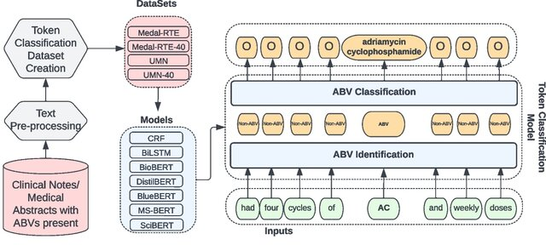
Sequence labeling serves as a cornerstone in natural language processing (NLP) applications such as information extraction, sentiment analysis, and speech recognition. By structuring raw text into labeled formats, it allows systems to extract and classify meaningful data from unstructured inputs. To provide a clearer understanding of this process, the diagram below illustrates the step-by-step flow of sequence labeling—from the first text input through to the generation of labeled output.
Figure 1 Sequence Labeling classification pipeline.

Applications of sequence labeling
Sequence labeling plays a pivotal role in various applications across multiple industries, enhancing the way we interact with and process textual data. Here are key applications where sequence labeling techniques are particularly effective:

Information retrieval
Sequence labeling is crucial in information retrieval systems where the goal is to extract structured information from unstructured text. For example, in legal and financial documents, entities such as case law references, statutes, monetary amounts, or party names can be named and used to index documents, making them easier to search and retrieve [3].

Healthcare analytics
In the healthcare sector, sequence labeling is used to extract medical entities from clinical notes. This includes naming symptoms, diagnoses, medications, and dosages, which can then be used for patient management systems, billing, and research purposes. By automating the extraction of these entities, healthcare providers can improve patient care efficiency and accuracy [4].

Sentiment analysis
In customer service and marketing, sequence labeling helps analyze customer feedback by naming and categorizing sentiments expressed in reviews and social media posts. This application is crucial for businesses to gauge public sentiment, understand customer needs, and tailor their services or products accordingly [5].

Application example: Sentiment analysis
Before we dive into the technical setup of a sequence labeling model, let us consider a practical example of sentiment analysis applied to social media monitoring. Companies often use sentiment analysis to track how customers feel about their brand in real time by analyzing tweets, Facebook posts, and other social media content. By labeling sequences of words in these posts as positive, negative, or neutral, companies can quickly respond to customer complaints, gauge overall sentiment about product launches, and tailor marketing strategies to better align with public opinion.
This practical example sets the stage for the following Python code demonstration, where we will implement a basic Conditional Random Field (CRF) model for part-of-speech tagging, which is a foundational technique that can be adapted for more complex sequence labeling tasks like sentiment analysis.
By linking these applications with the upcoming code example, readers can see the direct relevance and impact of their learning, enhancing both understanding and engagement.

Part-of-Speech (POS) Tagging
Part-of-Speech tagging assigns grammatical labels to words in a sentence, finding their role as nouns, verbs, adjectives, and so forth. This task plays a critical role in syntactic and semantic analysis, making it fundamental for various NLP tasks, including machine translation, sentiment analysis, and information retrieval. With the Hugging Face Diffusion library, POS tagging becomes streamlined and accessible, using pre-trained models to assign grammatical labels to tokens in text.
To implement POS tagging, you begin by loading a pre-trained model and applying it to a sample text. Below is an example showing how to tokenize the text and use the Hugging Face Diffusion library to assign POS tags:

Application Example: Implementing a Conditional Random Field (CRF) for Part-of-Speech (POS) Tagging
In the context of sequence labeling tasks, Part-of-Speech (POS) tagging is a crucial step for syntactic analysis in NLP applications. POS tagging assigns grammatical labels, such as nouns, verbs, and adjectives, to each word in a sentence. One effective approach for this task is the use of a Conditional Random Field (CRF), which is a probabilistic model commonly used for structured prediction tasks like sequence labeling. CRFs model the relationships between labels in a sequence, making them well-suited for tasks where the context of neighboring labels matters, such as POS tagging.
In this example, we will implement a CRF model using Python's sklearn-crfsuite library to perform POS tagging on a simplified dataset. Below is the code showing the process, from feature extraction to model training and evaluation.
``python
import sklearn_crfsuite
from sklearn_crfsuite import metrics
from sklearn.model_selection import train_test_split
# Example dataset (simplified)
sentences = [
[("I", "PRON"), ("saw", "VERB"), ("the", "DET"), ("cat", "NOUN")],
[("The", "DET"), ("cat", "NOUN"), ("sat", "VERB"), ("on", "ADP"), ("the", "DET"), ("mat", "NOUN")]
]
# Feature extraction for CRF
def word2features(sent, i):
word = sent[i][0]
features = {
'bias': 1.0,
'word.lower()': word.lower(),
'word[-3:]': word[-3:],
'word[-2:]': word[-2:],
'word.isupper()': word.isupper(),
'word.istitle()': word.istitle(),
'word.isdigit()': word.isdigit(),
}
if i > 0:
word1 = sent[i-1][0]
features.update({
'-1:word.lower()': word1.lower(),
'-1:word.istitle()': word1.istitle(),
})
else:
features['BOS'] = True
if i < len(sent)-1:
word1 = sent[i+1][0]
features.update({
'+1:word.lower()': word1.lower(),
'+1:word.istitle()': word1.istitle(),
})
else:
features['EOS'] = True
return features
# Generate features
X = [[word2features(s, i) for i in range(len(s))] for s in sentences]
y = [[label for token, label in s] for s in sentences]
# Split the data
X_train, X_test, y_train, y_test = train_test_split(X, y, test_size=0.25, random_state=0)
# Train CRF model
crf = sklearn_crfsuite.CRF(
algorithm='lbfgs',
c1=0.1,
c2=0.1,
max_iterations=100,
all_possible_transitions=True
)
crf.fit(X_train, y_train)
# Predictions
y_pred = crf.predict(X_test)
print("Accuracy:", metrics.flat_accuracy_score(y_test, y_pred))
``
The code begins by preparing a simplified dataset of sentences, where each word is paired with its corresponding Part-of-Speech (POS) tag, such as "PRON" for pronoun or "VERB" for verb. To feed the data into the CRF model, the word2features function extracts relevant features for each word in a sentence. These features include various characteristics like the lowercase form of the word, the last few characters (which are helpful for naming suffixes), and whether the word is capitalized or in title case. This contextual information aids the CRF in learning the relationships between the words and their respective tags. The function also captures neighboring words, allowing the model to consider the influence of surrounding tokens when making predictions.
Next, the CRF model is trained using the sklearn-crfsuite library. The training process involves splitting the dataset into training and testing sets and applying the CRF algorithm. The model is optimized using the lbfgs algorithm, with both L1 (c1) and L2 (c2) regularization to prevent overfitting. After the model is trained, it makes predictions on the test set, which are compared to the actual labels to compute the accuracy of the model. The accuracy score calculated using metrics.flat_accuracy_score, evaluates how well the model performs on unseen data.
This example highlights the practical application of a CRF model for sequence labeling tasks like POS tagging. By considering the features of words and their neighboring tokens, CRF models can effectively label each word in a sentence with its right grammatical role, highlighting the utility of advanced NLP techniques in structured prediction tasks.

Named Entity Recognition (NER)
Named Entity Recognition involves naming and classifying named entities such as persons, organizations, and locations in a text. It plays a crucial role in tasks like information extraction, knowledge graph creation, and question answering. With the Hugging Face Diffusion library, implementing NER becomes accessible using pre-trained models like BERT.
To show, we can load a pre-trained model fine-tuned on NER tasks and then fine-tuned it further for domain-specific use cases, such as finding biomedical entities. In this example, we will use a pre-trained BERT model fine-tuned on NER for general purposes.
`python
from transformers import AutoModelForTokenClassification, AutoTokenizer, pipeline # Load a pre-trained model
tokenizer = AutoTokenizer.from_pretrained("bert-base-cased")
model = AutoModelForTokenClassification.from_pretrained("dbmdz/bert-large-cased-finetuned-conll03-english") # Use Hugging Face pipeline for Named Entity Recognition
ner_pipeline = pipeline("ner", model=model, tokenizer=tokenizer)
# Test the NER pipeline text = "Hugging Face is a company based in New York." print(ner_pipeline(text))
`
This code snippet proves how to load a pre-trained BERT model and use it to perform NER. The pipeline function from the Hugging Face library simplifies the process by encapsulating the model and tokenizer, allowing easy text input for entity recognition. In the example, the text "Hugging Face is a company based in New York" is processed, and the model finds the relevant named entities such as "Hugging Face" (organization) and "New York" (location). The pre-trained model can be further fine-tuned for domain-specific tasks, offering flexibility and accuracy for more specialized applications.
This streamlined implementation highlights the ease with which NER can be customized using the Hugging Face Diffusion library, displaying its potential for both general and domain-specific applications.

Mechanisms of NER
NER systems typically work by combining grammatical rules with statistical techniques, including machine learning algorithms that have been trained on large, annotated corpora. Advanced NER systems use deep learning models, particularly those based on the transformer architecture, to enhance the accuracy and efficiency of entity recognition.
- Rule-Based systems: Early NER systems relied heavily on handcrafted rules. These systems perform well when the language structure is consistent, but they lack flexibility and scalability.
- Statistical models: With the advent of statistical NLP, models like Conditional Random Fields (CRF) and Hidden Markov Models (HMM) have been used. These models learn from data and can generalize across different contexts [1].
- Deep learning approaches: Recent advancements involve using deep learning models such as Bidirectional Encoder Representations from Transformers (BERT) and other transformer-based models, which consider the context of each word in a sentence to improve the accuracy of entity recognition [6].
The mechanisms behind Named Entity Recognition (NER) range from early rule-based systems to advanced deep learning approaches using transformer models like BERT. These methods enable the extraction of valuable information, such as people, organizations, and locations, from raw text, making NER a versatile tool across industries like healthcare, journalism, and finance. To better illustrate the concept, the following diagram gives an example of how NER transforms a sample text input into labeled entities, clearly showing how each part of the input is categorized based on the entities it finds.
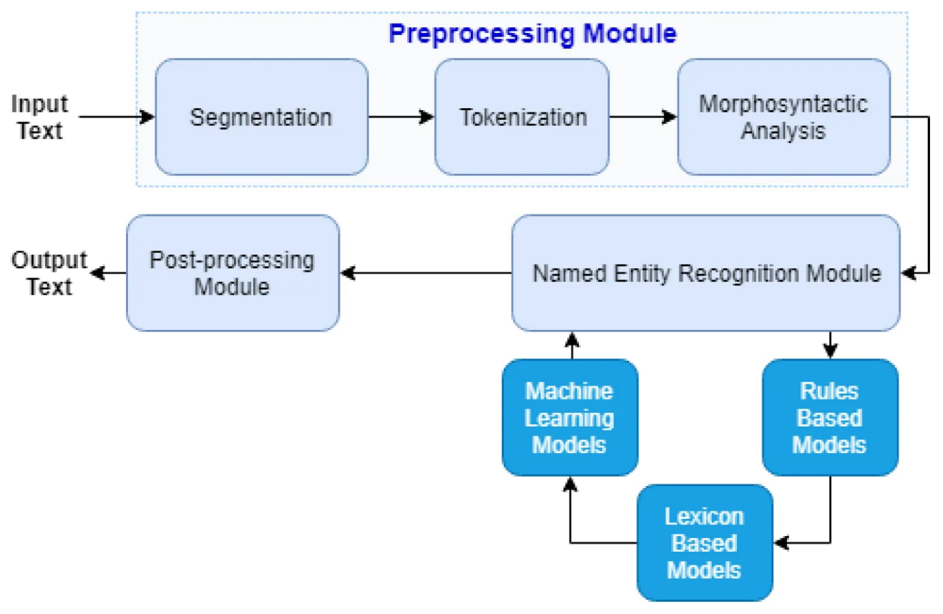
Figure 2 Example of Named Entity Recognition (NER) a sample text input and its transformation into labeled entities.

Applications of NER
NER has proven invaluable across various industries, streamlining processes and improving the extraction of critical information from unstructured text. Below are key examples of how NER is applied in real-world scenarios:
- Healthcare: In healthcare, NER systems extract medical information from patient records, such as disease names, medication types, and dosages, which are crucial for patient care management and clinical decision-making [4].
- Media and Journalism: In the media industry, NER helps in automatically categorizing news articles and extracting relevant entities such as people, organizations, and locations, thus aiding in content management and recommendation systems.
- Finance: In the financial sector, NER is used to check and analyze financial documents, extracting critical data points like company names, stock symbols, and financial indicators, which are essential for automated trading systems and financial analysis.

Application example: Implementing NER with Hugging Face Transformers
This example proves how to implement Named Entity Recognition (NER) using the Hugging Face transformers library, which uses a pre-trained BERT model fine-tuned for NER tasks. BERT models are particularly effective for tasks like NER due to their ability to capture context and dependencies between words in a sentence.
The code begins by loading a pre-trained BERT model that has been fine-tuned on the CoNLL-2003 dataset, specifically designed for NER tasks. Alongside the model, a tokenizer is also loaded, which manages converting the raw text into a format suitable for the model to process. Once the model and tokenizer are in place, the next step is to set up the NER pipeline. The pipeline abstracts the complex operations needed for named entity recognition, allowing for a streamlined approach to processing text and detecting entities.
The provided example sentence, “Microsoft was founded by Bill Gates and Paul Allen on April 4, 1975,” is passed through the NER pipeline. The model processes this text and outputs the recognized entities along with their respective categories, such as persons or organizations. The results are then printed, showing how the model correctly finds and classifies "Microsoft," "Bill Gates," and "Paul Allen" as entities, providing insights into the model's ability to parse and analyze structured information within unstructured text.
``python
from transformers import AutoModelForTokenClassification, AutoTokenizer, pipeline
# Load pre-trained model and tokenizer
model = AutoModelForTokenClassification.from_pretrained("dbmdz/bert-large-cased-finetuned-conll03-english")
tokenizer = AutoTokenizer.from_pretrained("dbmdz/bert-large-cased-finetuned-conll03-english")
# Setup NER pipeline
ner_pipeline = pipeline("ner", model=model, tokenizer=tokenizer)
# Example text
text = "Microsoft was founded by Bill Gates and Paul Allen on April 4, 1975."
# Perform NER
results = ner_pipeline(text)
# Display results
print("Detected Entities:")
for entity in results:
print(f"Entity: {entity['word']}, Type: {entity['entity']}")
``
The implementation of this NER task with Hugging Face begins by loading the pre-trained BERT model and tokenizer. This model, fine-tuned on the CoNLL-2003 dataset, has already been trained to find entities such as people, organizations, locations, and dates. The tokenizer prepares the text by converting it into a tokenized format, which the model can process to perform the NER task.
Next, the NER pipeline is set up. This pipeline simplifies the overall process by encapsulating the tokenization, model prediction, and result generation in a single step. By passing the input text into this pipeline, the model automatically finds named entities and categorizes them. In the example, "Microsoft" is identified as an organization, while "Bill Gates" and "Paul Allen" are classified as persons. The detected entities and their categories are printed for review, proving the model's ability to interpret the text effectively.
This implementation highlights how pre-trained models, like BERT, can be used to perform NER tasks efficiently, making it a valuable tool for tasks such as information extraction, question answering, and document analysis. By using the Hugging Face Diffusion library, even complex NLP tasks like NER become more accessible, allowing practitioners to apply innovative AI techniques in real-world scenarios.

Part-of-Speech (POS) tagging
Part-of-Speech (POS) tagging is a fundamental task in natural language processing (NLP) that involves assigning a part-of-speech tag (such as noun, verb, adjective, among others) to each word in each text. This process is critical for understanding the syntactic structure and semantics of language, which supports different NLP tasks such as parsing, sentiment analysis, and machine translation.

Importance in syntax and semantics
POS tagging is essential for parsing sentences correctly, as it helps disambiguate word meanings and grammatical functions, improving the accuracy of syntactic analysis. For example, distinguishing between "record" (a noun) and "record" (a verb) based on context is crucial for correct sentence structure interpretation and next processing.

Techniques and Models for Effective POS Tagging
To implement Part-of-Speech (POS) tagging effectively, different techniques and models have evolved over time, each offering unique advantages based on the complexity of the text and the goals of the tagging process. From early rule-based methods to sophisticated deep learning approaches, the advancements in POS tagging have greatly enhanced the accuracy of syntactic and semantic analysis. The following is a sample of the most used techniques and models for POS tagging, reflecting the progression from traditional methodologies to innovative neural networks:
- Rule-Based Techniques: Early POS taggers used handwritten rules to decide tags based on word suffixes and the context within a sentence.
- Statistical Models: These include Hidden Markov Models (HMMs) and Maximum Entropy Markov Models (MEMMs), which calculate the probability of a tag sequence given a sequence of words [7].
- Deep Learning Approaches: Recent approaches use neural networks, especially Recurrent Neural Networks (RNNs) and Long Short-Term Memory networks (LSTMs), to consider the context more effectively. These models often outperform traditional methods, especially when combined with techniques like Conditional Random Fields (CRFs) for sequence prediction [8].

Applications of POS Tagging
Part-of-Speech (POS) tagging plays an integral role in various applications, enhancing the functionality and precision of language-based tools. For instance, in text editing and grammar checking tools like Grammarly, POS tagging finds specific parts of speech in a sentence, enabling the system to provide grammatical suggestions. Similarly, content filtering systems use POS tagging to categorize content based on specific nouns, verbs, or adjectives, making it indispensable in recommendation systems. In voice recognition systems, POS tagging improves the accuracy of speech-to-text conversion, helping the model better understand and process speech subtleties.
As discussed, POS tagging is a fundamental process for analyzing the syntactic and semantic structure of language, supporting a broad spectrum of NLP applications. The different techniques—rule-based methods, statistical models, and deep learning approaches—all contribute to the precision and reliability of this task. To illustrate the steps involved in POS tagging, the following diagram shows the entire process, from input text to the assignment of part-of-speech tags, offering a clear visualization of how these tags are applied in real-world scenarios.

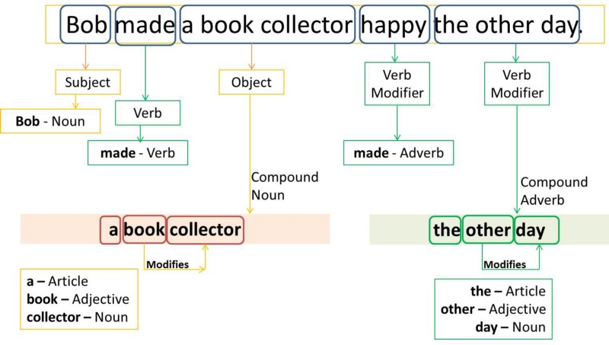
Figure 3 POS Tagging Process Diagram:

Application Example: Implementing POS Tagging with Hugging Face Transformers
This example proves how to implement POS tagging using the Hugging Face transformers library with a pre-trained BERT model fine-tuned for the POS tagging task. The process begins by loading both the tokenizer and model that have been specifically trained to perform token classification. The pipeline for POS tagging is set up, which simplifies the entire task of token classification by integrating tokenization, model inference, and result generation into a single step.
Once the pipeline is set up, we provide an example sentence, "The quick brown fox jumps over the lazy dog." The pipeline processes this input and outputs the POS tags for each word, naming them as nouns, verbs, adjectives, and other parts of speech. This approach highlights the utility of transformer-based models in simplifying and improving the efficiency of common NLP tasks, such as POS tagging, which are foundational for tasks like grammar checking, machine translation, and syntactic analysis.
The code snippet below illustrates how this process works in practice:
``python
from transformers import AutoModelForTokenClassification, AutoTokenizer, pipeline
# Load tokenizer and model
model = AutoModelForTokenClassification.from_pretrained("bert-base-cased-finetuned-pos")
tokenizer = AutoTokenizer.from_pretrained("bert-base-cased-finetuned-pos")
# Setup POS tagging pipeline
pos_pipeline = pipeline("token-classification", model=model, tokenizer=tokenizer)
# Example sentence
sentence = "The quick brown fox jumps over the lazy dog."
# Perform POS tagging
pos_results = pos_pipeline(sentence)
# Display POS tags
print("POS Tags:")
for token in pos_results:
print(f"Word: {token['word']}, POS Tag: {token['entity']}")
``
In this example, the model setup involves loading a pre-trained BERT model specifically fine-tuned for POS tagging. The POS tagging pipeline simplifies the token classification task, where each word in the sentence is analyzed and tagged with its corresponding part of speech. As the model processes the input sentence, it outputs the POS tags, showing the model's ability to correctly name and label distinct parts of speech for each word.
This section offers a comprehensive understanding of POS tagging, detailing its technical mechanisms and practical applications while giving a firsthand coding example that proves how to implement this task using advanced models like BERT. By using the Hugging Face transformers library, we can streamline complex NLP tasks, making them more accessible and efficient in real-world applications.

Model training and evaluation
Training and evaluating sequence labeling models effectively are crucial for achieving high performance in tasks such as Named Entity Recognition (NER) and Part-of-Speech (POS) tagging. This section outlines the best practices for training these models and the methodologies used to evaluate their performance.

Best practices for training sequence labeling models
Training sequence labeling models requires a careful approach to ensure that the model not only learns to predict the correct labels but also generalizes well to new, unseen data.
- Data preparation: Quality and quantity of training data significantly affect model performance. It is crucial to use a well-annotated, diverse dataset that stands for the variability of language in real-world scenarios.
- Feature selection: Choosing the right set of features is vital. For traditional models like CRFs, manually crafted features such as word suffixes, prefixes, and POS tags are useful. For neural models, embeddings that capture semantic meanings, like word2vec or GloVe, enhance the model's understanding.
- Regularization and dropout: To prevent overfitting, especially in deep learning models, techniques like L2 regularization and dropout are employed during training.
- Transfer learning: Using pre-trained models and fine-tuning them on specific tasks can drastically improve performance due to the pre-learned contextual representations in the model [6].

Methods for evaluating the performance of NER and POS Tagging systems.
When training sequence labeling models, it is essential to follow best practices that ensure robust performance and adaptability across various real-world datasets. These practices not only help the model learn correct label predictions but also improve its ability to generalize effectively to unseen data. The following key strategies are fundamental for achieving best results when training sequence labeling models:
- Accuracy: The most straightforward metric, accuracy measures the proportion of correctly predicted labels over all predictions.
- Precision, recall, and F1-Score: Precision measures the accuracy of positive predictions, recall measures the coverage of actual positive cases, and the F1-score provides a balance between precision and recall.
- Confusion matrix: Provides a detailed breakdown of predictions versus actual labels, helping name specific areas where the model is underperforming.

Examples of application
Named Entity Recognition (NER) and Part-of-Speech (POS) tagging are powerful tools that support a wide range of real-world applications, from biomedical research to understanding social media language. These applications highlight the versatility and importance of these NLP techniques in extracting meaningful information, enabling advanced insights across diverse domains. Below are specific examples that show the practical use of NER and POS tagging, as well as an illustrative case of training and evaluating an NER model.

Application: NER on biomedical text
In the biomedical field, Named Entity Recognition (NER) systems are vital for extracting critical medical entities such as drug names, symptoms, and diseases from clinical texts. These extractions play a key role in enhancing patient care, advancing medical research, and supporting drug discovery. For example, an NER system could parse electronic health records to find mentions of specific medications or conditions, enabling data-driven decision-making in healthcare settings.

Application: POS Tagging on social media text
Social media text is often informal, having slang, abbreviations, and emoticons. Applying POS tagging in this domain offers structural insights into the language, helping tasks like sentiment analysis, content filtering, and linguistic research. By assigning parts of speech to informal language elements, researchers and practitioners can gain a deeper understanding of communication trends, helping to refine algorithms for tasks such as automated moderation or opinion mining.

Application example: Training and evaluating an NER Model
This example illustrates the process of training and evaluating a Named Entity Recognition (NER) model using the Hugging Face Transformers library. In this scenario, the goal is to adapt a pre-trained BERT model for token classification to recognize entities such as names or locations in text data. The process begins with loading a labeled dataset and preparing the data through tokenization using the BERT tokenizer. Labels are aligned with the tokenized inputs to ensure consistency during training. The model is then fine-tuned with a specified number of epochs and batch size. Following training, the model is evaluated using metrics like precision, recall, and F1-score to measure its effectiveness in accurately naming entities.
The following code snippet proves the process of training and evaluating the NER model:
`python
from transformers import BertTokenizer, BertForTokenClassification, Trainer, TrainingArguments
from datasets import load_dataset

# Load tokenizer and model
tokenizer = BertTokenizer.from_pretrained('bert-base-cased')
model = BertForTokenClassification.from_pretrained('bert-base-cased', num_labels=9)

# Load and preprocess dataset
dataset = load_dataset("conll2003")
def tokenize_and_align_labels(examples):
tokenized_inputs = tokenizer(examples['tokens'], truncation=True, padding='max_length', is_split_into_words=True)
labels = []
for i, label in enumerate(examples['ner_tags']):
word_ids = tokenized_inputs.word_ids(batch_index=i)
label_ids = [label[word_idx] if word_idx is not None else -100 for word_idx in word_ids]
labels.append(label_ids)
tokenized_inputs['labels'] = labels
return tokenized_inputs
dataset = dataset.map(tokenize_and_align_labels, batched=True)

# Define training arguments
training_args = TrainingArguments(
output_dir='./results',
num_train_epochs=3,
per_device_train_batch_size=16,
learning_rate=2e-5
)

# Initialize trainer
trainer = Trainer(
model=model,
args=training_args,
train_dataset=dataset['train'],
eval_dataset=dataset['validation']
)

# Train the model
trainer.train()
`
In this code, we first prepare and tokenize the dataset using a BERT tokenizer, ensuring the labels are properly aligned with the tokenized inputs through the function tokenize_and_align_labels. This preprocessing step is essential for training the model with the correct label mappings. Next, we set up a pre-trained BERT model that has been fine-tuned for token classification tasks, which includes configuring the model to manage the specific number of labels present in the dataset. The training process is started by specifying key parameters such as the number of epochs and the batch size, after which the model undergoes evaluation using metrics like precision, recall, and F1-score to assess its performance in recognizing and classifying named entities. This streamlined workflow highlights the process of building and optimizing an NER model using Hugging Face transformers, offering both a theoretical and practical understanding of how these systems function in real-world applications.
not only provides an in-depth understanding of training and evaluating sequence labeling models but also illustrates their practical applications in real-world scenarios, supported by a coding example.

Wrapping up chapter 5
In Chapter 5, we thoroughly explored the fundamentals of sequence labeling in natural language processing (NLP), focusing on key tasks such as Named Entity Recognition (NER) and Part-of-Speech (POS) tagging. We began by introducing the importance of sequence labeling in structuring and analyzing raw text data, followed by a deep dive into the practical applications of NER and POS tagging across fields like healthcare, media, and finance. Throughout the chapter, we showed how advanced models, especially those based on transformers, have significantly improved the accuracy and adaptability of these tasks. Practical coding examples using Hugging Face Diffusion illustrated the real-world implementation of these techniques, solidifying our understanding of how sequence labeling models can be trained and improved.
Our goal was to equip readers with the knowledge and tools necessary to effectively implement, train, and evaluate sequence labeling models. With the detailed discussions, examples, and case studies presented, we have successfully laid a solid foundation for tackling real-world NLP challenges.
Looking Ahead to Chapter 6
As we transition to Chapter 6, we will shift from the task of labeling and structuring data to the exciting domain of generative AI. In "Advanced Generative Tasks with Hugging Face Diffusion," we will explore how to use transformer-based models for creating content, including text-to-image and image-to-video synthesis. Building on the principles of deep learning and model training covered in Chapter 5, this next chapter will show the innovative potential of generative AI to not only interpret but also create complex multimedia content.
By the end of Chapter 6, you will gain insight into innovative generative models and their applications, further expanding the horizons of what can be achieved with AI in creative fields. Let's dive into this new frontier of AI-driven creativity.

References

[1] | M. A. Lafferty and F. C. N. Pereira, "Conditional random fields: Probabilistic models for segmenting and labeling sequence data," in Proceedings of the Eighteenth International Conference on Machine Learning, 2001.
[2] | L. R. Rabiner, "A Tutorial on Hidden Markov Models and Selected Applications in Speech Recognition," in Proceedings of the IEEE,, 1989.
[3] | A. McCallum, "Information extraction: Distilling structured data from unstructured text," Queue, vol. 3, p. 48–57, 2005.
[4] | A. Jagannatha and H. Yu, "Structured prediction models for RNN based sequence labeling in clinical text," in Proceedings of the Conference on Empirical Methods in Natural Language Processing, 2016.
[5] | C. K. C. G. Mikolov and J. Dean, "Efficient estimation of word representations in vector space," 2013.
[6] | J. Devlin, M. W. Chang, K. Lee and K. Toutanova, "BERT: Pre-training of deep bidirectional transformers for language understanding," NAACL-HLT, 2018.
[7] | C. D. Manning, "Part-of-Speech Tagging from 97% to 100%: Is It Time for Some Linguistics?," in Computational Linguistics and Intelligent Text Processing, 2011.
[8] | Z. Huang, W. Xu and K. Yu, "Bidirectional LSTM-CRF Models for Sequence Tagging," preprint, 2015.
[9] | J. Pennington, R. Socher and C. D. Manning, "Glove: Global vectors for word representation," in Proceedings of the 2014 conference on empirical methods in natural language processing (EMNLP), 2014.
[10] | B. Pang and L. Lee, "Opinion mining and sentiment analysis," Foundations and Trends® in Information Retrieval, vol. 2, p. 1–135, 2008.
[11] | C. D. Manning, "The Stanford CoreNLP Natural Language Processing Toolkit," Association for Computational Linguistics (ACL) System Demonstrations, p. 55–60, 2014.
[12] | G. Lample, M. Ballesteros, S. Subramanian, K. Kawakami and C. Dyer, "Neural architectures for named entity recognition," preprint, 2016.
[13] | M. Honnibal and I. Montani, "spaCy 2: Natural language understanding with Bloom embeddings, convolutional neural networks and incremental parsing," preprint, 2017.

