Chapter 1

Introduction to Hugging Face Diffusers Library

Introduction
The Hugging Face Diffusers library has become a transformative tool in natural language processing (NLP), enabling users to leverage the power of transformer-based models across various applications. From sentiment analysis to text generation, this library provides a seamless interface for utilizing cutting-edge architectures, including Bidirectional Encoder Representations from Transformers (BERT) and Generative Pre-trained Transformer (GPT). These models have set new standards in NLP by delivering unmatched performance in both understanding and generating language.
In this chapter, we will embark on a comprehensive journey through the Hugging Face Diffusers library, exploring its key features, functionalities, and practical implications. Beginning with an overview of its architecture, capabilities, and installation process, this chapter aims to provide a foundational understanding of how the library compares to other tools in the NLP landscape. Beyond the basics, we delve into advanced topics, such as training models from scratch, fine-tuning pre-trained models, and deploying these models in real-world production environments.
The practical focus of this chapter ensures that by its conclusion, readers will have the essential skills to effectively train, fine-tune, and deploy models for various NLP tasks. From preparing datasets to optimizing fine-tuning performance and implementing strong deployment strategies, this chapter equips readers with actionable insights and techniques for mastering the Hugging Face Diffusers library.

Structure
In this chapter, we will cover the following topics:
- Hugging Face Diffusers
- Model training with Hugging Face Diffusers
- Introduction to dataset loading and preparation
- Fine-tuning models with Hugging Face Diffusers
- Inference and deployment with Hugging Face Diffusers
- Practicing fine-tuning the transformer model for Sentiment analysis

Technical Overview of Hugging Face Diffusers
Initially known for its work in conversational AI, Hugging Face quickly expanded its offerings to leverage the power of transformer architectures, such as BERT and GPT, to enhance the way machines understand and generate human language through an open-source platform that simplifies the implementation of state-of-the-art NLP models. ^{[1]}.
The Hugging Face Diffusers library was developed to democratize access to powerful transformer-based models, making innovative NLP technology more accessible to researchers and developers. It offers pre-trained models that can be easily fine-tuned for specific tasks, without needing extensive computational resources or deep learning expertise. These models are available through the Hugging Face model hub, a community-driven repository that hosts over 10,000 pre-trained models covering a wide variety of languages and domains ^{[1]}.
Before the advent of transformer architecture, traditional models like RNNs and LSTMs were widely used for NLP tasks. However, these models inherently suffer from the vanishing gradient problem, particularly when handling long-range dependencies in textual data. For instance, RNNs process sequences token by token, meaning they may forget valuable information at the start of a long text by the time they reach the end, resulting in inferior performance on tasks requiring global context ^{[2].}
Transformers address this challenge by employing a self-attention mechanism that assigns varying importance to different words in a sentence, regardless of their position within the sentence. This is accomplished through multi-headed self-attention layers, which enable the model to focus on multiple parts of a sequence simultaneously, rather than just one part at a time. Consequently, transformers can capture long-range dependencies far more effectively than their predecessors' architecture. ^{[3]}.
This shift was pivotal in advancing state-of-the-art performance in various NLP tasks, including language modeling, machine translation, question answering, and text summarization, leading to the widespread adoption of transformer models in both research and industry. ^{[4]; [5]}.
Key features and functionalities
The core architecture of Hugging Face Diffusors includes:
- Encoder-decoder structure: This feature enables bidirectional understanding and generation of text, which is essential for tasks requiring a comprehensive grasp of language context, such as machine translation and content summarization.
- Self-attention mechanism: By dynamically weighing the importance of different words in a sentence, this mechanism significantly enhances the model's ability to comprehend the context and nuances of language.
- Positional encoding: This component integrates positional information with input embeddings, helping the model maintain awareness of word order and the structural flow of language.
Comparison with other NLP libraries
Compared to earlier NLP models, Hugging Face Diffusers offer distinct advantages:
- Pre-trained model accessibility: Hugging Face offers a wide range of pre-trained models that can be fine-tuned with relative ease. This pre-training phase significantly reduces the need for large-scale computational resources to train models from scratch, thereby democratizing access to high-performance NLP models.
- Parallel processing: The capability to process input sequences simultaneously greatly accelerates both training and inference phases.
- Flexibility and scalability: Hugging Face Diffusers support multiple frameworks, including PyTorch and TensorFlow, making it highly flexible for integration into various development pipelines. The library is also scalable, capable of handling models across a range of use cases, from small-scale deployments on mobile devices to large-scale distributed systems. ^{[6]}.
- Support for multi-modal tasks: Although primarily focused on NLP, Hugging Face Diffusers also support multi-modal tasks that combine text with images or other inputs, further expanding their range of applications. This capability is critical for functions such as visual question answering and image captioning, where textual and visual inputs must be processed simultaneously.
- Superior performance: Hugging Face Diffusors consistently achieve cutting-edge results on various NLP benchmarks, underscoring their exceptional accuracy and generalization capabilities across different languages and tasks ^{[7]}.
- Transformers API: The core API integrates seamlessly with both PyTorch and TensorFlow, enabling users to train and deploy models with their preferred deep learning framework. This flexibility makes it accessible to a broad audience of developers and researchers ^{[8]; [9]}.
- Tokenizers: Efficient tokenization is crucial for transformer models, and Hugging Face provides the Tokenizers library, optimized for handling various text formats and ensuring the efficient processing of input sequences. Tokenization entails splitting text into sub-word units, adding special tokens, and preparing the data for model input ^{[3]}.
- Model fine-tuning: Fine-tuning pre-trained models for specific tasks remains one of the library’s most powerful features. Hugging Face supports a wide variety of NLP tasks, from text classification to generative tasks, enabling users to adapt general-purpose models to specialized fields with minimal data ^{[10]}.
- Trainer API: The Trainer API abstracts the complexities of managing training loops, making it easy to train models from scratch or fine-tune pre-trained models. The API handles all essential aspects of training, including gradient computation, loss optimization, and evaluation, while supporting multi-GPU and distributed training environments. ^{[11]}.

Model training with Hugging Face Diffusers
Training a transformer model from scratch is computationally intensive due to the model's architecture, which involves millions or even billions of parameters that must be learned through exposure to large-scale datasets. ^{[12]} Unlike smaller models such as RNNs or LSTMs, transformers can handle large sequences of text data, but this requires robust infrastructure, including powerful Graphics Processing Units (GPUs) and Tensor Processing Units (TPUs), as well as a well-optimized codebase. Hugging Face Diffusers helps mitigate these complexities by offering pre-built libraries and optimized APIs that streamline the model training process.
When training from scratch, the focus is on two main parts: the data pipeline and the training loop. The data pipeline transforms raw data into a format suitable for the model. Meanwhile, the training loop manages the iterative process of updating the model's parameters to reduce prediction errors. Both steps require careful setup to ensure effective learning.
In this section, we will explore the detailed steps of training a transformer-based model from scratch, including setting up the environment, preparing datasets, and adjusting training parameters.
Setting up the environment and installation
The first step in training a model with Hugging Face Diffusers is to set up the proper development environment. This involves installing necessary dependencies and configuring the hardware infrastructure, especially if GPU acceleration is needed for efficient training. Although training transformer models on CPUs is technically feasible, the time and computational resources required make it impractical for all but the smallest datasets.

Hardware requirements
To ensure efficient training of transformer models with Hugging Face Diffusers, solid hardware infrastructure is crucial. GPUs are almost always necessary because of the high computational demands of these models. Hugging Face supports training with NVIDIA GPUs using either PyTorch or TensorFlow, enabling the parallel processing of large data batches and accelerating both training and inference times. ^{[13]} Alternatively, TPUs offer a practical solution for large-scale projects. These specialized accelerators, available through services like Google Colab and Google Cloud, can significantly cut down the training time for complex models by providing high-throughput matrix operations optimized for deep learning tasks. ^{[14]}.

Software requirements
Python is the primary programming language for the Hugging Face Diffusers library, requiring version 3.8 or later to ensure compatibility with its dependencies and underlying frameworks. In terms of deep learning infrastructure, the library supports both PyTorch and TensorFlow, two of the most widely used frameworks for building and training neural networks. While each framework has its distinct advantages, PyTorch is often the preferred choice within the research community due to its dynamic computation graph, offering greater flexibility for iterative experimentation and model prototyping. ^{[8]}.
Pip enables an easy Installation, as follows:
``` bash
pip install transformers torch
```
To ensure a clean and reproducible environment, it is advisable to use virtual environments or Docker containers. Virtual environments help isolate project dependencies, which prevents version conflicts, while Docker ensures consistency in the training environment across different machines.

Virtual environment setup
To ensure a clean and reproducible development environment, it's advisable to set up a Python virtual environment before installing the Hugging Face Diffusers library. You can achieve this using the following commands:
``` bash
python -m venv hf-env
`
source hf-env/bin/activate # On Windows: hf-env\Scripts\activate
```
This setup isolates the Hugging Face Diffusers library along with its dependencies from other projects on the system, preventing version conflicts and improving reproducibility across development and deployment environments.

Loading and preparing datasets
Central to practical model training is the availability and preparation of high-quality datasets:
- Dataset selection: Guidance on selecting appropriate datasets for specific NLP tasks, considering factors like data size, domain relevance, and annotation quality. Examples include publicly available datasets such as IMDb for sentiment analysis and CoNLL-2003 for named entity recognition.
- Data preprocessing: Detailed procedures for data preprocessing, including tokenization, padding, and encoding, are crucial. Illustrative examples or code snippets can clarify how to transform raw text data into a format suitable for training transformer models within the Hugging Face Diffusers framework.

Introduction to dataset loading and preparation
Practical model training relies significantly on the quality and readiness of the datasets used. The Hugging Face Diffusers library provides a robust framework for working with textual datasets, allowing users to easily load, preprocess, and transform raw data into formats suitable for advanced transformer-based models. Proper dataset selection and preparation are essential for achieving optimal model performance and adaptability to specific NLP tasks. Whether working with popular datasets, such as IMDb for sentiment analysis or CoNLL-2003 for named entity recognition, understanding dataset preprocessing techniques is key to unlocking the potential of modern NLP models.
Figure 1.1 provides a high-level view of how a Hugging Face text classification pipeline, such as BERT, can be deployed to analyze product reviews, transforming raw text into sentiment predictions and actionable business insights.
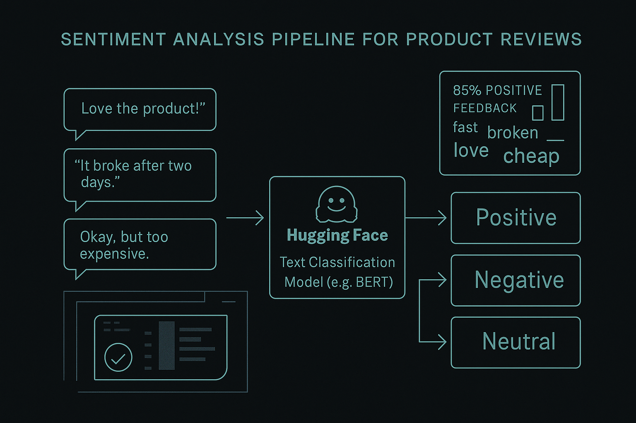
Figure 1.1 Sentiment analysis pipeline for product reviews.
The visual representation of the sentiment analysis pipeline for product reviews, utilizing a Hugging Face transformer model as shown in the previous figure, where raw text inputs are classified into positive, negative, or neutral sentiments, while aggregated insights support broader decision-making.
This code snippet illustrates how to establish training arguments as part of the preprocessing and training pipeline. These parameters define essential aspects of the training process, including batch sizes, learning rate schedules, and directory management, ensuring a controlled and efficient training workflow.

```python

from transformers import TrainingArguments
training_args = TrainingArguments(
output_dir='./results', # output directory
num_train_epochs=3, # number of training epochs
per_device_train_batch_size=16, # batch size for training
per_device_eval_batch_size=64, # batch size for evaluation
Wampuses=500, # number of warmup steps for learning rate scheduler
weight decay=0.01, # strength of weight decay
logging Dir='./logs', # directory for storing logs
)
```
The provided code demonstrates how to configure training arguments using the TrainingArguments class from the Hugging Face Transformers library. These arguments establish the foundation for training and evaluating NLP models, specifying parameters that directly influence performance, computational efficiency, and resource management.
- Output directory: The output_dir parameter specifies the path where the model's checkpoints and other outputs will be stored. This ensures that all training artifacts are saved for later use, including resuming training or fine-tuning.
- Number of training epochs: The num_train_epochs parameter specifies the total number of passes over the training dataset. A value of 3 indicates that the model will iterate over the dataset three times, striking a balance between learning the data's patterns and avoiding overfitting.
- Batch size: The per_device_train_batch_size and per_device_eval_batch_size parameters define the number of samples processed in a single batch during training and evaluation, respectively. Smaller batch sizes decrease memory requirements, while larger batch sizes can lead to faster convergence but may demand more computational resources.
- Warmup steps: The warmup_steps parameter specifies the number of first steps during which the learning rate gradually increases from zero to its peak value. This prevents abrupt changes in weight updates early in training, improving stability and convergence.
- Weight decay: The weight decay parameter applies regularization to prevent overfitting. Penalizing large weights in the model encourages simpler, more generalizable solutions.
- Logging directory: The logging_dir parameter specifies the location where the training process logs are stored. These logs include critical metrics such as loss, accuracy, and validation scores, which are essential for monitoring and debugging the training pipeline.
Essentially, this configuration creates a foundation for a controlled and efficient training process. When combined with appropriately preprocessed datasets and a well-designed model architecture, these training arguments ensure that the model learns effectively from the data while maintaining scalability and adaptability for various NLP tasks.
Training models from scratch using Hugging Face Diffusers
Here is how to configure and train your model from scratch:
- Model configuration: Set the configuration parameters such as the number of epochs, learning rate, and batch size:
```python
from transformers import TrainingArguments
training_args = TrainingArguments(
output_dir='./results', # output directory
num_train_epochs=3, # number of training epochs
per_device_train_batch_size=16, # batch size for training
per_device_eval_batch_size=64, # batch size for evaluation
warmup_steps=500, # number of warmup steps for learning rate scheduler
weight_decay=0.01, # strength of weight decay
logging_dir='./logs', # directory for storing logs
)
```
- Model initialization and training: Initialize the model and start the training process:
```python
from transformers import BertForSequenceClassification, Trainer
model = BertForSequenceClassification.from_pretrained('bert-base-uncased')
trainer = Trainer(
model=model, # the instantiated 🤗 Transformers model to be trained
args=training_args, # training arguments, defined above
train_dataset=train_dataset, # training dataset
eval_dataset=eval_dataset # evaluation dataset
)
trainer.train()
```
With a solid foundation in training models from scratch, we are now equipped to delve into the fine-tuning process, where we will adapt pre-trained models to excel on specific NLP tasks, further enhancing their performance and applicability in real-world scenarios.

Fine-tuning models with Hugging Face Diffusers
Fine-tuning pre-trained models is a crucial step in adapting these advanced models to specific tasks. In this section, we first examine the significance of fine-tuning in natural language processing workflows, followed by a thorough, step-by-step guide that covers data preparation, model selection, training procedures, and evaluation strategies.
Importance of fine-tuning pre-trained models
Fine-tuning pre-trained models are essential in NLP for distinct reasons:
- Domain adaptation: Pre-trained models, such as BERT and GPT, which are trained on large-scale datasets, capture general language patterns. Fine-tuning enables these models to adapt to domain-specific nuances and vocabulary, enhancing performance on tasks ^{[4]}.
- Task specificity: By fine-tuning, researchers can customize models for specific NLP tasks such as sentiment analysis, named entity recognition (NER), or machine translation. This process involves adjusting model parameters to optimize performance metrics relevant to the task at hand.
- Efficiency: Fine-tuning utilizes the transfer learning paradigm, where models trained on large datasets require fewer annotated examples to adapt to new tasks. This efficiency minimizes the data and computational resources needed for training domain-specific models ^{[7]}.
Before a model can generate insightful predictions, it must first be attuned to the task at hand. Fine-tuning transforms a generic transformer into a task-specific engine, precisely calibrated to the linguistic and structural nuances of your data. Figure 1.2 below illustrates a step-by-step schematic of the fine-tuning process for a pre-trained transformer model (e.g., BERT) in binary sentiment classification. Each stage—from data preparation and tokenization to model selection and training—ensures task alignment and optimal performance.
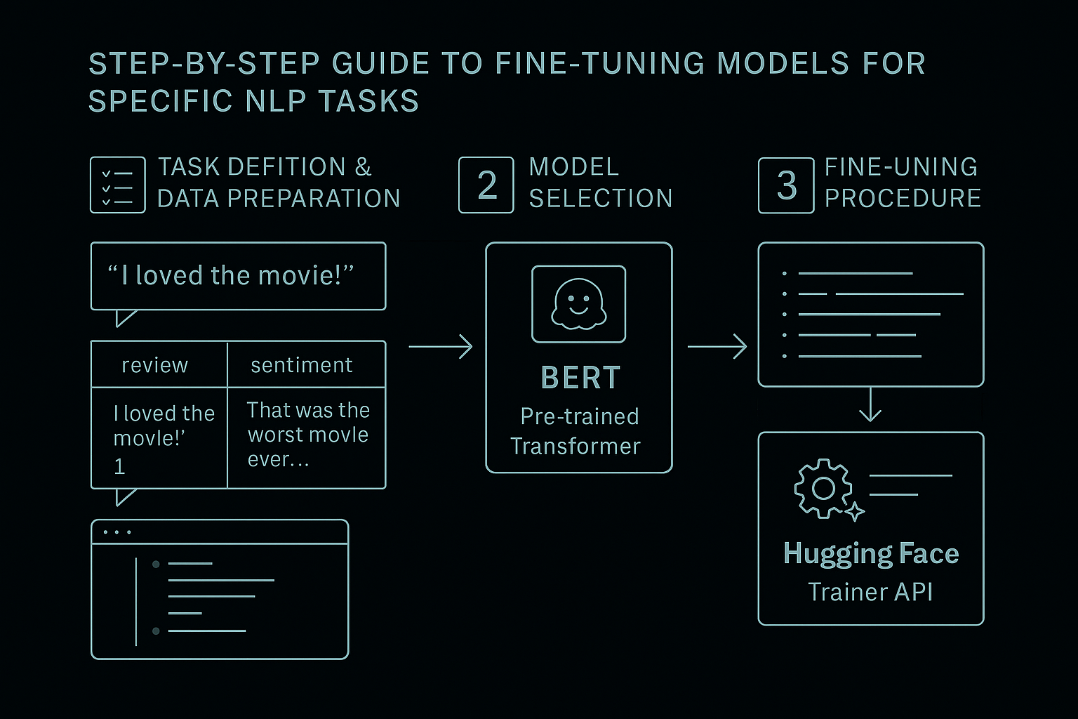
Figure 1. 2 Fine-tuning process of a pre-trained BERT model.
Step-by-step guide to fine-tuning models for specific NLP tasks
Fine-tuning a pre-trained transformer model requires a structured approach that adapts the model to the specific nuances of a chosen NLP task. In the following example, we will walk through the process of fine-tuning a BERT-based model for sentiment analysis. This task involves classifying short text reviews as expressing either positive or negative sentiment. Each step will illustrate not only what needs to be done but also how to do it, providing concrete implementation details and code snippets:
- Task definition and data preparation:
- To start, define your NLP task, in this case, binary sentiment classification, and prepare your dataset accordingly. Let us say we are working with a small dataset of movie reviews, where each review is labeled as either positive (1) or negative (0). First, create a simple DataFrame and split it into training and testing sets:
```python

import pandas as pd
from sklearn.model_selection import train_test_split

data = {
'review': ['I loved the movie!', 'That was the worst movie ever...'],
'sentiment': [1, 0] # 1 = positive, 0 = negative
}

df = pd.DataFrame(data)
train_df, test_df = train_test_split(df, test_size=0.25)
```
- Next, tokenize and encode the text data using a custom PyTorch Dataset class:
```python

from transformers import BertTokenizer
from torch.utils.data import Dataset
import torch

class MovieReviewDataset(Dataset):
def __init__(self, reviews, sentiments):
self.reviews = reviews
self.sentiments = sentiments
self.tokenizer = BertTokenizer.from_pretrained('bert-base-uncased')

def __len__(self):
return len(self.reviews)

def __getitem__(self, idx):
review = str(self.reviews[idx])
sentiment = self.sentiments[idx]
encoding = self.tokenizer.encode_plus(
review,
add_special_tokens=True,
max_length=512,
return_token_type_ids=False,
padding='max_length',
return_attention_mask=True,
return_tensors='pt',
)
return {
'input_ids': encoding['input_ids'].flatten(),
'attention_mask': encoding['attention_mask'].flatten(),
'labels': torch.tensor(sentiment)
}

train_dataset = MovieReviewDataset(train_df['review'].tolist(), train_df['sentiment'].tolist())
test_dataset = MovieReviewDataset(test_df['review'].tolist(), test_df['sentiment'].tolist())
```
- Model selection:
- Select a pre-trained transformer model that suits the task. For binary sentiment classification, we use BERT with two output labels:
`python

from transformers import AutoModelForSequenceClassification

model = AutoModelForSequenceClassification.from_pretrained('bert-base-uncased', num_labels=2)
`
b. This configuration loads a BERT model that is fine-tuned for classification tasks with two target classes.
- Fine-tuning procedure:
- Set the training hyperparameters and initiate the fine-tuning process using Hugging Face's Trainer API. This automates the training loop and performance tracking:
```python

from transformers import Trainer, TrainingArguments

training_args = TrainingArguments(
output_dir='./results',
num_train_epochs=3,
per_device_train_batch_size=4,
per_device_eval_batch_size=4,
warmup_steps=500,
weight_decay=0.01,
evaluation_strategy="epoch",
logging_dir='./logs',
)

trainer = Trainer(
model=model,
args=training_args,
train_dataset=train_dataset,
eval_dataset=test_dataset
)

trainer.train()
```
This section demonstrates how to fine-tune transformer models by adapting pre-trained architectures to specific NLP tasks through data preparation, model selection, and parameter tuning. These skills are essential for optimizing model performance in real-world applications.
Once fine-tuned, a model’s actual value is realized only when deployed accurately, repeatably, and at scale. Inference marks the moment training becomes application. Figure 1.3 below shows a flowchart detailing the complete inference and deployment workflow using Hugging Face Diffusers. It includes model loading, input preprocessing, prediction generation, API deployment, and production monitoring.
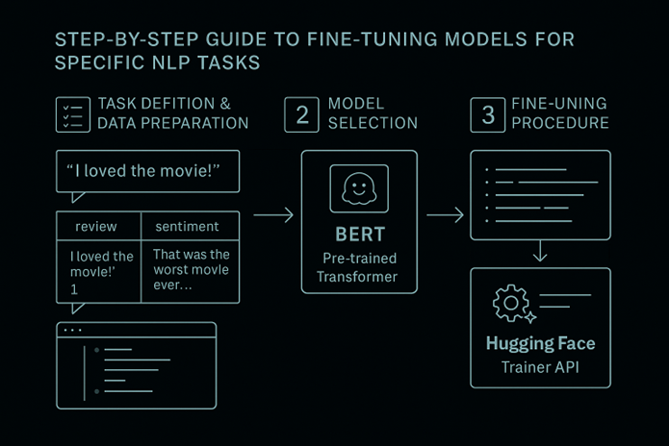
Figure 1.3 Complete inference and deployment workflow.
In the next section, we will examine the practical applications of these trained models.

Inference and deployment with Hugging Face Diffusers
This section examines the key aspects of performing inference and deploying trained transformer models using the Hugging Face Diffusers library. It provides a thorough guide for carrying out inference tasks, techniques for deploying models in production settings, and strategies for monitoring and maintaining deployed models.
Performing inference with trained models
Inference is the process of using a trained model to make predictions or process new data. Essential steps are taken to perform this task effectively by processing input and generating output. These steps ensure the model functions as intended on new data:
- Model loading: Retrieve the trained transformer model from storage or checkpoint files by using Hugging Face's model loading utilities. This step ensures that the model is prepared for inference tasks without any issues during retraining.
- Input data processing: Prepare input data for inference by tokenizing and encoding text or sequences to meet the model's requirements. Hugging Face's tokenizer and data preprocessing pipelines simplify this process.
- Prediction generation: Feed the preprocessed data into the loaded model to carry out inference tasks. Depending on the task, generate predictions such as classification labels, text generation, or sequence tagging ^{[1]}.
Techniques for deploying models in production
Deploying NLP models in production environments involves several key considerations:
- Environment setup: Set up production environments to enable model inference while ensuring compatibility with software dependencies, hardware specifications, and scalability requirements.
- API integration: Expose model functionalities via RESTful APIs or microservices to enable seamless integration with other applications or systems. Utilize frameworks like Flask or FastAPI to develop robust APIs endpoints. ^{[15]}.
- Containerization: Package models and their dependencies within Docker containers to ensure portability and reproducibility across various deployment environments. Container orchestration tools, such as Kubernetes, enable efficient deployment and scaling of containerized applications.
Monitoring and keeping deployed models
Maintaining model performance and reliability in production requires ongoing monitoring and management.
- Performance metrics: Define and monitor KPIs like inference latency, throughput, and error rates to assess model effectiveness and responsiveness.
- Error handling: Implement strong error handling mechanisms to manage exceptions and edge cases during inference, ensuring smooth degradation resilience.
- Model versioning: Maintain multiple versions of deployed models using version control systems or model registries. This practice enables rollbacks to earlier versions and supports A/B testing for new model iterations.
Fine-tuning enables transformer models to tailor their performance to specific NLP tasks, thereby enhancing their accuracy. With this foundation in place, we can now shift our focus to model deployment.
The following section provides practical strategies for making inferences and using trained models in real-world settings.

Practicing fine-tuning the transformer model for sentiment analysis
This example demonstrates how to fine-tune a pre-trained transformer model from Hugging Face's library for sentiment analysis. The task involves classifying movie reviews as either positive or negative sentiments. Let us get started:
- Let us import the required libraries: To develop and train a sentiment classifier based on BERT, we start by importing the necessary libraries. These include modules from Hugging Face Transformers, PyTorch, and standard utilities for data management and model training.
`python
from transformers import BertTokenizer, BertForSequenceClassification, Trainer, TrainingArguments
import torch
from torch.utils.data import DataLoader, Dataset
import pandas as pd
from sklearn.model_selection import train_test_split
`
- Dataset preparation: The code starts by preparing a small dataset of movie reviews and their sentiments. This dataset is divided into training and testing subsets.
```python
# Sample dataset
data = {'review': ['I loved the movie!', 'That was the worst movie ever...'],
'sentiment': [1, 0]} # 1 for positive, 0 for negative
df = pd.DataFrame(data)
# Splitting the dataset
train_df, test_df = train_test_split(df, test_size=0.25)
```
- Custom dataset class: A custom PyTorch Dataset class is created to handle the tokenization and encoding of reviews using the BERT tokenizer.
```python
class MovieReviewDataset(Dataset):
def __init__(self, reviews, sentiments):
self.reviews = reviews
self.sentiments = sentiments
self.tokenizer = BertTokenizer.from_pretrained('bert-base-uncased')
def __len__(self):
return len(self.reviews)
def __getitem__(self, idx):
review = str(self.reviews[idx])
sentiment = self.sentiments[idx]
encoding = self.tokenizer.encode_plus(
review,
add_special_tokens=True,
max_length=512,
return_token_type_ids=False,
padding='max_length',
return_attention_mask=True,
return_tensors='pt',
)
return {
'review_text': review,
'input_ids': encoding['input_ids'].flatten(),
'attention_mask': encoding['attention_mask'].flatten(),
'labels': torch.tensor(sentiment)
}
# Prepare the dataset
train_dataset = MovieReviewDataset(train_df['review'].tolist(), train_df['sentiment'].tolist())
test_dataset = MovieReviewDataset(test_df['review'].tolist(), test_df['sentiment'].tolist())
```
- Model initialization: BertForSequenceClassification is initialized with two labels, suitable for binary classification (positive and negative reviews).
```python
# Load the pre-trained BERT model
model = BertForSequenceClassification.from_pretrained('bert-base-uncased', num_labels=2)
```
- Training setup: TrainingArguments are set up for the training process, specifying the number of epochs, batch size, warmup steps, and directories for outputs and logs.
```python
# Training arguments
training_args = TrainingArguments(
output_dir='./results',
num_train_epochs=3,
per_device_train_batch_size=4,
per_device_eval_batch_size=4,
warmup_steps=500,
weight_decay=0.01,
evaluate_during_training=True,
logging_dir='./logs',
)
```
- Training: The model is trained using Hugging Face's Trainer API, which simplifies the training loop evaluation.
```python
# Initialize the Trainer
trainer = Trainer(
model=model,
args=training_args,
train_dataset=train_dataset,
eval_dataset=test_dataset
)
# Start training
trainer.train()
```
This example is ideal for proving how to fine-tune a transformer model on a specific NLP task using real-world data.
Results analysis
During training, the model should show improved accuracy in classifying sentiments as positive or negative. By testing the model on the test dataset, we can evaluate its precision, recall, and F1 Score to ensure it performs consistently across various text samples. These performance metrics help understand the model's ability to generalize from training data to new data, providing insights into its real-world deployment.
Key takeaways
Let us discuss the key learnings from this practical exercise:
- Model adaptability: The example illustrates how BERT, trained initially on a large corpus for various tasks, can be effectively fine-tuned for a specific task, such as sentiment analysis. This adaptability is essential for employing pre-trained models, thereby minimizing the time and resources required for training models from scratch.
- Simplicity of implementation: Utilizing Hugging Face's Transformers and Trainer API streamlines the implementation of complex training routines, enabling researchers and developers to concentrate more on model tuning and less on boilerplate code.
- Practical application: The final trained model can be integrated into various applications, ranging from automated review systems to real-time sentiment analysis tools, demonstrating the model's utility in enhancing user interaction and understanding consumer sentiment.
This practical example not only provides a comprehensive understanding of fine-tuning transformers but also lays a foundation for readers to explore more complex NLP tasks, thereby enhancing their skills in developing AI-driven solutions. As we continue, we will investigate model optimization and deployment strategies in greater detail to ensure these models perform optimally in production environments.

Conclusion
In this chapter, we examine the foundational elements of the Hugging Face Diffusers library, which has become a cornerstone in advancing natural language processing (NLP) tasks. We start with an introduction to the library's architecture and unique capabilities, exploring its core functionalities, including model training, fine-tuning, inference, and deployment. Through detailed explanations and practical steps, we provide insights into setting up the library, preparing datasets, and training models from scratch with its seamless integration into frameworks like PyTorch.
We emphasized the importance of fine-tuning pre-trained models for specific NLP tasks, providing a systematic guide to enhance performance and tailor models to specialized datasets. The chapter covered best practices for improving model generalization and robustness, highlighting the significance of fine-tuning in achieving cutting-edge results. Additionally, we explored inference techniques and deployment strategies, ranging from real-world integration to maintaining model performance in production environments.
We have also explored the essential process of fine-tuning pre-trained transformer models using the Hugging Face Diffusion library. By adjusting models to fit specific tasks, we enhance their performance and tailor them to meet the unique demands of various NLP challenges. Fine-tuning not only helps adapt models to domain-specific languages but also refines them for precise tasks, making this approach invaluable for achieving high accuracy in specialized applications.
In the next chapter, we will further explore the Hugging Face Diffusers library by focusing on its advanced features and methodologies. Topics will include a comprehensive examination of transformer-based architecture, the underlying mathematical principles of its success, and its implications for various NLP applications, by connecting foundational knowledge with advanced insights. It aims to equip you with the skills necessary to harness the potential of these transformative models fully.

References

1. [1] | T. Wolf, V. Sanh, J. Chaumond and C. Delangue, "Transformers: State-of-the-Art Natural Language Processing," in Proceedings of the 2020 Conference on Empirical Methods in Natural Language Processing: System Demonstrations, 2020.
2. [2] | R. Pascanu, T. Mikolov and Y. Bengio, "On the difficulty of training recurrent neural networks.," in Proceedings of the 30th International Conference on Machine Learning (ICML-13), 2013.
3. [3] | C. Raffel, N. Shazeer, A. Roberts, K. Lee, S. Narang, M. Matena, Y. Zhou, W. Li and P. J. Liu, "Exploring the Limits of Transfer Learning with a Unified Text-to-Text Transformer.," Journal of Machine Learning Research, vol. 21, no. 140, pp. 1-67, 2020.
4. [4] | J. Devlin, M. Chang, K. Lee and K. Toutanova, BERT: Pre-training of Deep Bidirectional Transformers for Language Understanding, 2019.
5. [5] | A. Radford, J. Wu, R. Child, D. Luan, D. Amodei and I. Sutskever, "Language Models are Unsupervised Multitask Learners," 2019. [Online].
6. [6] | T. B. Brown, B. Mann, N. Ryder, M. Subbiah, J. Kaplan, P. Dhariwal and D. Amodei, "Language Models are Few-Shot Learners," arXiv preprint, 2020.
7. [7] | D. Rao and B. McMahan, Natural Language Processing with PyTorch: Build Intelligent Language Applications Using Deep Learning, O'Reilly Media, 2019.
8. [8] | A. Paszke, S. Gross, F. Massa, A. Lerer, J. Bradbury, G. Chanan and S. Chintala, "PyTorch: An imperative style, high-performance deep learning library," Information Processing Systems, vol. 32, p. 8024–8035, 2019.
9. [9] | M. Abadi, P. Barham, J. Chen, Z. Chen, A. Davis, J. Dean and M. Kudlur, "TensorFlow: A system for large-scale machine learning," in 12th {USENIX} Symposium on Operating Systems Design and Implementation {OSDI}, 2016.
10.[10] | J. Howard and S. Ruder, "Universal Language Model Fine-tuning for Text Classification," arXiv preprint, 2018.
11.[11] | S. Ruder, "An overview of gradient descent optimization algorithms," arXiv preprint, 2016.
12.[12] | A. Vaswani, N. Shazeer, N. Parmar, J. Uszkoreit, L. Jones, A. N. Gomez and I. Polosukhin, "Attention is All You Need," in Advances in Neural Information Processing Systems (NIPS, 2017, p. 5998–6008.
13.[13] | K. Pykes, "Understanding TPUs vs GPUs in AI: A Comprehensive Guide," 30 May 2024. [Online]. Available: https://www.datacamp.com/blog/tpu-vs-gpu-ai. [Accessed 02 October 2024].
14.[14] | N. P. Jouppi, C. Young, N. Patil, D. Patterson, G. Agrawal, R. Bajwa and J. Hennessy, "In-datacenter performance analysis of a tensor processing unit," in roceedings of the 44th Annual International Symposium on Computer Architecture (ISCA), 2017.
15.[15] | F. Pedregosa, G. Varoquaux, A. Gramfort, B. Michel, B. Thirion, G. O. and E. Duchesnay, "Scikit-learn: Machine learning in Python," Journal of Machine Learning Research, vol. 12, p. 2825–2830, 2011.
16. [16] | Y. Liu, M. Ott, N. Goyal, J. Du, M. Joshi, D. Chen, O. Levy, M. Lewis, L. Zettlemoyer and V. Stoyanov, "RoBERTa: A Robustly Optimized BERT Pretraining Approach," arXiv preprint, 26 July 2019.
17.[17] | J. Lu, D. Batra, D. Parikh and S. Lee, "VilBERT: Pretraining Task-Agnostic Visiolinguistic Representations for Vision-and-Language Tasks," Advances in Neural Information Processing Systems, 2019.
18.[18] | L. Huang, A. Vaswani, J. S. N. Uszkoreit, I. Simon, C. Hawthorne and A. M. Dai, "Music transformer: Generating music with long-term structure," arXiv preprint, 2019.
19.[19] | R. Jurado and R. Roselló, "A Survey of Deep Learning in Medicine: Analyzing the Impact of Deep Learning in Disease Diagnosis," Computational Intelligence, vol. 37, p. 321–344, 2021.

