CHAPTER 7

Developer Tools and DevOps

Introduction
This chapter explores the evolving landscape of software development in cloud environments, focusing on how AWS enables agility, scalability, and automation throughout the development lifecycle. It begins with an overview of serverless computing, highlighting how AWS services allow developers to concentrate on code rather than infrastructure. The discussion then shifts to integrated development environments (IDEs) and machine learning to improve code quality and automate reviews.
We examine how continuous integration and deployment (CI/CD) pipelines are implemented using AWS CodeBuild, CodePipeline, and CodeDeploy tools. We also provide security for best practices for CI/CD pipelines, ensuring robust application delivery. The chapter further explores Infrastructure as Code (IaC) using AWS CloudFormation and AWS Cloud Control API to manage scalable, repeatable infrastructure.
Advanced topics such as artifact management, chaos engineering, and resilience testing are introduced to demonstrate how AWS supports robust and fault-tolerant applications. Finally, we explore event-driven architectures (EDA) and their role in building responsive, loosely coupled systems using services like SNS and Step Functions.
By the end of this chapter, readers will understand how to use AWS developer tools and DevOps practices to streamline development, enhance security, and accelerate innovation in the cloud.

Structure
In this chapter, we will go through the following topics:
- Developer Tools
  - Amazon CodeCatalyst
  - Amazon CodeGuru
  - Amazon Corretto
  - AWS Cloud Control API
  - AWS Cloud Development Kit (CDK)
  - AWS Cloud9
  - AWS CloudShell
  - AWS CodeArtifact
  - AWS CodeBuild
  - AWS CodeCommit
  - AWS CodeDeploy
  - AWS CodePipeline
  - AWS CodeStar
  - AWS Command Line Interface (CLI)
  - AWS Device Farm
  - AWS Fault Injection Simulator
  - AWS Tools and SDKs
  - AWS X-Ray
  - Amazon CodeWhisperer

Objectives
We aim to provide readers with a deep understanding of contemporary software development practices within cloud environments, focusing on AWS as the primary platform. This module covers a range of tools, methodologies, and best practices essential for scalable and efficient application development and deployment.
By the end of this module, readers will:
- Understand the principles and benefits of serverless computing, particularly its impact on productivity and operational efficiency in cloud-native applications.
- Gain skills in using IDEs to enhance coding efficiency, collaborate effectively, and use debugging tools for rapid software development.
- Learn how to integrate machine learning algorithms into software development for code quality improvement, automated code reviews, and performance optimization.
- Master artifact management, version control, and dependency management using AWS tools like CodeArtifact to ensure reliable software builds.
- Learn how to implement CI/CD pipelines using AWS CodeBuild, CodeCommit, and CodePipeline, emphasizing best practices for secure and efficient CI/CD processes.
- Become proficient in deploying Infrastructure as Code (IaC) using AWS CloudFormation and Cloud Control API to manage cloud resources programmatically.
- Explore advanced deployment strategies like blue/green and canary releases to achieve zero-downtime deployments.
- Gain knowledge in resilience testing and fault tolerance through chaos engineering to ensure the reliability of cloud applications.
- Understand event-driven architectures (EDA) and learn how to use AWS services like SNS and Step Functions to create scalable and responsive applications.
- Integrate DevOps practices with AWS services to simplify collaboration, automate workflows, and accelerate the software development lifecycle.

Developer tools
AWS offers various developer tools to enhance productivity, simplify workflows, and ensure code quality. Services like Amazon CodeGuru and the AWS Cloud Development Kit (CDK) help developers work more efficiently. At the same time, tools like AWS CloudShell and AWS CodePipeline provide integrated environments for efficient development processes. These tools allow developers to automate the entire development lifecycle, from code creation to deployment on a scale. Exposure to these services will equip you to harness AWS’s full potential for your projects.

DevOps practices
DevOps, an essential part of modern software development, stresses efficient collaboration between development and operations teams to speed up software delivery. AWS offers an extensive suite of services that support DevOps practices. This section explores their capabilities and shows how AWS CodePipeline, AWS CodeBuild, and AWS CodeDeploy automate tasks in the software delivery pipeline. With Amazon CodeStar, you can kick-start projects with well-architected pipelines, while the AWS CDK offers a programmatic way to define infrastructure as code, streamlining cloud infrastructure management.

Application integration
In today’s interconnected world, efficient application integration is vital. This section covers services like Amazon EventBridge and AWS Step Functions, which enable efficient communication between different application components. These tools help coordinate various AWS resources and third-party services, allowing applications to respond quickly to events and messages. By using Amazon AppFlow, developers can simplify data transfers between multiple services. Amazon Simple Queue Service (SQS) and Amazon Simple Notification Service (SNS) help manage event-driven and message-based interactions efficiently.

Containers and robotics
The rise in containerization has brought about significant changes in software deployment and management. AWS offers a complete ecosystem for managing containers with services like Amazon ECS, Amazon EKS, and AWS Fargate. These services allow you to run containerized applications at scale, while AWS App2Container and AWS Copilot make migrating and managing containers in the cloud easier. In addition, AWS provides tools like AWS RoboMaker for developing robotic applications, highlighting the versatility of AWS’s DevOps tools across various domains.

Quantum technologies
The next technological frontier is Quantum computing, and AWS is leading the way with Amazon Braket. This service gives developers access to quantum computing resources, enabling them to experiment with quantum algorithms and hardware. By providing an intuitive interface, Amazon Braket aims to democratize access to quantum computing, making it easier for developers to integrate quantum solutions into their applications. This section explores how developers can experiment with quantum computing and the future potential of this transformative technology.

Developer tools and DevOps
In the digital age, having a deep understanding of developer tools and DevOps practices is essential for accelerating cloud-powered innovation. With AWS’s broad range of tools, developers are equipped to simplify workflows, automate tasks, and improve code quality. These tools support everything from collaborative coding to automated testing and deployment, ensuring your applications are strong and scalable.
Mastering these tools will allow you to build and deploy software more efficiently, collaborate better with your team, and keep a high standard of code quality throughout your projects.
To better visualize how these AWS tools interact within the DevOps pipeline, the diagram below illustrates how services like AWS CodePipeline, AWS CodeBuild, and AWS CodeDeploy integrate to simplify and automate the software delivery process. This integration fosters collaboration across development and operations teams, ensuring efficient and continuous delivery.
Figure 7.1 illustrates how AWS DevOps tools integrate across the software development lifecycle, enabling continuous integration, delivery, and monitoring through a unified set of services.
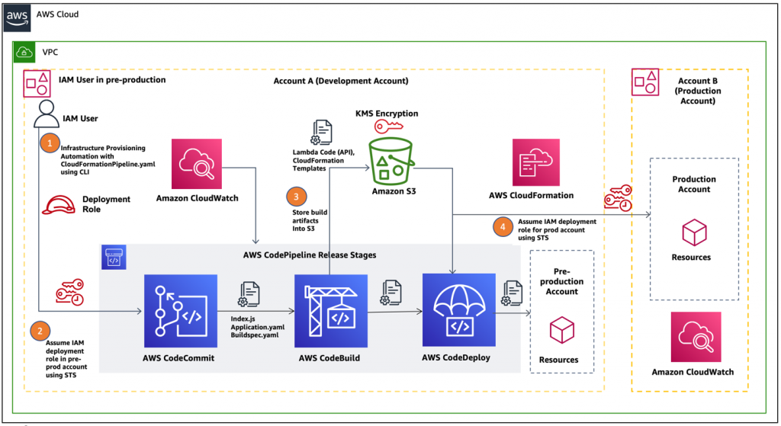
Figure 7.1: AWS DevOps tools integrations (AWS Architecture Blog)

AWS developer tools overview
AWS’s Developer Tools suite provides comprehensive solutions to enhance developer productivity, simplify workflows, and ensure secure and efficient application development. Whether automating code reviews, managing CI/CD pipelines, or deploying cloud-native applications, AWS’s tools enable an efficient development experience. From the real-time collaboration features of AWS Cloud9 to the AI-powered insights of Amazon CodeGuru, these tools cater to diverse development needs, helping developers build, evaluate, and deploy applications faster and more reliably.

Amazon CodeCatalyst
In the fast-paced world of cloud-based application development, AWS constantly strives to empower developers with tools and services that enhance productivity, simplify workflows, and improve code quality. Amazon CodeCatalyst is one such offering within AWS’s Developer Tools ecosystem. It facilitates the development and deployment processes, allowing developers to focus on creating and refining software solutions. [1]

Key features
Amazon CodeCatalyst integrates deeply with AWS services and is a strong and flexible Integrated Development Environment (IDE), creating an efficient environment for building, testing, and deploying applications. This integration reduces the complexities of managing resources, allowing developers to focus on writing code. It also supports collaborative coding, enabling multiple developers to work on the same project simultaneously, making reviewing and iterating on code easier.
- AWS service integration: CodeCatalyst integrates smoothly with AWS services, offering developers a smooth environment for building, testing, and deploying applications [1].
- Collaborative capabilities: It supports real-time collaborative coding, which ensures that multiple developers can work on the same project at once [2]; [3].
- Serverless development: Amazon CodeCatalyst enables serverless application development using AWS Lambda, freeing developers from managing server infrastructure.
- Code insights: The IDE provides real-time insights and recommendations, helping developers improve code quality and adhere to best practices.
Amazon CodeCatalyst is a valuable addition to the AWS Developer Tools portfolio. It accelerates the development process by enabling developers to create, collaborate, and refine applications more efficiently.

Amazon CodeGuru
Efficient and optimized software development remains a priority in cloud computing, and Amazon CodeGuru addresses this by combining machine learning with best practices to improve code quality and application performance. CodeGuru performs automated code reviews, finds code defects, and optimizes performance, reducing developers' time debugging and enhancing their applications. [4].
Amazon CodeGuru integrates machine learning into the code review process, allowing it to learn from Amazon's extensive codebase to provide developers with actionable insights. This tool enables developers to make real-time improvements, ensuring that best practices are followed from the outset.

Key features
In the ever-evolving landscape of cloud computing, efficient and optimized software development is paramount. Amazon CodeGuru, a groundbreaking developer tool offered by AWS, addresses this imperative by using machine learning to enhance code quality and application performance. This section provides a detailed exploration of Amazon CodeGuru, shedding light on its features, functionalities, and the transformative impact it brings to software development.
- Automated code reviews: CodeGuru Reviewer analyzes source code, finds defects, and offers suggestions for improvements, streamlining the code review process [4].
- Code insights: Powered by machine learning, CodeGuru offers insights that enhance code quality, performance, and adherence to best practices.
- Application profiling: The CodeGuru Profiler offers deep insights into runtime behavior, helping developers find bottlenecks and improve their applications.
Amazon CodeGuru empowers developers by automating code reviews and profiling. [5], improving overall software quality and application performance.

Amazon Corretto
About Java development in the cloud, Amazon Corretto offers a strong, production-ready runtime environment that simplifies Java application management. This open-source distribution of the Open Java Development Kit (OpenJDK) delivers a high-performance, secure runtime ideal for cloud-native application developers.
Amazon Corretto integrates smoothly with AWS services, making it a strong choice for any team relying on Java. AWS fully supports it, and as a long-term supported version of OpenJDK, it ensures that Java developers can work confidently, knowing they are using a stable, secure platform with continuous updates and security patches.

Key features
One of Amazon Corretto's key strengths is its focus on performance and security. AWS emphasizes prompt updates and patches to address security vulnerabilities, ensuring that developers can build and deploy Java applications with confidence [6]. Corretto incorporates performance enhancements derived from the collaboration within the OpenJDK community, contributing to a faster and more efficient runtime environment. [7].
- Long-Term Support (LTS): Amazon Corretto is built to last with long-term support, ensuring that developers receive prompt updates and security patches.
- Security and monitoring: Corretto includes performance enhancements, security updates, and tools for monitoring Java applications, helping developers improve their Java runtime environment.
- Multi-platform compatibility: Whether you are working on Amazon EC2, AWS Lambda, or even on-premises, Corretto works across platforms to deliver consistent experience.
Amazon Corretto is an essential tool for Java developers on AWS. It offers a stable, secure, high-performance solution for running Java applications in the cloud.

AWS cloud control API
Cloud orchestration is a key element for modern software development. Developers need to manage and provision cloud resources smoothly, and the AWS Cloud Control API is built to simplify that process. The API simplifies resource provisioning, updates, and deletion across different AWS services, all from a unified interface by providing a programmatic interface to interact with AWS resources.
The Cloud Control API is essential in automating AWS resource management, making it ideal for teams looking to manage cloud infrastructure with code. With this service, developers can easily incorporate resource management into their CI/CD pipelines, ensuring that infrastructure and applications scale efficiently and reliably.
To visualize how the AWS Cloud Control API helps resource management and simplify cloud orchestration, the diagram below highlights its capabilities in providing a unified interface for interacting with various AWS and third-party services. This visualization underscores the API’s role in automating infrastructure management within modern DevOps workflows.
Figure 7.2 illustrates how the AWS Cloud Control API simplifies cloud orchestration by providing a unified interface for managing AWS resources and integrating third-party services, enhancing the efficiency of modern DevOps workflows.
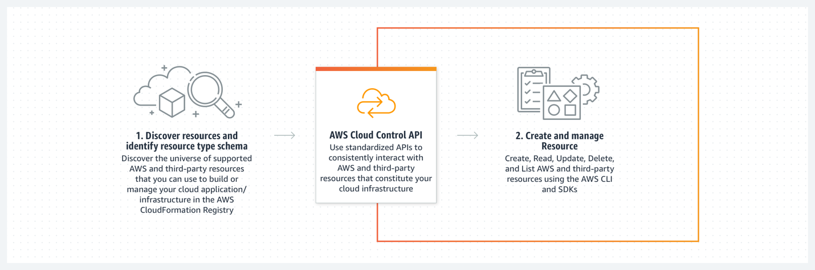
Figure 7.2: AWS Cloud Control AP (AWS Blog)

Key features
The key features and capabilities are as follows:
- Cross-service resource management: The Cloud Control API simplifies the management of AWS resources by unifying them under a single API. This is particularly useful in complex cloud environments where multiple services must work together.
- Infrastructure as Code (IaC): The API’s integration with IaC allows developers to define and manage AWS resources programmatically, helping to achieve a version-controlled and repeatable approach to infrastructure management.
- Consistent resource schema: The API simplifies management and accelerates cloud deployment workflows by enforcing a consistent schema across resources. This makes it easier for developers to interact with different AWS services without understanding each service's unique API.
Use case examples
Let us visit examples of scenarios to introduce the practical application of AWS Cloud Control API:
- Automated resource provisioning: DevOps teams can leverage the AWS Cloud Control API to automate the provisioning of resources, ensuring rapid and consistent deployments across development, testing, and production environments [8].
- Multi-service workflows: In scenarios where applications span multiple AWS services, the Cloud Control API becomes instrumental in orchestrating and managing the entire stack of resources cohesively [8].
- IaC: The AWS Cloud Control API is particularly beneficial in IaC scenarios, where developers define and manage infrastructure using code. Offering a unified API enables the creation and management of AWS resources in a programmatic and version-controlled manner.
- IaC pipelines: Integration with Infrastructure as Code pipelines enables the automation of resource updates and ensures that the infrastructure remains coordinated with the codebase throughout its lifecycle [9].
- Automation and orchestration: DevOps practices emphasize automation and orchestration. The Cloud Control API enables developers and DevOps teams to automate resource provisioning, updates, and deletion, streamlining deployment processes.
- Multi-service applications: In scenarios where applications span multiple AWS services, the Cloud Control API simplifies the coordination of resources. It becomes instrumental in keeping consistency and coherence across distinct parts of a distributed application.
The AWS Cloud Control API provides a powerful tool for consistently and efficiently managing resources for any DevOps team aiming to implement infrastructure as code at scale.

AWS Cloud9
AWS Cloud9 offers a strong, collaborative, fully integrated development environment (IDE) in a cloud-native world. With Cloud9, developers can write, run, and debug code directly from a browser, ending the need for complex local setups or worrying about environment configurations. [9].
Cloud9 is designed for teams, enabling real-time collaboration and efficient access to cloud-based development resources. This cloud-based IDE allows developers to work from anywhere without losing access to the tools they need for effective and productive software development.

Key features
Here, we visit a sample of key features and capabilities of AWS Cloud9:
- Collaborative coding: Cloud9 allows multiple developers to work on the same project simultaneously, improving teamwork and reducing development cycles.
- Built-in tools: Integrated debugging and terminal tools help simplify development. Developers can run code, test functionality, and debug from within the IDE, saving time and improving workflow efficiency [10].
- Language support: AWS Cloud9 supports various programming languages and frameworks, ensuring it works for all cloud development projects.
Use case examples
A sample of real-life applications of AWS Cloud9 is as follows:
- Remote development environments: AWS Cloud9 is particularly valuable for teams distributed across separate locations. It enables developers to access a consistent and fully configured development environment from anywhere with an internet connection [11].
- Education and training: AWS ++Cloud9's collaborative nature makes it an excellent choice for educational purposes. Instructors can create shared environments for students to collaborate on coding exercises and projects, fostering a cooperative learning environment.
- Serverless application development: AWS Cloud9 simplifies the development experience for developers working on serverless applications. It integrates smoothly with AWS Lambda, making building, evaluating, and deploying serverless functions easier.
AWS Cloud9 is the go-to tool for teams needing a cloud-based IDE that fosters collaboration and simplifies the development workflow across languages and cloud resources.

AWS CodeArtifact
Managing dependencies and software packages is a critical task in modern development workflows. AWS CodeArtifact helps solve this problem by providing a fully managed artifact repository service that integrates smoothly with your CI/CD pipeline. By securely storing and sharing software packages in the cloud, CodeArtifact ensures that all your dependencies are managed efficiently across the development lifecycle.
For teams working in environments with complex dependencies or across multiple teams, CodeArtifact simplifies artifact management, versioning, and access control, improving collaboration while keeping a high standard of security.

Key features
AWS CodeArtifact is a fully managed artifact repository service that allows organizations to securely store, publish, and share software packages and dependencies [12]. With native integration into popular build and deployment tools, CodeArtifact simplifies the management of dependencies in the software development lifecycle. The following are the key features and capabilities:
- Universal package management: CodeArtifact supports multiple package formats, including Maven, npm, and PyPI, ensuring it fits a wide range of development needs and supports polyglot environments.
- Security and access control: With deep integration into AWS Identity and Access Management (IAM), CodeArtifact enables fine-grained access control, ensuring only authorized users can access or publish packages.
- Scalability: CodeArtifact scales with your team’s needs, managing increasing volumes of artifacts without sacrificing performance or reliability.
Use cases and scenarios.
Let us review a sample of actual use scenarios for AWS CodeArtifact:
- Dependency management in CI/CD pipelines: CodeArtifact simplifies the process of managing dependencies in CI/CD pipelines, ensuring consistent and reliable builds [13].
- Centralized artifact repository: Organizations with multiple projects and teams receive help from a centralized repository for managing and sharing software artifacts. CodeArtifact simplifies the organization-wide use of shared packages.
- Support for Polyglot development: By supporting various package formats, CodeArtifact facilitates polyglot development environments in which different projects may use distinct programming languages and dependencies [14].
AWS CodeArtifact is essential for teams managing complex dependencies or building software with various package formats, helping them keep track of versions and support secure access to dependencies.

AWS CodeBuild
With cloud-native development practices, building and testing software should be automated to enable faster release cycles. AWS CodeBuild delivers a fully managed build service that compiles source code, runs tests, and packages software for deployment. This service is integrated with other AWS tools to support efficient CI/CD workflows, improving the speed and reliability of your software delivery pipeline.
Whether your team is dealing with minor code updates or large-scale feature builds, CodeBuild automatically scales to meet your needs, ensuring consistent, repeatable builds across your organization.
Figure 7.3 below shows what happens when you run a build with CodeBuild:
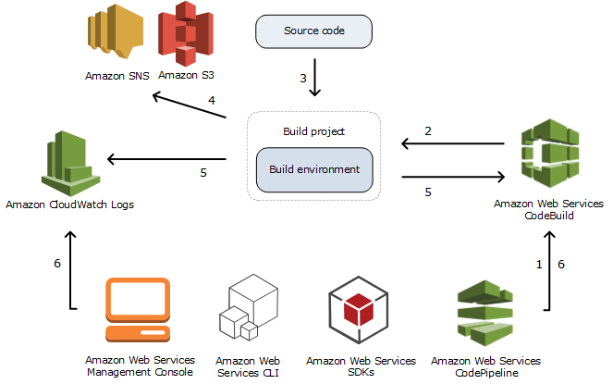
Figure 7.3: Running a build with CodeBuild (AWS Documentation)

Key features
AWS CodeBuild is a cloud-based build service that compiles source code, runs tests, and produces ready-to-deploy software artifacts [15]. It integrates smoothly with other AWS services and supports popular programming languages, enabling developers to focus on writing code rather than managing build infrastructure. The following are the key features and capabilities:
- Fully managed service: AWS CodeBuild automates the process of compiling source code, running tests, and packaging software, removing the need for teams to manage build infrastructure [15].
- Support for multiple languages: With support for a wide variety of programming languages, CodeBuild fits into almost any development pipeline, handling the build and test phases for your team, regardless of the language or framework [13].
- Customizable build environments: Developers can define their build environments, including build commands, environment variables, and custom tools to ensure that each build matches their project’s needs [15].
Use cases and scenarios
The use cases and scenarios are as follows:
- Continuous Integration (CI): CodeBuild is a key part of CI pipelines, automating the build and test phases. It integrates smoothly with AWS CodePipeline, enabling a continuous integration workflow.
- Scalable build processes: With its ability to scale automatically, CodeBuild is well-suited for projects with varying build workloads. Whether managing small code changes or significant feature additions, CodeBuild adapts to the demands of the development pipeline [16].
- Integration with source control: CodeBuild smoothly integrates with version control systems such as AWS CodeCommit, GitHub, and Bitbucket, automatically triggering builds when changes are pushed to the repository [17].
AWS CodeBuild is the backbone of any CI/CD pipeline, ensuring that code is built, evaluated, and packaged efficiently without introducing bottlenecks in your development workflow.

AWS CodeCommit
Version control is essential for any development team to track changes, collaborate, and maintain consistency across projects. AWS CodeCommit is a fully managed source control service that provides secure and scalable hosting for Git repositories. This service helps teams keep code integrity while simplifying collaboration and streamlining development.
AWS CodeCommit provides a reliable and secure environment for version control, supporting large teams and complex projects. With integration into the broader AWS ecosystem, CodeCommit smoothly fits into DevOps workflows and automation pipelines.

Key features
AWS CodeCommit allows developers to store and version their code in the cloud, helping collaboration and ensuring a secure and accessible repository. Key aspects include [7]:
- Secure git repositories: CodeCommit ensures data is encrypted in transit and at rest. It integrates with AWS IAM, allowing teams to manage permissions and access securely.
- Scalability: CodeCommit scales your needs, supporting repositories of any size and accommodating growing teams and projects.
- Integration with AWS tools: It works smoothly with AWS CodePipeline and AWS CodeBuild, creating continuous integration and deployment pipelines that enhance workflow efficiency.
Use cases
In this section, we will go through the use cases:
- Collaborative software development: CodeCommit facilitates team collaboration by providing a central repository for code changes, enabling version control and efficient collaboration [18].
- Continuous integration and deployment (CI/CD): Integration with AWS CodePipeline allows for the efficient implementation of CI/CD pipelines, automating code builds, testing, and deployments [19].
- Secure code storage: CodeCommit serves as a secure and compliant storage solution for source code, meeting the requirements of industries with stringent security and compliance standards [20].
For development teams looking for a dependable, scalable, and secure version control solution, AWS CodeCommit simplifies the process and integrates with the AWS ecosystem, ensuring consistency across environments.

Best practices for AWS CodeCommit implementation
Now, we introduce the best practices for implementing AWS CodeCommit. We can find case studies and best practices born from practice from AWS, its partners, and other companies delivering professional services or building products for the AWS Cloud. They are beneficial, helpful, and easy to find. It is possible to generalize them as tools to keep code quality and ensure adherence to coding standards [18].
- Branching strategies: Adopt effective branching strategies to manage feature development, bug fixes, and releases efficiently [20].
- Code reviews: Leverage CodeCommit's built-in code review tools to keep code quality and ensure adherence to coding standards [18].
- Repository structure: Organize repositories logically, considering factors like team structure, project dependencies, and deployment pipelines [19].

AWS CodeDeploy
Software deployment can be complex, especially when managing updates across distributed systems. AWS CodeDeploy automates this process, helping teams deploy applications to various compute services with minimal downtime and fewer manual interventions. Whether deploying EC2 instances, Lambda functions, or on-premises servers, CodeDeploy simplifies the deployment process, improving efficiency and reducing deployment risks.

Key features
By supporting different deployment strategies, CodeDeploy offers flexibility, allowing teams to choose the approach that best suits their needs, from blue/green deployments to rolling updates. The following are the key features of AWS CodeDeploy:
- Flexible deployment strategies: AWS CodeDeploy supports multiple deployment strategies, including in-place deployments, blue/green deployments, and canary releases. This flexibility ensures that teams can choose the most suitable approach for their application and infrastructure needs [7].
- Multi-platform support: CodeDeploy works across platforms, enabling deployments on EC2, Lambda, and on-premises servers, making it versatile for various application types and deployment requirements.
- Rollback capabilities: CodeDeploy includes automatic rollback functionality, minimizing risk by ensuring that if a deployment fails, it can quickly revert to the earlier working version, reducing downtime.
Figure 7.4 below shows a high-level architecture for AWS CodeDeploy, a fully managed deployment service:
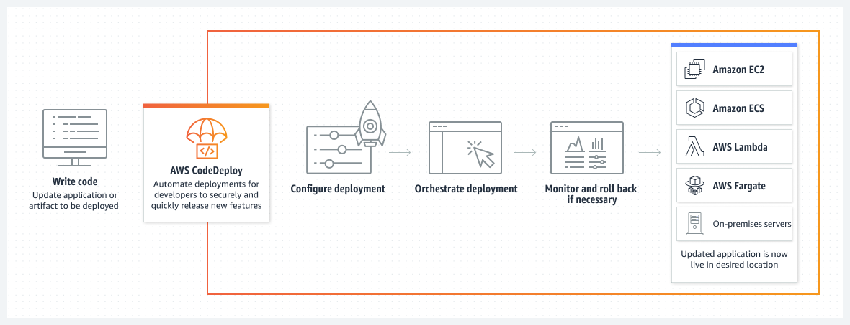
Figure 7.4: CodeDeploy: fully managed deployment service (Amazon Web Services)
AWS CodeDeploy simplifies the deployment process, allowing development teams to deploy faster, with fewer issues and greater flexibility.

AWS CodePipeline
CI/CD pipelines are critical to modern development workflows, ensuring that applications are delivered quickly and reliably. AWS CodePipeline automates the entire process, from code changes to build, test, and deployment stages, integrating with AWS and third-party tools to create a fully automated pipeline.
CodePipeline enhances efficiency by automating repetitive tasks and reducing the manual overhead associated with deployment. It supports parallel and sequential stages, enabling flexibility in deployment strategies and workflows.

Key features
The key features of AWS CodePipeline are as follows. [21]:
- Automated workflows: CodePipeline automates the flow of code changes through build, test, and deployment processes, removing manual interventions and improving the speed of application delivery [22].
- Integration with AWS and third-party tools: CodePipeline integrates with a wide range of AWS services, like AWS CodeBuild and AWS CodeDeploy, as well as third-party tools such as GitHub, to offer flexibility in workflows [19].
- Parallel and sequential execution: CodePipeline supports both parallel and sequential execution of stages, allowing teams to tailor their workflows to the needs of their applications and deployment environments [20].
Use cases of AWS CodePipeline
The following are the use cases of AWS CodePipeline:
- Multi-environment deployments: CodePipeline facilitates the creation of pipelines that support deploying applications to multiple environments, such as development, testing, and production.
- Microservices architectures: Ideal for orchestrating CI/CD workflows in microservices-based applications, allowing independent testing and deployment of individual services [23].
- Serverless application deployments: Well-suited for automating the deployment of serverless applications, managing the build and deployment of AWS Lambda functions and related resources.

Best practices for AWS CodePipeline implementation
The following are the best practices for AWS CodePipeline implementation:
- Version control integration: Integrate CodePipeline with version control systems like AWS CodeCommit or GitHub for efficient source code management [21].
- Automated testing strategies: Implement automated testing at each stage of the pipeline to find and address issues early in the development process [24].
- Security best practices: Follow AWS security best practices, including least privilege principles and encryption of sensitive data within the pipeline.
By automating the release process, AWS CodePipeline allows development teams to focus more on innovation and less on manual deployment tasks, making the entire process more efficient and dependable.

AWS CodeStar
Managing and building applications on AWS requires an integrated platform that connects development tools, code repositories, and deployment pipelines. AWS CodeStar serves as that unified platform, allowing teams to set up and manage their software development activities quickly. With built-in support for various AWS tools, CodeStar accelerates the creation of fully configured CI/CD pipelines for a smoother development experience.
Whether building a new project or managing an existing one, AWS CodeStar’s simplicity and integration with AWS services make it ideal for developers who want simplified experience.

Key features
The key features of AWS CodeStar are as follows. [25]:
- Unified development platform: CodeStar integrates tools for coding, building, testing, and deploying applications into a single interface, simplifying the management of the software development lifecycle.
- Project templates: CodeStar provides pre-configured templates for various programming languages and AWS services, making it easier to start new projects.
- Built-in CI/CD pipeline: Each project automatically receives a CI/CD pipeline that manages code builds, testing, and deployments, helping to simplify development operations.
- Team collaboration: CodeStar’s integration with AWS IAM enables role-based access control, making team management easier and ensuring secure access to project resources.
Use cases
The following are the use cases of AWS CodeStar. [26]; [25]:
- Rapid prototyping: CodeStar is beneficial for rapidly prototyping applications, allowing developers to focus on coding while it manages the underlying infrastructure.
- Multi-language support: This feature is ideal for projects involving multiple programming languages, providing a flexible environment for diverse development needs.
- Serverless application development: Suited for serverless application development, simplifying the process of building and deploying AWS Lambda functions.

Best practices for AWS CodeStar implementation
The following are the best practices for AWS CodeStar implementation:
- Customization of templates: Customize project templates to align with specific project requirements and coding standards [27].
- Integration with AWS services: Leverage integrations with other AWS services, such as AWS CodeCommit and AWS CodeBuild, to enhance the CI/CD pipeline [28].
- Regular monitoring and optimization: Monitor project activity and resource usage regularly, improving configurations based on project needs and changing requirements [25].
AWS CodeStar is the go-to service for teams to simplify their cloud-based application development processes, offering a unified platform for efficient collaboration and project management.

AWS command line interface
The AWS CLI provides a command-line interface to AWS services, allowing developers to manage their AWS resources directly from a terminal. It provides a powerful and efficient way to interact with AWS services, especially for tasks that need to be automated or run on a scale.

Key features
The AWS CLI helps teams simplify workflows, automate tasks, and save time by enabling scripting, automation, and batch operations. Its simplicity and flexibility make it a valuable tool for developers and DevOps teams. The following are the key features of the AWS CLI. [29]:
- Cross-service commands: The AWS CLI enables users to interact with various AWS services, providing a consistent experience regardless of the service they are using.
- Scripting and automation: Using the AWS CLI in scripts, developers can automate repetitive tasks, reduce manual errors, and accelerate workflows.
- Customization and configuration: The CLI allows users to configure it to meet their needs, including setting default regions, output formats, and security credentials.
Use cases
The use cases of AWS CLI are as follows:
- Batch operations: Ideal for executing batch operations, AWS CLI allows users to automate repetitive tasks and manage resources at scale [29].
- Integration with scripts: Suited for integration into scripts and third-party tools, enabling efficient incorporation of AWS actions into existing workflows [30].
- Quick resource management: Users can quickly create, configure, and manage AWS resources without accessing the AWS Management Console, offering a simplified experience [29].

Best practices for AWS CLI usage
The following are the best practices for AWS CLI Usage. [29]:
- Security best practices: Adhere to security best practices by securely managing and storing AWS CLI credentials, utilizing IAM roles, and implementing MFA.
- Version compatibility: Ensure compatibility by using the latest version of the AWS CLI, staying informed about updates, and checking for any breaking script changes.
- Output Formatting: Improve output formatting for scripts by selecting proper output options, such as JSON or table format, to enhance readability and parsing [31].
AWS CLI is an essential tool for developers. It enables easy management of AWS resources, automates tasks, and improves workflow efficiency.

AWS Device Farm
Testing mobile applications across various devices ensures your app works smoothly on all platforms. AWS Device Farm is a cloud-based mobile app testing service that provides access to a wide range of real devices for testing purposes. This section explores how AWS Device Farm helps developers ensure their mobile applications work flawlessly across different devices, operating systems, and configurations.
AWS Device Farm simplifies the testing process by allowing developers to run tests in parallel on multiple devices, saving valuable time and improving the quality of the application. Device Farm better represents how the app will perform in real-world scenarios by providing access to real devices rather than relying on emulators.

Key features
AWS Device Farm simplifies the testing process by allowing developers to run tests in parallel on multiple devices, saving valuable time and improving the quality of the application. Device Farm offers a more accurate representation of how the app will perform in real-world scenarios by providing access to real devices rather than relying on emulators. The following are the key features of AWS Device Farm. [32]:
- Device compatibility testing: AWS Device Farm allows developers to assess their mobile apps on a wide range of real devices, ensuring compatibility across multiple platforms, screen sizes, and configurations.
- Parallel testing: Device Farm supports parallel test execution, enabling multiple tests to run concurrently on different devices and accelerating the testing process.
- Built-in test scripts: The service comes with built-in support for popular test automation frameworks such as Appium, XCTest, and Espresso, simplifying the creation and execution of tests.
Use cases
The following are the cases of AWS Device Farm:
- Automated testing: Well-suited for automated testing scenarios, AWS Device Farm supports popular test automation frameworks such as Appium, XCTest, and Espresso [32].
- Real-device testing: Allows developers to perform testing on real devices rather than relying solely on emulators, ensuring correct simulation of user interactions [33].
- Performance testing: Ideal for performance testing, developers can assess app behavior under various conditions, such as different network strengths and device specifications [32].

Best practices for AWS Device Farm usage
The following are the best practices for AWS Device Farm Usage:
- Test on real devices: Prioritize testing on real devices to uncover issues that may not be clear in emulator-based testing [33].
- Parallel execution planning: Efficiently plan parallel test executions to maximize testing throughput and minimize overall testing time [32].
- Regular test updates: Keep test scripts updated to align with the latest features and capabilities of AWS Device Farm, ensuring the best testing performance [34].
AWS Device Farm simplifies the testing process for mobile applications, ensuring that developers can quickly find issues, improve performance, and deliver high-quality apps.

AWS Fault Injection Simulator
Ensuring the resilience of cloud-based applications is critical in today's environment, where uptime and reliability are paramount. AWS Fault Injection Simulator provides developers and operations teams with a controlled environment for assessing the resilience of their applications by simulating various failure scenarios. This service helps teams understand how their systems behave under stress and find potential vulnerabilities before they affect real users.
AWS Fault Injection Simulator (FIS) enables chaos engineering by introducing failures into production systems to evaluate how well applications manage disruptions. This initiative-taking approach allows teams to make necessary adjustments to improve their cloud applications' fault tolerance and resilience.

Key features
AWS Fault Injection Simulator enables chaos engineering by introducing failures into production systems to evaluate how well applications manage disruptions. This initiative-taking approach allows teams to make necessary adjustments to improve their cloud applications' fault tolerance and resilience. The following are the key features of the AWS Fault Injection Simulator. [35]:
- Fault injection scenarios: AWS Fault Injection Simulator allows users to create and execute failure scenarios, simulating various conditions like latency, errors, and timeouts to evaluate application behavior.
- Observability integration: It integrates with AWS observability tools such as Amazon CloudWatch, providing insights into system performance during fault injection experiments.
- Automation capabilities: The service supports automation for fault injection experiments, allowing DevOps teams to schedule resilience tests regularly.
The AWS Fault Injection Simulator enables teams to inject controlled faults, ensuring that cloud applications can withstand failures and remain dependable under various adverse conditions.
Benefits of using AWS Fault Injection Simulator
Building resilient cloud applications requires more than high availability architecture; it demands proactive failure testing to uncover vulnerabilities before they affect production. AWS FIS provides a controlled, cost-effective environment for conducting realistic failure simulations, allowing teams to confirm system resilience, improve recovery strategies, and ensure business continuity. The following are key benefits of using AWS FIS:
- Resilience validation: The service allows teams to confirm the resilience of their applications by testing how they perform during unexpected disruptions.
- Cost-effective testing: The AWS Fault Injection Simulator offers a cost-effective way to perform resilience testing without requiring complex infrastructure setup.
- Realistic failure simulations: By simulating real-world failure conditions, the service ensures that testing is correct and relevant, helping teams better prepare for potential issues in production.
The AWS Fault Injection Simulator is an essential tool for organizations looking to enhance the resilience of their cloud-native applications and prepare for unexpected disruptions.
Practical applications
The following are examples of practical applications:
- Chaos engineering: Supports the principles of chaos engineering by allowing controlled injection of faults, helping organizations understand how their systems behave under adverse conditions [35].
- Continuous resilience testing: Helps the incorporation of continuous resilience testing into the development and deployment pipelines, ensuring ongoing evaluation of application strength [36].

Best practices for AWS Fault Injection Simulator
The following are the best practices for the AWS Fault Injection Simulator:
- Start with low-impact scenarios: Begin by injecting faults with minimal impact to understand the first response of the system before progressing to more severe scenarios [37].
- Regularly review results: Regularly review and analyze the results of fault injection experiments to find patterns and potential areas for improvement [35].

AWS tools and software development kits
AWS provides a comprehensive set of tools and Software Development Kits (SDKs) that enable developers to build, deploy, and manage applications efficiently on the AWS Cloud. These tools simplify interactions with AWS services, improve productivity, and foster the adoption of DevOps practices across organizations.
AWS SDKs help developers easily integrate AWS services into their applications by providing language-specific libraries and APIs, streamlining the development process. In addition, AWS Tools extend the functionality of SDKs, offering capabilities such as automation, scripting, and command-line interactions with AWS services.

Key features
AWS SDKs help developers easily integrate AWS services into their applications by providing language-specific libraries and APIs, streamlining the development process. In addition, AWS Tools extend the functionality of SDKs, offering capabilities such as automation, scripting, and command-line interactions with AWS services. The following are the key features of AWS Tools and SDKs:
- Multi-language support: AWS SDKs support various programming languages such as Java, Python, JavaScript, .NET, and more, making it easier for developers to integrate AWS services into their applications [38].
- Comprehensive service coverage: AWS Tools and SDKs cover a wide range of AWS services, providing developers with the necessary libraries and utilities to interact with AWS resources [23].
- Integration with popular IDEs: The tools and SDKs integrate smoothly with popular IDEs like Visual Studio, Eclipse, and IntelliJ IDEA, enhancing the overall development experience.
By using AWS Tools and SDKs, developers can reduce the time and effort needed to interact with AWS services and simplify their workflows.
Benefits of using AWS tools and SDKs
The following are the benefits of using AWS Tools and SDKs
- Efficiency and productivity: AWS Tools and SDKs help automate repetitive tasks, provide pre-built functions, and reduce the complexity of interacting with AWS services [23].
- Consistent development experience: These tools offer a consistent development experience across multiple languages, ensuring that development teams working with various technology stacks can rely on the same tools and processes [38].
- Version compatibility: AWS SDKs maintain compatibility with the latest AWS service updates, allowing developers to take advantage of new features and improvements without worrying about version discrepancies [38].
AWS Tools and SDKs help developers build and deploy cloud-native applications faster and more reliably while ensuring consistency and productivity across development teams.
Figure 7.5 visualizes the SDKs and how they provide pre-built modules, components, packages, and tools for developers to build, evaluate, and deploy software applications.
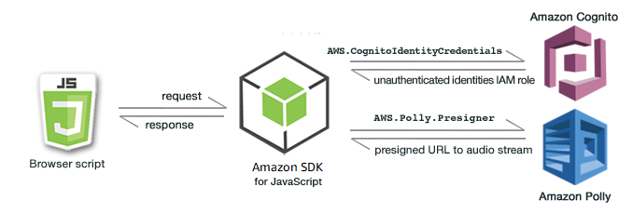
Figure 7.5SDKs provide pre-built tools (Amazon Web Services).
Practical applications
In this section, we will go through the practical applications:
- Application development: Helps the development of cloud-native applications by providing tools and SDKs that abstract the complexities of AWS service interaction [40].
- Automation and scripting: Enables automation and scripting of everyday tasks, allowing DevOps teams to create efficient and repeatable workflows [38].
Best practices for using AWS Tools and SDKs
The following are the best practices for using AWS Tools and SDKs:
- Regularly update SDK versions: Stay up to date with the latest SDK versions to access new features, improvements, and security updates [38].
- Utilize code samples and documentation: Leverage code samples and comprehensive documentation provided by AWS to speed up development and troubleshoot issues effectively [40].

AWS X-Ray
Monitoring the performance of distributed applications can be challenging, especially as microservices architectures become more common. AWS X-Ray is a service that helps developers analyze and troubleshoot their applications' performance, offering real-time insights into system behavior. This section explores how AWS X-Ray enables developers to find performance bottlenecks, detect errors, and improve applications for improved user experiences.

Key features
AWS X-Ray uses distributed tracing to track requests as they flow through various components of an application, allowing developers to see how their services interact and find areas for optimization. The following are the key features of AWS X-Ray:
- Distributed tracing: AWS X-Ray enables developers to trace requests across different microservices, providing a detailed map of how requests are processed [41].
- Performance monitoring: The service helps find performance bottlenecks by highlighting the slowest segments of an application, enabling teams to improve critical paths [41].
- Error detection: AWS X-Ray automatically detects errors and exceptions, offering detailed insights into where and why issues occur in the system [42].
By offering deep insights into application behavior, AWS X-Ray helps developers ensure that their applications run efficiently and meet performance expectations.

Benefits of using AWS X-Ray
The following are the benefits of using AWS X-Ray. [41]:
- Improved debugging: AWS X-Ray offers real-time debugging capabilities, allowing developers to pinpoint the root causes of errors and issues in their applications.
- Enhanced performance optimization: With detailed performance insights, developers can improve their applications, improving response times and overall user satisfaction.
- Reduced downtime: By detecting errors quickly and accurately, AWS X-Ray minimizes downtime and ensures that issues are resolved before they affect end users.
Practical applications
The following are the practical applications:
- Microservices architecture: Particularly valuable in microservices architectures, AWS X-Ray helps developers understand the interactions between different services [41].
- Production issues: Simplifies the process of troubleshooting and diagnosing production issues by offering detailed insights into application behavior [39].

Best practices for using AWS X-Ray
In this section, we will go through the best practices for using AWS X-Ray:
- Instrumentation of code: Implement thorough instrumentation of code to capture trace data effectively and gain comprehensive insights [41].
- Integration with AWS Services: Leverage integration with other AWS services, such as AWS Lambda and Amazon EC2, to capture traces from various components [39].
AWS X-Ray enables developers to check and troubleshoot distributed applications, ensuring their systems perform optimally and reliably.

Amazon CodeWhisperer
Amazon CodeWhisperer is a machine learning-powered tool that helps developers by providing real-time code suggestions and automating the code review process. Using machine learning, CodeWhisperer learns from large code bases and offers developers helpful suggestions that improve the quality and efficiency of their coding tasks.

Key features
CodeWhisperer enhances collaboration and accelerates the software development lifecycle by offering real-time feedback and suggestions that help teams keep high coding standards. The following are the key features of Amazon CodeWhisperer:
- Real-time collaboration: CodeWhisperer facilitates real-time collaboration among developers by providing in-line comments and suggestions directly within the code.
- Automated code reviews: The service automates code reviews, ensuring all code adheres to predefined best practices and coding standards.
- In-line comments and suggestions: Developers can receive in-line suggestions while working, helping simplify the review process and improving code quality.
Benefits of using Amazon CodeWhisperer
The following are the benefits of using Amazon CodeWhisperer:
- Accelerated code review process: This simplifies and accelerates the code review process by automating routine checks and providing a collaborative environment for developers [43].
- Code quality improvement: Contributes to improved code quality by flagging potential issues and ensuring adherence to coding best practices [42].
- Knowledge transfer: Helps knowledge transfer among team members by promoting collaboration and shared understanding of the codebase [42].
Practical applications
In this section, we will go through the practical applications:
- Large-scale development projects: Particularly beneficial in large-scale development projects with distributed teams, where efficient code collaboration is crucial [42].
Open-source contributions: Supports open-source contributors by providing a transparent and collaborative platform for reviewing and contributing code changes [43].
Figure 7.6 is a visual representation of the Amazon CodeWhisperer, the ML-powered coding companion:
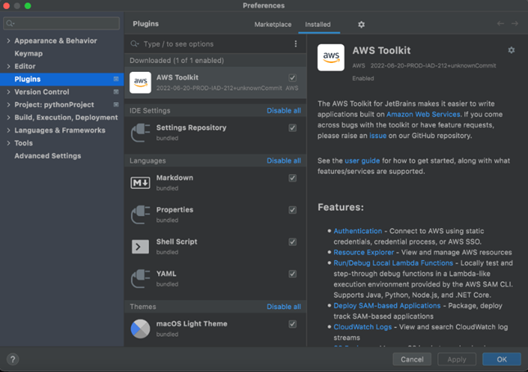
Figure 7.6Amazon CodeWhisperer, the ML-powered coding companion (AWS Blog)

Best practices for using Amazon CodeWhisperer
In this section, we will go through the best practices for using Amazon CodeWhisperer:
- Define clear review guidelines: Set up clear guidelines for code reviews to ensure that the team focuses on critical aspects of code quality and functionality [42]
- Regularly update review rules: Regularly update and customize automated review rules to align with evolving coding standards and project requirements [43].
Amazon CodeWhisperer fosters collaboration and improves code quality across development teams by providing real-time feedback.

Conclusion
This chapter has thoroughly explored the AWS Developer Tools and DevOps practices that enable modern software development in the cloud. We have examined tools such as Amazon CodeWhisperer, AWS CodePipeline, and AWS X-Ray, which help enhance developer productivity, simplify workflows, and ensure application quality and reliability. AWS services like CodeBuild, CodeDeploy, and CodeCommit have also proven essential in automating the development pipeline and providing the scalability of cloud-native applications.
As we move into Chapter 8, Developer Tools & DevOps (Part 2), the second part of DevOps and Developer Tools, we will delve deeper into the advanced services and practices that drive continuous integration and deployment, exploring tools like AWS CodeStar and AWS Cloud Control API to improve the development and operational lifecycle.

