Chapter 12

Road Ahead

Introduction
Chapter 12, Road Ahead, concludes our in-depth examination of reinforcement learning, the Hugging Face Diffusion library, and their transformative impact on artificial intelligence (AI). Reflecting on the journey through the book, this chapter shifts the focus to the future by summarizing the main ideas, exploring new technologies and environments, and examining the ethical and societal issues associated with AI development.
Throughout this chapter, readers will enhance their understanding, explore new research areas, and gain insights into responsible AI development. The chapter concludes with a comprehensive view of the future of reinforcement learning and its transformative power to shape society.

Structure
This chapter covers the following topics:
- Revisiting core concepts of deep reinforcement learning
- Future trends and research directions

Objectives
By the end of this chapter, readers will have strengthened their basic understanding of reinforcement learning by reflecting on its core principles, methods, and historical development. They will explore advanced tools and simulation environments, such as DeepMind Lab and Unity ML-Agents, that are driving innovation in modern reinforcement learning research and development. The chapter also encourages a critical examination of the ethical issues and societal impacts of AI, fostering a mindset rooted in responsible development and deployment. Readers will be prepared to identify and understand emerging research trends and future directions in reinforcement learning, setting the stage for ongoing learning and experimentation. Ultimately, the chapter advocates for a broader perspective on AI’s transformative role in shaping industries, economies, and everyday life, highlighting both its tremendous potential and the complex challenges it presents.

Revisiting core concepts of deep reinforcement learning
As we conclude our review of reinforcement learning, it is beneficial to revisit the core principles that underpin the field. These ideas have shaped the innovative techniques and applications we have studied and will continue to influence the future of AI development. These fundamental concepts form the basis for the advanced algorithms and methods discussed throughout this book. By revisiting these principles, we can gain a deeper understanding of their enduring importance and prepare to explore the future of reinforcement learning in the subsequent sections.
This section starts by summarizing the key insights and takeaways of deep reinforcement learning, providing readers with a concise yet thorough review of the ideas that have shaped the field and will continue to influence its development. Through this reflection, we aim to strengthen understanding and create a smooth transition to discussions on emerging trends, ethical issues, and potential advancements in reinforcement learning.
To reestablish the foundational mechanics of deep reinforcement learning, in Figure 12.1, we introduce a conceptual diagram that captures the interconnected dynamics of policy learning, value estimation, and exploration:
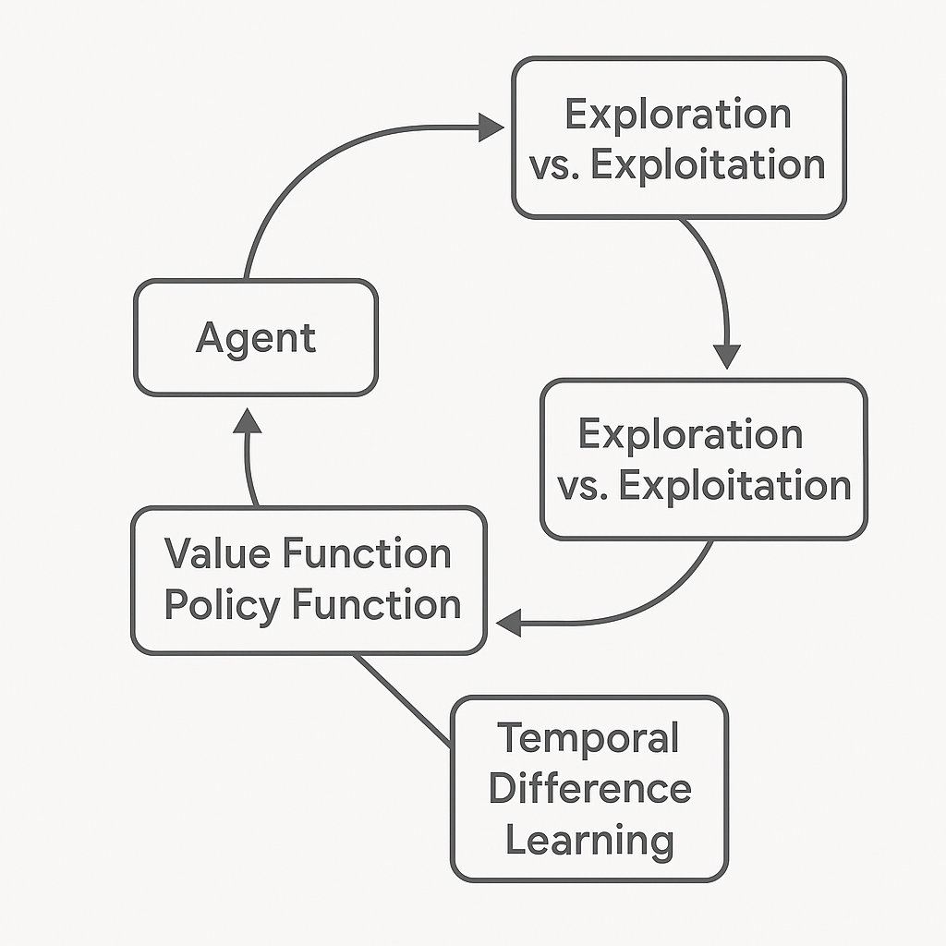

Figure 12.1: Core principles of deep reinforcement learning

This figure highlights the essential parts of deep reinforcement learning. The agent interacts with the environment, balancing exploration and exploitation by using policy and value functions that are updated through temporal-difference learning. These principles collectively define the learning loop that governs the agent's behavior in dynamic environments.

Key insights and takeaways
Deep reinforcement learning (DRL) combines the decision-making power of reinforcement learning with the expressive capabilities of deep neural networks. It has achieved significant progress in fields ranging from gaming to robotics, thanks to its ability to learn complex policies in high-dimensional spaces.

Fundamental concepts
These fundamental elements form the foundation on which DRL algorithms are built. They offer a guide to understanding how agents perceive, learn, and act within complex environments, enabling advanced applications and innovations:
- Agent-environment interaction: The iterative loop where agents learn from environment feedback.
- Exploration vs. exploitation: Balancing discovery of new strategies with optimizing known ones.
- Value and policy functions: Key tools for guiding agent decision-making.
- Temporal difference learning: A powerful method for bootstrapping value estimates.

Key algorithms
Building on these core principles, key algorithms have become transformative milestones in the field of reinforcement learning. The following demonstrates how theoretical insights turn into practical breakthroughs, expanding what AI systems can accomplish:
- Deep Q-Networks (DQN): Revolutionized reinforcement learning with its application to Atari games.
- AlphaZero: Mastered strategy games through Monte Carlo Tree Search (MCTS) and self-play.
- Asynchronous Actor-Critic (A3C): Accelerated learning by enabling parallel updates.

Reflection on learning
Throughout the book, practical implementations of these algorithms, ranging from classic games to real-world challenges, demonstrated their versatility. By incorporating Hugging Face libraries, we demonstrated how cutting-edge tools simplify the development and deployment of sophisticated models.

Code recap: Simple DQN example
To understand how deep reinforcement learning can be applied in a real-world setting, we examine a practical example using a Connect4 environment. This code illustrates the creation and training of a DQN agent, demonstrating how an AI learns to develop effective strategies and play the game. By applying core reinforcement learning principles, such as agent-environment interaction, value estimation, and policy optimization, the agent gradually develops advanced decision-making skills.

```python

import numpy as np
from keras.models import Sequential
from keras.layers import Dense
from keras.optimizers import Adam
from rl.agents.dqn import DQNAgent
from rl.memory import SequentialMemory
from rl.policy import EpsGreedyQPolicy

# Environment setup
from gym.envs.classic_control import CartPoleEnv
env = CartPoleEnv()

# Model architecture
model = Sequential([
Dense(24, activation='relu', input_shape=(1,) + env.observation_space.shape),
Dense(24, activation='relu'),
Dense(env.action_space.n, activation='linear')
])

# DQN Agent configuration
memory = SequentialMemory(limit=50000, window_length=1)
policy = EpsGreedyQPolicy()
dqn = DQNAgent(model=model, nb_actions=env.action_space.n, memory=memory, policy=policy)
dqn.compile(Adam(learning_rate=1e-3), metrics=['mae'])

# Training
dqn.fit(env, nb_steps=5000, visualize=False, verbose=2)
```
This code demonstrates a practical application of deep reinforcement learning in the Connect4 game, where the goal is to train an agent to make optimal moves based on the game state.
To reinforce the earlier discussed DQN implementation, the following figure illustrates the entire training loop, showing how important components like the replay buffer and target network work together to stabilize learning:
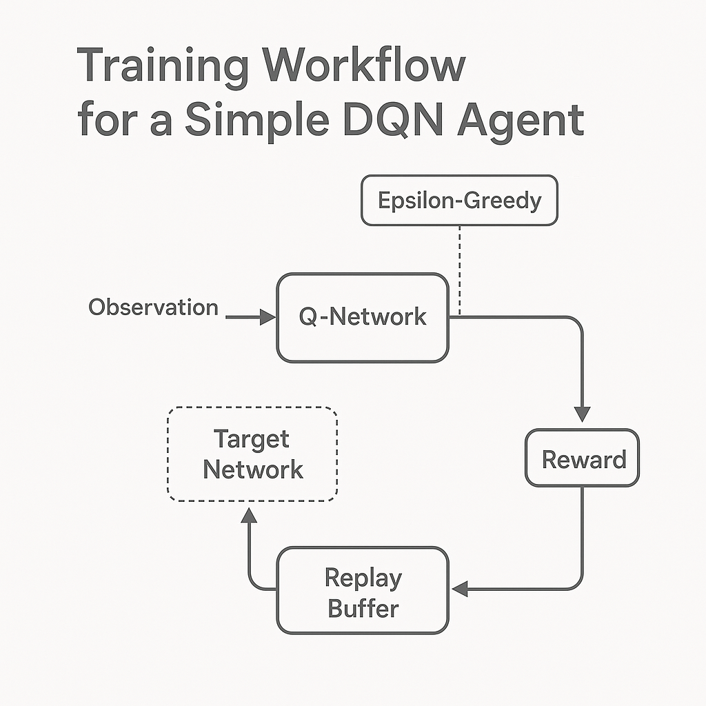

Figure 12.2: Training workflow for a simple DQN agent

Figure 12.2 describes the training cycle of a DQN agent. Observations are processed by the Q-network, which chooses actions using an epsilon-greedy strategy. Rewards and transitions are stored in a replay buffer, then used to update the Q-network against a slowly changing target network. This process promotes stable and sample-efficient learning.
The implementation starts with setting up the environment, represented by the Connect4Env class. This custom environment encapsulates the game's rules and mechanics, providing the agent with a structured environment in which to interact. By cycling through various states and rewards, the agent learns the game's dynamics, much like humans refine their strategies through trial and error.
To enable the agent to process game states and generate actionable insights, a neural network model is built using the Keras library. This model has two hidden layers, each with 24 neurons and relu activation functions. These layers are essential for identifying meaningful patterns in high-dimensional game states. The final layer produces Q-values for each possible action, guiding the agent's decision-making.
The agent is configured using a DQNAgent, which combines the neural network with reinforcement learning-specific components. A memory buffer, created through SequentialMemory, stores past experiences to enable replay-based learning, which helps stabilize the agent's training. The exploration-exploitation strategy of the agent is guided by a BoltzmannQPolicy, allowing it to find new strategies while leveraging known rewards. Additionally, periodic updates to the target model help ensure smoother convergence during training.
Training the agent involves executing 5,000 steps within the environment. During this process, the agent interacts with the game, collecting rewards and refining its policy to maximize total gains. As it learns from both successes and failures, the Q-values become more accurate, resulting in improved gameplay performance. After training, the model's weights are saved, allowing for future use or further refinement without the need for retraining.
This example captures the core of deep reinforcement learning, illustrating how key concepts are applied to build an intelligent agent. It provides a basic template for applying similar methods to more complex problems and environments, emphasizing the strength and flexibility of reinforcement learning frameworks.

Exploring the latest environments and advancements
As reinforcement learning evolves, new tools, platforms, and research directions emerge, offering exciting opportunities to expand its applications. This section examines advanced environments designed to challenge and enhance AI capabilities, as well as key trends shaping the future of reinforcement learning. By examining these topics, we highlight the technologies and methods driving the next wave of innovation.

Emerging tools and platforms
To advance breakthroughs in reinforcement learning, researchers depend on advanced tools and environments that mimic real-world challenges. These platforms not only provide controlled settings for testing but also help develop robust algorithms that can adapt to various tasks. In the upcoming section, we highlight two top platforms that represent the cutting edge of reinforcement learning research and development.
To help practitioners choose the most suitable simulation framework, the following comparison highlights the core strengths of two dominant platforms for reinforcement learning research and development:
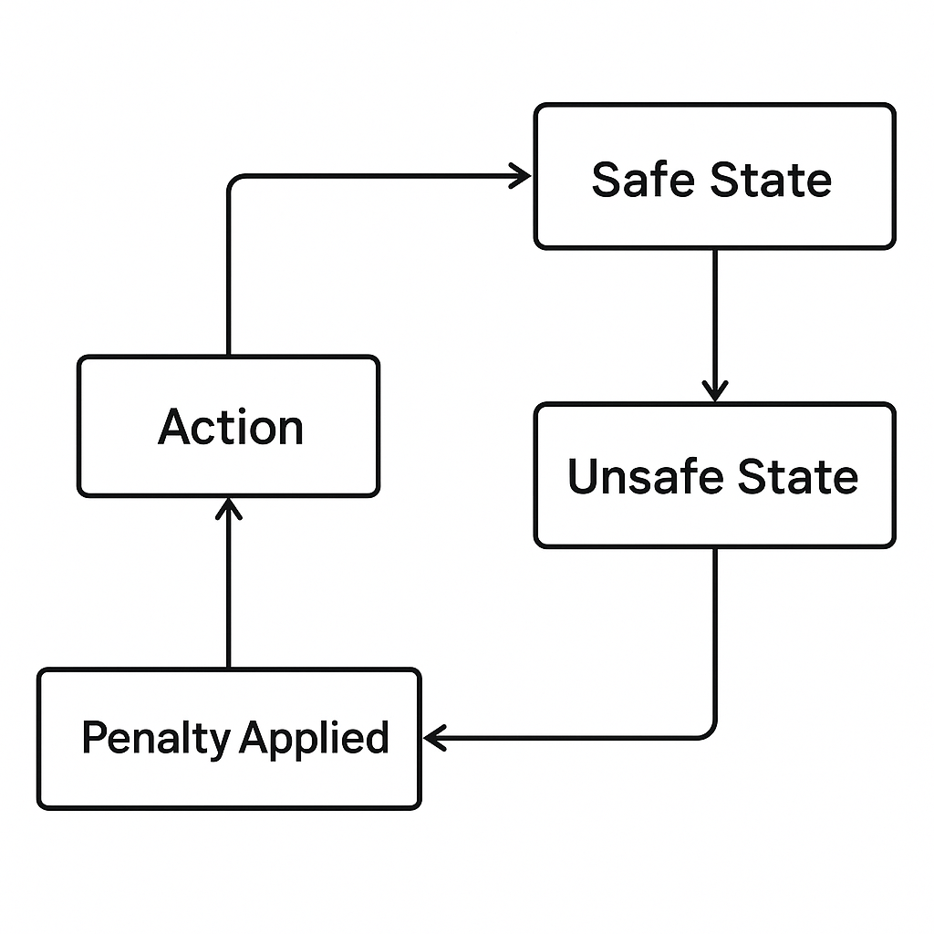

Figure 12.3: Comparison - DeepMind Lab vs. Unity ML-agents

The side-by-side diagram in Figure 12.3 compares DeepMind Lab and Unity ML-Agents. DeepMind Lab excels particularly in tasks involving 3D navigation and memory, whereas Unity ML-Agents specializes in supporting multi-agent systems and sim-to-real workflows. Both platforms provide strong environments for training and testing intelligent agents:
- DeepMind Lab:
- An immersive 3D platform for training AI agents in visually rich, interactive environments.
- Encourages research in navigation, memory, and problem-solving.
- Unity Machine Learning Agents (ML-Agents):
- Integrates Unity’s game engine with reinforcement learning libraries.
- Supports multi-agent scenarios and sim-to-real applications.

Applications and trends
The latest advancements in reinforcement learning extend far beyond traditional applications, employing innovative approaches to tackle complex problems. Emerging trends show how reinforcement learning addresses meta-learning, sim-to-real transfer, and Reinforcement-agent systems. The following advancements signal a shift toward developing intelligent agents that can adapt to diverse and unpredictable environments, bridging theoretical breakthroughs with practical, real-world applications:
- Meta-learning: Enabling agents to generalize across tasks by learning adaptable policies.
- Sim-to-real transfer: Bridging the gap between simulation and real-world deployments.
- Multi-agent systems: Tackling cooperative and competitive dynamics in shared environments.

Unity ML-agents integration
Unity ML-Agents is a powerful framework that combines Unity's advanced game engine with reinforcement learning libraries. This integration enables researchers to create highly interactive environments, simulate complex behaviors, and develop intelligent agents that can handle multi-agent scenarios, thereby bridging the gap between simulation and real-world applications. The following is a code example showing how to set up a simple environment using ML-Agents to train an agent in a Unity-based game:
```python

from mlagents_envs.environment import UnityEnvironment
from stable_baselines3 import PPO

# Initialize the Unity environment
unity_env_path = "path/to/your/Unity/environment" # Replace with the actual path to your Unity environment
env = UnityEnvironment(file_name=unity_env_path)

# Define the PPO agent
model = PPO("MlpPolicy", env, verbose=1)

# Train the agent
model.learn(total_timesteps=10000)

# Save the trained model
model.save("unity_agent_model")

# Test the trained agent
obs = env.reset()
while True:
action, _ = model.predict(obs, deterministic=True)
obs, reward, done, info = env.step(action)
if done:
obs = env.reset()
```
The code starts by importing necessary modules, including UnityEnvironment from mlagents_envs to connect with Unity-based environments and PPO from the stable_baselines3 library for implementing the reinforcement learning algorithm.
The Unity environment is set up using the UnityEnvironment class. Here, the file_name parameter indicates the path to the Unity environment file, which serves as the training ground for the agent. This environment could be as simple as a gridworld or as complex as a 3D scenario, depending on the simulation being modeled.
Next, a Proximal Policy Optimization (PPO) agent is set up using the stable_baselines3 library. PPO is selected for its balance between stability and performance in training reinforcement learning agents. The MlpPolicy specifies the use of a multilayer perceptron neural network for the policy architecture, while the verbose parameter allows detailed logging of the training process.
The training phase runs with the model.learn() method, which takes the total number of timesteps as a parameter. During this phase, the agent interacts with the environment to learn the best actions to maximize its overall reward.
Once training is complete, the model is saved using model.save(). This ensures the trained agent can be reloaded and tested without retraining.
The testing phase begins by resetting the environment with env.reset() and then allowing the agent to take actions in a loop. The model.predict() function determines the agent's actions based on the current state observations (obs). The environment responds with feedback, including the next state, reward, and a flag (done) indicating if the episode has ended. If the episode ends, the environment resets to allow further evaluation.
This example shows how Unity ML-Agents works with reinforcement learning frameworks to create, train, and test agents in dynamic and interactive environments. Such tools are essential for advancing artificial intelligence applications, from gaming to solving real-world problems.

Ethical considerations and societal impact
As AI technologies continue to advance, their integration into daily life raises important ethical and societal concerns. Beyond technical progress, responsible development and use of AI require a commitment to principles that protect fairness, privacy, and accountability. This section examines these key ethical principles and explores the diverse societal roles of AI, emphasizing both the opportunities it provides and the challenges it introduces.
To contextualize ethical considerations in reinforcement learning, we introduce a conceptual hierarchy that outlines key values guiding the responsible development and deployment of AI systems, as shown in the following figure:
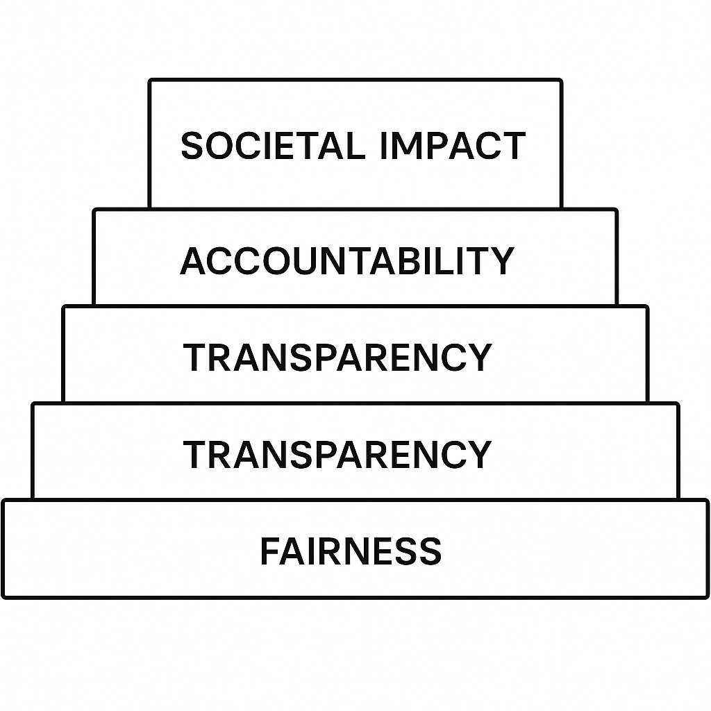

Figure 12.4: Ethical foundations and societal impact of AI

This layered diagram illustrates the ethical principles guiding AI’s impact on society. Fairness is the foundation, followed by transparency, accountability, and then the wider influence on society. This framework highlights how ethical principles support long-term trust, governance, and public benefit in the development of AI.

Core ethical principles
Ethical considerations lie at the heart of AI development, providing a moral compass to guide its applications and ensure they contribute positively to society. By addressing transparency, bias, and accountability, these principles lay the groundwork for creating AI systems that are both equitable and trustworthy [1]. The details are as follows:
- Transparency: AI systems must be interpretable, with decisions that are explainable to stakeholders. This principle becomes critical in high-stakes areas like healthcare and criminal justice, where opaque decision-making can lead to severe consequences [1] [2].
- Bias mitigation: Addressing biases embedded in training datasets or algorithms is essential to prevent harm, particularly to vulnerable populations. For instance, research shows that biased AI systems can perpetuate inequality, [3].
- Accountability: Mechanisms for auditing AI behaviors and outcomes ensure that developers and organizations can be held responsible for unintended consequences. Accountability frameworks are especially critical in autonomous systems, such as self-driving cars or AI-driven medical diagnostics [2].
AI’s societal role
AI has become a transformative force across industries, revolutionizing the way tasks are performed and paving new paths for innovation. However, alongside these benefits, AI also introduces challenges that must be carefully managed to ensure its advantages are shared broadly and its risks are effectively mitigated. The following list outlines the key opportunities and challenges:
- Opportunities:
- Automation of repetitive tasks increases productivity and efficiency, freeing human workers to focus on more creative and strategic activities [4].
- Innovations in AI foster economic growth, spurring the development of new industries, such as personalized medicine and smart cities [5].
- Challenges:
- Job displacement is a significant concern, particularly in sectors like manufacturing and customer service. Estimates suggest millions of jobs may be automated in the coming decade, creating the need for reskilling programs [6].
- The risks of surveillance and privacy erosion grow with AI-powered tools capable of mass data collection and analysis. Governments and corporations must implement stringent data protection measures to counterbalance these risks [7].

Practical tools for ethical AI
To ensure that AI systems adhere to ethical principles, developers can utilize practical tools to assess their models for fairness, transparency, and accountability. These tools provide actionable insights into whether an AI system meets established guidelines and identify areas for improvement. The following is a code example of a Python function designed to evaluate a model's fairness by detecting bias in its predictions:
```python

def evaluate_ai_ethics(model, dataset):
# Check for fairness
predictions = model.predict(dataset)
bias_detected = np.std(predictions) > 0.1 # Example threshold
print("Bias Detected:", bias_detected)
```
This code snippet demonstrates a straightforward approach to evaluating the fairness of an AI model. The evaluate_ai_ethics function takes two inputs: model, representing the AI system being tested, and dataset, the data used to evaluate the model's predictions.
The function uses model.predict() to generate predictions on the dataset. It then measures the variability in these predictions by calculating the standard deviation np.std(predictions). A high deviation, exceeding a set threshold (such as 0.1), may indicate that the predictions are unevenly distributed, suggesting possible bias in the outputs.
Finally, the function indicates whether bias has been detected, providing a clear signal of the model's fairness. This tool serves as a fundamental step for developers to assess AI ethics, providing a quick and effective way to identify potential issues that could compromise the system's fairness or trustworthiness.

Future trends and research directions
As reinforcement learning continues to advance, new trends and research areas are expanding their scope. From improving AI safety to developing energy-efficient methods, these innovations not only enhance technical skills but also address pressing societal and environmental issues.
Additionally, as it progresses into high-stakes settings, safe exploration becomes crucial. The following figure illustrates how agents can distinguish between safe and unsafe results, modifying their actions accordingly:


Figure 12.5: Safe exploration and penalty feedback in reinforcement learning

Figure 12.5 illustrates the safe exploration loop in reinforcement learning. The agent performs an action, which may lead to a safe or unsafe state. If the result is unsafe, a penalty is applied, and the agent adjusts its behavior to avoid similar risks. This framework facilitates risk-aware learning, a vital aspect when implementing AI in real-world systems.

Exciting frontiers
The horizons of reinforcement learning are broadening into exciting new areas, driven by innovations in safety, sustainability, and generalization. These advances are poised to make AI systems more dependable, flexible, and impactful across a range of key applications, such as:
- Safe reinforcement learning: It focuses on designing algorithms that prioritize safe exploration, minimizing risks in sensitive domains like healthcare and autonomous vehicles.
- Energy-efficient AI: It addresses the environmental impact of training large-scale models by optimizing resource usage and reducing carbon footprints.
- General AI: It represents a bold leap toward systems capable of mastering diverse tasks without domain-specific tailoring, heralding a new era of versatility in AI.

Safe exploration in reinforcement learning
In safety-critical environments, reinforcement learning must account for the risks associated with unsafe actions or states. This example demonstrates a practical approach to safe exploration, where the environment penalizes the agent for entering unsafe states, thereby encouraging safer learning behavior:
```python

class SafeEnvWrapper:
def __init__(self, env):
self.env = env

def step(self, action):
state, reward, done, info = self.env.step(action)
# Penalize unsafe states
reward -= 10 if self.is_unsafe(state) else 0
return state, reward, done, info

def is_unsafe(self, state):
# Define unsafe conditions
return state[0] < -1.0 or state[0] > 1.0
```
The SafeEnvWrapper class wraps a standard reinforcement learning environment (env) while adding safety constraints. This wrapper discourages agents from exploring unsafe states by penalizing their rewards. The details are as follows:
- Initialization: The SafeEnvWrapper class takes an existing environment as input during initialization, making it compatible with any reinforcement learning environment.
- Step function: The step method intercepts actions performed by the agent. After executing the action in the environment, the method checks if the resulting state violates predefined safety conditions. If the state is deemed unsafe, a penalty of 10 is subtracted from the agent’s reward, signaling that such behavior is undesirable.
- Safety Conditions: The is_unsafe method defines the criteria for unsafe states. In this example, any state where the first dimension exceeds the range [-1.0, 1.0] is flagged as unsafe. These conditions can be tailored to specific applications, enabling flexibility across different domains.
This approach is especially useful in applications where safety is critical. By incorporating such mechanisms into reinforcement learning environments, developers can train agents to adhere to safety constraints, ensuring robust and dependable performance in real-world situations. This example underscores the increasing importance of striking a balance between ethics and practicality in the design of AI systems.

Key takeaways
In summarizing the core lessons of this book, the main takeaways act as a guide to understanding the fundamental concepts, practical implications, and ethical responsibilities that form the basis of reinforcement learning. The following insights capture the essence of what has been discussed, offering a clear understanding of AI’s role in shaping the future:
- Core concepts: Understanding reinforcement learning principles is crucial for designing robust AI systems.
- Practical applications: From mastering games to optimizing logistics, reinforcement learning has proven its versatility.
- Ethical AI: As AI continues to integrate into daily life, ethical considerations must guide its development.
To conclude this exploration, in Figure 12.6 we present a forward-looking roadmap that outlines the evolving trajectory of reinforcement learning, from foundational techniques to more complex and ethically aligned systems.
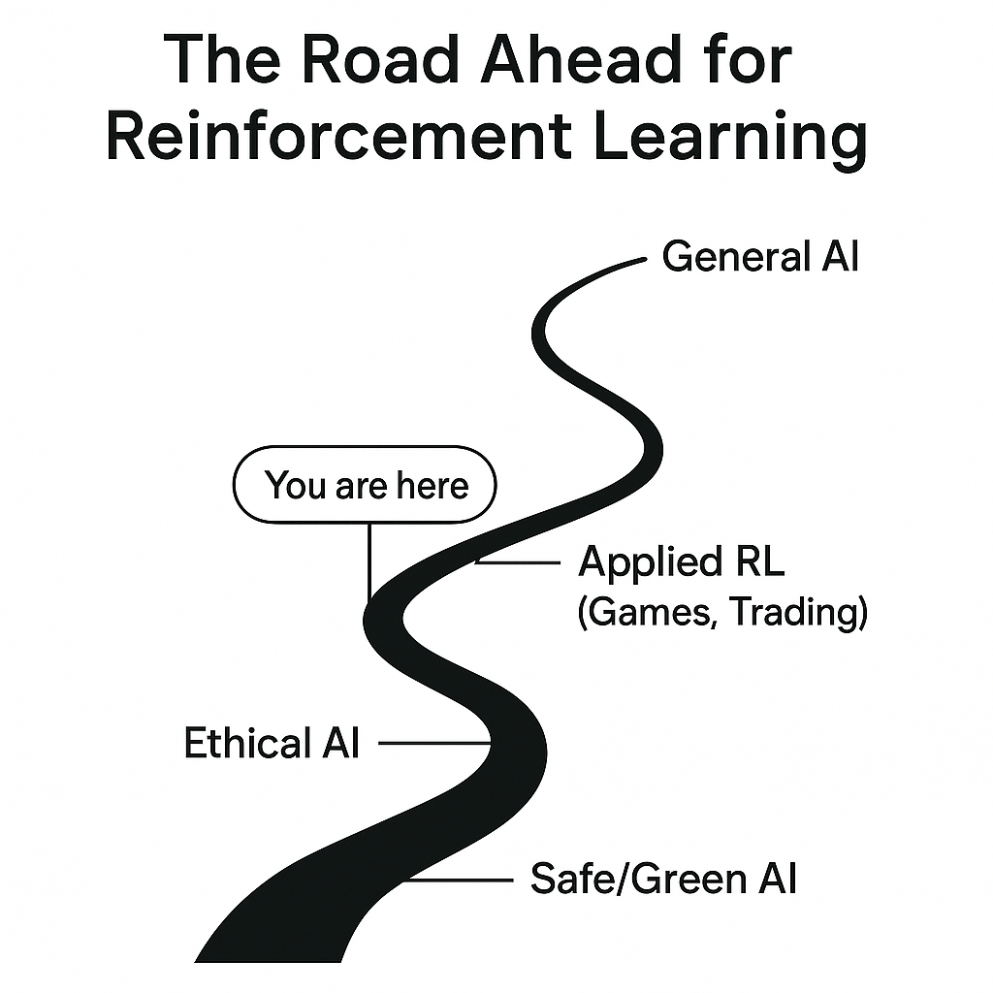

Figure 12.6: The road ahead for reinforcement learning

The preceding figure shows the future development of reinforcement learning. It begins with basic RL ideas, moves through practical areas such as gaming and trading, and aims for ethical and sustainable AI, culminating in the goal of achieving general intelligence. The You are here marker indicates the current stage of the field and encourages readers to envision their next steps.

Conclusion
As we reach the end of this journey, reinforcement learning stands out as a driving force in the evolution of artificial intelligence. By revisiting its core principles, exploring advanced tools, and examining the ethical implications of AI, this work underscores the importance of striking a balance between technological innovation and social responsibility. Reinforcement learning’s ability to combine adaptive intelligence with practical applications continues to redefine how machines learn, make decisions, and collaborate with humans.
This book has provided a foundation for understanding and navigating the rapidly expanding world of AI. As the field advances, our challenge is not only to master its capabilities but also to guide its development with fairness, transparency, and accountability. Through curiosity, experimentation, and ethical awareness, we can ensure that innovation serves both progress and the public good.
The road ahead is rich with opportunities and challenges, offering boundless potential for discovery and transformation. With the knowledge and insights gained from these chapters, readers are equipped to make meaningful contributions to AI’s future, whether by advancing research, creating impactful applications, or promoting responsible practices. By aligning human creativity with machine intelligence, we can build a future where technology empowers rather than replaces, illuminating new paths toward a more sustainable and inclusive world.

References
- F. Doshi-Velez and B. Kim, "Towards a rigorous science of interpretable machine learning," 2017.
- L. Floridi, "AI4People - An ethical framework for a good AI society: Opportunities, risks, principles, and recommendations," Minds and Machines, vol. 28, pp. 689, 707, 2018.
- C. O'Neil, Weapons of math destruction: How big data increases inequality and threatens democracy, Crown Publishing Group, 2016.
- E. Brynjolfsson and A. McAfee, The second machine age: Work, progress, and prosperity in a time of brilliant technologies, W.W. Norton and Company, 2014.
- S. Russell and P. Norvig, Artificial Intelligence: A modern approach, Fourth edition ed., Pearson, 2020.
- C. B. Frey and M. A. Osborne, "The future of employment: How susceptible are jobs to computerisation?," Technological Forecasting and Social Change, vol. 114, pp. 254, 280, 2017.
- S. Zuboff, The age of surveillance capitalism: The fight for a human future at the new frontier of power, PublicAffairs, 2019.

