Chapter 1
The Rise of Agentic AI in Cybersecurity
Paulo H Leocadio

Part I
Foundations of agentic cybersecurity
Part I defines the structural logic of agentic cybersecurity. It establishes the progression from rule-based automation to adaptive autonomy and finally to bounded agency under governance constraints. Rather than presenting isolated techniques, this section constructs the conceptual framework necessary to understand intelligent security systems as controllable infrastructures. The chapters that follow build the vocabulary, constraints, and formal distinctions required before any discussion of deployment or industrialization can be meaningful.
Structural foundations of agentic autonomy
Autonomous security systems are not defined by intelligence alone, but by constrained decision-making under uncertainty. Before examining architectures or deployment models, it is necessary to formalize the structural conditions under which agency can exist without degenerating into stochastic behavior.
Principle I
Autonomy is optimization under constraint
Autonomy in adversarial security environments is the minimization of expected loss subject to observability and governance bounds.
$$π^{*}=\arg{\underset{π∈Π}{\min{}}E\left[L\left(s,a\right)\right]}\text{s.t.}O(s)≠∅, G(a)=1$$
Where:
- $π$is the policy governing action selection.
- $L(s,a)$ is the loss incurred under state $s$ and action $a$.
- $O(s)$ represents state observability.
- $G(a)$ is a governance admissibility function.
Interpretation.
Autonomy is not unconstrained optimization. It is a bounded optimization under incomplete information and institutional policy constraints. Removal of either observability or governance invalidates the claim of bounded agency.
Principle II
Agency expands the failure surface
As decision latitude increases, systemic risk variance increases proportionally to the dimensionality of the action space.
$$\text{Var}(R)∝\text{Dim}(A)$$
Where:
- $R$ denotes systemic risk.
- $A$ is the action space available to the agent.
Interpretation.
Greater agency increases adaptive capacity while simultaneously expanding the space for potential misalignment and failure. Capability growth and risk growth are structurally coupled.
Principle III
Agency requires closed control loops
An agentic system must operate within a measurable feedback loop to remain controllable.
$$s_{t+1}=f(s_{t},a_{t},ϵ_{t}),a_{t}=π(s_{t})$$
With the feedback observability condition:
$$\frac{∂s_{t+1}}{∂a_{t}}\text{ is measurable}$$
Where:
- $s_{t}$ is system state at time $t$.
- $a_{t}$ is the selected action.
- $ϵ_{t}$ represents environmental uncertainty.
Interpretation.
Without measurable state transitions attributable to actions, autonomy collapses into uncontrolled actuation. Bounded agency requires inspectable feedback.
Principle IV
Autonomy operates over belief, not certainty
Agentic systems do not act on true states, but on probabilistic belief distributions over states.
$$b_{t}(s)=P(s_{t}=s∣o_{1:t},a_{1:t-1})$$
Where:
- $b_{t}(s)$ is the belief distribution at time $t$.
- $o_{1:t}$ are observations up to time $t$.
- $a_{1:t-1}$ are prior actions.
Belief update follows Bayesian conditioning:
$$b_{t+1}(s^{'})∝P(o_{t+1}∣s^{'})\sum_{s}{P(}s^{'}∣s,a_{t})b_{t}(s)$$
Interpretation.
Autonomous security systems do not possess direct knowledge of the system state; they maintain probabilistic beliefs that are updated through observation and action. All optimization and control occur in the belief space, not the ground truth.
Intellectual lineage
The formal foundations introduced in this section draw from established traditions in control theory, decision theory, and probabilistic inference. Optimization under constraint reflects classical dynamic programming and sequential decision-making (Bellman 1957, Bertsekas 1999, Sutton and Barto 2018). Feedback closure and state observability align with modern control theory (Kalman 1960, Åström and Murray 2008). Belief-based decision processes derive from Bayesian probability theory (Bayes 1963, Kolmogorov 1950) and their computational realization in partially observable Markov decision processes (Kaelbling, Littman and Cassandra 1998).
Together, these traditions frame autonomy not as emergent intelligence, but as constrained decision-making under uncertainty within measurable feedback systems.

These principles do not constitute a complete theory of intelligent systems. They establish the minimum structural conditions under which autonomy in cybersecurity can be meaningfully discussed. The chapters that follow expand these foundations, moving from rule-based automation to adaptive autonomy and ultimately to bounded agency within real-world governance and infrastructure constraints.
Introduction
From automation to agency, the historical trajectory of cybersecurity mirrors the conceptual development of artificial intelligence. In the 1990s, defensive automation consisted of rule-based intrusion detection systems that matched byte signatures and issued alerts (Russell and Norvig 2022). These systems operated without understanding: a rule was activated, a log was recorded, and the machine returned to sleep. Early security engineers viewed automation as a way to boost labor rather than as a form of intelligence.
By the mid-2000s, the rise in network telemetry rendered fixed rules obsolete. The introduction of machine-learning classifiers and Bayesian filters has given systems a degree of autonomy, enabling them to learn thresholds and detect spam, malware, and anomalies with minimal human input (Goodfellow, Bengio and Courville 2016). Nonetheless, these models remained goal-agnostic: they aimed to enhance detection accuracy but did not grasp the strategic objectives behind their tasks.
The 2020s represent a significant advance in agency, defined as an artificial system's ability to set goals, reason about context, and select actions aligned with its mission. In a modern Security Operations Center (SOC), an agentic architecture can analyze threat narratives from natural-language feeds, hypothesize causal chains, and recommend mitigations, tasks previously limited to analysts (Leocadio 2025). These systems are not only adaptable but also reflective: they evaluate whether their earlier decisions have enhanced the overall defense posture.
The shift from automation to agency reflects broader debates in knowledge. Automation relates to mechanical determinism; autonomy to cybernetic adaptation; and agency to cognitive delegation (Tegmark 2017). As each stage grants machines more decision-making power, control becomes both a technical and ethical concern. This chapter examines how new learning architectures (Transformers, Diffusers, and multi-agent frameworks) make such delegation not only possible but, given modern threats, unavoidable.
Transformers and diffusers as cognitive catalysts
Two algorithmic breakthroughs ignited the agentic turn: the Transformer and the Diffuser. Introduced by (Vaswani, et al. 2017), the Transformer's attention mechanism replaced recurrence with context-wide relational reasoning. In cybersecurity analytics, attention enables correlation across heterogeneous evidence (e.g., system logs, packet flows, and textual advisories), allowing the model to infer multi-stage intrusion patterns (OpenAI, et al. 2023).
Diffusion models (Ho, Jain and Abbeel 2020) complement this capability by learning to reconstruct structure from noise. They model probability trajectories in high-dimensional latent space, providing an internal simulation engine. Where Transformers understand sequences, Diffusers imagine possibilities. When integrated, they enable architectures capable of reasoning over both observed states and plausible futures.
"In the same way diffusion models imagine variations of an image, agentic systems imagine variations of an attack" (Leocadio 2025).
Practical deployments demonstrate this interaction. A Transformer can summarize vulnerabilities from Common Vulnerabilities and Exposures (CVE^{™)} feeds, while a Diffuser can generate or simulate counterfactual propagation scenarios under modeled assumptions. The resulting ensemble forecasts attack surfaces before exploitation, transforming incident response from reactive triage to preventive foresight (LangChain 2024).
Figure 1.1 depicts the Agentic AI lifecycle, from automation to reasoning and feedback loops.
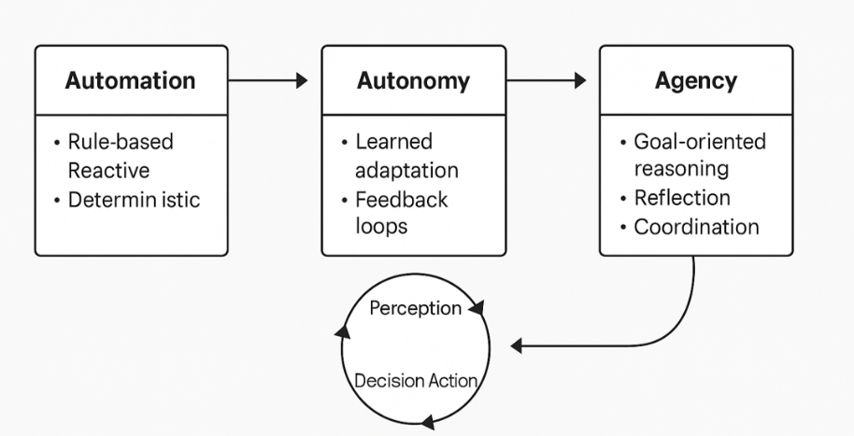
Figure 1.1 Agentic AI lifecycle.
These cognitive catalysts also democratize capability. Open-source ecosystems such as Hugging Face Diffusers and PyTorch Lightning have standardized reproducible checkpoints, enabling security researchers to fine-tune threat-specific reasoning models on modest hardware (Leocadio 2025). What started as image synthesis now influences cyber-simulation, a remarkable example of cross-domain generative transfer.
Emergent agency in cyber defense
Agency, unlike autonomy, emerges rather than being hard-coded. Reinforcement learning (RL) environments provide feedback between predicted and observed states; when combined with self-supervised pretraining, the system begins to exhibit adaptive planning (Goodfellow, Bengio and Courville 2016). In this book, "agentic" refers to systems capable of goal-directed decision-making under constraint, while multi-agent architectures represent one implementation pattern for distributing such decision capacity across coordinated entities.
Within SOC ecosystems, multi-agent frameworks coordinate these capabilities. LangChain, (LangChain 2024) and AutoGen (Wu, et al. 2024) enable role-based reasoning: one agent triages alerts, another contextualizes incidents, and a third drafts mitigation scripts. (CrewAI, 2025) extends this paradigm to persistent "agent teams" operating around shared memory stores.
Empirical studies show that collaboration, rather than individual accuracy, determines defensive intelligence (Borgeaud, et al. 2021). As (Rahwan 2019) observes, emergent behavior scales non-linearly; doubling the number of agents can yield exponential coverage if communication bandwidth and reward alignment are meticulously designed.
Table 1.1 Comparative capabilities of reactive, autonomous, and agentic AI systems.
Capability | Reactive Automation | Autonomous Systems | Agentic AI Systems
Knowledge scope | Fixed rules | Learned patterns | Dynamic contexts
Adaptation | Manual | Limited | Self-directed
Goal representation | Pre-defined | task-specific | strategic
Feedback | External | Internal | Multi-Agent
Example | IDS signature | ML classifier | Self-optimizing SOC
In applied contexts, emergent agency manifests as collective intuition. Agents learn which peer to query for expertise, forming knowledge graphs that mirror organizational learning (CrewAI 2025). Such properties hint at the dawn of synthetic collaboration: defense ecosystems that co-evolve operational knowledge and executable logic.
The multidimensional transition from reactive to agentic systems extends beyond the categorical distinctions presented in Table 1.1. Where the table delineates functional differences in scope and feedback, the following visual summary captures the evolution of intelligence modes, how autonomy, adaptability, interactivity, and learning maturity expand across generations of Artificial Intelligence (AI) design.
Figure 1.2 situates these progressions within a single conceptual frame, illustrating the widening cognitive and operational gap between traditional automation and agentic intelligence. A visual summary highlighting how autonomy, adaptability, interactivity, and learning maturity progress from reactive automation to agentic intelligence.
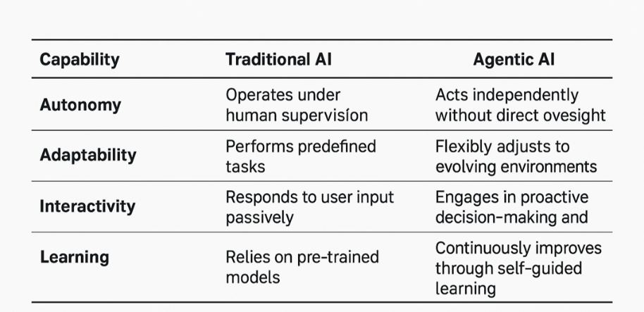
Figure 1.2 Comparative Evolution of Intelligence Modes.
The categorical comparison in Table 1.1 is extended in Figure 1.2.
Architectures of agency
An agentic system may be viewed as four interlocking layers: Perception, Memory, Planning, and Execution (MITRE Corporation 2022).
- Perception: Transformer encoders digest multimodal inputs (e.g., logs, binaries, human reports), embedding them into unified vector spaces for correlation.
- Memory: Differentiable retrieval modules (e.g., FAISS or Chroma DB) preserve contextual history, enabling longitudinal reasoning (Borgeaud, et al. 2021).
- Planning and Reflection: Reinforcement Learning (RL) evaluators generate candidate actions while diffusion samplers explore counterfactuals under uncertainty.
- Execution and governance: Security, Orchestration, Automation, and Response (SOAR) pipelines (e.g., Splunk Phantom, AWS Step Functions) enforce human-approved mitigations, maintaining traceability.
Communication across layers uses message-passing schemas, such as LangGraph, to transmit thought objects rather than raw data (LangChain 2024). When the feedback loop between perception and action tightens while reflective latency remains bounded, the system attains situated intelligence, fast, context-aware, and self-evaluating.
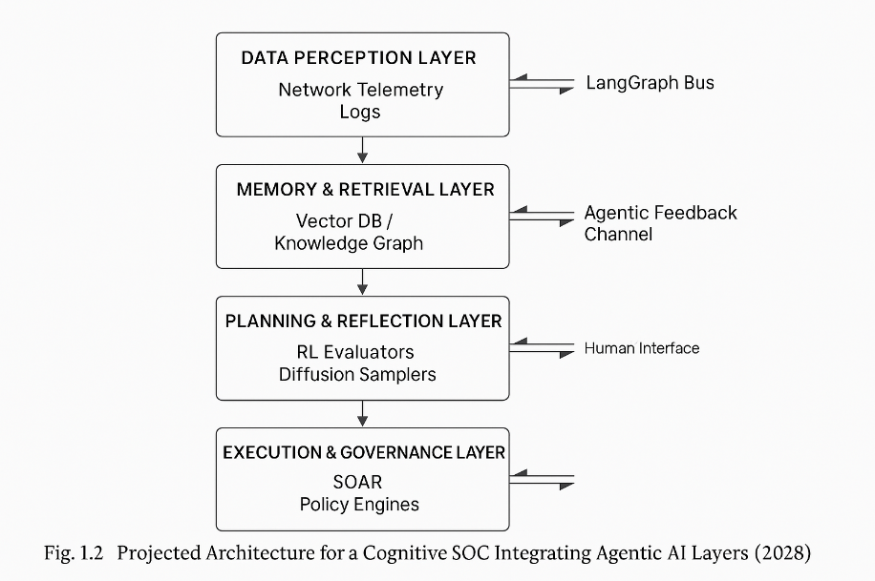
Figure 1.3 Projected Architecture for Cognitive SOC 2028.
Industrial prototypes validate this architecture. Microsoft Copilot for Security employs GPT-4-class (Generative Pre-trained Transformer class 4) Large Language Models (LLMs) to interrogate event graphs, hypothesize root causes, and evaluate mitigations within sandboxed Virtual Machines (VMs) (OpenAI, et al. 2023). Likewise, Hugging Face Pipelines integrate with AWS SageMaker for automated threat narrative summarization (Leocadio, 2025).
However, architectural sophistication alone cannot guarantee safety. Without governance, self-referential agents risk runaway decision loops. Embedding ethical constraints, policy-based access, confidence-bounded execution, and human oversight dashboards convert raw autonomy into disciplined agency (Floridi and Cowls 2019).
Ethics and governance of autonomous defense
Delegating defensive authority to machine agents introduces a moral architecture as complex as the technical one that sustains it.
When an AI system isolates a database or quarantines a production subnet in error, the question of responsibility arises: does culpability rest with the model's developer, the CISO (Chief Information Security Officer) who authorized deployment, or the organization that failed to supervise its learning process?
The EU Artificial Intelligence Act (2024) explicitly frames such dilemmas in terms of risk categories and human-in-the-loop obligations, while the NIST AI Risk Management Framework (2023) translates them into operational principles: traceability, accountability, and transparency.
From a governance perspective, cybersecurity is the perfect crucible for testing ethical AI because every decision entails the potential for rights violations: the rights to access, privacy, and data integrity (Floridi and Cowls 2019). Therefore, agentic systems must remain epistemically humble, aware of their confidence bounds, and able to request clarification before enacting irreversible measures. Bounded autonomy becomes an ethical design constraint rather than a performance limitation (Smethurst 2025).
In practice, four governance dimensions recur:
- Transparency of intent: Agents must expose reasoning chains and goal hierarchies so that humans can audit the motives behind mitigation.
- Reversibility of action: Every autonomous step must be undoable by authorized personnel through secure rollback functions.
- Value alignment: Reward functions should incorporate normative weights reflecting organizational ethics, not just technical success metrics (Tegmark 2017).
- Data provenance and explainability: Every inference should be traceable to its originating evidence (NIST 2023).
The environmental and social costs of persistent agentic inference cannot be ignored. A single large-scale LLM-driven SOC can consume megawatt-hours daily; thus, energy per incident mitigated becomes an essential governance metric (Rahwan 2019). Ethical design also demands socio-technical reflexivity: periodic evaluation of whether defensive algorithms reproduce bias or geopolitical asymmetries through training data. Without such reflection, AI may perpetuate digital colonialism under the guise of automation.
Governance must be immanent, built into the code itself.
Symbolic reasoning overlays, immutable decision logs, and consent-based escalation protocols transform ethical theory into executable policy (Floridi and Cowls 2019) The maturity of an agentic system will one day be measured not only by detection precision but by its ability to justify its existence within moral and legal boundaries.
Conclusion
Toward self-learning cyber systems, agentic AI completes a generational arc: automation executes instructions, autonomy optimizes outcomes, and agency now interprets purpose. By coupling transformer cognition, diffusion-based imagination, and reinforcement-learning feedback, these systems move from data processing to strategic reasoning (Russell and Norvig 2022).
Human analysts thus transition from operators to mentors of digital colleagues. The SOC of 2030 may resemble a cognitive research lab in which analysts curate objectives and agentic networks hypothesize, simulate, and report (Leocadio 2025). Such hybrid collaboration demands new educational models that teach machines ethical judgment and teach humans interpretive literacy.
Philosophically, agentic cybersecurity signifies an epistemological inversion: protection itself becomes a form of knowledge production.
Each defense iteration refines the system's understanding of threat ontology. Security ceases to be reactive engineering and becomes a self-reflective science, a dialogue between human intent and machine inference.
Emerging research frontiers in Agentic cyber defense
Three emerging research vectors promise to extend current capabilities:
- Neuro-symbolic Integration.
Projects at MIT Lincoln Lab and Oxford's AI Ethics Group investigate hybrid reasoning, in which symbolic logic modules constrain LLM-based agents to ensure policy compliance even under adversarial prompting (Smethurst 2025).
- Cross-Domain Simulation.
Diffusion-driven "red-team generators" use latent-space perturbation to craft synthetic attack sequences beyond existing threat intelligence, training blue-team agents for zero-day preparedness (Ho, Jain and Abbeel 2020).
- Cognitive Cyber Twins.
A developing concept at the Defense Advanced Research Projects Agency (DARPA) 's Computers and Humans Exploring Software Security (CHESS) program involves creating digital twins of analysts to preserve institutional knowledge; over time, these twins evolve into autonomous research collaborators (MITRE Corporation 2022).
Interdisciplinary collaboration will define progress.
Psychology contributes models of trust calibration; law introduces adaptive liability frameworks; philosophy ensures that technological self-assertion remains ethically bounded (Floridi and Cowls, 2019).
The convergence of these disciplines transforms "cybersecurity" into "cognitive security", the safeguarding of perception, reasoning, and memory themselves.
Future directions and integration roadmap
The immediate challenge is operational integration: embedding agentic architectures into heterogeneous enterprise environments without destabilizing existing controls.
A practical roadmap unfolds in four stages:
- Instrumentation and Data Ethics (2025–2026): Establish standard telemetry schemas and consent-aware data governance (NIST 2023).
- Hybrid Multi-Agent Pilots (2026–2027): Deploy constrained-scope agents within SOCs using LangChain or CrewAI frameworks (CrewAI 2025).
- Federated Learning for Threat Sharing (2027–2028): Adopt privacy-preserving collaboration across organizations to train cross-domain defense models (Borgeaud, et al. 2021).
- Cognitive Autonomy and Auditability (2029–2030): Evolve toward fully self-learning ecosystems with verifiable reasoning graphs and continuous compliance attestation (European Union 2024).
By 2030, the convergence of LLM reasoning, diffusion simulation, and reinforcement adaptation will yield self-governing security ecosystems, digital entities that perceive, hypothesize, and defend with minimal human prompting.
The final test will not be technological prowess but moral alignment: whether these entities defend humanity for us or, eventually, in ways misaligned with human intent.

References
Åström, Karl J., and Richard M. Murray. 2008. Feedback systems: an introduction for scientists and engineers. Press, Princeton University.
Bayes, Thomas. 1963. "An essay towards solving a problem in the doctrine of chances." Philosophical Transactions of the Royal Society of London 53: 370–418.
Bellman, Richard. 1957. Dynamic Programming. Princeton University Press.
Bertsekas, Dimitri P. 1999. Nonlinear Programming. Second. Athena Scientific.
Borgeaud, Sebastian, Arthur Mensch, Jordan Hoffmann, Trevor Cai, Eliza Rutherford, Katie Millican, George van den Driessche, et al. 2021. "Improving Language Models by Retrieving from Trillions of Tokens." arXiv:. doi:10.48550/arXiv.2112.04426.
CrewAI. 2025. "CrewAI: Multi-Agent Collaboration Framework." GitHub. https://github.com/joaomdmoura/crewai.
European Union. 2024. "Artificial Intelligence Act." Official Journal of the European Union L 217. https://eur-lex.europa.eu/legal-content/EN/TXT/?uri=CELEX:32024R1689.
Floridi, Luciano, and Josh Cowls. 2019. "A Unified Framework of Five Principles for AI in Society." Harvard Data Science Review. doi:10.1162/99608f92.8cd550d1.
Goodfellow, Ian, Yoshua. Bengio and Aaron. Courville. 2016. Deep learning. The MIT Press. https://mitpress.mit.edu/9780262035613/deep-learning/ http://link.springer.com/10.1007/s10710-017-9314-z.
Ho, Jonathan, Ajay Jain, and Pieter Abbeel. 2020. "Denoising Diffusion Probabilistic Models." arXiv preprint arXiv:2006.11239. http://arxiv.org/abs/2006.11239.
Kaelbling, Leslie Pack, Michael L. Littman, and Anthony R. Cassandra. 1998. "Planning and acting in partially observable stochastic domains." Artificial Intelligence 101: 99–134.
Kalman, Rudolf E. 1960. "A New Approach to Linear Filtering and Prediction Problems." Transactions of the ASME--Journal of Basic Engineering 82 (1): 34–45.
Kolmogorov, Andrey N. 1950As. Foundations of the theory of probability. Springer, Julius.
LangChain. 2024. "LangChain Documentation: Multi-Agent Systems." https://docs.langchain.com.
Leocadio, Paulo H. 2025. "The Role of Hugging Face Diffusers in Automating Cybersecurity Workflows." Authorea Preprint (Authorea Preprint). doi:10.13140/RG.2.2.20780.58240.
MITRE Corporation. 2022. MITRE ATT&CK® Framework Documentation v13. McLean: MITRE Corporation. https://attack.mitre.org/.
NIST. 2023. “Artificial Intelligence Risk Management Framework (NIST AI 100-1)." In the Artificial Intelligence Risk Management Framework (NIST AI 100-1). National Institute of Standards and Technology (NIST).
OpenAI, Josh Achiam, Steven Adler, Sandhini Agarwal, Lama Ahmad, Ilge Akkaya, Florencia Leoni Aleman, et al. 2024. “GPT-4 Technical Report." http://arxiv.org/abs/2303.08774.
Rahwan, Iyad. 2019. "Machine Behaviour." Nature 568 (7753): 477–486.
Russell, S., and P. Norvig. 2022. Artificial Intelligence: A Modern Approach. Fourth edition. © Pearson Education Limited.
Smethurst, Dr. Rebecca. 2025. "Lecture on AI Governance and Trust." In Oxford Intersections: AI in Society, edited by Philipp Hacker. Oxford University PressOxford. doi:10.1093/9780198945215.001.0001.
Sutton, R.S., and A.G. Barto. 2018. Reinforcement Learning. An Introduction. Second. Cambridge: Bradford Book.
Tegmark, Max. 2017. Life 3.0. 1. Alfred A. Knopf. https://books.google.com/books?id=Am9MnQAACAAJ.
Vaswani, Ashish, Noam Shazeer, Niki Parmar, Jakob Uszkoreit, Llion Jones, Aidan N. Gomez, Lukasz Kaiser and Illia Polosukhin. 2017. "Attention Is All You Need." Advances in Neural Information Processing Systems (NIPS 30. doi:10.48550/ARXIV.1706.03762.
Wu, Qingyun, Gagan Bansal, Jieyu Zhang Chi, Wu, Yiran, Beibin Zhu, Li Jiang, et al. 2024. “AutoGen: Enabling Next-Gen LLM Applications via Multi-Agent Conversation.” arXiv pre-print (arXiv). doi:https://doi.org/10.48550/arXiv.2308.08155.

HF Diffusers is a library of state-of-the-art pretrained diffusion models for generating videos, images, and audio.
An open-source DL framework that provides an interface for the PyTorch library to make the AI training process simpler.
A high-performance library developed by Meta for efficient similarity search and clustering of dense vectors.
An open-source, lightweight vector database designed for easy integration and rapid prototyping in AI workflows.
The former name for Splunk SOAR, a platform Splunk acquired to automate security workflows, integrate tools, and speed up incident response.
A serverless orchestration service that visually coordinates distributed applications and microservices into workflows (called state machines).
An open-source AI agent framework created by LangChain, designed to build, deploy, and manage complex generative AI agent workflows.
Currently called Microsoft Security Copilot, is a generative AI-powered assistant that integrates with different security tools to investigate threats.
GPT-4-class refers to large language models that match or exceed the advanced capabilities of OpenAI's GPT-4. Models in this class: GPT-4o or 4.1.
HF pipelines are objects that abstract most of the complex code from the diffuser’s library, offering a dedicated API.
A fully managed cloud platform that provides an integrated experience to build machine learning (ML) and generative AI models at scale.
AI-driven, virtual representations of human analysts to simulate their decision-making processes, automate repetitive analytical tasks, and augment their capabilities.

