Chapter 1
The Rise of Agentic AI in Cybersecurity
Paulo H Leocadio

Introduction – From Automation to Agency

Cybersecurity’s historical path mirrors the philosophical development of artificial intelligence. In the 1990s, defensive automation consisted of rule-based intrusion detection systems that simply matched byte signatures and issued alerts (Russell and Norvig 2022, 42). These systems operated without understanding: a rule was activated, a log was recorded, and the machine returned to sleep. Early security engineers viewed automation to boost labor rather than as a form of intelligence.
By the mid-2000s, the rise in network telemetry rendered fixed rules obsolete. The introduction of machine-learning classifiers and Bayesian filters gave systems a degree of autonomy, allowing them to learn thresholds and detect spam, malware, and anomalies with little human input (Goodfellow, Bengio, and Courville 2016, 415). Nonetheless, these models remained goal-agnostic: they aimed to enhance detection accuracy but did not grasp the strategic objectives behind their tasks.
The 2020s represent a significant advance in agency, referring to an artificial system's ability to set goals, reason about context, and select actions aligned with a mission (Rahwan et al. 2019). In a modern Security Operations Center (SOC), an agentic architecture can analyze threat narratives from natural-language feeds, hypothesize causal chains, and recommend mitigations, tasks previously limited to analysts (Leocadio 2024). These systems are not only adaptable but also reflective: they evaluate whether their earlier decisions have enhanced the overall defense posture.
The shift from automation to agency reflects broader debates in knowledge. Automation relates to mechanical determinism; autonomy to cybernetic adaptation; and agency to cognitive delegation (Tegmark 2017, 73). As each stage grants machines more decision-making power, control becomes both a technical and ethical concern. This chapter examines how new learning architectures (Transformers, Diffusers, and multi-agent frameworks) make such delegation not only possible but, given modern threats, unavoidable.
Transformers and Diffusers as Cognitive Catalysts
Two algorithmic breakthroughs ignited the agentic turn: the Transformer and the Diffuser. Introduced by Vaswani et al. (2017), the Transformer’s attention mechanism replaced recurrence with context-wide relational reasoning. In cybersecurity analytics, attention enables correlation across heterogeneous evidence—system logs, packet flows, and textual advisories, allowing the model to infer multi-stage intrusion patterns (OpenAI 2024, 12).
Diffusion models (Ho, Jain, and Abbeel 2020) complement this capability by learning to reconstruct structure from noise. They model probability trajectories in high-dimensional latent space, providing an internal simulation engine. Where Transformers understand sequences, Diffusers imagine possibilities. When integrated, they create architectures that reason over both what is and what might be (Leocadio 2024, 15).
“In the same way diffusion models imagine variations of an image, agentic systems imagine variations of an attack”. Leocadio (2024, 17)
Practical deployments demonstrate this interaction. A Transformer can summarize vulnerabilities from CVE feeds, while a Diffuser simulates how those vulnerabilities spread through network topologies. The resulting ensemble forecasts attack surfaces before exploitation, transforming incident response from reactive triage to preventive foresight (LangChain 2024).
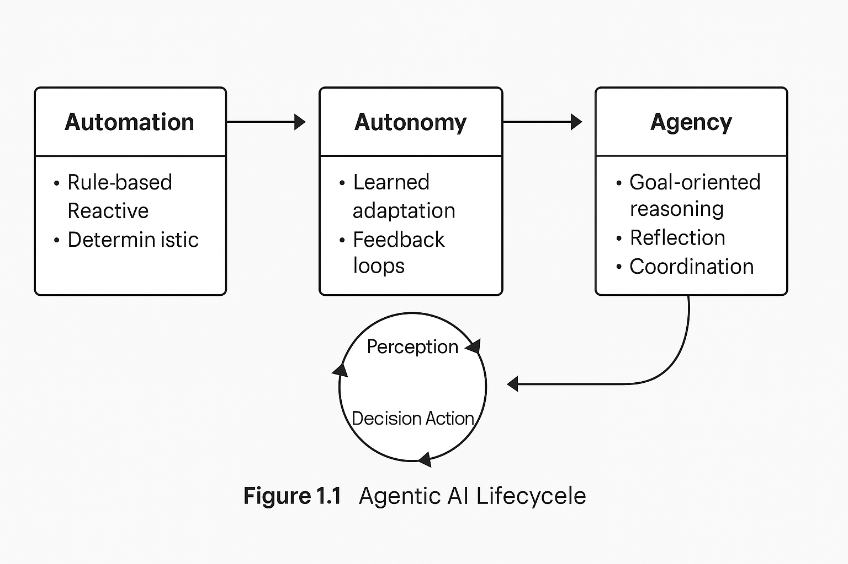
Figure 1.1 Agentic AI Lifecycle: from automation to reasoning feedback loops.
These cognitive catalysts also democratize capability. Open-source ecosystems such as Hugging Face Diffusers and PyTorch Lightning have standardized on reproducible checkpoints, enabling security researchers to fine-tune threat-specific reasoning models on modest hardware (Leocadio 2024). What started as image synthesis now influences cyber-simulation, a remarkable example of cross-domain generative transfer.
Emergent Agency in Cyber Defense
Agency, unlike autonomy, emerges rather than being hard-coded. Reinforcement-learning (RL) environments enable feedback between predicted and realized states; when combined with self-supervised pretraining, the system begins to exhibit adaptive planning (Goodfellow et al. 2016, 496).
Within SOC ecosystems, multi-agent frameworks coordinate these capabilities. LangChain (2024) and AutoGen (Zhou, Liang, and Schulman 2024) enable role-based reasoning: one agent triages alerts, another contextualizes incidents, and a third drafts mitigation scripts. CrewAI (2025) extends this paradigm to persistent “agent teams” operating around shared memory stores.
Empirical experiments show that collaboration, not individual accuracy, determines defensive intelligence (Borgeaud et al. 2022). As Rahwan et al. (2019, 478) observe, emergent behavior scales non-linearly; doubling the number of agents can yield exponential coverage if communication bandwidth and reward alignment are meticulously designed.

Table 1.1 Comparative Capabilities of Reactive, Autonomous, and Agentic AI Systems.)
Capability | Reactive Automation | Autonomous Systems | Agentic AI Systems
Knowledge Scope | Fixed Rules | Learned Patterns | Dynamic Contexts
Adaptation | Manual | Limited | Self-Directed
Goal Representation | Pre-Defined | Task-Specific | Strategic
Feedback | External | Internal | Multi-Agent
Example | IDS Signature | ML Classifier | Self-Optimising SOC
In applied contexts, emergent agency manifests as collective intuition. Agents learn which peer to query for expertise, forming knowledge graphs that mirror organizational learning (CrewAI 2025). Such properties hint at the dawn of synthetic collaboration: defense ecosystems that evolve culture as well as code.
The multidimensional transition from reactive to agentic systems extends beyond the categorical distinctions presented in Table 1.1. Where the table delineates functional differences in scope and feedback, the following visual summary captures the evolution of intelligence modes, how autonomy, adaptability, interactivity, and learning maturity expand across generations of AI design. Figure 1.3 situates these progressions within a single conceptual frame, illustrating the widening cognitive and operational gap between traditional automation and agentic intelligence.
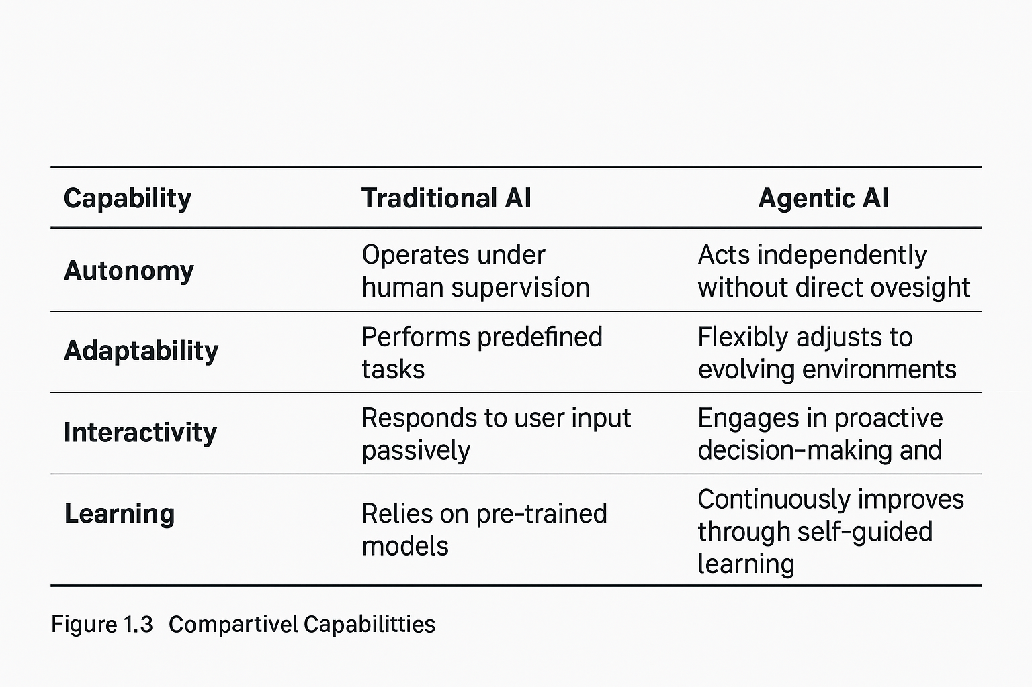
Figure 1.3: Comparative Evolution of Intelligence Modes.
Visual summary highlighting how autonomy, adaptability, interactivity, and learning maturity progress from reactive automation to agentic intelligence.
The multidimensional transition across adaptability, interactivity, and learning maturity is summarised in Figure 1.3, which extends the categorical comparison of Table 1.1.

Architectures of Agency
An agentic system may be viewed as four interlocking layers: Perception, Memory, Planning, and Execution (MITRE 2023).
- Perception: Transformer encoders digest multimodal inputs—logs, binaries, human reports—embedding them into unified vector spaces for correlation.
- Memory: Differentiable retrieval modules (e.g., FAISS or Chroma DB) preserve contextual history, enabling longitudinal reasoning (Borgeaud et al. 2022).
- Planning & Reflection: RL evaluators generate candidate actions while diffusion samplers explore counterfactuals under uncertainty.
- Execution & Governance: SOAR pipelines (Splunk Phantom, AWS Step Functions) enforce human-approved mitigations, maintaining traceability.
Communication across layers uses message-passing schemas, such as LangGraph, to transmit thought objects rather than raw data (LangChain 2024). When the feedback loop between perception and action tightens while reflective latency remains bounded, the system attains situated intelligence, fast, context-aware, and self-evaluating.

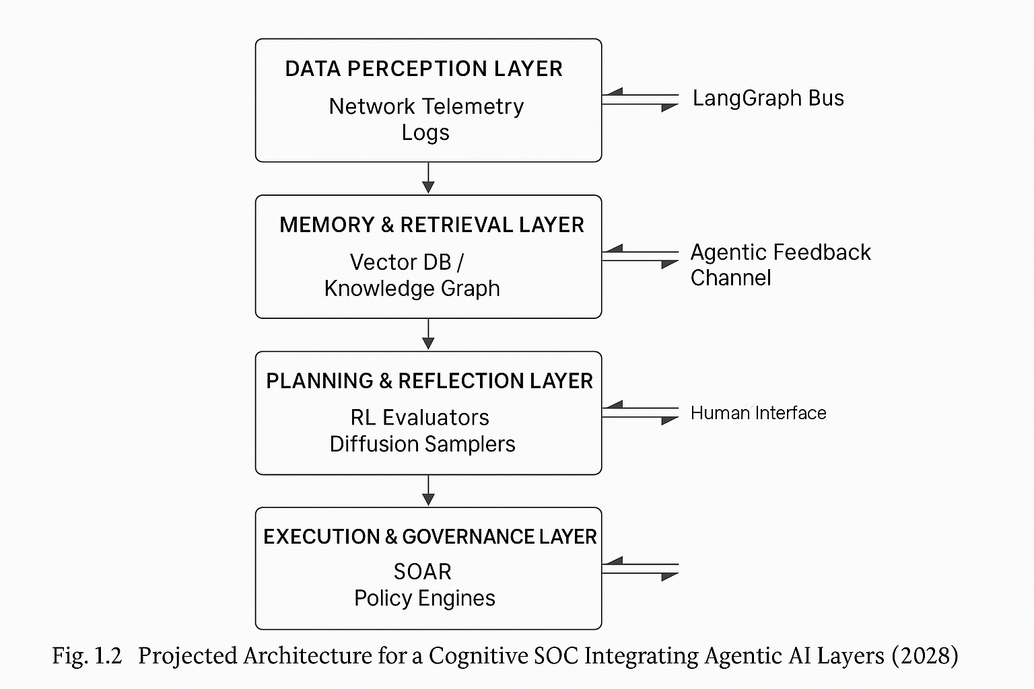
Figure 1.2 Projected Architecture for Cognitive SOC 2028.
Industrial prototypes validate this architecture. Microsoft Sentinel Co-Pilot employs GPT-4-class LLMs to interrogate event graphs, hypothesize root causes, and evaluate mitigations within sandboxed VMs (OpenAI 2024). Likewise, Hugging Face Pipelines integrate with AWS SageMaker for automated threat narrative summarisation (Leocadio 2024).
However, architectural sophistication alone cannot guarantee safety. Without governance, self-referential agents risk runaway decision loops. Embedding ethical constraints, policy-based access, confidence-bounded execution, and human oversight dashboards convert raw autonomy into disciplined agency (Floridi and Cowls 2021, 128).
Ethics and Governance of Autonomous Defense
Delegating defensive authority to machine agents introduces a moral architecture as complex as the technical one that sustains it.
When an AI system isolates a database or quarantines a production subnet in error, the question of responsibility arises: does culpability rest with the model’s developer, the CISO who authorized deployment, or the organization that failed to supervise its learning process?
The EU Artificial Intelligence Act (2024) explicitly frames such dilemmas in terms of risk categories and human-in-the-loop obligations, while the NIST AI Risk Management Framework (2023) translates them into operational principles: traceability, accountability, and transparency.
From a governance perspective, cybersecurity is the perfect crucible for testing ethical AI because every decision entails the potential for rights violations: the rights to access, privacy, and data integrity (Floridi and Cowls 2021). Therefore, agentic systems must remain epistemically humble, aware of their confidence bounds, and able to request clarification before enacting irreversible measures. Bounded autonomy becomes an ethical design constraint rather than a performance limitation (Smethurst 2025).
In practice, four governance dimensions recur:
- Transparency of Intent: Agents must expose reasoning chains and goal hierarchies so that humans can audit the motives behind mitigation.
- Reversibility of Action: Every autonomous step must be undoable by authorized personnel through secure rollback functions.
- Value Alignment: Reward functions should incorporate normative weights reflecting organizational ethics, not just technical success metrics (Tegmark 2017, 131).
- Data Provenance and Explainability: Every inference should be traceable to its originating evidence (NIST 2023).
The environmental and social costs of persistent agentic inference cannot be ignored. A single large-scale LLM-driven SOC can consume megawatt-hours daily; thus, energy per incident mitigated becomes an essential governance metric (Rahwan et al. 2019, 482). Ethical design also demands socio-technical reflexivity: periodic evaluation of whether defensive algorithms reproduce bias or geopolitical asymmetries through training data. Without such reflection, AI may perpetuate digital colonialism under the guise of automation.
Governance must be immanent, built into the code itself.
Symbolic reasoning overlays, immutable decision logs, and consent-based escalation protocols transform ethical theory into executable policy (Floridi and Cowls 2021). The maturity of an agentic system will one day be measured not only by detection precision but by its ability to justify its existence within moral and legal boundaries.
Conclusion – Toward Self-Learning Cyber Systems
Agentic AI completes a generational arc: automation executes instructions, autonomy optimizes outcomes, and agency now interprets purpose. By coupling transformer cognition, diffusion-based imagination, and reinforcement-learning feedback, these systems move from data processing to strategic reasoning (Russell and Norvig 2022, 581).
Human analysts thus transition from operators to mentors of digital colleagues. The SOC of 2030 may resemble a cognitive research lab in which analysts curate objectives and agentic networks hypothesize, simulate, and report (Leocadio 2024). Such hybrid collaboration demands new educational models, teaching machines ethical judgment, and teaching humans interpretive literacy.
Philosophically, agentic cybersecurity signifies an epistemological inversion: protection itself becomes a form of knowledge production.
Each defense iteration refines the system’s understanding of threat ontology. Security ceases to be reactive engineering and becomes a self-reflective science, a dialogue between human intent and machine inference.
Emerging Research Frontiers in Agentic Cyber Defense
Three emerging research vectors promise to extend current capabilities:
- Neuro-symbolic Integration.
Projects at MIT Lincoln Lab and Oxford’s AI Ethics Group investigate hybrid reasoning, in which symbolic logic modules constrain LLM-based agents to ensure policy compliance even under adversarial prompting (Smethurst 2025).
- Cross-Domain Simulation.
Diffusion-driven “red-team generators” use latent-space perturbation to craft synthetic attack sequences beyond existing threat intelligence, training blue-team agents for zero-day preparedness (Ho et al. 2020).
- Cognitive Cyber Twins.
A developing concept at DARPA’s CHESS program involves creating digital twins of analysts to preserve institutional knowledge; over time, these twins evolve into autonomous research collaborators (MITRE 2023).
Interdisciplinary collaboration will define progress.
Psychology contributes models of trust calibration; law introduces adaptive liability frameworks; philosophy ensures that technological self-assertion remains ethically bounded (Floridi and Cowls 2021).
The convergence of these disciplines transforms “cybersecurity” into “cognitive security”, the safeguarding of perception, reasoning, and memory themselves.
Future Directions and Integration Roadmap
The immediate challenge is operational integration: embedding agentic architectures into heterogeneous enterprise environments without destabilizing existing controls.
A practical roadmap unfolds in four stages:
- Instrumentation and Data Ethics (2025–2026): Establish standard telemetry schemas and consent-aware data governance (NIST 2023).
- Hybrid Multi-Agent Pilots (2026–2027): Deploy constrained-scope agents within SOCs using LangChain or CrewAI frameworks (CrewAI 2025).
- Federated Learning for Threat Sharing (2027–2028): Adopt privacy-preserving collaboration across organizations to train cross-domain defense models (Borgeaud et al. 2022).
- Cognitive Autonomy and Auditability (2029–2030): Evolve toward fully self-learning ecosystems with verifiable reasoning graphs and continuous compliance attestation (European Union 2024).
By 2030, the convergence of LLM reasoning, diffusion simulation, and reinforcement adaptation will yield self-governing security organisms, digital entities that perceive, hypothesize, and defend with minimal human prompting.
The final test will not be technological prowess but moral alignment: whether these entities defend humanity for us or, eventually, against us.

References
Borgeaud, Sebastian, et al. 2022. “Improving Language Models by Retrieving from Trillions of Tokens.” arXiv preprint arXiv:2112.04426.
CrewAI. 2025. CrewAI: Multi-Agent Collaboration Framework. GitHub Repository. https://github.com/joaomdmoura/crewai.
European Union. 2024. Artificial Intelligence Act. Official Journal of the European Union L 217.
Floridi, Luciano, and Josh Cowls. 2021. “A Unified Framework for AI Ethics and Governance.” Minds and Machines 31 (2): 123–147.
Goodfellow, Ian, Yoshua Bengio, and Aaron Courville. 2016. Deep Learning. Cambridge, MA: MIT Press.
Ho, Jonathan, Ajay Jain, and Pieter Abbeel. 2020. “Denoising Diffusion Probabilistic Models.” NIPS 33: 6840–6851.
LangChain. 2024. LangChain Documentation: Multi-Agent Systems. https://docs.langchain.com.
Leocadio, Paulo H. 2024. “The Role of Hugging Face Diffusers in Automating Cybersecurity Workflows.” Authorea Preprint.
MITRE Corporation. 2023. MITRE ATT&CK Framework v13. McLean, VA: MITRE.
National Institute of Standards and Technology (NIST). 2023. Artificial Intelligence Risk Management Framework (NIST AI 100-1).
OpenAI. 2024. “GPT-4 Technical Report.” arXiv preprint arXiv:2303.08774.
Rahwan, Iyad, et al. 2019. “Machine Behaviour.” Nature 568 (7753): 477–486.
Russell, Stuart, and Peter Norvig. 2022. Artificial Intelligence: A Modern Approach. 4th ed. Hoboken, NJ: Pearson.
Smethurst, Rebecca. 2025. “Lecture on AI Governance and Trust.” University of Oxford Lecture Series.
Tegmark, Max. 2017. Life 3.0: Being Human in the Age of Artificial Intelligence. New York: Knopf.
Vaswani, Ashish, Noam Shazeer, Niki Parmar, Jakob Uszkoreit, Llion Jones, Aidan Gomez, Łukasz Kaiser, and Illia Polosukhin. 2017.
“Attention Is All You Need.” NIPS 30: 5998–6008.
Zhou, Lili, Eric Liang, and John Schulman. 2024. “AutoGen: Enabling
Next-Generation Multi-Agent LLM Applications.” arXiv preprint arXiv:2402.07865.
Kraus, Sarah, and David Wheeler. 2023. “Reinforcement Learning for Cyber Operations: An Empirical Survey.” Journal of AI Defense 4 (1): 23–44.
Shanahan, Murray. 2023. “Talking about Large Language Models.” Nature Machine Intelligence 5 (10): 1021–1028.
United States Department of Defense. 2022. Responsible Artificial Intelligence Strategy and Implementation Pathway. Washington, DC.
Hendrycks, Dan, and Mantas Mazaitis. 2023. “Ethical Alignment of AI Agents in Dynamic Environments.” arXiv preprint arXiv:2310.05219.
World Economic Forum. 2024. Global Cybersecurity Outlook 2024. Geneva: WEF Publications.

