Chapter 2
Architecting Open-Source Intelligence Pipelines
Paulo H. Leocadio

Introduction: From Infrastructure to Cognition
Modern digital defense infrastructures have undergone a profound transformation as computation moves from fixed on-premise environments into fluid, cloud-native ecosystems. Security Operations Centers (SOCs), once grounded in static rules and centralized event pipelines, now operate in landscapes defined by scale, heterogeneity, and rapid adversarial evolution. In such environments, defense systems must transcend monitoring and become cognitive infrastructures, capable of perceiving uncertainty, generating hypotheses, validating their own reasoning, and acting adaptively in real time (Gartner 2023).
This chapter presents a holistic architecture of Cognitive Defense, building on three integrated layers:
- Cloud-Native Cognitive Foundations
- Multi-Agent Adaptive Defense Intelligence
- Zero-Trust Inference and Epistemic Integrity
Together, these architectures represent a continuum: from infrastructure cognition to collective reasoning to epistemic self-verification.

2.1 Cloud-Native Foundations of Cognitive Defense
Cloud-native architectures form the foundation for cognitive defense. Traditional SOCs rely on deterministic workflows and centralized correlation engines. In contrast, cloud-native SOCs utilize containerization, microservices, and elastic compute to coordinate cognitive functions, with ephemeral intelligence modules deployed, scaled, and retired as needed (AWS 2024).
Cognition begins in the observability layer, where metrics, logs, traces, and events provide sensory input. These heterogeneous signals are vectorized, often via diffusion or transformer encoders, converting raw telemetry into structured latent representations. These embeddings feed reasoning modules that detect semantic correlations beyond human-defined rule sets.
The layered organization of these computational planes can be visualized in the Cloud-Native Cognitive Defense Stack shown in Figure 2.1.

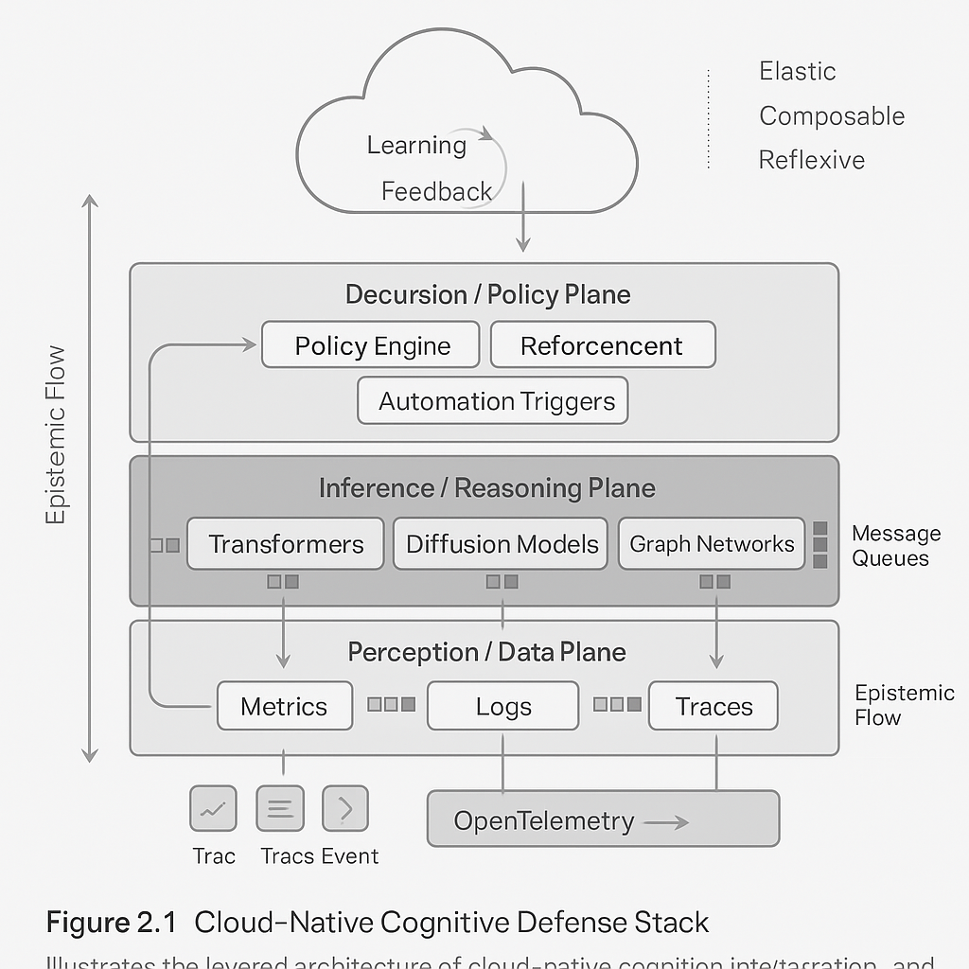
Figure 2.1 Cloud-Native Cognitive Defense Stack.
Illustrates the multilayered architecture in which perception, inference, decision, and learning planes interact through continuous epistemic feedback within elastic, cloud-native environments.
Above perception lies the inference plane, populated with modular reasoning containers, graph neural networks, diffusion models, and causal engines, each specialized for a domain of defense. Distributed message queues facilitate communication across models, enabling asynchronous and parallel cognition.
The decision plane implements policy logic, reinforcement controllers, and automation triggers. It defines how inferences translate into actions, such as network isolation, priority escalation, or targeted observability.
Finally, the learning plane governs continuous adaptation. MLOps workflows retrain models when performance drifts, incorporate analyst feedback, and re-evaluate data quality. This creates a reflexive loop in which perception informs reasoning, reasoning triggers action, and action reshapes future perception (Minsky 1988).
Cloud-native cognition thus forms a self-similar architecture whose layers interact continuously through event streams, feedback loops, and epistemic flow.

2.2 Cognitive Multi-Agent Systems and Adaptive Defense Intelligence
While cloud-native layers provide the anatomical foundation, cognitive defense becomes truly adaptive when intelligence is distributed across multi-agent systems (MAS). A single model cannot reason effectively across asynchronous contexts, but a mesh of cooperating agents can.
Agents operate autonomously within bounded domains, identify behavior, analyze network flows, and monitor endpoint telemetry, each equipped with specialized inference models. Mediator agents translate latent representations between domains, while coordinator agents enforce consensus, reinforcement alignment, and global objectives (Wooldridge 2021).
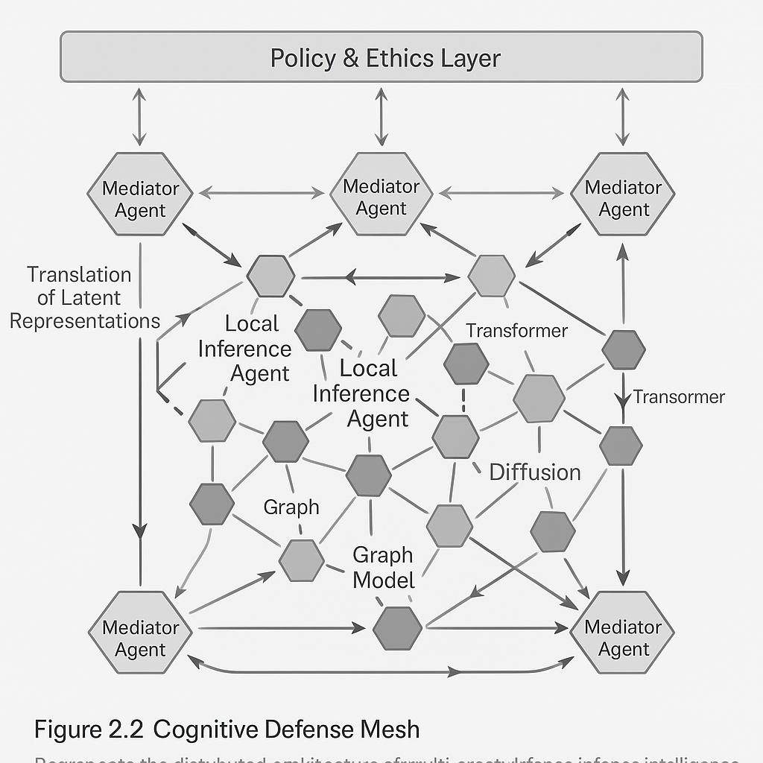
Figure 2.2 Cognitive Defense Mesh.
Shows the distributed topology of heterogeneous agents, including inference, mediator, and coordinator entities, cooperating through shared latent representations under a unified policy and ethics layer.
This architecture transforms the SOC into a Defense Ecosystem: a dynamic system where hypotheses are shared, debated, and combined. Agents communicate using vector-space tokens that describe confidence, context, and origin. Cognitive convergence can be formalized by tracking epistemic entropy across agents:
Decision-making mechanisms determine how much mental effort to devote to uncertainty, balancing cost and knowledge gain (Simon 1982).
Collective learning mechanisms such as Federated Reinforcement Learning (FRL) allow agents to improve without centralizing raw telemetry, aligning naturally with zero-trust principles. Swarm intelligence protocols enable predictive resilience: distributed detectors elevate weak signals into consensus-driven escalation (Bonabeau et al. 1999).
Security is preserved through intra-agent authentication, trust scoring, and cryptographic attestation. Agents build reputational capital through historical accuracy and cooperation. Unreliable or compromised agents enter quarantine, ensuring systemic robustness.
Multi-agent cognition represents the physiology of cognitive defense, the circulation of meaning, trust, and adaptation.
The dynamics of uncertainty reduction during multi-agent reasoning cycles are illustrated in Figure 2.4.

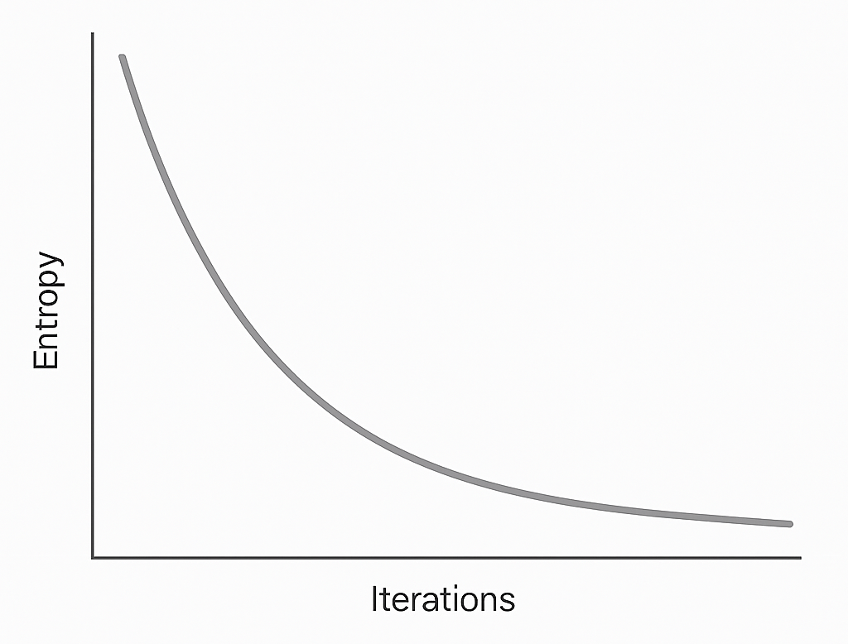
Figure 2.3 Entropy Trajectory in Multi-Agent Consensus.
Demonstrates the expected decline in epistemic entropy as distributed agents iteratively negotiate and converge toward a shared conclusion.
Differences between deterministic and stochastic consensus behavior are shown in Figure 2.5.
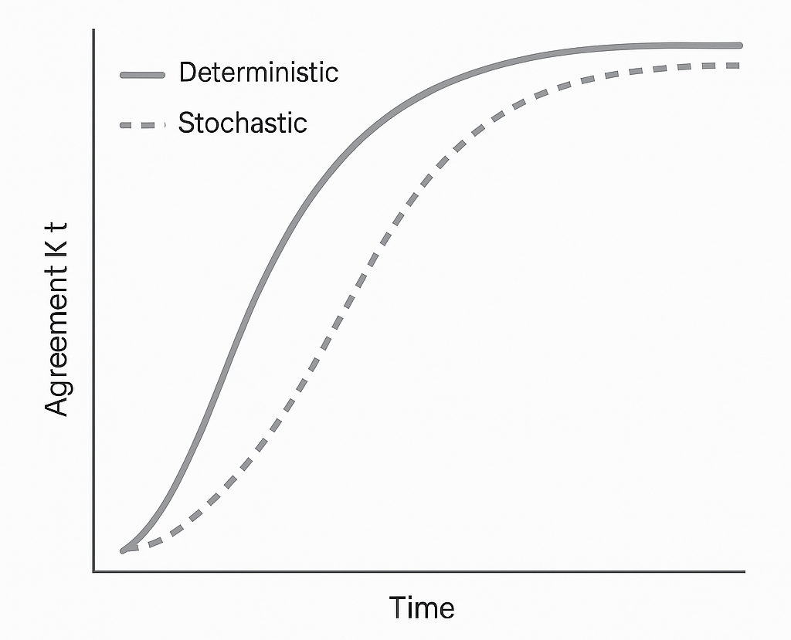
Figure 2.4 Consensus Curves Analogizing Point Agreement.
Compares deterministic and stochastic multi-agent consensus mechanisms, showing their respective trajectories as agreement strengthens over time.

2.3 Zero-Trust Inference and Epistemic Integrity
Historically, zero-trust principles have applied to identity and access. In cognitive defense, the principle evolves into epistemic zero trust, the notion that no inference is accepted without verification. Given that generative models are susceptible to manipulation (Carlini et al. 2024), inference must be treated as a potential attack vector.
Zero-trust inference frameworks embed verification at every level:
- Input Verification: Cryptographically signed data, provenance hashes, and secure enclaves validate input lineage.
- Model Integrity: Model binaries undergo checksum attestation; inference can only occur through audited versions.
- Inference Attestation: Each inference produces a Verifiable Reasoning Token (VRT) recording attention paths, latent transitions, and model parameters.
Figure 2.6 provides a structural view of how inference states are cryptographically chained to create verifiable epistemic lineage.
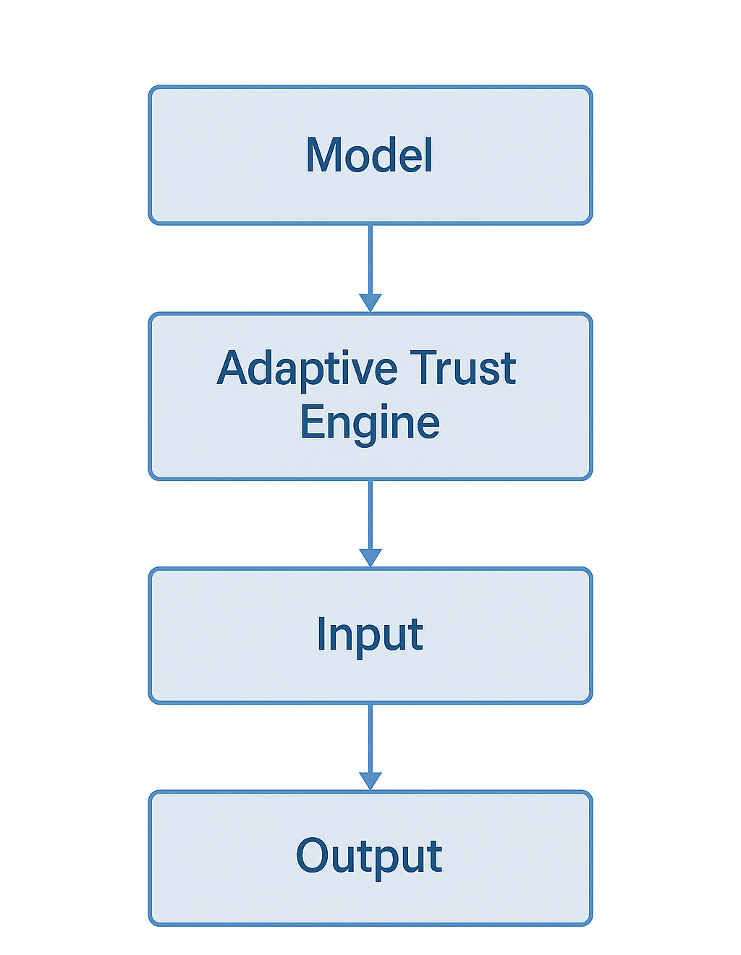
Figure 2.5 Proof-of-Inference Hash Chain.
Depicts the sequence of inference states linked via cryptographic hashing, forming an immutable ledger that records the provenance of reasoning across cognitive processes.
- Policy & Ethics Layer: Governance engines evaluate inferences against fairness, safety, and legal predicates (Jobin et al. 2019).
- Adaptive Trust Engine: Dynamic trust vectors compute epistemic entropy and regulate model participation.
The full epistemic verification pipeline is summarized in Figure 2.3 through the Zero-Trust Inference Framework.
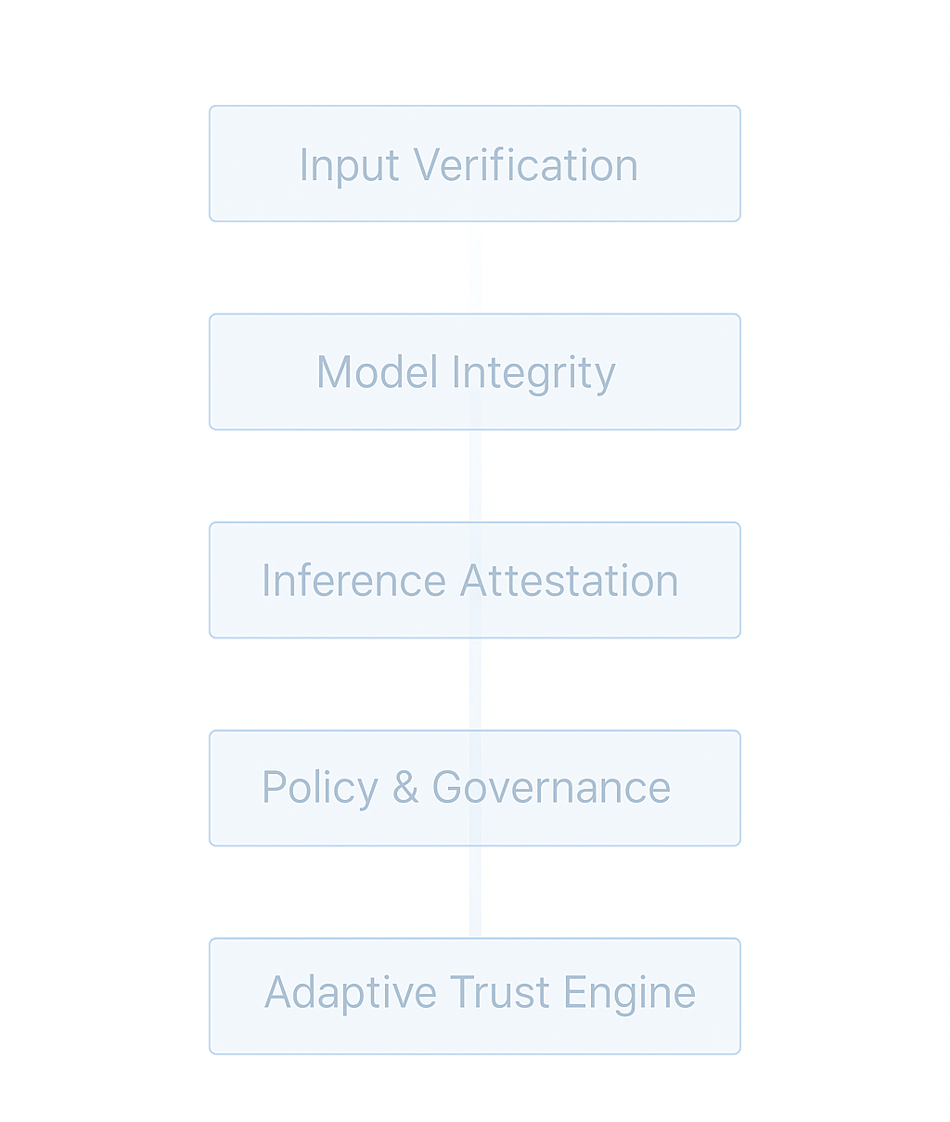
Figure 2.6 Zero-Trust Inference Framework (ZTIF).
Presents the sequential verification architecture in which input provenance, model integrity, inference attestation, governance policies, and adaptive trust computation form a continuous zero-trust reasoning loop.
Generative diffusion models also serve diagnostic functions: by reconstructing data under controlled priors, the system detects epistemic inconsistencies and potential corruption. This allows for cognitive forensics, reconstructing how false beliefs propagate through model space.
When corruption spreads, epistemic isolation domains quarantine compromised reasoning paths, preserving evidence while preventing cross-contamination. Rehabilitation occurs through retraining or causal debugging—machine epistemology grounded in falsifiability (Popper 1959).
Zero-trust inference grants cognitive defense a conscience: the ability to doubt, verify, and correct its own reasoning.

Conclusion: Toward an Epistemic Organism
Chapter 02 has established a comprehensive architecture where cloud-native computation, distributed intelligence, and epistemic self-verification form a single cognitive organism.
- Section 2.1 built the anatomical substrate.
- Section 2.2 described the emergence of collective intelligence.
- Section 2.3 embedded epistemic integrity as its governing principle.
This architecture positions cognitive defense not simply as a technical system, but as a self-aware epistemic institution capable of defending both infrastructure and truth.
The next chapter will extend this architecture into multi-cloud cognition, where intelligence spans providers, geographies, and trust boundaries.

