Chapter 2
Architecting Cognitive Defense Systems: Multi-Agent Control, Entropy, and Generative
Paulo H. Leocadio

Introduction
From infrastructure to cognition, modern digital defense infrastructure has undergone a profound transformation as computation moves from fixed on-premises environments to fluid, cloud-native ecosystems. System and Organization Controls (SOCs), once grounded in static rules and centralized event pipelines, now operate in landscapes defined by scale, heterogeneity, and rapid adversarial evolution. In such environments, defense systems must transcend mere monitoring and become cognitive infrastructures capable of perceiving uncertainty, generating hypotheses, validating their reasoning, and acting adaptively in real time.
This chapter presents a holistic architecture of cognitive defense, building on three integrated layers:
- Cloud-native cognitive foundations
- Multi-agent adaptive defense intelligence
- Zero-trust inference and epistemic integrity
Together, these architectures represent a continuum: from infrastructure cognition to collective reasoning to epistemic self-verification.
2.1 Cloud-native foundations of cognitive defense
The architectural layers described below operationalize the structural principles introduced in Chapter 1, translating bounded optimization, belief-based inference, and feedback closure into deployable computational planes.
Cloud-native architectures reinforce cognitive defense. Traditional Security Operations Centers (SOCs) rely on deterministic workflows and centralized correlation engines. In contrast, cloud-native SOCs utilize containerization, microservices, and elastic compute to coordinate cognitive functions, with ephemeral intelligence modules deployed, scaled, and retired as needed. (AWS 2024).
Cognition begins in the observability layer, where metrics, logs, traces, and events provide sensory input. These heterogeneous signals are vectorized, often via diffusion or transformer encoders, converting raw telemetry into structured latent representations. These embeddings feed reasoning modules that detect semantic correlations beyond human-defined rule sets.
The layered organization of these computational planes is illustrated in the Cloud-Native Cognitive Defense Stack shown in Figure 2.1.

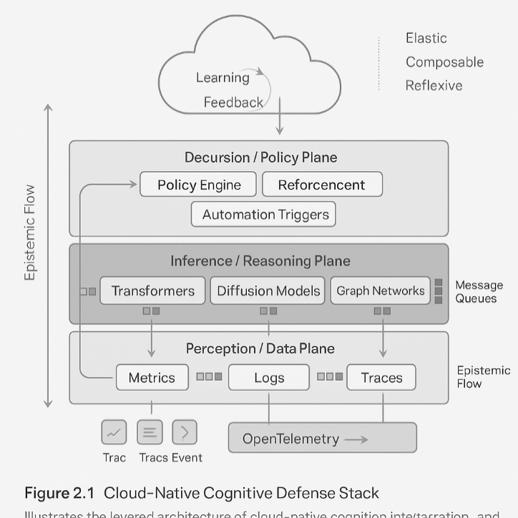
Figure 2.1 Cloud-Native Cognitive Defense Stack.

The figure illustrates the multilayered architecture in which perception, inference, decision, and learning planes interact through continuous epistemic feedback within elastic, cloud-native environments.
Above perception lies the inference plane, populated with modular reasoning containers, graph neural networks, diffusion models, and causal engines, each specialized for a domain of defense. Distributed message queues facilitate communication across models, enabling asynchronous and parallel cognition.
The decision plane implements policy logic, reinforcement controllers, and automation triggers. It defines how inferences translate into actions, such as network isolation, priority escalation, or targeted observability.
Finally, the learning plane governs continuous adaptation. Machine Learning Operations (MLOps) workflows retrain models when performance drifts, incorporate analyst feedback, and re-evaluate0F data quality. This creates a reflexive loop in which perception informs reasoning, reasoning triggers action, and action reshapes future perception (Minsky 1988).
Cloud-native cognition thus forms a self-similar architecture whose layers interact continuously through event streams, feedback loops, and epistemic flow.
2.2 Cognitive multi-agent systems and adaptive defense intelligence
While cloud-native layers provide the anatomical foundation, cognitive defense becomes truly adaptive when intelligence is distributed across multi-agent systems (MAS). A single model cannot reason effectively across asynchronous contexts, but a mesh of cooperating agents can.
Agents operate autonomously within bounded domains, identify behavior, analyze network flows, and monitor endpoint telemetry, each equipped with specialized inference models. Mediator agents translate latent representations between domains, while coordinator agents enforce consensus, reinforcement alignment, and global objectives (Wooldridge 2009).
Figure 2.2 shows the distributed topology of heterogeneous agents, including inference, mediator, and coordinator entities, cooperating through shared latent representations under a unified policy and ethics layer.

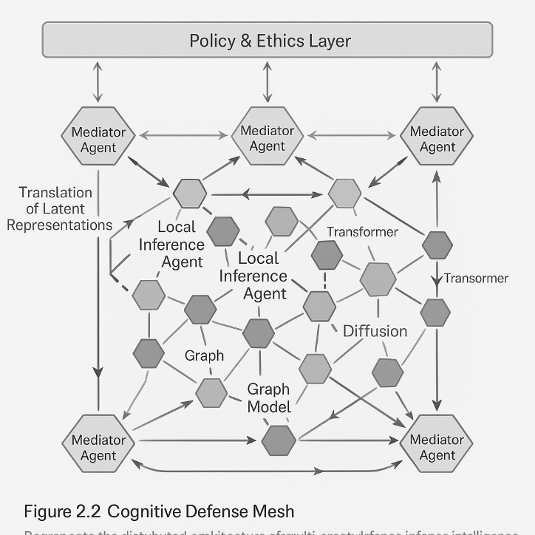
Figure 2.2 Cognitive Defense Mesh.
This architecture transforms the SOC into a defense ecosystem: a dynamic system in which hypotheses are shared, debated, and combined. Agents communicate using vector-space tokens encoding confidence, context, and provenance. To regulate convergence across distributed belief states, the system requires a scalar measure of uncertainty. We therefore adopt the standard information-theoretic definition of entropy:
$$H_{t}=-\sum_{i}{p_{i}\left(t\right)}\log{p_{i}}\left(t\right)$$
Following Shannon's definition of information content, the entropy at iteration t is given by the expected negative log-likelihood of the hypothesis distribution:
$$H_{t}​=E\left[I\left(x\right)\right]=\sum_{i}{​p_{i​}\left(t\right)I\left(x_{i}​\right)}=\sum_{i}{{​p}_{i}​\left(t\right)\left[-logp_{i}​\left(t\right)\right]}.$$
Operationally, $H_{t}$ measures concentration versus dispersion in the system's belief state: low entropy indicates convergent belief (high confidence, low diversity), while high entropy indicates distributed belief (uncertainty or competing hypotheses). In cognitive defense, this provides a quantitative control signal for escalation thresholds, agent delegation, or additional evidence acquisition.
In the context of cognitive defense, $p_{i}\left(t\right)$ denotes the confidence distributed across candidate explanations for an observed pattern. High entropy means the agents are spread across different competing explanations; declining entropy, as seen in Figure 2.3, which illustrates the dynamics of uncertainty reduction during multi-agent reasoning cycles, indicates that the defense ecosystem is converging on a shared interpretation.
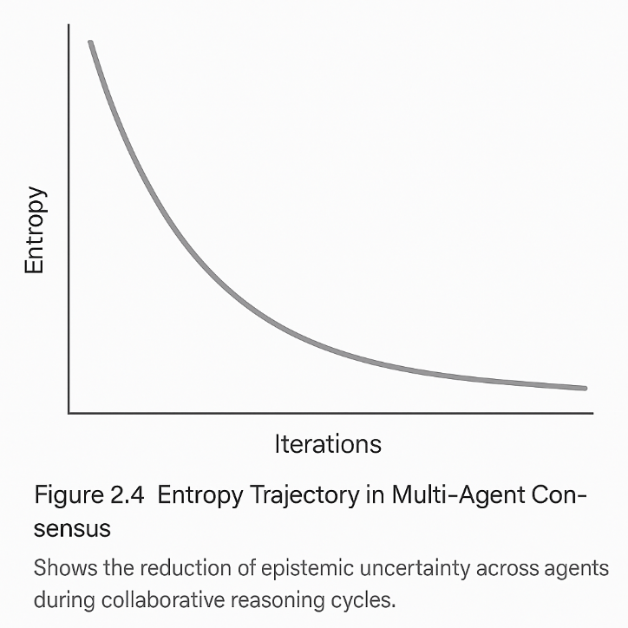

Figure 2.3 Entropy Trajectory in Multi-Agent Consensus.
The figure demonstrates the expected decline in epistemic entropy as distributed agents iteratively negotiate and converge toward a shared conclusion.
Interpretation and scientific context: The entropy expression formalizes the distribution of uncertainty among the agents participating in a collaborative reasoning process. The quantity $H_{t}$ originates from Shannon's information theory, where it represents the expected "surprise" of a probabilistic system. In cognitive defense, this translates into the degree of epistemic ambiguity agents hold at iteration $t$. Each probability $p_{i}\left(t\right)$ corresponds to the confidence an agent assigns to a candidate hypothesis or latent representation. Early in the coordination cycle, these probabilities are diffused, and entropy is high, reflecting competing explanations and incomplete shared context. As agents exchange vector-space messages and refine their beliefs, the distribution sharpens, reducing entropy. This mirrors how early anomaly signals appear, noisy and weak, but gradually cohere into a consensus trajectory, as seen in Figure 2.3. The formula thus emerges naturally from the operational requirement to track how rapidly distributed agents reduce uncertainty, and it provides a measurable link between inference collaboration and defensive responsiveness.
Decision-making mechanisms determine how much mental effort to devote to uncertainty, balancing cost and knowledge gain (Simon 1982).
Collective learning mechanisms, such as Federated Reinforcement Learning (FRL), enable agents to improve without centralizing raw telemetry, thereby aligning with zero-trust principles. Swarm intelligence protocols enable predictive resilience: distributed detectors elevate weak signals into consensus-driven escalation (Bonabeau et al. 1999).
An autonomous defense agent operating under uncertainty must evaluate actions by their expected long-term impact under stochastic transitions rather than by immediate reward alone. This requirement is formalized in reinforcement learning through the notion of return:
$$G_{t}​=​\sum_{k=0}^{∞}{γ^{k}R_{t+k}}​,$$
where $R_{t+k}$ is the reward at the step $t+k$and $γ∈(0,1)$ discounts distant future rewards. This optimization layer governs how defensive resources are allocated across time under uncertainty.
The value of a state under policy $π$is the expected return when the system starts in state $s$and follows $π$thereafter:
$$V^{π}(s)=\sum_{a}{π(a∣s)}\sum_{s^{'}}{P(s^{'}∣s,a) [R(s,a)}+γV^{π}(s^{'})]$$
The formulation above evaluates value under a fixed policy $π$. Bounded optimization emerges when agents instead select actions that maximize expected value at each state. This yields the Bellman optimality condition:
$$V^{*}(s)=\underset{a}{max⁡}\sum_{s^{'}}{P(}s^{'}∣s,a)\left[R(s,a)+γV^{*}(s^{'})\right]$$
Within cognitive defense systems, this condition governs adaptive policy refinement, enabling agents to pursue defensive strategies that maximize long-term resilience in the face of uncertainty.
This recursion is the mathematical expression of bounded autonomy: the agent does not choose outcomes, but actions under stochastic transitions, discounting future uncertainty via $γ$. In security systems, this value function quantifies the desirability of a defensive posture over the full trajectory of attacks and responses rather than at a single timestep. The consensus curves in Figure 2.4 illustrate how deterministic and stochastic policies converge to stable values under repeated application of this principle.
Differences between deterministic and stochastic consensus behavior are shown in Figure 2.4.
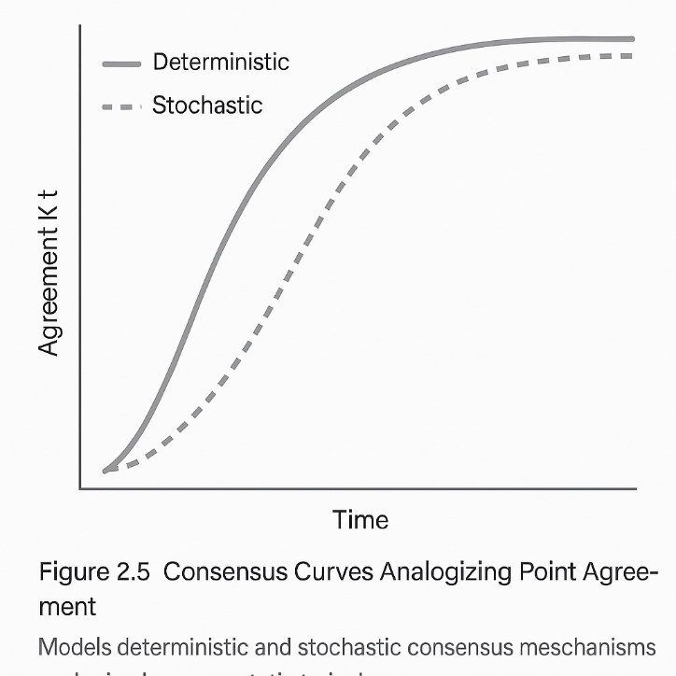

Figure 2.4 Consensus curves analogizing point.
The illustration compares deterministic and stochastic multi-agent consensus mechanisms, showing their respective trajectories as agreement strengthens over time.
Interpretation and scientific context: The policy evaluation function $V^{π}(s)$captures the long-term utility of actions under a fixed policy $π$. In cognitive defense environments, agents operate across sequences of ambiguous and adversarial states, making recursive valuation essential. The transition term $P(s^{'}∣s,a)$ encodes environmental stochasticity, while the reward function $R(s,a)$ reflects the defensive impact of actions such as isolation, regeneration, or escalation. The discount factor $γ$regulates temporal horizon, balancing immediate clarity against future resilience. The convergence behaviors illustrated in Figure 2.4 arise directly from this formulation: deterministic policies converge with lower variance, whereas stochastic policies propagate uncertainty across reasoning cycles.
Security is preserved through intra-agent authentication, trust scoring, and cryptographic attestation. Agents build reputational capital through historical accuracy and cooperation. Unreliable or compromised agents are quarantined to ensure systemic robustness.
Multi-agent cognition constitutes the operational substrate through which meaning, trust, and adaptation propagate across the defense ecosystem.
2.3 Zero-trust inference and epistemic integrity
Historically, zero-trust principles have applied to identity and access. In cognitive defense, the principle gives rise to epistemic zero trust, the notion that no inference is accepted without verification. Because generative models are susceptible to manipulation (Carlini et al. 2024), inference must be treated as a potential attack vector.
Zero-trust inference frameworks embed verification at every level:
- Input verification: Cryptographically signed data, provenance hashes, and secure enclaves validate input lineage.
- Model integrity: Model binaries undergo checksum attestation; inference can only occur through audited versions.
- Inference attestation: Each inference produces a Verifiable Reasoning token (VRT) recording attention paths, latent transitions, and model parameters.
- Policy and ethics layer: Governance engines evaluate inferences against fairness, safety, and legal predicates (Jobin, Ienca, and Vayena 2019).
- Adaptive trust engine: Dynamic trust vectors compute epistemic entropy and regulate model participation.
The full epistemic verification pipeline is summarized in Figure 2.5 through the Zero-Trust Inference Framework.
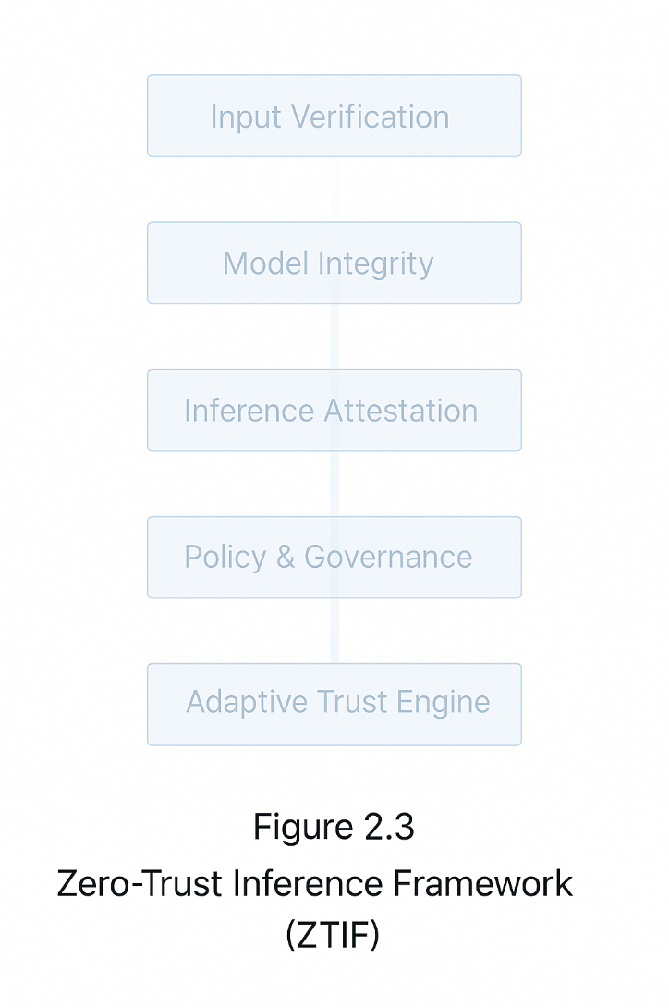

Figure 2.5 Zero-Trust Inference Framework (ZTIF).
The illustration presents the sequential verification architecture in which input provenance, model integrity, inference attestation, governance policies, and adaptive trust computation form a continuous zero-trust reasoning loop.
Generative diffusion models also serve diagnostic functions: by reconstructing data under controlled priorities, the system detects epistemic inconsistencies and potential corruption. This allows for cognitive forensics, reconstructing how false beliefs propagate through model space.
This reconstruction process is governed by the standard reverse diffusion step:
$$x_{t-1}=\frac{1}{\sqrt{α_{t}}}\left(x_{t}-\frac{1-α_{t}}{\sqrt{1-\overline{α_{t}}}} ϵ_{θ}\left(x_{t},t\right)\right)+σ_{t}z$$

The reverse-step equation arises from inverting the forward-noising process used in denoising diffusion probabilistic models. The forward process progressively perturbs $x_{0}$into $x_{t}$via Gaussian noise under a predefined variance schedule.
$$x_{t}​=\sqrt{α_{t}}​​x_{t-1}​+\sqrt{1-α_{t}}​​ϵ,$$
where $ϵ∼N(0,I)$ and $α_{t}∈(0,1)$controls the extent to which the original signal is retained. If we knew the exact posterior distribution $p(x_{t-1}∣x_{t})$, we could sample backward directly, but in practice, this condition is intractable. Instead, we train a neural network $ϵ_{θ}(x_{t},t)$ to predict the noise component $ϵ$ given the noisy sample $x_{t}$. Substituting this estimate into the forward relation and solving for $x_{t-1}$ gives
$$x_{t-1}​≈\frac{1}{\sqrt{α_{t}}}​​​(x_{t}​-\sqrt{1-α_{t}} ​​ϵ_{θ}​(x_{t}​,t)),$$
which is then refined into the more stable form used above by incorporating the cumulative product ${\overset{ˉ}{α}}_{t}$ and an additional stochastic term $σ_{t}z$ to reflect residual uncertainty. The reverse update is not 'denoising’ in a generic sense; it is a controlled inference step that reconstructs plausible clean states under uncertainty. In cognitive defense terms, this resembles evidence reconstruction under adversarial noise: the model must infer structure from corrupted observations while remaining robust to manipulation.
Figure 2.6 provides a structural view of how inference states are cryptographically chained to create verifiable epistemic lineage.

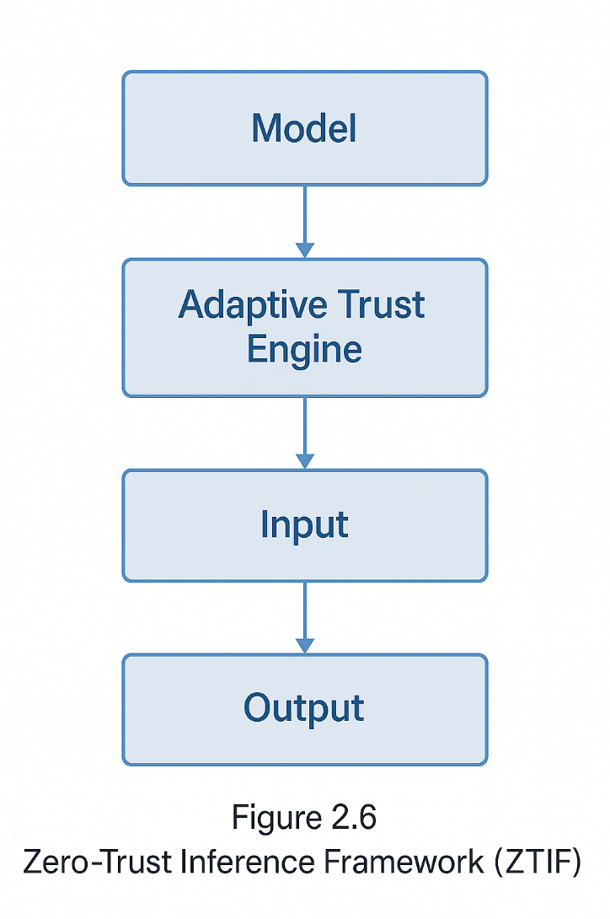

Figure 2.6 Proof-of-Inference Hash Chain.
.
The illustration depicts the sequence of inference states linked via cryptographic hashing, forming an immutable ledger that records the provenance of reasoning across cognitive processes.
Interpretation and scientific context: The reverse diffusion equation describes how a model reconstructs an underlying signal from noise, step by step, using learned denoising functions. In a cognitive defense context, this mechanism becomes a powerful tool for epistemic reconstruction, recovery of latent attack paths, restoration of corrupted telemetry, and generation of plausible intermediate states that were never directly observed.
The term $ϵ_{θ}\left(x_{t},t\right)$ represents the model's estimate of the noise component at timestep $t$, while $α_{t}$and ${\overset{ˉ}{α}}_{t}$control the pace at which information is gradually reintroduced. The additional noise term $σ_{t}z$accounts for the uncertainty inherent in the reverse stochastic process, ensuring that reconstructions reflect probabilistic realism rather than deterministic oversimplification.
This reconstruction perspective is directly linked to Figure 2.6, in which each inference state is cryptographically anchored. Together, they describe a pipeline in which epistemic consistency is both mathematically reconstructed and cryptographically verifiable, a foundational pairing for trustworthy autonomous defense.
When corruption spreads, epistemic isolation domains quarantine compromised reasoning paths, preserving evidence while preventing cross-contamination. Rehabilitation occurs through retraining or causal debugging; machine epistemology is grounded in falsifiability (Popper and Weiss 1959).
Zero-trust inference grants cognitive defense a conscience: the ability to doubt, verify, and correct its own reasoning.
Conclusion
Chapter 02 establishes a comprehensive architecture in which cloud-native computation, distributed intelligence, and epistemic self-verification form an integrated cognitive architecture.
- Section 2.1 built the anatomical substrate.
- Section 2.2 described the emergence of collective intelligence.
- Section 2.3 embedded epistemic integrity as its governing principle.
This architecture positions cognitive defense not simply as a technical system, but as a self-aware epistemic institution capable of defending both infrastructure and truth.
The next chapter will extend this architecture to multi-cloud cognition, in which intelligence spans providers, geographies, and trust boundaries.

References

AWS. 2024. “Amazon SageMaker.” Preprint.
Bonabeau, Eric, Marco Dorigo, and Guy Theraulaz. 1999. Swarm Intelligence. Oxford University Press. https://doi.org/10.1093/oso/9780195131581.001.0001.
Minsky, Marvin Lee. 1988. The Society of Mind. In Systems Research, First Edit, vol. 5, no. 3. Simon and Schuster. https://doi.org/10.1002/sres.3850050312.
Simon, Herbert A. 1982. Models of Bounded Rationality. The MIT Press. https://doi.org/10.7551/mitpress/4711.001.0001.
Wooldridge, Michael J.. 2009. An Introduction to Multiagent Systems. John Wiley & Sons.
Carlini, Nicholas, Daniel Paleka, Krishnamurthy Dj Dvijotham, Thomas Steinke, Jonathan Hayase, A. Feder Cooper, Katherine Lee, et al. 2024. “Stealing Part of a Production Language Model.” Proceedings of the 20th ACM Asia Conference on Computer and Communications Security, July, 425–41. http://arxiv.org/abs/2403.06634.
Jobin, Anna, Marcello Ienca, and Effy Vayena. 2019. “The Global Landscape of AI Ethics Guidelines.” Nature Machine Intelligence 1 (9): 389–99. https://doi.org/10.1038/s42256-019-0088-2.
Popper, Karl R., and George Weiss. 1959. "The Logic of Scientific Discovery.” Physics Today 12 (11): 53–54. https://doi.org/10.1063/1.3060577.

MLOps is a set of practices and principles that automate and standardize the machine learning lifecycle, bridging data science development with IT operations.

