Chapter 3
Architectural foundations, cyber-defence equations, and mathematical models of cyber risk
Paulo H Leocadio

Introduction

Cybersecurity has evolved from a domain defined by static perimeters and deterministic controls into a complex, dynamic discipline shaped by hybrid infrastructure, interconnected trust boundaries, automated adversaries, and machine-speed threats. Modern digital ecosystems integrate distributed microservices, cloud-native architectures, API-driven dependencies, software supply chains, and continuous delivery systems, each contributing to a fluid and ever-shifting attack surface. This complexity demands an analytical and architectural framework capable of describing not only what vulnerabilities exist, but why they propagate and how defensive systems respond under adversarial pressure (Anderson, 2020; Daniel Geer et al., 2023).
This chapter constructs such a framework by synthesizing three foundational perspectives:
(1) the architectural principles that shape exposure and defensive maneuverability.
(2) the formal cyber-defense equation (CDE), which models the dynamic tension between exposure, adversarial capability, control efficacy, and detection speed; and
(3) mathematical models, epidemiological, graph-theoretic, probabilistic, and control-theoretic, that describe cyber-risk propagation and stabilization.

The first section establishes structural concepts fundamental to security design: the segmentation of control, data, and management planes; identity and trust boundaries; architectural exposure profiles; and observability pipelines. These constructs form the substrate upon which all subsequent computational and defensive models operate. Without a coherent architectural base, even the most advanced analytical and AI-enhanced systems lack visibility, precision, and resilience (Kindervag, 2016; Zonouz & Haghani, 2013).
The second section introduces the cyber-defense equation, a formal analytic abstraction unifying classical risk models, dependability engineering, and modern cyber-operations theory. By expressing risk as a function of exposure, adversarial capability, control strength, and detection latency, the CDE offers a conceptual bridge between qualitative architectural reasoning and quantitative defense design (Verizon, 2025; Bishop, 2019). Two figures illustrate the nonlinear behavior of risk under varying control and detection conditions, with detailed interpretations that link the mathematical structure to operational significance.
The third section provides the mathematical backbone of contemporary cybersecurity analysis. We examine epidemic-style propagation models adapted to malware spread, graph-theoretic representations of network exposure and attack reachability, Bayesian inference techniques for adversarial likelihood estimation, Markov chains for quantifying expected time to breach, consensus-based models for distributed defense alignment, and control-theoretic representations that treat cybersecurity as a stability problem under adversarial disturbance (Nowak and May, 2000; Newman, 2018; Jordan and Mitchell, 2015). Each subsection introduces derivations, variable definitions, figures, captions, and interpretative commentary.
Finally, the chapter integrates these architectural and mathematical frameworks with AI-driven cyber-defense. By transforming each term of the cyber-defense equation (exposure, adversarial capability, detection speed, and control efficacy) into AI-enhanced equivalents, we demonstrate how predictive modeling, transformer-based inference, graph neural networks, and diffusion-based orchestration redefine defensive posture in machine-speed environments (Goodfellow et al., 2016; Sommer and Paxson, 2010).
Through this integrated approach, Chapter 3 becomes the structural, analytical, and theoretical foundation for all subsequent chapters. It equips the reader with a rigorous, multidimensional understanding of how cyber risk emerges, evolves, and can be mitigated in modern digital systems.

3.1 Architectural foundations of cyber defence
Cybersecurity begins not with algorithms or threat intelligence but with architecture. System design determines the geometry of exposure, the available propagation pathways for adversaries, the visibility of defensive controls, and the limits of detection and containment. Understanding these architectural substrates is essential for constructing both the cyber-defense equation and the mathematical models presented later in this chapter (Saltzer et al., 1974; Hafner and Lyon, 2020).
3.1.1 The three operational planes
Modern digital infrastructures are partitioned into three principal planes (data, control, and management), each representing a distinct locus of functionality, privilege, and potential compromise. Recognizing how adversaries target these planes provides a framework for understanding risk propagation and control-point failures.

(a) Data plane
The data plane is responsible for executing operational workload. It carries application traffic, database queries, file transfers, containerized workload execution, and raw data movement between services. Compromises at this level manifest as data exfiltration, process tampering, unauthorized queries, or manipulation of runtime state. Because the data plane is the most active and densely populated operational layer, it is often the first target for adversaries conducting reconnaissance or lateral movement.

(b) Control plane
The control plane manages system behavior at scale. It handles routing decisions, identity policies, workload scheduling, cluster coordination, and configuration updates. Small misconfigurations in this layer, especially in Identity and Access Management (IAM) roles, security groups, Kubernetes manifests, and routing policies, can cause widespread security breaches. Since the plane's control system directs the actions of different interconnected components, malicious interference can quickly lead to systemic failure (Adam et al., 2022).

(c) Management plane
The management plane encompasses administrative interfaces and privileged orchestration tools: cloud dashboards, Continuous Integration/Continuous Delivery or Deployment (CI/CD) pipelines, monitoring interfaces, Application Programming Interface (API) gateways, DevOps automation, and remote administration protocols. Adversaries often target management-plane assets because they offer concentrated privilege, high-authority credentials, and access to system-wide configurations. Phishing, credential theft, Multi-Factor Authentication (MFA) fatigue, and console exploitation disproportionately affect this layer.
Understanding the interdependence between these planes is crucial. A minor misconfiguration in the management plane can propagate into the control plane and manifest as a data-plane compromise. Conversely, anomalies in the data plane indicate that control-plane manipulation may be underway. This coupling informs later mathematical models, including Markovian transition systems (Klin, 2009) for privilege escalation and graph-theoretic representations of cross-plane reachability.
3.1.2 Identity, access, and trust boundaries
Identity has replaced the traditional perimeter as the primary security boundary. In Zero Trust architectures, access control depends not on location or network zone but on cryptographically verifiable assertions about users, services, and devices (Kindervag, 2016). Identity becomes the fundamental abstraction through which trust is granted or withheld.
Trust boundaries are defined by:
- Authentication: establishing the legitimacy of an entity, typically through composite credentials (passwords, tokens, certificates, or biometric proofs).
- Authorization: determining what actions the entity is permitted to take, based on roles, policies, and attribute-based control.
- Contextual validation: evaluating environmental conditions such as device health, network source, behavioral patterns, and session risk.
- Privilege minimization: ensuring entities operate with the least privileges necessary to perform a function (Rose et al., 2020).
Weak trust boundaries create low-resistance attack surfaces. For example, permissive IAM roles in cloud environments often create privilege escalation paths that adversaries exploit for lateral movement or resource takeover. Similarly, service-to-service communication without mutual authentication collapses segmentation, resulting in fully traversable environments.
Identity systems become variables in the cyber-defense equation, influencing both exposure ($E\left(t\right)$) and control efficacy ($C\left(t\right)$). Later models incorporate Bayesian inference to evaluate authentication anomalies and graph-theoretic structures to analyze trust relationship density.
3.1.3 Segmentation, microsegmentation, and exposure geometry
Segmentation divides systems into distinct trust zones to reduce the blast radius of compromise. Traditional network segmentation relied on Virtual Local Area Networks (VLANs), firewalls, and subnet isolation. Modern architectures use identity-aware proxies, service meshes, and microsegmentation at the workload level.
Segmentation modifies exposure geometry in three ways:
- Reduces the number of reachable nodes from any compromised asset.
- Increases the complexity of lateral movement by introducing cryptographic authentication and policy gates.
- Creates topological chokepoints that can serve as sensor or enforcement points.
In Section 3.3, we model segmentation using graph theory, where nodes represent workloads and edges represent allowed communication. Exposure becomes a function of reachable subgraphs, adjacency matrix density, and edge weights representing trust strength.
3.1.4 Observability pipelines prerequisite for detection
Detection is impossible without visibility. Observability pipelines define how logs, metrics, traces, and event streams flow through the environment. The lifecycle typically includes:
- Collection: gathering data from endpoints, networks, services, and cloud Application Programming Interfaces (APIs).
- Normalization: transforming heterogeneous formats into structured schemas.
- Enrichment: attaching contextual metadata such as geolocation, identity attributes, or threat intelligence.
- Correlation: linking related events across time windows, sessions, services, or identities.
- Retention: storing time-series telemetry for analysis, investigation, and machine learning.
Deficiencies in any stage reduce detection speed ($D\left(t\right)$), impair anomaly identification, and weaken the mathematical models introduced in Section 3.3. For example, Bayesian threat inference requires high-quality evidence streams; Markovian lateral-movement models require sufficiently granular log data; and control-theoretic stabilization assumes feedback loops with bounded latency.
Observability also creates the conditions under which AI-based detection can function. Low telemetry completeness or excessive sampling gaps lead to blind spots that no algorithm, no matter how advanced, can overcome.
3.1.5 Exposure surfaces and architectural preconditions for mathematical defense models
The architecture defines the initial conditions for all analytical models presented later. Specifically:
- The SIR-style propagation models require definitions of susceptible, infected, and removed states based on architectural segmentation.
- The graph-theoretic attack models depend on adjacent structures shaped by identity and network design.
- The Bayesian inference systems require high-fidelity evidence from observability pipelines.
- The Markov models rely on well-defined privilege states and transitions inherent in the control plane.
- The control-theoretic models assume measurable feedback loops and quantifiable defensive interventions.
Thus, architecture not only influences exposure but also constrains the mathematical tools available for defense. Without architectural rigor, no analytic model or AI system can reliably predict, detect, or contain adversarial behavior.
3.2 The cyber-defense equation (CDE)
Risk in cybersecurity is not static, linear, or purely qualitative. It evolves in time as adversaries probe systems, pivot across trust boundaries, escalate privileges, and adapt to defensive countermeasures. Likewise, the defensive posture fluctuates with control strength, configuration correctness, detection speed, and architectural resilience. The cyber-defense equation (CDE) captures this dynamic interplay through a formal abstraction that unifies architectural determinants of exposure with mathematical determinants of adversarial pressure and defensive capability (Bishop, 2002); Daniel Geer et al., 2023).
The CDE expresses instantaneous cyber risk as the ratio between adversarial forces (exposure and capability) and defensive forces (control efficacy and detection speed):
$$R\left(t\right)=\frac{E\left(t\right)⋅A\left(t\right)​}{C\left(t\right)⋅D\left(t\right)}$$
This representation is not intended as a predictive model in the classical statistical sense, but rather as a structural equation that clarifies how architectural and operational variables collectively shape security outcomes. Each term can be interpreted as follows:
- Exposure ($E\left(t\right)$)
The reachable attack surface at time ttt is determined by architecture, segmentation, identities, and dependencies.
- Adversarial capability ($A\left(t\right)$)
The skill, automation, computational resources, and persistence available to the attacker.
- Control efficacy ($C\left(t\right)$)
The strength, correctness, and coverage of defensive controls (e.g., firewall rules, segmentation policies, IAM enforcement, patching).
- Detection speed ($D\left(t\right)$)
The time required to identify anomalies or intrusions.
3.2.1 Historical and analytical origins
The structure of the CDE traces its roots to dependability engineering, where system reliability was initially modeled as a function of component defects and environmental stress. Cybersecurity researchers adopted this logic to represent adversarial stressors (e.g., exploit development and privilege escalation) and architectural defects (e.g., misconfigurations and unpatched vulnerabilities). Over time, operational security teams introduced additional mitigating measures, including improvements to detection technologies, logging fidelity, and control hardening.
The CDE synthesizes these traditions into a unified abstraction suitable for quantitative reasoning, comparative analysis, and the application of mathematical models introduced later in this chapter.
Figure 3.1 plots the risk function $R(t)$ under varying detection speeds while holding exposure, adversarial capability, and control efficacy constant. Illustrates the nonlinear reduction in risk when detection transitions from manual (minutes–hours) to automated (milliseconds–seconds).

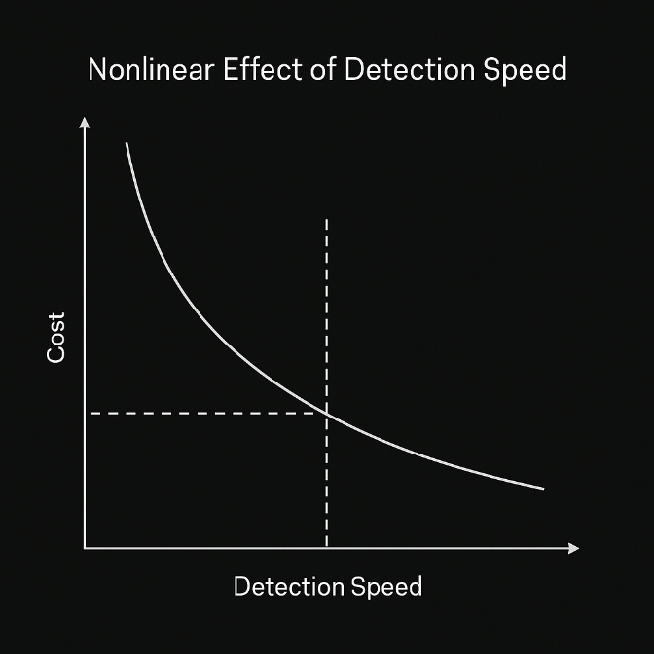
Figure 3 1 Nonlinear relationship between detection speed and risk
The curve shows that incremental improvements in detection latency yield disproportionately significant reductions in risk. This nonlinearity reflects real-world operational dynamics: adversaries expand their foothold quickly during early intrusion phases, exploiting architectural blind spots and trust relationships before defensive telemetry stabilizes. Automated detection systems, particularly those augmented by machine learning, reduce adversarial dwell time, narrowing the window in which lateral movement and privilege escalation can occur (CrowdStrike, 2025).
3.2.2 Deriving the CDE from architectural principles
Each term in the CDE is rooted in architectural logic:
- Segmentation, trust boundaries, and surface reduction define exposure.
- Management-plane protections and identity hardening influence adversarial capability.
- Control efficacy emerges from correct configuration and enforcement.
- Detection speed depends on observability pipelines and telemetry completeness.
Thus, architecture determines not only the initial values of each term but also the feasible ranges for each term. For example, a highly segmented environment structurally constrains exposure by reducing the reachable subgraphs, while robust identity architecture increases the upper bound on achievable control efficacy.
The CDE serves as the bridge between these architectural realities and the mathematical models of propagation presented in Section 3.3.
3.3 Mathematical models of cyber risk, propagation, and stabilization
Understanding cyber risk requires analytical models capable of describing how threats propagate, how adversaries navigate topologies, how likelihoods evolve with evidence, and how defensive interventions stabilize or destabilize a system under adversarial pressure. This section introduces six major classes of models drawn from epidemiology, graph theory, probability, and control theory. Each model is contextualized within cybersecurity, with formulas, figures, and interpretation.
3.3.1 Epidemic models for cyber propagation
Classical epidemic models, originally developed to describe the spread of pathogens in populations, map naturally to the propagation of malware, ransomware, and worm-like threats in digital (Pastor-Satorras & Vespignani, 2000; Newman, 2018). In cybersecurity adaptation, nodes represent systems or workloads; edges represent communication pathways; and infection corresponds to compromise.
The simplest model is the SIR model, partitioning systems into susceptible (S), infected (I), and removed (R) states:
$$\frac{dS}{dx} =-βSI$$

$$\frac{dI​}{dt} =βSI-ΓI$$

$$\frac{dR​}{dt​}​=ΓI$$
Where:
- $β$ measures the compromise (infection) rate.
- Γ measures containment or remediation rate.

Figure 3.2 shows the evolution of susceptible, infected, and removed systems in a malware outbreak with moderate infection and remediation rates.
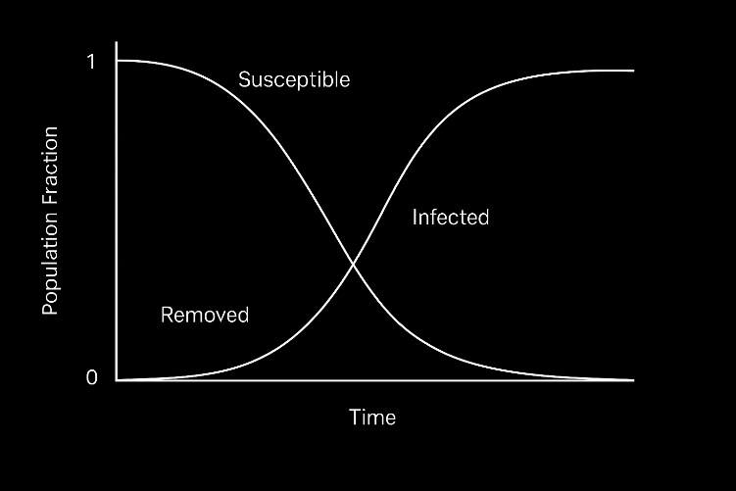
Figure 3.2 SIR propagation of cyber compromise over time
The curve illustrates the classical peak compromise phenomenon: infection accelerates rapidly when the number of susceptible nodes is high, then declines as remediation catches up. In cybersecurity contexts, segmentation reduces effective $β$ by limiting reachable nodes, while rapid remediation increases $γ$. Later sections integrate SIR parameters with AI-based early detection, which effectively accelerates the transition from infection to removal.
3.3.2 Graph-theoretic models of attack surfaces
Networks can be represented as graphs. $G=\left(V,E\right)$, where nodes $V$ are workloads and edges $E$ represent permitted communication. Exposure depends on graph density, edge weights (trust scores), adjacency patterns, and subgraph reachability (Barabási, 2016). Attackers exploit these structures to perform lateral movement.
Let $A$ denote the adjacency matrix of the graph. The number of length-$k$ attack paths between two nodes are given by:
$$P_{ij}^{\left(k\right)}=(A^{k})_{ij}$$

The left graph in Figure 3.4 shows dense cross-service communication with high reachability. The right graph shows a micro-segmented topology with reduced lateral movement paths.
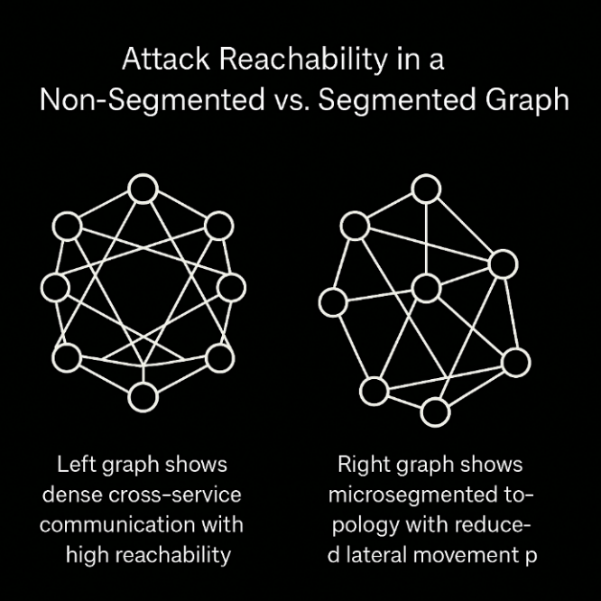
Figure 3.3 Attack reachability in a non-segmented vs. segmented graph
Graph density directly correlates with the number of reachable subgraphs available for adversarial traversal. Microsegmentation breaks connectivity, decreasing $A^{k}$values for all $k$. This demonstrates why segmentation is not merely a network design practice; it is a mathematically grounded method for reducing the multiplicity of attack paths.
3.3.3 Markov models and expected time to breach
Adversarial movement through privileged states can be modeled as a Markov chain with a transition matrix $T$, where each state represents a privilege level or control boundary (Santos et al., 2018). The expected time to breach (ETTB) is:

$$ETTB={\left(I-Q\right)}^{-1}1$$
Where:
- $Q$ is the submatrix of non-absorbing (intermediate) states.
- $1$ is a vector of ones.
- The absorbing state represents full compromise.

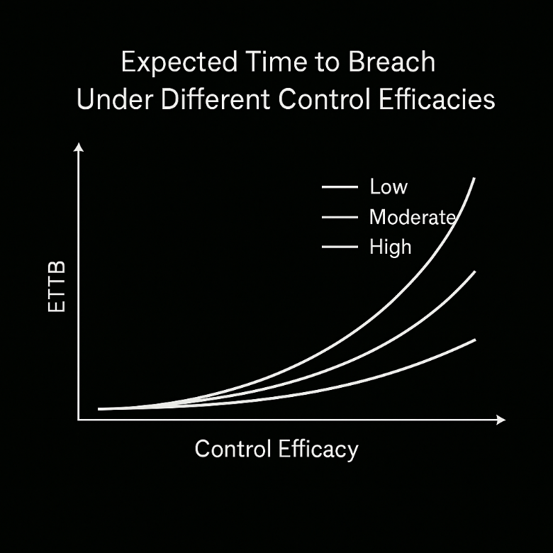
Figure 3.4 Expected time to breach under different control efficacies
Figure 3.4 plots ETTB for multiple values of control efficacy, showing that minor configuration improvements significantly increase the expected adversarial traversal time.
Markov models reveal how architectural hardening amplifies defensive depth. Increasing control efficacy reduces transition probabilities into higher-privilege states, extending ETTB and narrowing the feasible window for adversarial progression. This mathematical structure complements the architectural analysis in Section 3.1, demonstrating that even modest improvements in IAM or segmentation can dramatically impede an attacker's progress.
3.3.4 Bayesian threat inference and evidence updating
Threat likelihood evolves as evidence accumulates. Bayesian inference provides a formal model for updating breach probability as telemetry arrives (Murphy, 2012):

$$P\left(Threat ∣ E\right)=\frac{\left(E ∣ Threat\right)P\left(Threat\right)}{P\left(E\right)P}$$

Where $E$ represents observed evidence (e.g., anomalous activity, unusual identity behavior, privilege escalations).
Figure 3.5 shows the prior probability of compromise and posterior updates as correlated anomalies accumulate.

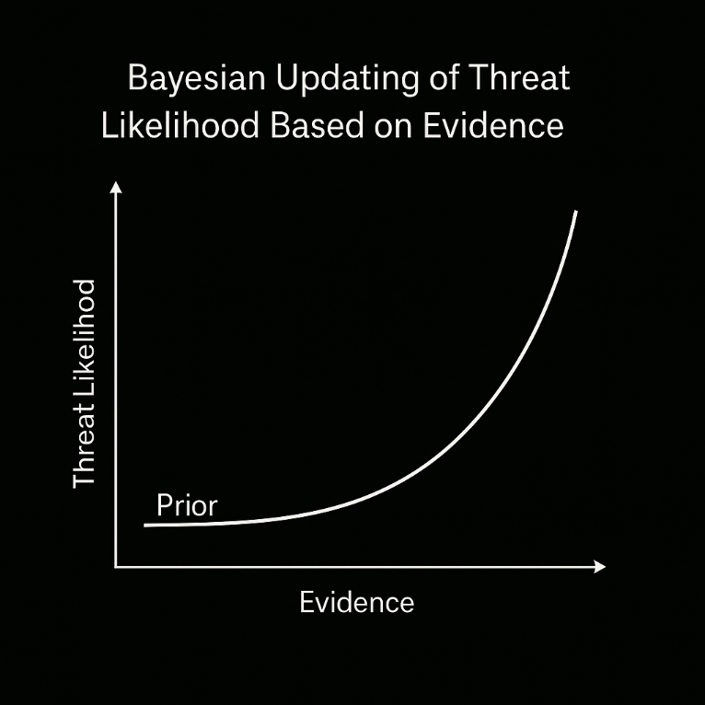
Figure 3.5 Bayesian updating of threat likelihood based on evidence
This figure demonstrates how threat likelihood grows gradually in response to weak signals and sharply when correlated evidence appears. Bayesian systems integrate naturally with AI-based anomaly detectors, where the outputs form likelihood ratios that feed updates. Telemetry quality from Section 3.1 directly affects posterior accuracy.
3.3.5 Consensus curves and multi-agent defensive alignment
Distributed defensive systems, Intrusion, Detection and Prevention System (IDPS), Endpoint, Detection and Response (EDR) agents, or microservice-level anomaly detectors often operate as multi-agent systems that converge on a shared interpretation of system state. Consensus dynamics can be modeled using weighted averaging:
$$xi​\left(t+1\right)=\sum_{j=1}^{n}{w_{ij}{​x}_{j​}\left(t\right)}$$
Figure 3.6 compares deterministic and stochastic consensus trajectories as distributed agents align on threat-state estimations.
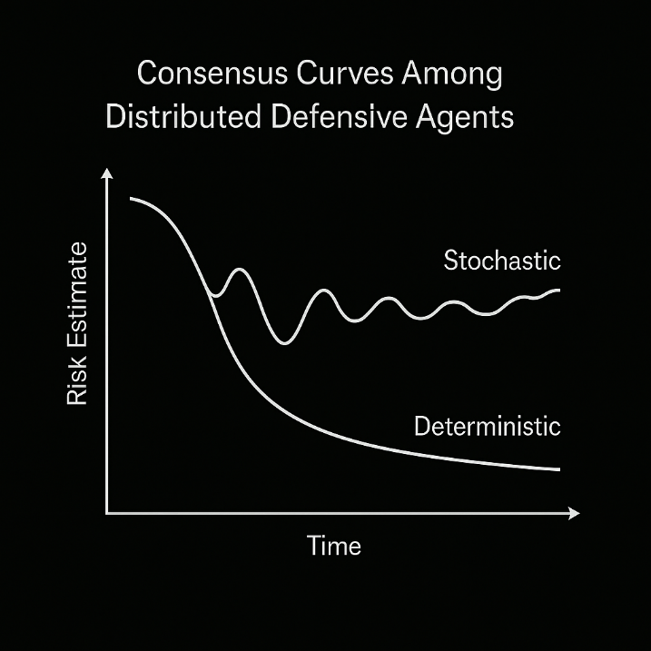
Figure 3.6 Consensus curves among distributed defensive agents
Consensus models demonstrate how distributed defenses stabilize when agents share reliable telemetry. Architectural segmentation influences weight matrices $w_{ij}$ by shaping communication pathways. If observability gaps exist, consensus converge slowly or inaccurately, reflecting the critical connection between architecture, telemetry, and distributed intelligence.
3.3.6 Control-theoretic stabilization of cyber systems
Cybersecurity can be modeled as a control problem where adversarial disturbance $u\left(t\right)$pushes the system toward instability, and defensive control $v\left(t\right)$ attempts to restore equilibrium (Zonouz & Haghani, 2013):
$$\dot{x}\left(t\right)=Ax\left(t\right)+Bu\left(t\right)-Kv\left(t\right)$$Where $x\left(t\right)$represents system state (e.g., trust level, privilege integrity, or compromise probability).
Next figure shows how increasing defensive control $K$ shifts system dynamics from unstable to stable trajectories, even under constant adversarial disturbance.:
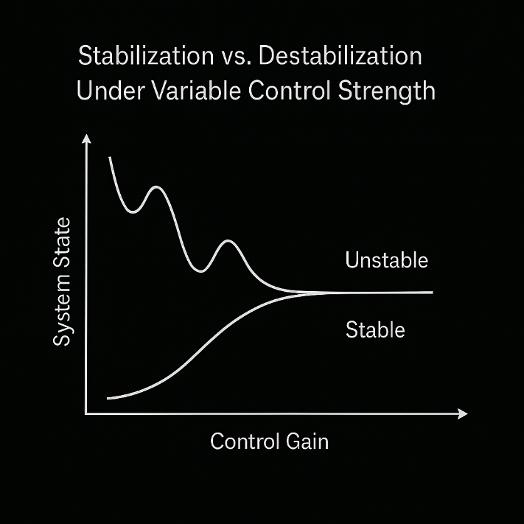
Figure 3.7 Stabilization vs. Destabilization Under Variable Control Strength
Control theory reveals that cybersecurity stability depends on maintaining adequate feedback intensity and response strength. If the defensive gain $K$it is too weak; adversarial disturbances drive the system into instability, paralleling real-world cascading failures. Strong architectural controls (identity hardening, access restrictions, and segmentation) collectively increase effective $K$, improving system resilience.

3.4 Integrating AI into the cyber-defense equation
Artificial intelligence fundamentally transforms each term of the cyber-defense equation by introducing prediction, inference, automation, and learned representations into processes that were historically reactive and manual. As digital ecosystems increasingly operate at machine speed, AI becomes an essential component in reducing detection latency, predicting exposure conditions, identifying adversarial intent, and orchestrating autonomous responses (Jordan & Mitchell, 2015; Goodfellow et al., 2017).
To integrate AI into defensive modeling, we extend the cyber-defense equation to incorporate predictive and automated components:
At machine speed, AI becomes an essential component for reducing detection latency, predicting exposure conditions, identifying adversarial intent, and orchestrating autonomous responses (Jordan & Mitchell, 2015; Goodfellow et al., 2017).
$$R_{AI}​\left(t\right)=\frac{E_{predicted}​\left(t\right)⋅A_{inferred}​\left(t\right)}{C_{auto​}\left(t\right)⋅D_{real-time}​\left(t\right)}​​$$

Where:
- $E_{pred}\left(t\right)$: Predicted exposure derived from AI-based surface analysis.
- $A_{inf}\left(t\right)$: Inferred adversarial capability based on ML/AI-driven pattern analysis.
- $C_{auto}\left(t\right)$: Automated control efficacy enhanced by AI-driven policies, patches, or configuration corrections.
- $D_{real\text{-}time}\left(t\right)$: Real-time detection facilitated by AI anomaly detection, behavioral modeling, and telemetry fusion.
This formulation embeds AI in AI into the structural logic of cybersecurity system dynamics.

AI-augmented exposure prediction $\left(E_{pred}\left(t\right)\right)$
Exposure no longer needs to be a static measurement derived solely from architectural inspection. AI systems can infer exposure from:
- anomaly patterns in network flow.
- predicted trust relationship shifts.
- unsupervised clustering of service communication.
- graph neural networks (GNNs) analyzing latent connectivity.
- time-series predictions of configuration drift (Kipf & Welling, 2017).
A predictive exposure model identifies emerging vulnerabilities before they become exploitable, modifying $E\left(t\right)$ dynamically and allowing defensive teams to correct configurations or close channels before adversaries’ act.
Next illustration compares AI-predicted exposure (based on graph inferences and configuration-drift trends) with real exposure observed during an attack simulation.

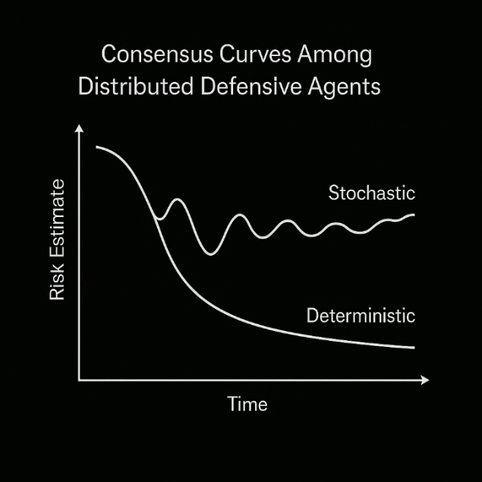
Figure 3.8 Predicted exposure surface vs. actual exposure surface
Predictive exposure systems identify topological weaknesses earlier than manual assessments, reducing the probability that adversaries exploit upcoming misconfigurations. As predicted, exposure declines under corrective actions, overall risk $R_{AI}(t)$drops accordingly.

3.4.2 AI-based adversarial inference ($A_{inf}(t)$)
Transformers, recurrent models, and specialized adversarial-inference systems can estimate attacker capability by analyzing historical intrusion behavior, Tactics, Techniques, and Procedures (TTP) patterns, event sequences, identity anomalies, and behavioral signatures (Sewak et al., 2022). This allows defenders to anticipate adversarial capability even before full exploitation unfolds.
Inference models examine:
- Identity misuse sequences.
- Privilege escalation heuristics.
- Command-line pattern embeddings.
- Cloud API misuse trajectories.
- Behavioral distances from benign baselines.
Next figure displays adversarial capability scores increasing as multiple correlated anomalies suggest sophisticated lateral movement and resource enumeration.

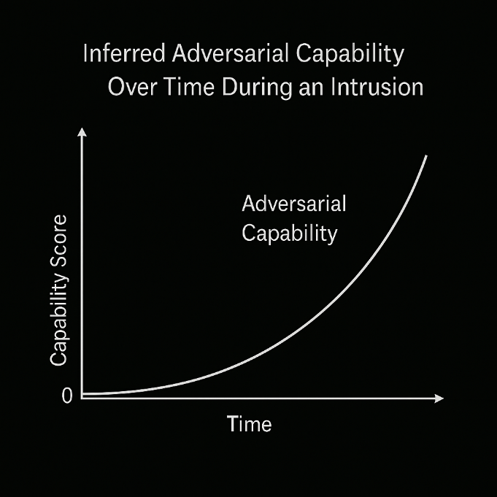
Figure 3.9 Inferred adversarial capability over time during an intrusion
AI systems detect escalation of attacker capabilities earlier than signature-based systems. By raising $A_{inf}(t)$ in response to weak signals, defensive systems can harden controls, accelerate response pacing, and reduce the adversarial advantage window.

3.4.3 AI-Enhanced Control Automation ($C_{auto}(t)$)
AI systems can automatically enforce configuration correctness, patch vulnerabilities, adapt IAM policies, and reconfigure network boundaries. This increases $C(t)$ by:
- identifying missing controls.
- validating trust policies.
- automating microsegmentation enforcement.
- adjusting firewall or routing rules.
- triggering rapid container or workload isolation.
Diffusion-based AI systems were initially developed for generative modeling. can also orchestrate complex multi-step responses by sampling from trajectories that lead to system stabilization (Ho et al., 2020).
Next illustration shows control-efficacy improvements when AI identifies misconfigurations, deploys patches, and isolates high-risk assets.

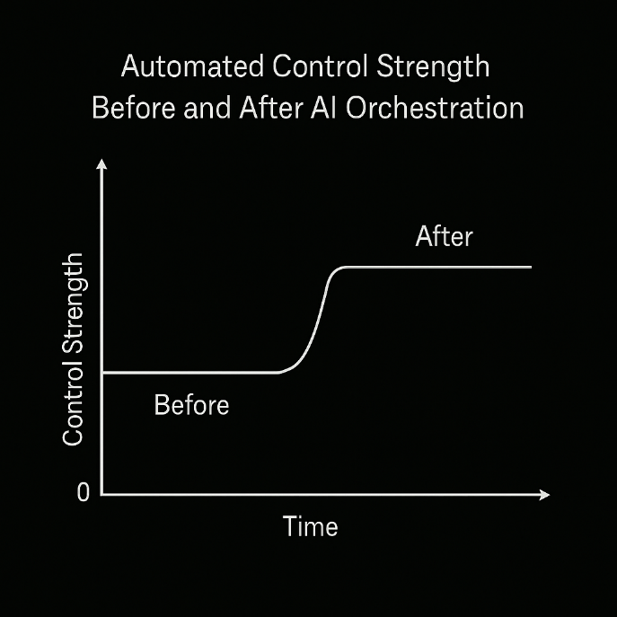
Figure 3.10 Automated Control Strength Before and After AI Orchestration
Increases sharply after AI-assisted orchestration. This corresponds directly to reductions in the risk numerator and improved system stability, as modeled in Section 3.3.6.

3.4.4 AI-Driven Real-Time Detection ($D_{real\text{-}time}(t)$)
AI systems dramatically reduce detection latency. Techniques include:
- real-time anomaly detection via autoencoders.
- transformer-based behavioral analysis.
- graph-based anomaly propagation.
- time-series drift detection.
- multi-modal telemetry fusion (Ramalingam & Pattabiraman, 2024).
These capabilities compress detection times from hours or minutes into milliseconds, transforming how fast defenders can respond.
The next figure compares manual SOC detection times with automated AI detection pipelines, showing orders-of-magnitude reductions in detection latency.

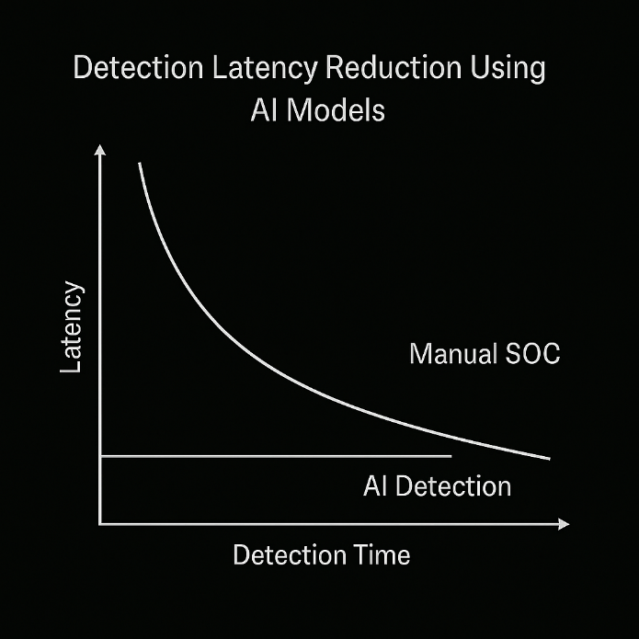
Figure 3.11 Detection Latency Reduction Using AI Models
By increasing $D_{real\text{-}time}(t)$, AI shrinks the adversarial dwell window and prevents adversaries from reaching higher-privilege states modeled in the Markovian system of Section 3.3.3.

3.4.5 Unifying the AI-augmented CDE with mathematical defense models
The AI-augmented CDE interacts with all mathematical models:
- Predictive exposure modifies SIR infection rates (β).
- Inferred capability affects graph traversal expectations and Markov transitions.
- Automated controls shift system dynamics toward stability in control-theoretic models.
- Real-time detection provides evidence for Bayesian updates, increasing posterior accuracy.
- Distributed AI agents improve consensus convergence speed and accuracy.
This unification creates an integrated AI–mathematical–architectural model for cybersecurity system dynamics. Instead of reacting to attacks, systems behave proactively, adaptively, and autonomously. AI does not replace traditional controls; it magnifies them by making each component of the cyber-defense equation faster, stronger, and more predictive.

Summary
This chapter synthesized architectural principles, analytical abstractions, and mathematical models into a unified framework for understanding cybersecurity in modern digital ecosystems. We began by establishing foundational architectural elements, operational planes, identity and trust boundaries, segmentation, and an observability pipeline that determines exposure, detection potential, and the structural limits of defensive capability.
We then introduced the cyber-defense equation (CDE) as a structural abstraction linking exposure, adversarial capability, control efficacy, and detection speed. Through nonlinear analysis and graphical illustrations, we demonstrated how risk emerges from the interplay between adversarial force and defensive strength, and how minor improvements in detection or controls yield disproportionately significant reductions in overall risk.
The mathematical models in Section 3.3 provided formal tools for quantifying system behavior: epidemic propagation models for malware spread, graph-theoretic structures for lateral movement, Markov chains for privilege escalation, Bayesian inference for evidence-based threat estimation, consensus models for distributed defense, and control-theoretic models describing cybersecurity as a stability problem.
Finally, we integrated AI into this structural and mathematical foundation. By augmenting each term of the cyber-defense equation with predictive, inferential, and automated mechanisms, AI transforms static defenses into dynamic, real-time systems capable of anticipating threats, reducing exposure, accelerating detection, and orchestrating autonomous responses.
Together, these elements form a cohesive and rigorous foundation for the subsequent chapters, which build upon this architecture-mathematics-AI triad to explore advanced detection, automation, diffusion-based modeling, and next-generation cyber-defense strategies.

References

Adam, C., Adebayo, A., Franke, H., Snible, E., Feldman-Fitzthum, T., Cadden, J., & Jean-Louis, N. (2022). Partially Trusting the Service Mesh Control Plane. http://arxiv.org/abs/2210.12610
Anderson, Ross. (2020). Security Engineering, 3rd Edition (R. Anderson, Ed.). Wiley.
Bishop, M. (2002). Computer Security (Second Edition). Addison-Wesley Professional.
CrowdStrike. (2025). CROWDSTRIKE 2025 GLOBAL THREAT REPORT 2.
Geer, D., Pfleeger, C. P., Schneier, B., Quarterman, J. S., Metzger, P., Gutmann, P., & Bace, R. (2023). CyberInsecurity: The Cost of Monopoly.
Goodfellow, I., Bengio, Y., & Courville, A. (2017). Deep learning. The MIT Press. https://mitpress.mit.edu/9780262035613/deep-learning/
Ho, J., Jain, A., & Abbeel, P. (2020). Denoising Diffusion Probabilistic Models. ArXiv Preprint ArXiv:2006.11239. http://arxiv.org/abs/2006.11239
Horvitz, E., & Mulligan, D. (2015). Data, privacy, and the greater good. Science, 349(6245), 253–255. https://doi.org/10.1126/science.aac4520
Kindervag, J. (2016). No More Chewy Centers: The Zero Trust Model of Information Security. https://www.forrester.com/report/No-More-Chewy-Centers-The-Zero-Trust-Model-Of-Information-Security/RES56682
Kipf, T. N., & Welling, M. (2017). Semi-Supervised Classification with Graph Convolutional Networks. http://arxiv.org/abs/1609.02907
Klin, B. (2009). Structural Operational Semantics for Weighted Transition Systems. In J. Palsberg (Ed.), Semantics and Algebraic Specification. Lecture Notes in Computer Science. (Vol. 5700, pp. 121–139). Springer, Berlin. https://doi.org/10.1007/978-3-642-04164-8_7
Murphy, K. P. (2012). Machine learning: a probabilistic perspective. MIT Press.
Newman, M. (2018). Networks. Oxford University PressOxford. https://doi.org/10.1093/oso/9780198805090.001.0001
Pastor-Satorras, R., & Vespignani, A. (2000). Epidemic spreading in scale-free networks. https://doi.org/10.1103/PhysRevLett.86.3200
Ramalingam, G. K., & Pattabiraman, S. (2024). AI-Enhanced Multimodal Search Engines for Cybersecurity Threat Detection. https://ssrn.com/abstract=4903692
Rose, S., Borchert, O., Mitchell, S., & Connelly, S. (2020). Zero Trust Architecture. https://doi.org/10.6028/NIST.SP.800-207
Saltzer, J. H., Schroeder, M. D., Saltzer, J. H., & Schroeder, M. D. (1974). THE PROTECTION OF INFORMATION IN COMPUTER SYSTEMS. Fourth ACM Symposium on Operating System Principles.
Sewak, M., Sahay, S. K., & Rathore, H. (2022). Deep Reinforcement Learning for Cybersecurity Threat Detection and Protection: A Review. In Secure Knowledge Management In The Artificial Intelligence Era (Vol. 1549, pp. 51–72). Springer, Cham. https://doi.org/10.1007/978-3-030-97532-6_4
Verizon. (2025). 2025 Data Breach Investigations Report (DBIR). https://www.verizon.com/business/resources/reports/2025-dbir-data-breach-investigations-report.pdf
Zonouz, S., & Haghani, P. (2013). Cyber-physical security metric inference in smart grid critical infrastructures based on system administrators’ responsive behavior. Computers & Security, 39, 190–200. https://doi.org/10.1016/j.cose.2013.07.003

MFA fatigue is a social engineering cyberattack where criminals repeatedly spam users with authentication requests.
Often referred to as a Markov chain or Markov process is a mathematical framework used to model systems that transition from one state to another over time based on fixed probabilities.
Section 2.3, Chapter 2
A statistical method that updates the probability of a hypothesis as more evidence or data becomes available, using Bayes' theorem to combine prior beliefs (prior probability) with new information (likelihood) to form an updated belief (posterior probability).
These models use compartments (S, I, R) to track how diseases, rumors, or malware spread through populations, dividing people into those who can get sick (S), those who are sick and contagious (I), and those who are immune/removed (R).
patterns refer to the distinct behavioral fingerprints of cyber threat actors, detailing their high-level goals (Tactics), methods (Techniques like phishing), and specific steps (Procedures like using a certain script) to carry out attacks, helping

