Chapter 5
Triage, Forensics, and Feedback Loops
Paulo H. Leocadio

Introduction

Cybersecurity has spent decades refining its ability to observe. Signals multiplied, telemetry deepened, and detection accuracy steadily improved. Yet outcomes did not follow. Breaches continued to escalate in scope and impact, not because adversaries became invisible, but because defensive systems remained structurally incapable of acting at the speed required to alter adversarial trajectories.
From detection to decision, this chapter marks a transition in the book's argument: from cognitive loops in autonomous cyber defense, only monitoring or seeing, to deciding.
The central claim is not that intelligence is missing from modern security systems, but that control authority remains misplaced. Detection, no matter how accurate, does not constitute defense unless it is embedded within a closed decision loop capable of modifying system state under uncertainty and time pressure. Without such closure, security operations devolve into high-resolution observation of failure in progress.
Chapter 05 introduces cognitive loops as the minimal unit of autonomous cyber defense. These loops are not metaphors, nor do they imply agency or intent. They are control structures, grounded in classical systems theory, that bind perception, state estimation, policy evaluation, and action into a continuous, auditable cycle. Their value lies not in prediction, but in latency compression.
By reframing cybersecurity as a control problem rather than a detection problem, this chapter lays the architectural foundation for an autonomous response that is bounded, governed, and operationally legitimate. What follows is not a vision of intelligent machines replacing human judgment but a disciplined account of how decision authority can be redistributed to restore temporal balance in adversarial environments.

5.1 Why Detection Alone Collapses Under Scale
By the late 2010s, detection accuracy no longer served as the primary bottleneck in cybersecurity. Although signature coverage expanded and anomaly detection matured, breach outcomes did not decline proportionally. This disconnect reflects a structural limitation: improvements in sensing did not translate into equivalent gains in control or mitigation effectiveness (Anderson and McGrew 2021).
In adversarial environments, alerts increasingly function as informational artifacts rather than mechanisms of intervention, accumulating faster than organizations can act upon them (Sommer and Paxson 2010).

5.2 The Decision Gap in Security Operations
Security Operations Centers (SOCs) are commonly portrayed as sensing hubs, but in practice, operate as decision queues constrained by human approval chains, policy ambiguity, and tool fragmentation. As telemetry velocity increases, these queues expand, shifting security operations from control systems to observational systems (Lee and Kim 2020).
This divergence between detection and corrective action, the decision gap, is a primary determinant of breach impact (Han and Lee 2022).

5.3 Cognitive Loops as Control Structures
Autonomous cyber defense does not require general intelligence. It requires closed control loops capable of continuous perception, state estimation, action selection, execution, and feedback integration (Xu, Du and Li 2018). This framing aligns autonomous defense systems with classical agent-based and control-theoretic models rather than expert systems or static automation (Russell and Norvig 2022).
In cybersecurity terms, triage corresponds to the state-estimation phase of the loop. Rather than treating alerts as isolated events, the system continuously infers the latent security state of the environment, integrating heterogeneous artifacts into a probabilistic assessment of compromise (Xu, Du and Li 2018). This assessment relies on sequence-modeling architectures capable of treating system logs not as static text, but as dynamic state transitions. By applying deep learning to log diagnostics, the state-estimation phase can detect subtle deviations in system behavior—such as anomalous process lineage or memory access—that precede explicit alerts.
This reframes triage from an analyst-driven workflow into a control-theoretic inference process. Consequently, action selection must include forensic preservation. Containment actions that discard state information weaken subsequent estimation; therefore, effective control requires that mitigation be coupled with structured state capture, such as process lineage, memory context, and network flow windows. This ensures the next loop iteration operates on preserved evidence rather than a sanitized environment. Learning-based control further demonstrates that defensive effectiveness emerges from this continuous loop closure rather than representational complexity alone (Zhou and Leung 2019).
Action selection must therefore include forensic preservation. Containment actions that discard state information weaken subsequent estimation. Effective control requires that mitigation be coupled with structured state capture (e.g., process lineage, memory context, network flow windows), enabling the next loop iteration to operate on preserved evidence.
Learning-based control further demonstrates that effectiveness emerges from loop closure rather than representational complexity alone (Sutton and Barto 1992).
The representational competence illustrated in Figure 5.1 forms the statistical foundation of the triage phase. Without the latent consistency produced by large-scale pre-training and subsequent task-specific fine-tuning, the system cannot perform reliable state estimation. In operational terms, triage requires probabilistic priors capable of distinguishing routine administrative behavior from adversarial artifacts, such as the memory-resident traces of Kerberos ticket forgery. The training infrastructure is therefore not merely a mechanism for model creation; it is the factory in which the priors governing every decision cycle are produced.
Figure 5.1 establishes representational competence as a prerequisite for autonomous decision loops:

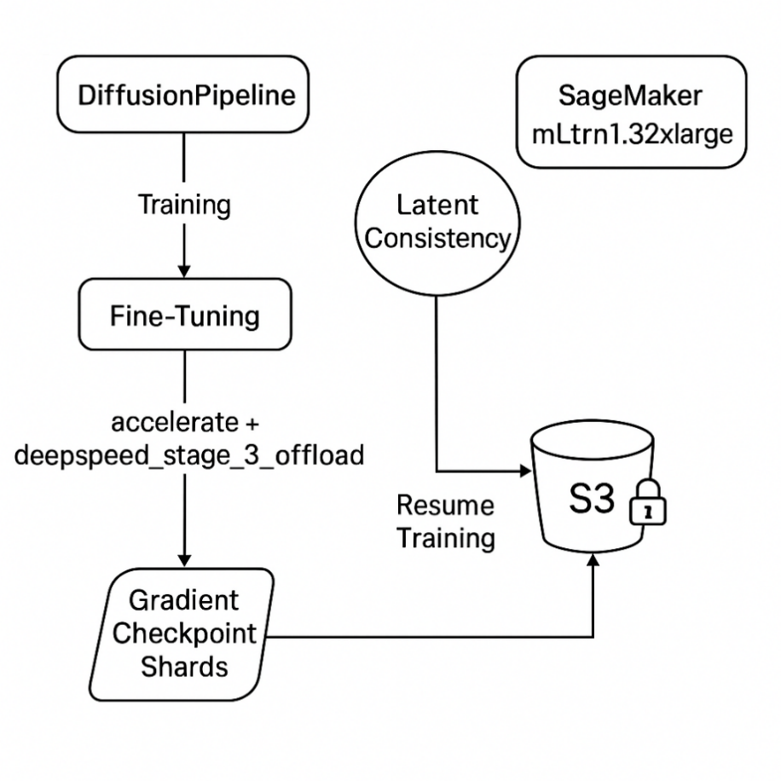
Figure 5.1 Pre-training and task-specific fine-tuning workflow
Once representational competence is established through pre-training and fine-tuning, decision relevance emerges through lightweight task heads layered atop the encoder architect
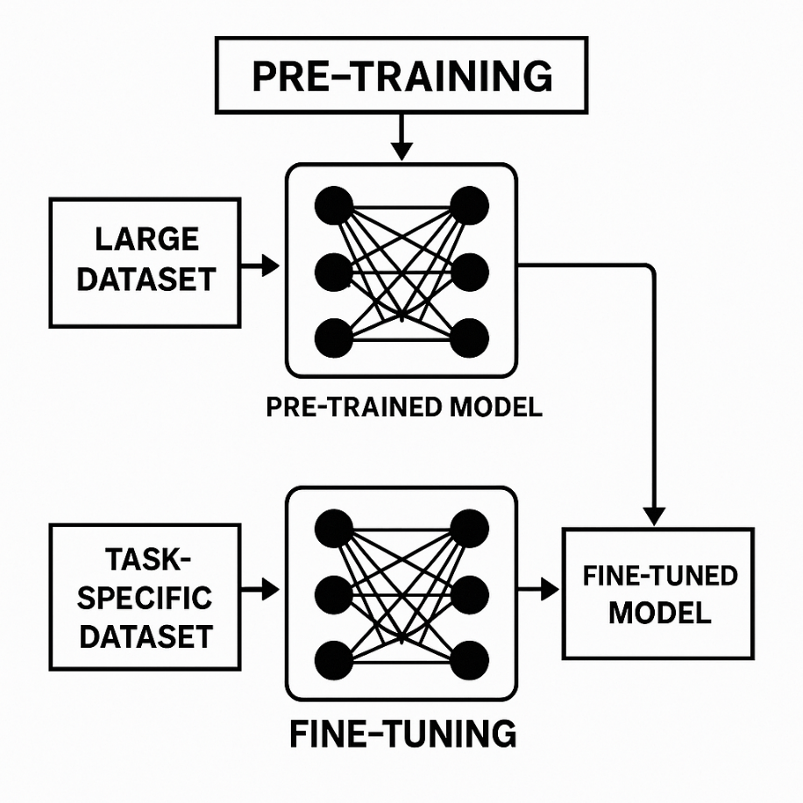
Figure 5.2 Transformer encoder classification path.
Tokenized input sequences propagate through stacked self-attention layers, with the contextual representation of the [CLS] token serving as the decision vector mapped to discrete outcome classes by the classification head.

5.4 From Rules to Policy-Bounded Optimization
Traditional security automation relies on deterministic mappings between conditions and actions. Cognitive defense replaces this paradigm with policy-bounded optimization, in which actions are selected to minimize expected loss under uncertainty while respecting explicit constraints.
The choice of model architecture therefore reflects operational constraints rather than abstract accuracy targets.
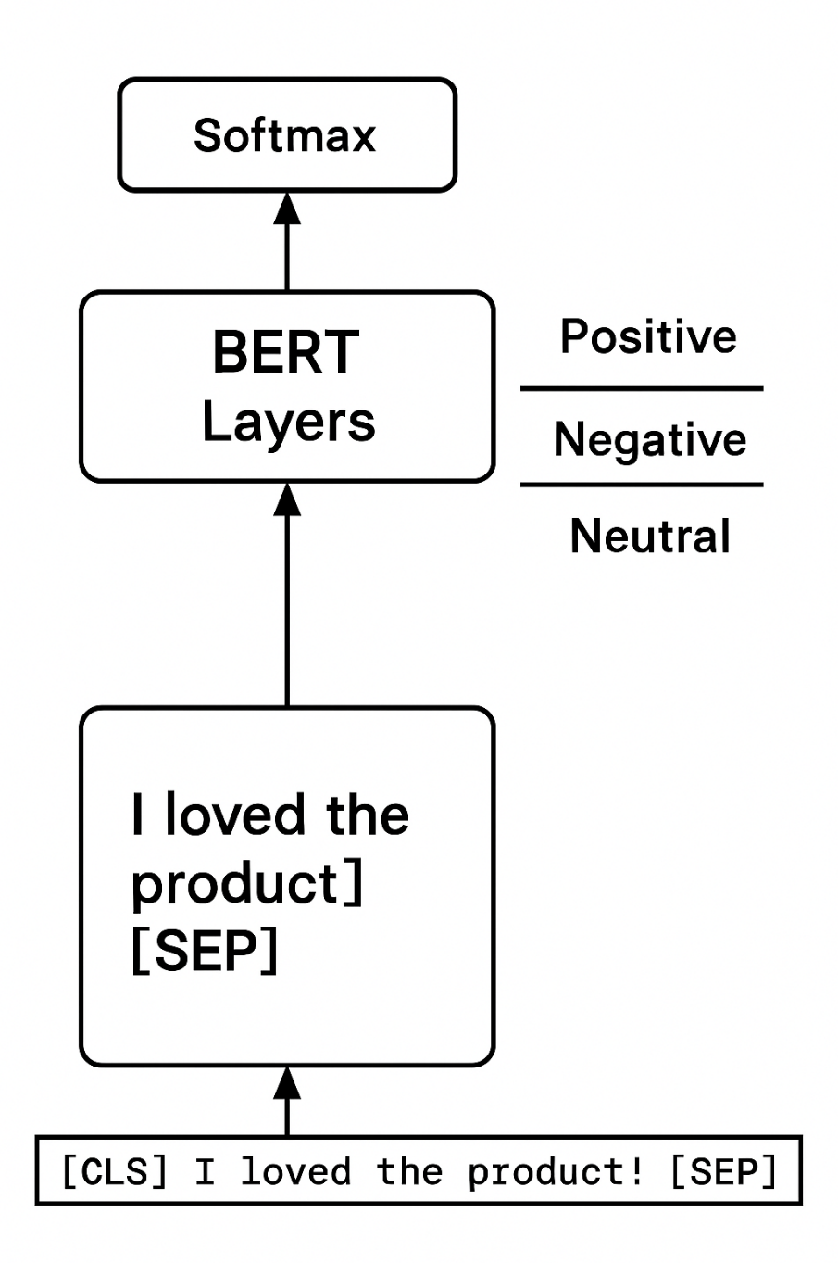
Figure 5.3 Trade-off between domain-specialized models and compressed architectures.
Compression does not eliminate learned structure; it transfers it.
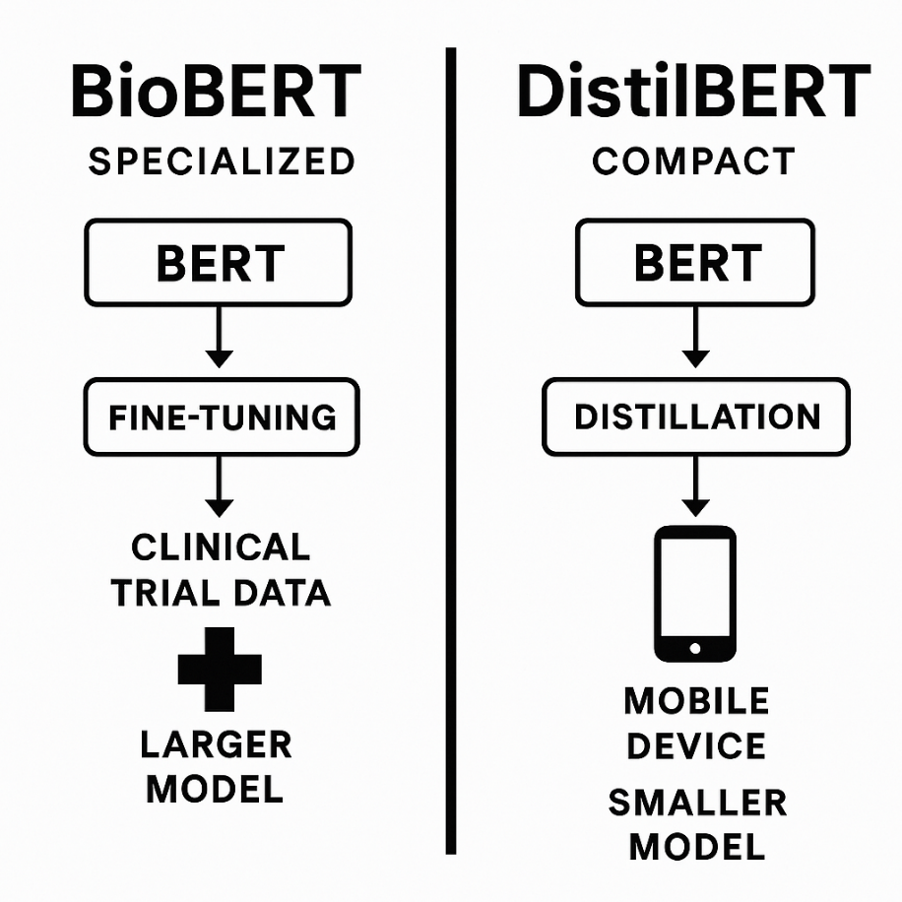
Large domain-adapted models offer deeper representational capacity, while distilled variants sacrifice some capacity in exchange for lower latency and deployability within constrained environments.
Figure 5.4 Knowledge distillation workflow.
This approach reflects broader advances in safe autonomy, in which decision authority is constrained by admissible action spaces rather than exhaustive rule specification (Radford, et al. 2019, Rahwan 2019).

5.5 Legitimate Control Surfaces for Autonomy
Autonomy is most effective when applied to reversible or low-blast-radius actions, such as credential invalidation, session throttling, and microsegmentation. These controls enable rapid intervention without introducing irreversible system risk.
Such layered architectures mirror safety-critical control systems, where local controllers operate autonomously within boundaries defined by supervisory policy (Holland 1992).
In practice, maintaining reliable autonomy requires infrastructure capable of sustaining continuous model updates and policy refinement under operational load.
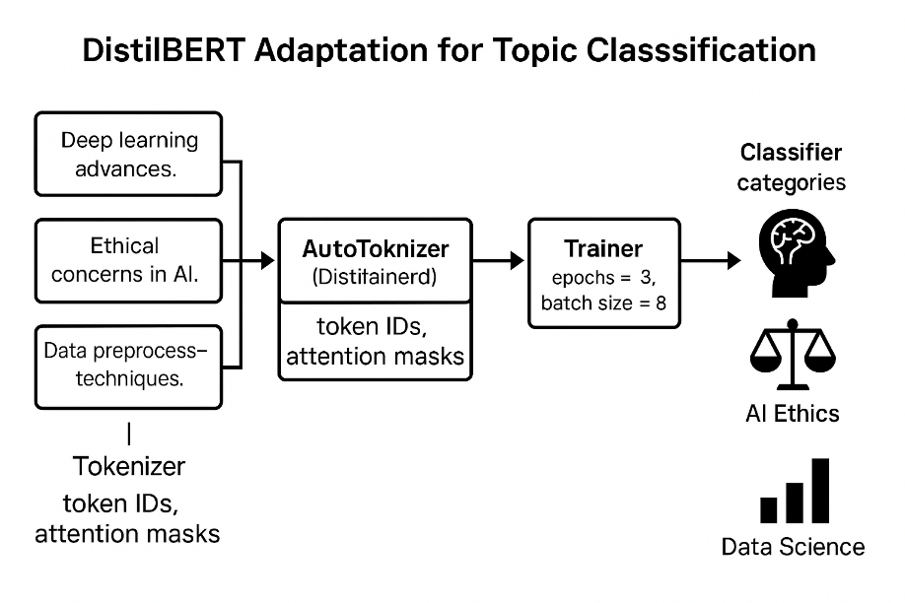
Multiple training nodes periodically persist gradient state and model parameters to durable storage, allowing interrupted training to resume without loss of latent consistency.
Figure 5.5 Distributed training and checkpointing architecture.

5.6 Adversarial Time as a First-Class Variable
Adversarial success is governed not only by capability but by temporal asymmetry. The system remains defensible only when the combined detection and response latency remains below adversarial adaptation time (Sommer and Paxson 2010).
We define the System Response Ratio (Rs) as:
$$R_{s}=\frac{T_{adv}}{T_{det}+T_{dec}+T_{act}}$$
where $T_{adv}$ denotes the time required for an adversary to achieve a meaningful objective, and the denominator represents full loop latency.
This relationship can be visualized as a temporal inequality between adversarial progress and defensive response.
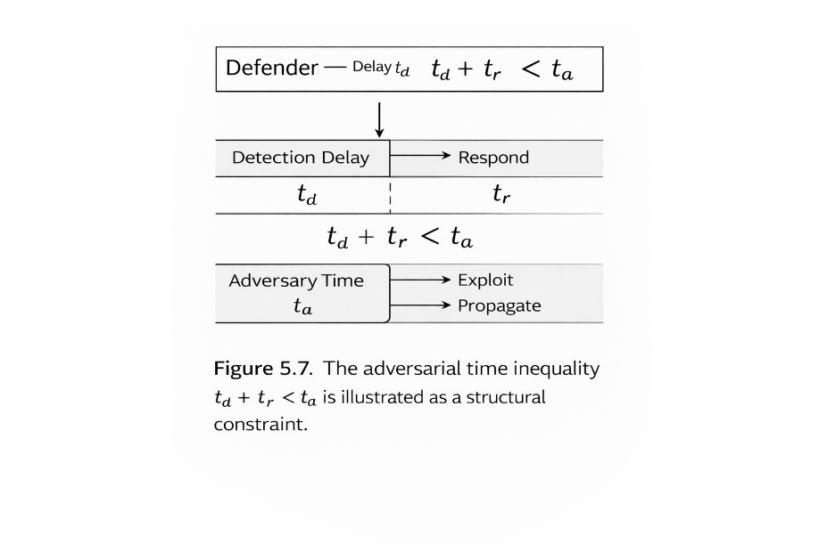
Defensive control is feasible only when total response latency remains below adversarial objective completion time.
Figure 5.6 Adversarial time inequality.
If $R_{s}<1$, adversarial objective completion precedes defensive action. Control is structurally impossible regardless of model sophistication.
If $R_{s}>1$, temporal dominance is established, rendering effective control feasible though not guaranteed.
This formulation extends W. Ross (Ashby, et al. 1956)'s logic by recognizing temporal dominance as a prerequisite for requisite variety. Regulatory capacity is irrelevant if it cannot be deployed within the disturbance window.
Closed cognitive loops compress response latency to machine timescales, restoring temporal dominance without requiring predictive certainty. Time compression, rather than intelligence amplification, is therefore the primary operational advantage of autonomous defense (Ashby, et al. 1956, Wiener, Hill and Mitter 2019).

5.7 Threat Models as Probabilistic Priors
Threat frameworks such as ATT&CK provide structured priors over adversarial behavior but do not prescribe control logic. In autonomous systems, these frameworks function as probabilistic transition graphs rather than deterministic playbooks (Strom et al. 2018).
Sequence modeling approaches extend this view by treating attack progression as stochastic state evolution rather than linear kill chains (Almukaynizi et al. 2021).

5.8 Failure Modes of Naïve Autonomy
Autonomous systems that optimize proxy metrics without interpretability or auditability are vulnerable to reward misalignment, policy drift, and escalation cascades (Everitt et al. 2019). These failures are architectural rather than algorithmic.
Interpretability and decision traceability, therefore, become control requirements rather than auxiliary diagnostics (Doshi-Velez and Kim 2017).

5.9 Cognitive Defense as Infrastructure
Perception feeds state estimation, policy evaluation selects bounded actions, mitigation preserves forensic state, and feedback signals propagate corrections across iterations.
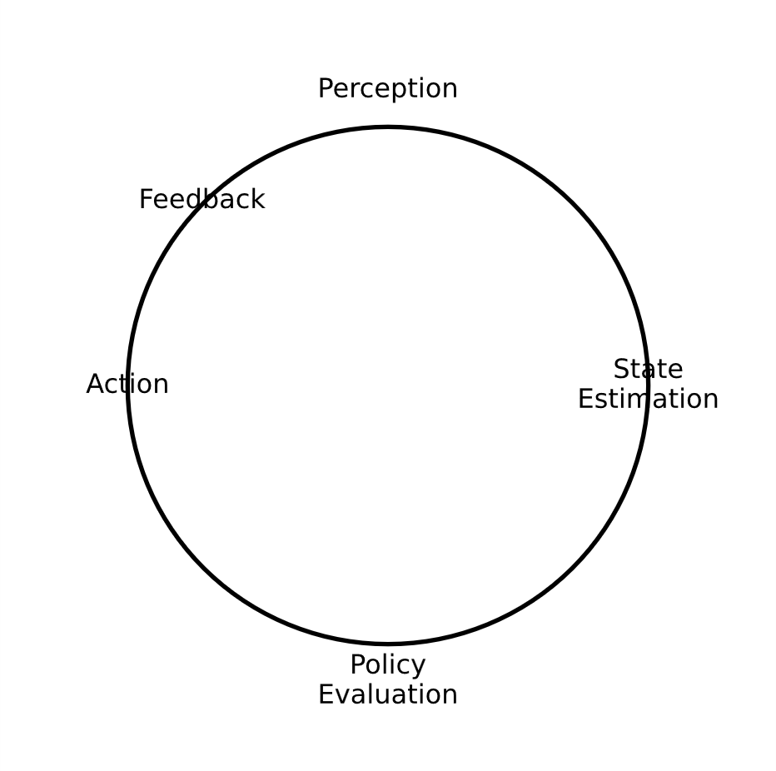
Perception feeds state estimation, policy evaluation selects bounded actions, mitigation preserves forensic state, and feedback signals propagate corrections across iterations.
Figure 5.7 Figure 5.6 Closed cognitive control loop for autonomous cyber defense.
Cognitive defense should be understood as infrastructure rather than intelligence amplification. Effectiveness arises from reliable closure of control loops under observability and governance constraints, not from model complexity alone (LeCun, Bengio and Hinton 2015).
Closed control loops require correction signals. In cybersecurity systems, correction arises from measurable risk differentials between pre- and post-action states. If containment fails to reduce the estimated compromise probability, policy thresholds and decision boundaries must be updated.
Human analyst overrides the function as supervisory feedback. False-positive corrections decrease sensitivity; false-negative discoveries increase it. In this way, governance events propagate backward into model calibration, preserving accountability while maintaining autonomy.
When a human analyst overrides an autonomous action, the event functions as a labeled correction signal rather than a simple audit artifact. Such interventions propagate backward through the control loop, updating policy boundaries and recalibrating sensitivity thresholds. If a containment action proves unnecessarily disruptive, the correction reduces the system’s aggressiveness; if a missed intrusion is discovered, policy sensitivity increases accordingly. In this sense, governance events operate as supervisory signals that ensure the system’s reward function (minimization of expected organizational loss) remains aligned with institutional risk appetite rather than raw detection metrics.

5.10 Transitioning Toward Cognitive Control Planes
Organizations do not deploy autonomy abruptly; they progressively seal control loops through observation, simulation, bounded execution, and continuous audit. The endpoint is not the elimination of human oversight but its relocation, from execution to policy governance (Russell and Norvig 2022).

Case Study: Autonomous Triage of Kerberos Ticket Forgery
To illustrate the transition from detection-centric security operations to control-bounded autonomy, consider a laboratory simulation of a Kerberos “Golden Ticket” attack within an enterprise directory environment.
In conventional SOC workflows, anomalous Ticket Granting Ticket (TGT) lifetimes typically generate high-severity alerts that enter analyst queues. Manual verification of ticket validity and directory state can introduce delays ranging from 15 to 30 minutes.

Cognitive Loop Execution
1. Perception (Sensing)
The system detects a Kerberos service request exhibiting an anomalous lifetime (e.g., multiple years) or a Relative Identifier (RID) inconsistent with the current directory state.
2. State Estimation (Integrated Forensics)
Rather than generating an isolated alert, the loop initiates structured state estimation. It correlates the originating host's recent process lineage with a detected memory access to lsass.exe observed shortly prior.
Aggregated telemetry increases the estimated probability of compromise beyond a predefined threshold (e.g., 0.85).
3. Policy Evaluation (Decision)
The policy engine evaluates account classification and privilege tier. If the affected principal is categorized as a standard user account, predefined governance constraints authorize reversible containment actions without supervisory escalation.
4. Action (Execution with Preservation)
Two reversible actions are executed:
- Credential Invalidation: Global invalidation of Kerberos tickets for the affected principal.
- Microsegmentation: Dynamic relocation of the originating workstation to a restricted forensic network segment permitting communication only with designated analysis infrastructure.
Containment is therefore coupled with structured state preservation.
By coupling containment with structured state preservation—such as capturing the lsass.exe memory context and recent credential access traces—the loop ensures that mitigation does not erase evidentiary state. Even when the threat is neutralized within seconds, the forensic truth of the intrusion is retained for subsequent audit, attribution analysis, and long-term model improvement.
5. Feedback (Loop Closure)
Post-action telemetry is continuously evaluated.
If anomalous Kerberos requests cease, the event is recorded as successful containment.
If equivalent signatures appear elsewhere, state estimation expands to adjacent nodes, escalating inference scope accordingly.
Illustrative Latency Comparison (Controlled Lab Conditions)
Metric | Human-Centric SOC | Autonomous Loop (Lab Simulation)
Detection to Triage | ~12 minutes | ~400 ms
Triage to  Action | ~22 minutes (approval workflow) | ~1.2 seconds
Forensic Capture | Manual / Post-event | Simultaneous with  containment
Resulting Impact | Elevated domain risk | Single host isolation
The timings above reflect controlled laboratory observations intended to demonstrate loop compression effects rather than production benchmarks.

Structural Interpretation
Under the human-centric workflow, the total response latency is approximately 34 minutes. If adversarial objective completion occurs within minutes, the System Response Ratio (Rs) falls below unity, placing the system in a structural failure regime.
Under autonomous execution, total latency falls below two seconds, restoring temporal dominance (Rs ≫ 1). The distinction is not informational but temporal.
To conclude the chapter, this table summarizes the structural transition from the traditional "Observational" model to the "Autonomous Control" model as established.
Concept | Traditional SOC (Observational) | Cognitive Loop (Autonomous)
Triage | Manual queue sorting based on severity. | Probabilistic state estimation using deep log analysis.
Forensics | Post-mortem investigation after the incident. | Real-time state capture simultaneous with action.
Latency | Limited by human approval and tool fragmentation. | Compressed to machine timescales (Target $R_s > 1$).
Action | Deterministic rules or manual intervention. | Policy-bounded optimization under uncertainty.
Goal | Detection accuracy and alert volume. | Temporal dominance and loop closure.
Table 5.1 The shift to cognitive control

Conclusion
Cybersecurity does not fail because defenders lack information. It fails because information arrives faster than decisions can be made, validated, and executed. The resulting delay (often measured in minutes or hours) provides adversaries with the only advantage they consistently require.
This chapter demonstrated that autonomous cyber defense is not an exercise in intelligence amplification, but in loop closure. When perception, decision, and action are separated by organizational friction, security systems become observational. When they are bound together within policy-constrained cognitive loops, defense becomes active control.
Crucially, autonomy in this context is neither unrestricted nor opaque. Effective cognitive defense operates within clearly defined control surfaces, prioritizing reversible actions, continuous feedback, and auditability. Failure modes emerge not from autonomy itself, but from architectures that lack observability, constraint enforcement, or interpretability.
The implication is architectural rather than philosophical: security systems must be designed to act before adversaries complete the work of proving intent. Time, not intelligence, is the dominant variable. Systems that compress response latency below adversarial adaptation thresholds regain control without requiring perfect foresight.
In this sense, cognitive defense represents an infrastructural shift. It transforms security from a discipline of interpretation into a discipline of intervention, where humans govern policy and machines execute within bounds that preserve safety, accountability, and intent.
If Chapter 05 establishes why decision authority must move closer to the machine and where autonomy is legitimate, the next question is unavoidable: how are those decisions learned, evaluated, and refined over time?
Chapter 06 moves beyond static policy boundaries to examine adaptive decision-making under uncertainty. It introduces learning-driven response strategies, reinforcement mechanisms, and feedback-conditioned policy evolution, and shows how cognitive loops not only act but also improve. The transition is not from control to intelligence, but from fixed response to measured adaptation, under continuous governance.
This is where autonomy ceases to be reactive and becomes strategic.

References
Anderson, B., and D. McGrew. 2021. “Machine Learning for Threat Hunting: Techniques and Tools.” Journal of Cybersecurity and Privacy 1 (2): 134-156.
Ashby, Jill, Sally Bannister, Ruth Pettit, and Mick Ashby. 1956. “An Introduction to Cybernetics.” http://pcp.vub.ac.be/books/IntroCyb.pdf.
Han, J., and Y. Lee. 2022. “Threat Intelligence Integration in Security Information and Event Management Systems.” Computers & Security 112: 102535.
Holland, John H. 1992. Adaptation in Natural and Artificial Systems. The MIT Press. https://direct.mit.edu/books/book/2574/Adaptation-in-Natural-and-Artificial-SystemsAn.
LeCun, Y., Y. Bengio, and G. Hinton. 2015. “Deep learning.” Nature 521. doi:10.1038/nature14539.
Lee, C., and J. Kim. 2020. “AI-Driven Digital Forensics: Challenges and Approaches.” Proceedings of the International Conference on Digital Forensics. 98-112.
Radford, A., J. Wu, R. Child, D. Luan, D. Amodei, and I. Sutskever. 2019. “Language models are unsupervised multitask learners.” OpenAI.
Rahwan, Iyad. 2019. “Machine Behaviour.” Nature 568 (7753): 477-486.
Russell, S, and P Norvig. 2022. Artificial Intelligence: A modern approach. 4th. Hoboken, NJ: © Pearson Education Limited.
Sharafaldin, I., A. H. Lashkari, and A. A. Ghorbani. 2018. “Toward Generating a New Intrusion Detection Dataset and Intrusion Traffic Characterization.” Proceedings of the ICISSP 2018 108-116.
Sommer, R., and V. Paxson. 2010. “Outside the Closed World: On Using Machine Learning for Network Intrusion Detection.” IEEE Symposium on Security and Privacy 305-316.
Stallings, W. 2017. Cryptography and Network Security: Principles and Practice. 7. Pearson Education.
Sutton, Richard S, and Andrew G Barto. 1992. Reinforcement Learning: An Introduction. 2nd. Cambridge, MA: MIT Press. https://web.stanford.edu/class/psych209/Readings/SuttonBartoIPRLBook2ndEd.pdf.
Wiener, Norbert., Doug. Hill, and Sanjoy. Mitter. 2019. Cybernetics : or, Control and communication in the animal and the machine. MIT Press. https://mitpress.mit.edu/9780262537841/cybernetics-or-control-and-communication-in-the-animal-and-the-machine/.
Xu, W., X. Du, and Z. Li. 2018. “DeepLog: Anomaly Detection and Diagnosis from System Logs through Deep Learning.” Proceedings of the 2018 ACM Conference on Computer and Communications Security. 1285-1298.
Zhou, Y., and H. Leung. 2019. “Deep Learning Based Log Analysis for Anomaly Detection.” Information Sciences 482: 193-210.

