Chapter 6

Model Governance and Ethics in Operational AI
Paulo Leocadio

Introduction

Operational AI systems do not fail ethically because they lack principles; they fail because governance is under-specified at the points where models interact with budgets, authority, and irreversible outcomes. In production environments, ethical risk materializes through biased alerting, untraceable model evolution, and explanations that cannot withstand audit or legal scrutiny. This chapter treats model governance and ethics as engineering constraints rather than philosophical add-ons. It focuses on how bias enters alert pipelines, how accountability degrades without versioning and audit trails, and why explainability must serve institutional defense rather than user reassurance. The objective is not to moralize automated decision-making, but to specify the control structures required to deploy AI systems that remain governable under pressure.
In the architectural framework proposed in this book, governance is not implemented through policy documents but through measurable control functions. Bias is bounded through calibration metrics, explainability is enforced through decision gates, and accountability is preserved through immutable audit artifacts.
6.1 Bias in alert classification
Bias in operational alert classification systems is not primarily a social or ideological artifact; it is a structural consequence of how these systems are built, trained, and embedded into decision loops. In security operations, emergency response, fraud detection, and public-sector monitoring, alerts are not neutral observations. They are compressed representations of complex environments, filtered through imperfect sensors, selective labeling practices, and historically contingent priorities. Bias, in this context, emerges when these compressions systematically distort risk allocation, resource deployment, or escalation pathways.
This approach moves beyond anecdotal concerns of 'fairness' and treats bias as a measurable drift in model calibration. By monitoring the Operational Bias Coefficient $\left(B_{c}\right)$, we implement the practical requirements for fairness in industry settings as outlined by (Holstein, et al. 2019). Furthermore, by programmatically forcing the loop into a 'Degraded Trust' state when $B_{c}$ spikes, we are essentially codifying the 'Ethical Algorithm' framework proposed by (Kearns and Roth 2021), ensuring that social awareness is an algorithmic constraint rather than a post-hoc manual review."
metric measures the divergence between the model's predicted risk distribution $\left(P_{m}\right)$ and the historically validated ground truth $\left(P_{a}\right)$ across network segments:
$$B_{c}=\sum_{i=1}^{n}{\left|P_{m}\left(x_{i}\right)-P_{a}\left(x_{i}\right)\right|}$$

where $P_{m}$ represents the model-estimated risk distribution and $P_{a}$ represents the empirically validated alert distribution across monitored segments.
In the proposed system, if $B_{c}$ exceeds a pre-defined threshold (e.g., 0.15), the autonomous loop is programmatically forced into a 'Degraded Trust' state. In this state, the system is stripped of its authority to perform irreversible actions (e.g., such as account deletions) and is restricted to reversible 'Throttling' maneuvers until a human auditor recalibrates the model's priors.
A defining characteristic of alerting systems is extreme class imbalance. True incidents are rare compared with benign events, and labels are often assigned post hoc by analysts under time pressure. This creates a feedback loop: alerts that align with analysts' expectations are more likely to be confirmed and reinforced in subsequent training data, whereas anomalous or ambiguous cases are more likely to be dismissed or deprioritized. Over time, the model does not merely learn "what incidents look like"; it learns what the organization has historically chosen to see. Bias is therefore encoded not only in data distributions but in institutional behavior.
Proxy variables further amplify operational bias. Because ground truth is expensive or unavailable, systems rely on correlates such as alert frequency, past incident tags, or heuristic severity scores. These proxies often entangle technical signals with organizational convenience. For example, systems may overprioritize environments with richer telemetry while underdetection of risks in legacy or resource-constrained systems. The resulting bias is not discriminatory in a demographic sense. However, it is strategically consequential: it shifts attention, budgets, and remediation capacity away from structurally opaque zones where failures may be most damaging.
Alert fatigue introduces an additional layer of distortion. High false-positive rates lead analysts to ignore certain alert classes, thereby biasing labeling and retraining pipelines. Alerts that are routinely dismissed receive fewer confirmations, degrading future model sensitivity in precisely those regions where early weak signals might matter. This phenomenon converts human coping strategies into statistical artifacts, embedding operational stress directly into the model.
Crucially, traditional fairness metrics offer limited protection in this setting. Measures such as equalized odds or demographic parity presuppose stable populations and well-defined protected attributes (assumptions that rarely hold in infrastructure, cybersecurity, or public-sector domains). The relevant question is not whether alerts are "fair" in an abstract sense, but whether error is systematically concentrated in ways that undermine mission objectives, safety margins, or fiscal accountability.
Mitigating bias in alert classification, therefore, requires governance interventions upstream of model training. Dataset documentation, explicit articulation of labeling policies, and continuous bias audits must be treated as operational controls rather than ethical add-ons. Bias cannot be eliminated, but it can be bounded, surfaced, and managed (provided that it is recognized as an architectural property of socio-technical systems, rather than a flaw that can be remedied by post hoc calibration alone).
In Figure 6.1, we present a representation of bias in operational alerting systems that emerges through repeated interactions among telemetry coverage, human triage behavior, retraining practices, and resource allocation. Rather than entering at a single point, bias manifests as a distortion field that selectively amplifies some alerts while suppressing others over time.
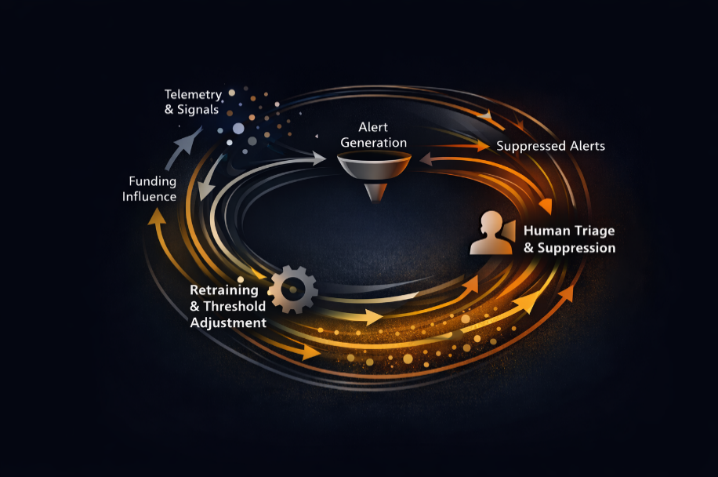
Figure 6.1 Bias as a feedback field in alerting systems.
The figure illustrates how bias accumulates dynamically rather than originating from a single flawed dataset or decision rule. As alerts circulate through human and automated processes, organizational responses (particularly suppression, prioritization, and funding decisions) reshape the statistical landscape on which future models are trained. Bias, therefore, persists not because it is unnoticed, but because it becomes structurally reinforced.

Sources: This subsection synthesizes prior work on dataset governance, operational bias, and fairness in socio-technical machine learning systems, particularly Gebru et al. (2018), Holstein et al. (2019), and Binns (2018).

When bias becomes a budget decision
A national infrastructure monitoring program deploys an AI-driven alerting system to prioritize maintenance and incident response across thousands of distributed assets. The system is trained on historical incident data labeled by regional operations teams over several years. On paper, performance metrics look strong: high precision, acceptable recall, and steadily declining false positives.
Within eighteen months, budget allocation begins to shift. Regions with dense telemetry and mature reporting practices receive disproportionate funding increases, justified by higher "model-detected risk." Less-instrumented regions, often older, more failure-prone, and politically quieter, show fewer alerts and are deprioritized. No one flags this as bias; it appears data-driven.
The failure occurs during a cascading outage originating in an underfunded region. Post-incident analysis reveals that the root cause was evident months earlier, as weak, noisy alerts were repeatedly dismissed by analysts and down-weighted during retraining. The model did not "miss" the risk (it was trained not to see it).
The ethical failure was not malicious intent or demographic discrimination. It was the absence of governance mechanisms capable of detecting that alert suppression had become a financial signal. By the time the system was audited, the model could no longer reproduce earlier states, the training data had drifted, and accountability dissolved into plausible deniability.

Sources: This analysis is informed by research on institutional fairness and the political consequences of algorithmic decision-making, with particular grounding in Binns (2018) and Holstein et al. (2019).

Bias control surfaces in alerting systems.
To prevent this class of failure, bias must be treated as a system-level property rather than as a static metric. Conceptually, bias enters and propagates through three primary surfaces:
- Data ingress layer
  - Sensor coverage asymmetry
  - Logging fidelity differences
  - Selective data retention
These factors determine what can be seen before any model is trained.
- Labeling and feedback layer
  - Analyst confirmation bias
  - Alert fatigue-driven dismissal
  - Policy-driven escalation thresholds
This layer directly encodes organizational behavior into the ground truth.
- Model and policy layer
  - Class imbalance handling
  - Proxy feature selection
  - Retraining cadence and criteria
Here, historical bias is normalized into operational logic.
Effective governance introduces control surfaces at each layer:
- Dataset documentation and coverage audits at ingress
- Explicit labeling protocols and rejection logging at feedback
- Bias stress-testing and counterfactual analysis at the model layer
Critically, these controls must be observable over time. One-time fairness checks are insufficient; bias evolves as systems learn from their own consequences. Governance architecture, therefore, requires continuous monitoring of where alerts are suppressed, ignored, or never generated, and of the reasons for this suppression, ignoring, or non-generation.
While bias determines where errors emerge, governance determines whether those errors remain detectable. The mechanism that enables such detection is lineage. Without the ability to reconstruct the model state, policy context, and data regime under which a decision was made, organizations cannot meaningfully investigate failures. Systems that learn continuously or retrain automatically may appear stable while silently drifting away from the assumptions under which they were approved. In this environment, governance depends not on static documentation but on the ability to recover the system's exact configuration at the moment a decision was made.

Sources: The governance framing in this section draws on established practices in dataset documentation and model reporting, particularly those of Gebru et al. (2018) and Mitchell et al. (2019).

6.2 Model versioning and audit trails
In operational AI, a model without lineage is an unaccountable actor. When decisions affect safety, public funds, or legal exposure, the inability to reconstruct which model made which decisions, when, and under what assumptions constitutes a governance failure in its own right.
Model versioning must extend beyond artifact storage. It must capture the full decision context, including:
- Training data snapshots and sampling logic
- Feature extraction pipelines and transformations
- Hyperparameters, thresholds, and policy constraints
- Deployment environment and upstream dependencies
Without this, post-incident reviews collapse into speculation. Explanations may describe how a model behaves in the present, but they cannot justify why a past decision occurred. This gap is especially dangerous in systems that retrain continuously or adapt online, where silent drift can invalidate prior assurances without triggering alarms.
Audit trails serve two functions. First, they enable forensic reconstruction, allowing organizations to trace decisions back to specific model states and data regimes. Second, they impose ex ante discipline: when teams know decisions are traceable, design shortcuts become visible liabilities rather than invisible optimizations.
From an ethical standpoint, accountability is temporal. Responsibility cannot be assigned if system evolution is opaque. From an operational standpoint, auditability is a defensive infrastructure that protects organizations not only from technical failure but also from regulatory, financial, and reputational fallout.
In this sense, model governance is not about slowing innovation. It is about ensuring that adaptive systems remain legible to the institutions that depend on them. Without versioned models and durable audit trails, explainability degrades into narrative, and ethics into after-the-fact rationalization.

Next, in Figure 6.2, we see that model accountability depends on the alignment of data state, model state, and policy state at the moment a decision is made. Decisions that fall outside aligned accountability windows cannot be reliably reconstructed or defended, even when model artifacts are retained.
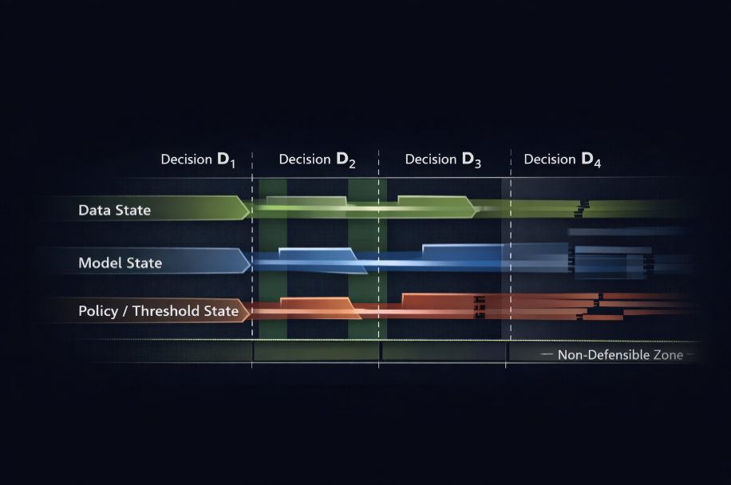
Figure 6.2 Temporal model lineage and accountability windows.
This figure emphasizes that versioning alone is insufficient for governance. Without temporal alignment across data, model, and policy layers, post-incident reconstruction becomes approximate. Accountability failures arise not from missing artifacts but from broken temporal continuity between decisions and the system states that produced them.
The use of 'Cyber-Model Cards' transitions model reporting from a passive documentation task to an active governance gate. This implementation is a direct operationalization of the Model Cards for Model Reporting framework (Mitchell, et al. 2019). By embedding max_blast_radius and allowed_actions into the model's metadata, the system ensures that the 'Datasheets for Datasets' logic (Gebru, et al. 2021) extends into the model's execution phase. This ensures that a model trained on low-fidelity telemetry is never 'authorized' by the control plane to perform high-fidelity actions, such as domain-level credential flushes.
Accountability in the autonomous system is enforced through Governance-as-Code. Every model deployed within the control plane must carry a standardized 'Cyber-Model Card.' Below is the schema required for a Model 05-Alpha classifier in our SageMaker/Vertex AI pipeline:
```yaml

model_metadata:
id: "kerberos-anomaly-v4"
version: "2024.10.12"
intended_use: "Triage of Kerberos TGT anomalies"
governance_constraints:
max_blast_radius: "Single Subnet"
allowed_actions: ["Flush-Ticket", "Isolate-Host"]
prohibited_actions: ["Disable-Domain-Admin", "Wipe-Drive"]
audit_requirement: "Full SHAP explanation per action"
risk_calibration:
bias_threshold: 0.12
last_validation_date: "2024-09-01"
```
This schema ensures that the 'Decision Loop' cannot execute an action that exceeds the model's pre-authorized mandate.

Sources: This subsection builds on prior work in model accountability, deployment-time safety, and interpretability, notably Mitchell et al. (2019), Amodei et al. (2016), and Doshi-Velez and Kim (2017).

6.3 Explainability and institutional defense
Explainability in operational AI is frequently mischaracterized as a matter of user trust or model transparency. In high-stakes environments, this framing is insufficient. When automated decisions influence emergency response, infrastructure shutdowns, financial reallocations, or regulatory enforcement, explanations are not conveniences; they are justifications under scrutiny.
Operational explainability must therefore be evaluated against adversarial conditions. An explanation is not adequate merely because it is intuitive, visual, or persuasive; it must withstand challenge from auditors, investigators, legal counsel, and domain experts. This requirement sharply distinguishes explanatory tooling from explanatory accountability. Techniques such as local surrogate models or feature attributions may illuminate model behavior, but they do not, by themselves, establish responsibility.
A common failure mode arises when explainability is treated as a post hoc interface layered on top of an otherwise opaque system. Dashboards present importance scores or confidence intervals, yet the underlying decision path remains inseparable from undocumented preprocessing steps, policy thresholds, or retraining artifacts. In such cases, explanation becomes narrative rather than evidence. The system can describe what it appears to value without demonstrating why that valuation is legitimate within organizational or legal constraints.
In practice, meaningful explainability is inseparable from governance infrastructure. Explanations must be tied to specific model versions, data regimes, and policy contexts. A decision explanation that cannot be reproduced after a model update is operationally void. Similarly, explanations that abstract away uncertainty, dissenting signals, or suppressed alerts create a false sense of determinism, masking the probabilistic nature of automated judgment.
Crucially, explainability must align with decision rights. Analysts, managers, and executives require different explanatory resolutions. Over-simplified explanations can obscure systemic risk at the executive level, while overly technical explanations can overwhelm frontline operators. Designing explanations without regard to organizational roles effectively redistributes power without oversight, shifting accountability away from those formally responsible.
From an ethical standpoint, the core question is not whether a model can explain itself, but whether an institution can defend the decisions it delegates to it. Explainability, in this sense, is a property of the socio-technical system rather than of the model alone. When lives and budgets are on the line, explanations must prioritize governance over intuition.
Explainability is not for the machine; it is for the institution's legal defense. We utilize SHAP (SHapley Additive exPlanations) values to decompose every autonomous decision into its contributing features.
For an incident involving a 'Golden Ticket' attack, the system must generate a visual explanation (Figure 6.1) that justifies why the 'Ticket Lifetime' and 'Source RID' variables triggered the isolation. If the explanation falls below a Certainty Score $\left(C_{s}\right)$, the system's 'Explainability Logic Gate' prevents execution.

$$C_{s} = \frac{∑\left|{SHAP}_{critical} \right|}{∑\left|{SHAP}_{all} \right|}$$

This ensures that 'black box' reasoning never results in a high-impact network disruption.
While deep learning models are often criticized as 'black boxes,' the use of SHapley Additive exPlanations (SHAP) provides a mathematically rigorous way to assign credit to specific features during an incident. This addresses the core requirement for transparency in automated systems, as argued by (Doshi-Velez and Kim 2017). By requiring a Certainty Score $\left(C_{s}\right)$ before execution, we ensure that the system's reasoning is not only accurate but 'traceable' for the legal and institutional defense requirements that govern modern cybersecurity operations.

Figure 6.3 shows that not all explanations are institutionally defensible. Operational accountability exists only where explanations are reproducible, traceable to specific system states, and aligned with formal decision authority.
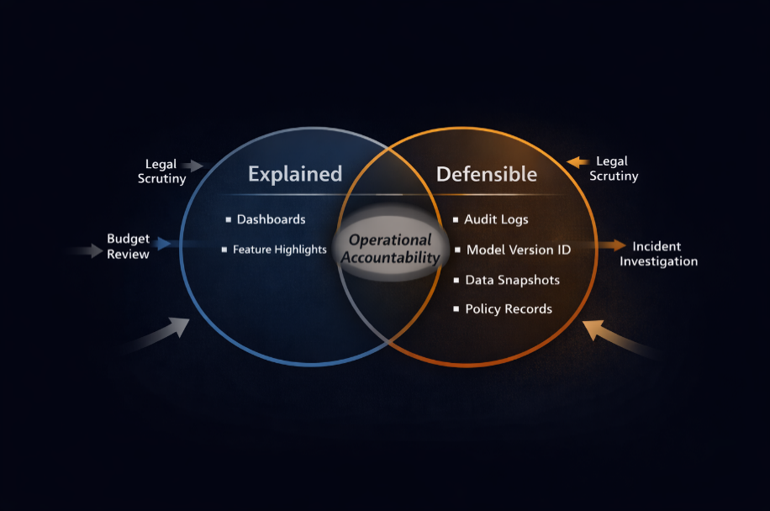
Figure 6.3 Explainability versus defensibility in operational AI.
The illustration clarifies why many explainability efforts fail under audit or legal scrutiny. While explanatory tools may clarify model behavior, they do not establish accountability unless coupled to lineage, policy context, and decision rights. Defensibility, not interpretability alone, determines whether automated decisions can be justified when challenged.
Next, Figure 6.4 reinforces a subtle, yet important claim made in this section: human-in-the-loop does not guarantee accountability. This figure makes that distinction visually perceptible.

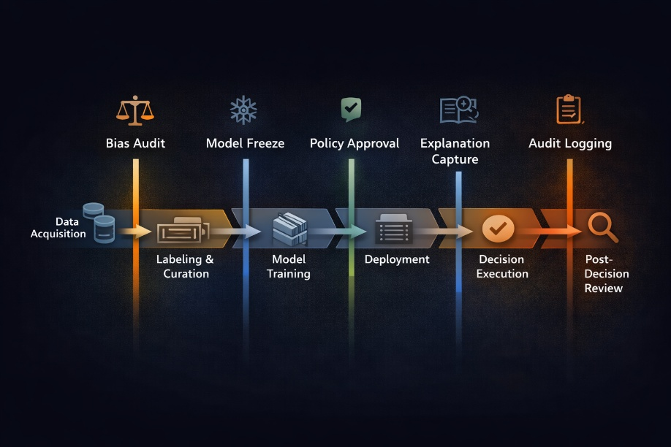
Figure 6.4 Human oversight is not human control.
Sources: This block draws on prior work by Ribeiro et al. (2016), Doshi-Velez and Kim (2017), and Amodei et al. (2016).

6.4 Governance examples
This section illustrates how governance constraints can be encoded directly into operational AI systems. The goal is not to prescribe implementation details but to demonstrate how accountability, traceability, and defensibility can be embedded in deployed models. Code and mathematical formulations are used only as explanatory artifacts rather than optimization mechanisms.
Figure 6.5 establishes that ethics, governance, and control are equivalent. The illustration makes this explicit by showing where governance is applied rather than what the model does.
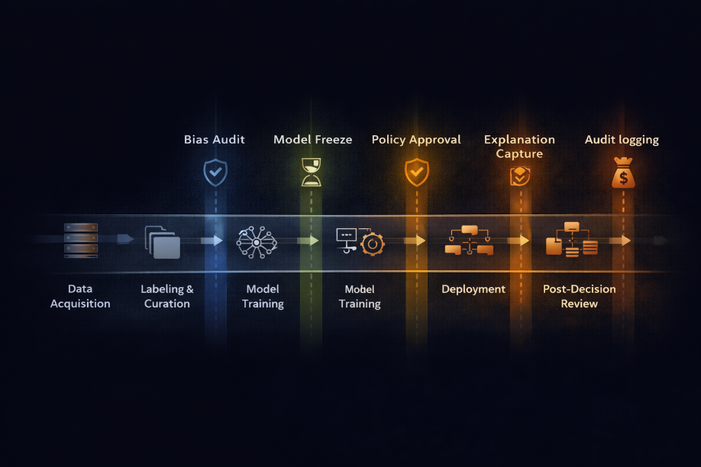
Figure 6.5 Governance control points across the AI lifecycle.
Decision traceability through structured logging
A core governance requirement is the ability to reconstruct the rationale for a specific decision, using the system state that existed at the time of execution. This requires more than storing predictions or confidence scores; it requires capturing the decision context as a first-class artifact.
The following example illustrates a minimal decision record suitable for audit and post-incident review.
```python
decision_record = {
"decision_id": "D-2025-06-1421",
"timestamp": "2025-06-18T14:32:11Z",
"model_id": "alert_classifier_v3.4.2",
"model_hash": "8f2c9a1e",
"data_snapshot": "telemetry_snapshot_2025_06_18",
"policy_version": "policy_escalation_2.1",
"threshold": 0.87,
"prediction": "escalate",
"confidence": 0.91,
"executor": "automated",
"review_required": true
}
audit_log.append(decision_record)
```
This structure ensures that decisions remain reproducible even after models evolve. Crucially, it links predictions to the policy context and the authority for execution, thereby preventing post hoc reinterpretation.

Sources. This block draws on prior work by Mitchell et al. (2019) and Amodei et al. (2016).

Quantifying risk concentration rather than accuracy
Traditional performance metrics obscure the governance-relevant question: where does error concentrate, and what does it cost? A simple risk formulation clarifies this distinction.
$$R=\sum_{i=1}^{n}{〖P(〗e_{i} ∣ a_{i})}⋅C\left(e_{i}\right)$$
Where:
- $a_{i}$represents an alert class,
- $P\left(e_{i} ∣ a_{i}\right)$ is the conditional probability of error for that class,
- $C\left(e_{i}\right)$ is the operational cost associated with that error.
This formulation highlights that bias becomes operationally significant when high-cost errors are systematically concentrated in specific alert categories, even if global accuracy remains high. Governance interventions should therefore prioritize bounding risk concentration rather than maximizing aggregate performance metrics.

Sources. This block draws on prior work by Kearns and Roth (2019) and Binns (2018).

Explainability as evidence, not narrative
Explainability mechanisms are frequently deployed as user-facing interfaces. From a governance perspective, however, explanations must function as evidence (capable of examination, challenge, and reproduction).
The following example illustrates how an explanation artifact can be bound to a specific decision without embedding interpretability tooling directly into operational logic.
```python
explanation_record = {
"decision_id": "D-2025-06-1421",
"explanation_method": "local_surrogate",
"feature_contributions": {
"failed_login_rate": 0.42,
"anomalous_ip_score": 0.31,
"privilege_escalation_signal": 0.18
},
"model_version": "alert_classifier_v3.4.2",
"generated_at": "2025-06-18T14:32:13Z"
}
explanation_store.write(explanation_record)
```
By storing explanations as immutable records linked to decision identifiers, organizations preserve explanatory accountability without conflating interpretability with real-time decision-making.
Sources. This block draws on prior work by Ribeiro et al. (2016) and Doshi-Velez and Kim (2017).
Governance failures as detectable conditions
Governance breakdowns often manifest subtly: missing data snapshots, silent retraining, or policy drift. These conditions can be detected if governance expectations are formalized.
One example is a simple lineage integrity check:
```python
if not lineage.is_complete(decision_id):
raise GovernanceViolation(
"Decision lacks complete data, model, or policy lineage."
)
```
While simplistic, such checks enforce the principle that decisions without provenance are, by definition, invalid. This shifts governance from reactive investigation to proactive enforcement.

Sources. This block draws on prior work by Amodei et al. (2016) and Mitchell et al. (2019).

The examples in this section demonstrate that governance is not an abstract constraint imposed after deployment. It is an operational property that can be encoded, validated, and enforced through concrete system artifacts. Code and mathematics serve governance only when they enhance traceability, accountability, and institutional defensibility. When they do not, they add complexity without control.
Figure 6.6 illustrates how governance can fail even in "well-designed" systems.
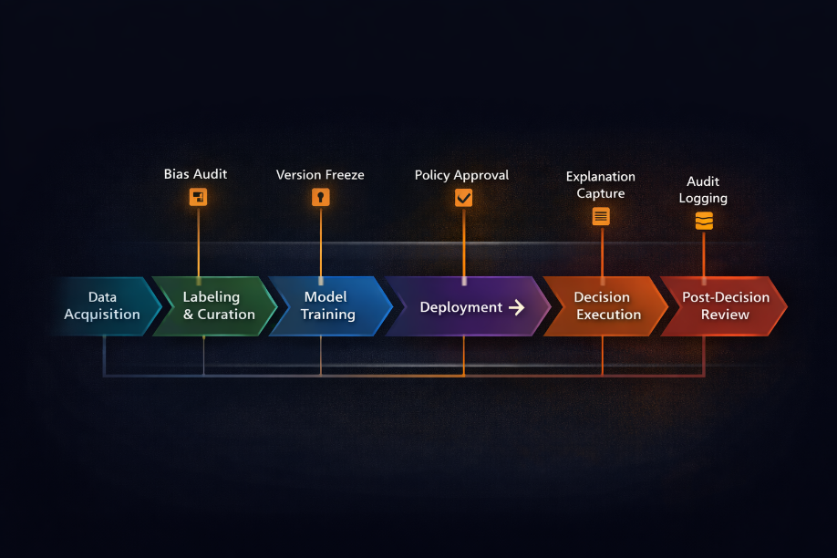
Figure 6.6 Governance failure modes in operational AI.
Conclusion
Model governance and ethics in operational AI do not reside in abstract principles or aspirational guidelines. They emerge from concrete design decisions: how alerts are labeled, how models evolve, how decisions are traced, and how explanations are constructed under pressure. Ethical failures in such systems are rarely sudden; they accumulate silently through unexamined defaults and missing controls.
This chapter has treated bias, auditability, and explainability as control problems rather than moral ones. The implication is direct: organizations that deploy autonomous or semi-autonomous systems without governance infrastructure are not merely taking technical risk; they are assuming ethical liability by design.
As governance structures solidify, the limiting factor in operational AI shifts from whether systems can be trusted to how far they can be allowed to act. Once bias is bounded, lineage is enforced, and decisions are defensible, autonomy becomes a design question rather than a philosophical risk. The next chapter examines this transition point: how organizations progressively extend machine agency through controlled escalation, bounded execution, and human override, transforming governed models into operational actors without surrendering accountability.

References
Amodei, Dario, Chris Olah, J. Steinhardt, P. Christiano, John Schulman, and Dandelion Mané. 2016. "Concrete Problems in AI Safety." arXiv preprint arXiv:1606.06565. https://arxiv.org/abs/1606.06565.
Binns, Reuben. 2018. "What Can Political Philosophy Teach Us about Algorithmic Fairness?" IEEE Security &amp; Privacy (Institute of Electrical and Electronics Engineers (IEEE)) 16: 73–80. doi:10.1109/msp. 2018.2701147.
Doshi-Velez, Finale, and Been Kim. 2017. "Towards a Rigorous Science of Interpretable Machine Learning." arXiv preprint arXiv:1702.08608. https://arxiv.org/abs/1702.08608.
Gebru, Timnit, Jamie Morgenstern, Briana Vecchione, Jennifer Wortman Vaughan, Hanna Wallach, I. I. I. Hal Daumé, and Kate Crawford. 2021. "Datasheets for Datasets." Communications of the ACM (Association for Computing Machinery (ACM)) 64: 86–92. doi:10.1145/3458723.
Holstein, Kenneth, Jennifer Wortman Vaughan, Hal Daumé, Miro Dudik, and Hanna Wallach. 2019. "Improving Fairness in Machine Learning Systems: What Do Industry Practitioners Need?" Proceedings of the 2019 CHI Conference on Human Factors in Computing Systems. ACM. 1–16. doi:10.1145/3290605.3300830.
Kearns, Michael, and Aaron Roth. 2021. "The Ethical Algorithm: The Science of Socially Aware Algorithm Design." Perspectives on Science and Christian Faith (American Scientific Affiliation, Inc.) 73: 55–56. doi:10.56315/pscf3-21kearns.
Mitchell, Margaret, Simone Wu, Andrew Zaldivar, Parker Barnes, Lucy Vasserman, Ben Hutchinson, Elena Spitzer, Inioluwa Deborah Raji, and Timnit Gebru. 2019. "Model Cards for Model Reporting." Proceedings of the Conference on Fairness, Accountability, and Transparency. ACM. 220–229. doi:10.1145/3287560.3287596.
Ribeiro, Marco Tulio, Sameer Singh, and Carlos Guestrin. 2016. "Why Should I Trust You?": Explaining the Predictions of Any Classifier." Proceedings of the 22nd ACM SIGKDD International Conference on Knowledge Discovery and Data Mining. ACM. 1135–1144. doi:10.1145/2939672.2939778.

