Workloads Cloud AI Platforms: AWS vs. GCP vs. Azure for Machine-Learning Workloads

Vitaly Sem
Nov 6, 2025
Audience: engineering managers, machine-learning (ML) leads, and founders, validating an ML stack.
Note: Pricing and limits here are illustrative. They change often—always check the current documentation and your region.
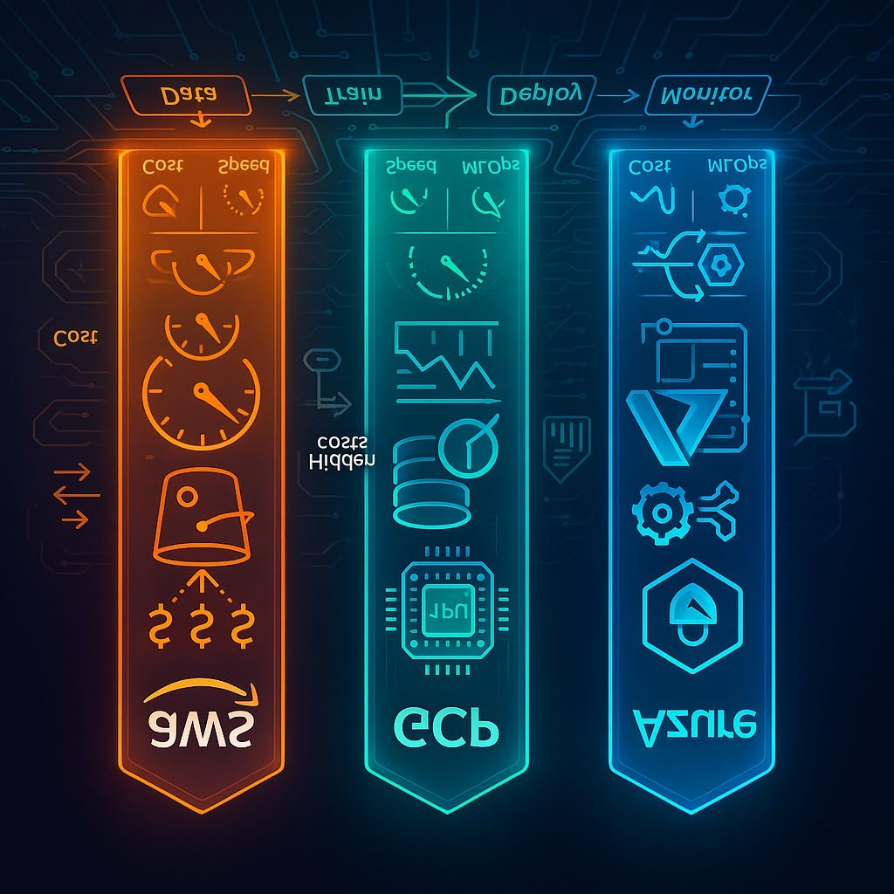

How we evaluate
We compare the platforms across three practical dimensions:
- Latency & throughput on like-for-like GPU (Graphics Processing Unit) setups
- End-to-end cost of training and serving across different data scales
- MLOps (Machine Learning Operations) integration: deployment, monitoring, and model lifecycle tooling
Quick prototyping tip: BotHub is an aggregator of AI models that hides API-key wrangling and setup, so you can focus on experiments instead of plumbing. New accounts get promo credits for test runs.

Amazon SageMaker (AWS — Amazon Web Services)
A fully managed service covering the ML lifecycle — from data prep and experimentation to deployment, monitoring, and governance.

Pricing posture
AWS markets a pay-for-what-you-use model across compute, storage, and data processing, plus optional discount programs (e.g., SageMaker Savings Plans, introduced in 2021) and a free tier.

Gotchas the author calls out:
Ancillary charges add up: CloudWatch (≈$0.10 per 1K metrics), EBS (Elastic Block Store) volumes for notebooks, and inter-AZ (Availability Zone) data transfer (~$0.01/GB). These are easy to miss in early budgets.
Savings Plan trade-offs: commitment is tied to specific instance families; a quoted $547/year minimum can be uneconomical for small projects and hard to reallocate if your workload shifts.
Free tier limits: ~250 hours on _{ml.t2.medium} —about 10 days nonstop—and no GPU access. Useful for clicking around the UI, not for running meaningful modern training.
SageMaker Studio (≈$24/month) unlocks experiment tracking, data UX, and collaboration. Without it, the free tier feels too bare for pro use.
Net: SageMaker delivers strong cost savings once workloads are steady and predictable. In early-stage R&D, hidden line items can push actuals 30–50% above the napkin math.

Flexibility & developer experience
Custom Docker is first-class: bring nightly PyTorch, custom TensorFlow, etc. Expect longer image builds (reported up to ~15 minutes vs. 2–3 for simple bases).
Distributed frameworks such as Ray and Dask are supported; Dask clusters often require manual setup via Processing jobs.
Dependencies are pinned and built during image creation, helping prevent "works on my machine" drift.

Speed to production
Commit-to-pipeline typically takes 10–15 minutes due to mandatory Docker build steps, even for small code changes.
SageMaker Projects wires CI/CD (Continuous Integration/Continuous Delivery) via CodePipeline/CodeBuild, but you'll need some AWS familiarity.

Strength: elastic endpoints
Autoscaling for inference endpoints is excellent — smoothly handling hundreds to tens of thousands of requests per minute without manual tuning.

Ecosysem lock-in (the double-edged sword)
Top-tier integrations with S3, CloudWatch, IAM (Identity and Access Management), Redshift, and Glue.
SageMaker Pipelines offers mature MLOps but introduces a DSL (Domain-Specific Language) and deeper integration with AWS semantics.

Google Cloud Platform (GCP) — Vertex AI
Google's Vertex AI favors opinionated, integrated ML development. Compared to AWS's "constructor set," Vertex AI pushes ready-to-use cycles and tight data integrations.

Pricing posture
Optimized serving (e.g., via prebuilt containers) and batching can substantially reduce prediction costs; for classic vision models like ResNet-50, figures as low as ~$0.0001/request are reported in tuned setups.
Per-second billing on TPUs (Tensor Processing Units) (e.g., $1.35/hour for TPU v2) reduces overpay for short tests.
Sustained Use Discounts: automatic reductions after 25% monthly utilization
(e.g., V100 dropping from ~$2.48/h to ~$1.74/h) without upfront commitments.
Hidden costs to watch:
Network egress/ingress: inter-region up to $0.19/GB; public egress ~$0.08/GB. Heavy load-balancing can add 15–20% to bills.
Ops telemetry: Logging ~$0.50/GB; tracing/profling can rack up hundreds per month on large models.
Storage & analytics: BigQuery adds ~$0.02/GB-month plus per-query costs; ML prediction queries (e.g., $0.10 per 1K) scale quickly.
Idle resources: Stopped but not fully released GPUs/VMs can silently accrue charges — an easy $3,000/month mistake.
Operational advice: automate resource lifecycles, enforce budgets/quotas, and audit network flows. Otherwise, network + observability can eclipse compute by 1.5–2×.

features that stand out
Vertex AI + BigQuery: train on warehouse data without complex ETL (Extract, Transform, Load).
Feature Store keeps training/serving features in sync; Vertex Pipelines gives lineage, experiment tracking, and versioning.
TPUs: for large language models and vision/NLP, TPUs can significantly reduce training time (e.g., large BERT under an hour on TPUs vs. >5 hours on 8× V100 GPUs). You can mix TPU and GPU per stage.

Microsoft Azure Machine Learning (Azure ML)
Azure ML excels in enterprise rollouts: security, governance, and hybrid deployment are first-class. Train in the cloud, serve on-prem (on-premises) if needed — great for data residency and regulatory controls.

Pricing posture
Platform fee: ~$0.075/hour for base ML workspace features; free tier includes 10 GB model storage and basic monitoring.
GPU pricing: NVIDIA V100 around $2.55/hour (region-dependent).
Distributed CPU (Central Processing Unit): from $0.045 per vCPU-hour.
Spot VMs (capacity-reclaimable) can reduce compute costs by up to ~90% for preemption-tolerant jobs.
Hidden costs to watch:
Modular billing across services stacks up:
AKS (Azure Kubernetes Service) control plane (~$0.10/hour) for model serving
Azure Storage (~$0.018/GB-month)
Inter-region data transfer (~$0.02/GB) even on private backbone
The upside: for organizations on Microsoft 365/Office 365, Active Directory, and Power BI, the integration and SSO (Single Sign-On) story is hard to beat.

Enterprise strengths
Tight hooks into Power BI (analytics), Azure Data Lake (big data), and Defender for Cloud (security).
Hybrid/edge via Azure IoT Edge: deploy models to factory/retail/feld gear, sync results to cloud.
End-to-end automation: dataset versioning, lineage, model monitoring in production.

When each platform makes the most sense
Platform Best For Why AWS SageMaker Expert teams needing fine-grained control and elastic at-scale inference Deep AWS integrations, custom Docker everywhere, robust endpoint autoscaling GCP Vertex AI Research & startups optimizing for time-to-insight and warehouse-native ML BigQuery + Vertex AI, TPUs for rapid training, strong managed MLOps defaults Azure ML Enterprises with Microsoft stacks, compliance, and hybrid/on-prem needs AD-driven security, Power BI, IoT Edge, predictable enterprise onboarding

A pragmatic decision framework
- Data gravity: If most data lives in S3 → SageMaker; BigQuery → Vertex AI; Azure Data Lake / SQL Server → Azure ML.
- Training profile:
Large-model pretraining / LLM/NLP vision → consider TPUs (Vertex AI).
Heavy custom containers and exotic stacks → SageMaker.
On-prem inference or strict residency → Azure ML.
- Ops maturity:
Greenfeld team: prefers opinionated pipelines (Vertex AI).
AWS-savvy DevOps: SageMaker Projects + CodePipeline.
Corporate IT + SSO/compliance: Azure ML.
- Cost controls:
Enforce budgets, auto-shutdown, and tag-based chargeback across all clouds.
Model serving: benchmark with and without batching; measure real egress and observability volume.

TL;DR
There's no universal "best." Match the platform to your data location, team skills, regulatory constraints, and latency/throughput goals.
AWS SageMaker = maximum flexibility and industrial-grade endpoint scaling — great once workloads stabilize.
GCP Vertex AI = fastest path from dataset to results (BigQuery + Vertex, TPUs) with sensible managed defaults.
Azure ML = enterprise integration, security, and hybrid deployments — ideal if you're already a Microsoft shop.
Whatever you pick, model the hidden costs (network, logs/metrics, storage) and set up guardrails on day one.

