Chapter 9
Synthetic Data for Red-Teaming and Threat Simulation
Paulo H Leocadio

Introduction
Synthetic data is not an auxiliary technique in cybersecurity research; it is a structural necessity. As defensive systems become increasingly autonomous, the absence of adversarial pressure during design and evaluation becomes a liability. Real-world attack data is sparse, sensitive, and historically biased. Consequently, defensive arhitectures that rely exclusively on observed incidents risk overfitting the past.
This chapter examines synthetic adversarial modeling as a control instrument within cognitive defense architectures. It formalizes the generation of simulated attacker behavior, analyzes the role of infrastructure in constraining autonomous execution, and explores how platforms, privacy controls, vault mechanisms, and bounded execution surfaces jointly govern safe autonomy. The objective is not to increase automation, but to structure adversarial pressure within enforceable infrastructure constraints.
Scenario framing
Why do synthetic adversaries exist? Before discussing platforms and vaults, we must answer a prior question: Why simulate adversaries at all?
Real-world cybersecurity data is subject to three structural limitations. First, labeled multi-stage intrusion datasets remain scarce and often exhibit synthetic artifacts or outdated threat patterns (Ring, et al. 2019). Second, telemetry used for machine learning often contains noisy labels and exhibits non-stationary distributions, which limit generalization. (Anderson and McGrew 2017). Third, legal and privacy constraints restrict access to realistic operational datasets, impeding large-scale experimentation, or:
- Scarcity of labeled multi-stage attacks
- Legal/privacy constraints on telemetry sharing
- Bias toward known threat patterns
Synthetic adversarial modeling addresses all three (Ring, et al. 2019, Anderson and McGrew 2017).
Synthetic adversarial modeling addresses these limitations by enabling controlled generation of attack sequences under reproducible conditions. Recent surveys demonstrate the growing use of generative adversarial networks and related techniques for intrusion detection benchmarking and traffic simulation (Dunmore, et al. 2023, Gimenez 2025, Steinel, Lim and Ku 2025, Cullen, et al. 2022). Unlike static datasets, generative approaches allow structured variation across attack stages and intensity.
Consider a municipal digital infrastructure (aligned with your prior government consulting background). The environment includes:
- Identity services
- Citizen portals
- Payment systems
- Cloud-managed infrastructure
Adversarial simulation further aligns with structured red-teaming methodologies, where defensive systems are stress-tested through controlled hostile interaction (Ganguli, et al. 2022). The generative mechanisms used in synthetic threat modeling are conceptually grounded in adversarial learning frameworks, first formalized in generative adversarial networks (Goodfellow, et al. 2014) and later refined for improved stability (Arjovsky, Chintala and Bottou 2017).
From a governance perspective, reliance solely on observed incidents contradicts established risk management doctrine, which emphasizes proactive scenario modelling and structured threat assessment (Blank and Gallagher 2012, Shostack 2014, Brundage, et al. 2020).
Waiting for real adversarial events to evaluate detection agents is both unethical and operationally negligent. Instead, we construct programmable threat environments (Blank and Gallagher 2012, Shostack 2014, Brundage, et al. 2020).
Synthetic data is not mock data; it is deliberately applied counterfactual adversarial pressure to cognitive defense systems.
9.1 Platforms as cognitive substrates
The discussion that follows is organized around four interdependent infrastructural dimensions: platforms, privacy controls, vault boundaries, and execution surfaces. Together, these define the containment geometry within which synthetic adversarial pressure can be safely applied.
Platforms are not neutral deployment environments. They encode assumptions about identity, persistence, isolation, observability, and control, all of which directly shape the behavior of autonomous or semi-autonomous systems. In cognitive defense architectures, the platform serves as the substrate that constrains reasoning, action, and auditability.
Modern cloud platforms (from global cloud providers such as Amazon Web Services, Microsoft Azure, and Google Cloud Platform) provide elastic compute and managed services. However, elasticity alone is not the relevant property. The decisive factor is whether the platform allows bounded execution with enforceable guarantees.
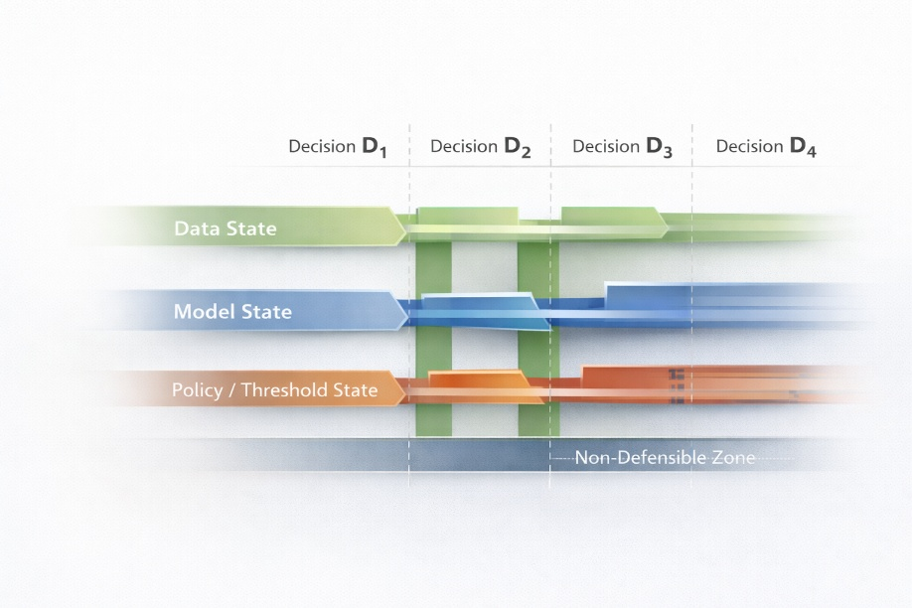
As introduced in Chapter 7, agent decisions operate across coordinated data, model, and policy states. Synthetic adversarial modeling extends that structure by treating attacks as staged transitions through these layered decision boundaries rather than isolated intrusion events.
Cognitive defense systems require platforms that can:
Figure 9.1 Layered decision-state adversarial flow
- Enforce identity-scoped execution
- Provide strong isolation between reasoning and action
- Support deterministic replay and forensic reconstruction
- Treat telemetry as a first-class control signal, not a debugging artifact
Platforms optimized purely for throughput or cost efficiency tend to blur these boundaries. In contrast, platforms that expose fine-grained controls over the execution context enable architectures in which autonomy is contained rather than unleashed.
To reason rigorously about containment, we must formalize how infrastructure restricts action. At any time step, a model may propose an action $a$, but whether that action is executed depends not on the model alone, but on the surrounding control environment. We therefore define a platform constraint function:
$$C\left(a,s\right)∈0,1$$Where:
- $a$ denotes a proposed action,
- $s$ denotes the current system state,
- $C=1$ if the platform permits execution under policy.
In safe autonomy, execution is not equivalent to proposal. Instead:
$$Execution=A_{t}⋅C\left(A_{t},S_{t}\right)$$

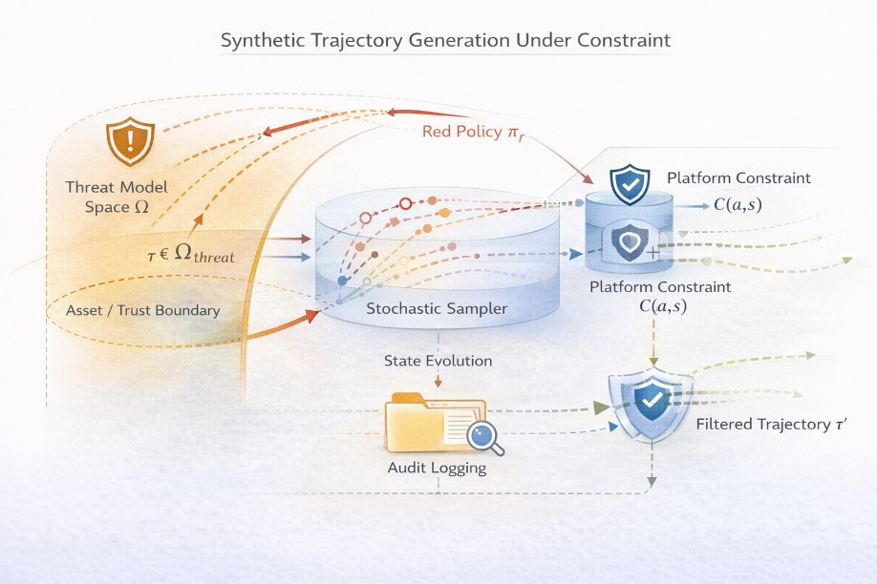
Building on the execution gating concept formalized in Chapter 7, synthetic trajectories are sampled within a defined threat space Ω but admitted only through the platform constraint function $C\left(a , s\right)$. This separation preserves adversarial exploration while preventing unauthorized state transitions.
Figure 9.2 Constrained adversarial trajectory sampling.
This expression captures a fundamental architectural inversion: models generate candidate actions, but infrastructure determines admissibility. The constraint function is not a mathematical abstraction; it represents policy evaluation, access control enforcement, rate limiting, and environmental guardrails implemented by the platform.
Platforms are therefore not neutral because they define $C$.
Example: Bounded Execution (Cloud Function Policy Gate)
```python
def policy_gate(action, confidence_score):
if confidence_score < 0.85:
return "simulate"
elif action == "delete_resource":
return "require_human_approval"
else:
return "execute"

action_decision = policy_gate("delete_resource", 0.78)
print(action_decision)
```
This short example illustrates a graded execution surface.
Real systems implement this via:
- IAM conditional policies
- Role-scoped tokens
- Just-in-time ephemeral credentials
9.1.1 Synthetic Adversaries as Strategic Processes
Synthetic adversaries must not be treated as static log generators. In cognitive defense architectures, they are better understood as strategic processes that evolve in response to defensive behavior. This reframing prevents synthetic generation from degenerating into patterned replay and instead positions it as an interactive system.
A minimal formalization expresses the adversarial interaction as:
$$S_{t+1}=f\left(S_{t},π_{r}\left(S_{t}\right),π_{b}\left(S_{t}\right)\right)$$Where:
- $S_{t}$ denotes the shared system state at time $t$,
- $π_{r}$ represents the red (adversarial) policy,
- $π_{b}$ represents the blue (defensive) policy,
- $f$ encodes the state transition dynamics imposed by infrastructure constraints.
In this formulation, the adversary is not an exogenous disturbance but an adaptive actor. Red and blue policies may be stochastic, deterministic, or learning-based. What distinguishes synthetic adversaries in this context is not merely their artificial origin, but their controllable rationality.
This stochastic transition model extends the risk-acceleration framework introduced in Chapter 3 by embedding adversarial progression directly into state evolution.
Multi-agent system theory provides a structured language for analyzing such interactions under partial observability and competing objectives (Wooldridge 2009). The red agent may optimize stealth or impact; the blue agent may optimize detection speed or containment efficiency. The platform, however, constrains both.
This triadic structure (adversary, defender, infrastructure) prevents the model from collapsing into a two-player game where policy competition alone determines outcomes. Infrastructure imposes the admissible action space:
$$A_{t}^{allowed}=a∈A∣C\left(a,S_{t}\right)=1$$
Synthetic adversarial modeling, therefore, becomes the study of how policies compete within bounded execution surfaces rather than how one model outperforms another in isolation.
This distinction is critical. Without infrastructure mediation, adversarial simulation becomes an optimization contest detached from governance. In infrastructure mediation, it serves as a controlled form of stress testing.
The reinforcement learning formulation introduced later in this chapter extends naturally from this framework. Reward optimization (Sutton and Barto 1992) operates within the constraint set defined by the platform. Learning occurs, but always inside containment.
By explicitly modeling synthetic adversaries as strategic processes, we establish that adversarial pressure is a policy-driven interaction governed by architectural constraints and not random variability.
9.1.2 Formalizing synthetic threat generation
Let:
- $S_{t}$ = system state at time $t$
- $A_{t}$ = adversarial action
- $D_{t}$ = detection response
- $O_{t}$ = observable telemetry
We model adversarial progression like:
$$S_{t+1}=f\left(S_{t},A_{t}\right)+ϵ_{t}$$Where:
- $f$ encodes attack dynamics
- $ϵ_{t}$ models' environmental noise
Synthetic generation of sample trajectories (Dunmore, et al. 2023, Gimenez 2025):
$$τ=\left(S_{0},A_{0},S_{1},A_{1},…,S_{T}\right)$$
The objective is not to duplicate previous attacks, but to explore potential adversarial developments within plausible variations (Steinel, Lim and Ku 2025, Cullen, et al. 2022).
Example: Probabilistic Multi-Stage Attack Simulation
```python
import numpy as np

states = ["normal", "initial_access", "lateral_movement", "exfiltration"]
transition_matrix = np.array([
[0.90, 0.10, 0.00, 0.00],
[0.00, 0.60, 0.35, 0.05],
[0.00, 0.00, 0.70, 0.30],
[0.00, 0.00, 0.00, 1.00]
])

def simulate_attack(start_state=0, steps=10):
current_state = start_state
trajectory = [states[current_state]]

for _ in range(steps):
current_state = np.random.choice(
range(len(states)),
p=transition_matrix[current_state]
)
trajectory.append(states[current_state])

return trajectory

print(simulate_attack())
```
This Markovian example becomes significantly more powerful when:
- Conditioned on infrastructure topology graphs
- Coupled with diffusion-style perturbations
- Integrated with reinforcement learning red agents
9.2 Privacy as a Control Property
Privacy is often discussed as a legal or ethical obligation. In cognitive systems, it must be treated as an architectural control variable.
Autonomous agents that operate on sensitive datasets (e.g., logs, credentials, behavioral traces, or incident narratives) must reason without retaining data. Persistent memory is not only a privacy risk but also an amplifier of misalignment. Privacy attacks in machine learning demonstrate how retained model state can expose sensitive information (Rigaki and Garcia 2024). When models accumulate contextual residue across sessions, they implicitly adapt to self-optimizing for historical correlations rather than present intent.
From a control perspective, privacy is enforced through:
- Ephemeral context windows
- Non-persistent inference paths
- Explicit data lifetimes
- Separation between the reasoning state and storage state
Privacy-preserving design, therefore, aligns directly with safety. Systems that cannot forget cannot be governed.
Chapter 7 established that memory coordination precedes safe execution. Here, privacy is formalized as a control variable that regulates persistence across reasoning cycles, preventing long-horizon drift and reducing leakage risk under repeated adversarial exposure.
9.2.1 Stateless inference enforcement technical logic
In an autonomous red-teaming environment, privacy is a control property that prevents Cognitive Residue, the leakage of sensitive environment data into the model's long-term weights. We enforce this through a Volatile Context Protocol:
- Instruction: "All inference sessions must be instantiated with a zero-retention policy. System prompts must explicitly block the ingestion of PII into the model's ephemeral memory."
- Verification:
```python
def enforce_stateless_inference(session_data):
# Strip environment-specific identifiers before model ingestion
clean_payload = privacy_vault.anonymize(session_data)

# Execute inference with 'store: false' to prevent training leakage
response = llm.generate(clean_payload, store_data=False)
return response

```
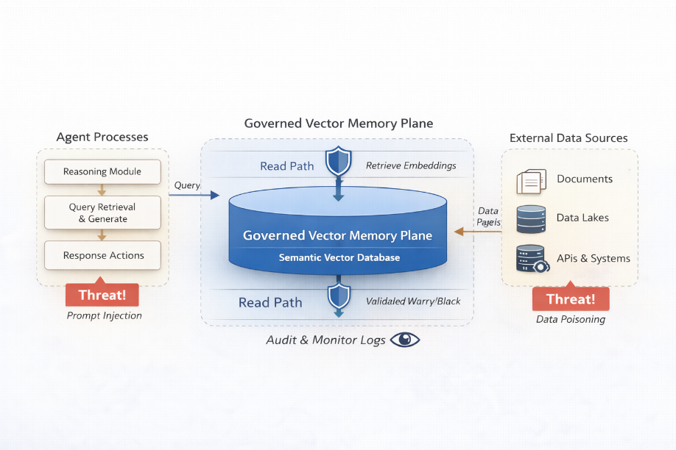
Figure 9.3 Privacy enforcement through controlled memory dynamics.
9.2.1 Privacy as a Control Variable
The mathematical framing:
Persistent model memory creates drift.
Let:
- $M_{t}$= model memory state
- $I_{t}$= input context
If:
$$M_{t+1}=g\left(M_{t},I_{t}\right)$$
Then privacy leakage occurs when:
$$\frac{∂M}{∂I_{t-k}}≠0\text{for large }k$$
In stateless inference:$M_{t+1}=0$
Each session resets cognitive residue.
Persistent memory violates the bounded control loop defined in Chapter 7 by introducing historical dependencies that cannot be externally audited.
Example: Ephemeral Context Enforcement
```python
class EphemeralSession:
def __init__(self):
self.context = None

def infer(self, input_data):
result = model.predict(input_data)
self.context = None # Explicit reset
return result
```
Privacy here is control stability, not compliance.
9.3 Vaults as trust boundaries
Secrets management is commonly reduced to credential storage. In cognitive defense architectures, vaults define the boundary between cognition and authority.
A vault is not merely a secure database; it is a gatekeeper for actionability. Access to credentials, tokens, signing keys, or privileged APIs must be mediated by policies orthogonal to model behavior.
Effective vault integration exhibits three properties:
- Non-addressability: models cannot enumerate or infer stored secrets
- Just-in-time access: credentials are injected only at execution time
- Contextual revocation: Access can be withdrawn dynamically based on system state
Crucially, vaults must not be embedded inside the cognitive layer. They must remain external, auditable, and independently governed. When cognition and authority collapse into a single plane, escalation becomes inevitable.
The capability–authority separation articulated in Chapter 7 is enforced infrastructurally through vault boundaries. By externalizing credentials and enforcing policy mediation, cognition remains distinct from privileged execution authority.
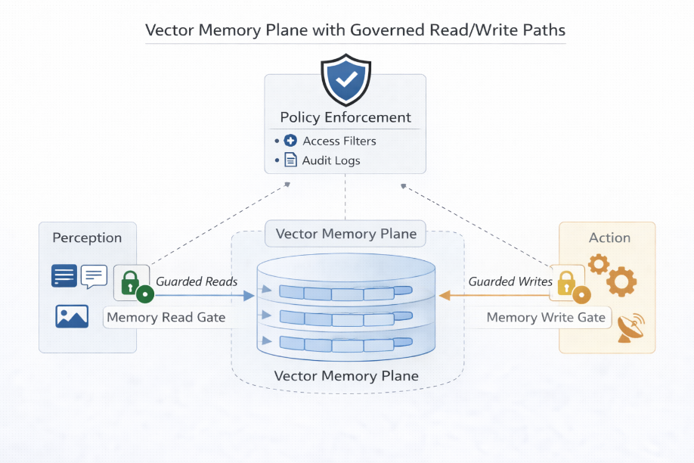
Figure 9.4 Trust boundaries separating cognition from authority (vault-mediated authority separation).
9.3.1 Vaults as trust geometry
Authority must not be inside the reasoning graph.
Define:
- $R$ = reasoning system
- $V$ = vault
- $A$ = authority1
Secure architecture enforces:
$$R∩A=∅$$
Access is mediated:
$$R→Policy→V→Token→Execution$$
Never:
$$R→Secret→Execution$$
9.4 Execution surfaces and the geometry of risk
Execution surfaces are the locations where reasoning transitions into action, such as API calls, infrastructure changes, alert suppressions, or automated responses. These surfaces define the geometry of risk.
Naïve autonomy treats execution as a binary capability: either allowed or denied. Cognitive defense requires graded execution surfaces, where actions are:
- Simulated before enactment
- Scoped by blast radius
- Rate-limited by confidence
- Subject expected to undergo a post-hoc audit
Execution surfaces should be narrow, explicit, and observable. Wide or implicit execution paths (such as unrestricted scripting, shell access, or broad API permissions) create nonlinear escalation channels.
The goal is not to eliminate action, but to shape it.
9.4.1 Execution surfaces and risk gradient
Execution surfaces define a risk function:
$$Risk=f\left(Scope,Confidence^{-1},Irreversibility\right)$$
We can approximate:
$$Risk=αB+β\frac{1}{Conf}+γI$$
Where:
- $B$= blast radius
- $Conf$= detection confidence
- $I$= irreversibility factor
Actions are permitted only if:
$$Risk<θ$$
This linear approximation operationalizes the nonlinear risk-reduction dynamics introduced in Chapter 3 by translating detection confidence into an execution-weighted constraint.
Example: Risk-Aware Action Filter
```python
def risk_score(blast_radius, confidence, irreversibility):
return 0.4*blast_radius + 0.4*(1/confidence) + 0.2*irreversibility

if risk_score(0.7, 0.92, 0.8) < 1.5:
print("Execute")
else:
print("Escalate to human")
```
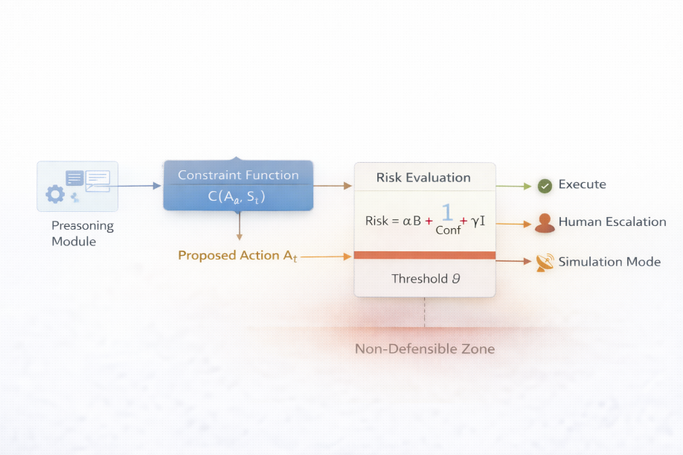
Extending the graded execution surfaces introduced in Chapter 7, risk is modeled here as a function of blast radius, confidence, and irreversibility. This transforms autonomy from binary permission into quantifiable, bounded action.
Figure 9.5 Risk-weighted execution gating.

The formalization of risk (balancing blast radius, confidence, and irreversibility) serves as the normative basis for autonomous governance. To move from this mathematical abstraction to an enforceable substrate, we implement the Control Surface Interface (CSI), ensuring that infrastructure constraints are not merely suggestions, but physical boundaries of the reasoning graph.
9.4.2 The governance interface
To move from the risk abstraction introduced in the previous section, we define the Control Surface Interface (CSI). This ensures that even a compromised or "hallucinating" red/blue agent cannot bypass the platform constraint function $C\left(a,s\right)$.
A. Formalizing Blast Radius ($B$)
While Chapter 9 introduces the risk function $Risk=αB+β{\text{Conf}}^{-1}+γI$, operationalizing this requires calculating $B$ based on Identity Graph Density. We define the normalized blast radius of an identity. $u$ as:

$$B\left(u\right)=\frac{\left|\{v∈V:∃\text{ path}\left(u,v\right)\}\right|}{\left|V\right|}$$

Where:
- $u$ is the acting identity (the agent).
- $V$ is the set of all reachable cloud resources within the environment.
- The path represents effective permissions (e.g., IAM roles, cross-account trusts).
To operationalize the risk variables defined in Section 9.4.1 [Source 240], the following Technical Specification demonstrates the integration of the linear risk function into a governed execution gate.
B. The Policy-as-Code gate (OPA/Rego)
The platform constraint function $C\left(a,s\right)$ is implemented via Open Policy Agent (OPA) to ensure authority is external to the reasoning graph.
```rego

# Rego Policy: Risk-Weighted Execution Gating
package cybersecurity.authz

default allow = false

# Constraints defined in Chapter 9.4.1
theta := 1.5

allow {
input.risk_score < theta
input.action_type != "delete_resource" # Requires higher threshold
}

# Administrative override / Human-in-the-loop (HITL)
allow {
input.risk_score >= theta
input.human_approval == true
}

```
C. Reference Implementation: Vault-Mediated Authority
In production environments, the transition from $D_{3}$ to $D_{4}$ (Decision States) often requires a non-blocking callback to maintain system stability.
```python

class VaultMediatedAuthority:
def __init__(self, vault_client, policy_engine):
self.vault = vault_client
self.policy = policy_engine

def execute_agent_request(self, agent_id, proposed_action, context):
# 1. Externalize the decision to the Policy Engine
# Calculate Risk based on Section 9.4.1 metrics
score = self.calculate_risk(context)
is_admissible = self.policy.evaluate(proposed_action, score)

if not is_admissible:
# Trigger Chapter 10 Industrialization: Human-in-the-loop [cite: 303, 337]
return pubsub.publish_escalation_event(proposed_action, score)

# 2. Request JIT token from Vault (Cognition != Authority) [cite: 258, 283]
try:
temp_token = self.vault.get_ephemeral_token(
scope=proposed_action.resource_target,
ttl="5m" # Just-in-time access [cite: 251]
)
# 3. Execution occurs through constrained surface [cite: 286]
return self.perform_action(proposed_action, temp_token)
finally:
self.vault.revoke(temp_token) # Contextual revocation [cite: 252]

def calculate_risk(self, context):
# Implementation of the Chapter 9.4.1 Risk Function
# Risk = alpha*B + beta*(1/Conf) + gamma*I
return 0.4*context['blast_radius'] + 0.4*(1/context['conf']) + 0.2*context['irrev']

```
9.5 Platform-mediated closure of control loops
When platforms, privacy controls, vaults, and execution surfaces are composed correctly, they enable closure of cognitive control loops.
In such systems:
- Observation feeds reasoning
- Reasoning proposes bounded actions
- Execution occurs through constrained surfaces
- Outcomes are observed and audited
- Deviations trigger revocation or human escalation
Notably, the platform (and not the model) enforces these constraints. Models reason; platforms govern.
This inversion is deliberate. Trust is placed in infrastructure because infrastructure can be inspected, certified, and constrained. Models cannot.
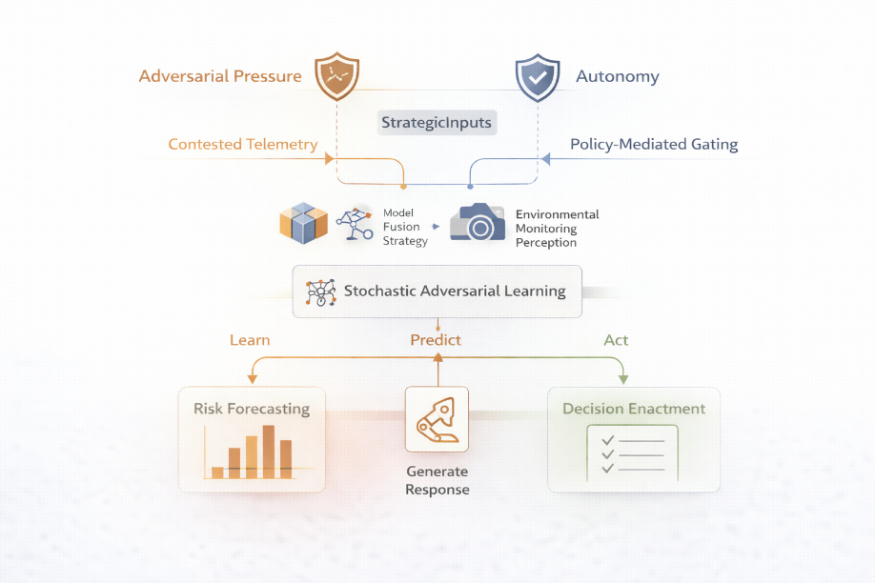
The coordinated loops described in Chapter 7 close safely only when synthetic pressure, privacy controls, vault isolation, and execution constraints are composed within enforceable infrastructure. Models reason; platforms govern.
Figure 9.6 Platform-enforced control loop closure.
9.6 Implications for cognitive defense architectures
Cognitive defense does not scale by increasing model size or autonomy. It is scaled by tightening the coupling between reasoning and control.
Platforms that provide fine-grained execution controls, privacy-first data handling, and externalized authority mechanisms enable safe autonomy. Platforms that prioritize convenience over containment become liabilities.
The architectural lesson is clear:
- Autonomy without infrastructure is improvisation.
- Infrastructure without control is exposed.
Cognitive defense emerges only when both are treated as inseparable.
9.6.1 Synthetic adversaries training defensive agents
We now return to red teaming.
We define reward:

$$R=-λ_{1}DetectionDelay-λ_{2}FalsePositive+λ_{3}ContainmentSpeed$$
This formulation follows standard reinforcement learning reward optimization principles (Sutton and Barto 1992). The reward formulation mirrors the scheduler optimization principles discussed in Chapter 6, where stability emerged from balancing responsiveness and overcorrection.
Training loop:
```python

for episode in range(episodes):
attack = red_agent.generate()
for event in attack:
response = blue_agent.act(event)
reward = compute_reward(event, response)
blue_agent.update(reward)
red_agent.adapt()

```
This mirrors adversarial self-play frameworks, such as those pioneered by DeepMind in AlphaZero-style systems, but are applied here to infrastructure defense.
9.7 Infrastructure governs cognition
Your original ending was strong. Let us sharpen it.
Autonomy without synthetic pressure is complacency.
Synthetic pressure without infrastructure is chaos.
Cognitive defense emerges when:
- Synthetic adversaries generate bounded stress
- Platforms constrain execution
- Vaults isolate authority
- Privacy enforces stateless reasoning
- Execution surfaces shape risk geometry
Models reason, infrastructure governs.
Synthetic adversaries ensure that neither becomes complacent.
The mathematical structures introduced here are not isolated formal devices; they extend the state-transition, risk-acceleration, and policy-gating principles developed in earlier chapters, now applied under adversarial pressure.
9.8 Audit autonomous intent with forensic reconstruction
: When the platform constraint function $C\left(a,s\right)$ denies an action, the system must not simply fail; it must generate a Forensic Reconstruction Packet (FRP). This ensures that autonomous intent is auditable even if the execution is blocked.
9.8.1 The evidence chain
A reconstruction packet must capture the state of the Triad (Adversary, Defender, Infrastructure) at the exact moment of the decision ($D_{3}$). This transforms a "blocked action" into a "learning event" for the industrial SOC. The following data points are non-negotiable for industrial-grade forensic integrity:
- Intent hash ($I_{h}$): A cryptographic summary of the model's internal reasoning or context window that led to the request.
- Policy snapshot ($P_{θ}$): The version of the OPA/Rego policy and the specific threshold ($θ$) active at the time of denial.
- Graph state ($G_{s}$): The identity graph density used to calculate the Blast Radius ($B$).
9.8.2 The forensic logger technical specification
This implementation demonstrates how to capture blocked intent as a structured event for downstream forensic analysis, as described in Chapter 10.
```python

import json
import hashlib

def generate_forensic_packet(proposed_action, context, risk_score):
"""
Creates a forensic record of a denied autonomous request.
Ensures 'intent' is preserved even when 'execution' is denied.
"""
intent_data = f"{proposed_action.reasoning}_{context.timestamp}"

forensic_packet = {
"event_id": hashlib.sha256(intent_data.encode()).hexdigest(),
"actor_id": proposed_action.agent_id,
"calculated_risk": risk_score,
"denial_reason": "Threshold Exceeded",
"state_capture": {
"blast_radius": context.get('blast_radius'),
"confidence": context.get('conf'),
"identity_scope": proposed_action.resource_target
},
"policy_version": "v1.4.2-stable"
}

# Dispatch to the immutable Vault for forensic reconstruction
return vault.secure_log(json.dumps(forensic_packet))

```
9.8.3 Why this matters for Industrialization
By capturing the Intent Hash, we prevent phantom failures. In Chapter 10, we will see how these forensic packets are used to fine-tune blue-team policies without requiring human investigators to parse raw LLM logs manually. This transforms the infrastructure from a simple gatekeeper into a continuous learning sensor.

9.6 Forensic Reconstruction: The Audit of Autonomous Intent
When the platform constraint function $C(a,s)$ denies an action, the system must generate a Forensic Reconstruction Packet (FRP). This ensures that autonomous intent is auditable even when execution is halted.
The Evidence Chain
A reconstruction packet captures the state of the "Triad" (Adversary, Defender, Infrastructure) at the moment of the decision. This transforms a "blocked action" into a "learning event" for the industrial SOC.
Python
def generate_forensic_packet(proposed_action, risk_score, context):
"""
Captures 'Intent' when 'Execution' is denied.
Essential for the industrial monitoring discussed in Chapter 10.
"""
packet = {
"intent_hash": hashlib.sha256(proposed_action.reasoning.encode()).hexdigest(),
"denial_threshold": 1.5,
"actual_risk": risk_score,
"context_snapshot": {
"blast_radius": context.get('blast_radius'),
"identity": proposed_action.agent_id
}
}
# Secure logging to an immutable vault
return forensic_vault.emit(packet)

Conclusion
Synthetic adversarial modeling reframes red teaming from episodic penetration testing into continuous architectural evaluation. Rather than waiting for empirical breach data, defensive systems can be subjected to structured, reproducible, and parameterized adversarial pressure. This shift transforms cybersecurity from reactive analysis to controlled experimentation.
However, synthetic generation alone is insufficient. Without infrastructure-bound constraints (platform isolation, privacy-preserving inference paths, vault-mediated authority, and graded execution surfaces), autonomous reasoning systems risk amplifying rather than containing adversarial dynamics. The stability of cognitive defense architectures does not emerge from model sophistication, but from enforceable control geometry.
The central inversion introduced in this chapter remains decisive: models reason; infrastructure governs. Synthetic adversaries exist not to increase autonomy, but to test whether governance mechanisms hold under stress.
When synthetic hostility is coupled with bounded execution and audited control loops, cybersecurity systems transition from brittle automation toward disciplined autonomy.
During Chapter 10, we will explore why the remaining question is not whether synthetic adversarial systems can be constructed, but whether they can be deployed at scale without eroding containment guarantees.
The next chapter examines the industrialization of cognitive cybersecurity; how synthetic red-teaming, agent-based defense, and infrastructure governance evolve from experimental architectures into operational platforms. It examines compression, deployment surfaces, economic constraints, and the secure integration of open- and proprietary-AI systems within enterprise environments.
Synthetic pressure validates architecture. Industrialization tests sustainability. In Chapter 10, we transition from controlled simulation to real-world production.

References
Anderson, Blake, and David McGrew. 2017. "Machine learning for encrypted malware traffic classification: accounting for noisy labels and non-stationarity." Proceedings of the 23rd ACM SIGKDD International Conference on Knowledge Discovery and Data Mining. ACM. 1723–1732. doi:10.1145/3097983.3098163.
Arjovsky, Martin, Soumith Chintala, and Léon Bottou. 2017. "Wasserstein gan." (arXiv). doi:10.48550/ARXIV.1701.07875.
Blank, Rebecca M., and Patrick D. Gallagher. 2012. "Guide for conducting risk assessments." Tech. Rep, National Institute of Standards and Technology. doi:10.6028/NIST.SP.800-30r1.
Böhme, Rainer und Galina Schwartz. 2010. "Modeling cyber-insurance: towards a unifying framework." Workshop on the Economics of Information Security. https://api.semanticscholar.org/CorpusID:14172008.
Brundage, Miles, Shahar Avin, Jasmine Wang, Haydn Belfield, Gretchen Krueger, Gillian Hadfield, Heidy Khlaaf, et al. 2020. "Toward trustworthy AI development: mechanisms for supporting verifiable claims." doi:10.48550/arxiv. 2004.07213.
Cate, Mia, and Zaynab Sai. 2024. "Synthetic data generation for training AI models in web security contexts." Tech. rep. https://www.researchgate.net/publication/392518778_Synthetic_Data_Generation_for_Training_AI_Models_in_Web_Security_Contexts.
Cullen, Drake, James Halladay, Nathan Briner, Ram Basnet, Jeremy Bergen, and Tenzin Doleck. 2022. "Evaluation of synthetic data generation techniques in the domain of anonymous traffic classification." IEEE Access (of the Institute of Electrical and Electronics Engineers) 10: 129612–129625. doi:10.1109/access. 2022.3228507.
Doshi-Velez, Finale, and Been Kim. 2017. "Towards a rigorous science of interpretable machine learning." (arXiv). doi:10.48550/ARXIV.1702.08608.
Dunmore, Aeryn, Julian Jang-Jaccard, Fariza Sabrina, and Jin Kwak. 2023. "A comprehensive survey of generative adversarial networks (GANs) in cybersecurity intrusion detection." IEEE Access (Institute of Electrical and Electronics Engineers (IEEE), 11: 76071–76094). doi:10.1109/access. 2023.3296707.
Everitt, Tom, Gary Lea, and Marcus Hutter. 2018. "Agi safety literature review." (arXiv) 5441–5449. doi:10.24963/ijcai. 2018/768.
Ganguli, Deep, Liane Lovitt, Jackson Kernion, Amanda Askell, Yuntao Bai, Saurav Kadavath, Ben Mann, et al. 2022. "Red teaming language models to reduce harms: methods, scaling behaviors, and lessons learned." doi:10.48550/ARXIV.2209.07858.
Gimenez, Pierre-François. 2025. "Synthetic network traffic generation for intrusion detection systems: a systematic literature review." ANUBIS 2025 - 1st International Workshop on Assessment with New Methodologies. de Limoges, Université. 1–18. doi:10.34894/VQ1DJA.
Goodfellow, Ian J., Jean Pouget-Abadie, Mehdi Mirza, Bing Xu, David Warde-Farley, Sherjil Ozair, Aaron Courville, and Yoshua Bengio. 2014. "Generative adversarial nets." Edited by Z. Ghahramani, M. Welling, C. Cortes, N. Lawrence, and K. Q. Weinberger. Advances in Neural Information Processing Systems. Curran Associates, Inc. https://proceedings.neurips.cc/paper_files/paper/2014/file/f033ed80deb0234979a61f95710dbe25-Paper.pdf.
LeCun, Yann, Yoshua Bengio, and Geoffrey Hinton. 2015. "Deep learning." Nature (Science, Springer and Business Media, L. L. C.) 521: 436–444. doi:10.1038/nature14539.
Nayak, Janmenjoy. 2024. Machine learning for cyber-physical systems: advances and challenges. Edited by Janmenjoy Nayak, Bighnaraj Naik, Vimal S, and Margarita Favorskaya. Vol. 60. Switzerland, Springer Nature. doi:10.1007/978-3-031-54038-7.
Nichol, A. Q., and P. Dhariwal. 2021. "Improved denoising diffusion probabilistic models."
OpenAI. n.d. "Gpt-4o system card | openai." GPT-4o system card | OpenAI. https://openai.com/index/gpt-4o-system-card/.
Rigaki, Maria, and Sebastian Garcia. 2024. "A survey of privacy attacks in machine learning." ACM Computing Surveys (for Computing Machinery, Association) 56 (4): 1–34. doi:10.1145/3624010.
Ring, Markus, Sarah Wunderlich, Deniz Scheuring, Dieter Landes, and Andreas Hotho. 2019. "A survey of network-based intrusion detection data sets." Computers and Security (Elsevier, B. V.) 86: 147–167. doi:10.1016/j.cose.2019.06.005.
Ruan, Da, Jun Xu, and Jie Lu. 2010. Advances in artificial intelligence for privacy protection and security. Edited by Agusti. Solanas y Antoni Martínez-Ballesté. Vol. 1. Scientific, World.
Shostack, Adam. 2014. Threat modeling. Indianapolis, IN: Wiley. https://books.google.com/books?id=asPDAgAAQBAJ.
Song, Houbing, Glenn A Fink, and Sabina. Jeschke. 2018. Security and privacy in cyber-physical systems: foundations, principles, and applications. John Wiley & Sons, Inc.
Steinel, Ricky B., Kiho Lim, and Cyril S. Ku. 2025. "Synthetic data generation for cybersecurity applications: an exploratory study of GAN models." 2025 INTERNATIONAL CONFERENCE ON CONVERGENT AND SMART SYSTEMS (ICCSS 2025). PIONEER INTERNATIONAL UNIVERSITY, NAIROBI, K. E. N. Y. A. https://www.wpunj.edu/cosh/macs-scholars-program/assets/SyntheticData.pdf.
Sutton, Richard S., and Andrew G. Barto. 1992. Reinforcement learning. second. Edited by Andrew Barto. Cambridge, Massachusetts: Press, M. I. T. https://web.stanford.edu/class/psych209/Readings/SuttonBartoIPRLBook2ndEd.pdf https://mitpress.ublish.com/ebook/reinforcement-learning-an-introduction-2-preview/2351/viii.
Wooldridge, Michael J. 2009. An introduction to multi-agent systems. second. Chichester: Sons, John Wiley &. https://uranos.ch/research/references/Wooldridge_2001/TLTK.pdf https://www.wiley.com/en-be/An+Introduction+to+MultiAgent+Systems%2C+2nd+Edition-p-9780470519462 https://www.amazon.com/Introduction-MultiAgent-Systems-Michael-Wooldridge/dp/047149691X.

Processes where the future state depends only on the current state, not the history of how the system arrived there (Wikipedia).

