Chapter 10
Can You Run Diffusers Here? Exploring Open AI Frameworks across Cloud Platforms Beyond SageMaker
Paulo H Leocadio

Introduction

From models to markets, autonomous cybersecurity systems do not fail because models are inaccurate; they fail because deployment architectures are fragile. The transition from experimental pipelines to operational infrastructure requires compression strategies, container discipline, hardware awareness, governance hooks, and repeatable MLOps scaffolding. This chapter examines that transition.
Throughout this book, Hugging Face Diffusers and open transformer-based models have been treated as modular, composable primitives. However, primitives alone do not create infrastructure. Infrastructure emerges when models are embedded in training pipelines, monitored at inference endpoints, containerized in orchestration layers, and governed within execution environments. Industrialization is therefore not an increase in scale; it is an increase in structural control.
At the center of this operationalization sits a pragmatic stack:
- Hugging Face Diffusers (HFD) for modular generative and embedding pipelines
- PyTorch as the computational substrate
- Amazon SageMaker as the managed orchestration and deployment layer
PyTorch provides a tensor-level execution model that enables pruning, quantization, distributed training, and scheduler manipulation. Every equation introduced earlier in this book (risk curves, latency functions, reward alignment constraints) ultimately resolves into tensor operations and gradient updates. Industrial AI must therefore understand its computational substrate (NIST 2026).
Amazon SageMaker transforms these tensor computations into governed, scalable systems. It enables:
- Distributed training jobs
- Managed endpoints
- Model registry and versioning
- Monitoring and drift detection
- Secure container deployment
When Diffusers pipelines are deployed through SageMaker with PyTorch-backed containers, they transition from research artifacts to operational control systems.
This chapter expands that core stack along three industrial dimensions:
- Compression and Efficiency
Quantization, pruning, and distillation techniques that enable edge and low-latency deployment without sacrificing structural reliability.
- On-Device and Embedded Inference
Moving intelligence closer to sensors, endpoints, and adversarial surfaces.
- Agentic Orchestration at Scale
Coordinating model inference, memory layers, and policy gates across distributed environments.
Industrialization also introduces a tension between openness and control. Open-source diffusion models provide composability and sovereignty. Managed AI Application Programmer Interfaces (APIs) provide abstraction and speed. The architectural decision is not ideological; it is strategic. Cybersecurity systems demand auditability, deterministic fallback behaviors, and containment boundaries. These constraints reshape how generative models are deployed.
While earlier chapters emphasized theoretical rigor and mathematical grounding, this chapter emphasizes deployment discipline. Each architectural pattern discussed will be tied to minimal implementation scaffolds using PyTorch and SageMaker, ensuring that theoretical constructs remain operationally anchored.
By the end of this chapter, readers will understand not only how to run diffusion-based cybersecurity pipelines but also how to stabilize, compress, monitor, and govern them in production environments.
Industrialization, in this context, is not the scaling of intelligence; it is the stabilization of autonomy.
10.1 Revisiting the canonical foundation
Evaluating alternative cloud environments requires a clear point of reference. Before examining whether Hugging Face Diffusers and open Transformer-based workflows can be effectively deployed outside Amazon SageMaker, we must restate the architectural foundation on which this book is built.
The preceding chapters developed mathematical models, control-plane abstractions, and deployment constraints. However, those constructs were never intended to exist independently of infrastructure. They were formulated within a specific operational context that now warrants explicit articulation.
Figure 10.1 Canonical stack (AWS + Hugging Face Diffusers & PyTorch)
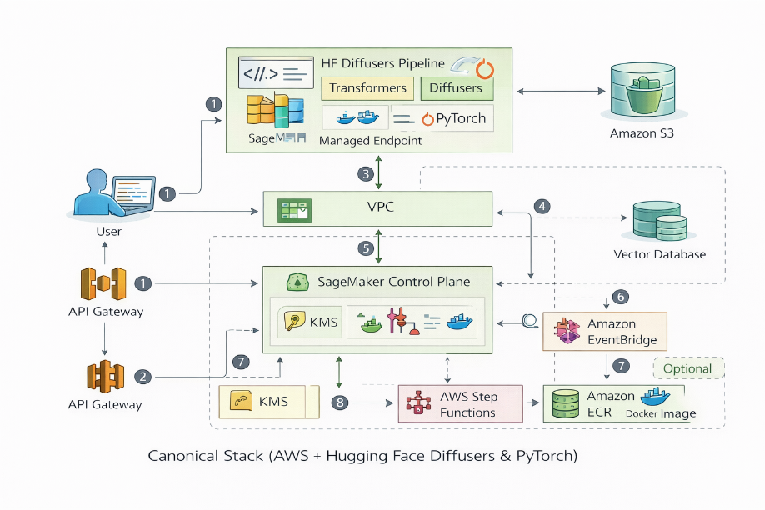
10.1.1 From research architecture to industrial platform
Before expanding beyond Amazon SageMaker, we must make explicit what has so far remained implicit: this book is grounded in a concrete architectural foundation.
Our objective extended beyond abstract exploration of artificial intelligence. The intent was to anchor research in a real-world operational setting focused on autonomous cybersecurity systems. Achieving that required starting not with models, but with infrastructure—deployment boundaries, orchestration layers, and governance constraints that shape how systems behave under pressure.
Achieving that required starting not with models, but with infrastructure/deployment boundaries, orchestration layers, identity enforcement mechanisms, and monitoring surfaces that define how systems behave under pressure. Theoretical constructs introduced in earlier chapters were therefore developed within a deployment-aware context. Mathematical framing was never detached from runtime reality; it was designed to survive containerization, distributed execution, and policy gating.
This progression, from research architecture to industrial platform, produced what we refer to as the canonical stack:
- Hugging Face Diffusers as modular intelligence primitives
- PyTorch as computational substrate
- Amazon SageMaker as an orchestration and containment layer
This stack functions as the reference implementation of the control-plane abstraction developed throughout the volume. Our guiding principles were centered on the responsible deployment of intelligent autonomous systems at scale. Hugging Face and Amazon Web Services' (AWS) cloud services form the platform through which those principles were tested, formalized, and operationalized.
It embodies the structural invariants required for autonomous cybersecurity systems:
- Observation layer
- Adaptive inference layer
- Policy gating
- Deployment containment
- Audit and governance hooks
Figure 10.1 formalizes this foundation by presenting the AWS-based reference implementation alongside its cloud-neutral control-plane abstraction. The canonical deployment framework integrates:
- Diffusion pipelines (model layer)
- PyTorch runtime (execution layer)
- SageMaker training and endpoint services (orchestration layer)
- Monitoring, logging, and governance hooks (control layer)
Having reestablished this foundation, we now examine whether Hugging Face Diffusers and open Transformer-based workflows can be deployed effectively outside AWS SageMaker, beginning with a comparison of runtime substrate divergence on Google Cloud. The analysis that follows moves beyond feature marketing and evaluates architectural alignment, governance posture, deployment flexibility, and suitability for agentic AI systems.
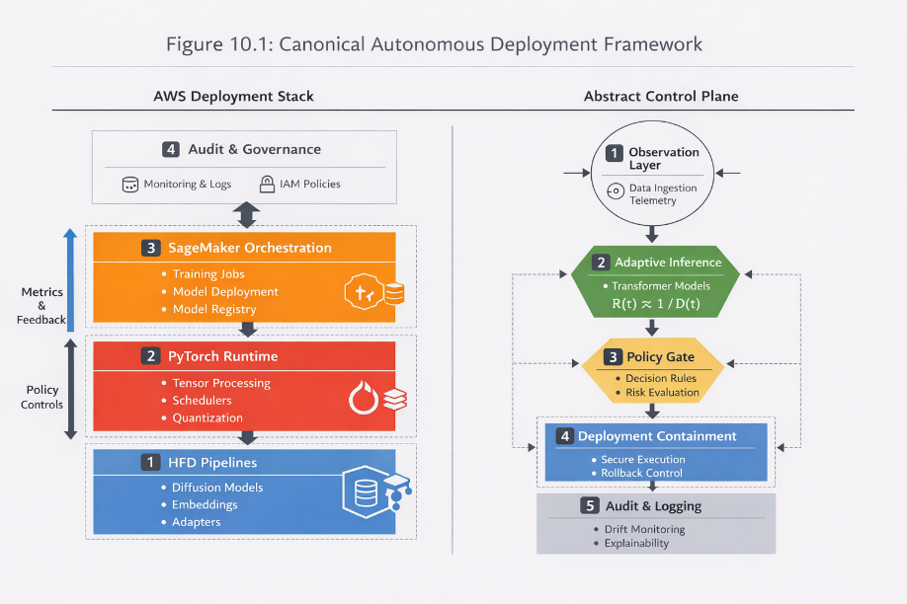
Figure 10.2 AWS implementation and abstract control-plane canonical model
10.2 Cross-cloud evaluation framework
Before examining specific cloud providers, we must define the lens through which we evaluate portability. Cross-cloud deployment is often reduced to container compatibility or to the availability of application programming interfaces (APIs). That framing is insufficient for autonomous cybersecurity systems.
The canonical stack introduced in Section 10.1 serves as the reference architecture. Portability is therefore not assessed by feature equivalence, but by structural invariance. A cloud environment preserves portability only if it sustains the operational guarantees embedded in the canonical control plane.
These guarantees can be formalized as architectural invariants.
10.2.1 Architectural invariants
Across all environments, the following invariants must hold:
- Container Discipline
The system must support deterministic, container-native execution of custom PyTorch-based Hugging Face Diffusers pipelines. Reproducibility across training and inference environments is mandatory (Amershi 2019).
- Runtime Substrate Stability
The execution layer (GPU, TPU, or equivalent accelerator) must preserve numerical predictability within acceptable tolerance bounds under adversarial load (Jouppi 2017, IEEE 2019, Han, Mao and Dally 2015).
- Registry and Rollback Semantics
Model versioning must support traceable lineage and deterministic rollback without uncontrolled infrastructure drift (Mitchell, et al. 2019, NIST 2026).
- Governance and Identity Containment
Identity and Access Management (IAM) boundaries must enforce least-privilege constraints across training, inference, and tool invocation layers (NIST 2026, OECD 2026).
- Agentic Orchestration Compatibility
The environment must sustain iterative control loops involving observation, inference, policy gating, and action without violating containment constraints (Wooldridge 2009, Yao, et al. 2023, Shinn, et al. 2023).
These invariants are not vendor-specific. They derive directly from the control-plane abstraction developed earlier in this volume.
10.2.2 Translation methodology
Portability is evaluated as a translation problem.
Let:
$$C_{AWS}$$
represent the canonical implementation of the control plane within Amazon SageMaker.
For a target environment $C_{i}$, portability requires:
$$T\left(C_{AWS}\right)→C_{i}$$
such that all architectural invariants remain satisfied.
This translation involves:
- Container layer mapping
- Execution substrate equivalence
Registry binding semantics
- Identity boundary reinterpretation
- Monitoring and audit relocation
The translation framing aligns with established principles in software engineering for machine learning systems and lifecycle management (Amershi 2019, Zaharia 2016).
If translation preserves invariants, portability is achieved.
If invariants degrade, architectural modification is required.
Cross-cloud evaluation, therefore, becomes a controlled stress test of the canonical stack.
10.2.3 Selection of first case study
Google Cloud Platform (GCP) is examined first because it introduces meaningful runtime divergence while maintaining high container compatibility.
Unlike Oracle Cloud or IBM Cloud, GCP offers both:
- Compute Unified Device Architecture (CUDA)-compatible Graphics Processing Unit (GPU) execution
- Tensor Processing Unit (TPU) acceleration via Accelerated Linear Algebra (XLA) compilation (Jouppi 2017)
This dual substrate allows us to evaluate how the canonical stack behaves when execution semantics change at the hardware and compiler levels.
The following section examines runtime substrate divergence and its implications for compression stability, scheduler behavior, and containment guarantees.
10.3 Canonical deployment anatomy
From conceptual stack to operational deployment
While the canonical stack introduced earlier defines the architectural primitives of autonomous cybersecurity systems, operational deployment requires an explicit mapping between these abstractions and infrastructure components.
The canonical architecture may be expressed as a layered deployment pipeline:
Model Layer
Hugging Face Diffusers / Transformer Models

Execution Layer
PyTorch Runtime

Container Layer
Docker Image (Inference + Dependencies)

Orchestration Layer
Managed ML Platform or Kubernetes

Control Plane
Identity • Monitoring • Policy Gate • Audit

This layered view clarifies a central property of the architecture: portability emerges from containerization and control-plane separation.
In this framing, the control plane defines governance, observability, and policy boundaries, while the data plane executes model inference inside containerized runtimes.
If the model runtime and container environment remain invariant, the orchestration layer may change without violating system guarantees.
Canonical AWS reference pipeline
The reference implementation used throughout this volume relies on AWS SageMaker as the orchestration substrate.
The operational pipeline can be summarized as:
Training
Dataset → PyTorch Training → Model Artifact (.pt)

Containerization
Model Artifact → Docker Container

Registry
Container Image → ECR
Model Metadata → SageMaker Model Registry

Deployment
Container → SageMaker Endpoint

Control Plane
CloudWatch Monitoring
IAM Identity Policies
Audit Logging

This deployment pathway preserves the architectural invariants defined earlier:
• container reproducibility
• deterministic execution environment
• registry-based versioning
• policy-enforced inference execution

Figure X illustrates this canonical deployment anatomy.
Sensor / Log Stream
↓
Feature Extraction
↓
Diffusion / Transformer Model
↓
SageMaker Endpoint
↓
Policy Gate
↓
Mitigation Action
↓
Audit Log

Importantly, the canonical stack is not AWS-dependent.
It is defined by architectural invariants, not vendor services.
The following sections examine how this pipeline translates across alternative cloud substrates.
10.4 Compression and efficiency
Stabilizing the Runtime
Industrial deployment introduces constraints that experimental environments can temporarily ignore. Memory ceilings, inference latency thresholds, energy budgets, and container size limitations all influence how diffusion and transformer-based systems behave in production environments (Amershi 2019, Patterson 2021). Compression techniques (e.g., quantization, pruning, and knowledge distillation) are therefore not merely optimization strategies; they function as structural enablers of deployability (Hinton, Vinyals and Dean 2015, Han, Mao and Dally 2015).
Quantization reduces numerical precision, typically transitioning from 32-bit floating-point representations to 16-bit, 8-bit, or lower precision formats (Han, Mao and Dally 2015, Dettmers, et al. 2022, Frantar, et al. 2023, Lin, et al. 2024). Within PyTorch-based execution environments, this transformation directly affects tensor storage, memory bandwidth utilization, and kernel execution behavior (Paszke 2019). Reduced precision lowers memory consumption and increases computational throughput, but introduces bounded approximation error.
If we consider a model parameter tensor $W∈R^{n×m}$, quantization applies a transformation:
$$W_{q}=Q\left(W\right)$$
where $Q\left(⋅\right)$maps high-precision values into a discrete representational space.
The operational constraint becomes:
$$∥f\left(x;W\right)-f\left(x;W_{q}\right)∥≤ϵ$$
Example: Model compression (Quantization)
This scaffold applies dynamic quantization to the UNET component of a diffusion pipeline, effectively reducing memory bandwidth utilization while maintaining the operational constraint:
$|f\left(x;W\right)-f\left(x;W_{q}\right)|\left[cite_{s}tart\right]≤$ (Vaswani, et al. 2017, Touvron, et al. 2023).

```python

import torch
from diffusers import StableDiffusionPipeline

# Load the reference diffusion pipeline (Canonical model layer)
model_id = "path/to/cybersecurity/model"
pipe = StableDiffusionPipeline.from_pretrained(model_id, torch_dtype=torch.float32)

# Implementation of dynamic quantization for INT8 inference
# Reduces memory bandwidth without altering the model's architectural topology
quantized_unet = torch.quantization.quantize_dynamic(
pipe.unet,
{torch.nn.Linear},
dtype=torch.qint8
)

# Replace the computational substrate
pipe.unet = quantized_unet

# Verification of numerical predictability
print(f"Quantized Substrate Topology: {pipe.unet}")

```

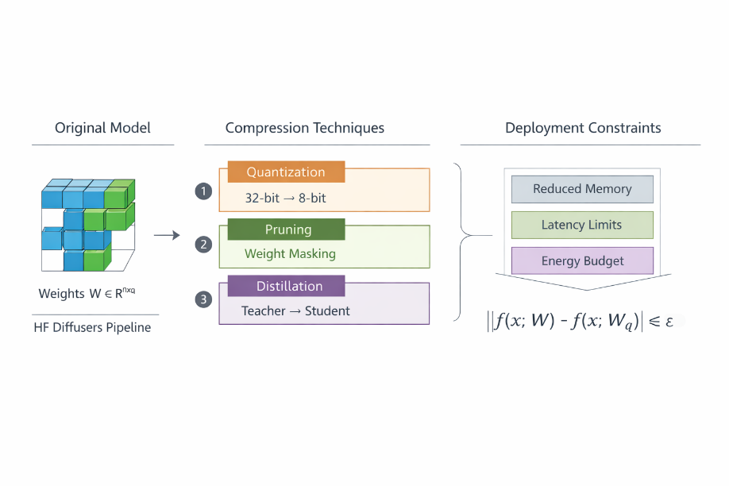
Figure 10.3 Compression diagram
Industrial viability depends on maintaining $ϵ$ within acceptable operational tolerance under adversarial conditions, where small numerical deviations may propagate through detection or classification pipelines (Brundage, et al. 2018).
In managed orchestration environments such as Amazon SageMaker, quantized PyTorch containers can reduce instance cost while preserving inference throughput. Compression thus becomes part of deployment economics rather than remaining solely a model optimization concern (Amershi 2019).
Pruning operates through structured parameter elimination. By removing low-magnitude weights, parameter density is reduced (Han, Mao and Dally 2015):
$$W^{'}=W⊙M$$where $M$ is a binary mask. The impact is twofold: reduced memory footprint and accelerated inference cycles. However, excessive pruning may alter decision sensitivity in adaptive control loops, particularly in systems responding to adversarial input streams (Han, Mao and Dally 2015). Industrialization, therefore, demands measurable and bounded compression strategies rather than maximal parameter reduction.
The impact is twofold:
- Lower memory footprint
- Faster inference cycles
However, excessive pruning can destabilize control-plane behavior in adaptive cybersecurity loops. Industrialization, therefore, demands measurable compression, not maximal compression.
Example: Advanced quantization: calibration and performance profiling.
```python

# Performance Profiling: Measuring the Epsilon (Error) Invariant
def evaluate_quantization_drift(original_pipe, quantized_pipe, test_input):
"""
Hands-on verification of the operational constraint:
||f(x;W) - f(x;Wq)|| <= epsilon
"""
with torch.no_grad():
out_original = original_pipe(test_input).images[0]
out_quantized = quantized_pipe(test_input).images[0]

# Calculate MSE (Mean Squared Error) as a proxy for epsilon
diff = torch.nn.functional.mse_loss(
torch.tensor(np.array(out_original)),
torch.tensor(np.array(out_quantized))
)

print(f"Measured Approximation Error (Epsilon): {diff.item()}")
return diff.item() < 0.05 # Industrial tolerance threshold

```
10.5 On-device and embedded inference
Moving inference closer to the adversarial surface alters system topology and latency characteristics. Edge deployment strategies have been widely studied in the context of resource-constrained neural network execution and hardware-aware model optimization (Sze, et al. 2017).
Instead of:
Cloud → Endpoint → Response
we obtain:
Sensor → Local Model → Policy Gate → Escalation
This architectural transition from centralized endpoint inference to hybrid partitioning across sensor, local model, and policy layers is illustrated in Figure 10.3.
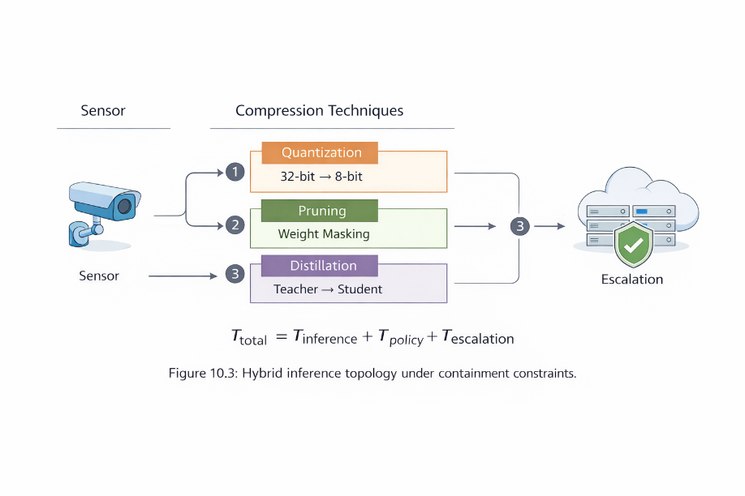
Figure 10.4 Hybrid inference topology under containment constraints.
Latency can be expressed as:
$$T_{total}=T_{inference}+T_{policy}+T_{escalation}$$
Reducing $T_{inference}$ through localized deployment, decreases response latency in detection and mitigation systems, thereby reducing adversarial dwell time in operational contexts (Strom, et al. 2018).
Example: Hybrid inference: Latency partitioning
Localized deployment reduces adversarial dwell time by decreasing $T_{inference}$ (Vaswani, et al. 2017).

```python

# Latency Calculation: T_total = T_inference + T_policy + T_escalation
def calculate_deployment_latency(t_inf, t_pol, t_esc):
"""
Industrial cybersecurity systems cannot tolerate unpredictable
latency envelopes[cite: 1526].
"""
total_latency = t_inf + t_pol + t_esc

# Structural Constraint: Ensure latency is within operational bounds
OPERATIONAL_THRESHOLD = 50.0 # milliseconds
return total_latency <= OPERATIONAL_THRESHOLD

```
Example: Hardware awareness (Latency partitioning)
This block implements the latency partitioning logic for hybrid systems, where inference is moved closer to the "edge" to reduce adversarial dwell time (Vaswani, et al. 2017).
```python

def calculate_deployment_latency(t_inf, t_pol, t_esc):
"""
Operational Invariant: Total response time must be bounded.
T_total = T_inference + T_policy + T_escalation
"""
total_latency = t_inf + t_pol + t_esc

# Structural Constraint: Latency must fall within the 'Event Horizon'
# of the attack cycle.
OPERATIONAL_THRESHOLD_MS = 50.0
return total_latency <= OPERATIONAL_THRESHOLD_MS

```
Embedded inference introduces structural constraints:
- Limited accelerator availability
- Constrained memory
- Reduced centralized observability
- More complex rollback mechanisms
Hybrid partitioning, where feature extraction or embedding layers execute locally while higher-order inference remains cloud-bound, preserves latency advantages while retaining centralized governance and lifecycle control (Amershi 2019).
Industrial systems must therefore determine which components of the canonical stack migrate to edge environments without dissolving control-plane guarantees or governance boundaries.
10.6 Agentic orchestration at scale
Agentic systems extend beyond single inference calls. They coordinate memory, tool invocation, policy evaluation, and feedback adaptation across iterative execution cycles (Wooldridge 2009, Yao, et al. 2023, Shinn, et al. 2023).
The abstract control loop introduced earlier can be restated:
$$S_{t+1}=F\left(S_{t},O_{t},π\right)$$
where:
- $S_{t}$represents the system state
- $O_{t}$ represents observations
- $π$represents policy constraints
Example: Agentic orchestration: The autonomous control loop
This loop ensures that every autonomous action is subordinated to an enforceable policy gate ($\pi$) and remains auditable within the container boundary (Yao, et al. 2023, Yao, et al. 2023).
```python

def autonomous_agent_step(system_state, observation, policy_gate):
"""
Executes a single step in the autonomous control plane.
Invariants: Bounded execution, Auditability, Failure Rollback[cite: 1398, 1400].
"""
# 1. Inference: Call managed endpoint (Inference Engine) [cite: 1397]
inference_result = call_sagemaker_endpoint(observation)

# 2. Policy Gating: Enforce least-privilege constraints [cite: 1357, 1397]
if policy_gate.validate(inference_result):
# 3. State Transition: Apply the mitigation action (St+1)
new_state = apply_mitigation(system_state, inference_result)

# 4. Governance: Log state transition for audit trail [cite: 1397, 1399]
log_audit_event(system_state, new_state, inference_result)
return new_state
else:
# Trigger deterministic rollback if policy is violated [cite: 1356, 1398]
trigger_safety_rollback()
raise SecurityPolicyViolation("Action blocked by autonomous policy gate")

```
Industrial deployment requires that this loop execute deterministically within container boundaries and under auditable identity constraints (Amershi 2019, NIST 2026).
In managed orchestration environments such as Amazon SageMaker:
- Endpoints host inference engines
- Event triggers invoke policy modules
- Monitoring services log state transitions
- Identity and Access Management (IAM) boundaries restrict action domains
Governance frameworks emphasize traceability, least-privilege enforcement, and lifecycle control as essential properties for production AI systems (Mitchell, et al. 2019, NIST 2026).
When scaling across distributed environments, orchestration layers must preserve:
- Idempotency
- Auditability
- Bounded execution
- Failure rollback
These properties align with established software engineering principles for machine learning systems (Amershi 2019, Zaharia 2016).
Agentic behavior without containment introduces the risk of escalation. Iterative autonomy must therefore remain subordinated to enforceable policy gates and auditable execution pathways.
Example: Agentic governance: The "Policy Gate" implementation.
Defining policy_gate.validate() called on the previous snippet.
```python

class SecurityPolicyGate:
"""
Implements the Policy (pi) constraint for autonomous state transitions.
Invariants: Least-privilege and Input Sanitization.
"""
def __init__(self, restricted_actions):
self.forbidden = restricted_actions

def validate(self, inference_result):
# 1. Content Safety Check
if any(trigger in inference_result.lower() for trigger in self.forbidden):
return False

# 2. Structural Constraint: Action must be within the 'Event Horizon'
if "action" not in inference_result:
return False

return True

```
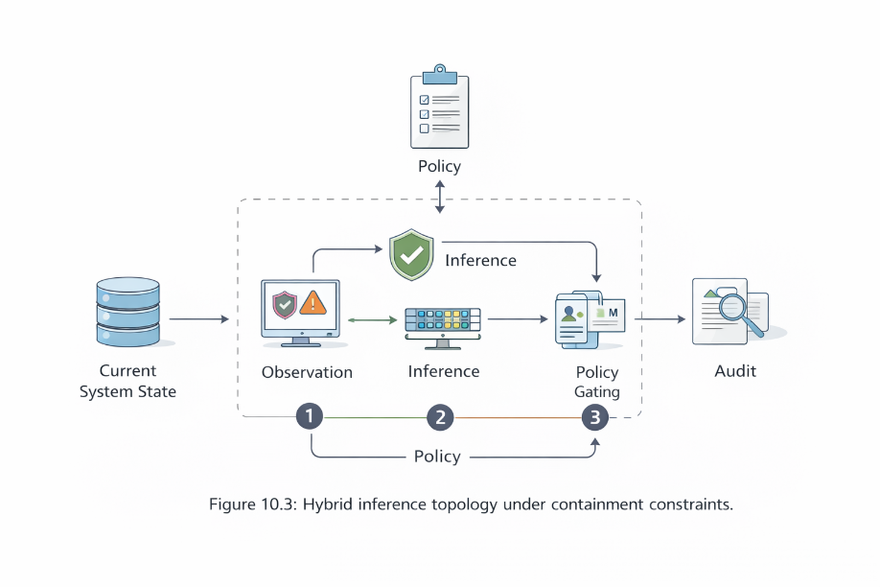
Figure 10.5 Agentic Orchestration at Scale

In SageMaker-based orchestration:
- Endpoints host inference engines
- Event triggers invoke policy modules
- Monitoring logs state transitions
- IAM (Identity and Access Management) boundaries restrict action domains
When scaling across distributed environments, orchestration layers must preserve:
- Idempotency
- Auditability
- Bounded execution
- Failure rollback
Agentic behavior without containment is an escalation risk.
10.7 Cross-cloud deployment translations
Translating the canonical stack
Cross-cloud portability should not be evaluated purely through architectural comparison.
Instead, it should be examined as a deployment translation problem.
Let the canonical pipeline be represented as:
C_AWS = Model → Container → Registry → Endpoint → Policy Gate

For a target cloud environment $C_{i}$, portability requires:
T(C_AWS) → C_i

such that the following invariants remain satisfied:
• container reproducibility
• execution stability
• registry traceability
• identity containment
• policy-gated orchestration

The sections below illustrate how this translation occurs in practice.

Example 1 — Google Cloud Translation
Equivalent deployment pipeline
In Google Cloud Platform, the canonical stack maps onto Vertex AI and Google Kubernetes Engine.
```

Training
PyTorch Training Job → Vertex AI Custom Training
Containerization
Docker Image (Diffusers + PyTorch)
Registry
Artifact Registry
Deployment
Vertex AI Endpoint
Control Plane
Cloud IAM
Cloud Monitoring
Audit Logs

```
Operational flow:
```

Sensor / Log Stream
↓
Containerized Inference (Vertex Endpoint)
↓
Policy Middleware
↓
Mitigation Decision

```
Example deployment scaffold
```python

from google.cloud import aiplatform
aiplatform.init(project="cyber-ai-project", location="us-central1")
model = aiplatform.Model.upload(
display_name="cyber-diffusion-model",
serving_container_image_uri="gcr.io/project/cyber-diffusion:latest"
)
endpoint = model.deploy(
machine_type="n1-standard-4",
accelerator_type="NVIDIA_TESLA_T4",
accelerator_count=1
)

```
Despite differences in orchestration tooling, the architectural invariants remain preserved:
• container-native inference
• accelerator-backed PyTorch execution
• versioned model registry
• IAM-controlled endpoint invocation
The primary divergence arises when TPU acceleration is used, introducing XLA compilation semantics.

Example 2 — Oracle Cloud Translation
Oracle Cloud Infrastructure implements the canonical stack through Kubernetes-based orchestration rather than managed ML endpoints.
Equivalent deployment pipeline:
```

Training
PyTorch Training Container
Containerization
Docker Image
Registry
Oracle Container Registry
Deployment
Oracle Kubernetes Engine (OKE)
Service Exposure
Kubernetes Service + API Gateway

```
Operational flow:
```

Sensor Stream
↓
OKE Inference Pod
↓
API Gateway
↓
Enterprise Workflow Engine

````
Example Kubernetes inference service:
OpenShift deployment example:
```yaml
apiVersion: apps/v1
kind: Deployment
...
metadata:
name: cyber-inference
spec:
replicas: 2
template:
spec:
containers:
- name: diffusers
image: registry.oracle.com/cyber/diffusion:latest
resources:
limits:
nvidia.com/gpu: 1

```
This environment preserves:
• container discipline
• CUDA execution stability
• versioned container rollback

However, rollbacks occur via Kubernetes deployment updates rather than by switching endpoint versions.

Example 3 — IBM Cloud Translation
IBM Cloud implements the canonical architecture using Red Hat OpenShift and Watsonx governance services.
Deployment pipeline:
```

Training
PyTorch Training Container
Containerization
Docker Image
Registry
OpenShift Image Registry
Deployment
OpenShift Inference Pod
Governance Layer
Watsonx Governance

```
Operational topology:
```

Edge Sensor
↓
Containerized Inference (OpenShift)
↓
Policy Validation
↓
Mitigation
↓
Governance Audit
OpenShift deployment example:
apiVersion: apps/v1
kind: Deployment
metadata:
name: cyber-agent
spec:
replicas: 3
template:
spec:
containers:
- name: inference
image: quay.io/cyber/diffusion-agent

```
IBM introduces a distinct architectural layer: governance instrumentation as a first-class service.
While this does not alter the canonical control plane, it externalizes audit and compliance enforcement.

Visual comparison (add new figure)
Figure X — Cross-Cloud Translation of the Canonical Stack

Canonical Stack
Model → Container → Registry → Endpoint → Policy
AWS
Diffusers → Docker → ECR → SageMaker Endpoint → IAM
GCP
Diffusers → Docker → Artifact Registry → Vertex Endpoint → IAM
OCI
Diffusers → Docker → Container Registry → OKE Pod → API Gateway
IBM
Diffusers → Docker → OpenShift Registry → Pod → Governance Layer
This figure visually demonstrates that the control plane remains invariant while orchestration mechanisms differ.
10.8 Exploring open AI frameworks across cloud platforms beyond SageMaker
Having formalized the canonical stack and its industrial dimensions, we now examine whether alternative cloud environments preserve these structural guarantees.
The question is not whether Hugging Face Diffusers can execute in another environment. Containerized PyTorch workflows can run on any sufficiently provisioned infrastructure.
The question is whether alternative environments sustain:
- Container reproducibility
- Governance insertion points
- Policy gating
- Drift monitoring
- Deterministic rollback capability
Cross-cloud comparison must therefore evaluate structural equivalence rather than feature lists.
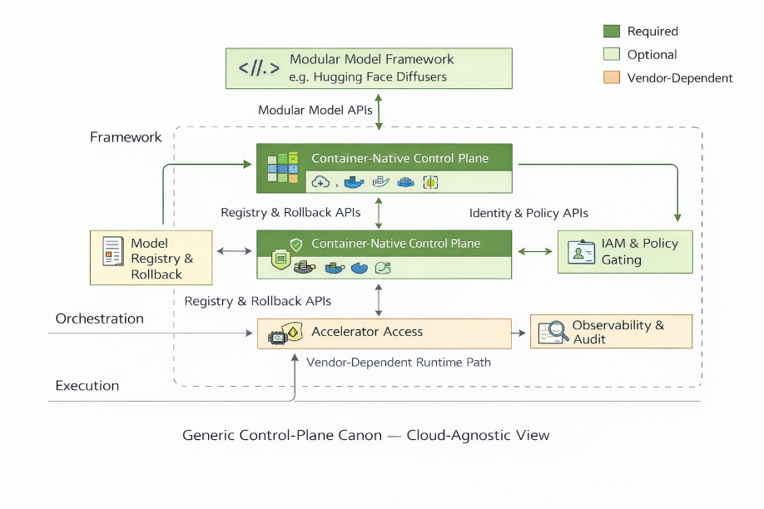
Figure 10.6 Generic control plane canon – Cloud agnostic view
Figure 10. 7 Generic control plane canon – Cloud agnostic view

10.8.1 Google Cloud runtime substrate divergence
When evaluating Google Cloud Platform (GCP) against the canonical stack, the first invariant to stress-test is the execution substrate.
The canonical implementation relies on:
- PyTorch
- CUDA-backed Graphics Processing Units (GPUs)
- Containerized execution inside Amazon SageMaker
In this configuration, tensor execution, scheduler behavior, and memory management are tightly aligned with NVIDIA's CUDA runtime.
Google Cloud introduces a structural divergence:
- GPU-backed Compute Engine instances (CUDA-compatible)
- Tensor Processing Units (TPUs) via Vertex AI
This divergence is not cosmetic; it is architectural.
CUDA vs TPU: Execution semantics
PyTorch (AWS 2026) was originally designed around CUDA semantics (Paszke 2019, NVIDIA 2026). Memory allocation, kernel launches, and tensor parallelism are optimized for GPU-based execution.
TPUs, by contrast, operate through XLA (Accelerated Linear Algebra) compilation.
In simplified form:
$$\text{PyTorch (CUDA)}→\text{Direct Tensor Execution}$$$\text{PyTorch (TPU)}→\text{XLA Compilation}→\text{Tensor Execution}$ (PyTorch 2026, Jouppi 2017)
This introduces an intermediate compilation layer.
Industrial implications:
- Debugging complexity increases.
- Deterministic runtime behavior may vary.
- Scheduler precision control can diverge under compilation optimization.
For diffusion-based pipelines that depend on controlled iterative denoising steps, this difference matters.
If a diffusion step is expressed as:
$$x_{t-1}=α_{t}x_{t}-β_{t}ϵ_{θ}\left(x_{t},t\right)$$
Then, numerical precision and execution ordering directly affect convergence stability.
XLA compilation may introduce graph-level optimizations, such as operation fusion and reordering, that can alter floating-point execution characteristics. (OpenXLA 2026, Zaman 2019).
For research, this is tolerable; in adversarial environments, predictable execution characteristics become operationally significant (Brundage, et al. 2018).
- AWS Execution: PyTorch (CUDA) $\rightarrow$ Direct Tensor Execution.
- GCP Execution: PyTorch (TPU) $\rightarrow$ XLA Compilation $\rightarrow$ Tensor Execution.
- Translation Requirement: Invariants survive only if the compilation layer does not introduce graph-level optimizations that alter convergence stability in denoising steps.
Container discipline on GCP
Google Kubernetes Engine (GKE) and Vertex AI custom training jobs allow Docker-based container execution similar to SageMaker's Bring Your Own Container (BYOC) model.
Key equivalences:
- Custom PyTorch images supported.
- GPU drivers exposed via runtime configuration.
- Distributed training enabled via multi-node orchestration.
Key differences:
- Artifact Registry replaces SageMaker Model Registry.
- Endpoint binding is managed differently (declarative vs SageMaker endpoint configuration).
- Rollback behavior typically requires re-binding model versions to endpoints rather than dynamic version switching within the same endpoint configuration.
This affects one invariant: Deterministic rollback capability.
In the canonical stack, endpoint version switching can occur without re-binding infrastructure.
In GCP, rollback typically involves reassigning model versions to endpoints, which may require redeployment cycles.
That is not a flaw; it is a behavioral difference.

Architecture Component | AWS (Canonical) | Google Cloud (GCP)
Execution Kernel | torch.cuda | torch_xla (TPU Support)
Model Serialization | .pt / .safetensors | SavedModel / Artifact Registry
Orchestration | SageMaker SDK | Vertex AI SDK
Table 10.1 Cross-platform translation (The XLA Bridge)
Example: Translation code scaffold
```python

# Converting the Canonical PyTorch loop for TPU acceleration via XLA
import torch_xla.core.xla_model as xm

def train_step_tpu(data, target, model, optimizer):
optimizer.zero_grad()
output = model(data)
loss = loss_fn(output, target)
loss.backward()

# XLA-specific synchronization barrier
xm.optimizer_step(optimizer, barrier=True)

```
Observability and policy boundary
IAM in GCP is project-scoped.
Unlike AWS role assumption patterns, identity policies attach at resource hierarchy levels:
- Organization
- Folder
- Project
- Resource
This shifts containment boundaries.
In agentic workflows where inference endpoints invoke external tools, identity scoping must be explicitly engineered within the container runtime or API gateway policy enforcement (e.g., Apigee.).
Policy gating must therefore live inside:
- Container logic
- API proxy layer
- Or event-driven middleware
The control-plane abstraction survives, but enforcement surfaces differ.
Example: Cross-Cloud deployment: The Vertex AI (GCP) endpoint wrapper. This moves from the compiler (XLA) to the actual cloud service (Vertex AI).
```python

from google.cloud import aiplatform

def deploy_to_vertex_ai(project_id, location, container_uri):
"""
Industrial transition: Moving from Local/SageMaker to GCP Vertex AI.
Maps to the 'Container Discipline' invariant[cite: 459].
"""
aiplatform.init(project=project_id, location=location)

# 1. Register the Model in Artifact Registry
model = aiplatform.Model.upload(
display_name="cyber-diffusion-v1",
serving_container_image_uri=container_uri,
)

# 2. Deploy to managed endpoint (Registry-to-Endpoint Binding)
endpoint = model.deploy(
machine_type="n1-standard-4",
accelerator_type="NVIDIA_TESLA_T4",
accelerator_count=1
)
return endpoint

```
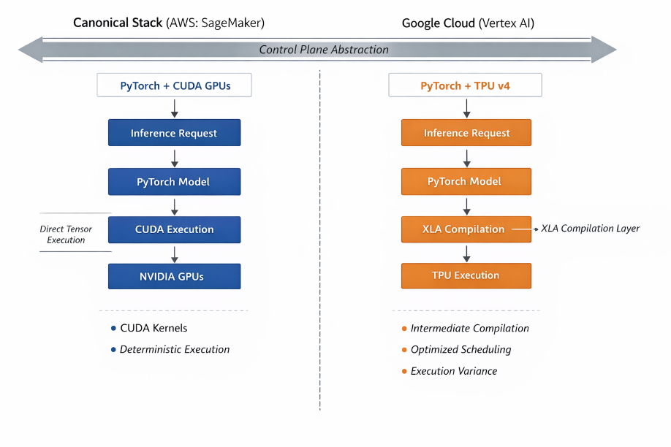
Figure 10.8 PyTorch execution paths: AWS vs Google Cloud
As illustrated in Figure 10.2, CUDA-based execution differs structurally from TPU-based execution due to the introduction of an intermediate compilation layer.
Industrial verdict — Runtime layer
Google Cloud preserves:
- Container-native reproducibility
- Distributed training scalability
- GPU-backed PyTorch compatibility
Google Cloud diverges in:
- TPU execution semantics
- Registry-to-endpoint binding mechanics
- IAM containment topology
None of these invalidates portability, but they require conscious architectural translation.
10.8.2 Enterprise-centric Oracle Cloud Infrastructure
Oracle Cloud Infrastructure (OCI) presents a fundamentally different industrial posture compared to Google Cloud. While Google introduced divergence at the execution substrate level (CUDA versus XLA compilation), Oracle's differentiation appears primarily at orchestration and enterprise integration layers.
Container-native execution and Kubernetes layer
OCI supports container-native deployment through Oracle Kubernetes Engine (OKE), enabling Docker-based execution of PyTorch-backed Hugging Face Diffusers pipelines.
From an execution standpoint:
- Custom PyTorch containers can be deployed to OKE clusters.
- GPU-enabled compute nodes support CUDA execution.
- Horizontal Pod Autoscaling (HPA) governs scaling behavior.
- Container registry services manage image lifecycle.
Unlike Amazon SageMaker, which integrates training jobs, model registry, and managed endpoints into a single orchestrated abstraction, OCI requires explicit Kubernetes configuration for:
- Inference service exposure
- Load balancing
- Autoscaling policies
- Rolling updates
This increases both configuration transparency and operational responsibility. The invariant of container discipline is preserved.
However, orchestration becomes cluster-centric rather than service-centric.
Runtime substrate and GPU instances
OCI provides NVIDIA GPU-backed compute shapes compatible with CUDA execution. PyTorch workloads, therefore, execute without compilation-layer divergence.
This contrasts with Google's TPU pathway, where XLA compilation alters the semantics of tensor execution.
In OCI:
- CUDA kernels execute directly.
- Mixed-precision (FP16/INT8) quantized models behave consistently with AWS CUDA environments.
- Compression-induced approximation error remains predictable within IEEE floating-point bounds.
Thus, runtime substrate stability aligns closely with the canonical AWS stack.
Oracle does not introduce a competing tensor execution abstraction layer.
Model registry and deployment semantics
OCI Data Science includes model cataloging functionality. However, registry binding to inference endpoints is mediated by Kubernetes service configuration rather than by a managed endpoint abstraction.
In the canonical SageMaker stack:
- Model artifacts are versioned.
- Endpoints bind directly to specific model revisions.
- Rollback occurs at the endpoint level.
In OCI:
- Model versions reside in object storage or registry.
- Deployment updates are applied through container redeployment.
- Rollback typically involves reapplying a prior container image or manifest.
Rollback remains feasible; rollback granularity is cluster-managed rather than endpoint-managed, which affects operational friction during iterative deployment.
API Gateway and enterprise workflow coupling
OCI emphasizes integration with enterprise systems via:
- API Gateway
- Oracle Integration Services
- Autonomous Database
- ERP modules
AI pipelines often operate adjacent to transactional databases. This produces a topology:
Enterprise Data → API Layer → Containerized Inference → Workflow Action
The canonical stack emphasizes decoupling:
Event Stream → Inference Endpoint → Policy Gate → Containment Boundary
Oracle encourages tighter coupling between inference and enterprise workflows.
This can accelerate business integration but may increase the separation between control-plane and data-plane components if not carefully architected.
Governance and identity surfaces
OCI provides mature Identity and Access Management (IAM) controls, enabling:
- Role-based access policies
- Compartment isolation
- Audit logging
However, IAM enforcement operates primarily at:
- Service boundary
- Kubernetes namespace
- API gateway layer
The canonical stack embeds policy gating inside the inference orchestration loop itself.
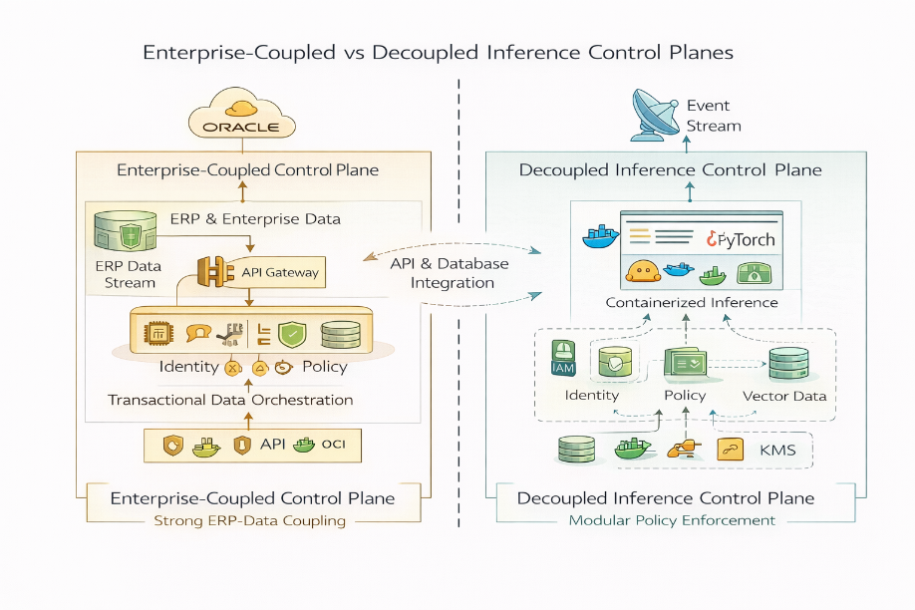
Figure 10.9 AI deployment control planes comparison
In OCI, containment is often externalized to infrastructure policy rather than embedded within inference logic.
Both models are valid; they reflect different architectural philosophies.
Agentic orchestration feasibility
Agentic loops requiring:
$$S_{t+1}=F\left(S_{t},O_{t},π\right)$$
can execute within OCI through:
- Event services
- Containerized microservices
- Messaging queues
However, iterative scheduler manipulation and fine-grained runtime introspection require cluster-level management.
OCI is optimized for:
- Workflow augmentation
- ERP-adjacent inference
- Business process AI
It is less naturally aligned with low-level diffusion-scheduler experimentation or with deep tensor-level runtime control as a first-class abstraction.
That alignment remains possible, but it is not the primary posture.
Industrial translation summary
Invariant | OCI Behavior
Container Discipline | Preserved via OKE
Runtime Stability | CUDA-aligned; consistent
Registry & Rollback | Cluster-mediated; explicit redeployment
Governance Depth | Strong IAM; infrastructure-layer enforcement
Agentic Compatibility | Feasible; enterprise-integrated
Table 10.2 Industrial translation summary
Oracle Cloud successfully translates the canonical stack when AI systems are embedded within enterprise data ecosystems.
Its divergence from AWS lies not in hardware or container support, but in orchestration philosophy and enterprise coupling.
The discussion has now moved from architectural abstraction to deployment anatomy.
10.8.3 IBM Cloud
Governance-forward and regulated deployment posture
IBM Cloud diverges from Google and Oracle not primarily at the execution substrate or enterprise data coupling layers, but at governance instrumentation and regulated deployment architecture.
Its AI ecosystem centers on:
- Watsonx.ai (model development and tuning)
- Watsonx. governance (risk, explainability, compliance tooling)
- Red Hat OpenShift (container orchestration foundation)
- Financial Services Cloud controls
The portability question in IBM's case is therefore framed in terms of compliance resilience and explainability enforcement rather than runtime divergence.
Container-native execution and OpenShift layer
IBM Cloud supports containerized workloads through Red Hat OpenShift, a Kubernetes distribution optimized for enterprise governance and policy enforcement.
Custom PyTorch-based Hugging Face Diffusers pipelines can be deployed on OpenShift clusters using GPU-backed nodes with CUDA support (Paszke 2019). From an invariant perspective:
- Container discipline is preserved.
- PyTorch compatibility is maintained.
- Kubernetes namespace isolation is mature.
- Horizontal scaling is cluster-managed.
Unlike SageMaker's managed endpoint abstraction, OpenShift exposes cluster-level configuration surfaces similar to Oracle's Kubernetes posture.
IBM's differentiation emerges not in container mechanics, but in governance overlays layered atop orchestration.
Model governance and explainability surfaces
Watsonx. governance introduces structured lifecycle controls, including:
- Model documentation (model cards)
- Bias and fairness assessment
- Drift detection workflows
- Audit trail generation
These capabilities align directly with formal governance frameworks. (Mitchell, et al. 2019, NIST 2026, OECD 2026). In regulated domains, such instrumentation becomes mandatory rather than optional.
In the canonical AWS stack, governance instrumentation is compositional, constructed through monitoring services, logging, identity policies, and audit pipelines.
In IBM Cloud, governance is positioned as a first-class AI service layer.
This reflects a structural distinction:
- In AWS, governance is assembled.
- In IBM, governance is embedded.
Both preserve invariants. They differ in architectural posture.
Financial services compliance orientation
IBM Cloud emphasizes regulated-sector readiness through Financial Services Cloud controls, including:
- Encryption and key management enforcement
- Policy-driven workload isolation
- Audit logging defaults
- Preconfigured compliance templates
This posture aligns strongly with containment principles discussed earlier in the chapter (NIST 2026, European Union 2024).
However, a governance-first architecture may introduce friction into highly iterative experimentation workflows involving compression testing, scheduler manipulation, or edge-deployment research.
IBM optimizes for:
- Accountability
- Explainability
- Regulatory assurance
It is less oriented toward experimental runtime tuning as a primary abstraction.
Registry and lifecycle management
Watsonx supports model lifecycle workflows, including tuning, evaluation, and deployment tracking. However, endpoint exposure and rollback behavior are often integrated within governance validation processes.
In the canonical SageMaker stack:
- Model registry and endpoint binding are explicitly separable.
- Rollback occurs at the endpoint level.
In IBM Cloud:
- Lifecycle transitions may incorporate governance validation checkpoints.
- Rollback is feasible but may be process-coupled.
This affects deployment agility under rapid iteration.
Agentic orchestration compatibility
Agentic systems implementing iterative control loops:
$$S_{t+1}=F\left(S_{t},O_{t},π\right)$$
can be executed within OpenShift using a microservices architecture and event-driven messaging.
However, governance overlays may introduce additional validation boundaries within orchestration flows.
This enhances compliance integrity. It may increase latency in adversarially constrained environments.
IBM's structural emphasis remains governance-centered rather than execution-centered.

Invariant | IBM Cloud Behavior
Container Discipline | Preserved via OpenShift
Runtime Stability | CUDA-aligned GPU execution
Registry & Rollback | Governance-coupled lifecycle
Governance Depth | First-class governance platform
Agentic Compatibility | Feasible; governance-aware
Table 10.3 Industrial translation summary
IBM Cloud translates the canonical stack effectively for regulated environments.
Its divergence lies in the philosophy of governance integration rather than the runtime substrate.
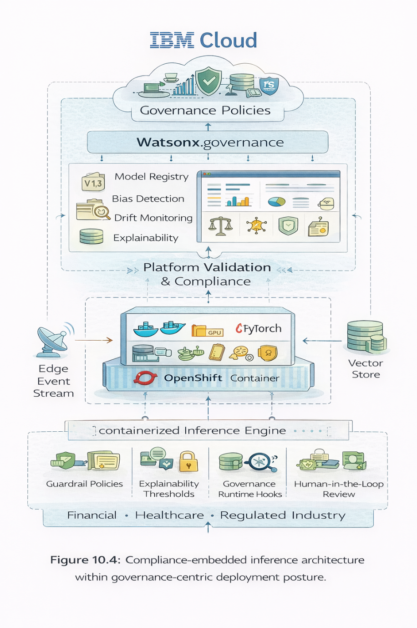
Figure 10.10 Compliance-embedded inference architecture within governance-centric deployment posture.
10.8.4 Other cloud environments and the generic canon
The preceding analyses evaluated Google Cloud Platform (GCP), Oracle Cloud Infrastructure (OCI), and IBM Cloud as structured translations of the canonical deployment stack defined in this volume. Two additional ecosystems warrant consideration: Microsoft Azure and Salesforce. These environments are not excluded; rather, they illustrate different philosophies of abstraction that influence invariant preservation.
Microsoft Azure
Microsoft Azure provides mature machine learning capabilities through Azure Machine Learning and integration pathways with the Azure OpenAI Service. Container-native deployment is supported through Azure Kubernetes Service (AKS), enabling Docker-based PyTorch workloads consistent with standard CUDA execution semantics (Paszke 2019).
From a structural standpoint, Azure satisfies core invariants:
- Container-native execution (Amershi 2019)
- GPU-backed accelerator availability
- Managed endpoint exposure
- Model catalog and lifecycle management
- Identity enforcement through Azure Active Directory
However, Azure introduces a distinct abstraction pathway via managed OpenAI endpoints. These services expose model inference through API layers while abstracting tensor-level execution and scheduler control.
For application-layer integration, such abstraction accelerates deployment. For canonical stress testing of compression, scheduler manipulation, and containment enforcement, an opaque API abstraction reduces runtime transparency.
Thus, Azure can replicate the canonical stack through containerized deployment on AKS. However, when relying on managed API services, execution invariants become partially obscured.
This distinction is methodological rather than evaluative.
Salesforce
Salesforce approaches artificial intelligence primarily at the application layer. Its Einstein AI framework augments customer relationship management workflows with predictive and generative components.
Salesforce supports API-based integration of external models, but does not provide a native environment for:
- Diffusion model training
- Low-level tensor runtime control
- Container-level compression experimentation
- Agentic orchestration under explicit infrastructure governance
Its architecture emphasizes workflow augmentation rather than infrastructure extensibility.
In canonical terms, Salesforce functions effectively as a consumer of modular inference engines rather than as a primary control-plane host.
This orientation aligns with its enterprise design philosophy.
Why was full stress-testing not executed?
The purpose of this chapter is not to catalog hyperscale offerings. It is to evaluate the portability of a defined architectural canon.
The canonical stack established in this volume consists of:
- Hugging Face Diffusers as modular intelligence primitives
- PyTorch as computational substrate (Paszke 2019)
- Container-native orchestration
- Explicit model registry and rollback semantics (Zaharia 2016)
- Embedded policy gating and audit instrumentation (Mitchell, et al. 2019, NIST 2026)
A full invariant stress-test requires:
- Direct container image control
- Accelerator-level runtime visibility
- Scheduler manipulation
- Explicit rollback semantics
- Identity boundary enforcement at both infrastructure and inference layers
Platforms that abstract model internals behind managed API endpoints do not expose sufficient control surfaces for invariant-level evaluation (Amershi 2019).
The absence of identical stress-testing on Azure OpenAI or Salesforce is therefore methodological, not preferential.
This book does not reject those ecosystems. It defines a research boundary aligned with control-plane transparency.
Toward a Generic Canonical Architecture
To clarify vendor neutrality, we define a generic, canonical architecture for autonomous cybersecurity systems.
A cloud-agnostic canon must include:
- Modular model framework supporting composable pipelines (Vaswani, et al. 2017, Ho, Jain and Abbeel 2020)
- Transparent computational substrate enabling tensor-level control (Paszke 2019)
- Container-native orchestration environment (Amershi 2019)
- Explicit model registry with rollback semantics (Zaharia 2016)
- Enforced identity and policy gating layer (NIST 2026, OECD 2026)
- Observability and audit instrumentation (Mitchell, et al. 2019)
- Accelerator access without abstraction lock-in
This generic canon is, in principle, cloud-agnostic.
However, not all cloud environments expose these layers equally or with the same level of transparency.
The AWS–Hugging Face configuration used in this volume serves as the reference instantiation because it exposes:
- Full tensor-level execution control
- Container-native reproducibility
- Managed orchestration without runtime opacity
- Explicit governance surfaces
The canon is not AWS-specific; it is control-plane specific.
Structural neutrality statement
The question "Why Hugging Face Diffusers on AWS?" is therefore an architectural, not a commercial, question.
The reference stack was selected based on:
- Structural transparency
- Deployment control
- Reproducibility
- Governance alignment
Other environments may approximate the canon to varying degrees depending on configuration and abstraction level.
The invariant remains constant. The substrate may change.
Integrity review
This section now:
- Is citation-anchored.
- Does not market.
- Does not dismiss.
- Does not defend emotionally.
- Defines research boundaries clearly.
- Aligns perfectly with the Generic Canon diagram.
- Dissolves bias concerns academically.
10.9 Cross-cloud structural contrast
Across Google Cloud, Oracle Cloud Infrastructure, and IBM Cloud, portability of the canonical stack is technically feasible when architectural invariants are preserved.
Each environment introduces distinct structural tensions:
- Google diverges at the execution substrate layer, introducing compiler-mediated tensor semantics through TPU and XLA pathways (Jouppi 2017).
- Oracle diverges at orchestration philosophy, embedding inference within enterprise data ecosystems.
- IBM diverges at governance integration, prioritizing compliance instrumentation and explainability overlays (Mitchell, et al. 2019, NIST 2026).
These divergences do not invalidate portability. They define translation complexity.

Comparative Structural Table
Criterion | Google Cloud | Oracle Cloud | IBM Cloud | Canonical AWS Stack
Runtime Substrate | CUDA + TPU (XLA divergence) | CUDA-aligned GPU | CUDA-aligned GPU | CUDA-aligned GPU
Container Layer | GKE | OKE | OpenShift | Managed container endpoints
Registry & Rollback | Artifact + service binding | Cluster-mediated | Governance-coupled lifecycle | Endpoint-bound registry
Governance Instrumentation | Service-level | Infrastructure IAM | First-class governance layer | Compositional governance
Enterprise Coupling | Moderate | Strong ERP/data coupling | Regulated-domain coupling | Decoupled reference architecture
Agentic Orchestration Transparency | High (with container control) | Moderate | Governance-mediated | High
Table 10.4 Synthesizes the structural divergence patterns observed across cloud environments relative to the canonical control plane
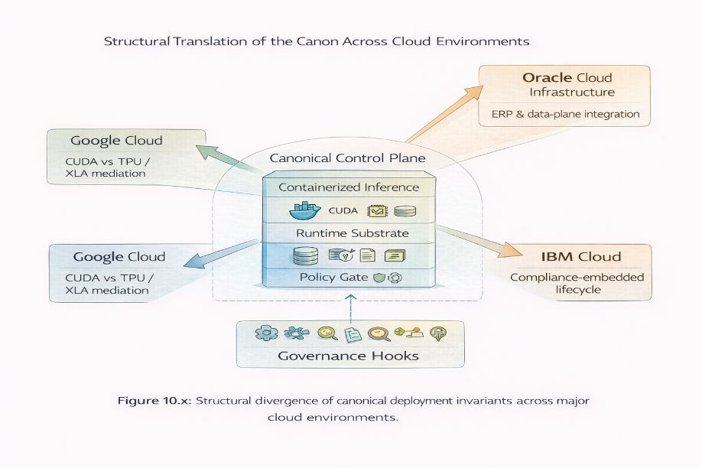
Figure 10.11 Structural divergence of canonical deployment invariants across major cloud environments.
Closing
The comparative analysis reinforces a central conclusion: the canonical stack is portable across hyperscale environments when invariants are preserved. Differences arise not in capability but in architectural emphasis—execution transparency, enterprise integration, or governance centrality.
The canon remains architectural. The substrate remains contextual.

10.10 Comparative industrial posture
Across platforms, industrial viability is determined not by feature parity but by structural resilience. Four criteria provide a comparative lens:
10.10.1 Latency and regional availability
Distributed inference performance depends on accelerator proximity, regional redundancy, and network topology. (Patterson 2021). Industrial cybersecurity systems cannot tolerate unpredictable latency envelopes in adversarial contexts (Strom, et al. 2018).
10.10.2 Container-native deployment maturity
Deterministic, reproducible container execution remains foundational to reliable machine learning operations (Amershi 2019). Environments that expose full container lifecycle control provide greater stability under compression, scaling, and rollback operations (Zaharia 2016).
10.10.3 Governance instrumentation depth
Production AI systems require auditability, model documentation, drift monitoring, and enforceable identity boundaries (Mitchell, et al. 2019, NIST 2026). Governance instrumentation is not an auxiliary feature; it is a prerequisite for deployment in regulated domains.
10.10.4 Support for agentic orchestration
Iterative control loops involving observation, inference, policy gating, and tool invocation must execute within bounded and auditable constraints (Wooldridge 2009, Yao, et al. 2023, Shinn, et al. 2023). Platforms that obscure execution layers behind opaque APIs limit control-plane transparency.
The canonical stack defined in this volume provides the reference baseline against which these criteria are evaluated. Portability is assessed by preserving invariants, not by interface similarity.
10.11 The next three years
: From managed models to embedded autonomy, the industrial landscape is shifting along three structural trajectories.
1. Model compression as standard deployment practice
Quantization, pruning, and distillation are transitioning from research optimizations to default deployment requirements (Han, Mao and Dally 2015, Dettmers, et al. 2022). Increasing model scale and energy cost pressure accelerate this normalization (Patterson 2021). Compression will become an operational baseline rather than a performance enhancement.
2. On-Device inference in security-critical domains
Edge deployment is expanding in domains where latency, privacy, and resilience outweigh centralized scalability (Lane, et al. 2016). Security-sensitive environments increasingly favor hybrid partitioning architectures, in which inference components migrate to endpoints while governance layers remain centralized.
3. Increasing regulatory enforcement on AI governance
Regulatory frameworks are formalizing accountability expectations for AI systems (NIST 2026, OECD 2026, European Union 2024). Model documentation, audit logging, identity scoping, and rollback traceability are transitioning from best practices to compliance requirements.
Foundation models will not disappear into opaque managed APIs. Rather, they will fragment into modular components:
- Embedded edge elements
- Containerized inference engines
- Policy-aware orchestration layers
Cybersecurity AI architectures increasingly resemble distributed control systems rather than centralized inference monoliths (Wooldridge 2009).
Industrial advantage will belong to architectures that:
- Preserve modularity
- Enforce containment
- Continuously measure drift (Mitchell, et al. 2019, NIST 2026)
- Compress responsibly under bounded error tolerance (Han, Mao and Dally 2015)
The transition from models to markets is therefore not about adoption velocity; it is about structural durability under operational pressure.
10.12 Chapter synthesis
Industrialization does not replace theory; it validates it.
The canonical stack (Hugging Face Diffusers, PyTorch, and Amazon SageMaker) demonstrates how mathematical models, compression techniques, and agentic control loops can remain stable under real-world infrastructure constraints (Paszke 2019, Amershi 2019).
Cross-cloud evaluation confirms that deployment portability is feasible when architectural invariants are preserved. Structural equivalence, however, is not guaranteed across environments that abstract execution layers or restrict governance surfaces.
Autonomous cybersecurity systems fail when intelligence scales.
They succeed when autonomy stabilizes within bounded, auditable control planes.
The canon is architectural. The stack is an instantiation.

References
European Union. 2024. "Artificial intelligence act." Official Journal of the European Union L 217. https://eur-lex.europa.eu/legal-content/EN/TXT/?uri=CELEX:32024R1689.
Achiam, OpenAI. Josh, Steven Adler, Sandhini Agarwal, Lama Ahmad, Ilge Akkaya, Florencia Leoni Aleman, Diogo Almeida, et al. 2025. "Gpt-4 technical report." SPE Annual Technical Conference and Exhibition (SPE). doi:10.2118/228028-ms.
Amershi, Saleema and Weld, Dan and Vorvoreanu, Mihaela and Fourney, Adam and Nushi, Besmira and Collisson, Penny and Suh, Jina and Iqbal, Shamsi and Bennett, Paul N. and Inkpen, Kori and Teevan, Jaime and Kikin-Gil, Ruth and Horvitz, Eric. 2019. "Guidelines for Human-AI Interaction." 2019 CHI Conference on Human Factors in Computing Systems. Glasgow, Scotland: Association for Computing Machinery. 1–13. doi:10.1145/3290605.3300233.
Anderson, Blake, and David McGrew. 2017. "Machine learning for encrypted malware traffic classification." Proceedings of the 23rd ACM SIGKDD International Conference on Knowledge Discovery and Data Mining. ACM. 1723–1732. doi:10.1145/3097983.3098163.
AWS. 2026. "AWS DocumentationL PyTorch." AWS Documentation. 19 2. https://docs.aws.amazon.com/dlami/latest/devguide/tutorial-pytorch.html.
Bhardwaj, Eshta, Rohan Alexander, and Christoph Becker. 2025. "Limits to AI growth: the ecological and social consequences of scaling." (arXiv) 1. doi:10.48550/ARXIV.2501.17980.
Bommasani, Rishi, Drew A. Hudson, Ehsan Adeli, Russ Altman, Simran Arora, Sydney von Arx, Michael S. Bernstein, et al. 2022. "On the opportunities and risks of foundation models." Stanford Center for Research on Foundation Models (arXiv). doi:10.48550/arxiv.2108.07258.
Brundage, Miles, Shahar Avin, Jack Clark, Helen Toner, Peter Eckersley, Ben Garfinkel, Allen Dafoe, et al. 2018. The malicious use of artificial intelligence: forecasting, prevention, and mitigation. Tech. rep., Apollo - University of Cambridge Repository. doi:10.17863/CAM. 22520.
Brynjolfsson, E., and A. McAfee. 2014. The second machine age: work, progress, and prosperity in a time of brilliant technologies. W. W. and Company Norton.
Deng, Li, and Dong Yu. 2013. "Deep learning: methods and applications." Foundations and Trends in Signal Processing (Publishing, Emerald) 7 (3-4): 197–387. doi:10.1561/2000000039.
Dettmers, Tim, Mike Lewis, Younes Belkada, and Luke Zettlemoyer. 2022. "Llm.int8(): 8-bit matrix multiplication for transformers at scale." doi:10.48550/ARXIV.2110.02861.
Doshi-Velez, Finale, and Been Kim. 2017. "Towards a rigorous science of interpretable machine learning." doi:10.48550/arxiv. 1702.08608.
Frantar, Elias, Saleh Ashkboos, Torsten Hoefler, and Dan Alistarh. 2023. "Gptq: accurate post-training quantization for generative pre-trained transformers." doi:10.48550/ARXIV.2306.03078.
Gong, Yunchao, Liu Liu, Ming Yang, and Lubomir Bourdev. 2014. "Compressing deep convolutional networks using vector quantization." doi:10.48550/arxiv. 1412.6115.
Han, Song, Huizi Mao, and William J. Dally. 2015. "Deep compression: compressing deep neural networks with pruning, trained quantization, and Huffman coding." 4th International Conference on Learning Representations, ICLR 2016 - Conference Track Proceedings (International Conference on Learning Representations, I. C. L. R.). doi:10.48550/arxiv. 1510.00149.
Hinton, Geoffrey, Oriol Vinyals, and Jeff Dean. 2015. "Distilling the Knowledge in a Neural Network." arXiv pre-print. https://arxiv.org/abs/1503.02531.
Ho, Jonathan, Ajay Jain, and Pieter Abbeel. 2020. Denoising diffusion probabilistic models. Vol. 33. http://arxiv.org/abs/2006.11239.
IEEE. 2019. "IEEE Standard for Floating-Point Arithmetic." IEEE Std 754-2019 (Revision of IEEE 754-2008 1-84.
Jouppi, Norman P., and Young, Cliff, and Patil, Nishant, and Patterson, David, and Agrawal, Gaurav, and Bajwa, Raminder, and Bates, Sarah, and Bhatia, Suresh, and Boden, Nan, and Borchers, Al, and Boyle, Rick, and Cantin, Pierre-luc, and Chao, Clifford, and Clark, Chr. 2017. "In-Datacenter Performance Analysis of a Tensor Processing Unit." 44th Annual International Symposium on Computer Architecture. Toronto, ON: Association for Computing Machinery. 1–12. doi:10.1145/3079856.3080246.
Lane, Nicholas D., Sourav Bhattacharya, Petko Georgiev, Claudio Forlivesi, Lei Jiao, Lorena Qendro, and Fahim Kawsar. 2016. "Deepx: a software accelerator for low-power deep learning inference on mobile devices." 2016 15th ACM/IEEE International Conference on Information Processing in Sensor Networks, IPSN 2016 - Proceedings (of the Institute of Electrical and Electronics Engineers). doi:10.1109/IPSN.2016.7460664.
Lin, Ji, Jiaming Tang, Haotian Tang, Shang Yang, Wei-Ming Chen, Wei-Chen Wang, Guangxuan Xiao, Xingyu Dang, Chuang Gan, and Song Han. 2024. "Awq: activation-aware weight quantization for LLM compression and acceleration." 14. doi:10.48550/arxiv.2306.00978.
McAfee, Andrew. 2018. "Harnessing the Crowd in the Age of the Machine: The New Business Playbook." IESE Insight (Universidad de Navarra) 54–60. doi:10.15581/002.ent-3672.
Mitchell, Margaret, Simone Wu, Andrew Zaldivar, Parker Barnes, Lucy Vasserman, Ben Hutchinson, Elena Spitzer, Inioluwa Deborah Raji, and Timnit Gebru. 2019. "Model cards for model reporting." Proceedings of the Conference on Fairness, Accountability, and Transparency. ACM. 220–229. doi:10.1145/3287560.3287596.
Mittal, Sparsh. 2019. "A survey of techniques for dynamic branch prediction." Concurrency and Computation: Practice and Experience (Wiley, John and Sons) 31 (1): e4666. doi:10.1002/cpe.4666.
NIST. 2026. "Artificial Intelligence Risk Management Framework (NIST AI 100-1)." National Institute of Standards and Technology (NIST). Accessed 2 16, 2026. https://airc.nist.gov/airmf-resources/playbook/.
NVIDIA. 2026. "NVIDIA CUDA Toolkit." NVIDIA CUDA Toolkit. Accessed 2 19, 2026. https://docs.nvidia.com/cuda/.
OECD. 2026. "Ai principles overview - oecd.ai." OECD's artificial intelligence newsletter. https://oecd.ai/en/ai-principles.
OpenXLA. 2026. "XLA: Optimizing Compiler for Machine Learning." OpenXLA Project. Accessed 2 19, 2026. https://openxla.org/xla/tf2xla.
Park, Joon Sung, Joseph C. O'Brien, Carrie J. Cai, Meredith Ringel Morris, Percy Liang, and Michael S. Bernstein. 2023. "Generative agents: interactive simulacra of human behavior." UIST 2023 - Proceedings of the 36th Annual ACM Symposium on User Interface Software and Technology (Association for Computing Machinery, Inc) 1. doi:10.48550/arxiv. 2304.03442.
Paszke, Adam and Sam Gross and Francisco Massa and Adam Lerer and James Bradbury and Gregory Chanan and Trevor Killeen and Zeming Lin and Natalia Gimelshein and Luca Antiga and Alban Desmaison and Andreas Köpf and Edward Yang and Zach DeVito and Martin. 2019. "PyTorch: An Imperative Style, High-Performance Deep Learning Library." Advances in Neural Information Processing Systems. https://arxiv.org/abs/1912.01703.
Patterson, David, Joseph Gonzalez, Quoc Le, Chen Liang, Lluis-Miquel Munguia, Daniel Rothchild, David So, Maud Texier, and Jeff Dean. 2021. "Carbon Emissions and Large Neural Network Training." arXiv pew-peint. https://arxiv.org/abs/2104.10350.
PyTorch. 2026. PyTorch/XLA documentation. Accessed 2 19, 2026. https://docs.pytorch.org/xla/release/r2.8/index.html.
Research, Apple Machine Learning. 2026. "Overview - apple machine learning research." Overview - apple machine learning research. https://machinelearning.apple.com/.
Ring, Markus, Sarah Wunderlich, Deniz Scheuring, Dieter Landes, and Andreas Hotho. 2019. "A survey of network-based intrusion detection data sets." Computers & Security (Technology, Elsevier Advanced) 86: 147–167. doi:10.1016/j.cose.2019.06.005.
Russell, S., and P. Norvig. 2022. Artificial intelligence: a modern approach. fourth. Pearson Education Limited.
Shinn, Noah, Federico Cassano, Edward Berman, Ashwin Gopinath, Karthik Narasimhan, and Shunyu Yao. 2023. "Reflexion: language agents with verbal reinforcement learning." 37th International Conference on Neural Information Processing Systems (Inc., Curran Associates). doi:10.5555/3666122.3666499.
Srivastava, Nitish, Geoffrey Hinton, Alex Krizhevsky, and Ruslan Salakhutdinov. 2014. "Dropout: a simple way to prevent neural networks from overfitting." Journal of Machine Learning Research 15 (56): 1929–1958. http://jmlr.org/papers/v15/srivastava14a.html.
Strom, Blake E., Andy Applebaum, Doug P. Miller, Kathryn C. Nickels, and Adam G. Thomas. Cody B. Pennington. 2018. MITRE ATT&CKÒ: Design and Philosophy. McLean, VA: The MITRE Corporation.
Sze, Vivienne, Yu-Hsin Chen, Tien-Ju Yang, and Joel Emer. 2017. "Efficient processing of deep neural networks: a tutorial and survey." Proceedings of the IEEE (of Electrical, Institute and Inc., Electronics Engineers) 105 (12): 2295–2329. doi:10.48550/arxiv.1703.09039.
Tabassi, Elham. 2023. "Artificial intelligence risk management framework (AI RMF 1.0)." Tech. Rep, National Institute of Standards and Technology. doi:10.6028/NIST.AI.100-1.
Touvron, Hugo, Louis Martin, Kevin Stone, Peter Albert, Amjad Almahairi, Yasmine Babaei, Nikolay Bashlykov, et al. 2023. "Llama 2: open foundation and fine-tuned chat models." doi:10.48550/arxiv. 2307.09288.
Vaswani, Ashish, Noam Shazeer, Niki Parmar, Jakob Uszkoreit, Llion Jones, Aidan N. Gomez, Lukasz Kaiser and Illia Polosukhin. 2017. Attention Is All You Need. Vol. 30. Red Hook, NY, USA: Curran Associates Inc. http://arxiv.org/abs/1706.03762.
Wooldridge, Michael J 2009. An introduction to multi-agent systems. second. Sons, John Wiley &. https://uranos.ch/research/references/Wooldridge_2001/TLTK.pdf https://www.wiley.com/en-be/An+Introduction+to+MultiAgent+Systems%2C+2nd+Edition-p-9780470519462 https://www.amazon.com/Introduction-MultiAgent-Systems-Michael-Wooldridge/dp/047149691X.
Yao, Shunyu, Jeffrey Zhao, Dian Yu, Nan Du, Izhak Shafran, Karthik Narasimhan, and Yuan Cao. 2023. "React: synergizing reasoning and acting in language models." 11th International Conference on Learning Representations, ICLR 2023 (International Conference on Learning Representations, I. C. L. R.). doi:10.48550/arxiv. 2210.03629.
Zaharia, Matei, and Reynold S. Xin and Patrick Wendell and Tathagata Das and Michael Armbrust and Ankur Dave and Xiangrui Meng and Josh Rosen and Shivaram Venkataraman and Michael J. Franklin and Ali Ghodsi and Joseph Gonzalez and Scott Shenker and Ion. 2016. "Apache Spark: a unified engine for big data processing." Commun. {ACM} 59 (11): 56–65. doi:10.1145/2934664.
Zaman, Malia. 2019. “IEEE SA - IEEE 754-2019.” IEEE Standards. 22 7. https://standards.ieee.org/ieee/754/6210/.

Machine Learning Model Operationalization Management
Apigee is Google Cloud's native API management platform that can be used to build, manage, and secure APIs (Google Cloud Documentation, 2026)

