Chapter 11
From Models to Markets: Industrializing Cybersecurity AI
Paulo H. Leocadio

Introduction

Artificial intelligence in cybersecurity has advanced beyond initial testing. The last decade has been marked by architectural innovations (transformers, large language models, and diffusion-based generative systems) that have demonstrated unmatched capabilities in pattern recognition, anomaly detection, and language-driven automation. However, capability alone does not make a technology ready for industry. The key question for organizations today is not whether models can perform, but whether they can operate reliably, securely, and economically in production environments.
The transition from research artifact to deployable system represents a structural inflection point. Early cybersecurity AI implementations relied heavily on centralized cloud inference, opaque vendor APIs, and resource-intensive model stacks. While these approaches accelerated experimentation, they introduced architectural fragility: latency dependencies, cost volatility, governance ambiguity, and strategic reliance on proprietary platforms. Industrialization demands a different posture, one centered on compression, controllability, auditability, and infrastructural integration.
Three converging trends define this new phase. First, model efficiency engineering has shifted from being a luxury to an operational necessity. Techniques such as quantization, pruning, and knowledge distillation enable large language models to operate within constrained compute environments. Compression is no longer just a cost-saving tactic; it acts as the key mechanism for distributed deployment across enterprise networks and edge devices.
Second, edge and on-device inference reshape the landscape of trust. Instead of routing all telemetry through centralized cloud services, detection and behavioral modeling increasingly happen at the data source. In cybersecurity situations where milliseconds count, this architectural decentralization boosts resilience, privacy, and operational continuity.
Third, the emergence of embedded agentic systems reframes AI not as a passive analytical tool but as an active participant in security control loops. Contemporary platforms integrate large language models with policy engines, workflow orchestration, and constrained execution layers. Industrial viability, however, depends on governance scaffolding (interpretability, audit logging, and bounded autonomy) (Doshi-Velez and Kim 2017, NIST 2023).
The next three years will likely determine whether cybersecurity AI becomes foundational infrastructure or remains an experimental overlay. Market viability will hinge on reconciling performance with policy constraints, autonomy with oversight, and scalability with cost discipline. The competitive frontier will not be defined by parameter count alone, but by architectural stability and system-level coherence.
This chapter examines that transition. It explores engineering strategies that translate model capability into production resilience, the trade-offs between closed API ecosystems and open-source sovereignty, and the infrastructural patterns likely to shape cybersecurity AI markets in the near future. The goal is not speculative futurism but structured anticipation rooted in observable technical trajectories.
Industrialization, in this context, is not the end of innovation, but the beginning of infrastructure.
11.1 From capability to operational constraint
Artificial intelligence systems in cybersecurity have achieved significant progress in pattern recognition, anomaly detection, and language-based reasoning. Transformer architectures and the broader foundation model approach demonstrate that large-scale pretraining can encode generalized behavioral representations. In controlled environments, these systems reach high benchmark scores in classification, summarization, and threat analysis tasks.
However, benchmark capability does not equal industrial viability. Production cybersecurity environments impose constraints that academic evaluations often overlook. These include latency budgets measured in milliseconds, strict data locality requirements, deterministic audit trails, adversarial robustness, and predictable cost ranges. A model that performs well under unrestricted GPU resources may become impractical when deployed across distributed endpoints or high-volume telemetry streams.
Industrialization, therefore, begins with the recognition of constraints.
Three operational forces redefine how AI systems must be engineered for market deployment:
- Compute efficiency: Models must operate within bounded hardware budgets.
- Control & governance: Outputs must be explainable, auditable, and policy aligned.
- Deployment topology: Inference must align with architectural realities: cloud, hybrid, or edge.
This shift changes model design priorities. During research, scaling laws encouraged increasing parameters and data. In production, the focus shifts to minimizing memory use, reducing inference latency, and ensuring stable behavior under adversarial conditions.
The transition is not gradual. It is architectural. Cybersecurity AI must shift from centralized experimentation platforms to distributed control-plane components integrated within enterprise infrastructure. Instead of functioning as isolated analytical services, models increasingly operate as nodes within structured decision loops—collecting telemetry, producing probabilistic evaluations, interacting with policy engines, and escalating bounded actions.
Industrialization, therefore, requires redefining AI systems as infrastructural subsystems rather than just tools. Performance remains essential but is no longer enough. Viability depends on controllability, portability, and economic sustainability.
The sections that follow examine how compression techniques, edge-native deployment models, and embedded agentic architectures collectively redefine the operationalization of cybersecurity AI at market scale.
11.2 Efficiency engineering and model compression
Resource limitations primarily constrain the industrial deployment of large language models in cybersecurity environments. Memory footprint, inference latency, bandwidth consumption, and energy utilization define practical limits long before theoretical performance ceilings are reached. Efficiency engineering is therefore not an optimization afterthought but a prerequisite for viability.
Early scaling paradigms prioritized parameter growth as the primary driver of performance gains. Empirical scaling laws suggested monotonic improvements as model size and data volume increased. However, production cybersecurity systems operate within heterogeneous hardware environments: edge devices, virtualized cloud instances, containerized clusters, and occasionally air-gapped infrastructure, where unconstrained scaling is economically and operationally untenable.
Model compression addresses this tension by reducing computational and memory requirements while preserving functionality.
11.2.1 Quantization
Quantization reduces the numerical precision of model weights and activations from 32-bit floating-point representations to lower-bit-width formats (e.g., 16-bit, 8-bit, 4-bit). Post-training quantization techniques such as GPTQ (Frantar, et al. 2023) and low-bit fine-tuning strategies such as QLoRA (Dettmers, et al. 2023) demonstrate that large transformer models can retain competitive performance under aggressive precision reduction.
From an industrial perspective, quantization yields:
- Reduced VRAM requirements
- Increased inference throughput
- Lower hardware cost thresholds
- Feasibility of on-device execution
In cybersecurity pipelines processing high-volume telemetry, these gains translate directly into operational scalability. A quantized model deployed across distributed endpoints may outperform a centralized high-precision model once network latency and concurrency are factored into system-wide evaluation.
Quantization thus shifts optimization from model-centric metrics to system-level performance.
The industrialization of cybersecurity AI is best understood as a structural reorientation. Early deployments prioritized model capability and centralized inference. Mature deployments prioritize control, distribution, and governance. Figure 11.1 illustrates this transition from model-centric design toward system-centric architecture.
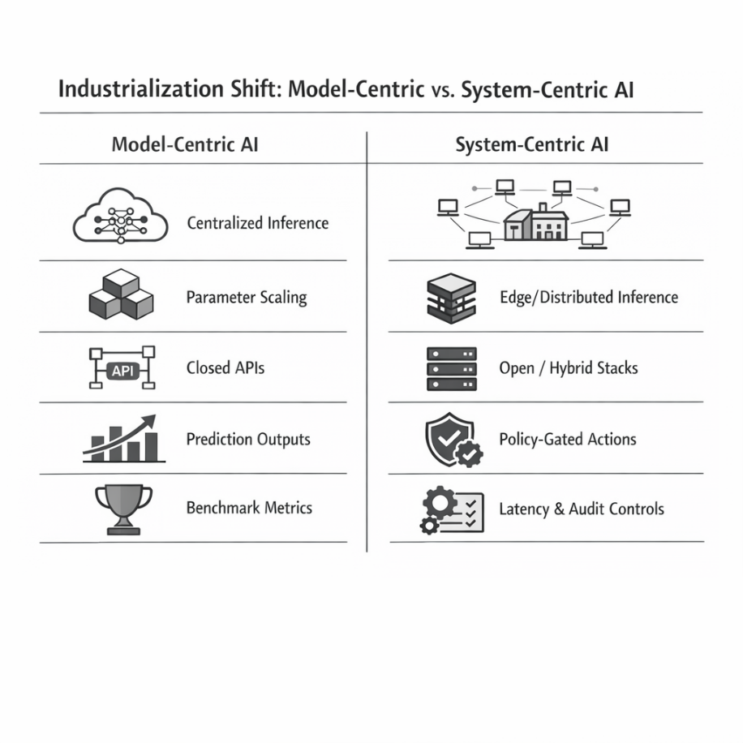
Figure 11.1 Industrial transition from model-centric to system-centric AI architectures
11.2.2 Pruning and sparsification
Pruning techniques remove parameters deemed redundant or minimally contributing to output behavior (Han, Mao and Dally 2015). Structured pruning eliminates entire attention heads, neurons, or layers, enabling hardware-level acceleration. Unstructured pruning yields sparsity patterns that reduce effective compute requirements, though exploiting this sparsity on hardware remains nontrivial.
In cybersecurity contexts, pruning must be evaluated under adversarial conditions. Removing parameters may inadvertently degrade robustness against distributional shifts or adversarial perturbations. Consequently, compression strategies must incorporate stress testing against realistic threat scenarios rather than rely solely on aggregate accuracy metrics.
Efficiency gains that compromise adversarial stability are economically counterproductive.
11.2.3 Knowledge distillation
Knowledge distillation (Hinton, Vinyals and Dean 2015) transfers behavioral characteristics from a larger "teacher" model to a smaller "student" architecture. For cybersecurity AI, distillation enables:
- Deployment of compact models fine-tuned to domain-specific threat corpora
- Reduction of dependency on large proprietary backbones
- Improved interpretability in constrained architectures
Distillation is particularly relevant for sovereign or air-gapped deployments where full-scale foundation models may be impractical due to hardware or policy constraints. A distilled model trained on internal threat intelligence can maintain contextual relevance while remaining operationally lightweight.
11.2.4 Low-rank adaptation and parameter-efficient fine-tuning
Low-rank adaptation techniques decompose weight update matrices into lower-dimensional representations, thereby significantly reducing the number of trainable parameters. Parameter-efficient fine-tuning (PEFT) frameworks enable domain adaptation without full model retraining.
For industrial cybersecurity systems, this allows:
- Rapid iteration cycles
- Lower compute budgets for fine-tuning
- Modular domain specialization
Rather than retraining entire models when threat landscapes evolve, organizations can apply incremental adapters to adjust behavioral priors. This supports continuous adaptation without destabilizing production stacks.
11.2.5 System-level implications
Compression techniques are often evaluated in isolation. Industrialization requires evaluating them holistically within the deployment architecture.
Key system-level trade-offs include:
- Latency vs. precision loss
- Memory reduction vs. robustness degradation
- Throughput scaling vs. interpretability constraints
- Energy efficiency vs. retraining complexity
The objective is not maximal compression but optimal compression relative to mission constraints.
In distributed cybersecurity environments, a moderately compressed model deployed across multiple nodes may outperform a single high-capacity centralized model in both containment speed and cost efficiency. Evaluation must therefore shift from isolated model benchmarks to integrated pipeline performance.
Efficiency engineering marks the beginning of infrastructural maturity. It redefines large models not as static monoliths but as adaptable components whose scale and precision can be tuned to the deployment topology, governance requirements, and economic constraints.
The following section extends this logic spatially: if compression makes models lighter, edge inference determines where they operate.
11.3 Edge and on-device inference
If compression reduces computational burden, edge inference redistributes computational authority.
Traditional cybersecurity AI architectures centralize inference in cloud environments. Telemetry flows from endpoints to aggregation layers, models evaluate risk centrally, and responses propagate outward. This topology simplifies orchestration but introduces structural vulnerabilities: network latency, bandwidth bottlenecks, cloud dependency, and potential data exposure.
Edge and on-device inference invert that topology.
Instead of transporting data to models, models are transported to data.
11.3.1 Latency as a security variable
In cybersecurity systems, latency is not a cosmetic performance metric. It is an exposure window.
Let:
- $T_{d}$ = detection latency
- $T_{e}$ = exploitation time
- $R$ = residual risk
In time-sensitive attack scenarios, detection latency directly influences the probability of containment. When $T_{d}>T_{e}$, containment probability declines sharply. Centralized inference introduces network-dependent delays, particularly in high-volume telemetry environments or geographically distributed infrastructures.
Deploying inference locally reduces $T_{d}$ by eliminating round-trip dependencies. Even modest reductions in latency can materially alter the probability of containment in "such conditions attack scenarios.
Edge inference, therefore, transforms response time from a network function into a local compute function.
11.3.2 Data locality and privacy boundaries
Industrial environments increasingly operate under regulatory constraints requiring strict data locality. Sensitive telemetry, especially in financial, defense, and healthcare sectors, cannot always traverse external cloud services without introducing compliance risk.
On-device inference provides:
- Reduced external data transmission
- Lower exposure of raw logs
- Improved compliance alignment
- Partial insulation from API-level telemetry capture
Rather than exporting entire log streams, systems can transmit only structured alerts or probabilistic risk scores. This reduces bandwidth while preserving operational awareness.
The architecture shifts from data export → alert export.
11.3.3 Resilience and network independence
Centralized AI systems implicitly assume network stability. In adversarial conditions (e.g., ransomware, distributed denial-of-service events, or infrastructure outages), network dependency becomes a liability.
Edge-deployed models continue functioning under partial isolation. Even if upstream services are degraded, local anomaly detection can:
- Isolate suspicious processes
- Flag anomalous privilege escalations
- Initiate bounded containment actions
Edge inference thus enhances resilience through partial autonomy.
This does not imply full independence from centralized orchestration. Instead, it establishes layered autonomy:
- Local detection and preliminary scoring
- Escalation to centralized policy engines
- Coordinated remediation when connectivity permits
Such layered control loops align with industrial reliability principles rather than monolithic model dependency.
11.3.4 Resource constraints and hardware diversity
Edge environments impose heterogeneous hardware constraints: CPUs without GPUs, limited memory, embedded chipsets, and energy-sensitive devices.
The compression techniques described in Section 11.2 are enabling prerequisites for edge viability. Quantized models and parameter-efficient adapters reduce memory footprint sufficiently to allow transformer inference on commodity hardware.
The design problem, therefore, becomes co-optimization:
- Bit-width precision
- Model size
- Throughput requirements
- Hardware capability
Edge deployment is not a single architecture, but a family of configurations tuned to device capability and threat model severity.
11.3.5 Distributed cognitive topologies
The industrial implication of edge inference is a distributed cognitive mesh.
Rather than one centralized intelligence service, cybersecurity AI becomes:
- A network of lightweight inference nodes
- Coordinated through policy frameworks
- Periodically synchronized with central model registries
This topology supports:
- Horizontal scalability
- Fault tolerance
- Reduced single-point-of-failure risk
- Gradual model updates via staged rollout
The system begins to resemble a control-plane architecture rather than a single predictive service.
Edge-native AI, therefore, represents more than performance optimization. It represents decentralization of analytical authority within enterprise infrastructure.
If compression makes AI feasible under constraints, edge inference embeds AI at the edge.
The next progression is functional: once models are distributed and efficient, they can participate directly in bounded decision loops.
Section 11.4 examines this transition toward embedded agentic security systems.
11.4 Embedded agentic security systems
Efficiency and distribution alone do not industrialize cybersecurity AI. The decisive transition occurs when models cease to function as passive classifiers and instead participate in bounded operational loops.
Traditional deployments produce probabilistic outputs. Agentic systems influence system state. The architectural shift is therefore not incremental but categorical.
An embedded agentic system operates within a structured control loop:
Telemetry → Representation → Evaluation → Policy Gate → Action → Feedback
Each stage must remain independently constrained and auditable.
11.4.1 Layered agentic architecture
Industrial deployment requires strict separation of reasoning from enforcement. A minimal layered architecture is shown below.
Layer | Function | Engineering Constraint | Industrial Constraint
Inference Layer | Feature extraction, embedding, anomaly scoring | Must be edge-native to minimize detection latency ($T_{d}$). | Latency & compute efficiency
Reasoning Layer | Hypothesis generation, correlation, context synthesis | Requires explainable outputs to prevent unclear decision-making. | Explainability & bounded scope
Policy Layer | Compliance validation, rule enforcement | Must be deterministic; models do not modify state without a policy gate. | Regulatory alignment & role authorization
Policy Layer above acts as a non-probabilistic validator
Execution Layer | Quarantine, revoke access, escalate | All actions must have a fail-safe, reversible pathway. | Reversibility & fail-safe fallback
Audit Layer | Logging, trace reconstruction, forensic review | Every state change must be traceable for post-hoc review. | Deterministic traceability
Figure 11.2 Layered agentic control plane
This separation ensures that:
- Models do not directly modify production state.
- Policy constraints remain external to model reasoning.
- Every action is reconstructible post hoc.
Agentic capability without layered separation introduces systemic instability.
As established in Section 11.2, compression techniques enable deployment under operational constraints. Their relevance here is architectural: they make agentic integration feasible. Figure 11.3 summarizes these mechanisms and their relationship to resource constraints.
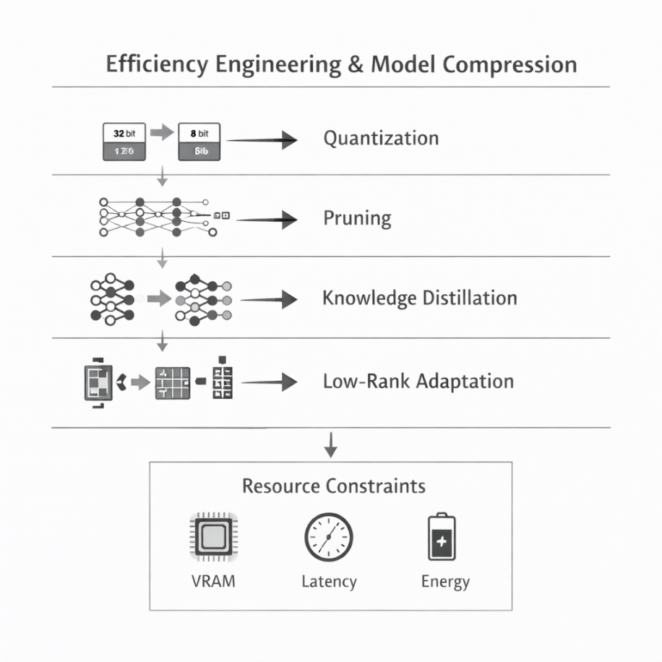
Figure 11.3 Efficiency engineering and model compression.
Architectural layers and constraints
To scale this to an industrial level, the system must separate probabilistic reasoning from deterministic enforcement.
- Inference layer (efficiency engine): Executes high-speed feature extraction and anomaly scoring using quantized, edge-native models.
- Reasoning layer (the proposer): Generates remediation hypotheses and correlates context using domain-specific distilled architectures.
- Policy layer (the gate): A non-probabilistic validator that enforces regulatory compliance and role-based authorization.
- Execution layer (the actor): Performs bounded actions (e.g., quarantine) within reversible pathways to prevent systemic instability.
- Audit layer (the record): Maintains deterministic traceability for every state change, ensuring that autonomy remains observable and accountable.
11.4.2 Mathematical formalism for the stability criterion
To formalize system stability, we define containment in terms of detection latency and exploitation time.
Let $T_{d}$ represent detection latency and $T_{e}$ represent the exploitation time of a given threat. In a centralized cloud-inference model, $T_{d}$ is a function of network round-trip time, which introduces architectural fragility. In our distributed cognitive mesh, inference is shifted to the edge to ensure:

$$T_{d}≪T_{e}$$

In centralized systems, $T_{d}$ It is subject to network entropy, making the exposure window unpredictable. By moving inference to the edge, detection latency transitions from a stochastic network-dependent variable to a bounded compute function.
This constrains the Residual Risk ($R$) remains bounded. If $T_{d}$ exceeds $T_{e}$, the system enters a failure regime in which the exposure window renders even high-accuracy models irrelevant.
11.4.3 Bounded autonomy
Bounded autonomy restricts decision authority to predefined surfaces:
- Pre-authorized remediation categories
- Confidence thresholds for escalation
- Mandatory human approval for high-impact actions
- Deterministic rollback pathways
Autonomy becomes granular rather than global.
In industrial cybersecurity, full autonomy is rarely appropriate. Controlled delegation preserves operational continuity while reducing cognitive burden on analysts.
11.4.4 Feedback stability and risk containment
Agentic systems introduce feedback dynamics. Poorly constrained loops can amplify errors:
- Over-aggressive quarantine policies
- Misclassification cascades
- Escalation storms under adversarial manipulation
Stability mechanisms include:
- Rate limiting
- Multi-signal validation
- Secondary confirmation models
- Explicit human override channels
Industrialization, therefore, requires treating autonomy as a stability-engineering problem rather than an intelligence-maximization problem.
Agentic cybersecurity systems achieve infrastructural legitimacy only when embedded within layered governance and reversible execution pathways.
With efficiency achieved and autonomy stabilized, the remaining industrial question becomes strategic: who controls the model stack?
11.5 Building secure open-source alternatives to closed AIs
Closed AI APIs accelerated experimentation by abstracting infrastructure complexity. Organizations gained access to frontier-scale models without having to manage training pipelines, weight storage, or inference clusters.
However, industrial cybersecurity systems introduce constraints that challenge exclusive reliance on proprietary endpoints:
- Data sovereignty requirements
- Audit traceability
- Long-term cost predictability
- Vendor dependency risk
- Limited visibility into training provenance
Open-source model ecosystems provide an alternative path toward architectural control.
Dependency introduces infrastructural risk. A common response is to adopt sovereign or hybrid AI architectures.
- Open-source sovereignty: Utilizing self-hosted, compressed models shifts the economic curve from per-call variable billing to fixed infrastructure amortization. Quantization techniques such as GPTQ and QLoRA enable model deployments that shift costs from per-call billing to infrastructure amortization.
- Architectural control: Open-source stacks allow for the direct inspection of model weights and the explicit configuration of quantization strategies (e.g., GPTQ or QLoRA).
- Hybrid resiliency: A pragmatic strategy uses proprietary APIs for prototyping while reserving distilled, on-device variants for mission-critical, latency-sensitive operations.
11.5.1 Control and transparency
Open-source deployments enable:
- Direct inspection of model weights
- Controlled fine-tuning on domain-specific threat corpora
- Explicit configuration of quantization and compression strategies
- Isolation within private cloud or air-gapped environments
Transparency enhances trust boundaries. In regulated sectors, demonstrating model provenance and configuration can materially influence the compliance posture.
11.5.2 Economic stability
API-based pricing models introduce usage volatility. In high-volume cybersecurity environments, inference calls scale linearly with telemetry flow.
Self-hosted compressed models shift the cost from per-call billing to infrastructure amortization. While initial deployment complexity increases, long-term cost curves may stabilize.
Industrial decision-making must therefore evaluate:
- Variable API cost models
- Fixed infrastructure expenditure
- Hardware lifecycle management
- Scaling elasticity
The economically optimal solution often becomes hybrid.
11.5.3 Hybrid architectures
A pragmatic industrial strategy frequently includes:
- Proprietary APIs for rapid prototyping and non-sensitive tasks
- Open-source compressed models for mission-critical or regulated workloads
- Edge-deployed distilled variants for latency-sensitive operations
This hybrid approach balances innovation velocity with infrastructural sovereignty.
The objective is not ideological alignment with openness but structural resilience.
With architectural control reestablished, the final question concerns trajectory. What patterns are likely to define the near-term evolution of cybersecurity AI markets?
11.6 The next three years: architectural forecast
Forecasting technological evolution requires distinguishing durable structural trends from transient hype cycles. The following developments appear structurally probable.
11.6.1 Compression becomes default
Uncompressed frontier-scale models will remain valuable in research and high-capacity cloud environments. However, industrial deployments will increasingly standardize quantized, pruned, or distilled variants as baseline configurations.
Efficiency will become an assumption rather than a differentiator.
11.6.2 Edge-native detection pipelines
Detection architectures will progressively decentralize. Local anomaly scoring, lightweight behavioral profiling, and pre-filtered alert generation will reduce centralized processing burden.
Edge-native models will operate as first-line cognitive filters rather than full analytical replacements.
11.6.3 Policy-aware agents
Agentic systems will expand, but bounded autonomy will remain the governing principle. Expect tighter integration between AI reasoning layers and formalized policy engines.
Autonomy will be permitted only within explicitly codified operational envelopes.
11.6.4 Sovereign AI architectures
Geopolitical and regulatory pressures will encourage domestic or private model hosting strategies. Organizations will invest in model registries, internal fine-tuning pipelines, and auditable deployment frameworks.
Strategic dependency on opaque external APIs will increasingly be viewed as an infrastructural risk.
11.6.5 AI as control-plane infrastructure
Cybersecurity AI will transition from analytical enhancement to structural integration. Models will be embedded within control planes, interfacing with identity systems, access management frameworks, and incident orchestration engines.
Competitive advantage will derive less from raw parameter count and more from:
- Stability
- Governance clarity
- Deployment elasticity
- Cost discipline
Industrialization does not signal the end of innovation. It signals the normalization of AI as infrastructure.
The model ceases to be the product; the system becomes the product.
Conclusion
Industrialization marks the transition from experimental capability to operational responsibility. Throughout this chapter, we examined how efficiency engineering, edge-native deployment, bounded agentic integration, and infrastructural sovereignty collectively redefine cybersecurity AI as a systems discipline rather than a model-centric pursuit.
Compression techniques recalibrate the scale under constraint. Edge inference redistributes analytical authority. Layered agentic architectures embed intelligence within governed control loops. Open-source strategies restore architectural control in environments where compliance, resilience, and economic predictability matter as much as raw performance.
The trajectory is clear: competitive advantage will not be determined by parameter count alone. It will be shaped by stability, auditability, deployment elasticity, and disciplined autonomy.
Cybersecurity AI is entering its infrastructural phase. Models will persist, improve, and evolve. However, their industrial relevance will depend on how well they are integrated into resilient, governed, and economically sustainable systems.
Industrial maturity is not the triumph of autonomy. It is the stabilization of autonomy.
Now we move to the larger closure.
Book Conclusion — AI as Infrastructure
This volume began with foundational architectures and progressed through reinforcement learning systems, governance frameworks, synthetic environments, and agentic integration. Across these domains, a consistent principle has emerged: artificial intelligence becomes transformative only when embedded within structured systems.
Early enthusiasm for AI often centered on performance metrics and benchmark supremacy. However, throughout this exploration, a deeper pattern became visible. Models do not operate in isolation. They exist within topologies (of data, policy, infrastructure, and human oversight). Their value is realized not at the moment of prediction, but at the moment of integration.
Reinforcement learning demonstrated how agents learn within constrained environments. Governance frameworks illustrated that autonomy without accountability destabilizes trust. Synthetic data pipelines showed that robustness emerges from deliberate stress testing. Industrialization revealed that scalability requires economic and architectural discipline.
The arc of this book, therefore, converges on a single conclusion:
Artificial intelligence is not merely an analytical tool. It is a structural component of modern infrastructure.
Its maturation depends less on increasing complexity and more on increasing coherence. Systems must remain observable. Actions must remain reversible. Autonomy must remain bounded. Innovation must remain accountable.
As AI continues to evolve (toward greater efficiency, deeper integration, and broader deployment), the challenge will not be to maximize capability without limit. It will be to embed capability within resilient frameworks that preserve stability, security, and governance.
The future of cybersecurity AI will not be defined by spectacle. It will be defined by disciplined architecture.
The model is not the destination.
The system is.

This volume traced the evolution of artificial intelligence from model architecture to infrastructural integration. Across reinforcement learning, governance design, synthetic environments, and industrial deployment, a consistent constraint emerged: capability without structure does not scale.
Performance is necessary.
Control is mandatory.
Integration is decisive.
Artificial intelligence becomes durable only when embedded within observable systems, bounded by policy, and stabilized through layered control loops. Autonomy that cannot be audited is unstable. A scale that cannot be governed is a liability.
The maturation of cybersecurity AI will not be measured by parameter count or benchmark acceleration, but rather by resilience under constraint.
The model is not the endpoint.
The control plane is.

References
Bommasani, Rishi, Drew A. Hudson, Ehsan Adeli, Russ Altman, Simran Arora, Sydney von Arx, Michael S. Bernstein, et al. 2021. "On the Opportunities and Risks of Foundation Models." Stanford Center for Research on Foundation Models (arXiv). doi:10.48550/arXiv.2108.07258.
Dettmers, Tim, Artidoro Pagnoni, Ari Holtzman, and Luke Zettlemoyer. 2023. "QLoRA: Efficient Finetuning of Quantized LLMs." (arXiv). doi:10.48550/arXiv.2305.14314.
Doshi-Velez, Finale, and Been Kim. 2017. "Towards A Rigorous Science of Interpretable Machine Learning." (arXiv). doi:10.48550/arXiv.1702.08608.
Frantar, Elias, Saleh Ashkboos, Torsten Hoefler, and Dan Alistarh. 2023. "SpQR: A Sparse-Quantized Representation for Near-Lossless LLM Weight Compression." (arXiv). doi:10.48550/arXiv.2306.03078.
Han, Song, Huizi Mao, and William J. Dally. 2015. "Deep Compression: Compressing Deep Neural Networks with Pruning, Trained Quantization and Huffman Coding." 4th International Conference on Learning Representations, ICLR 2016 - Conference Track Proceedings (International Conference on Learning Representations, ICLR). doi:10.48550/arXiv.1510.00149.
Hinton, Geoffrey, Oriol Vinyals, and Jeff Dean. 2015. "Distilling the Knowledge in a Neural Network." arXiv pre-print. https://arxiv.org/abs/1503.02531.
NIST. 2023. Artificial Intelligence Risk Management Framework (NIST AI 100-1). National Institute of Standards and Technology (NIST).
Satyanarayanan, Mahadev. 2017. "The Emergence of Edge Computing." Computer 50 (1): 30–39. Accessed 2 23, 2026. doi:10.1109/MC.2017.9.
Vaswani, Ashish, Noam Shazeer, Niki Parmar, Jakob Uszkoreit, Llion Jones, Aidan N. Gomez, Lukasz Kaiser und Illia Polosukhin. 2017. "Attention Is All You Need." Advances in Neural Information Processing Systems (NIPS (Curran Associates Inc.) 30: 6000–6010. doi:10.48550/arXiv.1706.03762.
Zhou, Zhi, Xu Chen, En Li, Liekang Zeng, Ke Luo, and Junshan Zhang. 2019. "Edge Intelligence: Paving the Last Mile of Artificial Intelligence with Edge Computing." (arXiv). doi:10.48550/arXiv.1905.10083.

