Chapter 5

Transfer Learning for NLP Tasks

Introduction
Transfer learning has greatly impacted natural language processing (NLP) by allowing models trained on large datasets to adapt efficiently to specific tasks. This chapter explores the potential of transfer learning within the Hugging Face Diffusers library, highlighting its efficiency, performance, and versatility. By the end of this chapter, you will understand how to use pre-trained models, fine-tune them for sentiment analysis and text classification, and implement these techniques for real-world NLP challenges.

Structure
This chapter covers the following topics:
- Introduction to transfer learning in NLP
- Techniques for transfer learning using Hugging Face Diffusers
- Practical applications and examples

Objectives
By the end of this chapter, the readers will understand the fundamentals of transfer learning in NLP and its significance, gain the ability to use pre-trained models within Hugging Face Diffusers, learn fine-tuning strategies for various NLP tasks, evaluate the performance of models adapted through transfer learning, and apply transfer learning to real-world NLP scenarios such as sentiment analysis and text classification.

Introduction to transfer learning in NLP
Transfer learning in NLP involves applying knowledge from one task to solve related but distinct tasks, thereby significantly reducing the need for substantial amounts of data and computing resources. This section outlines the key concepts, benefits, and implementation approaches.

Concept and benefits of transfer learning
Transfer learning has emerged as a powerful technique in NLP, enabling models to leverage knowledge from training on large, diverse datasets and apply it to specific tasks or datasets. This two-phase process, comprising pre-training and fine-tuning, enables models to efficiently learn general linguistic patterns and use them in specialized contexts. Pre-training involves exposing models to extensive corpora, such as Common Crawl or Wikipedia, which helps develop a foundational understanding of language. Fine-tuning then focuses the model’s capabilities on a target task, using smaller, domain-specific datasets. Transfer learning has demonstrated substantial utility in NLP, particularly for functions such as sentiment analysis, machine translation, and text summarization, where labeled data can be scarce ^{[1]} ^{[2]}.

Benefits
Transfer learning offers several advantages, making it a crucial tool for NLP tasks. By utilizing pre-trained models, practitioners can significantly improve training efficiency, enhance performance on specialized tasks, and tailor models to various applications with limited data. These advantages help address resource constraints and task-specific challenges in NLP, making transfer learning a vital part of modern AI methods.

Efficiency
Pre-trained models significantly reduce the computational effort and training time required to develop task-specific models. Instead of starting from scratch, practitioners utilize a model that already understands fundamental linguistic structures, allowing them to focus on fine-tuning. For instance, Bidirectional Encoder Representations from Transformers (BERT) minimizes the need for large, labeled datasets by leveraging pre-trained embeddings, enabling high-performance results at lower computational cost ^{[3]}. An example is the use of GPT models for sentiment analysis, where pre-training on billions of words accelerates adaptation to downstream tasks with limited data and resources.
Figure 5.1: A model is pre-trained first on a large-scale dataset, then fine-tuned with task-specific data to adapt it to downstream applications:
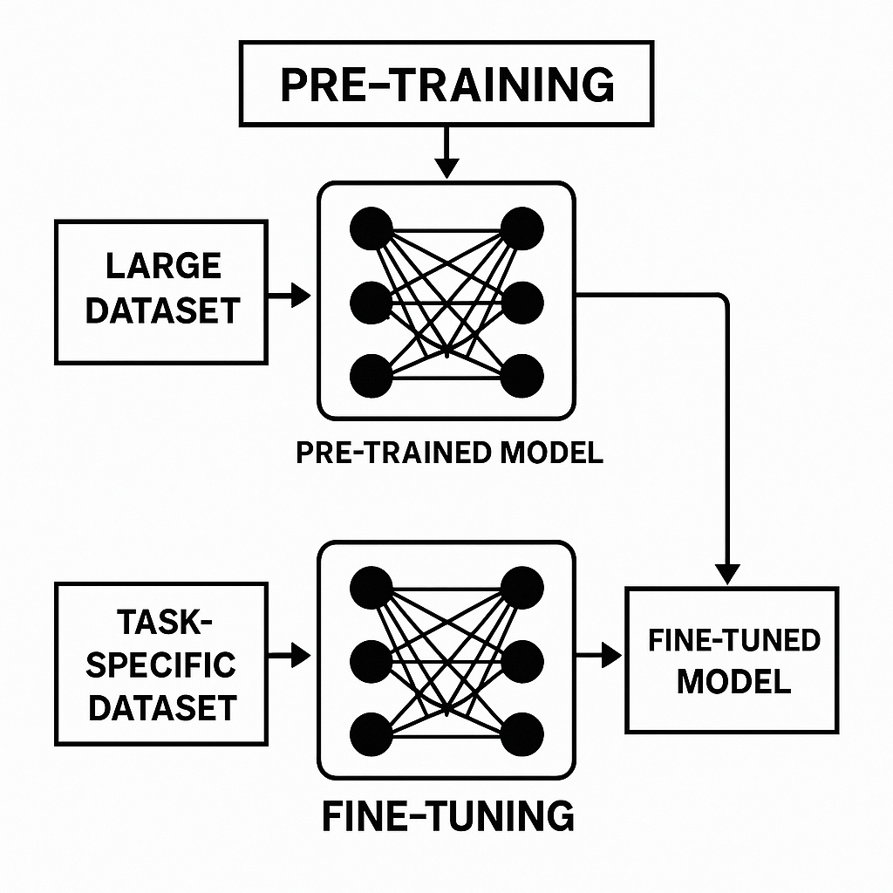
Figure 5.1: The transfer learning paradigm

Enhanced performance
Pre-trained models often show better generalization even with small datasets. This is because they have already developed a deep understanding of syntactic and semantic patterns during pre-training. For example, the Text-to-Text Transfer Transformer (T5) model achieved high accuracy in summarization and translation tasks by applying learned patterns across different datasets ^{[4]}. In applications like medical text classification, transfer learning with pre-trained language models such as BioBERT has shown significant improvements over traditional methods, even with limited labeled data ^{[5]}.

Flexibility
Transfer learning allows models to adapt to new languages, tasks, or specialized fields with minimal labeled data. This versatility is beneficial for low-resource languages or domains where annotated datasets are scarce. For example, multilingual models like Cross-lingual Language Model (XLM-R) can be fine-tuned on texts from underrepresented languages and still deliver competitive results. Similarly, in fields such as legal or financial analysis, pre-trained models can be tailored to small, focused datasets, achieving high accuracy on domain-specific tasks without extensive retraining.

Overview of transfer learning techniques
Transfer learning has become a powerful method in NLP, enabling the adaptation of pre-trained models to various tasks. By leveraging models trained on large datasets, transfer learning reduces the resources and time required for specific applications. This section discusses the primary techniques of transfer learning, explaining how they work, their benefits, and their real-world applications. ^{[3]}; ^{[4]}; ^{[2]}.

Feature extraction
Uses representations from pre-trained models as features for new models. Feature extraction leverages the knowledge embedded in pre-trained models to represent data in a new context. Instead of training a model from scratch, pre-trained representations are used as input features for task-specific models. For example, the embedding generated by models like BERT or GPT can serve as high-quality inputs for classifiers, enabling strong performance with minimal additional training. In sentiment analysis, for instance, BERT’s contextual embeddings have been used to predict sentiment polarity accurately, even with small datasets accurately ^{[3]}. Similarly, in named entity recognition (NER), pre-trained embeddings recognize linguistic patterns that facilitate downstream learning more easily ^{[2]}.

Fine-tuning
Updates the weights of a pre-trained model using task-specific data. Fine-tuning adjusts the model's parameters with this data, helping it adapt to specific needs. This process updates all or selected layers of the model during training. For example, the T5 model, pre-trained on a diverse corpus, achieved top performance in tasks like summarization and translation by fine-tuning on task-specific datasets ^{[4]}. Fine-tuning has also been applied in specialized fields, such as medical NLP, where BioBERT enhanced its results by adjusting its weights for clinical text analysis ^{[5]}.

Layer freezing
Layer freezing involves keeping specific layers of a pre-trained model fixed while fine-tuning other layers for a particular task. This method is beneficial when computational resources are limited or when the task closely aligns with the model’s original purpose. For example, in text classification tasks, the early layers of a pre-trained model, such as GPT-3, which capture general linguistic features, can be frozen. Meanwhile, the task-specific layers are fine-tuned to improve performance. This approach is practical in low-resource languages, where the available training data is insufficient to train a model fully ^{[6]}. Additionally, layer freezing reduces the risk of overfitting, as static layers preserve the general patterns learned during pre-training.
Each of these techniques plays a distinct role in transfer learning, offering solutions for adapting pre-trained models to various tasks and datasets. By understanding and applying these methods, practitioners can unlock the full potential of transfer learning in NLP.

Applications for transfer learning
Transfer learning has proven to be a valuable tool across various NLP applications, allowing models to be adapted for specific tasks and contexts. By utilizing pre-trained models, practitioners can achieve high accuracy and efficiency even with limited labeled data. This section examines two primary applications: language adaptation and sentiment analysis, and illustrates how transfer learning advances progress in these fields ^{[3]}; ^{[4]}; ^{[6]}.

Language adaptation
Adapting models for different languages or dialects using minimal linguistic data has been a breakthrough in NLP. Multilingual models like XLM-R and mBERT have been designed to handle text in multiple languages, enabling effective knowledge transfer across linguistic boundaries ^{[6]}. For example, mBERT, trained on data from over 100 languages, can be fine-tuned on small datasets of low-resource languages, such as Swahili, to perform tasks like part-of-speech tagging or machine translation. Likewise, XLM-R has demonstrated remarkable performance on cross-lingual tasks, including NER and question-answering. Using embeddings from these pre-trained models, researchers have also addressed challenges related to dialectal variation within the same language. For instance, fine-tuning mBERT on regional Arabic dialects enables accurate text classification, thereby helping close linguistic gaps in underrepresented communities ^{[7]}.
Trained on data from over a hundred languages, it can be fine-tuned on small datasets of low-resource languages, such as Swahili, to perform tasks like part-of-speech tagging or machine translation. Similarly, XLM-R has demonstrated exceptional performance on cross-lingual tasks, including NER and question-answering. By using embeddings from these pre-trained models, researchers have also addressed challenges posed by dialectal variation within the same language. For example, fine-tuning mBERT on regional Arabic dialects enables accurate text classification, helping bridge language gaps in underserved communities. To better understand how a transformer performs sentiment classification, Figure 5.2 shows the architecture of a fine-tuned BERT model applied to a single review, using Hugging Face. Input sequences are tokenized and passed through BERT layers to predict sentiment categories.
-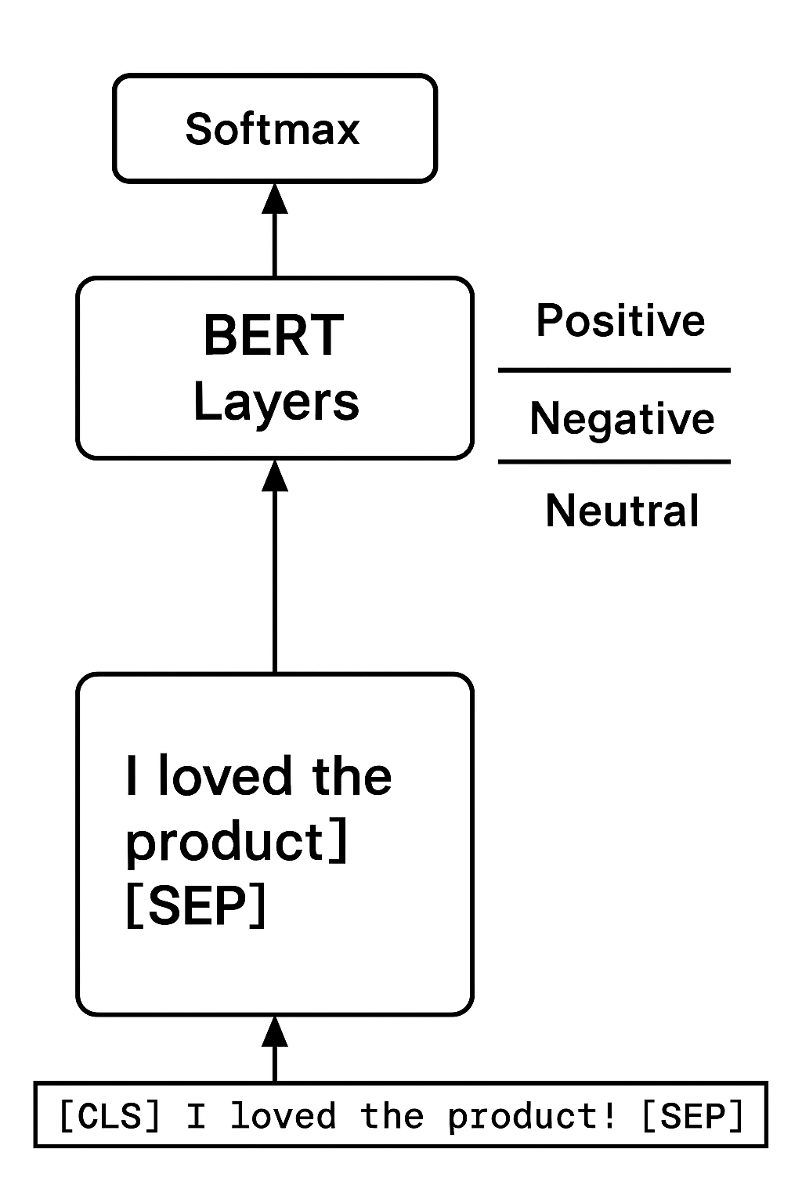
Figure 5.2: Architecture of a fine-tuned transformer model for sentiment classification

Sentiment analysis
Refining a general language model with sentiment-specific datasets improves sentiment detection accuracy. Sentiment analysis benefits significantly from transfer learning, fine-tuning pre-trained models such as BERT or RoBERTa on labeled datasets, such as IMDb movie reviews or Twitter sentiment data, to achieve high-precision sentiment detection ^{[3]}. For example, BERT, fine-tuned on a large set of product reviews, has been used to classify sentiment as positive, negative, or neutral in customer feedback systems. Furthermore, domain-specific models like SciBERT and BioBERT have been adapted for sentiment analysis in specialized domains, such as scientific literature and clinical text, yielding superior results compared to traditional methods ^{[5]}. A practical example includes fine-tuning RoBERTa on a dataset of political tweets to assess public opinion trends, displaying transfer learning’s ability to adapt to diverse sentiment analysis needs.

Fine-tuning sentiment analysis
Sentiment analysis is one of the most widely used applications of NLP, particularly in domains like customer feedback analysis, social media monitoring, and market research. Transfer learning, enabled by models like BERT, allows high accuracy in sentiment classification by leveraging pre-trained knowledge and adapting it to specific tasks. Fine-tuning BERT for sentiment analysis on a custom dataset enhances its ability to find subtle sentiment patterns in textual data. The following example demonstrates the step-by-step process of fine-tuning a BERT model to classify product reviews as positive, negative, or neutral, illustrating its adaptability to various sentiment-related use cases ^{[3]}, ^{[4]}.
```python

from transformers import BertForSequenceClassification, BertTokenizer, Trainer, TrainingArguments
from datasets import Dataset

# Prepare a custom dataset
data = {"text": ["Great product!", "Terrible service.", "Average experience."],
"label": [0, 1, 2]} # 0: Positive, 1: Negative, 2: Neutral
dataset = Dataset.from_dict(data)

# Load tokenizer and model
tokenizer = BertTokenizer.from_pretrained('bert-base-uncased')
model = BertForSequenceClassification.from_pretrained('bert-base-uncased', num_labels=3)

# Tokenize data
def tokenize_data(example):
return tokenizer(example['text'], truncation=True, padding='max_length')
dataset = dataset.map(tokenize_data, batched=True)

# Define training arguments
training_args = TrainingArguments(
output_dir='./results',
num_train_epochs=3,
per_device_train_batch_size=8,
logging_dir='./logs'
)

# Initialize trainer
trainer = Trainer(
model=model,
args=training_args,
train_dataset=dataset
)

# Fine-tune the model
trainer.train()
```
This example illustrates the process of fine-tuning a BERT model using a small, custom dataset containing three sample product reviews, each labeled as positive, negative, or neutral. First, a custom dataset is created and formatted for compatibility with the Hugging Face library. The Dataset.from_dict method then organizes the text data along with its sentiment labels.
The BERT tokenizer preprocesses the input text, ensuring each review is tokenized, truncated, or padded as needed to maintain a consistent input size. This preprocessing step ensures compatibility with the pre-trained BERT model.
The model, BertForSequenceClassification, utilizes the bert-base-uncased architecture, which is pre-trained on general language understanding tasks. For this specific application, the model is configured to categorize inputs into three sentiment categories.
Fine-tuning is orchestrated using the Trainer class provided by Hugging Face, which simplifies the training pipeline. Training parameters, such as the number of epochs, batch size, and logging configuration, are specified via the TrainingArguments object. The trainer.train() method then executes the fine-tuning process, adjusting the model's weights to improve sentiment classification.
This method leverages BERT's pre-trained embeddings, which already encode general language patterns, making the model highly effective even with limited labeled data. Expanding this setup to larger datasets or across multiple epochs would further improve performance and generalization ^{[3]}. This process exemplifies BERT's adaptability in real-world sentiment analysis tasks, providing a robust solution for understanding consumer opinions across diverse contexts.

Techniques for transfer learning using Hugging Face Diffusers
Transfer learning has become a crucial method for adapting pre-trained language models to specialized NLP tasks. The Hugging Face Diffusers library offers a range of tools and models optimized for transfer learning, allowing practitioners to fine-tune pre-trained architectures effectively. This section covers key techniques and considerations, such as model selection, fine-tuning strategies, and practical constraints, to maximize the benefits of transfer learning ^{[3]}; ^{[4]}.

Model selection and adaptation
Selecting a suitable pre-trained model is a foundational step in transfer learning, as it establishes a baseline for downstream task capabilities and scalability. The process requires aligning model attributes with task-specific requirements and resource constraints.

Model suitability
For a more precise understanding, models like BERT excel at specific tasks, while GPT models are best suited for generative functions. Different models perform well on tasks depending on their architecture and training goals. For instance, BERT is ideal for tasks that require deep understanding of context, such as NER or question answering ^{[3]}. On the other hand, GPT models, designed for autoregressive token prediction, are well-suited for generative tasks such as text summarization or chatbot development ^{[8]}. For example, in summarization tasks, T5 has demonstrated exceptional accuracy by treating all tasks in a unified text-to-text framework ^{[4]}.

Model size
Balancing performance with computational resources is crucial when selecting model sizes. Larger models, such as GPT-3, offer superior performance but require substantial memory and processing power. Conversely, more minor variants, such as DistilBERT, provide faster inference speeds with reduced computational requirements, making them suitable for edge deployments or resource-constrained environments ^{[9]}. A practical scenario includes deploying DistilBERT on mobile devices for real-time text classification, where efficiency outweighs the marginal accuracy trade-off.

Domain-specific models
Domain-adapted models offer tailored solutions for specialized fields, including medical, legal, and financial text processing. Models like BioBERT, trained on biomedical literature, outperform general-purpose models on tasks such as disease diagnosis and drug interaction prediction ^{[5]}. Similarly, LegalBERT, pre-trained on legal texts, excels in contract analysis and case law classification ^{[10]}. For instance, fine-tuning BioBERT on clinical trial datasets enables exact classification of drug efficacy reports, illustrating the advantages of domain adaptation.
By carefully selecting and customizing pre-trained models, practitioners can achieve optimal performance while meeting specific task requirements and resource limitations. The Hugging Face Diffusers library makes this process easier by providing access to a wide range of models and fine-tuning tools for various NLP applications.

Fine-tuning strategies for different NLP tasks
Fine-tuning pre-trained models is a crucial step in applying their broad language understanding to specific tasks such as sentiment analysis, text summarization, or machine translation. This process involves adjusting parameters, regularizing training, and efficiently managing resources to achieve optimal performance. By customizing the fine-tuning process for each task, practitioners can maximize the value of pre-trained embeddings and effectively handle task-specific challenges. The following strategies highlight best practices for fine-tuning models, supported by examples and recent NLP research ^{[3]}; ^{[4]}:
- Learning rate adjustment:
When fine-tuning large pre-trained transformer models, the learning rate becomes the most sensitive control variable governing the stability–plasticity trade-off: too high, and the model catastrophically overwrites pre-trained linguistic representations; too low, and task-specific adaptation stagnates. Unlike training from scratch, fine-tuning operates in a narrow optimization corridor where gradient magnitudes must be carefully constrained to preserve semantic structure while allowing task alignment.
For BERT-family models applied to supervised NLP tasks such as text classification or sequence labeling, empirical studies consistently place stable fine-tuning in the low learning-rate regime, typically within the range of $2 × 10^{-5}$ to $5 × 10⁻⁵$ ^{[3]}. This range reflects the balance between convergence speed and representational preservation observed across GLUE-style benchmarks and real-world domain adaptation tasks.
Beyond static rates, adaptive learning-rate scheduling plays a critical stabilizing role. Linear warm-up schedules, where the learning rate increases gradually during the initial optimization steps before transitioning into decay, mitigate early-stage gradient shocks that otherwise destabilize higher transformer layers. This is particularly important for deep encoder stacks, where early updates propagate nonlinearly through self-attention blocks and layer normalization.
In practice, learning-rate policy selection becomes an architectural decision rather than a mere hyperparameter tweak. For example, low-resource NER fine-tuning may favor conservative warm-up with slow decay. In contrast, large-scale instruction tuning may tolerate more aggressive early adaptation when combined with gradient clipping and mixed-precision training.
- Epoch and batch size:
Choosing the proper number of epochs and batch size is crucial for balancing computational efficiency and model performance. Fewer epochs may lead to underfitting, where the model fails to capture task-specific patterns, while excessive epochs risk overfitting, where the model becomes overly tailored to the training data and performs poorly on unseen examples.
For instance, when fine-tuning GPT models for text generation, two to five epochs typically suffice, especially with large datasets. A smaller batch size, such as 16 or 32, can also help when memory constraints exist, as is often the case with high-dimensional transformer models. However, smaller batches may require compensatory adjustments, such as gradient accumulation, to keep effective learning rates and training dynamics ^{[8]}.
- Regularization techniques:
Regularization methods, such as dropout and layer freezing, are essential for improving generalization during fine-tuning. Dropout randomly turns off some of the model’s neurons during training, reducing the risk of overfitting by preventing the model from relying too heavily on specific features ^{[11]}. This technique is beneficial for tasks with limited labeled data.
Layer freezing is another effective strategy, particularly when adapting pre-trained models to tasks closely related to the original training data. By freezing earlier layers and fine-tuning only the top layers, the model keeps its foundational language representations while adapting the final layers to task-specific features. For example, when fine-tuning BioBERT for medical text classification, freezing the lower layers enables the model to retain its understanding of medical terminology while adapting to specific diagnostic categories ^{[5]}.
Together, these strategies form a comprehensive toolkit for fine-tuning NLP models. By adjusting learning rates, improving training configurations, and applying regularization techniques, practitioners can achieve high performance across a diverse range of NLP tasks while minimizing computational overhead.
Transfer learning is not just a shortcut; it is a transformation. In the Hugging Face Diffusers ecosystem, pre-trained language models develop into adaptable tools, refined for domain-specific accuracy through careful architecture choice, calibrated learning rates, and precise fine-tuning. Whether deploying BioBERT to interpret clinical trial records or compressing a compact BERT variation for mobile inference (Figure 6.3 shows a visual comparison), the relationship between model type and tuning strategy becomes a precise instrument, enhancing relevance, reducing overhead, and pushing the boundaries of what is possible in NLP. The following section explores these mechanisms in action: BioBERT represents a domain-specific, fine-tuned architecture optimized for clinical NLP tasks, while DistilBERT exemplifies model compression for efficient deployment on resource-constrained environments, such as mobile devices.
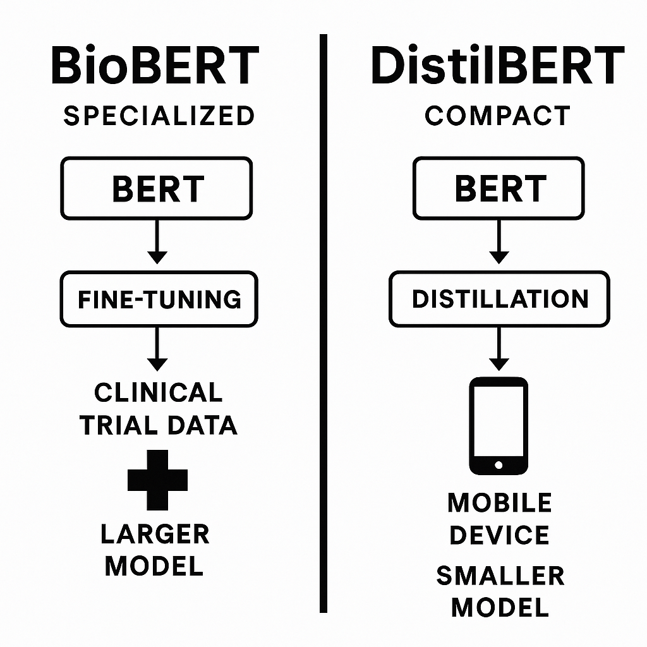
Figure 5.3: Comparison of BioBERT and DistilBERT within the transfer learning paradigm

Example of fine-tuning a BERT model for entity recognition
NER is a crucial task in NLP that identifies and categorizes entities, including names, organizations, locations, and dates, within text. Fine-tuning a pre-trained BERT model for entity recognition enables practitioners to tailor the model's language understanding to this specific task. The following script shows the fine-tuning process using the well-known CoNLL-2003 dataset. This dataset includes labeled text for entities, making it ideal for training and testing NER models. The Hugging transformers library offers powerful tools to simplify the fine-tuning process ^{[3]}.
`python
from transformers import BertTokenizer, BertForTokenClassification, Trainer, TrainingArguments
from datasets import load_dataset

# Load tokenizer and model
tokenizer = BertTokenizer.from_pretrained('bert-base-cased')
model = BertForTokenClassification.from_pretrained('bert-base-cased', num_labels=9)

# Load and preprocess dataset
dataset = load_dataset("conll2003")
def tokenize_and_align_labels(examples):
tokenized_inputs = tokenizer(examples['tokens'], truncation=True, padding='max_length', is_split_into_words=True)
labels = []
for i, label in enumerate(examples['ner_tags']):
word_ids = tokenized_inputs.word_ids(batch_index=i)
label_ids = [label[word_idx] if word_idx is not None else -100 for word_idx in word_ids]
labels.append(label_ids)
tokenized_inputs['labels'] = labels
return tokenized_inputs
dataset = dataset.map(tokenize_and_align_labels, batched=True)

# Define training arguments
training_args = TrainingArguments(
output_dir='./results',
num_train_epochs=3,
per_device_train_batch_size=16,
learning_rate=2e-5
)

# Initialize trainer
trainer = Trainer(
model=model,
args=training_args,
train_dataset=dataset['train'],
eval_dataset=dataset['validation']
)

# Train the model
trainer.train()
```
The script begins by loading a pre-trained BERT model (bert-base-cased) and its corresponding tokenizer. BERT is particularly well-suited for token-level tasks such as NER because it encodes contextualized representations for each token. Then, the model configuration is executed for token classification with a specified number of labels (num_labels=9), corresponding to the entity categories in the dataset.
The CoNLL-2003 dataset is loaded and preprocessed. Tokenization is a crucial step that transforms raw text into tokenized inputs that the model can handle. The function tokenize_and_align_labels makes sure that tokens are correctly aligned with their corresponding labels. This step is necessary because tokenization often splits words into sub-word units, so careful alignment is needed to maintain label consistency. The preprocessing function uses the word_ids method to map labels to the correct tokens, assigning an exclusive value (-100) to tokens that should be ignored during loss calculation.
Training arguments are defined using the TrainingArguments class. Key hyperparameters include the number of epochs (num_train_epochs=3), batch size (per_device_train_batch_size=16), and learning rate (learning_rate=2e-5). These parameters are carefully chosen to strike a balance between computational efficiency and model performance, as overfitting can occur in token-level tasks with small datasets ^{[4]}.
The Trainer class makes fine-tuning easier by handling the training loop, gradient updates, and evaluation. The script designates the training and validation datasets, enabling the trainer to optimize the model while monitoring performance on a holdout set. The training process involves updating BERT's pre-trained weights to improve its predictions for NER-specific labels, leveraging knowledge from large pre-training corpora.
The model is fine-tuned over three epochs, during which the weights are updated to minimize the classification loss for each token. The training loop refines the model's parameters to better classify entities on unseen data. After training, the fine-tuned model can be used to predict entities in text, achieving high performance on entity recognition tasks with minimal additional training.

Practical applications and examples
Practical applications and case studies give tangible examples of how transfer learning can be effectively employed to address specific NLP challenges. By examining real-world scenarios, readers can gain insights into how theoretical concepts translate into actionable strategies, enabling the adaptation of pre-trained models for diverse tasks.

Fine-tuning for sentiment analysis
Case study: A company uses sentiment analysis to check customer opinions on products through social media. Transfer learning fine-tunes a general model to capture subtle differences in sentiment within its domain.
NER is a core NLP task that identifies and categorizes entities, such as names, organizations, locations, and dates, within a text. Fine-tuning a pre-trained BERT model for entity recognition allows practitioners to adapt the model's language understanding to this specific task. The following script proves the fine-tuning process using the widely recognized CoNLL-2003 dataset. This dataset includes annotated text for entities, making it ideal for training and evaluating NER models. The Hugging Face transformers library provides robust tools to streamline the fine-tuning process ^{[3]}.
```python

from transformers import BertForSequenceClassification, BertTokenizer, Trainer, TrainingArguments
from datasets import load_dataset

# Load tokenizer and model
tokenizer = BertTokenizer.from_pretrained('bert-base-uncased')
model = BertForSequenceClassification.from_pretrained('bert-base-uncased', num_labels=2)

# Load and preprocess dataset
dataset = load_dataset('glue', 'sst2')
dataset = dataset.map(lambda e: tokenizer(e['sentence'], truncation=True, padding='max_length'), batched=True)

# Define training arguments
training_args = TrainingArguments(
output_dir='./model_save',
num_train_epochs=3,
per_device_train_batch_size=16
)
# Initialize trainer
trainer = Trainer(
model=model,
args=training_args,
train_dataset=dataset['train'],
eval_dataset=dataset['validation']
)
# Fine-tune the model
trainer.train()
```
The script begins by loading a pre-trained BERT model (bert-base-cased) and its corresponding tokenizer. BERT is particularly well-suited for token-level tasks, such as NER, because it encodes contextualized representations for each token. It then configures the model for token classification with a specified number of labels (num_labels=9), corresponding to the entity categories in the dataset.
The CoNLL-2003 dataset is loaded and preprocessed. Tokenization is a critical step that converts raw text into tokenized inputs that the model can process. The function tokenize_and_align_labels ensures that tokens are correctly aligned with their corresponding labels. This step is necessary because tokenization often splits words into subword units, requiring careful alignment to keep label consistency. The preprocessing function utilizes the word_ids method to map labels to the corresponding tokens, assigning a special value (-100) to tokens that should be ignored during loss computation.
Training arguments are defined using the TrainingArguments class. Key hyperparameters include the number of epochs (num_train_epochs=3), batch size (per_device_train_batch_size=16), and learning rate (learning_rate=2e-5). These parameters are carefully chosen to strike a balance between computational efficiency and model performance, as overfitting can occur in token-level tasks with small datasets ^{[1]}.
The Trainer class simplifies the fine-tuning process by managing the training loop, gradient updates, and evaluation. The script specifies the training and validation datasets, allowing the trainer to fine-tune the model while watching performance on a holdout set. The training process involves fine-tuning BERT's pre-trained weights to improve its predictions for NER-specific labels, leveraging information captured during pre-training on large corpora.
The model is fine-tuned over three epochs, during which the weights are updated to minimize the classification loss for each token. The training loop optimizes the model's parameters to improve its ability to accurately classify entities on unseen data. Upon completion, the fine-tuned model can be used to predict entities in text, achieving high performance on entity recognition tasks with minimal added training.
These examples demonstrate the adaptability of pre-trained transformers, such as BERT, to downstream tasks, highlighting the efficiency and effectiveness of transfer learning for specialized NLP applications. By leveraging established libraries and datasets, practitioners can achieve state-of-the-art results in tasks such as NER with straightforward implementations.

Case study of fine-tuning for text classification
Text classification is a foundational task in NLP that involves categorizing text into predefined categories, such as topics or sentiments. This capability is crucial for applications such as sentiment analysis, spam detection, and news categorization. In the following example, we focus on fine-tuning the pre-trained transformer model DistilBERT to classify news articles into topics such as sports, politics, and technology. The AG News dataset, a widely recognized benchmark for multi-class text classification, provides the labeled data needed for this task ^{[12]}.
```python

from transformers import AutoModelForSequenceClassification, AutoTokenizer, Trainer, TrainingArguments
from datasets import load_dataset

# Load tokenizer and model
tokenizer = AutoTokenizer.from_pretrained('distilbert-base-uncased')
model = AutoModelForSequenceClassification.from_pretrained('distilbert-base-uncased', num_labels=3)

# Prepare dataset
dataset = load_dataset('ag_news')
dataset = dataset.map(lambda e: {'labels': e['label'], **tokenizer(e['text'], padding='max_length', truncation=True)}, batched=True)

# Define training arguments
training_args = TrainingArguments(
output_dir='./results',
num_train_epochs=4,
per_device_train_batch_size=8
)

# Initialize trainer
trainer = Trainer(
model=model,
args=training_args,
train_dataset=dataset['train'],
eval_dataset=dataset['test']
)

# Fine-tune the model
trainer.train()
```
The script starts by loading the DistilBERT model and its tokenizer. DistilBERT is a smaller, faster version of BERT that retains some of its language understanding capabilities while being more efficient computationally ^{[9]}. This makes it an excellent choice for tasks that need both performance and speed. The model is configured for sequence classification, with three output labels corresponding to the topics in the AG News dataset.
The AG News dataset is loaded using the Hugging Face datasets library. Each news article is labeled with one of the three topics. To prepare the dataset for training, the map function applies a lambda function that tokenizes the text and assigns the corresponding labels. Tokenization converts the raw text into input formats suitable for the model, including token IDs and attention masks. Padding and truncation ensure that all sequences conform to the model's maximum input length.
Training arguments are defined using the TrainingArguments class. Key hyperparameters include the number of epochs (num_train_epochs=4) and batch size (per_device_train_batch_size=8). The output directory for saving the fine-tuned model and logging configuration is also specified. These parameters are chosen to strike a balance between computational efficiency and the model's ability to generalize well to unseen data.
The Trainer class from the Hugging Face transformers library is used to manage the fine-tuning process. It simplifies the training pipeline by handling tasks such as gradient updates, loss computation, and evaluation. The script specifies the training and evaluation datasets, enabling the trainer to check performance metrics on the test set during training.
The fine-tuning process adjusts the pre-trained DistilBERT weights to improve its classification performance on the AG News dataset. This involves updating the model's parameters to minimize the classification loss for each example in the dataset. By leveraging the language understanding capabilities acquired during pre-training, the model efficiently adapts to the task of topic classification.
Upon completion of the fine-tuning process, the model is ready to classify news articles into topics with high accuracy. This script demonstrates the power of transfer learning and the utility of pre-trained transformer models, such as DistilBERT, for real-world NLP tasks. By starting with a model already trained on extensive language data, practitioners can achieve ultramodern results in text classification with minimal computational resources and training time.

Application example of adapting a DistilBERT model
Fine-tuning pre-trained transformer models, such as DistilBERT, offers an efficient approach to customizing NLP systems for specific tasks, like categorizing research articles. This example illustrates how to adapt DistilBERT for classifying articles into topics like machine learning (ML), Data Science, and AI Ethics. By using the language to understand capabilities developed during pre-training, the model can be tailored to meet the subtle demands of specialized applications in academic or professional domains ^{[9]}.
```python

from transformers import AutoModelForSequenceClassification, AutoTokenizer, Trainer, TrainingArguments
from datasets import Dataset

# Prepare a sample dataset
data = {"text": ["Deep learning advances.", "Ethical concerns in AI.", "Data preprocessing techniques."
"label": [0, 1, 2]} # 0: Machine Learning, 1: AI Ethics, 2: Data Science
dataset = Dataset.from_dict(data)

# Load tokenizer and model
tokenizer = AutoTokenizer.from_pretrained('distilbert-base-uncased')
model = AutoModelForSequenceClassification.from_pretrained('distilbert-base-uncased', num_labels=3)

# Tokenize data
dataset = dataset.map(lambda e: tokenizer(e['text'], truncation=True, padding='max_length'), batched=True)

# Define training arguments
training_args = TrainingArguments(
output_dir='./results',
num_train_epochs=3,
per_device_train_batch_size=8,
logging_dir='./logs'
)

# Initialize trainer
trainer = Trainer(
model=model,
args=training_args,
train_dataset=dataset
)

# Fine-tune the model
trainer.train()
```
The script begins by creating a sample dataset containing text snippets and their associated labels. Each label belongs to one of the predefined categories. Although this example uses a small dataset for illustration, practitioners can expand it with more varied and extensive examples to enhance performance.
The Hugging Face transformers library provides the DistilBERT tokenizer and model. The tokenizer processes the input text, converting it into token IDs and attention masks required by the model. Tokenization ensures that the textual data aligns with DistilBERT's input specifications. The pre-trained model is configured for sequence classification with three output labels corresponding to the dataset's categories.
The dataset is preprocessed using the map function, which applies a lambda function to tokenize the text. Truncation and padding ensure that all inputs conform to DistilBERT's maximum sequence length. This step standardizes the data for training, enabling efficient batch processing during fine-tuning.
The TrainingArguments class defines key hyperparameters for the fine-tuning process, such as the number of epochs (num_train_epochs=3) and the batch size (per_device_train_batch_size=8). The output_dir parameter specifies where the fine-tuned model and logs will be saved, while the logging_dir parameter defines the location for training logs.
The Hugging Face Trainer class manages the fine-tuning pipeline, streamlining tasks like gradient updates, loss computation, and evaluation. The script specifies the training dataset, enabling the trainer to improve the model's weights to minimize classification loss. The fine-tuning process adjusts the model's parameters to align its predictions with the dataset's labels.
After training, the model is fine-tuned to classify research articles into the specified categories with high accuracy. This example demonstrates DistilBERT's adaptability for specialized text classification tasks. By starting with a pre-trained model, practitioners can achieve ultramodern performance with minimal computational overhead and significantly reduced training time.
The following illustration demonstrates how a pre-trained DistilBERT model can be efficiently adapted to classify research articles into specialized academic topics using Hugging Face’s fine-tuning pipeline. Text samples are tokenized and processed through a pre-trained model, then fine-tuned with task-specific labels to categorize content into domains such as ML, AI Ethics, and Data Science.
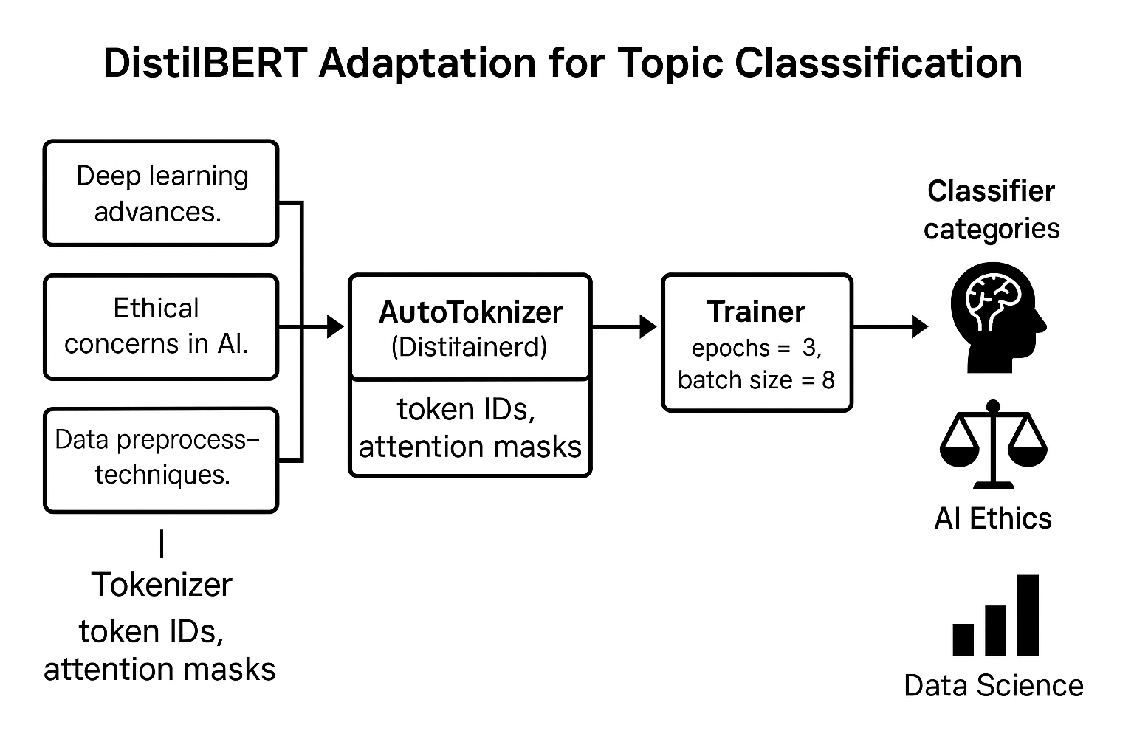
Figure 5.4: Fine-tuning DistilBERT for topic classification.

The flexibility of this approach makes it suitable for a wide range of applications, including categorizing academic publications, organizing professional documents, or even creating domain-specific search engines. With more labeled data and careful hyperparameter tuning, the model can be further fine-tuned to manage more complex classification scenarios, such as multi-label categorization or hierarchical taxonomy.

Experimentation with model comparison for sentiment analysis
When selecting a model for NLP tasks, it is crucial to consider the trade-offs between speed, accuracy, and computational resources. This example demonstrates how to compare the performance of multiple pre-trained transformer models, such as BERT, RoBERTa, and DistilBERT, on a sentiment analysis task. By systematically examining their performance metrics, practitioners can determine the most suitable model for their specific use case ^{[3]}, ^{[13]}, ^{[9]}.
The script uses the Hugging Face transformers library and its pipeline feature, making it easier to implement various NLP tasks. In this case, the sentiment analysis pipeline is configured with multiple pre-trained models from the Hugging Face model hub. The pre-trained models include:
- BERT: Known for its bidirectional understanding of language and robust performance across diverse NLP tasks.
- RoBERTa: A robustly optimized variant of BERT, designed to manage larger datasets and longer training durations, improving accuracy in different tasks.
- DistilBERT: A distilled version of BERT, which is smaller and faster while keeping comparable accuracy for different applications.
The script iterates over the selected models, applying each to a sample sentiment analysis task. The input text, The product is fantastic!, is processed through the pipeline, and the results are displayed for each model. This approach enables direct comparison of model outputs and serves as a starting point for a more detailed performance evaluation.
```python

from transformers import pipeline
# Load different models
models = ['bert-base-uncased', 'roberta-base', 'distilbert-base-uncased']
for model_name in models:
sentiment_model = pipeline('sentiment-analysis', model=model_name)
print(f"Results for {model_name}:")
print(sentiment_model("The product is fantastic!"))
```
This script provides a first comparison of model outputs for a single input. Refer to the following list to conduct a comprehensive evaluation:
- Dataset consistency: Fine-tune all models on the same sentiment analysis dataset, ensuring that performance differences are attributable to model architecture rather than training data inconsistencies.
- Evaluation metrics: Compare metrics such as accuracy, F1-score, precision, recall, and training/inference times. For example, RoBERTa might yield higher accuracy but require more computational resources than DistilBERT.
- Resource constraints: Consider the trade-offs between performance and efficiency. Models like DistilBERT are ideal for real-time applications with limited resources, whereas BERT and RoBERTa may be better suited for scenarios that prioritize accuracy over speed.
This experimentation highlights the strengths and limitations of various transformer models, enabling practitioners to make informed decisions tailored to their specific operational requirements. By documenting and analyzing these results, one can find the most proper model for deployment in practical applications. For instance, a balance between accuracy and computational efficiency may favor DistilBERT on mobile platforms, while RoBERTa might excel in cloud-based environments with abundant resources.

Layer freezing experimentation
Layer freezing is a transfer learning technique that limits updates to specific layers of a pre-trained model during fine-tuning. This method can significantly reduce training time and computational needs while maintaining the pre-trained model's broad language understanding ^{[3]}. However, it also limits the model's ability to adapt to task-specific nuances, underscoring the importance of experimenting with layer freezing to balance efficiency and flexibility.
The following code demonstrates how to apply layer freezing to fine-tune a BERT model for sentiment analysis. The example utilizes a small dataset of text samples categorized into three sentiment categories: positive, negative, and neutral. The primary objective of this implementation is to freeze all layers of the BERT model, except for the classification head, thereby ensuring that the pre-trained language representations remain unchanged. At the same time, the classifier adapts to the task.
```python

from transformers import BertForSequenceClassification, BertTokenizer, Trainer, TrainingArguments
from datasets import Dataset

# Prepare a small dataset
data = {"text": ["Amazing experience.", "Horrible outcome.", "Decent results."],
"label": [0, 1, 2]} # 0: Positive, 1: Negative, 2: Neutral
dataset = Dataset.from_dict(data)

# Load tokenizer and model
tokenizer = BertTokenizer.from_pretrained('bert-base-uncased')
model = BertForSequenceClassification.from_pretrained('bert-base-uncased', num_labels=3)

# Freeze all layers except the classification head
for param in model. bert.parameters():
param.requires_grad = False

# Tokenize data
dataset = dataset.map(lambda e: tokenizer(e['text'], truncation=True, padding='max_length'), batched=True)

# Define training arguments
training_args = TrainingArguments(
output_dir='./results',
num_train_epochs=3,
per_device_train_batch_size=8
)
# Initialize trainer
trainer = Trainer(
model=model,
args=training_args,
train_dataset=dataset
)
# Fine-tune the model
trainer.train()
```
This example illustrates the steps involved in freezing layers and fine-tuning a model for a specific task:
- Dataset preparation: It creates a small dataset with text samples and their corresponding sentiment labels and converts the dataset into a format compatible with the transformer library.
- Tokenizer and model initialization: The BERT tokenizer processes input text by truncating and padding it to a consistent length. The pre-trained BERT model is loaded and configured for sequence classification with three output labels representing sentiment categories.
- Layer freezing: The parameters of all layers in the BERT model, except the classification head, are frozen by setting the requires_grad attribute. This stops weight updates during backpropagation, maintaining the pre-trained model's language understanding representations.
- Training arguments: The training parameters, such as the number of epochs, batch size, and output directory, are defined. These parameters control the fine-tuning process.
- Trainer initialization: The Trainer class streamlines the fine-tuning process by handling the training loop, optimization, and evaluation. The dataset and training arguments are provided to the Trainer instance.
- Fine-tuning: The train() method fine-tunes the classification head while keeping the frozen layers unchanged. This ensures that the model uses its pre-trained knowledge while adapting to the specific task.

Observations
Freezing layers can reduce training time and lower the risk of overfitting, especially with small datasets. However, it might limit the model's ability to adapt to new tasks that require significant changes to its representations. Trying different freezing strategies, such as unfreezing specific layers near the output, can help strike a balance between efficiency and task-specific performance. For example, unfreezing the last few transformer layers may improve adaptability without significantly increasing computational costs.

Conclusion
In this chapter, we explored the powerful potential of transfer learning in NLP, emphasizing its efficiency, adaptability, and ability to improve performance on specialized tasks. Using pre-trained models like BERT and DistilBERT within the Hugging Face Diffusers library, we examined techniques such as fine-tuning, feature extraction, and layer freezing to enhance models for various applications. The chapter included practical examples of adapting these models for sentiment analysis and text classification, demonstrating their flexibility in real-world situations.
The direct exercises and in-depth case studies provided readers with a complete toolkit for applying transfer learning techniques to their NLP projects. By understanding and applying these methods, practitioners can significantly reduce training times and improve model performance, even with limited labeled data.
With a deeper understanding of the foundation of transfer learning, the next chapter will explore advanced applications of these techniques across various industries. Titled Chapter 6, Advanced Generative Applications in NLP and Beyond, will demonstrate how pre-trained models are used in creative and technical fields to solve complex problems. Through detailed case studies and innovative use cases, we will examine the broader implications of these technologies in shaping the future of AI-driven workflows.

References
- S. Ruder, M. E. Peters, S. Swayamdipta and T. Wolf, "Transfer Learning in NLP," in Proceedings of NAACL 2019 Tutorial, 2019.
- J. Howard and S. Ruder, "Universal language model fine-tuning for text classification," 2018.
- J. Devlin, M.-W. Chang, K. Lee and K. Toutanova, "BERT: Pre-training of deep bidirectional transformers for language understanding," 2019.
- C. Raffel, "Exploring the limits of transfer learning with a unified text-to-text transformer," 2020.
- J. Lee, "BioBERT: A pre-trained biomedical language representation model for biomedical text mining," Bioinformatics, vol. 36, pp. 1234, 1240, 2020.
- A. Conneau, "Unsupervised cross-lingual representation learning at scale," 2020.
- T. Pires, E. Schlinger and D. Garrette, "How Multilingual is Multilingual BERT?," in Proceedings of the 57th Annual Meeting of the Association for Computational Linguistics, 2019.
- T. Brown, B. Mann, N. Ryder, M. Subbiah, J. D. Kaplan, P. Dhariwal, A. Neelakantan, P. Shyam, G. Sastry, A. Askell, S. Agarwal, A. Herbert-Voss, G. Krueger, T. Henighan, R. Child, A. Ramesh, D. M. Ziegler, J. Wu, C. Winter and D. Amodei, "Language Models are Few-Shot Learners," Advances in Neural Information Processing Systems, vol. 33, p. 1877–1901, 2020.
- V. Sanh, D. L. J. Chaumond and T. Wolf, "DistilBERT, a distilled version of BERT: smaller, faster, cheaper and lighter," 2019.
- I. Chalkidis, M. Fergadiotis, P. Malakasiotis, N. Aletras and I. Androutsopoulos, "LEGAL-BERT: The Muppets straight out of law school," 2020.
- N. Srivastava, G. Hinton, A. Krizhevsky, I. Sutskever and R. Salakhutdinov, "Dropout: A Simple Way to Prevent Neural Networks from Overfitting," Journal of Machine Learning Research, vol. 15, no. 56, p. 1929–1958, 2014.
- X. Zhang, Z. J. and Y. LeCun, "Character-level Convolutional Networks for Text Classificatio," Advances in Neural Information Processing Systems, vol. 28, p. 649–657, 2015.
- Y. Liu, M. Ott, N. Goyal, J. Du, M. Joshi, D. Chen, O. Levy, M. Lewis, L. Zettlemoyer and V. Stoyanov, "RoBERTa: A Robustly Optimized BERT Pretraining Approach," 2019.

