Chapter 7

Schedulers in Hugging Face Diffusers

Introduction
Schedulers play a crucial role in the Hugging Face Diffusers library, significantly impacting the efficiency and performance of machine learning workflows. They dynamically adjust parameters like learning rates during training and inference, helping models converge to optimal values while reducing risks such as overfitting and underfitting. This chapter examines the functionality, types, and practical applications of schedulers, offering readers comprehensive guidance on implementing and integrating them into real-world NLP pipelines.

Structure
This chapter covers the following topics:
- Introduction to schedulers
- Discrete vs. continuous schedulers
- Using schedulers during training
- Using schedulers during inference
- Case studies: Practical applications for schedulers

Objectives
By the end of this chapter, readers will have developed a thorough understanding of the function and importance of schedulers, enabling them to comprehend their role in machine learning (ML) workflows and their significance in creating high-performing models. They will be able to implement various scheduling techniques using different strategies to enhance training, improve model efficiency, and improve accuracy. Readers will also learn to enhance model performance through advanced scheduling by using schedulers to implement techniques such as noise addition and sample updating, thereby improving robustness and generalization. Additionally, they will be able to customize schedulers for specific tasks by adapting scheduler settings to meet the requirements of specific natural language processing (NLP) tasks, thereby ensuring optimal performance across diverse applications. Finally, they will be able to evaluate and compare scheduling strategies by critically assessing and choosing the most effective approaches for various modeling scenarios. This chapter equips readers with the skills to implement and improve schedulers, enabling advanced model training and enhanced performance in NLP projects.

Introduction to schedulers
Schedulers play a crucial role in guiding ML models toward convergence by dynamically adjusting training parameters during learning. In ML workflows, optimal performance often depends on balancing the learning rate and other hyperparameters. Schedulers provide a means to adaptively modify these parameters, enabling models to overcome issues such as slow convergence, overfitting, and underfitting [1], [2].

Role of schedulers
Schedulers play a dual role in ML workflows. During training, they help models find the most efficient path toward convergence by adjusting the learning rate or other parameters based on progress. During inference, schedulers stabilize predictions, especially in scenarios involving noisy or dynamic data [3]. This adaptability enables models to be computationally efficient while producing reliable results. For instance, cyclical learning rate schedulers have proven effective in tasks that require quick convergence without overtraining [4].

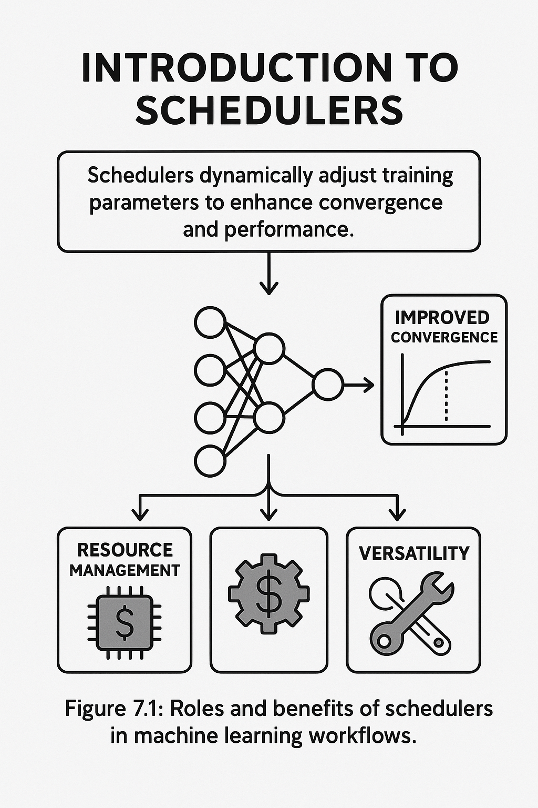
Figure 7.1 Rules and benefits of schedulers in machine learning workflow.

Key benefits
Schedulers play a crucial role in the success of ML workflows by enhancing convergence, optimizing resource utilization, and adapting to diverse tasks. The details are as follows:
- Improved convergence: Schedulers help models converge more quickly by adjusting learning rates based on the training progress. For example, exponential decay schedulers gradually decrease the learning rate over epochs, allowing the model to fine-tune its parameters as it approaches the optimal solution. Research shows that this method accelerates convergence in neural networks by reducing oscillations around minima [5]. In practice, schedulers such as the cosine annealing scheduler are utilized in image recognition tasks to enhance model accuracy without incurring additional computational costs.
- Resource management: Effective schedulers reduce computational waste by smartly adjusting training parameters. For example, linear warm-up schedulers start with a low learning rate and gradually raise it during the initial epochs, helping models avoid unstable gradients early on. This approach decreases the need for extensive hyperparameter tuning, saving computing resources and maintaining training efficiency [6].
- Versatility: Schedulers offer unparalleled adaptability, making them valuable across a range of tasks and data structures. For instance, in NLP tasks like translation and summarization, schedulers can dynamically adjust learning rates for pre-trained transformer models to fine-tune them for specific datasets. The success of adaptive schedulers like AdamW in these tasks underscores their versatility in handling diverse linguistic structures and achieving high-quality outputs [7].

Overview of scheduler types
Schedulers play a crucial role in dynamically adjusting model parameters during training, providing a structured approach to optimize learning and enhance generalization. They form a critical backbone for ML workflows, particularly in complex tasks such as NLP and computer vision, where convergence and efficiency are crucial. By systematically managing learning rates and other optimizer parameters, schedulers enable models to adapt to training progress, ensuring faster convergence and robust performance [1]. [3], [6].

Learning rate schedulers
Learning rate schedulers are a foundational element in training deep learning models, systematically adjusting the learning rate throughout the training process to achieve the best weight updates.
Learning rate schedulers operate on the idea that different phases of training require varying levels of sensitivity when adjusting weights. In the early stages, higher learning rates promote faster convergence by enabling the model to explore a broader range of parameters. As training continues, decreasing the learning rate enables more precise updates, which can lead the model to become stuck in local minima or saddle points [4].
For example, exponential decay schedulers reduce the learning rate by a fixed factor at each epoch, gradually refining the model's weight updates. This approach has been widely adopted in tasks such as image classification, where models like ResNet achieve state-of-the-art performance by decaying progressively the learning rate [5]. In NLP, cyclical learning rate schedulers oscillate the learning rate within a defined range to keep momentum and escape suboptimal minima. This strategy has proven effective in tasks such as text classification and translation, where periodic exploration of higher learning rates enhances model generalization [4].
Practical implementations of learning rate schedulers include TensorFlow’s ExponentialDecay and PyTorch’s StepLR, offering seamless integration into modern training pipelines.
Schedulers in ML are not merely convenient features: they are precision instruments that shape how models learn, converge, and adapt. Whether fine-tuning learning rates or managing optimizer states, schedulers function as dynamic regulators, ensuring stability, speed, and scalability across NLP workflows.

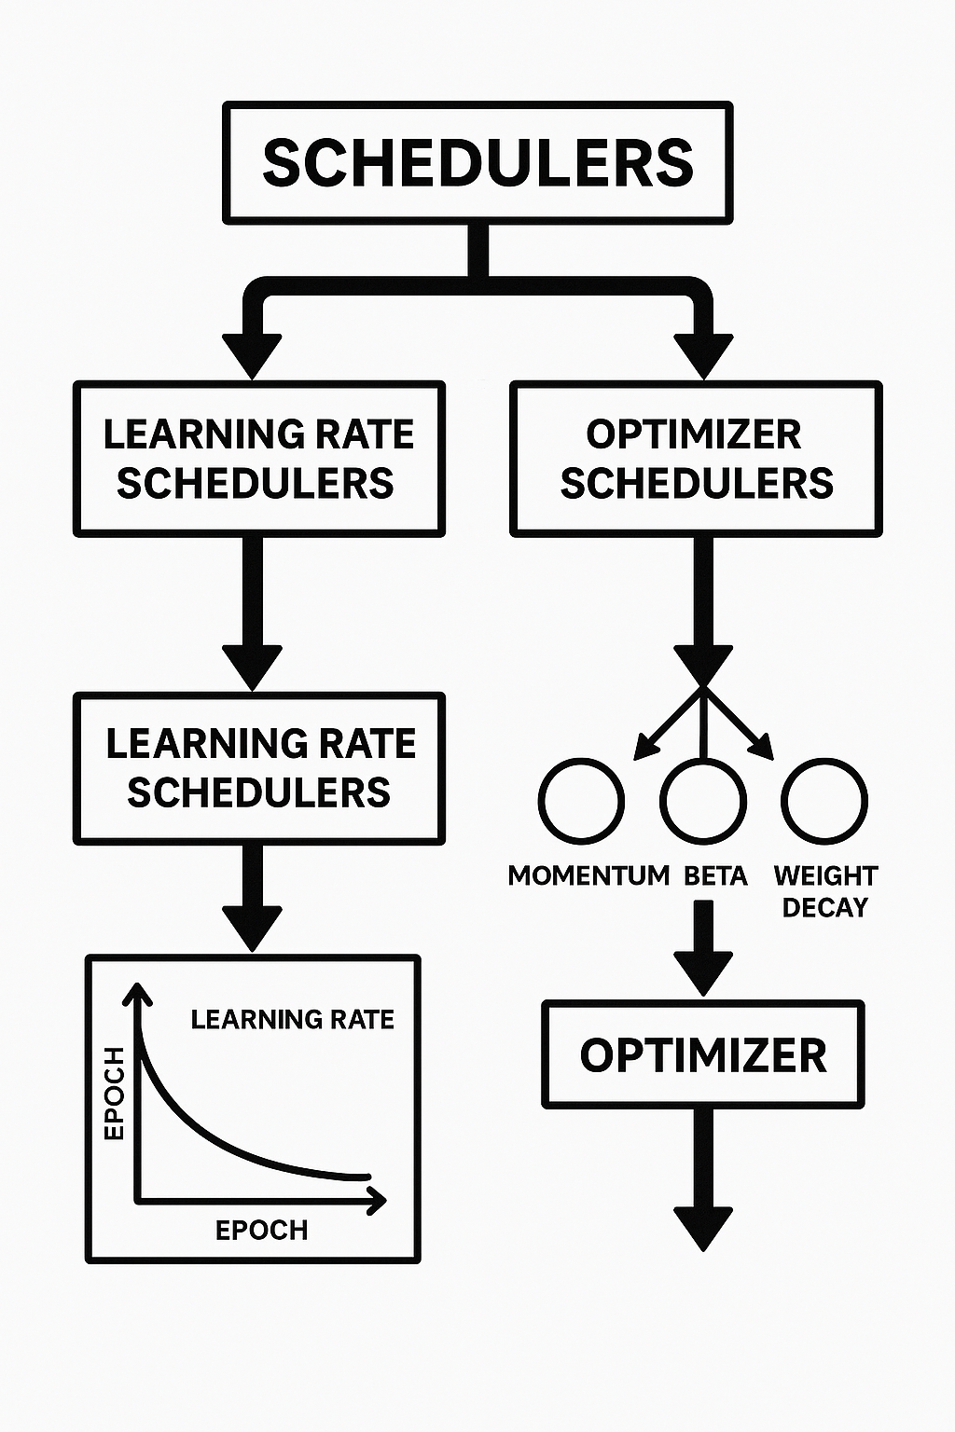
Figure 7.2: Learning rate vs. optimizer schedulers

Optimizer schedulers
Optimizer schedulers refine training efficiency by changing key parameters of optimization algorithms, such as momentum, beta values, or weight decay. These adjustments ensure that optimizers adapt during training, improving both convergence speed and model stability.
For instance, AdamW schedulers combine learning rate adjustment with weight decay regularization, addressing overfitting while keeping efficient gradient updates. This approach has been instrumental in fine-tuning large language models, such as BERT, for downstream NLP tasks, achieving superior performance across sentiment analysis, named entity recognition, and summarization [7].
Another notable example is momentum-based schedulers, which dynamically adjust the momentum parameter in optimizers like Stochastic Gradient Descent (SGD). By fine-tuning the momentum, these schedulers stabilize training in scenarios where gradients exhibit high variance, such as those encountered in reinforcement learning or adversarial training [8].
Tools like Hugging Face Diffusers feature integrated optimizer schedulers that simplify adapting training workflows to various model architectures and datasets. For example, Hugging Face's training arguments allow users to set weight decay or beta values, along with learning rate adjustments, offering a unified framework for optimization.
By combining the principles of learning rate and optimizer schedulers, modern ML pipelines achieve unparalleled flexibility, enabling practitioners to tackle a wide array of tasks efficiently and effectively.

Discrete vs. continuous schedulers
Schedulers play a crucial role in adjusting model parameters during both training and inference, influencing convergence, resource utilization, and overall performance. This section categorizes schedulers into discrete and continuous types, offering insights into their applications and the impact on various NLP and ML tasks. These methods reflect different philosophies in parameter tuning, with their appropriateness often depending on the task's complexity and resource constraints [7], [9].
Schedulers differ not only in how they adjust parameters but also in the temporal pattern by which they influence learning. The contrast between discrete and continuous approaches can be visualized through their update dynamics, where each method governs the rhythm and smoothness of parameter transitions during training, as illustrated in Figure 7.3:
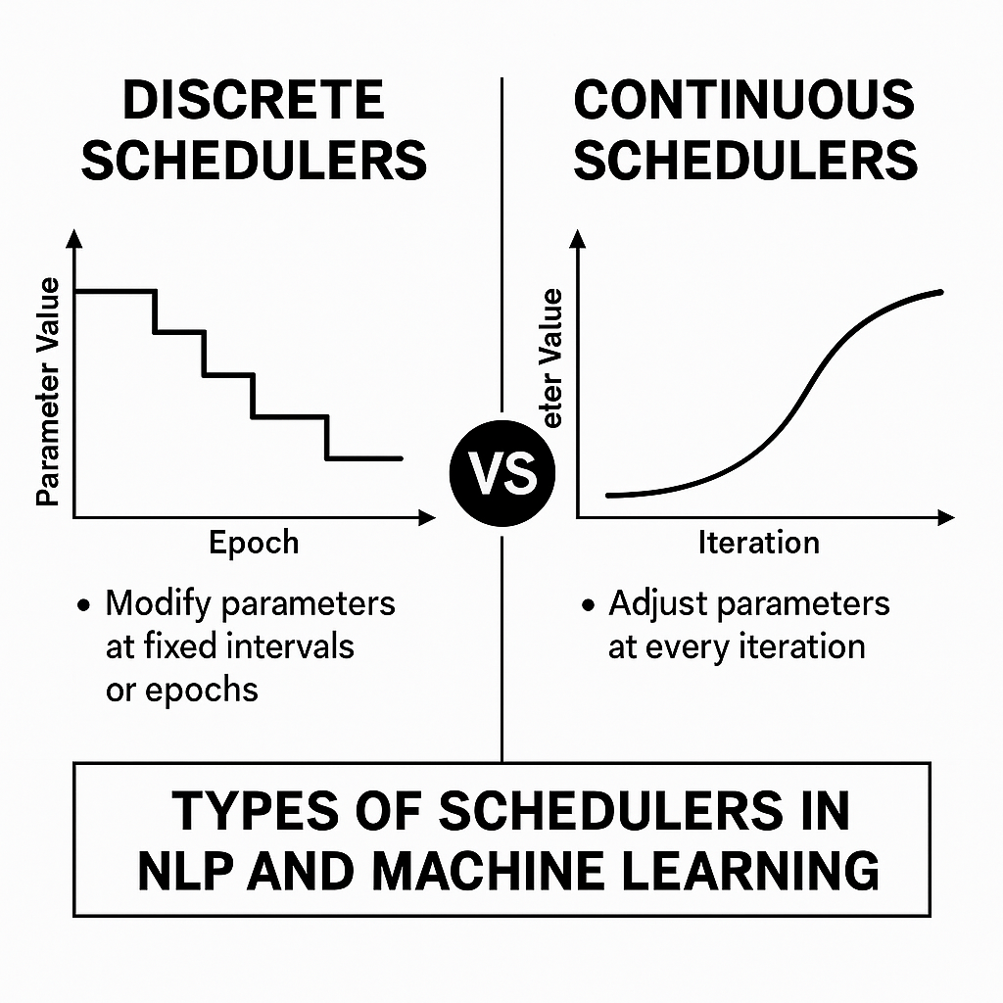
Figure 7.3: Contrasting discrete and continuous schedulers
Schedulers do not merely adjust parameters; they orchestrate learning itself. By switching between discrete and continuous approaches, they determine the rhythm and responsiveness of model optimization, defining how swiftly or subtly a model converges on insight.
Figure 7.3 illustrates a side-by-side schematic comparing the interval-based rigidity of discrete schedulers with the smooth, responsive flow of continuous scheduling methods, highlighting their respective roles in managing learning rate dynamics during training.

Discrete schedulers
Discrete schedulers modify parameters in discrete steps at set intervals. These schedulers are commonly used in general-purpose training due to their simplicity and predictability. By adhering to a clear update schedule, they provide stability in training processes, making them suitable for structured tasks and large datasets with abundant computational resources. Their fixed adjustments help prevent early convergence and enable models to gradually fine-tune their parameters, often achieving a balance between exploration and exploitation.
The key operational characteristics of discrete schedulers can be summarized as follows:
- Modify parameters at fixed intervals or epochs: Discrete schedulers follow a step-by-step approach, updating parameters at specific points during training. For instance, a learning rate schedule might reduce the learning rate by a set amount every 10 epochs. This approach prevents early convergence and enables gradual refinement of the model's weights. A typical example is the step-decay scheduler, which decreases the learning rate by a fixed fraction after a fixed number of epochs [1].
- Commonly used in step decay and multi-step learning rate schedules: Step decay schedulers are highly effective in tasks requiring slow convergence, such as image classification or language modeling on massive datasets. Multi-step schedules extend this concept by adjusting parameters at multiple predefined points, offering more flexibility for fine-tuning models.

Example: Reducing the learning rate by half every 10 epochs
This common scheduling technique reduces the learning rate by a fixed fraction at regular intervals, helping the model stabilize its optimization as training progresses. The following is the Python implementation of this strategy:
```python

from tensorflow.keras.callbacks import LearningRateScheduler

def step_decay(epoch, lr):
drop_rate = 0.5
drop_interval = 10
if epoch % drop_interval == 0 and epoch > 0:
return lr * drop_rate
return lr

lr_scheduler = LearningRateScheduler(step_decay)
model.fit(x_train, y_train, callbacks=[lr_scheduler])
```
In this example, the LearningRateScheduler callback adjusts the learning rate using the step_decay function. The function reduces the learning rate by half (drop_rate = 0.5) after every 10 epochs (drop_interval = 10). This approach ensures that the learning rate starts high, allowing the model to explore the parameter space effectively in the beginning. As the model converges, the learning rate decreases, enabling more precise updates to fine-tune the weights. This method is beneficial for tasks such as image classification or language modeling, where large datasets benefit from a stepwise refinement strategy [1].

Continuous schedulers
Continuous schedulers offer a more precise and flexible approach to parameter updates, adjusting them at every iteration. Unlike discrete schedulers, which only change at specific points, continuous schedulers respond dynamically during training. This flexibility leads to smoother learning rate transitions, helping to avoid overshooting or sudden shifts that could destabilize the training process. Continuous schedulers are especially helpful in situations that require exact control, such as fine-tuning on small datasets or training models for tasks with sensitive data distributions.
The main characteristics that define continuous schedulers and distinguish them from their discrete counterparts are summarized in the following list:
- Adjust parameters at every iteration to offer smoother transitions: Unlike discrete schedulers, continuous schedulers dynamically adjust parameters throughout the training process, allowing the model to respond to nuanced patterns in the data. This real-time adaptability minimizes overshooting or under-adjustment, ensuring better convergence [4].
- Suitable for tasks requiring precise control over training dynamics: Tasks involving sensitive datasets, such as those related to low-resource languages or specialized medical fields, often need help from continuous schedulers. These schedulers offer detailed control over learning rates and other settings, improving stability and reducing errors in small or changing datasets.

Example: Cosine annealing and exponential decay
Cosine annealing is a scheduler that gradually decreases the learning rate using a cosine curve. Exponential decay, on the other hand, reduces the learning rate by a factor of 2 each time step. These methods are beneficial for tasks that need smooth transitions and consistent convergence.
The following code presents the implementation of a cosine annealing scheduler in PyTorch, showcasing how continuous learning rate adjustments can promote smooth convergence and stable model optimization:
```python …

import torch.optim.lr_scheduler as lr_scheduler

optimizer = torch.optim.Adam(model.parameters(), lr=0.01)
scheduler = lr_scheduler.CosineAnnealingLR(optimizer, T_max=50)

for epoch in range(100):
train(model, train_loader, optimizer)
scheduler.step()
```
This example uses PyTorch's CosineAnnealingLR scheduler to adjust the learning rate. The parameter T_max defines the period for one cycle of the cosine curve (50 epochs in this case). The learning rate decreases smoothly, mimicking a cooling process. This gradual reduction helps the model focus on fine-tuning its parameters as it converges, avoiding abrupt changes that could disrupt learning. Continuous schedulers, such as cosine annealing, are well-suited for tasks involving transfer learning or low-resource datasets, where precise adjustments can significantly enhance model performance [7].

Practical comparison
Schedulers address various tasks and resource limitations, providing distinct benefits based on the selected method. The following table highlights key differences between discrete and continuous schedulers:
Feature | Discrete schedulers | Continuous schedulers
Adjustment frequency | Fixed intervals | Every iteration
Complexity | Simpler to implement | Requires more computation
Use cases | Stable tasks with large datasets | Dynamic or sensitive tasks
Table 7.1: Key differences between scheduler types

Choosing the exemplary scheduler depends on the task's specific needs, the dataset's characteristics, and the available computational resources. Discrete schedulers are easy to implement and work well in stable environments with large datasets, where their step-by-step updates ensure consistency and reliability. In contrast, continuous schedulers offer a more subtle approach, with smoother transitions and adaptive adjustments, making them essential for dynamic or sensitive training scenarios. Understanding the differences between these scheduler types helps practitioners fine-tune their training workflows, improving performance and efficiency across various NLP and ML tasks. By carefully combining these strategies, models can achieve their full potential, ensuring robust and scalable solutions.

Using schedulers during training
Practical ML model training depends on carefully managing the learning rate, which determines how weights are updated during gradient descent. Schedulers play a crucial role in dynamically adjusting the learning rate during training, enabling efficient convergence while preventing overfitting and underfitting. By fine-tuning this key parameter, schedulers allow models to reach optimal performance across various NLP tasks. This section examines the implementation of schedulers during training and explores how to maximize their benefits in multiple scenarios, supported by both theoretical insights and practical examples [1].

Implementation strategies
Schedulers can be integrated into training workflows to manage the learning rate and enhance model convergence dynamically. Depending on the task and dataset, various strategies can be employed to adapt to the complexities of training dynamics. This section outlines key strategies and demonstrates how to utilize well-known libraries, such as PyTorch, for implementation. Adjusting the learning rate with schedulers enables models to fine-tune their weight updates, providing stability during optimization and facilitating better generalization across tasks.

Step decay scheduler
Step decay schedulers reduce the learning rate by a fixed factor at predefined intervals. This strategy is particularly beneficial for stabilizing training in tasks where initial learning phases require a high learning rate to explore parameter space, followed by a reduced rate to fine-tune the model.
The following code illustrates how to implement a step decay scheduler in PyTorch, reducing the learning rate at fixed intervals to balance exploration in early epochs with fine-tuning in later training stages:
```python …
from torch.optim.lr_scheduler import StepLR
scheduler = StepLR(optimizer, step_size=10, gamma=0.1)
for epoch in range(epochs):
train(...)
scheduler.step()
```
This example demonstrates how to implement a step-decay scheduler using PyTorch. The StepLR scheduler reduces the learning rate by a factor of gamma (here, 0.1) after every step_size epochs (here, 10). The scheduler.step() function is called at the end of each epoch to apply the scheduled learning rate adjustment. By progressively decreasing the learning rate, this approach ensures that significant updates occur during early training, when the model is exploring, and that more minor updates are applied later to refine the model's parameters for precise optimization.

Cosine annealing scheduler
Cosine annealing schedulers provide a smoother transition in learning rate adjustments by following a cosine curve. This method prevents sudden changes and is especially helpful for tasks that require gradual refinement, where abrupt shifts in the learning rate can disrupt training.
The following code demonstrates the use of a cosine annealing scheduler to gradually reduce the learning rate in accordance with a cosine function, promoting smooth convergence and enhanced training stability:
```python …
from torch.optim.lr_scheduler import CosineAnnealingLR
scheduler = CosineAnnealingLR(optimizer, T_max=50)
for epoch in range(epochs):
train(...)
scheduler.step()
```
In this code snippet, the CosineAnnealingLR scheduler smoothly reduces the learning rate over a cycle defined by T_max, which is the maximum number of iterations (here, 50 epochs). The scheduler follows a cosine curve to decrease the learning rate, mimicking a gradual cooling process. This smooth transition minimizes sudden disruptions in weight updates, ensuring stability during training. By gradually reducing the learning rate following a cosine curve, the model can fine-tune its parameters with precision, especially in later training stages. This method is beneficial in scenarios that require careful convergence, such as fine-tuning on small datasets or tasks where overfitting needs to be closely controlled.

Using schedulers during inference
Schedulers, while traditionally associated with training, also play a crucial role during inference, especially in advanced models such as diffuser-based frameworks. Inference schedulers adapt parameters in real-time to maintain stability, enhance prediction accuracy, and optimize resource use. By carefully managing factors such as noise levels and sampling methods, schedulers improve the model's output, ensuring reliable and high-quality predictions even in challenging or noisy conditions. This section examines the primary functions of schedulers during inference, with a focus on noise scheduling and sample updates, and provides detailed examples to illustrate their impact on model performance.

Noise scheduling
In diffuser models, noise scheduling plays a vital role in the inference process. These models repeatedly turn random noise into accurate predictions, so precise control of noise levels is necessary. Noise scheduling gradually reduces noise during inference, helping stabilize the model's output and avoid unpredictable results. This approach is essential in applications such as image generation, where the output must be clear and consistent, and in NLP tasks such as text-to-text generation, where semantic accuracy is critical.
Noise scheduling typically follows a predetermined plan, such as linear or cosine annealing, to gradually adjust noise levels. For instance, a linear noise schedule decreases noise by a fixed amount at each step, creating a smooth, predictable refinement process. On the other hand, cosine annealing offers a more adaptable approach, enabling the model to reduce noise at varying rates across inference stages.

Example: Managing noise in diffuser models
In this example, the noise decreases gradually by over 100 steps. This slow reduction ensures a smooth transition for the model from the initial noisy state to a refined output.
The following code presents a simple implementation of a linear noise schedule, demonstrating how noise levels can be progressively reduced across multiple inference steps to ensure smooth and stable model refinement:
```python …

import numpy as np

def linear_noise_schedule(t, max_noise=1.0, min_noise=0.01):
return max_noise - (max_noise - min_noise) * t

# Simulating noise levels across 100 inference steps
steps = 100
noise_levels = [linear_noise_schedule(t/steps) for t in range(steps)]

print("Noise levels:", noise_levels)
```

Such scheduling is essential for tasks where overly aggressive noise reduction can lead to incomplete or inaccurate predictions, while overly conservative noise reduction can waste computational resources on unnecessary refinement [5].

Sample updates
Schedulers also actively manage sample updates during inference, enabling models to allocate their computational resources to high-value predictions. By prioritizing samples that significantly impact the results and minimizing effort on noise-heavy or low-value samples, schedulers enhance efficiency without harming output quality. This approach is particularly beneficial in resource-limited settings or for real-time applications that require fast, reliable predictions.
Dynamic sample updating is achieved through techniques such as importance sampling, which assign greater weights to samples that lead to more meaningful predictions. For instance, in a text-generation task, a scheduler might identify tokens with high uncertainty or low probability and focus on improving them in subsequent iterations. This process ensures the model's focus is on the most critical areas, boosting overall output coherence and relevance.

Example - Dynamic sample prioritization
In this example, tokens are prioritized based on their importance scores:
```python …

import torch

# Simulating importance sampling for text tokens
tokens = ["The", "model", "is", "generating", "outputs"]
importance_scores = torch.tensor([0.2, 0.4, 0.1, 0.7, 0.6]) # Simulated importance values

# Prioritize tokens with higher importance scores
priority_indices = torch.argsort(importance_scores, descending=True)
prioritized_tokens = [tokens[i] for i in priority_indices]

print("Prioritized tokens:", prioritized_tokens)
```
The scheduler allocates computational resources to refining high-priority tokens, such as generating and outputting, which carry greater semantic importance in the sentence. This method not only boosts efficiency but also improves the semantic depth of the output, making it more meaningful and contextually relevant [10].

We proceed with our deep exploration
Schedulers during inference are not limited to noise management and sample updates. They also play a vital role in resource optimization and adaptive inference strategies. For instance, progressive sampling methods, which adjust the number of inference steps based on the model's complexity, can significantly reduce computational costs while preserving output quality. Additionally, advanced techniques like stochastic scheduling introduce controlled randomness into the inference process, fostering diversity in model predictions for creative tasks such as text or image generation.
By understanding and using these advanced scheduling techniques, practitioners can tailor inference workflows to meet specific requirements, ensuring that models deliver robust, efficient, and high-quality predictions across a wide range of NLP and ML tasks.

Practical applications for schedulers (case study)
Schedulers play a transformative role in solving real-world ML challenges, bridging theoretical advancements with practical outcomes. By dynamically managing parameters such as learning rates and noise levels, schedulers can improve convergence, reduce overfitting, and enhance the quality of model outputs. This section presents detailed case studies and exercises to show the versatility of schedulers in addressing specific NLP problems and their potential for customization and innovation.

Case study 1 - Text summarization
Problem: Training a text summarization model on large datasets poses challenges, particularly in terms of convergence. Even with extensive computational resources, the model struggled to strike a balance between underfitting and overfitting, resulting in subpar Bilingual Evaluation Understudy (BLEU) scores.
Solution: Implementing a cosine annealing scheduler improved the model’s convergence rate by 15%, leading to more stable training dynamics. By gradually decreasing the learning rate in a cosine pattern, the scheduler enabled the model to fine-tune its weights more effectively during later training epochs, thereby enhancing summary quality while maintaining high BLEU scores.
The following code demonstrates the implementation of a cosine annealing scheduler for a text summarization model, illustrating how gradual learning rate adjustments can improve convergence and stability during training:
```python …

import torch
from torch.optim import Adam
from torch.optim.lr_scheduler import CosineAnnealingLR

# Define model, optimizer, and data loader
model = SummarizationModel()
optimizer = Adam(model.parameters(), lr=0.01)
scheduler = CosineAnnealingLR(optimizer, T_max=50)

# Training loop with scheduler
for epoch in range(100):
for batch in data_loader:
optimizer.zero_grad()
loss = model(batch)
loss.backward()
optimizer.step()
scheduler.step()

# Evaluate model performance
bleu_score = evaluate_model(model, test_data)
print(f"BLEU Score: {bleu_score:.2f}")
```
Results: The scheduler enabled smoother weight adjustments, reducing sudden changes in learning rates that could destabilize training. This method achieved a 15% faster convergence while maintaining a BLEU score above 30, demonstrating its effectiveness in handling large datasets [11].

Case study 2 - Sentiment analysis
Problem: Fine-tuning a sentiment analysis model on noisy and imbalanced data led to overfitting and inconsistent predictions. Traditional training approaches did not generalize well to unseen data because learning rates fluctuated.
Solution: A step decay scheduler mitigated overfitting by reducing the learning rate at fixed intervals, encouraging stable and gradual optimization. This approach resulted in an 8% increase in model accuracy while preserving robustness across varied data samples.
The following implementation illustrates how a step decay scheduler can be applied to stabilize training in a sentiment analysis model, systematically reducing the learning rate at fixed intervals to improve generalization and accuracy:
```python …

from torch.optim import SGD
from torch.optim.lr_scheduler import StepLR

# Define model and optimizer
model = SentimentAnalysisModel()
optimizer = SGD(model.parameters(), lr=0.1)
scheduler = StepLR(optimizer, step_size=10, gamma=0.5)

# Training loop with scheduler
for epoch in range(50):
train_loss = 0.0
for batch in data_loader:
optimizer.zero_grad()
loss = model(batch)
loss.backward()
optimizer.step()
train_loss += loss.item()
scheduler.step()

# Evaluate model
accuracy = evaluate_model(model, test_data)
print(f"Model Accuracy: {accuracy:.2f}")
```
Results: By systematically reducing the learning rate every 10 epochs, the step-decay scheduler mitigated the effects of noise and class imbalance, resulting in consistent improvements in prediction accuracy [1].

Conclusion
This chapter delved into the pivotal role of schedulers in shaping the training and inference phases of ML models. By examining discrete and continuous scheduling strategies, practical implementations, and real-world case studies, the chapter illustrates how these mechanisms improve convergence, resource allocation, and overall model performance. Readers gained a nuanced understanding of how to select and tailor schedulers to specific tasks, ensuring robustness, adaptability, and efficiency in a variety of NLP workflows. The comprehensive insights and examples provided serve as a foundation for integrating advanced scheduling techniques into complex ML pipelines.
As we enter Chapter 8, Advanced Inference Techniques, the focus shifts from training optimization to enhancing model performance during inference. Advanced inference techniques in the Hugging Face Diffusers library, including active sampling, multi-stage inference, and prompt engineering, offer new ways to enhance outputs and improve scalability. By combining the core principles of schedulers with these innovative strategies, the following chapter will equip readers with the tools to unlock the full potential of NLP applications across challenging environments.

References
- I. Goodfellow, Y. Bengio and A. Courville, Deep Learning, MIT Press, 2016.
- R. S. Sutton and A. G. Barto, ReinforceSment learning: An introduction, MIT Press, 2018.
- Y. Bengio, "Practical Recommendations for Gradient-Based Training of Deep Architectures," in Neural Networks: Tricks of the Trade, 2nd ed., Berlin, Heidelberg: Springer, 2012, p. 437–478.
- L. N. Smith, "Cyclical Learning Rates for Training Neural Networks," in 2017 IEEE Winter Conference on Applications of Computer Vision (WACV, 2017.
- J. Ho, A. Jain and P. Abbeel, "Denoising Diffuser Probabilistic Models," Advances in Neural Information Processing Systems, vol. 33, p. 6840–6851, 2020.
- P. Goyal, P. Dollár, R. Girshick, P. Noordhuis, L. Wesolowski, A. Kyrola, A. Tulloch, Y. Jia and K. He, "Accurate, Large Minibatch SGD: Training ImageNet in 1 Hour," arXiv preprint, 2017.
- I. Loshchilov and F. Hutter, "SGDR: Stochastic Gradient Descent with Warm Restarts," 2016.
- I. Sutskever, J. Martens, G. Dahl and G. Hinton, "On the importance of initialization and momentum in deep learning," in Proceedings of the 30th International Conference on Machine Learning (ICML), 2013.
- D. P. Kingma and J. Ba, "Adam: A Method for Stochastic Optimization," 2015.
- A. Q. Nichol and P. Dhariwal, "Improved Denoising Diffuser Probabilistic Models," in International Conference on Machine Learning (ICML), 2021.
- A. Vaswani, "Attention Is All You Need," 2017.
- N. Srivastava, "Dropout: A Simple Way to Prevent Neural Networks from Overfitting," Journal of Machine Learning Research, vol. 15, pp. 1929, 1958, 2014.
- V. Sanh, "DistilBERT, a distilled version of BERT: smaller, faster, cheaper and lighter," 2019.
- J. Devlin, M. W. Chang, K. Lee, and K. Toutanova, "BERT: Pre-training of Deep Bidirectional Transformers for Language Understanding," in Proceedings of NAACL-HLT, 2019.
- I. Chalkidis, "Legal-BERT: The Muppets straight out of Law School," 2020.
- T. B. Brown, "Language Models are Few-Shot Learners," 2020.

