Chapter 8

Advanced Inference Techniques

Introduction
The refinement of inference methods is a cornerstone for deploying natural language processing (NLP) systems that perform effectively in complex, real-world scenarios. Chapter 8, Advanced Inference Techniques, explores a range of advanced inference techniques designed to enhance pipeline functionality, elevate output precision, and achieve scalability using the Hugging Face Diffusers library. The chapter integrates theoretical perspectives with practical implementations, empowering readers to implement innovative approaches to achieve high-performance NLP solutions.

Structure
This chapter covers the following topics:
- Enhancing pipeline functionality
- Techniques for distributed inference
- Improving inference quality
- Using ensemble methods for better inference results
- Improving inference speed and efficiency

Objectives
By the end of this chapter, readers will be able to implement callbacks and extensions by understanding and applying callback functions and custom extensions to enhance artificial intelligence (AI) pipelines and foster dynamic, responsive model behavior. They will be able to deploy distributed inference systems by gaining skills to implement systems that efficiently process large-scale data across multiple computing resources. Readers will also learn to refine inference with prompt engineering by mastering techniques for refining input queries and improving post-processing strategies, ensuring better model output. Additionally, they can leverage ensemble methods by combining predictions from multiple models to enhance robustness and accuracy. Readers will be able to improve inference efficiency by developing strategies to accelerate inference and minimize computational overhead, thereby enabling the scalable deployment of AI systems.

Enhancing pipeline functionality
Enhancing pipeline functionality with callbacks and custom extensions lays the foundation for flexible, dynamic NLP systems, enabling real-time adjustments tailored to specific use cases. These features are vital for allowing responsive interactions and simplifying complex processes, directly improving the performance and scalability of advanced applications. They offer mechanisms for dynamic interaction within the inference process, allowing interventions that optimize outputs and support advanced customization.

Key concepts
Adapting and expanding pipeline functionality is key to modern NLP systems. Incorporating callbacks and extensions creates a highly customizable framework that responds flexibly to changing needs. These ideas form the basis for building intelligent, adaptable models that can solve various real-world challenges, such as:
- Callbacks: Functions executed at specific stages of model training or inference. Callbacks facilitate tasks such as dynamic logging, halting processes based on specific conditions, or making real-time adjustments to parameters [1].
- Extensions: Tailored modifications to training loops or inference pipelines, expanding standard functionalities with novel features such as domain-specific preprocessing or customized loss functions [2].
Figure 8.1 illustrates a flow diagram showing a transformer-based pipeline with labeled hooks for callbacks like EarlyStopping, Logging, and LR Adjustments:
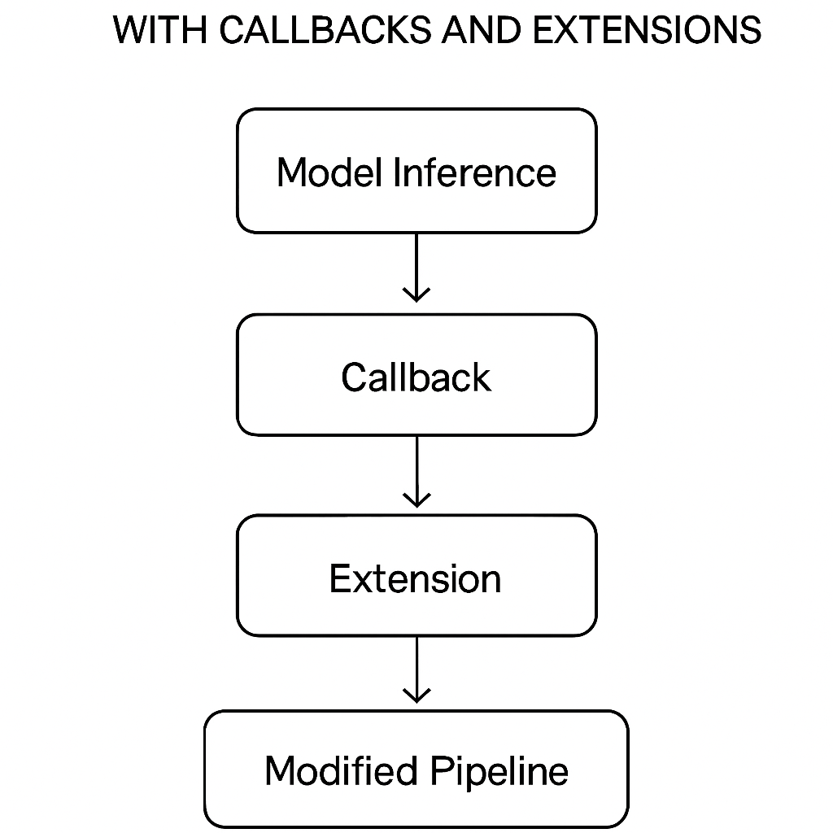
Figure 8.1: Dynamic inference pipeline with callbacks

Practical applications
The following list outlines practical applications of callbacks and extensions in enhancing pipeline functionality. These mechanisms enable developers to embed dynamic behavior within training and inference processes, allowing for adaptive responses to changes in model performance, convergence, and data characteristics:
- Early stopping in training: Callbacks can prevent overfitting by halting training when validation performance stagnates. For example, in a neural network model, an early stopping callback monitors the validation loss. It stops training if no improvement is observed over a specified number of epochs, preventing overfitting to the training data.
- Dynamic learning rate adjustment: Extensions enable real-time learning rate modifications to adapt to model convergence patterns. Dynamic learning rate adjustments can ensure the model explores optimal solutions during early training phases and fine-tunes its performance in later stages, thereby enhancing convergence efficiency.

EarlyStopping callback (Example)
Early stopping is a vital method in training machine learning (ML) models, especially neural networks, to prevent overfitting and save computational resources. By tracking model performance during training, early stopping terminates training when improvements in the chosen metric slow or stop, thereby helping the model perform well on new data. The following code demonstrates how to implement this method using the Keras library, showing its practical advantages in efficient and reliable training:
```python …
from tensorflow.keras.callbacks import EarlyStopping

early_stopping = EarlyStopping(monitor='val_loss', patience=3, verbose=1)
model.fit(x_train, y_train, validation_data=(x_val, y_val), callbacks=[early_stopping])
```
This example uses the Keras EarlyStopping callback, a built-in mechanism that checks a specified performance metric during training and halts training when the metric stops improving. The goal is to avoid overfitting, which occurs when a model becomes too specialized in the training data and performs poorly on unseen data.
The EarlyStopping class is initialized with the following three key parameters:
- monitor='val_loss': This parameter specifies the metric to check. In this case, the validation loss (val_loss) is chosen. Validation loss is how well the model performs on a separate validation dataset, which is not used for training. Monitoring this metric helps ensure that the model generalizes well with new data.
- patience=3: This parameter sets the number of epochs to wait after the last observed improvement in the monitored metric before halting training. A patience value of 3 means that if the validation loss does not improve for three consecutive epochs, the training process will stop. This avoids premature stopping while ensuring that unnecessary epochs are not run.
- verbose=1: This parameter controls the verbosity of the output. A value of 1 ensures that the user receives a message showing when early stopping is triggered, providing insight into the training process.
The model.fit function is used to train the model on the training data (x_train and y_train) with validation performed on a separate validation dataset (x_val and y_val). The callbacks argument accepts a list of callback functions, including the EarlyStopping callback defined earlier. During training, Keras evaluates the validation loss at the end of each epoch. If no improvement in the validation loss is observed for three consecutive epochs, the training process is halted.
Using this callback helps practitioners use computational resources efficiently by preventing unnecessary training epochs once the model reaches optimal performance. Additionally, early stopping reduces the risk of overfitting, supporting the development of models that perform well on both training and validation datasets. This approach is especially beneficial in situations where training is computationally costly or when balancing training time and model performance is crucial.

Understanding Keras
Keras is an open-source deep learning library that provides a high-level interface for building, training, and evaluating neural networks [3]. Developed initially as an independent library, Keras is now fully integrated with TensorFlow, one of the most widely used frameworks for ML and deep learning.
The following list outlines the key features of Keras:
- User-friendly and modular: Keras makes designing deep learning models easier by providing a clear and straightforward application programming interface (API). Its modular setup lets users easily define models, layers, and other components, making it an excellent choice for both beginners and experienced practitioners.
- Support for multiple backends: Initially, Keras supported multiple computational backends, including TensorFlow, Theano, and Microsoft Cognitive Toolkit (CNTK). Today, Keras is integrated with TensorFlow, using TensorFlow's backend for high-performance computation [4].
- Prebuilt layers and models: Keras includes a wide range of prebuilt layers (e.g., dense, convolutional, recurrent) and models that can be quickly customized for specific tasks. This speeds up development and reduces the need for extensive coding.
- Flexibility and scalability: Keras supports both simple sequential models and more complex architectures with multiple branches, shared layers, and custom components. It is scalable, allowing users to train models on central processing units (CPUs), graphics processing units (GPUs), or distributed systems [2].
- Extensive ecosystem: Integrated with TensorFlow, Keras benefits from a robust ecosystem, including tools for visualization (TensorBoard), deployment (TensorFlow Lite and TensorFlow Serving), and model optimization.
- Community and documentation: With a large community and comprehensive documentation, Keras provides extensive resources, tutorials, and examples for learning and troubleshooting [3].

Role of Keras in EarlyStopping
In the context of early stopping, Keras simplifies the implementation by offering a ready-to-use EarlyStopping callback. This feature exemplifies Keras's focus on usability and efficiency, allowing practitioners to integrate advanced techniques into their workflows with minimal effort.
By using Keras, developers can focus more on designing and refining their models rather than dealing with the complexities of low-level computation. This makes it a preferred tool for rapid prototyping and deployment of deep learning applications.

Techniques for distributed inference
Large-scale NLP tasks require distributed inference methods to manage heavy computational workloads. These techniques split tasks across multiple systems, ensuring efficient data processing and optimal use of available resources.
Large-scale NLP tasks often require processing massive datasets or running complex models that go beyond the capacity of a single device or traditional setups. Distributed inference addresses these challenges by dividing computational tasks across multiple systems, enabling efficient processing and optimal resource use. The following are the main strategies that support distributed inference:
Core strategies: To efficiently manage the computational workload in distributed inference, two primary methods are commonly used: data parallelism and model parallelism. These approaches optimize hardware utilization, ensuring large-scale tasks are completed quickly and effectively.

Data parallelism
Splits data into subsets distributed across processors. Each processor applies the same model to its subset, aggregating the results for final predictions [5].
Data parallelism involves dividing the dataset into smaller parts and distributing them across multiple processors. Each processor independently runs the same model on its assigned data, and the results are combined to generate the final predictions. This method is especially effective for large datasets, where processing can be parallelized.
For example, in a distributed text classification task, the dataset is divided into chunks, and each chunk is sent to a different GPU or CPU. After processing, the individual results are combined to produce a unified output. Frameworks like TensorFlow and PyTorch simplify data parallelism by offering built-in tools for synchronizing models and sharing gradients across devices.
The primary advantage of data parallelism is its ability to scale. As datasets grow larger, more processors can be added to sustain high performance. Sharing model gradients between devices can create a bottleneck, particularly in large distributed systems, due to synchronization overhead.
Figure 8.2 illustrates a cluster map of multiple GPUs/virtual machines (VMs) with data split (data parallelism) and model segment (model parallelism), where arrows indicate the task flow:
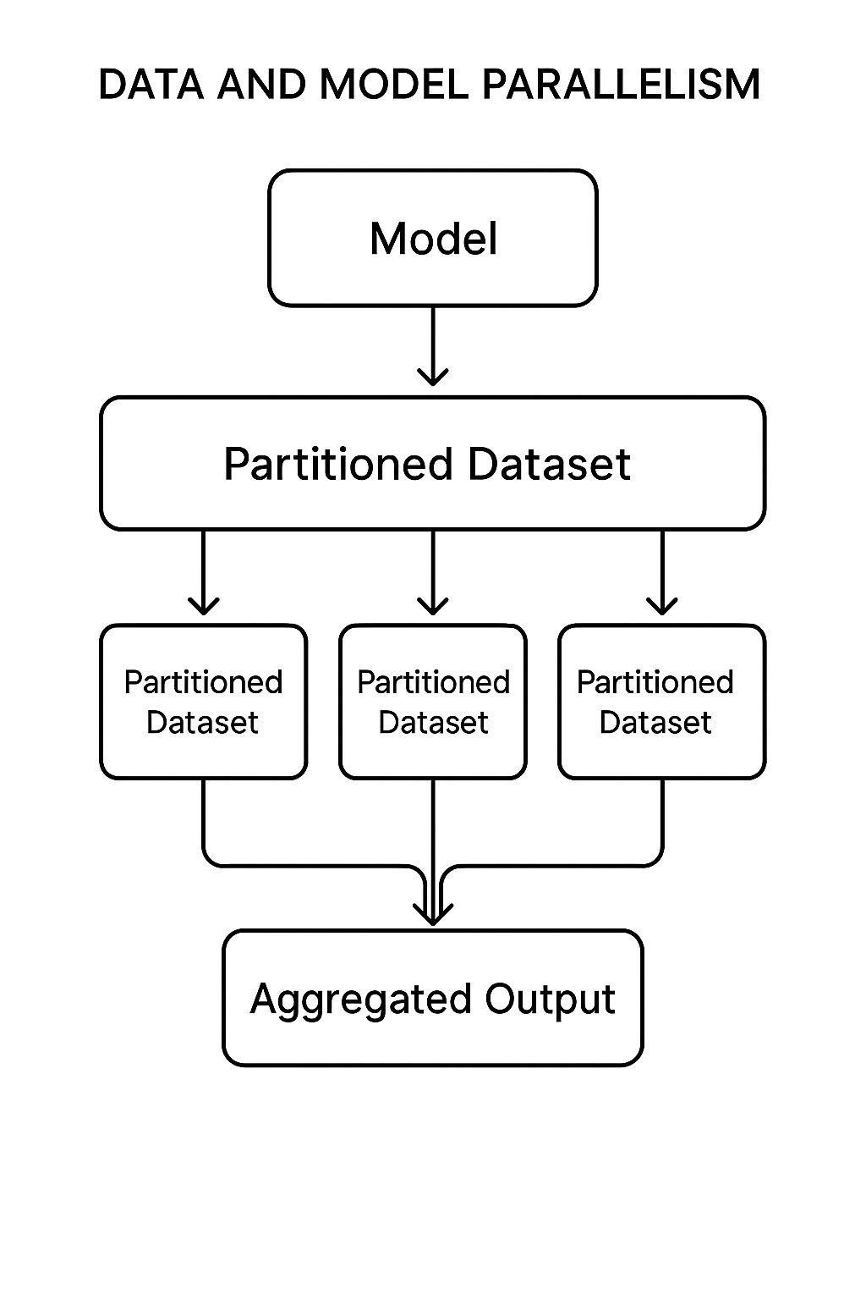
Figure 8.2: Distributed inference strategy

Refer to the following code snippet of data parallelism with TensorFlow:
```python

import tensorflow as tf

strategy = tf.distribute.MirroredStrategy()
with strategy.scope():
model = tf.keras.Sequential([
tf.keras.layers.Embedding(input_dim=10000, output_dim=256),
tf.keras.layers.GlobalAveragePooling1D(),
tf.keras.layers.Dense(1, activation='sigmoid')
])
model.compile(optimizer='adam', loss='binary_crossentropy', metrics=['accuracy'])
model.fit(x_train, y_train, epochs=5, batch_size=512)
```
This example demonstrates TensorFlow’s MirroredStrategy, which achieves data parallelism by splitting the dataset across multiple GPUs. Each GPU trains the model on its subset of data, and the gradients are synchronized after each batch.

Model parallelism
Distributes large models across devices, enabling efficient processing of complex tasks with limited memory.
Model parallelism, on the other hand, divides a large model into smaller parts and distributes them across multiple devices. Each device manages a specific section of the model and passes intermediate results to the next. This approach is efficient when the model’s memory requirements exceed what a single device can manage, as seen with transformer-based architectures such as Generative Pre-trained Transformer (GPT) or Bidirectional Encoder Representations from Transformers (BERT).
For example, in a transformer model, the encoder layers could be assigned to one GPU, while the decoder layers to another. Intermediate computations are transferred between devices during both the forward and backward passes. Model parallelism enables the utilization of high-capacity models on limited hardware, but it requires careful partitioning to minimize communication overhead between devices.
The following is an example of model parallelism:
```python

import torch
from torch import nn + lass ModelModel(nn.Module):).
def __init__(self):
super(Model, self).__init__()
self.layer1 = nn.Linear(1000, 500).to('cuda:0') # Assign to GPU 0
self.layer2 = nn.Linear(500, 10).to('cuda:1') # Assign to GPU 1

def forward(self, x):
x = self.layer1(x.to('cuda:0'))
x = self.layer2(x.to('cuda:1'))
return x

model = Model() input_data = torch.randn(64, 1000) output = model(input_data)
```
In this example, the model's layers are split across two GPUs, and the data is transferred between devices during the forward pass. This ensures that no single GPU is overloaded with memory-intensive tasks, enabling the training of large models on hardware with limited capacity.

Challenges and trade-offs
Both data parallelism and model parallelism pose challenges. Data parallelism requires effective gradient synchronization, while model parallelism demands optimized communication routes to reduce latency. Combining these techniques, called hybrid parallelism, can enhance performance by leveraging both methods.
By effectively leveraging data and model parallelism, developers can overcome the limitations of single-device setups, enabling scalable, efficient NLP solutions that meet the needs of modern applications.

Distributed text classification (Example)
The following code demonstrates how distributed inference can be used to manage large-scale text classification tasks, enhancing computational efficiency across multiple devices:
```python …
import tensorflow as tf

strategy = tf.distribute.MirroredStrategy()
with strategy.scope():
model = tf.keras.Sequential([
tf.keras.layers.Embedding(input_dim=10000, output_dim=256),
tf.keras.layers.GlobalAveragePooling1D(),
tf.keras.layers.Dense(1, activation='sigmoid')
])
model.compile(optimizer='adam', loss='binary_crossentropy', metrics=['accuracy'])

model.fit(x_train, y_train, epochs=5, batch_size=512)
```
This code demonstrates data parallelism using TensorFlow’s MirroredStrategy, enabling distributed training across GPUs.

Improving inference quality
The quality of inference output depends heavily on well-designed input prompts and effective post-processing methods. Careful prompt engineering guides the model's behavior, while post-processing enhances outputs for specific applications.
Figure 8.3 illustrates the flow of input prompt shaping | tokenization | model generation | post-processing | response:
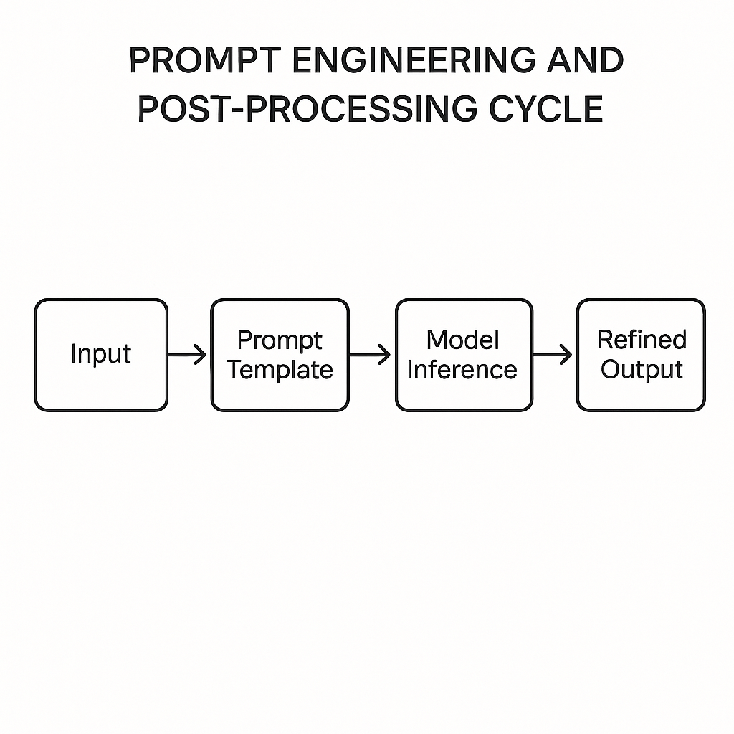
Figure 8.3: Prompt engineering lifecycle

Techniques
Improving inference speed is crucial for deploying NLP models in real-time systems. By reducing latency and computational load, these methods ensure models deliver accurate results quickly, meeting the demands of interactive and large-scale applications.
Improving inference quality requires a combination of strategic input design and effective output refinement. The following list outlines two essential techniques (prompt engineering and post-processing) that together enhance model performance, ensure contextual accuracy, and adapt inference outputs to real-world application needs:
- Prompt engineering: Carefully designed prompts improve model performance by providing context and guiding response generation [6].
- Post-processing: Techniques like text normalization, confidence filtering, and domain-specific adjustments enhance output usability.

Prompt engineering for chatbots (Example)
This example shows the use of prompt engineering to tailor a model’s responses to user queries by structuring input prompts:
```python …
def generate_prompt(user_input):
return f"The user says: '{user_input}'. Respond with a helpful reply."

response = model.generate(generate_prompt("I need help resetting my password."))
```
This example demonstrates practical prompt engineering by organizing user input to efficiently guide model responses.

Using ensemble methods for better inference results
Ensemble techniques integrate multiple models to enhance the precision and dependability of predictive outcomes. By using various algorithms, ensemble techniques reduce errors and improve robustness.

Key approaches
Refining inference often requires advanced ensemble techniques to address the complexities of diverse NLP tasks. These methods, by combining multiple models or approaches, improve accuracy, reliability, and adaptability, making them indispensable in scenarios where robustness and precision are critical.

Figure 8.4 illustrates the multi-model ensemble [logistic regression, Support Vector Machine (SVM) - decision tree] | Meta-Learner | Output, which shows the soft-voting vs. stacking path:

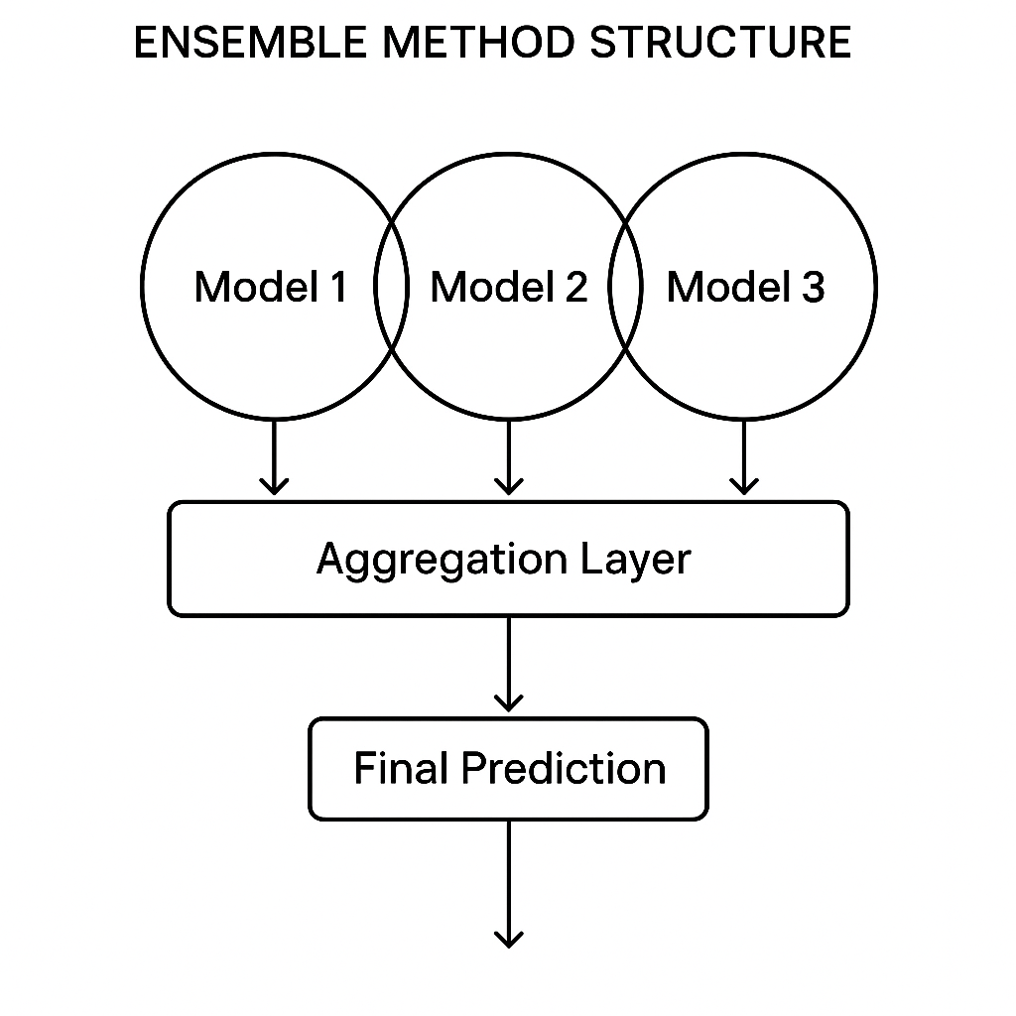
Figure 8.4: Ensemble method structure (bagging, boosting, stacking)

Bagging
It combines predictions from multiple models through majority voting or averaging, improving overall generalization and robustness [7]. Bagging, also known as bootstrap aggregating, is a powerful ensemble learning technique that reduces variance and prevents overfitting by combining the outputs of multiple models. The approach involves training different base models, often weak learners such as decision trees, on various subsets of the training dataset. These subsets are created using bootstrapping, a method that generates random samples with replacement. The predictions of these models are then aggregated, either by majority voting for classification tasks or by averaging for regression problems.
Why it works: Bagging leverages model diversity. Since each model is trained on a unique subset of data, it captures distinct aspects of the dataset and aggregating their output leads to more robust and generalized predictions.
Example: Random forests are a prime application of bagging, where multiple decision trees are combined to make a collective prediction. In NLP, bagging can be applied to tasks like sentiment analysis by training multiple models on diverse subsets of user-generated content and combining their predictions to account for variations in text.

Bagging, also known as bootstrap aggregating, is a powerful ensemble learning technique that reduces variance and prevents overfitting by combining the outputs of multiple models. The approach involves training different base models, often weak learners such as decision trees, on various subsets of the training dataset. These subsets are created using bootstrapping, a method that generates random samples with replacement. The predictions of these models are then aggregated, either by majority voting for classification tasks or by averaging for regression problems.
Why it works: Bagging leverages model diversity. Since each model is trained on a unique subset of data, it captures distinct aspects of the dataset, and aggregating their output leads to more robust and generalized predictions.
Example: Random forests are a prime application of bagging, where multiple decision trees are combined to make a collective prediction. In NLP, bagging can be applied to tasks like sentiment analysis by training multiple models on diverse subsets of user-generated content and combining their predictions to account for variations in text.
Real-world scenario: In fraud detection systems, bagging helps mitigate the impact of noisy or outlier data by allowing multiple models to identify suspicious transactions, thereby collectively enhancing reliability.

Boosting
It sequentially adjusts model weights to address difficult predictions. Boosting is a sequential ensemble learning approach in which models are trained iteratively, and each new model focuses on correcting the errors of its predecessor. The ensemble assigns higher weights to misclassified instances during training, ensuring that subsequent models pay more attention to challenging cases.
How it works: Boosting combines the predictions of all models in the ensemble, giving more weight to more accurate models. Techniques like AdaBoost and Gradient Boosting build models sequentially, improving for residual errors in each iteration.
Advanced techniques: Gradient Boosting, a popular variant, constructs an additive model in a stage-wise manner, where each new tree predicts the residuals of the earlier trees. In NLP, this can improve text classification by learning nuanced patterns in complex datasets.
Example: XGBoost, a widely used boosting framework, excels at tasks that require high predictive accuracy. In NLP, boosting can refine named entity recognition (NER) by focusing on edge cases, such as rare or ambiguous entity mentions.
Real-world scenario: In search engines, boosting enhances ranking algorithms by repeatedly refining results, ensuring that the most relevant pages appear at the top, even when search queries are unclear.

Stacking
It uses a meta-model to aggregate outputs from diverse models, achieving superior performance. Stacking, also known as stacked generalization, is an advanced ensemble technique that combines the predictions of multiple models via a meta-model that learns to aggregate individual model outputs effectively. Unlike bagging and boosting, stacking uses diverse base models, each contributing unique strengths to the ensemble.
How it works: The base models make predictions, which are then used as inputs for the meta-model. This secondary model, often a logistic regression or a neural network, learns to weight and combine these predictions to maximize overall accuracy.
Example: In NLP, stacking can enhance machine translation systems by combining outputs from models trained on various linguistic features, such as syntax, semantics, and contextual embeddings. The meta-model merges these complementary predictions to improve translation quality.
Implementation: A stacking ensemble might include BERT for semantic understanding, a Convolutional Neural Network (CNN) for extracting local patterns, and a Long Short-Term Memory (LSTM) for capturing sequential dependencies. The meta-model assesses the outputs of these various architectures to make a final prediction.
Real-world scenario: In recommendation systems, stacking combines predictions from collaborative filtering, content-based filtering, and deep learning models to deliver personalized suggestions that adjust to user preferences and behaviors.

Example - Sentiment analysis ensemble
This example shows how ensemble methods can improve the accuracy of sentiment analysis by combining predictions from multiple models:
```python …
from sklearn.ensemble import VotingClassifier
from sklearn.linear_model import LogisticRegression
from sklearn.svm import SVC
from sklearn.tree import DecisionTreeClassifier

model1 = LogisticRegression()
model2 = SVC(probability=True)
model3 = DecisionTreeClassifier()

ensemble_model = VotingClassifier(
estimators=[('lr', model1), ('svm', model2), ('dt', model3)],
voting='soft'
)

ensemble_model.fit(X_train, y_train)
accuracy = ensemble_model.score(X_test, y_test)
print(f"Ensemble accuracy: {accuracy:.2f}")
```
This code shows an ensemble approach to sentiment analysis using the VotingClassifier from the scikit-learn library. The ensemble model combines the predictions of three base models: logistic regression, a support vector machine (SVM), and a decision tree. Each of these base models contributes unique strengths to improve overall prediction accuracy in the sentiment analysis task.
The code begins by importing the necessary libraries and defining the three base models. The logistic regression model (Model 1) is particularly effective for binary classification tasks due to its simplicity and ability to handle linearly separable data. The SVM (model2) is configured to output probability estimates, making it suitable for integration in the ensemble. The decision tree classifier (model3) is included for its interpretability and ability to capture nonlinear relationships in the data.
Next, the VotingClassifier is instantiated with the three models as its components. The voting='soft' parameter specifies that the ensemble will use probability-weighted voting. This method accounts for each model's confidence in its predictions, enabling the ensemble to capitalize on the models' strengths where they perform best. For example, if logistic regression is more reliable for specific patterns, its higher confidence in those predictions will have a more significant influence on the outcome.
The fit method is then used to train the ensemble model on the training dataset (X_train, y_train). During this process, each base model is trained independently on the same dataset, and the ensemble later aggregates its predictions. The ensemble's ability to integrate diverse decision boundaries and use complementary strengths of its base models often results in better generalization and robustness than any single model.
Finally, the score method evaluates the ensemble's accuracy on the test dataset (X_test, y_test), providing a quantitative measure of its performance. The code concludes by printing the accuracy score, which indicates how well the ensemble model predicts sentiment labels relative to the ground truth.
This approach demonstrates how combining multiple classifiers can improve predictive performance in NLP tasks, such as sentiment analysis. By utilizing the strengths of different models, the ensemble minimizes individual weaknesses and boosts overall robustness and reliability.

Improving inference speed and efficiency
Inference speed and computational efficiency are critical for real-time NLP applications. Optimization strategies reduce latency while ensuring accuracy, enabling seamless deployment in resource-constrained environments.
Figure 8.5 illustrates the transformer model, pruning, quantization blocks, and deployment paths: mobile edge, cloud, and embedded.
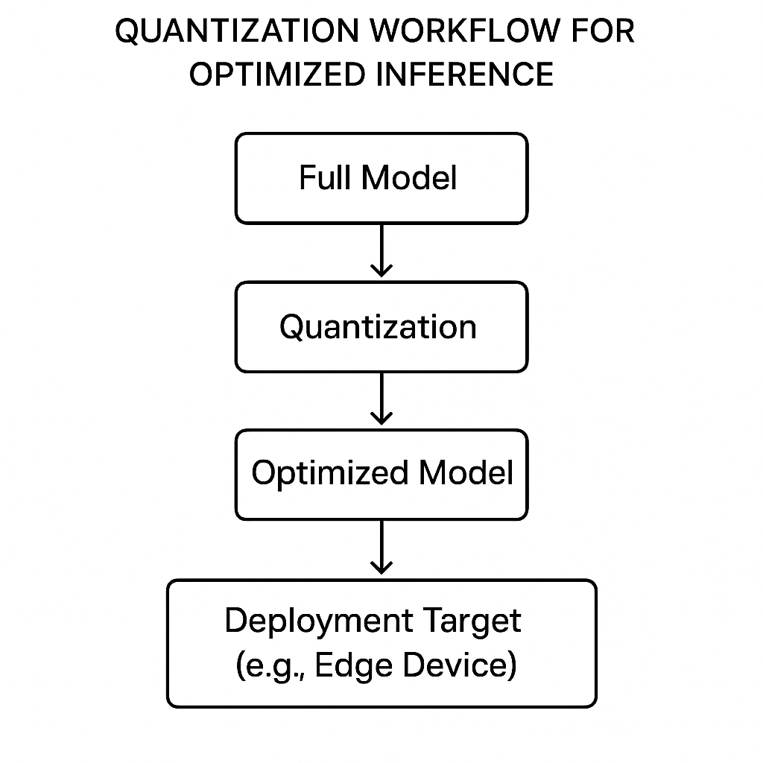
Figure 8.5: Quantization and optimization flow

Techniques
Improving inference speed and efficiency is crucial for deploying NLP models in real-world applications. These enhancements not only reduce latency but also ensure that models perform well in resource-constrained environments, such as edge devices or systems with limited computing power. Here are key techniques that simplify inference and support scalable, high-performance applications.

Model simplification
Pruning or distillation reduces model complexity without compromising performance.
Simplification techniques, such as pruning and distillation, aim to reduce model size and computational requirements while maintaining performance. Pruning eliminates less important parameters or connections, resulting in a smaller, more efficient structure. For instance, in a neural network, weights near zero can be removed without significantly affecting overall accuracy. This size reduction reduces memory usage and speeds up processing. Meanwhile, distillation involves training a smaller "student" model to mimic the behavior of a larger "teacher" model. By transferring knowledge from the teacher to the student, distillation attains similar performance with fewer parameters. These techniques are especially valuable for deploying models on devices with limited memory and processing ability, such as smartphones or Internet of Things (IoT) devices.

Quantization
Converts model weights to lower precision, accelerating computation and reducing memory usage [8].
Quantization transforms model weights and activations from higher-precision data types, such as 32-bit floating-point, to lower-precision formats, such as 8-bit integers. This change significantly reduces the model's memory footprint and accelerates computation, as lower-precision arithmetic consumes fewer resources. For example, TensorFlow Lite provides tools for post-training quantization, enabling developers to optimize pre-trained models for deployment. Quantization is especially beneficial in environments such as embedded systems and mobile apps, where storage and processing power are limited. Despite lowering precision, careful quantization preserves the original accuracy, making it a popular choice for improving large-scale NLP models used in real-time applications.

Example - Model quantization
Quantization is a powerful optimization technique that reduces the precision of model weights and activations, enabling faster and more efficient inference. This approach is particularly beneficial when deploying models on resource-constrained devices, such as mobile phones, IoT devices, or embedded systems. The following example shows how to convert a high-precision model into a quantized format using TensorFlow Lite, making it suitable for real-time applications with limited computational resources:
```python
import tensorflow as tf

converter = tf.lite.TFLiteConverter.from_keras_model(model)
converter.optimizations = [tf.lite.Optimize.DEFAULT]
quantized_model = converter.convert()

with open('quantized_model.tflite', 'wb') as f:
f.write(quantized_model)
This example demonstrates TensorFlow Lite quantization, enabling faster inference on edge devices.
```
The provided code example demonstrates how to quantize a model with TensorFlow Lite. Quantization reduces the memory requirements and computational cost of an ML model by converting its parameters from a high-precision data type (e.g., 32-bit floating-point) to a lower-precision type (e.g., 8-bit integers). This optimization increases inference speed while maintaining acceptable accuracy.
The process begins by importing the TensorFlow library. The TFLiteConverter class initiates the conversion from a standard TensorFlow model to a TensorFlow Lite model, specifically designed for lightweight, on-device inference.
The from_keras_model function takes the trained TensorFlow model as input. This function creates a converter object that transforms the model into a format suitable for TensorFlow Lite. The optimizations parameter is then set to [tf.lite.Optimize.DEFAULT], which applies default optimization strategies, including quantization. This step enables the model to be converted into a quantized format, reducing its precision while ensuring efficiency and preserving accuracy as much as possible.
The convert method performs the conversion, creating a quantized TensorFlow Lite model. The resulting model is stored in memory and is ready for deployment. The final part of the code saves the quantized model to a .tflite file using standard file I/O operations. With the open block, open a file in write-binary mode and write the quantized model to it. This file can then be loaded on compatible edge devices for inference.
This example demonstrates the simplicity and efficiency of TensorFlow Lite quantization, showing how developers can adapt complex models for deployment in resource-constrained environments. By reducing precision without sacrificing performance, quantization enables faster computations and lower energy consumption, making it a vital technique for modern AI applications.
Figure 8.6 presents a comparative table illustrating the trade-offs between inference speed and accuracy across all techniques:
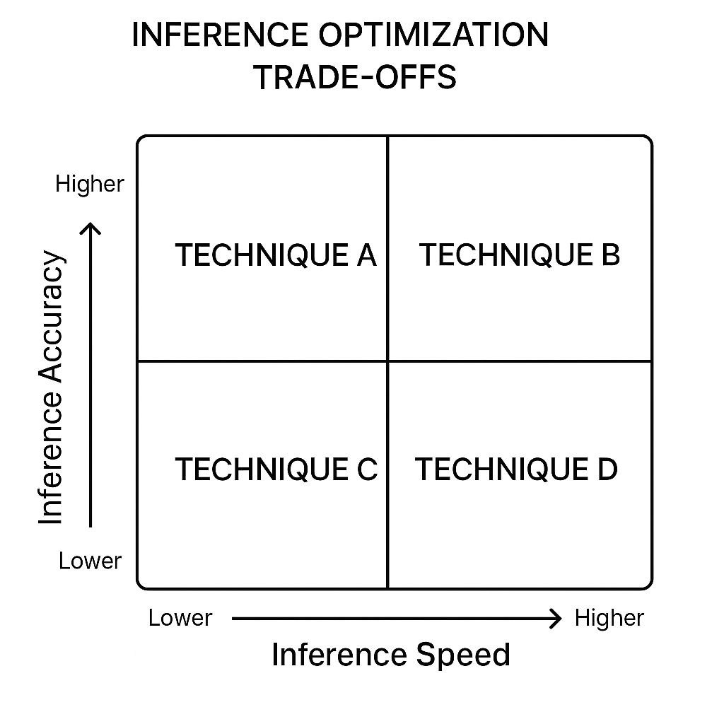
Figure 8.6: Inference optimization trade-offs matrix

Conclusion
This chapter examined advanced inference strategies integral to NLP applications. Readers learned how to enhance pipeline functionality using callbacks and extensions, implement distributed inference for scalable tasks, refine outputs through prompt engineering and post-processing, leverage ensemble methods for robust predictions, and improve inference speed and efficiency through quantization and hardware acceleration.
Chapter 9, Emerging Trends and Technologies, examines emerging NLP trends, including the integration of AI with advanced technologies, the addressing of ethical concerns, and innovations in language comprehension. This transition prepares readers to engage with upcoming advancements in NLP.

References
- R. S. Sutton and A. G. Barto, Reinforcement learning: An introduction, Second edition. Cambridge, MA: The MIT Press, 2018. Accessed: Nov. 10, 2025. [Online]. Available: https://mitpress.ublish.com/ebook/reinforcement-learning-an-introduction-2-preview/2351/viii
- J. Heaton, “Ian Goodfellow, Yoshua Bengio, and Aaron Courville: Deep learning,” Genet Program Evolvable Mach, vol. 19, no. 1–2, pp. 305–307, Jun. 2018, doi: 10.1007/s10710-017-9314-z.
- F. Chollet, “Keras,” GitHub Repository, Jun. 2015, Accessed: Nov. 10, 2025. [Online]. Available: https://www.odbms.org/2018/06/keras-the-python-deep-learning-library/
- F. Chollet, Keras: The high-level API for TensorFlow, Second. GitHub, 2017. Accessed: Nov. 10, 2025. [Online]. Available: https://www.tensorflow.org/guide/keras
- J. Dean and S. Ghemawat, “MapReduce,” Commun ACM, vol. 51, no. 1, pp. 107–113, Jan. 2008, doi: 10.1145/1327452.1327492.
- C. B. Browne et al., “A Survey of Monte Carlo Tree Search Methods,” IEEE Trans Comput Intell AI Games, vol. 4, no. 1, pp. 1–43, Mar. 2012, doi: 10.1109/TCIAIG.2012.2186810.
- L. Breiman, “Bagging predictors,” Mach Learn, vol. 24, no. 2, pp. 123–140, Aug. 1996, doi: 10.1007/BF00058655.
- B. Jacob et al., “Quantization and Training of Neural Networks for Efficient Integer-Arithmetic-Only Inference,” in 2018 IEEE/CVF Conference on Computer Vision and Pattern Recognition, IEEE, Jun. 2018, pp. 2704–2713. doi: 10.1109/CVPR.2018.00286.

