Chapter 9

Build Your Own AlphaZero AI

Introduction
AlphaZero represents one of the most important advances in artificial intelligence, demonstrating how reinforcement learning techniques can effectively solve complex problems with superhuman skills. By combining Monte Carlo Tree Search (MCTS) with deep neural networks, AlphaZero surpasses traditional AI limits, mastering games like chess, Go, and shogi. This chapter examines AlphaZero's theoretical foundation, real-world applications, and broader implications, laying the groundwork for a more in-depth exploration of reinforcement learning models.
To discuss the relevance of AlphaZero: it is a landmark AI developed by DeepMind that redefined strategic decision-making in games. Through self-play and without relying on human data or pre-existing knowledge, it achieved mastery in chess, Go, and shogi. This chapter examines AlphaZero's architecture, practical implementation, and its applications, which extend beyond gaming. By the end, readers will grasp the methodologies that underlie AlphaZero’s success and the knowledge gained for implementing similar systems.

Structure
This chapter covers the following topics:
- History and significance of AlphaZero
- Monte Carlo Tree Search and its applications
- Step-by-step guide to implementing AlphaZero for Connect4
- Training and evaluating AlphaZero in complex environments

Objectives
By the end of this chapter, readers will gain a comprehensive understanding of the AlphaZero framework, including its fundamental principles and the unique integration of deep neural networks with reinforcement learning techniques [1]. They will be able to apply MCTS in strategic decision-making algorithms, using it to explore and evaluate potential actions in complex environments. This chapter also guides readers through developing AlphaZero-like systems for specific games, with a step-by-step implementation for Connect4, while offering practical insights for adapting this methodology to other game settings. Beyond gaming, readers will explore advanced applications of AlphaZero in real-world domains [2], understanding how its reinforcement learning strategies can adapt to diverse and dynamic tasks. They will acquire expertise in training and evaluating AlphaZero models across complex environments, employing best practices to develop scalable, high-performance, and adaptable AI systems.

History and significance of AlphaZero
AlphaZero's development marked a transformative moment in artificial intelligence (AI), displaying how reinforcement learning techniques could achieve superhuman performance without human guidance. By learning solely from self-play, AlphaZero introduced a paradigm of generalizable, scalable AI systems capable of mastering diverse tasks.

Rise of AlphaZero
AlphaZero appeared as a revolutionary AI system capable of mastering complex board games through self-play reinforcement learning. Unlike traditional AI systems that relied on hand-crafted heuristics or extensive datasets, AlphaZero introduced a generalized approach, enabling:
- Neural networks to predict both move probabilities (policy) and game outcomes (value) [3].
- MCTS to simulate and evaluate game states efficiently [4].

AlphaZero neural network
AlphaZero consists of two primary components: a deep neural network and an MCTS algorithm. The neural network takes a game state that includes the current board configuration, a history of prior moves, and contextual attributes such as castling rights. It produces two critical outputs: a policy that encodes the probability distribution over potential next moves, and a value that estimates the expected game outcome from the current position.
The network is refined through gradient descent, minimizing the error between predicted policies/values and actual outcomes from self-play. This feedback loop allows AlphaZero to improve iteratively, learning strategies directly from experience and reinforcing accurate estimations, all anchored on the architecture presented in Figure 9.1 [1]:
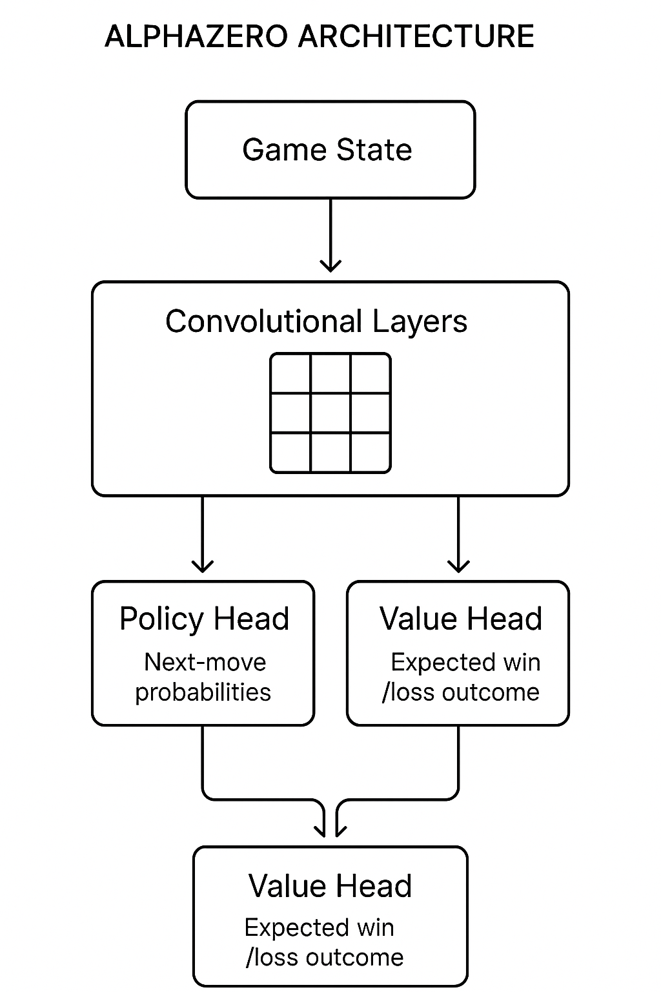
Figure 9.1: The AlphaZero architecture (policy and value heads)
These outputs originate from dual-headed architecture comprising the policy and value heads, as illustrated in Figure 9.1. The input state vector passes through a shared stack of convolutional layers, which extract spatial and temporal features. This representation then branches into two parallel paths: the policy head outputs action probabilities, while the value head provides a scalar prediction of win/loss likelihood.
Training begins with a randomly initialized network. Data is generated through self-play; AlphaZero plays against itself using MCTS, which relies on the current neural network to guide simulation and move selection. These self-play games form a high-quality training dataset. Over time, the system populates and updates a replay buffer, replacing older games with stronger ones.
The input game state is processed by shared convolutional layers, split into two heads: the policy head outputs a move probability distribution. In contrast, the value head predicts the expected game outcome.

Achievements of AlphaZero
AlphaZero's success in strategic decision-making games underscores its capabilities. Through groundbreaking training methodologies, it achieved notable victories:
- Chess: AlphaZero defeated Stockfish, the leading chess engine, after just four hours of self-training [5].
- In this training, AlphaZero utilized 700,000 games of self-play, employing MCTS to refine its strategic depth with every iteration.
- Go: It surpassed AlphaGo Zero, itself a groundbreaking AI, setting up new levels of ability in Go [6].
- By using its neural network, AlphaZero integrated historical match data and dynamically adjusted move probabilities to optimize strategy.
- Shogi: Within hours, AlphaZero dominated Elmo, a world-class shogi engine.
- Through intensive training and simulation, AlphaZero analyzed millions of states, building an unprecedented understanding of shogi tactics.
These achievements not only highlight AlphaZero’s technical capabilities but also show its ability to generalize across different gaming environments. Each of these victories underscores a methodical approach combining computational efficiency with unparalleled strategy learning, achieved through iterative self-play and powerful simulations [7].

Relevance to AI research
AlphaZero's methodologies have catalyzed advancements in artificial intelligence, leading to breakthroughs in different fields:
- Autonomous decision-making systems: AlphaZero’s principles enable robotics and autonomous vehicles to develop adaptive strategies. By simulating potential actions and outcomes, autonomous systems can enhance performance in tasks such as efficient navigation and dynamic obstacle avoidance.
- Example: Autonomous vehicles apply AlphaZero’s principles to predict traffic flow and dynamically adjust routes to minimize delays.
- Optimization tasks: AlphaZero's methodologies revolutionize planning, energy distribution, and scheduling systems by simulating multiple scenarios and finding the best resource allocation strategies [8]. For instance, in planning, AlphaZero-inspired algorithms can dynamically adapt routes based on real-time data.
- Example: In planning, AlphaZero-inspired frameworks dynamically adjust delivery routes, reducing costs and enhancing efficiency.
- Generalized AI frameworks: AlphaZero inspires architectures that apply reinforcement learning across diverse fields, such as healthcare or financial modeling [4]. These frameworks use self-play techniques to iteratively refine predictions and strategies.
- In healthcare applications, AlphaZero-inspired systems improve treatment plans by simulating patient outcomes under various interventions and personalizing care strategies [9].

Monte Carlo Tree Search and its applications
MCTS lies at the heart of AlphaZero’s decision-making process, serving as a robust mechanism for balancing exploration and exploitation in uncertain environments. By iteratively simulating potential outcomes, MCTS enables precise decision-making, even in high-dimensional and unpredictable tasks. Its implementation underscores the principles of strategic foresight and adaptability that define modern AI systems.

Introduction to MCTS
MCTS is a search algorithm that balances exploration and exploitation to make informed decisions in complex, uncertain environments. MCTS builds a search tree incrementally, using four key steps:
- Selection: Navigate the tree to the most promising node using the Upper Confidence Bound (UCB1) formula. The UCB1 formula balances nodes that are well-explored with those that may hold untapped potential.
- The algorithm prioritizes nodes with higher win rates while also considering less often visited nodes for exploration.
- In AlphaZero, this step prioritizes nodes that maximize cumulative win rates while keeping exploration of less often visited options. This is crucial for finding the best strategies while avoiding local maxima.
- Expansion: Conduct random rollouts to evaluate the potential outcome of a state. Simulations play out the game from a given node to the end, using random actions to estimate the value of that state.
- AlphaZero leverages neural network predictions at this stage to prioritize expansions based on successful outcomes, enhancing computational efficiency.
- Simulation: Conduct random rollouts to evaluate the potential outcome of a state. Simulations play out the game from a given node to the end, using random actions to estimate the value of that state.
- In AlphaZero, simulations are enhanced by value predictions from the neural network, replacing random rollouts with informed estimates that increase accuracy.
- Backpropagation: Update the statistics of nodes based on simulation results (Browne et al., 2012). Results from simulations propagate back through the tree, updating win rates and visit counts to refine future selections.
Backpropagation ensures that the performance of every explored path contributes to improving decision-making at the root level.
The four-stage cycle of MCTS - from node selection to statistical backpropagation - forms the core of AlphaZero’s tactical reasoning. This process is illustrated in Figure 9.2, showing how each phase contributes to strategic decision-making in complex environments:

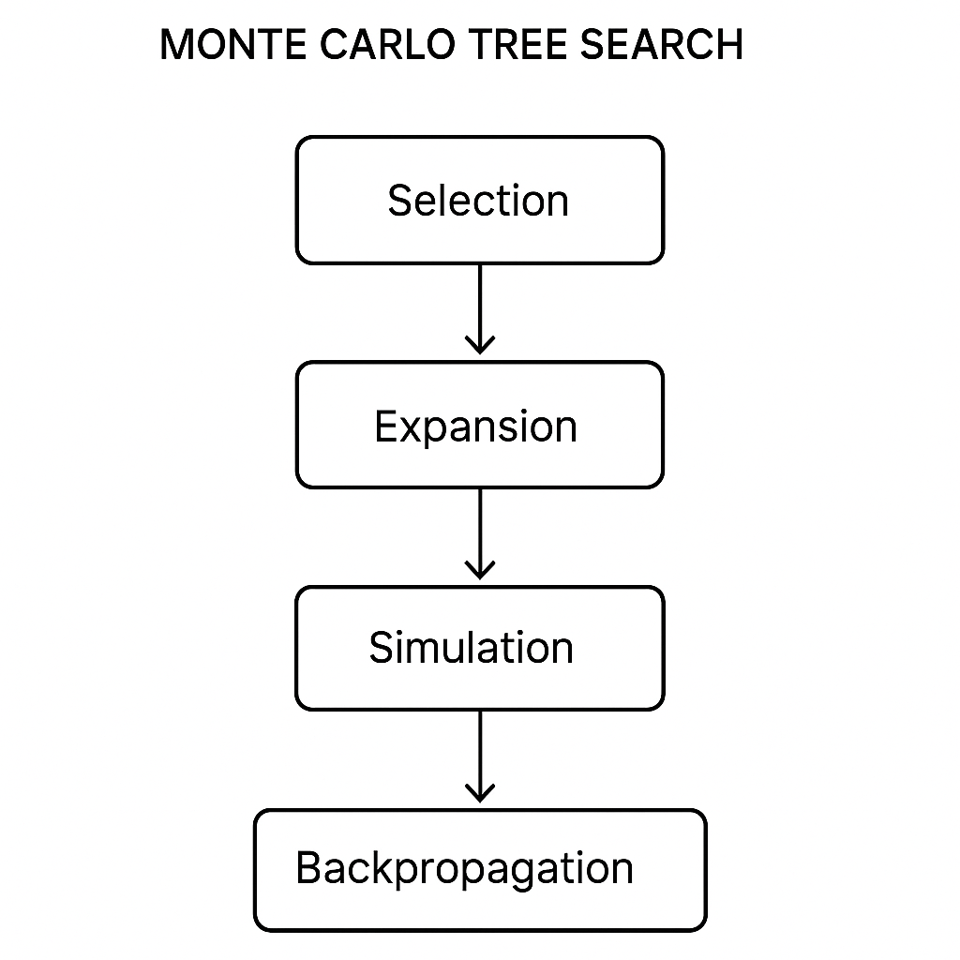
Figure 9.2: MCTS flow

Advanced applications
AlphaZero's reinforcement learning methods and MCTS's versatility have led to adoption across various fields, not confined to traditional board games. Its principles can be extended to more complex gaming environments, such as real-time strategy games or multiplayer online battle arenas (MOBAs). These environments present unique challenges, including larger state and action spaces and the need for real-time decision-making.

Extensions to real-world problems
Beyond gaming, AlphaZero's techniques are increasingly being adapted for use in diverse real-world applications:
- Supply chain optimization: AlphaZero-like models can improve planning by simulating various supply chain scenarios to minimize costs and improve efficiency [10]. MCTS enhances resource allocation by simulating and selecting actions that minimize costs while maximizing throughput.
- Financial trading: In financial markets, similar algorithms can help in developing strategies for trading stocks or cryptocurrencies by simulating various market conditions and decision-making scenarios.
- Robotics: In robotics, these methods can be used for path-finding and strategic planning, especially in environments where robots must adapt to dynamic obstacles and conditions [5].
- Games: AlphaZero’s use of MCTS enabled strategic planning in chess, Go, and Connect4. For instance, MCTS enabled AlphaZero to evaluate millions of potential moves in real time, finding the best strategies even in complex game states.
The feedback loop between self-play, model training, and policy refinement is central to AlphaZero’s learning cycle. Figure 9.3 visualizes this training loop, highlighting how the system evolves by learning from its own games:
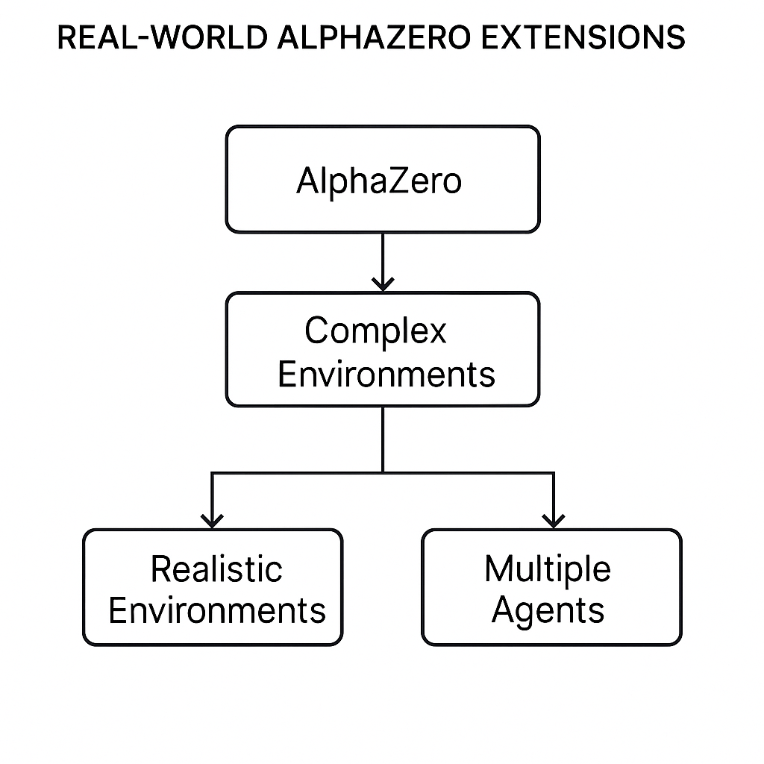
Figure 9.3: Real-world AlphaZero extensions

Self-play generates data for network training, producing a stronger model that drives the next iteration.

Basic MCTS implementation (Code example)
MCTS is a key component in decision-making algorithms, such as AlphaZero, enabling systematic exploration and assessment of potential outcomes in complex environments. The following implementation demonstrates the essential structure of MCTS, highlighting its role in balancing the exploration of less-visited nodes and the exploitation of known high-value nodes to make optimal decisions in strategic situations:
```python …
import random

class MCTSNode:
def __init__(self, state, parent=None):
self.state = state
self.parent = parent
self.children = []
self.visits = 0
self.wins = 0
self.untried_actions = self.get_legal_actions()

def get_legal_actions(self):
# This function should return the legal actions from this state
return ['action1', 'action2', 'action3']

def select_child(self):
# Select a child node with the highest UCB1 score
return max(self.children, key=lambda c: c.wins / c.visits + (2 * (2 * self.visits / c.visits)**0.5))

def expand(self):
# Expand the tree by creating a new child node
action = self.untried_actions.pop()
next_state = self.state.perform_action(action)
child_node = MCTSNode(next_state, self)
self.children.append(child_node)
return child_node

def simulate(self):
# Simulate a random playout from this node
current_node = self
while not current_node.is_terminal():
current_node = random.choice(current_node.get_legal_actions())
return current_node.get_result()

def backpropagate(self, result):
# Update nodes with the simulation result
self.visits += 1
self.wins += result
if self.parent:
self.parent.backpropagate(result)

def monte_carlo_tree_search(root, iterations=1000):
for _ in range(iterations):
node = root
while node.untried_actions == [] and node.children != []:
node = node.select_child()
if node.untried_actions != []:
node = node.expand()
result = node.simulate()
node.backpropagate(result)
# Example usage
initial_state = GameState()
root_node = MCTSNode(initial_state)
monte_carlo_tree_search(root_node)
```
This code defines the core mechanics of Connect4, enabling move validation, representing the game state, and identifying legal moves.
It illustrates the fundamental processes of MCTS and their functional significance in decision-making. The select_child method uses the Upper Confidence Bound (UCB1) formula to strategically navigate the tree, balancing exploration of less-visited nodes with exploitation of high-value ones. The expand method introduces new nodes into the search tree, ensuring that the algorithm continuously evaluates unexplored actions to discover the best outcomes. The backpropagate method iteratively updates the statistics of visited nodes, propagating the results of simulated outcomes back through the tree to refine decision-making at all levels. Together, these methods enable a systematic and adaptive approach to navigating complex decision spaces, forming the backbone of advanced AI implementations, such as AlphaZero. By integrating this structure with neural network predictions, AlphaZero enhances the computational efficiency and accuracy of traditional MCTS methods.

Implementing MCTS for a simple game (Example)
To further illustrate how MCTS can be applied in decision-making scenarios, let us use it in the classic game of Tic-Tac-Toe. This example shows the practical use of MCTS to simulate, evaluate, and optimize moves in a simple game environment. By walking through this implementation, we can gain insight into how MCTS enables strategic foresight in game-playing AI:
```python …

class TicTacToe:
def __init__(self):
self.board = [[None]*3 for _ in range(3)]
self.player = 'X'

def move(self, x, y):
if self.board[x][y] is None:
self.board[x][y] = self.player
self.player = 'O' if self.player == 'X' else 'X'
return self

def is_winner(self, player):
win_conditions = [
[self.board[i][0] == player and self.board[i][1] == player and self.board[i][2] == player for i in range(3)],
[self.board[0][i] == player and self.board[1][i] == player and self.board[2][i] == player for i in range(3)],
[self.board[i][i] == player for i in range(3)],
[self.board[i][2-i] == player for i in range(3)]
]
return any(win_conditions)

def get_legal_moves(self):
return [(x, y) for x in range(3) for y in range(3) if self.board[x][y] is None]
```
This portion of the code defines the basic structure of the Tic-Tac-Toe game. The TicTacToe class initializes the game board and manages the game's state. It includes methods to make a move (move), check for a winner (is_winner), and find available legal moves (get_legal_moves).
Next, we define the core MCTS logic that will interact with this game environment:
```python …
def mcts(root_state, iterations=1000):
root_node = MCTSNode(root_state)

for _ in range(iterations):
node = root_node
state = deepcopy(root_state)

# Selection
while node.children:
node = node.select_child()
state = state.move(*node.move)

# Expansion
if not state.is_winner('O') and not state.is_winner('X'):
legal_moves = state.get_legal_moves()
for move in legal_moves:
new_state = deepcopy(state).move(*move)
node.add_child(new_state, move)

# Simulation
while legal_moves:
move = random.choice(legal_moves)
state = state.move(*move)
legal_moves = state.get_legal_moves()

# Backpropagation
while node is not None:
node.update(state.result(node.player))
node = node.parent

return root_node.best_action()

# Example usage
game = TicTacToe()
mcts(game)
```
This function integrates the four fundamental stages of MCTS:
- Selection: The algorithm traverses the search tree, selecting child nodes based on their win statistics and exploration potential.
- Expansion: If an unvisited node is encountered, the tree expands by adding child nodes for all moves.
- Simulation: Random rollouts are conducted from the newly expanded node to estimate potential game outcomes.
- Backpropagation: Simulation results propagate back up the tree, updating win statistics for all visited nodes.
Finally, the MCTS function outputs the best action found during the simulation process.

Further insights from the code
The TicTacToe class serves as the environment for the MCTS algorithm. The move method allows players to make moves on the board, alternating between 'X' and 'O'. The is_winner method evaluates the board to decide if a player has achieved a winning condition, checking all winning combinations - rows, columns, and diagonals. Meanwhile, get_legal_moves dynamically finds all available spaces on the board where a move can be made.
The MCTS implementation iterates through 1,000 simulations to explore the game space. During choice, the select_child function uses the Upper Confidence Bound (UCB1) formula to balance exploration and exploitation, selecting nodes with high win probabilities. In the expansion stage, all potential moves from the current node are added as children, allowing the algorithm to explore new states. Simulations use random moves to complete the game and approximate the value of a given node. Finally, backpropagation updates win rates and visit counts for all nodes along the path, ensuring that each simulation contributes to the overall optimization of decision-making.
This example demonstrates how MCTS can be applied to simple games, such as Tic-Tac-Toe, providing a foundation for more complex implementations, including those in AlphaZero. By systematically exploring the decision space and refining strategies through self-play, MCTS displays its versatility and effectiveness in optimizing decision-making in uncertain environments.

Guide to implement AlphaZero for Connect4
AlphaZero's approach to mastering games through reinforcement learning can be adapted to simpler yet strategically complex games, such as Connect4. This section outlines the implementation of an AlphaZero-like model for Connect4, focusing on the training process and subsequent performance evaluation.
Implementing AlphaZero for Connect4 involves combining neural networks with MCTS to create a self-learning agent. Key steps include setting up the environment, designing the neural network, integrating MCTS, and conducting iterative self-play training.
The feedback loop between self-play, model training, and policy refinement is central to AlphaZero’s learning cycle. Figure 9.3 visualizes this training loop, highlighting how the system evolves by learning from its own games:
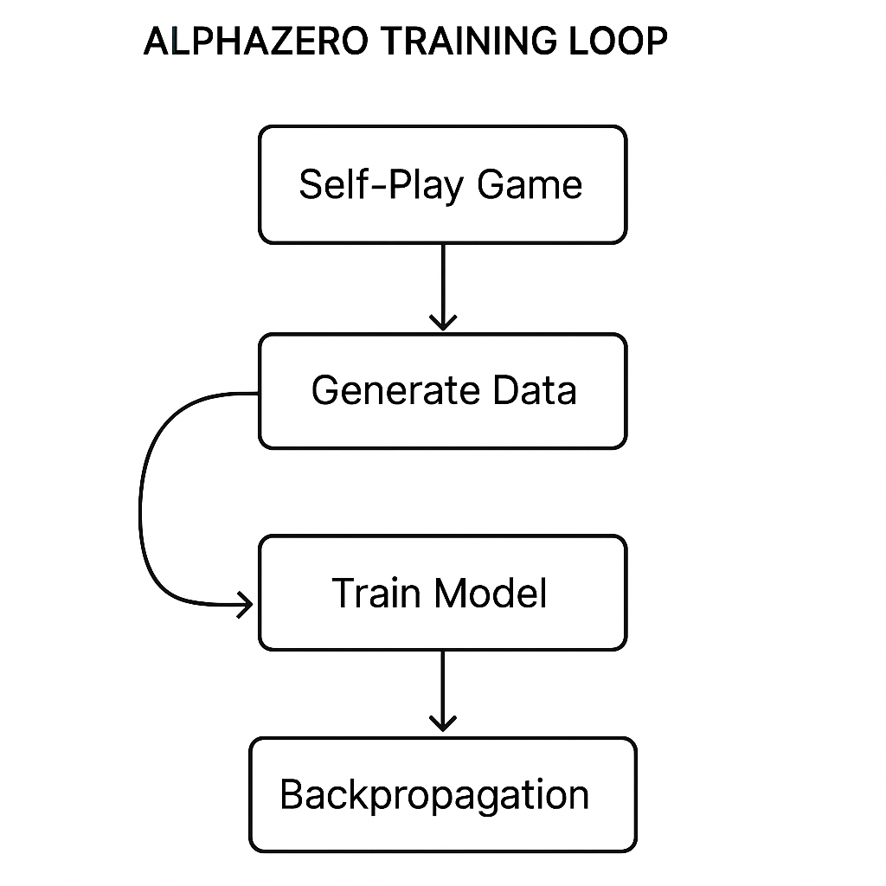
Figure 9.4: AlphaZero training loop

Self-play generates data for network training, producing a stronger model that drives the next iteration.

Step-by-step implementation
Building an AlphaZero-like model for Connect4 requires a systematic approach that combines basic game mechanics with advanced reinforcement learning techniques. Each step in the implementation process helps create an AI capable of making strategic decisions through self-play and iterative improvement. In the following section, we outline the essential stages, from setting up the game environment to integrating neural networks and MCTS for optimal gameplay.
To contextualize these components, Figure 9.4 presents the architecture of the Connect4 AlphaZero stack, mapping the relationship between the environment, the agent, and its underlying neural network:
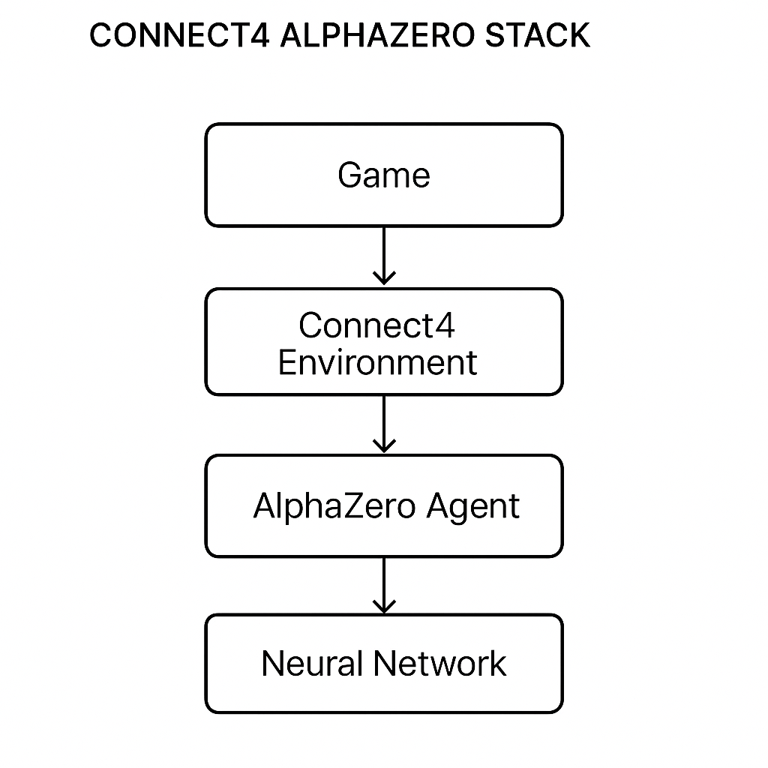
Figure 9.5: Connect4 AlphaZero stack

The following layered architecture of the Connect4 implementation presents how the environment, AlphaZero agent, and model interact:
- Environment setup: First, we need to define the Connect4 game rules and board state representation.
- Neural network design: Implementing a neural network that predicts both probabilities and the expected outcome from any given board state.
- MCTS integration: Integrating MCTS to use the neural network’s predictions for robust game-playing strategy development.
- Self-play training loop: Using self-play to generate data, train the neural network, and refine the MCTS.

Training and evaluation
Once the implementation framework is complete, the following key step is to train the model and assess its performance. This stage ensures that the AI effectively learns from self-play and can surpass baseline strategies. Training involves repeated cycles of generating gameplay data and improving the model, while evaluation assesses the AI's progress by comparing it to previous versions and established benchmarks. The following two processes are essential for confirming the robustness and scalability of the developed model:
- Training process: The model is trained iteratively; each training cycle involves self-play sessions to generate new game data, followed by network retraining using this accumulated data.
- Evaluation: The trained model is evaluated against baseline strategies and earlier versions of itself to measure improvement.

Connect4 environment (Code example)
To implement AlphaZero for Connect4, the first step is to set up the game environment. This environment provides a structured view of the game board, outlines the rules of play, and ensures that all moves adhere to the Connect4 logic. By creating a clean and functional environment, we lay the foundation for integrating advanced techniques, such as neural networks and MCTS. The following code demonstrates how to build a Connect4 environment, handle player moves, and verify game states:
```python …

import numpy as np

class Connect4:
def __init__(self):
self.board = np.zeros((6, 7), dtype=int)
self.current_player = 1

def make_move(self, col):
for row in range(5, -1, -1):
if self.board[row, col] == 0:
self.board[row, col] = self.current_player
self.current_player = 3 - self.current_player
return True
return False

def is_winner(self, player):
# Check for wins (horizontal, vertical, diagonal)
pass

def get_legal_moves(self):
return [c for c in range(7) if self.board[0, c] == 0]
# Example of initiating a game and making a move
game = Connect4()
game.make_move(3) # Player 1 moves in the middle column
```
This code snippet provides a functional Connect4 environment that serves as the foundation for training and testing reinforcement learning algorithms, such as AlphaZero. The following list outlines a detailed breakdown of its components:
- Class definition (Connect4): The Connect4 class encapsulates the rules and mechanics of the game. This class allows for object-oriented management of the game state, making it easy to extend and integrate with other systems.
- Game board initialization (__init__):
- The board is represented as a 6x7 matrix initialized with zeros (np.zeros((6, 7), dtype=int)), where each cell corresponds to an empty slot in the Connect4 grid.
- The current_player attribute tracks the active player (1 or 2), alternating after every valid move.
- Move execution (make_move):
- This method enables players to place their token in a specified column.
- The method iterates from the bottom row upwards (for row in range(5, -1, -1)) to find the first available slot in the chosen column.
- Upon successfully placing a token, the current_player switches to the other player using self.current_player = 3 - self.current_player.
- If the column is full, the method returns False, signaling an invalid move.
- Winning condition checker (is_winner):
- Although currently a placeholder, this method is intended to evaluate whether a player has achieved four consecutive tokens horizontally, vertically, or diagonally.
- By implementing this method, the game environment will be able to detect victory conditions, a crucial feature for training and evaluating reinforcement learning models.
- Legal moves (get_legal_moves):
- This method returns a list of columns where a token can legally be placed ([c for c in range(7) if self.board[0, c] == 0]).
- It ensures that players cannot make moves in already full columns, maintaining the integrity of gameplay.
- Example usage:
- The example demonstrates initializing a Connect4 game (game = Connect4()) and executing a move in the middle column (game.make_move(3)).
- This serves as a basic test case to confirm the functionality of the Connect4 class.
This code offers a solid base for integrating MCTS and neural networks. It simplifies the complexities of Connect4 gameplay, enabling reinforcement learning models to concentrate on strategic decision-making. By adding features like win detection and state evaluation, you can further enhance it to meet the needs of advanced AI training workflows, such as AlphaZero.

Resource management simulation (Code example)
AlphaZero's methods are not limited to traditional board games; they also apply to real-world scenarios that require strategic resource management and decision-making under constraints. Resource management, a key challenge across logistics, robotics, and energy distribution, involves balancing competing priorities and optimizing outcomes. The following code simulates a simplified real-time strategy (RTS) game where an AI agent must gather resources, build units, and assess performance. The following code illustrates how versatile AlphaZero's decision-making framework can be in dynamic, constrained environments:
```python …
class RTSGame:
def __init__(self):
self.resources = 100
self.units = 0

def step(self, action):
if action == "gather":
self.resources += 10
elif action == "build" and self.resources >= 20:
self.units += 1
self.resources -= 20

def evaluate(self):
return self.resources + 10 * self.units
```
This code provides a basic simulation of resource management, highlighting the trade-offs and decisions involved in such scenarios. Here is a detailed breakdown of the implementation:
- Class definition (RTSGame):
- The RTSGame class represents a simplified real-time strategy environment. It encapsulates attributes and methods necessary to simulate resource gathering, unit building, and performance evaluation.
- This abstraction provides a flexible framework for testing reinforcement learning algorithms in resource management scenarios.
- Attributes (__init__):
- The resources attribute tracks the total available resources, initialized to one hundred units.
- The units attribute keeps count of the number of units constructed, starting at zero.
- These attributes model the fundamental constraints and goals in a resource management problem.
- Actions (step): The step method defines the game's possible actions and their effects:
- "gather": Increases the resource pool by ten units, simulating a resource collection activity.
- "build": Constructs a unit if sufficient resources (20 units) are available. Each unit decreases the resource pool by twenty units.
By implementing actions under resource constraints, this method mirrors real-world scenarios in which trade-offs must be evaluated.
- Performance evaluation (evaluate):
- The evaluate method calculates a performance metric based on the current state of the game.
- The formula self.resources + 10 * self.units assigns higher value to states with more units, emphasizing unit production while maintaining resource efficiency.
- This metric can be adapted to reflect different strategic priorities, making the simulation versatile for various applications.
- Dynamic decision-making:
- This simulation captures the essence of dynamic decision-making by requiring the AI agent to balance immediate resource collection against long-term unit production.
- For example, overemphasizing resource gathering may result in fewer units, reducing overall performance, while prioritizing unit building too early could deplete resources and limit future options.
- Real-world relevance: This simulation shows how AlphaZero-inspired algorithms can manage trade-offs in resource allocation problems. For instance:
- In planning, similar frameworks can optimize inventory replenishment versus distribution.
- In robotics, they can decide between recharging batteries or completing tasks under power constraints.
By extending the RTSGame class with added complexity, such as time constraints or stochastic events, the simulation can more closely approximate real-world resource management challenges.
This example offers a concrete starting point for adapting AlphaZero's reinforcement learning techniques to real-world situations. By combining neural networks and MCTS, the simulation could develop into a more advanced system capable of tackling complex resource management issues in dynamic environments.

Example - Adapting AlphaZero for a game simulation
Let us examine a simplified version of a real-time strategy game in which the AI must manage resources, build units, and defeat an opponent. We will describe how to adapt the AlphaZero framework for this setting:
```python …

class RTSGame:
def __init__(self):
self.resources = 100
self.units = 0
self.enemy_units = 5
self.time = 0

def simulate_action(self, action):
if action == "gather":
self.resources += 10
elif action == "build":
if self.resources >= 20:
self.units += 1
self.resources -= 20
elif action == "attack":
if self.units > 0:
self.enemy_units -= 1
self.units -= 1
self.time += 1

def is_game_over(self):
return self.enemy_units <= 0 or self.time > 100

def evaluate_state(self):
if self.enemy_units <= 0:
return 1 # Win
elif self.time > 100:
return -1 # Lose
return 0 # Ongoing

# Example usage of RTSGame
game = RTSGame()
while not game.is_game_over():
action = np.random.choice(["gather", "build", "attack"])
game.simulate_action(action)
print(f"Resources: {game.resources}, Units: {game.units}, Enemy Units: {game.enemy_units}")
```
This section emphasizes the versatility and strength of AlphaZero's methods, demonstrating their use beyond games to address complex, real-world issues. By applying these techniques across various fields, researchers and practitioners can harness the power of deep reinforcement by learning to address challenges that require strategic thinking and flexible decision-making. [11].

Training and evaluating AlphaZero in complex environments
Training AlphaZero in complex environments requires specialized strategies to manage increased complexity and uncertainty. These strategies often involve enhancing the model's exploration capabilities and refining the reward system to gain a deeper understanding of the environment's details, which are as follows:
- Enhanced exploration techniques: Incorporating mechanisms such as noise injection into the policy network during training phases to promote exploration of less frequent but potentially rewarding actions.
- Dynamic reward adjustment: Changing reward functions dynamically based on the state and progress of the environment to focus learning on critical aspects that lead to long-term success.

Case studies
The following list outlines case studies where AlphaZero’s reinforcement learning framework has been applied or adapted to complex, real-world environments, demonstrating its capacity to handle continuous decision-making under uncertainty and dynamic constraints:
- Autonomous driving simulations: Training AlphaZero to manage real-time decision-making in simulated urban environments, where the model must learn to navigate complex traffic scenarios safely. These simulations illustrate how self-play and MCTS-based exploration can improve adaptive control and collision-avoidance systems.
- Energy grid management: Using AlphaZero to improve energy distribution and consumption in simulated smart grids, handling fluctuations in energy demand and supply efficiently. This case illustrates how reinforcement learning can enhance grid stability and optimize resource allocation in large-scale infrastructure systems.

Code example - AlphaZero for energy grid management
AlphaZero's reinforcement learning framework, renowned for its success in gaming, can also address critical real-world challenges, such as energy management. The energy grid is a dynamic system where supply and demand constantly fluctuate, requiring adaptive decision-making to maintain stability and efficiency. The following code illustrates a simplified energy grid environment, showing how AlphaZero-inspired strategies can balance production and consumption while optimizing performance metrics. The approach highlights how advanced AI techniques can be applied to domains that need continuous adaptation and resource management.
```python …

class EnergyGrid:
def __init__(self):
self.energy_supply = 100
self.energy_demand = 50

def step(self, action):
if action == "increase":
self.energy_supply += 10
elif action == "decrease" and self.energy_supply > 10:
self.energy_supply -= 10
self.energy_demand = np.random.randint(30, 70) # Demand varies
reward = -abs(self.energy_supply - self.energy_demand)
return self.energy_supply, reward
# Simulate AlphaZero's decision-making process in the energy grid
grid = EnergyGrid()
for _ in range(20): # Run a few steps
action = np.random.choice(["increase",
"decrease"])
supply, reward = grid.step(action)
print(f"Action: {action}, Supply: {supply}, Reward: {reward}")
```
This code models a simple energy grid system, demonstrating how reinforcement learning methods, such as AlphaZero, can manage dynamic resource management. The following is a breakdown of its main parts:
- Class definition (EnergyGrid):
- The EnergyGrid class models the energy grid, encapsulating its attributes (energy_supply and energy_demand) and behaviors (step method).
- This abstraction allows for the simulation of an energy grid environment, where decisions directly affect the balance between supply and demand.
- Attributes (__init__):
- energy_supply: It represents the current energy production, initialized at one hundred units.
- energy_demand: It represents the fluctuating energy consumption, starting at 50 units.
- These attributes define the system's state and serve as inputs to the decision-making process.
- Actions (step):
- The step method implements two actions:
- "increase": It increases the energy supply by ten units, simulating actions like ramping up power plant output or integrating additional energy sources.
- "decrease": It reduces energy supply by ten units, provided the supply remains above a minimum threshold, simulating actions like scaling down production or redirecting surplus energy.
- The demand (energy_demand) varies stochastically, simulating real-world scenarios where consumption patterns are unpredictable.
- The reward is calculated as the negative absolute difference between supply and demand (-abs(self.energy_supply - self.energy_demand)), encouraging actions that minimize the imbalance.
- Simulation:
- The simulation iterates over a series of twenty decision steps, using randomly chosen actions ("increase" or "decrease") to modify the grid's state.
- After each action, the resulting supply and reward are printed, providing feedback on the effectiveness of the decision.
- Dynamic adaptation:
- This simulation captures the essence of balancing supply and demand in an energy grid, a challenge faced by utility companies and grid operators worldwide.
- By minimizing the difference between supply and demand, the system maximizes efficiency and reduces waste, aligning with objectives in energy grid management.
- Real-world relevance:
- Grid stability: In real-world grids, balancing supply and demand ensures stability and prevents outages. This simulation mimics such decision-making processes in a simplified manner.
- Renewable integration: The approach can be extended to manage variability in renewable energy sources like wind or solar, where production depends on environmental factors.
- Dynamic pricing: This framework could also be adapted to incorporate economic incentives, optimizing grid operations based on real-time electricity prices and costs.
By incorporating AlphaZero-inspired algorithms into this energy grid model, the system could autonomously learn optimal strategies over time, outperforming static or rule-based methods. This key example serves as a bridge toward deploying AI-driven energy management systems, demonstrating how reinforcement learning can help create a sustainable, efficient energy future.

Training strategies
Designing and implementing effective training strategies is crucial for achieving optimal performance in reinforcement learning systems, such as AlphaZero. These strategies enable the model to iteratively learn and enhance its decision-making capabilities in increasingly complex situations. Through self-play and customized reward systems, AlphaZero can recognize patterns, optimize outcomes, and adapt to a wide variety of environments. This section explores the essential components of AlphaZero's training approach and how they enhance its adaptability and effectiveness:
- Self-play: Self-play is a crucial component of AlphaZero's training, where the model generates its own data by playing against itself. This method ensures that the model encounters challenging scenarios as it improves, pushing its limits with each iteration. By utilizing MCTS during gameplay, AlphaZero updates its policy and value networks based on the outcomes of these simulated games. This approach eliminates the need for labeled datasets, enabling an automatic, scalable training process. For example, AlphaZero's self-play system helped it beat Stockfish in chess by developing new, unexpected strategies that human-designed systems had not considered.
- Reward engineering: Effective reward engineering is vital for guiding the model's learning process. AlphaZero’s rewards promote behaviors that lead to long-term success over short-term gains. For example, in a game setting, rewards might be tied to winning rather than to earning intermediate points, encouraging deeper strategic gameplay. Likewise, in real-world applications such as supply chain optimization, reward functions can focus on minimizing overall costs and delays, rather than just individual deliveries. Well-designed reward systems help the model strike a balance between complex trade-offs and achieve objectives aligned with desired outcomes.

Evaluation metrics
Assessing the performance of reinforcement learning models is just as crucial as their training. Strong evaluation metrics provide valuable insights into the model's strengths, weaknesses, and its ability to generalize beyond the training setup. For AlphaZero, metrics such as win rates and generalization skills demonstrate its progress and readiness for real-world use. The following list discusses methods to evaluate AlphaZero’s performance, ensuring its effectiveness and scalability:
- Win rates: Win rates are a key metric for assessing AlphaZero's performance. By comparing its results with baseline models and previous versions, the win rates demonstrate the model's ability to outperform competitors and improve over time. For instance, AlphaZero's win rate against Stockfish in chess provided straightforward evidence of its superiority. Additionally, win rates offer insights into the model's consistency across different conditions, such as time limits or various initial setups, which helps refine its decision-making process.
- Generalization: Generalization measures AlphaZero's ability to adapt its strategies to new situations and environments it has not encountered during training. This metric is significant for applications in unpredictable or changing fields, such as energy grid management or autonomous driving. A well-generalized model can smoothly transition from simulated settings to real-world conditions, maintaining high performance across various challenges. For example, an AlphaZero-inspired model trained on traffic simulations should generalize effectively to manage real-world traffic patterns, including unexpected events such as accidents or roadblocks. By assessing generalization abilities, researchers ensure the model's dependability and resilience in practical use [8].
The relationship between win rate and generalization offers valuable insight into AlphaZero’s overall performance. While win rates reflect short-term competitive success against benchmarks, generalization measures the model’s ability to sustain this performance across new and unseen environments. Figure 9.6 illustrates the interaction between these two metrics, showing the balance between specialization for specific tasks and adaptability for broader, real-world applications:
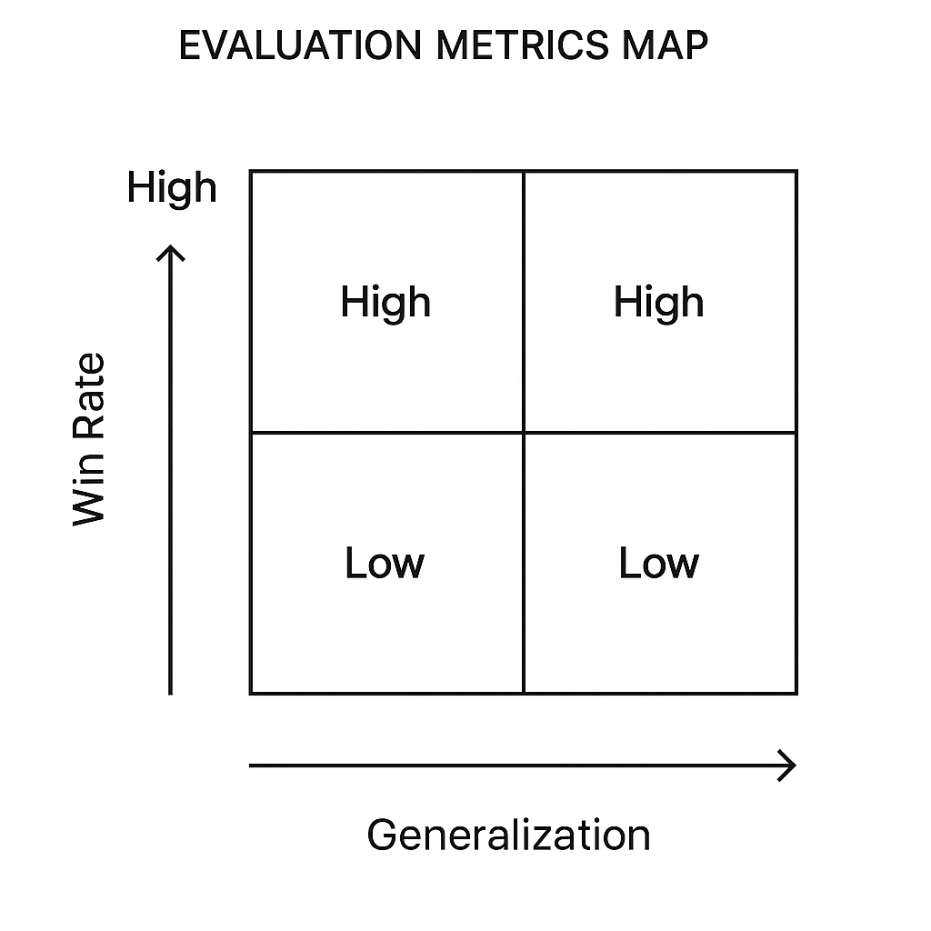
Figure 9.6: Evaluation metrics map (win rate vs generalization)

Conclusion
Chapter 9 explores the AlphaZero algorithm, highlighting its success in mastering games like chess, shogi, and Go, as well as its impact on artificial intelligence and reinforcement learning. By examining MCTS, offering a step-by-step guide to implementing AlphaZero for Connect4, and discussing practical applications such as energy grid management and autonomous driving, the chapter demonstrates how AlphaZero adapts to different challenges. Through strategies for training in complex environments and useful code examples, readers gain hands-on experience in effectively applying and customizing AlphaZero. The principles introduced here continue to influence advances in AI, opening new possibilities for various applications.
In the next chapter, we explore Deep Q-Networks (DQN) and their use in Atari games. Building on AlphaZero's self-play and MCTS approaches, we examine how DQNs improve learning in complex, high-dimensional environments.

References
- T. McGrath, A. Kapishnikov, T. Toma, A. Pearce, D. Hassabis, B. Kim, U. Paquet and V. Kramnik, Acquisition of Chess Knowledge in AlphaZero", 2022.
- C. B. Browne, E. Powley, D. Whitehouse, S. M. Lucas, P. I. Cowling, P. lfshagen and S. Colton, "A Survey of Monte Carlo Tree Search Methods," IEEE Transactions on Computational Intelligence and AI in Games, vol. 4, no. 1, pp. 1-43, 2012.
- D. Silver, T. Hubert, J. Schrittwieser, I. Antonoglou, M. Lai, A. Guez and D. Hassabis, "A general reinforcement learning algorithm that masters chess, shogi, and Go through self-play," Science, vol. 362, no. 6419, pp. 1140, 1144, 2018.
- R. D. Sutton and A. G. Barto, "Sparse rewards and stochastic transitions are central to many real-world problems and are effectively captured in environments like FrozenLake," 2018. [Online].
- D. Silver, J. Schrittwieser, K. Simonyan, I. Antonoglou, A. Huang, A. Guez and D. Hassabis, "Mastering Chess and Shogi by Self-Play with a General Reinforcement Learning Algorithm," 2017.
- D. Silver, J. Schrittwieser and K. Simonyan, "Mastering the game of Go without human knowledge," Nature, vol. 550, no. 7676, pp. 354, 359, 2017.
- G. Tesauro, "Temporal difference learning and TD-Gammon," Communications of the ACM, vol. 38, pp. 58, 68.
- O. Vinyals, I. Babuschkin, W. M. Czarnecki, M. Mathieu, A. Dudzik, J. Chung and D. Silver, "Grandmaster Level in StarCraft II Using Multi-Agent Reinforcement Learning," Nature, vol. 575, no. 7782, pp. 350-354, 2019.
- R. S. Sutton and A. G. Barto, Reinforcement Learning: An Introduction, MIT press, 2018.
- L. Kocsis and C. Szepesvári, "Bandit-Based Monte-Carlo Planning," in European Conference on Machine Learning, Berlin, Heidelberg, 2006.
- V. Mnih, K. Kavukcuoglu and D. Silver, "Human-level control through deep reinforcement learning," Nature, vol. 518, pp. 529, 533.

