Chapter 12

Road Ahead

Introduction
Chapter 12, Road Ahead, concludes our in-depth examination of reinforcement learning, the Hugging Face Diffuser library, and their transformative impact on artificial intelligence (AI). Reflecting on the journey through the book, this chapter shifts the focus to the future by summarizing the main ideas, exploring new technologies and environments, and examining the ethical and societal issues associated with AI development.
Throughout this chapter, readers will enhance their understanding, explore new research areas, and gain insights into responsible AI development. The chapter concludes with a comprehensive view of the future of reinforcement learning and its transformative power to shape society.

Structure
This chapter covers the following topics:
- Revisiting core concepts of deep reinforcement learning
- Future trends and research directions

Objectives
By the end of this chapter, readers will have strengthened their basic understanding of reinforcement learning by reflecting on its core principles, methods, and historical development. They will explore advanced tools and simulation environments, such as DeepMind Lab and Unity ML-Agents, which are driving innovation in modern reinforcement learning research and development. The chapter also encourages a critical examination of the ethical issues and societal impacts of AI, fostering a mindset rooted in responsible development and deployment. Readers will be prepared to identify and understand emerging research trends and future directions in reinforcement learning, setting the stage for ongoing learning and experimentation. Ultimately, the chapter advocates for a broader perspective on AI’s transformative role in shaping industries, economies, and everyday life, highlighting both its tremendous potential and the complex challenges it presents.

Core concepts of deep reinforcement learning
As we conclude our review of reinforcement learning, it is beneficial to revisit the core principles that underpin the field. These ideas have shaped the innovative techniques and applications we have studied and will continue to influence the future of AI development. These fundamental concepts form the basis for the advanced algorithms and methods discussed throughout this book. By revisiting these principles, we can gain a deeper understanding of their enduring importance and prepare to explore the future of reinforcement learning in the subsequent sections.
This section starts by summarizing the key insights and takeaways of deep reinforcement learning, providing readers with a concise yet thorough review of the ideas that have shaped the field and will continue to influence its development. Through this reflection, we aim to strengthen understanding and create a smooth transition to discussions on emerging trends, ethical issues, and potential advancements in reinforcement learning.
To reestablish the foundational mechanics of deep reinforcement learning, in Figure 12.1, we introduce a conceptual diagram that captures the interconnected dynamics of policy learning, value estimation, and exploration:
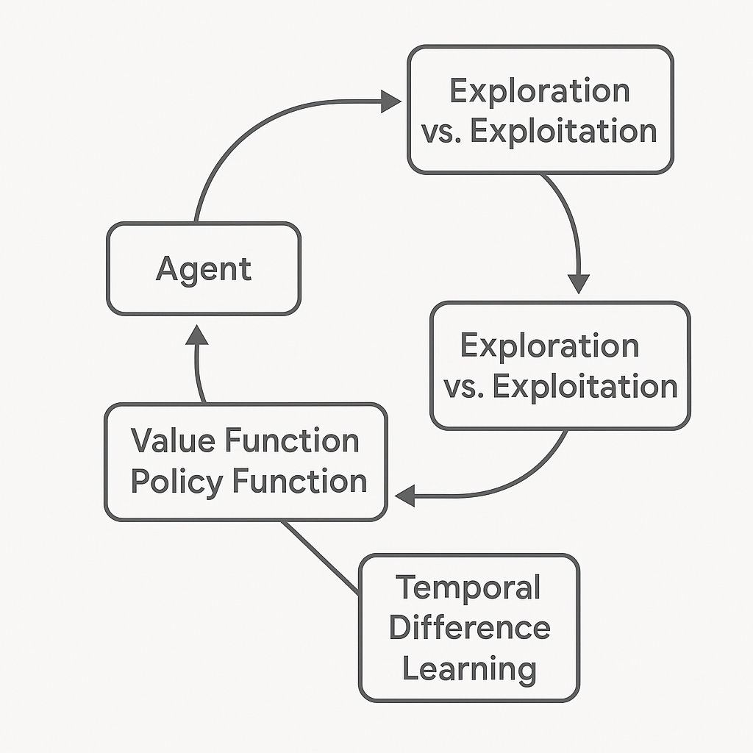

Figure 12.1: Core principles of deep reinforcement learning

This figure highlights the essential parts of deep reinforcement learning. The agent interacts with the environment, balancing exploration and exploitation by using policy and value functions that are updated through temporal-difference learning. These principles collectively define the learning loop that governs the agent's behavior in dynamic environments.

Key insights and takeaways
Deep reinforcement learning (DRL) unifies the sequential decision-making framework of reinforcement learning with the representational power of deep neural networks. This synthesis enables agents not merely to act, but to perceive, evaluate, plan, and adapt within environments characterized by high dimensionality, delayed rewards, uncertainty, and strategic complexity. Across domains ranging from gaming and robotics to cybersecurity, finance, and autonomous systems, DRL has demonstrated an unparalleled capacity to learn complex policies directly from raw data, establishing itself as a central paradigm of modern artificial intelligence.
What distinguishes DRL from earlier generations of learning systems is its ability to scale simultaneously across state-space complexity, action-space richness, and temporal depth, allowing agents to operate in regimes previously inaccessible to traditional control or optimization methods.

Fundamental concepts
The core of deep reinforcement learning is based on a few key principles that shape how intelligent agents understand their environments, gather experience, and optimize their long-term goals. These ideas recur throughout the book and serve as the foundation for all practical implementations discussed.
- Agent–environment interaction:
The continuous feedback loop in which the agent observes the environment, selects actions, receives rewards, and updates its internal representations. This closed-loop interaction defines learning as an emergent property of experience rather than as a function of supervision.
- Exploration vs. exploitation:
The fundamental tension between discovering new strategies and exploiting existing knowledge. Effective DRL systems must dynamically resolve this trade-off to avoid premature convergence while maintaining training efficiency.
- Value and policy functions:
Value functions estimate long-term expected return, while policy functions define the agent’s action-selection behavior. Together, they form the mathematical core of decision optimization in DRL.
- Temporal-difference learning:
A bootstrapping mechanism that enables agents to update value estimates based on partial returns, allowing learning to proceed efficiently under delayed and sparse reward conditions.
These principles provide the conceptual lens through which all deep reinforcement-learning architectures can be understood, regardless of their specific implementations.

Key algorithms
Building on these theoretical foundations, several landmark algorithms have revolutionized reinforcement learning by demonstrating how abstract mathematical principles can be transformed into scalable, high-performance systems.
- Deep Q-Networks (DQN):
Established that value-based reinforcement learning can scale to raw pixel input and high-dimensional environments, revolutionizing game-based benchmarks such as Atari.
- AlphaZero:
Demonstrated that self-play combined with Monte Carlo Tree Search (MCTS) can yield superhuman performance in complex strategic domains without reliance on human knowledge.
- Asynchronous Advantage Actor–Critic (A3C):
Proved that parallelized experience collection and asynchronous optimization dramatically accelerate learning and stabilize training in visually complex, stochastic environments.
Together, these algorithms illustrate the evolution of reinforcement learning from reactive control systems to strategic, planning-capable intelligence architectures.

Reflection on learning
Throughout this book, these algorithms have been explored not only in abstract form but also through hands-on implementations spanning classic control problems, retro-gaming environments, and real-world applications. By integrating Hugging Face libraries into these workflows, the book demonstrated how modern open-source ecosystems radically simplify the development, scaling, deployment, and reproducibility of deep reinforcement-learning systems.
More importantly, this progression illustrates a central theme of contemporary AI: the shift from handcrafted intelligence toward self-organizing, adaptive, and autonomous learning systems. The techniques presented here form not just a toolkit, but a foundation for building the next generation of agents capable of operating in complex, uncertain, and adversarial environments.

Code recap - Simple DQN example
To understand how deep reinforcement learning can be applied in a real-world setting, we examine a practical example using a Connect4 environment. This code illustrates the creation and training of a DQN agent, demonstrating how an AI learns to develop effective strategies and play the game. By applying core reinforcement learning principles, such as agent-environment interaction, value estimation, and policy optimization, the agent gradually develops advanced decision-making skills.

```python

import numpy as np
from keras.models import Sequential
from keras.layers import Dense
from keras.optimizers import Adam
from rl.agents.dqn import DQNAgent
from rl.memory import SequentialMemory
from rl.policy import EpsGreedyQPolicy

# Environment setup
from gym.envs.classic_control import CartPoleEnv
env = CartPoleEnv()

# Model architecture
model = Sequential([
Dense(24, activation='relu', input_shape=(1,) + env.observation_space.shape),
Dense(24, activation='relu'),
Dense(env.action_space.n, activation='linear')
])

# DQN Agent configuration
memory = SequentialMemory(limit=50000, window_length=1)
policy = EpsGreedyQPolicy()
dqn = DQNAgent(model=model, nb_actions=env.action_space.n, memory=memory, policy=policy)
dqn.compile(Adam(learning_rate=1e-3), metrics=['mae'])

# Training
dqn.fit(env, nb_steps=5000, visualize=False, verbose=2)
```
This code demonstrates a practical application of deep reinforcement learning in the Connect4 game, where the goal is to train an agent to make optimal moves based on the game state.
To reinforce the earlier discussed DQN implementation, the following figure illustrates the entire training loop, showing how essential components like the replay buffer and target network work together to stabilize learning:
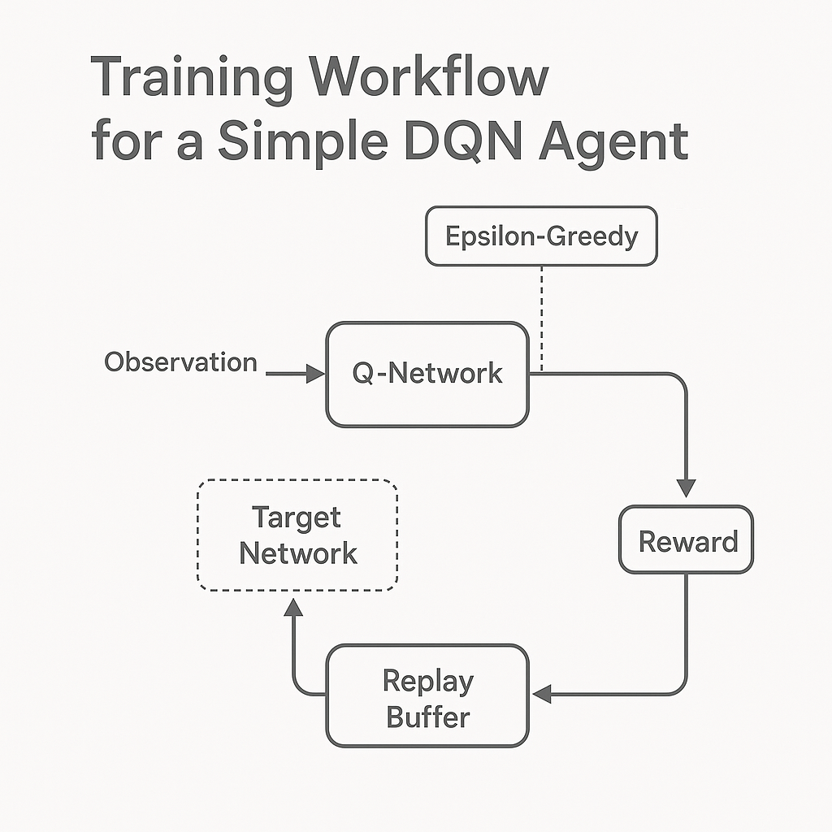

Figure 12.2: Training workflow for a simple DQN agent

Figure 12.2 describes the training cycle of a DQN agent. Observations are processed by the Q-network, which chooses actions using an epsilon-greedy strategy. Rewards and transitions are stored in a replay buffer, then used to update the Q-network against a slowly changing target network. This process promotes stable and sample-efficient learning.
The implementation starts with setting up the environment, represented by the Connect4Env class. This custom environment encapsulates the game's rules and mechanics, providing the agent with a structured environment in which to interact. By cycling through various states and rewards, the agent learns the game's dynamics, much like humans refine their strategies through trial and error.
To enable the agent to process game states and generate actionable insights, a neural network model is built using the Keras library. This model has two hidden layers, each with 24 neurons and relu activation functions. These layers are essential for identifying meaningful patterns in high-dimensional game states. The final layer produces Q-values for each possible action, guiding the agent's decision-making.
The agent is configured using a DQNAgent, which combines the neural network with reinforcement learning-specific components. A memory buffer, created with SequentialMemory, stores past experiences to enable replay-based learning, helping stabilize the agent's training. The agent's exploration-exploitation strategy is guided by a BoltzmannQPolicy, allowing it to discover new strategies while leveraging known rewards. Additionally, periodic updates to the target model help ensure smoother convergence during training.
Training the agent involves executing 5,000 steps within the environment. During this process, the agent interacts with the game, collecting rewards and refining its policy to maximize total gains. As it learns from both successes and failures, the Q-values become more accurate, resulting in improved gameplay performance. After training, the model's weights are saved, allowing for future use or further refinement without retraining.
This example highlights the core of deep reinforcement learning, showing how key concepts are used to create an intelligent agent. It offers a simple template for applying similar methods to more complex problems and environments, underscoring the strength and adaptability of reinforcement learning frameworks.

Exploring the latest environments and advancements
As reinforcement learning continues to mature, a new generation of tools, simulation platforms, and methodological frameworks is reshaping both its experimental and applied horizons. These advances extend learning beyond classical benchmarks into richly instrumented, multi-agent, and physically grounded environments that better approximate real-world complexity. This section examines the most critical emerging environments and architectural trends that are redefining how reinforcement-learning systems are trained, evaluated, and deployed, highlighting the technologies and research directions driving the next wave of intelligent autonomous systems.

Emerging tools and platforms
To advance breakthroughs in reinforcement learning, researchers depend on advanced tools and environments that mimic real-world challenges. These platforms not only provide controlled testing environments but also help develop robust algorithms that can adapt to diverse tasks. In the upcoming section, we highlight two top platforms that represent the cutting edge of reinforcement learning research and development.
To help practitioners choose the most suitable simulation framework, the following comparison highlights the core strengths of two dominant platforms for reinforcement learning research and development:
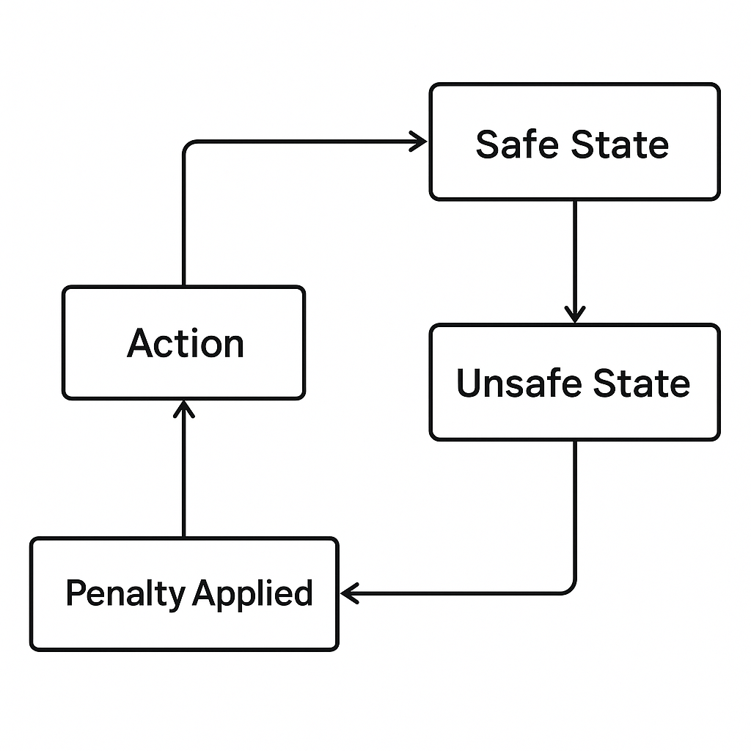

Figure 12.3: Comparison - DeepMind Lab vs. Unity ML-agents

The side-by-side diagram in Figure 12.3 compares DeepMind Lab and Unity ML-Agents. DeepMind Lab excels at 3D navigation and memory tasks, whereas Unity ML-Agents specializes in supporting multi-agent systems and sim-to-real workflows. Both platforms provide strong environments for training and testing intelligent agents:
- DeepMind Lab:
- An immersive 3D platform for training AI agents in visually rich, interactive environments.
- Encourages research in navigation, memory, and problem-solving.
- Unity Machine Learning Agents (ML-Agents):
- Integrates Unity’s game engine with reinforcement learning libraries.
- Supports multi-agent scenarios and sim-to-real applications.

Applications and trends
The latest advancements in reinforcement learning extend far beyond traditional single-agent control tasks and static environments. Contemporary research is increasingly focused on building agents that learn how to learn, transfer knowledge across domains, and operate within distributed, interactive ecosystems. These emerging directions signal a decisive shift from narrowly optimized policies toward adaptive, generalizable, and collaborative intelligence. Collectively, these trends bridge theoretical innovation with deployable, real-world reinforcement-learning systems.
- Meta-learning:
Meta-learning, often described as “learning to learn,” enables reinforcement-learning agents to rapidly adapt to new tasks by leveraging prior experience across related problem distributions. Instead of optimizing a single fixed policy, agents learn transferable strategies, enabling fast policy adaptation with limited data. This capability is critical for real-world systems operating in non-stationary environments, where retraining from scratch is impractical.
- Sim-to-real transfer:
Sim-to-real transfer addresses one of the most persistent challenges in reinforcement learning: the discrepancy between simulated training environments and physical deployment. By using domain randomization, representation alignment, and robust policy learning, agents trained in simulation can be transferred to real-world systems such as robots, autonomous vehicles, and industrial controllers with minimal performance degradation. This paradigm dramatically reduces experimental cost, risk, and development time.
- Multi-agent systems:
Multi-agent reinforcement learning extends decision-making beyond isolated agents into shared environments characterized by cooperation, competition, and strategic interaction. Agents must now reason not only about environmental dynamics, but also about the behaviors, incentives, and adaptation of other learning entities. These systems underpin applications in swarm robotics, autonomous traffic coordination, distributed cybersecurity defense, financial market modeling, and large-scale infrastructure optimization.
Together, these trends reflect a broader transformation in reinforcement learning—from task-specific optimization toward scalable, transferable, and socially interactive intelligence architectures capable of operating in highly dynamic and adversarial real-world settings.

Unity ML-agents integration
Unity ML-Agents is a robust framework that combines Unity's advanced game engine with reinforcement learning libraries. This integration enables researchers to create highly interactive environments, simulate complex behaviors, and develop intelligent agents capable of handling multi-agent scenarios, thereby bridging the gap between simulation and real-world applications. The following is a code example showing how to set up a simple environment using ML-Agents to train an agent in a Unity-based game:
```python

from mlagents_envs.environment import UnityEnvironment
from stable_baselines3 import PPO

# Initialize the Unity environment
unity_env_path = "path/to/your/Unity/environment" # Replace with the actual path to your Unity environment
env = UnityEnvironment(file_name=unity_env_path)

# Define the PPO agent
model = PPO("MlpPolicy", env, verbose=1)

# Train the agent
model.learn(total_timesteps=10000)

# Save the trained model
model.save("unity_agent_model")

# Test the trained agent
obs = env.reset()
while True:
action, _ = model.predict(obs, deterministic=True)
obs, reward, done, info = env.step(action)
if done:
obs = env.reset()
```
The code starts by importing the necessary modules, including UnityEnvironment from mlagents_envs to connect to Unity-based environments and PPO from the stable_baselines3 library to implement the reinforcement learning algorithm.
The Unity environment is set up using the UnityEnvironment class. Here, the file_name parameter specifies the path to the Unity environment file, which serves as the agent's training ground. This environment could range from a gridworld to a 3D scenario, depending on the simulation being modeled.
Next, a Proximal Policy Optimization (PPO) agent is set up using the stable_baselines3 library. PPO is selected for its balance between stability and performance in training reinforcement learning agents. The MlpPolicy specifies a multilayer perceptron neural network for the policy architecture, and the verbose parameter enables detailed logging of the training process.
The training phase runs with the model.learn() method, which takes the total number of timesteps as a parameter. During this phase, the agent interacts with the environment to discover the best actions to maximize its overall reward.
Once training is complete, the model is saved using model.save(). This ensures the trained agent can be reloaded and tested without retraining.
The testing phase begins by resetting the environment with env.reset() and then allowing the agent to take actions in a loop. The model.predict() function determines the agent's actions based on the current state observations (obs). The environment provides feedback, including the next state, the reward, and a flag (done) indicating whether the episode has ended. If the episode ends, the environment resets to allow further evaluation.
This example shows how Unity ML-Agents integrates with reinforcement learning frameworks to create, train, and test agents in dynamic, interactive environments. Such tools are essential for advancing artificial intelligence applications, from gaming to solving real-world problems.

Ethical considerations and societal impact
As AI technologies continue to advance, their integration into daily life raises significant ethical and societal concerns. Beyond technical progress, responsible development and use of AI require a commitment to principles that protect fairness, privacy, and accountability. This section examines these key ethical principles and explores the diverse societal roles of AI, emphasizing both the opportunities it provides and the challenges it introduces.
To contextualize ethical considerations in reinforcement learning, we introduce a conceptual hierarchy that outlines key values guiding the responsible development and deployment of AI systems, as shown in the following figure:
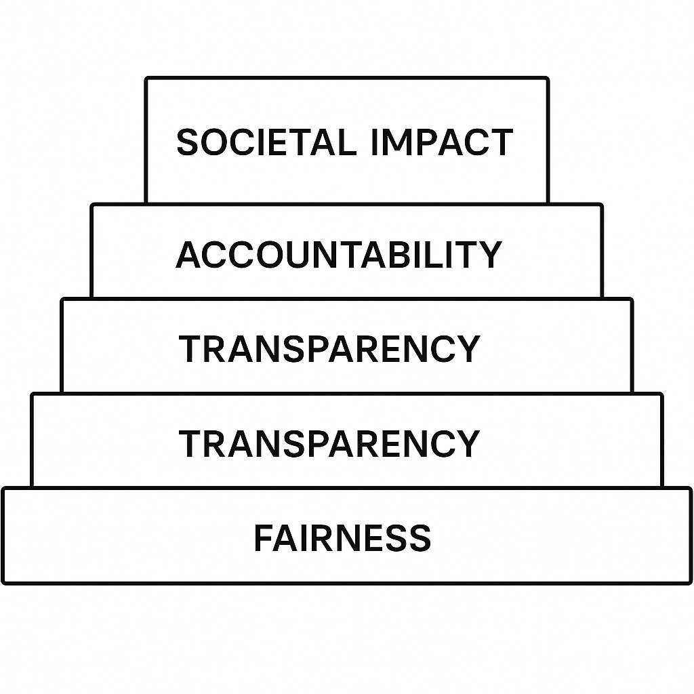

Figure 12.4: Ethical foundations and societal impact of AI

This layered diagram illustrates the ethical principles guiding AI’s impact on society. Fairness is the foundation, followed by transparency, accountability, and then the wider influence on society. This framework highlights how ethical principles support long-term trust, governance, and public benefit in the development of AI.

Core ethical principles
Ethical considerations lie at the heart of AI development, providing a moral compass to guide its applications and ensure they contribute positively to society. By addressing transparency, bias, and accountability, these principles lay the groundwork for creating AI systems that are both equitable and trustworthy [1]. The details are as follows:
- Transparency: AI systems must be interpretable, with decisions that are explainable to stakeholders. This principle becomes critical in high-stakes areas like healthcare and criminal justice, where opaque decision-making can lead to severe consequences [1] [2].
- Bias mitigation: Addressing biases embedded in training datasets or algorithms is essential to prevent harm, particularly to vulnerable populations. For instance, research shows that biased AI systems can perpetuate inequality, [3].
- Accountability: Mechanisms for auditing AI behaviors and outcomes ensure that developers and organizations can be held responsible for unintended consequences. Accountability frameworks are especially critical in autonomous systems, such as self-driving cars or AI-driven medical diagnostics [2].
AI’s societal role
AI has become a transformative force across industries, revolutionizing how tasks are performed and paving the way for innovations. However, alongside these benefits, AI also introduces challenges that must be carefully managed to ensure its advantages are shared broadly and its risks are effectively mitigated. The following list outlines the key opportunities and challenges:
- Opportunities:
- Automation of repetitive tasks increases productivity and efficiency, freeing human workers to focus on more creative and strategic activities [4].
- Innovations in AI foster economic growth, spurring the development of new industries, such as personalized medicine and smart cities [5].
- Challenges:
- Job displacement is a significant concern, particularly in sectors like manufacturing and customer service. Estimates suggest millions of jobs may be automated in the coming decade, creating the need for reskilling programs [6].
- The risks of surveillance and privacy erosion grow with AI-powered tools capable of mass data collection and analysis. Governments and corporations must implement stringent data protection measures to counterbalance these risks [7].

Practical tools for ethical AI
To ensure that AI systems adhere to ethical principles, developers can utilize practical tools to assess their models for fairness, transparency, and accountability. These tools provide actionable insights into whether an AI system meets established guidelines and identify areas for improvement. The following is a code example of a Python function designed to evaluate a model's fairness by detecting bias in its predictions:
```python

def evaluate_ai_ethics(model, dataset):
# Check for fairness
predictions = model.predict(dataset)
bias_detected = np.std(predictions) > 0.1 # Example threshold
print("Bias Detected:", bias_detected)
```
This code snippet demonstrates a straightforward approach to evaluating the fairness of an AI model. The evaluate_ai_ethics function takes two inputs: model, representing the AI system being tested, and dataset, the data used to evaluate the model's predictions.
The function uses model.predict() to generate predictions on the dataset. It then measures the variability in these predictions by calculating the standard deviation np.std(predictions). A high deviation exceeding a set threshold (e.g., 0.1) may indicate unevenly distributed projections, suggesting bias in the outputs.
Finally, the function indicates whether bias has been detected, providing a clear signal of the model's fairness. This tool serves as a fundamental step for developers to assess AI ethics, providing a quick and effective way to identify potential issues that could compromise the system's fairness or trustworthiness.

Future trends and research directions
As reinforcement learning continues to advance, new trends and research areas are expanding their scope. From improving AI safety to developing energy-efficient methods, these innovations not only enhance technical skills but also address pressing societal and environmental issues.
Additionally, as it progresses into high-stakes settings, safe exploration becomes crucial. The following figure illustrates how agents can distinguish between safe and unsafe results, modifying their actions accordingly:


Figure 12.5: Safe exploration and penalty feedback in reinforcement learning

Figure 12.5 illustrates the safe exploration loop in reinforcement learning. The agent performs an action, which may lead to a secure or unsafe state. If the result is hazardous, a penalty is applied, and the agent adjusts its behavior to avoid similar risks. This framework facilitates risk-aware learning, a vital aspect when implementing AI in real-world systems.

Exciting frontiers
The frontiers of reinforcement learning are rapidly expanding beyond performance optimization toward questions of safety, sustainability, and general intelligence. These emerging directions reflect a maturation of the field—from proving that agents can learn, to ensuring that they learn responsibly, efficiently, and with broad generality. Together, these advances are shaping the next generation of AI systems as dependable, adaptive, and societally aligned technologies.
- Safe reinforcement learning:
Safe reinforcement learning introduces explicit constraints to prevent harmful exploration and catastrophic behavior. Rather than optimizing reward alone, agents must now satisfy safety conditions under uncertainty, making this paradigm essential for high-risk domains such as healthcare, autonomous driving, aerospace, and critical infrastructure. Techniques such as constrained policy optimization, risk-sensitive objectives, and shielded learning architectures are redefining how intelligent systems balance performance with reliability.
- Energy-efficient AI:
As reinforcement-learning models scale in size and computational demand, energy efficiency has become a central research concern. Energy-aware training strategies, hardware-optimized learning pipelines, and adaptive computation techniques seek to reduce carbon footprint while preserving model performance. This frontier links reinforcement learning directly to sustainable computing, ethical AI deployment, and long-term environmental responsibility.
- General AI:
The pursuit of general artificial intelligence represents the most ambitious frontier of reinforcement learning: the development of agents capable of transferring knowledge across vastly different tasks without domain-specific engineering. Advances in world-model learning, self-supervised representation discovery, and universal policy architectures move the field closer to systems that reason, plan, and adapt across open-ended problem spaces. This evolution signals a shift from task-specialized intelligence toward truly general learning systems.
Together, these frontiers mark a transition in reinforcement learning from experimental success to societal-scale responsibility and the design of long-horizon intelligence. This transition will define the next decade of autonomous systems research and deployment.

Safe exploration in reinforcement learning
In safety-critical environments, reinforcement learning must account for the risks associated with unsafe actions or states. This example demonstrates a practical approach to safe exploration, where the environment penalizes the agent for entering unsafe states, thereby encouraging safer learning behavior:
```python

class SafeEnvWrapper:
def __init__(self, env):
self.env = env

def step(self, action):
state, reward, done, info = self.env.step(action)
# Penalize unsafe states
reward -= 10 if self.is_unsafe(state) else 0
return state, reward, done, info

def is_unsafe(self, state):
# Define unsafe conditions
return state[0] < -1.0 or state[0] > 1.0
```
The SafeEnvWrapper class wraps a standard reinforcement learning environment (env) while adding safety constraints. This wrapper discourages agents from exploring unsafe states by penalizing their rewards. The details are as follows:
- Initialization: The SafeEnvWrapper class takes an existing environment as input during initialization, making it compatible with any reinforcement learning environment.
- Step function: The step method intercepts actions performed by the agent. After executing the action in the environment, the process checks if the resulting state violates predefined safety conditions. If the state is deemed unsafe, a penalty of 10 is subtracted from the agent’s reward, signaling that such behavior is undesirable.
- Safety Conditions: The is_unsafe method defines the criteria for unsafe states. In this example, any state where the first dimension exceeds the range [-1.0, 1.0] is flagged as dangerous. These conditions can be tailored to specific applications, enabling flexibility across different domains.
This approach is instrumental in applications where safety is critical. By incorporating such mechanisms into reinforcement learning environments, developers can train agents to adhere to safety constraints, ensuring robust, dependable performance in real-world settings. This example underscores the growing importance of balancing ethics and practicality in the design of AI systems.

Key takeaways
In summarizing the core lessons of this book, the main takeaways serve as a guide to understanding the fundamental concepts, practical implications, and ethical responsibilities that underpin reinforcement learning. The following insights capture the essence of what has been discussed, offering a clear understanding of AI’s role in shaping the future:
- Core concepts: Understanding reinforcement learning principles is crucial for designing robust AI systems.
- Practical applications: From mastering games to optimizing logistics, reinforcement learning has proven its versatility.
- Ethical AI: As AI continues to integrate into daily life, ethical considerations must guide its development.
To conclude this exploration, we present a forward-looking roadmap in Figure 12.6 outlining the trajectory of reinforcement learning, from foundational techniques to more complex, ethically aligned systems.
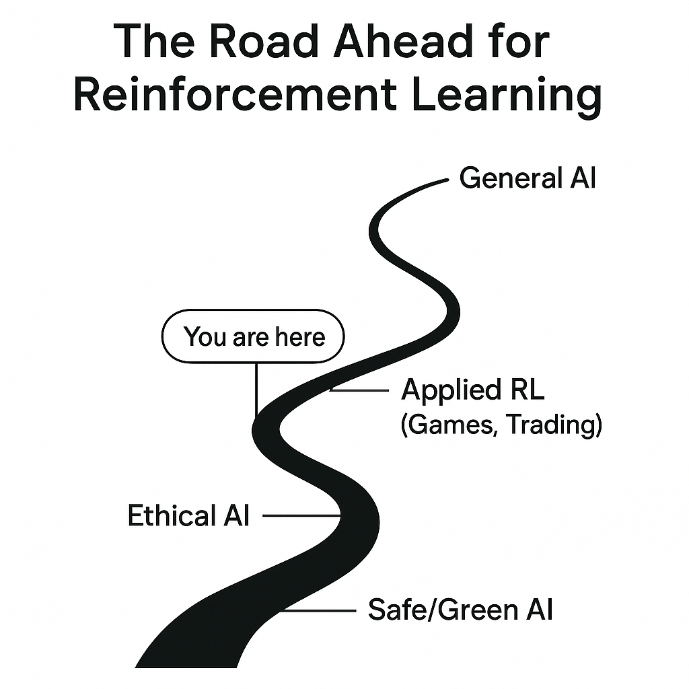

Figure 12.6: The road ahead for reinforcement learning

The preceding figure shows the future development of reinforcement learning. It begins with basic RL ideas, moves through practical areas such as gaming and trading, and aims for ethical and sustainable AI, culminating in the goal of achieving general intelligence. The You are here marker indicates the current stage of the field and encourages readers to envision their next steps.

Conclusion
As we reach the end of this journey, reinforcement learning stands out as a driving force in the evolution of artificial intelligence. By revisiting its core principles, exploring advanced tools, and examining the ethical implications of AI, this work underscores the importance of striking a balance between technological innovation and social responsibility. Reinforcement learning’s ability to combine adaptive intelligence with practical applications continues to redefine how machines learn, make decisions, and collaborate with humans.
This book has provided a foundation for understanding and navigating the rapidly expanding world of AI. As the field advances, our challenge is not only to master its capabilities but also to guide its development with fairness, transparency, and accountability. Through curiosity, experimentation, and ethical awareness, we can ensure that innovation serves both progress and the public good.
The road ahead is rich with opportunities and challenges, offering boundless potential for discovery and transformation. With the knowledge and insights gained from these chapters, readers are equipped to make meaningful contributions to AI’s future, whether by advancing research, creating impactful applications, or promoting responsible practices. By aligning human creativity with machine intelligence, we can build a future where technology empowers rather than replaces, illuminating new paths toward a more sustainable and inclusive world.

References
- F. Doshi-Velez and B. Kim, "Towards a rigorous science of interpretable machine learning," 2017.
- L. Floridi, "AI4People - An ethical framework for a good AI society: Opportunities, risks, principles, and recommendations," Minds and Machines, vol. 28, pp. 689, 707, 2018.
- C. O'Neil, Weapons of math destruction: How big data increases inequality and threatens democracy, Crown Publishing Group, 2016.
- E. Brynjolfsson and A. McAfee, The second machine age: Work, progress, and prosperity in a time of brilliant technologies, W.W. Norton and Company, 2014.
- S. Russell and P. Norvig, Artificial Intelligence: A modern approach, Fourth edition ed., Pearson, 2020.
- C. B. Frey and M. A. Osborne, "The future of employment: How susceptible are jobs to computerisation?," Technological Forecasting and Social Change, vol. 114, pp. 254, 280, 2017.
- S. Zuboff, The age of surveillance capitalism: The fight for a human future at the new frontier of power, PublicAffairs, 2019.

