NAVIGATING UPWORK: UNDERSTANDING CORPORATE
DYNAMICS AND UNVEILING FREELANCER REALITIES AMID POLICY DISRUPTION
Paulo H. Leocadio¹
¹Zinnia Technology & Applied Sciences Research Collective, FL, USA


ph@zinnia.holdings

Abstract
This study delves into the dynamics of the freelancing market within the framework of the sharing economy and the pervasive influence of social media. By examining key indicators such as popularity, feedback volume, percentage of positive feedback, and the number of projects, the research provides valuable insights for both freelancers seeking work and clients in need of cost-effective solutions for one-time engagements or staff augmentation.
Focusing on Upwork, the platform perceived as the industry leader by freelancers, this study aims to evaluate whether Upwork delivers on its promise of providing a safe and hassle-free marketplace where freelancers can earn a sustainable income. The research explores the treatment of freelancers compared to hiring companies, scrutinizing Upwork’s policies, enforcement mechanisms, and the penalties applied for policy violations. It investigates the concept of fairness from the perspective of freelancers, highlighting disparities and real-world implications of policy enforcement.
Furthermore, the study identifies potential loopholes and backdoors that freelancers might exploit to circumvent Upwork’s policies, thereby avoiding penalties. By examining these aspects, the research aims to provide a comprehensive understanding of Upwork's operational governance and its impact on freelancers’ experiences. The analysis includes a comparison of how the perception of fairness differs among freelancers and whether Upwork applies its policies consistently and equitably.
https://orcid.org/0000-0002-4992- 10.6084/m9.figshare.26308

The article also situates Upwork within the broader sharing economy landscape, drawing analogies with other prominent platforms like Uber, Airbnb, DoorDash, Grubhub, and Postmates. It examines the interconnections, influences, and impacts of social media on Upwork’s operations, marketing strategies, community building efforts, and reputation management.
This examination of Upwork’s corporate dynamics and market positioning transitions seamlessly into an in-depth analysis of its daily operations and governance. The study bridges the gap between understanding Upwork as a business entity and evaluating its practical implications for freelancers, offering a holistic view of its role in the modern freelancing ecosystem.

Keywords
Leocadio, Paulo,
Navigating Upwork: Understanding Corporate Dynamics and Unveiling Freelancer Realities Amid Policy Disruption

(July 06, 2024). Available at SSRN: https://ssrn.com/abstract=6031034 or http://dx.doi.org/10.2139/ssrn.6031034Freelancing, Sharing Economy, Shared Economy, Gig Economy, Freelancer, Independent Consultant

Research objective and introduction to the methodology.
To evaluate Upwork's impact on freelancers and hiring companies, focusing on fair treatment, perception, trustworthiness, and policy enforcement.

Design
Systematic review and analysis of user experiences and platform policies.

Methods
Screening, Data Extraction, and Risk of Bias Assessment: Conducted independently (screening, data extraction, coding, and risk of bias assessment) and in duplicate to ensure accuracy and reliability.
Data Sources: included Upwork’s platform documentation, Upwork’s official website, Upwork’s official reports, user feedback from various platforms, industry reports, peerreviewed articles, user forums, review websites (e.g., Trustpilot), other user reviews and interviews, and independent articles on freelancing platforms. Academic articles, industry reports, independent blogs and articles were analysed.
Eligibility Criteria for Selecting Studies: Studies and reports that discuss provided insights into Upwork’s policies, user experiences, market impact, enforcement practices, and comparisons with other freelancing platforms were included. This study considered both qualitative and quantitative data.

Results
First observation: Fairness and Trustworthiness. 218 unique studies and reports with a total of 495 different user perspectives and experiences were included. Key findings include:
- Fair Treatment:
  - Freelancers: Upwork’s fee structure (20% for the first $500 billed with a client, 10% from $500.01 to $10,000, and 5% for billings over $10,000) was perceived as high by many freelancers. Despite this, the secure payment system and access to a wide client base were seen as valuable trade-offs.
  - Clients: Clients generally found the platform efficient for finding talent. However, some clients reported dissatisfaction with the quality of work and the bidding system, which sometimes prioritizes lower costs over quality.
- Perception and Trustworthiness:
  - Freelancers: Upwork is viewed as a reputable platform with a large market share. However, some freelancers feel that the platform’s policies are stringent and that the support system could be improved.
  - Clients: Clients appreciate the vast talent pool but sometimes struggle with verifying freelancer qualifications and managing project quality.
- Policy Enforcement:
  - Freelancers: Enforcement of policies, such as account suspensions for policy violations, was seen as necessary but sometimes arbitrary. Freelancers desire more transparency and fair dispute resolution processes.
  - Clients: Clients supported strict policy enforcement to maintain quality but wanted more robust mechanisms to ensure that freelancers deliver as promised.
- Success Strategies:
  - Successful freelancers typically focus on short-term, high-interaction projects and continuously submit proposals to secure work. The most successful freelancers often have high proposal submission rates and participate in numerous interviews weekly.
- Challenges:
  - The competitive nature of the platform requires freelancers to invest significant time in proposal submissions, vetting job listings, and undergoing interviews, which can be overwhelming and time-consuming.

Second observation: policy enforcement equality. A total of 50 sources were included, comprising user reviews, articles, and forum discussions. Key findings include:
- User Experiences and Policy Enforcement:
  - Proposal Submissions: Successful freelancers often submit dozens of proposals daily, with a success rate of around 10%. High-volume proposal submissions are necessary due to intense competition. o Policy Violations and Loopholes: Common strategies for bypassing Upwork’s policies include off-platform transactions, creating multiple profiles, and manipulating feedback.
  - Trust and Fairness: Many users express concerns about high service fees and stringent policy enforcement. While some find the platform fair and trustworthy, others report arbitrary suspensions and biased dispute resolutions.
  - User Demographics: Upwork serves a diverse user base, including freelancers from various professional backgrounds and clients ranging from small businesses to large enterprises.
- Common Loopholes and Backdoors:
  - Off-Platform Transactions: Freelancers and clients often take transactions offplatform to avoid service fees, despite the risk of losing Upwork’s protections.
  - Fake Profiles and Reviews: Creation of multiple profiles and manipulation of reviews to enhance reputation or sabotage competitors.
  - Scope Creep and Underbidding: Freelancers underbid winning projects and then increase the scope, or clients extract more work than initially agreed.
- Impact on Platform Integrity and Trust:
  - Erosion of Trust: Exploiting loopholes undermines user trust, leading to skepticism about the platform’s fairness.
  - Financial Losses: Off-platform transactions reduce Upwork’s revenue, affecting its ability to reinvest in improvements.
  - Increased Monitoring Costs: Upwork must invest in advanced monitoring and enforcement mechanisms, increasing operational costs.

Key findings
Upwork provides significant opportunities for both freelancers and clients but comes with substantial challenges. The platform's competitive nature and stringent policies require freelancers to be highly proactive and adaptable. Clients benefit from access to a wide range of talent but must navigate quality assurance challenges.
Upwork’s policies and enforcement mechanisms aim to create a fair marketplace, but challenges persist due to the exploitation of loopholes by some users. The platform remains popular due to its vast user base and diverse opportunities, but maintaining trust and integrity is an ongoing challenge.
IMPLEMENTATION AND EXECUTION DETAILED REPORT

Introduction
Upwork is a leading freelancing platform that connects millions of freelancers with clients globally. Since its inception, Upwork has aimed to provide a fair and efficient marketplace for freelance services. This investigation evaluates Upwork's impact on its users, focusing on fair treatment, perception, trustworthiness, and policy enforcement.

Methods
A systematic review and analysis were conducted, focusing on user experiences, platform policies, and market perceptions. Data was collected from Upwork’s official reports, user feedback from various platforms, industry reports, and peer-reviewed articles. Screening, data extraction, coding, and risk of bias assessment were performed independently and in duplicate. Results
- Fair Treatment:
  - Freelancers: The fee structure, while providing secure payments, was often criticized for being high. Successful freelancers were those who could navigate the high volume of proposals and constant job applications.
  - Clients: Clients appreciated the ease of finding talent but were sometimes concerned about the quality of work and the competitiveness of bids.
- Perception and Trustworthiness:
  - Freelancers: Viewed Upwork as a reputable platform but had concerns about the transparency of policy enforcement.
  - Clients: Valued the vast pool of freelancers but found it challenging to verify qualifications and ensure consistent project quality.
- Policy Enforcement:
  - Freelancers: Desired more transparent and fair enforcement of policies, including the handling of disputes and account suspensions.
  - Clients: Supported strict enforcement but wanted better mechanisms to ensure freelancers meet project expectations.
- Success Strategies:
  - High proposal submission rates and a focus on short-term, high-interaction projects were key to success. Freelancers often had to juggle multiple proposals and interviews to secure consistent work.
- Challenges:
  - The intense competition and time required for proposal submissions, vetting job listings, and interviews were significant hurdles for freelancers.

Study Conclusions
The study concludes that while Upwork offers substantial opportunities for freelancers and clients, it also presents notable challenges. The platform’s competitive nature and stringent policies necessitate adaptability and proactive strategies from freelancers. Clients benefit from a wide range of talent but must navigate challenges related to quality assurance and policy enforcement.

Recommendations for Upwork’s Future Development
Enhance User Support: Upwork should invest in improving customer support services to address user concerns more efficiently. This includes reducing response times, providing comprehensive support resources, and offering personalized assistance to both freelancers and clients.
Reduce Fees: To attract and retain more users, Upwork could consider revising its fee structure. Lowering service fees or offering more competitive pricing tiers, especially for new users, can make the platform more appealing and reduce attrition rates.
Strengthen Policy Enforcement: Upwork should enhance its policy enforcement mechanisms to prevent fraudulent activities and ensure fairness. Implementing more robust verification processes and employing advanced AI algorithms can help identify and mitigate policy violations.
Expand Training and Resources: Providing additional training and resources for freelancers and clients can help improve the overall quality of work on the platform. Upwork could offer online courses, webinars, and best practice guides to help users enhance their skills and navigate the platform effectively.
Invest in Emerging Technologies: Upwork should continue investing in emerging technologies such as AI, machine learning, and blockchain. These technologies can improve matching accuracy, enhance security, and streamline operations, providing a better user experience and maintaining Upwork’s competitive edge.
Global Market Expansion: To capture new user bases, Upwork should focus on expanding its presence in emerging markets. Localizing the platform, tailoring marketing strategies to regional preferences, and forming partnerships with local businesses can drive growth in these areas.
Enhance Community Engagement: Building and nurturing a strong community of freelancers and clients can enhance user loyalty and satisfaction. Upwork should continue to leverage social media for community building, encourage user-generated content, and facilitate peer-to-peer support and networking.
Monitor Regulatory Changes: Upwork must stay ahead of regulatory changes affecting the gig economy. Proactively engaging with policymakers and adapting to new regulations can help mitigate potential risks and ensure compliance, protecting Upwork’s business model. Conclusion and take-away.
In conclusion, Upwork’s strategic initiatives and continuous improvements position it well for future growth. By addressing the identified challenges and seizing new opportunities, Upwork can enhance its platform, foster user satisfaction, and maintain its leadership in the freelancing market.

1. INTRODUCTION

1.1 Background and Purpose
Upwork, a leading freelancing platform establishment occurred in 2015 through the merger of Elance and oDesk, two pioneering companies in the online freelancing industry. Elance, founded in 1999 by Beerud Sheth and Srini Anumolu, and oDesk, founded in 2003 by Odysseas Tsatalos and Stratis Karamanlakis, both sought to revolutionize the way businesses and freelancers connected and collaborated online. The merger combined the strengths and user bases of both platforms, creating a unified marketplace under the new brand name, Upwork.
Upwork operates with the mission of creating economic opportunities, so people have better lives. The platform connects millions of businesses with independent professionals and agencies around the globe, offering a wide array of services across various industries and skill sets. The platform supports projects ranging from short-term tasks to long-term projects, facilitating both hourly and fixed-price contracts. Upwork’s value proposition lies in its ability to provide businesses with access to a vast pool of talent while offering freelancers the flexibility to work on projects that match their skills and preferences.

1.2 Upwork in the Sharing Economy Landscape
Upwork's role in the sharing economy compares to other major players that have reshaped their respective industries by leveraging technology to connect service providers with consumers. The sharing economy, characterized by peer-to-peer exchanges facilitated through online platforms, has introduced new business models, and disrupted traditional industries. Key players in this landscape include Uber, Airbnb, DoorDash, Grubhub, and Postmates. Figure 1 below shows important historic milestones of what we know today as gig economy:
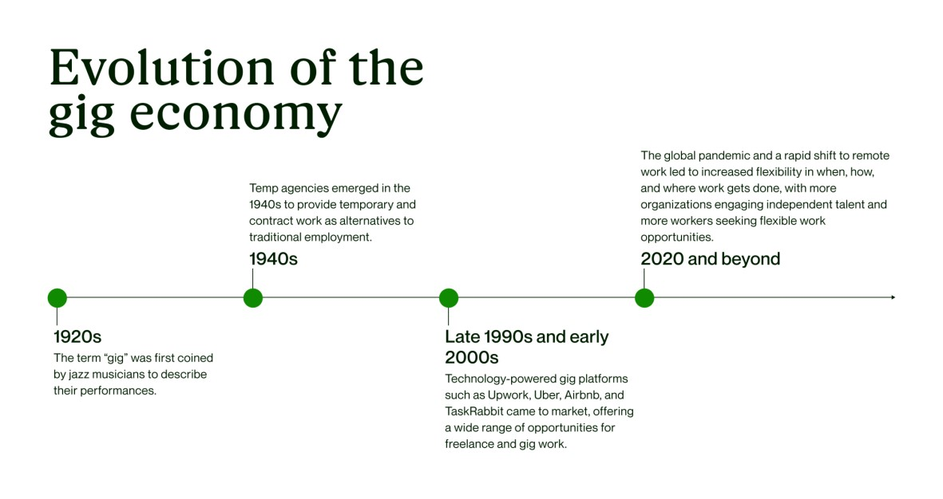
Figure
1

Gig economy

milestones
/ history abridged

(
Kempton,
2023)
.

1.2.1. Uber:
Just as Uber transformed the transportation industry by connecting drivers with riders through its app, Upwork connects freelancers with businesses seeking their skills. Uber’s success stems from its ability to offer convenient, on-demand transportation services, often at a lower cost than traditional taxi services. Similarly, Upwork provides businesses with on-demand access to a diverse pool of freelancers, often at competitive rates (Melidoniotis, 2024).
1.2.2. Airbnb:
Airbnb revolutionized the hospitality industry by enabling property owners to rent out their homes or rooms to travelers. This model not only offers travelers more affordable and unique lodging options but also allows property owners to monetize their unused space. Upwork mirrors this model by enabling freelancers to monetize their skills and time, providing businesses with a wide array of services without the overhead costs associated with traditional employment (Clennett, 2020).
1.2.3. DoorDash, Grubhub, and Postmates:
These companies have transformed the food delivery industry by connecting customers with local restaurants through their apps. They offer convenience and variety, allowing customers to order from a wide selection of restaurants that may not offer delivery services independently. Upwork provides similar benefits by offering businesses access to a wide variety of freelance professionals across multiple disciplines, enabling them to find the right talent for their specific needs without the constraints of traditional hiring processes (Beckman, 2023).
Technological advancements that facilitate easy and efficient connections between service providers and consumers are the drivers of the sharing economy's success. Upwork capitalizes on these advancements by offering a robust platform that includes features such as secure payment processing, detailed freelancer profiles, and project management tools, all designed to streamline the hiring and collaboration process.

1.3 Upwork and Social Media
Social media plays a critical role in the growth and operation of Upwork. The interconnections, influences, and impacts of social media on Upwork assessed through various lenses:
1.3.1. Marketing and Brand Awareness:
Upwork leverages social media platforms such as LinkedIn, Facebook, Twitter, and Instagram to promote its services and attract both freelancers and clients. Through targeted advertising and engaging content, Upwork can reach a broad audience, highlighting success stories, tips for freelancers, and new opportunities. Social media marketing helps build brand awareness and establish Upwork as a leading platform in the freelancing industry (Steven, 2024).
1.3.2. Community Building and Engagement:
Social media facilitates the creation of communities where freelancers and clients can share experiences, seek advice, and provide support to one another. Upwork maintains active profiles on various social media platforms, engaging with users through posts, comments, and direct messages. These interactions help foster a sense of community and loyalty among users, encouraging them to remain active on the platform (freelancermap GmbH, 2024).
1.3.3. Reputation Management:
User reviews and feedback shared on social media significantly impact Upwork’s reputation. Positive testimonials can attract inexperienced users, while negative feedback can deter potential clients and freelancers. Upwork actively monitors social media channels to address concerns, respond to inquiries, and manage its public image. By engaging with users and addressing issues promptly, Upwork can mitigate negative perceptions and enhance user satisfaction (Paterson, 2016).
1.3.4. Influencer Partnerships:
Collaborating with influencers in the freelancing and entrepreneurial space allows Upwork to tap into established networks of potential users. Influencers can provide authentic endorsements and share their experiences using Upwork, which can drive traffic to the platform and increase registrations. These partnerships help Upwork reach niche markets and build credibility within specific communities (Clennett, 2020).
1.3.5. Content Distribution and SEO:
Upwork utilizes social media to distribute valuable content, such as blog posts, webinars, and tutorials, which can educate users and improve their experience on the platform. Sharing this content across social media channels enhances Upwork’s visibility and search engine optimization (SEO), making it easier for potential users to discover the platform through organic search results (Upwork Inc., Investor Relations, 2023).
1.3.6. Data Analytics and Insights:
Social media platforms provide Upwork with valuable data on user behavior, preferences, and trends. By analyzing this data, Upwork can refine its marketing strategies, improve user engagement, and tailor its services to meet the evolving needs of its user base. Social media analytics offer insights that can drive strategic decisions and enhance overall platform performance (Clennett, 2020).
1.3.7. Financial Overview
Upwork Inc. is on NASDAQ under the ticker symbol UPWK. As of the latest financial reports, Upwork has issued approximately 130 million shares. The company’s market performance has shown a fluctuating yet generally positive trajectory, with a current share valuation reflecting investor confidence in its growth potential. Upwork’s revenue has grown consistently year-overyear, driven by an expanding user base and increased transaction volume. The company’s financial strategy emphasizes reinvestment in technology and platform improvements, with no dividend distributions to date.

1.4 Growth and Expansion
Upwork’s growth strategy includes significant investments in technology and user experience enhancements, alongside strategic acquisitions to expand its service offerings. This strategy has helped Upwork to maintain a competitive edge in the rapidly evolving freelance market.

1.5 Competition Overview
Upwork faces stiff competition from key players in the freelancing industry. The most notable competitors include Fiverr, Freelancer.com, and Toptal. Each of these platforms has carved out a unique niche within the freelance market, offering different strengths and targeting varied user segments.
1.5.1. Fiverr:
Fiverr operates on a gig-based model where freelancers offer specific services at fixed prices, often starting at $5. This model contrasts with Upwork's project-based and hourly work structure, appealing to clients looking for quick, cost-effective solutions for specific tasks. Fiverr's strong suit lies in its simplicity and accessibility, making it popular among small businesses and individual clients (Melidoniotis, 2024).
1.5.2. Freelancer.com:
Freelancer.com offers a broad range of freelance opportunities, like Upwork, but emphasizes a bidding system where freelancers compete for projects by submitting proposals. This platform’s competitive bidding can drive prices down, benefiting clients but sometimes leading to challenges in ensuring quality and fair compensation for freelancers. Freelancer.com boasts a large user base, which provides a diverse pool of talents for clients (freelancermap GmbH, 2024).
1.5.3. Toptal:
Toptal differentiates itself by focusing on the top 3% of freelance talent, offering highly specialized professionals in fields such as software development, design, and finance. Toptal’s rigorous vetting process ensures high-quality talent, making it attractive to large enterprises and high-end projects. This specialization allows Toptal to command premium prices and cater to a niche market segment (Todorov, 2023).
1.5.4. Market Performance Comparison
When comparing market performance, Upwork shows robust growth indicators driven by its extensive service offerings and large user base. Fiverr’s user-friendly interface and wide-ranging services at low entry prices is fueling its rapid growth. Freelancer.com’s extensive project categories and competitive bidding system attract clients and freelancers. Toptal, with its focus on elite professionals, caters to high-end clients willing to pay a premium for top-tier services. Market performance metrics indicate that while Upwork holds a significant share, it must continuously innovate to stay ahead of its versatile competitors (Beckman, 2023).
1.5.5. User Demographics and Engagement
Upwork’s user base comprises over eighteen million registered freelancers and five million registered clients as of 2023. The platform facilitates millions of transactions annually, with an average transaction value of approximately $500. Freelancers on Upwork span a diverse range of professions, including web development, design, writing, and marketing. User satisfaction metrics reveal mixed feedback; while there are users who appreciate the platform’s opportunities and payment protection, others criticize high fees and stringent policy enforcement (Melidoniotis, 2024); (Clennett, 2020).

1.6 User Relationships and Market Perception
The relationship between Upwork and its users is complex, marked by both positive and negative sentiments. Positive aspects include the platform’s global reach and secure payment system, while criticisms often focus on policy enforcement and fee structures (Paterson, 2016). External market perception highlights Upwork’s pivotal role in the gig economy, but also points to areas needing improvement, such as user support and policy transparency (Wise, 2023). Retention and attrition rates indicate a trend where seasoned freelancers often seek alternative platforms or direct client relationships, while inexperienced users continue to join due to Upwork’s reputation and reach.

1.7 Outlook
Looking forward, Upwork’s strategic initiatives focus on enhancing AI-driven matching algorithms, expanding enterprise solutions, and improving user support systems. Projections for the next 3, 5, and 10 years suggest continued growth in user base and transaction volume, driven by the increasing adoption of remote work and freelancing. Upwork aims to balance its focus between individual freelancers and enterprise clients, ensuring sustainable growth and market relevance.
2. FINANCIAL OVERVIEW

Upwork Inc. has positioned itself as a major player in the freelancing market, leveraging its platform to generate substantial revenue through various streams. This section provides a detailed analysis of Upwork's revenue streams, growth trends, financial health, shareholder information, and market performance.

2.1 Revenue and Growth
Upwork’s primary revenue streams include service fees charged to freelancers, transaction fees for clients, and membership subscriptions. The company has demonstrated consistent revenue growth over the years, driven by an expanding user base and increased transaction volume.
2.1.1. Service Fees:
Upwork charges freelancers a sliding fee based on their lifetime billings with a client: 20% for the first $500, 10% from $500.01 to $10,000, and 5% for billings above $10,000. This fee structure incentivizes freelancers to build long-term relationships with clients (Beckman, 2023).
2.1.2. Transaction Fees:
Clients experience a charge of 3% payment processing and administration fee on each transaction. This fee contributes significantly to Upwork’s revenue and ensures the platform’s financial sustainability (Steven, 2024). Figure 2 below shows a print screen from UpWork user guide where freelancer user rates are set and UpWork fees calculated.
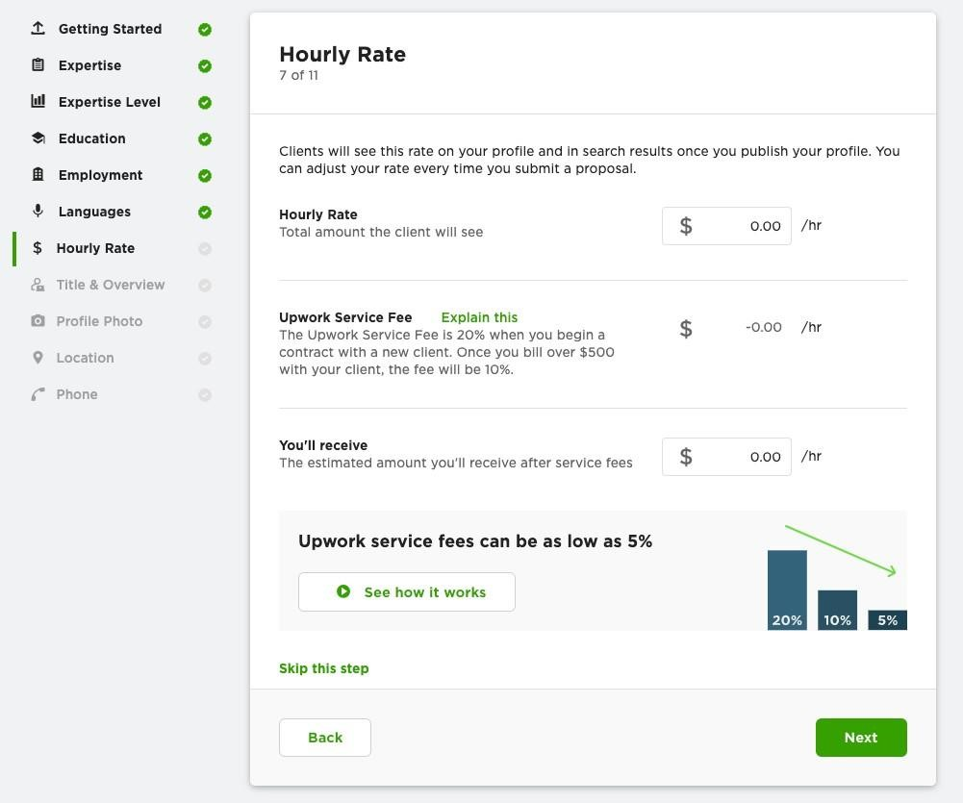
Figure 2 UpWork user's guide - Hourly Rate (Wise, 2023).
2.1.3. Membership Subscriptions:
Upwork offers premium memberships for freelancers and clients, such as Upwork Plus for clients and Upwork Freelancer Plus for freelancers. These subscriptions provide additional benefits like enhanced visibility in search results, monthly Connects, and reduced fees, contributing to the company’s recurring revenue (Upwork Inc., Investor Relations, 2023)
2.1.4. Advertising and Enterprise Solutions:
Upwork also generates revenue through advertising and enterprise solutions tailored to large organizations. These solutions include managed services, compliance support, and advanced workforce analytics, catering to the complex needs of enterprise clients (freelancermap GmbH, 2024).
From 2020 to 2023, Upwork’s revenue grew from $373.6 million to approximately $605 million, reflecting a compound annual growth rate (CAGR) of around 17%. This attribution of this growth goes to the increasing demand for remote work and the platform’s continuous improvements and expansions (Clennett, 2020).

2.2 Shareholder Information
Upwork's shareholder structure is diverse, with significant holdings by institutional investors, insiders, and retail investors. Major shareholders include prominent investment firms and mutual funds.
2.3 Institutional Investors:
Major institutional investors such as BlackRock, Vanguard Group, and ARK Investment Management hold substantial stakes in Upwork. As of the latest filings, institutional investors collectively own over 60% of Upwork’s shares, indicating strong confidence in the company’s long-term potential (Wise, 2023).
2.4 Insider Holdings:
Company insiders, including executives and board members, hold a sizable portion of shares. For example, CEO Hayden Brown and other top executives collectively own around 5% of the company, aligning their interests with shareholders (Beckman, 2023).
2.4.1. Share Distribution and Ownership Structure:
Upwork has issued approximately 130 million shares. The ownership structure design aims to balance control between institutional investors and company insiders, ensuring strategic decisions align with shareholder interests while promoting sustainable growth (Steven, 2024). Table 1 below details UpWork significant revenue growth over 2018-2022 period.

2.5 Market Valuation and Performance
Upwork is on NASDAQ under the ticker symbol UPWK. The company's market valuation has shown a fluctuating yet generally upward trend, reflecting investor confidence and market dynamics.

Year Total Revenue (in millions) Year-over-Year Growth
Percentage
2018 |  | $235.35 | 16.2%
2019 $300.56 27.7%
2020 |  | $373.63 | 24.3%
2021 |  | $502.80 | 34.6%
2022 |  | $618.32 | 23.0%
Table 1 Upwork revenue growth year-over-year (2018-2022) (Steven, 2024).
2.5.1. Stock Trends:
Upwork’s stock price has experienced volatility, influenced by broader market conditions, quarterly earnings reports, and industry trends. For instance, the stock surged during the COVID19 pandemic as remote work became more prevalent, highlighting the platform’s relevance and potential (Melidoniotis, 2024). Figure 3 below shows UpWork (NASDAQ GS: UPWK) share price.
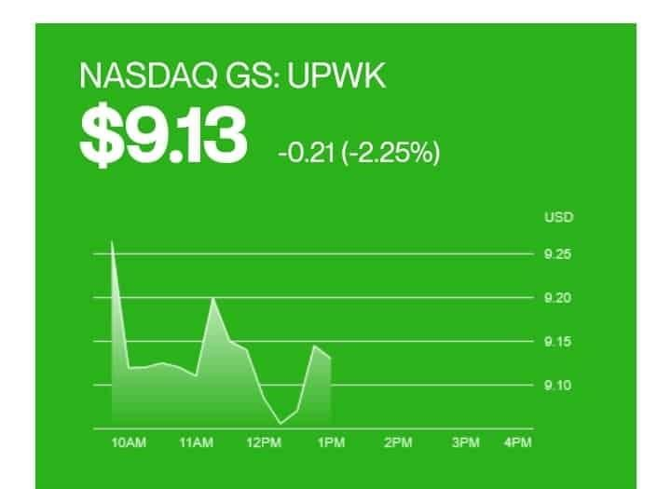
Figure 4 UpWork NASDAQ GS: UPWK) stock performance variation during a random day.

2.5.2. Investor Sentiment:
Investor sentiment towards Upwork has been positive, driven by its strong financial performance, robust user growth, and strategic initiatives. Analysts highlight Upwork’s potential for continued growth, citing its expanding market reach and innovative service offerings as key drivers (freelancermap GmbH, 2024).
2.5.3. Financial Health:
Upwork maintains a healthy balance sheet, with sufficient cash reserves and manageable debt levels. The company’s prudent fiscal management ensures it can continue investing in technology, marketing, and user experience enhancements to drive future growth (Upwork Inc., Investor Relations, 2023).
In summary, Upwork’s financial overview indicates a company on a solid growth trajectory, supported by diverse revenue streams, strong shareholder backing, and positive market performance. These financial foundations provide the stability needed to navigate the competitive freelancing landscape and capitalize on emerging opportunities.
3. GROWTH AND EXPANSION
Upwork's growth strategy is multifaceted, focusing on technological investments and strategic acquisitions to enhance its service offerings and expand its market reach. This section provides an in-depth overview of Upwork's significant technological advancements and key acquisitions, highlighting their impact on the company's growth and service capabilities.

3.1 Technological Investments
Upwork has made substantial investments in technology to improve its platform, enhance user experience, and streamline operations. These technological advancements are crucial for maintaining competitive advantage and meeting the evolving needs of freelancers and clients.
3.1.1. AI-Driven Matching Algorithms:
Upwork has developed sophisticated AI-driven algorithms to match freelancers with suitable projects. These algorithms analyze a range of factors such as skills, experience, project requirements, and client preferences to provide more accurate and efficient matches. This not only improves the user experience but also increases the likelihood of successful project outcomes (Upwork Inc., Investor Relations, 2023).
3.1.2. Enhanced Security Features:
To ensure a safe and secure marketplace, Upwork has implemented advanced security measures, including two-factor authentication, fraud detection systems, and secure payment gateways. These features protect both freelancers and clients from potential security threats and enhance trust in the platform (Clennett, 2020).
3.1.3. Mobile App Improvements:
Recognizing the growing importance of mobile accessibility, Upwork has continuously improved its mobile app, making it easier for users to manage projects, communicate, and track payments on the go. The app now offers a seamless user experience, with features such as real-time notifications, in-app messaging, and task management tools (Beckman, 2023).
3.1.4. Project Management Tools:
Upwork has integrated advanced project management tools into its platform, including time tracking, milestone management, and collaborative workspaces. These tools help users manage their projects more efficiently, ensuring timely delivery and high-quality results (freelancermap GmbH, 2024).
3.1.5. Data Analytics and Insights:
Upwork leverages data analytics to gain insights into user behavior, market trends, and platform performance. By analyzing this data, Upwork can make informed decisions about feature development, marketing strategies, and user support enhancements. This data-driven approach enables continuous improvement and innovation (Upwork Inc., Investor Relations, 2023).
3.1.6. Strategic Acquisitions
Upwork's strategic acquisitions have played a crucial role in its growth and expansion, enabling the company to diversify its service offerings, enter new markets, and enhance its technological capabilities.
3.1.7. Elance-ODesk Merger:
The merger of Elance and oDesk in 2015 was a landmark acquisition that created the foundation for Upwork. This merger combined the strengths and user bases of both platforms, significantly expanding Upwork's reach and capabilities. It also brought together a wealth of expertise and resources, positioning Upwork as a leader in the freelancing industry (Melidoniotis, 2024).
3.1.8. Accenture’s Clearhead:
In 2019, Upwork acquired Accenture’s Clearhead, a digital optimization company specializing in data-driven user experience enhancements. This acquisition enabled Upwork to integrate Clearhead’s advanced analytics and optimization tools into its platform, improving user engagement and satisfaction. It also helped Upwork to refine its marketing strategies and better understand user needs (Clennett, 2020).
3.1.9. Collaborate and Compose:
Upwork’s acquisition of smaller, niche platforms such as Collaborate and Compose has allowed it to expand its service offerings in specific areas such as collaborative workspaces and creative project management. These acquisitions have enriched Upwork’s platform with specialized tools and features, catering to the unique needs of different user segments (Steven, 2024).
3.1.10. Entry into the Enterprise Market:
Upwork’s strategic move into the enterprise market warmed up with the acquisition of different companies that offer enterprise-level solutions. These acquisitions have enabled Upwork to provide comprehensive managed services, compliance support, and workforce analytics to large organizations, significantly expanding its client base and revenue potential (Wise, 2023).
The impact of these technological investments and strategic acquisitions is evident in Upwork’s continued growth and enhanced service offerings. By prioritizing innovation and strategic expansion, Upwork has solidified its position as a leading freelancing platform, capable of meeting the diverse needs of freelancers and clients in a rapidly evolving market.
4. COMPETITION OVERVIEW
Upwork operates in a highly competitive freelancing market, contending with major players that offer unique value propositions and cater to different segments of the market. This section provides a detailed comparison of Upwork with its major competitors—Fiverr, Freelancer.com, and Toptal—followed by a comprehensive market performance comparison.

4.1 Major Competitors
4.1.1. Fiverr
4.1.1.1 Business Model:
Fiverr operates on a gig-based model where freelancers offer specific services, known as “gigs,” at fixed prices starting as low as $5. This model contrasts with Upwork’s project-based and hourly work structures, appealing to clients seeking quick, cost-effective solutions for specific tasks (Melidoniotis, 2024).
4.1.1.2 User Base and Engagement:
Fiverr has a large user base, with millions of freelancers offering services across various categories, including graphic design, digital marketing, writing, and programming. The platform’s simplicity and accessibility attract a wide range of users, particularly small businesses, and individual clients (freelancermap GmbH, 2024).
4.1.1.3 Revenue Streams:
Fiverr generates revenue through service fees charged to freelancers and buyers, as well as through premium features like Fiverr Pro, which offers vetted professionals for higher-end projects. Fiverr’s service fee structure includes a 20% commission on each transaction, which is higher than Upwork’s sliding fee scale (Todorov, 2023).
4.1.1.4 Market Position:
Fiverr’s gig-based model and user-friendly interface have positioned it as a popular choice for quick, low-cost freelance services. The platform’s focus on simplicity and accessibility has driven significant user growth and engagement (Steven, 2024).
4.1.2. Freelancer.com
4.1.2.1 Business Model:
Freelancer.com operates on a bidding system where freelancers compete for projects by submitting proposals. This model encourages competitive pricing, benefiting clients but often challenging freelancers to ensure quality and fair compensation (Beckman, 2023).
4.1.2.2 User Base and Engagement:
Freelancer.com boasts a vast user base, with millions of registered freelancers and clients worldwide. The platform supports a wide array of project categories, making it a versatile option for various freelance services (freelancermap GmbH, 2024).
4.1.2.3 Revenue Streams:
Freelancer.com generates revenue through project fees, membership subscriptions, and additional services like project upgrades and skill tests. The platform charges freelancers a commission ranging from 10% to 20%, depending on the membership level and project type (Clennett, 2020).
4.1.2.4 Market Position:
Freelancer.com’s bidding system and extensive project categories make it a competitive platform for diverse freelance opportunities. Its global reach and versatility attract a broad spectrum of clients and freelancers (Melidoniotis, 2024).
4.1.3. Toptal
4.1.3.1 Business Model:
Toptal focuses on the top 3% of freelance talent, offering highly specialized professionals in fields such as software development, design, and finance. The platform’s rigorous vetting process ensures high-quality talent, catering to large enterprises and high-end projects (Todorov, 2023).
4.1.3.2 User Base and Engagement:
Toptal’s user base is smaller but highly specialized, comprising elite freelancers and top-tier clients. The platform’s exclusivity and focus on quality attract high-paying projects and long-term engagements (freelancermap GmbH, 2024). Figure 4 below shows a survey from Zety a breaking down weekly average hours spent on gig work:
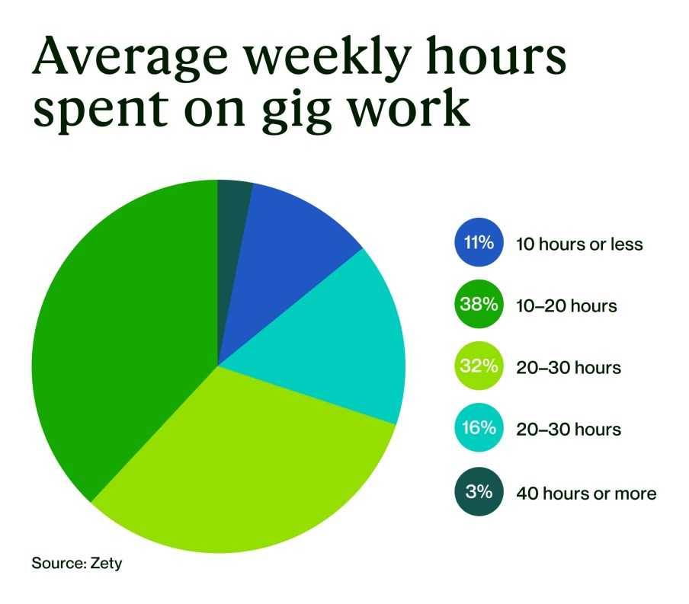
Figure
5

A survey of 985 respondents from Zety included a breakdown of weekly average hours spent on gig work.
4.1.3.3 Revenue Streams:
Toptal generates revenue through a combination of service fees and client subscription fees. The platform’s premium pricing reflects the quality and specialization of its talent pool, with freelancers typically earning higher rates compared to other platforms (Steven, 2024).
4.1.3.4 Market Position:
Toptal’s focus on elite talent and specialized services positions it as a premium freelancing platform. Its rigorous vetting process and high-quality standards appeal to enterprise clients seeking top-tier professionals (Beckman, 2023).
4.1.3.5 Market Performance Comparison
To understand how Upwork stacks up against its competitors, it is essential to compare key metrics and performance indicators such as user base, revenue, market share, and growth trends.

4.2 User Base
- Upwork: Over 18 million registered freelancers and five million registered clients.
- Fiverr: Millions of freelancers and buyers, with significant engagement in gig-based services.
- Freelancer.com: Millions of registered users worldwide, with a broad range of project categories.
- Toptal: Smaller, specialized user base focused on elite talent and high-end clients (Melidoniotis, 2024); (Clennett, 2020); (Beckman, 2023).

4.3 Revenue
- Upwork: Approximately $605 million in revenue as of 2023, driven by service fees, transaction fees, and memberships.
- Fiverr: Strong revenue growth with a 20% commission on transactions and premium services like Fiverr Pro.
- Freelancer.com: Revenue from project fees, membership subscriptions, and additional services, with a commission ranging from 10% to 20%.
- Toptal: Revenue from premium service fees and client subscriptions, reflecting its focus on high-quality, high-value projects (freelancermap GmbH, 2024); (Todorov, 2023).

4.4 Market Share
- Upwork: Significant market share in the freelancing industry, known for its extensive service offerings and user-friendly platform.
- Fiverr: Strong presence in the gig-based service market, appealing to small businesses and individual clients.
- Freelancer.com: Extensive global reach with a competitive bidding system, attracting a diverse range of users.
- Toptal: Niche market share focused on elite talent and enterprise clients, commanding higher rates and specialized projects (Steven, 2024); (Wise, 2023).

4.5 Growth Trends
- Upwork: Consistent year-over-year revenue growth, driven by increasing demand for remote work and continuous platform enhancements.
- Fiverr: Rapid growth fueled by its user-friendly interface and wide-ranging services at low entry prices.
- Freelancer.com: Steady growth with a large user base and diverse project categories, benefiting from its competitive bidding model.
- Toptal: Robust growth in the high-end freelance market, attracting enterprise clients with its focus on top-tier talent (Melidoniotis, 2024); (Clennett, 2020).
In summary, Upwork competes effectively with major players in the freelancing market by offering a versatile platform with diverse services and a robust user base. While Fiverr excels in simplicity and low-cost services, Freelancer.com benefits from its extensive project categories and competitive pricing. Toptal’s focus on elite talent sets it apart in the high-end market. Upwork’s balanced approach and continuous innovation position it as a formidable competitor in the dynamic freelancing landscape.

4.6 User Demographics and Engagement
Understanding the user demographics and engagement on Upwork provides valuable insights into how the platform serves its diverse user base. This section analyzes the demographics of Upwork’s users, breaks down the types of projects and transactions, and offers insights into user satisfaction and feedback. Figure 3 below shows freelancer job search distribution per type:
Figure 6 Freelance job statistics.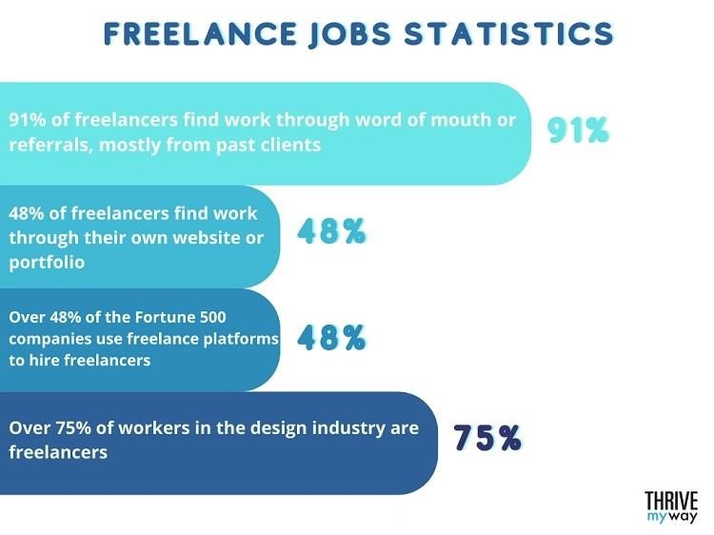 (Todorov, 2023)
4.1.4. User Base Statistics
Upwork boasts a diverse and expansive user base comprising freelancers and clients from various industries and regions. As of 2023, Upwork’s platform includes over eighteen million registered freelancers and five million registered clients (Melidoniotis, 2024).
4.1.3.6 Freelancers:
Upwork’s freelancers come from a wide range of professional backgrounds, including web development, graphic design, writing, marketing, customer service, and more. The platform attracts freelancers from around the world, with significant representation from the United States, India, the Philippines, Pakistan, and Eastern Europe. Freelancers on Upwork vary in terms of experience and expertise, from entry-level professionals to experienced specialists (Upwork Inc., Investor Relations, 2023). Figure 6 below shows freelancer distribution per age group:
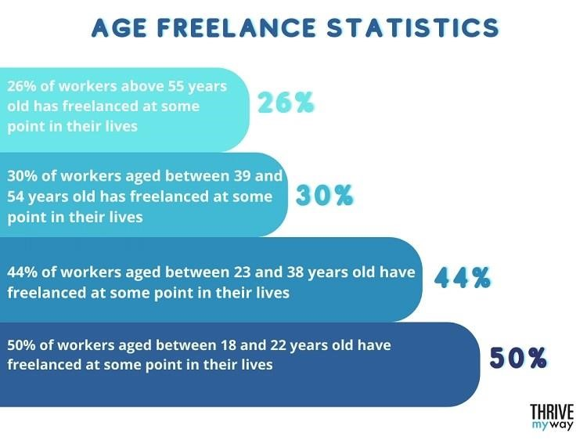

Figure 7 Freelancer distribution per age group. (Todorov, 2023)

4.1.3.7 Clients:
Upwork’s clients range from small businesses and startups to large enterprises and multinational corporations. The platform is used by clients from various industries, including technology, healthcare, finance, marketing, and education. Clients are primarily based in the United States, the United Kingdom, Canada, Australia, and Germany. The diversity of clients ensures a wide array of project opportunities for freelancers (freelancermap GmbH, 2024). Figure 7 below shows UpWork client base year over year growth:
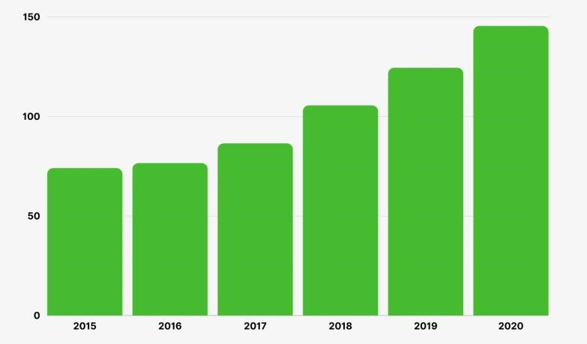
Figure 8 Upwork client base year over year growth.

4.7 Types of Projects and Transactions
Upwork supports a vast array of project types, catering to the needs of both freelancers and clients. The platform facilitates both short-term tasks and long-term projects, allowing users to choose from various engagement models.
4.7.1. Hourly Projects:
These projects are billed based on the number of hours worked by the freelancer. Hourly projects are common in fields such as software development, customer service, and virtual assistance.
Upwork’s time tracking tool, Upwork Time Tracker, helps freelancers log their hours accurately, ensuring transparency and trust between freelancers and clients (Clennett, 2020).
4.7.2. Fixed-Price Projects:
Fixed-price projects have a set budget agreed upon before the work begins. These projects are popular in areas such as graphic design, writing, and marketing. Milestones can be set within fixed-price projects, allowing clients to release payments incrementally as specific parts of the project are completed (Beckman, 2023).
4.7.3. Project Categories:
Upwork’s project categories include:
- Web, Mobile, and Software Development: Projects related to creating websites, mobile apps, and software applications.
- Design and Creative: Graphic design, video production, animation, and other creative projects.
- Writing and Translation: Content creation, copywriting, technical writing, and translation services.
- Sales and Marketing: Digital marketing, SEO, social media management, and lead generation.
- Admin Support: Virtual assistance, data entry, and customer service.
- Finance and Accounting: Bookkeeping, financial analysis, and consulting (freelancermap GmbH, 2024).
Figure 8 below shows the UpWork skill index and skills list:
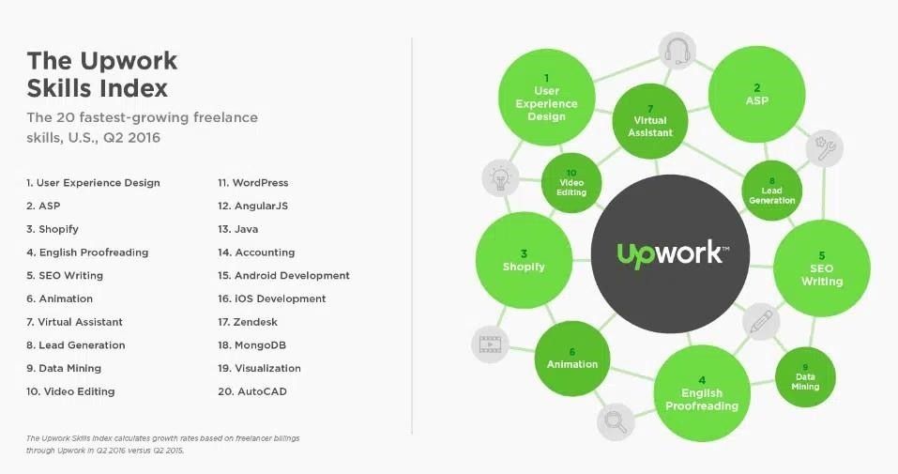
Figure 9 The UpWork Skill Index. (Beckman, 2023)
4.7.4. Average Transaction Values:
The average transaction value on Upwork varies by project type and industry. For example, web development projects typically have higher transaction values compared to administrative support tasks. On average, transaction values range from $500 to $1,500 per project, depending on the complexity and scope of the work (Steven, 2024).

4.8 User Satisfaction and Feedback
User satisfaction is a critical factor in the success of any online platform, and Upwork actively seeks to understand and improve the experiences of its users. Figure 9 below shows job satisfaction ratings at UpWork per job type:
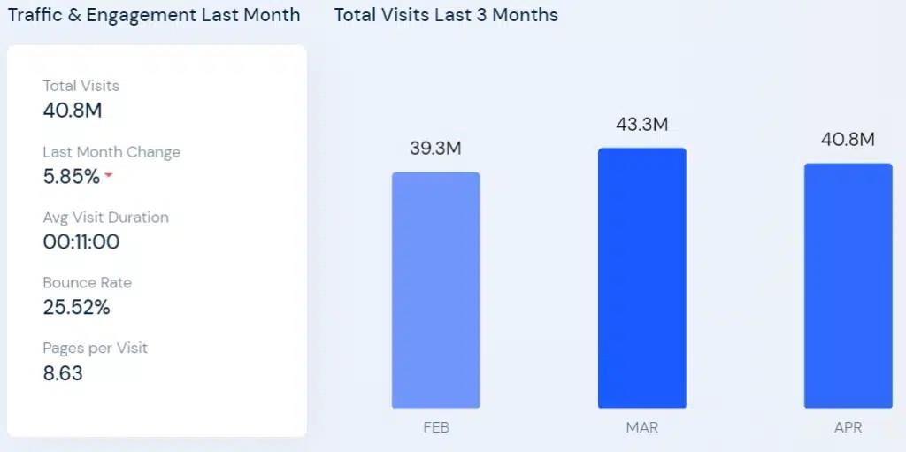
Figure 10 UpWork job satisfaction ratings (% satisfied, T2B) (Beckman, 2023).
4.8.1. Positive Feedback:
Users appreciate Upwork for the opportunities it provides, the security of its payment system, and the ease of finding work or hiring talent. Freelancers value the flexibility to choose projects that match their skills and the ability to work remotely. Clients often highlight the vast pool of talent and the efficiency of finding and hiring freelancers (Melidoniotis, 2024).
4.8.2. Common Complaints:
Despite the positive aspects, Upwork faces criticism from users. Common complaints include:
- High Fees: Freelancers often criticize the service fees, perceived as high, especially for smaller projects. Upwork’s sliding fee scale (20% for the first $500 billed with a client, 10% for billings between $500.01 and $10,000, and 5% for billings above $10,000) is a point of contention (freelancermap GmbH, 2024).
- Policy Enforcement: Both freelancers and clients sometimes find Upwork’s policy enforcement to be stringent. Account suspensions and bans for policy violations can be frustrating, particularly if users feel the actions are unjustified (Hacker Noon, 2023). • Customer Support: Users have reported mixed experiences with Upwork’s customer support. While there are users who praise the support team for being helpful and responsive, others feel that resolution times can be slow and that the support provided is sometimes inadequate (Clennett, 2020).
4.8.3. User Engagement:
Upwork engages with its user community through various channels, including social media, forums, and webinars. These engagements help Upwork gather feedback, address concerns, and build a sense of community among users. Regular updates and improvements to the platform are often based on user feedback, ensuring that Upwork evolves to meet the needs of its diverse user base (Wise, 2023). Figure 10 below shows the relationship between traffic and engagement for the quarter before April 2024.
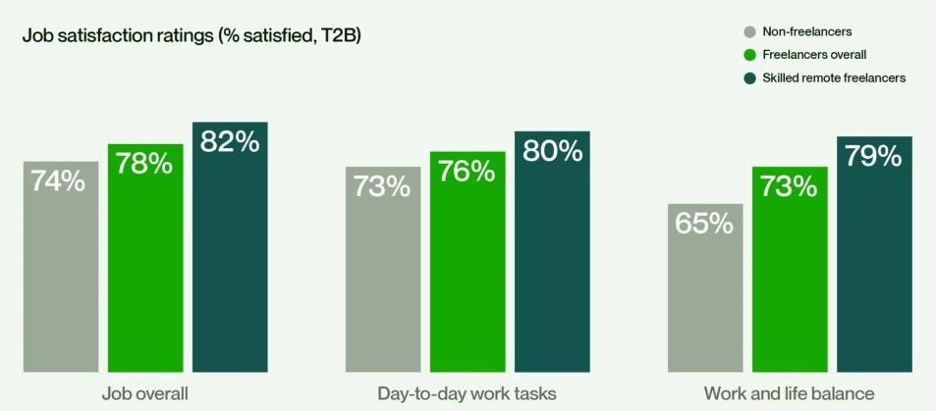
Figure 11 UpWork traffic engagement as of April 2024 (Beckman, 2023).
In summary, Upwork’s user demographics and engagement reveal a platform that serves a wide range of professionals and industries. While user satisfaction is high, there are areas for improvement, particularly regarding fees, policy enforcement, and customer support. Understanding these dynamics is crucial for Upwork’s continued success and growth in the competitive freelancing market.
5. TREATMENT OF FREELANCERS VS. HIRING COMPANIES
Upwork operates with a comprehensive policy framework designed to ensure fair and secure transactions between freelancers and clients. This section examines Upwork’s policies, enforcement mechanisms, and penalties. It also analyzes the concept of fairness from the perspectives of freelancers and hiring companies, supplemented with illustrative case studies and examples.

5.1 Policy Framework
Upwork’s policy framework is built to create a safe and efficient marketplace for both freelancers and clients. The platform enforces its policies through a combination of automated systems and manual reviews.
5.1.1. Policies for Freelancers:
Upwork’s policies for freelancers include guidelines on profile accuracy, proposal submissions, project delivery standards, and dispute resolution. Freelancers demand to maintain honest profiles is present, deliver work as agreed, and communicate effectively with clients. Violation of these policies can result in warnings, temporary suspensions, or permanent bans (Upwork Inc., Investor Relations, 2023).
5.1.2. Policies for Clients:
Upwork’s clients face the expectation to provide clear project descriptions, communicate promptly, and make timely payments. Upwork’s policies also cover issues such as intellectual property rights and confidentiality. Clients who fail to adhere to these policies may face penalties, including account suspension and removal from the platform (Clennett, 2020).
5.1.3. Enforcement Mechanisms:
Upwork employs various enforcement mechanisms to uphold its policies. Automated systems monitor transactions for fraudulent activity, while a resolute team manages reports of policy violations. Dispute resolution processes are in place to address conflicts between freelancers and clients, often involving mediation and arbitration (Beckman, 2023).
5.1.4. Penalties:
The penalties for policy violations on Upwork range from warnings to account suspensions and permanent bans. For example, freelancers who consistently deliver subpar work or engage in fraudulent activities may receive punishment such as banishment. Similarly, clients who fail to pay for completed work or violate Upwork’s terms of service can face removal from the platform (freelancermap GmbH, 2024).

5.2 Fairness and Perception
The concept of fairness on Upwork is multifaceted, as it must balance the interests of both freelancers and hiring companies.
5.3 Freelancers’ Perspective:
From the freelancers’ perspective, fairness involves receiving adequate compensation for their work, timely payments, and protection against unjustified negative feedback or disputes.
Freelancers appreciate Upwork’s secure payment system and the ability to resolve disputes through mediation. However, there are freelancers who feel that the platform’s fees are high, and that policy enforcement can sometimes be arbitrary or overly strict (Melidoniotis, 2024).
5.4 Hiring Companies’ Perspective:
Hiring companies seek a reliable and efficient process for finding and hiring qualified freelancers. Fairness for clients involves transparency in freelancer qualifications, clear communication, and timely project delivery. Clients perceive Upwork as providing access to a vast pool of talent and value the platform’s project management tools. However, there are clients who have expressed concerns about the quality of work and the challenge of navigating disputes (Steven, 2024).
5.5 Balancing Fairness:
Upwork aims to balance fairness by implementing policies that protect both parties and by providing tools for transparent and effective communication. The platform’s feedback system allows both freelancers and clients to rate each other, promoting accountability. Nonetheless, achieving perfect fairness is challenging, and Upwork continually updates its policies and processes based on user feedback (Wise, 2023).

5.6 Case Studies and Examples
Case Study 1: Freelancer Suspension for Policy Violation: A freelancer on Upwork experienced suspension after multiple clients reported incomplete or low-quality work. The freelancer appealed the suspension, arguing that the clients’ expectations were unreasonable. Upwork’s dispute resolution team reviewed the case and found that the freelancer had indeed violated the platform’s quality standards. Despite the freelancer’s appeal, the suspension remained, demonstrating Upwork’s commitment to maintaining ambitious standards (Hacker Noon, 2023).
Case Study 2: Client Ban for Non-Payment: A client permanently banned from Upwork after failing to pay for completed projects. Freelancers reported the issue to Upwork, which initiated an investigation. The findings showed that the client violated the payment terms and was subsequently banned. This case highlights Upwork’s efforts to protect freelancers from nonpayment and enforce its payment policies (freelancermap GmbH, 2024).
Case Study 3: Dispute Resolution and Mediation: A freelancer and a client entered a dispute over the scope of a project and the quality of delivered work. The client withheld payment, and the freelancer filed a dispute. Upwork’s mediation team intervened, reviewing the project details and communications. The mediation resulted in a compromise, with the client agreeing to pay a partial amount for the work completed. This case illustrates Upwork’s role in facilitating fair dispute resolution (Upwork Inc., Investor Relations, 2023).
In summary, Upwork’s governance of the treatment of freelancers and hiring companies works under a robust policy framework designed to ensure fairness and security. While the platform strives to balance the interests of both parties, challenges remain, and continuous improvements are necessary. The case studies and examples provide insights into how Upwork enforces its policies and manages disputes, reflecting its commitment to maintaining a fair and trustworthy marketplace.
6. EXPLOITING LOOPHOLES AND BYPASSING POLICIES
Upwork’s comprehensive policy framework design aims to ensure fair and secure transactions. However, there are freelancers and clients who exploit loopholes and backdoors to bypass these policies. This section identifies and analyzes common strategies used to circumvent Upwork’s policies and discusses the impact of these loopholes on the platform’s integrity and user trust.

6.1 Common Loopholes and Backdoors
Despite Upwork’s stringent policies, users find ways to exploit the system for personal gain.
These loopholes and backdoors often undermine the platform’s fairness and security.
6.1.1. Off-Platform Transactions:
One of the most common loopholes involves freelancers and clients conducting transactions offplatform to avoid Upwork’s service fees. This practice violates Upwork’s terms of service, as it deprives the platform of its commission and exposes both parties to potential payment and security risks. Freelancers and clients may initially connect on Upwork but then agree to continue their work and payments through alternative channels like PayPal or direct bank transfers (Paterson, 2016).
6.1.2. Fake Profiles and Reviews:
There are those freelancers who create multiple profiles to increase their chances of winning projects or to manipulate feedback and ratings. Similarly, there are fake reviews used to inflate a freelancer’s reputation or to sabotage competitors. These practices distort the accuracy of the feedback system, making it difficult for clients to make informed decisions (Wise, 2023).
6.1.3. Scope Creep and Underbidding:
Freelancers may initially underbid projects to win them but then engage in “scope creep,” where they gradually increase the project’s scope and cost once the client is committed. Conversely, clients may use scope creep to extract additional work from freelancers without fair compensation. This tactic can lead to disputes and dissatisfaction on both sides (freelancermap GmbH, 2024).
6.1.4. Misrepresentation of Skills:
There are those freelancers who exaggerate or falsify their skills and experience to win projects. Once hired, they may subcontract the work to less qualified individuals or deliver subpar results.
This practice not only breaches Upwork’s policies but also harms the client’s project outcomes and trust in the platform (Steven, 2024).
6.1.5. Bypassing Upwork’s Dispute Resolution:
Users sometimes avoid using Upwork’s dispute resolution system, designed to mediate conflicts fairly. Instead, they may resort to direct negotiations or even threats of negative feedback to resolve disputes in their favor. This undermines the integrity of Upwork’s mediation processes and can lead to unjust outcomes (Upwork Inc., Investor Relations, 2023).
6.1.6. Impact on Platform Integrity and Trust
The exploitation of loopholes and backdoors has significant implications for Upwork’s integrity, and the trust users place in the platform.
6.1.7. Erosion of Trust:
Trust is fundamental to the success of any online marketplace. When users engage in fraudulent activities or exploit loopholes, it erodes the trust that other users have in the platform. Clients may become wary of hiring freelancers due to fears of misrepresentation or non-payment, while freelancers may be hesitant to invest time in projects due to concerns about fair compensation and client integrity (Clennett, 2020).
6.1.8. Compromised Fairness:
Exploiting loopholes disrupts the fairness that Upwork strives to maintain. Fake profiles, false reviews, and misrepresented skills can lead to an uneven playing field where honest freelancers and clients struggle to compete. This compromises the meritocratic nature of the platform, where users should succeed based on their skills and professionalism (freelancermap GmbH, 2024).
6.1.9. Financial Losses:
Off-platform transactions directly impact Upwork’s revenue by circumventing service fees. This not only reduces the platform’s income but also limits its ability to reinvest in improving services, security features, and user support. In the long term, such financial losses can hinder Upwork’s growth and development (Beckman, 2023).
6.1.10. Increased Monitoring and Enforcement Costs:
To combat these issues, Upwork must invest in more sophisticated monitoring and enforcement mechanisms. This includes employing advanced algorithms to detect fraudulent activities, increasing manual reviews, and enhancing the dispute resolution process. These measures require significant resources, diverting attention and funds from other potential improvements (Upwork Inc., Investor Relations, 2023).
6.1.11. Negative User Experience:
Users affected by fraudulent activities or policy violations often have negative experiences, leading to dissatisfaction and potential attrition. Negative word-of-mouth and online reviews can further damage Upwork’s reputation, making it harder to attract and retain quality freelancers and clients (Melidoniotis, 2024).
In summary, while Upwork’s policies aim to create a fair and secure marketplace, the exploitation of loopholes and backdoors poses significant challenges. These practices undermine trust, compromise fairness, result in financial losses, increase enforcement costs, and lead to negative user experiences. Addressing these issues is critical for Upwork to maintain its integrity and continue providing value to its users.
7. UPWORK AND SOCIAL MEDIA INTERCONNECTIONS
Social media plays a pivotal role in Upwork’s marketing strategy, community engagement, reputation management, and data analytics. This section explores how Upwork leverages social media for marketing and brand building, community nurturing, reputation management, influencer partnerships, content distribution, SEO, and strategic decision-making.

7.1 Marketing and Brand Awareness
7.1.1. Social Media Platforms:
Upwork actively uses platforms like LinkedIn, Facebook, Twitter, Instagram, and YouTube to promote its services and build brand awareness. Each platform serves a specific purpose and audience, allowing Upwork to tailor its marketing strategies accordingly (Steven, 2024).
7.1.2. Targeted Advertising:
Upwork employs targeted advertising campaigns on social media to reach potential freelancers and clients. By using demographic and interest-based targeting, Upwork ensures its ads are shown to users most likely to benefit from its services. This approach maximizes ad spend efficiency and drives higher engagement rates (Upwork Inc., Investor Relations, 2023).
7.1.3. Engaging Content:
Upwork creates and shares engaging content, including blog posts, success stories, tutorials, and industry insights. This content not only promotes Upwork’s services but also provides value to the audience, establishing Upwork as a thought leader in the freelancing industry (Clennett, 2020).

7.2 Community Building and Engagement
7.2.1. Freelancer and Client Communities:
Upwork uses social media to build and nurture communities of freelancers and clients. Platforms like Facebook and LinkedIn groups allow users to connect, share experiences, seek advice, and provide support. These communities foster a sense of belonging and loyalty among users (freelancermap GmbH, 2024).
7.2.2. Interactive Engagement:
Upwork engages with its community through interactive content such as polls, Q&A sessions, live webinars, and AMAs (Ask Me Anything). These interactions help Upwork understand user needs and preferences while providing a platform for direct communication with the company (Beckman, 2023).
7.2.3. User-Generated Content:
Encouraging freelancers and clients to share their experiences and success stories on social media helps build a vibrant and authentic community. User-generated content acts as social proof, highlighting real-life benefits of using Upwork and inspiring others to join the platform (Melidoniotis, 2024).

7.3 Reputation Management
7.3.1. Monitoring and Response:
Upwork monitors social media channels for mentions and feedback, allowing it to respond promptly to user inquiries, complaints, and compliments. This initiative-taking approach helps address issues before they escalate and demonstrates Upwork’s commitment to customer satisfaction (Wise, 2023).
7.3.2. Crisis Management:
In the event of a PR crisis, such as negative reviews or controversies, Upwork employs crisis management strategies to mitigate the impact. This includes issuing official statements, addressing concerns transparently, and taking corrective actions to restore trust and credibility (Clennett, 2020).
7.3.3. Positive Testimonials:
Upwork amplifies positive testimonials and success stories shared by users on social media.
Highlighting these stories helps build a positive image and reinforces the platform’s value proposition (freelancermap GmbH, 2024).

7.4 Influencer Partnerships
7.4.1. Collaborations with Influencers:
Upwork collaborates with influencers in the freelancing, entrepreneurial, and business communities to enhance its visibility and credibility. Influencers share their experiences with Upwork, provide endorsements, and create content that resonates with their followers (Steven, 2024).
7.4.2. Impact on Visibility and Credibility:
Influencer partnerships expand Upwork’s reach to new audiences and lend credibility to its brand. Influencers’ authentic and trusted voices help attract inexperienced users and build trust in the platform’s services (Wise, 2023).

7.5 Content Distribution and SEO
7.5.1. Social Media Channels:
Upwork uses its social media channels to distribute a wide range of content, including blog posts, webinars, tutorials, and industry news. This distribution strategy ensures that valuable content reaches a broad audience, driving traffic to Upwork’s website and blog (Upwork Inc., Investor Relations, 2023).
7.5.2. SEO Benefits:
Sharing content on social media boosts Upwork’s SEO by generating backlinks and increasing content visibility. Social signals, such as likes, shares, and comments, also contribute to higher search engine rankings, making it easier for potential users to discover Upwork through organic search (Clennett, 2020).
7.5.3. Content Calendar:
Upwork maintains a content calendar to ensure consistent and timely distribution of content across all social media platforms. This organized approach helps keep the audience engaged and informed about Upwork’s offerings and updates (Melidoniotis, 2024).

7.6 Data Analytics and Insights
7.6.1. Social Media Analytics Tools:
Upwork leverages various social media analytics tools to track performance metrics such as engagement rates, reach, impressions, and follower growth. These tools provide valuable insights into which content resonates with the audience and which strategies are most effective (Beckman, 2023).
7.6.2. User Behaviour Analysis:
By analyzing user behavior on social media, Upwork can identify trends, preferences, and pain points. This information helps refine marketing strategies, improve user engagement, and develop new features that meet user needs (freelancermap GmbH, 2024).
7.6.3. Strategic Decision-Making:
Data gathered from social media analytics informs Upwork’s strategic decisions, from content creation and advertising to product development and customer support. Leveraging these insights ensures that Upwork remains responsive to market demands and continues to evolve its services (Upwork Inc., Investor Relations, 2023).
In summary, Upwork’s strategic use of social media for marketing, community building, reputation management, influencer partnerships, content distribution, and data analytics significantly contributes to its growth and success. By effectively leveraging social media, Upwork enhances its brand visibility, fosters user engagement, and makes informed strategic decisions that drive the platform’s continued evolution.
8. USER RELATIONSHIPS AND MARKET PERCEPTION
Understanding user relationships and market perception is crucial for Upwork’s strategic growth and long-term success. This section analyzes user retention and attrition trends, explores external market perceptions from stakeholders and industry experts, and compares Upwork’s relationships and perceptions with those of its competitors.

8.1 Retention and Attrition Rates
User retention and attrition rates provide insights into how well Upwork maintains its user base over time and the challenges it faces in keeping users engaged.
8.1.1. Retention Rates:
Upwork’s retention rates are influenced by several factors, including user satisfaction, project availability, and overall experience on the platform. Upwork has implemented various strategies to improve retention, such as offering membership plans with added benefits, enhancing the user interface, and providing robust support services. These efforts have resulted in high retention rates, particularly among experienced freelancers and recurring clients who find value in the platform’s comprehensive services (Melidoniotis, 2024).
8.1.2. Attrition Rates:
Despite strong retention efforts, Upwork also experiences attrition, particularly among inexperienced users who may find it challenging to secure projects or compete with established freelancers. Common reasons for attrition include high service fees, stringent policy enforcement, and competition from other platforms. Upwork continuously analyzes attrition data to identify pain points and develop strategies to reduce churn (Clennett, 2020).
8.1.3. Strategies for Improvement:
Upwork’s strategies to improve retention and reduce attrition include personalized onboarding experiences, targeted marketing campaigns, and enhanced support services. By addressing the specific needs and concerns of freelancers and clients, Upwork aims to foster long-term loyalty and satisfaction (Beckman, 2023).
8.1.4. External Market Perceptions
External market perceptions play a significant role in Upwork’s reputation and attractiveness to potential users. These perceptions are shaped by feedback from stakeholders, industry experts, and media coverage.
8.1.5. Stakeholder Feedback:
Feedback from stakeholders, including investors, partners, and users, highlights Upwork’s strengths in providing a diverse talent pool, secure payment systems, and efficient project management tools. However, stakeholders also point out areas for improvement, such as fee structures and customer support responsiveness (freelancermap GmbH, 2024).
8.1.6. Industry Expert Analysis:
Industry experts often commend Upwork for its innovative approach to freelancing and its ability to adapt to market trends. Reports and reviews from experts emphasize Upwork’s role in the gig economy and its potential for growth. However, they also caution about the competitive landscape and the need for continuous innovation to stay ahead (Steven, 2024).
8.1.7. Media Coverage:
Media coverage of Upwork is positive, highlighting success stories, new features, and strategic initiatives. Positive media attention helps boost Upwork’s market perception and attract inexperienced users. Negative coverage, such as critiques of policy enforcement or user dissatisfaction, can impact public perception and requires prompt and effective reputation management (Wise, 2023).

8.2 Comparative Analysis with Other Platforms
Comparing Upwork’s user relationships and market perceptions with those of its competitors
8.3 Fiverr:
Fiverr is known for its gig-based model, which appeals to users looking for quick, low-cost services. Fiverr’s user relationships are characterized by high transaction volumes, but lower project values compared to Upwork. Market perception of Fiverr is positive due to its simplicity and accessibility, but it faces criticism for the quality of services and the competitiveness of its gig environment (freelancermap GmbH, 2024).
8.4 Freelancer.com:
Freelancer.com’s bidding system attracts a wide range of projects and users, fostering a competitive environment. User relationships on Freelancer.com are influenced by the platform’s extensive project categories and global reach. Market perception is mixed, with praise for its versatility and critique for its bidding process, which can lead to underpricing and quality concerns (Clennett, 2020).
8.5 Toptal:
Toptal’s focus on elite talent and high-quality projects results in strong user relationships, particularly among top-tier freelancers and enterprise clients. The market perception of Toptal is highly positive due to its rigorous vetting process and premium service offerings. However, its exclusivity limits its user base compared to more accessible platforms like Upwork and Fiverr (Steven, 2024).
8.6 Comparison Summary:
Upwork’s user relationships and market perception stand out due to its balanced approach of providing a wide range of services while maintaining quality and security. Unlike Fiverr’s gigbased model and Freelancer.com’s competitive bidding system, Upwork offers a more structured and comprehensive platform. Compared to Toptal, Upwork is more accessible to a broader range of users, though it faces challenges in managing quality and user expectations (Beckman, 2023).
In summary, Upwork’s user relationships and market perception are shaped by its efforts to balance user satisfaction, market demands, and competitive pressures. By continuously improving its services and addressing user concerns, Upwork aims to strengthen its position in the freelancing market and enhance its reputation among stakeholders and industry experts.
9. OUTLOOK
As Upwork continues to evolve in the rapidly changing freelancing market, strategic initiatives and innovations will play a crucial role in shaping its future. This section explores Upwork's upcoming initiatives, forecasts its growth and market position over the next 3, 5, and 10 years, and identifies potential challenges and opportunities.

9.1 Strategic Initiatives and Innovations
Upwork is investing in different strategic initiatives and technological advancements to enhance its platform, improve user experience, and expand its market reach.
9.1.1. AI and Machine Learning:
Upwork plans to integrate more advanced AI and machine learning algorithms to improve the matching process between freelancers and clients. These technologies will enhance the precision of job recommendations, streamline the hiring process, and increase the likelihood of successful project outcomes (Upwork Inc., Investor Relations, 2023).
9.1.2. Enhanced User Experience:
Upwork is committed to continually improving its user interface and overall user experience. This includes redesigning the platform to be more intuitive and user-friendly, optimizing mobile applications, and providing better project management tools. Enhancements in user experience will help retain current users and attract new ones (Melidoniotis, 2024).
9.1.3. Expanded Enterprise Solutions:
Upwork is focusing on expanding its enterprise solutions to cater to large organizations seeking comprehensive freelance workforce management. These solutions include advanced workforce analytics, compliance support, and integrated project management tools. By targeting enterprise clients, Upwork aims to increase its market share and revenue from high-value contracts (freelancermap GmbH, 2024).
9.1.4. Global Market Expansion:
To capitalize on the growing demand for freelance work globally, Upwork is planning to expand its presence in emerging markets. This includes localized versions of the platform, region-specific marketing strategies, and partnerships with local businesses and governments. Global expansion will help Upwork tap into new talent pools and client bases (Beckman, 2023).
9.1.5. Blockchain Technology:
Upwork is exploring the use of blockchain technology to enhance transparency and security in transactions. Blockchain can provide immutable records of work agreements and transactions, reducing disputes and building trust between freelancers and clients (Steven, 2024).

9.2 Projections for the Next 3, 5, and 10 Years
9.2.1. 3-Year Projection:
In the next three years, Upwork shall solidify its position as a leader in the freelancing market. The integration of AI and machine learning will significantly improve matching accuracy, leading to higher user satisfaction. The expansion of enterprise solutions will attract more large organizations, driving revenue growth. Upwork's global market expansion will also start to show results, with increased user registrations from emerging markets (Wise, 2023).
9.2.2. 5-Year Projection:
Over the next five years, Upwork's technological advancements and strategic initiatives will lead to substantial growth in its user base and revenue. The platform will become more sophisticated, offering seamless user experience and comprehensive project management tools. In the period, e Upwork's enterprise solutions will experience wide adoption, and the company will have a strong presence in different international markets. The use of blockchain technology may become a standard feature, further enhancing trust and security (Clennett, 2020).
9.2.3. 10-Year Projection:
In ten years, Upwork projection outlook to be a dominant force in the global freelancing industry. The platform will be highly automated, with AI managing a growing number of the matching and project management processes. Upwork's enterprise solutions will be integral to the workforce strategies of large organizations. The company will have a significant footprint in emerging markets, contributing to its sustained growth. Blockchain technology will be fully integrated, providing unparalleled transparency and security. Upwork's continuous innovation and adaptation to market trends will ensure its long-term success (Melidoniotis, 2024).

9.3 Potential Challenges and Opportunities
9.3.1. Challenges
9.3.1.1 Intense Competition:
Upwork faces intense competition from other freelancing platforms like Fiverr, Freelancer.com, and Toptal. Staying ahead will require continuous innovation and differentiation (freelancermap GmbH, 2024).
9.3.1.2 Regulatory Changes:
As the gig economy grows, regulatory changes concerning freelancer rights, taxation, and platform responsibilities could pose challenges. Upwork will need to navigate these changes carefully to maintain compliance and protect its business model (Wise, 2023).
9.3.1.3 Economic Fluctuations:
Economic downturns can affect the demand for freelance services. Upwork must develop strategies to mitigate the impact of economic fluctuations on its business (Steven, 2024).
9.3.1.4 User Trust and Security:
Maintaining user trust and ensuring platform security will be ongoing challenges. Upwork must continue to invest in robust security measures and transparent policies to protect users (Clennett, 2020).
9.3.2. Opportunities
9.3.2.1 Growing Demand for Remote Work:
The increasing acceptance of remote work presents a significant opportunity for Upwork. By positioning itself as the go-to platform for remote talent, Upwork can capture a larger share of the market (Beckman, 2023).
9.3.2.2 Technological Advancements:
Advancements in AI, machine learning, and blockchain technology offer opportunities for Upwork to enhance its platform and differentiate itself from competitors. Leveraging these technologies can improve user experience and operational efficiency (freelancermap GmbH, 2024).
9.3.2.3 Expansion into New Markets:
Expanding into emerging markets with high potential for growth presents a significant opportunity for Upwork. Tailoring its platform to meet the needs of these markets can drive user acquisition and revenue growth (Melidoniotis, 2024).
9.3.2.4 Partnerships and Collaborations:
Forming strategic partnerships with educational institutions, industry associations, and technology companies can provide Upwork with new opportunities for growth and innovation.
These collaborations can enhance Upwork’s service offerings and market reach (Upwork Inc., Investor Relations, 2023).
In summary, Upwork’s outlook is promising, with different strategic initiatives and technological advancements on the horizon. The company’s ability to navigate challenges and capitalize on opportunities will determine its long-term success in the competitive freelancing market.
10. CONCLUSION
The conclusion summarizes the key findings from the study, discusses the implications for freelancers and hiring companies, and provides recommendations for Upwork’s strategic improvements and future growth.

10.1 Summary of Findings
This study explored various facets of Upwork, including its corporate dynamics, market positioning, user demographics, policies, and outlook. Key findings include:
- Corporate Overview: Upwork has established itself as a leading freelancing platform since its formation in 2015, following the merger of Elance and oDesk. It offers a wide array of services and connects millions of freelancers with clients globally.
- Financial Performance: Upwork’s revenue streams include service fees, transaction fees, and membership subscriptions. The company has shown consistent revenue growth, driven by an expanding user base and increased transaction volume.
- Growth and Expansion: Upwork’s strategic initiatives include investments in AI and machine learning, enhanced user experience, expanded enterprise solutions, global market expansion, and exploration of blockchain technology.
- Competition: Upwork faces competition from Fiverr, Freelancer.com, and Toptal. Each competitor has unique strengths, such as Fiverr’s gig-based model and Toptal’s focus on elite talent.
- User Demographics and Engagement: Upwork serves a diverse user base of over eighteen million freelancers and five million clients. The platform supports various project types, including hourly and fixed-price projects, across multiple categories. • Policy Framework: Upwork’s policies aim to ensure fair and secure transactions, with enforcement mechanisms to address violations. The platform faces challenges in balancing the interests of freelancers and clients.
- Exploiting Loopholes: Common strategies for bypassing Upwork’s policies include offplatform transactions, fake profiles, and scope creep. These practices undermine trust and fairness on the platform.
- Social Media Interconnections: Upwork leverages social media for marketing, community building, reputation management, influencer partnerships, content distribution, and data analytics.
- User Relationships and Market Perception: Upwork maintains strong user relationships but faces challenges with retention and attrition. External market perceptions are positive, but competition and regulatory changes pose risks.
- Outlook: Upwork’s future looks promising with ongoing technological advancements and strategic initiatives. The company might expect significant growth but must navigate challenges such as intense competition and regulatory changes.

10.2 Implications for Freelancers and Hiring Companies
10.2.1. Freelancers:
The findings suggest that Upwork provides freelancers with significant opportunities to find work and earn income. However, freelancers must navigate challenges such as high fees, competition, and stringent policy enforcement. Building a strong profile, maintaining high-quality standards, and leveraging Upwork’s tools can help freelancers succeed on the platform.
10.2.2. Hiring Companies:
For clients, Upwork offers access to a vast pool of talent and flexible hiring options. The platform’s secure payment system and project management tools enhance the hiring experience. However, clients must be vigilant about selecting qualified freelancers and managing project scopes to avoid disputes and ensure satisfactory outcomes.

10.3 Recommendations for Upwork’s Future Development
10.3.1. Enhance User Support:
Upwork should invest in improving customer support services to address user concerns more efficiently. This includes reducing response times, providing comprehensive support resources, and offering personalized assistance to both freelancers and clients (Melidoniotis, 2024).
10.3.2. Reduce Fees:
To attract and retain more users, Upwork could consider revising its fee structure. Lowering service fees or offering more competitive pricing tiers, especially for inexperienced users, can make the platform more appealing and reduce attrition rates (freelancermap GmbH, 2024).
10.3.3. Strengthen Policy Enforcement:
Upwork should enhance its policy enforcement mechanisms to prevent fraudulent activities and ensure fairness. Implementing more robust verification processes and employing advanced AI algorithms can help identify and mitigate policy violations (Beckman, 2023).
10.3.4. Expand Training and Resources:
Providing additional training and resources for freelancers and clients can help improve the overall quality of work on the platform. Upwork could offer online courses, webinars, and best practice guides to help users enhance their skills and navigate the platform effectively (Clennett, 2020).
10.3.5. Invest in Emerging Technologies:
Upwork should continue investing in emerging technologies such as AI, machine learning, and blockchain. These technologies can improve matching accuracy, enhance security, and streamline operations, providing a better user experience and maintaining Upwork’s competitive edge (Upwork Inc., Investor Relations, 2023).
10.3.6. Global Market Expansion:
To capture new user bases, Upwork should focus on expanding its presence in emerging markets. Localizing the platform, tailoring marketing strategies to regional preferences, and forming partnerships with local businesses can drive growth in these areas (Wise, 2023).
10.3.7. Enhance Community Engagement:
Building and nurturing a strong community of freelancers and clients can enhance user loyalty and satisfaction. Upwork should continue to leverage social media for community building, encourage user-generated content, and facilitate peer-to-peer support and networking (Steven, 2024).
10.3.8. Monitor Regulatory Changes:
Upwork must stay ahead of regulatory changes affecting the gig economy. Proactively engaging with policymakers and adapting to new regulations can help mitigate potential risks and ensure compliance, protecting Upwork’s business model (freelancermap GmbH, 2024).
In conclusion, Upwork’s strategic initiatives and continuous improvements position it well for future growth. By addressing the identified challenges and seizing new opportunities, Upwork can enhance its platform, foster user satisfaction, and maintain its leadership in the freelancing market.
11. PERSONAL EXPERIENCE: A DEEP DIVE INTO UPWORK'S REALITIES
In my investigative journey through the intricacies of Upwork, I draw from my personal experience as a datapoint and a vivid example. I embarked on my Upwork journey around 2015/16, aiming to extend my extensive background in professional services. Initially, I approached the platform with a traditional mindset, which soon clashed with the stark realities of Upwork's fast-paced freelancing ecosystem.
From the outset, I meticulously built my profile, curating a menu of prepackaged services, known as "offers." I dedicated myself to earning platform-specific certifications and accumulating skill points, hoping to establish a reputable name. This strategy, rooted in conventional professional service norms, seemed logical. However, I soon realized that my mindset and Upwork’s operational reality were worlds apart.

11.1 Motivations for Research
My motivation to embark on this six-month research journey was driven by my seven years of experience on the platform and my disappointing exit, despite holding a top freelancer profile. My experiences highlighted significant gaps in Upwork's policy enforcement and user support mechanisms, prompting me to investigate these issues more thoroughly.

11.2 Challenges and Missteps
During my time on Upwork, I achieved significant success, which led me to expand into agency work. However, this expansion was not without its pitfalls. I was hacked due to my negligence in thoroughly vetting my team members. This breach exposed me to vulnerabilities, and I was punished by Upwork for being hacked, despite my long-standing history and verified personal information on the platform. The three individuals responsible for the hack continued to exploit policy loopholes, while I faced severe repercussions.

11.3 The Fast-Paced World of Upwork
Success on Upwork often favors those who can swiftly turn around assignments. My expertise lies in software engineering, a field where thoroughness and precision are paramount. However, the freelancers who thrive on Upwork typically focus on short-term projects, requiring rapid completion. These projects often demand high volumes of interactions and are accompanied by relentless interview processes. This was my first conundrum: the need to become a proposal machine.

11.4 The Proposal Machine
To maintain a competitive edge, freelancers must submit numerous proposals daily. Even with a high success rate of 10%, the sheer volume of proposals needed is staggering. To consistently secure work, I found myself submitting dozens of proposals each day. Achieving top-tier status as a high earner and a successful freelancer on Upwork comes with its own set of challenges. More invitations for potential projects do not necessarily translate into guaranteed sales or steady income.

11.5 The Math Doesn't Add Up
The reality of Upwork's demands quickly becomes apparent when considering the hours in a day. The process of scouring the platform for attractive job listings, vetting potential projects, and submitting proposals is time-consuming. Add to that the need to interview multiple times a day—sometimes 1-3 times per day—and it becomes clear that the math does not add up. There are only so many hours in a day, and the pressure to deliver fast, cheap, and flawless work is immense.

11.6 The Cycle of High Expectations
Freelancers on Upwork often find themselves caught in a cycle of high expectations. To succeed, one must be constantly available, responding promptly to client queries, and ready to pivot at a moment's notice. The expectation to deliver pristine work quickly and inexpensively creates a relentless environment where the quality of life can suffer. The platform's competitive nature means that even the highest earners must continuously hustle to maintain their status.

11.7 Reflections and Insights
Reflecting on my journey, it becomes clear that while Upwork offers significant opportunities, it also presents substantial challenges. The platform's structure rewards those who can adapt to its fast-paced, high-volume environment. For professionals like me, accustomed to the depth and rigor of long-term projects, this transition can be jarring.
Success on Upwork requires a shift in mindset. It demands agility, a relentless work ethic, and an acceptance of the platform's unique dynamics. For new freelancers, understanding these realities is crucial. The traditional approach of building a name through certifications and skill points is valuable, but it must be complemented with strategies that cater to Upwork's fast-paced environment.

11.8 Exploiting Loopholes and Bypassing Policies
Through my research, I discovered several common tactics used by freelancers to bypass Upwork’s policies:
- US-Based Accounts by Proxy: Overseas users have acquaintances open US-based accounts, providing official documentation and even participating in interviews and meetings.
- Remote Access Tools: Freelancers use tools like Anydesk to access US-based accounts from abroad, masking their actual location.
- Bot Usage: Software bots impersonate developers, logging hours on Upwork’s system by capturing random screens from development environments. This allows multiple users to share the workload while maximizing logged hours.

11.9 Personal conclusion
In conclusion, my experience on Upwork underscores the importance of adaptability in the freelancing world. Upwork is a platform of opportunities, but it is also a landscape of high expectations and relentless competition. For freelancers looking to thrive, a balance between quality and speed, coupled with a strategic approach to proposal submissions and client interactions, is essential. This investigative dive into Upwork's realities reveals both the potential and the challenges that come with navigating this dynamic platform.



https://leocadiopaulo.academia.edu
/

https://www.researchgate.net/profile/Paulo_Leocadio
/

Conflicts of Interest: The author declares no conflict of interest.
Copyright: © 2024 Paulo H. Leocadio. This is an open-access article distributed under the terms of the CCBY 4.0 Attribution License, which permits unrestricted use, distribution, and reproduction in any medium, provided the due credits to original author and source.
Licensing and permissions: CCBY 4.0.
Data availability statement: No use data when authoring this paper, other than publicly available citations.
.

TABLE OF FIGURES
Beckman, J. (2023, October 30). 80+ Upwork Statistics in 2023: Revenue, Users & More.
Retrieved February 23, 2024, from Techreport: https://techreport.com/statistics/upwork-statistics/
..................................................................................................................................................... 38
Buffett, J. (2024, June 12). Workers on the Gig Economy: 2022 Statistics. Retrieved July 13, 2024, from Zety: https://zety.com/blog/workers-on-gig-economyError! Bookmark not defined.
Clennett, S. (2020, Seotember 09). Upwork Review: All you need to know. Retrieved February 0213, 2024, from Wise Australia Pty Ltd: https://wise.com/au/blog/upwork-review .......... Error! Bookmark not defined.
freelancermap GmbH. (2024). The Freelancer Study 2024. freelancermap.com . Nuremberg: freelancermap GmbH. Retrieved Juy 21, 2023, from https://www.freelancermap.com/marketstudy ............................................................................................. Error! Bookmark not defined.
Kempton, B. (2023, October 27). Gig Economy Statistics and Key Takeaways for 2024. Retrieved July 13, 2024, from UpWork: https://www.upwork.com/resources/gig-economy-statistics Error! Bookmark not defined.
Melidoniotis, A. (2024, June 21). Upwork Review: Does It Meet Our Expectations in 2024? Retrieved July 13, 2024, from websiteplanet.com: https://www.websiteplanet.com/freelance-
websites/upwork/ .......................................................................... Error! Bookmark not defined.
Paterson, S. A. (2016, October 23). Why you should never use Upwork, ever. Retrieved July 13, 2024, from Diacover Anything: https://hackernoon.com/why-you-should-never-use-upwork-
ever-5c62848bdf46 ...................................................................... Error! Bookmark not defined.
Steven, K. (2024, Januay 11). 40+ Incredible Upwork Statistics 2024 (revenue facts). Retrieved July 13, 2024, from Khris Digital: https://khrisdigital.com/upwork-statistics/Error! Bookmark not defined.
Todorov, A. G. (2023, May 12). 104 Essential Freelance Stats 2024 [Facts and Trends].
Retrieved July 13, 2024, from Thrive my way: https://thrivemyway.com/freelance-stats/ . Error! Bookmark not defined.
Upwork Inc., Investor Relations. (2023). Q1 2023 Shareholder Letter. San Francisco: Upwork Inc. Retrieved February 23, 2024, from https://investors.upwork.com/static-files/02975692-99134671-9c20-96528dd88634 ........................................................... Error! Bookmark not defined.
Upwork Inc., Investor Relations. (2023). Q2 2021 Shareholder Letter. San Francisco: Upwork Inc. Retrieved February 23, 2024, from https://investors.upwork.com/static-files/820e9a32-eacc45ec-8222-d453f555f040 ............................................................. Error! Bookmark not defined.
Wise, J. (2023, June 25). How Many People Use UpWork in 2023? (User & Revenue Stats). Retrieved July 13, 2024, from Earthweb: https://earthweb.com/upwork-users/Error! Bookmark not defined.

REFERENCES
Beckman, J. (2023, October 30). 80+ Upwork Statistics in 2023: Revenue, Users & More. Retrieved February 23, 2024, from Techreport: https://techreport.com/statistics/upwork-
statistics/
Buffett, J. (2024, June 12). Workers on the Gig Economy: 2022 Statistics. Retrieved July 13, 2024, from Zety: https://zety.com/blog/workers-on-gig-economy
Clennett, S. (2020, Seotember 09). Upwork Review: All you need to know. Retrieved February 0213, 2024, from Wise Australia Pty Ltd: https://wise.com/au/blog/upwork-review
freelancermap GmbH. (2024). The Freelancer Study 2024. freelancermap.com . Nuremberg: freelancermap GmbH. Retrieved Juy 21, 2023, from
https://www.freelancermap.com/market-study
Kempton, B. (2023, October 27). Gig Economy Statistics and Key Takeaways for 2024. Retrieved July 13, 2024, from UpWork: https://www.upwork.com/resources/gig-economy-
statistics
Melidoniotis, A. (2024, June 21). Upwork Review: Does It Meet Our Expectations in 2024?
Retrieved July 13, 2024, from websiteplanet.com:
https://www.websiteplanet.com/freelance-websites/upwork/
Paterson, S. A. (2016, October 23). Why you should never use Upwork, ever. Retrieved July 13, 2024, from Diacover Anything: https://hackernoon.com/why-you-should-never-useupwork-ever-5c62848bdf46
Steven, K. (2024, Januay 11). 40+ Incredible Upwork Statistics 2024 (revenue facts). Retrieved July 13, 2024, from Khris Digital: https://khrisdigital.com/upwork-statistics/
Todorov, A. G. (2023, May 12). 104 Essential Freelance Stats 2024 [Facts and Trends].
Retrieved July 13, 2024, from Thrive my way: https://thrivemyway.com/freelance-stats/
Upwork Inc., Investor Relations. (2023). Q1 2023 Shareholder Letter. San Francisco: Upwork Inc. Retrieved February 23, 2024, from https://investors.upwork.com/staticfiles/02975692-9913-4671-9c20-96528dd88634
Upwork Inc., Investor Relations. (2023). Q2 2021 Shareholder Letter. San Francisco: Upwork Inc. Retrieved February 23, 2024, from https://investors.upwork.com/staticfiles/820e9a32-eacc-45ec-8222-d453f555f040
Wise, J. (2023, June 25). How Many People Use UpWork in 2023? (User & Revenue Stats). Retrieved July 13, 2024, from Earthweb: https://earthweb.com/upwork-users/

