Cultivating Success: The Intersection of PayPal's Mass Internet Services and Essential Help Desk Support
Paulo H. Leocadio¹
¹Zinnia Technology & Applied Sciences, USA

ph@zinnia.holdings

Abstract
This paper gives complete guidelines for authors submitting papers for the flyccs Journals.

Keywords

Network Protocols, Mobile Network, Virus, Worms &Trojon
1. Abstract
In this article, I depart from my usual academic style to embark on an investigative journey into the world of internet-based services, focusing particularly on giants like Coinbase and PayPal. As a business owner, shareholder, and advisor, I've delved deep into the realm of corporate America, navigating its intricacies, and experiencing firsthand the pivotal role that internet technologies play in modern transactions and collaborations.
At the heart of this exploration lies a pressing question: How do companies like PayPal balance the demands of high-quality customer service with the realities of cost and operational efficiency? Help desks, customer support services, and the management of customer expectations emerge as critical factors that can either elevate a company to greatness or leave it struggling to bridge the gap between success and stagnation.
Drawing from personal anecdotes, insights gleaned from online articles and blogs, and the vibrant discussions found in online forums, I uncover a nuanced landscape where the pursuit of growth often clashes with the imperative of providing top-notch customer care. What emerges is a dichotomy — a tension between aspirations for expansion and the challenges inherent in maintaining robust customer service structures.
This mini-study is not merely an exercise in critique; rather, it seeks to unravel the systemic issues deeply ingrained within the core of modern businesses. Through careful analysis and reflection, I aim to shed light on the complex interplay between technology, user experience, and the prioritization of customer needs.
In this foray into daily news editorial territory, I dare to conclude the priorities driving companies as they navigate the ever-evolving landscape of digital services. Join me as we unpack the intricacies of customer-centricity in an age defined by technological innovation and user empowerment.

2. Introduction
In an era dominated by digital transactions and online collaborations, internet-based services have become integral to everyday life. Companies such as PayPal and Coinbase stand as prominent examples, shaping the landscape of e-commerce and financial technologies. As businesses and consumers alike embrace the convenience and accessibility afforded by these platforms, questions regarding the efficacy of their customer support structures have come to the fore.
This study delves into the intricate dynamics between technology-driven companies and their customer service operations, with a particular focus on the dichotomy between providing high-quality support and managing operational costs. Drawing from personal experiences as a business owner, shareholder, and advisor, the author embarks on an investigative journey to uncover the underlying tensions and systemic challenges that define modern customer service practices.
At the heart of this inquiry lies the juxtaposition between the aspirations for growth and the imperative of delivering exceptional customer care. As internet-based services continue to proliferate, the ability to navigate this delicate balance becomes increasingly paramount for companies seeking to thrive in the digital marketplace.
This introduction serves as a roadmap for the ensuing exploration, setting the stage for a nuanced examination of the factors influencing customer service standards within technology-driven enterprises. By shedding light on the underlying mechanisms driving customer-centricity, this study aims to contribute to a deeper understanding of the evolving relationship between businesses and their clientele in an age defined by technological innovation and user empowerment.
2.1. General Format, Page Layout and Margins
Standard A4 (210mm x 297mm) portrait page set-up should be used. The left, right, top and bottom margins should be 30mm. Do not use any headers, footers or footnotes. No page numbers. Single column. All main text paragraphs, including the abstract, must be fully (left and right) justified. All text, including title, authors, headings, captions and body, will be Times New Roman font.
2.2. Title
The title is to be written in 20 pt. Garamond font, centred and using the bold and “Small Caps” formats. There should be 24 pt. (paragraph) spacing after the last line.
2.3. Authors
Author names are to be written in 13 pt. Times New Roman format, centred and followed by a 12pt. paragraph spacing. If necessary, use superscripts to link individual authors with institutions as shown above. Author affiliations are to be written in 12 pt. Times New Roman, centred, with email addresses, in 10 pt. Courier New, on the line following. The last email address will have an 18 pt. (paragraph) spacing following.
2.4. Abstract
The Abstract section begins with the word, “Abstract” in 13 pt. Times New Roman, bold italics, “Small Caps” font with a 6pt. spacing following. The abstract must not exceed 150 words in length in 10 pt. Times New Roman italics. The text must be fully justified, with a 12 pt. paragraph spacing following the last line.
2.5. Keywords
The Keywords section begins with the word, “Keywords” in 13 pt. Times New Roman, bold italics, “Small Caps” font with a 6pt. spacing following. There may be up to five keywords (or short phrases) separated by commas and six spaces, in 10 pt. Times New Roman italics. An 18 pt. line spacing follows.
2.6. Section and sub-section headings
Section headings are numbered 1. Xxx, 2. Yyy, etc. in 14 pt. bold “Small Caps” Times New Roman font with a 6 pt. line spacing following.
Subsection headings are numbered 1.1. Aaa, 1.2. Bbb, etc. in 12 pt. bold Times New Roman font with a 6pt line spacing following.
2.6.1. Further Subsections
Further sub-sectioning, if required, is indicated using 1.1.1. Qqq, etc. headings with 11 pt. bold Times New Roman font with a 6pt line spacing following.
2.7. Text
Main-body text is to written in fully (left and right) justified 11 pt. Times New Roman font with a 6pt. (paragraph) line spacing following the last line of each paragraph, but a 12pt. (paragraph) line spacing following the last paragraph. Do not indent paragraphs.
2.8. Figures and Tables
Table 1. Heading and text fonts.
Text | Alingnment | Font | Followed by:
Title | Centre | 20 pt. TNR, bold, small-caps | 24 pt. line sp.
Authors | Centre | 13 pt. TNR | 12 pt. line sp.
Addresses | Centre | 12 pt. TNR
emails | Centre | 11 pt. italic TNR | 18 pt. line sp. (last)
Abstract heading | Left | 13 pt. bold italic TNR, small caps | 6 pt. line sp.
Abstract text | Left | 10 pt. italic TNR | 12 pt. line sp.
Keywords heading | Left | 13 pt. bold italic TNR, small caps | 6 pt. line sp.
Keywords | Left, left, .. | 10 pt. italic TNR | 18 pt line sp.
Section headings | Left | 14 pt. bold TNR, small caps | 6 pt. line sp.
Sub-section heads | Left | 12 pt. bold TNR | 6 pt. line sp.
Sub-sub-sections | Left | 11 pt. bold TNR | 6 pt. line sp.
Body text | Full (left/right) | 11 pt. TNR | 12 pt line sp. (last)
Figures | Centre |  | 6 pt. line sp.
Figure captions | Centre | 11 pt. TNR | 12 pt. line sp.
References | Left | 10 pt. TNR (as shown) | 6 pt. line sp

All inserts, figures, diagrams, photographs and tables must be centre-aligned, clear and appropriate for black/white or greyscale reproduction.
Figures (eg, Figure 1) must be numbered consecutively, 1, 2, etc., from start to finish of the paper, ignoring sections and subsections. Tables (eg, Table 1) are also numbered consecutively, 1, 2, etc., from start to finish of the paper, ignoring sections and subsections, and independently from figures
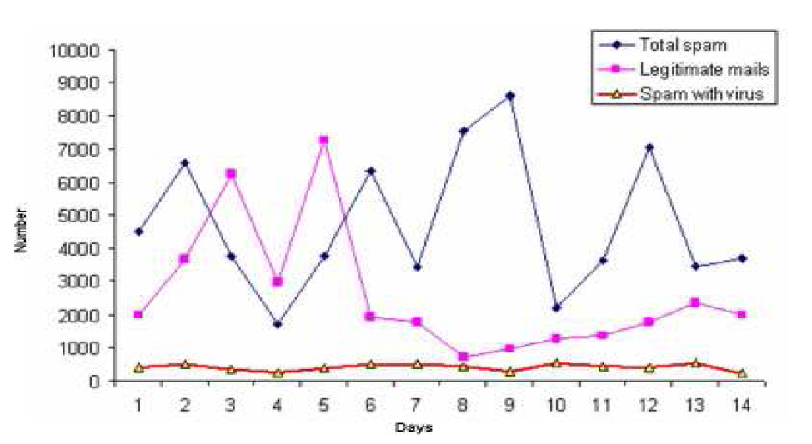
Figure 1. Spam traffic sample
All figures, tables, etc. must have a caption, centre-justified in 11 pt. Times New Roman. Captions precede tables but follow figures. Tables and figures must appear as close to their point of reference as satisfactory formatting of the final document permits.
2.9. Acknowledgements
An (unnumbered) acknowledgements section may be inserted if required.
2.10. References
References should be cited in the main text, in passing [1] or explicitly as in [2]. The full references should be given as below (essentially IEEE format), in the order in which they are cited, in 10 pt. Times New Roman, with a 6pt spacing between each.
3. Conclusions
Papers in this format must not exceed twenty (20) pages in length. Papers should be submitted to the secretary AIRCC. Papers for initial consideration may be submitted in either .doc or .pdf format. Final, camera-ready versions should take into account referees’ suggested amendments.
Acknowledgements
The authors would like to thank everyone, just everyone!

References
[1] Lee, S.hyun. & Kim Mi Na, (2009) “This is my paper”, ABC Transactions on ECE, Vol. 10, No. 5, pp120-122.
[2] Gizem, Aksahya & Ayese, Ozcan (2010) Coomunications & Networks, Network Books, ABC Publishers.

