EXPERT REVIEW COPY v0.1 | NOT APPROVED FOR DISTRIBUTION
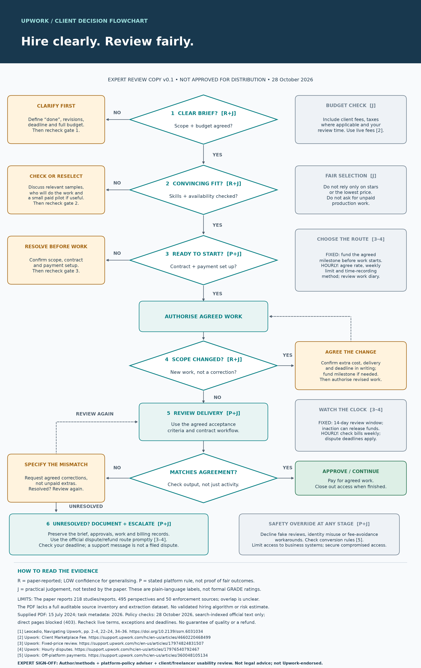

Expert review: evidence and policy audit
Purpose: review the client-facing flowchart, not endorse the paper or certify legal compliance. All items below are OPEN; this packet prepares a review and does not claim one has occurred.
Version under review: client flowchart v0.1, 28 October 2026. Source: Leocadio, Navigating Upwork, DOI 10.2139/ssrn.6031034. The PDF is dated 15 July 2024; task metadata says 2026. Confirm the citation before release.
Reviewer: ____________________ Role/organisation: ____________________ Date: __________
For each row, record Accept / Revise / Unable to verify, the supporting source and access date, and exact replacement wording if needed. Open release blockers must be resolved or the affected claim removed.
ID / owner | Target and release-blocking check | Decision / evidence / correction
R1 — Author / methods | Evidence footer: verify 218 studies/reports, 495 perspectives and 50 enforcement sources (paper pp. 2–4); explain overlap. Supply included-source inventory, search/extraction details and bias assessment, or retain the low-confidence caveat. Confirm 2024/2026 version. | OPEN  Decision: __________  Source/date: __________  Change: __________
R2 — Policy adviser | Gate 1: verify client fees against source [2] and the relevant plan/account. Check taxes, initiation fees and exceptions. Keep “use live fees”; do not import historical freelancer fee tiers. | OPEN  Decision: __________  Source/date: __________  Change: __________
R3 — Policy adviser | Gate 3: verify active-contract and milestone funding workflow; confirm hourly rate, weekly-limit and time-recording guidance. Ensure no box implies guaranteed quality, payment recovery or a refund. Sources [3–4]. | OPEN  Decision: __________  Source/date: __________  Change: __________
R4 — Policy adviser | Watch the clock: verify the 14-day fixed-price window, trigger, change-request/resubmission effects and automatic-release exceptions. Check the client contract workflow. Source [3]. | OPEN  Decision: __________  Source/date: __________  Change: __________
R5 — Policy adviser | Gate 6: verify hourly dispute filing deadline, timezone, eligible grounds and filing method. Distinguish formal disputes from support messages and refund requests. Review fixed-price escalation too. Sources [3–4]. | OPEN  Decision: __________  Source/date: __________  Change: __________
R6 — Policy / legal adviser | Safety override: verify conversion requirements, permitted exceptions and off-platform restrictions [5]. Check access/privacy advice and local legal implications; avoid implying an exception or guaranteed remedy. | OPEN  Decision: __________  Source/date: __________  Change: __________
Verification limitation: earlier checks used search-indexed official text; direct official-page retrieval returned HTTP 403. No new live-policy verification or external expert approval was completed for this packet.

Usability, issue log and release decision
R = paper-reported, low confidence for generalising. P = stated platform rule, not independent proof of fairness. J = practical judgement, not tested by the paper. These labels are not formal GRADE ratings.
Client and freelancer reviewers: walk through (a) an unfunded milestone, (b) an extra deliverable beyond scope, (c) defective work against the original brief, and (d) disputed hourly time near a deadline. Record the route taken and whether the next action is clear.
R7 — Flow and fairness: Can a reviewer distinguish new scope from an agreed correction? Does the return arrow lead to the right gate? Does any correction loop risk missing a dispute deadline? Are “continue” and access close-out clear? Confirm protection against unpaid extras and feedback pressure.
R8 — Accessibility: Check at intended print size and on a phone; confirm text size, contrast, arrow direction and meaning without colour. The chart is a large-format graphic, not a validated hiring instrument. Add an accessible text companion if needed; the existing client guide provides the full narrative.
Issue / gate | Proposed change + source/date | Owner / resolution
R7 / usability: __________ | ________________________________  ________________________________ | Owner: __________  Resolved/date: __________
R8 / accessibility: __________ | ________________________________  ________________________________ | Owner: __________  Resolved/date: __________
Other: __________ | ________________________________  ________________________________ | Owner: __________  Resolved/date: __________

Sign-off — complete after corrections
Each reviewer approves only their scope. “Revise” is not permission to distribute. Final release requires closed blockers, a checked final version and a named release owner.
Review scope | Name / signature / date | Decision
Author / methods | ________________________ | Accept / Revise / Cannot verify
Platform policy / legal | ________________________ | Accept / Revise / Cannot verify
Client usability | ________________________ | Accept / Revise / Cannot verify
Freelancer fairness / usability | ________________________ | Accept / Revise / Cannot verify
Final disposition: HOLD / APPROVE FOR DEFINED USE / DO NOT USE. Release owner: ____________________
Approved version/date: ____________________ Audience/jurisdiction/format: ____________________
Next policy recheck: ____________________ Outstanding limitations to retain: ____________________
Source index (same numbering as chart): [1] https://doi.org/10.2139/ssrn.6031034; [2] https://support.upwork.com/hc/en-us/articles/4660220468499; [3] https://support.upwork.com/hc/en-us/articles/17974824831507; [4] https://support.upwork.com/hc/en-us/articles/17976540792467; [5] https://support.upwork.com/hc/en-us/articles/360048105134
Prepared for expert review only. No expert has signed this copy. Not legal advice; not endorsed by Upwork.

