An AI generated a novel hypothesis for you:

Differentiable Latent Indexing inside Large Language Models (DLI-LLM)

Problem
Traditional retrieval engines sit outside the LLM and operate on separate embeddings, leading to bottlenecks and modality mismatch.

Motivation
Embed an on-the-fly, differentiable key-value index directly inside the transformer layers, allowing training to jointly learn what keys to store and how to retrieve.

Proposed Method
Differentiable Latent Index LLM (DLI-LLM) augments each transformer block with a learnable associative memory. During pre-training, every output token is paired with a latent key (projected hidden state) and stored in a product-quantized key table. Retrieval queries are generated by an auxiliary head that predicts when external evidence is needed. The memory returns the top-k value vectors, which are fused back into attention via cross-attention.
To bridge long contexts, we feed document chunk embeddings generated at ingestion time into the same latent space. Because both token memories and document memories live in identical vector spaces, the model can seamlessly interleave parametric and non-parametric knowledge. Gradient-based updates allow the LLM to tweak both keys and the attention gating function.
At inference, the index is frozen and can be sharded across GPUs for billion-scale corpora. A sparsity-promoting loss limits the number of retrieval calls. Fine-tuning on QA tasks teaches the model to prefer latent index hops over hallucination when evidence is needed.
This architecture essentially blurs the line between RAG and long-context processing: the model internally decides whether to recall its own training memories or look up freshly indexed documents, all inside the forward pass.

Experiment Plan
Implement on top of 7-B and 13-B open LLMs. Compare to external RAG baselines on TriviaQA, HotpotQA, and BioASQ. Measure latency, GPU memory, and retrieval recall. Conduct ablations removing latent index or freezing it. Evaluate hallucination rate on fact-checking tasks.
Think of giving an AI a built-in Rolodex where it can jot down important facts and instantly flip to them while talking, instead of calling another service to look things up. DLI-LLM stitches the Rolodex inside the AI’s ‘brain,’ making look-ups faster and more natural.

Non-Expert Description
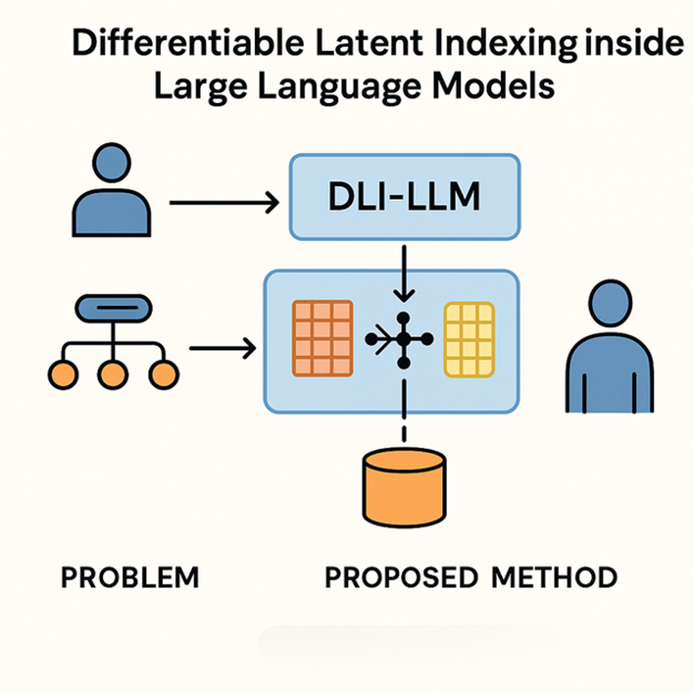
How we generate hypotheses for you:
- Our system digests 100 million peer-reviewed papers to build the knowledge base.
- A large language model then uses this knowledge base to generate 92,000 draft ideas, using about 30 million tokens of generation.
- The drafts face 23,000 rapid AI match-ups to choose the top 50 ideas—a 0.05% acceptance rate.

Rate the novelty of this hypothesis
Lock
PRIVATE TO YOU
1 Not novel at all
No meaningful differences from existing ideas; identical to many prior works.
2 Very low novelty
Minimal and unsubstantial differences; closely resembles existing ideas.
3 Low novelty
Minor differences present, but the hypothesis remains highly similar to existing ideas.
4 Slight novelty
Some differences from existing ideas, but overall still closely aligned.
5 Moderate novelty
Clear differences from existing ideas, but likely not enough to form a distinct paper.
6 Reasonable novelty
Notable differences from existing ideas; potentially sufficient to support a new paper.
7 Good novelty
Distinct differences from most existing ideas, offering potential for new contributions.
8 Strong novelty
Major differences from all known ideas; clearly stands apart from existing work.
9 Very strong novelty
High originality with minimal resemblance to existing ideas; notably innovative.
10 Exceptional novelty
Fundamentally different from all existing ideas in a uniquely clever and compelling way.
Add your comments (optional)

This idea integrates memory retrieval into the transformer architecture itself, forming a hybrid between long-context modeling and retrieval-augmented generation. It proposes a fundamentally different architecture for knowledge grounding—differentiable, latent, and self-managed—within the LLM’s forward pass.

Submit

