Chapter 1
The Rise of Agentic AI in Cybersecurity
Paulo H Leocadio

Secondary headings

Main text (10 point and justified). Main text (10 point and justified). Main text (10 point and justified). Main text (10 point and justified). Main text (10 point and justified).

Quotations (9 point, indented .5cm left and right). Quotations (9 point, indented .5cm left and right). Quotations (9 point, indented .5cm left and right). Quotations (9 point, indented .5cm left and right). Quotations (9 point, indented .5cm left and right).

Main text (10 point and justified). Main text (10 point and justified). Main text (10 point and justified). Main text (10 point and justified). Main text (10 point and justified).
Main text (10 point and justified). Main text (10 point and justified). Main text (10 point and justified). Main text (10 point and justified). Main text (10 point and justified).
Main text (10 point and justified). Main text (10 point and justified). Main text (10 point and justified). Main text (10 point and justified). Main text (10 point and justified).
Main text (10 point and justified). Main text (10 point and justified). Main text (10 point and justified). Main text (10 point and justified). Main text (10 point and justified).
Main text (10 point and justified). Main text (10 point and justified). Main text (10 point and justified). Main text (10 point and justified). Main text (10 point and justified).
Main text (10 point and justified). Main text (10 point and justified). Main text (10 point and justified). Main text (10 point and justified). Main text (10 point and justified).

Quotations (9 point, indented .5cm left and right). Quotations (9 point, indented .5cm left and right). Quotations (9 point, indented .5cm left and right). Quotations (9 point, indented .5cm left and right). Quotations (9 point, indented .5cm left and right).

Main text (10 point and justified). Main text (10 point and justified). Main text (10 point and justified). Main text (10 point and justified). Main text (10 point and justified).

Quotations (9 point, indented .5cm left and right). Quotations (9 point, indented .5cm left and right). Quotations (9 point, indented .5cm left and right). Quotations (9 point, indented .5cm left and right). Quotations (9 point, indented .5cm left and right).

Introduction – From Automation to Agency
Cybersecurity’s historical path mirrors the philosophical development of artificial intelligence. In the 1990s, defensive automation consisted of rule-based intrusion detection systems that simply matched byte signatures and issued alerts (Russell and Norvig 2022, 42). These systems operated without understanding: a rule activated, a log was recorded, and the machine returned to sleep. Early security engineers viewed automation as a way to boost labor rather than as a form of intelligence.
By the mid-2000s, the rise in network telemetry rendered fixed rules obsolete. The introduction of machine-learning classifiers and Bayesian filters gave systems a degree of autonomy, allowing them to learn thresholds and detect spam, malware, and anomalies with little human input (Goodfellow, Bengio, and Courville 2016, 415). Nonetheless, these models remained goal-agnostic: they aimed to enhance detection accuracy but did not grasp the strategic objectives behind their tasks.
The 2020s represent a significant advance in agency, referring to an artificial system's ability to set goals, reason about context, and select actions aligned with a mission (Rahwan et al. 2019). In a modern Security Operations Center (SOC), an agentic architecture can analyze threat narratives from natural-language feeds, hypothesize causal chains, and recommend mitigations—tasks previously limited to analysts (Leocadio 2024). These systems are not only adaptable but also reflective: they evaluate whether their earlier decisions have enhanced the overall defense posture.
The shift from automation to agency reflects broader debates in knowledge. Automation relates to mechanical determinism; autonomy to cybernetic adaptation; and agency to cognitive delegation (Tegmark 2017, 73). As each stage grants machines more decision-making power, control becomes both a technical and ethical concern. This chapter examines how new learning architectures (Transformers, Diffusers, and multi-agent frameworks) make such delegation not only possible but, given modern threats, unavoidable.
Transformers and Diffusers as Cognitive Catalysts
Two algorithmic breakthroughs ignited the agentic turn: the Transformer and the Diffuser. Introduced by Vaswani et al. (2017), the Transformer’s attention mechanism replaced recurrence with context-wide relational reasoning. In cybersecurity analytics, attention enables correlation across heterogeneous evidence—system logs, packet flows, and textual advisories, allowing the model to infer multi-stage intrusion patterns (OpenAI 2024, 12).

Diffusion models (Ho, Jain, and Abbeel 2020) complement this capability by learning to reconstruct structure from noise. They model probability trajectories in high-dimensional latent space, providing an internal simulation engine. Where Transformers understand sequences, Diffusers imagine possibilities. When integrated, they create architectures that reason over both what is and what might be (Leocadio 2024, 15).

“In the same way diffusion models imagine variations of an image, agentic systems imagine variations of an attack.” Leocadio (2024, 17)
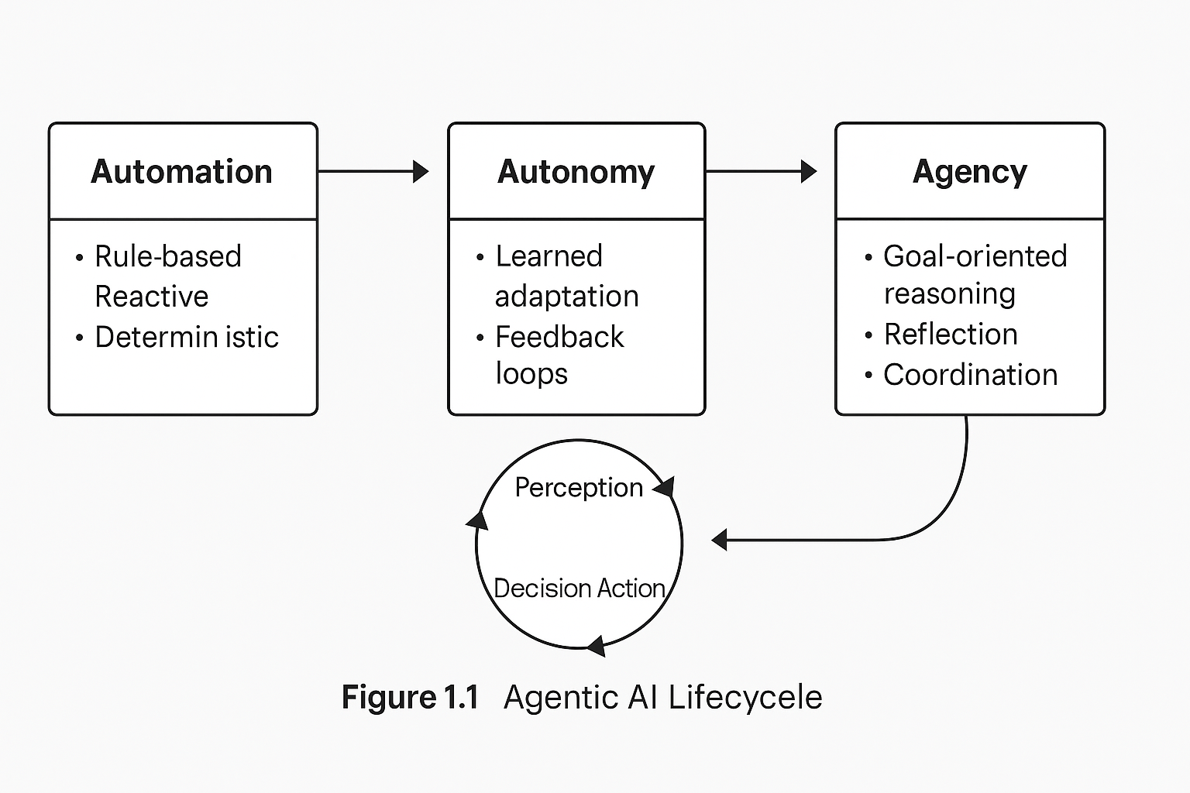
Figure 1.1 Agentic AI Lifecycle: from automation to reasoning feedback loops.

Practical deployments demonstrate this interaction. A Transformer can summarize vulnerabilities from CVE feeds, while a Diffuser simulates how those vulnerabilities spread through network topologies. The resulting ensemble forecasts attack surfaces before exploitation, transforming incident response from reactive triage to preventive foresight (LangChain 2024).

These cognitive catalysts also democratize capability. Open-source ecosystems like Hugging Face Diffusers and PyTorch Lightning have standardized reproducible checkpoints, enabling security researchers to fine-tune threat-specific reasoning models on modest hardware (Leocadio 2024). What started as image synthesis now influences cyber-simulation, a remarkable example of cross-domain generative transfer.

Footnotes 9pt and justified. Footnotes 9pt and justified. Footnotes 9pt and justified. Footnotes 9pt and justified. Footnotes 9pt and justified. Footnotes 9pt and justified. Footnotes 9pt and justified. Footnotes 9pt and justified. Footnotes 9pt and justified. Footnotes 9pt and justified.

