**Test evidences**

**Project:** Phsp-Dlg-Python-Test

**Author:** Paulo Henrique Silva Pinto

**Date:** August 30, 2020

Index

About 3

Procedure 3

1 - Deploying the code to AWS 3

Input 3

Expected 3

Output 3

2 – Subscribing to the SNS topic 6

Input 6

Expected 6

Output 6

3 – Uploading csv files 7

Input 7

Expected 7

Output 7

4 – Lambda Execution 8

Input 8

Expected 8

Output 8

5 – Data Validation 11

Input 11

Expected 11

Output 11

6 – Forcing an error 13

Input 13

Expected 13

Output 13

# About

This document describes the procedure used to test the project and evidences its results.

# Procedure

## 1 - Deploying the code to AWS

### Input

The code was deployed to AWS by running:

* **.\infra\deploy.ps1 dev**

### Expected

AWS resources created successfully.

### Output

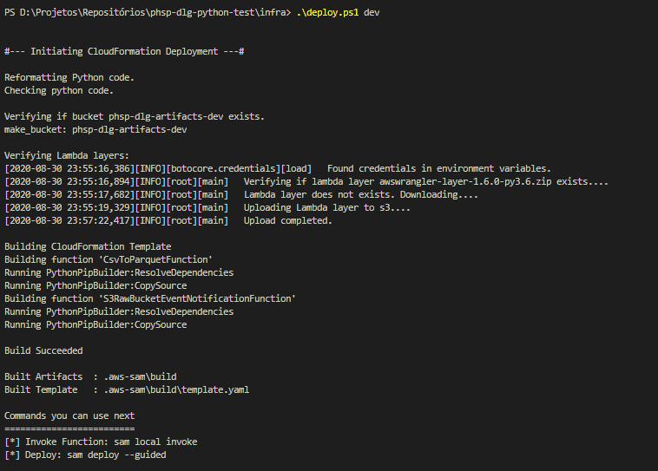

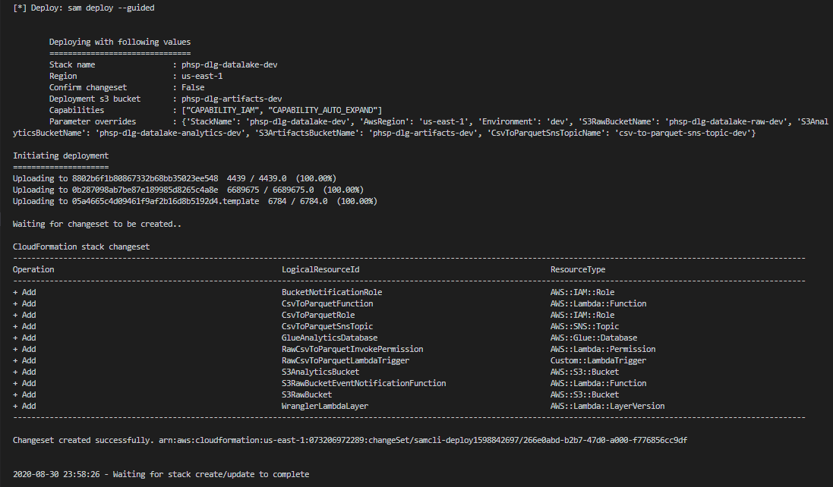

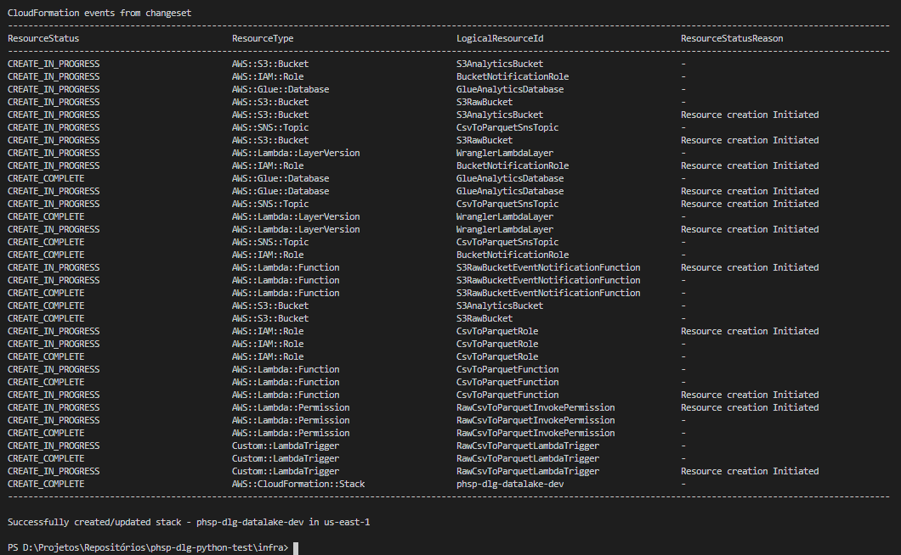

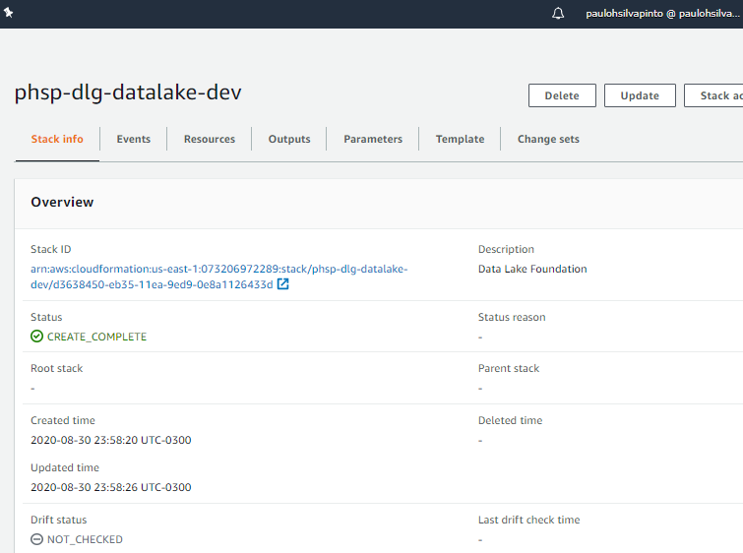

## 2 – Subscribing to the SNS topic

### Input

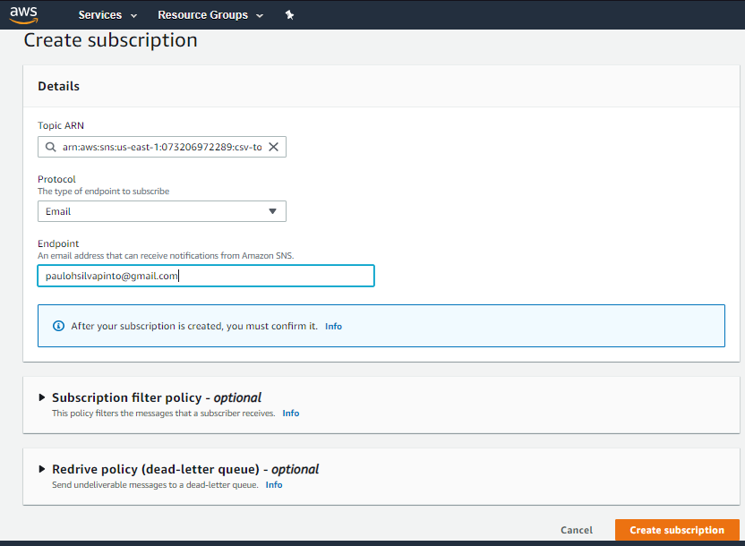

### Expected

Receiving the subscription confirmation e-mail.

### Output

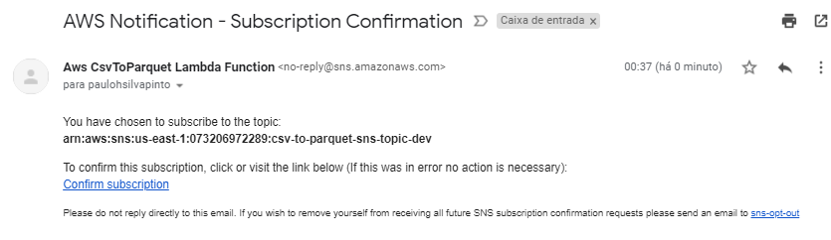

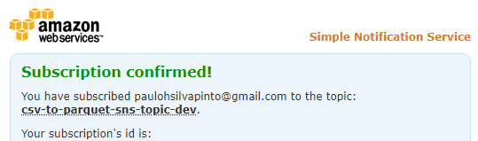

## 3 – Uploading csv files

### Input

The following commands were executed:

* **cd ..\test-data\weather\**
* **.\upload_data_to_s3.ps1 dev**

### Expected

* Files successfully uploaded to S3 raw bucket;
* Lambda Function triggered automatically by a S3 Event Notification.

### Output

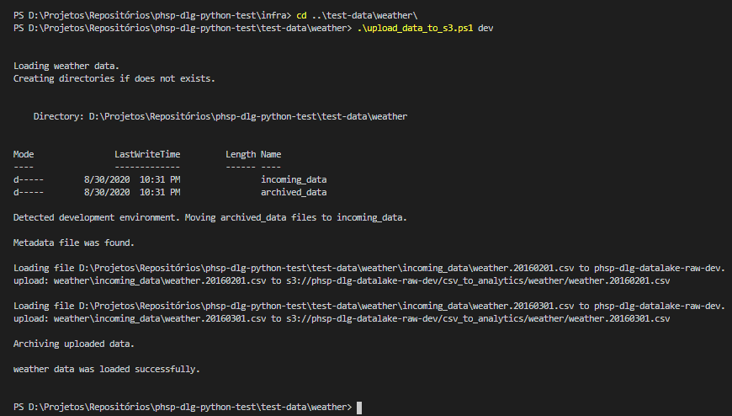

Files successfully uploaded to S3 raw bucket:

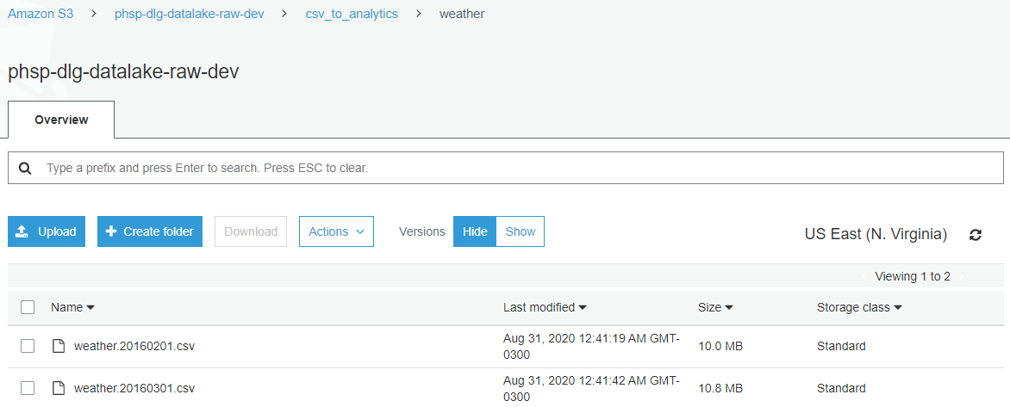

Lambda Function triggered automatically by a S3 Event Notification:

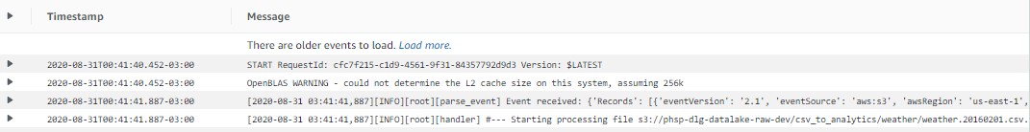



## 4 – Lambda Execution

### Input

The input was a S3 Event Notification sent automatically to the Lambda Function.

### Expected

* Lambda Function finishes execution without errors;
* Files successfully saved to S3 analytics bucket, as parquet, compressed and partitioned by observation_date;
* Table created on AWS Glue Data Catalog with expected data types;
* SNS notification sent to E-mail.

### Output

Lambda Function finishes execution without errors:

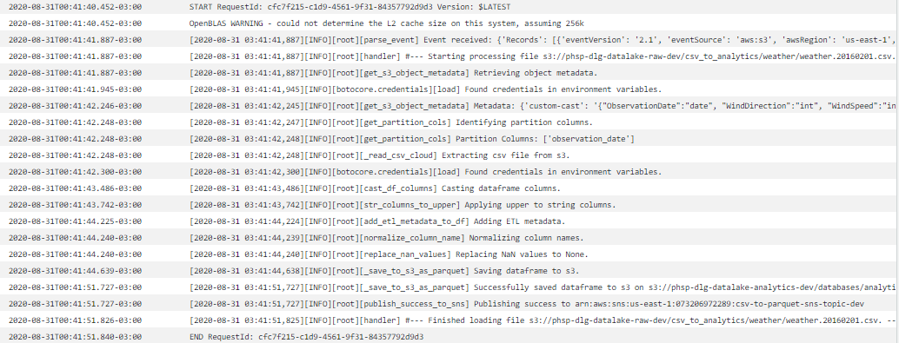

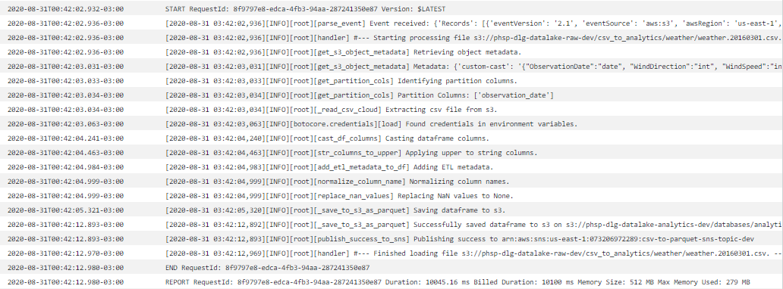

Files successfully saved to S3 analytics bucket, as parquet, compressed and partitioned by observation_date:

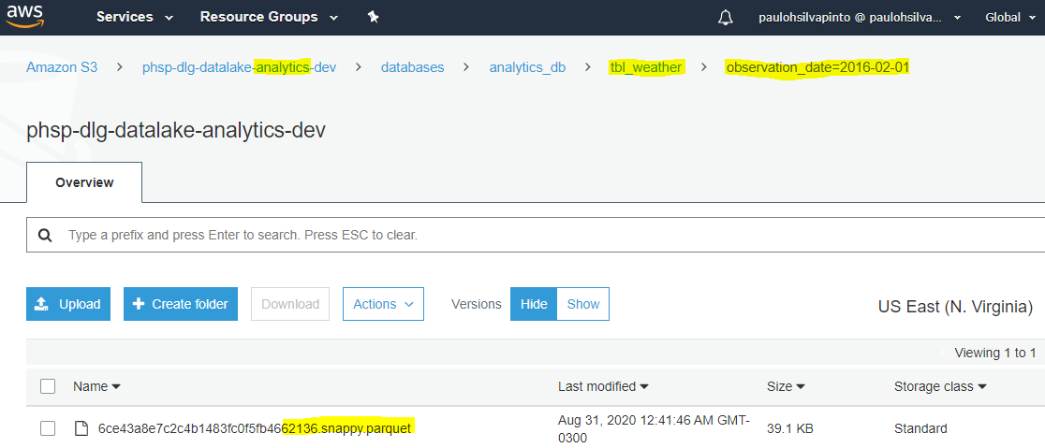

Table created on AWS Glue Data Catalog with expected data types:

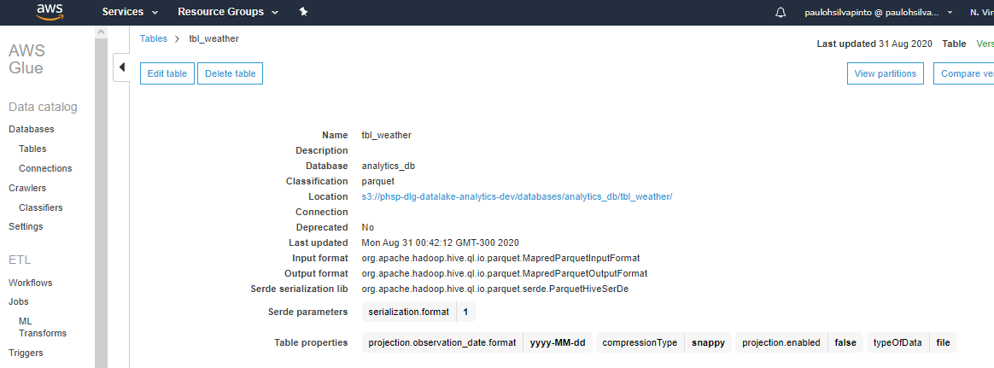

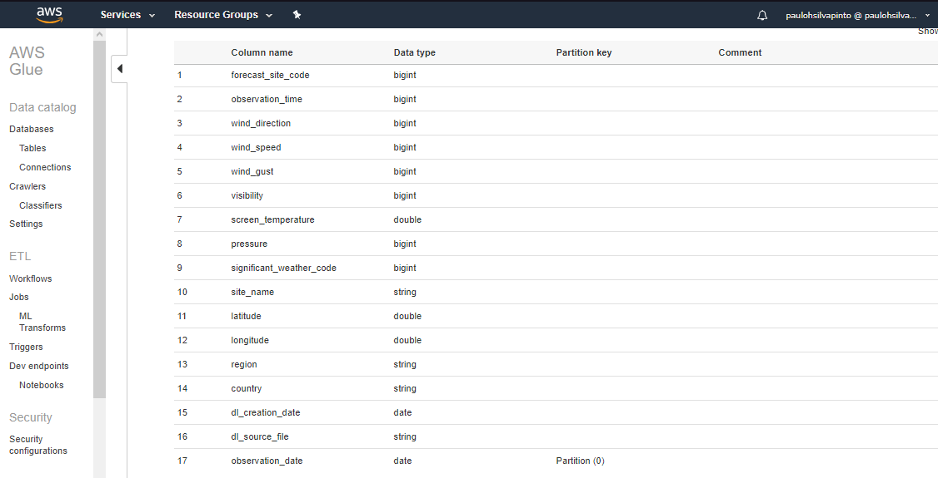

SNS notification sent to E-mail:



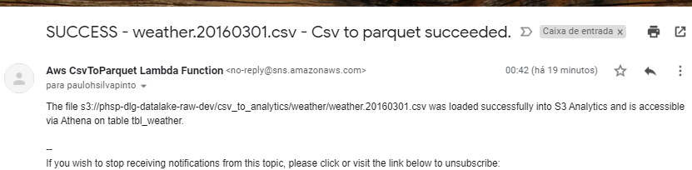

## 5 – Data Validation

### Input

Queries executed via Athena.

### Expected

* 93,255 rows in 2016-02 and 101,442 rows in 2016-03;
* Strings in uppercase;
* Well formatted numbers;
* Well formatted dates.

### Output

93,255 rows in 2016-02 and 101,442 rows in 2016-03:

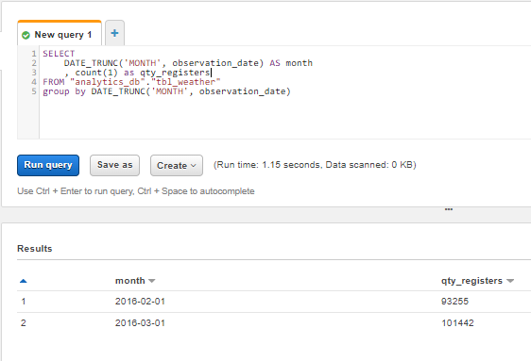

Well formatted numbers: 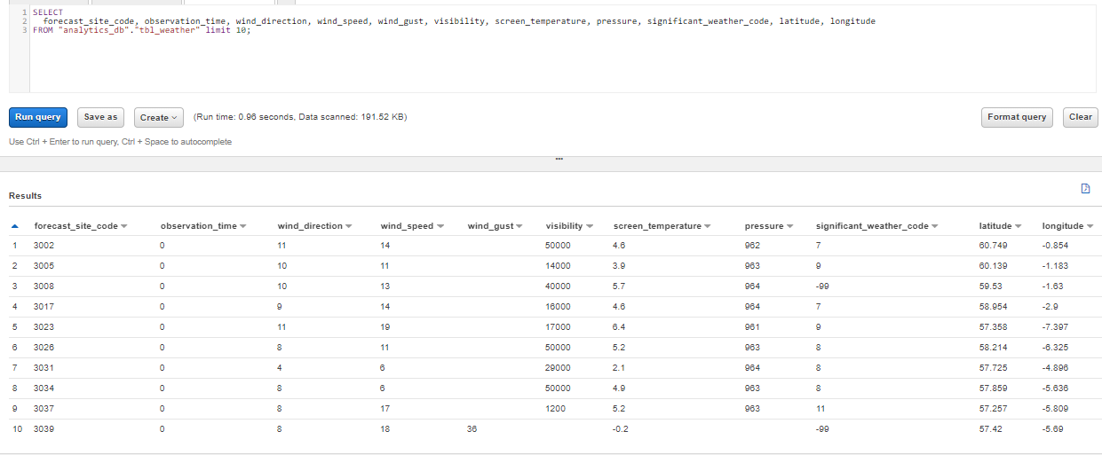

Strings in uppercase: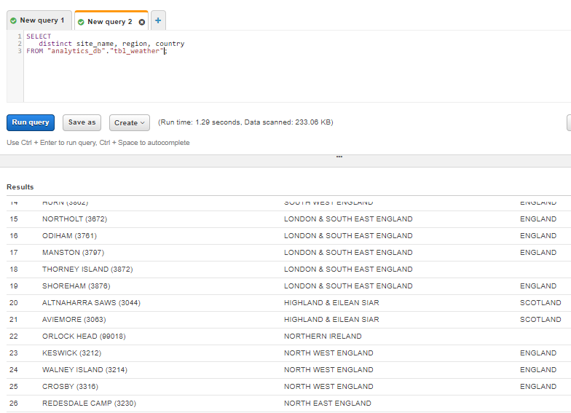

Well formatted dates:

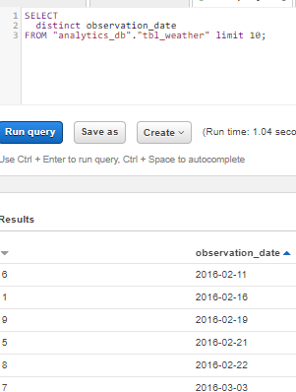

## 6 – Forcing an error

### Input

CSV file uploaded with invalid value for the data type specified.

Specified Integer and received String.



### Expected

* Lambda failure;
* SNS notification sent to E-mail.

### Output

Lambda failure:

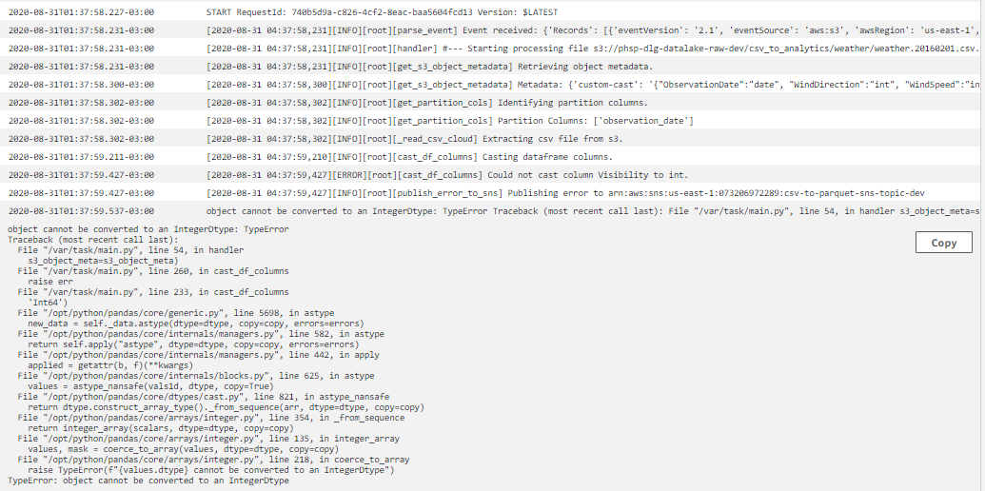

SNS notification sent to E-mail:

