tinySA AR
Field Probe
Augmented Reality RF Mapping Tool
━━━━━━━━━━━━━━━━━━━━━━━━━━━━━━━
User Manual — tinySA_AR.exe

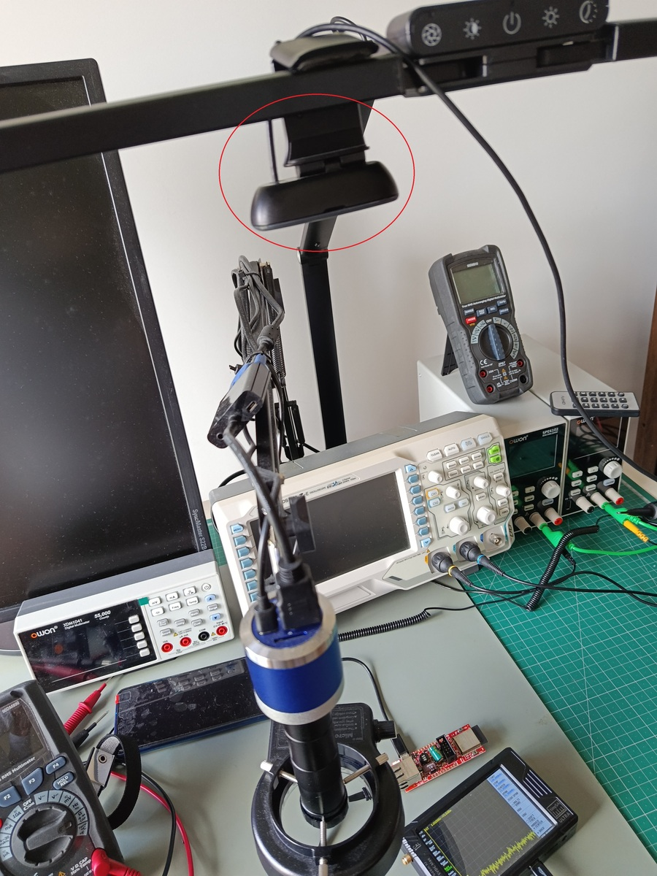
Figure 1 – Lab setup: webcam on tripod pointed at the DUT, tinySA Ultra+ and test instruments
Tested and validated hardware
tinySA Ultra+ ZS406 | Logitech C270 | Windows 11 | Python 3.12

1. What is tinySA AR?

tinySA AR is a Windows application that combines the tinySA Ultra+ spectrum analyser with a webcam to generate a real-time RF heat map overlaid on the live camera image.

It lets you visually locate the source of electromagnetic emissions on a PCB or electronic device using a near-field probe — without any post-processing.

What can it do?

- Locate RF-emitting components on a live PCB
- Measure near-field electromagnetic field strength in real time
- Record and export RF emission maps with timestamp and frequency
- Informal pre-compliance EMC/EMI assessment

What do you need?

Item | Description
tinySA_AR.exe | The application (this file)
Roboto-Regular.ttf | Required font — must be in the same folder as the .exe
tinySA Ultra+ ZS406 | Spectrum analyser connected via USB
Near-field probe | H-field or E-field probe with SMA connector
Webcam | Any USB camera (e.g. Logitech C270)
Windows 10 / 11 | 64-bit operating system

⚠ NOTE: No Python or any other software installation is required. tinySA_AR.exe includes everything.

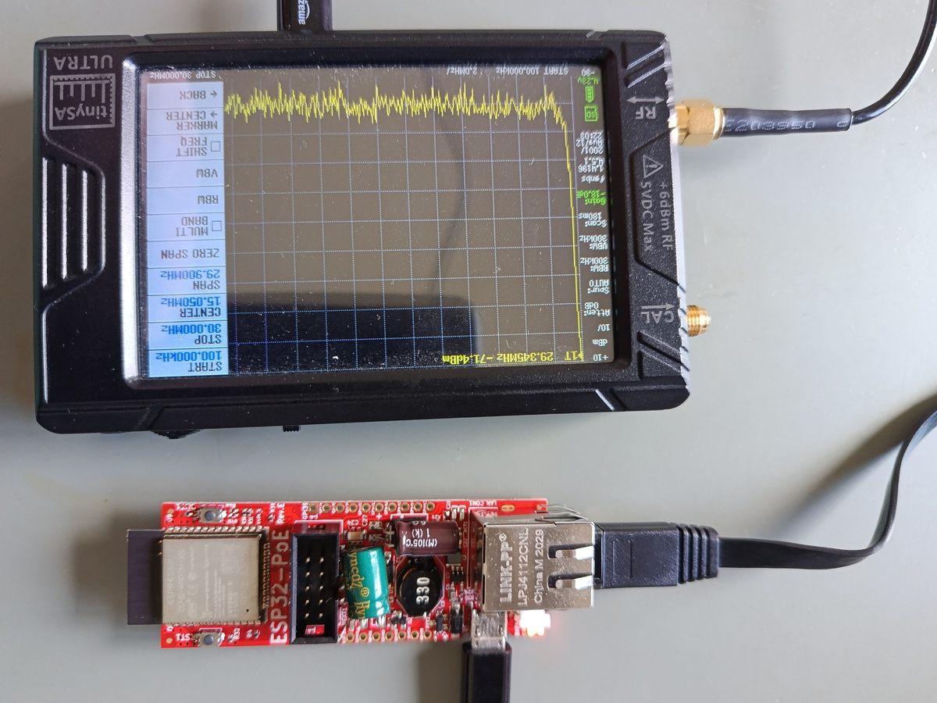
Figure 2 – tinySA Ultra+ ZS406 showing the spectrum from 100 kHz to 30 MHz, and ESP32-PoE board under test

2. First Use

2.1 Prepare your files

Create a folder for the application (e.g. C:\tinySA_AR) and place the following files inside:

File | Required?
tinySA_AR.exe | Yes — the main application
Roboto-Regular.ttf | Yes — the application will not start without this font file

✔ TIP: Exported files (PNG and CSV) are automatically saved in the same folder as the .exe.

2.2 Configure the tinySA Ultra+

Before launching the application, set the sweep on the tinySA:

- Connect the tinySA Ultra+ to the PC with a USB cable.
- On the tinySA screen: press the centre button to open the menu.
- Go to Frequency → Start and set 100k (100 kHz).
- Go to Frequency → Stop and set the desired maximum frequency (e.g. 30M = 30 MHz).
- Confirm the sweep is running (the trace on screen is updating).

⚠ NOTE: It is critical that Start is set to 100 kHz, not 0 Hz. At 0 Hz the tinySA Ultra+ produces a DC artefact spike in the first data points that distorts readings. The software filters it automatically, but configuring the device correctly is the most reliable solution.

2.3 Set up the camera

- Connect the webcam to the PC via USB.
- Mount it on a tripod or stable surface, pointing perpendicularly downward at the device under test (DUT).
- Make sure both the DUT and the near-field probe are visible in the camera's field of view.


Figure 3 – Recommended setup: webcam (circled) mounted on a tripod pointing down at the DUT. tinySA Ultra+ visible on the right.

3. Starting the Application

3.1 Launch tinySA AR

- Double-click tinySA_AR.exe.
- A black terminal window opens showing status messages — this is normal, do not close it.
- The application automatically detects the tinySA connected to the PC.
- You will be asked: Camera index:

Enter | When to use
0 | If you have only one camera, or want to use the laptop's built-in webcam
1 | If you have two cameras and want to use the second (e.g. external USB webcam)
2 | If you have three cameras and want to use the third

✔ TIP: If you are unsure, type 0 and press Enter. If the wrong camera opens, close the application and try 1.

- Press Enter after typing the number.
- The main tinySA AR window opens with the live camera image.

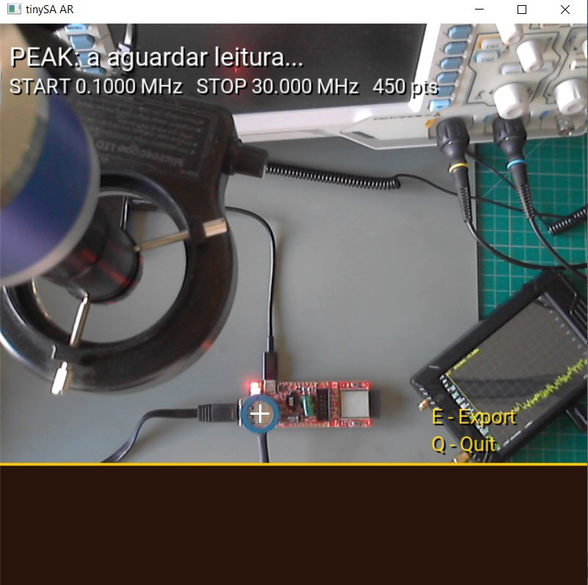
Figure 4 – tinySA AR main window on startup. The application is waiting for the first tracked reading. START 0.1 MHz and STOP 30 MHz are read directly from the tinySA.

3.2 If the tinySA is not found

If the terminal shows tinySA device not found:
- Check the USB cable is firmly connected at both ends.
- Open Windows Device Manager and confirm STM32 Virtual COM Port appears.
- If it does not appear, reinstall the tinySA driver from www.tinysa.org.
- Try a different USB cable — some cables are charge-only and do not transfer data.

4. Application Interface

The tinySA AR window is divided into three zones:

A | Video zone with RF heat map  Live camera image with the heat map overlay. Red = strongest signal, blue = weakest signal.
B | HUD — real-time measurement (top of window)  Shows: peak amplitude in dBm and dBuV, peak frequency, and sweep configuration.
C | Top-10 peaks table (bottom of window)  Lists the 10 strongest signals recorded in the session, with time, dBm, dBuV, frequency and grid coordinates.

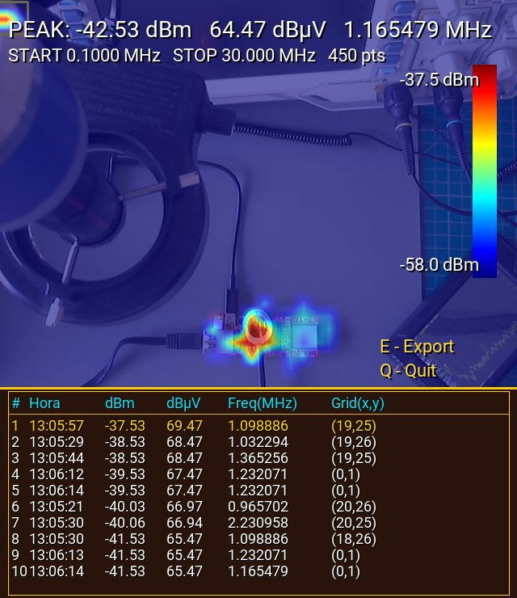
Figure 5 – tinySA AR during a measurement session. Zone A: heat map overlaid on the live image (ESP32-PoE board). Zone B: HUD showing peak -42.53 dBm at 1.165 MHz. Zone C: top-10 peaks table with time, dBm, dBuV, frequency and grid coordinates.

4.1 HUD readouts (top of window)

What you see | What it means
PEAK: -53.59 dBm | Amplitude of the strongest signal in the current sweep
53.41 dBuV | Same reading in dBuV (= dBm + 107, valid for 50 Ω systems — the tinySA input impedance is 50 Ω)
24.339644 MHz | Frequency at which the strongest signal was detected
START 0.1000 MHz | Sweep start frequency as configured on the tinySA
STOP 30.000 MHz | Sweep stop frequency
450 pts | Number of measurement points in the sweep

4.2 Colour bar (right side)

The vertical colour bar on the right side of the image shows the heat map scale:
- Red (top) = maximum value recorded in the session (highest dBm)
- Blue (bottom) = minimum value recorded in the session (lowest dBm)
- The scale updates automatically as new peaks are measured

4.3 Top-10 peaks table (bottom)

The table shows the 10 strongest signals recorded since the application was started:

# | Time | dBm | dBuV | Freq (MHz) | Grid (x,y)
1 | 13:05:57 | -37.53 | 69.47 | 1.098886 | (19,25)
2 | 13:05:29 | -38.53 | 68.47 | 1.032294 | (19,26)
... | ... | ... | ... | ... | ...

- Row #1 (highest peak) is highlighted in gold
- Remaining rows are shown in white
- Grid (x,y) indicates the position in the internal 40x30 heat map grid

4.4 Buttons (bottom-right of the image)

Key | Action
E | Export — saves a PNG snapshot and updates the CSV log
Q or ESC | Quit — closes the application

5. How to Perform a Measurement

5.1 Step-by-step procedure

- Place the device under test (DUT) within the camera's field of view.
- Connect the near-field probe to the INPUT SMA connector of the tinySA.
- Hold the probe so that it is visible in the application window.
- Left-click with the mouse on the probe tip in the image.

After clicking, a cyan bounding box appears around the probe — this is the CSRT tracker that will follow the probe as you move it.

- Move the probe slowly over the DUT surface.
- The heat map builds up in real time — hotter colours indicate stronger emissions.
- Check the table at the bottom to see the 10 points with the highest amplitude.
- When finished, press E to export or Q to quit.

⚠ NOTE: The measurement interval is 0.5 seconds. Move the probe slowly to ensure good spatial resolution in the heat map.

5.2 Tips for best results

- Move the probe slowly — the application updates every 0.5 seconds
- Keep the probe close to the DUT surface — signal drops rapidly with distance
- Mount the camera on a tripod — camera movement corrupts the heat map
- Make multiple passes to confirm hot spots before drawing conclusions

✔ TIP: The heat map accumulates all readings from the session. Restarting the tracker (clicking again) does not clear the heat map — all previous readings are preserved.

5.3 If the tracker loses the probe

The CSRT tracker may lose the probe if:
- The probe moves out of the camera's field of view
- It is temporarily occluded (by a hand, cable, etc.)
- Movement is too fast

Solution: simply click on the probe in the image again to restart tracking.

6. Near-Field Measurement Guide

This section provides important context for interpreting tinySA AR results correctly, based on established EMC near-field probing practice.

6.1 What the heat map actually shows

The tinySA AR heat map shows RELATIVE near-field signal strength. It is NOT a calibrated measurement of radiated emissions. It is a diagnostic and localisation tool, not a compliance instrument.

Near-field readings correlate with — but are not equal to — the far-field radiated emissions measured in a certified EMC test chamber. A near-field hot spot indicates a likely emission source, but the final severity depends on how effectively the surrounding PCB traces, cables and enclosure act as antennas at that frequency.

6.2 Near field vs. far field — key facts

Property | Explanation
Near field | Strong field very close to the source. Measured by the probe and shown in the heat map.
Far field | Propagating radio wave picked up by the EMC test chamber antenna. Causes pass/fail on certification.
Key rule 1 | A near field always exists where a far field exists. Locating a near-field hot spot helps find the far-field emitter.
Key rule 2 | Every electromagnetic source produces both near and far fields simultaneously. What varies is the far-field INTENSITY — it depends on how efficiently nearby conductors (cables, traces, enclosure) act as antennas at that frequency. A near-field source with no efficient radiating structure nearby produces a negligible far field at the 3m test distance.
Class B context | Only 5 uA of RF common-mode current on a cable is enough to exceed the FCC/CISPR Class B radiated emission limit (40 dBuV/m at 3 m for FCC; 30 dBuV/m at 10 m for CISPR 32). In practice, the warning threshold is 5-8 uA. Even modest near-field hot spots near connectors can indicate a real compliance risk.

6.3 H-field vs. E-field probe — practical reality

Near-field probe sets typically include both H-field (loop) and E-field probes. In practice, the distinction is less critical than often described:

⚠ NOTE: In real circuits, H and E fields always coexist — a switching node generates both simultaneously. Both probe types will detect the same emission sources. The choice of H vs. E probe has far less impact on results than probe size and distance.

Probe type | How it works | Practical use
H-field (loop) | Detects magnetic flux passing through the loop. Signal proportional to flux change and loop area. | Good near inductors and current-carrying traces. Note: the loop is directional — if held parallel to the field lines, signal drops significantly. In practice this rarely requires deliberate rotation; simply keeping the loop face towards the PCB surface is sufficient for most scans.
E-field | Acts as half a capacitor. Displacement current flows into the probe tip from switching voltage nodes. | Good near high-voltage switching nodes (MOSFETs, hot nodes). Flat probes couple best parallel to the trace. Spherical probes are omnidirectional.

6.4 Probe size strategy — start large, go small

This is the most effective practical technique in near-field scanning:

Step | Probe size | Purpose
1 — Locate | Large loop (20–50 mm) | Wide area scan. High signal level makes it easy to find the general emission region. Low spatial resolution — cannot pinpoint the exact component.
2 — Narrow down | Medium loop (5–15 mm) | Reduce the scan area. Improved resolution to identify the PCB zone or component group.
3 — Pinpoint | Small loop (1–5 mm) | Place directly over individual components or traces. Identifies the exact emitting inductor, trace or via.

✔ TIP: In tinySA AR: use the large probe first to build the overall heat map. Then switch to a smaller probe and click to restart the tracker — the heat map persists, so you can overlay the fine-detail scan on top of the coarse one.

6.5 Probe safety

⚠ NOTE: Always use probes with insulated bodies when scanning live circuits. An uninsulated probe tip can short adjacent traces or components, permanently damaging the DUT or the tinySA input. The probe shield also protects the tinySA SMA input from transients if accidental contact occurs.

The coaxial shield on H-field probes serves two equally important purposes: (1) Safety — it protects the tinySA input from electrical breakdown if the probe tip contacts a live conductor; (2) Selectivity — without a shield, the outer surface of the coaxial cable acts as an E-field antenna, making the probe respond to both H and E fields and losing its magnetic selectivity. The shield interrupts the common-mode current path on the cable exterior, ensuring predominantly H-field sensitivity.

6.6 Common emission sources by frequency

Frequency range | Typical cause | Where to scan with tinySA AR
100 kHz – 10 MHz | Switching PSU fundamental and low harmonics | Near inductors, MOSFETs, bootstrap capacitors
10 – 100 MHz | Common-mode current on cables; cable quarter-wave resonances begin in this range (a 1 m cable resonates at ~75 MHz; a 2 m cable at ~38 MHz). Cables are the dominant radiating structure in most radiated emission failures. | Near cable connectors, cable routing on PCB, and chassis entry points
100 – 400 MHz | High-order switching harmonics; clock signals | Near oscillators, MCU clock pins, high-speed data lines
400 MHz – 1 GHz | High-speed digital interfaces; PCB trace resonances | Near RF modules, HDMI/USB3 connectors, small PCB structures

Most radiated emission failures in certified tests are caused by CABLES, not by the PCB itself. The PCB generates the interference; the cables act as the antenna that radiates it. If the heat map shows a hot spot near a connector, the cable attached to it is likely the radiating structure.

6.7 Limitations of near-field scanning

- Results are relative, not absolute — different probe types or scan heights give different dBm values for the same source
- A hot spot does not automatically mean a radiated emission failure — it depends on how efficiently the system radiates at that frequency
- Near-field scanning cannot replace a certified EMC test — it is a pre-compliance and debugging tool
- The heat map is most useful for COMPARISON: before vs. after a PCB modification, component swap or shielding change

✔ TIP: Best practice: apply a fix (ferrite bead, layout change, ground stitch), then re-scan the same area and compare heat maps. A relative reduction in the hot spot confirms the fix is effective — even before going to a certified test lab.

6.8 Signal falloff with probe height — critical for consistency

Near-field signal strength falls off extremely rapidly with distance. This is the most important factor for producing consistent, comparable heat map results:

Probe type | Falloff law | Practical consequence
H-field loop (magnetic dipole) | 1/r³ | Doubling probe height: −18 dB. A 1mm height change at 2mm above the PCB changes the reading by ~10 dB.
E-field (electric dipole) | 1/r² | Doubling probe height: −12 dB. Less extreme but still very sensitive to distance.
Far field (EMC chamber reference) | 1/r | Doubling distance: −6 dB. The EMC test antenna at 3m or 10m operates in this regime.

⚠ NOTE: Absolute dBm values in the heat map are only meaningful when probe height above the PCB is consistent across the entire scan. Maintain a constant scan height — ideally 1-3 mm — throughout a session. Results from different scan heights cannot be directly compared.

6.9 What the heat map peak reading represents

In each measurement cycle, tinySA AR finds and records the single highest amplitude point across the ENTIRE sweep frequency range at the current probe position. This has important implications:

- If two emission sources exist at different frequencies (e.g., a 1 MHz PSU harmonic and a 25 MHz clock harmonic), the heat map always shows the STRONGER of the two at each probe position. The weaker source may be invisible in the heat map even if it is the more relevant one.
- The frequency shown in the HUD is the frequency of the global sweep peak, not necessarily the dominant frequency at that spatial location.

✔ TIP: To map a specific frequency: narrow the tinySA sweep span to a small range around that frequency (e.g., 24-26 MHz). The heat map will then show spatial emissions only in that band, allowing targeted mapping of a single emission source or harmonic.

6.10 RBW consistency — required for valid comparisons

The tinySA Resolution Bandwidth (RBW) setting directly affects measured dBm levels. A 10x reduction in RBW (e.g., 300 kHz to 30 kHz) changes readings for broadband noise sources by approximately 10 dB.

⚠ NOTE: Comparisons between measurement sessions are only valid with the same RBW setting. Before starting a session, note the RBW on the tinySA display and keep it constant throughout. The RBW is not captured in the exported CSV — record it manually in your documentation.

6.11 tinySA input power limit — protect your equipment

The tinySA Ultra+ INPUT connector is rated for a maximum of +10 dBm. This can be exceeded when scanning close to:
- Active oscillator outputs or clock generator pins
- SMPS switching nodes under light or no load
- Any RF transmit path or antenna connector

⚠ NOTE: Always begin scanning at a safe distance (5-10 mm) before approaching suspected strong sources. A 10-20 dB SMA attenuator on the tinySA input provides protection when scanning high-power nodes. Symptoms of a damaged front end: the noise floor rises permanently and strong signals no longer produce a response.

7. Exporting Results

Press the E key at any time during a measurement session. Two files are created in the same folder as the application:

7.1 PNG image

Filename: tinysa_export_YYYYMMDD_HHMMSS.png
A full snapshot of the application window including the heat map, HUD readouts and top-10 peaks table. Useful for documenting the measurement state at a specific moment.


Figure 6 – Example exported PNG. The complete window is captured including heat map, HUD and top-10 table.

7.2 CSV log

Filename: tinysa_export_YYYYMMDD_HHMMSS.csv
Automatically created when the session starts. Updated after every reading. Contains the complete history of all measurements:

Column | Content
timestamp | Exact date and time of the reading (e.g. 2025-11-20T13:05:57)
dBm | Peak amplitude in dBm
dBuV | Amplitude in dBuV (= dBm + 107, 50 Ω reference)
freq_Hz | Peak frequency in Hz
grid_x | Horizontal position in the heat map grid (0 to 39)
grid_y | Vertical position in the heat map grid (0 to 29)

✔ TIP: The CSV file can be opened directly in Microsoft Excel or Google Sheets for further analysis.

8. Troubleshooting

Problem | Solution
Antivirus blocks the .exe | This is a common false positive with PyInstaller builds. Add a folder exception in your antivirus settings.
tinySA not found | Check the USB cable. Confirm the STM32 driver in Device Manager. Try a different USB cable.
Camera does not open | Try index 0, 1 or 2. Close other apps using the camera (Teams, Zoom, OBS, etc.).
Incorrect dBm readings / very high values | Set the tinySA Start frequency to 100 kHz (not 0 Hz). See Section 2.2.
Frequency shows 0.000 MHz | The tinySA did not respond. Close and reopen the application.
Heat map is entirely blue | Signal is very weak. Move the probe closer to the DUT. Check the probe connection to the tinySA.
Error: font not found | Place Roboto-Regular.ttf in the same folder as tinySA_AR.exe.
Black terminal window closes immediately | An error occurred on startup. Open a Command Prompt, navigate to the folder and run tinySA_AR.exe directly to see the error message.

9. Credits

Developed by Paulo Onofre, 2025.
Code generation assistance: Claude (Anthropic).

This software is distributed under the MIT License — free to use, modify and distribute with attribution.

Font: Roboto by Google, Apache License 2.0 — https://fonts.google.com/specimen/Roboto

tinySA is a registered trademark. This software is not affiliated with or endorsed by the creators of the tinySA hardware. For hardware information: www.tinysa.org

