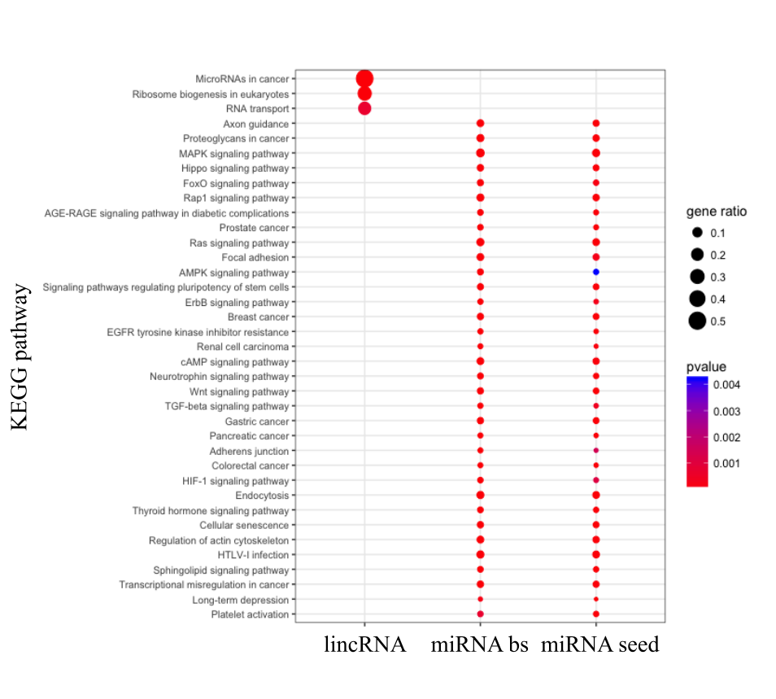

**Figure S1.** KEGG enrichment analysis of genes where SNPs mapped to miRNA seeds (right column), miRNA binding sites (middle column) and lincRNAs (left column) are located.

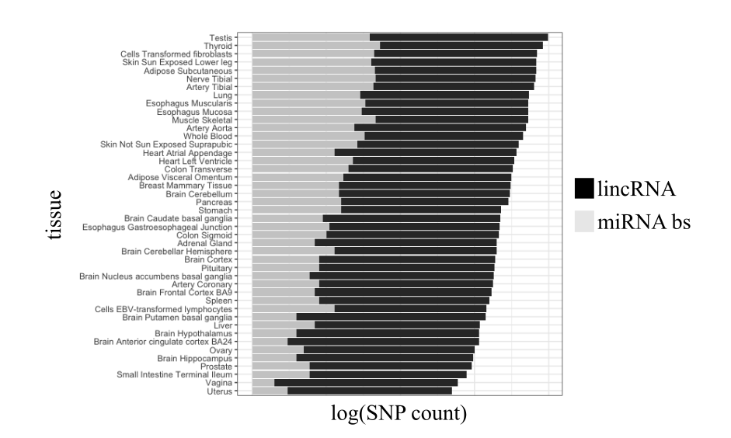**Figure S2.** GTEX eQTL analysis results. The amount of SNPs (log) for each tissue.

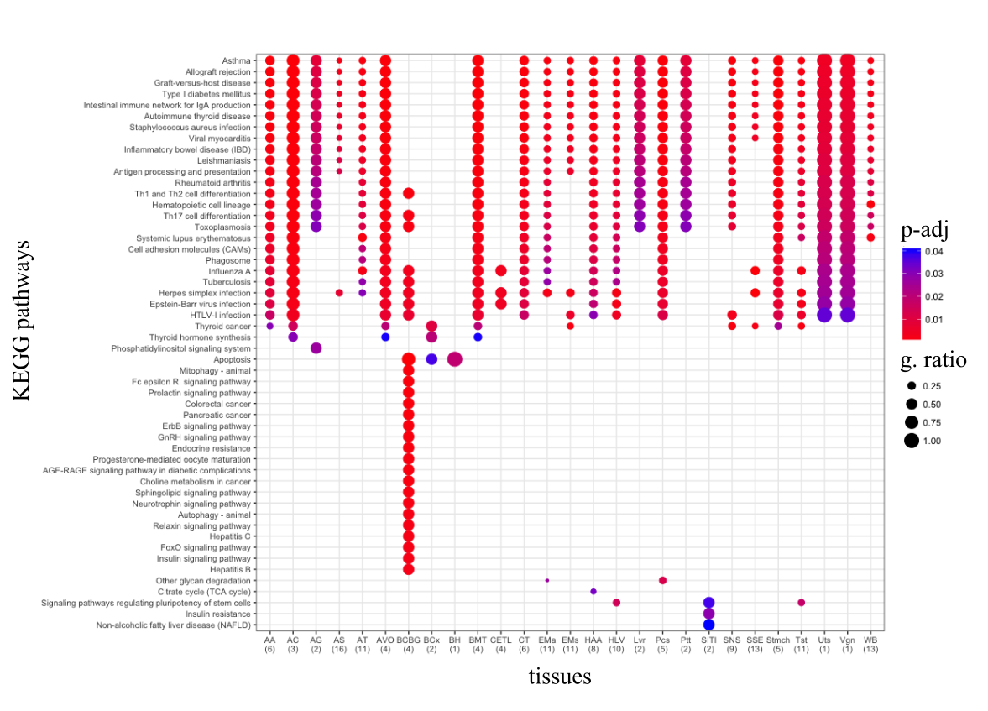**Figure S3.** KEGGenrichment analysis plot for GTEx eQTL analysis on miRNA binding sites. X-axis representing the tissues and y-axis representing the KEGG pathways.

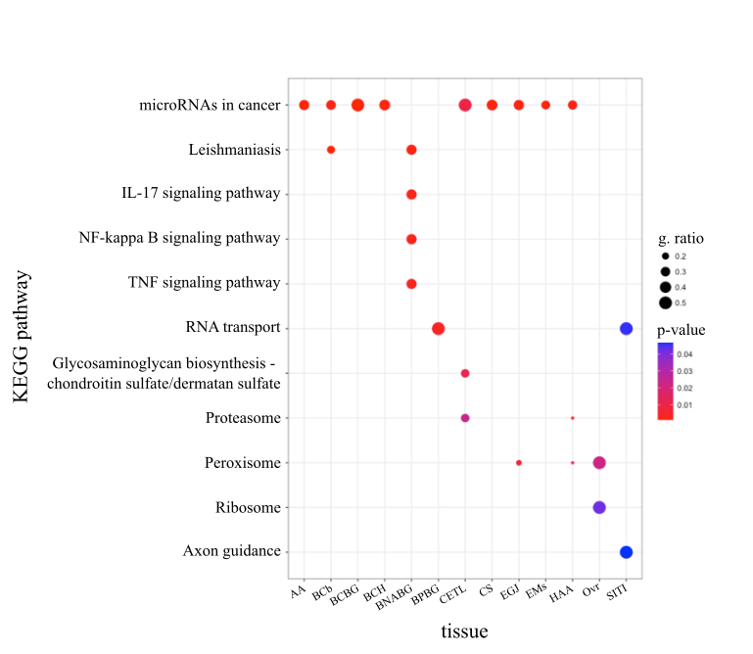

**Figure S4.** KEGGenrichment analysis plot for GTEx overlapping on lincRNAs. X-axis representing the tissues and y-axis representing the KEGG pathways.