Versão SDK já instalada localmente

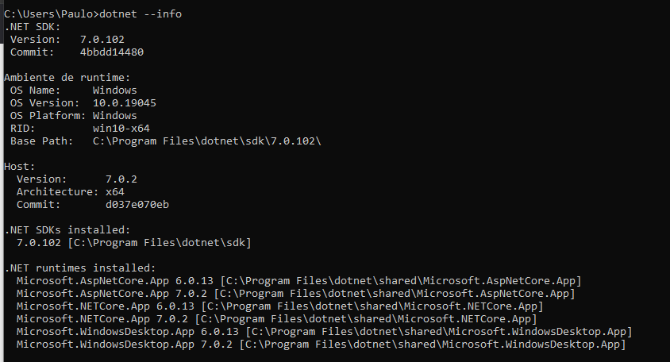

Teste - ok

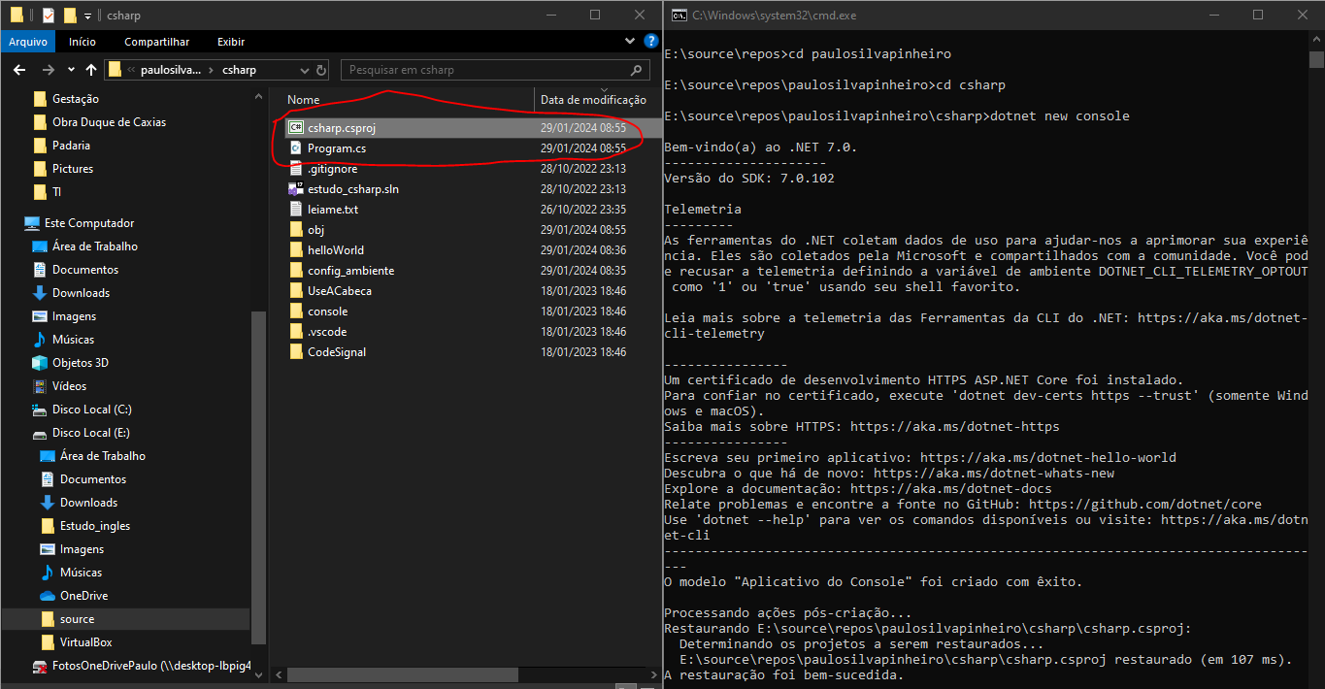

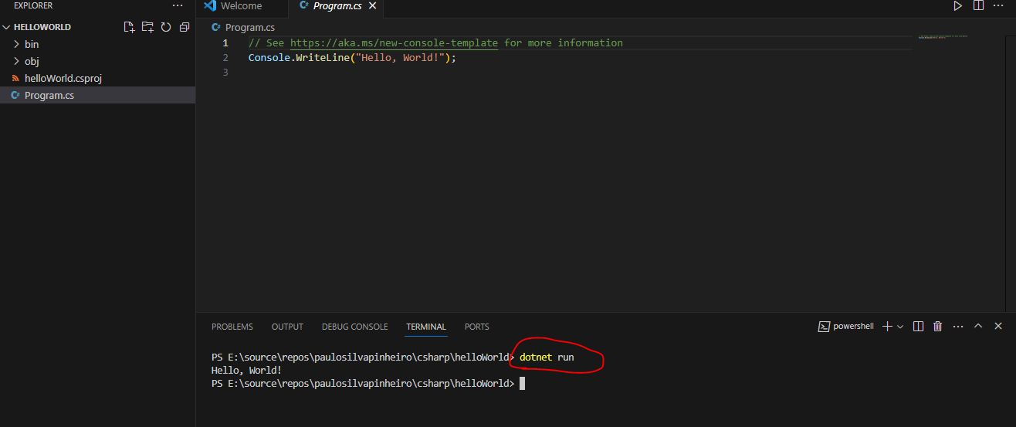

VS-CODE

1. Install C# Dev Kit (The [C# extension](https://marketplace.visualstudio.com/items?itemName=ms-dotnettools.csharp), the [IntelliCode for C# Dev Kit](https://marketplace.visualstudio.com/items?itemName=ms-dotnettools.vscodeintellicode-csharp" \o "https://marketplace.visualstudio.com/items?itemName=ms-dotnettools.vscodeintellicode-csharp), and the [.NET Install Tool](https://marketplace.visualstudio.com/items?itemName=ms-dotnettools.vscode-dotnet-runtime) will automatically be installed)

