R Notebook

library(tidyverse)

## -- Attaching packages --------------------------------------- tidyverse 1.3.0 --

## v ggplot2 3.3.3 v purrr 0.3.4  
## v tibble 3.1.0 v dplyr 1.0.5  
## v tidyr 1.1.3 v stringr 1.4.0  
## v readr 1.4.0 v forcats 0.5.1

## -- Conflicts ------------------------------------------ tidyverse_conflicts() --  
## x dplyr::filter() masks stats::filter()  
## x dplyr::lag() masks stats::lag()

library(hrbrthemes)  
theme_set(theme_minimal())

plot_ics = function(d) {  
 d %>%  
 ggplot(aes(  
 ymin = low,  
 y = mid,  
 ymax = high,  
 x = metodo  
 )) +  
 geom_linerange() +  
 geom_point(color = "coral", size = 3) +  
 scale_y_continuous(limits = c(-1, 1)) +  
 labs(x = "", y = "Diferença na precisão (novo - atual)") +  
 coord_flip()  
}

tribble(  
 ~metodo, ~low, ~mid, ~high,   
 "C1", .35, .45, .55,   
 "C2", -.65, -.5, -.35) %>%   
 plot_ics()

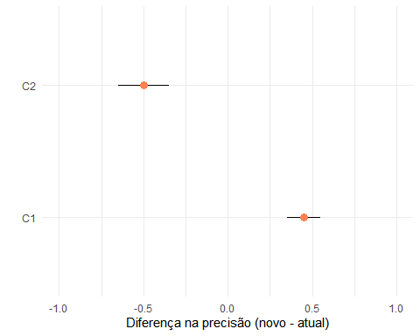

tribble(  
 ~metodo, ~low, ~mid, ~high,   
 "C1", -.65, -.55, -.45,   
 "C2", -.5, -.1, .35,   
 "C3", -.93, -.44, .18,   
 "C4", -.1, 0, .1  
 ) %>%   
 plot_ics()

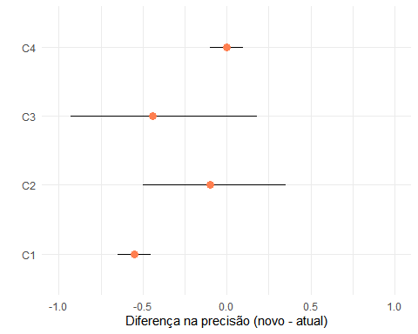

tribble(  
 ~metodo, ~low, ~mid, ~high,   
 "C5", .05, .1, .15,   
 "C6", -.07, .01, .08,   
 "C7", -.4, .1, .6   
 ) %>%   
 plot_ics()

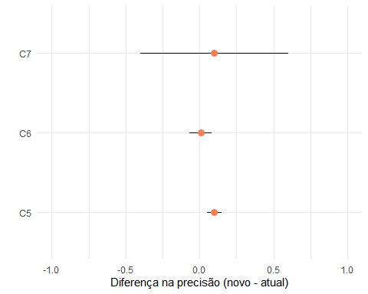

tribble(  
 ~metodo, ~low, ~mid, ~high,   
 "C1", -1, -.9, -.8,   
 "C2", -.6, -.45, -.3,   
 "C3", -.4, -.1, .2,   
 "C4", -.5, 0.05, .5,   
 "C5", -.07, -.02, .03,   
) %>%   
 plot_ics()

