The base screen. Each pile represents a theme from the film and database. The images on each frame within the piles will be a thumbnail image representing the media file it will play.
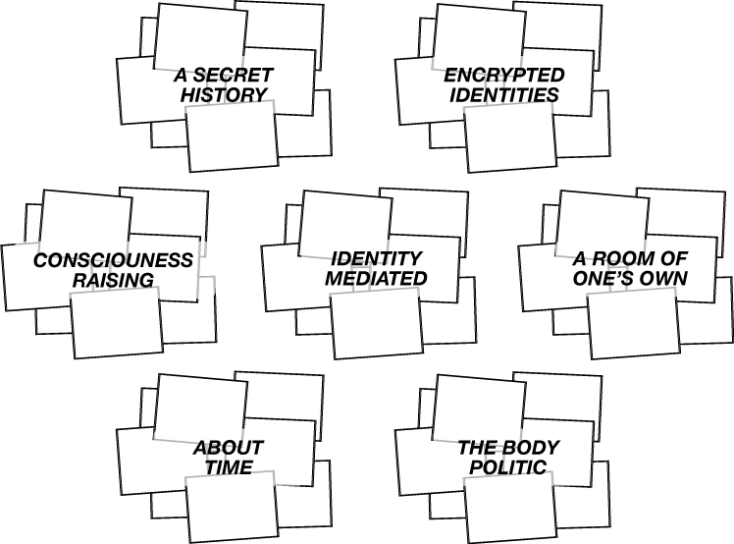
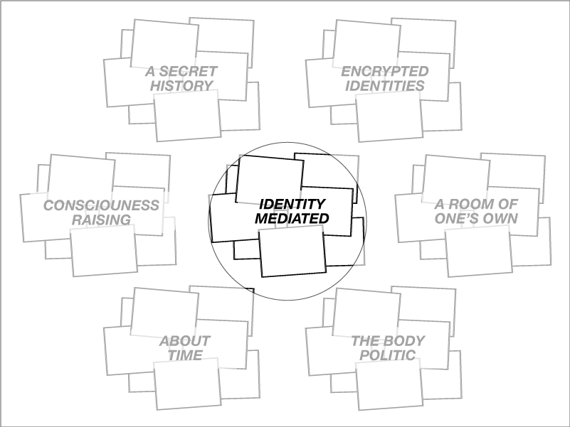

A user focuses the flashlight on a single pile and hovers for a couple of seconds which registers as a selection with the system.

The pile opens and expands presenting several of the videos from that them. In order to conserve screen space only a set number of media objects can be placed.
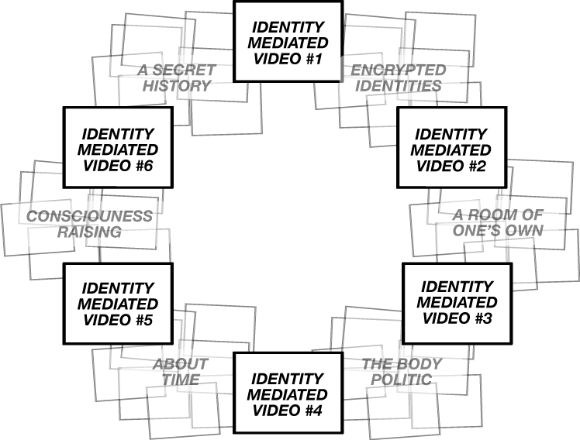

Shining the light for a couple seconds on one of the media objects registers another selection and the object expands further and begins to play.

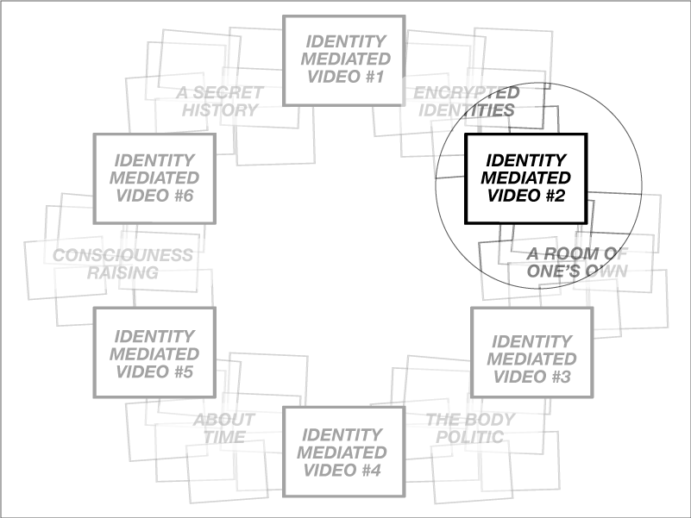

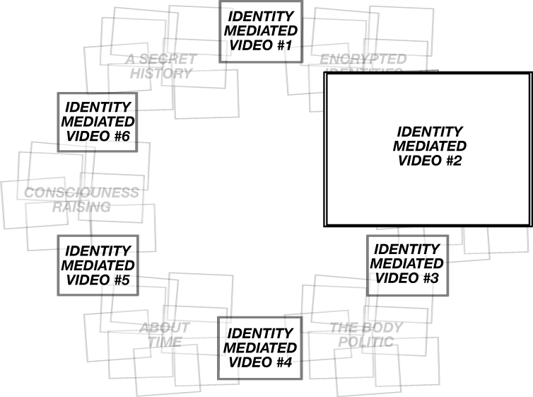

A second user shines their light on one of the media objects not currently playing. The object starts to expand in recognition of this light.

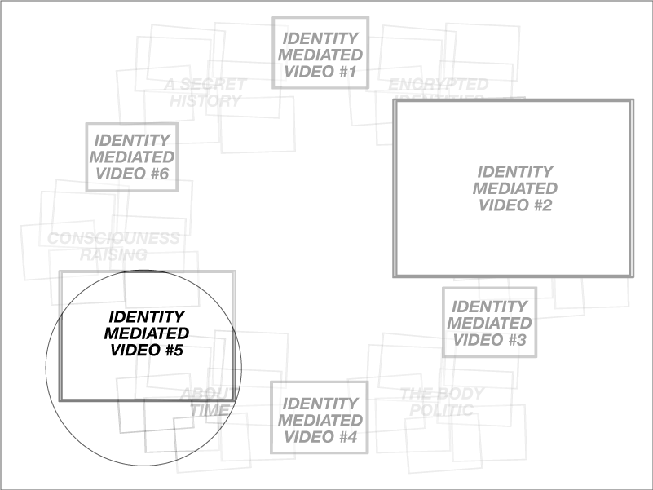

This causes the causes the system to create a new set of media objects using the various data points that the object currently playing and the object that the second user has selected have in common. Data points here are themes, artist, date of creation.
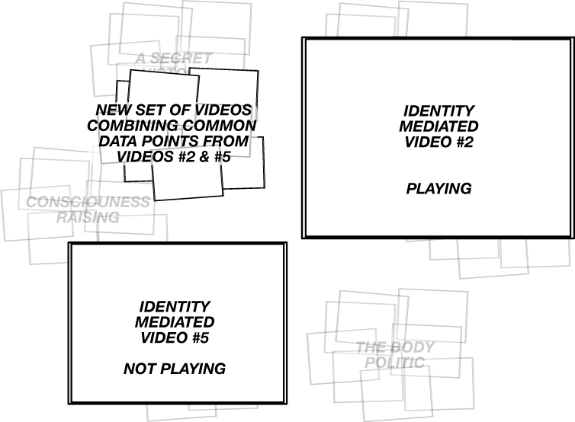
A third user now selects the new set represented by the pile in the upper left.

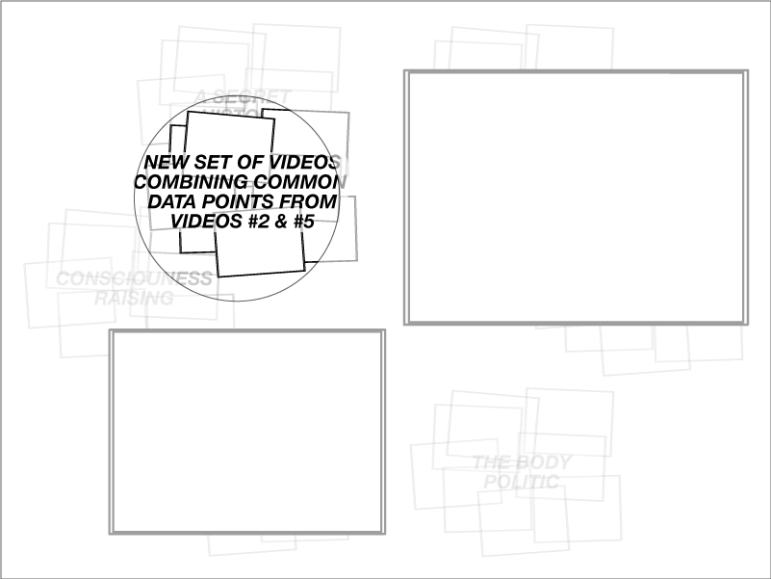
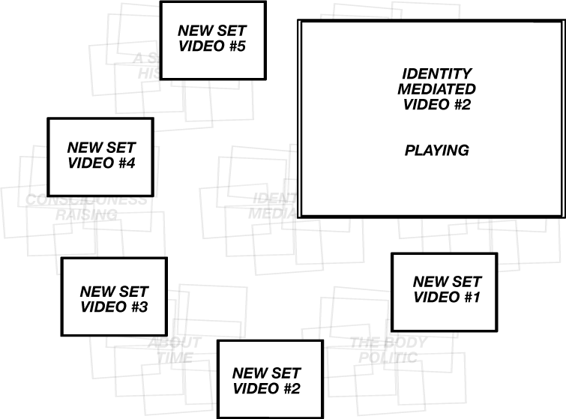
This causes the new set to expand, along with whatever media objects are currently being viewed.

When a user now selects one of the objects from the new set another new set will be created as before drawing from connections between whatever media are currently being played or selected. This process can continue on infinitely allowing users to endlessly shuffle and expand new combinations of media and explore the connections between them.

