USER FEEDBACK OUTPUT

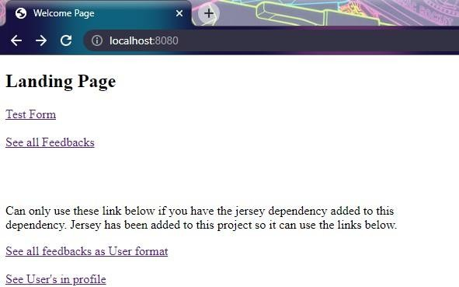

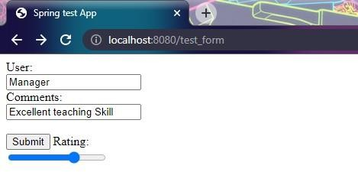





 IocaJhast

Successfully added: Feedback [id=3, comrnents=Excellerit tenrhirip= Ski_ll rating=7, user=Manager]



0 !=ca1host:8080 •’feedback

X

+

C

loca1hast

[( "cormients" :"E xceI I ent teaching 5k111 " " rat ing" :10,"user": "Rahul ”) , ( "coaments" : "ExceI bent teach1ng 5k111 " " *rat* ing" :5, "user" : "Hanager") ,

{ "comments " : "E xce1tent teach1ng *SkiLL* " "T•at ing" :7, "usef•" : "Hanage " } ]



[{’comments”:”Excellent teaching Skill ",’rating’:7,”user":”Manager”}]