**MINISTRY OF EDUCATION**

**AND TRAINING OF VIETNAM**

**Capstone Project Document**

Fruit

SEMO website

|  |  |
| --- | --- |
| **SEMO** | |
| **Group Member** | SE05930 - Chế Quang Hưng |
| SE05058 - Phạm Thị Hồng Hà |
| SE06039 - Nguyễn Thành Đạt |
| SE06022 - Bùi Trần Việt Anh |
| SE05476 - Hồ Đức Mạnh |
| **Supervisor** | Nguyễn Văn Sang |
| **Project Code** | SEMO |

Hanoi, May 2020

Table of Contents

DEFINITIONS AND ACRONYMS

CHAPTER 1: INTRODUCTION

1.1. Purpose................................................................................................................... 6

1.2. Project information ................................................................................................ 6

1.3. The People.............................................................................................................. 6

1.3.1. Supervisor........................................................................................................ 6

1.3.2. Team members................................................................................................ 7

1.4. Background ............................................................................................................ 7

1.5. Problem.................................................................................................................. 8

1.6. Existing systems................................................................................................... 10

1.7. Proposal of system ............................................................................................... 20

* 1. Purpose

At present, farmers grow fruits and sell them to traders, but there is often a situation of price squeeze, and when fruits have been planted, there are no buyers or traders cancel the sale contracts. The reason is mostly because they reach few customers. They are passive in consuming fruits, they do not have many options. Every year we still witness a repeated situation that is the fruit with good harvest, the loss of the price, the price of the crop failure. Not only that, the climate also makes it difficult to estimate the amount of agricultural products after harvest.

From the difficulties that fruit farmers face, we want to use our capabilities in technology to help them reach more customers to improve economic efficiency.

This chapter introduces the background and initial idea of our Capstone Project *SEMO*, including the motives and visions that we – the developing team – have been establishing throughout the development timeline.

As we look forward to our project’s profound advantages that benefit every user involving in *SEMO*, we also point out its limitation and risks that it might face in the future.

* 1. Project information

Project name: Sell More

Project code: SEMO

Project group name: Tiểu đội đồ án không kính

Product type: Web application

Timeline: From May 2020 to September 2020

* 1. The people

1.3.1. Supervisor

|  |  |  |  |  |
| --- | --- | --- | --- | --- |
|  | Full name | Phone | E-mail | Title |
| Supervisor | Nguyễn Văn Sang | 0912210727 | [sangnv@fe.edu.vn](mailto:sangnv@fe.edu.vn) | Lecturer |

Table 1. Supervisor’s information

1.3.2 Team members

|  |  |  |  |  |
| --- | --- | --- | --- | --- |
| No | **Role** | **Phone number** | **Email** | **Student code** |
| 1 | Leader, designer | 0935435973 | hungcqse05930@fpt.edu.vn | SE05930 |
| 2 | QA, backend dev | 0963514484 | phamhongha.innerpiece@gmail.com | SE05058 |
| 3 | Backend dev | 0943379203 | datntse06039@fpt.edu.vn | se06039 |
| 4 | Frontend dev | 0936281998 | anhbtvse06022@fpt.edu.vn | SE06022 |
| 5 | Tester, backend | 0326188282 | manhhdse05476@fpt.edu.vn | se05476 |

Table 2. Team member’s information

1.4. Background

Today, the popularity of the internet has crept into every corner of the country, even in rural areas. Farmers who drain blood, sweat and tears growing crops also know how to use smart devices to get access to the internet. Along with it is the explosion of e-commerce exchanges. Some famous e-commerce platforms are Shopee, Tiki, Lazada, and Zalo that act as "online department stores" or "online supermarkets" with all kinds of items such as clothes, furniture, bicycles, motorcycles, beds, wardrobes, ready meals and so on ...

Those e-commerce platforms have been very successful in satisfying the diverse shopping needs of customers, and also succeed in bringing customers and store owners closer together.

“Vietnam's e-commerce market is growing rapidly with 35.4 million users and generating more than 2.7 billion dollars in revenue in 2019. There are currently 59.2 million internet users, accounting for more than a half of the country's population, this number is forecast to rise to 68 million by 2021.” (<https://thuonggiathitruong.vn/>)

1.5. Problem

For decades, ‘farmers growing fruits to sell to the wholesalers’ has been a common course, yet there lies its tremendous limitations that could have been resolved.  
Farmers are forced to sell the crops for low price because of ‘price squeezing’, or find it hard to sell their fruits since there are no customers that ever reach or stay until the end of the business contract.  
Farmers are inferior when it comes to consumption, as they do not have many customers that they can actually sale.  
Recent years, despite being in their seasons, lots of types of fruits have been facing dramatic ‘price drop’ like dragon fruit, mango, watermelon, and the list goes on.

From the difficulties that farmers face, we want to use our capabilities in technology to help them reach more wholesalers to improve economic efficiency.

It has been the norm for decades in Vietnam that farmers grow fruits and sell them to any traders with a satisfied dealing price, still there are concerning problems yet to be solved.  
New and small scale farmers especially in remote areas barely have access to quality assurance or production certificate and lack promotion. As a matter, they find it hard to really have customers. Wholesalers also take advantage of themselves as buyer to force price squeezing, or even to cancel the sale contracts which result in severe loss for the growers. That is why fruits face price drop and fruit rescue campaigns so often.

Acknowledged the difficulties and inferiority of the farmers, we – as developers – set ourselves to create a platform that will help connecting them to a large network of trustworthy wholesalers with the greatest deals, so they can focus solely on improving their yield and enhancing their production.

1.6. Existing systems

Currently, in Vietnam, there are only few companies which spontaneously auctioning rare and precious agricultural products, such as Saigon Co.op, a consumer goods retailer on the 30th anniversary of establishment and development, but not having a professional auction exchange to solve the permanent difficulties of farmers.

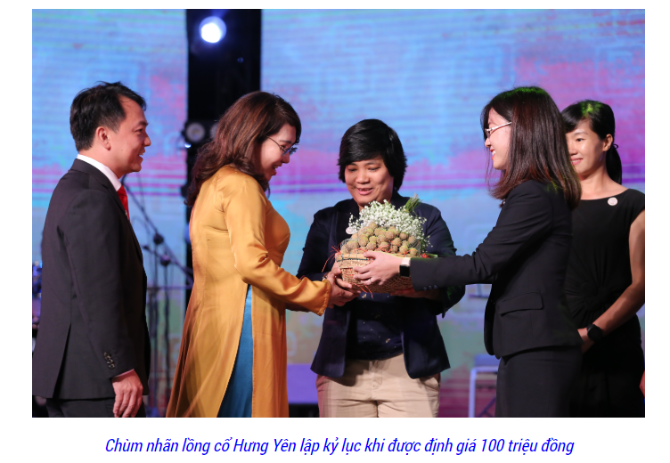

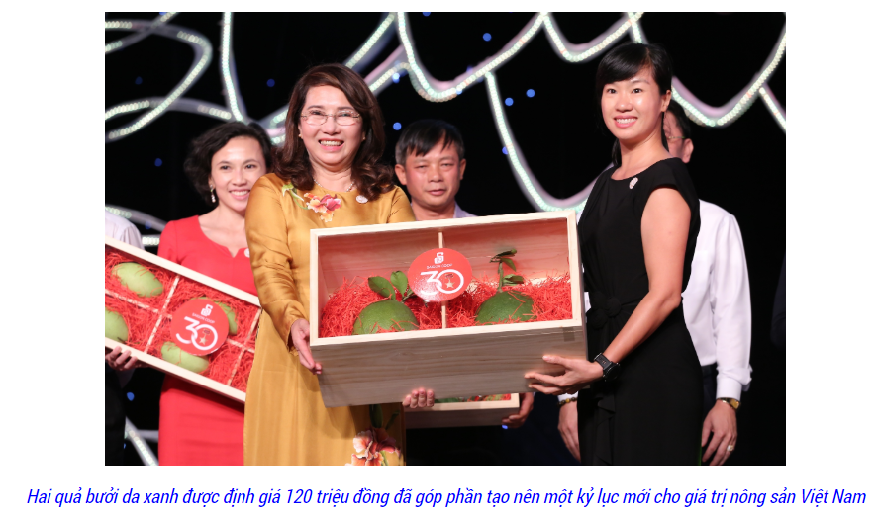

Obviously, agricultural products are the main products of Vietnam, but they are dispersed in small scale, lacking concentrated places to auction to improve the value of agricultural products before distributing to other places, including export. This will be an effective solution to enhance the image and value of Vietnam's agricultural products in general and farmers in particular, as well as advanced countries have successfully implemented in recent years.

1.7. Proposal of system

A proposed system is called FOSE, which includes a web application for farmers, wholesalers and administrators. Apparently, FOSE has 3 types of users:

- Farmers: People are in charge of planting and producing agricultural products. Specifically, they will be the users who post agricultural products to FOSE System for Wholesalers, shoppers can bid products to own.

- Wholesalers: People with certain knowledge about agricultural products who are willing to spend money to buy agricultural products in large quantities for business or other purposes. Specifically, they will be the direct auction of agricultural products on FOSE System, they will pay the highest and most reasonable bid to win the item they need.

- Administrators: They are SPCS’s staff, responsible for maintaining the system, handling reports and user feedback, advertising management and customer service.

FOSE’s core service is to connect Farmers and Wholesalers under a web application platform. Farmers can post an agricultural product, then they can offer the bid price, the quantity and information of the product. After that, they can wait until the auction ends to find the wholesaler that is winner. The wholesaler can find the farmer's post and overbid to have the chance to become the Winning bidder. With this process, we believe that both famer and wholesaler can have a better and more secure experience when bidding because now, they will feel it easier to connect to each other. However, Making the system become familiar to everyone and popular in society is never an easy task. It is also the limitation and risk that FOSE service has to face when functioning. But we had interviewed with some famers and some wholesalers at some big markets at Hanoi such as Long Bien Market, Hoang Mai Market,... and they were really wanted to use our system. These words are motivation of us to keep doing this project.