Quickly write down all of the numbers that are evenly divisible in the top number

<http://learnovate.ie/>

Hey! We just use the curriculum online website for all our lesson plans and all the strands and strand units are on that. Last year on placement I used the Busy at Maths book there’s loads of different ones you can get but I think a lot of schools use that one- Tara (friend of sarahs)

<https://www.cjfallon.ie/books/busy-at-maths/>

Mathletics:

<https://www.mathletics.com/uk/?gclid=Cj0KCQjwuNbsBRC-ARIsAAzITuc_1GHDiriNcJ2qXqXt5X8CYUnbrWZ_ZJt5Qfy5-LGi9qYfUvAiRAYaAjycEALw_wcB&fbclid=IwAR0I7ALum2bz7hky9HsfVOPP2zx9zqCxZGw2yaSkyB5tBackjDzGwcmpVEo>

confirmation email:

<https://realpython.com/python-send-email/>

research flutter

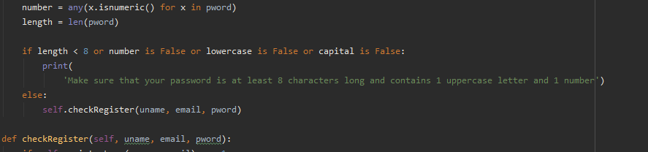

Talk about speed when doing verification by doing the password first to avoid having to check the email and username in the db multiple times if they get the password wrong

To avoid rechecking the db many times, when finally able to keep info between pages, keep everything loaded. E.g. for classroom, should know if the user has a classroom or not.

Give everyone in the db an ID for reference.

Overall XP only determines what level you unlock. Once you have reached a threshold you cant earn anymore overall xp form the previous levels to stop boosting from the easy levels.

In the individual levels there is a simple algorithm that determines the kinds of questions that can be asked

The app will only deal with simple operations

Addition: 0 - 9999

Subtraction: 0 - 9999

Multiplication: 0 -12

Division: 0-10

Have section of document talk about how some number ranges were too high to do in head so had to limit the numbers.

Research children and color and use color that kids like the most

<http://renketkisi.com/en/the-effects-of-colors-on-children.html>

mention allow_copy false for password

add confirm password and look up why this is a thing and add it to the document

talk about GIMP

unincentivise doing old levels by not giving xp for old levels or else 50% of xp earned

json file update function in case of multiple people sharing a device

speak about how firebase is not supported with buildozer so was impossible to get working on the phone.

Database is not a primary feature anyway but it is working perfectly in emulator

Cannot work on the phone

Talk about error checking in various places using the print to terminal functions

intro should be very clear

design should be professional

conclusion can be more colloquial

speak on corona virus about testing in person with teachers and student groups

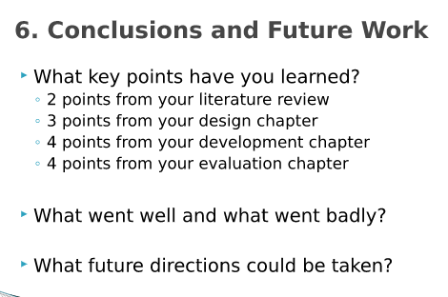

For future work, throw in a diagram of the “play” page and show what other types of minigames that could be implemented and talk about other minigames that could be added in, maybe a text input instead of multiple choice.

Fonts – Helvetica Textbook is chosen because it appeals to students more

Consola Bold was favorite among adults but the simpler and more typical font used in textbooks is easier for kids to understand. A big survey was sent out and over ~~~~people responded, adults overall voted for consola bold but the children who were overall more fond of the Helvetica font and this makes sense because they are used to seeing this font type in their school books and other educational resources. Both the A and the G were pointed out in consola bold for being out of the norm to younger children and so it makes sense to go with helvetica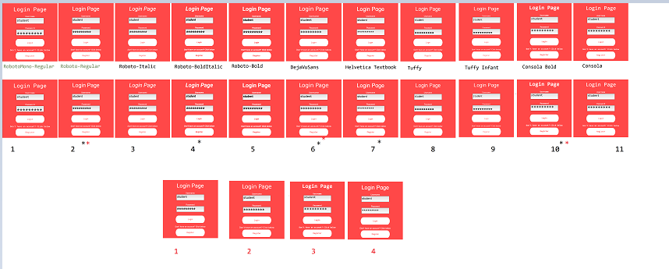

Talk about how guess the last digit of the expected answer can be used to quickly guess the answer without doing the whole equation so there needs to be extra work done on the code that picks the possible solutions

Old system where it was easy to guess which answer was correct based off the final digit of the expected answer

