

Project Title

Interim Report

DTXXX

BSc in XXX XXX

**Student Name**

**Student Number**

**Supervisor**

School of Computer Science

Technological University, Dublin

**Date**

Abstract

Mental Health is an epidemic. It is estimated that one in four of us will experience some mental health problems in our lifetime(1). These range from periods of low mood or anxiety to serious depressions and suicidal thoughts; and everything in between. Around the world there are around 300 Million people suffering from depression(2). In Ireland it is said 1 in 10 people suffer from depression at any one time which equates to about 450,000 people(3). Ireland has one of the highest rates of mental health illness in Europe which costs the Irish economy over €8.2 billion annually(4). These statistics cannot be ignored, and something needs to be done.

The goal for this project is to provide a modern, easy to use and accessible android phone application that will help users to manage and track their mental health. This application will be called Depression and Anxiety Manager - or DAM! The development of this app will be a completely user centred approach in every step from the research involved to the design decisions made.

The purpose of this project is to educate people in how to deal with their mental health and its related issues.

Hopefully DAM can show health professionals how technology can be used to help treat depression and anxiety - and perhaps give them ideas in incorporating technology in treating their patients.

Declaration

I hereby declare that the work described in this dissertation is, except where otherwise stated, entirely my own work and has not been submitted as an exercise for a degree at this or any other university.

Signed:

_________________________

Student Name

Date

Acknowledgements

Body text

Table of Contents

1. Introduction 7

1.1. Project Background 7

1.2. Project Description 7

1.3. Project Aims and Objectives 7

1.4. Project Scope 7

1.5. Thesis Roadmap 7

2. Literature Review 8

2.1. Introduction 8

2.2. Alternative Existing Solutions to Your Problem 8

2.3. Technologies you’ve researched 8

2.4. Other Research you’ve done 8

2.5. Existing Final Year Projects 8

2.6. Conclusions 8

3. Prototype Design 9

3.1 Introduction 9

3.2. Software Methodology 9

3.3. Overview of System 9

3.4. Front-End 9

3.5. Middle-Tier 9

3.6. Back-End 9

3.7. Conclusions 9

4. Prototype Development 10

4.1. Introduction 10

4.2. Prototype Development 10

4.3. Front-End 10

4.4. Middle-Tier 10

4.5. Back-End 10

4.6. Conclusions 10

5. Testing and Evaluation 11

5.1. Introduction 11

5.2. Plan for Testing 11

5.3. Plan for Evaluation 11

5.5. Conclusions 11

6. Issues and Future Work 12

6.1. Introduction 12

6.2. Issues and Risks 12

6.3. Plans and Future Work 12

6.3.1. GANTT Chart 12

Bibliography 13

# 1. Introduction

**As least 2 pages, but as many as you like**

## Project Background

Mental illness is more prevalent now than ever. It is estimated that one in four of us will experience some mental health problems in our lifetime(2). The spectrum of negative mental health can range from periods of low mood or anxiety to severe depressions and suicidal ideation. Around the world there are around 300 Million people suffering from depression(3). In Ireland it is said 1 in 10 people suffer from depression at any one time which equates to about 450,000 people(4). Ireland has one of the highest rates of mental health illness in Europe which costs the Irish economy over €8.2 billion annually(5). These statistics cannot be ignored, and something needs to be done to combat this invisible epidemic.

Technology may be an answer to creating a much-needed change in mental health services. While it can be easy to point the blame at technology for creating problems leading to mental health issues, many believe that technology can be a part of the solution. Using technology as a means to revolutionise the interaction between those suffering from mental illness could be of benefit in many ways including; bridging the gap to access support; provide instant and calming services at a user’s fingertips as well as aiding a user to seek help quickly in the case of a crisis.

Although there is a plethora of information on mental health and related issues on the internet, there are not many easy to use applications available that bring together all the most important features and information. It is for these reasons that Depression and Anxiety Manager (DAM) is being developed.

## Project Description

Depression and Anxiety Manager (or DAM) is a mental health app for users to manage and track their mental health through smart features and functionality. DAM will be an intuitive app beneficial to users from all backgrounds. Whether users struggle with depression, anxiety, other mental health issues, or just want to improve their overall mental well-being, using the DAM application on a regular basis will help.

The complexity of DAM comes in the usability and in the user experience it offers. Creating a user experience where users can feel safe and supported is a crucial component of DAM, this is especially important for people with mental health issues. A big part of the project is that once the initial prototypes are created it will be distributed to organisations and individuals where they will be asked what else they would like to see implemented. Doing this will make use of the “tangibility affect” where giving a user something physical will potentially bring about many more ideas once they can see the product as tangible. Feedback streams like this will inevitably introduce new key items of complexity as well as ensure continuous feedback leading to regular improvements.

A paramount part of this project is in establishing relationships with those organisations and to identify what they would like to see. Although, it is anticipated that working with these organizations may be difficult as many of them consist of employees on a volunteer basis and in general these organizations have extremely important and time-consuming facilities to provide to the public.

The approach for the project will consist of creating the prototypes, distributing these prototypes to organisations and individuals, gaining their experienced feedback, incorporating this feedback whilst also adding new features, and repeating these steps until a robust and well thought out application has been developed. This will be an overall feature driven development and once features are completed and tested, they will be integrated into the whole system.

Figure 1 below shows a couple screenshots from the DAM application.

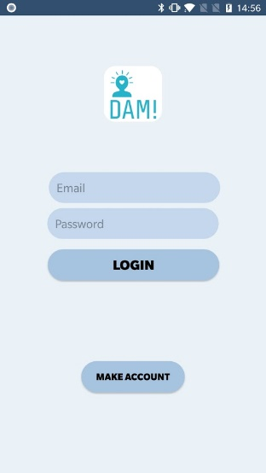 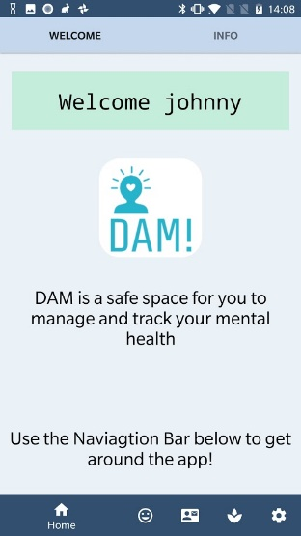

## Project Aims and Objectives

The overall aim of the project is a simple one: to provide a system that will both help those suffering from mental health issues and help reduce the stigmas surrounding mental health issues.

The goal for this project is to provide a modern, easy to use and accessible android phone application that will help users to manage and track their mental health. The development of this app will be a completely user centred approach in every step from the research involved to the design decisions made.

To achieve these aims some milestones were set. These milestones involved setting flexible dates to complete certain parts of the project. By setting specific time frames to have certain parts of the application developed it was insured that the final application would be completed to the best attempt by the end.

The purpose of this project is to educate people about mental illness; how to track and improve their mental health; and help them increase awareness of their mental health. Hopefully DAM can show health professionals how technology can be used to help treat depression and anxiety - and perhaps give them ideas in incorporating technology in treating their patients.

What DAM isn't about is "fixing" people or "formulating" happiness. It is hoped that information and habits provided by DAM are the start of a user's lifelong journey of improving and staying on top of their mental well-being. Even if DAM helps one person begin a journey to a happier version of themselves then it will be deemed a complete success.

## Project Scope

Project scope, what the project isn’t about – 200 words

## Thesis Roadmap

This section will provide a summary of each of the chapters covered in this report.

Research

This chapter explores background research related to mental health, exploring some current mental health issues in Ireland and the use of technology and the use of technology in helping people with mental health illnesses. Following this, a cross-examination of existing mental health related applications on the market will be completed. Finally, this chapter will discuss an array of other relevant research completed for this project.

### Design

This chapter delves into the methodology chosen for this project and how these choices came to be. Following this, detailed use-cases and personas related to the desired system will be presented. Finally, the designed technical architecture and software testing plans will be discussed.

### Development

The development chapter breaks down the entire development process of the system regarding the technical architecture outlined in the design chapter. Some of the challenged encountered in the development process will be explored also.

### Testing and Evaluation

This chapter describes how all the testing and evaluation of the system was executed. Each phase of testing will be described in detail, followed by an in-depth account of all user feedback received during user evaluation trials. Finally, the system will be evaluated to see if it adhered to Nielsen’s Heuristics for User Interface Design.

### Redevelopment

This chapter outlines some of the development steps taken as a result of the feedback gained from the user evaluation. The changes made and the importance of these changes will be examined.

### Conclusions and Future Work

This chapter will reflect on the entirety of the project and will discuss the conclusions drawn, personal reflections made, and the future work planned for the project.

# 2. Literature Review

## 2.1. Introduction

In this chapter some of the key areas of research that are important in this project will be presented. These topics include exploring some of the current mental health issues in Ireland; the use of technology in helping people with mental health illnesses; comparing existing mental health applications to see where they succeed and where they fail; and the best ways to design a competent interactive user experience.

## 2.2. Alternative Existing Solutions to Your Problem

There are existing apps on the market to help people deal with a variety of aspects regarding mental health. As Mental Health is a sensitive subject it is important that these apps are well researched and have been discussed with mental health experts. If an app does not follow these guidelines, then they could potentially provide a negative effect to a user who may be in a vulnerable situation.

The following are mobile apps that help users with their mental health:

Headspace

Headspace(15) is an app/service providing meditation and mindfulness sessions to its users. Headspace is based on the idea of allowing users to meditate anywhere with the app and claims to help users stay calm, reduce stress, stay focused, and boost compassion. Headspace tries to achieve this by providing users with small guided to sessions to help them meditate.

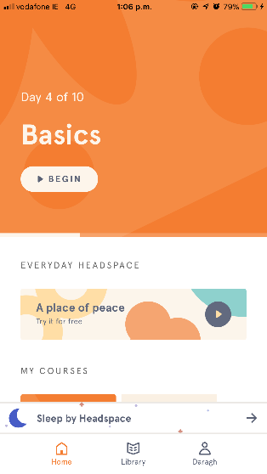 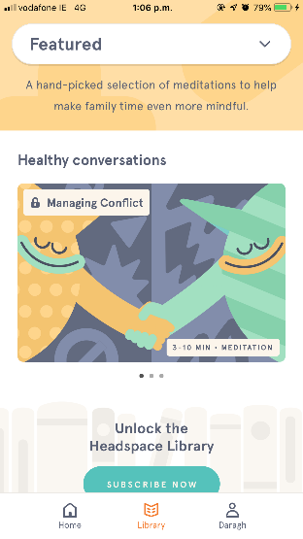 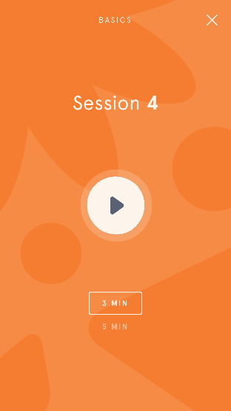

Figure 1 – Headspace App screenshots

Headspace offers an intuitive and easy to use app. The colour scheme throughout the app is easy on the eye and calming. The user is talked through the meditation sessions by a calming voice and these sessions tend to come courses that span over a ten-day period. Only the basic course is available to users for free, the rest of the courses and features included in the app are locked behind a subscription feature (**€**12.99 a month base).

Moods: Mental Health Tracking

Moods is an app that revolves around the user tracking and storing their mood. Whenever opened, the app prompts the user to enter their mood. First the user chooses if they feel *Good*, *Okay*, or *Bad* and then they choose a more specific emotion related to the chosen general mood and from there the user can add a specific note. The app shows logs of the user’s mood on a weekly basis.

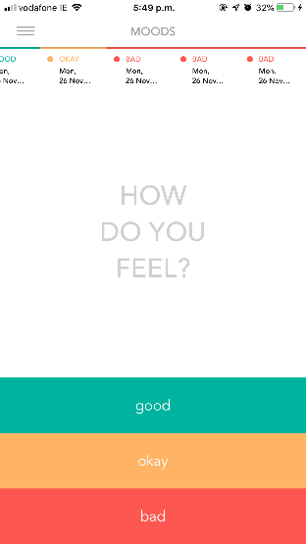 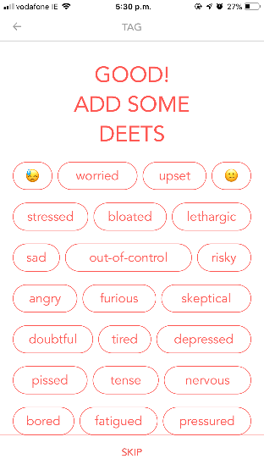 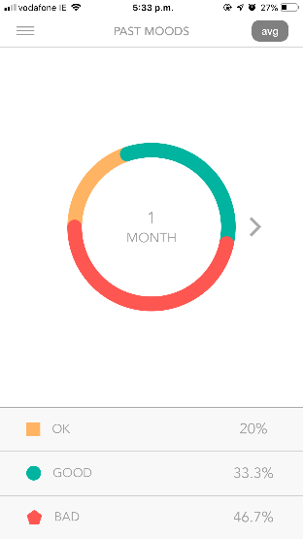

Figure 2 – Moods App Screenshots

This apps straightforward design makes it extremely easy to use which means a user won’t be deterred by an overwhelming cluster of functionalities. A possible negative impact that can be seen from this app is that if a user is suffering from a consistent low mood, they are constantly tracking this may cause negative thinking and further distress. A way to counteract this may be to have some underlying smart functionality that may notice when a user needs help and may prompt the user to talk to a confidential phone line or to communicate with someone that they are close with.

Happify

Happify(16) is a web and mobile app aimed at helping users take control of their feelings and thoughts. Happify offers a range of solutions for emotional health and wellbeing. These solutions range from meditation sessions to games. Happify also provides relevant articles on mental health, a feed for users to share photos and experiences, and more.

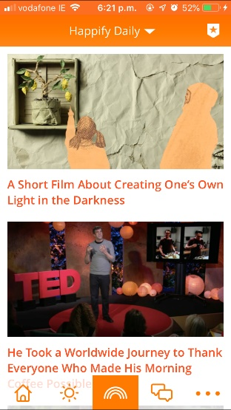 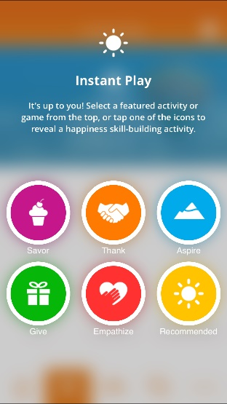 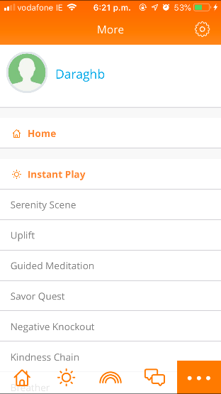

Figure 3 - Happify App Screenshots

This app has a lot of functionalities. While this provides features for a wide array of users, there may be a possibility of overcrowding of features. If a user is in a bad mental health state, they may not want to spend the time sifting through the app trying to find the functionality they wish to use. It would be easy to become overwhelmed while using this app. Perhaps if some redundant functionality /information was removed the app would become easier to use.

Simple Habit

Simple Habit(17) is a meditation app similar to Headspace. Upon starting the app for the first time Simple Habit goes through a list of questions to gain information about the user. This information is later used to make the user experience as personal as possible and so the app can suggest meditation sessions that will be helpful to the user in their situation. This app allows for many creators of mindfulness and meditation sessions to upload their content. Simple habit locks many features behind ‘premium’ which a user can access by paying a monthly fee.

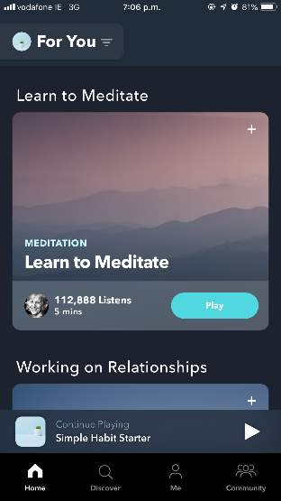 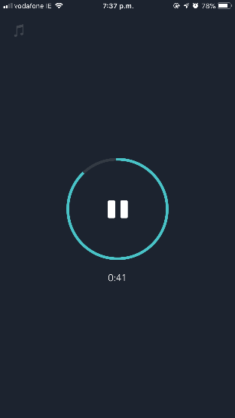 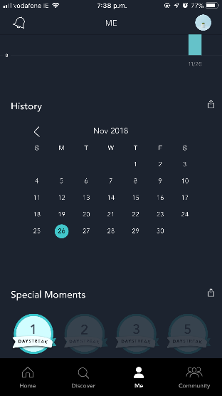

Figure 4 - Moods App Screenshots

The blue and navy colour tones through the app are well suited as blue is a calming, non-threatening colour(18). Simple habit is goal-oriented from the start. As you make an account you are asked the main purpose of you wanting to use the app, and this is echoed back to you throughout your experience. This is a great way to help users keep focused on the reasons they wanted to meditate and care for their wellbeing in the first place.

+Connections

+Connections is a mental health app aimed at Irish students with the goal to promote positive mental health(19). The main functionalities of the app are to provide students with awareness of the various mental health support services available to them in Ireland, to provide a safe space for students to share their mental health story and to read about how other Irish students deal with mental health.

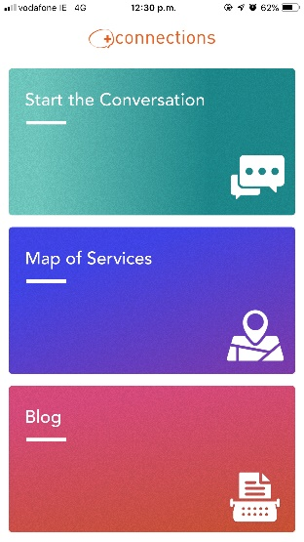 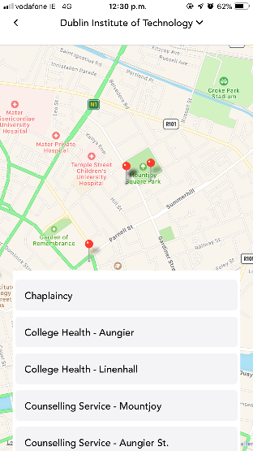 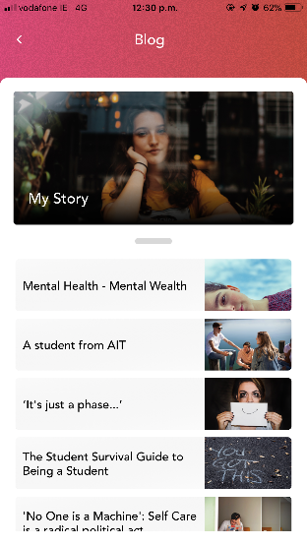

Figure 5 - +Connections App Screenshots

The simple and intuitive interface offered in +Connections make it an easy to use app. The app is not bogged down by pointless features and a user can get to the information relevant to them quickly.

Conclusion

Many of existing apps described above may burden users with mental health with additional cognitive loads. DAM plans to learn from these apps as to what features are successful and what ones are not when in the development and implementation phases. DAM will be similar in some functionalities but provide a crisp clean user experience.

## 2.3. Technologies you’ve researched

Mobile Technology

**Android** is a Linux-based mobile OS developed by Google. Android OS is the current leading mobile OS used with 88 percent of all smartphones sold in Q2 of 2018 having the Android Operating System (20). Android’s opensource code allows developers and device manufactures to customize and distribute the platform across the market. Java language is the go-to choose for native android app development. Android developers have the opportunity to distribute their programs to any device running android, and this ranges from phones and tablets to watches and cars.

**iOS** is a mobile Operating System developed by Apple. iOS is limited to being used on only Apple-made devices, unlike Android which can be used on a variety of devices. iOS is the second most popular mobile OS after android. As apple have control over both iPhone hardware and software, they have the ability to create an effective and clever user experience. This also allows apple to offer regular software updates to all its devices without having to require testing and approval from different manufacturers(21). Apple does a much better job than android at keeping most of their users’ devices on the most up to date iOS version. iOS applications are developed using XCode on the Swift platform.

In **conclusion**, the Android operating system is the best choice for the development of DAM as there is past experience in creating apps for this platform. Java will be the language of choice as it is used in the android studio development environment. Android also provides a large range of libraries and APIs that will be used in the development of this application.

Databases

For this application both local and remote database storage will be used.

**Local storage:**

The default storage for native android applications is SQLite. SQLite is an opensource SQL database that stores data on the device making it that important information is always readily available to access and query. In order to access the database no other connections need to be established (22). It is planned that user data can be accessed by health professionals such as counsellors, so a remote database would be needed also. Another reason for remote database as I may not have this function.

**Remote storage:**

For remote storage a few different approaches were researched but it was decided to use Firebase. Firebase is a Realtime database, meaning all the user data will be synced automatically to the cloud. If the user does not have a network connection when entering data, Firebase will push the data once a connection is gained. This is vital as the mental health information the user will enter will be stored as soon as they enter it, even if they are offline. Firebase has a lot of specific functionality(23) readily available that will benefit the development of DAM.

APIs

There is a variety of Application Programming Interfaces (APIs) to make use of when developing a native android application. Using APIs will be necessary for some desired features of the app.

An API will be used for the Mapping functionalities planned for the app. The Google Maps API will include directions while a “place” API will allow the app to provide nearby locations of mental health services near the user. Google Maps API will also allow the user to share their location with their emergency contacts if needed.

More API’s will be researched and implemented throughout the development of the project.

## 2.4. Other Research you’ve done

Nielsen’s Heuristics

Nielsen’s Heuristics are 10 general principles for interaction design(24). These heuristics are extremely important for any app, especially a heavily user-oriented app like DAM. These heuristics were also kept in mind while comparing existing mental health apps on the market.

These heuristics will be compared to for the duration of the development of the app.

Accessibility

Accessibility is of utmost importance in the development an app surrounding mental health. It is important to know what things to do, but also what things to avoid when designing apps for people with mental health issues. Some disabilities that must be considered in the development of any app include(25):

Visual – blindness, colour-blindness and visually impaired;

Hearing – deafness and hard of hearing;

Cognitive – learning disabilities, poor memory and inability to focus.

It is a possibility for a user with a disability such as the ones listed above to also from mental health issues meaning they are potential end users for the app. The goal for DAM is to make it as accessible as possible for a large range of users.

An example in the case of a user being visually impaired, the app layout should be completed so the contents of the app page will coherently read by a text-to-speech converter.

While accessibility is important, making an application overly accessible can compromise its security.

Smart Design

Giving users an amount of configurability will make the app more personal and may make them more inclined to use regularly.

Data Privacy

As DAM will be using some sensitive data by nature about the user regarding mental health, data privacy will be of utmost interest for the success of the system. Users may not be willing to share sensitive information about their mental health, especially If they are unsure of how that data will be used. The proposed use of location services on the app can pose a risk of data privacy as the user’s shared location could potentially be accessed by unauthorized users.

The developer will develop the app with the importance of security in mind and always chose development methods that keep user information secure.

## 2.5. Existing Final Year Projects

A couple of Final Year Projects from previous years were looked at in the research phase of the project. There was an attempt to focus on some projects with some relevance to the themes that will be tackled in the creation of the DAM system.

Anxiety Manager incorporating wearable technology - Katie Fitzgerald

The purpose of Anxiety Manager is to track the physical and non-physical characteristics associated with anxiety attacks using wearable technology (sensors) (31). The user can track their attacks in an anxiety diary to look back on later. Katie incorporates both the wearable sensors and a mobile application in the final development. The sensors can monitor changes in the user’s physical state such as heart rate and sweating. These changes are tracked, and the results added to a remote database which can be accessed via the mobile application.

Anxiety Manager inspired this project as the driving point for the project was also based around mental health and using technology to help users in providing them with useful features and functionalities. The approach Katie took in how she went about the project from research to implementation always had the best interests of the potentially vulnerable users at the forefront. This attention to detail is certainly something that will be kept in mind throughout the entire development process of DAM.

Training Pal – Daniel Tilley

Training Pal is a system for athletes and coaches to be able to share training data through logs, graphical representation of data, video consultations and more(32). The system is accessible through both web browser and mobile application and claims to be a simple and efficient method for users to access information on their training. Athletes and coaches have different logins which results in them being able to access different features.

Training Pal inspired this project as it was also using a mobile phone application and had comprehensive use of logs. While training Pal uses logs to track an athlete's training data, the DAM application will use logs to track a user's mood over a period. Like the Training Pal’s data being sent to the coach, it is planned for the DAM application’s mood data to be brought by the user to counselling sessions to help the counsellor help them get better.

## 2.6. Conclusions

With the necessary gained knowledge of Mental Health and its associated problems, development stages of the app can begin with this knowledge in mind. The true scope of the burden of mental health on so many members of society was uncovered.

From contacting and communicating with professionals from an array of Irish mental health organisations, a good understanding of what is needed in a mental health app was procured. The information provided by these organisations included what features to avoid, designing for a person with mental health needs, general ideas towards mental health technologies and more.

The technologies best suited for the project were decided after researching many different options.

Requirements Table

|  |  |  |
| --- | --- | --- |
| **Name** | **Description** | **Priority** |
| User Login | Enables a user to login on mobile device | HIGH |
| User Logout | Enables a user to logout of the system | HIGH |
| User create account | Enables user to create an account and enter relevant information about themselves | HIGH |
| User update profile | Allow user to update the information stored about them at any time | HIGH |
| Breadcrumb Navigation | Provide a simple navigation system for users to traverse through the app | HIGH |
| Mood Tracker | User enters their mood on a certain day to record emotions - “How do you feel today?” screen | HIGH |
| User view Mood graph | User’s recorded moods shown on graph | HIGH |
| Phone Links | Live phone link for someone needing immediate help. Samaritans – Pieta House - Counselling | MEDIUM |
| User Diaries | User can type/ voice record emotions on a current day, so they can recall these feelings at a later stage if needed. | MEDIUM |
| Breathing Visualisation | Guided breathing visualisation to calm a panicked user | MEDIUM |
| Map functionality | Shows closest Mental Health services to users on a map. | MEDIUM |
| ‘Code Red’ | Emergency functionality for user to contact specified contacts in case of urgency | MEDIUM |
| Mindfulness Session | A guided mindfulness session a user can access. | MEDIUM |
| Pill reminder | User-customised pill reminder function that helps remind a user when to take medication if needed. | MEDIUM |
| Update mood | User can update their mood for a day they missed | LOW |
| Information Links | Relevant link to information on depression, mental health, bullying, etc | LOW |
| Appreciation Log | Daily log to help users keep track of positives in their life | LOW |
| Sleep Log | User tracks their sleep schedule | LOW |

# 3. Prototype Design

## 3.1 Introduction

Following on from the previous chapter, where some of the key background research was presented, these themes will be continued in this chapter, where the design of the system will be presented. The first section will look at the software methodologies employed in this project which describes which methodology was chosen and why. After that, some example use-cases and user personas will be presented. The next section outlines the technical architecture of the system and will discuss in depth how the system architecture is planned to work. This will cover both front-end and back-end aspects of the system. The final section will discuss the plan for testing and evaluation of the system.

## 3.2. Software Methodology

## 

Waterfall Methodology

The Waterfall Methodology is a linear and sequential approach to the development of software(26). Waterfall Methodology follows an 8-step approach in a development cycle.

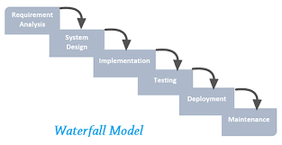

Figure 6 (27)

The benefits of the waterfall model are that it will be easy to use and manage; it will give the developer and users a clear idea of the scope, which would be beneficial for the time constraint for this project.

A big disadvantage of using waterfall for this project would be that there will be changing requirements during the development of the system as end user feedback is recorded. It is unlikely that we can be sure of all the functionality of the system, especially when the system is being developed around a sensitive subject such as mental health. By the nature of the Waterfall model, once a stage is completed then it should not be revisited. There is no way to be this sure of the requirements at such an early stage.

DAM will have evolving needs as research and feedback will take place for the duration of the project – Waterfall Methodology will not be suitable for the project.

Agile Methodology

Agile Methodology follows an incremental approach(26). This approach will allow the developer to be more flexible with the development of the project. In agile methodologies the project is broken into small chunks which are completed in “sprints”. At the end of these sprints project priorities are revaluated and the design and development plan for the project is changed accordingly.

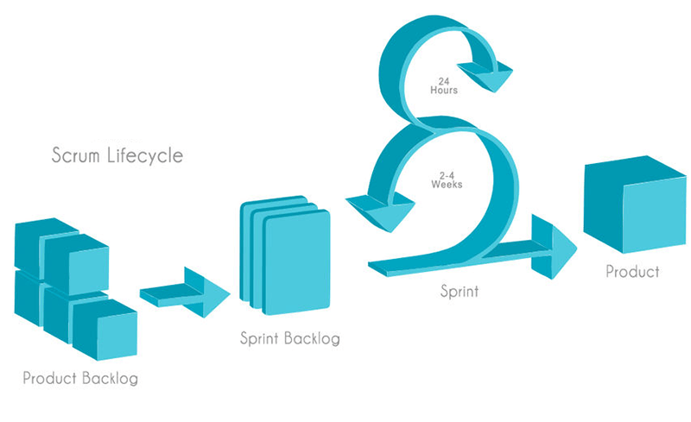

Figure 7 (27)

Agile methodology is well suited for the project as changes during the implementation stages are expected to occur; testing can occur through all development stages meaning bugs are caught during the development instead of at the end; development is more user-focused, and feedback can be gained from the contacted organisations after certain sprints to ensure the project is up to standard.

With Agile Methodology it may be easy to stray off the initial project plan, so it will be important to check back to the original plan and keep it in mind.

An Agile Methodology is more suitable for this project, specifically the Scrum Framework in Agile Methodology. Scrum focuses on the use of sprints in feature development which is essential as a Feature Driven Development approach will be followed. For the development of this project there will be an emphasis on short development cycles with heavy focus on documentation.

## 3.3. Overview of System

A feature driven development (FDD) approach will be used where a feature will be planned, implemented, and tested as part of a sprint. Once that feature is implemented, development of the next feature will begin.

This is approach is necessary for this project as features are the main driving point.

Design and code will be delivered in stages. A feature will be through designed and researched before implementation begins. It would not suit this project to complete all the design up front followed by all coding.

The current general approach for the project will be as follows:

1. Design and implement basic version of mobile application for Login. Thus, allowing demonstration of communication between layers.
2. Design a feature (for example setting up a user’s account)
3. Implement the feature
4. Test the feature
5. Repeat steps 2-4 implementing all desired features – implement by priority of the features.

The technical architecture shows how many layers there are in the application and how the layers communicate with each other. For this project a 3-Tier model will be used as seen below. This model was chosen as changes to one layer of the model should not affect the other layers.

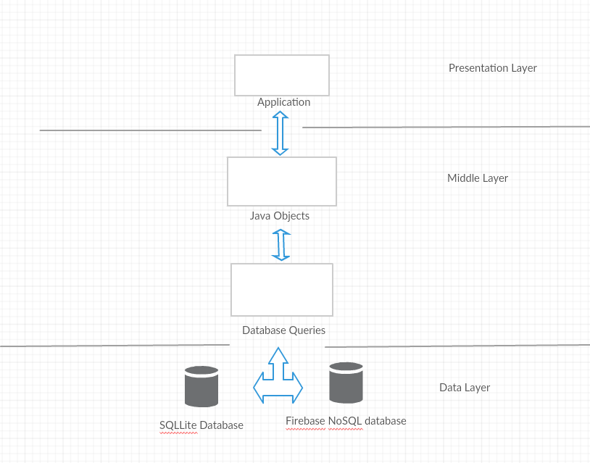Figure 8

## 3.4. Front-End

The presentation tier is the front-end layer in the system and consists of the user interface. This layer will allow the user to interact with the application through the mobile phone and display content to them. Here the user will use their phone to track their mood and enter other relevant data.

Paper Prototypes were used for the first iteration of the screen layouts and to provide allow fidelity prototype. These screen mock-ups were useful as they could be shown to potential users and give them a feel for the desired end product.

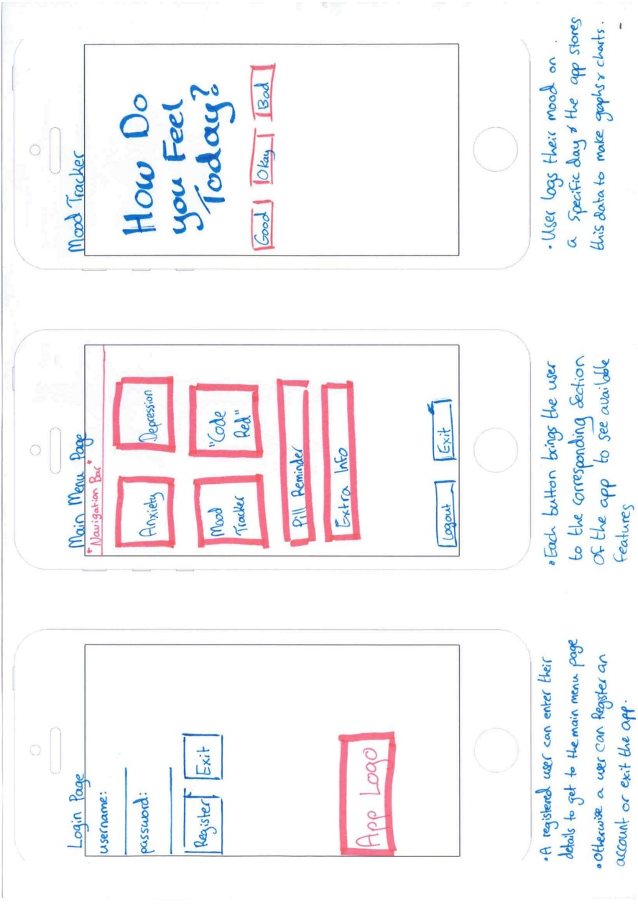Figure 9

This also enabled necessary feedback at an early of the design process. The image below shows feedback received from the DIT head of counselling. Extra features were proposed in this feedback.

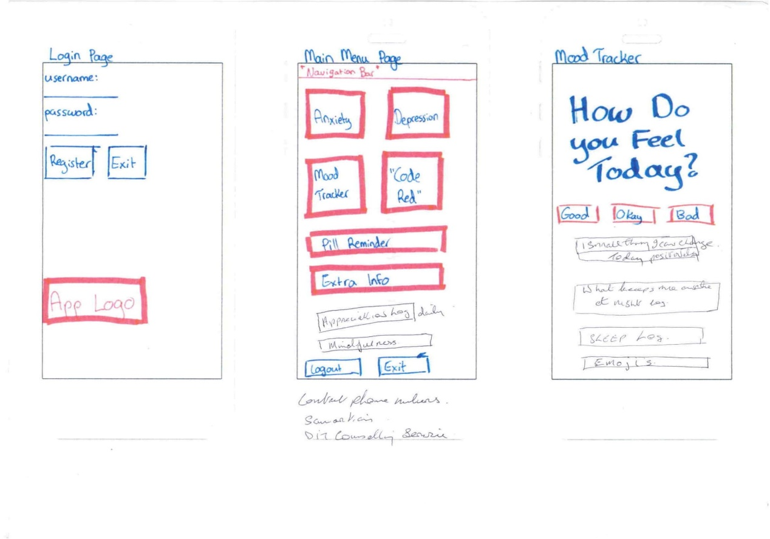

Figure 10

From here, the next stage of the screen layout design phase began. For this, a program called FluidUI was used. This program allowed for a high-level design for the screen layouts and interactions between the screens. This medium fidelity prototype can be seen below.

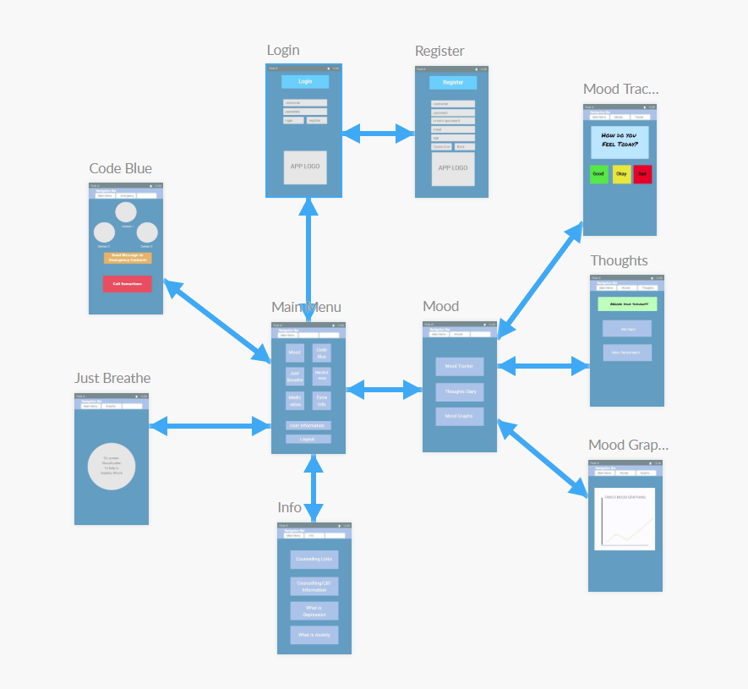

Figure 11

A closer look at some of the pages…

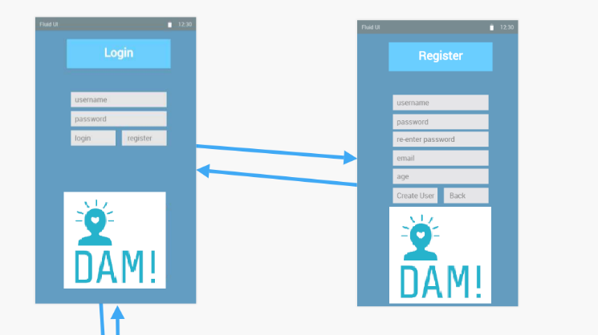 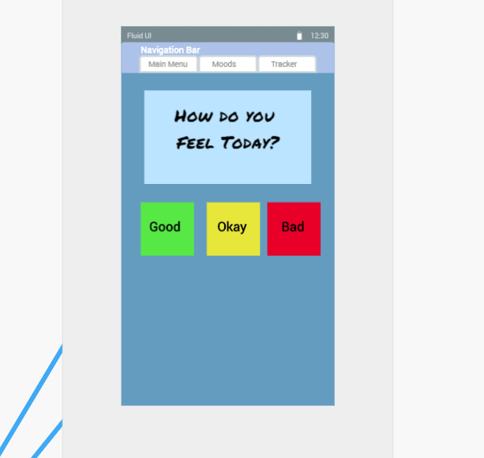

Figure 12

## 

## Use Case Diagrams

Use case diagrams are used to identify system functionality and communicate system behaviour. The use case diagrams in the below figures show the progression of the system functionality.

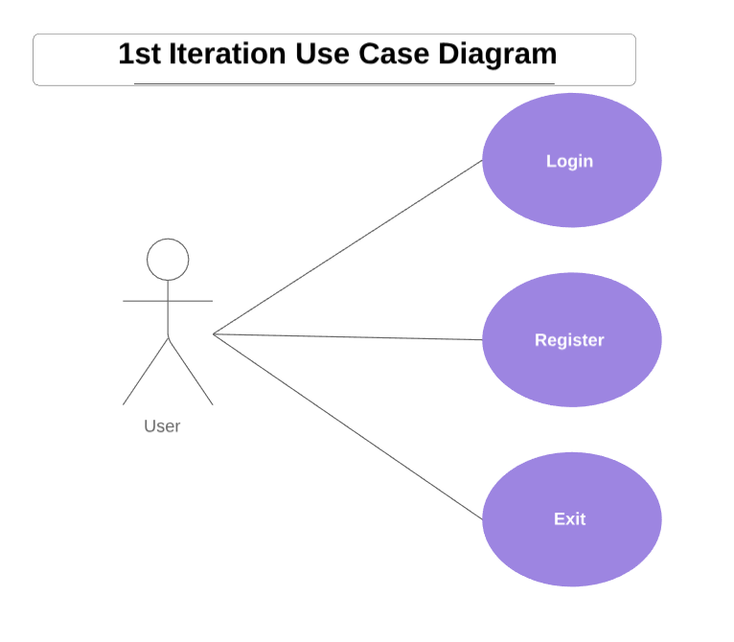

Figure 13

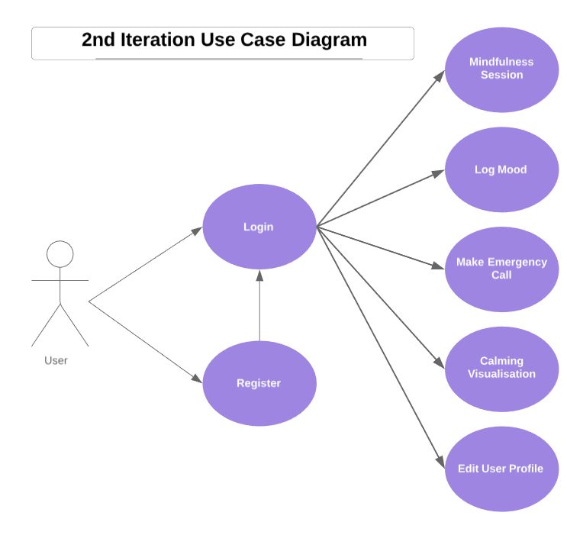

Figure 14

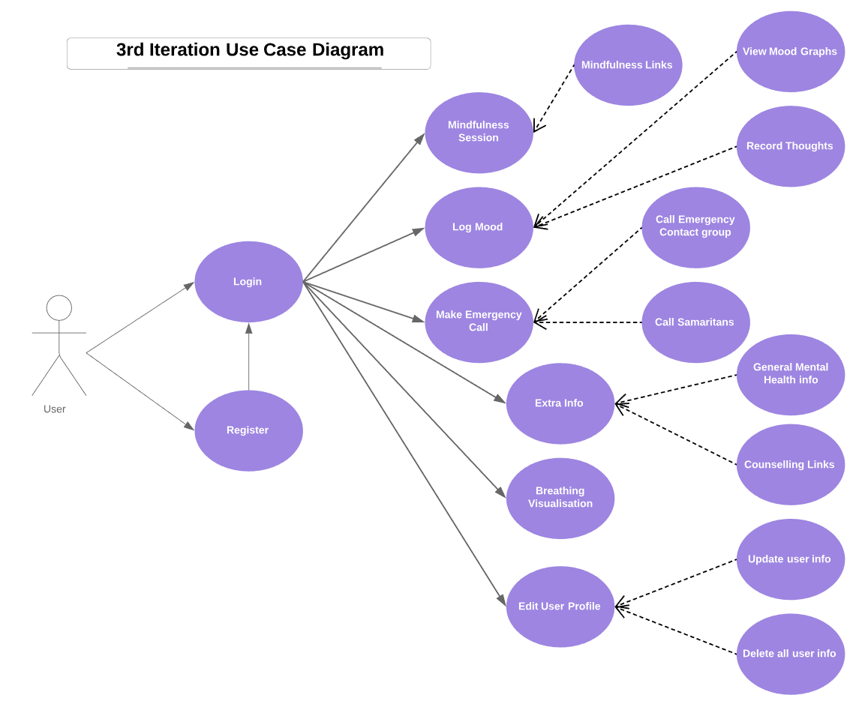

Figure 15

## 3.5. Middle-Tier

The middle tier or application layer contains the functional logic which will drive the application’s core capabilities.

The middle layer will provide the underlying functionality for users to switch between screens; login to their account; record their moods; and much more.

For example, Java objects will be implemented to provide access to the database. These objects will communicate and interact with the database allowing relevant information to be shown to the user. These objects also assist in pushing user-entered data to the database.

## 3.6. Back-End

The Data Layer comprises of the data storage system and data access layer. This is the DBMS layer and is generally accessed through the middle layer applications.

SQLite Database is the local android database. This will hold some necessary information that should not be stored on in a remote storage database.

For remote storage this application will use Firebase database provided by Google. This is a Real-Time NoSQL cloud database. A user can store data while offline as Firebase automatically pushes new data to the Firebase datastore when a network connection is gained again. This means the application will be able to store moods and other important data even when offline. Firebase will keep the important data secure as if something happened to the local phone SQLite data will be lost. Firebase has a lot of built-in features and functionalities that will help with the development of the project.

**1st Iteration ERD**

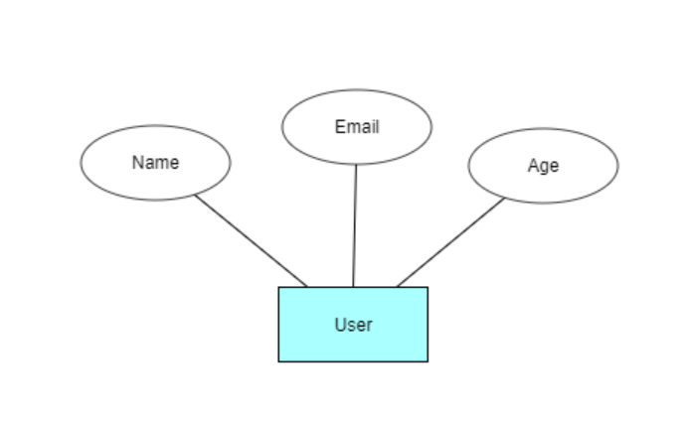

**2nd Iteration ERD**

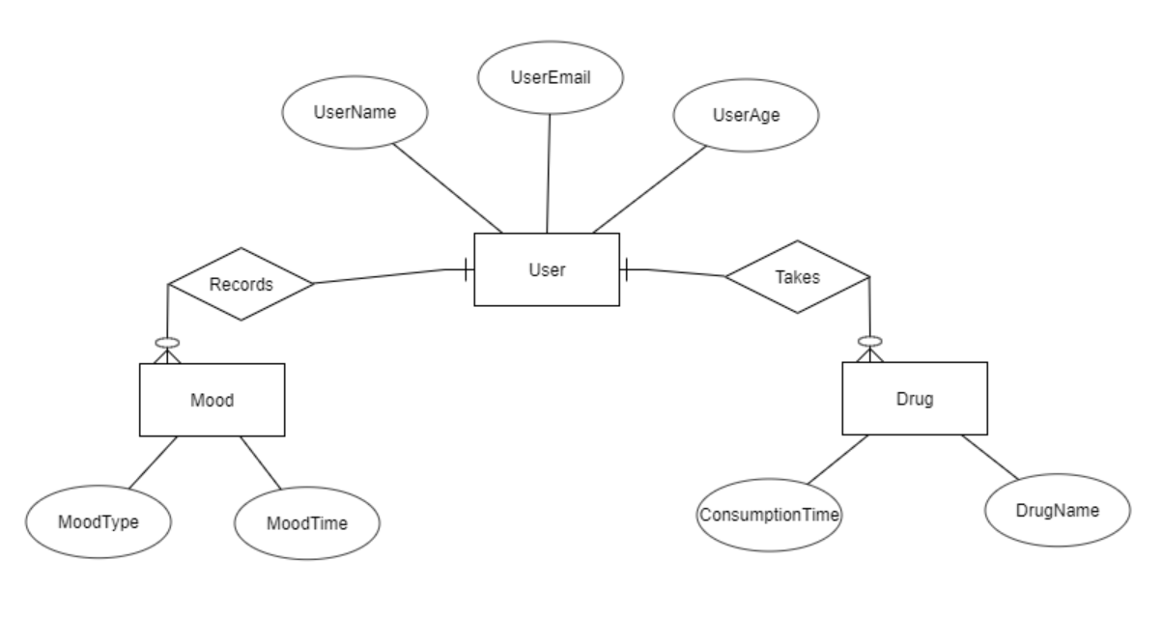

**3rd Iteration ERD**

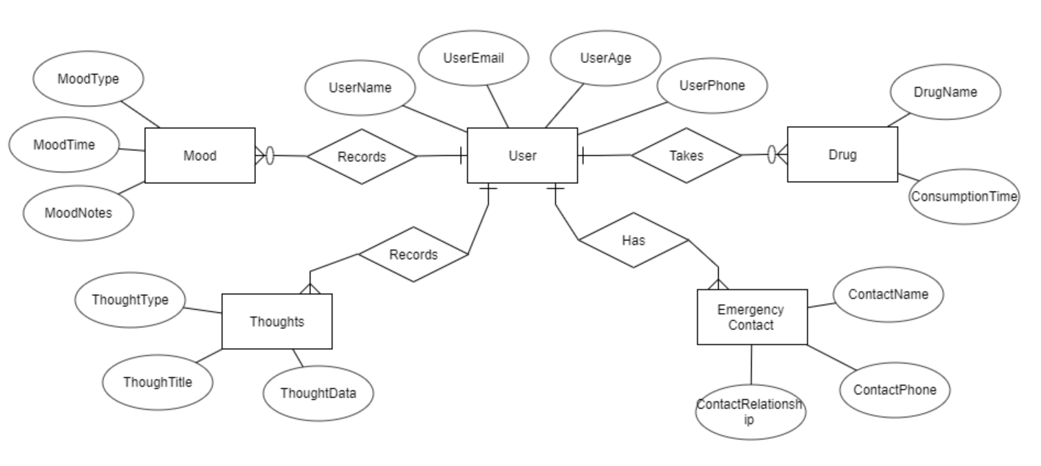

## 3.7. Conclusions

In this chapter we looked at the design of the system, first exploring the methodology that will be used in the development process, next a broad overview of the technical architecture was outlined, then into detail the front and back-end design. Finally testing was discussed regarding the different testing methods that will be followed and the software test plan.

Based on the key themes discussed in this chapter, the next chapter will cover the development process and will be revisiting many of the same issues covered here. The development chapter will discuss how these designs were implemented including any challenges or changes encountered along the way.

# 4. Prototype Development

## 4.1. Introduction

This chapter continues with the issues explored in the previous chapter and will outline the development process undertaken in this project. This chapter will present the key development processes and the challenges encountered during the creation of this system.

## 4.2. Prototype Development

The first step for the development of the application was to set up version control. It was decided that GIT was the best option for this project as it is easily integrated with Android Studio. GitHub would be used to manage the version control using GIT as it is a reliable web-based hosting service. After that project was created in Android Studio and linked to GitHub and thus the development could begin.

For the initial prototype it was decided that the goal was to show the initial screen layouts(horizontal) and show the layers of the project communicating with each other(vertical).

## Horizontal Prototype

The first screen created was the login screen.

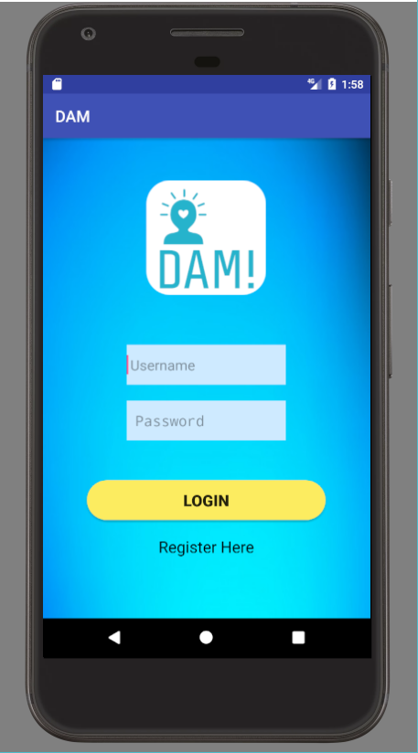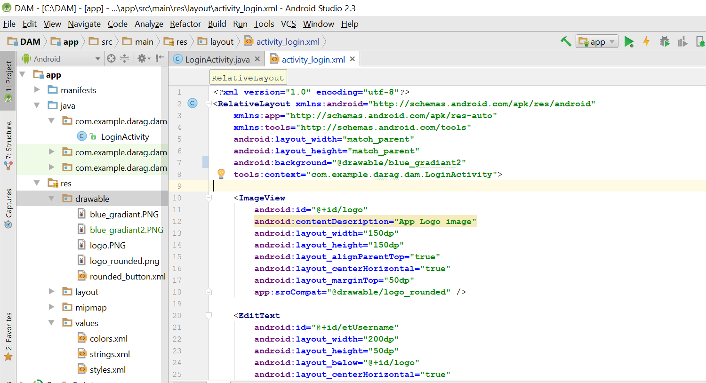

XML code was used to create the layout and the program was run on a phone emulator.

To provide these XML layout features with more functionality, a java file was used. In the LoginActivity.java file an intent was created. An intent is an object that provides runtime biding between separate components. In this case, an intent was created such that once the register button is pressed on the login screen, the user is brought to the register screen.

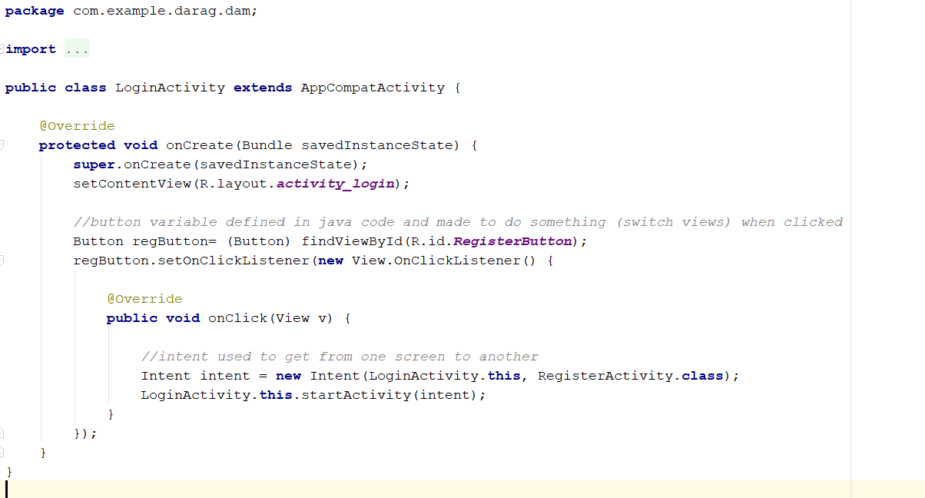

After getting the movement between screens completed, the next step was to set up the real time Firebase database. To do this a Firebase account was created and the required steps to connect this database to the android project were followed. This proved quite difficult and time consuming at first as Android Studio was causing some issues.

[make a register page and get inserting data into firebase working. That should be G for prototype]

## 4.3. Front-End

## 4.4. Middle-Tier

## 4.5. Back-End

## 4.6. Conclusions

# 5. Testing and Evaluation

**As least 2 pages, but as many as you like**

## 5.1. Introduction

## 5.2. Plan for Testing

The Project will be continuously tested throughout its entire life cycle. The app will be run on both emulators and real android phones throughout the development stages to ensure that it is working as intended and to provide hands on user trials.

Backing up and committing the project consistently using GIT version control will ensure that any changes can be rolled back if there are any major errors. Having multiple project backups will help in the inevitable “accidently deleting an important part of the project”.

Another plan to evaluate the project is by asking test groups to use the app. These groups will consist of a variety of possible end users, including people from organisations in the mental health industry such as counsellors and doctors.

Unit testing will be used as there will be so many individual parts to the project that will make up the whole app. Unit testing is where tests will be created which interact directly with the application. These tests will validate each unit of the software to ensure it is performing correctly. Unit testing is essential for the proposed agile approach as after each sprint all parts of the program created will be tested.

Blackbox testing will also be used as it provides a different angle when testing the project. The tester will not know about the internal structure/ design/ implementation of the item being tested (28). The black box testing method will attempt to find errors in areas such as: Interface errors, performance errors, incorrect functions, initialization errors and more (28).

It was decided that a mix of both unit testing and black box testing would be an adequate way to test the project. Manual testing will take place too wherein the developer will play the end user and use the app features to ensure correct behaviour.

Evaluation of this project will be done by the developer, potential users and mental health professionals.

## Test Plan

|  |  |  |  |
| --- | --- | --- | --- |
| **Test No.** | **Test Description** | **Expected Outcome** | **Pass?** |
| 1 | Does the phone app load when the icon is selected? | The app will load and bring the user to the login screen. |  |
| 2 | Does the app close when the exit button is pressed? | The app will shut down correctly when exit is pressed. |  |
| 3 | SQL injections working correctly. | SQL will be updated to the database when the user creates a profile. |  |
| 4 | Can a User login with their registered details? | A registered user who enters details will be able to login and get to the main screen. |  |
| 5 | User Login with invalid details. | Error is displayed to screen. |  |
| 6 | Can a user successfully logout? | The user can logout and return to the login screen from the main menu. |  |
| 7 | Can the user edit their profile? | User profile is updated and saved to the database. |  |
| 8 | Can the user delete all information stored about them? | When a “clear all” button is used it will remove all details stored about the user. |  |
| 9 | User enter mood details. | A user’s mood details will update the database. |  |
| 10 | User clicks view mood graph. | A graph will be displayed of the user’s mood over a time period. |  |
| 11 | User uses “Just breathe” anxiety calming functionality. | A visualisation will appear to the screen that will help slow and calm the user’s breathing. |  |
| 12 | Pill reminder editing. | User can successfully edit the medication reminder to suit their situation. |  |
| 13 | Pill reminder working. | The pill reminder successfully reminds a user to take their medication at the specified time. |  |
| 14 | Emergency contact number/links | The emergency contact number is correct, and the links take the user to the desired place. |  |
| 15 | Code Red messaging | User can send message to specified emergency contacts to inform them that they need help. |  |

## 5.3. Plan for Evaluation

Evaluation of this system is equally as important as testing. The reason for this is that user experience is one of the main complexities of the application. On the surface we want the application to be as easy to use as possible, even though underneath this there is a lot of complex code and decision being derived. As previously mentioned, the usability of the system being intuitive and instinctive was of high priority through the entire development process. Having the system be evaluated by potential users and mental health professionals will hopefully ensure that the system usability is of high quality and of an industry level standard.

This section will go into detail as to how the system was evaluated. Evaluating the system was done by surveying potential users (including mental health professionals) and by evaluating against the predefined metrics of Nielsen’s Heuristics for User Interface Design.

## 5.4. Conclusions

This chapter reviewed the testing and evaluation of the system. The testing consisted of performing Unit Testing, Integration Testing and Security Testing both while developing the system and on completion. The evaluation included evaluation from a variety of potential users and evaluating the system against Nielsen’s heuristics.

# 6. Issues and Future Work

**As least 5 pages, but as many as you like**

## 6.1. Introduction

## 6.2. Issues and Risks

The challenges that are unresolved in the project thus far are as follows:

* Lack of knowledge with Firebase especially with integrating it with App development.
* Lack of familiarity with using APIs and other android development functionalities.
* Keeping in contact with organisations and individuals who can give professional feedback.
* Figuring out the balance between keeping important and sensitive user info as secure versus keeping the app as accessible as possible.

How the author plans on approaching these various challenges are as follows(respectively):

* Complete an online Firebase course. Put in extra research into that area especially when working with android.
* Test different APIs to see which ones will work with the project.
* Keep a flow of communication with organisations to keep them up to date and interested in the project.
* Continue to try to keep the security/accessibility balance to the best possible standard as it will be an ongoing discussion/issue.

The risks that the author faces in the project are as follows:

* Bad WiFi connection could hinder the demoing or accessing of some features related to the app.
* Links that the author puts on the application (such as counselling links and phone numbers) might not be able to be accessed due to them no longer existing.
* Failing to complete the proposed work in time.

How the author plans on approaching these various risks are as follows:

* Ensure WiFi connection is strong by testing it before the demo.
* Ensure that the links that the author provides are viable by checking them weekly.
* Create and stick to a timetable for the project. This will ensure the proposed elements of the project are broken down into doable Sprints and make sure that they are completed in the proposed time allocated.

## 6.3. Plans and Future Work

The plan for the project can be seen in the GANTT chart below. Another GANTT chart will be filled in as the project is completed and these two charts will be able to be compared at the end to see the difference between the planned approach and the reality.

The Project will continue to be completed with communications with mental health organisations to ensure the final user experience will be at the best possible standards for people with mental health issues.

### 6.3.1. GANTT Chart

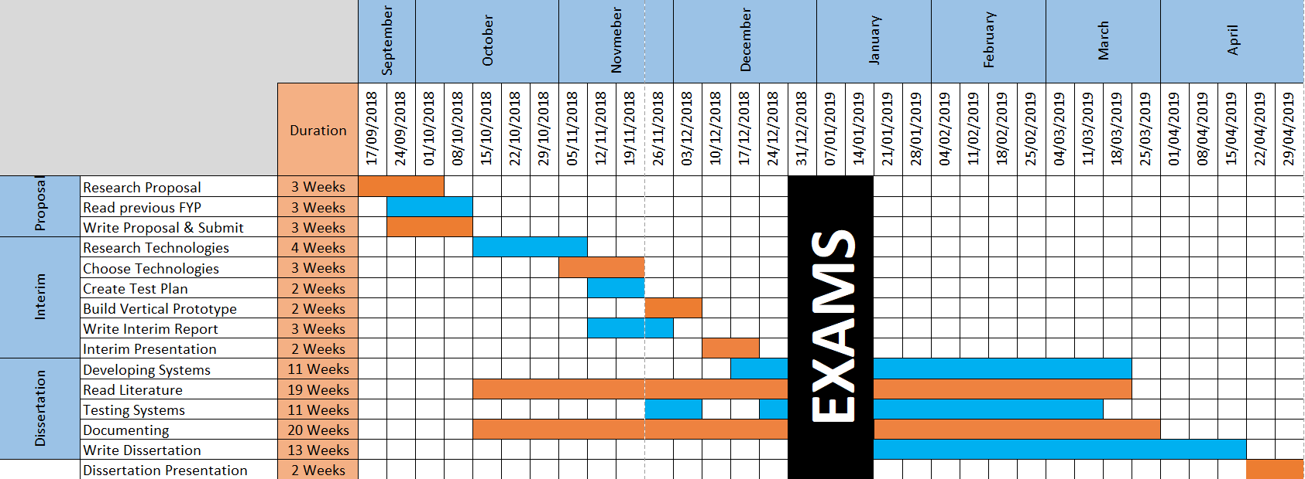

# Bibliography

1. Mental Health Services - HSE.ie [Internet]. [cited 2018 Nov 26]. Available from: https://www.hse.ie/eng/services/list/4/mental-health-services/

2. Depression [Internet]. [cited 2018 Nov 26]. Available from: http://www.who.int/news-room/fact-sheets/detail/depression

3. Depression | Depression Support | Depression Help Ireland | Aware [Internet]. [cited 2018 Nov 26]. Available from: https://www.aware.ie/information/depression/

4. Paul Cullen. Ireland has one of the highest rates of mental health illness in Europe, report finds [Internet]. [cited 2018 Nov 28]. Available from: https://www.irishtimes.com/news/health/ireland-has-one-of-the-highest-rates-of-mental-health-illness-in-europe-report-finds-1.3707073?fbclid=IwAR3r0caANfjUV7GfTBGFbD4XjGXQU6XxuUXC53gu6ZRlPQVHIyXBSGXGGAk

5. Mental health: strengthening our response [Internet]. [cited 2018 Nov 26]. Available from: http://www.who.int/news-room/fact-sheets/detail/mental-health-strengthening-our-response

6. Carl Kinsella. 8 Irish organisations that can help you if you are suffering from mental health problems | JOE is the voice of Irish people at home and abroad [Internet]. [cited 2018 Nov 26]. Available from: https://www.joe.ie/life-style/7-irish-charity-organisations-that-can-help-you-if-you-are-suffering-from-mental-health-problems-542173

7. Samaritans in Ireland [Internet]. [cited 2018 Nov 26]. Available from: https://www.samaritans.org/your-community/samaritans-ireland-scotland-and-wales/samaritans-ireland

8. Pieta House [Internet]. Available from: https://www.pieta.ie/

9. About - SpunOut.ie - Ireland’s Youth Information Website [Internet]. [cited 2018 Nov 26]. Available from: https://spunout.ie/about

10. About us – ReachOut.com [Internet]. [cited 2018 Nov 26]. Available from: https://ie.reachout.com/about/

11. Mental Health Ireland What we do - Mental Health Ireland [Internet]. [cited 2018 Nov 26]. Available from: http://www.mentalhealthireland.ie/what-we-do/

12. About Us | A Lust For Life [Internet]. [cited 2018 Nov 26]. Available from: https://www.alustforlife.com/about-us

13. How We Help | Grow [Internet]. [cited 2018 Nov 26]. Available from: https://grow.ie/how-we-help/

14. DIT Dublin Institute of Technology - Student Counselling [Internet]. [cited 2018 Nov 26]. Available from: http://www.dit.ie/counselling/

15. Meditation and Mindfulness Made Simple - Headspace [Internet]. [cited 2018 Nov 26]. Available from: https://www.headspace.com/

16. Happify: Science-Based Activities and Games [Internet]. [cited 2018 Nov 26]. Available from: https://www.happify.com/

17. Simple Habit | Press [Internet]. [cited 2018 Nov 27]. Available from: https://www.simplehabit.com/press

18. Kendra Cherry. Blue in Color Psychology - Impact on Mood [Internet]. [cited 2018 Nov 26]. Available from: https://www.verywellmind.com/the-color-psychology-of-blue-2795815

19. PR Comms. Mental Health: USI Launch ReCharge Campaign &amp; +Connections App | Union of Students in Ireland [Internet]. [cited 2018 Nov 27]. Available from: http://usi.ie/news-release/mental-health-usi-launch-recharge-campaign-connections-app/

20. • Mobile OS market share 2018 | Statista [Internet]. [cited 2018 Nov 26]. Available from: https://www.statista.com/statistics/266136/global-market-share-held-by-smartphone-operating-systems/

21. iOS: What you need to know about Apple’s mobile OS | finder.com [Internet]. [cited 2018 Nov 27]. Available from: https://www.finder.com/ios-operating-system

22. Android SQLite Database [Internet]. [cited 2018 Nov 27]. Available from: https://www.tutorialspoint.com/android/android_sqlite_database.htm

23. Documentation  |  Firebase [Internet]. [cited 2018 Nov 27]. Available from: https://firebase.google.com/docs/

24. Alertbox : current issues in Web usability. [Internet]. Nielsen Norman Group; [cited 2018 Nov 27]. Available from: https://www.nngroup.com/articles/ten-usability-heuristics/

25. Accessibility in Apps: the Necessity Often Forgotten | Netguru Blog on Product Design [Internet]. [cited 2018 Nov 27]. Available from: https://www.netguru.co/blog/accessibility-web-mobile-apps

26. Agile &amp; Waterfall Methodologies – A Side-By-Side Comparison | IT Staffing &amp; Technical Consulting [Internet]. [cited 2018 Nov 28]. Available from: http://www.base36.com/2012/12/agile-waterfall-methodologies-a-side-by-side-comparison/

27. Scrum or Waterfall - Which Methodology Best Suits Your Project Requirement [Internet]. [cited 2018 Nov 28]. Available from: https://www.mindinventory.com/blog/scrum-vs-waterfall-methodology/

28. Black Box Testing - Software Testing Fundamentals [Internet]. [cited 2018 Dec 2]. Available from: http://softwaretestingfundamentals.com/black-box-testing/