**Primary School Maths Teaching Aid**

**The idea:**

I’m making an app and writing a dissertation for my final year in college and I need to do some background research before I get going so I was just wondering if you could take a look at this and let me know if you have any suggestions, comments or ideas about anything I have so far!  
  
The app, hopefully, could be used as a teaching aid for primary school teachers to use when going through the math curriculum. The idea behind this is that every student goes at their own pace and so if the teacher moves on too fast for some students or is going to slow for other students that they can use this app to further their education one way or another.  
  
This app will be similar to Duolingo (but for maths obviously) in the sense that there is a hierarchy of topics/pathways. They will have to complete earlier tasks before they can move on to the more difficult ones.

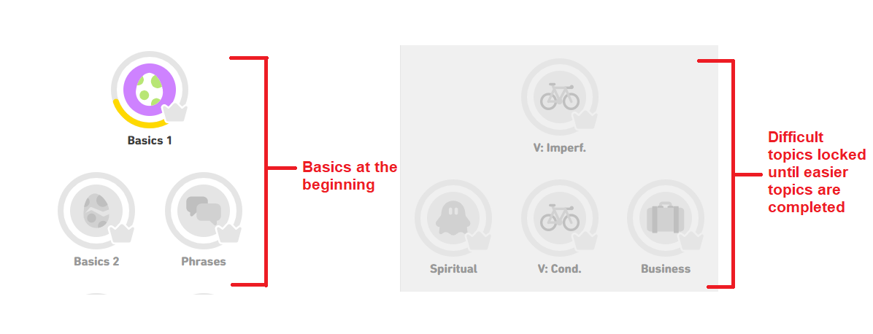 *Hierarchal System in Duolingo*

Below is an example of a question in Duolingo.  
The app I’m developing will follow a similar structure but with basic equations.

For example it could be something like:  
[ ] + 7 = 10  
  
[1] [2] [3] [4]  
  
Choose the correct number to complete the equation.

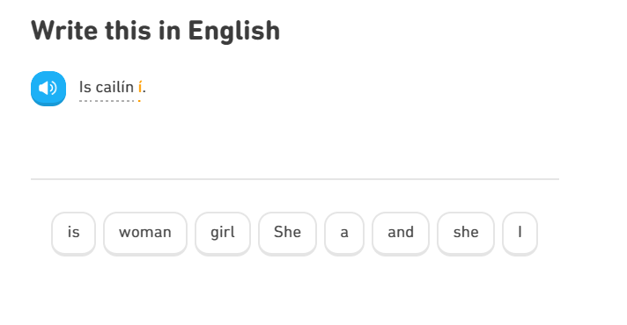Example of Duolingo Questions

The students will progress through levels, making mistakes and getting correct answers and at the end of the week the app will send the parent, teacher or both an easy-to-read report listing all of the progress the student has made and all of the mistakes that they have made so that revision can be done either in class or at home with a parent depending on where the teacher is in the curriculum.

**Your Input:**

1. [a] Do you think the app could be useful for you as a primary teacher?  
   [b] Would students use it?
2. I do believe that the app could be useful for a primary teacher. Especially for children who finish work quickly it would allow them to have an add on activity to push themselves further in their learning.
3. I think students would use it. It would be something different and new for them which makes it exciting.
4. Do you think there are any problems with the idea and if so what do you think could be done to correct them?

I think that creating an app like this there would be a lot of concern from parents in regard to how the children are learning and monitoring their work on the app.

1. Do you know of any resources (websites, books or both) that I could look into to access the curriculum for primary school maths?

Curriculum online

Haylock maths for primary teachers

Folens online (access to planet maths ebook& resources)

1. What form of device are primary school students most comfortable with? (e.g Desktop Computer, Laptop, iPad/Tablet, mobile phone)

Ipad/tablet or phone

1. Off the top of your head do you think there is any other kind of minigame-esque questions that would be helpful (and hopefully fun) to engage students more with the app?

Using pictures, odd one out games, matching games, students will get bored if similar sums are constantly appearing in front of them.

1. [a] Do you think having a section of the app dedicated to times tables would be worthwhile creating?  
   [b] Is there anything else in the same vein as this idea that you think could be essential to have in the app?

Yes I believe it would be helpful, especially if they could time themselves answering and try and beat their original time, I think breaking down the curriculum into different sections would be helpful as it would give the children a chance to master each of the curriculum skills required.

1. Is there a specific age the app should NOT be aimed at (junior, senior, 1st class)? Is there any point in targeting students this young?

I believe that all the students would benefit, it would take a long time to teach them exactly how to use the app etc.

1. Do you have any suggestions for the name of this app?

**Other Suggestions & Additional Feedback:**

I think that it’s a really worthwhile app and it would help the teachers differentiate their lessons, different settings could give children the chance to catch up with fellow classmates if struggling and the chance for more able students to challenge themselves further.